Bowel Cancer Quality Improvement Monitoring Report Update
Updated using 2017–2019 data

Acknowledgements
This report publishes quality performance indicator (QPI) data from the New Zealand Cancer Registry and the Ministry of Health’s national data collections for patients diagnosed with bowel cancer in Aotearoa New Zealand from 2017 to 2019.
The report is being released by Te Aho o Te Kahu, Cancer Control Agency (Te Aho o Te Kahu), in collaboration with the National Bowel Cancer Working Group. This builds on the work previously done by the Ministry of Health to identify and report on bowel cancer QPIs.
The development group acknowledges that each data point reflects an individual or cluster of patients and that each diagnosis of bowel cancer will have significantly affected the patient and their whānau/family. The group acknowledge all of those involved.

Authors
This report was prepared by Te Aho o Te Kahu and published as part of our quality improvement programme.
Citation: Te Aho o Te Kahu. 2022. Bowel Cancer Quality Improvement Monitoring Report Update: Updated using 2017–2019 data. Wellington: Te Aho o Te Kahu.
Published in April 2022 by Te Aho o Te Kahu, the Cancer Control Agency
PO Box 5013, Wellington 6140, New Zealand
ISBN 978-1-99-110020-7 (online)
HP 8039
This document is available at teaho.govt.nz and health.govt.nz.
This work is licensed under the Creative Commons Attribution 4.0 International licence. In essence, you are free to: share ie, copy and redistribute the material in any medium or format; adapt ie, remix, transform and build upon the material. You must give appropriate credit, provide a link to the licence and indicate if changes were made.

Contents
Executive summary vii
1 Key findings 1
1.1 Equity 1
1.2 Care pathway 2
1.3 Surgical care 2
1.4 Rectal cancer 3
2 Introduction 4
2.1 Background 4
2.2 Equity 5
2.3 Using this report 6
3 Methods 7
3.1 Funnel plots 7
3.2 Change over time 8
3.3 Adjusted outcomes 8
3.4 Additional comparisons 9
3.5 Abdominoperineal resection quality performance indicator 9
3.6 Definitions 10
3.7 Emergency surgery 10
4 Quality Performance Indicator: Care Pathway 11
4.1 Route to diagnosis 11
5 Quality Performance Indicators: Surgical Care 16
5.1 90-day post-operative mortality 16
5.2 Emergency surgery 21
5.3 Length of stay after surgery 25
5.4 Lymph node yield 27
6 Quality performance indicators: Rectal Cancer 32
6.1 Rectal cancer treatment 32
6.2 Abdominoperineal resection 37
Appendices 40
Appendix A: Description and Technical Specification for abdominoperineal resection indicator 40
Appendix B: References 46
Appendix C: Working group members 48

List of Figures
Figure 1: Proportion of people diagnosed with bowel cancer following presentation to an emergency department, referral to a clinic or screening, 2013–2019 13
Figure 2: Proportion of people diagnosed with bowel cancer following presentation at an emergency department, by district health board of domicile, 2017–2019 14
Figure 3: Proportion of people with bowel cancer who died within 90 days of elective or emergency surgery 18
Figure 4: Proportion of people with colon cancer who died within 90 days of elective or emergency surgery 18
Figure 5: Proportion of people with colon cancer who died within 90 days of surgery, emergency (acute) compared with elective 19
Figure 6: Observed 90-day post-operative mortality (elective and emergency admissions) for patients diagnosed with bowel cancer, by district health board of service, 2017–2019 19
Figure 7: Proportion of people with bowel cancer who had major resection performed as emergency surgery 23
Figure 8: Proportion of patients diagnosed with bowel cancer who underwent emergency surgery, by district health board of service, 2017–2019 23
Figure 9: Proportion of people with colon cancer who had surgery where 12 or more lymph nodes were pathologically examined 29
Figure 10: Proportion of people with colon cancer who had surgery where 12 or more lymph nodes were pathologically examined, by district health board of service, 2017–2019 29
Figure 11: Proportion of people with rectal cancer who had no radiotherapy (surgery alone) 34
Figure 12: Proportion of people with rectal cancer who received surgery and either long-course radiotherapy (LCRT) or short-course radiotherapy (SCRT) 34
Figure 13: Proportion of people with rectal cancer having no radiotherapy (surgery alone), by district health board of service for surgery,
2017–2019 35
Figure 14: Proportion of people with rectal cancer having pre-operative short-course radiotherapy, by district health board of service for surgery, 2017–2019* 35
Figure 15: Proportion of people with rectal cancer having pre-operative long-course radiotherapy, by district health board of service for surgery, 2017–2019* 36
Figure 16: Proportion of people having rectal cancer surgery who underwent abdominoperineal resection by district health board of service,
2017–2019* 39
Figure A1: Flow diagram for calculating BCQI21_a abdominoperineal resection 45

List of Tables
Table 1: People diagnosed with bowel cancer following presentation to an emergency department, referral to a clinic or screening, by year of diagnosis (2017–2019), age group, sex, ethnicity and deprivation 12
Table 2: 90-day post-operative mortality for people undergoing major surgery for bowel cancer in public hospitals, 2017–2019 17
Table 3: People undergoing emergency surgery for bowel cancer in public hospitals, by year of diagnosis (2017–2019), age group, sex, ethnicity and deprivation 22
Table 4: Length of stay after major surgery for bowel cancer, by year of diagnosis (2017–2019), age group, sex, ethnicity and deprivation 26
Table 5: Twelve or more lymph nodes pathologically examined for those undergoing surgical resection for colon cancer, by year of diagnosis (2017–2019), age group, sex, ethnicity and deprivation 28
Table 6: People with rectal cancer having surgery alone and short-course and long-course preoperative radiotherapy, by year of diagnosis
(2017–2019), age group, sex, ethnicity and deprivation 33
Table 7: People who underwent major surgical resection for rectal cancer who had an abdominoperineal resection, by year of diagnosis (2017–2019), age group, sex, ethnicity and deprivation 38

Executive summary
This report presents the second release of results of the investigations into the use of the Ministry of Health’s (the Ministry’s) national collections to calculate quality performance indicators (QPIs) for bowel cancer.

The primary audience for this report is those who deliver care to people with bowel cancer and manage the delivery of health services.

The aims of the report are to measure the quality of care and outcomes for people with bowel cancer in Aotearoa New Zealand and to provide information for ongoing quality improvement.

The report presents data for seven QPIs. Six of these were originally calculated and reported on in the first bowel cancer QPI monitoring report in 2019 (Ministry of Health 2019b).

The seven QPIs reported on in this report are generally accepted as measures of good bowel cancer care. The QPI that differs from the 2019 report (abdominoperineal resection) has been chosen to replace one of the original QPIs (stoma-free survival) because data challenges made it impossible to recalculate the original QPI.

The report compares the variation in these measures between district health boards (DHBs). It also presents change over time (between the 2019 calculations and the 2022 calculations) at a national level.

Geographic variation in services and outcomes can be seen with all indicators. For some indicators, there are also variations in access and outcomes for people belonging to different ethnic groups and ages.

Further investigation of the QPI results at the DHB level is needed to understand the variation between DHBs, particularly for those DHBs presenting as outliers, and to undertake quality improvement activities to reduce the variation. The results of further investigations will identify local opportunities to reduce inequalities, improve health services and care pathways and validate and improve local data collections.

Key findings
This section summarises the key findings. We have grouped the indicator results and recommendations under the following four headings: equity, care pathway, surgical care and rectal cancer.

Equity
Māori are more likely than European/Other to be diagnosed with bowel cancer following presentation to an emergency department (ED), undergo emergency surgery and undergo an abdominoperineal resection (APR) for rectal cancer.

For rectal cancer treatment, the proportion of Māori patients who had surgery alone was considerably lower compared with European/Other. Conversely, Māori patients were more likely to have radiotherapy in combination with surgery.

Māori appear less likely to have 12 or more lymph nodes pathologically examined at the time of colon cancer surgery.

The proportion of Pacific peoples diagnosed following an ED presentation also remains high as is the case with people living in areas of high deprivation.

Pacific peoples also have higher proportions of emergency surgery compared with European/Other.

Inequities in the routes to diagnosis and emergency surgery indicators are likely to reflect inequities in pre-hospital processes, including access to primary health care, and the presence of comorbidities (that may not be optimised or able to be optimised before surgery). We note that these, in turn, likely reflect differential access to the social determinants of health, such as education and employment, driven by a legacy of colonisation and racism (Te Aho o Te Kahu 2020).

It is recommended that district health boards (DHBs) prioritise the QPIs that highlight inequities, particularly for Māori and Pacific peoples.

Care pathway
Between 2017 and 2019, there was an increase in diagnoses of bowel cancer following screening (from 2.8 percent to 10.1 percent), which aligns with the rollout of the National Bowel Screening Programme, with a concurrent reduction in diagnosis following referral to clinic. However, the proportion of diagnoses following ED presentation did not appear to change, which is possibly a timing effect – a change in this QPI as a result of the bowel screening programme will possibly be evident in future calculations.

Similar to the previous report, people younger than 50 years or 75 years and older, women, Pacific peoples, Māori and those living in areas of high social deprivation were more likely to be diagnosed after presenting at an ED. This may reflect inequities in the diagnostic pathways and should be a priority area for DHBs. DHBs that are outliers should further investigate their data and the potential reasons for this variance compared with other DHBs.

Surgical care
Between 2017 and 2019, the 90-day post-operative mortality rate showed a downward annual trend (primarily in elective surgery, which experienced an annual decrease of 11 percent). Mortality rates remain higher for Māori compared with European/Other. There remains considerable variation between DHBs, although no DHB mortality rates are above the 95 percent confidence limits.

The proportion of emergency resections performed for bowel cancer in Aotearoa New Zealand is high compared with comparable countries and may contribute to poorer cancer outcomes. The proportion is highest for Māori and Pacific peoples, contributing to inequities in outcomes as well as probably being a reflection of inequities in other aspects of the patient pathway. This is particularly important to further understand considering the higher mortality rate seen with emergency surgery. It is unclear why there appears to have been an increase in the proportion of emergency surgeries for Pacific peoples with bowel cancer. DHBs should prioritise investigating and improving the emergency surgery QPI.

The median length of stay in hospital for people with bowel cancer following major resection was seven days with no change from the 2013-2016 time period. This report, compared with the previous report, has seen the median length of stay reduce for men and for patients 60 years and over. This indicator will continue to provide a useful monitor of overall post-operative care.

The proportion of people with 12 or more lymph nodes examined pathologically continues to increase, which is promising. However, a disparity remains for Māori. The higher proportions of emergency surgery for Māori may indirectly contribute to this result; however, further investigation at the DHB level is required.

Rectal cancer
The data suggest decreasing use of long-course radiotherapy (LCRT) over time. For this QPI, there was also a persistently lower proportion of rectal cancer management by surgery alone for Māori and a wide variation in practice across DHBs.

Among people who underwent major surgery for rectal cancer, 21.6 percent had an APR. There was wide variation in the proportion of APRs performed across DHBs, which warrants investigation at the local level.

Introduction

Background
Bowel cancer is a leading cause of illness, disability and death in Aotearoa New Zealand.

During 2017 and 2018, the Ministry of Health (the Ministry) and the National Bowel Cancer Working Group (NBCWG) collaborated to develop a set of proposed quality performance indicators (QPIs) for bowel cancer.

The proposed QPIs were selected to measure performance and drive quality improvement in bowel cancer diagnosis and treatment services in Aotearoa New Zealand. In some instances, the indicators were not able to be measured using data available in national data collections. The process identified areas where national data improvement is required (for example, on stage and grade of cancer) to enable future measurement at a national level.

The first Bowel Cancer Quality Improvement Report, using data from 2013–2016, was published in March 2019 (Ministry of Health 2019b).

In December 2019, Te Aho o Te Kahu was set up to provide national leadership for, and oversight of, cancer control in Aotearoa New Zealand. Te Aho o Te Kahu took over the cancer QPI programme of work from the Ministry.

Te Aho o Te Kahu has prepared this report in collaboration with the NBCWG. The report presents the second release of results for the bowel cancer QPIs for which robust national data is available. The report uses data from 2017-2019 and presents QPIs that are agreed measures of good care and primarily describes the variation in these measures between DHBs.

The primary audience for the report is those who deliver care to people with bowel cancer and manage the delivery of services.

Equity
In Aotearoa New Zealand, people have health differences that are not only avoidable but unfair and unjust. Equity recognises that people with different levels of advantage require different approaches and resources to get equitable health outcomes (Ministry of Health 2019a).

Māori currently experience a disproportionate and inequitable burden of mortality from bowel cancer. Addressing variations in the quality of cancer services provided around the country is pivotal to delivering equitable, high-quality care.

Internationally, QPIs are a recognised tool for identifying opportunities for quality improvement and addressing equity. By stratifying QPIs by ethnicity, Te Aho o Te Kahu and DHBs will be able to identify specific areas of inequity and develop quality improvement initiatives to address these and monitor progress over time.

Te Tiriti o Waitangi
Te Tiriti o Waitangi (the Treaty of Waitangi) provides an imperative for the Crown to protect and promote the health and wellbeing of Māori, including responding to and meeting Māori health needs.

The Waitangi Tribunal Health Services and Outcomes Inquiry (Wai 2575) that was initiated in November 2016 commenced hearing all claims concerning grievances relating to health services and outcomes of national significance for Māori.

Given that Māori have the poorest overall health status in Aotearoa New Zealand and are significantly disadvantaged in terms of health inequities, it is essential that we ensure the rights and meet the needs of Māori people (Ministry of Health 2019b). From the initial hearings related to primary health care, the Waitangi Tribunal made several recommendations in accordance with the principles of tino rangatiratanga, equity, active protection, options and partnership.

The QPIs were developed with these factors in mind, and a partnership approach should be taken with respect to all quality improvement initiatives, both existing and yet to be developed.

Using this report
We present the indicator results in sections 4–6 of this report. We present the care pathway indicator in section 4, surgical care indicators in section 5 and indicators specific to rectal cancer in section 6. The sources of data for the indicators and the methods of analysis are explained in the updated Bowel Cancer Quality Performance Indicator Descriptions (2022) and the Bowel Cancer Quality Performance Indicator Specifications (2022), both of which are available on the Te Aho o Te Kahu website.

While DHBs had access to the provisional results of the previous report in October 2018, due to the timing of the release of that report in March 2019, there is overlap with the period covered in this report (2017–2019). Therefore, while changes in QPI results are noted, it is not assumed that the previous report and associated activity are the only influencers on the current numbers. This report provides a way of tracking progress that will be influenced by numerous factors and give service providers important information that will help them continue to improve their delivery of cancer care.

Methods
For this report, we have calculated QPIs for people diagnosed with bowel cancer between the years 2017 and 2019. The sources of data for the indicators and the methods of analysis are explained in the updated Bowel Cancer Quality Performance Indicator Descriptions (2022) and the Bowel Cancer Quality Performance Indicator Specifications (2022), both of which are available on the Te Aho o Te Kahu website; however, in this section we outline key points and any additional methodology used.

The time period for this report (2017–2019) has been used because, at the time of doing the calculation, it was the most up to date and complete data on cancer registrations and mortality. It is our expectation that, as data completeness and quality improve as a result of projects being undertaken by Te Aho o Te Kahu, the Ministry of Health and other stakeholders, we will be able to report on more recent data in subsequent updates.

Most results reported in this report are descriptive. We report the results of categorical data as percentages. We typically group results by DHB of service (that is, where the service was located). We also present results by year of diagnosis, ethnic group (prioritised), sex, age group (years) and NZDep2013 quintile (based on the person’s place of main residence, otherwise known as domicile, at the time of diagnosis).

Funnel plots
This report uses funnel plots to make comparisons between DHBs. These funnel plots are presented in a similar fashion to that used in the previous report. We plot the proportion for each DHB against the total number of patients. The average across all DHBs appears as an orange line. The funnel limits depend on the average proportion and the number of patients included in the estimate; proportion estimates have greater uncertainty when estimated from fewer patients. Results fall outside the inner limits if they are statistically different from the average at a 0.05 level and outside the outer limits if they are statistically significantly different from the average at a 0.002 level. The DHB regions in each funnel plot may represent the DHB of service or DHB of domicile, and this is indicated in the caption of each plot.

Change over time
In addition to funnel plots and tables presented in the previous report, we have included graphs to explore the differences in QPIs across the time periods at a national level.

Each graph has error bars that represent 95 percent confidence interval. A trend analysis using Poisson regression was performed in R to estimate average change per year (rate ratios) (Atkinson et al 2008). Where relevant (ie, where the results were found to be statistically significant), analysis is provided in the commentary. The model used robust standard errors to control for mild violation of the distribution assumption that the variance equals the mean (Cameron et al 2009). We also calculated 95 percent confidence intervals for all estimates.

Rate data was modelled by including the log (n) term with the coefficient of 1 (Atkinson et al 2008). This is called an offset. Offset in the case of a general linear model (GLM) in R can be achieved using the offset ( ) function:
glm(y ~ offset(log(exposure)) + x, family=poisson(link=log))

Adjusted outcomes
We have made no risk adjustment to the data due to missing stage data and other risks, such as comorbidity. We encourage service providers to interpret their results in the context of the case mix of their unit. We have stratified data and present it in data tables. Stratifying variables include age group, sex, ethnic group (prioritised) and NZDep2013 quintile with data from the New Zealand Cancer Registry. Other variables (such as tumour, node, metastases (TNM) group stage and comorbidity) are not available in national collections but should be available for patients in local DHB records. We are reviewing the data analytic strategy for risk adjustment.

Additional comparisons
In addition to comparing these results with those of the previous QPI report, we have compared our results to two reports that have calculated and published similar bowel cancer indicators: the PIPER Project and the 2019 National Bowel Cancer Audit (NBOCA) report. Note that differences in data collection or analysis methods may limit comparisons with these reports.

The PIPER Project looked at colorectal cancer survival according to rurality, ethnicity and socioeconomic deprivation (Sharples et al 2018). It was a national retrospective cohort study of all Aotearoa New Zealand residents diagnosed with colorectal adenocarcinoma in Aotearoa New Zealand from 1 January 2007 to 31 December 2008, with an extended cohort of Māori and Pacific peoples. The study identified potential cases from the New Zealand Cancer Registry (ICD-10-AM codes C18–C20). Researchers obtained data from patient clinical records and national databases of hospitalisations and mortality.

The NBOCA describes and compares the care and outcomes of patients diagnosed with bowel cancer in England and Wales. The Healthcare Quality Improvement Partnership (HQIP) commissions this audit. Our comparison looked at the NBOCA’s 2019 annual report, which is the tenth such report. It includes data on over 30,000 patients diagnosed with bowel cancer between 1 April 2017 and 31 March 2018 (HQIP 2020).

Abdominoperineal resection quality performance indicator
We removed the stoma-free at 18 months quality performance indicator due to issues with the accuracy of data collection. We are unable to accurately capture people who have had stoma-forming operations and people who have had their stoma reversed. We have replaced this with an indicator measuring how many people who underwent rectal cancer surgery had an abdominoperineal resection (APR). We acknowledge that while there is better data accuracy for this indicator, it also has shortcomings as there are a variety of reasons for performing this procedure that are not captured in a single proportion. The description and technical specifications for this indicator are presented in Appendix A and have been included in the updated versions of these documents that can be found on the Te Aho o Te Kahu website.

Definitions

Bowel cancer
The term bowel cancer is synonymous with colorectal cancer for the purpose of this report. Bowel cancer excludes neuroendocrine tumours, gastrointestinal stromal tumours, lymphomas, squamous cell carcinomas and melanomas. This means that anal, appendiceal and small bowel cancers have been excluded.

Emergency surgery
In this report, we use the term emergency surgery to indicate surgery performed following an acute admission. We defined acute admission according to the Ministry’s Common Counting Standards 2013/14, ie:
An unplanned admission on the day of presentation at the admitting healthcare facility. Admission may have been from the emergency or outpatient departments of the healthcare facility or a transfer from another facility (Common Counting Technical Advisory Group and Ministry of Health 2017).

Quality Performance Indicator: Care Pathway

Route to diagnosis

Indicator description
Proportion of people with bowel cancer who are diagnosed following a referral to a clinic, screening or presentation to an emergency department (ED) (with or without surgery).

The National Bowel Screening Programme
The Bowel Screening Pilot, for people aged 60–74 years, began in Waitematā DHB in January 2012. Following its completion, the Ministry of Health started rolling out the National Bowel Screening Programme progressively across DHBs.

Before the time period covered in this report, only Waitematā DHB had screening available as a pilot scheme, as discussed in the previous bowel cancer quality improvement report (Ministry of Health 2019b). During the time period covered by this report (2017–2019) the following DHBs introduced bowel screening: Hutt Valley and Wairarapa DHBs in 2017; Waitematā, Southern and Counties Manukau DHBs in early–mid 2018; Nelson Marlborough and Hawke’s Bay DHBs in late 2018; Lakes DHB in early 2019 and Whanganui and MidCentral DHBs in late 2019. The introduction of bowel screening at these DHBs may have impacted their data; although, this effect is more likely to be seen in future updates of the bowel QPI calculations.

Results
Between 2017 and 2019, most people (67.8 percent) were diagnosed following referral to a clinic (Table 1). This represented a reduction compared with the 2013–2016 time period (71.1 percent).

By comparison, 5.9 percent of people were diagnosed following a referral from screening services (compared with 2.7 percent in the previous period), and 26.3 percent of people were diagnosed following presentation at an ED (with the latter proportion unchanged from the previous time period).

Between 2017 and 2019, there was an increase in diagnosis following screening from 2.8 percent to 10.1 percent (Table 1 and Figure 1). This aligns with the rollout of the National Bowel Screening Programme and seems to coincide with a reduction in diagnosis following referral to clinic from 71.7 percent down to 63.7 percent (Table 1 and Figure 1). The diagnosis following ED presentations had minimal change over the 2017–2019 period (Table 1 and Figure 1).

Table 1: People diagnosed with bowel cancer following presentation to an emergency department, referral to a clinic or screening, by year of diagnosis (2017–2019), age group, sex, ethnicity and deprivation
 | People diagnosed | ED  presentation |  | Referral  to clinic |  | Screening
 | N | N | % | N | % | N | %
Total | 8,690 | 2,282 | 26.3 | 5,891 | 67.8 | 517 | 5.9
Year of diagnosis
2017 | 2,746 | 699 | 25.5 | 1,969 | 71.7 | 78 | 2.8
2018 | 2,933 | 796 | 27.1 | 2,003 | 68.3 | 134 | 4.6
2019 | 3,011 | 787 | 26.1 | 1,919 | 63.7 | 305 | 10.1
Age group
18–49 | 685 | 224 | 32.7 | 461 | 67.3 | 0 | 0
50–59 | 1,090 | 273 | 25 | 779 | 71.5 | 38 | 3.5
60–74 | 3,363 | 700 | 20.8 | 2,222 | 66.1 | 441 | 13.1
75+ | 3,552 | 1,085 | 30.5 | 2,429 | 68.4 | 38 | 1.1
Sex
Female | 4,054 | 1,136 | 28 | 2,715 | 67 | 203 | 5
Male | 4,636 | 1,146 | 24.7 | 3,176 | 68.5 | 314 | 6.8
Ethnicity
Māori | 594 | 218 | 36.7 | 346 | 58.2 | 30 | 5.1
Pacific peoples | 214 | 95 | 44.4 | 101 | 47.2 | 18 | 8.4
Asian | 403 | 110 | 27.3 | 238 | 59.1 | 55 | 13.6
European/Other | 7,415 | 1,853 | 25 | 5,162 | 69.6 | 400 | 5.4
Unknown | 64 | 6 | 9.4 | 44 | 68.8 | 14 | 21.9
NZDep2013 quintile
1 | 1,668 | 372 | 22.3 | 1,191 | 71.4 | 105 | 6.3
2 | 1,669 | 396 | 23.7 | 1,152 | 69 | 121 | 7.2
3 | 1,845 | 461 | 25 | 1,276 | 69.2 | 108 | 5.9
4 | 1,893 | 498 | 26.3 | 1,285 | 67.9 | 110 | 5.8
5 | 1,613 | 555 | 34.4 | 985 | 61.1 | 73 | 4.5

Figure 1: Proportion of people diagnosed with bowel cancer following presentation to an emergency department, referral to a clinic or screening, 2013–2019
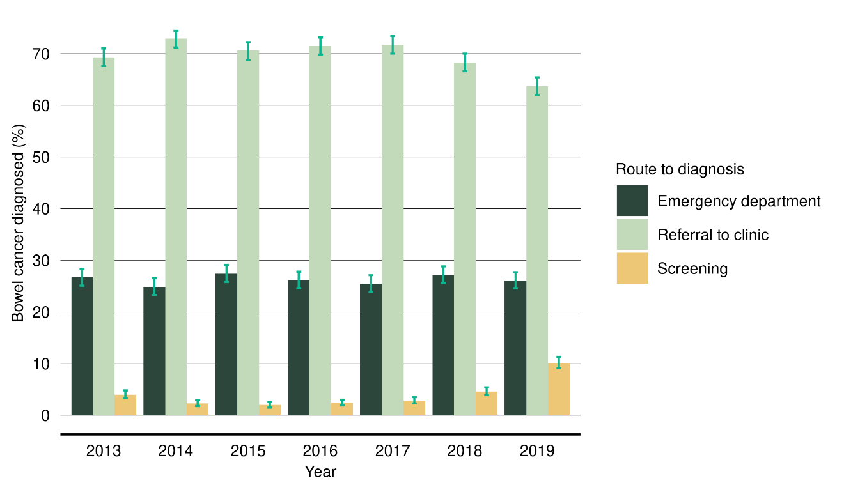
Note: Error bars represent 95 percent confidence intervals.

Although small numbers, over the 2017–2019 period, diagnoses following screening for Māori appeared to increase at 5.1 percent compared with 1.7 percent for the previous time period (2013–2016). There was no decrease in diagnosis after ED presentations for Māori, rather the reduction appears to be in diagnosis following clinic visits (63 percent in the 2013–2016 period compared with 58.2 percent in the 2017–2019 period).

Similar to the previous report, people aged younger than 50 years or 75 years and older, women, Pacific peoples, Māori and those living in areas of high social deprivation were more likely to be diagnosed after presenting at an ED. The percentage of Pacific peoples diagnosed after presenting to an ED was higher than any other group at 44.4 percent (43.6 percent in the previous report, 2013–2016).

Figure 2: Proportion of people diagnosed with bowel cancer following presentation at an emergency department, by district health board of domicile, 2017–2019
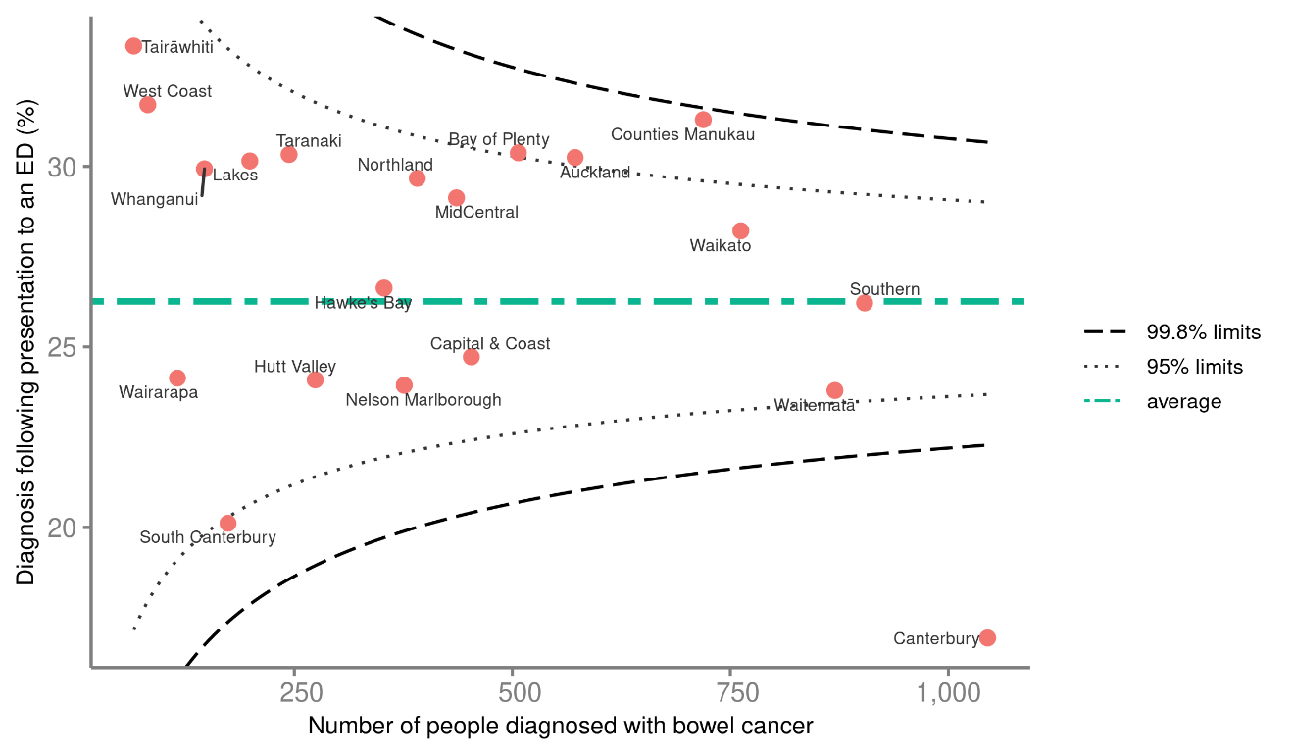

For the proportion of bowel cancer diagnosed following an ED presentation over the 2017–2019 period, no DHBs achieved above the upper 99.8 percent limit, while three (Counties Manukau, Bay of Plenty and Auckland DHBs) achieved above the 95 percent limit. One DHB (Canterbury) achieved below the lower 99.8 percent limit (Figure 2).

Discussion
Proportions of Māori and Pacific peoples being diagnosed following an ED presentation remain high, as do those for people living in areas of high deprivation. Similar inequities were found in the PIPER Project (using data from 2007 to 2008). After controlling for demographic characteristics and disease variables such as stage and grade at diagnosis, Māori patients and those in the highest quintile of deprivation were still significantly more likely to present directly to ED (Sharples et al 2018). This indicator is therefore likely to reflect inequities in diagnostic pathways and access to care.

This indicator continues to provide an opportunity to monitor the consequences of the National Bowel Screening Programme (NBSP). Although calculated while the NBSP was in the process of being rolled out, it shows an increase in diagnoses following screening. In comparison, in the United Kingdom, around 10 percent of bowel cancer patients were diagnosed following referral from a screening service in 2017/18 (HQIP 2020), a similar figure to that seen for Aotearoa New Zealand in 2019 at the early stages of the NBSP rollout. While ED-related diagnoses do not appear to have reduced in response to the rollout, this may represent the programme being in the early stages.

Recommendations
DHBs should prioritise investigating this indicator. DHBs who are outliers should further investigate their data and address potential reasons for variance compared with other DHBs.

The recommended actions for this QPI from the November 2020 Bowel Cancer Quality Improvement Plan (Te Aho o Te Kahu 2020a) are listed below.

Te Aho o Te Kahu
        - Continue to review diagnosis of bowel cancer following ED presentation, including inequities in the proportion of patients presenting to ED, and report to DHBs two-yearly. Report and review more regularly for those DHBs whose results lie outside the 99.8 percent limit above the mean.
        - Develop educational resources for primary health care providers on symptoms and appropriate management of patients, including direct access to colonoscopy referral for patients with symptoms consistent with bowel cancer.
        - Consider work to improve public understanding of symptoms of bowel cancer, with a focus on groups disproportionately affected by ED diagnosis.
        - Establish a primary health care advisory group to Te Aho o Te Kahu to provide advice on the factors occurring at primary health care level that support or act as barriers to the early diagnosis of cancer, including bowel cancer. This might cover pre-diagnosis and referral measures, as well as post-diagnosis primary health care management and support.
        - Support the ongoing rollout of the National Bowel Cancer Screening Programme.

District health boards
        - Review referral pathways to identify unwarranted variation or delays in the referral process. This may include consideration of the processes for direct referral from primary health care and a review of patients who have been diagnosed following acute presentation to identify barriers that may have prevented earlier diagnosis.
        - Establish robust ‘Did Not Attend’ processes that ensure patients are not removed from a waiting list until several attempts have been made to contact them, both in writing and by phone. Consider established outreach processes. No patient should be removed from a waiting list until a clinician has reviewed the referral and approved the removal and the DHB has formally notified the patient referrer that the patient could not be contacted. Encourage further attempts to contact the patient through primary health care.
        - Encourage and promote the use of educational resources to primary health care providers and priority populations.

Quality Performance Indicators: Surgical Care

90-day post-operative mortality

Indicator description
Proportion of people with bowel cancer who died within 90 days of surgery (all surgery and elective surgery).

Results
For people with bowel cancer, the overall 90-day mortality following major surgery was 3 percent (Table 2), a decrease from 4 percent in the 2013–2016 period.

Table 2: 90-day post-operative mortality for people undergoing major surgery for bowel cancer in public hospitals, 2017–2019
 | Major bowel cancer surgery | Death within 90 days  of surgery
 | N | N | %
Total | 5,303 | 160 | 3
Year of diagnosis
2017 | 1,721 | 57 | 3.3
2018 | 1,757 | 47 | 2.7
2019 | 1,825 | 56 | 3.1
Age group (years)
18–49 | 393 | 9 | 2.3
50–59 | 596 | 12 | 2
60–74 | 2,185 | 31 | 1.4
75+ | 2,129 | 108 | 5.1
Sex
Female | 2,483 | 64 | 2.6
Male | 2,820 | 96 | 3.4
Ethnicity
Māori | 365 | 17 | 4.7
Pacific peoples* | 103 | – | –
Asian* | 240 | – | –
European/Other | 4,555 | 137 | 3
Unknown* | 40 | – | –
NZDep2013 quintile**
1 | 921 | 14 | 1.5
2 | 992 | 16 | 1.6
3 | 1,140 | 39 | 3.4
4 | 1,209 | 48 | 4
5 | 1,039 | 42 | 4
* Due to small numbers, some figures have not been included.
** Missing and unknown categories are not included in this NZDep2013 category reporting and therefore the totals at the bottom of the table do not match the total at the beginning of the table.

Figure 3 shows data for 90-day mortality following bowel cancer surgery for 2013 to 2019. It shows a reduction in mortality over time, with an annual decrease of 7.4 percent from 2013 until 2019.

Figures 4 and 5 further explore the possible reduction in mortality for colon cancer. Overall, there has been an 8.4 percent annual decrease in mortality following colon cancer surgery (both elective and emergency) (Figure 4). The contribution of elective and emergency surgery to this overall decreased mortality is explored in Figure 5. There was an 11 percent annual reduction in post-operative mortality following elective surgery (Figure 5). The relatively small number of patients having emergency surgery each year make the annual mortality rates more variable and the trend to improvement less obvious.
Figure 3: Proportion of people with bowel cancer who died within 90 days of elective or emergency surgery
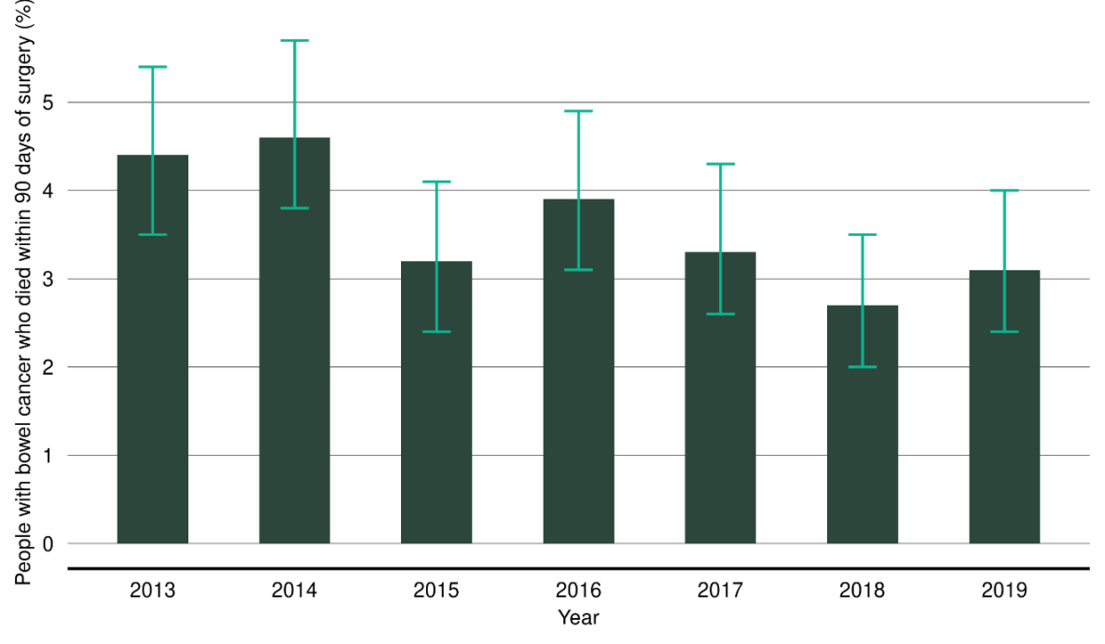
Note: Error bars represent 95 percent confidence intervals.

Figure 4: Proportion of people with colon cancer who died within 90 days of elective or emergency surgery
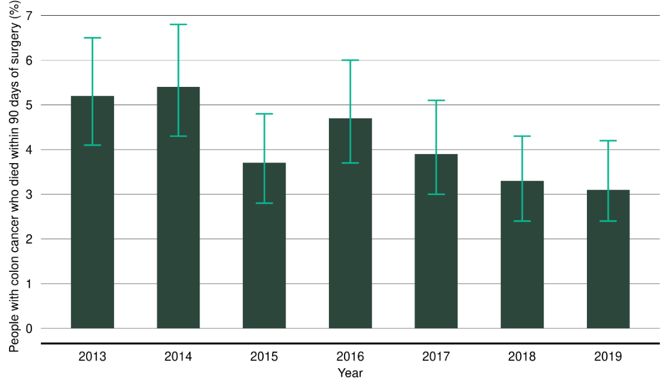
Note: Error bars represent 95 percent confidence intervals.
Figure 5: Proportion of people with colon cancer who died within 90 days of surgery, emergency (acute) compared with elective
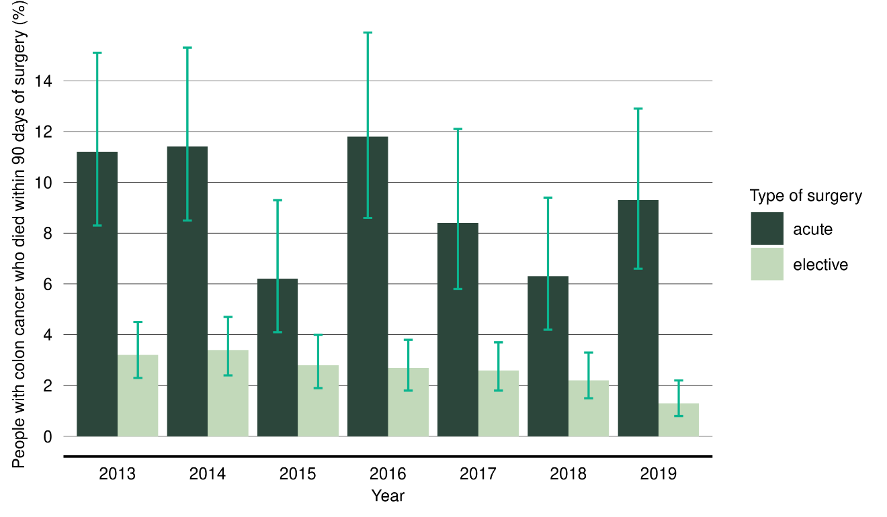
Note: Error bars represent 95 percent confidence intervals.

Figure 6: Observed 90-day post-operative mortality (elective and emergency admissions) for patients diagnosed with bowel cancer, by district health board of service, 2017–2019
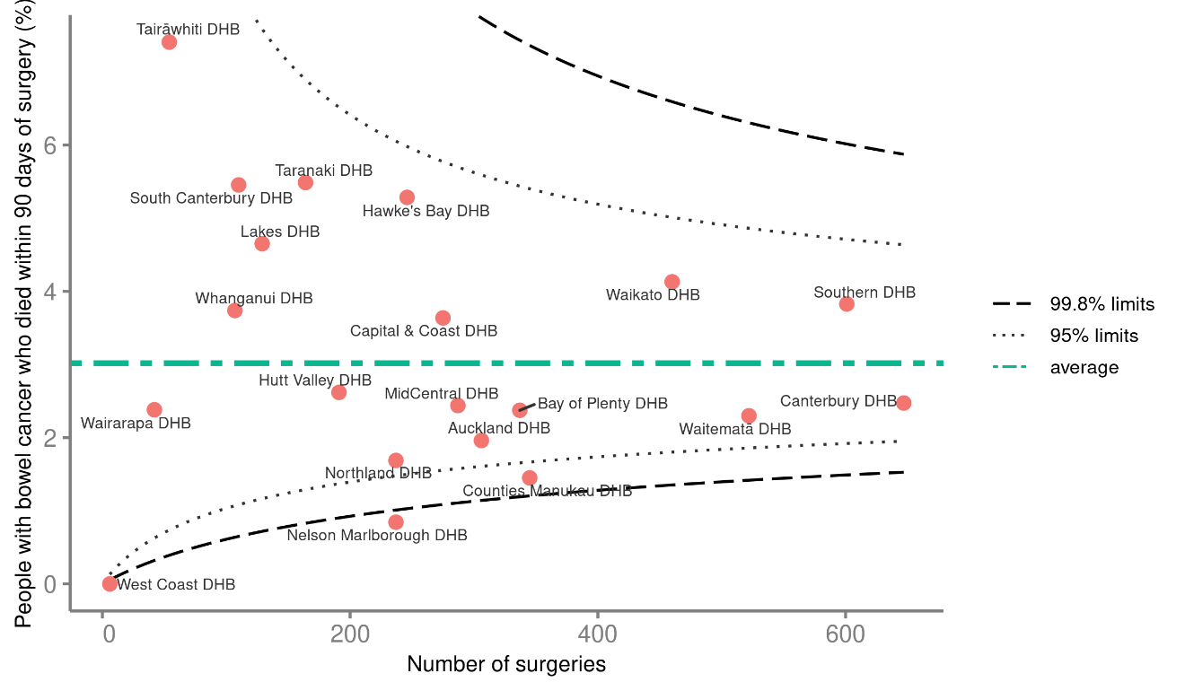

Post-operative 90-day mortality varied markedly across the DHBs from 0 to 7.4 percent for elective and emergency admissions, with no DHBs above the 95 percent limit (Figure 6).

Discussion
There is encouraging evidence presented in these results showing post-operative mortality has reduced over the 2013–2019 period for total bowel cancer surgery, total colon cancer surgery and elective colon cancer surgery. These results are now in line with the National Bowel Cancer Audit (NBOCA), which found the 90-day post-operative mortality rate in people undergoing major surgery was 3 percent for 2017–2018 (HQIP 2020).

There remains considerable variation between DHBs, partly driven by small numbers of events within DHBs, although no DHB mortality rates are above the 95 percent confidence limits (noting that this is not comparing against an ideal target). In addition, mortality rates appear higher for Māori and Pacific peoples compared with European/Other (noting that small numbers mean it is challenging to know if there is a true difference).

Recommendations
The recommended actions for this QPI from the November 2020 Bowel Cancer Quality Improvement Plan (Te Aho o Te Kahu 2020a) are listed below.

Te Aho o Te Kahu
        - Continue to review 90-day mortality following bowel cancer surgery, including inequities in this outcome, and report to DHBs two-yearly. Report and review more regularly for those DHBs whose results lie outside the 99.8 percent limit below the mean.
        - Determine whether there is a need for a nationally consistent and validated preoperative risk score (such as the Physiological and Operative Severity Score for the Enumeration of Mortality and Morbidity (POSSUM) or NZ RISK score).
        - Provide DHBs with advice to ensure pathways include robust preoperative assessment and physiological optimisation strategies (nutrition, cardiorespiratory fitness, etc).

District health boards
        - Where a patient dies within 90 days of bowel cancer surgery, facilitate a proactive audit and feedback process to identify and address factors that may have been preventable.
        - Ensure that a robust preoperative assessment covers patients’ nutritional, functional and comorbidity status, and provide support preoperatively to those who need it. Consider delaying definitive surgery while undertaking preoperative assessment and intervention where the clinical setting allows.
        - Use ‘enhanced recovery after surgery’ (ERAS) protocols (Ministry of Health 2015). This may include the use of specialist nurses to provide pre- and post-surgical support and education.
        - Consider surgical options including stenting and de-functioning colostomy for high-risk patients and/or those with advanced disease before embarking on major tumour resection.
        - Provide culturally appropriate preoperative support for Māori and Pacific patients and their whānau to avoid delays from missed appointments and to generally improve patient journeys and outcomes.

Emergency surgery

Indicator description
Proportion of people with bowel cancer undergoing major resection who have emergency surgery.

Results
From 2017 to 2019, of people with bowel cancer who had major surgical resection, 19.4 percent had their surgery performed as an emergency procedure (Table 3). This was similar to the proportion for the 2013–2016 time period (19.6 percent, see Figure 7).

Māori and Pacific peoples had higher proportions of emergency surgery compared with European/Other (Table 3). For Pacific peoples, the proportion was 28.2 percent compared with 20.4 percent for 2013–2016 and for Māori 24.9 percent compared with the previous period at 23.8 percent.

Table 3: People undergoing emergency surgery for bowel cancer in public hospitals, by year of diagnosis (2017–2019), age group, sex, ethnicity and deprivation
 | Major bowel cancer surgery | Emergency  surgery
 | N | N | %
Total | 5,303 | 1,031 | 19.4
Year of diagnosis
2017 | 1,721 | 321 | 18.7
2018 | 1,757 | 361 | 20.5
2019 | 1,825 | 349 | 19.1
Age group (years)
18–49 | 393 | 103 | 26.2
50–59 | 596 | 117 | 19.6
60–74 | 2,185 | 366 | 16.8
75+ | 2,129 | 445 | 20.9
Sex
Female | 2,483 | 547 | 22
Male | 2,820 | 484 | 17.2
Ethnicity
Māori | 365 | 91 | 24.9
Pacific peoples | 103 | 29 | 28.2
Asian | 240 | 44 | 18.3
European/Other | 4,555 | 862 | 18.9
Unknown | 40 | 5 | 12.5
NZDep2013 quintile*
1 | 921 | 181 | 19.7
2 | 992 | 176 | 17.7
3 | 1,140 | 217 | 19
4 | 1,209 | 244 | 20.2
5 | 1,039 | 213 | 20.5
* Missing and unknown categories are not included in this NZDep2013 category reporting and therefore the totals at the bottom of the table do not match the total at the beginning of the table.

Figure 7: Proportion of people with bowel cancer who had major resection performed as emergency surgery
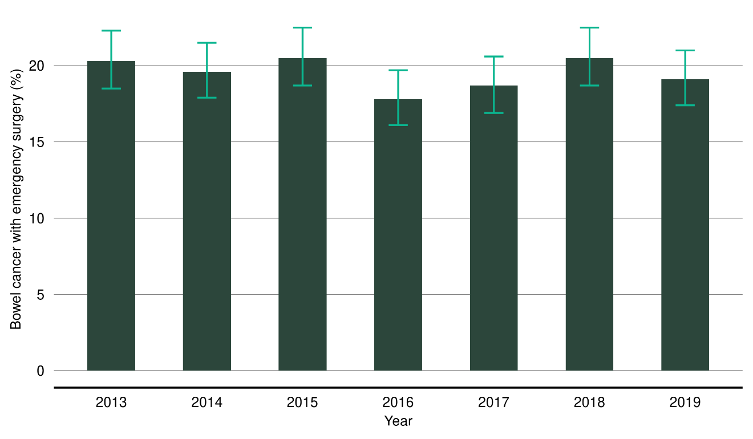
Note: Error bars represent 95 percent confidence intervals.

Figure 8: Proportion of patients diagnosed with bowel cancer who underwent emergency surgery, by district health board of service, 2017–2019
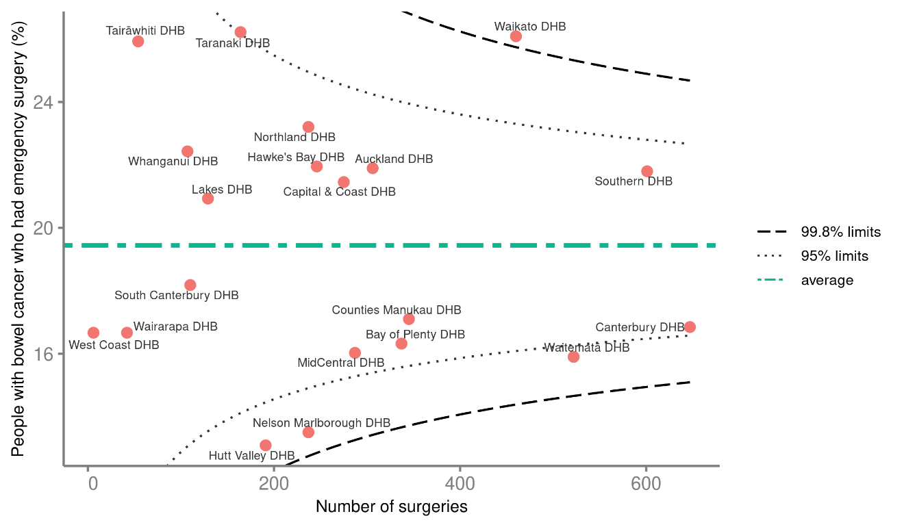

There were two DHBs above the 95 percent limits of the funnel plot and three below the 95 percent limits (Figure 8). There was considerable variation in rate of emergency surgery, from 13.1 percent to 26.2 percent.

Discussion
The proportion of emergency surgery performed for bowel cancer in Aotearoa New Zealand is high and may contribute to poorer cancer outcomes.

The proportion is highest for Māori and Pacific peoples, contributing to inequity of outcome as well as likely reflecting inequities in other aspects of the patient pathway. This is particularly important to understand better, considering the higher mortality rate seen with emergency (acute) surgery. It is unclear why there appears to have been an increase in the proportion of emergency surgery for Pacific peoples. While there are small numbers of Pacific patients in this group, meaning it is difficult to know if there is a true difference, this possible trend is concerning and needs continued monitoring.

The proportion of emergency surgery is lowest in the 60–74-year age group. It is possible that this is related to the introduction of the NBSP. Further QPI monitoring will be an opportunity to continue observing these trends.

Recommendations
DHBs should prioritise investigating this indicator further.

Consideration should be given to the link between emergency surgery rates and stage at diagnosis. We recommend that DHBs consider focusing on access to diagnosis (for example, primary health care access) and earlier diagnosis (for example, access to colonoscopy and symptom awareness).

Other activities to better understand and improve this indicator may include developing a clearer understanding of DHB data, considering and addressing inequities of access to care and any differences in onward referral.

There were no specific recommendations for the emergency surgery QPI in the November 2020 Bowel Cancer Quality Improvement Plan (Te Aho o Te Kahu 2020a).

Length of stay after surgery

Indicator description
Median length of stay following surgery for bowel cancer.

Results
The median length of stay in hospital for people with bowel cancer following major resection was seven days (Table 4). This represents no change from the previous QPI calculations, using data from the 2013–2016 period.

The median length of stay after surgery for bowel cancer ranged from five-and-a-half to eight days between DHBs. The median length of stay after surgery was six days for people with bowel cancer (compared with seven for the 2013–2016 period) and eight days for people with rectal cancer (no change). The length of stay in patients over the age of 60 years reduced by one day compared with the 2013–2016 period. The length of stay for male patient has also decreased by one day, from eight days to seven days.

Table 4: Length of stay after major surgery for bowel cancer, by year of diagnosis
(2017–2019), age group, sex, ethnicity and deprivation
 | Major bowel  cancer surgery | Median length  of stay
 | N | days
Total | 5,303 | 7
Year of diagnosis
2017 | 1,721 | 7
2018 | 1,757 | 7
2019 | 1,825 | 7
Age group (years)
18–49 | 393 | 7
50–59 | 596 | 7
60–74 | 2,185 | 6
75+ | 2,129 | 7
Sex
Female | 2,483 | 7
Male | 2,820 | 7
Ethnicity
Māori | 365 | 7
Pacific peoples | 103 | 7
Asian | 240 | 6
European/Other | 4,555 | 7
Unknown | 40 | 5.5
NZDep2013 quintile*
1 | 921 | 6
2 | 992 | 7
3 | 1,140 | 7
4 | 1,209 | 7
5 | 1,039 | 7
* Missing and unknown categories are not included in this NZDep2013 category reporting and therefore the totals at the bottom of the table do not match the total at the beginning of the table.

Discussion
There has been some improvement in the length of stay for patients over the age of 60 years and men, with both of these groups being discharged, on average, one day earlier compared to the previous time period. This may have been influenced by the increasing use of enhanced recovery after surgery (ERAS) programmes and their refining over time. It may also have been influenced by increased use of laparoscopic surgery, and for the 60–74-year age group, the increased proportion of screening-related diagnoses, meaning surgery is being performed at an earlier stage.

The NBOCA found the median length of stay following major resection to be stable over time at seven days for the 2017–2018 period.

This indicator will continue to provide a useful monitor of overall post-operative care.

Recommendations
Further improvements in length of stay could be expected with more universal use of ERAS programmes and greater proportions of laparoscopic surgeries.

Lymph node yield

Indicator description
Proportion of people with colon cancer who undergo surgical resection where 12 or more lymph nodes are pathologically examined.

Results
The percentage of people having surgery for colon cancer with 12 more lymph nodes examined increased from 81.5 percent in the 2013–2016 period to 84.4 percent in the current report period of 2017–2019 (Table 5). When examined using annual figures from 2013 to 2019, this represents a small but significant annual increase of 1.1 percent (Figure 9).

A lower proportion of Māori who have colon cancer surgery have 12 or more lymph nodes examined (79.8 percent) compared with European/Other (84.4 percent). However Pacific peoples and people of Asian ethnicity have higher rates than the average, at 88.6 percent and 89.2 percent respectively.

Among males, 83 percent had 12 or more lymph nodes examined compared with 85.7 percent of females. Younger age groups had higher proportion of 12 or more lymph nodes examined compared with the older age groups.

Table 5: Twelve or more lymph nodes pathologically examined for those undergoing surgical resection for colon cancer, by year of diagnosis (2017–2019), age group, sex, ethnicity and deprivation
 | Major colon cancer surgery | 12 or more lymph nodes examined
 | N | N | %
Total | 4,073 | 3,383 | 84.4
Year of diagnosis
2017 | 1,325 | 1,063 | 81.8
2018 | 1,351 | 1,122 | 84.1
2019 | 1,397 | 1,198 | 87
Age group (years)
18–49 | 262 | 220 | 87.6
50–59 | 393 | 322 | 85.2
60–74 | 1,592 | 1,336 | 84.9
75+ | 1,826 | 1,505 | 83.2
Sex
Female | 2,047 | 1,731 | 85.7
Male | 2,026 | 1,652 | 83
Ethnicity
Māori | 259 | 202 | 79.8
Pacific peoples | 72 | 62 | 88.6
Asian | 176 | 157 | 89.2
European/Other | 3,532 | 2,935 | 84.4
Unknown | 34 | 27 | 79.4
NZDep2013 quintile*
1 | 698 | 601 | 87.5
2 | 765 | 657 | 86.9
3 | 890 | 736 | 83.8
4 | 924 | 734 | 80.6
5 | 794 | 654 | 84.3
* Missing and unknown categories are not included in this NZDep2013 category reporting and therefore the totals at the bottom of the table do not match the total at the beginning of the table.

Figure 9: Proportion of people with colon cancer who had surgery where 12 or more lymph nodes were pathologically examined
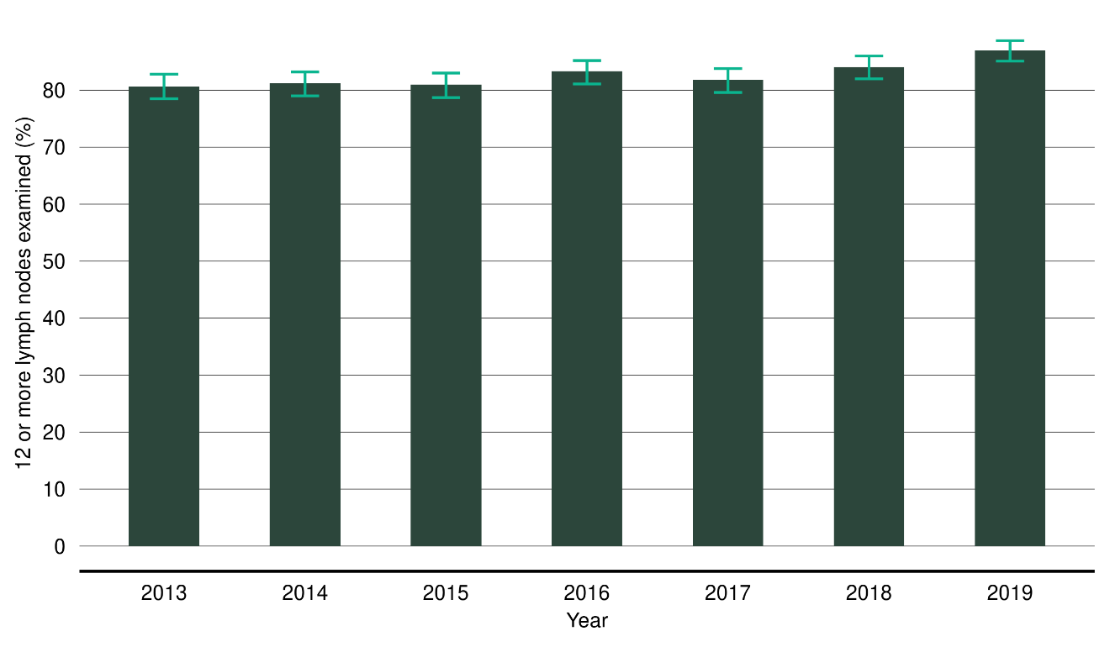
Note: Error bars represent 95 percent confidence intervals.

Figure 10 below shows the funnel plot representation of DHB variation for this indicator. Three DHBs were above the 99.8 percent limits (compared with six in the 2013–2016 period). Five DHBs were below the 95 percent confidence limits, compared with seven in the previous time period. This represents a decrease in outliers between the two time periods.

Figure 10: Proportion of people with colon cancer who had surgery where 12 or more lymph nodes were pathologically examined, by district health board of service,
2017–2019
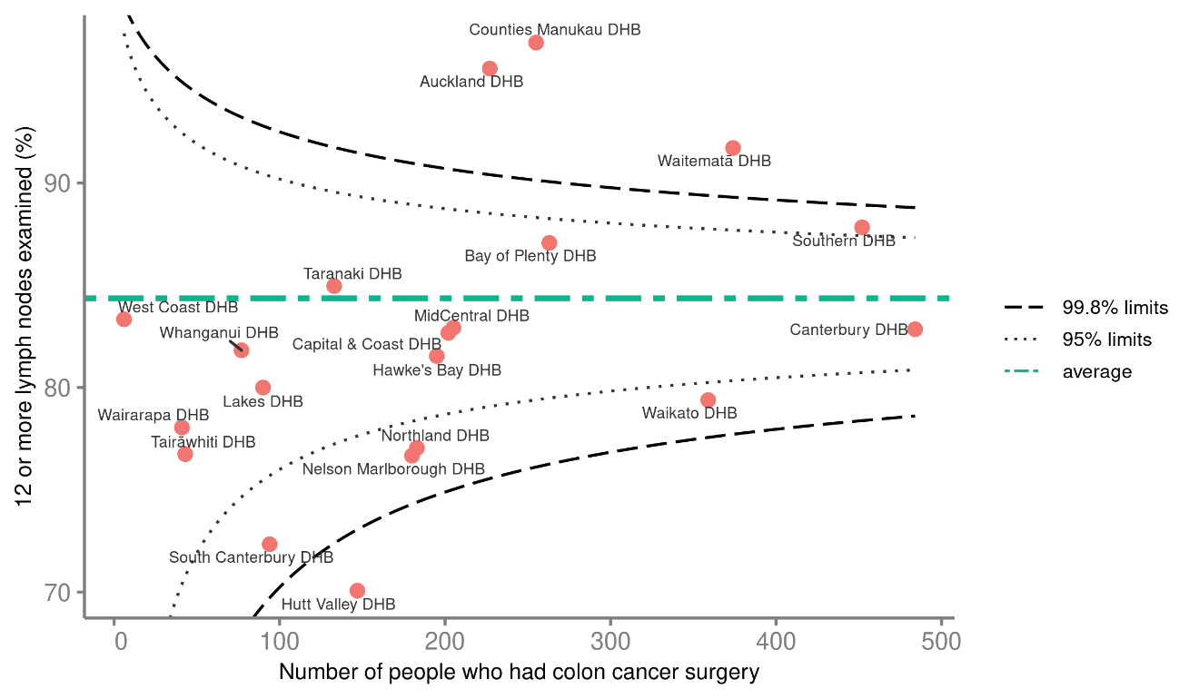

Discussion
The proportion of people with 12 or more lymph nodes pathologically examined appears to be continuing to increase, which is promising.

However, the disparity remains for Māori. The higher rates of emergency surgery for Māori may indirectly contribute to this result, however, further investigation at the DHB level is required. The lower lymph node yield for Māori may be partly explained by the finding that the DHBs with the greatest proportion of Māori in their populations (Northland, Tairāwhiti, Waikato and Lakes DHBs) all have lymph node yields well below the national average.

Recommendations
The recommended actions for this QPI from the November 2020 Bowel Cancer Quality Improvement Plan (Te Aho o Te Kahu 2020a) are listed below.

Te Aho o Te Kahu
        - Continue to review lymph node harvest following bowel cancer surgery, including inequities in this outcome, and report to DHBs two-yearly. Report and review more regularly for those DHBs whose results lie outside the 99.8 percent limit below the mean.
        - Investigate implementing a structured pathology reporting project with key stakeholders, including the Royal College of Pathologists of Australasia (RCPA) and DHB chief operating officers (COOs) aiming to incorporate structured reporting as a requirement in laboratory contracts. This would include seeking agreement on which structured report should be used.
        - Work with stakeholders to develop a structured histology request form for bowel cancer specimens, ensuring that pathologists are fully aware of each patient’s key surgical, anatomical, radiological and clinical staging details.
        - Ensure any process developed is mandated by International Accreditation New Zealand (IANZ) standards.

District health boards
        - Develop a quality improvement programme to improve the harvesting, examination and reporting of lymph node yields. This should involve discussions within multidisciplinary meetings and should incorporate an audit cycle to review and monitor progress.
        - Ensure that there is clear understanding among relevant staff (surgeons and pathologists) of the importance of a lymph node harvest of at least 12 nodes.
        - Implement a system whereby, if there are fewer than 12 lymph nodes identified in a surgical sample, a repeat review is requested. Pathology assistants may be able to assist with this.
        - Ensure that clinical staff and laboratory service providers support the implementation of the nationally agreed structured pathology reporting project and structured histology request form.

Quality performance indicators: Rectal Cancer

Rectal cancer treatment

Indicator description
Proportion of people having major surgery for rectal cancer who receive a) no radiotherapy (that is, surgery alone), b) pre-operative short-course radiotherapy (SCRT) or c) pre-operative long-course radiotherapy (LCRT).

Results
The percentage of people with rectal cancer having no radiotherapy (45.8 percent, Table 6) is almost the same as that for the 2013–2016 period (44.2 percent).

A small percentage more people with rectal cancer received short-course radiotherapy (SCRT) (16.3 percent during the 2017–2019 period, an increase of 1.2 percent on that for the 2013–2016 period), and a similar percentage received long-course radiotherapy (LCRT) (36.2 percent) compared with the previous period.

Māori have considerably lower rates of surgery alone at 36.8 percent compared with European/Other at 46.5 percent.

Table 6: People with rectal cancer having surgery alone and short-course and long-course preoperative radiotherapy, by year of diagnosis (2017–2019), age group, sex, ethnicity and deprivation
 | Major surgery for rectal cancer | Long-course  RT |  | Short-course  RT |  | No radiotherapy (surgery alone)
 | N | N | % | N | % | N | %
Total | 1,230 | 445 | 36.2 | 201 | 16.3 | 563 | 45.8
Year of diagnosis
2017 | 396 | 155 | 39.1 | 62 | 15.7 | 170 | 42.9
2018 | 406 | 153 | 37.7 | 61 | 15 | 186 | 45.8
2019 | 428 | 137 | 32 | 78 | 18.2 | 207 | 48.4
Age group
18–49 | 131 | 69 | 52.7 | 17 | 13 | 42 | 32.1
50–59 | 203 | 95 | 46.8 | 35 | 17.2 | 71 | 35
60–74 | 593 | 216 | 36.4 | 86 | 14.5 | 281 | 47.4
75+ | 303 | 65 | 21.5 | 63 | 20.8 | 169 | 55.8
Sex
Female | 436 | 158 | 36.2 | 73 | 16.7 | 201 | 46.1
Male | 794 | 287 | 36.1 | 128 | 16.1 | 362 | 45.6
Ethnicity
Māori | 106 | 52 | 49.1 | 14 | 13.2 | 39 | 36.8
Pacific peoples* | 31 | 18 | 58.1 | – | – | 12 | 38.7
Asian | 64 | 23 | 35.9 | 10 | 15.6 | 31 | 48.4
European/Other | 1,023 | 352 | 34.4 | 175 | 17.1 | 476 | 46.5
Unknown* | 6 | – | – | – | – | – | –
NZDep2013 quintile
1 | 223 | 80 | 35.9 | 33 | 14.8 | 107 | 48
2 | 227 | 81 | 35.7 | 24 | 10.6 | 118 | 52
3 | 250 | 94 | 37.6 | 49 | 19.6 | 104 | 41.6
4 | 285 | 101 | 35.4 | 60 | 21.1 | 118 | 41.4
5 | 245 | 89 | 36.3 | 35 | 14.3 | 116 | 47.3
* Due to small numbers, some figures have not been included.

Figures 11 and 12 show change over time from 2013 to 2019. The proportion of people with rectal cancer who had surgery alone has not significantly changed over this period nor has the proportion of people who had SCRT. There has been an annual decrease of 2.3 percent for those receiving LCRT, although there has been some fluctuation over the period, meaning further years’ results will be needed to examine the trend more accurately.

Figure 11: Proportion of people with rectal cancer who had no radiotherapy (surgery alone)
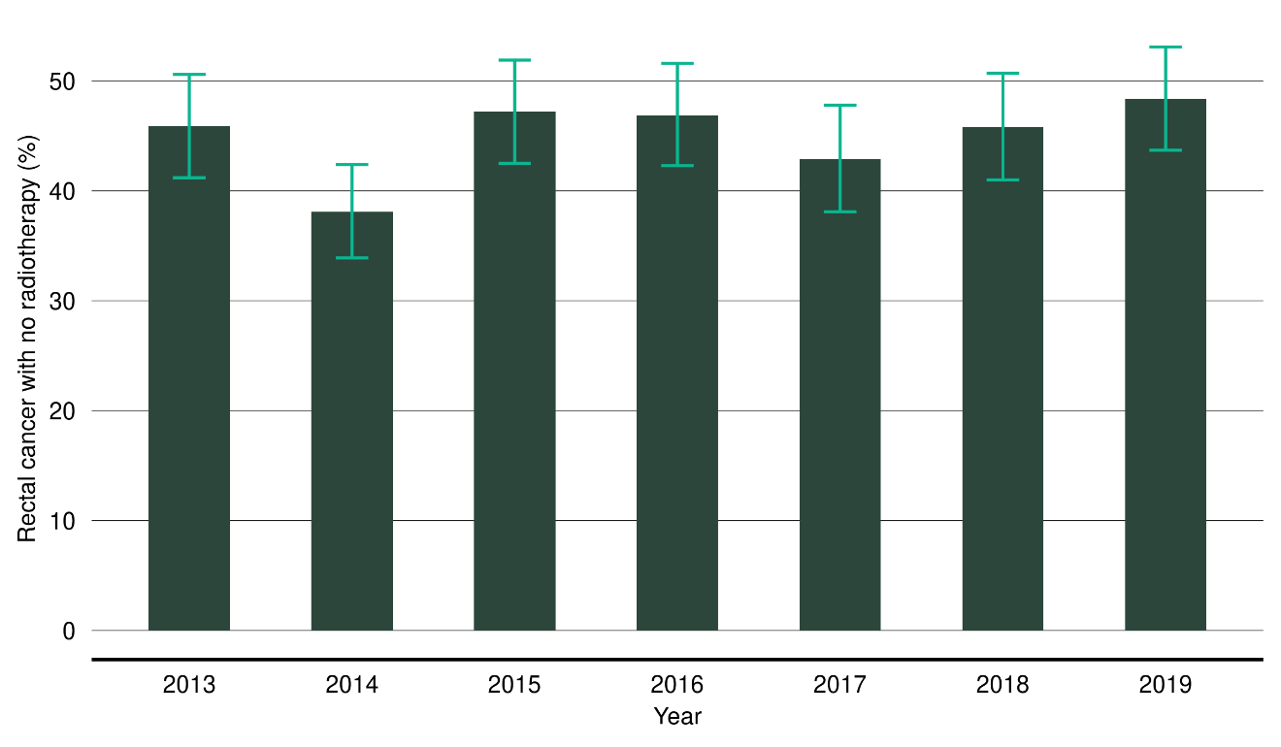
Note: Error bars represent 95 percent confidence intervals.

Figure 12: Proportion of people with rectal cancer who received surgery and either long-course radiotherapy (LCRT) or short-course radiotherapy (SCRT)
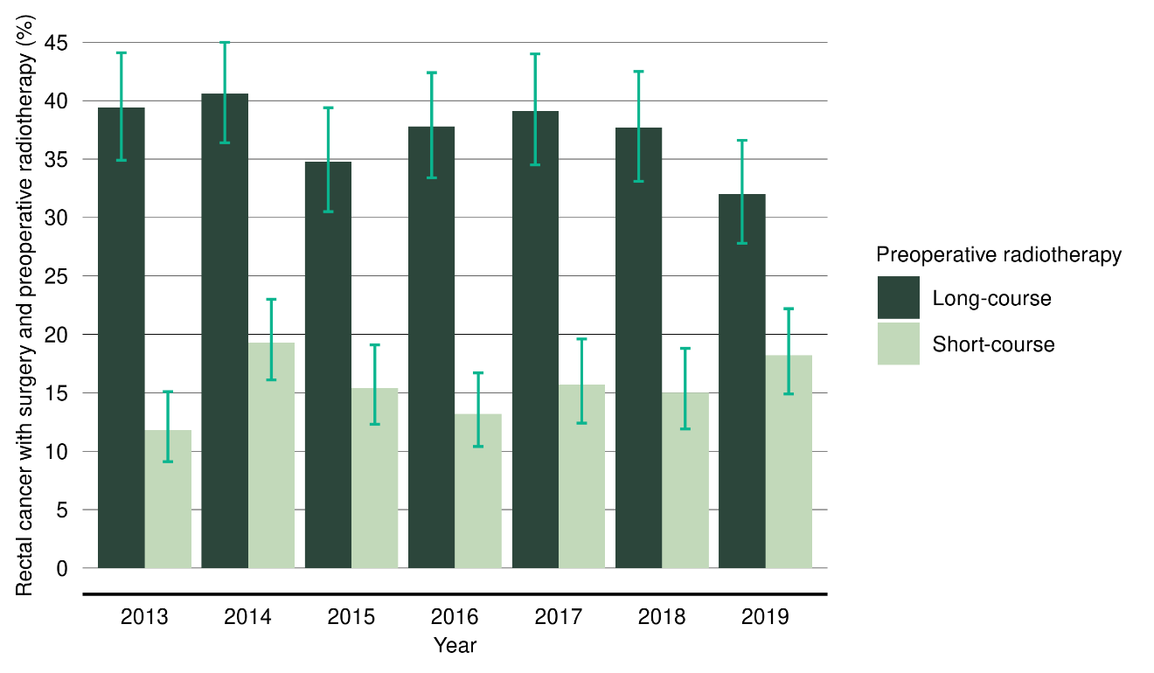
Note: Error bars represent 95 percent confidence intervals.

Figure 13: Proportion of people with rectal cancer having no radiotherapy (surgery alone), by district health board of service for surgery, 2017–2019
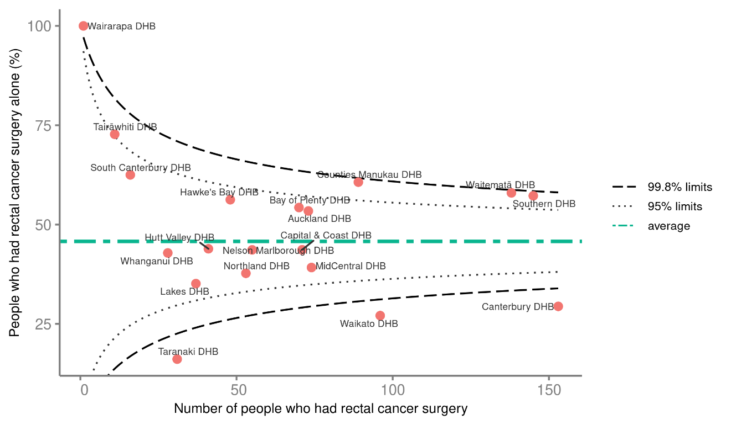

For surgery alone (no publicly funded radiotherapy), three DHBs were below the 99.8 percent limits and one was above the 99.8 percent limits (Figure 13).

For SCRT and LCRT, there was wide variation across DHB regions (Figures 14 and 15). For SCRT, four DHBs were above the 95 percent confidence limits and three were below the 99.8 percent confidence limits. For LCRT, two DHBs were above the 95 percent limits and three were below the 95 percent limits.

Figure 14: Proportion of people with rectal cancer having pre-operative short-course radiotherapy, by district health board of service for surgery, 2017–2019*
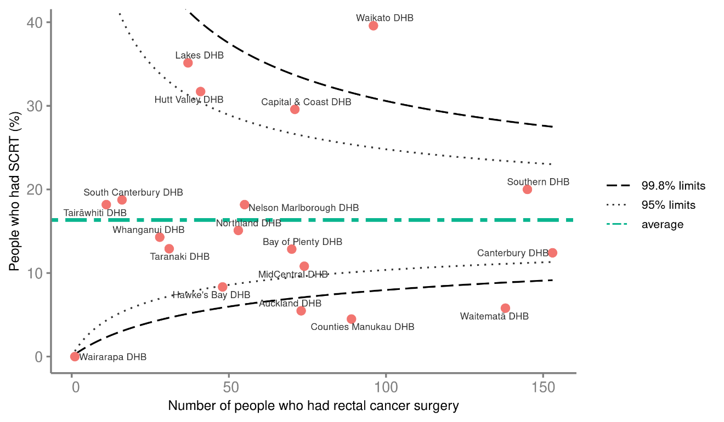
* West Coast DHB is missing from this plot because they do not provide this surgery – West Coast patients travel to Canterbury DHB.

Figure 15: Proportion of people with rectal cancer having pre-operative long-course radiotherapy, by district health board of service for surgery, 2017–2019*
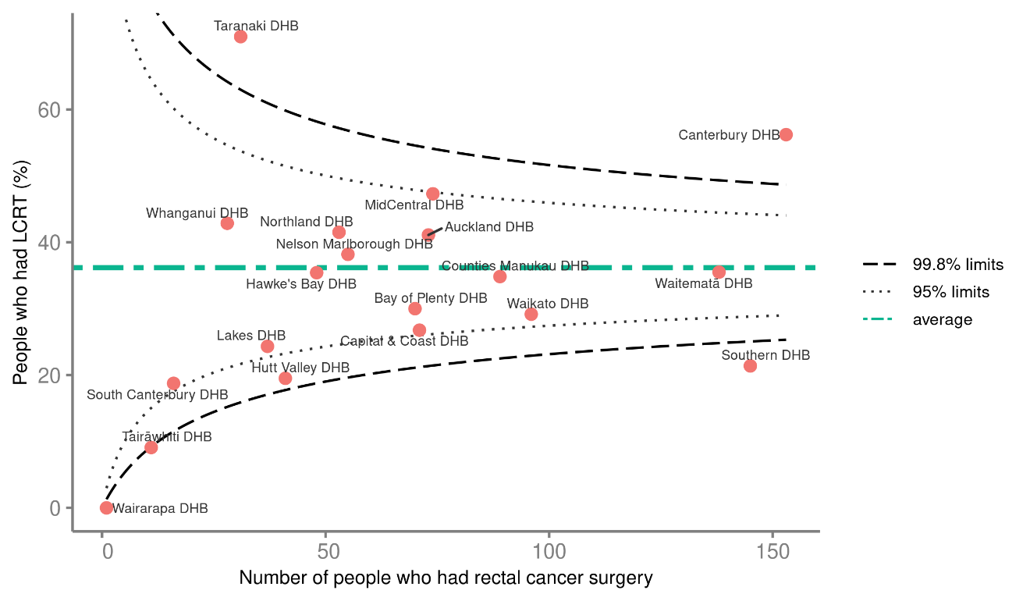
* West Coast DHB is missing from this plot because they do not provide this surgery – West Coast patients travel to Canterbury DHB.

Discussion
There is no clear change in the results for this indicator between the two time periods (2013–2016 and 2017–2019), although there is a suggestion of decreasing use of LCRT over time. There is no clear reason for the wide variation seen between DHB regions.

In comparison, the PIPER Project found that 52 percent of patients with non-metastatic rectal cancer received radiotherapy (Sharples et al 2018), similar to the findings of this and the previous monitoring report. In the NBOCA 2017–2018 data, 36 percent of rectal cancer patients had pre-operative treatment, with 25.8 percent having LCRT and 6.8 percent having SCRT (HQIP 2020).

There is a general change in international practice for the use of radiotherapy in rectal cancer, including an increasing use of pre-operative and non-operative therapy. This makes interpretation of this indicator challenging; however, it will provide helpful comparisons over the next 5–10 years. As part of our consideration of this result we looked at more recent data for both short and long course RT from the radiation oncology collection (ROC). While we could not compare the same time period (ROC data is complete from 2020 onwards), it is worth noting that this data showed an increase in uptake on the SCRT overall in more recent years. However, we should not be looking at RT decisions in isolation; they can often be confounded by other treatment decisions, such as surgery and/or chemotherapy, and also treatment intent (ie: curative vs palliative). Te Aho o Te Kahu will continue to monitor RT services and provide more detailed analysis in future reports.

There is a persistently lower rate of management of rectal cancer by surgery alone for Māori, with reasons for this remaining unclear. The rate may be influenced by higher numbers of Māori with rectal cancer presenting with advanced disease and the wide variation in practice between DHBs combined with varying population make-up in DHB regions.

Recommendations
The recommended actions for this QPI from the November 2020 Bowel Cancer Quality Improvement Plan (Te Aho o Te Kahu 2020a) are listed below.

Te Aho o Te Kahu
        - Continue to review radiotherapy use preceding rectal cancer surgery, including inequities in this outcome, and report to DHBs two-yearly. Report and review more regularly for those DHBs whose results lie outside the lower limit of the 99.8 percent confidence intervals for this indicator.
        - Work with the Radiation Oncology Working Group and NBCWG to develop standardised indications for long- and short-course radiotherapy.

District health boards
        - Implement and monitor standardised indications for long- and short-course radiotherapy, once developed.

Abdominoperineal resection

Indicator description
Proportion of people with rectal cancer who had major surgery and an abdominoperineal resection (APR).

Results
For this reports period, 21.6 percent of people who underwent major surgery for rectal cancer had an APR procedure (Table 7). Māori had a higher proportion of APR procedures compared with other ethnicities (25.5 percent); however, numbers were small.

Table 7: People who underwent major surgical resection for rectal cancer who had an abdominoperineal resection, by year of diagnosis (2017–2019), age group, sex, ethnicity and deprivation
 | Major surgery for rectal cancer | Abdominoperineal resection
 | N | N | %
Total | 1,230 | 266 | 21.6
Year of diagnosis
2017 | 396 | 86 | 21.7
2018 | 406 | 93 | 22.9
2019 | 428 | 87 | 20.3
Age group (years)
18–49 | 131 | 28 | 21.4
50–59 | 203 | 47 | 23.2
60–74 | 593 | 123 | 20.7
75+ | 303 | 68 | 22.4
Sex
Female | 436 | 98 | 22.5
Male | 794 | 168 | 21.2
Ethnicity
Māori | 106 | 27 | 25.5
Pacific peoples* | 31 | – | –
Asian* | 64 | – | –
European/Other | 1,023 | 224 | 21.9
Unknown* | 6 | – | –
NZDep2013 quintile
1 | 223 | 38 | 17
2 | 227 | 55 | 24.2
3 | 250 | 46 | 18.4
4 | 285 | 72 | 25.3
5 | 245 | 55 | 22.4
* Due to small numbers, some figures have not been included.

There was wide variation in the proportion of APR performed across DHBs (Figure 16). One DHB was below the 99.8 percent lower limit of the funnel plot, and no DHBs were above the 95 percent limit. DHBs with lower numbers of people who had rectal surgery appear to have higher rates of APR.

Figure 16: Proportion of people having rectal cancer surgery who underwent abdominoperineal resection by district health board of service, 2017–2019*
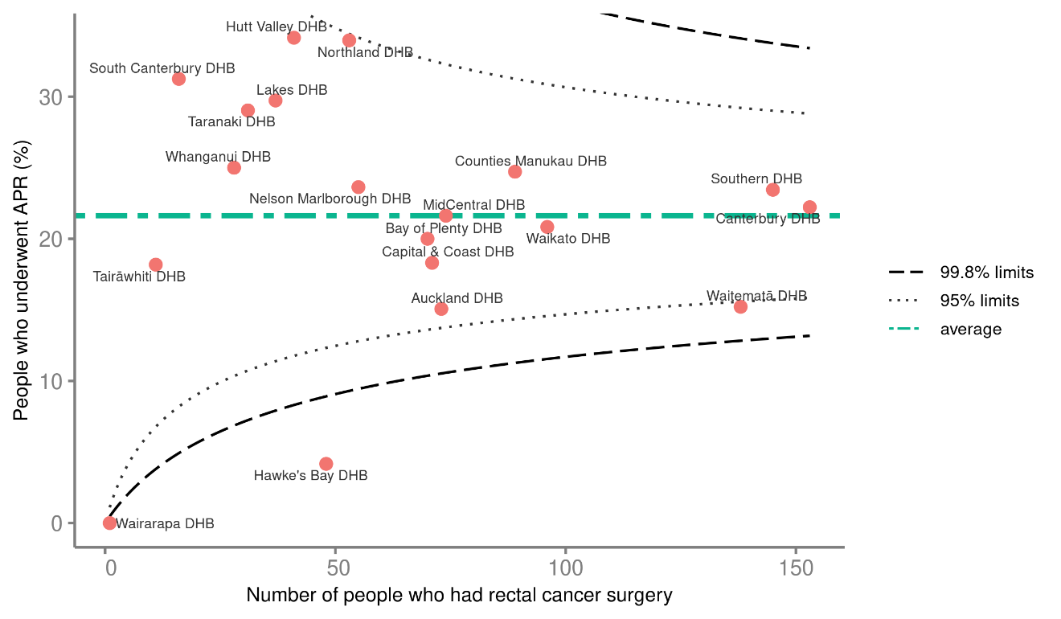
* West Coast DHB is missing from this plot because they do not provide this surgery – West Coast patients travel to Canterbury DHB.

Discussion
A lower APR rate generally means a lower proportion of permanent stomas. However, there are numerous reasons why people may undergo an APR and a lower rate does not necessarily indicate a better quality of life. However, this measure is used internationally and can provide helpful comparison. The NBOCA 2019 reported an APR rate of 26.4 percent for the years 2014–2017 (HQIP 2020), which is higher than the finding of this report at 21.4 percent.

Recommendations
Because this QPI was not included in the original 2019 monitoring report, there were no recommended actions for this QPI from the November 2020 Bowel Cancer Quality Improvement Plan. However, it is now recommended, as a result of the calculation of the APR QPI, that Te Aho o Te Kahu and DHBs should continue to aim for data quality improvement to enable calculation of stoma-free survival in future reports.

Appendices

Appendix A: Description and Technical Specification for abdominoperineal resection indicator
The sources of data for the indicators and the methods of analysis are explained in the updated Bowel Cancer Quality Performance Indicator Descriptions (2022) and the Bowel Cancer Quality Performance Indicator Specifications (2022), both of which are available on the Te Aho o Te Kahu website.

BCQI 21_a abdominoperineal resection
Indicator description | Proportion of people with rectal cancer who had major surgery and an abdominoperineal resection (APR).
Rationale and evidence | APR is the removal of the sigmoid colon, the rectum and the anus, leaving a permanent stoma. For patients undergoing resection for rectal cancer, sphincter preserving surgery should be considered if appropriate, with reversal of defunctioning stoma within 18 months.  APR may have poorer outcomes compared with low anterior resection (Ptok et al 2007), and APR may decrease quality of life due to the formation of a permanent stoma. However, sphincter-preserving surgery for low rectal cancer can have complications and require a permanent stoma (Campos-Lobato et al 2011; Holmgren et al 2017) Therefore this quality performance indicator (QPI) should be considered in conjunction with other markers of quality.  While there is some evidence that this QPI may not be a useful marker of overall hospital performance (Jorgensen et al 2013), it highlights variation between services (Morris E et al 2008) and, as this is a common indicator used internationally, it will allow for comparison.  Effective multidisciplinary team (MDT) planning and surgical techniques may lower the rate of permanent colostomy and ileostomy.
Equity / Māori health gain | There is international evidence of inequities in the provision of sphincter sparing surgery for disadvantaged population groups, for example, African American patients in the United States (Arsoniadis et al 2018; Morris AM et al 2004).
Specifications | Numerator | Number of people with rectal cancer who had an abdominoperineal resection.
 | Denominator | All patients who undergo major resection for rectal cancer.
Data sources | New Zealand Cancer Registry, National Minimum Dataset

Sources of data
This document refers to the following national data sources.
- New Zealand Cancer Registry (NZCR): a population-based register of all primary malignant diseases diagnosed in Aotearoa New Zealand, excluding squamous and basal cell skin cancers
- National Minimum Dataset (NMDS): a collection of public and private hospital discharge information, including coded clinical data for inpatients and day patients.

More information on these data sources can be found on the Ministry of Health’s website: www.health.govt.nz.

Measure items
Dataset | Data item | Description
NZCR | Site | Primary organ of the cancer’s origin
NZCR | Sex | Sex of patient
NZCR | Age at diagnosis | Age of patient at diagnosis
NZCR | Morphology | Microscopic or cellular anatomy of the cancer
NZCR | Behaviour code | Neoplastic behaviour of the cancer
NZCR | Date of initial diagnosis | Date the patient was first diagnosed with bowel cancer
NZCR | Basis | Basis of diagnosis
NZCR | Multiple tumour flags | Patient diagnosed with more than one tumour
NZCR | Registration status code | Status of registration processing
NMDS | DHB name | DHB of service for the patient
NMDS | Procedure code | Procedure code
NMDS | Procedure date | Date of procedure

Case eligibility criteria (denominator)
Diagram reference | Assessment | Item | Codes
1 | First or only diagnosis of malignant neoplasm | Site | Date of first diagnosis with colorectal cancer
2 | Primary site – rectum | Primary site | Rectum C20
3 | Exclude manually censored case | Exclusion | Patients diagnosed following death certificate only (basis = 0)  Patients domiciled outside Aotearoa New Zealand (DHB_code = 999)  Patients with appendiceal carcinomas C18.1 site code  Patients with neuroendocrine tumours (NETs), gastrointestinal stromal tumours (GISTs), lymphomas, squamous cell carcinomas, neuroendocrine carcinomas and melanomas  Morphology codes 8240, 8249, 8246, 8070, 8720, 8013, 8041, 8244 and 8936  Registration codes not R_C or R_R  Non-incident cancer (exclude patients with multiple tumour flags = yes)  Exclude patients who had their initial surgery 2 months before initial diagnosis or 6 months after their initial diagnosis
4 | Male or female | Sex | M or F
5 | Adult patient over the age of 17 at diagnosis | Age at diagnosis | 18 years and over
6 | Invasive tumours | Behaviour code | 3
7 | Diagnosis date | Date of initial diagnosis | 2016–18
8 | Surgical procedure | Surgical procedure of the primary site | Patients who undergo definitive surgery for rectal cancer (same procedures codes as bowel cancer) between 50 days before and 365 days after diagnosis. This excludes patients who undergo transanal endoscopic microsurgery, transanal resection of tumour or endoscopic resection of tumour (3210300, 3210500, 3210800)

Numerator criteria
Diagram reference | Assessment | Item | Codes
9 | Numerator: Number of patients with colorectal cancer who had an APR | APR | 9 Includes people who had an APR (3203900)  See ACHI procedure codes below

Australian Classification of Health Interventions (8th edition) procedure codes

Transanal resection codes
Code | Block short description | Clinical code description
3210300 | Excision lesion or tissue of rectum or anus | Per anal excision of lesion or tissue of rectum via stereoscopic rectoscopy
3210500 | Excision lesion or tissue of rectum or anus | Per anal full thickness excision of anorectal lesion or tissue
3210800 | Excision lesion or tissue of rectum or anus | Transsphincteric excision of lesion or tissue of rectum

Definitive surgery procedure codes for bowel cancer
Code | Block short description | Clinical code description
3200000 | Colectomy | Limited excision of large intestine with formation of stoma
3200001 | Colectomy | Right hemicolectomy with formation of stoma
3200300 | Colectomy | Limited excision of large intestine with anastomosis
3200301 | Colectomy | Right hemicolectomy with anastomosis
3200400 | Colectomy | Subtotal colectomy with formation of stoma
3200401 | Colectomy | Extended right hemicolectomy with formation of stoma
3200500 | Colectomy | Subtotal colectomy with anastomosis
3200501 | Colectomy | Extended right hemicolectomy with anastomosis
3200600 | Colectomy | Left hemicolectomy with anastomosis
3200601 | Colectomy | Left hemicolectomy with formation of stoma
3200900 | Colectomy | Total colectomy with ileostomy
3201200 | Colectomy | Total colectomy with ileorectal anastomosis
3201500 | Total proctocolectomy | Total proctocolectomy with ileostomy
3202400 | Anterior resection of rectum | High anterior resection of rectum
3202500 | Anterior resection of rectum | Low anterior resection of rectum
3202600 | Anterior resection of rectum | Ultra-low anterior resection of rectum
3202800 | Anterior resection of rectum | Ultra-low anterior resection of rectum with hand sutured coloanal anastomosis
3203000 | Rectosigmoidectomy or proctectomy | Rectosigmoidectomy with formation of stoma
3203900 | Rectosigmoidectomy or proctectomy | Abdominoperineal proctectomy
3205100 | Total proctocolectomy | Total proctocolectomy with ileo-anal anastomosis
3205101 | Total proctocolectomy | Total proctocolectomy with ileo-anal anastomosis and formation of temporary ileostomy
3206000 | Rectosigmoidectomy or proctectomy | Restorative proctectomy
3209900 | Excision of lesion or tissue of rectum or anus | Per anal submucosal excision of lesion or tissue of rectum
3211200 | Rectosigmoidectomy or proctectomy | Perineal rectosigmoidectomy
9220800 | Anterior resection of rectum | Anterior resection of rectum, level unspecified

Figure A1: Flow diagram for calculating BCQI21_a abdominoperineal resection
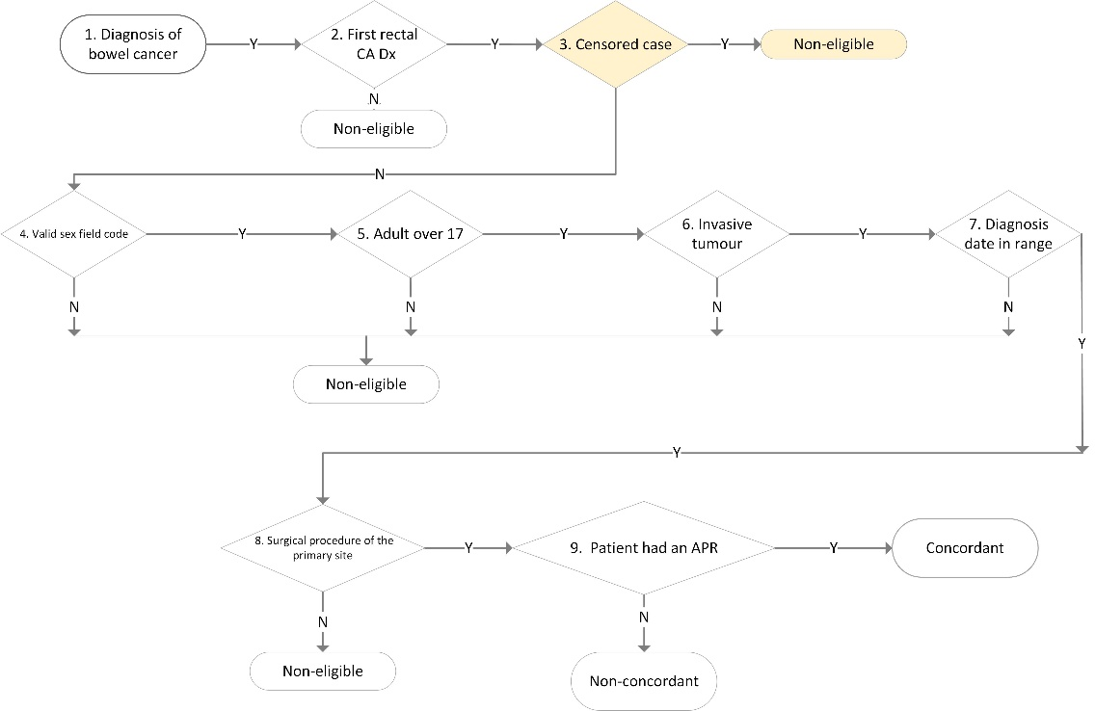

Appendix B: References
Arsoniadis EG, Fan Y, Jarosek S, et al. 2018. Decreased use of sphincter-preserving procedures among African Americans with rectal cancer. Annals of Surgical Oncology 25(3): 720–28. DOI: 10.1245/s10434-017-6306-4.
Atkinson E, Crowson C, Pedersen R, et al. 2008. Poisson models for person-years and expected rates. In Mayo Foundation Tech Report 81.
Cameron A, Trivedi P. 2009. Microeconometrics using Stata. College Station, TX: Stata Press.
Campos-Lobato LF, Alves-Ferreira PC, Lavery IC, et al. 2011. Abdominoperineal resection does not decrease quality of life in patients with low rectal cancer. Clinics (Sao Paulo) 66(6): 1,035–40. DOI: 10.1590/s1807-59322011000600019.
Common Counting Technical Advisory Group and Ministry of Health. 2017. Common Counting Standards 2013/14. Wellington: Ministry of Health. URL: https://nsfl.health.govt.nz/system/files/documents/publications/commoncountingstandards2013-14final_0_0.docx (accessed 10 December 2021).
Holmgren K, Kverneng Hultberg D, Haapamaki MM, et al. 2017. High stoma prevalence and stoma reversal complications following anterior resection for rectal cancer: a population-based multicentre study. Colorectal Dis 19(12): 1,067–75. DOI: 10.1111/codi.13771.
HQIP. 2020. National Bowel Cancer Audit Annual Report 2019. London: Healthcare Quality Improvement Partnership (HQIP). URL: https://www.nboca.org.uk/content/uploads/2020/01/NBOCA-2019-V2.0.pdf (accessed 10 December 2021).
Jorgensen ML, Young JM, Dobbins TA, et al. 2013. Assessment of abdominoperineal resection rate as a surrogate marker of hospital quality in rectal cancer surgery. Br J Surg 100(12): 1,655–63. DOI: 10.1002/bjs.9293.
Ministry of Health. 2015. Enhanced Recovery After Surgery. Wellington: Ministry of Health. URL: www.health.govt.nz/our-work/hospitals-and-specialist-care/enhanced-recovery-after-surgery (accessed 10 August 2020).
Ministry of Health. 2019a. Achieving Equity in Health Outcomes: Summary of a discovery process. Wellington: Ministry of Health. URL: www.health.govt.nz/system/files/documents/publications/achieving-equity-in-health-outcomes-summary-of-a-discovery-process-30jul2019.pdf (accessed 10 December 2021).
Ministry of Health. 2019b. Bowel Cancer Quality Improvement Report. Wellington: Ministry of Health. URL: www.health.govt.nz/system/files/documents/publications/bowel-cancer-quality-improvement-report-mar19v1.pdf (accessed 10 December 2021).
Ministry of Health. 2019c. New Zealand Cancer Action Plan 2019–2029: Te Mahere mō te Mate Pukupuku o Aotearoa 2019–2029. Wellington: Ministry of Health. URL: www.health.govt.nz/system/files/documents/publications/new-zealand-cancer-action-plan-revised-january-2020.pdf (accessed 10 December 2021).
Morris, AM, Billingsley KG, Baxter NN, et al. 2004. Racial disparities in rectal cancer treatment: a population-based analysis. Archives of Surgery 139(2): 151–55. DOI: 10.1001/archsurg.139.2.151.
Morris E, Quirke P, Thomas JD, et al. 2008. Unacceptable variation in abdominoperineal excision rates for rectal cancer: time to intervene? Gut 57(12): 1,690–97. DOI: 10.1136/gut.2007.137877.
Ptok H, Marusch F, Kuhn R, et al. 2007. Influence of hospital volume on the frequency of abdominoperineal resection and long-term oncological outcomes in low rectal cancer. Eur J Surg Oncol 33(7): 854–61. DOI: 10.1016/j.ejso.2006.12.020.
Sharples KJ, Firth MJ, Hinder VA, et al. 2018. The New Zealand PIPER Project: colorectal cancer survival according to rurality, ethnicity and socioeconomic deprivation-results from a retrospective cohort study. NZ Med J 131(1,476): 24–39.
Te Aho o Te Kahu. 2020a. Bowel Cancer Quality Improvement Plan, 2020. Wellington: Te Aho o Te Kahu, Cancer Control Agency. URL: https://teaho.govt.nz/static/reports/bowel-cancer-quality-improvement-plan-2Nov2020.pdf (accessed 13 December 2021).
Te Aho o Te Kahu. 2020b. He Pūrongo Mate Pukupuku o Aotearoa 2020, The State of Cancer in New Zealand 2020. Wellington: Te Aho o Te Kahu, Cancer Control Agency. URL: https://teaho.govt.nz/static/reports/state-of-cancer-in-new-zealand-2020.pdf (accessed 10 December 2021).

Appendix C: Working group members
The current NBCWG members are:
- Ian Bissett (chair), colorectal surgeon, Auckland District Health Board/The University of Auckland
- Anne Cleland, clinical nurse specialist, MidCentral District Health Board
- Ben Lawrence, medical oncologist, Auckland District Health Board
- David Vernon, general and colorectal surgeon, Lakes District Health Board
- Denise Robbins, consumer representative
- Iain Ward, radiation oncologist, Canterbury District Health Board
- Janet Hayward, general practitioner, Nelson
- John McMenamin, general practitioner, Whanganui
- Justin Hegarty, radiologist, Pacific Radiology
- Marianne Lill, general surgeon, Whanganui DHB
- Masato Yozu, pathologist, Counties Manukau District Health Board
- Nina Scott (Ngāti Whatua), public health physician, Waikato District Health Board
- Ralph Van Dalen, general surgeon, Waikato District Health Board
- Siraj Rajaratnam, general and colorectal surgeon and endoscopist, Waitematā District Health Board
- Susan Parry, gastroenterologist, Auckland District Health Board and clinical lead, National Bowel Screening Programme, Ministry of Health
- Teresa Chalmers-Watson, gastroenterologist, Canterbury District Health Board.

Others that contributed to this report are:
- Chris Harmston, general and colorectal surgeon, Northland District Health Board
- Sarah Derrett, consumer, Bowel Cancer New Zealand
- James Stanley, Biostatistician, Research Associate Professor, University of Otago, Wellington.

The PIPER Project (Presentations, Investigations, Pathways, Evaluation, Rx [treatment] project) commenced in 2011 following a joint Ministry of Health and Health Research Council of New Zealand call for a project to examine bowel cancer from presentation through to management and including treatment outcomes in order to better understand the context of this cancer for Aotearoa New Zealand.
Missing and unknown categories are not included in this NZDep2013 category reporting and therefore the totals at the bottom of the table add up to 8,688, which does not match the total at the beginning of the table (8,690).
It is possible that Canterbury DHB’s results for this QPI reflect data issues. Te Aho o Te Kahu will follow up with representatives from the DHB regarding this.
Bowel cancer screening has been fully in place in the United Kingdom since 2009, thus readers should use caution in comparing their rates with the early stages of Aotearoa New Zealand’s rollout. This is because there can be higher rates of screening detected cancers in the early stages of a screening programme than in later years.
Not all people with rectal cancer have surgery. Some people appear to have had a complete response to their scheduled pre-operative treatment, meaning that there is no detectable residual cancer. They are therefore managed with close observation and, although the number is small, the exact proportion of people with this scenario is unknown at present.
Hospital events in NMDS are coded using the International Statistical Classification of Diseases and Related Health Problems, Tenth Revision, Australian Modification (ICD-10-AM) for diagnoses and the Australian Classification of Health Interventions (ACHI) for procedures. Both ICD-10-AM and ACHI are from the Independent Hospital Pricing Authority (IHPA), Australia.

