

**COVID-19 and cancer services**

Working report on the impact of COVID-19 on cancer services for the period ending April 2022

**Released July 2022**

# Acknowledgements

With thanks to the Ministry of Health Data Management team for their technical support.

With thanks to members of the COVID-19 Data Response Advisory Group: Professor Diana Sarfati, Alex Dunn, Dr John Fountain, Dr Tess Luff, John Manderson, Michelle Mako, Dr Shaun Costello, Michelle Liu, Dr Liz Dennett, Gabrielle Nicholson, Dawn Wilson, Jan Smith, Cushla Lucas, Nicholas Glubb, Moira McLeod, Angela Pidd, Christine Fowler, Dr Nina Scott, Associate Professor Bridget Robson, Dr Bronwyn Rendle and Associate Professor Jason Gurney.

# Contents

Acknowledgements 2

Contents 3

Summary of findings 4

Introduction 6

Cancer Registrations 8

Gastrointestinal endoscopy 12

Bronchoscopy 14

Combined cancer surgery 17

Colorectal cancer surgery 19

Lung cancer surgery 21

Prostate cancer surgery 23

Medical oncology 25

Radiation oncology 29

Haematology 33

Appendix 1: Key Dates 37

Appendix 2: NZCR data information 38

Appendix 3: NZCR registrations by DHB 39

Appendix 4: Diagnosis and treatment data by DHB 43

Appendix 5: Surgical procedure codes 54

# Summary of findings

**Impact of COVID-19 on cancer services**

This is the third report to include data from the Omicron outbreak and covers the period up to April 2022. Cancer registrations data show a small decrease in April 2022 compared to the same month in 2018/19, however, 2022 to date has seen a 4% increase in cancer registrations compared to 2018/19. There was a decrease in cancer surgeries in April 2022 for the whole population compared with 2018/19. While there was a larger decrease for Māori cancer surgeries in April 2022, this was not reflected in cumulative 2022 data. Medical oncology first specialist assessments and IV chemotherapy in the year to date were the same or increased compared to the same period in 2018/19. Radiation oncology first specialist appointments and radiation therapy attendances were lower in April 2022 compared with 2018/19. Haematology first specialist assessments were lower in the year to date relative to the same time period in 2018/19, however there was an increase in the provision of IV chemotherapy for haematology compared with 2018/19.

Overall, the impact of the COVID-19 Omicron community outbreak on cancer services in 2022 does not appear to be as substantial as that seen during the initial outbreak and lockdown in 2020. Te Aho o Te Kahu continues to work with the sector and will monitor and further investigate as necessary.

## Background and data

* The purpose of this report is to provide a rapid assessment of the impact of COVID-19 on cancer services. It includes data up until 30 April 2022. This is the third report to include the Omicron outbreak.
* The report focuses on the aspects of the cancer care pathway for which we have readily available data and does not capture all aspects of cancer care.
* We acknowledge individuals with cancer may have been impacted in significant ways by COVID-19, including by changes to the way care has been delivered and that these may not be captured within the available data.
* This report compares 2022 with an average of 2018/19 data and provides additional graphs comparing 2022 data with that from 2021, 2020 and 2018/2019.
* For the purposes of this report, we have not adjusted for expected changes in incidence over time (such as due to population growth).
* There may be some backlogs in data entry with pandemic-related impacts on staffing across the health sector. This may result in future data updates altering the current results.

## Cancer diagnosis

### Registrations

* For April 2022 compared to the average of April 2018/19 there was a 2% decrease in cancer registrations. For Māori, there was a 1% decrease in registrations in April 2022 compared with April 2018/19.
* Cumulatively, for 2022 thus far there has been an increase of 4% in cancer registrations compared to the average of 2018/19 and a 1% decrease for Māori.

### Diagnostics

* **Gastrointestinal endoscopies:** there was an increase of 10% in gastrointestinal endoscopies performed in April 2022 compared to April 2018/19. For Māori, this increase was 20% in April 2022 compared to April 2018/19. For 2022 to date, there were 12% more gastrointestinal endoscopies performed as for the same time period in 2018/19.
* **Bronchoscopies:** April 2022 showed a 5% decrease in the number of bronchoscopies performed compared to April 2018/19. However, for Māori there was an increase of 72% in April 2022 compared to April 201/19. For 2022 to date, there was an 8% decrease in bronchoscopies compared with 2018/19, but a 16% increase for Māori.

## Cancer Treatment

### Surgery

* In April 2022, there were 6% fewer cancer surgeries (prostate, lung and colorectal) compared to April 2018/19. For 2022 to date there were 3% fewer surgeries performed compared to 2018/19.
* For Māori there was a 39% decrease in combined cancer surgeries for 2022 to date compared with 2018/19, with this percentage decrease reflecting a total of 13 fewer surgeries. However, this follows a 32% increase for Māori in combined cancer surgeries in February 2022 relative to 2018/19, and overall there has been a 5% increase in combined cancer surgeries for the year to date relative to 2018/19.

### Chemotherapy and radiotherapy

* **Medical oncology:** attendances for medical oncology first specialist assessments (FSAs) showed no difference in April 2022 compared to April 2018/19. For 2022 to date, there was a 9% increase in medical oncology FSAs compared with 2018/19. Attendances for intravenous (IV) chemotherapy increased by 7% in April 2022 compared to April 2018/19. For 2022 to date, there was a 9% increase in IV chemotherapy compared with 2018/19. These increases occurred across ethnic groups.
* **Radiation oncology:** attendances for radiation oncology first specialist assessments (FSAs) decreased by 2% in April 2022 compared to April 2018/19. For 2022 to date, there was a 5% increase in radiation oncology FSAs compared with 2018/19. Radiation therapy attendances decreased by 14% in April 2022 compared to April 2018/19. For 2022 to date, there was an 11% decrease in radiation therapy attendances. For Māori, there was a 15% decrease in FSAs in April 2022 compared to April 2018/19; however, this followed a 37% increase in March 2022 relative to 2018/19, and the cumulative number of FSAs and attendances are higher for Māori in 2022 relative to 2018/19.
* **Haematology:** there was a 13% decrease in attendances for haematology first specialist assessments (FSAs) in April 2022 compared to April 2018/19. For 2022 to date, there was a 5% decrease in haematology FSAs compared with 2018/19. Attendances for haematology intravenous (IV) chemotherapy increased by 1% in April 2022 compared to April 2018/19. For 2022 to date, there was a 12% increase in haematology IV chemotherapy compared with 2018/19. For Māori, there was a 12% decrease in FSAs but a 15% increase in attendances for April 2022 compared to 2018/19; while for Māori the cumulative number of FSAs reduced by 1% and attendances increased by 5% for the year to date relative to the same period in 2018/19.

# Introduction

## Background

In 2020, Te Aho o Te Kahu released a series of reports outlining the impact of COVID-19 on cancer services in New Zealand[1]. The 2020 reports showed that cancer treatment services – surgery, medical oncology, radiation oncology and haematology – continued during the start of the COVID-19 pandemic. Following an initial drop in new cancer registrations during the April 2020 lockdown, the number of cancer registrations in 2020 increased steadily in the following months and, by the end of September, had caught up to the number seen in 2019. As the COVID-19 situation and disruptions to health care settled, Te Aho o Te Kahu stopped regular COVID-19 and cancer reporting at the end of 2020.

Te Aho o Te Kahu re-instated COVID-19 monitoring with the re-emergence of COVID-19 in the community in August 2021 (Delta strain), and during the Omicron outbreak.

## Purpose

This is the seventh report looking at the impact of COVID-19 on cancer services since the reporting was reinstated in August 2021. As this report includes data up until the end of April 2022, this is the third report that includes the Omicron outbreak. The aim of this work is to collate evidence on delays to cancer diagnosis and treatment to support policy development and response planning.

The report focuses on the aspects of the cancer care pathway for which we have readily available data and does not capture all aspects of the care. Critical aspects of cancer care, including access to primary health care, radiology, palliative care and patient experience are not measured in this report. While the report focuses on the impact of COVID-19 on overall cancer diagnosis and treatment, we acknowledge that individuals with cancer may have been impacted in significant ways by COVID-19, including by changes to the way care has been delivered, and that this may not be captured within the available data.

## Data and analysis

The data in this report comes from the Ministry of Health’s national data collections. Each section of the report includes information on where the data is from and any limitations associated with the data. Numbers in this report may not match the previous report, due to exclusion of incomplete data in the previous reports and delayed coding/submission of data.

There may be some backlogs in data entry due to pandemic-related impacts on staffing across the health sector. This may result in future data updates altering the current results and may mean any disruption to services is less severe than is reported here.

The purpose of the analysis is to rapidly measure the impact of COVID-19 and the response on cancer services; therefore, the analysis does not consider pre-existing unmet need. The report also makes direct comparisons between 2022 and previous years and does not consider any increase in cancer diagnoses or population size over time.

### Comparator for this report

The first set of COVID-19 and Cancer reports, published in 2020, compared 2020 data directly with 2019 data. For reports looking at 2021 data, the main comparison used was an average of 2018 and 2019 data, due to 2020 not being considered an appropriate comparator given the disruption to health services in 2020 due to COVID-19. For the first report of 2022 we used 2021 as a comparator to 2022. For the second report of 2022 and for this, the third report of 2022, we have moved back to the previous methodology of comparing to the 2018/19 average, for a) consistency, b) to account for the variation seen in 2021 data[2], and c) to enable comparison to a pre-pandemic time period. We note that the 2018/19 time period will become less useful as a comparator the further away we move from this period, and we are currently exploring further comparator options for future reports.

Appendix 1 outlines key dates for COVID-19 restrictions in Aotearoa that may be of use when reviewing this report.

## Ongoing reporting

We are no longer at the peak of the Omicron outbreak but are navigating a steady plateau. Te Aho o Te Kahu will continue to monitor the impact of COVID-19 on cancer services but will move to quarterly reporting. The next report is planned for release in late August, including data to the end of June 2022.

# Cancer Registrations

## Notes on data

* The data below comes from laboratory reports to the New Zealand Cancer Register (NZCR). Cancers diagnosed without haematology or pathology, for example radiology alone, will not be counted in this analysis. Further information on these data is included in Appendix 2.
* The data below are provisional, and exact numbers will change as data are finalised. Data were extracted from NZCR on 07 June 2022.
* ‘Date’ is date of diagnosis on the NZCR – usually the date the specimen was taken from the person and sent to the laboratory. Analyses include all new provisional and registered cancer events based on pathology and haematology reports.
* The extract used for this report excludes carcinoma in situ for breast and cervical, meaning the numbers are lower than in the 2020 COVID-19 and Cancer reports.
* There may be some backlogs in laboratory reports with impacts on staffing across the health sector. This may result in future data updates altering the current results.

## Key points

* For April 2022 compared to the average of April 2018/19 there was a 2% decrease in cancer registrations. For Māori, there was a 1% decrease in registrations in April 2022 compared with April 2018/19. For Pacific peoples there was an 11% increase comparing the same time periods. For people of Asian ethnicity there was a 27% increase in registrations in April 2022 compared with 2018/19.
* Cumulatively, for 2022 thus far there has been an increase of 4% in cancer registrations compared to the average of 2018/19 and a 1% decrease for Māori.

## Results

Table : Number of provisional cancer registrations and percentage difference in 2022 compared to the average of 2018 and 2019, by month and cumulative year to date, by ethnicity

|  |  |  |  |  |  |  |  |  |  |  |  |  |
| --- | --- | --- | --- | --- | --- | --- | --- | --- | --- | --- | --- | --- |
|  | **February** | | | **March** | | | **April** | | | **Cumulative Jan-April** | | |
|  | **2018/19** | **2022** | **%change** | **2018/19** | **2022** | **%change** | **2018/19** | **2022** | **%change** | **2018/19** | **2022** | **%change** |
| Māori | 192 | 188 | -2% | 218 | 224 | 3% | 199 | 197 | -1% | 788 | 783 | -1% |
| Pacific Island | 67 | 97 | 46% | 95 | 99 | 4% | 81 | 90 | 11% | 319 | 351 | 10% |
| Asian | 86 | 120 | 40% | 101 | 128 | 27% | 94 | 119 | 27% | 358 | 472 | 32% |
| European/Other | 1,545 | 1,658 | 7% | 1,682 | 1,879 | 12% | 1,538 | 1,469 | -4% | 6162 | 6340 | 3% |
| Total population | 1,890 | 2,063 | 9% | 2,096 | 2,330 | 11% | 1,912 | 1,875 | -2% | 7,627 | 7,946 | 4% |

Figure : Number of cancer registrations by month, 2018/19 average, 2020, 2021 and 2022, total population and by ethnicity

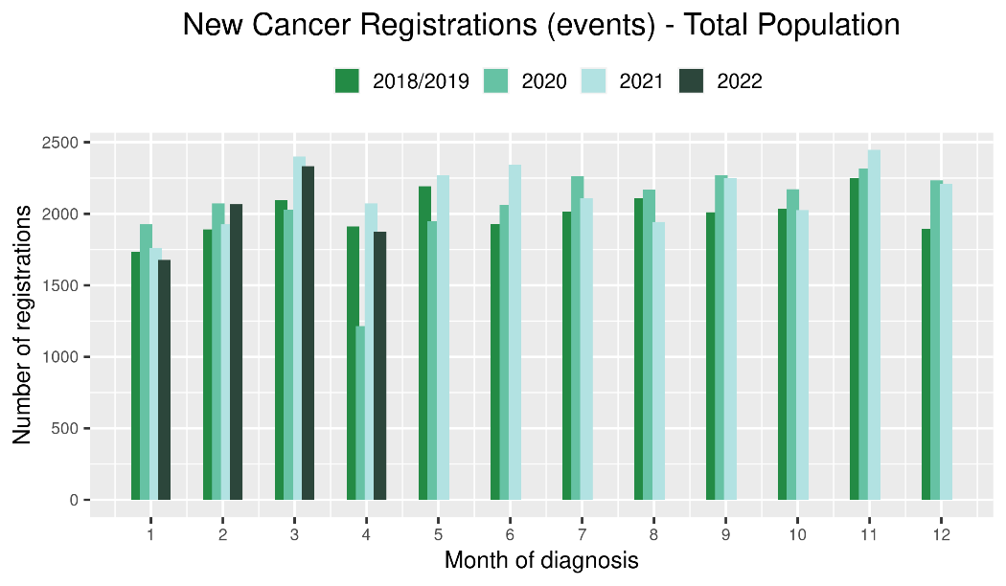 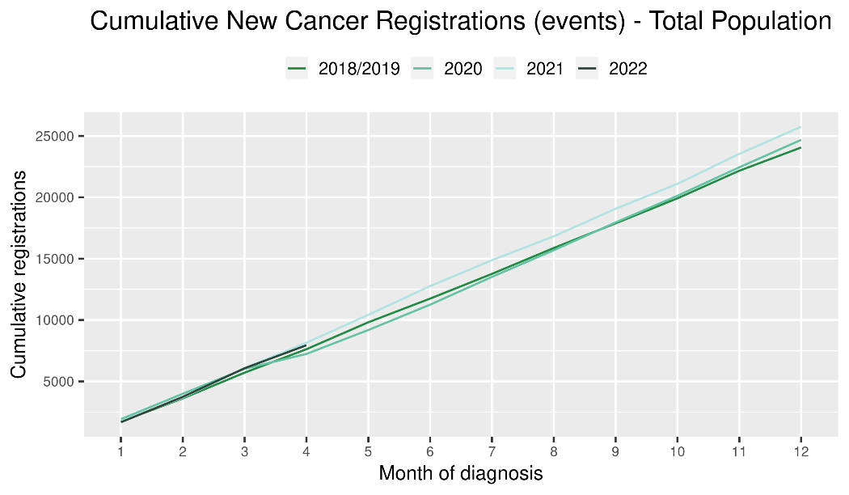

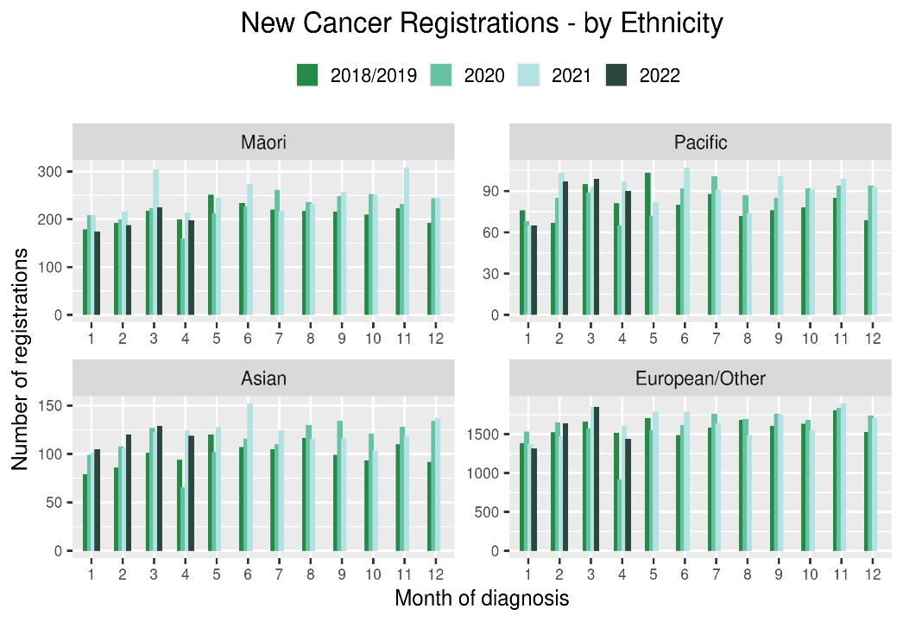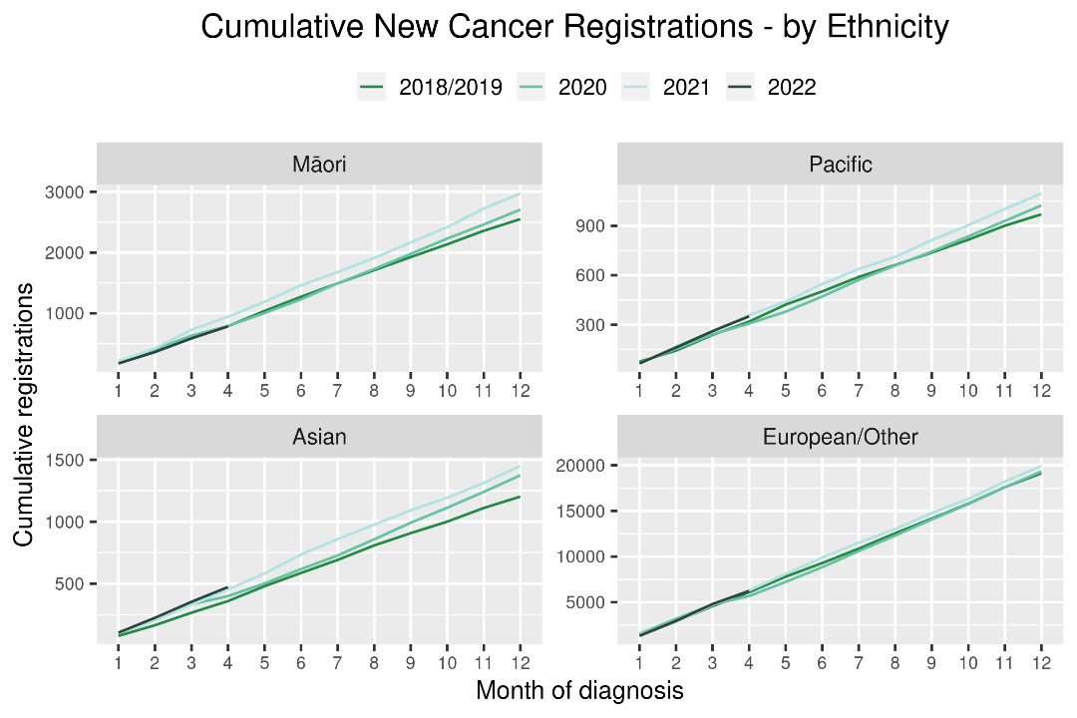

Table : Number of provisional cancer registrations* and percentage difference in 2022 compared to the average of 2018 and 2019, by month and cumulative year to date, by tumour group

|  |  |  |  |  |  |  |  |  |  |  |  |  |
| --- | --- | --- | --- | --- | --- | --- | --- | --- | --- | --- | --- | --- |
|  | **February** | | | **March** | | | **April** | | | **Cumulative January-April** | | |
| **Tumour group** | **2018/19** | **2022** | **%change** | **2018/19** | **2022** | **%change** | **2018/19** | **2022** | **%change** | **2018/19** | **2022** | **%change** |
| Breast | 282 | 303 | 8% | 295 | 348 | 18% | 309 | 278 | -10% | 1,143 | 1,160 | 1% |
| Colorectal | 243 | 299 | 23% | 269 | 310 | 15% | 257 | 244 | -5% | 991 | 1,100 | 11% |
| Gynaecology | 86 | 84 | -2% | 82 | 109 | 33% | 73 | 77 | 6% | 326 | 344 | 6% |
| Haematology and Lymphoid | 193 | 193 | 0% | 211 | 221 | 5% | 211 | 181 | -14% | 798 | 757 | -5% |
| Melanoma and non-melanoma skin cancer | 272 | 345 | 27% | 324 | 359 | 11% | 261 | 277 | 6% | 1,113 | 1,208 | 9% |
| Other digestive system | 110 | 127 | 15% | 128 | 170 | 33% | 110 | 116 | 5% | 464 | 523 | 13% |
| Prostate | 310 | 293 | -5% | 370 | 331 | -11% | 306 | 292 | -5% | 1,242 | 1,162 | -6% |
| Respiratory and thorax | 148 | 127 | -14% | 155 | 149 | -4% | 128 | 134 | 5% | 559 | 562 | 1% |
| Urinary system | 83 | 65 | -21% | 90 | 113 | 26% | 82 | 66 | -19% | 330 | 316 | -4% |

*This analysis uses provisional data for the 2021 registrations, some cancers may initially be classified as ‘non-specified’ and subsequently be re-classified into one of the cancer groups as more information becomes available.

Figure : Number of cancer registrations by month, 2018/19 average, 2020, 2021 and 2022, by tumour group

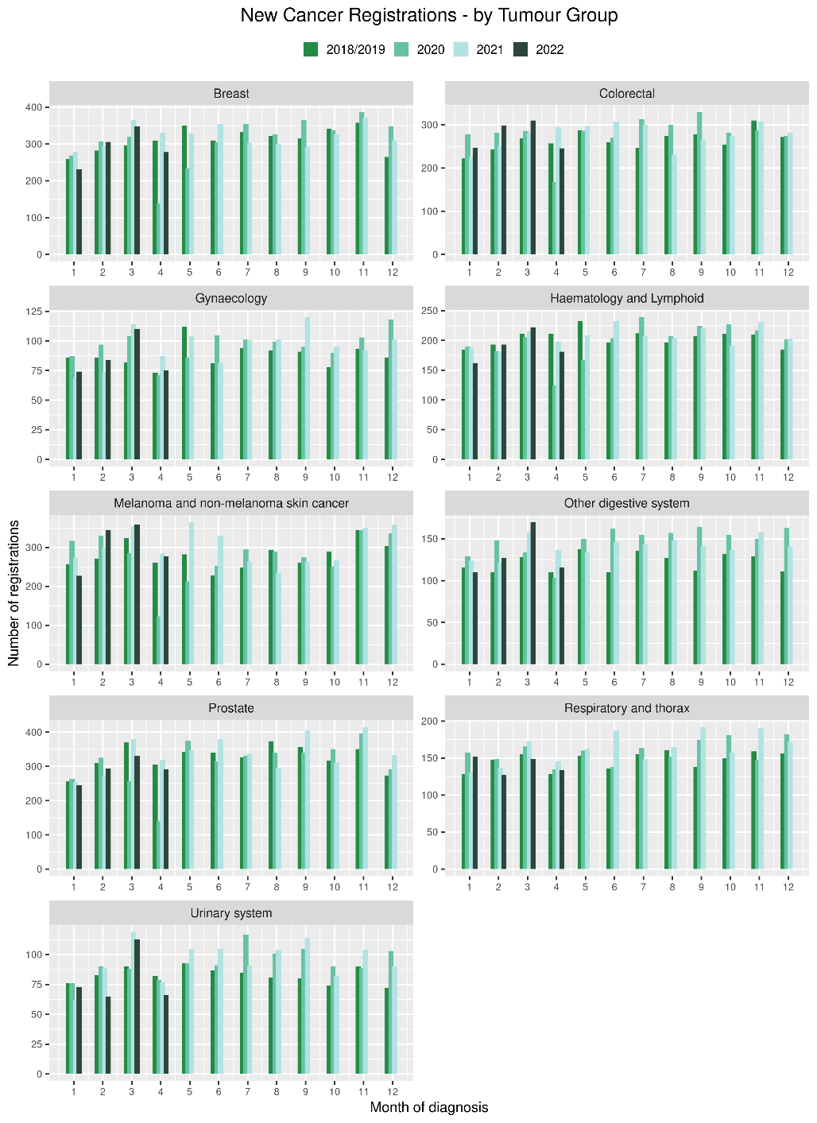 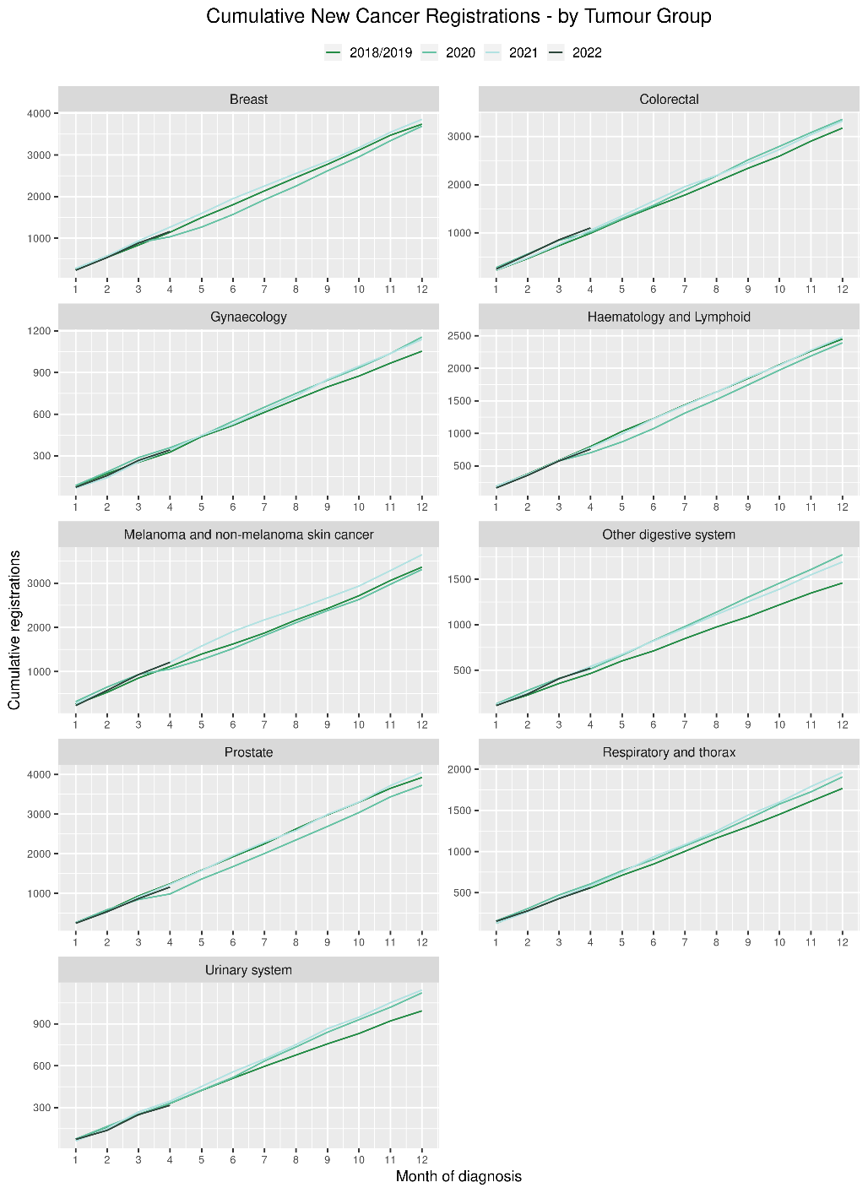

# Gastrointestinal endoscopy

## Notes on data

* Gastrointestinal endoscopy data were extracted from the National Non-admitted Patient Collection (NNPAC) and National Minimum Dataset (NMDS) on 09 June 2022.
* Includes colonoscopies and gastroscopies for all indications – not just cancer.
* Technical information: gastroscopies (Purchase Unit Code: MS02005), colonoscopies (Purchase Unit Code: MS02007), combined gastroscopies and colonoscopies (Purchase Unit Code: MS02014).

## Key points

* There was an increase of 10% in gastrointestinal endoscopies performed in April 2022, compared to April 2018/19. For Māori, this increase was 20% compared to 2018/19.
* For 2022 thus far, there is a 12% increase in gastrointestinal endoscopies, and a 28% increase for Māori compared with 2018/19.

## Results

Table : Number of colonoscopy and gastroscopy procedures and percentage difference in 2022 compared to the average of 2018 and 2019, by month and cumulative year to date, by ethnicity

|  |  |  |  |  |  |  |  |  |  |  |  |  |
| --- | --- | --- | --- | --- | --- | --- | --- | --- | --- | --- | --- | --- |
|  | **February** | | | **March** | | | **April** | | | **Cumulative January -April** | | |
|  | **2018/2019** | **2022** | **% change** | **2018/2019** | **2022** | **% change** | **2018/2019** | **2022** | **% change** | **2018/2019** | **2022** | **% change** |
| Māori | 480 | 636 | 33% | 516 | 710 | 38% | 482 | 577 | 20% | 1,924 | 2,464 | 28% |
| Pacific Peoples | 188 | 258 | 38% | 203 | 237 | 17% | 183 | 264 | 45% | 731 | 957 | 31% |
| Non-Māori/Non-Pacific | 4,774 | 5,760 | 21% | 5,265 | 5,862 | 11% | 4,810 | 5,154 | 7% | 19,240 | 21,132 | 10% |
| Total Population | 5,442 | 6,654 | 22% | 5,984 | 6,809 | 14% | 5,475 | 5,995 | 10% | 21,895 | 24,553 | 12% |

Figure : Number of gastrointestinal endoscopy procedures by month, 2018/19 average, 2020, 2021 and 2022 total population and Māori

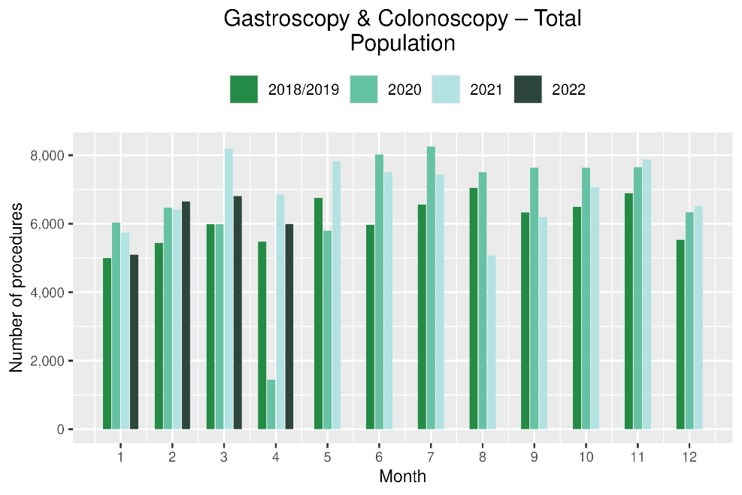 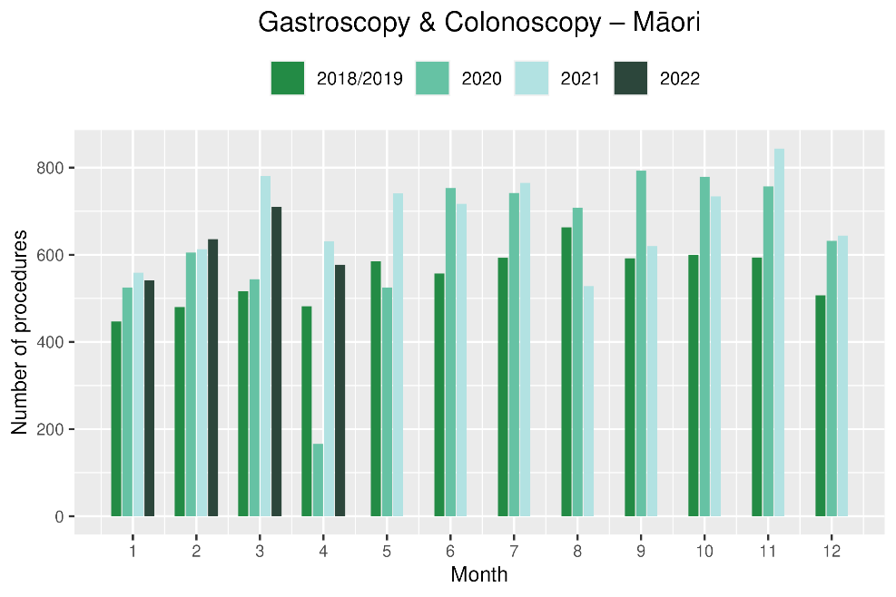

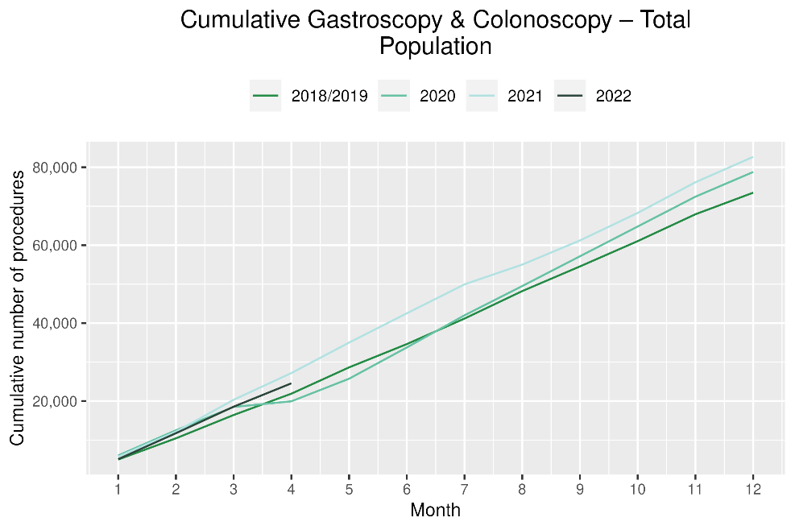 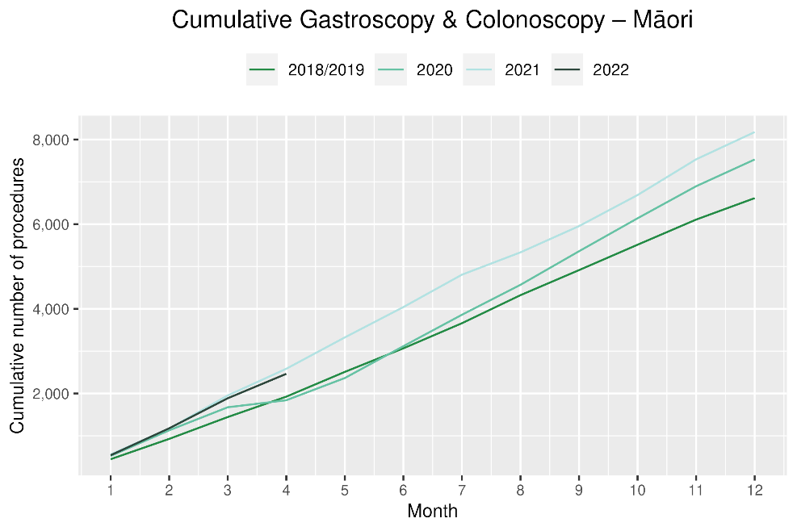

# Bronchoscopy

## Notes on data

* Bronchoscopy and CT Lung Biopsy data were extracted from NNPAC and NMDS on 09 June 2022.
* These data include bronchoscopies for all indications, not solely cancer related procedures.
* Technical information: bronchoscopies (Purchase Unit Code: MS02003) and CT Lung Biopsy (Procedure code: 3841808)

## Key points

* April 2022 showed a 5% decrease in the number of bronchoscopies performed compared to April 2018/19. For Māori there was an increase of 72% using the same comparison.
* For 2022 to date, there was an 8% decrease, and a 16% increase for Māori, in bronchoscopies compared with 2018/19.
* Te Aho o Te Kahu has discussed the potential reasons for the overall decrease in bronchoscopy volumes with respiratory physicians in the sector. It has been highlighted that due to the risks of COVID-19 transmission, logistical challenges and other factors, there has been a shift in modes of diagnosis for lung cancer away from bronchoscopy (noting that bronchoscopy is performed for a number of reasons, not just cancer diagnosis). These modes are thought to include Endobronchial Ultrasound Bronchoscopy (EBUS), Positron Emission Tomography - Computed Tomography (PET CT) scans and CT lung biopsy. PET CT and EBUS data are not reported here because the clinical coding of these procedures is not anatomically specific, meaning that we would not know whether they were performed on the lung. CT lung biopsy data were examined and are presented below (figure 5); however, although due to limited availability of pre-pandemic data, it is difficult to interpret whether any changes in the volume of these procedures have occurred.

## Results

Table : Number of bronchoscopies and percentage difference in 2022 compared to the average of 2018 and 2019, by month and cumulative year to date, by ethnicity

|  |  |  |  |  |  |  |  |  |  |  |  |  |
| --- | --- | --- | --- | --- | --- | --- | --- | --- | --- | --- | --- | --- |
|  | **February** | | | **March** | | | **April** | | | **Cumulative January -April** | | |
|  | **2018/2019** | **2022** | **% change** | **2018/2019** | **2022** | **% change** | **2018/2019** | **2022** | **% change** | **2018/2019** | **2022** | **% change** |
| Māori | 33 | 29 | -12% | 32 | 34 | 8% | 25 | 43 | 72% | 122 | 141 | 16% |
| Pacific Peoples | 9 | 12 | 33% | 9 | 10 | 18% | 8 | 9 | 13% | 34 | 38 | 12% |
| Non-Māori/Non-Pacific | 158 | 146 | -7% | 169 | 160 | -5% | 166 | 138 | -17% | 664 | 575 | -13% |
| Total Population | 200 | 187 | -6% | 210 | 204 | -2% | 199 | 190 | -5% | 820 | 754 | -8% |

*Due to small numbers, monthly figures have not been included for Māori and Pacific peoples

Figure : Number of bronchoscopies by month, 2018/19 average, 2020, 2021 and 2022, total population and Māori

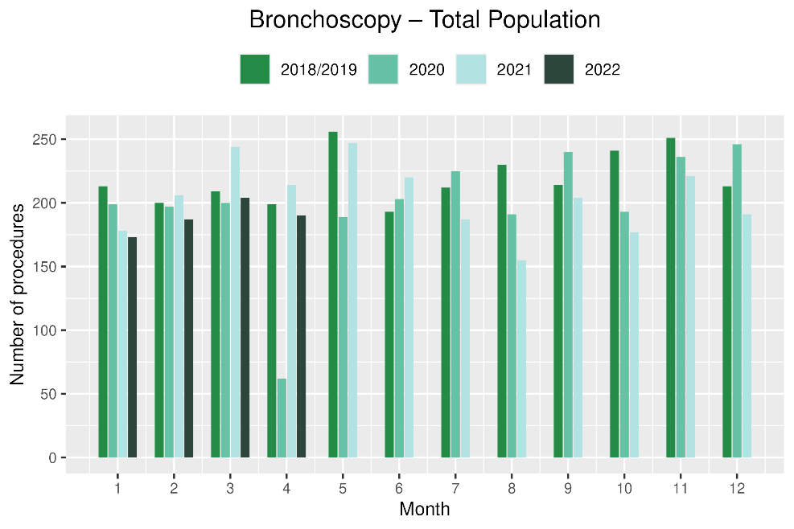 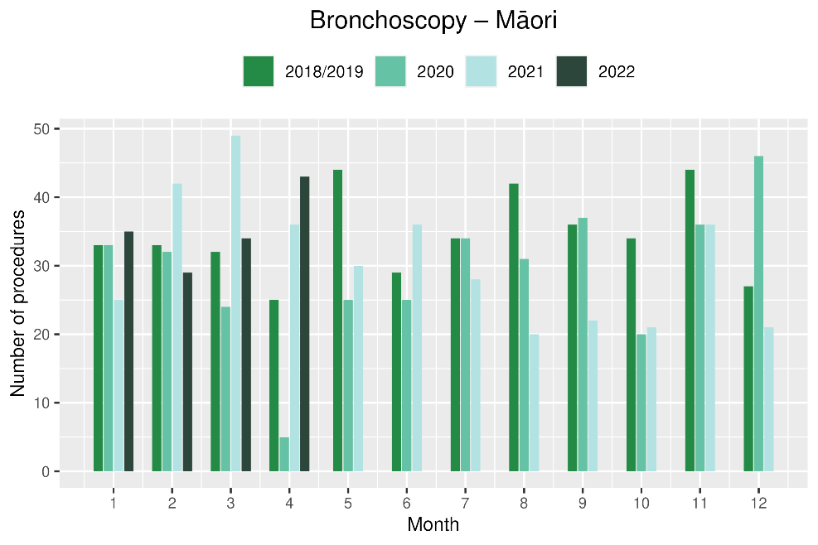

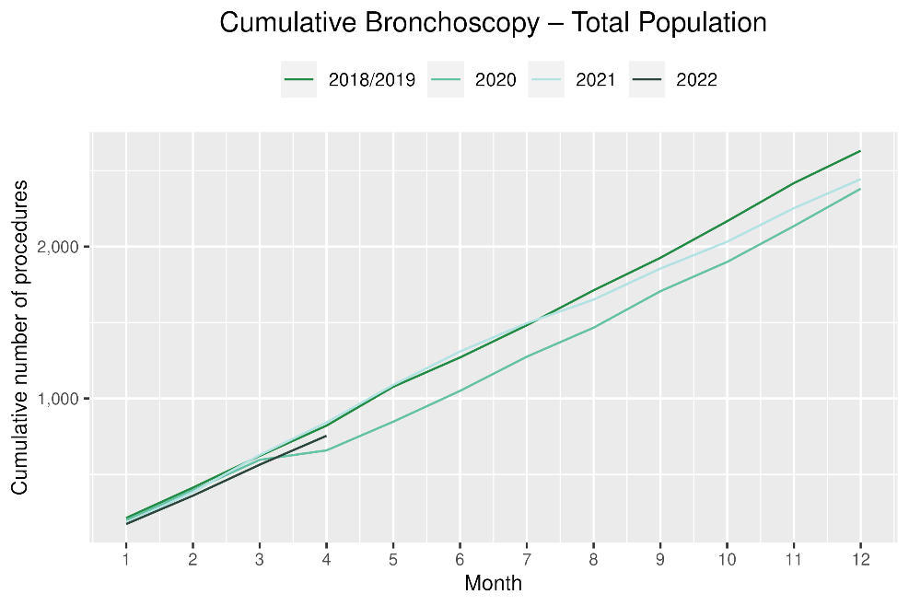 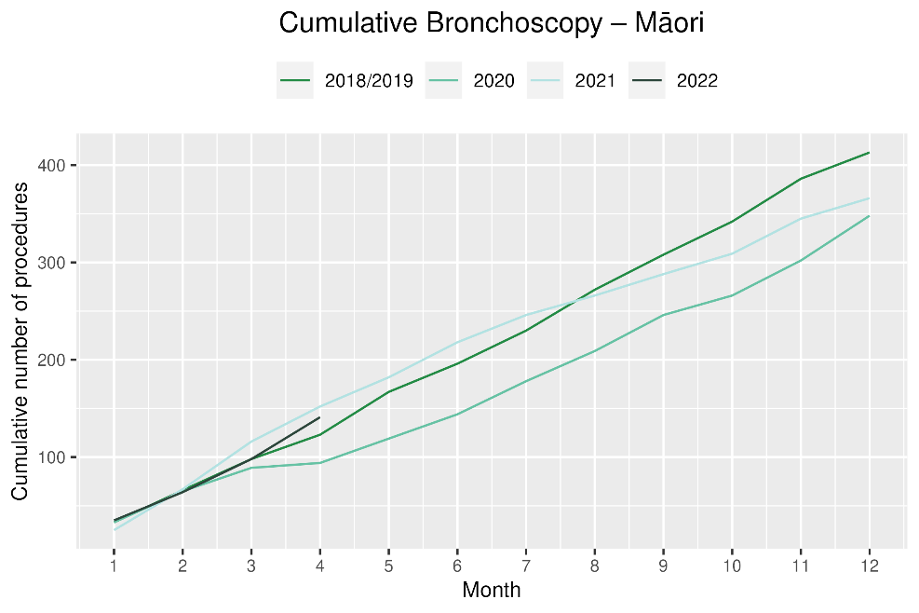

Figure : Number of CT lung biopsies by month, July 2019 to March 2022, total population and Māori

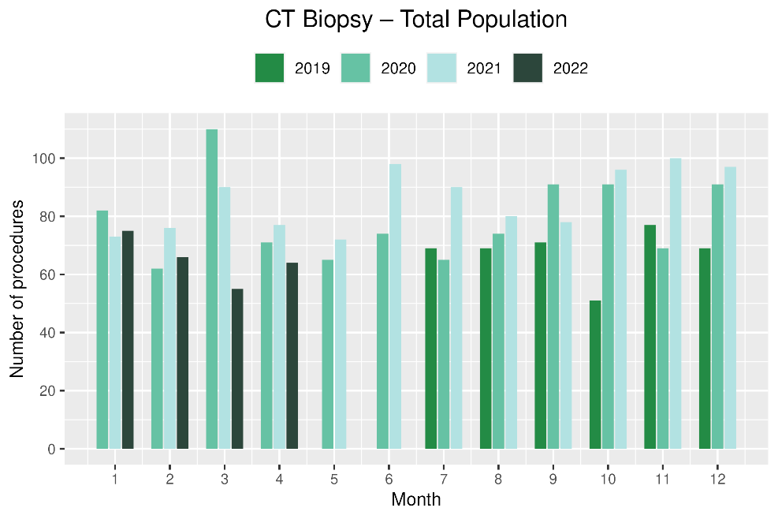 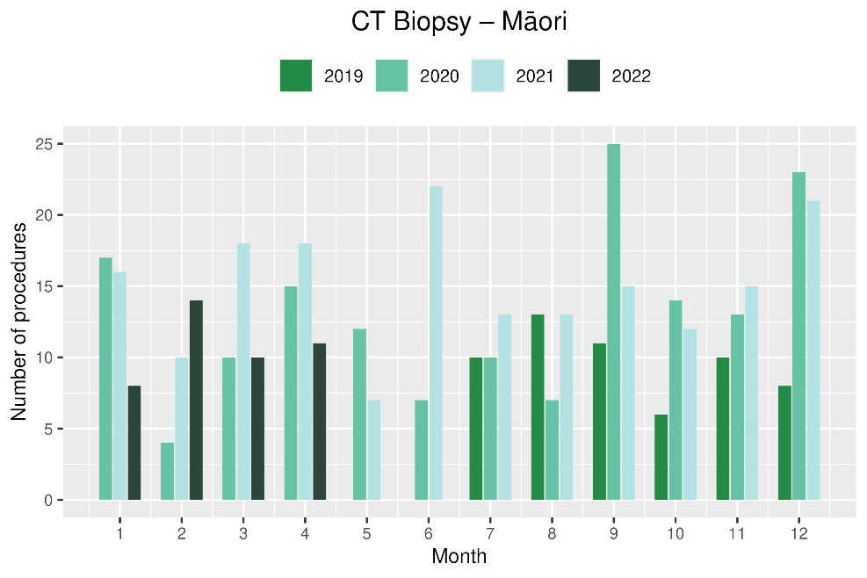

# Combined cancer surgery

## Notes on data

* This report includes data on surgery for colorectal, lung and prostate cancer. These cancers were chosen because Te Aho o Te Kahu already has a pre-validated list of surgical procedure codes for these cancers, agreed on as part of the quality performance indicator (QPI) work programme. These three cancers are therefore used as case studies for cancer surgery more generally. The surgical procedure codes are listed in Appendix 5.
* The data were extracted from the NMDS on 09 June 2022.

## Key points

* In April 2022, there were 6% fewer cancer surgeries (prostate, lung and colorectal) compared to April 2018/19. For 2022 to date there were 3% fewer surgeries performed compared to 2018/19.
* For Māori there was a 39% decrease in combined cancer surgeries for 2022 to date compared with 2018/19, noting small numbers with this percentage decrease reflecting 13 fewer surgeries. However, this follows a 32% increase for Māori in combined cancer surgeries in February 2022 relative to 2018/19, and overall there has been a 5% increase in combined cancer surgeries for Māori for the year to date relative to 2018/19.
* For Pacific peoples there was an increase of 44% in April 2022 compared to 2018/19, which represented 5 more surgeries, and a 28% cumulative increase for the year to date relative to 2018/19 (reflecting 9 nine more surgeries).

## Results

Table : Number of cancer surgeries (prostate, colorectal, lung) and percentage difference in 2022 compared to the average of 2018 and 2019 by month and cumulative year to date, by ethnicity

|  |  |  |  |  |  |  |  |  |  |  |  |  |  |  |
| --- | --- | --- | --- | --- | --- | --- | --- | --- | --- | --- | --- | --- | --- | --- |
|  | **February** | | | **March** | | | **April** | | | | **Cumulative January -April** | | | |
|  | **2018/2019** | **2022** | **% change** | **2018/2019** | **2022** | **% change** | **2018/2019** | **2022** | **% change** | **2018/2019** | | **2022** | **% change** |
| Māori | 28 | 37 | 32% | 34 | 37 | 10% | 33 | 20 | -39% | 120 | | 125 | 5% |
| Pacific Peoples | 4 | 7 | 75% | 11 | 12 | 14% | 13 | 18 | 44% | 32 | | 41 | 28% |
| Non-Māori/Non-Pacific | 259 | 267 | 3% | 317 | 316 | 0% | 309 | 295 | -4% | 1,120 | | 1,069 | -5% |
| Total Population | 291 | 311 | 7% | 362 | 365 | 1% | 355 | 333 | -6% | 1,272 | | 1,235 | -3% |

*Due to small numbers, monthly figures have not been included for Māori and Pacific peoples

Figure : Number of cancer surgeries (prostate, colorectal, lung) by month, 2018/19 average, 2020, 2021 and 2022, total population and Māori

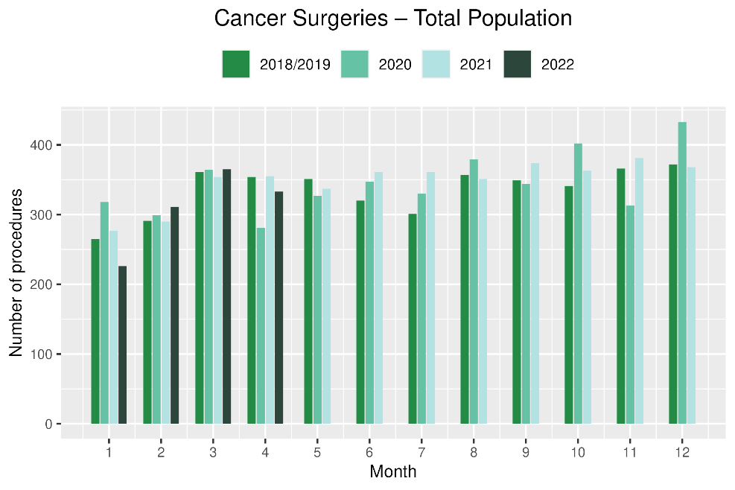 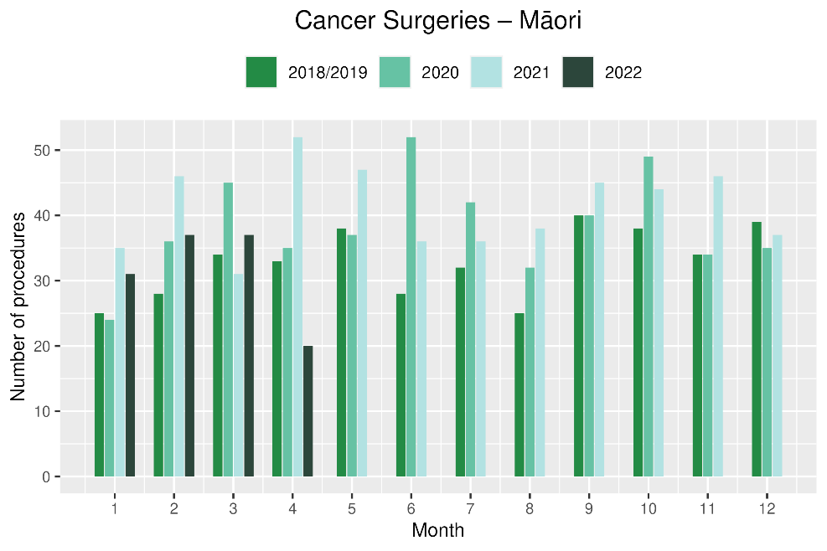

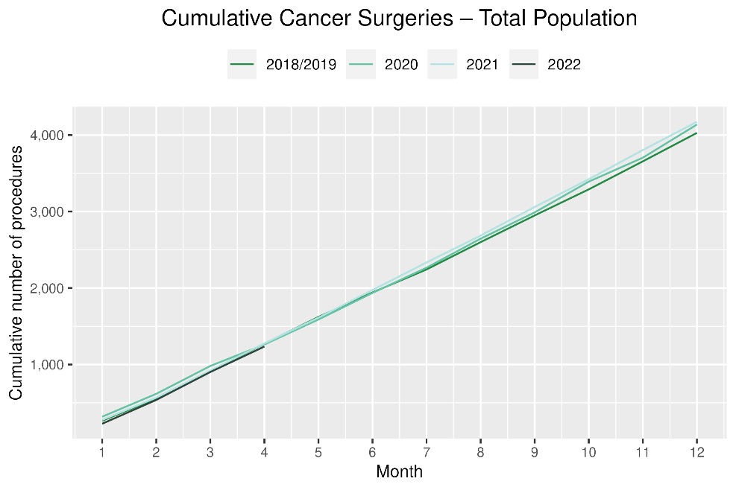 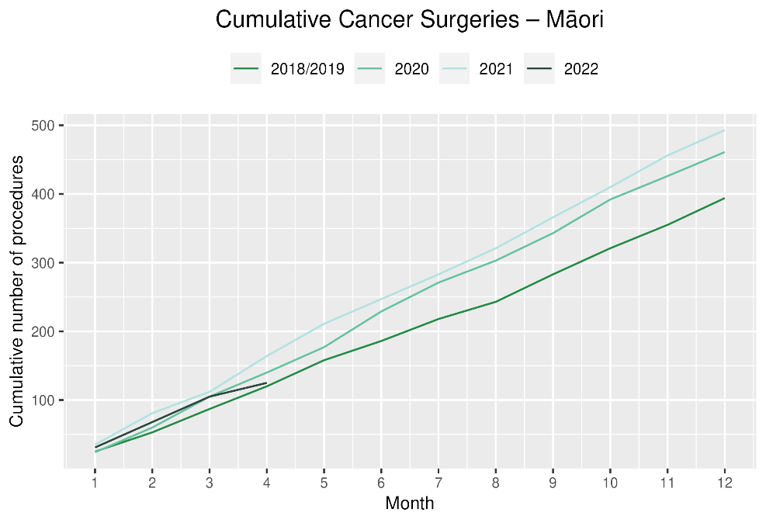

# Colorectal cancer surgery

## Notes on data

* The surgical procedure codes used for analysing colorectal cancer are listed in Appendix 5.
* The data were extracted from the NMDS on 09 June 2022.

## Key points

* There were 11% fewer colorectal cancer surgeries performed in April 2022 compared with April 2018/19.
* For 2022 to date, there were 8% fewer colorectal cancer surgeries performed in total, 14% increase for Pacific peoples (noting small numbers) and a 10% increase for Māori compared with 2018/19.

## Results

Table : Number of colorectal cancer surgeries and percentage difference in 2022 compared to the average of 2018 and 2019, by month and cumulative year to date, by ethnicity

|  |  |  |  |  |  |  |  |  |  |  |  |  |
| --- | --- | --- | --- | --- | --- | --- | --- | --- | --- | --- | --- | --- |
|  | **February** | | | **March** | | | **April** | | | **Cumulative January -April** | | |
|  | **2018/2019** | **2022** | **% change** | **2018/2019** | **2022** | **% change** | **2018/2019** | **2022** | **% change** | **2018/2019** | **2022** | **% change** |
| Māori | * | * | * | * | * | * | * | * | * | 66 | 72 | 10% |
| Pacific Peoples | * | * | * | * | * | * | * | * | * | 21 | 24 | 14% |
| Non-Māori/Non-Pacific | 165 | 165 | 0% | 206 | 191 | -7% | 207 | 184 | -11% | 735 | 663 | -10% |
| Total Population | 185 | 194 | 5% | 229 | 217 | -5% | 235 | 209 | -11% | 822 | 759 | -8% |

*Due to small numbers, monthly figures have not been included for Māori and Pacific peoples

**Figure 7: Number of colorectal cancer surgeries by month, 2018/19 average, 2020, 2021 and 2022, total population and Māori**

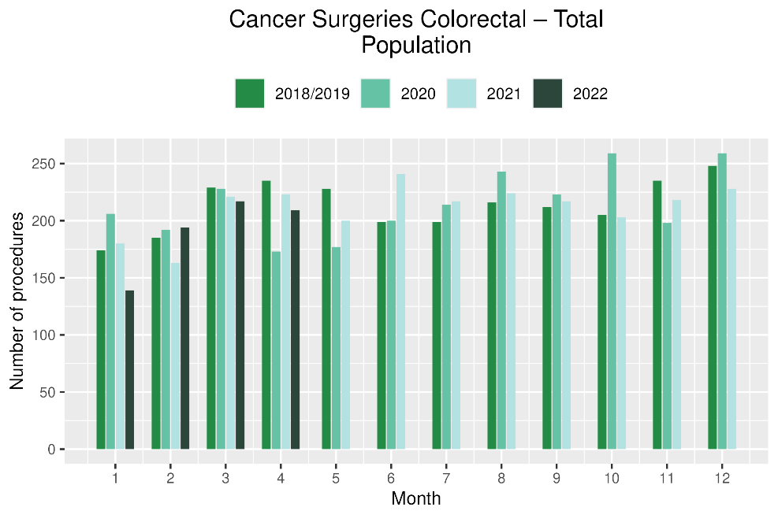 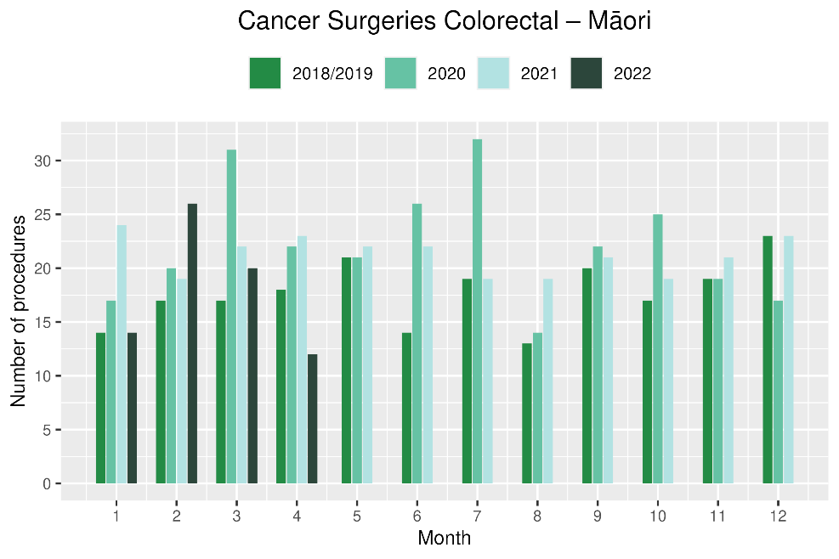

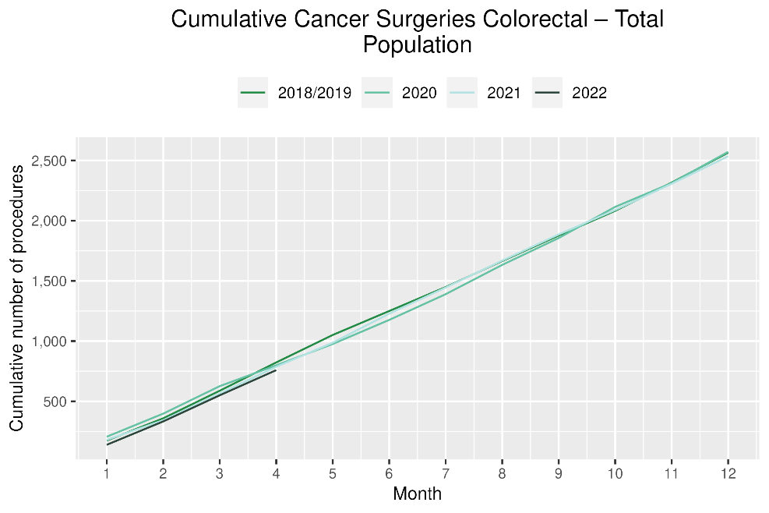 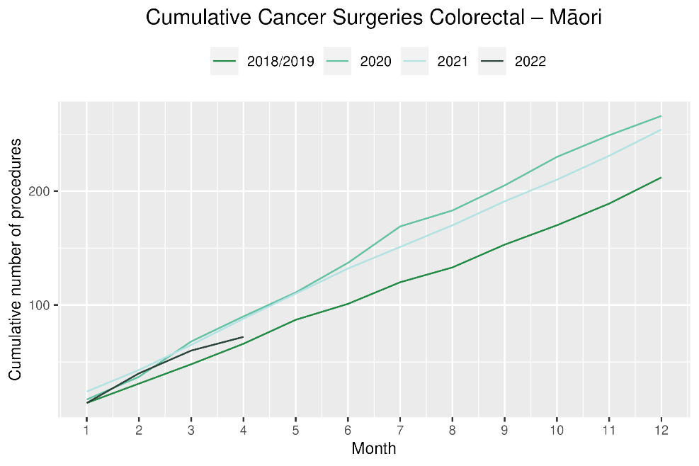

# Lung cancer surgery

## Notes on data

* A list of the surgical procedure codes used for analysis are included in Appendix 5.
* The data were extracted from the NMDS on 09 June 2022.
* The number of lung cancer surgeries performed each month is relatively small, so caution is needed when comparing data by month.

## Key points

* There was a 12% increase in the number of lung cancer surgeries performed in April 2022 compared with April 2018/19.
* For 2022 to date there was no change in the number of surgeries performed for the total population.
* For Māori there was a 29% decrease in lung cancer surgery, numbering 12 fewer surgeries in 2022 compared with 2018/19.

## Results

Table : Number of lung cancer surgeries and percentage difference in 2022 compared to the average of 2018 and 2019, by month and cumulative year to date, by ethnicity

|  |  |  |  |  |  |  |  |  |  |  |  |  |
| --- | --- | --- | --- | --- | --- | --- | --- | --- | --- | --- | --- | --- |
|  | **February** | | | **March** | | | **April** | | | **Cumulative January -April** | | |
|  | **2018/2019** | **2022** | **% change** | **2018/2019** | **2022** | **% change** | **2018/2019** | **2022** | **% change** | **2018/2019** | **2022** | **% change** |
| Non-Māori/Non-Pacific | 43 | 45 | 6% | 52 | 54 | 5% | 41 | 56 | 37% | 171 | 182 | 6% |
| Total Population | 53 | 56 | 6% | 65 | 66 | 2% | 55 | 61 | 12% | 220 | 220 | 0% |

* Due to small numbers, monthly figures have not been included for Māori and Pacific peoples

Figure : Number of lung cancer surgeries by month, 2018/19 average, 2020, 2021 and 2022, total population and Māori

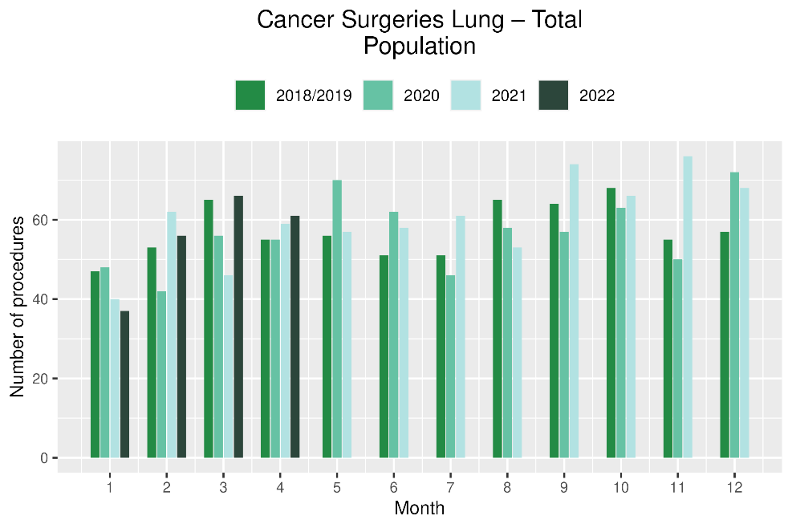 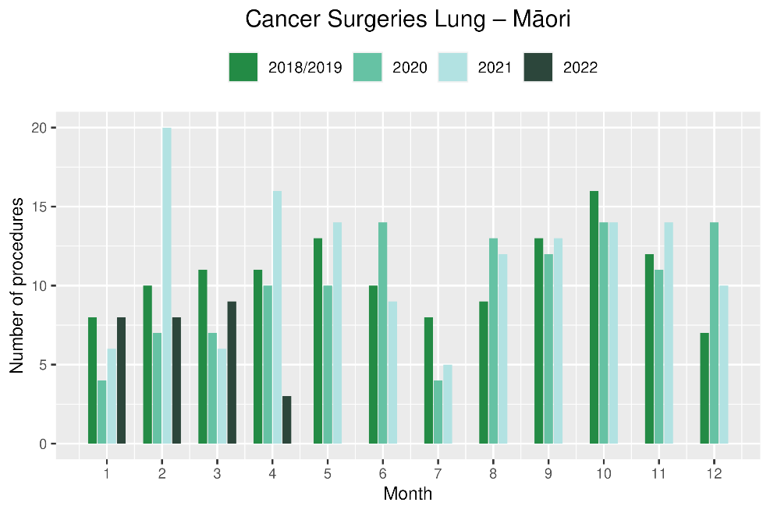

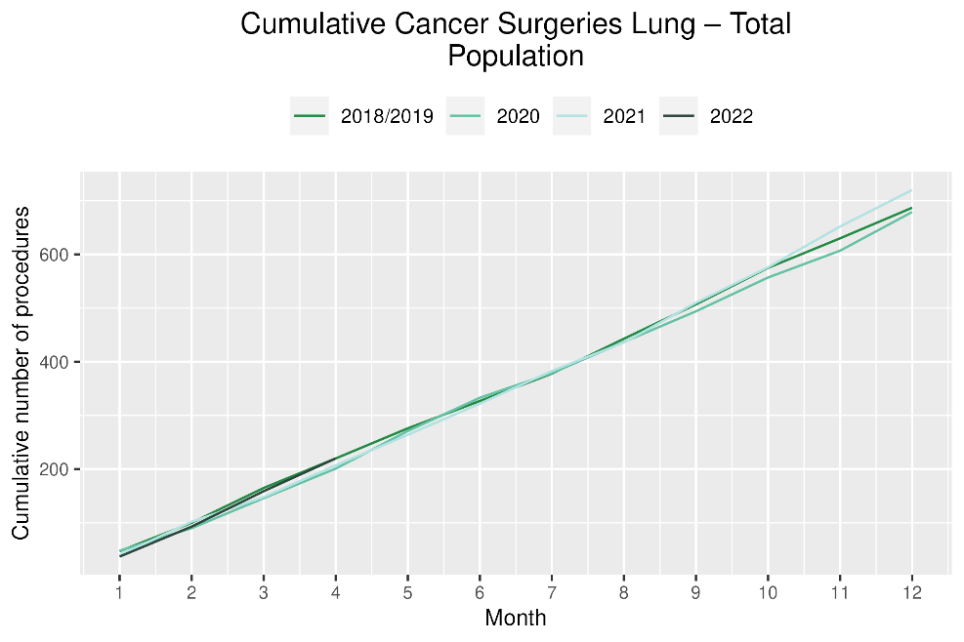 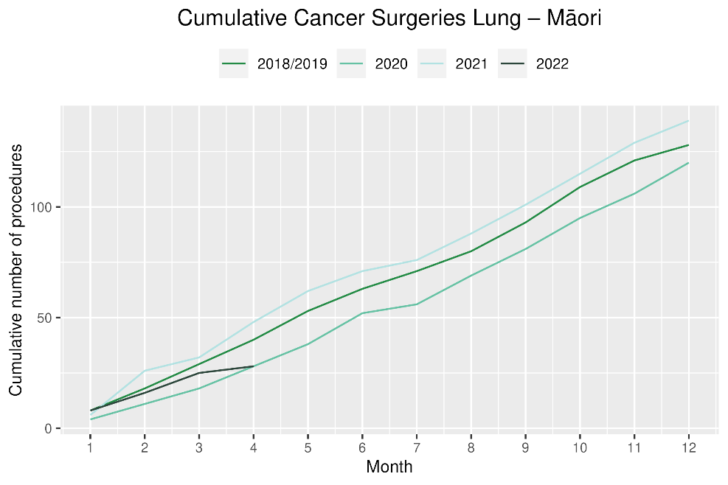

# Prostate cancer surgery

## Notes on data

* A list of the surgical procedure codes used for analysis are included in Appendix 5.
* The data was extracted from the NMDS on 09 June 2022.
* The number of prostate cancer surgeries performed each month is relatively small, so caution is needed when comparing data by month.

## Key points

* There was a 2% decrease in prostate cancer surgeries performed in April 2022 compared with April 2018/19.
* For 2022 to date there were 11% more prostate cancer surgeries compared with cumulative figures from 2018/19.

## Results

Table : Number of prostate cancer surgeries and percentage difference in 2022 compared to the average of 2018 and 2019 by month and cumulative year to date

|  |  |  |  |  |  |  |  |  |  |  |  |  |
| --- | --- | --- | --- | --- | --- | --- | --- | --- | --- | --- | --- | --- |
|  | **February** | | | **March** | | | **April** | | | **Cumulative January -April** | | |
|  | **2018/19** | **2022** | **% change** | **2018/19** | **2022** | **% change** | **2018/19** | **2022** | **% change** | **2018/19** | **2022** | **% change** |
| Total Population | 54 | 61 | 14% | 68 | 82 | 21% | 65 | 63 | -2% | 230 | 256 | 11% |

* Due to small numbers, monthly figures have not been included by ethnicity

Figure : Number of prostate cancer surgeries by month, 2018/19 average, 2020,2021 and 2022, total population and Māori

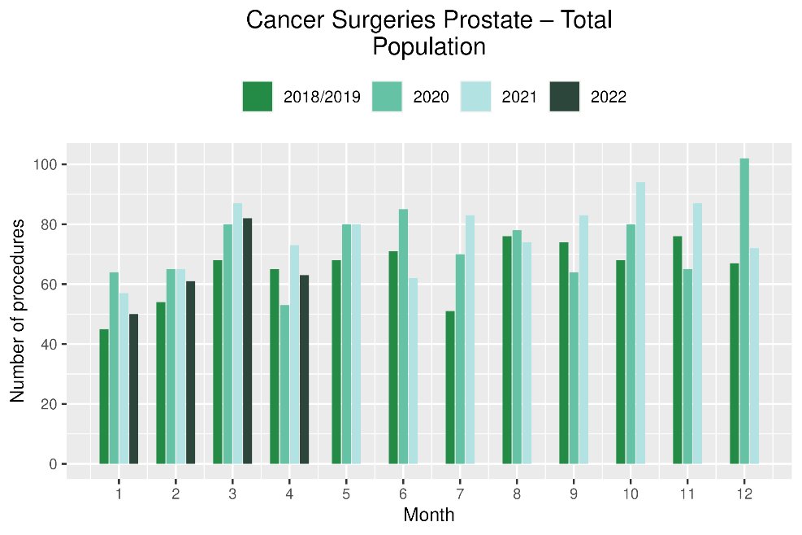 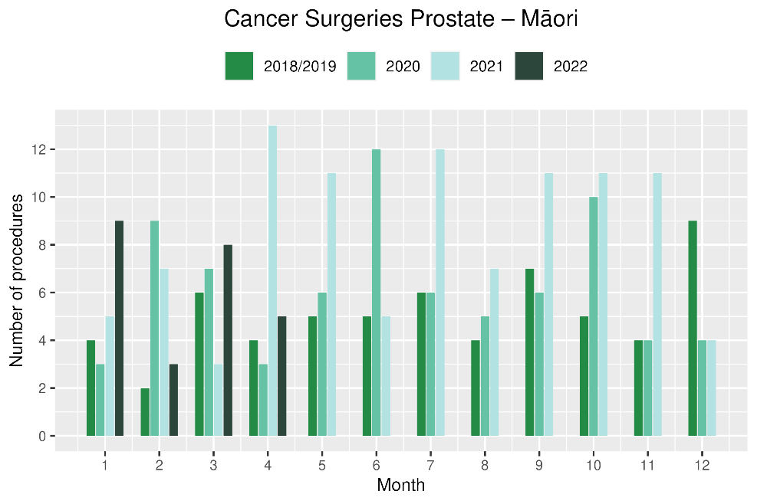

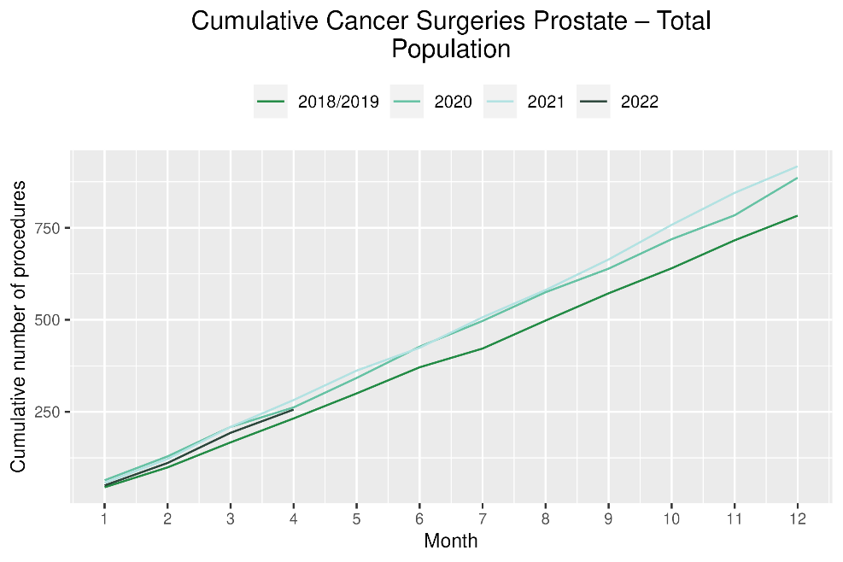 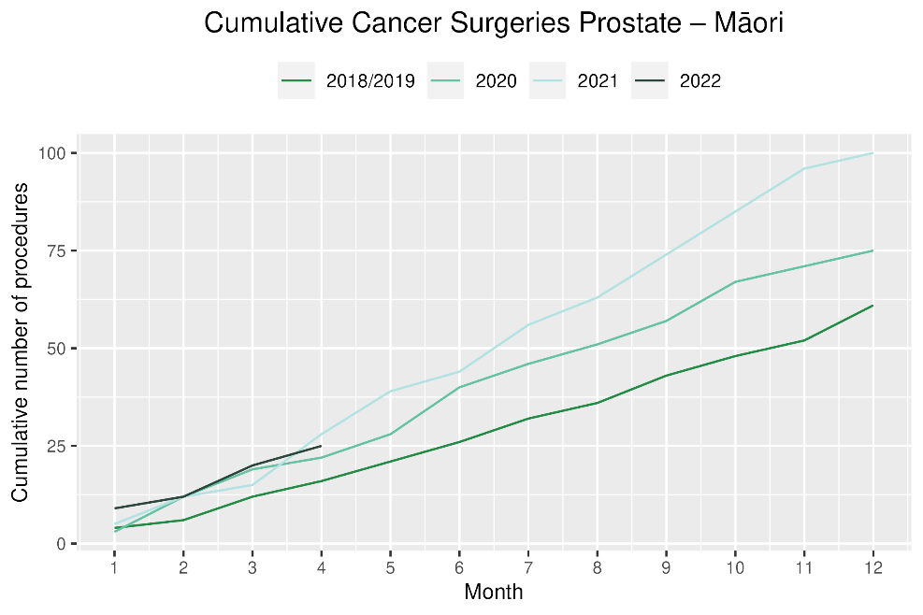

# Medical oncology

## Notes on data

* Data were extracted from NNPAC on 09 June 2022.
* First specialist assessment (FSA) reflects counts of first attendance for specialist medical oncology assessment.
* Intravenous (IV) chemotherapy reflects appointments for outpatient and inpatient IV chemotherapy for non-haematological indications.
* Technical information: medical oncology FSA (Purchase Unit Code: M50020) and IV chemotherapy (Purchase Unit Code: MS02009).

## Key points

* Attendances for medical oncology first specialist assessments (FSAs) showed no difference in April 2022 compared to April 2018/19. For Māori, there was an 8% increase in FSAs in April 2022 compared to April 2018/19.
* For 2022 to date, there was a 9% increase in medical oncology FSAs compared with 2018/19.
* Attendances for intravenous (IV) chemotherapy increased by 7% in April 2022 compared to April 2018/19. For Māori, there was a 36% increase in IV chemotherapy in April 2022 compared to April 2018/19.
* For 2022 to date, there was a 9% increase in IV chemotherapy compared with 2018/19.

## Results

Table : Number of medical oncology first specialist assessments and percentage difference in 2022 compared to the average of 2018 and 2019, by month and cumulative year to date, by ethnicity

|  |  |  |  |  |  |  |  |  |  |  |  |  |
| --- | --- | --- | --- | --- | --- | --- | --- | --- | --- | --- | --- | --- |
|  | **February** | | | **March** | | | **April** | | | **Cumulative January -April** | | |
|  | **2018/2019** | **2022** | **% change** | **2018/2019** | **2022** | **% change** | **2018/2019** | **2022** | **% change** | **2018/2019** | **2022** | **% change** |
| Māori | 97 | 123 | 27% | 97 | 139 | 44% | 94 | 101 | 8% | 373 | 444 | 19% |
| Pacific Peoples | 28 | 36 | 29% | 33 | 43 | 30% | 35 | 33 | -4% | 123 | 149 | 22% |
| Non-Māori/Non-Pacific | 572 | 636 | 11% | 615 | 786 | 28% | 544 | 540 | -1% | 2,311 | 2,477 | 7% |
| Total Population | 697 | 795 | 14% | 745 | 968 | 30% | 673 | 674 | 0% | 2,807 | 3,070 | 9% |

Figure : Number of medical oncology first specialist assessments by month, 2018/19 average, 2020, 2021 and 2022, total population and Māori

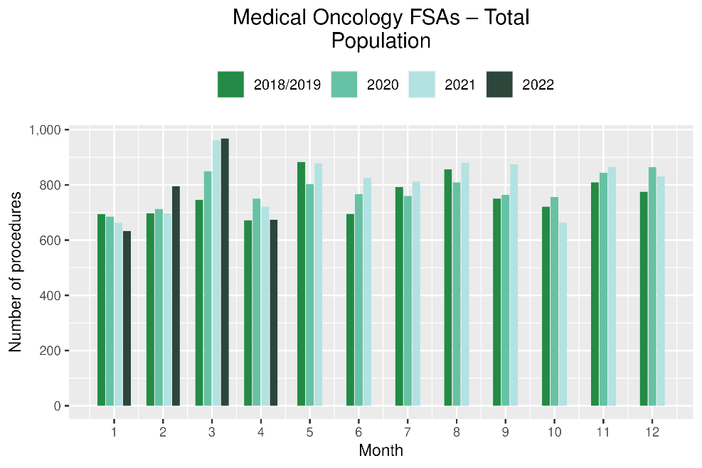 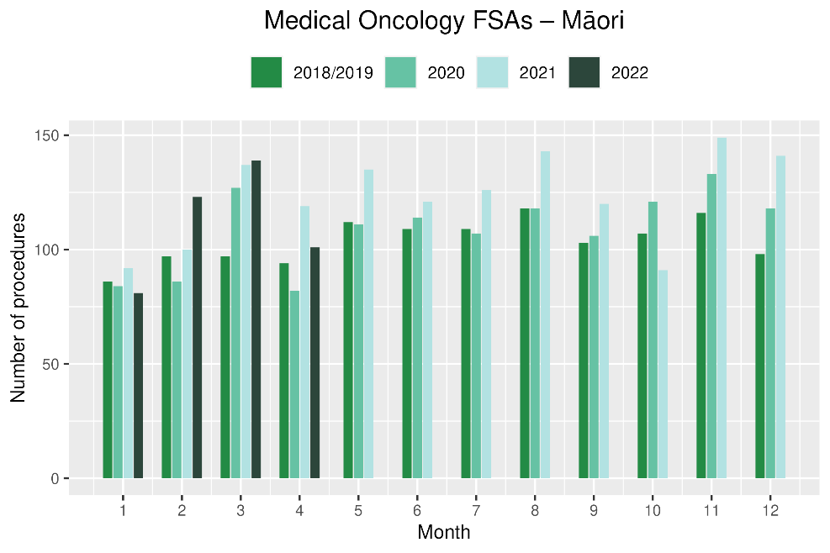

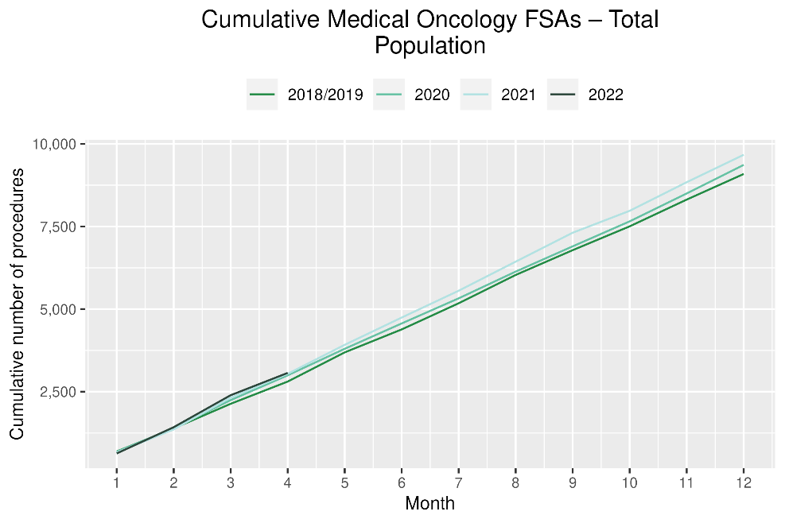 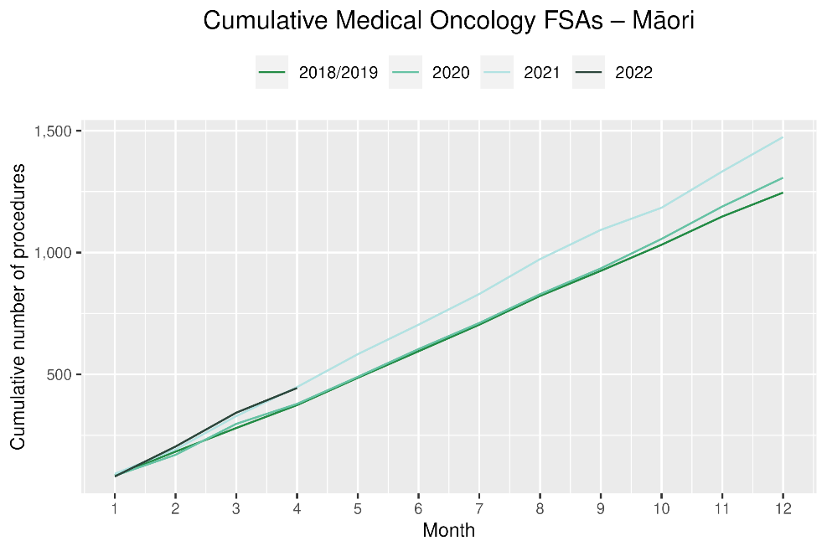

Table : Number of IV chemotherapy attendances and percentage difference in 2022 compared to the average of 2018 and 2019, by month and cumulative year to date, by ethnicity

|  |  |  |  |  |  |  |  |  |  |  |  |  |
| --- | --- | --- | --- | --- | --- | --- | --- | --- | --- | --- | --- | --- |
|  | **February** | | | **March** | | | **April** | | | **Cumulative January -April** | | |
|  | **2018/2019** | **2022** | **% change** | **2018/2019** | **2022** | **% change** | **2018/2019** | **2022** | **% change** | **2018/2019** | **2022** | **% change** |
| Māori | 664 | 879 | 32% | 709 | 995 | 40% | 674 | 919 | 36% | 2,771 | 3,728 | 35% |
| Pacific Peoples | 240 | 338 | 41% | 264 | 367 | 39% | 275 | 338 | 23% | 1,051 | 1,388 | 32% |
| Non-Māori/Non-Pacific | 4,429 | 4,782 | 8% | 4,765 | 5,353 | 12% | 4,753 | 4,828 | 2% | 18,881 | 19,675 | 4% |
| Total Population | 5,333 | 5,999 | 12% | 5,738 | 6,715 | 17% | 5,702 | 6,085 | 7% | 22,703 | 24,791 | 9% |

Figure : Number of IV chemotherapy attendances by month, 2018/19 average, 2020 and 2021, total population and Māori

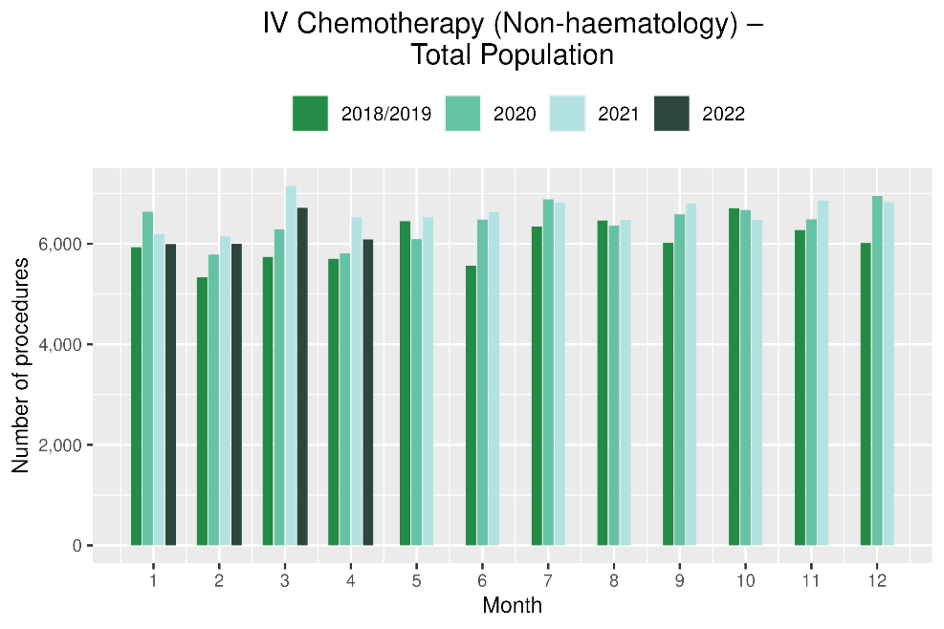 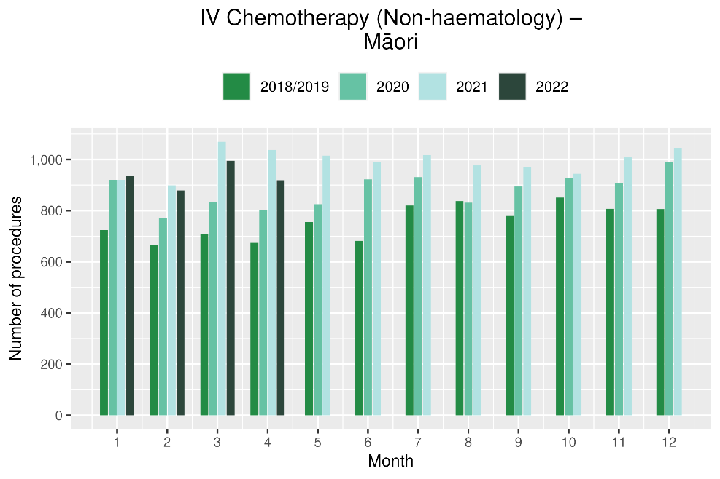

Figure : Cumulative number of attendances for IV chemotherapy, 2018/19 average, 2020 and 2021, total population and Māori

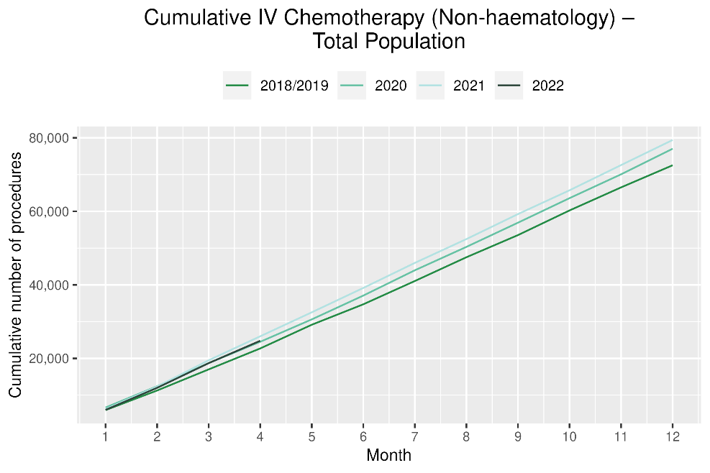 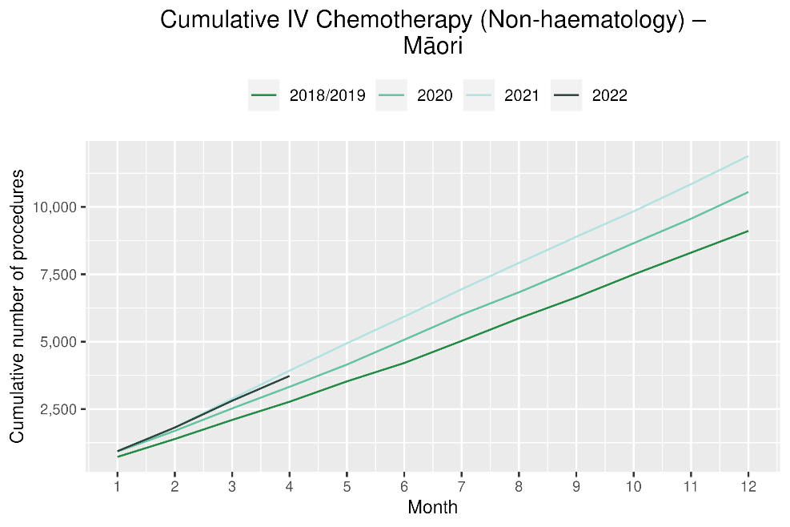

# Radiation oncology

## Notes on data

* Radiation oncology first specialist assessments and megavoltage attendances data were extracted from NNPAC on 09 June 2022.
* First specialist assessment (FSA) reflects counts of first attendance for radiation oncology specialist assessment.
* Radiation therapy attendances include appointments for planning/simulation and for treatment with radiation therapy on a linear accelerator.
* Technical information: radiation oncology FSA (Purchase Unit Code: M50022), megavoltage attendances (Purchase Unit Code: M50025).

## Key points

* Attendances for radiation oncology first specialist assessments (FSAs) decreased by 2% in April 2022 compared to April 2018/19. For Māori, there was a 15% decrease in FSAs in April 2022 compared to April 2018/19.
* For 2022 to date, there was a 5% increase in radiation oncology FSAs compared with 2018/19
* Radiation therapy attendances decreased by 14% in April 2022 compared to April 2018/19. For Māori, there was a 9% decrease in radiation therapy attendances in April 2022 compared to April 2018/19. For Pacific peoples there was a 22% decrease in radiation therapy attendances in April 2022 compared to April 2018/19. For 2022 to date, there was an 11% decrease in radiation therapy attendances.
* Radiation course data is available quarterly (most recently reported in the previous report covering data to March 2022), and in future reports will help with interpretation of the above trends, considering the increasing move toward the use of hypofractionation[3].

Table : Number of radiation oncology first specialist assessments and percentage difference in 2022 compared to the average of 2018 and 2019, by month and cumulative year to date, by ethnicity

|  |  |  |  |  |  |  |  |  |  |  |  |  |
| --- | --- | --- | --- | --- | --- | --- | --- | --- | --- | --- | --- | --- |
|  | **February** | | | **March** | | | **April** | | | **Cumulative January -April** | | |
|  | **2018/2019** | **2022** | **% change** | **2018/2019** | **2022** | **% change** | **2018/2019** | **2022** | **% change** | **2018/2019** | **2022** | **% change** |
| Māori | 110 | 123 | 12% | 106 | 145 | 37% | 112 | 95 | -15% | 430 | 473 | 10% |
| Pacific Peoples | 37 | 41 | 12% | 47 | 63 | 35% | 38 | 49 | 29% | 167 | 200 | 20% |
| Non-Māori/Non-Pacific | 782 | 865 | 11% | 852 | 980 | 15% | 741 | 731 | -1% | 3,154 | 3,268 | 4% |
| Total Population | 929 | 1,029 | 11% | 1,005 | 1,188 | 18% | 891 | 875 | -2% | 3,751 | 3,941 | 5% |

Figure : Number of radiation oncology first specialist assessments by month, 2018/19 average, 2020, 2021 and 2022, total population and Māori

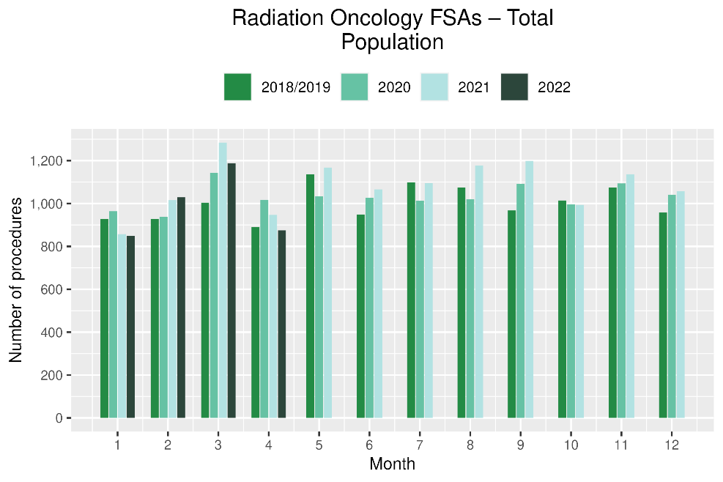 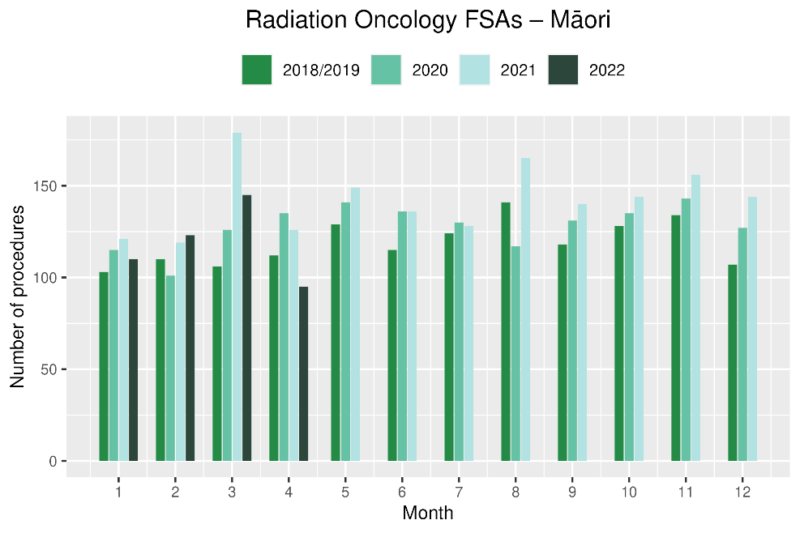

**Figure 14: Cumulative number of radiation oncology first specialist assessments by month, 2018/19 average, 2020, 2021 and 2022, total population and Māori**

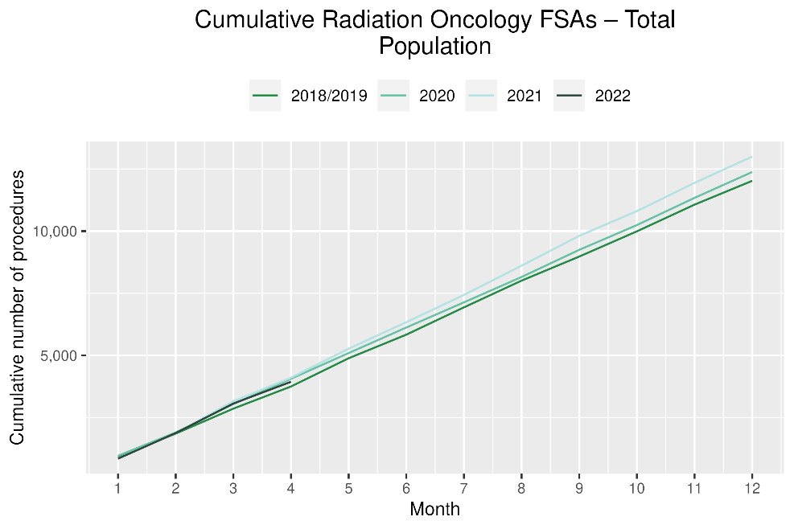 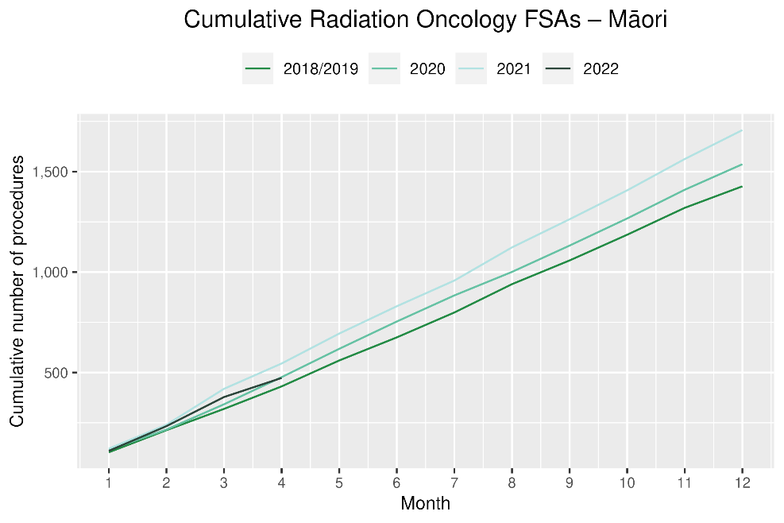

Table : Number of radiation therapy attendances and percentage difference in 2022 compared to the average of 2018 and 2019, by month and cumulative year to date, by ethnicity

|  |  |  |  |  |  |  |  |  |  |  |  |  |
| --- | --- | --- | --- | --- | --- | --- | --- | --- | --- | --- | --- | --- |
|  | **February** | | | **March** | | | **April** | | | **Cumulative January -April** | | |
|  | **2018/2019** | **2022** | **% change** | **2018/2019** | **2022** | **% change** | **2018/2019** | **2022** | **% change** | **2018/2019** | **2022** | **% change** |
| Māori | 1,523 | 1,784 | 17% | 1,752 | 1,732 | -1% | 1,711 | 1,564 | -9% | 6,660 | 6,780 | 2% |
| Pacific Peoples | 514 | 519 | 1% | 477 | 458 | -4% | 535 | 419 | -22% | 2,067 | 1,861 | -10% |
| Non-Māori/Non-Pacific | 10,590 | 9,466 | -11% | 11,778 | 11,032 | -6% | 11,110 | 9,449 | -15% | 44,975 | 39,348 | -13% |
| Total Population | 12,627 | 11,769 | -7% | 14,007 | 13,222 | -6% | 13,356 | 11,432 | -14% | 53,702 | 47,989 | -11% |

Figure : Number of radiation therapy attendances by month, 2018/19 average, 2020, 2021 and 2022, total population and Māori

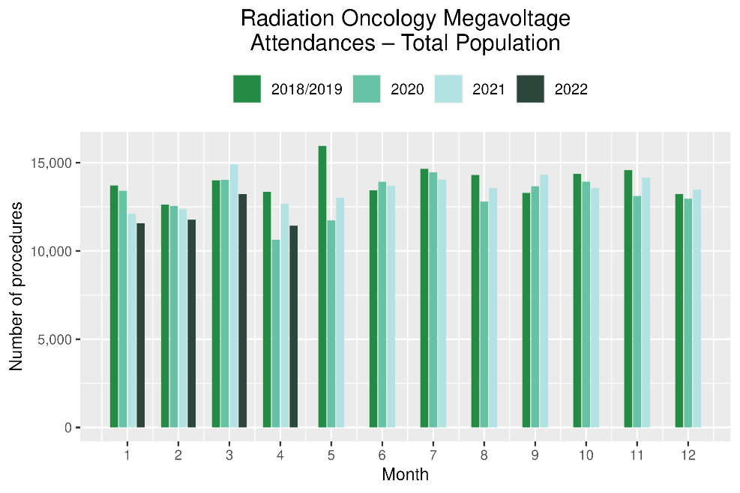 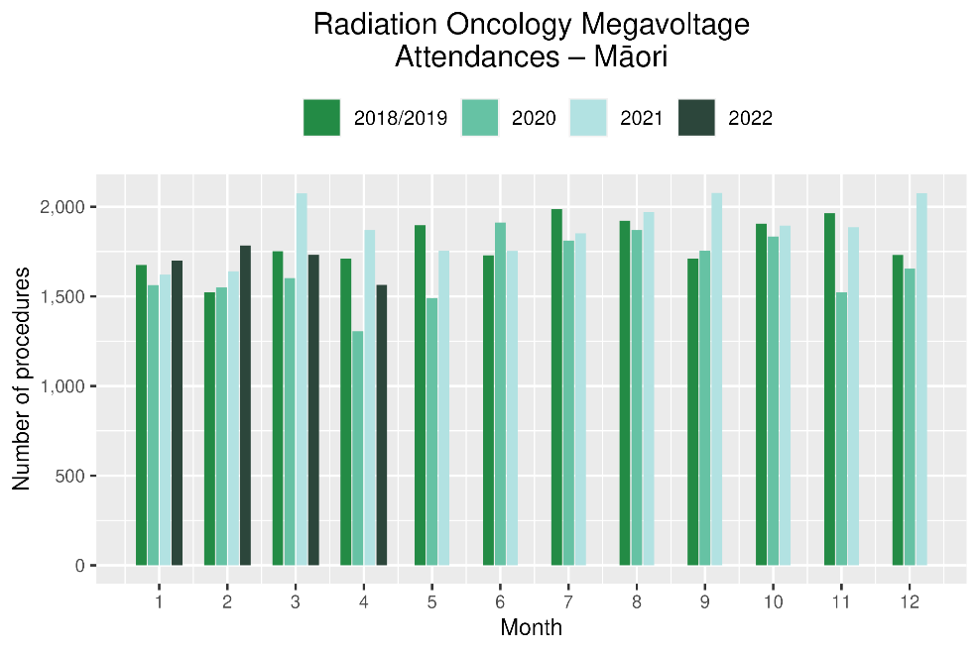

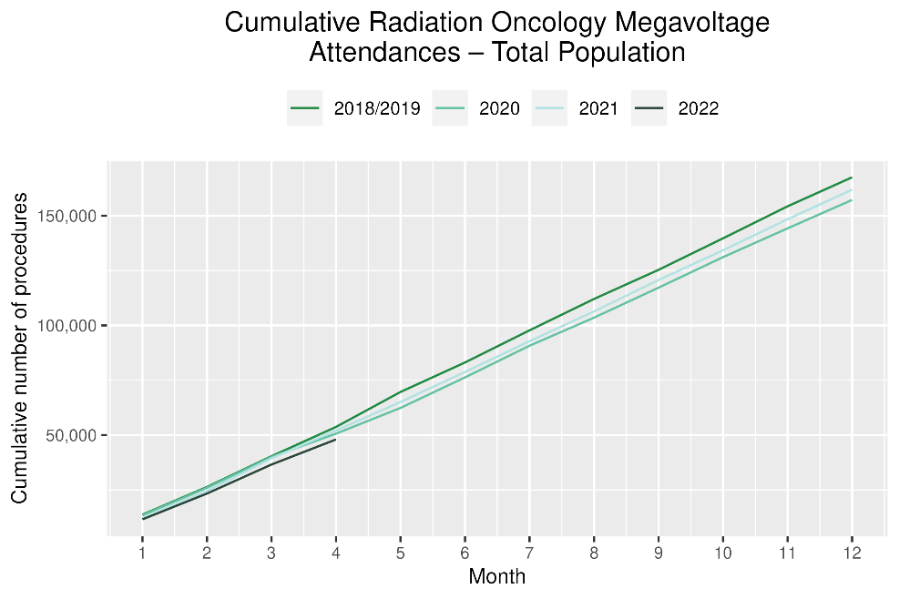 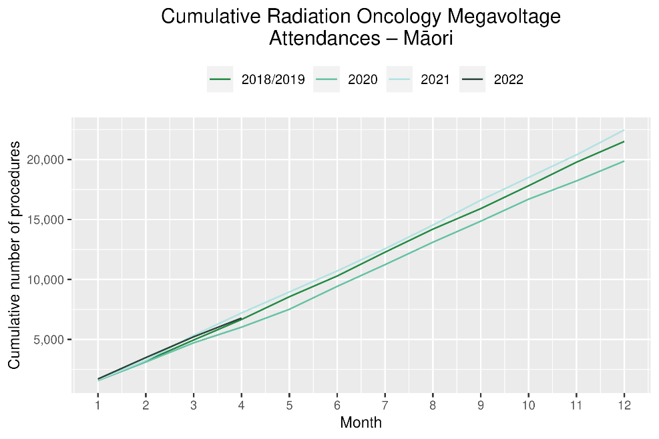

# 

# Haematology

## Notes on data

* Data were extracted from NNPAC and NMDS on 09 June 2022.
* First specialist assessment (FSA) reflects counts of first attendance for specialist haematology assessment for any indication, not just cancer.
* IV chemotherapy reflects appointments for IV chemotherapy for haematological malignancies.
* Technical information: Haematology FSA (Purchase Unite Code: M30002), IV haem/chemo (Purchase Unit Code: M30020).

## Key points

* There was a 13% decrease in attendances for haematology first specialist assessments (FSAs) in April 2022 compared to April 2018/19. For Māori, there was a 12% decrease in FSAs April 2022 compared to April 2018/19.
* For 2022 to date, there was a 5% decrease in haematology FSAs compared with 2018/19, and for Māori there was a 1% decrease.
* Attendances for haematology intravenous (IV) chemotherapy increased by 1% in April 2022 compared to April 2018/19. For Māori, there was an 18% increase in haematology IV chemotherapy in April 2022 compared to April 2018/19. For Pacific peoples there was a 5% increase in IV chemotherapy in April 2022 compared to April 2018/19.
* For 2022 to date, there was a 12% increase in haematology IV chemotherapy compared with 2018/19.

## Results

Table : Number of haematology first specialist assessment attendances and percentage difference in 2022 compared to the average of 2018 and 2019, by month and cumulative year to date, by ethnicity

|  |  |  |  |  |  |  |  |  |  |  |  |  |
| --- | --- | --- | --- | --- | --- | --- | --- | --- | --- | --- | --- | --- |
|  | **February** | | | **March** | | | **April** | | | **Cumulative January -April** | | |
|  | **2018/2019** | **2022** | **% change** | **2018/2019** | **2022** | **% change** | **2018/2019** | **2022** | **% change** | **2018/2019** | **2022** | **% change** |
| Māori | 47 | 47 | 0% | 65 | 67 | 3% | 49 | 43 | -12% | 207 | 204 | -1% |
| Pacific Peoples | 24 | 37 | 57% | 26 | 41 | 58% | 23 | 25 | 9% | 98 | 130 | 32% |
| Non-Māori/Non-Pacific | 441 | 414 | -6% | 476 | 498 | 5% | 427 | 366 | -14% | 1,760 | 1,633 | -7% |
| Total Population | 512 | 498 | -3% | 567 | 606 | 7% | 499 | 434 | -13% | 2,065 | 1,967 | -5% |

Figure 2: Number of haematology first specialist assessments by month, 2018/19 average, 2020, 2021 and 2022, total population and Māori

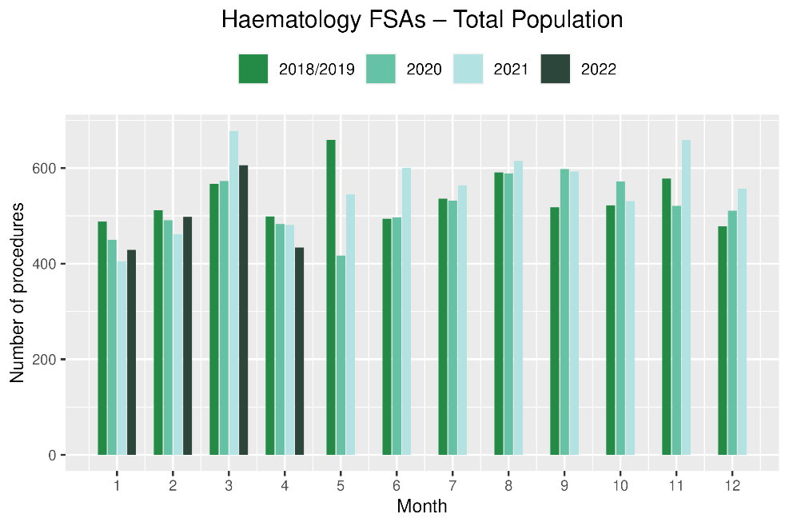 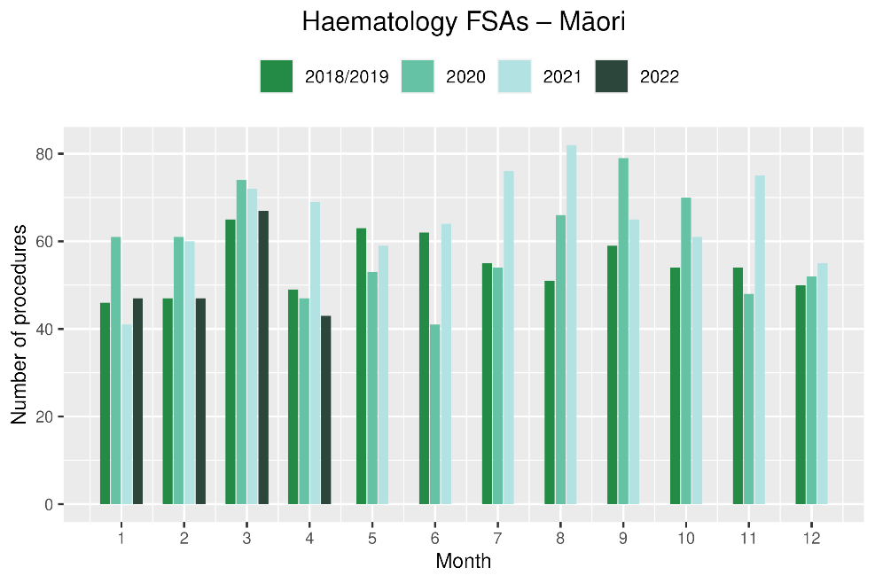

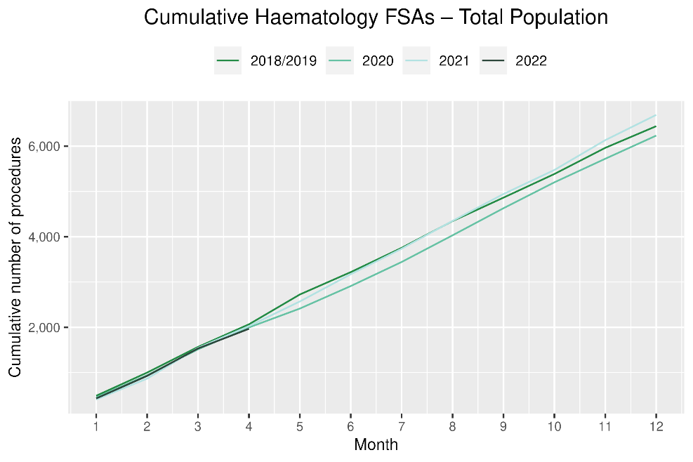 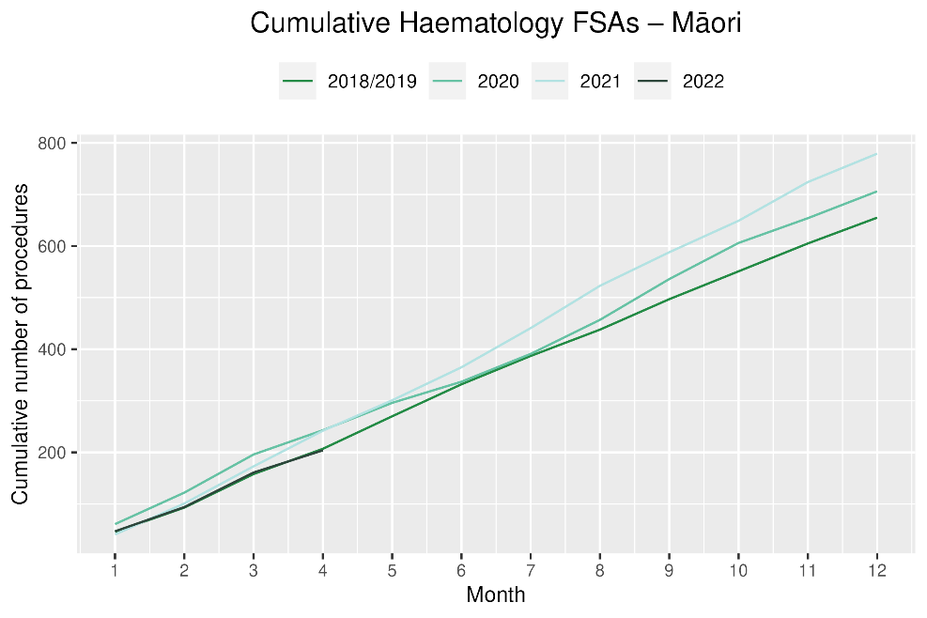

**Table 14: Number of IV chemotherapy attendances for haematological malignancies and percentage difference in 2022 compared to the average of 2018 and 2019, by month and cumulative year to date, by ethnicity**

|  |  |  |  |  |  |  |  |  |  |  |  |  |
| --- | --- | --- | --- | --- | --- | --- | --- | --- | --- | --- | --- | --- |
|  | **February** | | | **March** | | | **April** | | | **Cumulative January -April** | | |
|  | **2018/2019** | **2022** | **% change** | **2018/2019** | **2022** | **% change** | **2018/2019** | **2022** | **% change** | **2018/2019** | **2022** | **% change** |
| Māori | 196 | 197 | 1% | 193 | 197 | 2% | 163 | 193 | 18% | 755 | 796 | 5% |
| Pacific Peoples | 103 | 116 | 13% | 98 | 102 | 4% | 89 | 93 | 5% | 388 | 449 | 16% |
| Non-Māori/Non-Pacific | 1,505 | 1,811 | 20% | 1,582 | 1,916 | 21% | 1,563 | 1,555 | 0% | 6,305 | 7,111 | 13% |
| Total Population | 1,804 | 2,124 | 18% | 1,873 | 2,215 | 18% | 1,815 | 1,841 | 1% | 7,448 | 8,356 | 12% |

Figure : Number of attendances for IV chemotherapy for haematological malignancies by month, 2018/19 average, 2020, 2021 and 2022, total population and Māori

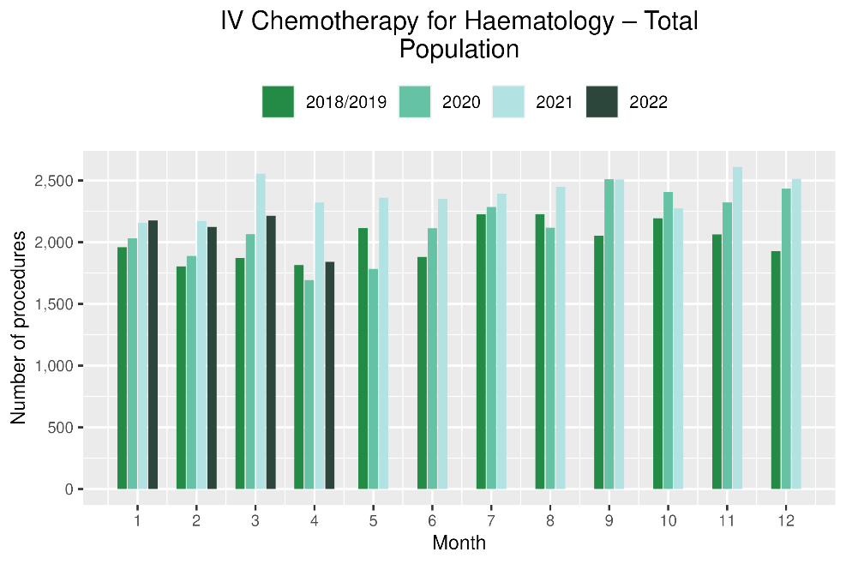 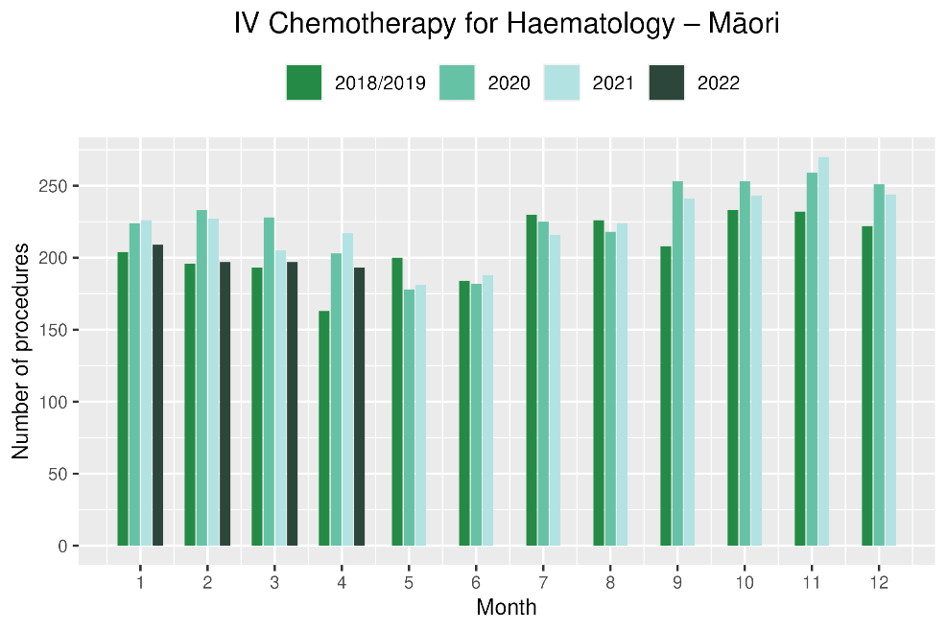

Figure : Cumulative number of attendances for IV chemotherapy for haematological malignancies, 2018/19 average, 2020, 2021 and 2022, total population and Māori

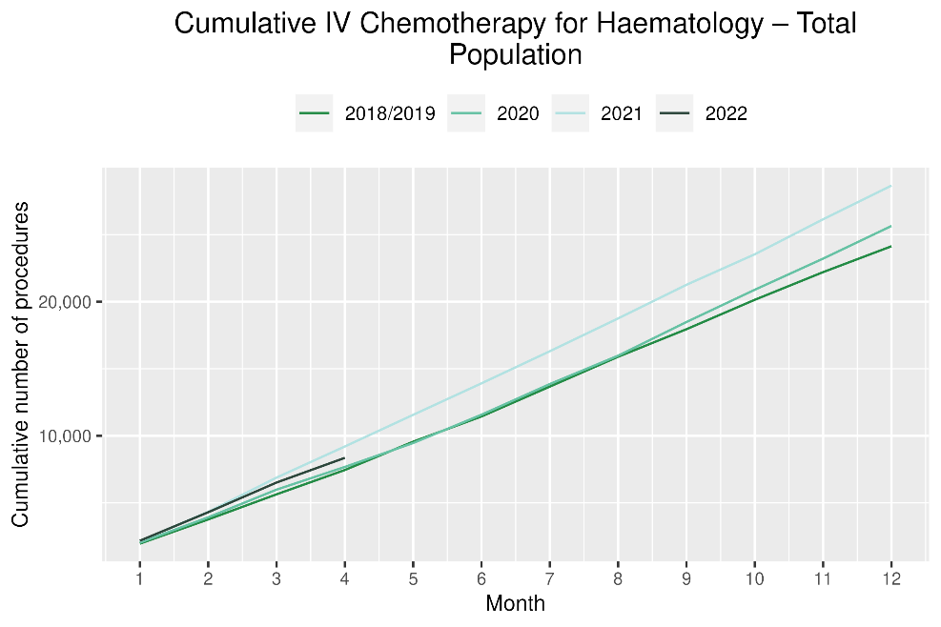 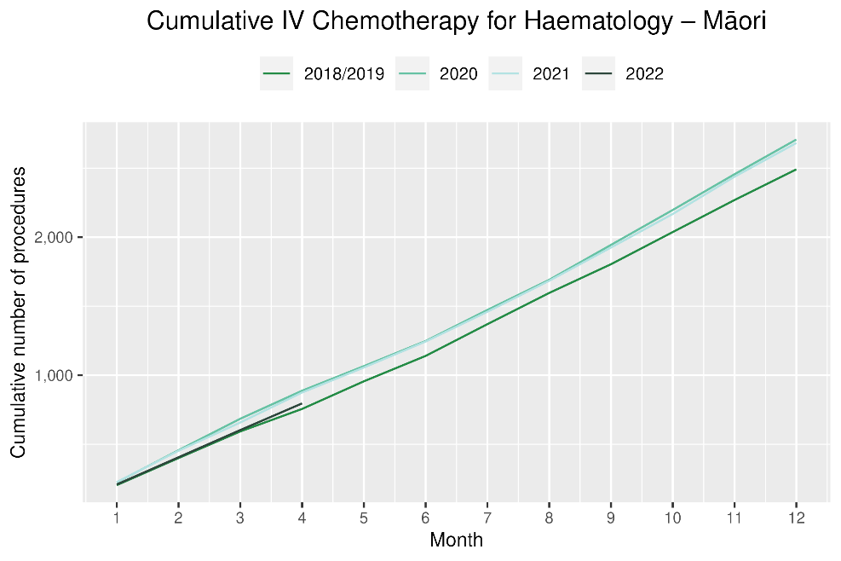

# Appendix 1: Key Dates

The follow provides a brief overview of key dates relating to COVID-19 restrictions (Alert Levels 3 and 4 where the greatest restrictions were in place) and outbreaks. More detailed information can be found on the Unite COVID-19 website[4], including an overview of Alert Levels and the COVID-19 Protection Framework[5].

|  |  |
| --- | --- |
| 23 March – 14 May 2020 | All Aotearoa New Zealand was at Alert Level 3 or 4 |
| 12 August – 30 September 2020 | Auckland only moved to Alert Level 3 |
| 28 Feb – 7 March 2021 | Auckland only was at Alert Level 3 |
| 17 August to 7 September 2021 | All Aotearoa New Zealand was at Alert 3 or 4 at the outset of the Delta variant outbreak |
| From 7 September 2021 | Auckland remained at Alert Level 4; the rest of the country moved to Alert Level 2 |
| September – December 2021 | Auckland moved to and remained at Alert Level 3 from 21 September. There were various regional changes between Alert Level 2 and 3 over this period some parts of the North Island including parts of Waikato. Details are available on the Unite COVID-19 website4. Note: The definition of Alert Level 3 was eased in early October and three gradually reducing steps of level 3 were introduced in October |
| 3 Dec 2021 | End of COVID-19 Alert System. All Aotearoa New Zealand moved to the COVID-19 Protection Framework (traffic lights) |
| 29 Dec 2021 | The first case of the Omicron variant in the community in New Zealand was detected |
| February 2022  10 March 2022  23 March 2022 | Omicron case numbers and hospitalisations increased more significantly in the second half of February onwards[6]  Seven day rolling average of cases is over 20,000, while daily count reaches over 23,000.  Changes are made to the Red Light setting: no limitations on numbers of people gathering outdoors, indoors limit increase to 2000 people. |
| 14 April 2022 | Deaths caused by or related to Covid-19 reached 513. New Zealand changes to the Orange traffic light setting. Indoor venue capacity rules are removed but facemasks are still required in most indoor venues. |
| 23 April 2022 | The first case of the Omicron XE variant is detected in New Zealand. |
|  |  |

# Appendix 2: NZCR data information

## The New Zealand Cancer Registry as a data source for new cancer diagnoses

Cancer registration is a process where data is collated from multiple sources about people diagnosed with cancer and rules are applied to determine the type of cancer they have. This information is recorded in the New Zealand Cancer Registry. Each tumour is classified using an international World Health Organization standard so that cancer incidence can be compared between countries. The tumour is staged based on all the information available within 4 months of diagnosis. This process may take up to six months or more depending on the number of missing reports that need to be followed up with laboratories.

For each registration there may be multiple pathology reports as there may be multiple procedures performed on the tumour. This means there will be more than one registration for people diagnosed with more than one type of tumour.

Cancer registrations come from pathology laboratories, haematology laboratories, mortality records and reviewing hospital discharge records. Laboratory reports provide the best source of near real time data to monitor new diagnoses of cancer in New Zealand.

## Pathology reports as a data source for providing near real time monitoring of cancer diagnoses

Pathology reports (documents) are received by the NZCR as electronic messages. An administrator triages these documents each day and if the document appears to meet the requirements for registration the document is “administered”. The document may relate to an existing registration or may contain information for a new cancer event. Documents that do not meet the cancer reporting requirements will be marked as “deleted”, “rejected” or “agreed not for registration”.

The administrator creates a new provisional cancer event if the pathology report identifies a new cancer diagnosis for this person. This new cancer event is assigned to a cancer group and this provisional event is then queued for further assessment by a clinical coder. If the required information has been provided the coder creates a new registration. If some information is not yet available, then the registration is held open until further information arrives to complete the registration or determine that the tumour does not meet the registration criteria.

# Appendix 3: NZCR registrations by DHB

Number of cancer registrations and percentage difference in 2022 compared to 2021 average, by month and cumulative year to date, by DHB of domicile

|  |  |  |  |  |  |  |  |  |  |  |  |  |
| --- | --- | --- | --- | --- | --- | --- | --- | --- | --- | --- | --- | --- |
|  | **February** | | | **March** | | | **April** | | | **Cumulative January-April** | | |
| **DHB** | **2018/19** | **2022** | **Change%** | **2018/19** | **2022** | **Change%** | **2018/19** | **2022** | **Change%** | **2018/19** | **2022** | **Change%** |
| Northland | 92 | 104 | 14% | 106 | 99 | -7% | 87 | 111 | 28% | 375 | 384 | 3% |
| Waitematā | 231 | 275 | 19% | 244 | 289 | 18% | 219 | 263 | 20% | 899 | 1,027 | 14% |
| Auckland | 174 | 182 | 5% | 185 | 203 | 10% | 156 | 160 | 3% | 650 | 692 | 7% |
| Counties Manukau | 162 | 185 | 14% | 196 | 217 | 11% | 166 | 170 | 3% | 684 | 731 | 7% |
| Waikato | 174 | 195 | 12% | 198 | 210 | 6% | 164 | 178 | 9% | 691 | 720 | 4% |
| Bay of Plenty | 106 | 101 | -4% | 129 | 154 | 20% | 106 | 108 | 2% | 441 | 468 | 6% |
| Tairāwhiti | 18 | 15 | -17% | 19 | 23 | 24% | 18 | 21 | 17% | 68 | 71 | 4% |
| Lakes | 48 | 47 | -2% | 43 | 59 | 39% | 42 | 42 | 1% | 169 | 185 | 9% |
| Taranaki | 57 | 63 | 12% | 46 | 60 | 30% | 59 | 43 | -26% | 205 | 211 | 3% |
| Hawkes Bay | 61 | 82 | 34% | 79 | 85 | 8% | 73 | 55 | -24% | 276 | 278 | 1% |
| Whanganui | 38 | 28 | -25% | 29 | 40 | 38% | 37 | 35 | -4% | 136 | 130 | -4% |
| MidCentral | 76 | 71 | -6% | 85 | 92 | 9% | 92 | 58 | -37% | 332 | 293 | -12% |
| Capital and Coast | 103 | 133 | 30% | 133 | 126 | -5% | 120 | 121 | 1% | 452 | 475 | 5% |
| Hutt Valley | 58 | 58 | 1% | 63 | 65 | 3% | 55 | 52 | -5% | 223 | 232 | 4% |
| Wairarapa | 19 | 29 | 57% | 26 | 18 | -29% | 22 | 24 | 9% | 91 | 90 | -1% |
| Nelson Marlborough | 69 | 69 | 1% | 84 | 93 | 11% | 85 | 58 | -31% | 297 | 281 | -5% |
| West Coast | 21 | 15 | -29% | 15 | 21 | 45% | 16 | 13 | -16% | 62 | 67 | 8% |
| Canterbury | 217 | 239 | 10% | 236 | 286 | 21% | 218 | 200 | -8% | 874 | 937 | 7% |
| South Canterbury | 31 | 31 | 0% | 26 | 41 | 61% | 30 | 33 | 10% | 117 | 132 | 13% |
| Southern | 140 | 141 | 1% | 158 | 149 | -6% | 153 | 130 | -15% | 589 | 542 | -8% |

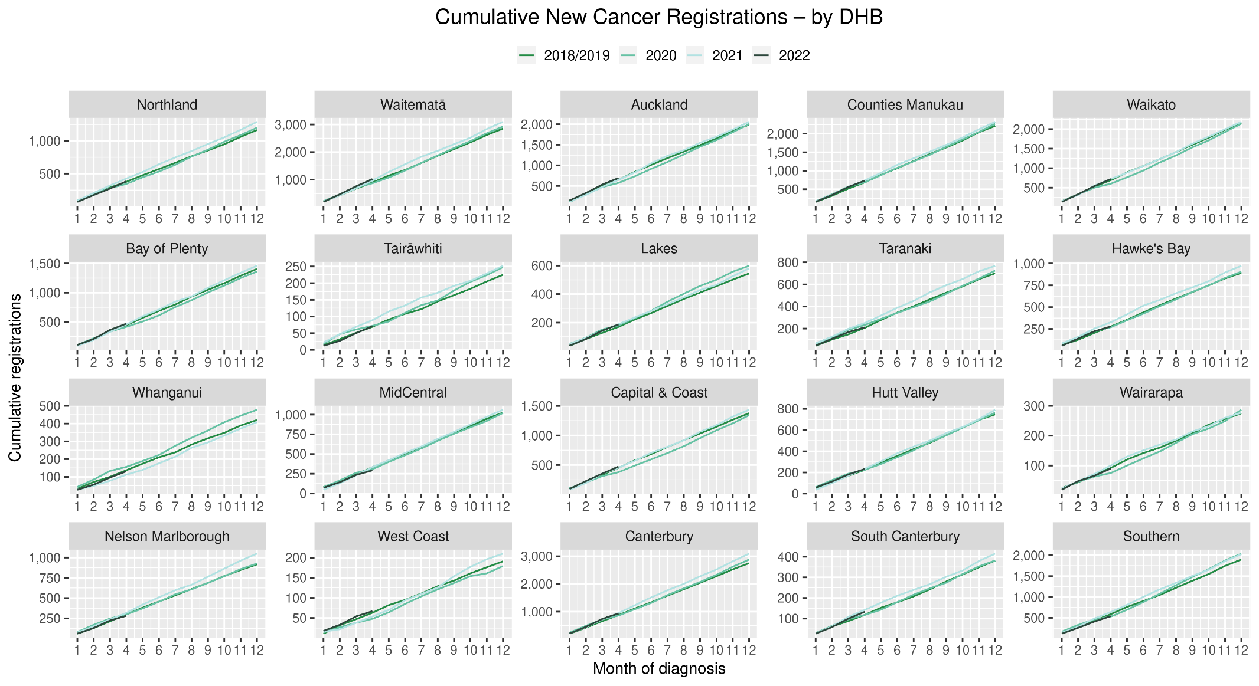

## Cumulative cancer registrations by DHB and ethnicity



## Cumulative cancer registrations by cancer type and ethnicity



# Appendix 4: Diagnosis and treatment data by DHB

Percentage differences are only presented if the cumulative total is 10 or greater. In some cases, the totals may differ to those presented in the national report due to non-DHB providers being excluded from the analyses within this appendix.

## Gastrointestinal endoscopy



## Bronchoscopy



## Colorectal cancer surgery



## Lung cancer surgery



## Prostate cancer surgery

## 

## Medical oncology first specialist assessments



## Medical oncology IV chemotherapy



## Radiation oncology first specialist assessments



## Radiation oncology megavoltage fractions

## 

## Haematology first specialist assessment



## Haematology IV chemotherapy



# Appendix 5: Surgical procedure codes

Below is a list of the surgical procedure codes that were used for analysis on cancer surgery.

|  |  |  |
| --- | --- | --- |
| **COLORECTAL CANCER SURGERY** | | |
| Clinical code | Block short description | Clinical code description |
| 3200000 | Colectomy | Limited excision of large intestine with formation of stoma |
| 3200001 | Colectomy | Right hemicolectomy with formation of stoma |
| 3200300 | Colectomy | Limited excision of large intestine with anastomosis |
| 3200301 | Colectomy | Right hemicolectomy with anastomosis |
| 3200400 | Colectomy | Subtotal colectomy with formation of stoma |
| 3200401 | Colectomy | Extended right hemicolectomy with formation of stoma |
| 3200500 | Colectomy | Subtotal colectomy with anastomosis |
| 3200501 | Colectomy | Extended right hemicolectomy with anastomosis |
| 3200600 | Colectomy | Left hemicolectomy with anastomosis |
| 3200601 | Colectomy | Left hemicolectomy with formation of stoma |
| 3200900 | Colectomy | Total colectomy with ileostomy |
| 3201200 | Colectomy | Total colectomy with ileorectal anastomosis |
| 3201500 | Total proctocolectomy | Total proctocolectomy with ileostomy |
| 3202400 | Anterior resection of rectum | High anterior resection of rectum |
| 3202500 | Anterior resection of rectum | Low anterior resection of rectum |
| 3202600 | Anterior resection of rectum | Ultra low anterior resection of rectum |
| 3202800 | Anterior resection of rectum | Ultra low anterior resection of rectum with hand sutured coloanal anastomosis |
| 3203000 | Rectosigmoidectomy or proctectomy | Rectosigmoidectomy with formation of stoma |
| 3203900 | Rectosigmoidectomy or proctectomy | Abdominoperineal proctectomy |
| 3205100 | Total proctocolectomy | Total proctocolectomy with ileo-anal anastomosis |
| 3205101 | Total proctocolectomy | Total proctocolectomy with ileo-anal anastomosis and formation of temporary ileostomy |
| 3206000 | Rectosigmoidectomy or proctectomy | Restorative proctectomy |
| 3209900 | Excision of lesion or tissue of rectum or anus | Per anal submucosal excision of lesion or tissue of rectum |
| 3211200 | Rectosigmoidectomy or proctectomy | Perineal rectosigmoidectomy |
| 9220800 | Anterior resection of rectum | Anterior resection of rectum, level unspecified |

|  |  |  |
| --- | --- | --- |
| **LUNG CANCER SURGERY** | | |
| Clinical code | Clinical code description | Block Description |
| 3844000 | Wedge resection of lung | Partial resection of lung |
| 3844001 | Radical wedge resection of lung | Partial resection of lung |
| 3843800 | Segmental resection of lung | Partial resection of lung |
| 9016900 | Endoscopic wedge resection of lung | Partial resection of lung |
| 3843801 | Lobectomy of lung | Lobectomy of lung |
| 3844100 | Radical lobectomy | Lobectomy of lung |
| 3844101 | Radical pneumonectomy | Pneumonectomy |
| 3843802 | Pneumonectomy | Pneumonectomy |

|  |  |  |
| --- | --- | --- |
| **PROSTATE CANCER SURGERY** | | |
| Clinical code | Block short description | Clinical code description |
| 3720004 | Open prostatectomy | Retropubic prostatectomy |
| 3720900 | Open prostatectomy | Radical prostatectomy |
| 3720901 | Other closed prostatectomy | Laparoscopic radical prostatectomy |
| 3721000 | Open prostatectomy | Radical prostatectomy with bladder neck reconstruction |
| 3721001 | Other closed prostatectomy | Laparoscopic radical prostatectomy with bladder neck reconstruction |
| 3721100 | Open prostatectomy | Radical prostatectomy with bladder neck reconstruction and pelvic lymphadenectomy |
| 3721101 | Other closed prostatectomy | Laparoscopic radical prostatectomy with bladder neck reconstruction and pelvic lymphadenectomy |
| 3720900 | Open prostatectomy | Radical prostatectomy |
| 3720901 | Closed prostatectomy | Laparoscopic radical prostatectomy |
| 3721000 | Open prostatectomy | Radical prostatectomy with bladder neck reconstruction |
| 3721001 | Closed prostatectomy | Laparoscopic radical prostatectomy with bladder neck reconstruction |
| 3721100 | Open prostatectomy | Radical prostatectomy with bladder neck reconstruction and pelvic lymphadenectomy |

1. Reports available here: <https://teaho.govt.nz/reports/cancer-care>
2. For example, for several measures in the March 2022 report, there were notably higher volumes for March 2021 compared with March in other recent years, including years presented in this report (2018, 2019, and 2020). The reasons for this data spike in March 2021 may include a catch-up period following lockdowns of the previous year.
3. Hypofractionation is a radiation treatment technique used to treat some cancers, whereby larger doses of radiation are given each treatment, meaning that patients require fewer sessions to complete their treatment. The technique is being increasingly used for some prostate and breast cancers.
4. <https://covid19.govt.nz/about-our-covid-19-response/history-of-the-covid-19-alert-system/>
5. <https://covid19.govt.nz/traffic-lights/covid-19-protection-framework>
6. <https://www.health.govt.nz/covid-19-novel-coronavirus/covid-19-data-and-statistics/covid-19-current-cases>