COVID-19 and cancer services

Working report on the impact of COVID-19 on cancer services for the period ending December 2022

Released May 2023

Acknowledgements
With thanks to the Ministry of Health Data Management team for their technical support.
With thanks to members of the COVID-19 Data Response Advisory Group: Dr John Fountain, Dr Tess Luff, John Manderson, Dr Shaun Costello, Michelle Liu, Dr Liz Dennett, Gabrielle Nicholson, Dawn Wilson, Jan Smith, Cushla Lucas, Nicholas Glubb, Angela Pidd, Christine Fowler, Dr Nina Scott, and Associate Professor Jason Gurney.

Contents
Acknowledgements 2
Contents 3
Summary of findings 4
Introduction 7
Cancer Registrations 9
Gastrointestinal endoscopy 13
Bronchoscopy 15
Faster cancer treatment 19
Combined cancer surgery 22
Breast cancer surgery (mastectomy) 24
Colorectal cancer surgery 26
Lung cancer surgery 28
Prostate cancer surgery 30
Medical oncology 32
Radiation oncology 36
Haematology 41
Appendix 1: Key Dates 46
Appendix 2: NZCR data information 48
Appendix 3: NZCR registrations by Te Whatu Ora District 49
Appendix 4: Diagnosis and treatment data by Te Whatu Ora District 53
Appendix 5: Surgical procedure codes 67

Summary of findings
This report includes data up to December 2022. Overall, these data show similar patterns to that seen in the previous COVID-19 and Cancer Services report (data up to September 2022).

Cancer registrations for 2022 were increased compared to pre-pandemic years (2018/19), including for Māori, however when comparing 2022 to 2021, there was a small decrease in registrations of 3% for Māori.
Gastrointestinal endoscopy volumes were increased in 2022 compared to 2018/19. Bronchoscopy and CT lung biopsy volumes were both decreased in 2022 compared with 2018/19, noting that there are other modes of diagnosis that may be being used during the pandemic.
For the four cancer surgeries included in the report (mastectomy, colorectal cancer, lung cancer and prostate cancer surgeries), there was a small 2% decrease for 2022 compared with 2018/19, however with an increase of 5% for Māori. The previous report included a focus section on lung cancer for Māori and this report shows that for lung cancer there was a 5% increase in lung cancer surgery with a 12% decrease for Māori (noting small numbers).
Overall, for medical oncology, radiation oncology and haematology, it appears that the differences compared to 2018/19 are slightly less pronounced compared to the winter months of 2022. For medical oncology in 2022 there were increases in first specialist assessments (FSAs) and for attendances for IV chemotherapy when compared with 2018/19 although a small decrease in IV chemotherapy attendances when compared to 2021. For radiation oncology in 2022 there was an increase in FSAs including for Māori. There was a small decrease of 1% in completed radiation courses, which is likely to better reflect service volume over time compared to radiation therapy attendances. For haematology in 2022 there was a 1% decrease in FSAs overall and for Māori a 9% increase. For IV chemotherapy attendances for haematology there was a 5% increase compared to 2081/19, although a 5% decrease compared with 2021.

These results support the premise that cancer care staff are working diligently to ensure the continuation of cancer care in Aotearoa New Zealand. Te Aho o Te Kahu continues to work with the sector toward constant improvement in service delivery and will monitor and investigate downturns in this delivery, with a particularly focus on equity. Te Aho o Te Kahu is reviewing the utility of ongoing reporting.

Background and data
- The purpose of this report is to provide a rapid assessment of the impact of COVID-19 on cancer services. It includes data up until 31 December 2022.
- We acknowledge individuals with cancer may have been impacted in significant ways by COVID-19, including by changes to the way care has been delivered and that these may not be captured within the available data.
- Our reporting so far has not identified extensive disruption; however, we acknowledge the considerable challenges cancer services have been working under as a result of the COVID-19 pandemic and other significant issues including workforce shortages.
- The report focuses on the aspects of the cancer care pathway for which we have readily available data and does not capture all aspects of cancer care.
- This report compares 2022 with an average of 2018/19 data and provides additional graphs comparing 2022 data with that from 2021, 2020 and 2018/2019.
- For the purposes of this report, we have not adjusted for expected changes in incidence over time (such as due to population growth). We acknowledge that the value of comparing current trends in registrations and treatment to pre-pandemic trends is reducing over time.
- There may be some backlogs in data entry with pandemic-related impacts on staffing across the health sector. This may result in future data updates altering the current results.

Cancer diagnosis

Registrations
- For the year 2022, there was an increase of 10% in cancer registrations compared to the average of 2018/19 and a 13% increase for Māori.

Diagnostics
- Gastrointestinal endoscopies: for 2022 compared to 2018/19, there was a 19% increase in gastrointestinal endoscopies for the total population, a 37% increase for Māori and a 40% increase for Pacific peoples.
- Bronchoscopies: for the year 2022, there was a 7% decrease in bronchoscopies compared with the same period in 2018/19. For Māori there was a 4% increase.

Cancer Treatment

Faster Cancer Treatment
- For the second half of 2022 (July to December), there was some fluctuation over time in the proportion of people with a high-suspicion of cancer and a need to be seen within 2-weeks who received their first treatment within 62 days of receipt of referral. The measure was met for 83% of people overall and 80% for Māori.

Surgery
- For 2022, there were 2% fewer cancer surgeries (breast, prostate, lung and colorectal combined) compared to 2018/19.
- For Māori, there has been a 5% increase in combined cancer surgeries relative to 2018/19 (reflecting 33 more surgeries), although the number of surgeries performed in 2022 was lower than in 2021.
- For Pacific peoples there was a 19% increase for the year to date relative to 2018/19 (reflecting 42 more surgeries).
- Breast cancer surgery (mastectomy only) volumes showed a 3% decrease in 2022 compared with 2018/19. Colorectal cancer surgery volumes showed a 6% decrease compared with 2018/19. Lung cancer surgery showed a 5% increase 2022 compared with 2018/19 with a 12% decrease for Māori (noting small numbers).

Chemotherapy and radiotherapy
- Medical oncology: for 2022, there was an overall 9% increase in medical oncology first specialist assessments (FSAs) compared with 2018/19 and a 16% increase for Māori. There was an 7% increase in IV chemotherapy attendances compared with 2018/19 overall and a 27% increase for Māori.
- Radiation oncology: for 2022, there was a 7% increase in radiation oncology first specialist assessments (FSAs) compared with 2018/19, with a 18% increase for Māori. There was an 8% decrease in radiation therapy attendances overall and a 1% decrease in completed radiation therapy courses.
- Haematology: for 2022, there was a 1% decrease in haematology first specialist assessments (FSAs) compared with 2018/19, and for Māori there was a 9% increase. There was a 5% increase in haematology intravenous (IV) chemotherapy compared with 2018/19 overall and for Māori an increase of 7%.

Introduction

Purpose
The aim of this work is to collate timely evidence on impacts to cancer diagnosis and treatment to support policy development and response planning.

Background
In 2020, Te Aho o Te Kahu released a series of reports outlining the impact of COVID-19 on cancer services in New Zealand. The 2020 reports showed that cancer treatment services – surgery, medical oncology, radiation oncology and haematology – continued during the start of the COVID-19 pandemic. Following an initial drop in new cancer registrations during the April 2020 lockdown, the number of cancer registrations in 2020 increased steadily in the following months and, by the end of September, had caught up to the number seen in 2019. As the COVID-19 situation and disruptions to health care settled, Te Aho o Te Kahu stopped regular COVID-19 and cancer reporting at the end of 2020. Te Aho o Te Kahu re-instated COVID-19 monitoring with the re-emergence of COVID-19 in the community in August 2021 (Delta strain) and continued with the arrival of the Omicron variant which continues to circulate in the community.
We acknowledge that any identified potential impacts on cancer services will not be solely because of the impacts of COVID-19 and that the pandemic has highlighted long-term issues within both the cancer care system (and wider health system). Te Aho o Te Kahu acknowledges the considerable challenges cancer services have been working under. In particular, we are aware of widespread issues with staff capacity and pressures on the cancer workforce. It is affirmation of the hard work and dedication of the cancer workforce that this national reporting continues to show only pockets of disruption.
We continue to liaise with cancer clinicians and service providers through our advisory groups and regional hubs and, when issues are identified, work with them to problem solve and support any work underway. Te Aho o Te Kahu is maintaining a focus on supporting Te Whatu Ora, Te Aka Whai Ora, and the Ministry of Health to navigate these issues and work towards system improvement.

Scope
The report focuses on the aspects of the cancer care pathway for which we have readily available national data and does not capture all aspects of care. Critical aspects of cancer care, including access to primary health care, radiology, palliative care, and patient experience are not measured.
As the purpose of the analysis is to rapidly measure the impact of COVID-19 and the pandemic response on cancer services; therefore, the analysis does not consider pre-existing unmet need or population growth over time.
We acknowledge that whānau affected by cancer may have been impacted in significant ways by COVID-19, including by changes to the way care has been delivered, and that this may not be captured within the available data.

Data and analysis
The data in this report comes from the Ministry of Health’s national data collections. Each section of the report includes information on where the data is from, and any limitations associated with the data.
Numbers in this report may not match the previous report, due to exclusion of incomplete data in the previous reports and delayed coding or submission of data.
There may be some backlogs in data entry due to pandemic-related impacts on staffing across the health sector. These backlogs may result in future data updates altering the current results, for example, apparent disruption to services may be less severe than is reported here.

Comparator for this report
The first set of COVID-19 and Cancer reports, published in 2020, compared 2020 data directly with 2019 data. The main comparison subsequently used was an average of 2018 and 2019 data, due to 2020 not being considered an appropriate comparator given the disruption to health services in 2020 due to COVID-19. For this report, we have actively chosen to continue the methodology of comparing to the 2018/19 average, for a) consistency, b) to account for the variation seen in 2021 data, and c) to enable comparison to a pre-pandemic time period. We acknowledge that the value of comparing current trends in registrations and treatment to pre-pandemic trends is reducing over time and provide commentary comparing 2022 to 2021 to augment the picture.

Future reporting
This report brings Te Aho o Te Kahu COVID-19 and cancer services reporting up to date to the end of 2022. This reporting was designed as a timely way to monitor cancer services during a period of acute change, to enable early detection of serious service concerns. The ongoing nature of the COVID-19 pandemic makes it less clear as to the causes of disruption outside of already recognised pressures to service provision (such as workforce capacity). Therefore, the utility of this reporting is currently under review.

Cancer Registrations

Notes on data
- The data below comes from laboratory reports to the New Zealand Cancer Register (NZCR). Cancers diagnosed without haematology or pathology, for example radiology alone, will not be counted in this analysis. Further information on these data is included in Appendix 2.
- The data below are provisional, and exact numbers will change as data are finalised. Data were extracted from NZCR on 02 March 2023.
- ‘Date’ is date of diagnosis on the NZCR – usually the date the specimen was taken from the person and sent to the laboratory. Analyses include all new provisional and registered cancer events based on pathology and haematology reports.
- The extract used for this report excludes carcinoma in situ for breast and cervical, meaning the numbers are lower than in the 2020 COVID-19 and Cancer reports.

Key points
- For the year 2022, there was an increase of 10% in cancer registrations compared to the average of 2018/19 and a 13% increase for Māori.
- While our primary comparison is with 2018/19, we note that figure 1 shows Māori registrations are lower in 2022 compared with 2021. Cumulatively, there was a 3% decrease for Māori cancer registrations in 2022 compared with 2021. This is less of a decrease than seen in the previous report which found a 5% decrease for Māori cancer registrations January – September 2022 compared with the same time period in 2021.
- There were no specific cancer types that showed a decrease for the total population for the year 2022 compared to 2018/19.

Results
Table 1: Number of provisional cancer registrations and percentage difference in 2022 compared to the average of 2018 and 2019, by month and cumulative year to date, by ethnicity
 | October |  |  | November |  |  | December |  |  | Cumulative January -December
 | 2018/2019 | 2022 | % change | 2018/2019 | 2022 | % change | 2018/2019 | 2022 | % change | 2018/2019 | 2022 | % change
Māori | 213 | 242 | 14% | 224 | 312 | 39% | 195 | 235 | 21% | 2,583 | 2,927 | 13%
Pacific Island | 79 | 95 | 20% | 88 | 120 | 37% | 70 | 93 | 34% | 976 | 1,176 | 20%
Asian | 96 | 126 | 31% | 110 | 159 | 45% | 93 | 122 | 32% | 1,206 | 1,596 | 32%
European/Other | 1,649 | 1,803 | 9% | 1,827 | 2,116 | 16% | 1,539 | 1,764 | 15% | 19,305 | 20,756 | 8%
Total population | 2,037 | 2,266 | 11% | 2,248 | 2,707 | 20% | 1,896 | 2,214 | 17% | 24,069 | 26,455 | 10%

Figure 1: Number of cancer registrations by month, 2018/19 average, 2020, 2021 and 2022, total population and by ethnicity

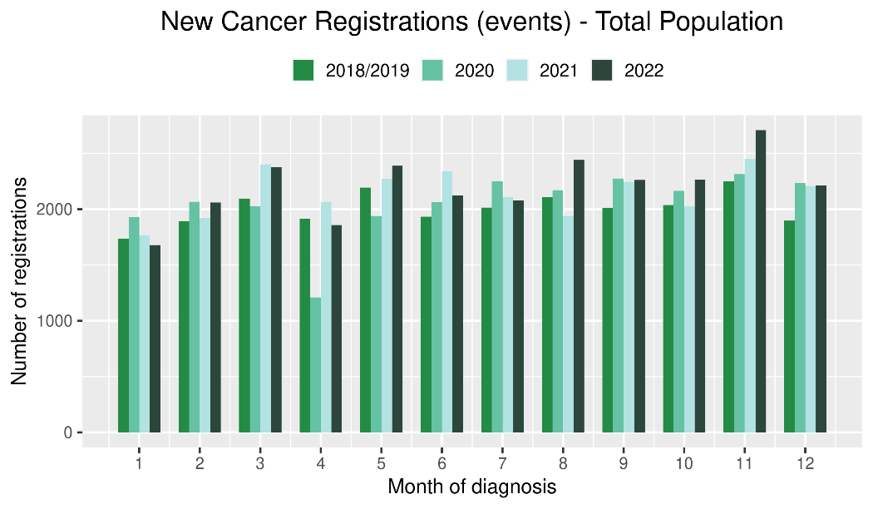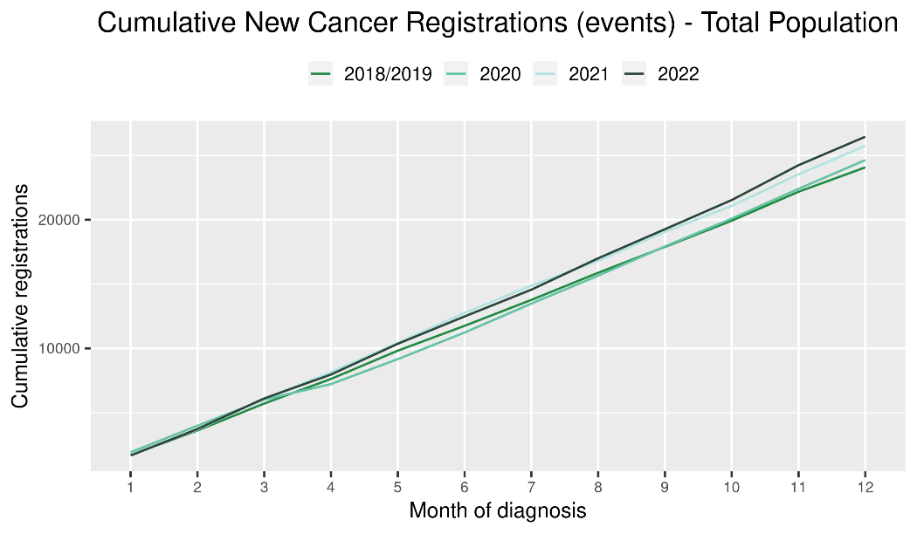

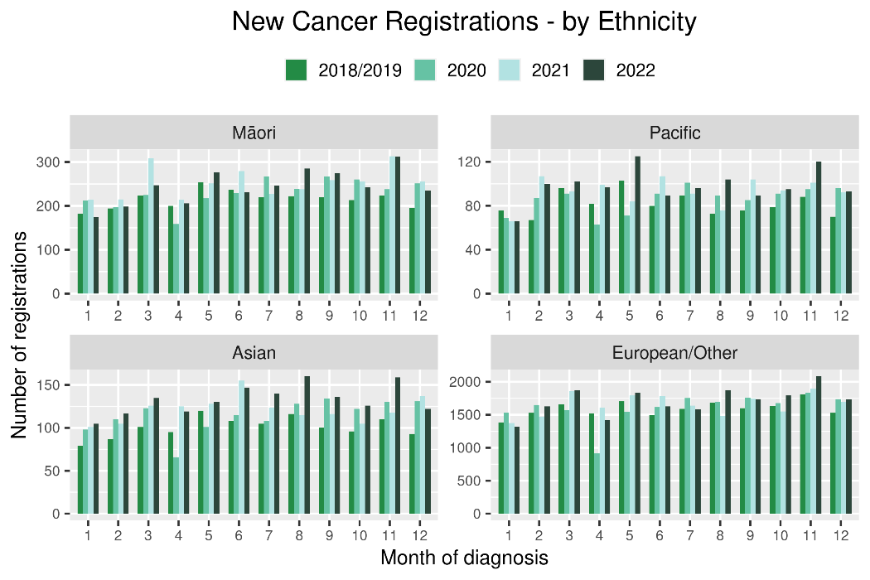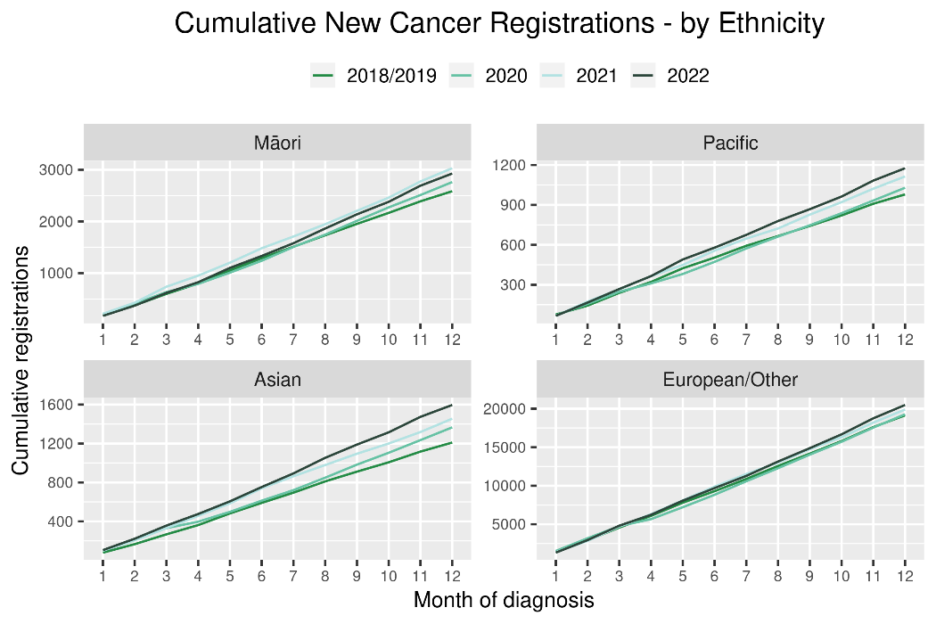
Table 2: Number of provisional cancer registrations* and percentage difference in 2022 compared to the average of 2018 and 2019, by month and cumulative year to date, by tumour group
 | October |  |  | November |  |  | December |  |  | Cumulative January-December
Tumour group | 2018/2019 | 2022 | % change | 2018/2019 | 2022 | % change | 2018/2019 | 2022 | % change | 2018/2019 | 2022 | % change
Breast | 341 | 339 | -1% | 358 | 424 | 19% | 266 | 319 | 20% | 3,737 | 3,935 | 5%
Colorectal | 254 | 261 | 3% | 311 | 331 | 7% | 273 | 282 | 3% | 3,174 | 3,480 | 10%
Gynaecology | 78 | 100 | 28% | 93 | 129 | 39% | 86 | 97 | 13% | 1,053 | 1,170 | 11%
Haematology and Lymphoid | 211 | 209 | -1% | 210 | 252 | 20% | 185 | 216 | 17% | 2,447 | 2,505 | 2%
Melanoma and non-melanoma skin cancer | 289 | 345 | 19% | 345 | 439 | 27% | 303 | 317 | 5% | 3,363 | 3,974 | 18%
Other digestive system | 132 | 127 | -3% | 129 | 163 | 26% | 111 | 155 | 40% | 1,459 | 1,740 | 19%
Prostate | 319 | 376 | 18% | 351 | 425 | 21% | 274 | 320 | 17% | 3,925 | 4,059 | 3%
Respiratory and thorax | 150 | 165 | 10% | 160 | 170 | 7% | 156 | 166 | 6% | 1,767 | 1,899 | 8%
Urinary system | 74 | 81 | 10% | 90 | 108 | 20% | 72 | 76 | 6% | 989 | 1,063 | 7%
*This analysis uses provisional data for the 2022 registrations, some cancers may initially be classified as ‘non-specified’ and subsequently be re-classified into one of the cancer groups as more information becomes available.
**For the purposes of this report, non-melanoma skin cancer excludes basal cell carcinoma and squamous cell carcinoma
Figure 2: Number of cancer registrations by month, 2018/19 average, 2020, 2021 and 2022, by tumour group
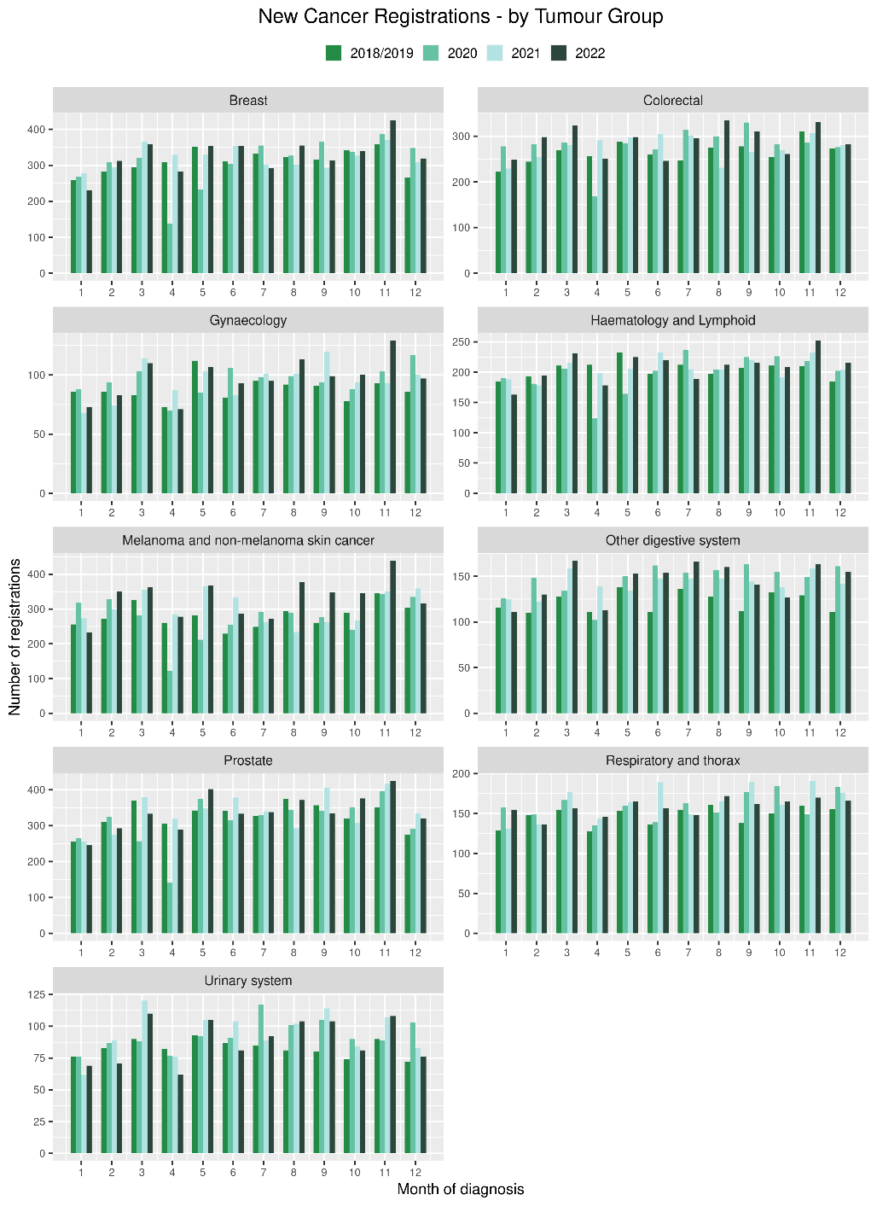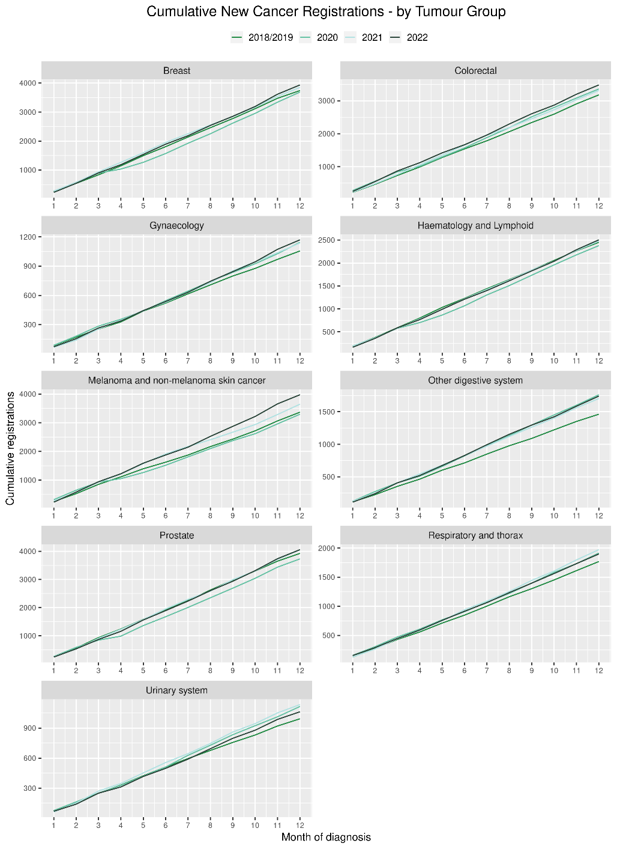

Gastrointestinal endoscopy

Notes on data
- Gastrointestinal endoscopy data were extracted from the National Non-admitted Patient Collection (NNPAC) and National Minimum Dataset (NMDS) on 13 Mar 2023.
- Includes colonoscopies and gastroscopies for all indications – not just cancer.
- Technical information: gastroscopies (Purchase Unit Code: MS02005), colonoscopies (Purchase Unit Code: MS02007), combined gastroscopies and colonoscopies (Purchase Unit Code: MS02014).

Key points
- For 2022 compared to 2018/19, there was a 19% increase in gastrointestinal endoscopies for the total population.
- There was a 37% increase for Māori compared with 2018/19 and a 40% increase for Pacific peoples.

Results
Table 3: Number of colonoscopy and gastroscopy procedures and percentage difference in 2022 compared to the average of 2018 and 2019, by month and cumulative year to date, by ethnicity
 | October |  |  | November |  |  | December |  |  | Cumulative January -December
 | 2018/2019 | 2022 | % change | 2018/2019 | 2022 | % change | 2018/2019 | 2022 | % change | 2018/2019 | 2022 | % change
Māori | 608 | 785 | 29% | 600 | 929 | 55% | 511 | 705 | 38% | 6,655 | 9,095 | 37%
Pacific Peoples | 235 | 307 | 31% | 228 | 346 | 52% | 183 | 250 | 37% | 2,482 | 3,469 | 40%
Non-Māori/Non-Pacific | 5,697 | 6,485 | 14% | 6,114 | 7,351 | 20% | 4,885 | 5,902 | 21% | 64,646 | 74,904 | 16%
Total Population | 6,539 | 7,577 | 16% | 6,942 | 8,626 | 24% | 5,578 | 6,857 | 23% | 73,782 | 87,468 | 19%

Figure 3: Number of gastrointestinal endoscopy procedures by month, 2018/19 average, 2020, 2021 and 2022 total population and Māori
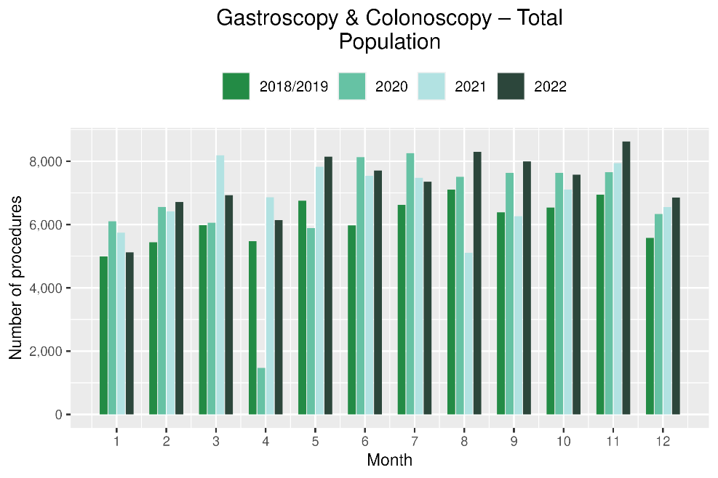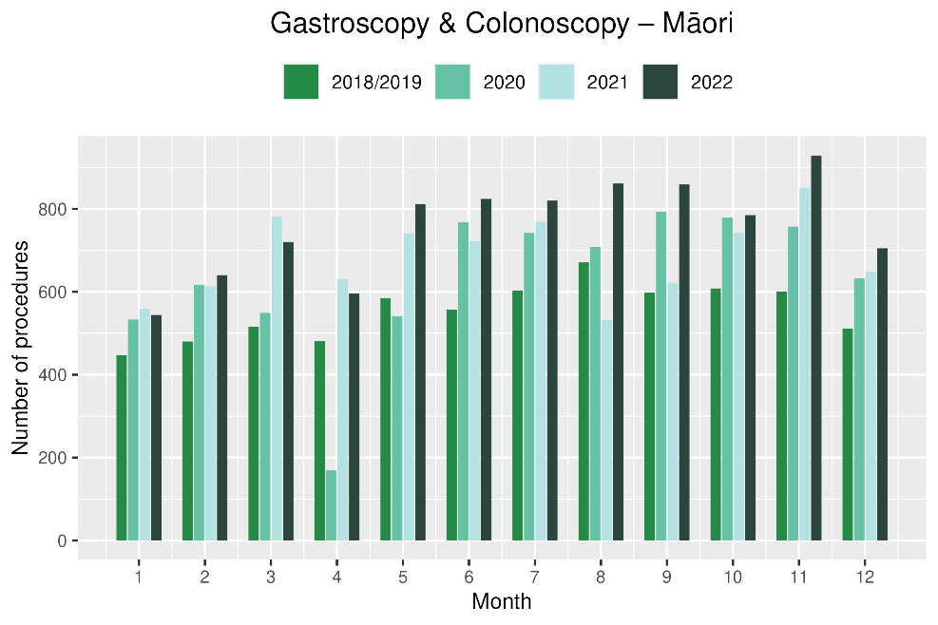
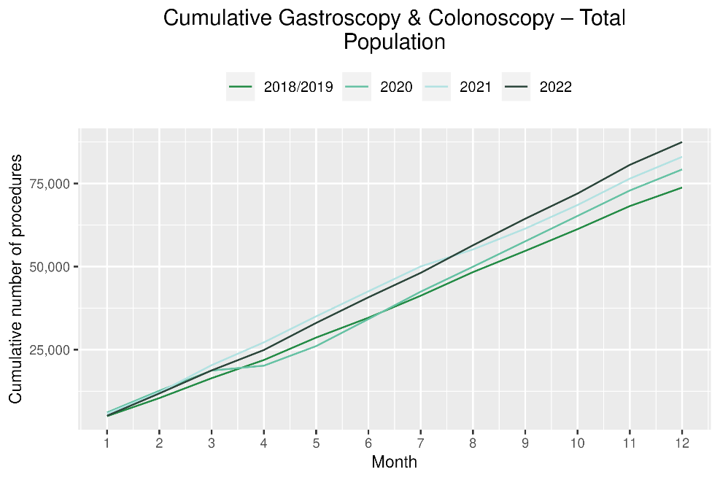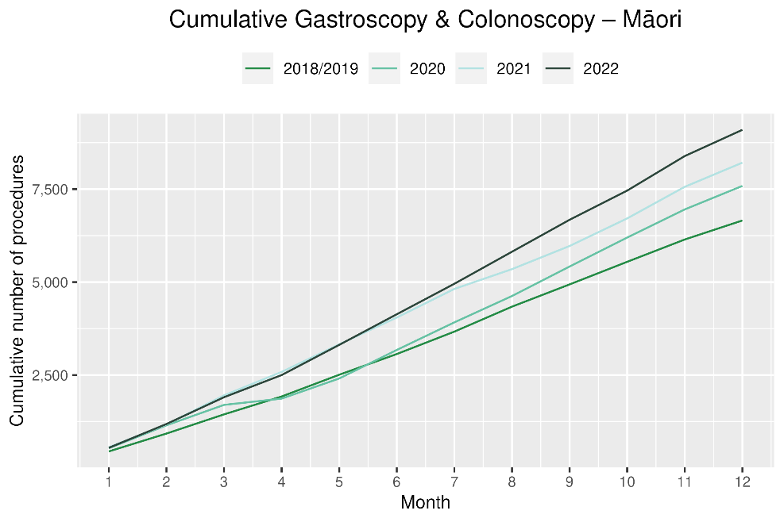

Bronchoscopy

Notes on data
- Bronchoscopy and CT Lung Biopsy data were extracted from NNPAC and NMDS on 13 Mar 2023.
- These data include bronchoscopies and CT lung biopsies for all indications, not solely cancer related procedures.
- Technical information: bronchoscopies (Purchase Unit Code: MS02003) and CT Lung Biopsy (Procedure codes: 3841808 and 3881200)

Key points
- For the year 2022, there was a 7% decrease in bronchoscopies compared with the same period in 2018/19. For Māori there was a 4% increase over the same time period.
- As noted in previous reports, Te Aho o Te Kahu has discussed potential reasons for the overall decrease in bronchoscopy volumes with respiratory physicians in the sector. It has been highlighted that due to the risks of COVID-19 transmission, logistical challenges and other factors, there has been a shift in modes of diagnosis for lung cancer away from bronchoscopy (noting that bronchoscopy is performed for a number of reasons, not just cancer diagnosis). These modes are thought to include Endobronchial Ultrasound Bronchoscopy (EBUS), Positron Emission Tomography - Computed Tomography (PET CT) scans and CT lung biopsy. PET CT and EBUS data are not reported here because the clinical coding of these procedures is not anatomically specific, meaning that we would not know whether they were performed on the lung. CT lung biopsy data were examined and are presented (Figure 5), with these data suggesting a small decrease in CT lung biopsies of 2% overall (but not for Māori where there is a 10% increase). Even with this additional data, the overall picture of diagnosis remains incomplete, and it is therefore difficult to interpret whether any changes in volume of lung cancer diagnostic procedures have occurred.

Results
Table 4: Number of bronchoscopies and percentage difference in 2022 compared to the average of 2018 and 2019, by month and cumulative year to date, by ethnicity
 | October |  |  | November |  |  | December |  |  | Cumulative January -December
 | 2018/2019 | 2022 | % change | 2018/2019 | 2022 | % change | 2018/2019 | 2022 | % change | 2018/2019 | 2022 | % change
Māori | 34 | 38 | 12% | 44 | 42 | -3% | * | 32 | * | 410 | 425 | 4%
Pacific Peoples | 17 | 13 | -21% | 15 | 13 | -13% | * | 12 | * | 126 | 128 | 2%
Non-Māori/Non-Pacific | 191 | 176 | -8% | 193 | 185 | -4% | 180 | 170 | -6% | 2,094 | 1,886 | -10%
Total Population | 241 | 227 | -6% | 252 | 240 | -5% | 214 | 214 | 0% | 2,630 | 2,439 | -7%
*Due to small numbers, monthly figures have not been included for Māori and Pacific peoples
Figure 4: Number of bronchoscopies by month, 2018/19 average, 2020, 2021 and 2022, total population and Māori
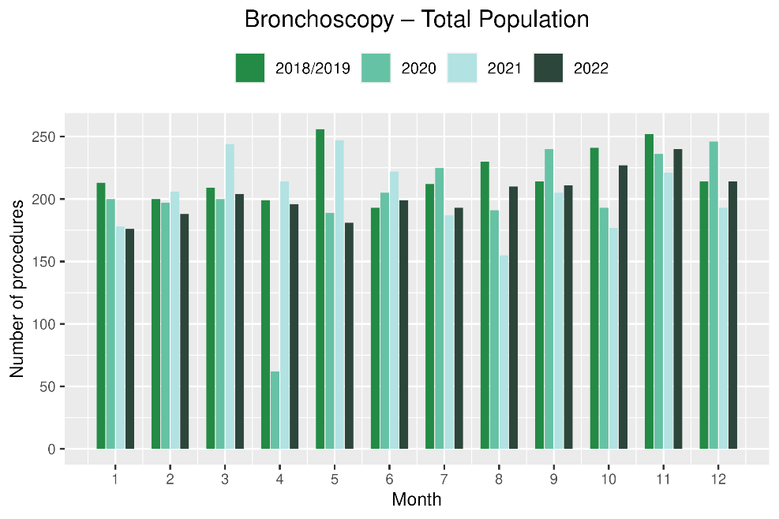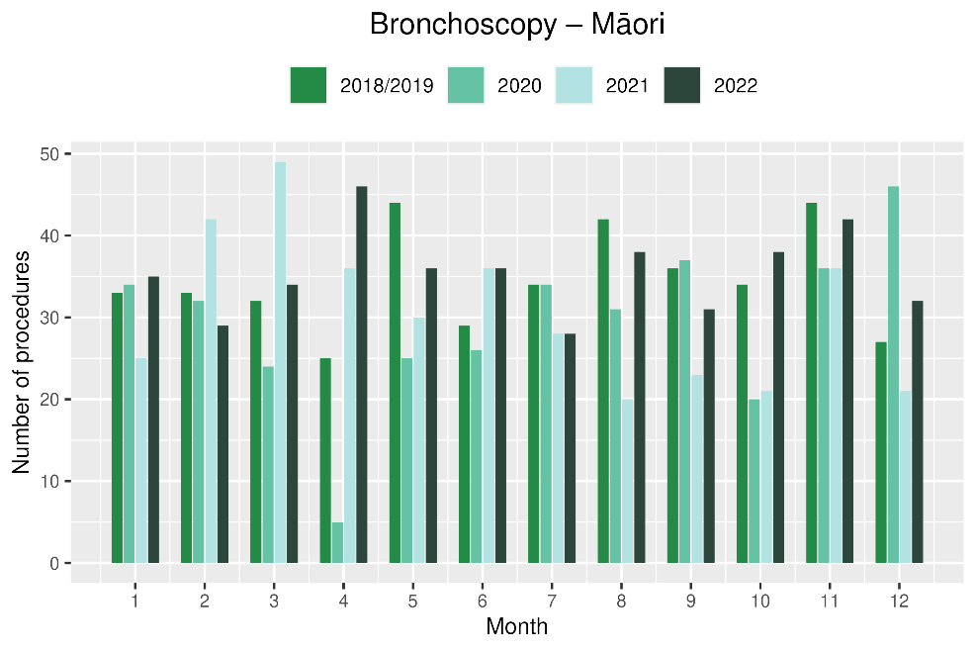
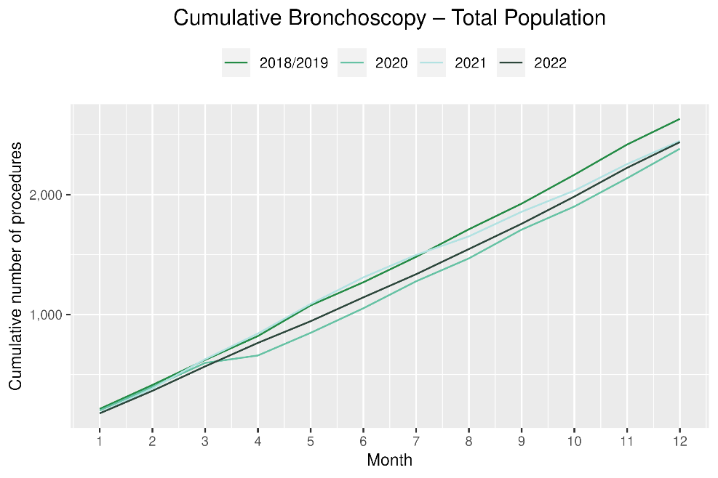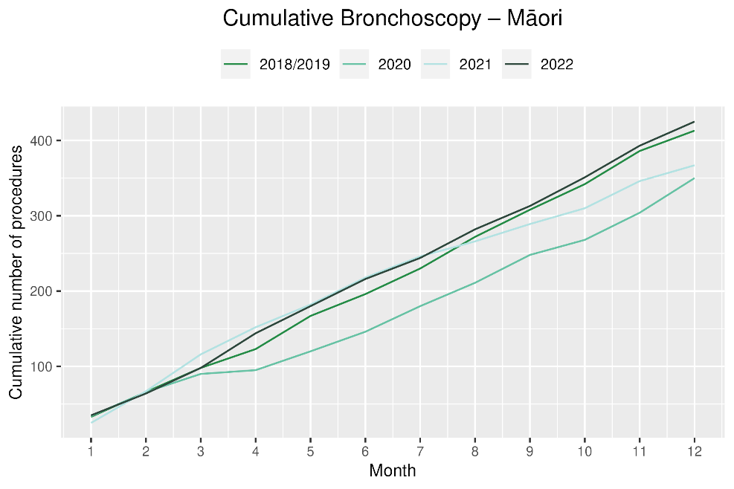
Table 5: Number of CT biopsy and percentage difference in 2022 compared to the average of 2018 and 2019, by month and cumulative year to date, by ethnicity
 | October |  |  | November |  |  | December |  |  | Cumulative January -December
 | 2018/2019 | 2022 | % change | 2018/2019 | 2022 | % change | 2018/2019 | 2022 | % change | 2018/2019 | 2022 | % change
Māori | * | * | * | * | * | * | * | * | * | 146 | 161 | 10%
Pacific Peoples | * | * | * | * | * | * | * | * | * | 37 | 31 | -15%
Non-Māori/Non-Pacific | 56 | 69 | 24% | 75 | 72 | -3% | 63 | 60 | -5% | 734 | 701 | -4%
Total Population | 65 | 84 | 29% | 86 | 88 | 3% | 73 | 69 | -5% | 915 | 893 | -2%

Figure 5: Number of CT lung biopsies by month, 2018/19 average, 2020, 2021 and 2022, total population and Māori
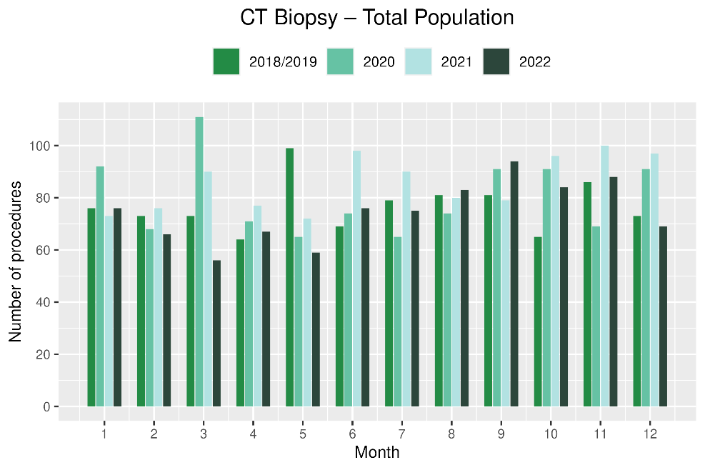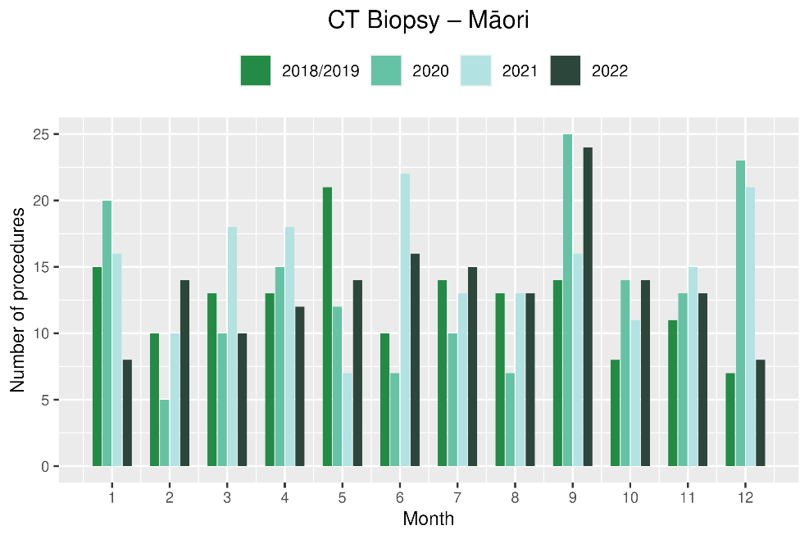

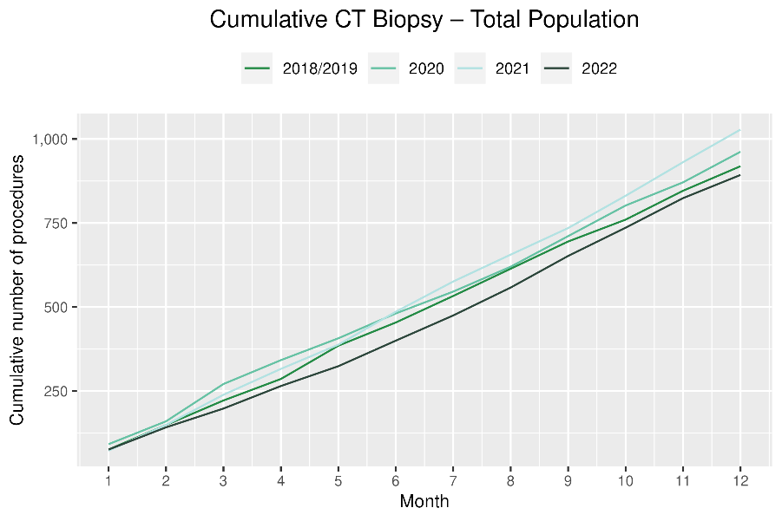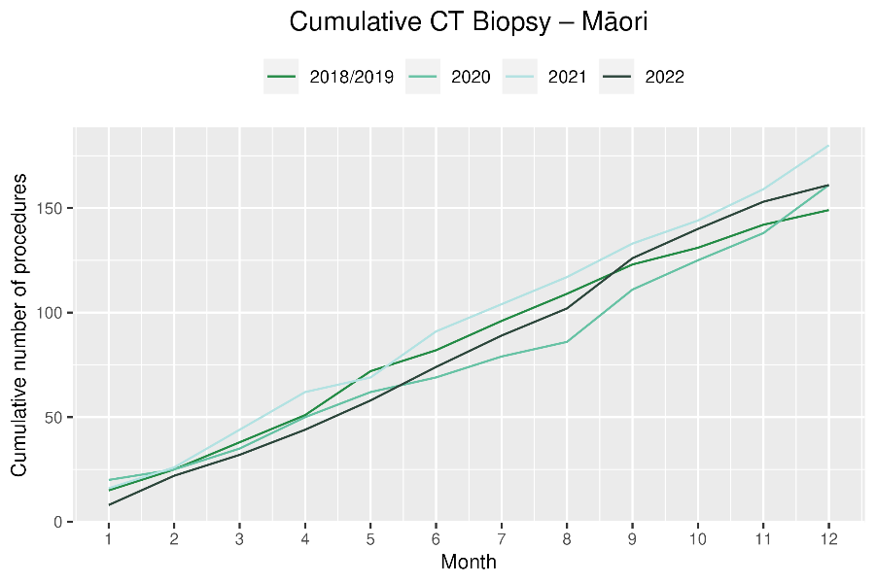

Faster cancer treatment

Notes on data
- The data were extracted from the Faster Cancer Treatment (FCT) database on 25 Jan 2023. Fast Cancer Treatment Data is reported quarterly.
- These data aim to capture a broader part of the diagnostic and referral pathway; however, they only include a subset of people being investigated for cancer. Data relate to the 62-day pathway and includes people with a high-suspicion of cancer and a need to be seen within two weeks. This group of people should receive their first treatment within 62-day of receipt of referral. The target is 90%.
- Te Aho o Te Kahu has an escalation pathway for monitoring the performance of Te Whatu Ora Districts against the FCT measure. Escalation includes regular meetings with service teams and CE to CE discussions against recovery planning and actions.
- Two Districts to our knowledge have not been able to submit all FCT data for 2022/23 quarter two, as a result of Patient Information System upgrade or reduced capacity for data coding and entry.

Key point
- For the second half of 2022 (July to December), there was some fluctuation in the proportion of people with a high suspicion of cancer and a need to be seen within two weeks receiving their first treatment within 62 days of receipt of referral. The measure was met for 83% of people overall and 80% for Māori. For the second half of 2021 the measure was met for 85% of the total population and 84% for Māori.
- Faster cancer treatment data are reported to Te Whatu Ora at quarterly intervals.

Results
Table 6: Number of referrals for people with a high suspicion of cancer, in 2022 by month, and total July to December
 | July | Aug | Sep | Oct | Nov | Dec | Total July to Dec
Māori | 42 | 69 | 66 | 60 | 69 | 51 | 357
Non-Māori/Non-Pacific | 275 | 363 | 341 | 362 | 393 | 305 | 2,039
Total Population | 347 | 456 | 430 | 437 | 483 | 377 | 2,530

*Due to small numbers, volumes have not been included for Pacific peoples

 | July | Aug | Sep | Oct | Nov | Dec | Total July to Dec
Māori | 88% | 74% | 83% | 80% | 76% | 84% | 80%
Non-Māori/Non-Pacific | 84% | 81% | 80% | 85% | 84% | 87% | 83%
Total Population | 85% | 80% | 81% | 84% | 82% | 87% | 83%
Table 7: Proportion of people with a high-suspicion of cancer and a need to be seen within 2-weeks who received their first treatment within 62 days of receipt of referral, in 2022 by month, and average July to December

*Due to small numbers, percentages have not been included for Pacific peoples

Figure 6: Proportion of patients with a high-suspicion of cancer and a need to be seen within 2-weeks who received their first treatment within 62 days of receipt of referral, by ethnicity, in 2022 by month
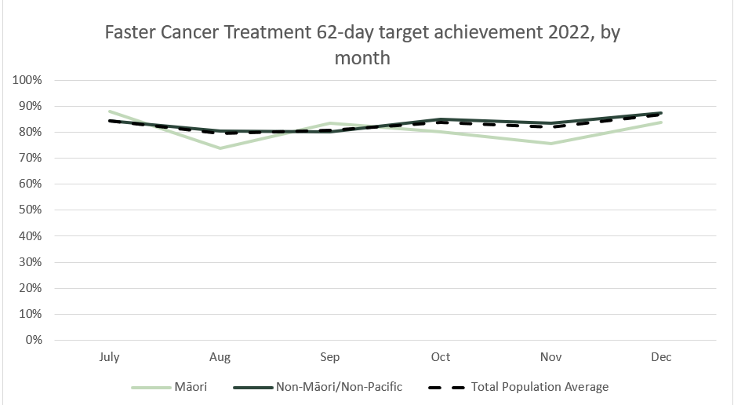

Combined cancer surgery

Notes on data
- This report includes data on surgery for breast, colorectal, lung and prostate cancer. These four cancers are therefore used as case studies for cancer surgery more generally.
- Colorectal, lung and prostate cancers were chosen because Te Aho o Te Kahu has a pre-validated list of surgical procedure codes for these cancers, agreed on as part of the quality performance indicator (QPI) work programme.
- For breast cancer, as the development of QPIs are currently underway, we have been able to provide provisional surgical procedure codes for the purposes of this report.
- The surgical procedure codes are listed in Appendix 5.
- The data were extracted from the NMDS on 13 Mar 2023.

Key points
- For 2022, there were 2% fewer cancer surgeries (breast, prostate, lung and colorectal combined) compared to 2018/19.
- For Māori, there has been a 5% increase in combined cancer surgeries relative to 2018/19 (reflecting 33 more surgeries), however, the number of surgeries performed in 2022 was lower than in 2021.
- For Pacific peoples there was a 19% increase for the year to date relative to 2018/19 (reflecting 42 more surgeries).

Results
Table 8: Number of cancer surgeries (breast, prostate, colorectal, lung) and percentage difference in 2022 compared to the average of 2018 and 2019, by month and cumulative year to date, by ethnicity
 | October |  |  | November |  |  | December |  |  | Cumulative January -December
 | 2018/2019 | 2022 | % change | 2018/2019 | 2022 | % change | 2018/2019 | 2022 | % change | 2018/2019 | 2022 | % change
Māori | 60 | 64 | 8% | 49 | 65 | 33% | 59 | 47 | -20% | 646 | 679 | 5%
Pacific Peoples | 24 | 30 | 25% | 18 | 28 | 60% | 24 | 21 | -11% | 227 | 269 | 19%
Non-Māori/Non-Pacific | 384 | 402 | 5% | 427 | 413 | -3% | 431 | 429 | 0% | 4,748 | 4,584 | -3%
Total Population | 468 | 496 | 6% | 494 | 506 | 3% | 513 | 497 | -3% | 5,621 | 5,532 | -2%

Figure 7: Number of cancer surgeries (breast, prostate, colorectal, lung) by month, 2018/19 average, 2020, 2021 and 2022, total population and Māori
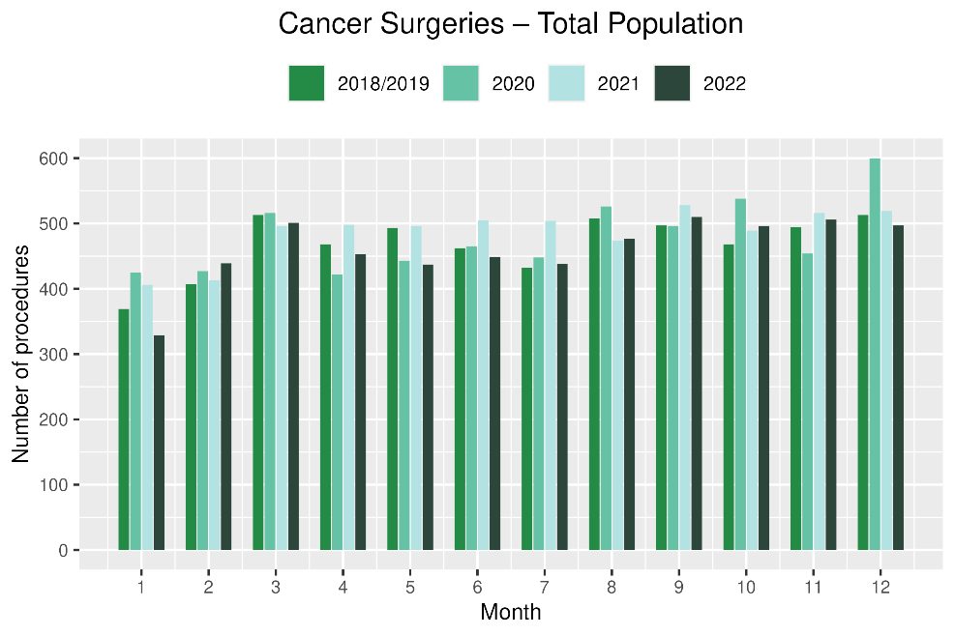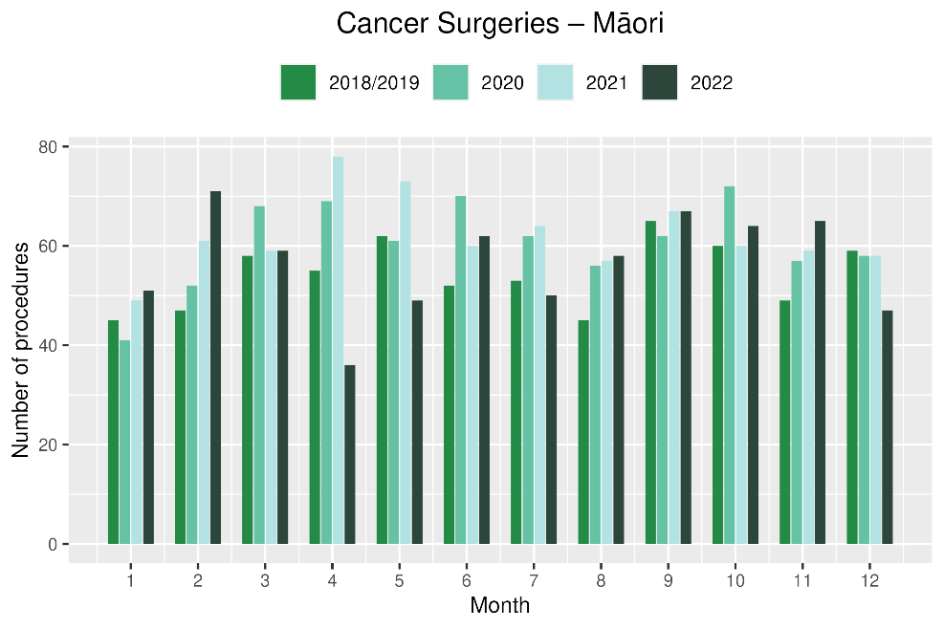
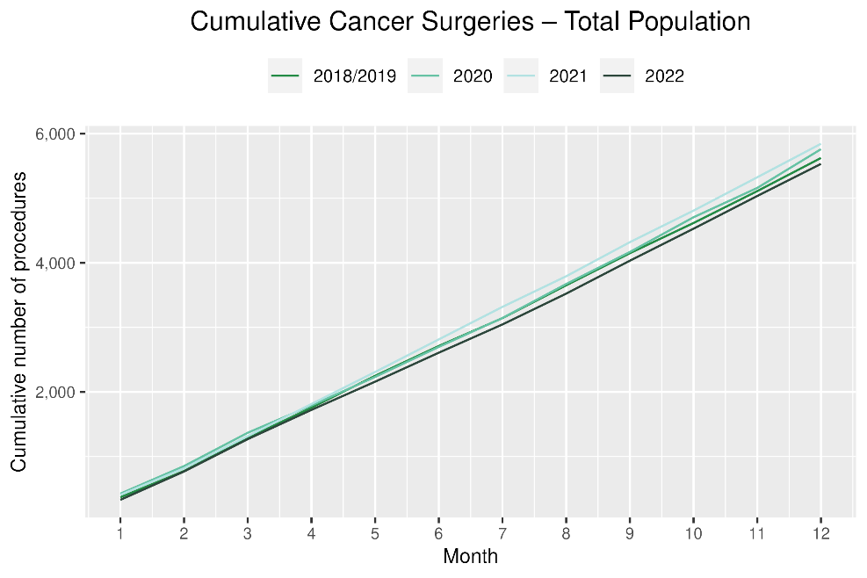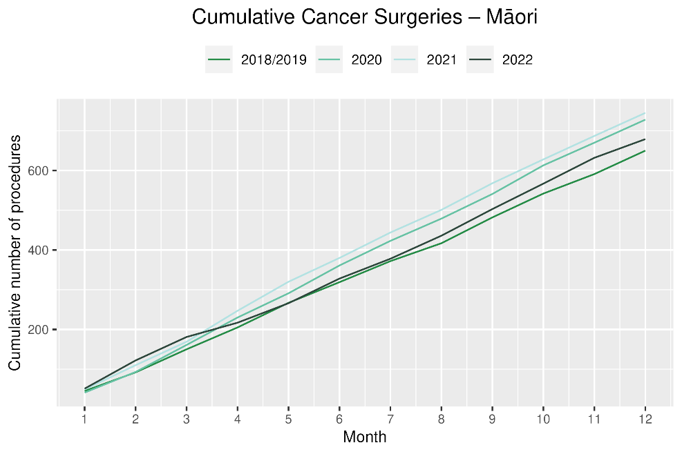

Breast cancer surgery (mastectomy)

Notes on data
- A list of the surgical procedure codes used for analysis are included in Appendix 5.
- The data were extracted from the NMDS on 13 March 2023.
- The number of mastectomies performed each month is relatively small, so caution is needed when comparing data by month.
- Procedure codes for mastectomy only are included in this report. There are a number of additional procedure codes used for breast cancer surgeries in addition to mastectomy, however the procedure codes for these surgeries are less specific for cancer. Therefore, using only mastectomy codes allows a more accurate view of any changes in breast cancer surgery volumes.

Key points
- For 2022, there was a 3% decrease in mastectomies compared with 2018/19. For Māori this decrease was 2% and for Pacific peoples there was a 19% increase.

Results
Table 9: Number of mastectomies and percentage difference in 2022 compared to the average of 2018 and 2019, by month and cumulative year to date, by ethnicity
 | October |  |  | November |  |  | December |  |  | Cumulative January -December
 | 2018/2019 | 2022 | % change | 2018/2019 | 2022 | % change | 2018/2019 | 2022 | % change | 2018/2019 | 2022 | % change
Māori | * | * | * | * | * | * | * | * | * | 255 | 249 | -2%
Pacific Peoples | * | * | * | * | * | * | * | * | * | 97 | 115 | 19%
Non-Māori/Non-Pacific | 96 | 104 | 9% | 106 | 112 | 6% | 114 | 106 | -7% | 1,244 | 1,188 | -5%
Total Population | 127 | 132 | 4% | 128 | 154 | 20% | 142 | 130 | -8% | 1,595 | 1,552 | -3%
*Due to small numbers, some figures have not been included for Māori and Pacific peoples
Figure 8: Number of mastectomies by month, 2018/19 average, 2020, 2021 and 2022, total population and Māori
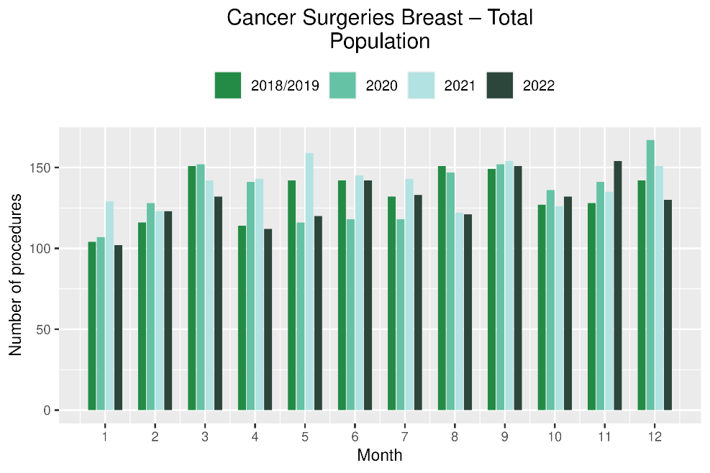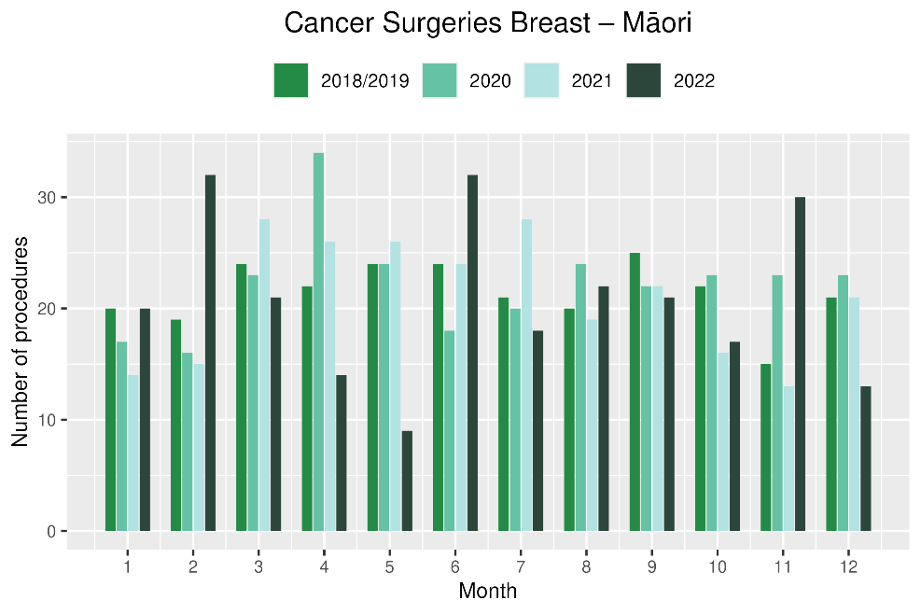
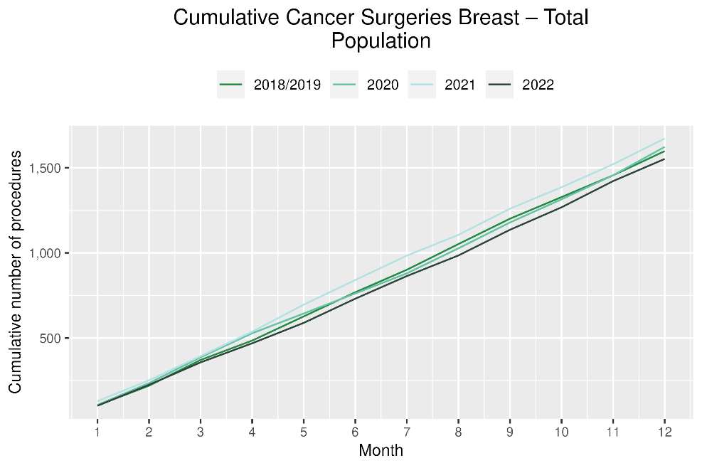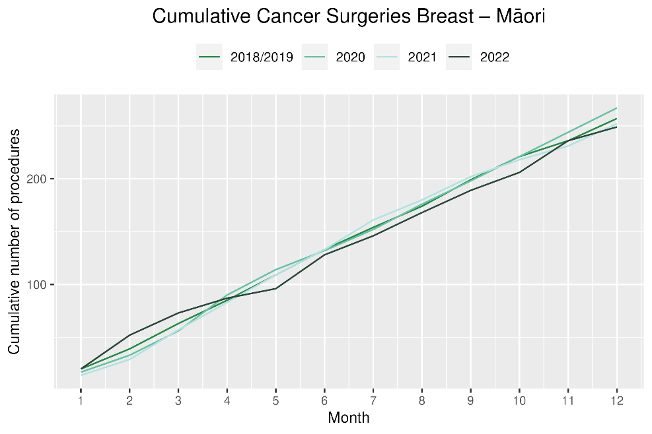

Colorectal cancer surgery

Notes on data
- The surgical procedure codes used for analysing colorectal cancer are listed in Appendix 5.
- The data were extracted from the NMDS on 13 Mar 2023.

Key points
- For 2022, there were 6% fewer colorectal cancer surgeries performed in total, 1% decrease for Pacific peoples (noting small numbers) and a 13% increase for Māori compared with 2018/19. However, the number of colorectal cancer surgeries for Māori was lower than that performed over the same time period in either 2020 or 2021 (figure 9).

Results
Table 10: Number of colorectal cancer surgeries and percentage difference in 2022 compared to the average of 2018 and 2019, by month and cumulative year to date, by ethnicity
 | October |  |  | November |  |  | December |  |  | Cumulative January -December
 | 2018/2019 | 2022 | % change | 2018/2019 | 2022 | % change | 2018/2019 | 2022 | % change | 2018/2019 | 2022 | % change
Māori | * | * | * | * | * | * | * | * | * | 209 | 235 | 13%
Pacific Peoples | * | * | * | * | * | * | * | * | * | 80 | 79 | -1%
Non-Māori/Non-Pacific | 179 | 173 | -3% | 210 | 198 | -6% | 216 | 196 | -9% | 2,274 | 2,106 | -7%
Total Population | 205 | 202 | -1% | 235 | 222 | -6% | 248 | 215 | -13% | 2,562 | 2,420 | -6%

*Due to small numbers, monthly figures have not been included for Māori and Pacific peoples

Figure 9: Number of colorectal cancer surgeries by month, 2018/19 average, 2020, 2021 and 2022, total population and Māori
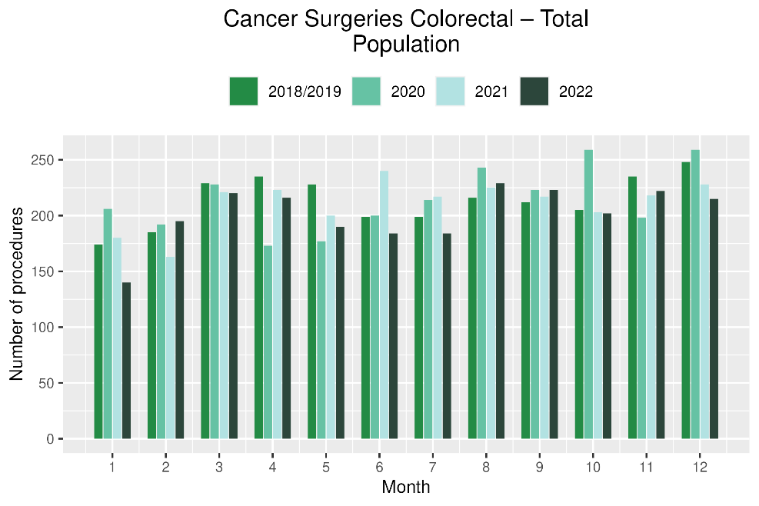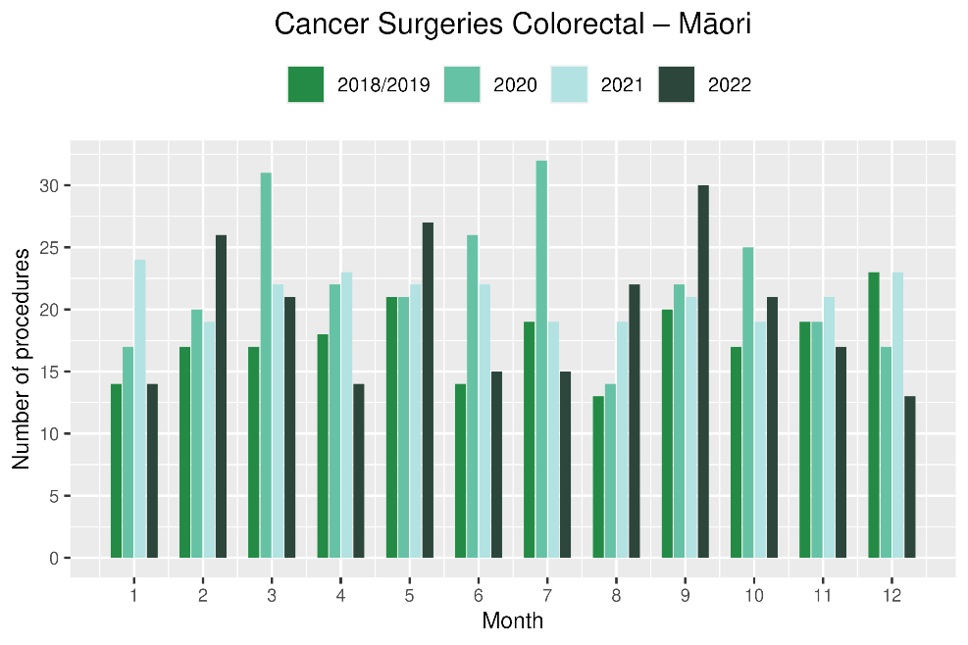
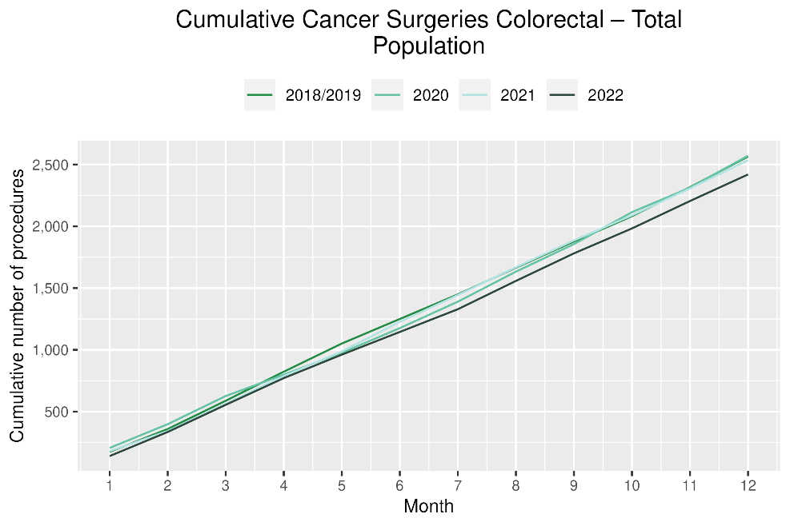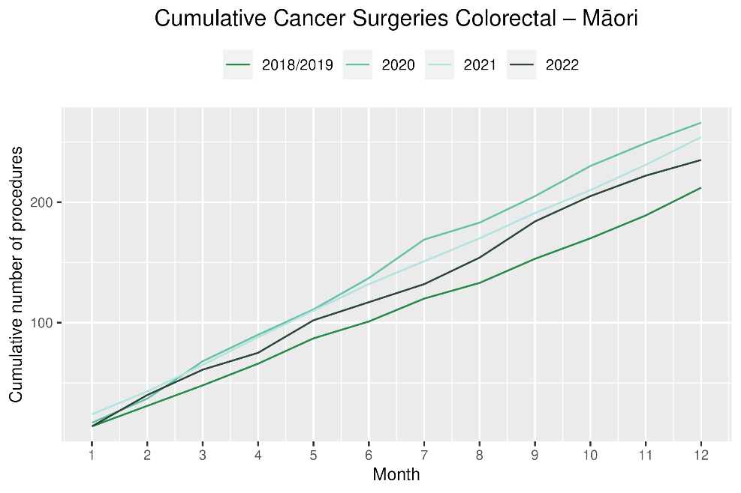

Lung cancer surgery

Notes on data
- A list of the surgical procedure codes used for analysis are included in Appendix 5.
- The data were extracted from the NMDS on 13 Mar 2023.
- The number of lung cancer surgeries performed each month is relatively small, so caution is needed when comparing data by month.

Key points
- For 2022 there was a 5% increase in the number of lung cancer surgeries performed for the total population compared with 2018/19.
- For Māori there was a 12% decrease in lung cancer surgery, numbering 15 fewer surgeries in 2022 compared with 2018/19. This represents a marginal improvement compared to the two previous reports, with the first half of 2022 (January – June) showing a 25% decrease (16 fewer surgeries over this time).
- For Pacific peoples there was a 32% increase, numbering 10 more surgeries.

Results
Table 11: Number of lung cancer surgeries and percentage difference in 2022 compared to the average of 2018 and 2019, by month and cumulative year to date, by ethnicity
 | October |  |  | November |  |  | December |  |  | Cumulative January -December
 | 2018/2019 | 2022 | % change | 2018/2019 | 2022 | % change | 2018/2019 | 2022 | % change | 2018/2019 | 2022 | % change
Māori | * | * | * | * | * | * | * | * | * | 124 | 109 | -12%
Pacific Peoples | * | * | * | * | * | * | * | * | * | 31 | 41 | 32%
Non-Māori/Non-Pacific | 49 | 59 | 20% | 41 | 45 | 10% | 46 | 59 | 30% | 530 | 567 | 7%
Total Population | 68 | 77 | 13% | 55 | 60 | 9% | 57 | 69 | 22% | 686 | 717 | 5%
* Due to small numbers, monthly figures have not been included for Māori and Pacific peoples

Figure 10: Number of lung cancer surgeries by month, 2018/19 average, 2020, 2021 and 2022, total population and Māori
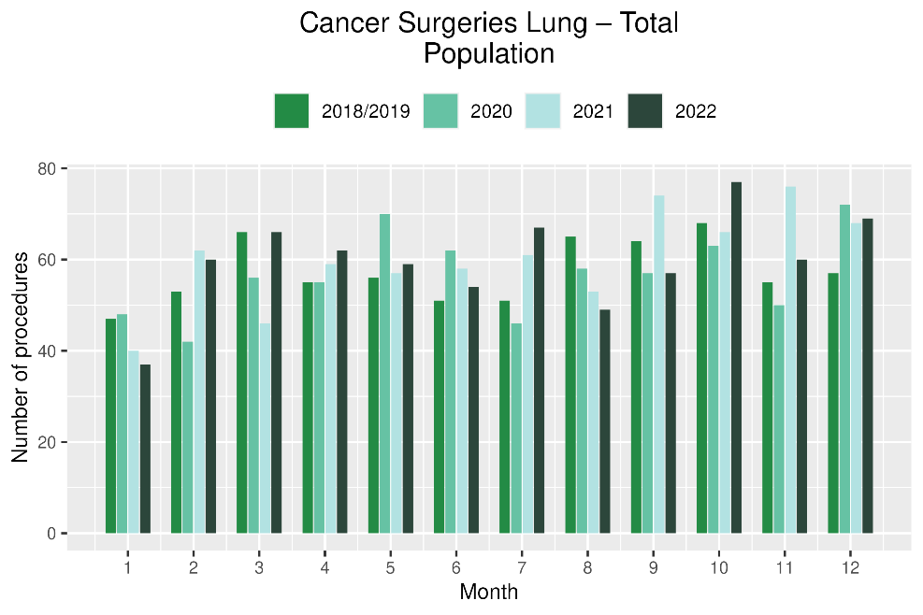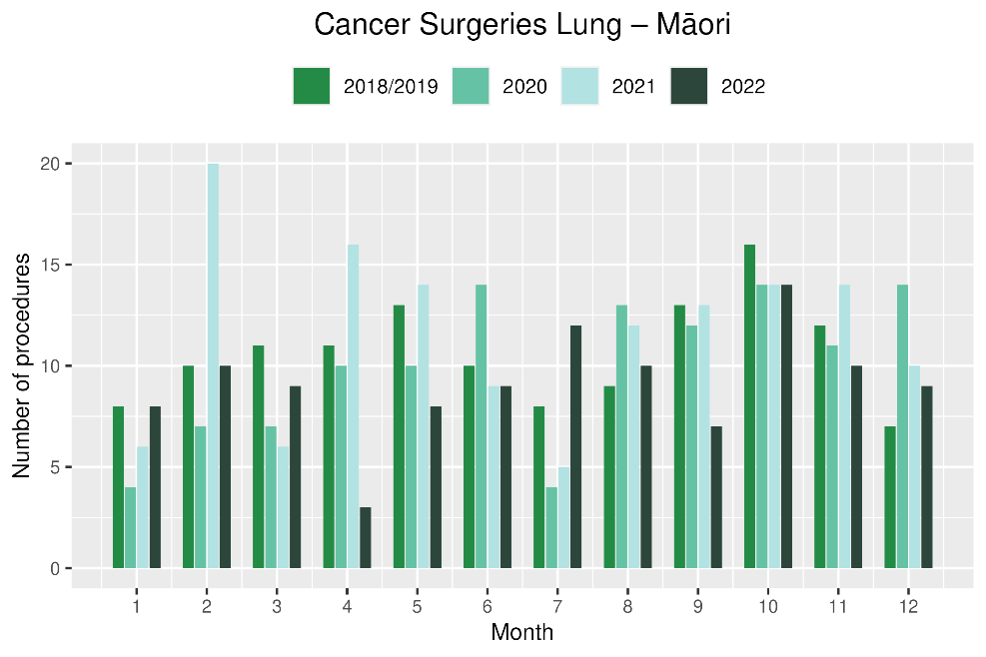
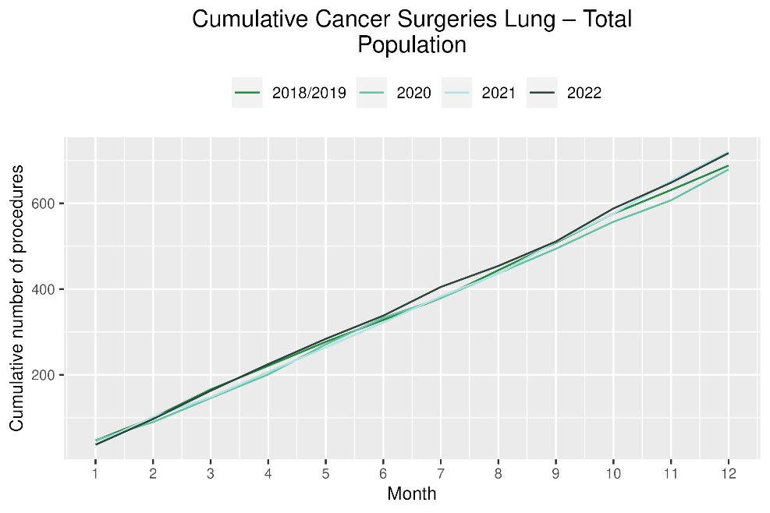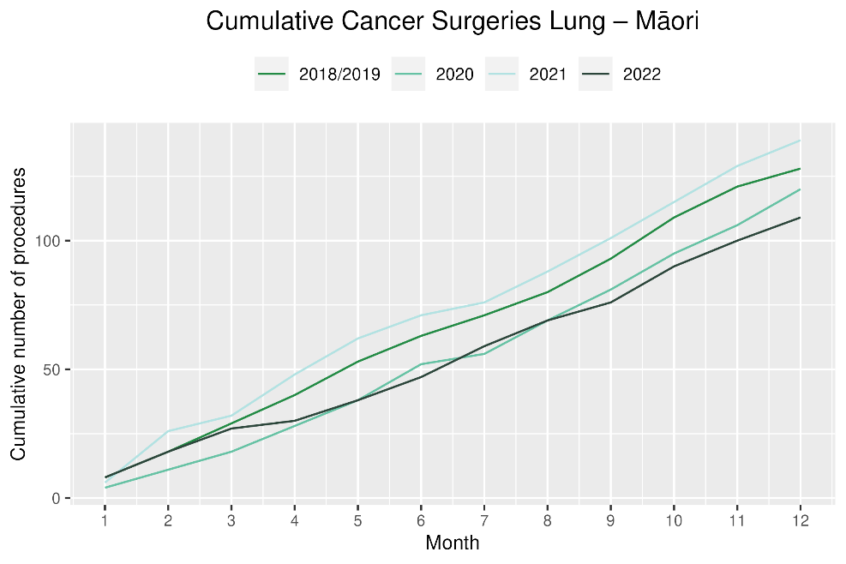

Prostate cancer surgery

Notes on data
- A list of the surgical procedure codes used for analysis are included in Appendix 5.
- The data was extracted from the NMDS on 13 Mar 2023.
- The number of prostate cancer surgeries performed each month is relatively small, so caution is needed when comparing data by month.

Key points
- For 2022 there were 8% more prostate cancer surgeries compared with cumulative figures from 2018/19. For Māori, there were 47% more surgeries performed (noting small numbers).
- However, both overall and for Māori, the number of prostate cancer surgeries performed was lower in 2021 (figure 11).

Results
Table 12: Number of prostate cancer surgeries and percentage difference in 2022 compared to the average of 2018 and 2019 by month and cumulative year to date
 | October |  |  | November |  |  | December |  |  | Cumulative January -December
 | 2018/2019 | 2022 | % change | 2018/2019 | 2022 | % change | 2018/2019 | 2022 | % change | 2018/2019 | 2022 | % change
Māori | * | * | * | * | * | * | * | * | * | 59 | 86 | 47%
Pacific Peoples | * | * | * | * | * | * | * | * | * | 21 | 34 | 66%
Non-Māori/Non-Pacific | 61 | 66 | 8% | 70 | 58 | -17% | 56 | 68 | 21% | 700 | 723 | 3%
Total Population | 68 | 85 | 25% | 76 | 70 | -7% | 67 | 83 | 24% | 779 | 843 | 8%
*Due to small numbers, some figures have not been included for Māori and Pacific peoples

Figure 11: Number of prostate cancer surgeries by month, 2018/19 average, 2020,2021 and 2022, total population and Māori
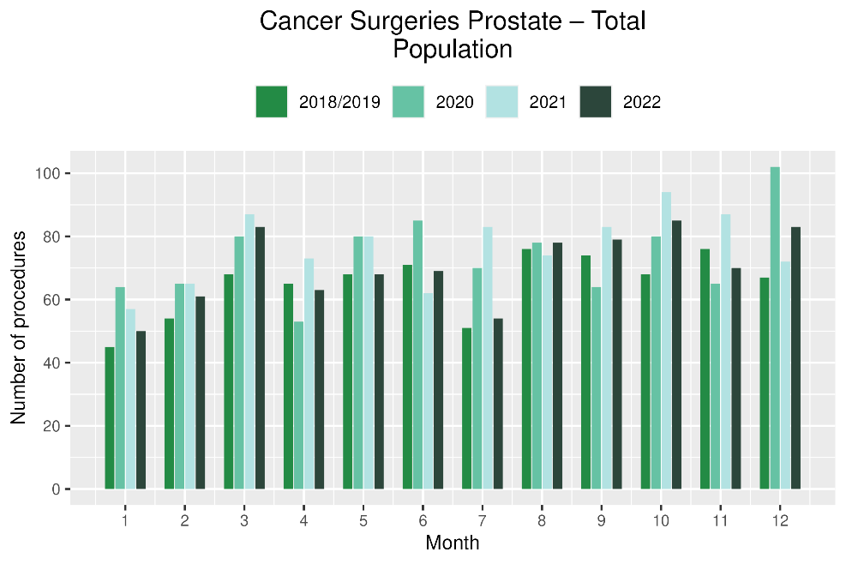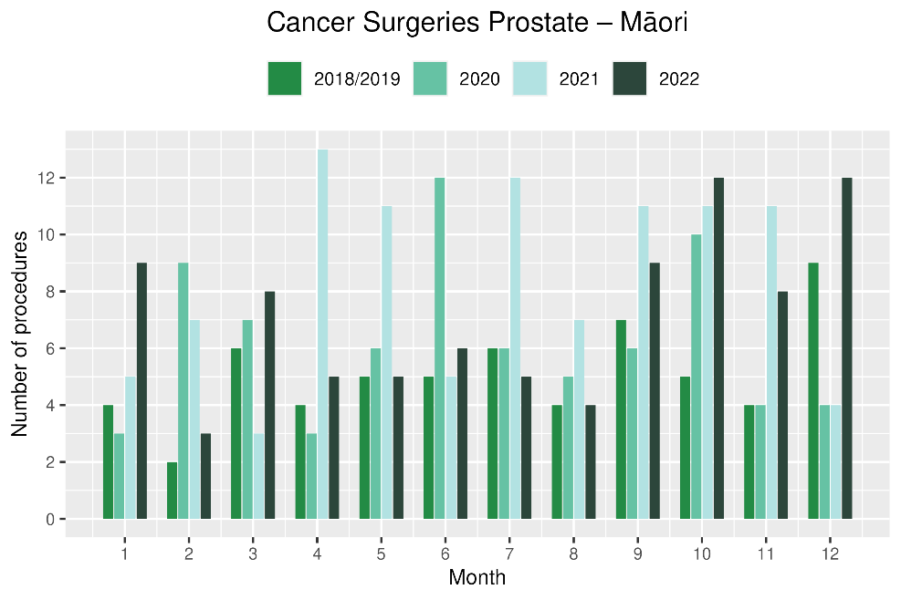
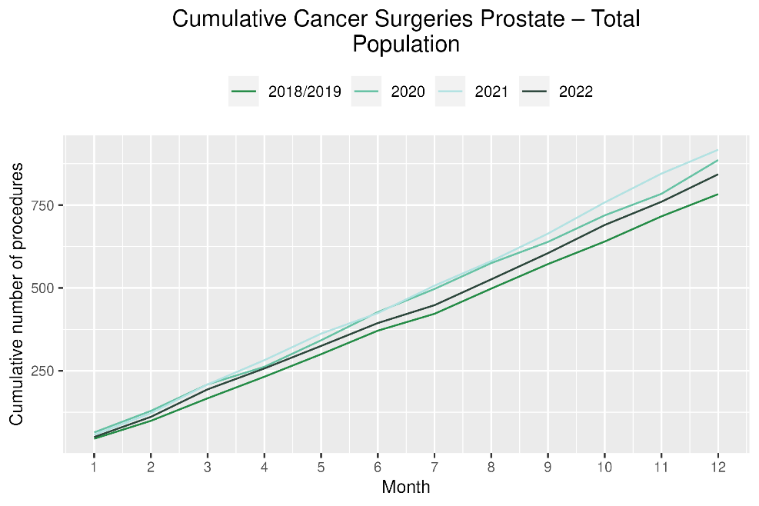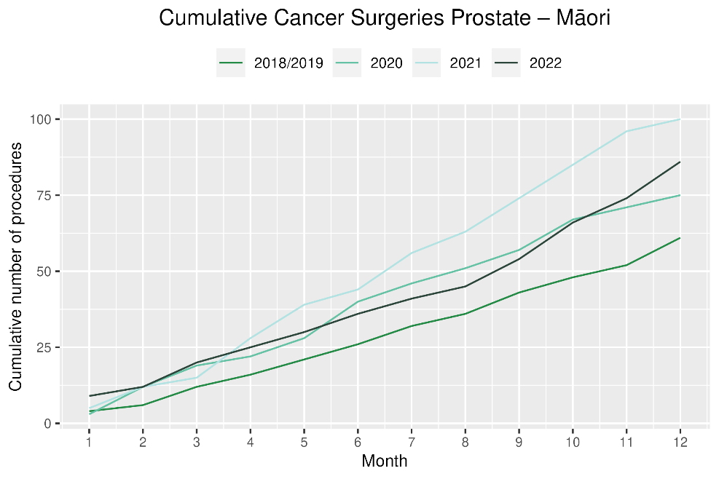

Medical oncology

Notes on data
- Data were extracted from NNPAC on 13 Mar 2023.
- First specialist assessment (FSA) reflects counts of first attendance for specialist medical oncology assessment.
- Intravenous (IV) chemotherapy reflects appointments for outpatient and inpatient IV chemotherapy for non-haematological indications.
- Technical information: medical oncology FSA (Purchase Unit Code: M50020) and IV chemotherapy (Purchase Unit Code: MS02009).

Key points
- For 2022, there was an overall 9% increase in medical oncology first specialist assessments (FSAs) compared with 2018/19 and a 16% increase for Māori. Compared to 2021 there was an increase of 2% in medical oncology FSAs for the total population, and for Māori there was a decrease of 3%.
- There was an 7% increase in IV chemotherapy attendances compared with 2018/19 overall and a 27% increase for Māori. However, when compared to 2021 there was a decrease of 3% for the total population and 2% for Māori.

Results
Table 13: Number of medical oncology first specialist assessments and percentage difference in 2022 compared to the average of 2018 and 2019, by month and cumulative year to date, by ethnicity
 | October |  |  | November |  |  | December |  |  | Cumulative January -December
 | 2018/2019 | 2022 | % change | 2018/2019 | 2022 | % change | 2018/2019 | 2022 | % change | 2018/2019 | 2022 | % change
Māori | 107 | 115 | 8% | 116 | 148 | 28% | 98 | 133 | 36% | 1,243 | 1,439 | 16%
Pacific Peoples | 33 | 45 | 36% | 38 | 49 | 31% | 36 | 51 | 42% | 422 | 535 | 27%
Non-Māori/Non-Pacific | 582 | 653 | 12% | 656 | 753 | 15% | 642 | 626 | -2% | 7,429 | 7,892 | 6%
Total Population | 722 | 813 | 13% | 809 | 950 | 17% | 776 | 810 | 4% | 9,093 | 9,866 | 9%

Figure 12: Number of medical oncology first specialist assessments by month, 2018/19 average, 2020, 2021 and 2022, total population and Māori
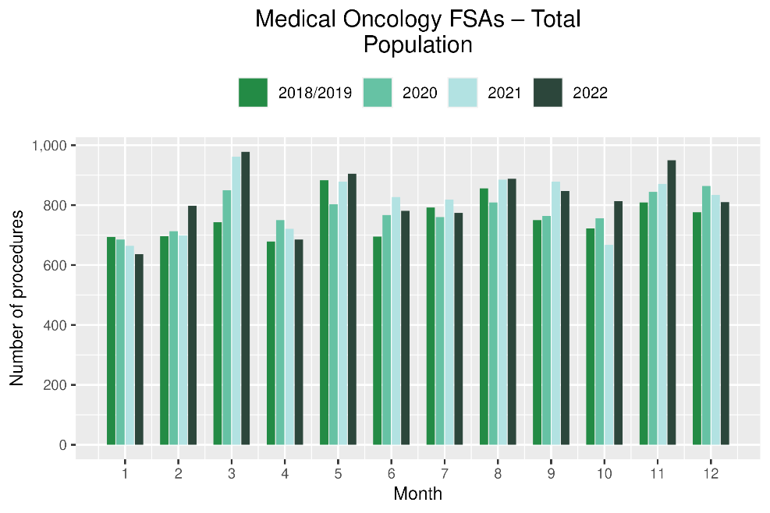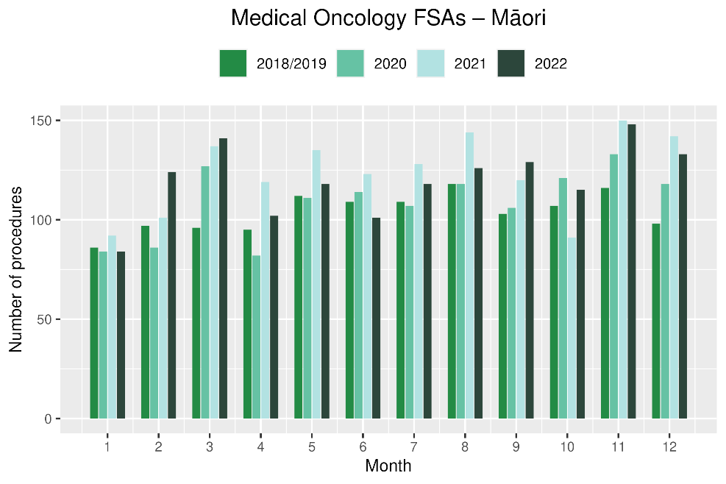
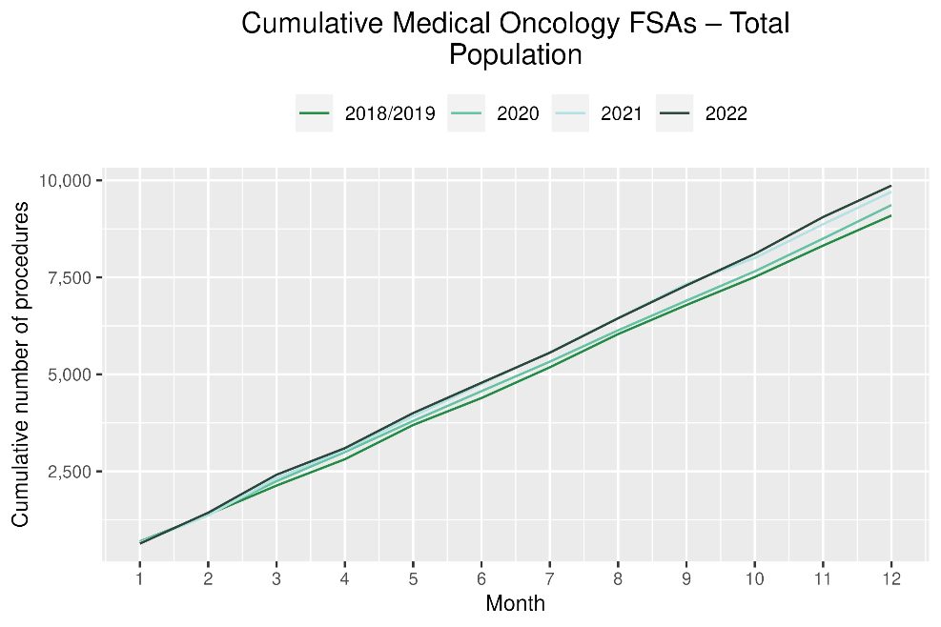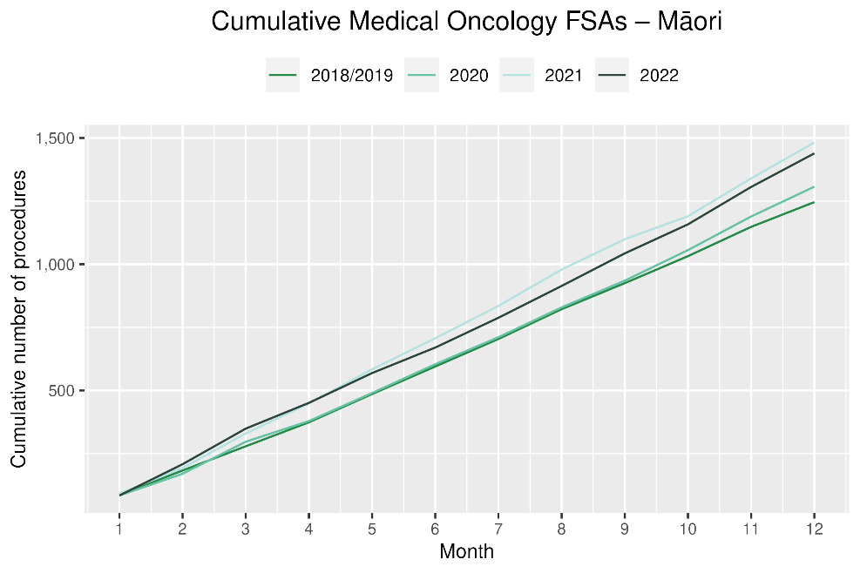
Table 14: Number of IV chemotherapy attendances and percentage difference in 2022 compared to the average of 2018 and 2019, by month and cumulative year to date, by ethnicity
 | October |  |  | November |  |  | December |  |  | Cumulative January -December
 | 2018/2019 | 2022 | % change | 2018/2019 | 2022 | % change | 2018/2019 | 2022 | % change | 2018/2019 | 2022 | % change
Māori | 851 | 906 | 7% | 809 | 1,082 | 34% | 808 | 1,025 | 27% | 9,116 | 11,577 | 27%
Pacific Peoples | 303 | 371 | 22% | 286 | 387 | 35% | 271 | 355 | 31% | 3,256 | 4,480 | 38%
Non-Māori/Non-Pacific | 5,556 | 4,894 | -12% | 5,182 | 5,284 | 2% | 4,943 | 5,126 | 4% | 60,194 | 61,305 | 2%
Total Population | 6,710 | 6,171 | -8% | 6,277 | 6,753 | 8% | 6,021 | 6,506 | 8% | 72,566 | 77,362 | 7%

Figure 13: Number of IV chemotherapy attendances by month, 2018/19 average, 2020 and 2021, total population and Māori

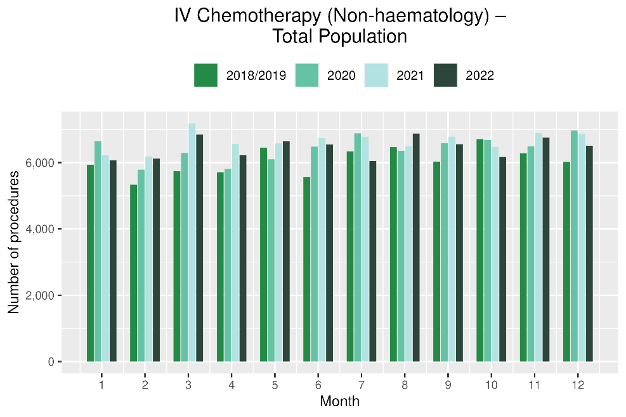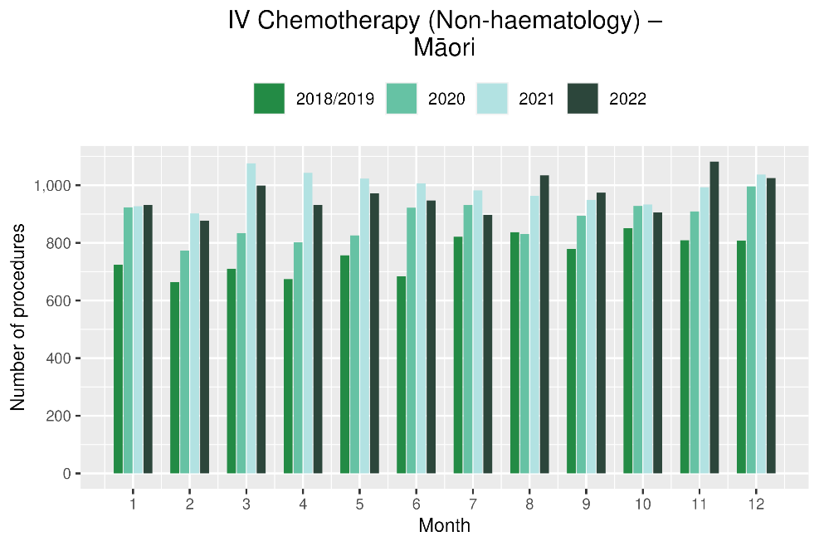

Figure 14: Cumulative number of attendances for IV chemotherapy, 2018/19 average, 2020 and 2021, total population and Māori
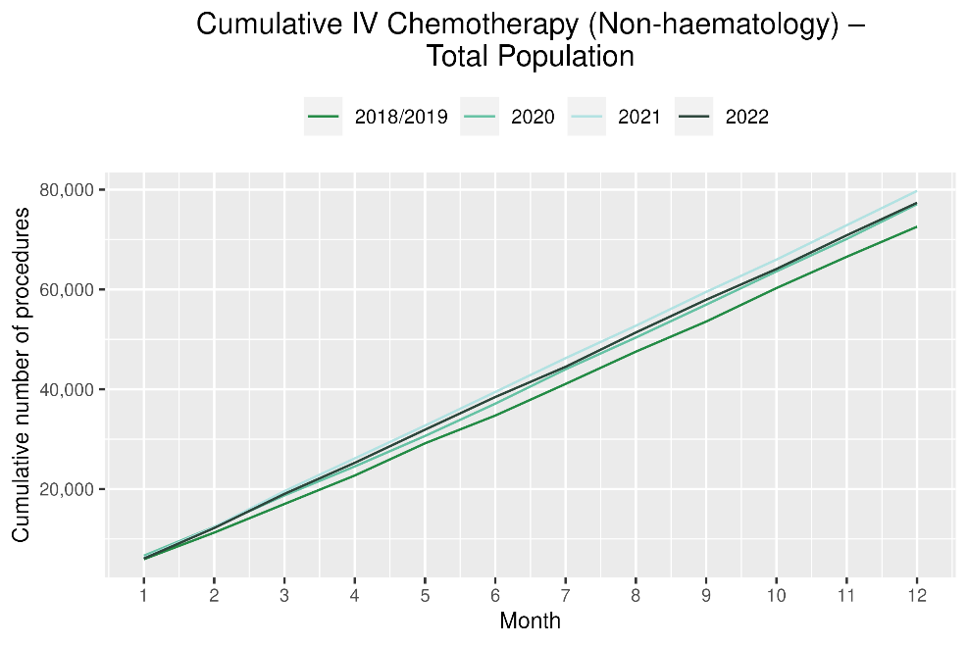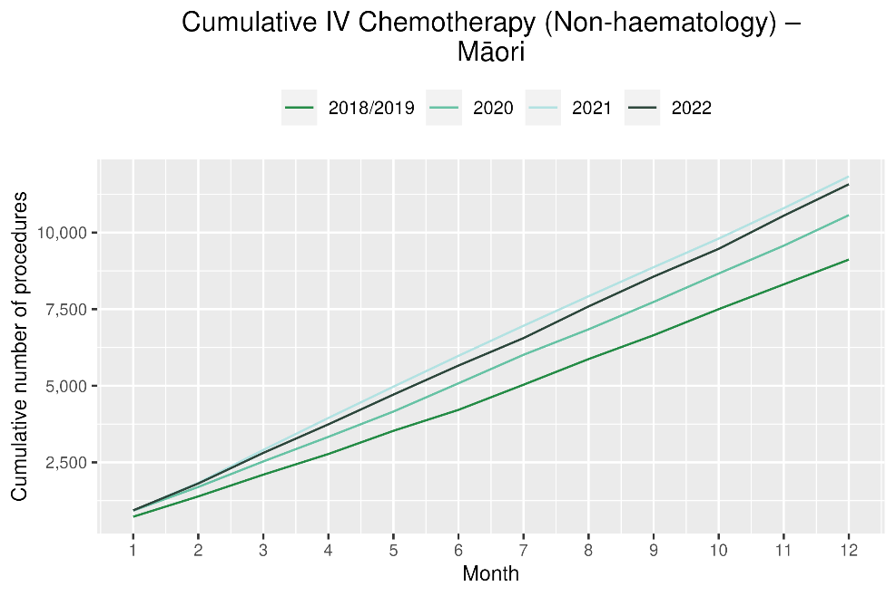

Radiation oncology

Notes on data
- Radiation oncology first specialist assessments and megavoltage attendances data were extracted from NNPAC on 13 Mar 2023.
- First specialist assessment (FSA) reflects counts of first attendance for radiation oncology specialist assessment.
- Radiation therapy attendances include appointments for planning/simulation and for treatment with radiation therapy on a linear accelerator.
- Radiation therapy courses data were extracted from Radiation Oncology Collection (ROC) on 8 March 2023. ROC is a national collection that contains diagnosis and treatment data for patients receiving radiation therapy from both the public and private providers. ROC is updated quarterly.
- A course of radiation therapy is a set of radiotherapy treatment(s) to a continuous or contiguous volume with a single intent from a single referral. A course can include multiple phases and multiple radiotherapy modalities. The monthly data here refers to the number of completed courses. The course starting date may not be in the same month.
- Radiation therapy course data reflect completed publicly funded radiation therapy courses. Treatments delivered by private providers with public funding are excluded with exception of Bay of Plenty District.
- Technical information: radiation oncology FSA (Purchase Unit Code: M50022), megavoltage attendances (Purchase Unit Code: M50025).

Key points
- For 2022, there was a 7% increase in radiation oncology first specialist assessments (FSAs) compared with 2018/19, with a 18% increase for Māori. However, FSAs were lower than in 2021, showing a decrease of 1% overall and 1% for Māori.
- There was an 8% decrease in radiation therapy attendances overall and a 2% decrease for Māori. It is helpful to consider the above results in relation to completed radiation therapy courses. This measure likely reflects trends in service volume over time better than radiation therapy attendance, as the increased use of hypofractionation is likely to contribute to a decrease in the number of attendances required to complete a course of treatment.
- For 2022, there was a decrease of 1% in completed radiation therapy courses. This appears to be an improvement compared to earlier in the year, with cumulative data as of September 2022 showing a decrease of 3% compared to 2018/19 and July 2022 data showing a decrease of 7%. Compared to 2021, there was a decrease of 2% in 2022 for completed radiation therapy courses.
- For 2022 in total, there was an increase of 10% for Māori in completed radiation therapy courses compared to 2018/19. When compared to 2021 this increase was 2%.
Table 15: Number of radiation oncology first specialist assessments and percentage difference in 2022 compared to the average of 2018 and 2019, by month and cumulative year to date, by ethnicity
 | October |  |  | November |  |  | December |  |  | Cumulative January -December
 | 2018/2019 | 2022 | % change | 2018/2019 | 2022 | % change | 2018/2019 | 2022 | % change | 2018/2019 | 2022 | % change
Māori | 128 | 144 | 13% | 134 | 186 | 39% | 107 | 160 | 50% | 1,422 | 1,684 | 18%
Pacific Peoples | 49 | 51 | 5% | 51 | 59 | 17% | 37 | 53 | 45% | 547 | 661 | 21%
Non-Māori/Non-Pacific | 837 | 816 | -2% | 889 | 975 | 10% | 814 | 875 | 7% | 10,046 | 10,464 | 4%
Total Population | 1,013 | 1,011 | 0% | 1,073 | 1,220 | 14% | 957 | 1,088 | 14% | 12,015 | 12,809 | 7%

Figure 15: Number of radiation oncology first specialist assessments by month, 2018/19 average, 2020, 2021 and 2022, total population and Māori

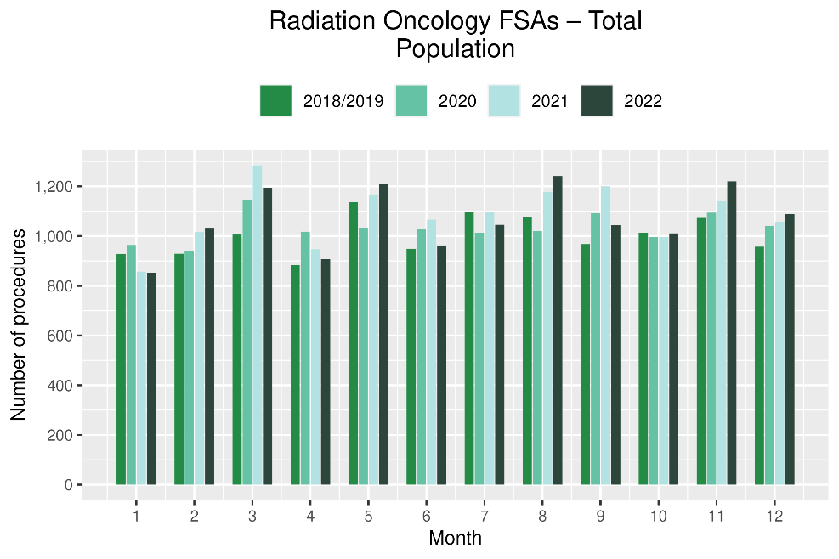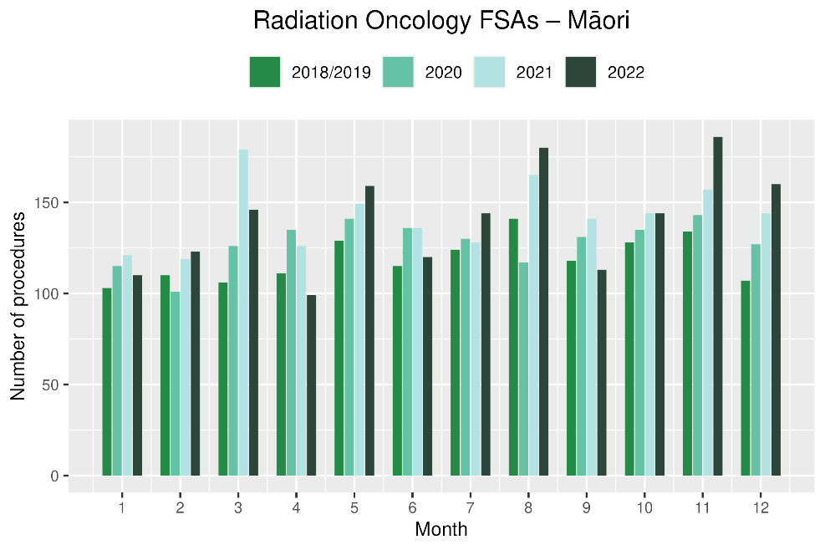

Figure 16: Cumulative number of radiation oncology first specialist assessments by month, 2018/19 average, 2020, 2021 and 2022, total population and Māori
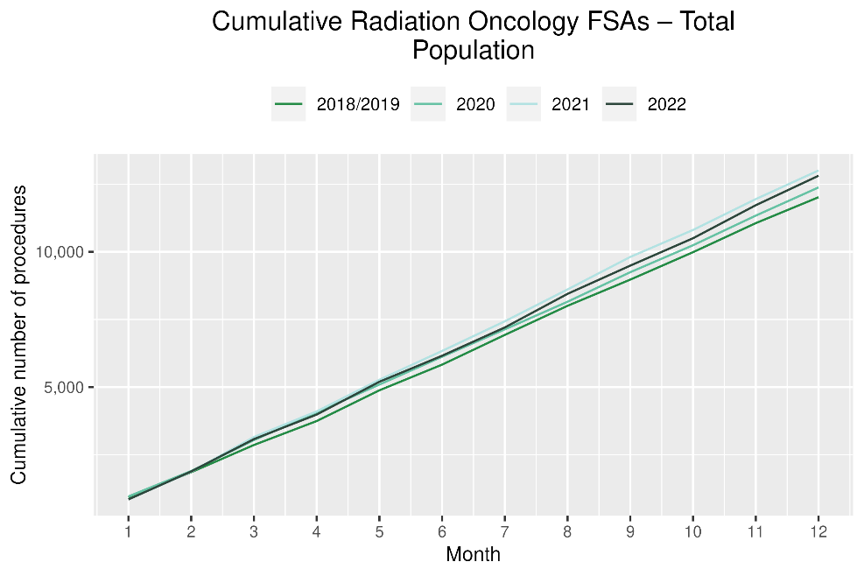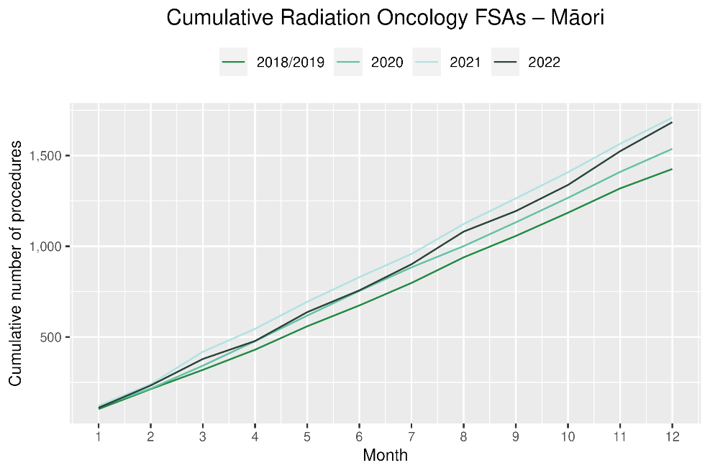
Table 16: Number of radiation therapy attendances and percentage difference in 2022 compared to the average of 2018 and 2019, by month and cumulative year to date, by ethnicity
 | October |  |  | November |  |  | December |  |  | Cumulative January -December
 | 2018/2019 | 2022 | % change | 2018/2019 | 2022 | % change | 2018/2019 | 2022 | % change | 2018/2019 | 2022 | % change
Māori | 1,906 | 1,515 | -21% | 1,964 | 2,060 | 5% | 1,731 | 2,101 | 21% | 21,506 | 21,007 | -2%
Pacific Peoples | 570 | 808 | 42% | 597 | 687 | 15% | 604 | 515 | -15% | 6,966 | 7,098 | 2%
Non-Māori/Non-Pacific | 11,908 | 10,901 | -8% | 12,025 | 11,069 | -8% | 10,913 | 10,708 | -2% | 139,167 | 125,764 | -10%
Total Population | 14,384 | 13,224 | -8% | 14,585 | 13,816 | -5% | 13,248 | 13,324 | 1% | 167,639 | 153,869 | -8%

Figure 17: Number of radiation therapy attendances by month, 2018/19 average, 2020, 2021 and 2022, total population and Māori
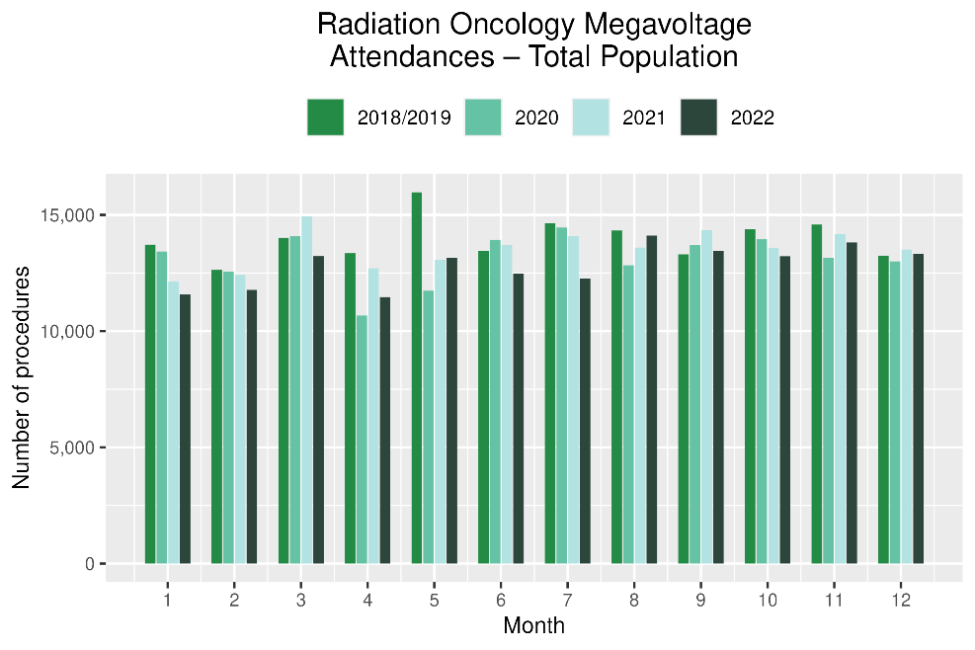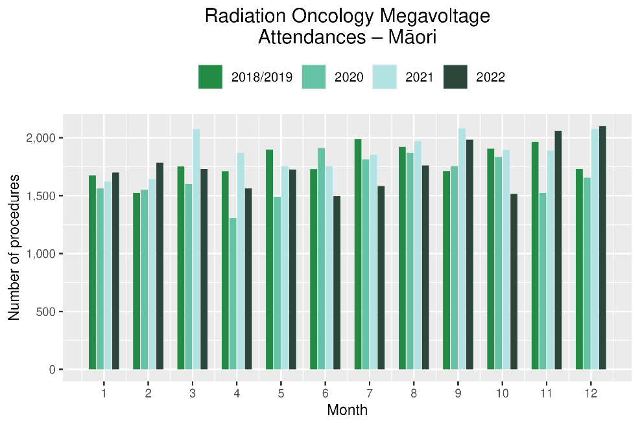
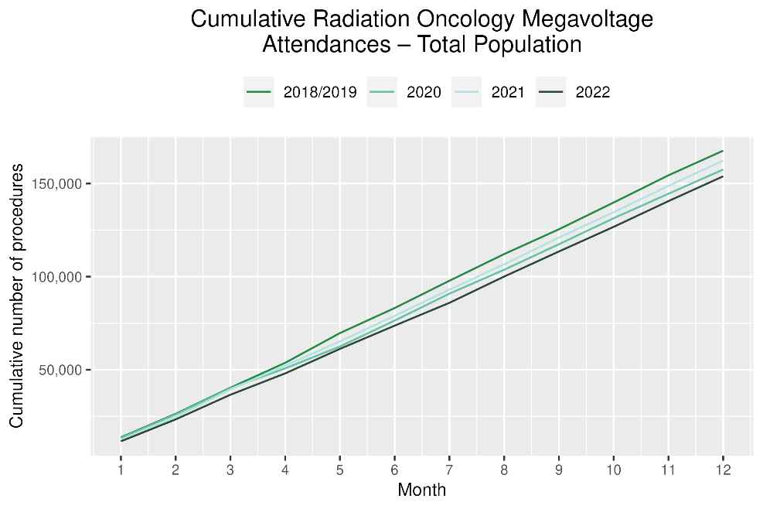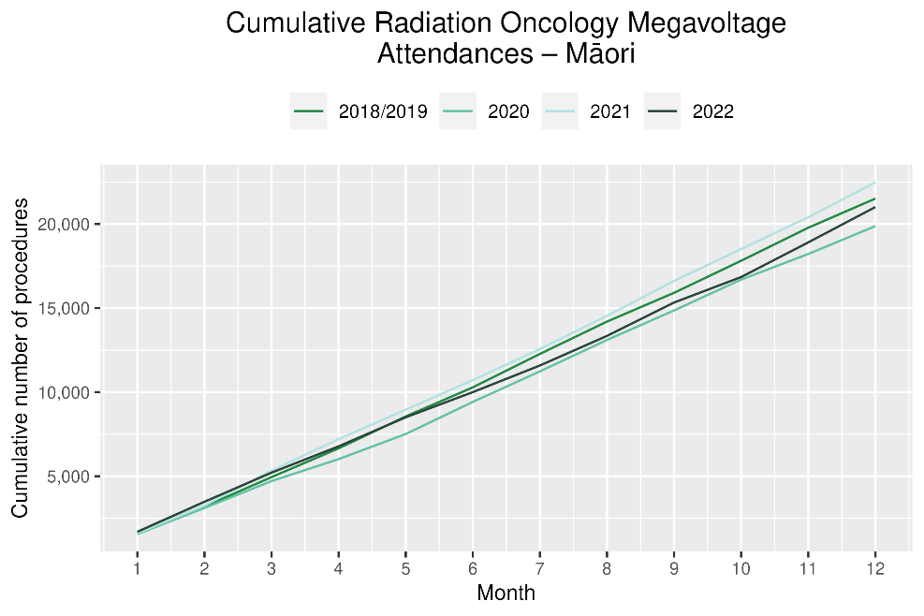

Table 17: Number of completed radiation therapy courses and percentage difference in 2022 compared to the average of 2018 and 2019, by month and cumulative year to date, by ethnicity
 | October |  |  | November |  |  | December |  |  | Cumulative January -December
 | 2018/2019 | 2022 | % change | 2018/2019 | 2022 | % change | 2018/2019 | 2022 | % change | 2018/2019 | 2022 | % change
Māori | 142 | 123 | -13% | 141 | 153 | 9% | 132 | 186 | 41% | 1,543 | 1,705 | 10%
Pacific Peoples | 43 | 53 | 25% | 47 | 64 | 36% | 55 | 53 | -3% | 540 | 569 | 5%
Non-Māori/Non-Pacific | 864 | 760 | -12% | 893 | 885 | -1% | 858 | 832 | -3% | 10,209 | 9,839 | -4%
Total Population | 1,048 | 936 | -11% | 1,081 | 1,102 | 2% | 1,044 | 1,071 | 3% | 12,292 | 12,113 | -1%

Figure 20: Number of completed radiation therapy courses by month, 2018/19 average, 2020, 2021 and 2022, total population and Māori

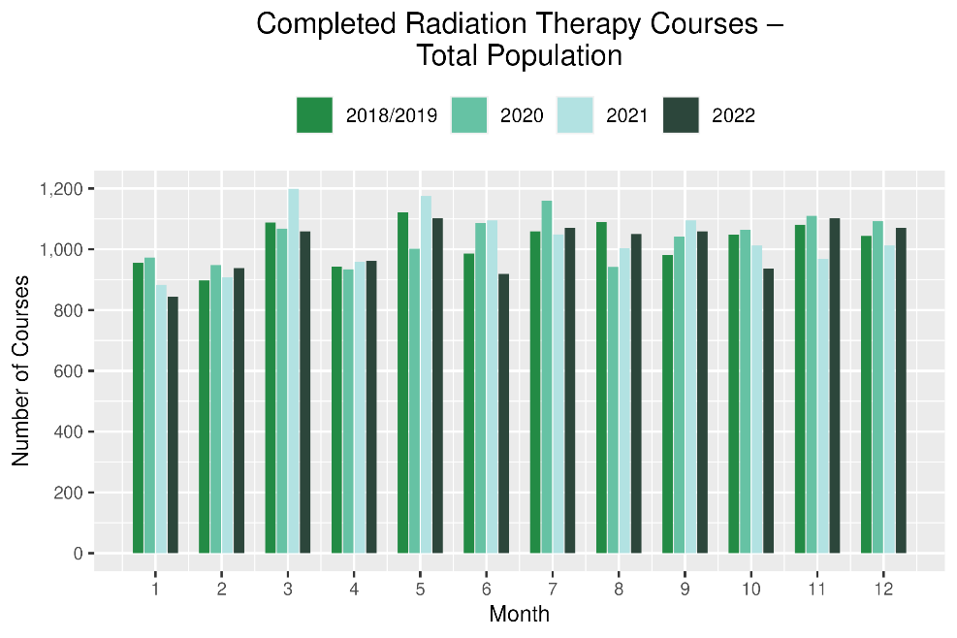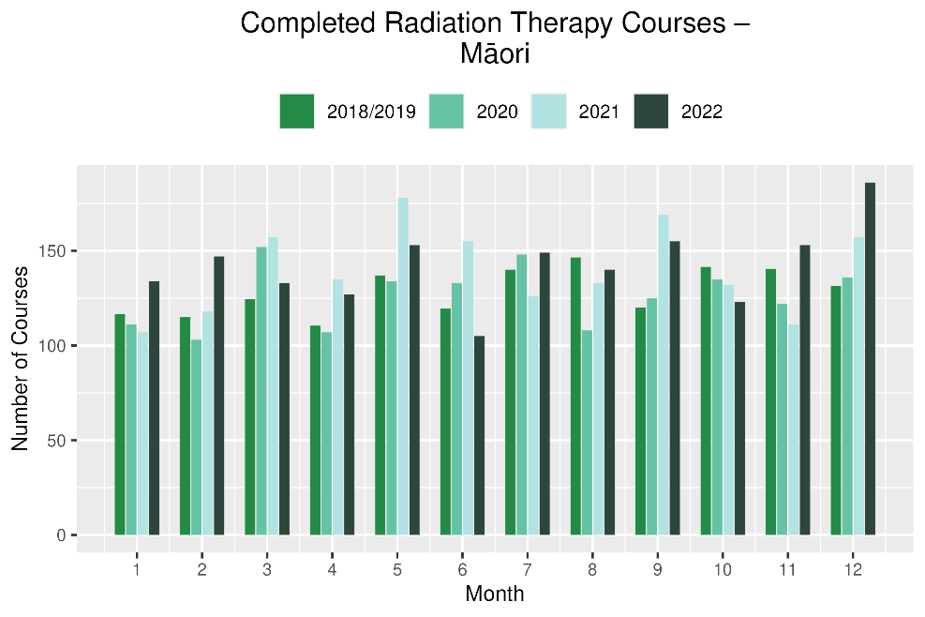

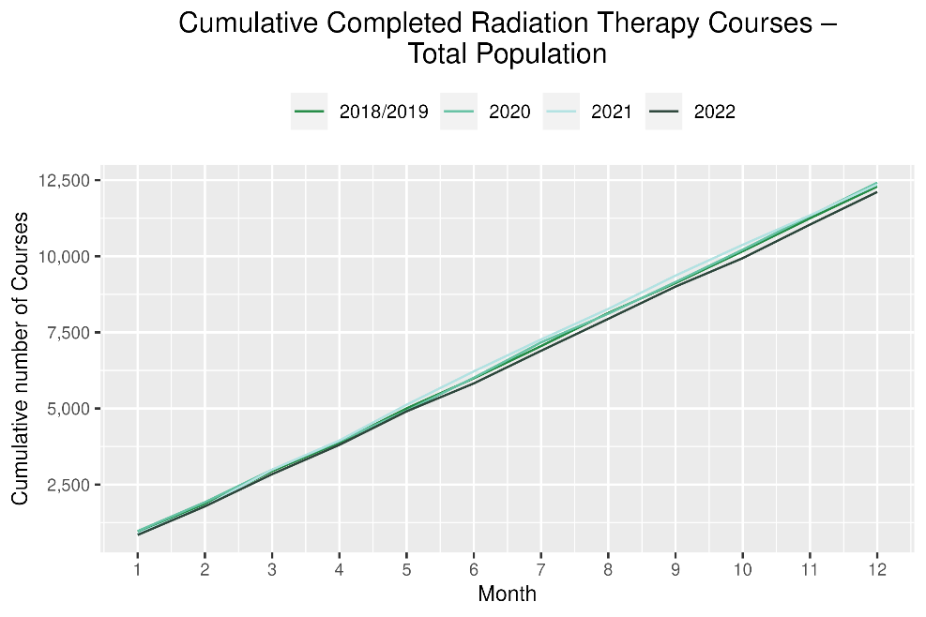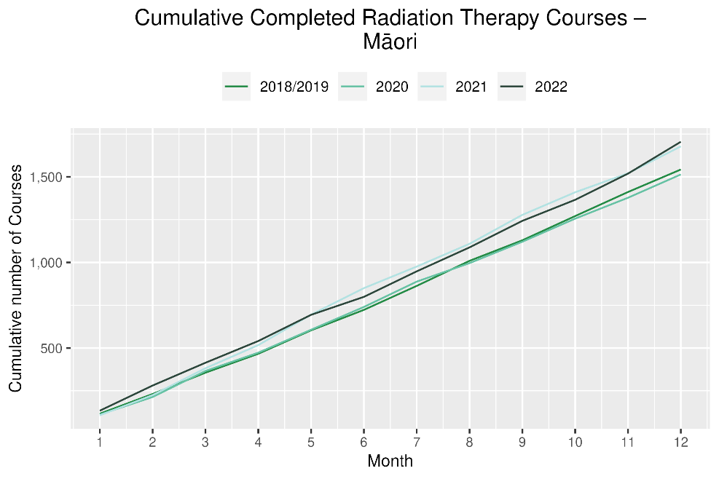

Haematology

Notes on data
- Data were extracted from NNPAC and NMDS on 13 Mar 2023.
- First specialist assessment (FSA) reflects counts of first attendance for specialist haematology assessment for any indication, not just cancer.
- IV chemotherapy reflects appointments for IV chemotherapy for haematological malignancies.
- Technical information: Haematology FSA (Purchase Unite Code: M30002), IV haem/chemo (Purchase Unit Code: M30020).

Key points
- For 2022, there was a 1% decrease in haematology first specialist assessments (FSAs) compared with 2018/19, and for Māori there was a 9% increase. The decrease has improved compared to mid-year where there was an 11% decrease overall for FSAs until June 2022. However, compared to 2021 there were 5% fewer FSAs, with figures similar to those seen in 2020 (figure 18).
- For 2022, there was a 5% increase in haematology intravenous (IV) chemotherapy compared with 2018/19 overall and for Māori an increase of 7%. When comparing 2022 with 2021, there were 5% fewer haematology chemotherapy attendances overall, and a 10% decrease for Māori.

Results
Table 18: Number of haematology first specialist assessment attendances and percentage difference in 2022 compared to the average of 2018 and 2019, by month and cumulative year to date, by ethnicity
 | October |  |  | November |  |  | December |  |  | Cumulative January -December
 | 2018/2019 | 2022 | % change | 2018/2019 | 2022 | % change | 2018/2019 | 2022 | % change | 2018/2019 | 2022 | % change
Māori | 54 | 54 | 0% | 54 | 71 | 33% | 50 | 45 | -9% | 653 | 709 | 9%
Pacific Peoples | 30 | 31 | 3% | 25 | 32 | 28% | 21 | 19 | -10% | 316 | 367 | 16%
Non-Māori/Non-Pacific | 438 | 445 | 2% | 500 | 538 | 8% | 408 | 411 | 1% | 5,471 | 5,328 | -3%
Total Population | 522 | 530 | 2% | 578 | 641 | 11% | 478 | 475 | -1% | 6,440 | 6,404 | -1%

Figure 18: Number of haematology first specialist assessments by month, 2018/19 average, 2020, 2021 and 2022, total population and Māori
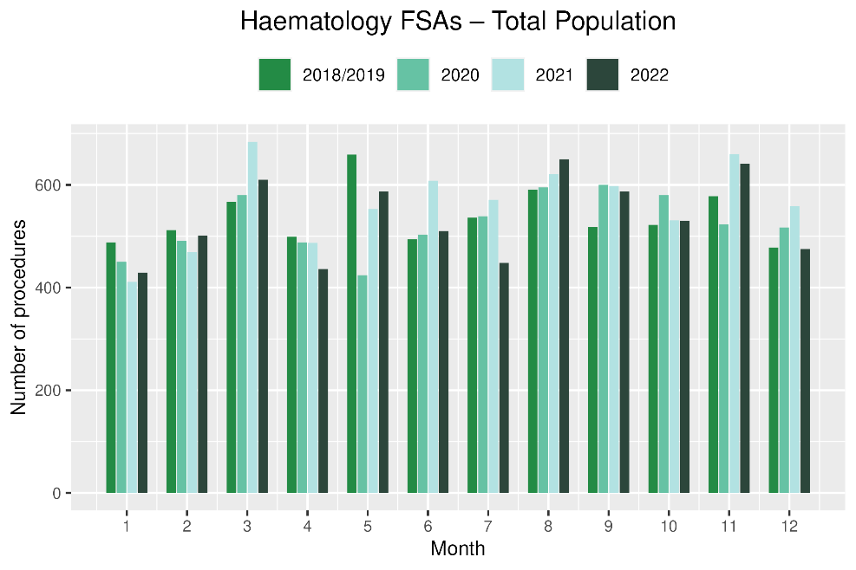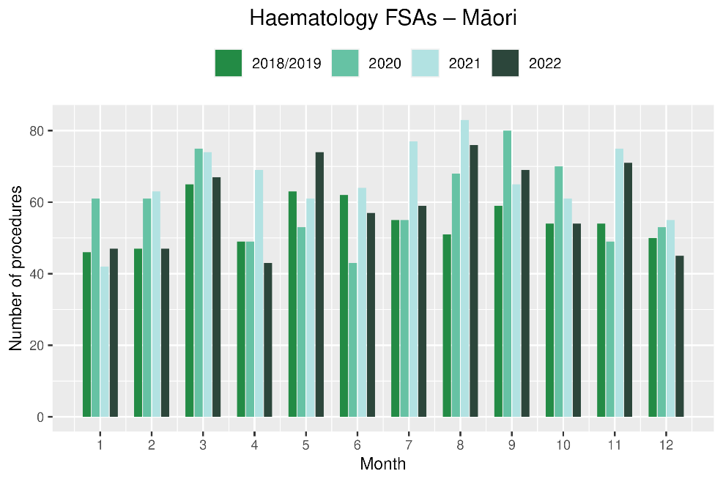
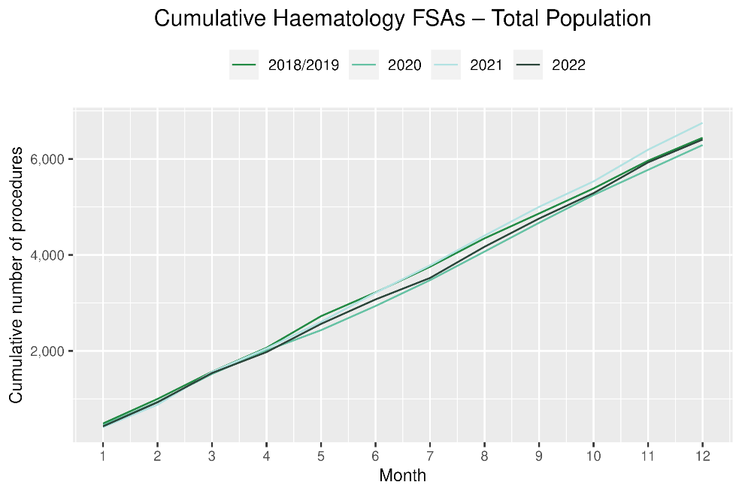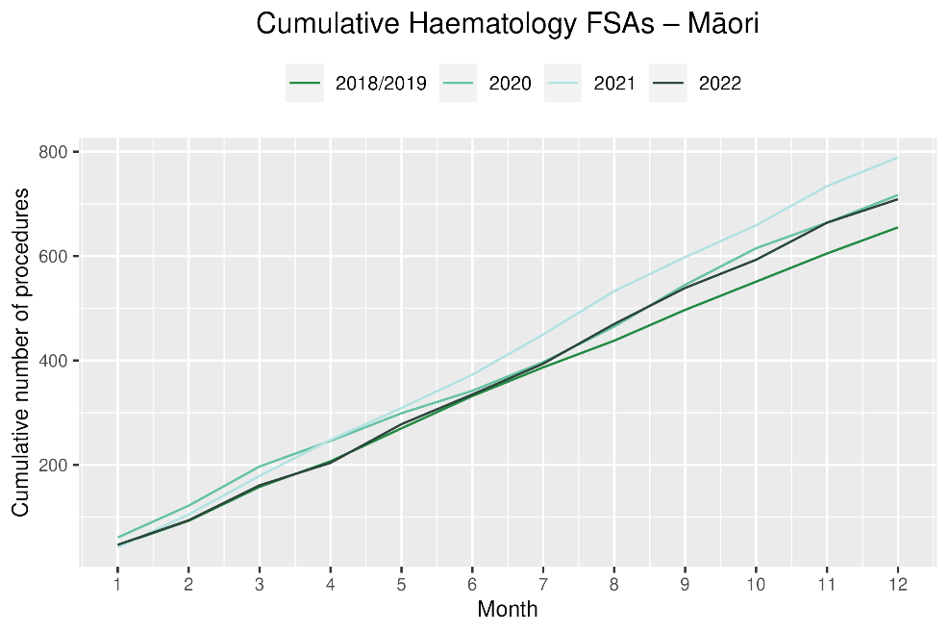
Table 19: Number of IV chemotherapy attendances for haematological malignancies and percentage difference in 2022 compared to the average of 2018 and 2019, by month and cumulative year to date, by ethnicity
 | October |  |  | November |  |  | December |  |  | Cumulative January -December
 | 2018/2019 | 2022 | % change | 2018/2019 | 2022 | % change | 2018/2019 | 2022 | % change | 2018/2019 | 2022 | % change
Māori | 233 | 234 | 1% | 232 | 234 | 1% | 223 | 231 | 4% | 2,531 | 2,699 | 7%
Pacific Peoples | 100 | 110 | 11% | 93 | 94 | 2% | 75 | 124 | 65% | 1,172 | 1,293 | 10%
Non-Māori/Non-Pacific | 1,862 | 1,779 | -4% | 1,738 | 1,840 | 6% | 1,631 | 1,830 | 12% | 20,629 | 21,654 | 5%
Total Population | 2,194 | 2,123 | -3% | 2,063 | 2,168 | 5% | 1,928 | 2,185 | 13% | 24,332 | 25,646 | 5%

Figure 19: Number of attendances for IV chemotherapy for haematological malignancies by month, 2018/19 average, 2020, 2021 and 2022, total population and Māori
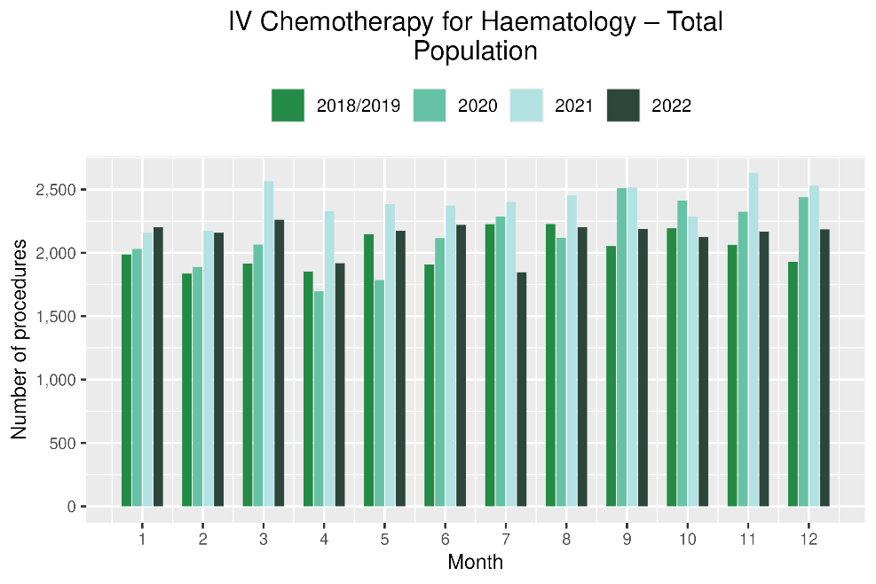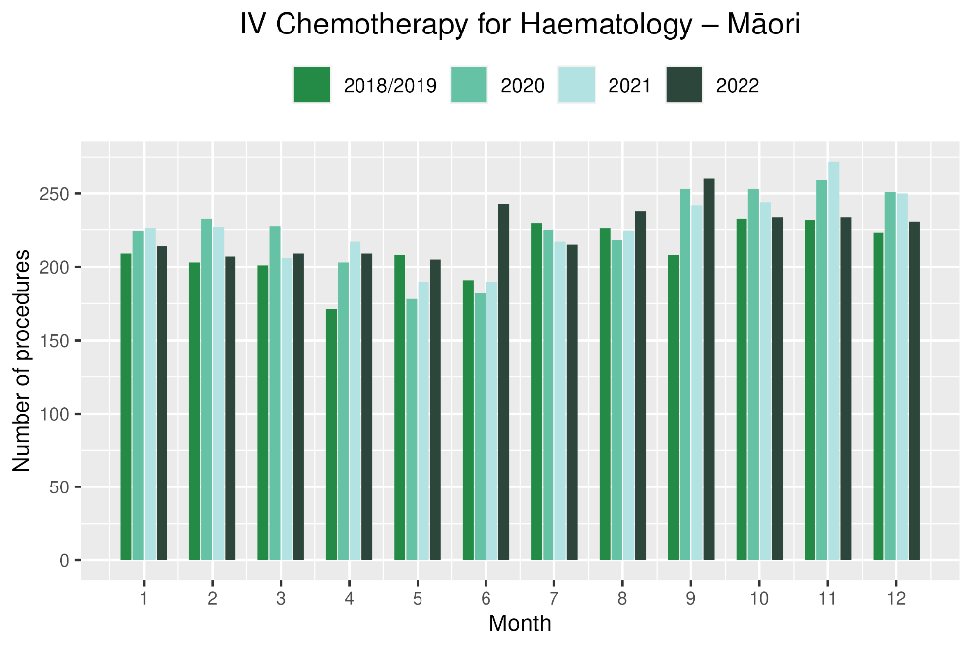

Figure 20: Cumulative number of attendances for IV chemotherapy for haematological malignancies, 2018/19 average, 2020, 2021 and 2022, total population and Māori
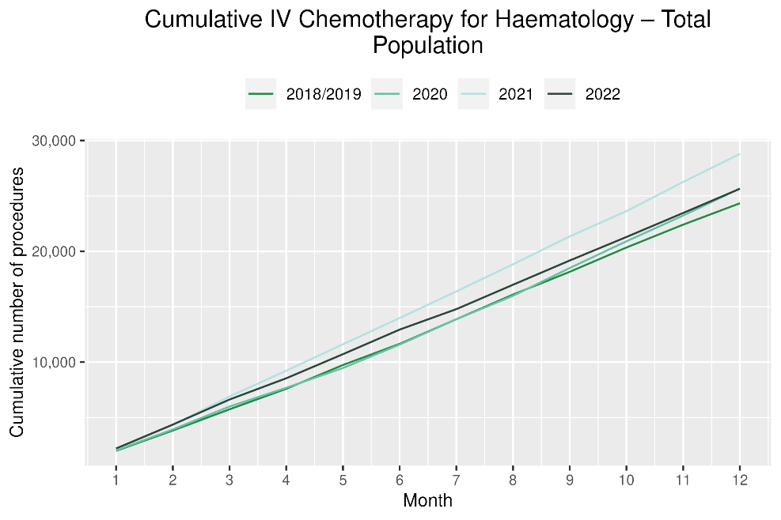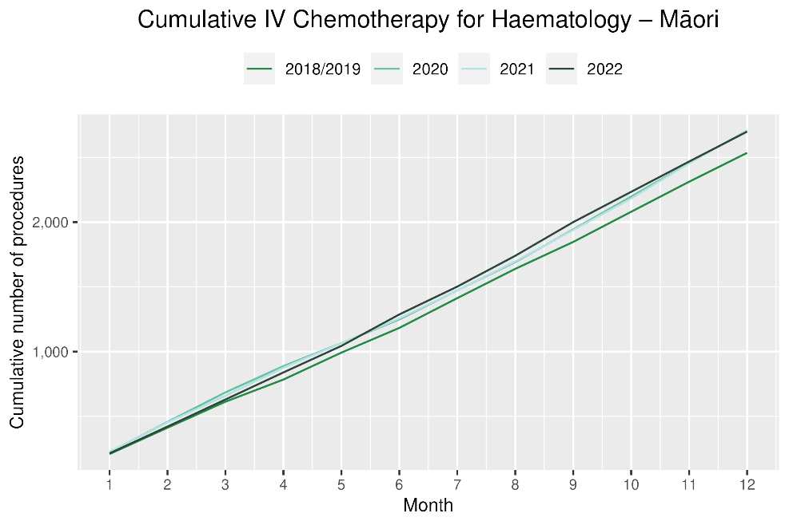

Appendix 1: Key Dates
The follow provides a brief overview of key dates relating to COVID-19 restrictions (Alert Levels 3 and 4 where the greatest restrictions were in place) and outbreaks. More detailed information can be found on the Unite COVID-19 website, including an overview of Alert Levels and the COVID-19 Protection Framework.
23 March – 14 May 2020 | All Aotearoa New Zealand was at Alert Level 3 or 4
12 August – 30 September 2020 | Auckland only moved to Alert Level 3
28 Feb – 7 March 2021 | Auckland only was at Alert Level 3
17 August to 7 September 2021 | All Aotearoa New Zealand was at Alert 3 or 4 at the outset of the Delta variant outbreak
From 7 September 2021 | Auckland remained at Alert Level 4; the rest of the country moved to Alert Level 2
September – December 2021 | Auckland moved to and remained at Alert Level 3 from 21 September. There were various regional changes between Alert Level 2 and 3 over this period some parts of the North Island including parts of Waikato. Details are available on the Unite COVID-19 website⁴. Note: The definition of Alert Level 3 was eased in early October and three gradually reducing steps of level 3 were introduced in October
3 Dec 2021 | End of COVID-19 Alert System. All Aotearoa New Zealand moved to the COVID-19 Protection Framework (traffic lights)
29 Dec 2021 | The first case of the Omicron variant in the community in New Zealand was detected
February 2022  10 March 2022  23 March 2022 | Omicron case numbers and hospitalisations increased more significantly in the second half of February onwards  Seven day rolling average of cases is over 20,000, while daily count reaches over 23,000. This was the peak of case numbers at the time of writing.  Changes are made to the Red-Light setting: no limitations on numbers of people gathering outdoors, indoors limit increase to 2000 people.
14 April 2022 | New Zealand changes to the Orange traffic light setting. Indoor venue capacity rules are removed but facemasks are still required in most indoor venues.
April – Dec 2022 | Continued Omicron outbreak. There were over 20,000 cases at the peak of the first Omicron wave in late February and over 11,000 cases at the peak of the second wave in mid-July before a downward trend into September 2022. See Figure 21. The ‘traffic light’ system ended in September 2022.

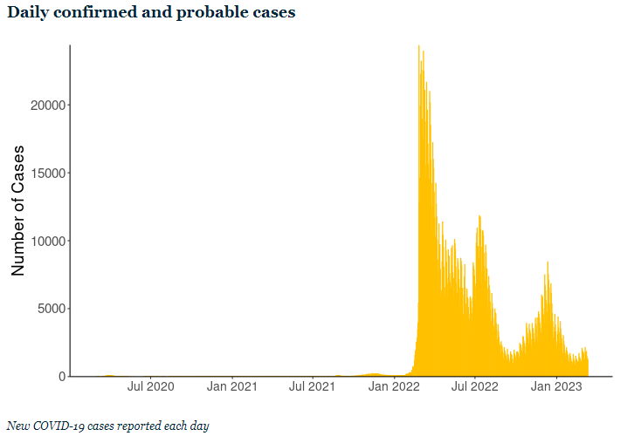
Figure 21 New COVID-19 cases reported each day (confirmed and probable) in Aotearoa New Zealand. Source: Ministry of Health, accessed March 2023 https://www.health.govt.nz/covid-19-novel-coronavirus/covid-19-data-and-statistics/covid-19-current-cases

Appendix 2: NZCR data information

The New Zealand Cancer Registry as a data source for new cancer diagnoses
Cancer registration is a process where data is collated from multiple sources about people diagnosed with cancer and rules are applied to determine the type of cancer they have. This information is recorded in the New Zealand Cancer Registry. Each tumour is classified using an international World Health Organization standard so that cancer incidence can be compared between countries. The tumour is staged based on all the information available within 4 months of diagnosis. This process may take up to six months or more depending on the number of missing reports that need to be followed up with laboratories.
For each registration there may be multiple pathology reports as there may be multiple procedures performed on the tumour. This means there will be more than one registration for people diagnosed with more than one type of tumour.
Cancer registrations come from pathology laboratories, haematology laboratories, mortality records and reviewing hospital discharge records. Laboratory reports provide the best source of near real time data to monitor new diagnoses of cancer in New Zealand.

Pathology reports as a data source for providing near real time monitoring of cancer diagnoses
Pathology reports (documents) are received by the NZCR as electronic messages. An administrator triages these documents each day and if the document appears to meet the requirements for registration the document is “administered”. The document may relate to an existing registration or may contain information for a new cancer event. Documents that do not meet the cancer reporting requirements will be marked as “deleted”, “rejected” or “agreed not for registration”.
The administrator creates a new provisional cancer event if the pathology report identifies a new cancer diagnosis for this person. This new cancer event is assigned to a cancer group and this provisional event is then queued for further assessment by a clinical coder. If the required information has been provided the coder creates a new registration. If some information is not yet available, then the registration is held open until further information arrives to complete the registration or determine that the tumour does not meet the registration criteria.

Appendix 3: NZCR registrations by Te WHATU ORA-DISTRICT
Number of cancer registrations and percentage difference in 2022 compared to 2018/19 average, by month and cumulative year to date, by Te Whatu Ora District of domicile
 | October |  |  | November |  |  | December |  |  | Cumulative January-December
Te Whatu Ora District | 2018/19 | 2022 | %Change | 2018/19 | 2022 | %Change | 2018/19 | 2022 | %Change | 2018/19 | 2022 | %Change
Northland | 94 | 126 | 34% | 112 | 154 | 38% | 104 | 95 | -8% | 1,161 | 1,341 | 16%
Waitematā | 245 | 297 | 21% | 264 | 334 | 27% | 235 | 299 | 27% | 2,852 | 3,439 | 21%
Auckland | 156 | 186 | 19% | 195 | 227 | 17% | 141 | 179 | 27% | 1,985 | 2,247 | 13%
Counties Manukau | 188 | 201 | 7% | 223 | 267 | 20% | 169 | 223 | 32% | 2,207 | 2,491 | 13%
Waikato | 180 | 178 | -1% | 204 | 230 | 13% | 173 | 184 | 7% | 2,155 | 2,257 | 5%
Bay of Plenty | 113 | 141 | 25% | 129 | 173 | 34% | 117 | 118 | 1% | 1,405 | 1,587 | 13%
Tairawhiti | 19 | 24 | 30% | 22 | 27 | 26% | 20 | 15 | -23% | 221 | 240 | 9%
Lakes | 45 | 47 | 4% | 46 | 64 | 41% | 44 | 59 | 34% | 544 | 577 | 6%
Taranaki | 56 | 76 | 36% | 66 | 85 | 30% | 53 | 73 | 39% | 696 | 774 | 11%
Hawkes Bay | 77 | 91 | 19% | 80 | 89 | 12% | 64 | 84 | 32% | 891 | 1,018 | 14%
Whanganui | 31 | 35 | 15% | 41 | 48 | 17% | 31 | 26 | -15% | 417 | 379 | -9%
MidCentral | 88 | 67 | -24% | 91 | 90 | -1% | 79 | 83 | 5% | 1,022 | 947 | -7%
Capital and Coast | 114 | 138 | 22% | 119 | 158 | 33% | 110 | 129 | 18% | 1,374 | 1,523 | 11%
Hutt Valley | 73 | 73 | 1% | 72 | 76 | 6% | 52 | 77 | 48% | 745 | 811 | 9%
Wairarapa | 29 | 26 | -10% | 19 | 33 | 78% | 19 | 24 | 30% | 272 | 300 | 10%
Nelson Marlborough | 84 | 75 | -11% | 75 | 97 | 30% | 69 | 67 | -2% | 913 | 948 | 4%
West Coast | 18 | 20 | 11% | 15 | 23 | 59% | 15 | 21 | 45% | 188 | 204 | 9%
Canterbury | 235 | 249 | 6% | 251 | 292 | 16% | 221 | 248 | 12% | 2,748 | 3,090 | 12%
South Canterbury | 34 | 40 | 18% | 35 | 37 | 6% | 32 | 28 | -11% | 379 | 394 | 4%
Southern | 162 | 176 | 9% | 195 | 203 | 4% | 155 | 182 | 18% | 1,899 | 1,888 | -1%

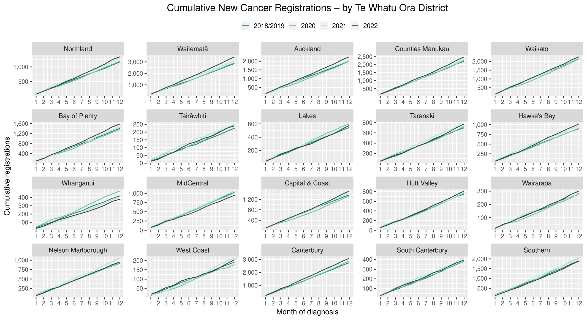

Cumulative cancer registrations by Te Whatu Ora District and ethnicity
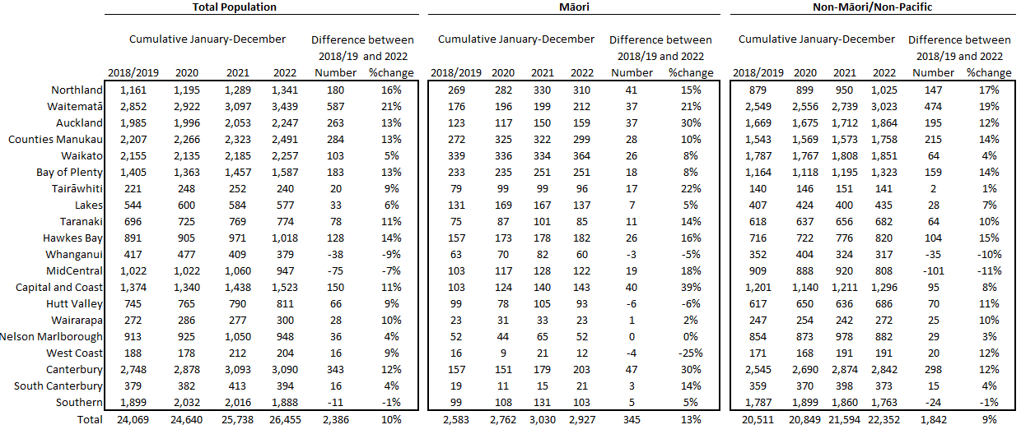

Cumulative cancer registrations by cancer type and ethnicity

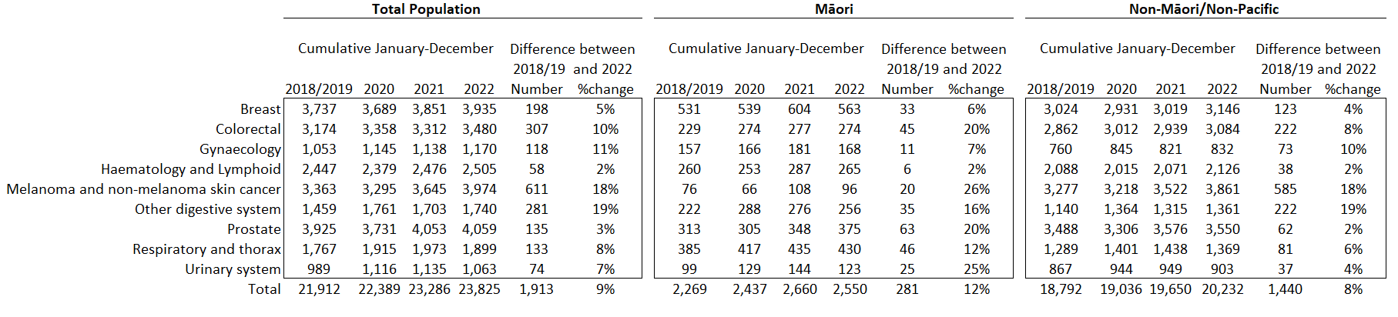

Appendix 4: Diagnosis and treatment data by Te Whatu Ora District
Percentage differences are only presented if the cumulative total is 10 or greater. In some cases, the totals may differ to those presented in the national report due to private providers being excluded from the analyses within this appendix.

Gastrointestinal endoscopy

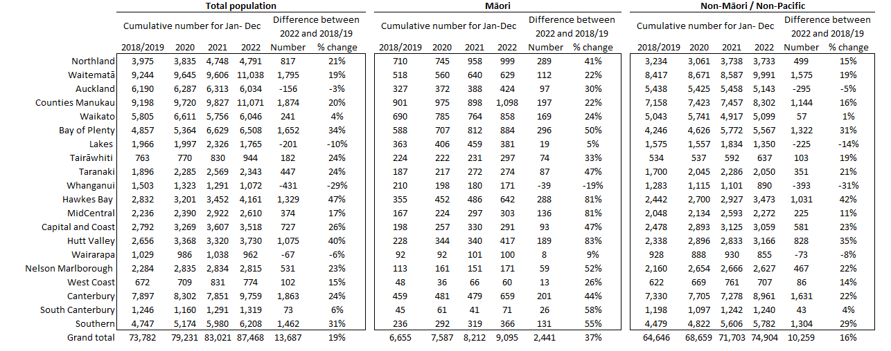

Bronchoscopy

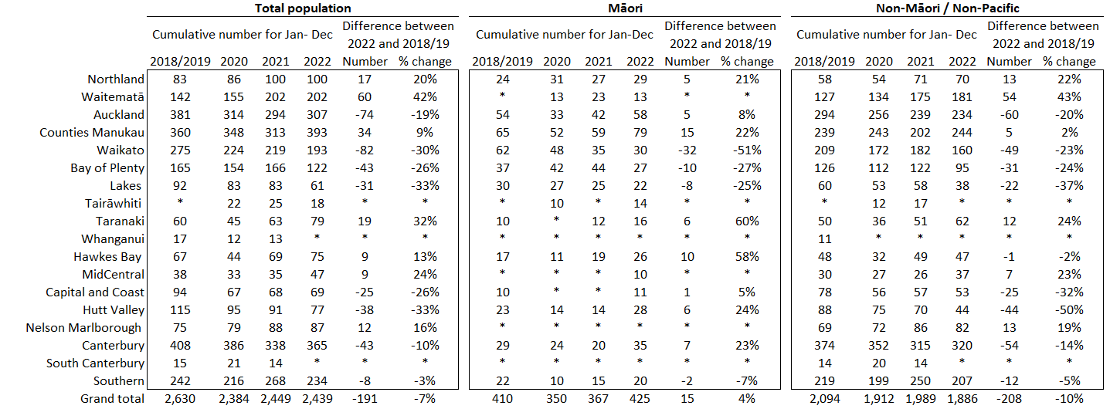

CT Lung Biopsy

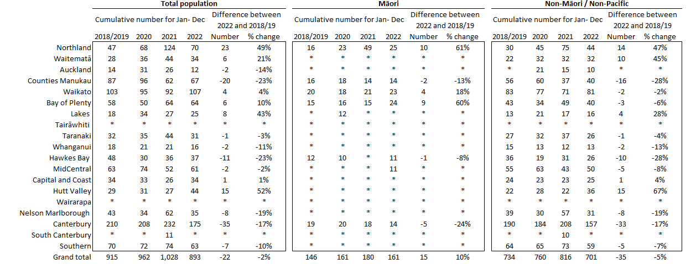

Breast cancer surgery (mastectomy)

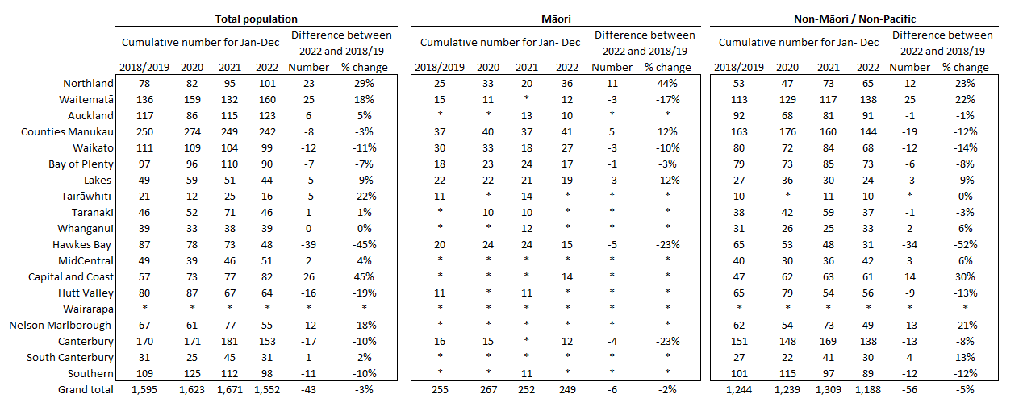

Colorectal cancer surgery

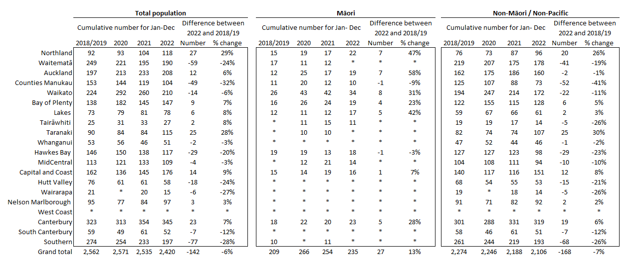

Lung cancer surgery

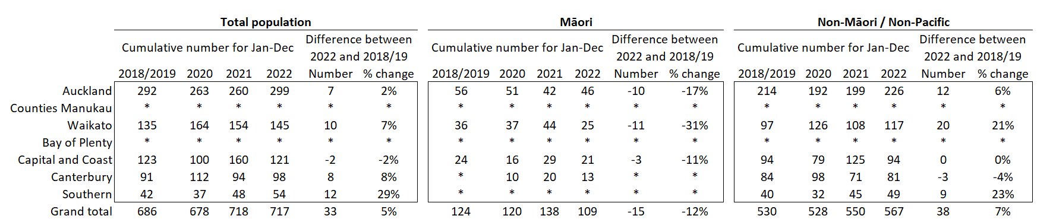

Prostate cancer surgery

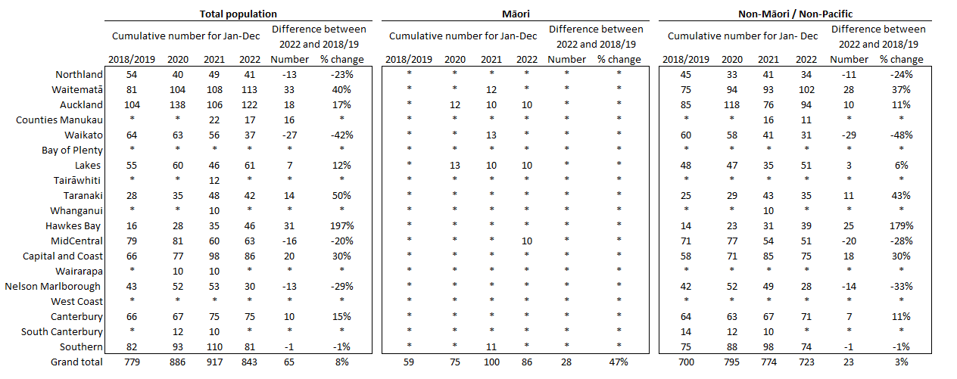

Medical oncology first specialist assessments

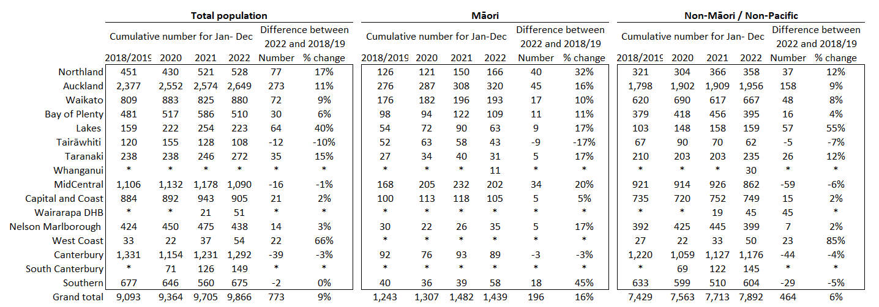

Medical oncology IV chemotherapy

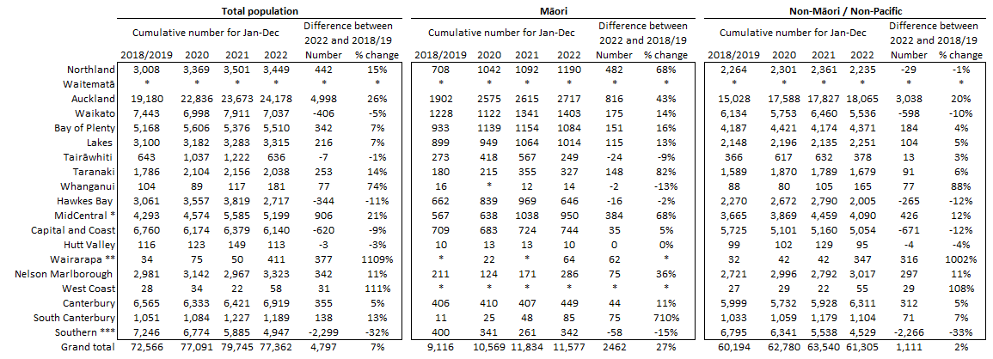
* MidCentral District is investigating potential data quality issues over 2021 and 2022 reporting period.
** We have noticed an unusual volume change at Wairarapa District and are seeking clarification.
*** Note the relatively high volumes in Southern Te Whatu Ora District in prior years are due to variation in coding between medical oncology and haematology.

Radiation oncology first specialist assessments

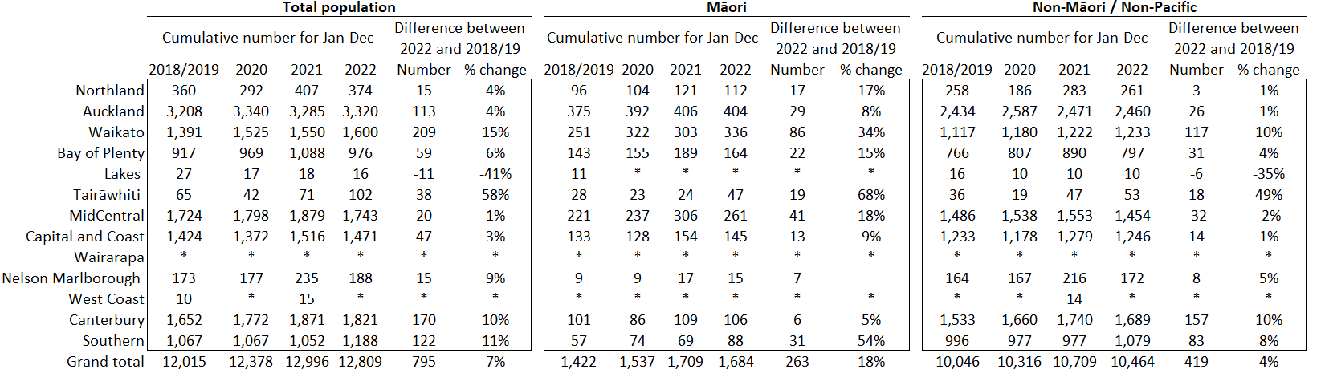

Radiation oncology megavoltage fractions

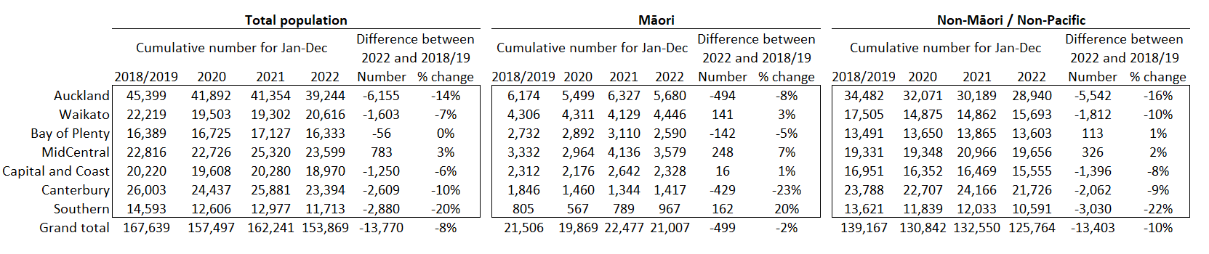

Radiation therapy completed courses

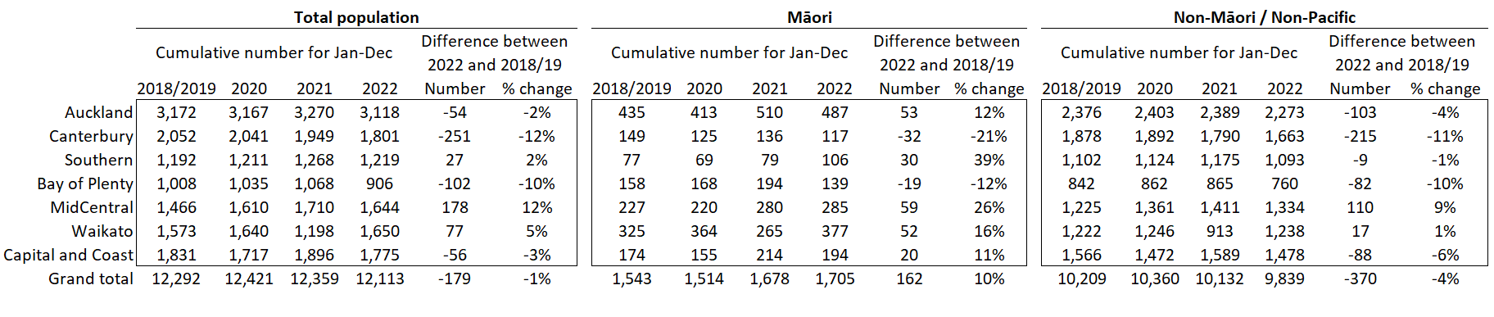

Haematology first specialist assessment

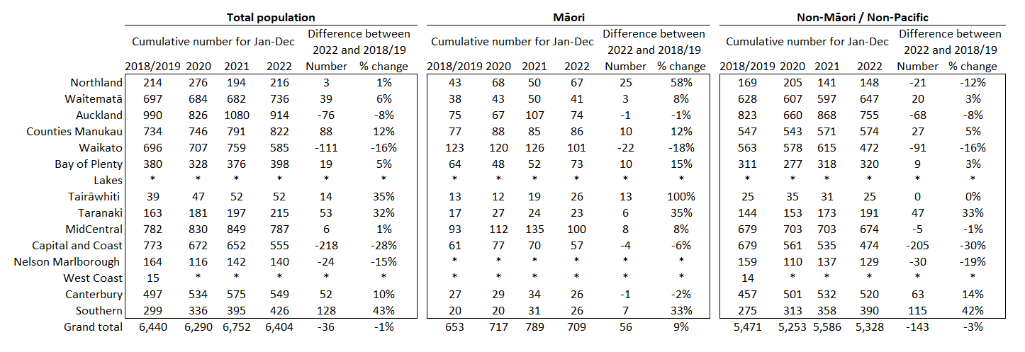

Haematology IV chemotherapy

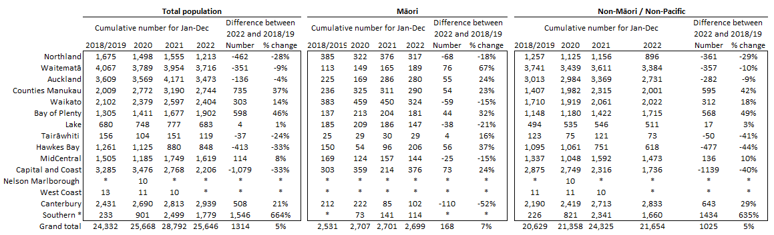
* Note the relatively low volumes in Southern Te Whatu Ora District in prior years are due to variation in coding between medical oncology and haematology.

Appendix 5: Surgical procedure codes
Below is a list of the surgical procedure codes that were used for analysis on cancer surgery.
COLORECTAL CANCER SURGERY
Clinical code | Block short description | Clinical code description
3200000 | Colectomy | Limited excision of large intestine with formation of stoma
3200001 | Colectomy | Right hemicolectomy with formation of stoma
3200300 | Colectomy | Limited excision of large intestine with anastomosis
3200301 | Colectomy | Right hemicolectomy with anastomosis
3200400 | Colectomy | Subtotal colectomy with formation of stoma
3200401 | Colectomy | Extended right hemicolectomy with formation of stoma
3200500 | Colectomy | Subtotal colectomy with anastomosis
3200501 | Colectomy | Extended right hemicolectomy with anastomosis
3200600 | Colectomy | Left hemicolectomy with anastomosis
3200601 | Colectomy | Left hemicolectomy with formation of stoma
3200900 | Colectomy | Total colectomy with ileostomy
3201200 | Colectomy | Total colectomy with ileorectal anastomosis
3201500 | Total proctocolectomy | Total proctocolectomy with ileostomy
3202400 | Anterior resection of rectum | High anterior resection of rectum
3202500 | Anterior resection of rectum | Low anterior resection of rectum
3202600 | Anterior resection of rectum | Ultra low anterior resection of rectum
3202800 | Anterior resection of rectum | Ultra low anterior resection of rectum with hand sutured coloanal anastomosis
3203000 | Rectosigmoidectomy or proctectomy | Rectosigmoidectomy with formation of stoma
3203900 | Rectosigmoidectomy or proctectomy | Abdominoperineal proctectomy
3205100 | Total proctocolectomy | Total proctocolectomy with ileo-anal anastomosis
3205101 | Total proctocolectomy | Total proctocolectomy with ileo-anal anastomosis and formation of temporary ileostomy
3206000 | Rectosigmoidectomy or proctectomy | Restorative proctectomy
3209900 | Excision of lesion or tissue of rectum or anus | Per anal submucosal excision of lesion or tissue of rectum
3211200 | Rectosigmoidectomy or proctectomy | Perineal rectosigmoidectomy
9220800 | Anterior resection of rectum | Anterior resection of rectum, level unspecified

LUNG CANCER SURGERY
Clinical code | Clinical code description | Block Description
3844000 | Wedge resection of lung | Partial resection of lung
3844001 | Radical wedge resection of lung | Partial resection of lung
3843800 | Segmental resection of lung | Partial resection of lung
9016900 | Endoscopic wedge resection of lung | Partial resection of lung
3843801 | Lobectomy of lung | Lobectomy of lung
3844100 | Radical lobectomy | Lobectomy of lung
3844101 | Radical pneumonectomy | Pneumonectomy
3843802 | Pneumonectomy | Pneumonectomy

PROSTATE CANCER SURGERY
Clinical code | Block short description | Clinical code description
3720004 | Open prostatectomy | Retropubic prostatectomy
3720900 | Open prostatectomy | Radical prostatectomy
3720901 | Other closed prostatectomy | Laparoscopic radical prostatectomy
3721000 | Open prostatectomy | Radical prostatectomy with bladder neck reconstruction
3721001 | Other closed prostatectomy | Laparoscopic radical prostatectomy with bladder neck reconstruction
3721100 | Open prostatectomy | Radical prostatectomy with bladder neck reconstruction and pelvic lymphadenectomy
3721101 | Other closed prostatectomy | Laparoscopic radical prostatectomy with bladder neck reconstruction and pelvic lymphadenectomy
3720900 | Open prostatectomy | Radical prostatectomy
3720901 | Closed prostatectomy | Laparoscopic radical prostatectomy
3721000 | Open prostatectomy | Radical prostatectomy with bladder neck reconstruction
3721001 | Closed prostatectomy | Laparoscopic radical prostatectomy with bladder neck reconstruction
3721100 | Open prostatectomy | Radical prostatectomy with bladder neck reconstruction and pelvic lymphadenectomy

BREAST CANCER SURGERY
Clinical code | Block short description | Clinical code description
3152400 | Subcutaneous mastectomy | Subcutaneous mastectomy, unilateral
3152401 | Subcutaneous mastectomy | Subcutaneous mastectomy, bilateral
3151800 | Simple mastectomy | Simple mastectomy, unilateral
3151801 | Simple mastectomy | Simple mastectomy, bilateral

Reports available here: https://teaho.govt.nz/reports/cancer-care
For example, for several measures in the March 2022 report, there were notably higher volumes for March 2021 compared with March in other recent years, including years presented in this report (2018, 2019, and 2020). The reasons for this data spike in March 2021 may include a catch-up period following lockdowns of the previous year.
This report includes an additional procedure code for CT Lung Biopsy (3881200). This is the back mapping code for CT Lung Biopsy prior to July 2019
COVID-19 and cancer services report for the period ending December 2021, released February 2022. https://teaho.govt.nz/covid-19/cancer-care
We recognise there are limitations to this approach and aim to strike a balance between timely data availability, completeness, and accuracy, with the purpose of the reporting being to provide an initial indication of the current situation which may then require further interrogation at a regional level.
Hypofractionation is a radiation treatment technique used to treat some cancers, whereby larger doses of radiation are given each treatment, meaning that patients require fewer sessions to complete their treatment. The technique is being increasingly used for some prostate and breast cancers in New Zealand and around the world.
https://covid19.govt.nz/about-our-covid-19-response/history-of-the-covid-19-alert-system/
https://covid19.govt.nz/traffic-lights/covid-19-protection-framework
https://www.health.govt.nz/covid-19-novel-coronavirus/covid-19-data-and-statistics/covid-19-current-cases

