

**COVID-19 and cancer services**

Working report on the impact of COVID-19 on cancer services for the period ending March 2022

**Released June 2022**

# Acknowledgements

With thanks to the Ministry of Health Data Management team for their technical support.

With thanks to members of the COVID-19 Data Response Advisory Group: Professor Diana Sarfati, Alex Dunn, Dr John Fountain, Dr Tess Luff, John Manderson, Michelle Mako, Dr Shaun Costello, Michelle Liu, Dr Liz Dennett, Gabrielle Nicholson, Dawn Wilson, Jan Smith, Cushla Lucas, Nicholas Glubb, Moira McLeod, Angela Pidd, Christine Fowler, Dr Nina Scott, Associate Professor Bridget Robson, Dr Bronwyn Rendle and Associate Professor Jason Gurney.

# Contents

Acknowledgements 2

Contents 3

Summary of findings 4

Introduction 6

Cancer Registrations 8

Gastrointestinal endoscopy 12

Bronchoscopy 14

Faster cancer treatment 17

Combined cancer surgery 19

Colorectal cancer surgery 21

Lung cancer surgery 23

Prostate cancer surgery 25

Medical oncology 27

Radiation oncology 31

Haematology 37

Appendix 1: Key Dates 41

Appendix 2: NZCR data information 42

Appendix 3: NZCR registrations by DHB 43

Appendix 4: Diagnosis and treatment data by DHB 47

Appendix 5: Surgical procedure codes 59

# Summary of findings

**Impact of COVID-19 on cancer services**

This is the second report to include data from the Omicron outbreak, and covers the period up to March 2022. For this report, March 2022 data is compared with March 2018/19. In contrast to earlier in 2022, cancer registration data for March show an increase across all ethnicities compared to 2018/19. There was a decrease in cancer surgeries in March 2022 compared with 2018/19, however this decrease was less pronounced than was observed earlier in 2022. There were increases in the provision of medical oncology treatment in March 2022 compared with March 2018/19. The decrease in first specialist assessments for haematology in January 2022 compared with January 2018/19 has resolved in March for the total population, but requires further monitoring for Māori. There were small decreases for radiation oncology attendances which will continue to be monitored. Overall, the impact of the COVID-19 Omicron community outbreak on cancer services in 2022 is not as substantial as that seen during the initial outbreak and lockdown in 2020. Te Aho o Te Kahu continues to work with the sector and will monitor and further investigate as necessary.

## Background and data

* The purpose of this report is to provide a rapid assessment of the impact of COVID-19 on cancer services. It includes data up until 31 March 2022. This is the second report to include the Omicron outbreak.
* The report focuses on the aspects of the cancer care pathway for which we have readily available data and does not capture all aspects of cancer care.
* We acknowledge individuals with cancer may have been impacted in significant ways by COVID-19, including by changes to the way care has been delivered and that these may not be captured within the available data.
* This report compares 2022 with an average of 2018/19 data, and provides additional graphs comparing 2022 data with that from 2021, 2020 and 2018/2019. The previous report used 2021 as a comparator, however we reverted to comparing to 2018/19 for consistency, to overcome 2021 data variation, and to compare to a pre-pandemic time period.
* For the purposes of this report, we have not adjusted for expected changes in incidence over time (e.g. due to population growth).
* There may be some backlogs in data entry with pandemic-related impacts on staffing across the health sector. This may result in future data updates altering the current results.

## Cancer diagnosis

### Registrations

* For March 2022 compared to the average of March 2018/19 there was a 9% increase in cancer registrations. For Māori, there was a 1% increase, and for Pacific peoples a 6% increase, when comparing the two time periods.
* Cumulatively, for 2022 thus far there has been an increase of 5% in cancer registrations compared to the average of 2018/19 and a 2% decrease for Māori.

### Diagnostics

* **Gastrointestinal endoscopies:** there was an increase of 9% in gastrointestinal endoscopies performed in March 2022, compared to March 2018/19. For Māori, this increase was 27% compared to 2018/19. For 2022 to date there were a similar number of gastrointestinal endoscopies performed as for the same time period in 2018/19.
* **Bronchoscopies:** March 2022 showed a 7% decrease in the number of bronchoscopies performed compared to March 2018/19. For Māori there was an increase of 2% using the same comparison. For 2022 to date there were fewer bronchoscopies performed as over the same time period in 2018/19.

## Cancer Treatment

### Faster Cancer Treatment

* For the number of referrals with a high suspicion of cancer, volumes in February and March 2022 are similar to the preceding two quarters, suggesting that people who presented to their GP with signs/symptoms highly suspicious of cancer are still being referred through to secondary care.
* The proportion of referrals meeting the 62-day target (patients receiving their first treatment within 62 days of receipt of referral) has remained stable overall with a decrease in proportion for the total population in February 2022 that was not seen in March 2022.

### Surgery

* In March 2022, there were 2% fewer cancer surgeries (prostate, lung and colorectal) compared to March 2018/19. For 2022 to date there were 4% fewer surgeries performed compared to 2018/19.
* For Māori there was a 17% increase in combined cancer surgeries for January, February and March 2022 (cumulative) compared with 2018/19, and for Pacific peoples this increase was 15%, noting small numbers.

### Chemotherapy and radiotherapy

* **Medical oncology:** attendances for medical oncology first specialist assessments (FSAs) increased by 16% (41% increase for Māori) in March 2022 compared to March 2018/19. Attendances for intravenous (IV) chemotherapy increased by 16% (40% increase for Māori) in March 2022 compared to March 2018/19.
* **Radiation oncology:** attendances for radiation oncology first specialist assessments (FSAs) increased by 13% (32% increase for Māori) in March 2022 compared to March 2018/19. Radiation therapy attendances decreased by 6% (1% decrease for Māori) in March 2022 compared to March 2018/19. Radiation therapy courses decreased by 11% (6% decrease for Māori) in March 2022 compared to March 2018/19.
* **Haematology:** there was a 5% increase in attendances for haematology first specialist assessments (FSAs) in March 2022 compared to March 2018/19. For Māori, there was a 2% decrease in FSAs in March 2022 compared to March 2018/19. Attendances for haematology intravenous (IV) chemotherapy increased by 17% in March 2022 compared to March 2018/19. For Māori, there was no change in haematology IV chemotherapy in March 2022 compared to March 2018/19, while for Pacific peoples there was an 4% increase over this time period.

# Introduction

## Background

In 2020, Te Aho o Te Kahu released a series of reports outlining the impact of COVID-19 on cancer services in New Zealand[1]. The 2020 reports showed that cancer treatment services – surgery, medical oncology, radiation oncology and haematology – continued during the start of the COVID-19 pandemic. Following an initial drop in new cancer registrations during the April 2020 lockdown, the number of cancer registrations in 2020 increased steadily in the following months and, by the end of September, had caught up to the number seen in 2019. As the COVID-19 situation and disruptions to health care settled, Te Aho o Te Kahu stopped regular COVID-19 and cancer reporting at the end of 2020.

Te Aho o Te Kahu re-instated COVID-19 monitoring with the re-emergence of COVID-19 in the community in August 2021 (Delta strain), and during the Omicron outbreak.

## Purpose

This is the sixth report looking at the impact of COVID-19 on cancer services since the reporting was reinstated in August 2021. As this report includes data up until the end of March 2022, this is the second report that includes the Omicron outbreak. The aim of this work is to collate evidence on delays to cancer diagnosis and treatment to support policy development and response planning.

The report focuses on the aspects of the cancer care pathway for which we have readily available data and does not capture all aspects of the care. Critical aspects of cancer care, including access to primary health care, radiology, palliative care and patient experience are not measured in this report. While the report focuses on the impact of COVID-19 on overall cancer diagnosis and treatment, we acknowledge that individuals with cancer may have been impacted in significant ways by COVID-19, including by changes to the way care has been delivered, and that this may not be captured within the available data.

## Data and analysis

The data in this report comes from the Ministry of Health’s national data collections. Each section of the report includes information on where the data is from and any limitations associated with the data. Numbers in this report may not match the previous report, due to exclusion of incomplete data in the previous reports and delayed coding/submission of data.

There may be some backlogs in data entry due to pandemic-related impacts on staffing across the health sector. This may result in future data updates altering the current results and may mean any disruption to services is less severe than is reported here.

The purpose of the analysis is to rapidly measure the impact of COVID-19 and the response on cancer services; therefore, the analysis does not consider pre-existing unmet need. The report also makes direct comparisons between 2022 and previous years and does not consider any increase in cancer diagnoses or population size over time.

### Comparator for this report

The first set of COVID-19 and Cancer reports, published in 2020, compared 2020 data directly with 2019 data. For reports looking at 2021 data, the main comparison used was an average of 2018 and 2019 data, due to 2020 not being considered an appropriate comparator given the disruption to health services in 2020 due to COVID-19. For the previous report we used 2021 as a comparator to 2022.

For the current report we have moved back to the previous methodology of comparing to the 2018/19 average, for consistency, to account for the variation seen in 2021 data, and to enable comparison to a pre-pandemic time period. For example, for several measures in this report, there were notably higher volumes for March 2021 compared with March in other recent years, including years presented in this report (2018, 2019, and 2020). The reasons for this data spike in March 2021 may include a catch-up period following lockdowns of the previous year. This has meant that the comparison between March 2022 and March 2021 does not provide an accurate reflection of overall changes over time. We note that the 2018/19 time period will become less useful as a comparator the further away we move from this period, and we are currently exploring further comparator options for future reports.

Appendix 1 outlines key dates for COVID-19 restrictions in Aotearoa that may be of use when reviewing this report.

## Ongoing reporting

Te Aho o Te Kahu will continue to monitor the impact of COVID-19 and lockdowns on cancer services. The next report is planned for release in late June, including data to the end of April 2022.

# Cancer Registrations

## Notes on data

* The data below comes from laboratory reports to the New Zealand Cancer Register (NZCR). Cancers diagnosed without haematology or pathology, for example radiology alone, will not be counted in this analysis. Further information on these data is included in Appendix 2.
* The data below are provisional, and exact numbers will change as data are finalised. Data were extracted from NZCR on 02 May 2022.
* ‘Date’ is date of diagnosis on the NZCR – usually the date the specimen was taken from the person and sent to the laboratory. Analyses include all new provisional and registered cancer events based on pathology and haematology reports.
* The extract used for this report excludes carcinoma in situ for breast and cervical, meaning the numbers are lower than in the 2020 COVID-19 and Cancer reports.
* There may be some backlogs in laboratory reports with impacts on staffing across the health sector. This may result in future data updates altering the current results.

## Key points

* For March 2022 compared to the average of March 2018/19 there was a 9% increase in cancer registrations. For Māori, there was a 1% increase in registrations in March 2022 compared with March 2018/19. For Pacific peoples there was a 6% increase comparing the same time periods. For people of Asian ethnicity there was a 23% increase in registrations in March 2022 compared with 2018/19.
* Cumulatively, for 2022 thus far there has been an increase of 5% in cancer registrations compared to the average of 2018/19 and a 2% decrease for Māori.

## Results

Table 1: Number of provisional cancer registrations and percentage difference in 2022 compared to the average of 2018 and 2019, by month and cumulative year to date, by ethnicity

|  |  |  |  |  |  |  |  |  |  |  |  |  |
| --- | --- | --- | --- | --- | --- | --- | --- | --- | --- | --- | --- | --- |
|  | **January** | | | **February** | | | **March** | | | **Cumulative January-March** | | |
|  | **2018/19** | **2022** | **%change** | **2018/19** | **2022** | **%change** | **2018/19** | **2022** | **%change** | **2018/19** | **2022** | **%change** |
| Māori | 179 | 175 | -2% | 193 | 186 | -4% | 218 | 220 | 1% | 590 | 581 | -2% |
| Pacific Peoples | 76 | 65 | -14% | 67 | 99 | 49% | 95 | 101 | 6% | 238 | 265 | 12% |
| Asian | 79 | 102 | 30% | 86 | 119 | 39% | 101 | 124 | 23% | 265 | 345 | 30% |
| European/Other | 1,398 | 1,330 | -5% | 1,544 | 1,649 | 7% | 1,682 | 1,846 | 10% | 4,623 | 4,825 | 4% |
| Total population | 1,731 | 1,672 | -3% | 1,889 | 2,053 | 9% | 2,095 | 2,291 | 9% | 5,715 | 6,016 | 5% |

Figure 1: Number of cancer registrations by month, 2018/19 average, 2020, 2021 and 2022, total population and by ethnicity

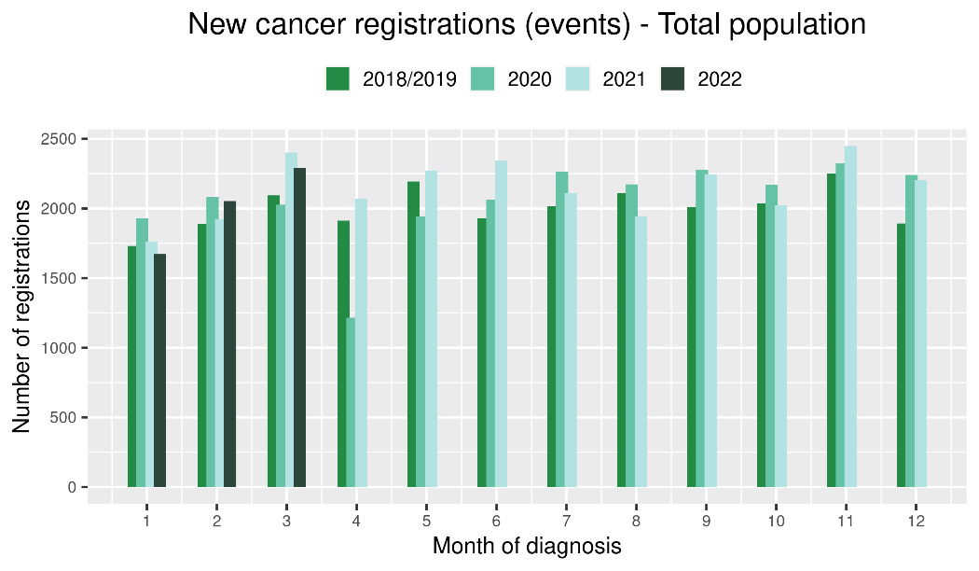 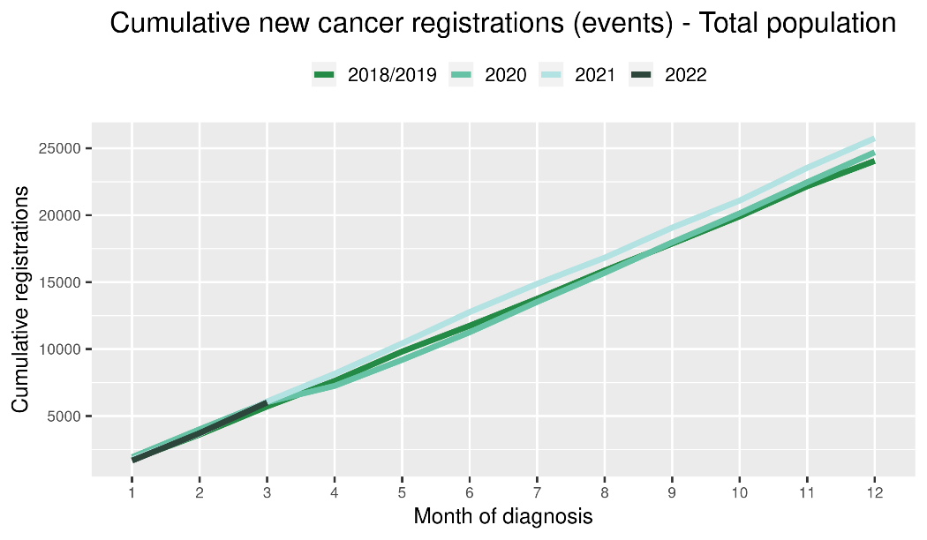

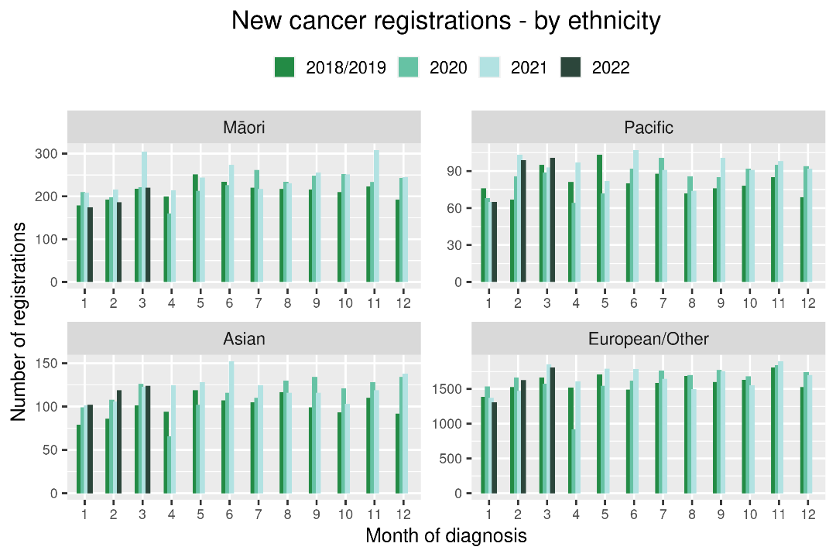 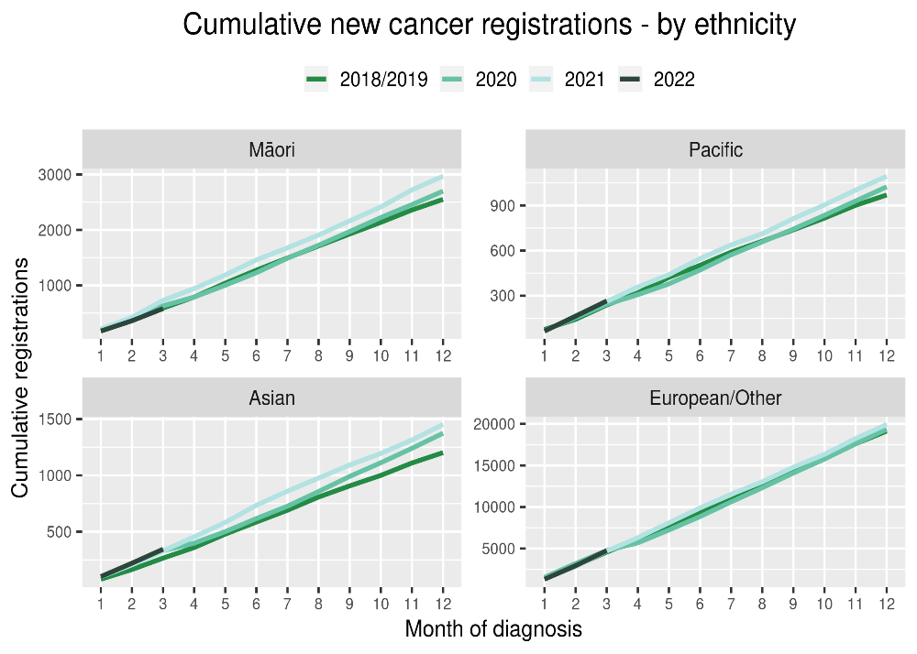

Table 2: Number of provisional cancer registrations* and percentage difference in 2022 compared to the average of 2018 and 2019, by month and cumulative year to date, by tumour group

|  |  |  |  |  |  |  |  |  |  |  |  |  |
| --- | --- | --- | --- | --- | --- | --- | --- | --- | --- | --- | --- | --- |
|  | **January** | | | **February** | | | **March** | | | **Cumulative January-March** | | |
| **Tumour group** | **2018/19** | **2022** | **%change** | **2018/19** | **2022** | **%change** | **2018/19** | **2022** | **%change** | **2018/19** | **2022** | **%change** |
| Breast | 259 | 232 | -10% | 282 | 301 | 7% | 295 | 346 | 17% | 835 | 879 | 5% |
| Colorectal | 222 | 244 | 10% | 243 | 297 | 22% | 269 | 310 | 15% | 734 | 851 | 16% |
| Gynaecology | 86 | 74 | -13% | 86 | 84 | -2% | 82 | 111 | 35% | 254 | 269 | 6% |
| Haematology and Lymphoid | 184 | 162 | -12% | 192 | 191 | -1% | 211 | 209 | -1% | 586 | 562 | -4% |
| Melanoma and non-melanoma skin cancer | 256 | 226 | -12% | 272 | 345 | 27% | 324 | 353 | 9% | 851 | 924 | 9% |
| Other digestive system | 116 | 109 | -6% | 110 | 124 | 13% | 128 | 166 | 30% | 354 | 399 | 13% |
| Prostate | 256 | 246 | -4% | 310 | 293 | -5% | 370 | 328 | -11% | 936 | 867 | -7% |
| Respiratory and thorax | 128 | 149 | 16% | 148 | 127 | -14% | 155 | 150 | -3% | 431 | 426 | -1% |
| Urinary system | 76 | 71 | -6% | 83 | 62 | -25% | 90 | 107 | 19% | 248 | 240 | -3% |

*This analysis uses provisional data for the 2021 registrations, some cancers may initially be classified as ‘non-specified’ and subsequently be re-classified into one of the cancer groups as more information becomes available.

Figure 2: Number of cancer registrations by month, 2018/19 average, 2020, 2021 and 2022, by tumour group

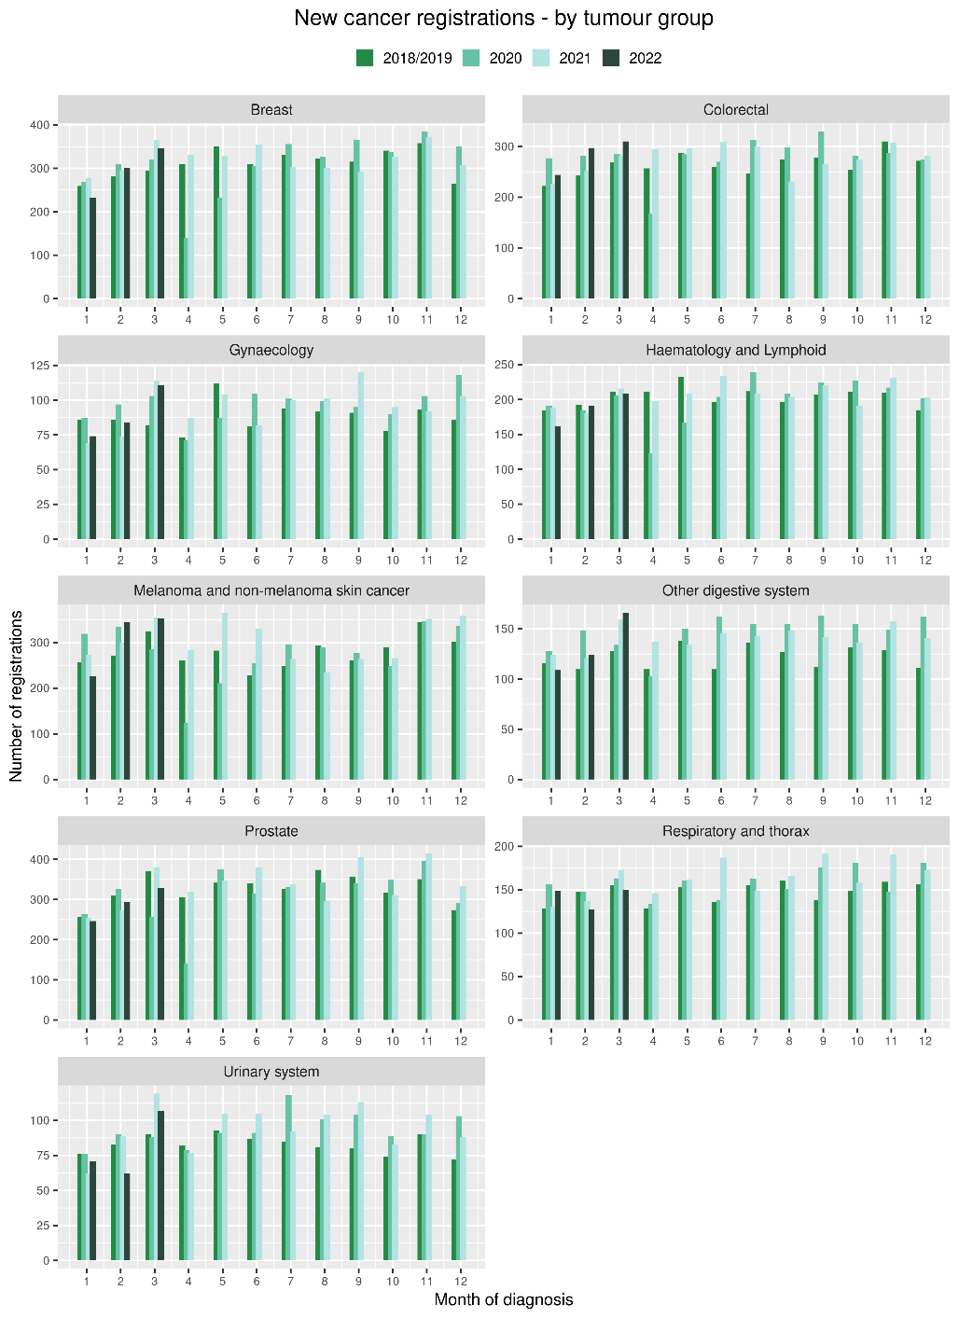 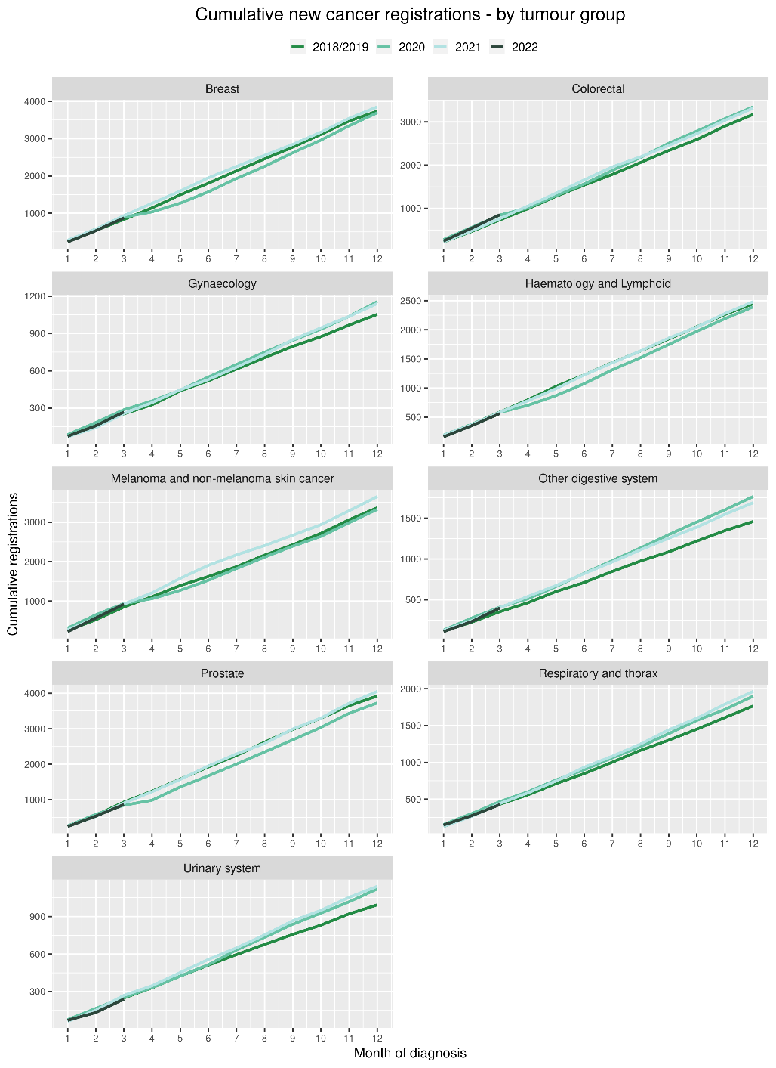

# Gastrointestinal endoscopy

## Notes on data

* Gastrointestinal endoscopy data were extracted from the National Non-admitted Patient Collection (NNPAC) and National Minimum Dataset (NMDS) on 05 May 2022.
* Includes colonoscopies and gastroscopies for all indications – not just cancer.
* Technical information: gastroscopies (Purchase Unit Code: MS02005), colonoscopies (Purchase Unit Code: MS02007), combined gastroscopies and colonoscopies (Purchase Unit Code: MS02014).

## Key points

* There was an increase of 9% in gastrointestinal endoscopies performed in March 2022, compared to March 2018/19. For Māori, this increase was 27% compared to 2018/19.
* For 2022 thus far, there is an 11% increase in gastrointestinal endoscopies compared with 2018/19.

## Results

Table 3: Number of colonoscopy and gastroscopy procedures and percentage difference in 2022 compared to the average of 2018 and 2019, by month and cumulative year to date, by ethnicity

|  |  |  |  |  |  |  |  |  |  |  |  |  |
| --- | --- | --- | --- | --- | --- | --- | --- | --- | --- | --- | --- | --- |
|  | **January** | | | **February** | | | **March** | | | **Cumulative January -March** | | |
|  | **2018/2019** | **2022** | **% change** | **2018/2019** | **2022** | **% change** | **2018/2019** | **2022** | **% change** | **2018/2019** | **2022** | **% change** |
| Māori | 447 | 541 | 21% | 480 | 635 | 32% | 516 | 655 | 27% | 1,442 | 1831 | 27% |
| Pacific Peoples | 159 | 198 | 25% | 188 | 258 | 38% | 203 | 234 | 16% | 549 | 690 | 26% |
| Non-Māori/Non-Pacific | 4,392 | 4,341 | -1% | 4,774 | 5,741 | 20% | 5,265 | 5,624 | 7% | 14,430 | 15,706 | 9% |
| Total Population | 4,998 | 5,080 | 2% | 5,441 | 6,634 | 22% | 5,983 | 6,513 | 9% | 16,421 | 18,227 | 11% |

Figure 3: Number of gastrointestinal endoscopy procedures by month, 2018/19 average, 2020, 2021 and 2022 total population and Māori

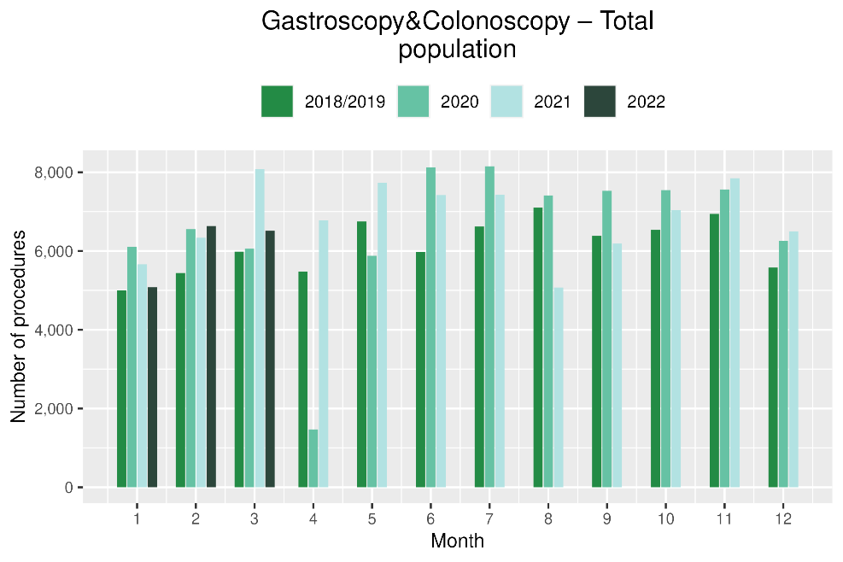 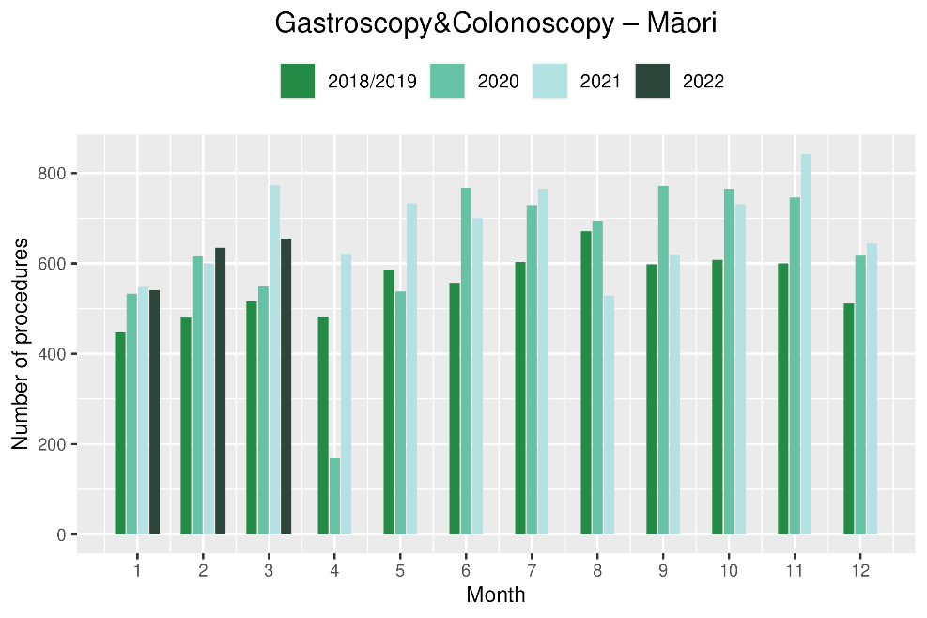

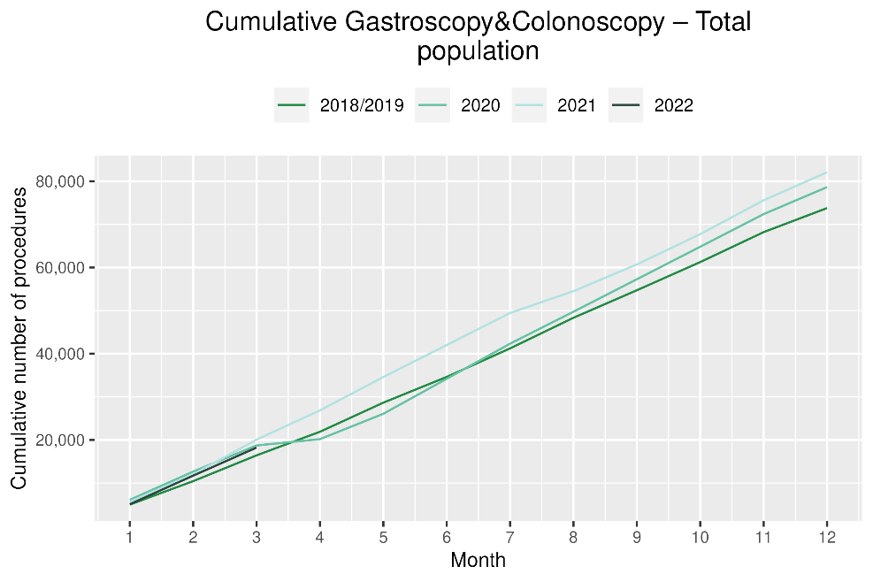 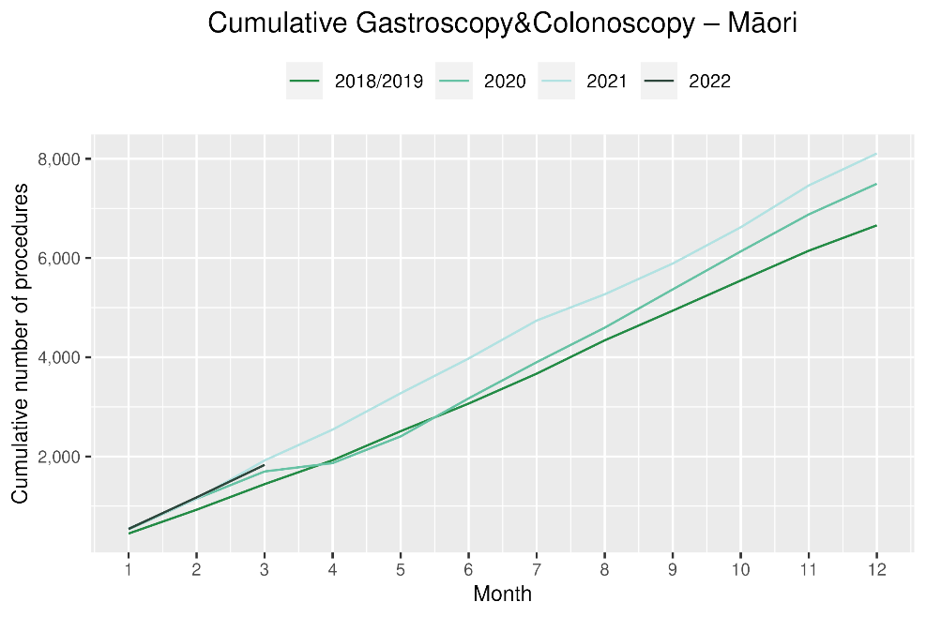

# Bronchoscopy

## Notes on data

* Bronchoscopy and CT Lung Biopsy data were extracted from NNPAC and NMDS on 05 May 2022.
* These data include bronchoscopies for all indications, not solely cancer related procedures.
* Technical information: bronchoscopies (Purchase Unit Code: MS02003) and CT Lung Biopsy (Procedure code: 3841808)

## Key points

* March 2022 showed a 7% decrease in the number of bronchoscopies performed compared to March 2018/19. For Māori there was an increase of 2% using the same comparison. For 2022 to date, there was an 11% decrease in bronchoscopies compared with 2018/19.
* Te Aho o Te Kahu has discussed the potential reasons for the overall decrease in bronchoscopy volumes with respiratory physicians in the sector. It has been highlighted that due to the risks of COVID-19 transmission, logistical challenges and other factors, there has been a shift in modes of diagnosis for lung cancer away from bronchoscopy (noting that bronchoscopy is performed for a number of reasons, not just cancer diagnosis). These modes are thought to include Endobronchial Ultrasound Bronchoscopy (EBUS), Positron Emission Tomography - Computed Tomography (PET CT) scans and CT lung biopsy. We have not reported PET CT and EBUS data are not reported here because the clinical coding of these procedures is not anatomically specific, meaning that we would not know whether they were performed on the lung. CT lung biopsy data were examined and are presented below (figure 5); however, although due to limited availability of pre-pandemic data, it is difficult to interpret whether any changes in the volume of these procedures have occurred.

## Results

Table 4: Number of bronchoscopies and percentage difference in 2022 compared to the average of 2018 and 2019, by month and cumulative year to date, by ethnicity

|  |  |  |  |  |  |  |  |  |  |  |  |  |
| --- | --- | --- | --- | --- | --- | --- | --- | --- | --- | --- | --- | --- |
|  | **January** | | | **February** | | | **March** | | | **Cumulative January -March** | | |
|  | **2018/2019** | **2022** | **% change** | **2018/2019** | **2022** | **% change** | **2018/2019** | **2022** | **% change** | **2018/2019** | **2022** | **% change** |
| Māori | 33 | 35 | 8% | 33 | 30 | -9% | 32 | 32 | 2% | 97 | 97 | 0% |
| Pacific Peoples | 9 | 7 | -18% | 9 | 12 | 33% | 9 | 10 | 18% | 26 | 29 | 12% |
| Non-Māori/Non-Pacific | 172 | 131 | -24% | 158 | 146 | -7% | 169 | 152 | -10% | 498 | 429 | -14% |
| Total Population | 213 | 173 | -19% | 200 | 188 | -6% | 209 | 194 | -7% | 621 | 555 | -11% |

*Due to small numbers, monthly figures have not been included for Māori and Pacific peoples

Figure 4: Number of bronchoscopies by month, 2018/19 average, 2020, 2021 and 2022, total population and Māori

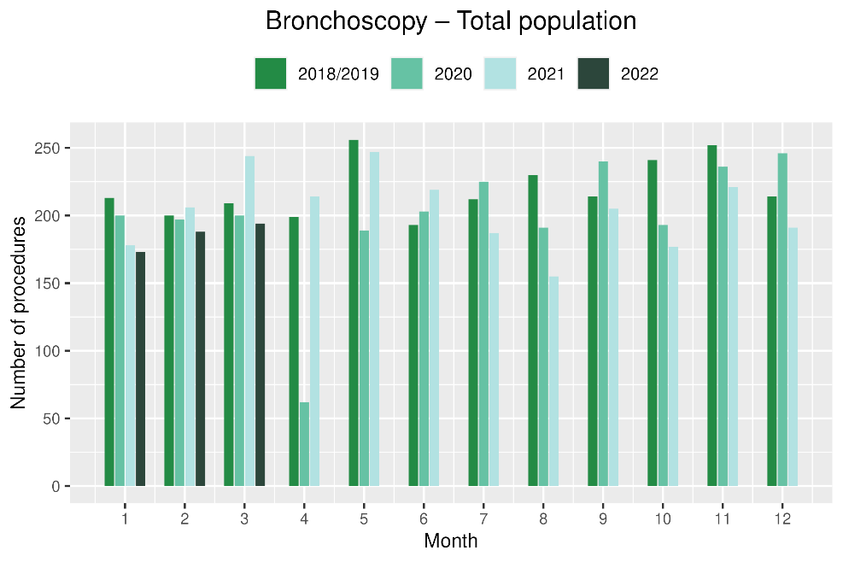 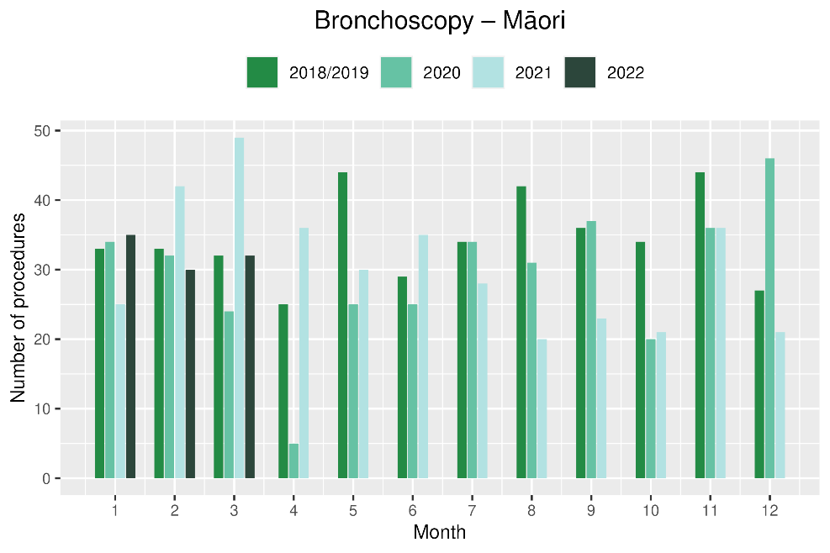

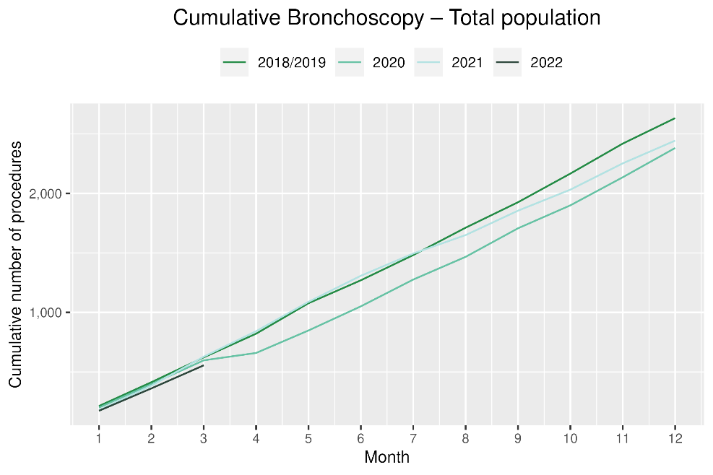 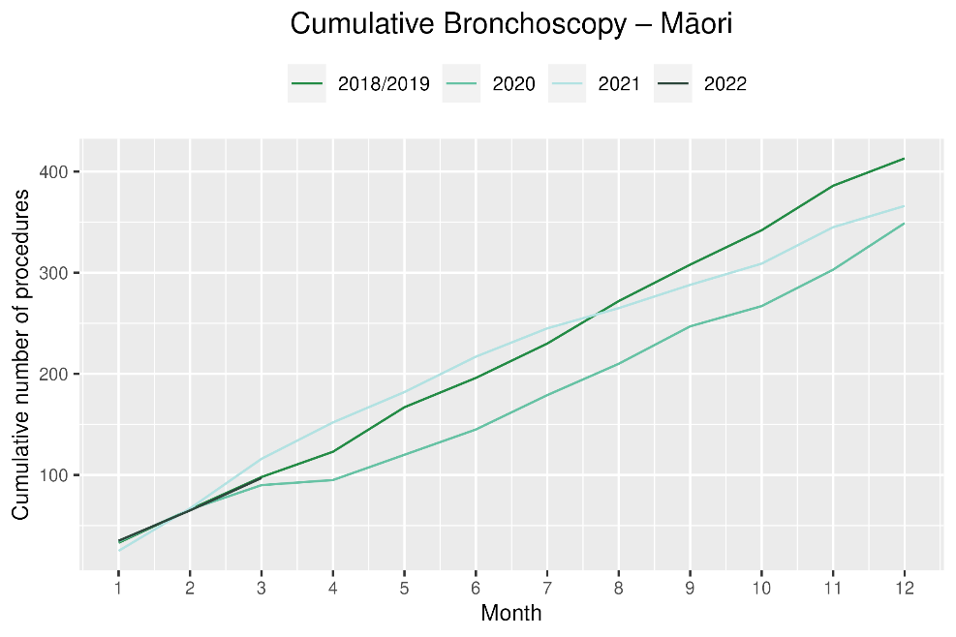

Figure 5: Number of CT lung biopsies by month, July 2019 to March 2022, total population and Māori

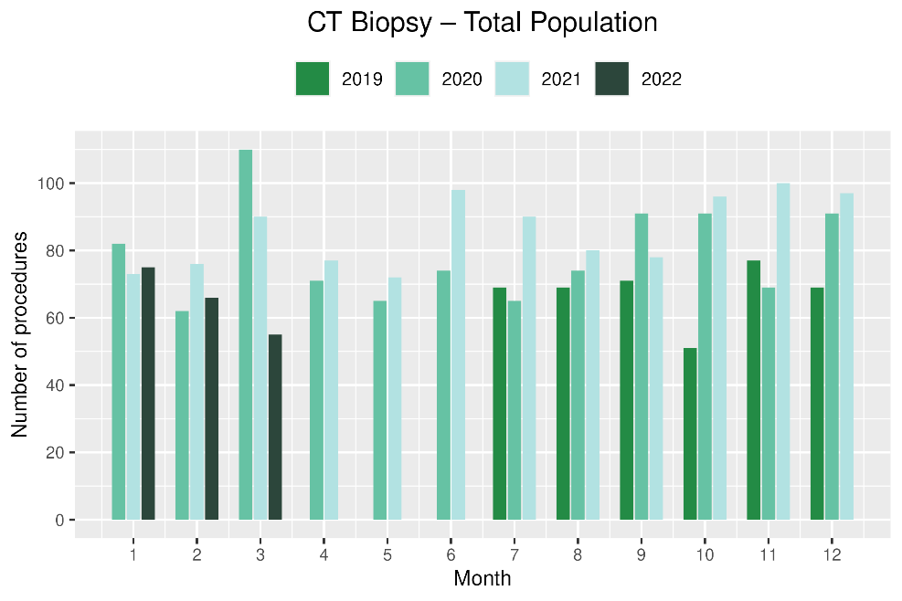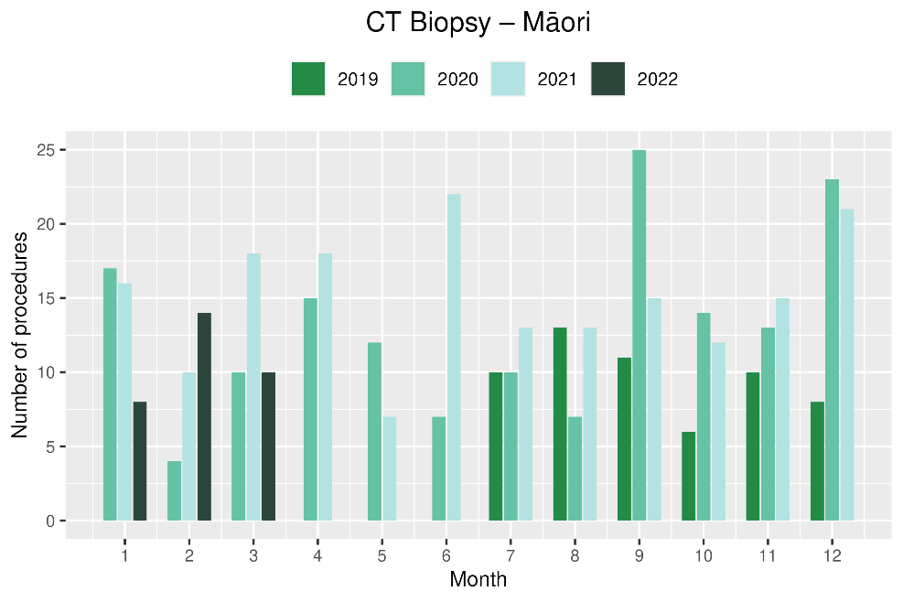

# Faster cancer treatment

## Notes on data

* The data were extracted from the Faster Cancer Treatment (FCT) database on 9 May 2022. Fast Cancer Treatment Data is reported quarterly.
* These data aim to capture a broader part of the diagnostic and referral pathway; however, they only include a subset of people being investigated for cancer.
* Data relate to the 62-day pathway and includes patients with a high-suspicion of cancer and a need to be seen within two weeks. These patients should receive their first treatment within 62-day of receipt of referral. The target is 90% and Te Aho o Te Kahu has an escalation pathway for monitoring the performance of DHBs against the 62-day measure. Escalation includes regular meetings with service teams and CE to CE discussions against recovery planning and actions.
* Analysis includes all referrals onto the 62-day pathway and does not include comparisons with the same time period in 2018/19.

## Key points

* For the number of referrals with a high suspicion of cancer, volumes in February and March 2022 are similar to the preceding two quarters.
* The proportion of referrals meeting the 62-day target (patients receiving their first treatment within 62 days of receipt of referral) has remained stable overall with a decrease in proportion for the total population in February 2022 that was not seen in March 2022. For January and March 2022 there was a decrease in proportion of Māori patients with a high suspicion of cancer who received their first treatment within 62 days (noting smaller numbers), however this was not the case in February 2022 where there was an increase for Māori.
* The FCT data suggest that people who presented to their GP with signs/symptoms highly suspicious of cancer are still being referred through to secondary care.

## Results

Table 5: Number of referrals for patients with a high suspicion of cancer, by month, and cumulative from October 2021 to date

|  |  |  |  |  |  |  |  |  |
| --- | --- | --- | --- | --- | --- | --- | --- | --- |
|  |  | **October 2021** | **November 2021** | **December 2021** | **January 2022** | **February 2022** | **March 2022** | **Total October 2021 to March 2022** |
|  | Māori | 68 | 68 | 55 | 61 | 52 | 52 | 356 |
|  | Non-Māori/Non-Pacific | 306 | 443 | 387 | 291 | 371 | 395 | 2,193 |

*Due to small numbers, volumes have not been included for Pacific peoples and total population

Table 6: Proportion of patients with a high-suspicion of cancer and a need to be seen within 2-weeks receiving their first treatment within 62 day of receipt of referral, by month, and average from October 2021 to date

|  |  |  |  |  |  |  |  |  |
| --- | --- | --- | --- | --- | --- | --- | --- | --- |
|  |  | **October 2021** | **November 2021** | **December 2021** | **January 2022** | **February 2022** | **March 2022** | **Total October 2021 to March 2022** |
|  | Māori | 85% | 81% | 84% | 78% | 90% | 81% | 83% |
|  | Non-Māori/Non-Pacific | 82% | 90% | 87% | 88% | 80% | 84% | 85% |
|  | Total Population | 83% | 89% | 87% | 86% | 80% | 84% | 85% |

*Due to small numbers, percentages have not been included for Pacific peoples

Figure 10: Proportion of patients with a high-suspicion of cancer and a need to be seen within 2-weeks receiving their first treatment within 62 day of receipt of referral, by ethnicity, in 2021 by month

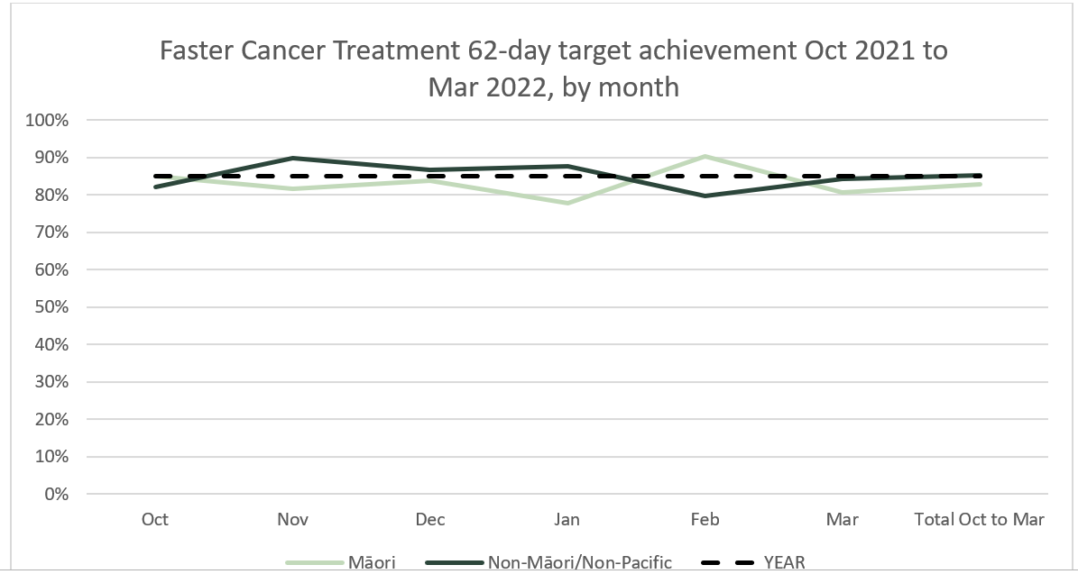

# Combined cancer surgery

## Notes on data

* This report includes data on surgery for colorectal, lung and prostate cancer. These cancers were chosen because Te Aho o Te Kahu already has a pre-validated list of surgical procedure codes for these cancers, agreed on as part of the quality performance indicator (QPI) work programme[2]. These three cancers are therefore used as case studies for cancer surgery more generally. The surgical procedure codes are listed in Appendix 5.
* The data were extracted from the NMDS on 05 May 2022.

## Key points

* In March 2022, there were 2% fewer cancer surgeries (prostate, lung and colorectal) compared to March 2018/19. For 2022 to date there were 4% fewer surgeries performed compared to 2018/19.
* For Māori there was a 17% increase in combined cancer surgeries for January, February and March 2022 (cumulative) compared with 2018/19, and for Pacific peoples this increase was 15%, noting small numbers for both these groups (and particularly for Pacific peoples).

## Results

Table 7: Number of cancer surgeries (prostate, colorectal, lung) and percentage difference in 2022 compared to the average of 2018 and 2019 by month and cumulative year to date, by ethnicity

|  |  |  |  |  |  |  |  |  |  |  |  |  |
| --- | --- | --- | --- | --- | --- | --- | --- | --- | --- | --- | --- | --- |
|  | **January** | | | **February** | | | **March** | | | **Cumulative January -March** | | |
|  | **2018/19** | **2022** | **% change** | **2018/19** | **2022** | **% change** | **2018/19** | **2022** | **% change** | **2018/19** | **2022** | **% change** |
| Māori | * | * | * | * | * | * | * | * | * | 87 | 101 | 17% |
| Pacific Peoples | * | * | * | * | * | * | * | * | * | 20 | 23 | 15% |
| Non-Māori/Non-Pacific | 235 | 190 | -19% | 259 | 265 | 2% | 317 | 305 | -4% | 811 | 760 | -6% |
| Total Population | 265 | 224 | -15% | 291 | 308 | 6% | 361 | 352 | -2% | 917 | 884 | -4% |

*Due to small numbers, monthly figures have not been included for Māori and Pacific peoples

Figure 7: Number of cancer surgeries (prostate, colorectal, lung) by month, 2018/19 average, 2020, 2021 and 2022, total population and Māori

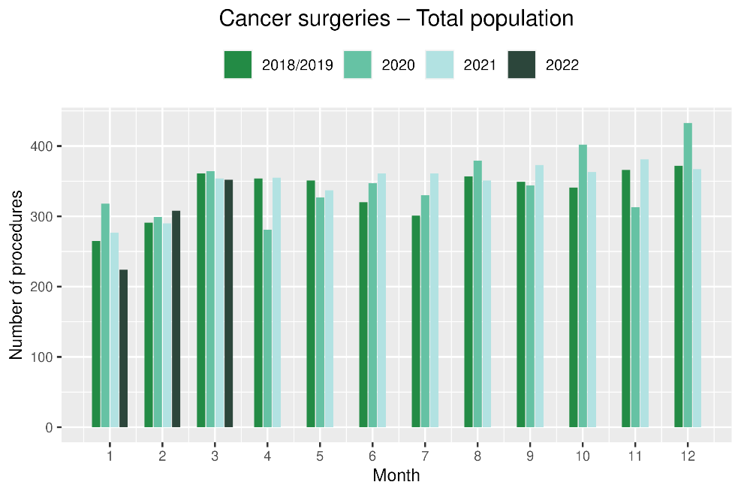 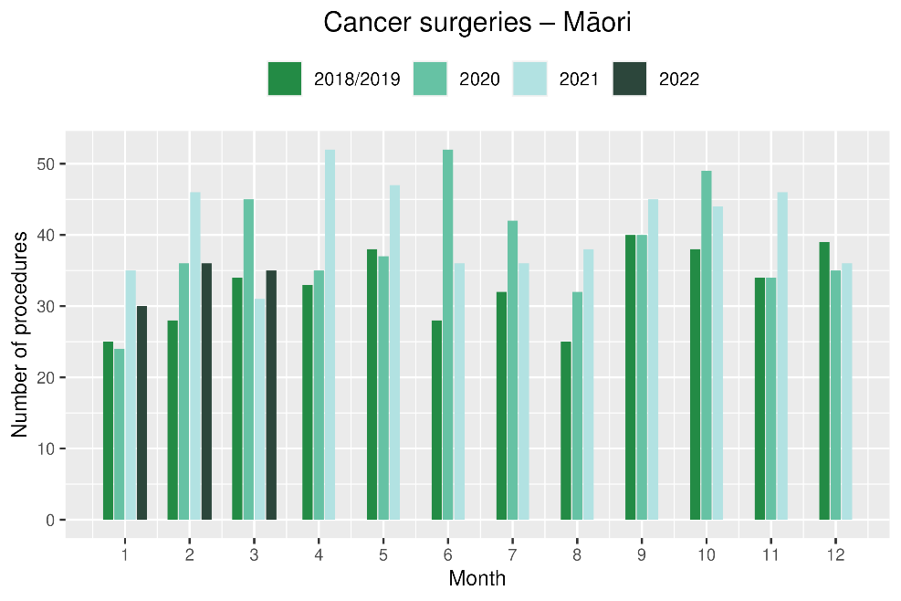

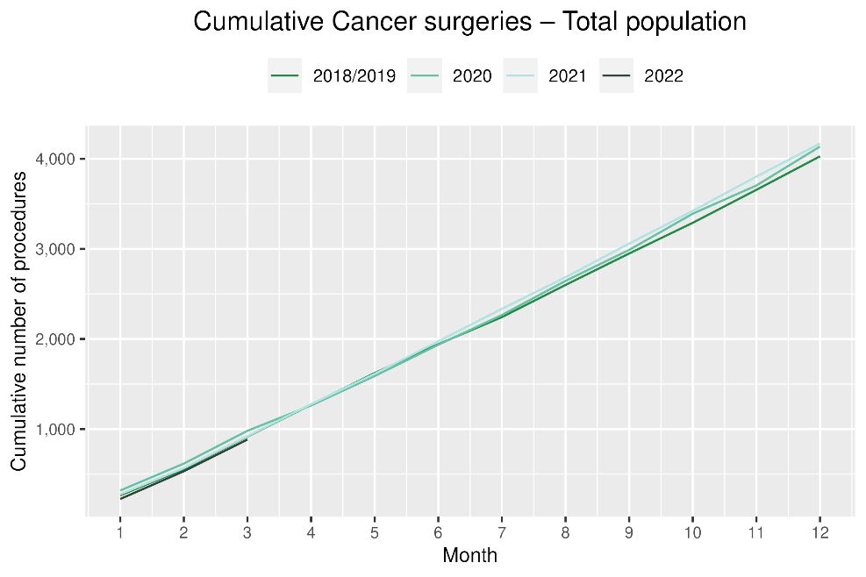 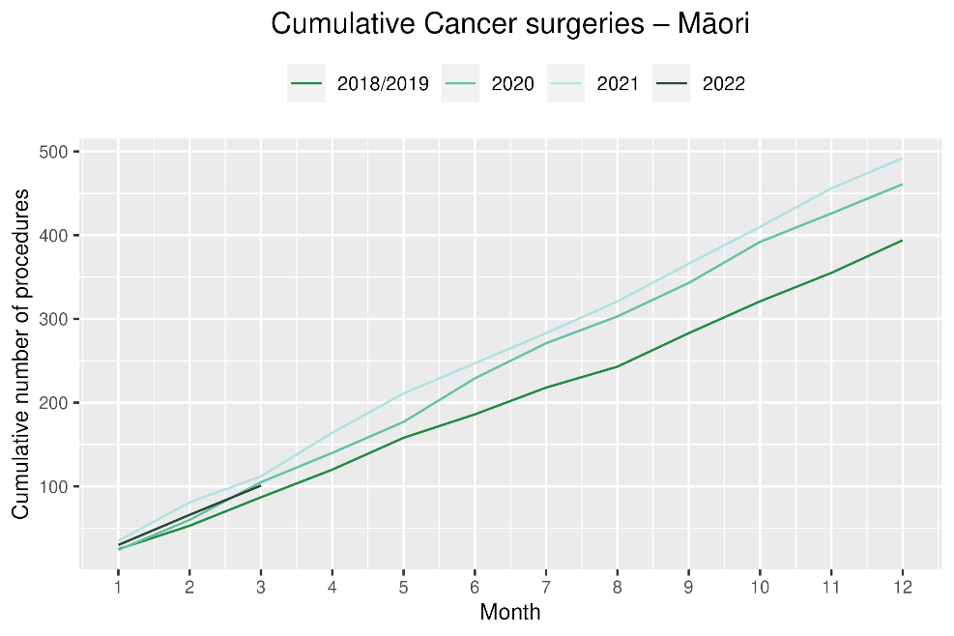

# Colorectal cancer surgery

## Notes on data

* The surgical procedure codes used for analysing colorectal cancer are listed in Appendix 5.
* The data were extracted from the NMDS on 05 May 2022.

## Key points

* There were 9% fewer colorectal cancer surgeries performed in March 2022 compared with March 2018/19.
* For 2022 to date (cumulative), there were 8% fewer colorectal cancer surgeries performed in total, 4% fewer for Pacific peoples (noting small numbers) and a 22% increase for Māori compared with 2018/19.

## Results

Table 8: Number of colorectal cancer surgeries and percentage difference in 2022 compared to the average of 2018 and 2019, by month and cumulative year to date, by ethnicity

|  |  |  |  |  |  |  |  |  |  |  |  |  |
| --- | --- | --- | --- | --- | --- | --- | --- | --- | --- | --- | --- | --- |
|  | **January** | | | **February** | | | **March** | | | **Cumulative January -March** | | |
|  | **2018/2019** | **2022** | **% change** | **2018/2019** | **2022** | **% change** | **2018/2019** | **2022** | **% change** | **2018/2019** | **2022** | **% change** |
| Māori | * | * | * | * | * | * | * | * | * | 48 | 58 | 22% |
| Pacific Peoples | * | * | * | * | * | * | * | * | * | 12 | 11 | -4% |
| Non-Māori/Non-Pacific | 158 | 122 | -23% | 165 | 163 | -1% | 206 | 183 | -11% | 528 | 468 | -11% |
| Total Population | 174 | 137 | -21% | 185 | 191 | 4% | 229 | 209 | -9% | 587 | 537 | -8% |

*Due to small numbers, monthly figures have not been included for Māori and Pacific peoples

**Figure 8: Number of colorectal cancer surgeries by month, 2018/19 average, 2020, 2021 and 2022, total population and Māori**

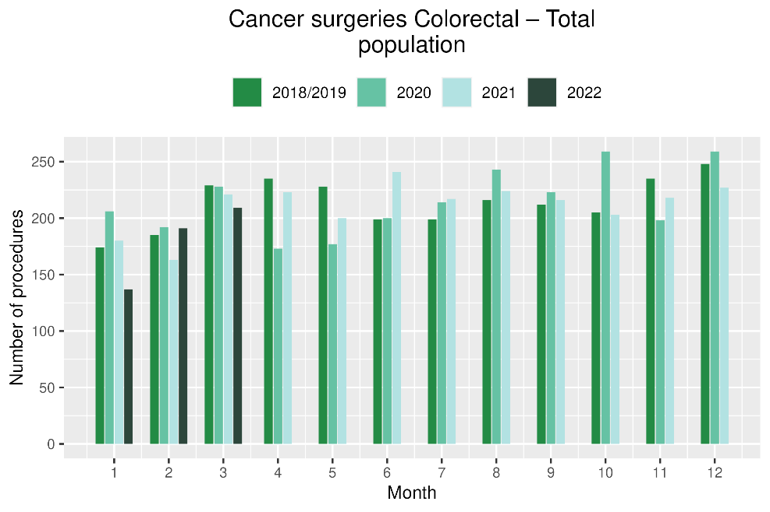 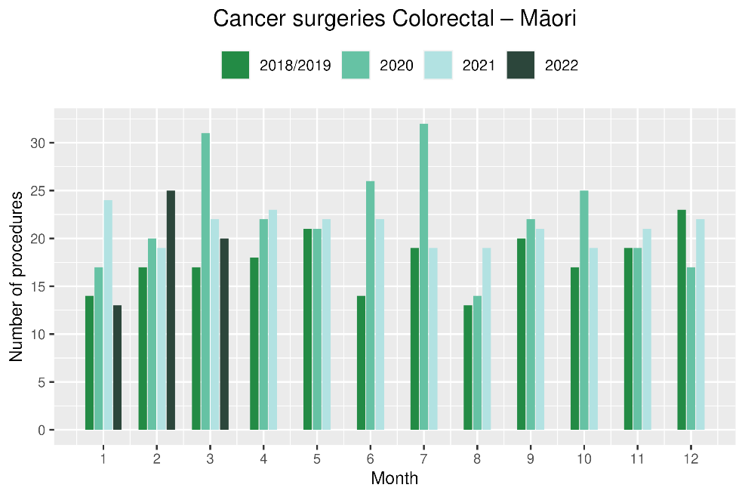

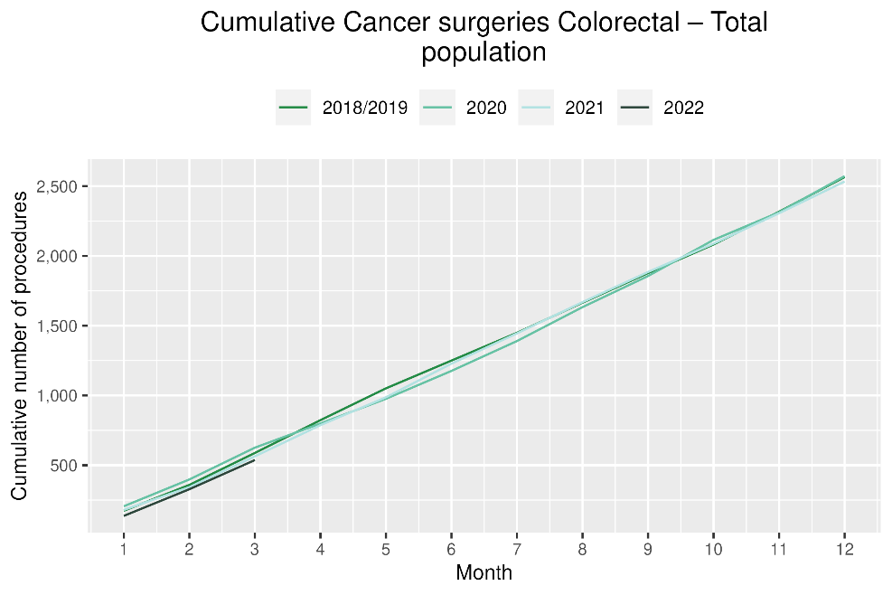 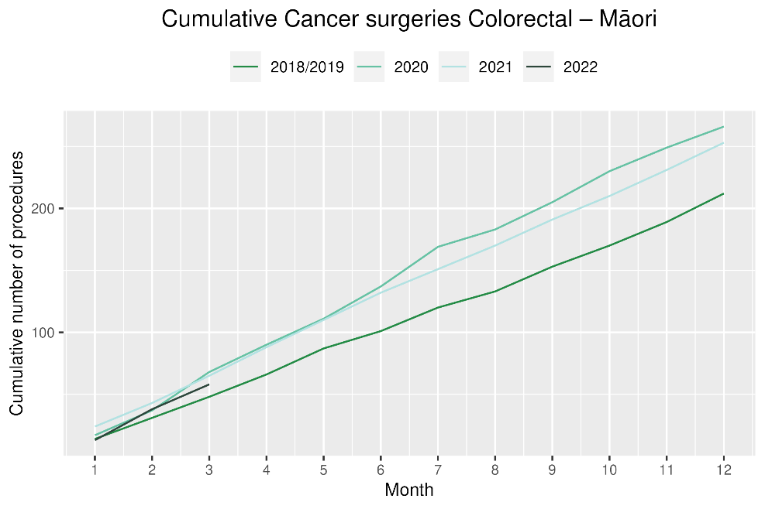

# Lung cancer surgery

## Notes on data

* A list of the surgical procedure codes used for analysis are included in Appendix 5.
* The data were extracted from the NMDS on 05 May 2022.
* The number of lung cancer surgeries performed each month is relatively small, so caution is needed when comparing data by month.

## Key points

* There was no change in the number of lung cancer surgeries performed in March 2022 compared with March 2018/19.
* For 2022, cumulatively, there was a 4% decrease in surgeries performed, reflecting the lower numbers of surgeries seen in January 2022 compared with January 2018/19.

## Results

Table 9: Number of lung cancer surgeries and percentage difference in 2022 compared to the average of 2018 and 2019, by month and cumulative year to date, by ethnicity

|  |  |  |  |  |  |  |  |  |  |  |  |  |
| --- | --- | --- | --- | --- | --- | --- | --- | --- | --- | --- | --- | --- |
|  | **January** | | | **February** | | | **March** | | | **Cumulative January -March** | | |
|  | **2018/2019** | **2022** | **% change** | **2018/2019** | **2022** | **% change** | **2018/2019** | **2022** | **% change** | **2018/2019** | **2022** | **% change** |
| Māori | * | * | * | * | * | * | * | * | * | * | * | * |
| Pacific Peoples | * | * | * | * | * | * | * | * | * | * | * | * |
| Non-Māori/Non-Pacific | 38 | 27 | -28% | 43 | 45 | 6% | 52 | 54 | 5% | 132 | 126 | -4% |
| Total Population | 47 | 37 | -21% | 53 | 56 | 6% | 65 | 65 | 0% | 165 | 158 | -4% |

* Due to small numbers, monthly figures have not been included for Māori and Pacific peoples

Figure 9: Number of lung cancer surgeries by month, 2018/19 average, 2020, 2021 and 2022, total population and Māori

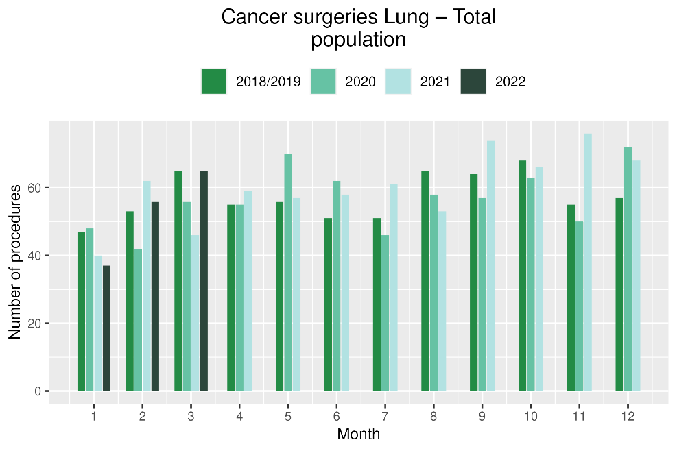 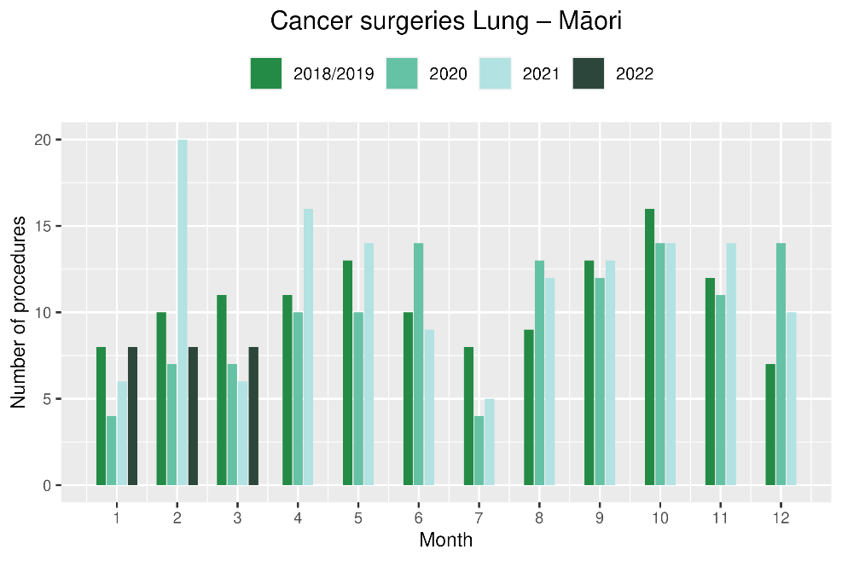

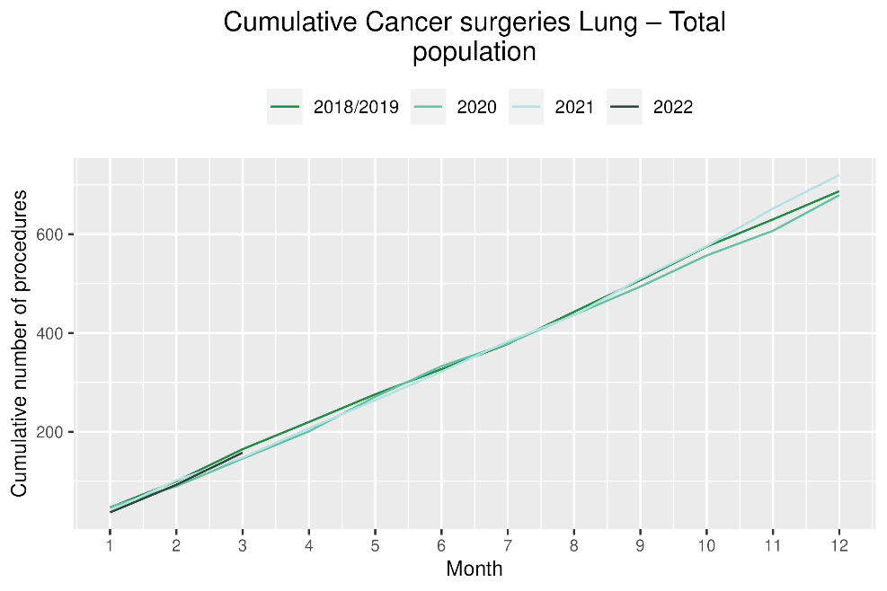 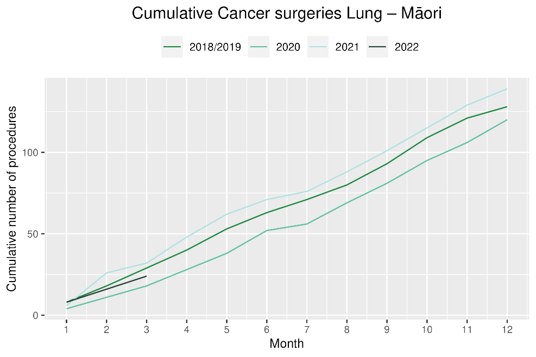

# Prostate cancer surgery

## Notes on data

* A list of the surgical procedure codes used for analysis are included in Appendix 5.
* The data was extracted from the NMDS on 05 May 2022.
* The volumes for prostate surgery are higher in this report than previously reported due to the inclusion of data from a private provider who provides publicly funded surgery.
* The number of prostate cancer surgeries performed each month is relatively small, so caution is needed when comparing data by month.

## Key points

* There was a 16% increase in prostate cancer surgeries performed in March 2022 compared with March 2018/19.
* For January, February and March 2022 combined there were 14% more prostate cancer surgeries compared with cumulative figures from 2018/19.

## Results

Table 10: Number of prostate cancer surgeries and percentage difference in 2022 compared to the average of 2018 and 2019 by month and cumulative year to date

|  |  |  |  |  |  |  |  |  |  |  |  |  |
| --- | --- | --- | --- | --- | --- | --- | --- | --- | --- | --- | --- | --- |
|  | **January** | | | **February** | | | **March** | | | **Cumulative January -March** | | |
|  | **2018/19** | **2022** | **% change** | **2018/19** | **2022** | **% change** | **2018/19** | **2022** | **% change** | **2018/19** | **2022** | **% change** |
| Total Population | 45 | 50 | 12% | 54 | 61 | 14% | 68 | 78 | 16% | 166 | 189 | 14% |

* Due to small numbers, monthly figures have not been included by ethnicity

Figure 10: Number of prostate cancer surgeries by month, 2018/19 average, 2020,2021 and 2022, total population and Māori

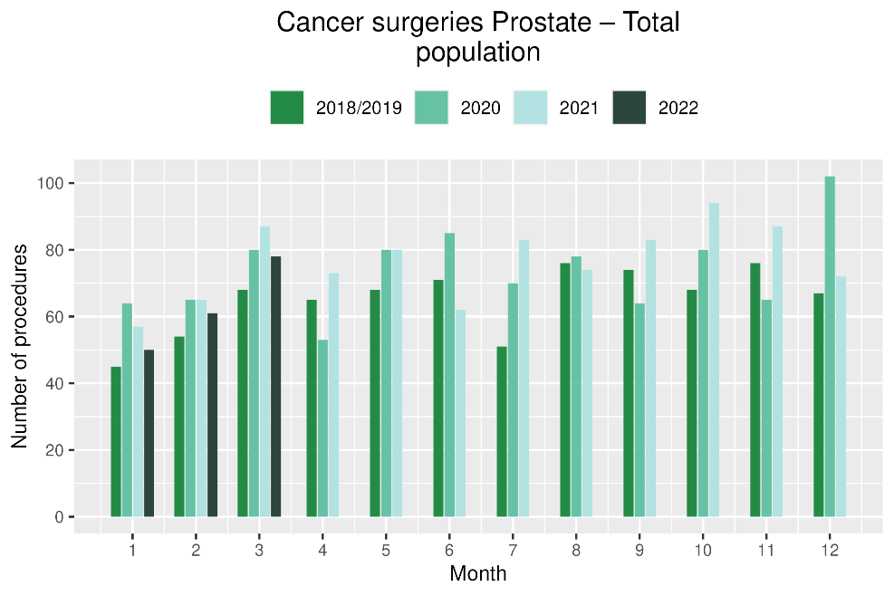 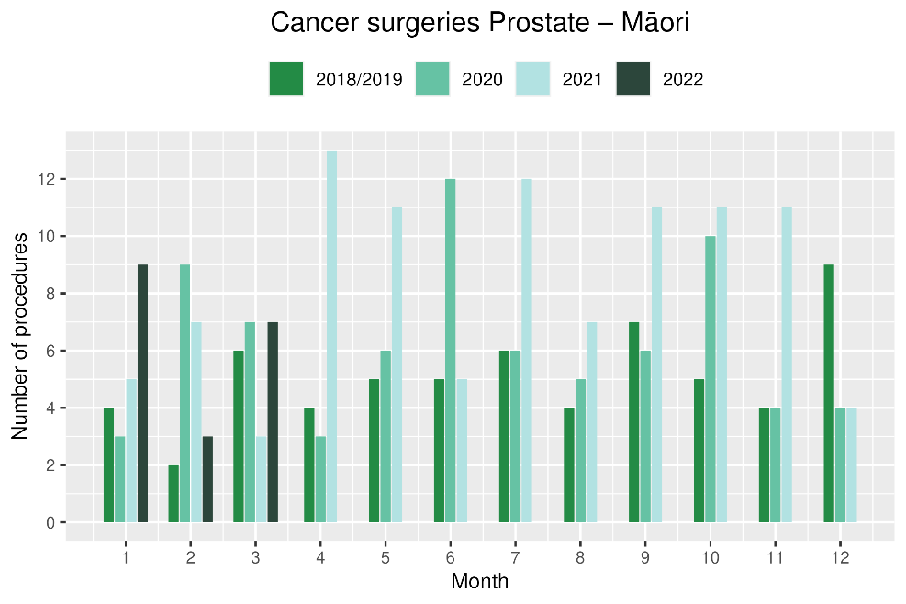

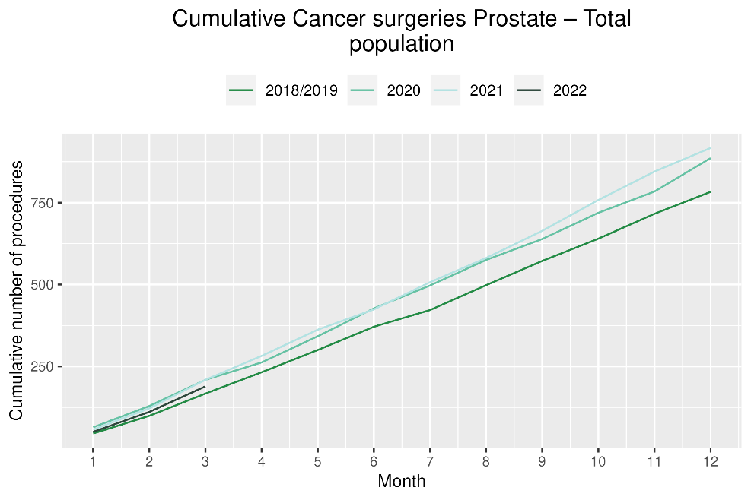 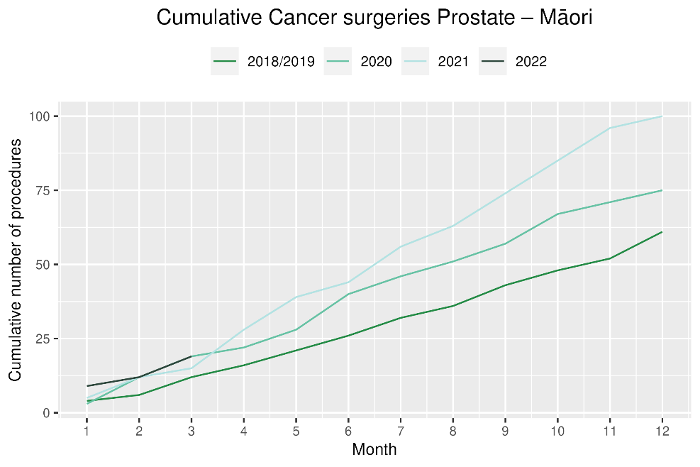

# Medical oncology

## Notes on data

* Data were extracted from NNPAC 05 May 2022.
* First specialist assessment (FSA) reflects counts of first attendance for specialist medical oncology assessment.
* Intravenous (IV) chemotherapy reflects appointments for outpatient and inpatient IV chemotherapy for non-haematological indications.
* Technical information: medical oncology FSA (Purchase Unit Code: M50020) and IV chemotherapy (Purchase Unit Code: MS02009).

## Key points

* Attendances for medical oncology first specialist assessments (FSAs) increased by 16% in March 2022 compared to March 2018/19. For Māori, there was a 41% increase in FSAs in March 2022 compared to March 2018/19. For 2022 to date, there was a 9% increase in medical oncology FSAs compared with 2018/19.
* Attendances for intravenous (IV) chemotherapy increased by 16% in March 2022 compared to March 2018/19. For Māori, there was a 40% increase in IV chemotherapy in March 2022 compared to March 2018/19. For 2022 to date, there was a 10% increase in IV chemotherapy compared with 2018/19.

## Results

Table 11: Number of medical oncology first specialist assessments and percentage difference in 2022 compared to the average of 2018 and 2019, by month and cumulative year to date, by ethnicity

|  |  |  |  |  |  |  |  |  |  |  |  |  |
| --- | --- | --- | --- | --- | --- | --- | --- | --- | --- | --- | --- | --- |
|  | **January** | | | **February** | | | **March** | | | **Cumulative January -March** | | |
|  | **2018/19** | **2022** | **% change** | **2018/19** | **2022** | **% change** | **2018/19** | **2022** | **% change** | **2018/19** | **2022** | **% change** |
| Māori | 86 | 81 | -6% | 97 | 123 | 27% | 97 | 136 | 41% | 280 | 340 | 22% |
| Pacific Peoples | 27 | 37 | 37% | 28 | 35 | 25% | 33 | 42 | 27% | 88 | 114 | 30% |
| Non-Māori/Non-Pacific | 581 | 515 | -11% | 572 | 629 | 10% | 615 | 738 | 20% | 1,768 | 1,882 | 6% |
| Total Population | 694 | 633 | -9% | 697 | 787 | 13% | 745 | 916 | 23% | 2,135 | 2,336 | 9% |

Figure 11: Number of medical oncology first specialist assessments by month, 2018/19 average, 2020, 2021 and 2022, total population and Māori

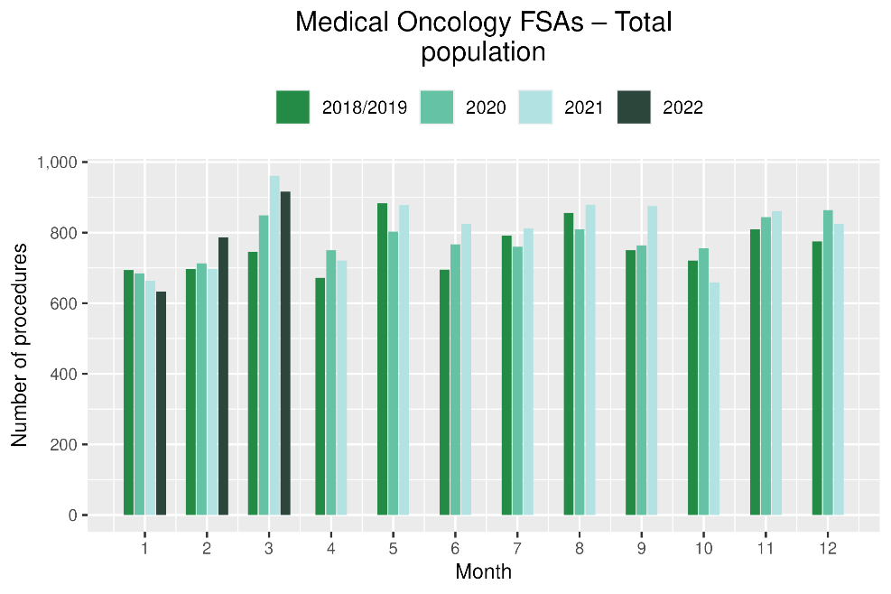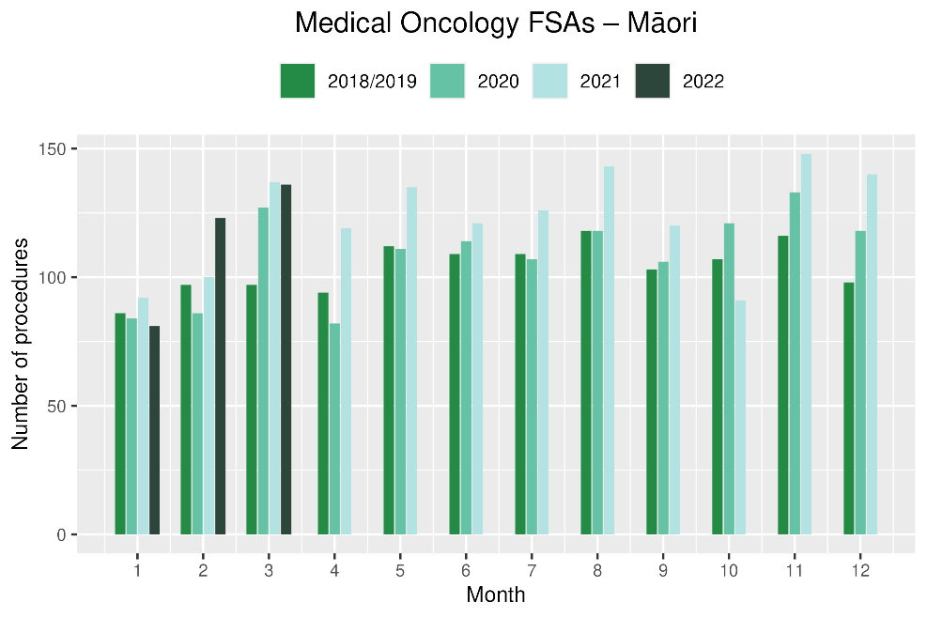

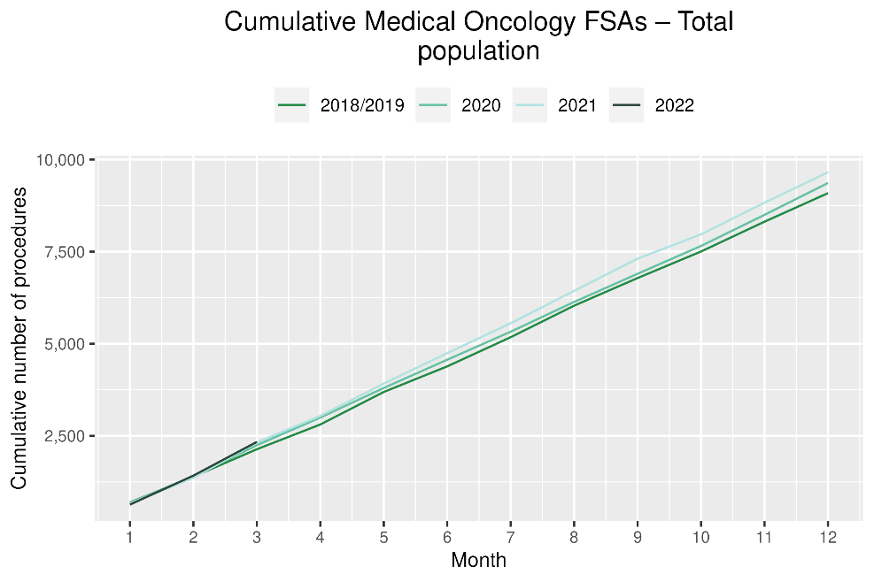 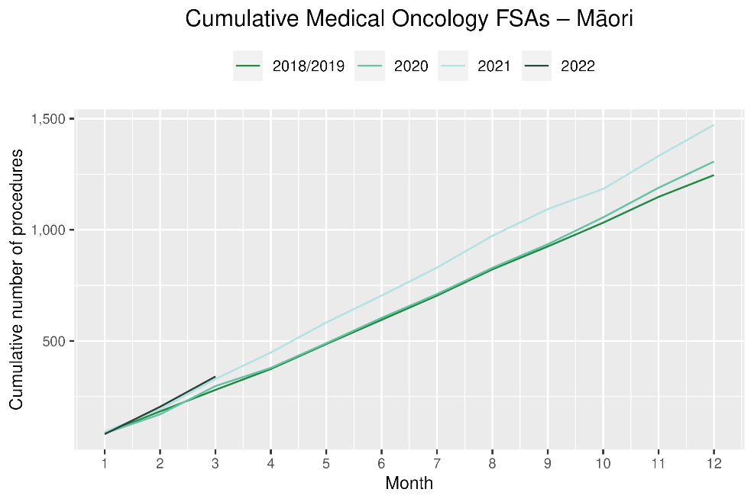

Table 12: Number of IV chemotherapy attendances and percentage difference in 2022 compared to the average of 2018 and 2019, by month and cumulative year to date, by ethnicity

|  |  |  |  |  |  |  |  |  |  |  |  |  |
| --- | --- | --- | --- | --- | --- | --- | --- | --- | --- | --- | --- | --- |
|  | **January** | | | **February** | | | **March** | | | **Cumulative January -March** | | |
|  | **2018/2019** | **2022** | **% change** | **2018/2019** | **2022** | **% change** | **2018/2019** | **2022** | **% change** | **2018/2019** | **2022** | **% change** |
| Māori | 724 | 935 | 29% | 664 | 877 | 32% | 709 | 994 | 40% | 2,097 | 2,806 | 34% |
| Pacific Peoples | 274 | 345 | 26% | 240 | 337 | 40% | 264 | 365 | 39% | 777 | 1,047 | 35% |
| Non-Māori/Non-Pacific | 4,935 | 4,709 | -5% | 4,429 | 4,779 | 8% | 4,765 | 5,324 | 12% | 14,128 | 14,812 | 5% |
| Total Population | 5,932 | 5,989 | 1% | 5,333 | 5,993 | 12% | 5,738 | 6,683 | 16% | 17,002 | 18,665 | 10% |

Figure 12: Number of IV chemotherapy attendances by month, 2018/19 average, 2020 and 2021, total population and Māori

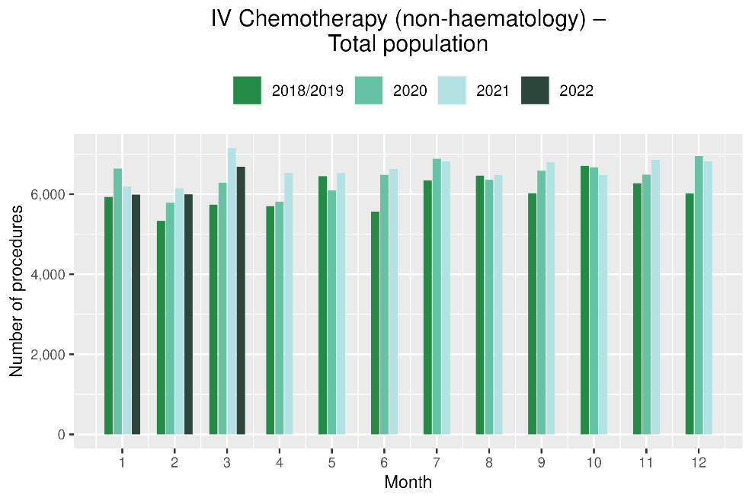 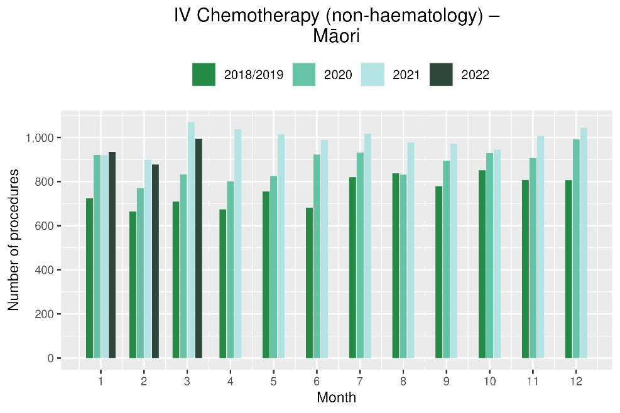

Figure 13: Cumulative number of attendances for IV chemotherapy, 2018/19 average, 2020 and 2021, total population and Māori

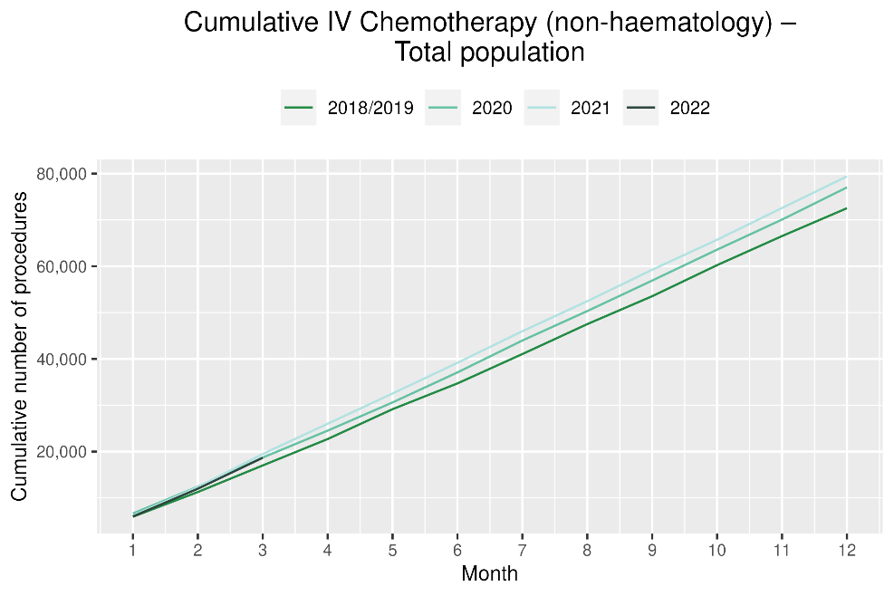 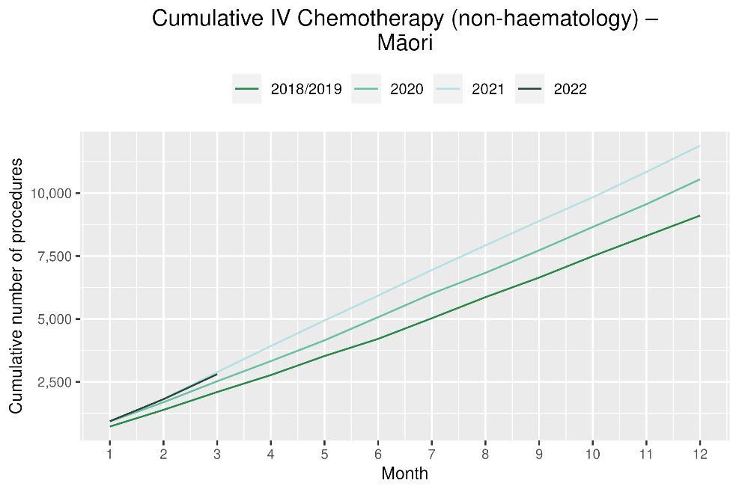

# Radiation oncology

## Notes on data

* Radiation oncology first specialist assessments and megavoltage attendances data were extracted from NNPAC on 05 May 2022.
* First specialist assessment (FSA) reflects counts of first attendance for radiation oncology specialist assessment.
* Radiation therapy attendances include appointments for planning/simulation and for treatment with radiation therapy on a linear accelerator.
* Radiation therapy courses data were extracted from Radiation Oncology Collection (ROC) on 28 April 2022. ROC is a national collection that contains diagnosis and treatment data for patients receiving radiation therapy from both the public and private providers. ROC is updated quarterly.
* A course of radiation therapy is a set of radiotherapy treatment(s) to a continuous or contiguous volume with a single intent from a single referral. A course can include multiple phases and multiple radiotherapy modalities. The monthly data here refers to the number of completed courses. The course starting date may not be in the same month.
* Radiation therapy course data reflect *completed* radiation therapy courses. This measure likely reflects trends in service volume over time better than radiation therapy attendance, as the increased use of hypofractionation[3] is likely to contribute to a decrease in the number of attendances required to complete a course of treatment.
* Technical information: radiation oncology FSA (Purchase Unit Code: M50022), megavoltage attendances (Purchase Unit Code: M50025).

## Key points

* Attendances for radiation oncology first specialist assessments (FSAs) increased by 13% in March 2022 compared to March 2018/19. For Māori, there was a 32% increase in FSAs in March 2022 compared to March 2018/19. For 2022 to date, there was a 4% increase in radiation oncology FSAs compared with 2018/19
* Radiation therapy attendances decreased by 6% in March 2022 compared to March 2018/19. For Māori, there was a 1% decrease in radiation therapy attendances in in March 2022 compared to March 2018/19. For Pacific peoples there was a 4% decrease in radiation therapy attendances in March 2022 compared to March 2018/19.
* Radiation therapy courses decreased by 11% in March 2022 compared to March 2018/19. For Māori, there was a 6% decrease in radiation therapy attendances in in March 2022 compared to March 2018/19. For Pacific peoples there was a 6% increase in radiation therapy attendances in March 2022 compared to March 2018/19.
* For 2022 to date, there was a 10 % decrease in radiation oncology attendances and a 7% decrease in completed radiation therapy courses compared with 2018/19

## Results

Table 13: Number of radiation oncology first specialist assessments and percentage difference in 2022 compared to the average of 2018 and 2019, by month and cumulative year to date, by ethnicity

|  |  |  |  |  |  |  |  |  |  |  |  |  |
| --- | --- | --- | --- | --- | --- | --- | --- | --- | --- | --- | --- | --- |
|  | **January** | | | **February** | | | **March** | | | **Cumulative January -March** | | |
|  | **2018/2019** | **2022** | **% change** | **2018/2019** | **2022** | **% change** | **2018/2019** | **2022** | **% change** | **2018/2019** | **2022** | **% change** |
| Māori | 103 | 109 | 6% | 110 | 123 | 12% | 106 | 139 | 32% | 318 | 371 | 17% |
| Pacific Peoples | 46 | 47 | 2% | 37 | 41 | 12% | 47 | 62 | 33% | 129 | 150 | 16% |
| Non-Māori/Non-Pacific | 780 | 683 | -12% | 782 | 848 | 8% | 852 | 935 | 10% | 2,414 | 2,466 | 2% |
| Total Population | 928 | 839 | -10% | 928 | 1,012 | 9% | 1,004 | 1,136 | 13% | 2,860 | 2,987 | 4% |

Figure 14: Number of radiation oncology first specialist assessments by month, 2018/19 average, 2020, 2021 and 2022, total population and Māori

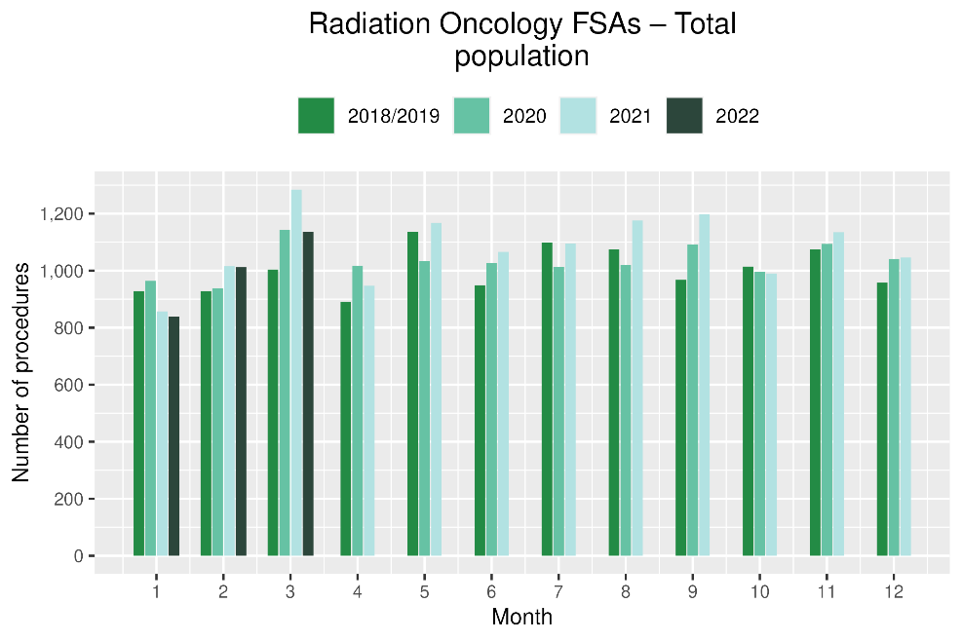 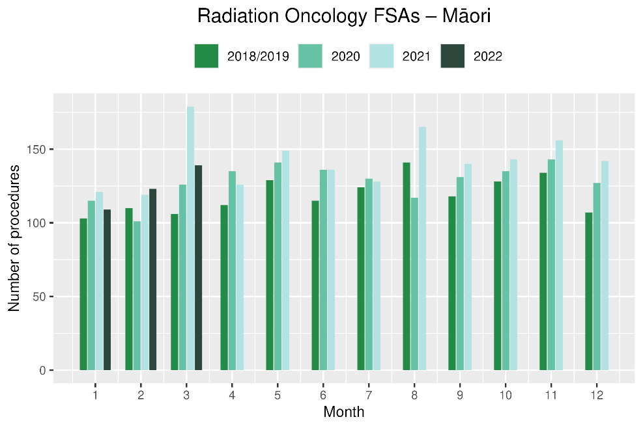

**Figure 15: Cumulative number of radiation oncology first specialist assessments by month, 2018/19 average, 2020, 2021 and 2022, total population and Māori**

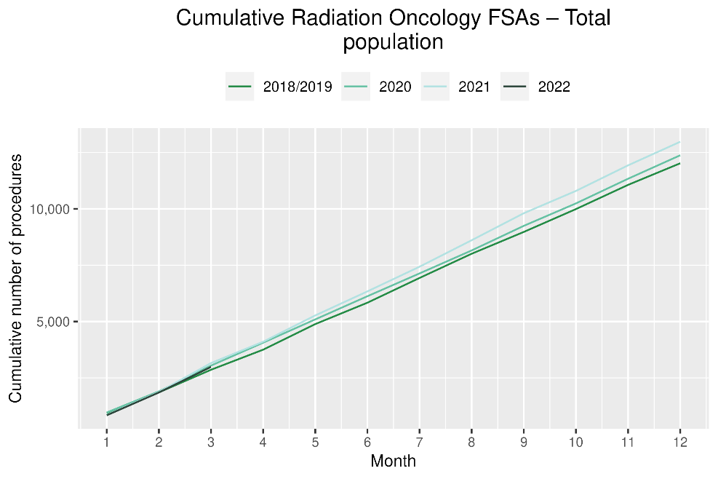 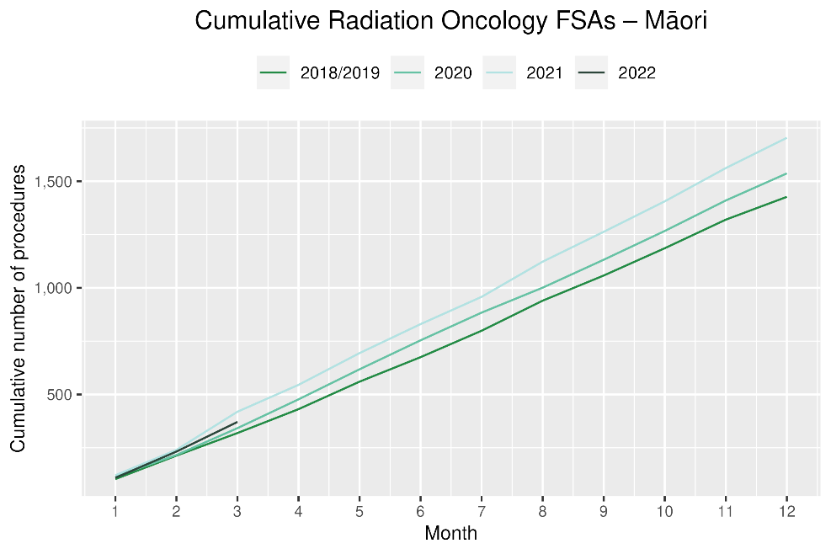

Table 14: Number of radiation therapy attendances and percentage difference in 2022 compared to the average of 2018 and 2019, by month and cumulative year to date, by ethnicity

|  |  |  |  |  |  |  |  |  |  |  |  |  |
| --- | --- | --- | --- | --- | --- | --- | --- | --- | --- | --- | --- | --- |
|  | **January** | | | **February** | | | **March** | | | **Cumulative January -March** | | |
|  | **2018/2019** | **2022** | **% change** | **2018/2019** | **2022** | **% change** | **2018/2019** | **2022** | **% change** | **2018/2019** | **2022** | **% change** |
| Māori | 1,666 | 1,697 | 2% | 1,519 | 1,782 | 17% | 1,751 | 1,726 | -1% | 4,936 | 5,205 | 5% |
| Pacific Peoples | 538 | 462 | -14% | 512 | 519 | 1% | 476 | 457 | -4% | 1,526 | 1,438 | -6% |
| Non-Māori/Non-Pacific | 11,482 | 9,354 | -19% | 10,564 | 9,403 | -11% | 11,773 | 10,980 | -7% | 33,818 | 29,737 | -12% |
| Total Population | 13,686 | 11,513 | -16% | 12,594 | 11,704 | -7% | 13,999 | 13,163 | -6% | 40,279 | 36,380 | -10% |

Figure 16: Number of radiation therapy attendances by month, 2018/19 average, 2020, 2021 and 2022, total population and Māori

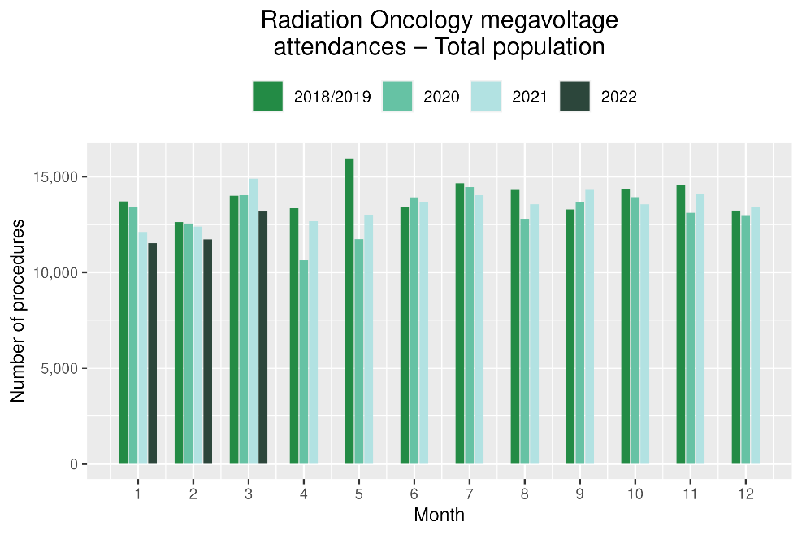 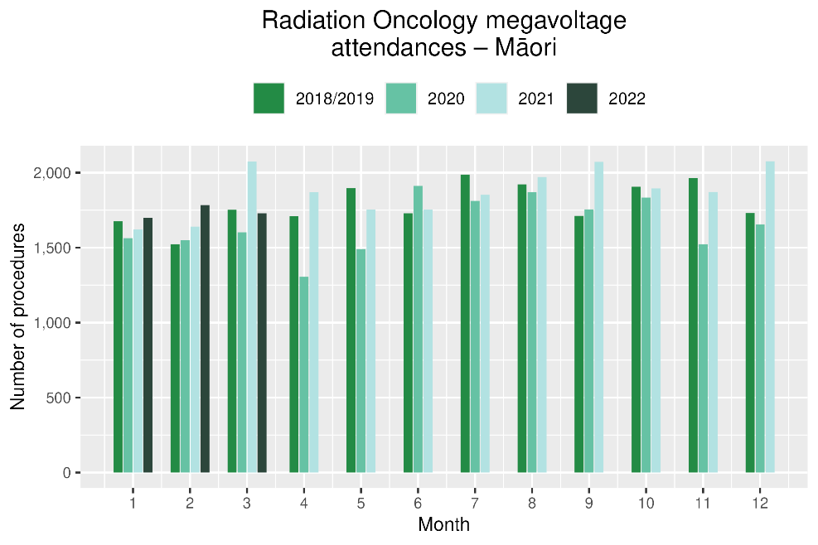

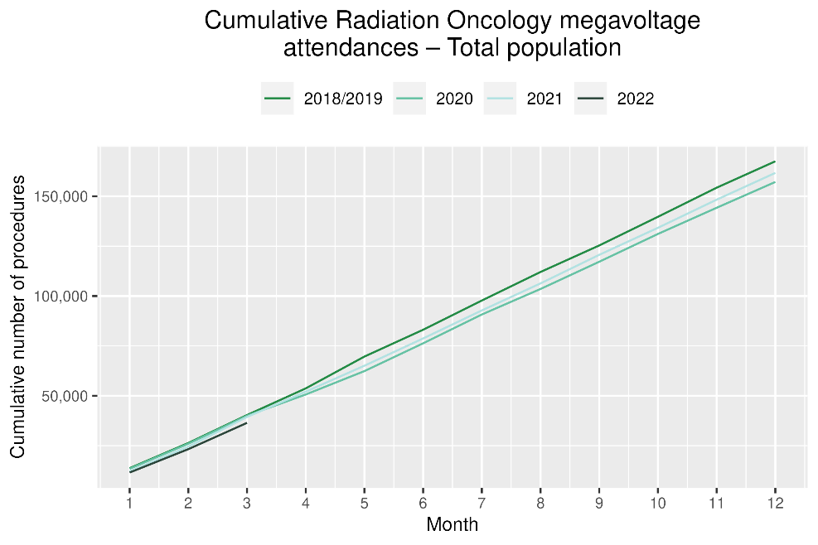 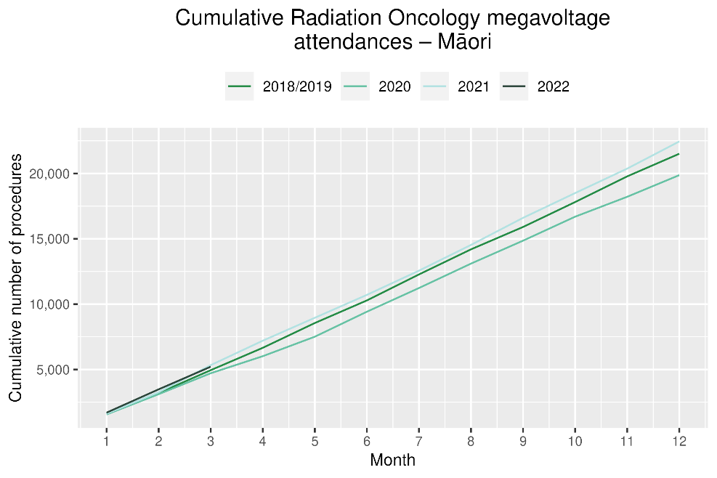

Table 15: Number of completed radiation therapy courses and percentage difference in 2022 compared to the average of 2018 and 2019, by month and cumulative year to date, by ethnicity

|  |  |  |  |  |  |  |  |  |  |  |  |  |
| --- | --- | --- | --- | --- | --- | --- | --- | --- | --- | --- | --- | --- |
|  | **January** | | | **February** | | | **March** | | | **Cumulative January -March** | | |
|  | **2018/2019** | **2022** | **% change** | **2018/2019** | **2022** | **% change** | **2018/2019** | **2022** | **% change** | **2018/2019** | **2022** | **% change** |
| Māori | 117 | 132 | 13% | 115 | 135 | 18% | 124 | 116 | -6% | 355 | 383 | 8% |
| Pacific Peoples | 38 | 35 | -8% | 41 | 41 | 1% | 35 | 37 | 6% | 114 | 113 | 0% |
| Non-Māori/Non-Pacific | 805 | 690 | -14% | 744 | 741 | 0% | 931 | 817 | -12% | 2,480 | 2,248 | -9% |
| Total Population | 959 | 857 | -11% | 899 | 917 | 2% | 1,090 | 970 | -11% | 2,948 | 2,744 | -7% |

Figure 17: Number of completed radiation therapy courses by month, 2018/19 average, 2020, 2021 and 2022, total population and Māori

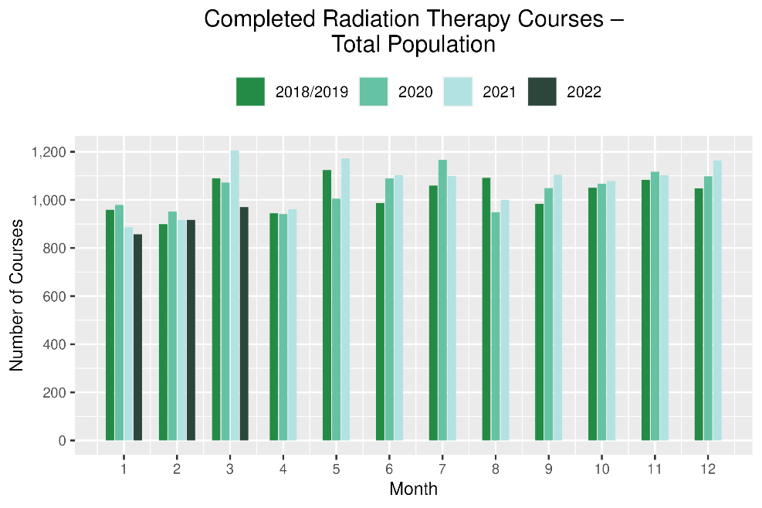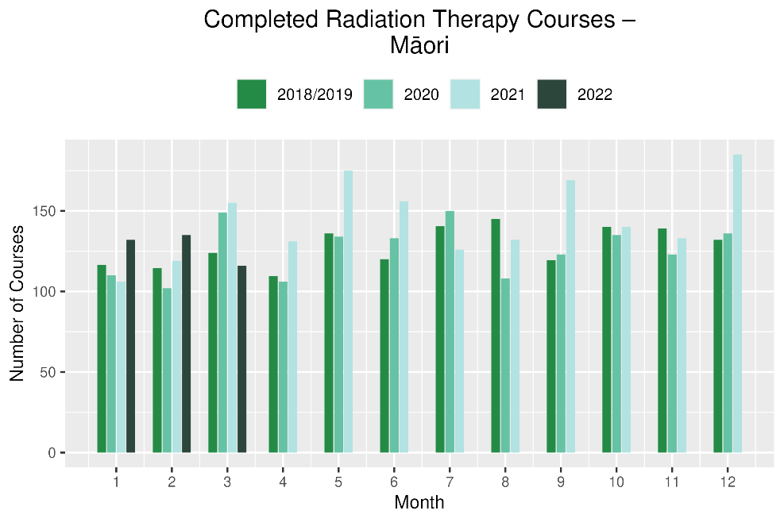

**Figure 18**: **Cumulative number of completed radiation therapy courses by month, 2018/19 average, 2020, 2021 and 2022, total population and Māori**

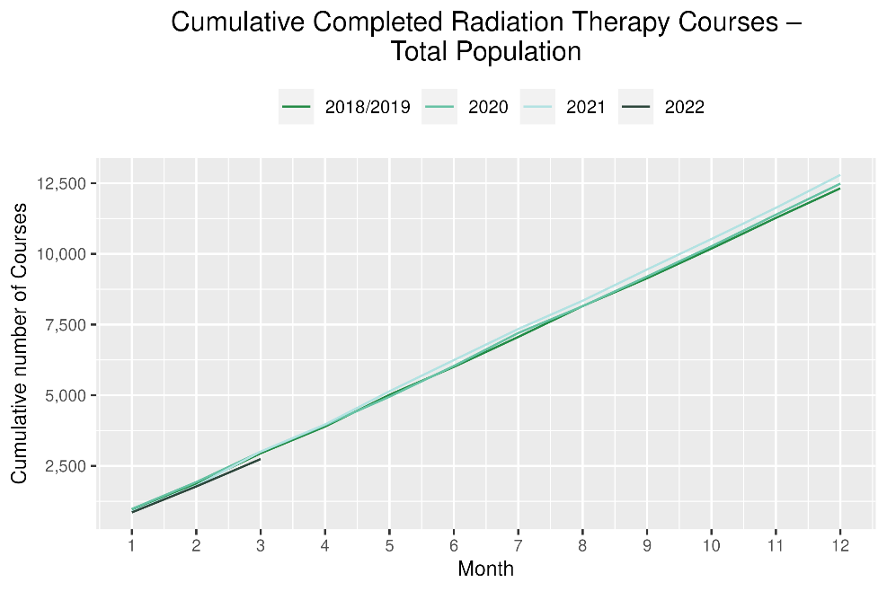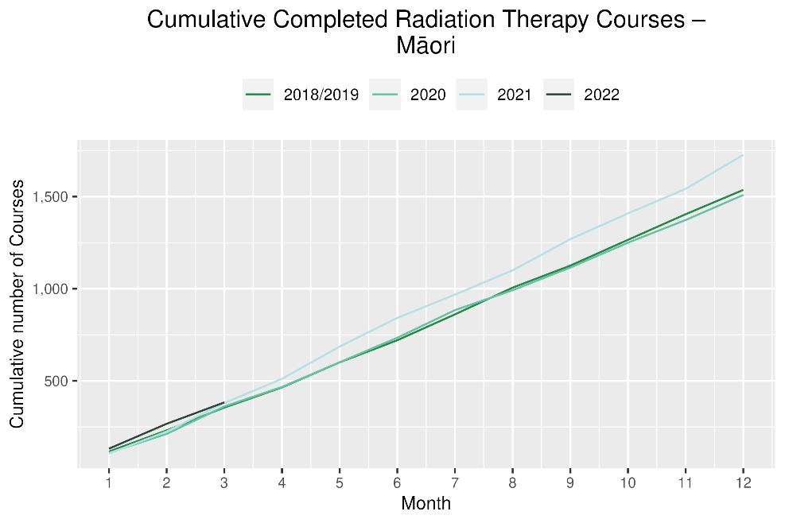

# Haematology

## Notes on data

* Data were extracted from NNPAC and NMDS on 05 May 2022.
* First specialist assessment (FSA) reflects counts of first attendance for specialist haematology assessment for any indication, not just cancer.
* IV chemotherapy reflects appointments for IV chemotherapy for haematological malignancies.
* Technical information: Haematology FSA (Purchase Unite Code: M30002), IV haem/chemo (Purchase Unit Code: M30020).

## Key points

* There was a 5% increase in attendances for haematology first specialist assessments (FSAs) in March 2022 compared to March 2018/19. For Māori, there was a 2% decrease in FSAs March 2022 compared to March 2018/19.
* For 2022 to date, there was a 3% decrease in haematology FSAs compared with 2018/19, and for Māori there was no change.
* Attendances for haematology intravenous (IV) chemotherapy increased by 17% in March 2022 compared to March 2018/19. For Māori, there was no change in haematology IV chemotherapy in March 2022 compared to March 2018/19. For Pacific peoples there was an 4% increase in IV chemotherapy in March 2022 compared to March 2018/19.
* For 2022 to date, there was a 15% increase in haematology IV chemotherapy compared with 2018/19.

## Results

Table 16: Number of haematology first specialist assessment attendances and percentage difference in 2022 compared to the average of 2018 and 2019, by month and cumulative year to date, by ethnicity

|  |  |  |  |  |  |  |  |  |  |  |  |  |
| --- | --- | --- | --- | --- | --- | --- | --- | --- | --- | --- | --- | --- |
|  | **January** | | | **February** | | | **March** | | | **Cumulative January -March** | | |
|  | **2018/2019** | **2022** | **% change** | **2018/2019** | **2022** | **% change** | **2018/2019** | **2022** | **% change** | **2018/2019** | **2022** | **% change** |
| Māori | 46 | 47 | 3% | 47 | 47 | 0% | 65 | 64 | -2% | 158 | 158 | 0% |
| Pacific Peoples | 26 | 27 | 4% | 24 | 37 | 57% | 26 | 41 | 58% | 76 | 105 | 39% |
| Non-Māori/Non-Pacific | 416 | 354 | -15% | 441 | 413 | -6% | 476 | 488 | 3% | 1,333 | 1,255 | -6% |
| Total Population | 488 | 428 | -12% | 512 | 497 | -3% | 567 | 593 | 5% | 1,566 | 1,518 | -3% |

Figure 22: Number of haematology first specialist assessments by month, 2018/19 average, 2020, 2021 and 2022, total population and Māori

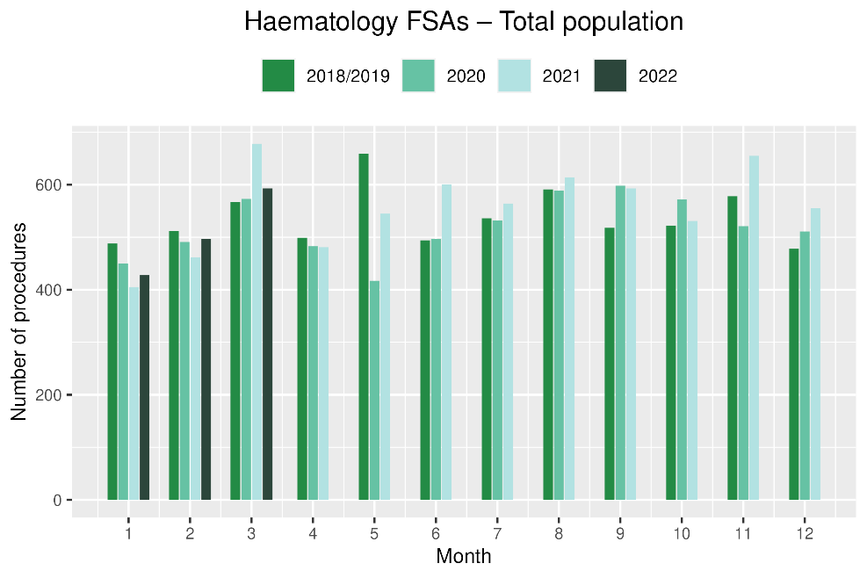 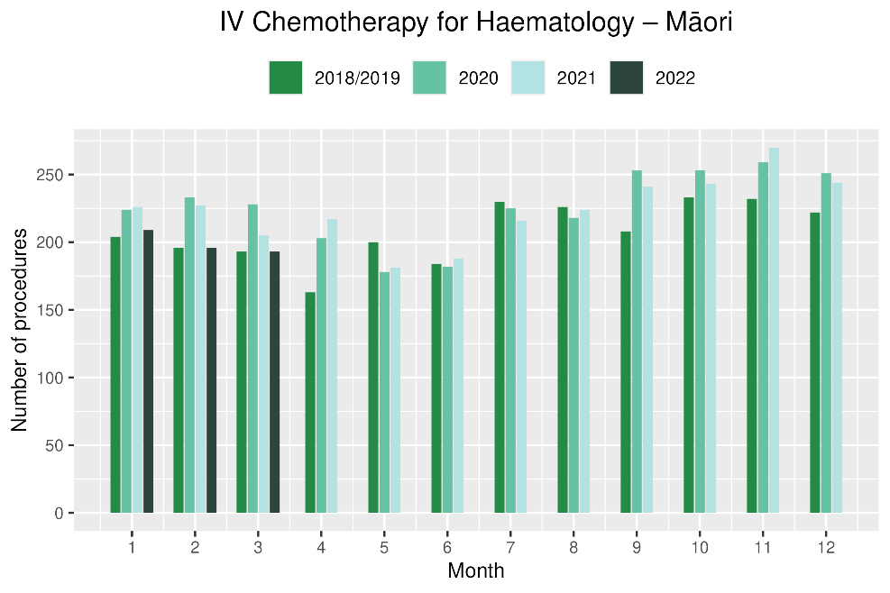

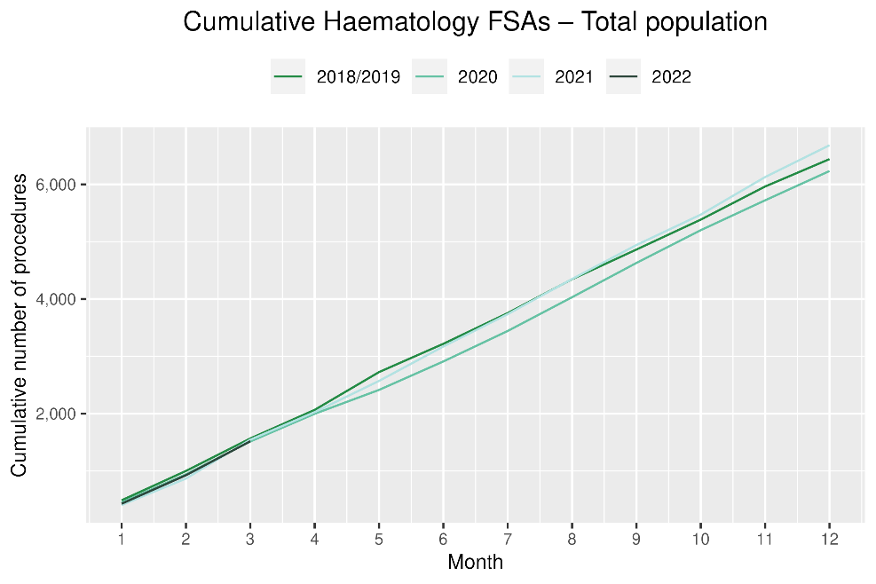 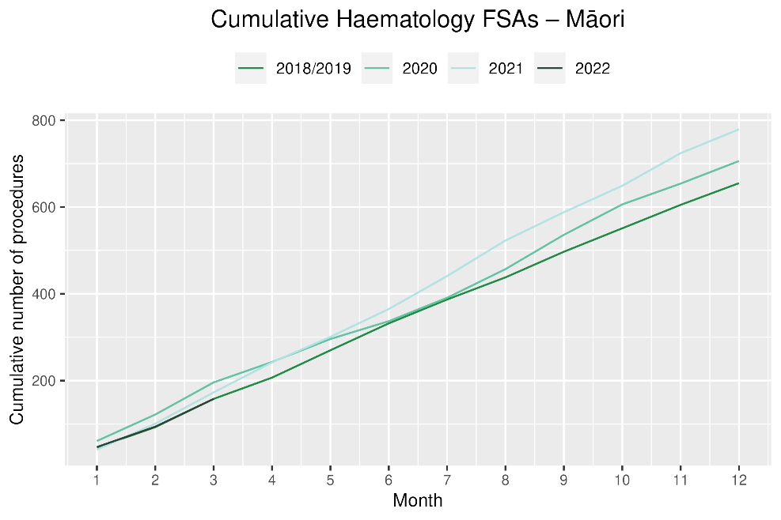

**Table 17: Number of IV chemotherapy attendances for haematological malignancies and percentage difference in 2022 compared to the average of 2018 and 2019, by month and cumulative year to date, by ethnicity**

|  |  |  |  |  |  |  |  |  |  |  |  |  |  |
| --- | --- | --- | --- | --- | --- | --- | --- | --- | --- | --- | --- | --- | --- |
|  | **January** | | | | **February** | | | **March** | | | **Cumulative January -March** | | |
|  | | **2018/2019** | **2022** | **% change** | **2018/2019** | **2022** | **% change** | **2018/2019** | **2022** | **% change** | **2018/2019** | **2022** | **% change** |
| Māori | | 204 | 209 | 3% | 196 | 196 | 0% | 193 | 193 | 0% | 592 | 598 | 1% |
| Pacific Peoples | | 99 | 138 | 39% | 103 | 116 | 13% | 98 | 102 | 4% | 300 | 356 | 19% |
| Non-Māori/Non-Pacific | | 1,656 | 1,829 | 10% | 1,505 | 1,811 | 20% | 1,582 | 1,904 | 20% | 4,742 | 5,544 | 17% |
| Total Population | | 1,959 | 2,176 | 11% | 1,804 | 2,123 | 18% | 1,872 | 2,199 | 17% | 5,634 | 6,498 | 15% |

Figure 20: Number of attendances for IV chemotherapy for haematological malignancies by month, 2018/19 average, 2020, 2021 and 2022, total population and Māori

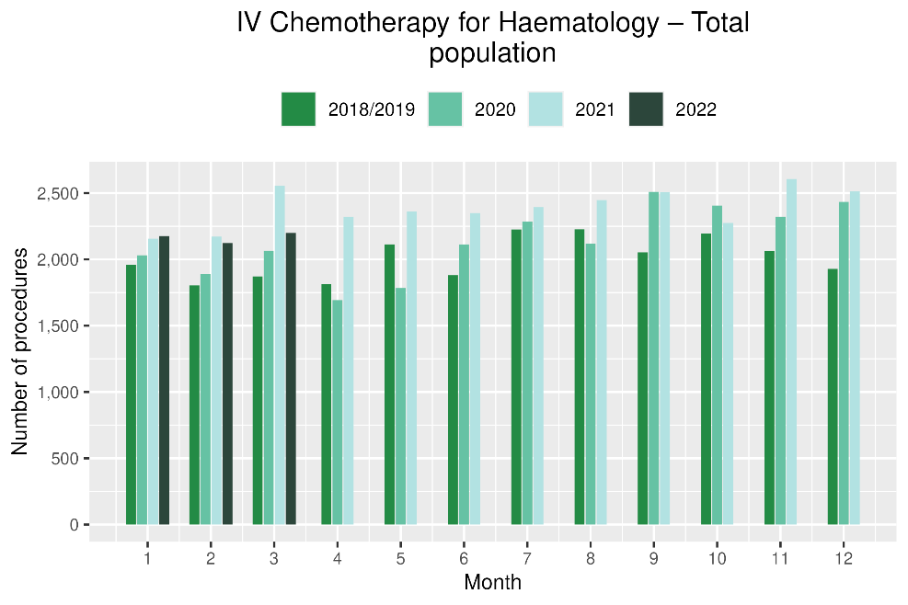 

Figure 21: Cumulative number of attendances for IV chemotherapy for haematological malignancies, 2018/19 average, 2020, 2021 and 2022, total population and Māori

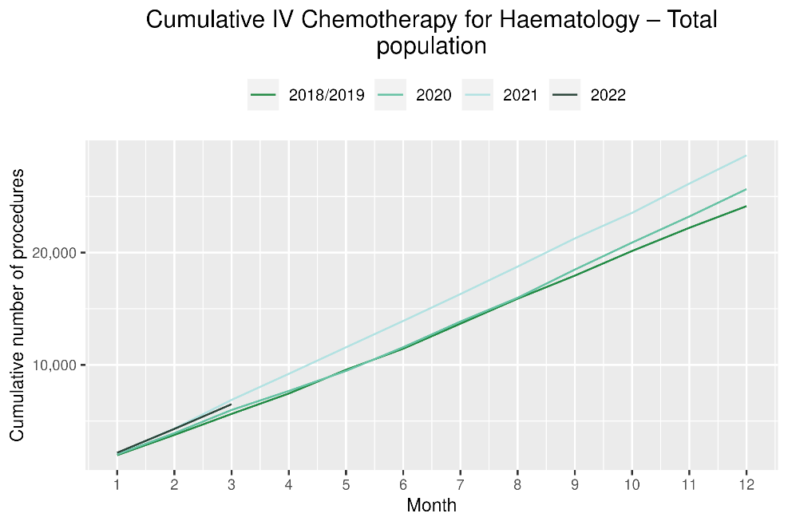 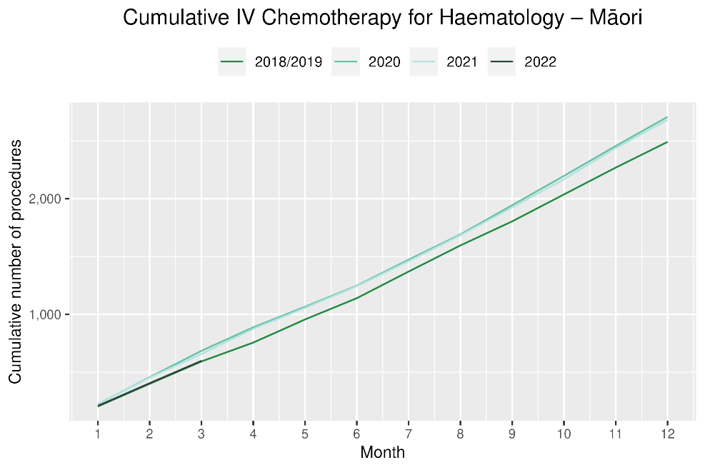

# Appendix 1: Key Dates

The follow provides a brief overview of key dates relating to COVID-19 restrictions (Alert Levels 3 and 4 where the greatest restrictions were in place) and outbreaks. More detailed information can be found on the Unite COVID-19 website[4], including an overview of Alert Levels and the COVID-19 Protection Framework[5].

|  |  |
| --- | --- |
| 23 March – 14 May 2020 | All Aotearoa New Zealand was at Alert Level 3 or 4 |
| 12 August – 30 September 2020 | Auckland only moved to Alert Level 3 |
| 28 Feb – 7 March 2021 | Auckland only was at Alert Level 3 |
| 17 August to 7 September 2021 | All Aotearoa New Zealand was at Alert 3 or 4 at the outset of the Delta variant outbreak |
| From 7 September 2021 | Auckland remained at Alert Level 4; the rest of the country moved to Alert Level 2 |
| September – December 2021 | Auckland moved to and remained at Alert Level 3 from 21 September. There were various regional changes between Alert Level 2 and 3 over this period some parts of the North Island including parts of Waikato. Details are available on the Unite COVID-19 website4. Note: The definition of Alert Level 3 was eased in early October and three gradually reducing steps of level 3 were introduced in October |
| 3 Dec 2021 | End of COVID-19 Alert System. All Aotearoa New Zealand moved to the COVID-19 Protection Framework (traffic lights) |
| 29 Dec 2021 | The first case of the Omicron variant in the community in New Zealand was detected |
| February 2022  10 March 2022  23 March 2022 | Omicron case numbers and hospitalisations increased more significantly in the second half of February onwards[6]  Seven day rolling average of cases is over 20,000, while daily count reaches over 23,000.  Changes are made to the Red Light setting: no limitations on numbers of people gathering outdoors, indoors limit increase to 2000 people. |

# Appendix 2: NZCR data information

## The New Zealand Cancer Registry as a data source for new cancer diagnoses

Cancer registration is a process where data is collated from multiple sources about people diagnosed with cancer and rules are applied to determine the type of cancer they have. This information is recorded in the New Zealand Cancer Registry. Each tumour is classified using an international World Health Organization standard so that cancer incidence can be compared between countries. The tumour is staged based on all the information available within 4 months of diagnosis. This process may take up to six months or more depending on the number of missing reports that need to be followed up with laboratories.

For each registration there may be multiple pathology reports as there may be multiple procedures performed on the tumour. This means there will be more than one registration for people diagnosed with more than one type of tumour.

Cancer registrations come from pathology laboratories, haematology laboratories, mortality records and reviewing hospital discharge records. Laboratory reports provide the best source of near real time data to monitor new diagnoses of cancer in New Zealand.

## Pathology reports as a data source for providing near real time monitoring cancer diagnoses

Pathology reports (documents) are received by the NZCR as electronic messages. An administrator triages these documents each day and if the document appears to meet the requirements for registration the document is “administered”. The document may relate to an existing registration or may contain information for a new cancer event. Documents that do not meet the cancer reporting requirements will be marked as “deleted”, “rejected” or “agreed not for registration”.

The administrator creates a new provisional cancer event if the pathology report identifies a new cancer diagnosis for this person. This new cancer event is assigned to a cancer group and this provisional event is then queued for further assessment by a clinical coder. If the required information has been provided the coder creates a new registration. If some information is not yet available, then the registration is held open until further information arrives to complete the registration or determine that the tumour does not meet the registration criteria.

# Appendix 3: NZCR registrations by DHB

Number of cancer registrations and percentage difference in 2022 compared to 2021 average, by month and cumulative year to date, by DHB of domicile

|  |  |  |  |  |  |  |  |  |  |  |  |  |  |
| --- | --- | --- | --- | --- | --- | --- | --- | --- | --- | --- | --- | --- | --- |
|  |  | **January** | | | **February** | | | **March** | | | **Cumulative January-March** | | |
|  | **DHB** | **2018/19** | **2022** | **Change%** | **2018/19** | **2022** | **Change%** | **2018/19** | **2022** | **Change%** | **2018/19** | **2022** | **Change%** |
|  | Northland | 91 | 70 | -23% | 92 | 104 | 14% | 106 | 98 | -8% | 288 | 272 | -6% |
|  | Waitematā | 205 | 198 | -3% | 231 | 273 | 18% | 244 | 286 | 17% | 680 | 757 | 11% |
|  | Auckland | 135 | 147 | 9% | 174 | 182 | 5% | 185 | 199 | 8% | 494 | 528 | 7% |
|  | Counties Manukau | 160 | 159 | -1% | 162 | 185 | 14% | 196 | 213 | 9% | 518 | 557 | 8% |
|  | Waikato | 156 | 138 | -12% | 173 | 194 | 12% | 198 | 203 | 3% | 527 | 535 | 2% |
|  | Bay of Plenty | 102 | 104 | 2% | 106 | 100 | -5% | 129 | 151 | 18% | 336 | 355 | 6% |
|  | Tairāwhiti | 14 | 12 | -11% | 19 | 15 | -19% | 19 | 22 | 19% | 51 | 49 | -3% |
|  | Lakes | 37 | 37 | 0% | 48 | 46 | -4% | 43 | 59 | 39% | 128 | 142 | 11% |
|  | Taranaki | 44 | 45 | 3% | 57 | 63 | 12% | 46 | 57 | 24% | 146 | 165 | 13% |
|  | Hawkes Bay | 63 | 55 | -13% | 61 | 81 | 33% | 79 | 84 | 7% | 203 | 220 | 9% |
|  | Whanganui | 33 | 27 | -18% | 38 | 29 | -23% | 29 | 40 | 38% | 100 | 96 | -4% |
|  | MidCentral | 81 | 72 | -11% | 76 | 70 | -7% | 85 | 90 | 7% | 241 | 232 | -4% |
|  | Capital and Coast | 97 | 93 | -4% | 103 | 132 | 29% | 133 | 123 | -7% | 332 | 348 | 5% |
|  | Hutt Valley | 48 | 55 | 16% | 58 | 58 | 1% | 63 | 64 | 2% | 168 | 177 | 5% |
|  | Wairarapa | 25 | 19 | -24% | 19 | 29 | 57% | 26 | 18 | -29% | 69 | 66 | -4% |
|  | Nelson Marlborough | 60 | 62 | 3% | 69 | 69 | 1% | 84 | 89 | 6% | 213 | 220 | 4% |
|  | West Coast | 11 | 18 | 64% | 21 | 15 | -29% | 15 | 21 | 45% | 47 | 54 | 16% |
|  | Canterbury | 204 | 212 | 4% | 217 | 237 | 9% | 236 | 282 | 20% | 656 | 731 | 11% |
|  | South Canterbury | 31 | 27 | -11% | 31 | 31 | 0% | 26 | 40 | 57% | 87 | 98 | 13% |
|  | Southern | 138 | 122 | -12% | 140 | 140 | 0% | 158 | 152 | -4% | 436 | 414 | -5% |

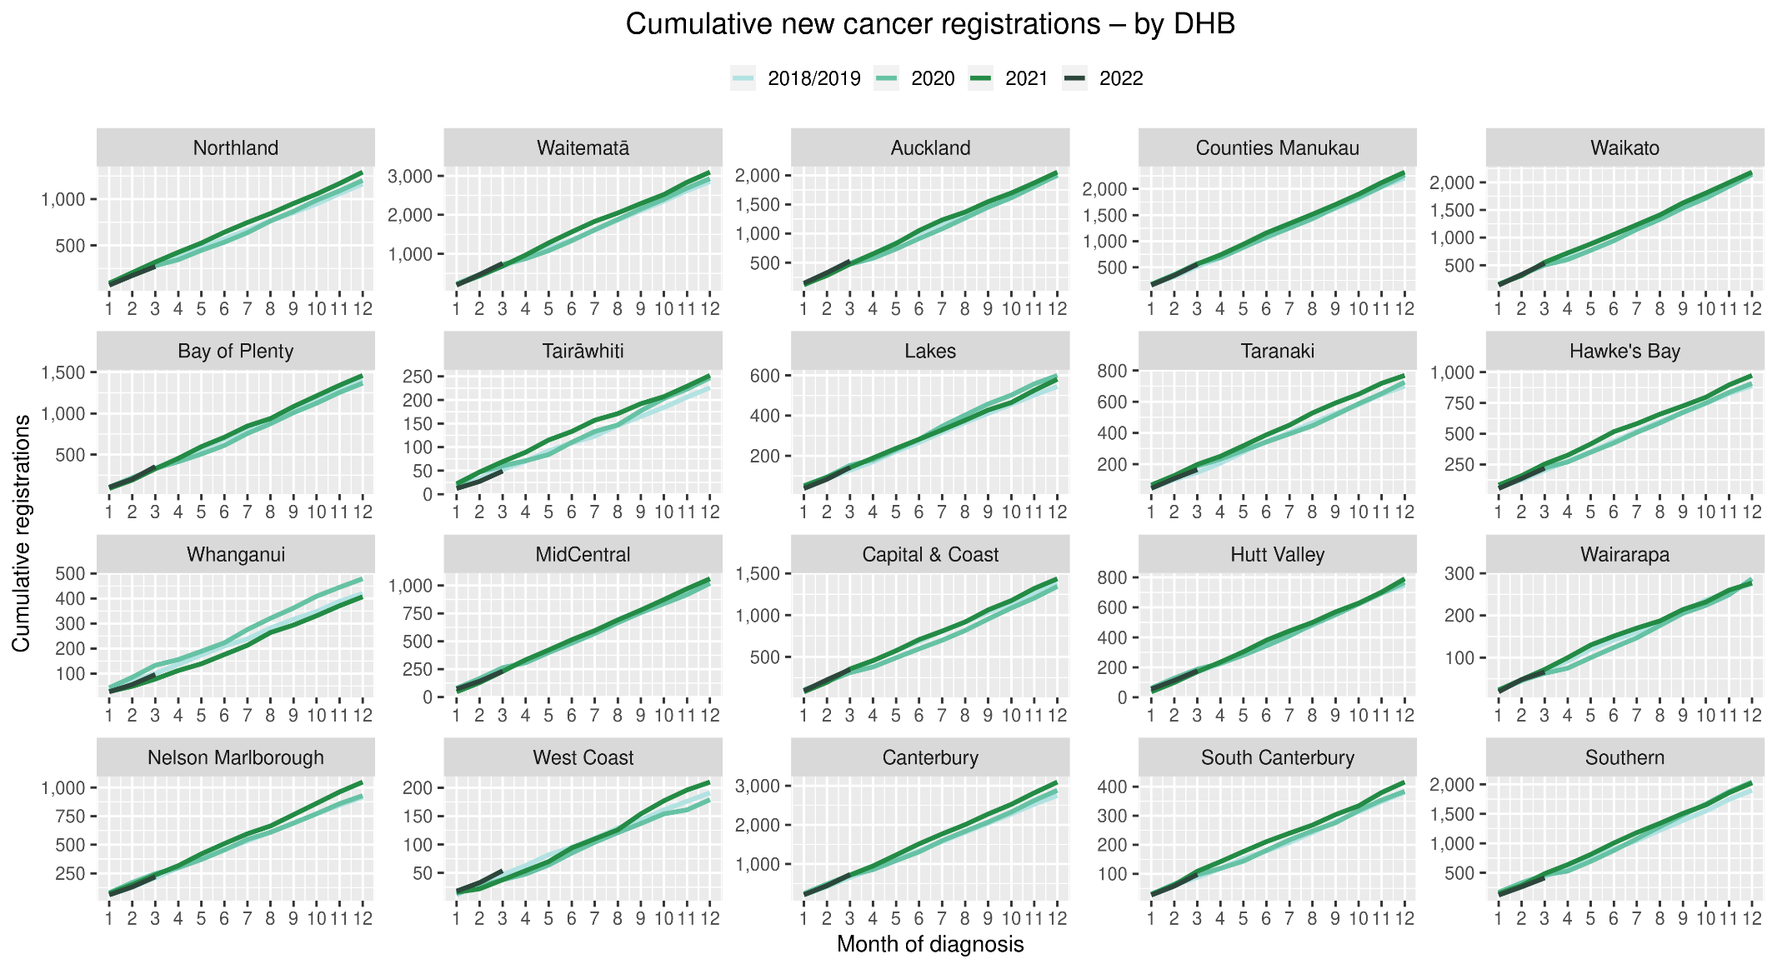

## Cumulative cancer registrations by DHB and ethnicity



## Cumulative cancer registrations by cancer type and ethnicity



# Appendix 4: Diagnosis and treatment data by DHB

Percentage differences are only presented if the cumulative total is 10 or greater. In some cases, the totals may differ to those presented in the national report due to non-DHB providers being excluded from the analyses within this appendix.

## Gastrointestinal endoscopy



## Bronchoscopy

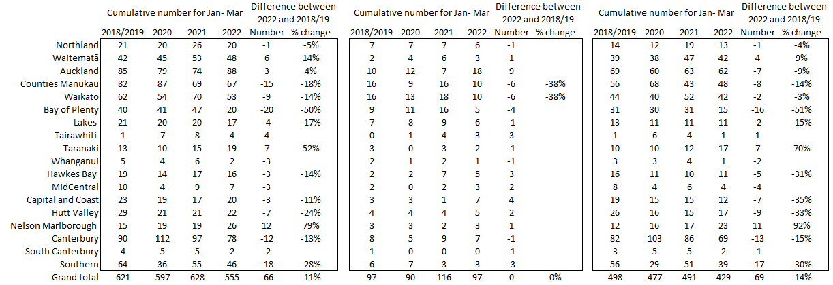

## Colorectal cancer surgery



## Lung cancer surgery



## Prostate cancer surgery

## 

## Medical oncology first specialist assessments



## Medical oncology IV chemotherapy



## Radiation oncology first specialist assessments



## Completed Radiation Oncology Courses

|  |  |  |  |  |  |  |  |  |  |  |  |
| --- | --- | --- | --- | --- | --- | --- | --- | --- | --- | --- | --- |
|  | Total population | | |  | Maori | | |  | Non-Maori/Non Pacific | | |
|  | Cumulative number Jan-March | | |  | Cumulative number Jan-March | | |  | Cumulative number Jan-March | | |
|  | 2018/2019 | 2022 | % change |  | 2018/2019 | 2022 | % change |  | 2018/2019 | 2022 | % change |
| Auckland | 759 | 659 | -13% |  | 103 | 108 | 5% |  | 579 | 491 | -15% |
| Waikato | 397 | 358 | -10% |  | 76 | 71 | -7% |  | 315 | 282 | -10% |
| Bay of Plenty | 238 | 195 | -18% |  | 40 | 34 | -15% |  | 196 | 157 | -20% |
| MidCentral | 350 | 355 | 2% |  | 55 | 72 | 32% |  | 292 | 277 | -5% |
| Captial and Coast | 440 | 458 | 4% |  | 35 | 44 | 28% |  | 387 | 384 | -1% |
| Canterbury | 485 | 453 | -7% |  | 32 | 28 | -13% |  | 450 | 420 | -7% |
| Southern | 281 | 266 | -5% |  | 16 | 26 | 68% |  | 264 | 237 | -10% |
| Total | 2,948 | 2,744 | -7% |  | 355 | 383 | 8% |  | 2,480 | 2,248 | -9% |

## Radiation oncology megavoltage fractions

## 

## Haematology first specialist assessment



## Haematology IV chemotherapy

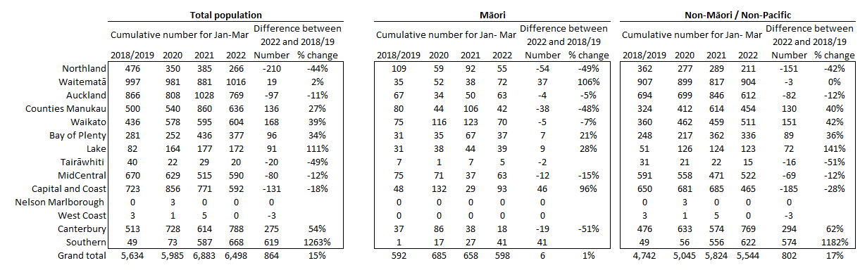

# Appendix 5: Surgical procedure codes

Below is a list of the surgical procedure codes that were used for analysis on cancer surgery.

|  |  |  |
| --- | --- | --- |
| **COLORECTAL CANCER SURGERY** | | |
| Clinical code | Block short description | Clinical code description |
| 3200000 | Colectomy | Limited excision of large intestine with formation of stoma |
| 3200001 | Colectomy | Right hemicolectomy with formation of stoma |
| 3200300 | Colectomy | Limited excision of large intestine with anastomosis |
| 3200301 | Colectomy | Right hemicolectomy with anastomosis |
| 3200400 | Colectomy | Subtotal colectomy with formation of stoma |
| 3200401 | Colectomy | Extended right hemicolectomy with formation of stoma |
| 3200500 | Colectomy | Subtotal colectomy with anastomosis |
| 3200501 | Colectomy | Extended right hemicolectomy with anastomosis |
| 3200600 | Colectomy | Left hemicolectomy with anastomosis |
| 3200601 | Colectomy | Left hemicolectomy with formation of stoma |
| 3200900 | Colectomy | Total colectomy with ileostomy |
| 3201200 | Colectomy | Total colectomy with ileorectal anastomosis |
| 3201500 | Total proctocolectomy | Total proctocolectomy with ileostomy |
| 3202400 | Anterior resection of rectum | High anterior resection of rectum |
| 3202500 | Anterior resection of rectum | Low anterior resection of rectum |
| 3202600 | Anterior resection of rectum | Ultra low anterior resection of rectum |
| 3202800 | Anterior resection of rectum | Ultra low anterior resection of rectum with hand sutured coloanal anastomosis |
| 3203000 | Rectosigmoidectomy or proctectomy | Rectosigmoidectomy with formation of stoma |
| 3203900 | Rectosigmoidectomy or proctectomy | Abdominoperineal proctectomy |
| 3205100 | Total proctocolectomy | Total proctocolectomy with ileo-anal anastomosis |
| 3205101 | Total proctocolectomy | Total proctocolectomy with ileo-anal anastomosis and formation of temporary ileostomy |
| 3206000 | Rectosigmoidectomy or proctectomy | Restorative proctectomy |
| 3209900 | Excision of lesion or tissue of rectum or anus | Per anal submucosal excision of lesion or tissue of rectum |
| 3211200 | Rectosigmoidectomy or proctectomy | Perineal rectosigmoidectomy |
| 9220800 | Anterior resection of rectum | Anterior resection of rectum, level unspecified |

|  |  |  |
| --- | --- | --- |
| **LUNG CANCER SURGERY** | | |
| Clinical code | Clinical code description | Block Description |
| 3844000 | Wedge resection of lung | Partial resection of lung |
| 3844001 | Radical wedge resection of lung | Partial resection of lung |
| 3843800 | Segmental resection of lung | Partial resection of lung |
| 9016900 | Endoscopic wedge resection of lung | Partial resection of lung |
| 3843801 | Lobectomy of lung | Lobectomy of lung |
| 3844100 | Radical lobectomy | Lobectomy of lung |
| 3844101 | Radical pneumonectomy | Pneumonectomy |
| 3843802 | Pneumonectomy | Pneumonectomy |

|  |  |  |
| --- | --- | --- |
| **PROSTATE CANCER SURGERY** | | |
| Clinical code | Block short description | Clinical code description |
| 3720004 | Open prostatectomy | Retropubic prostatectomy |
| 3720900 | Open prostatectomy | Radical prostatectomy |
| 3720901 | Other closed prostatectomy | Laparoscopic radical prostatectomy |
| 3721000 | Open prostatectomy | Radical prostatectomy with bladder neck reconstruction |
| 3721001 | Other closed prostatectomy | Laparoscopic radical prostatectomy with bladder neck reconstruction |
| 3721100 | Open prostatectomy | Radical prostatectomy with bladder neck reconstruction and pelvic lymphadenectomy |
| 3721101 | Other closed prostatectomy | Laparoscopic radical prostatectomy with bladder neck reconstruction and pelvic lymphadenectomy |
| 3720900 | Open prostatectomy | Radical prostatectomy |
| 3720901 | Closed prostatectomy | Laparoscopic radical prostatectomy |
| 3721000 | Open prostatectomy | Radical prostatectomy with bladder neck reconstruction |
| 3721001 | Closed prostatectomy | Laparoscopic radical prostatectomy with bladder neck reconstruction |
| 3721100 | Open prostatectomy | Radical prostatectomy with bladder neck reconstruction and pelvic lymphadenectomy |

1. Reports available here: <https://teaho.govt.nz/reports/cancer-care>
2. These lists were developed to focus on procedures that were more likely to be curative, however it is noted that there are palliative indications for these surgeries therefore we have removed the word curative from this report. The list of procedure codes remains the same, therefore comparisons with previous reports are unaffected.
3. Hypofractionation is a radiation treatment technique used to treat some cancers, whereby larger doses of radiation are given each treatment, meaning that patients require fewer sessions to complete their treatment. The technique is being increasingly used for some prostate and breast cancers in New Zealand and around the world.
4. <https://covid19.govt.nz/about-our-covid-19-response/history-of-the-covid-19-alert-system/>
5. <https://covid19.govt.nz/traffic-lights/covid-19-protection-framework>
6. <https://www.health.govt.nz/covid-19-novel-coronavirus/covid-19-data-and-statistics/covid-19-current-cases>