

**COVID-19 and cancer services**

Working report on the impact of COVID-19 on cancer services for the period ending June 2022

**Released September 2022**

# Acknowledgements

With thanks to the Ministry of Health Data Management team for their technical support.

With thanks to members of the COVID-19 Data Response Advisory Group: Professor Diana Sarfati, Alex Dunn, Dr John Fountain, Dr Tess Luff, John Manderson, Michelle Mako, Dr Shaun Costello, Michelle Liu, Dr Liz Dennett, Gabrielle Nicholson, Dawn Wilson, Jan Smith, Cushla Lucas, Nicholas Glubb, Moira McLeod, Angela Pidd, Christine Fowler, Dr Nina Scott, Associate Professor Bridget Robson, Dr Bronwyn Rendle and Associate Professor Jason Gurney.

# Contents

Acknowledgements 2

Contents 3

Summary of findings 4

Introduction 7

Cancer Registrations 9

Gastrointestinal endoscopy 13

Bronchoscopy 15

Faster cancer treatment 19

Combined cancer surgery 21

Breast cancer surgery (mastectomy) 23

Colorectal cancer surgery 25

Lung cancer surgery 27

Prostate cancer surgery 29

Medical oncology 31

Radiation oncology 35

Haematology 41

Appendix 1: Key Dates 45

Appendix 2: NZCR data information 47

Appendix 3: NZCR registrations by DHB 48

Appendix 4: Diagnosis and treatment data by DHB 52

Appendix 5: Surgical procedure codes 66

# Summary of findings

This report includes data up to June 2022, except for cancer registration data which were available up to May 2022.

Cancer registrations show a 9% increase overall compared with the average of May 2018/19 (ie, pre-COVID-19). For Māori there was an 8% increase in registrations over this time. Overall, for 2022 to date there were 4% fewer cancer surgeries performed compared to the average of 2018/19, due to lower volumes of colorectal cancer and breast cancer surgeries. For Māori, there has been a 3% increase in combined cancer surgeries for the year to date relative to 2018/19; however, the proportion of Māori lung cancer surgery in particular was down by 25% for the year to date relative to 2018/19 (16 fewer surgeries).

For 2022 to date, medical oncology first specialist assessments (FSAs) increased by 2% compared to the same period in 2018/19 and IV chemotherapy increased by 10%. Radiation oncology FSAs increased by 6% for 2022 to date compared to 2018/19; however, radiation therapy attendances and completed radiation therapy courses both decreased by 11% compared to 2018/19. For haematology, there was a 5% decrease in FSAs for 2022 to date, and an increase of 13% for IV chemotherapy attendances compared with 2018/19

Overall, there is evidence of some downturns in delivery of some services, and these downturns are likely to be the result of the impact of the ongoing COVID-19 pandemic on the normal delivery of care, with the added impact of other illnesses such as influenza. Te Aho o Te Kahu acknowledges the ongoing pressures on the cancer care system at this time, in particular on the cancer workforce due to staff illness and capacity issues as a result of COVID-19 and other illnesses. That this reporting shows many comparable results to the pre-pandemic period suggests that cancer care staff are working diligently to ensure the continuation of cancer care in Aotearoa New Zealand. Te Aho o Te Kahu continues to work with the sector and will monitor and further investigate downturns in service delivery, with particularly focus on evidence on inequity (such as lung cancer surgery for Māori).

## Background and data

* The purpose of this report is to provide a rapid assessment of the impact of COVID-19 on cancer services. It includes data up until 30 June 2022 (31 May 2022 for cancer registrations). This period includes the surge in COVID-19 cases that occurred from February 2022 as the Omicron variant spread throughout the community.
* We acknowledge individuals with cancer may have been impacted in significant ways by COVID-19, including by changes to the way care has been delivered and that these may not be captured within the available data.
* Te Aho o Te Kahu acknowledges the considerable challenges cancer services are working under during the current Omicron outbreak. Our reporting so far has not highlighted extensive disruption; however, this is not to say that there have not been significant impacts on cancer services as a result of COVID-19 and other winter illnesses such as influenza (in particular staff capacity).
* The report focuses on the aspects of the cancer care pathway for which we have readily available data and does not capture all aspects of cancer care.
* This report compares 2022 with an average of 2018/19 data and provides additional graphs comparing 2022 data with that from 2021, 2020 and 2018/2019.
* For the purposes of this report, we have not adjusted for expected changes in incidence over time (such as due to population growth). We acknowledge that the value of comparing current trends in registrations and treatment to pre-pandemic trends is reducing over time.
* There may be some backlogs in data entry with pandemic-related impacts on staffing across the health sector, and in particular this has prevented the presentation of cancer registration data for June. This may result in future data updates altering the current results.

## Cancer diagnosis

### Registrations

* For May 2022 compared to the average of May 2018/19 there was a 9% increase in cancer registrations. For Māori, there was an 8% increase in registrations in May 2022 compared with May 2018/19.
* Cumulatively up to May 2022, there has been an increase of 5% in cancer registrations compared to the average of 2018/19 and a 1% increase for Māori.

### Diagnostics

* **Gastrointestinal endoscopies:** There was an increase of 20% in gastrointestinal endoscopies performed in May 2022 and of 29% in June 2022, compared to the same months in 2018/19. For Māori, this increase was 38% in May and 48% in June compared to 2018/19. For 2022 thus far, there is an 18% increase in gastrointestinal endoscopies, and a 35% increase for Māori compared with 2018/19.
* **Bronchoscopies:** May 2022 showed a 30% decrease in the number of bronchoscopies, however there was a notably higher number of bronchoscopies in May 2018/19 to which this is compared. In June there was an overall 3% increase compared to June 2018/19. For 2022 to date, there has been a 10% decrease in bronchoscopies, and a 10% increase for Māori, compared with 2018/19. For CT lung biopsy for 2022 to date, there was an 11% decrease compared with 2018/19 for the total population and an 8% decrease for Māori.

## Cancer Treatment

### Faster Cancer Treatment

* For 2022 to date, there has been some fluctuation in the proportion of people with a high suspicion of cancer receiving their first treatment within 62 days of receipt of referral, with overall 84% of people of the total population and 86% for Māori.

### Surgery

* In May 2022, there were 11% fewer cancer surgeries (breast, prostate, lung and colorectal) compared to May 2018/19. In June 2022, there were 3% fewer cancer surgeries compared to June 2018/19. For 2022 to date there were 4% fewer surgeries performed compared to 2018/19.
* The above decreases are due to decreases in colorectal cancer surgery and breast cancer surgery (mastectomy). There were 8% fewer colorectal cancer surgeries and 5% fewer breast cancer surgeries performed in 2022 to date compared with 2018/19.
* For Māori, there has been a 3% increase in combined cancer surgeries for the year to date relative to 2018/19 (reflecting 10 more surgeries), however, the proportion of Māori lung cancer surgery in particular was down by 25% for the year to date relative to 2018/19 (16 fewer surgeries).
* For Pacific peoples there was a 25% increase for the year to date relative to 2018/19 (reflecting 25 more surgeries).

### Chemotherapy and radiotherapy

* **Medical oncology:** attendances for medical oncology first specialist assessments (FSAs) showed a 2% increase in May 2022 compared to May 2018/19 and a 12% increase in June. For 2022 to date, there was an overall 8% increase in medical oncology FSAs compared with 2018/19 and a 12% increase for Māori. Attendances for intravenous (IV) chemotherapy increased by 3% in May 2022 compared to May 2018/19 and increased by 17% in June. For 2022 to date, there was a 10% increase in IV chemotherapy compared with 2018/19 overall and a 34% increase for Māori.
* **Radiation oncology:** attendances for radiation oncology first specialist assessments (FSAs) increased by 6% in May 2022 compared to May 2018/19 and increased by 1% in June 2022. For 2022 to date, there was a 5% increase in radiation oncology FSAs compared with 2018/19, with a 12% increase for Māori over this time period. Radiation therapy attendances decreased by 18% in May 2022 compared to May 2018/19 and decreased by 7% in June 2022. For 2022 to date, there was an 11% decrease in radiation therapy attendances overall and a 3% decrease for Māori. Completed radiation therapy courses decreased by 6% in May 2022 compared to May 2018/19 and decreased by 11% in June 2022. For 2022 to date, there was a decrease of 7% in completed radiation therapy courses and an increase of 3% for Māori.
* **Haematology:** there was a 11% decrease in attendances for haematology first specialist assessments (FSAs) in May 2022 compared to May 2018/19 and a 3% increase in June 2022. For 2022 to date, there was a 5% decrease in haematology FSAs compared with 2018/19, and for Māori there was a 1% increase. Attendances for haematology intravenous (IV) chemotherapy increased by 3% in May 2022 compared to May 2018/19 and a 17% increase in June 2022. For 2022 to date, there was a 13% increase in haematology IV chemotherapy compared with 2018/19 overall and for Māori.

# Introduction

## Purpose

The aim of this work is to collate evidence on impacts to cancer diagnosis and treatment to support policy development and response planning.

## Background

In 2020, Te Aho o Te Kahu released a series of reports outlining the impact of COVID-19 on cancer services in New Zealand[1]. The 2020 reports showed that cancer treatment services – surgery, medical oncology, radiation oncology and haematology – continued during the start of the COVID-19 pandemic. Following an initial drop in new cancer registrations during the April 2020 lockdown, the number of cancer registrations in 2020 increased steadily in the following months and, by the end of September, had caught up to the number seen in 2019. As the COVID-19 situation and disruptions to health care settled, Te Aho o Te Kahu stopped regular COVID-19 and cancer reporting at the end of 2020. Te Aho o Te Kahu re-instated COVID-19 monitoring with the re-emergence of COVID-19 in the community in August 2021 (Delta strain), and again during the Omicron outbreak.

## Scope

The report focuses on the aspects of the cancer care pathway for which we have readily available national data and does not capture all aspects of care. Critical aspects of cancer care, including access to primary health care, radiology, palliative care, and patient experience are not measured.

Te Aho o Te Kahu acknowledges the considerable challenges cancer services are working under during the current Omicron outbreak. Our reporting so far has not highlighted extensive disruption; however, this is not to say that there have not been significant impacts on cancer services as a result of COVID-19 and other winter illnesses such as influenza. In particular, we are aware of widespread issues with staff capacity and pressures on the cancer workforce. It is affirmation of the hard work and dedication of the cancer workforce that this national reporting continues to only highlight pockets of disruption. We continue to liaise with cancer clinicians and service providers through our advisory groups and regional hubs and, when issues are identified, work with them to problem solve and support any work underway. We also note that the pandemic has further highlighted long-term issues within both the cancer care system (and wider health system. Te Aho o Te Kahu is maintaining a focus on supporting Te Whatu Ora , Te Aka Whai Ora and the Ministry of Health to navigate these issues and work towards system improvements.

We also acknowledge that whānau affected by cancer may have been impacted in significant ways by COVID-19, including by changes to the way care has been delivered, and that this may not be captured within the available data.

## Data and analysis

The data in this report comes from the Ministry of Health’s national data collections. Each section of the report includes information on where the data is from and any limitations associated with the data.

Numbers in this report may not match the previous report, due to exclusion of incomplete data in the previous reports and delayed coding/submission of data.

There may be some backlogs in data entry due to pandemic-related impacts on staffing across the health sector. In particular, this backlog has meant that it is not possible to report cancer registration data for June 2022 within the current report. These backlogsmay result in future data updates altering the current results and may mean any disruption to services is less severe than is reported here.

The purpose of the analysis is to rapidly measure the impact of COVID-19 and the response on cancer services; therefore, the analysis does not consider pre-existing unmet need. The report also makes direct comparisons between 2022 and previous years and does not consider any increase in cancer diagnoses or population size over time.

### Comparator for this report

The first set of COVID-19 and Cancer reports, published in 2020, compared 2020 data directly with 2019 data. For reports looking at 2021 data, the main comparison used was an average of 2018 and 2019 data, due to 2020 not being considered an appropriate comparator given the disruption to health services in 2020 due to COVID-19. For the first report of 2022 we used 2021 as a comparator to 2022. For the second report of 2022 and for this, the third report of 2022, we have moved back to the previous methodology of comparing to the 2018/19 average, for a) consistency, b) to account for the variation seen in 2021 data[2], and c) to enable comparison to a pre-pandemic time period. We acknowledge that the value of comparing current trends in registrations and treatment to pre-pandemic trends is reducing over time.

Appendix 1 outlines key dates for COVID-19 in Aotearoa that may be of use when reviewing this report.

# Cancer Registrations

## Notes on data

* The data below comes from laboratory reports to the New Zealand Cancer Register (NZCR). Cancers diagnosed without haematology or pathology, for example radiology alone, will not be counted in this analysis. Further information on these data is included in Appendix 2.
* The data below are provisional, and exact numbers will change as data are finalised. Data were extracted from NZCR on 15 Aug 2022.
* ‘Date’ is date of diagnosis on the NZCR – usually the date the specimen was taken from the person and sent to the laboratory. Analyses include all new provisional and registered cancer events based on pathology and haematology reports.
* The extract used for this report excludes carcinoma in situ for breast and cervical, meaning the numbers are lower than in the 2020 COVID-19 and Cancer reports.
* June NZCR data are excluded from this report as a lower volume of laboratory reports for the month of June were able to be processed and administered at the national level.

## Key points

* For May 2022 compared to the average of May 2018/19 there was a 9% increase in cancer registrations. For Māori, there was an 8% increase in registrations in May 2022 compared with May 2018/19. For Pacific peoples there was an 18% increase comparing the same time periods. For people of Asian ethnicity there was an 8% increase in registrations in May 2022 compared with 2018/19.
* Cumulatively up to May 2022, there has been an increase of 5% in cancer registrations compared to the average of 2018/19 and a 1% increase for Māori.

## Results

Table 1: Number of provisional cancer registrations and percentage difference in 2022 compared to the average of 2018 and 2019, by month and cumulative year to date, by ethnicity

|  |  |  |  |  |  |  |  |  |  |
| --- | --- | --- | --- | --- | --- | --- | --- | --- | --- |
|  | **April** | | | **May** | | | **Cumulative January-May** | | |
|  | **2018/2019** | **2022** | **% change** | **2018/2019** | **2022** | **% change** | **2018/2019** | **2022** | **% change** |
| Māori | 199 | 194 | -3% | 252 | 271 | 8% | 1042 | 1062 | 1% |
| Pacific Peoples | 81 | 91 | 12% | 102 | 120 | 18% | 420 | 472 | 13% |
| Asian | 94 | 117 | 25% | 119 | 129 | 8% | 478 | 602 | 26% |
| European/Other | 1,538 | 1,467 | -5% | 1,721 | 1,865 | 8% | 7883 | 8191 | 4% |
| Total population | 1,911 | 1,869 | -2% | 2,193 | 2,385 | 9% | 9,821 | 10,327 | 5% |

Figure 1: Number of cancer registrations by month, 2018/19 average, 2020, 2021 and 2022, total population and by ethnicity

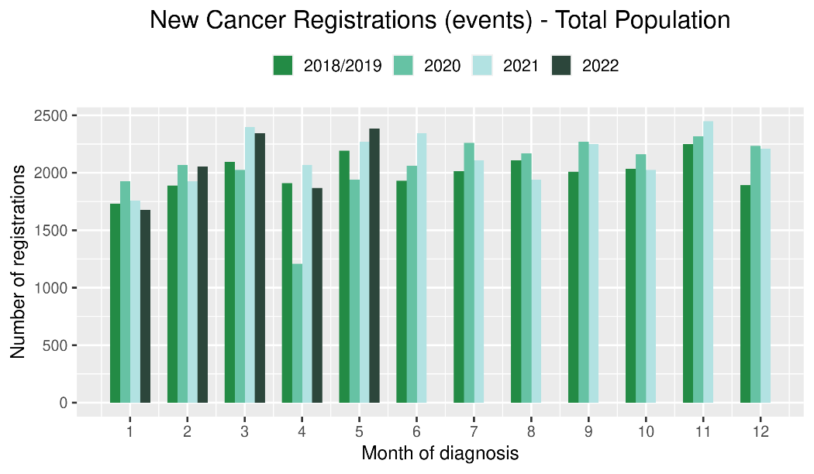 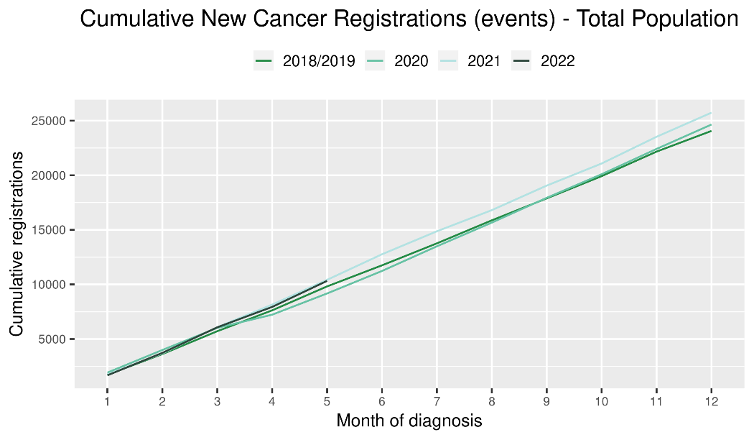

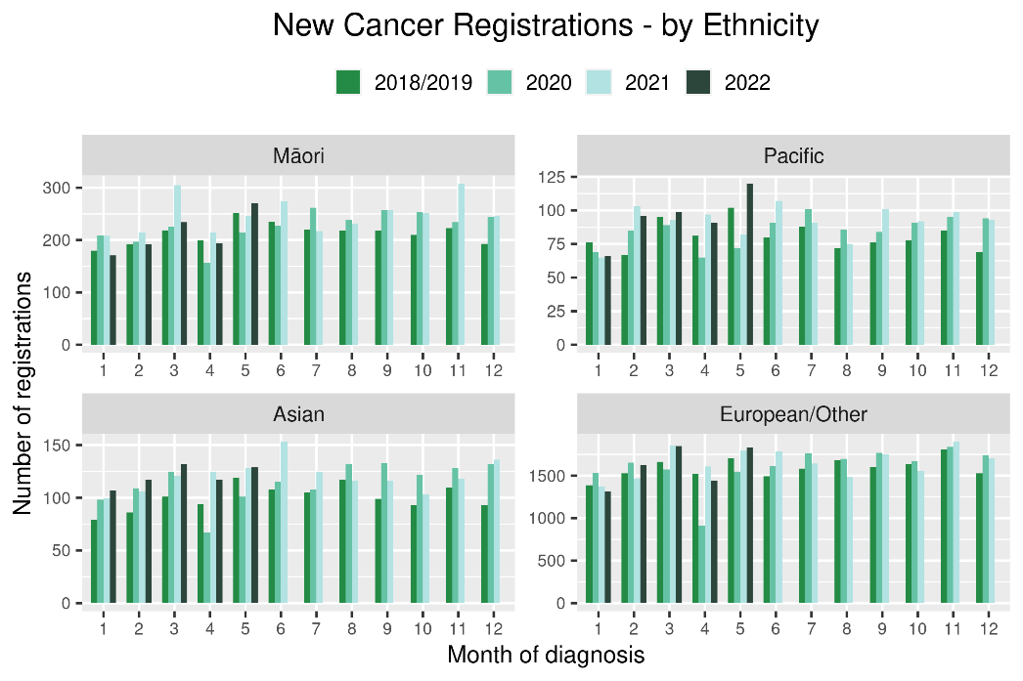 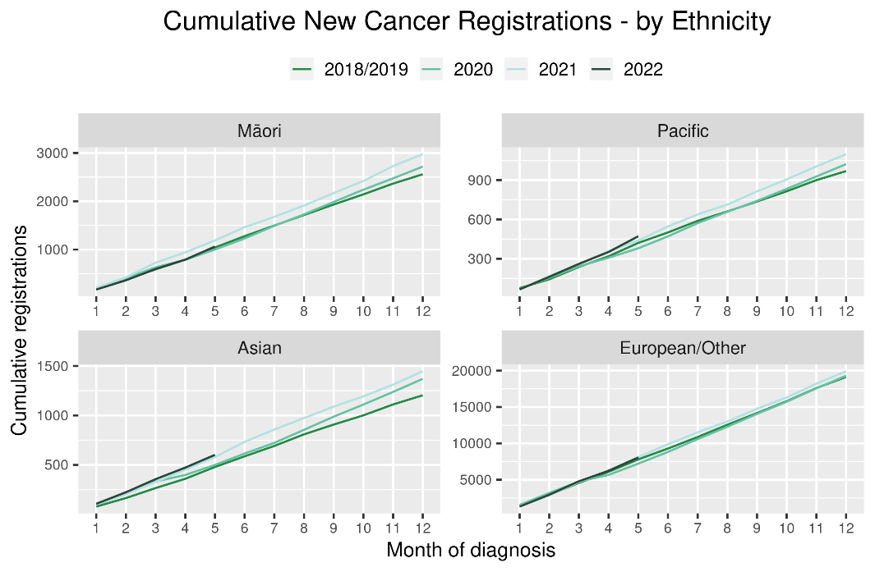

Table 2: Number of provisional cancer registrations* and percentage difference in 2022 compared to the average of 2018 and 2019, by month and cumulative year to date, by tumour group

|  |  |  |  |  |  |  |  |  |  |
| --- | --- | --- | --- | --- | --- | --- | --- | --- | --- |
|  | **April** | | | **May** | | | **Cumulative January-May** | | |
| **Tumour group** | **2018/2019** | **2022** | **% change** | **2018/2019** | **2022** | **% change** | **2018/2019** | **2022** | **% change** |
| Breast | 309 | 278 | -10% | 351 | 351 | 0% | 1,494 | 1,529 | 2% |
| Colorectal | 257 | 251 | -2% | 288 | 293 | 2% | 1,279 | 1,405 | 10% |
| Gynaecology | 73 | 71 | -2% | 112 | 101 | -10% | 438 | 441 | 1% |
| Haematology and Lymphoid | 211 | 173 | -18% | 232 | 211 | -9% | 1,030 | 966 | -6% |
| Melanoma and non-melanoma skin cancer** | 261 | 275 | 5% | 282 | 367 | 30% | 1,395 | 1,589 | 14% |
| Other digestive system | 111 | 112 | 1% | 138 | 157 | 14% | 602 | 672 | 12% |
| Prostate | 306 | 291 | -5% | 342 | 402 | 18% | 1,583 | 1,563 | -1% |
| Respiratory and thorax | 128 | 130 | 2% | 153 | 156 | 2% | 711 | 724 | 2% |
| Urinary system | 82 | 70 | -14% | 93 | 105 | 14% | 422 | 419 | -1% |

*This analysis uses provisional data for the 2022 registrations, some cancers may initially be classified as ‘non-specified’ and subsequently be re-classified into one of the cancer groups as more information becomes available.

**For the purposes of this report, non-melanoma skin cancer excludes basal cell carcinoma and squamous cell carcinoma

Figure 2: Number of cancer registrations by month, 2018/19 average, 2020, 2021 and 2022, by tumour group

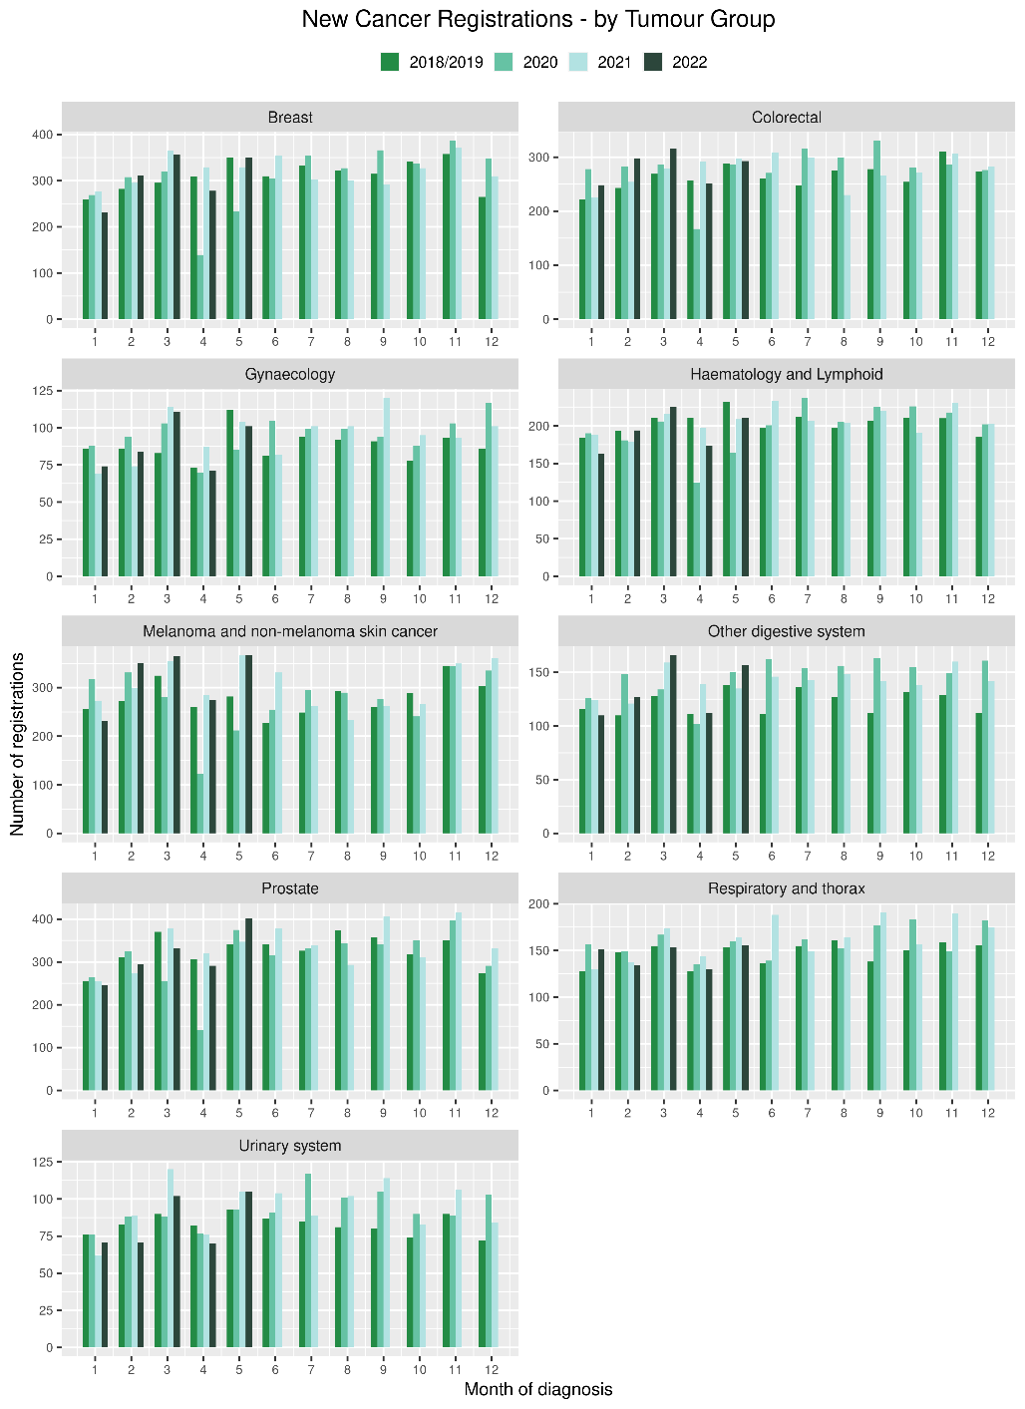 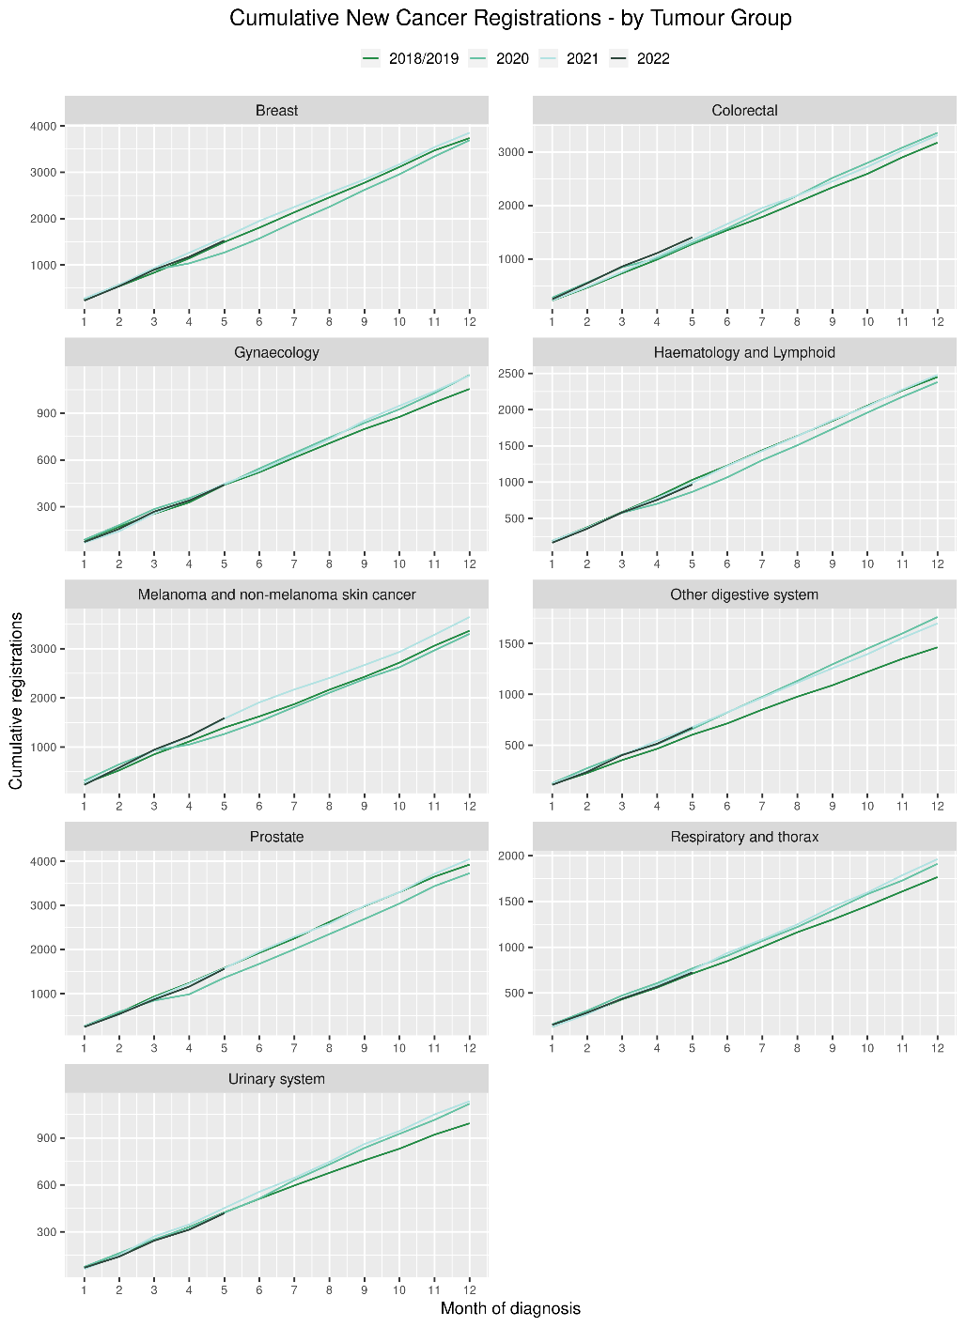

# Gastrointestinal endoscopy

## Notes on data

* Gastrointestinal endoscopy data were extracted from the National Non-admitted Patient Collection (NNPAC) and National Minimum Dataset (NMDS) on 08 Aug 2022.
* Includes colonoscopies and gastroscopies for all indications – not just cancer.
* Technical information: gastroscopies (Purchase Unit Code: MS02005), colonoscopies (Purchase Unit Code: MS02007), combined gastroscopies and colonoscopies (Purchase Unit Code: MS02014).

## Key points

* There was an increase of 20% in gastrointestinal endoscopies performed in May 2022 and of 29% in June 2022, compared to the same months in 2018/19. For Māori, this increase was 38% in May and 48% in June compared to 2018/19.
* For 2022 thus far, there is a 18% increase in gastrointestinal endoscopies, and a 35% increase for Māori compared with 2018/19.

## Results

Table 3: Number of colonoscopy and gastroscopy procedures and percentage difference in 2022 compared to the average of 2018 and 2019, by month and cumulative year to date, by ethnicity

|  |  |  |  |  |  |  |  |  |  |  |  |  |
| --- | --- | --- | --- | --- | --- | --- | --- | --- | --- | --- | --- | --- |
|  | **April** | | | **May** | | | **June** | | | **Cumulative January-June** | | |
|  | **2018/2019** | **2022** | **% change** | **2018/2019** | **2022** | **% change** | **2018/2019** | **2022** | **% change** | **2018/2019** | **2022** | **% change** |
| Māori | 481 | 596 | 24% | 585 | 808 | 38% | 557 | 827 | 48% | 3,065 | 4,131 | 35% |
| Pacific Peoples | 183 | 265 | 45% | 220 | 334 | 52% | 205 | 335 | 63% | 1,156 | 1,638 | 42% |
| Non-Māori/Non-Pacific | 4,809 | 5,265 | 9% | 5,947 | 6,976 | 17% | 5,211 | 6,540 | 26% | 30,396 | 34,916 | 15% |
| Total Population | 5,472 | 6,126 | 12% | 6,751 | 8,118 | 20% | 5,973 | 7,702 | 29% | 34,617 | 40,685 | 18% |

Figure 3: Number of gastrointestinal endoscopy procedures by month, 2018/19 average, 2020, 2021 and 2022 total population and Māori

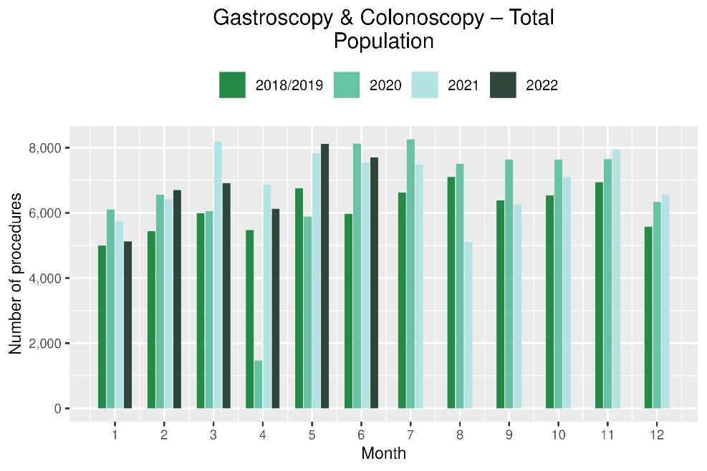 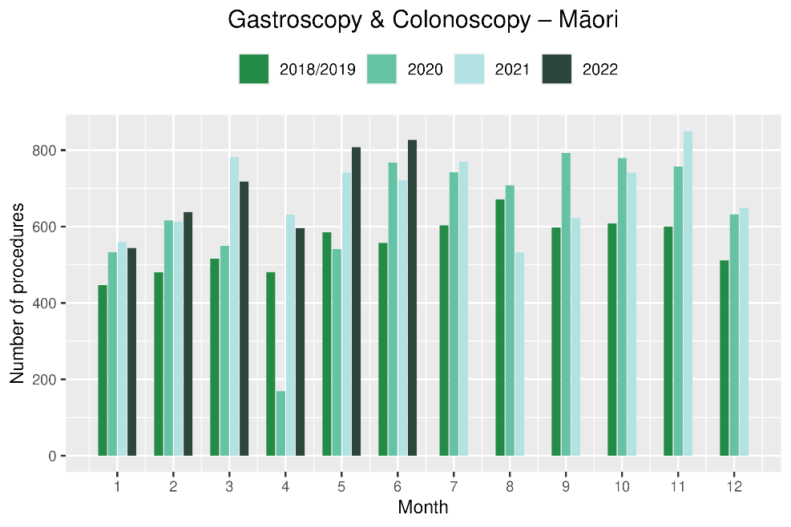

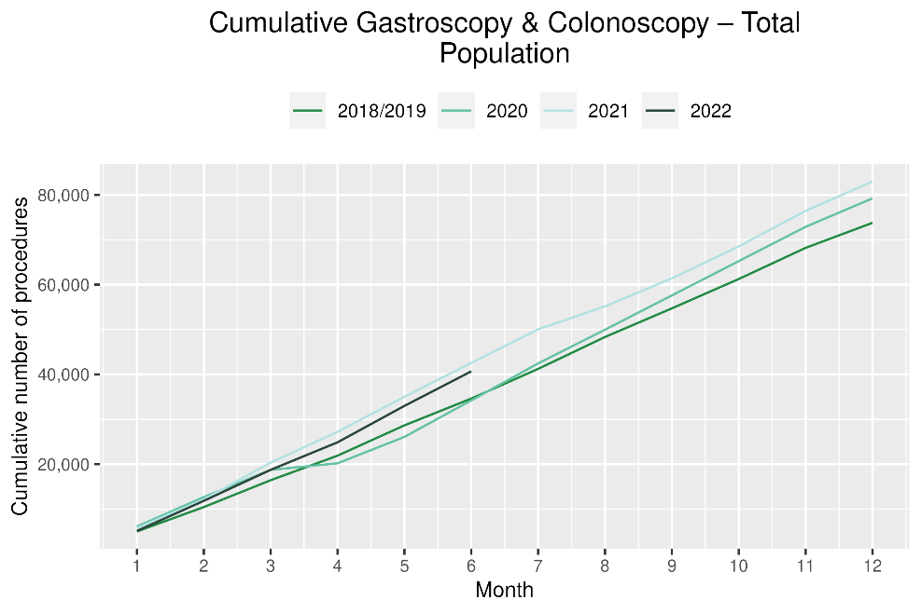 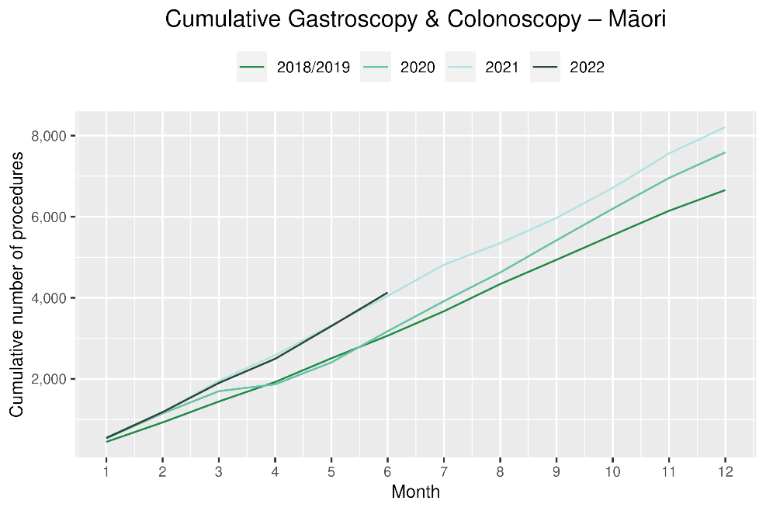

# Bronchoscopy

## Notes on data

* Bronchoscopy and CT Lung Biopsy data were extracted from NNPAC and NMDS on 08 Aug 2022.
* These data include bronchoscopies for all indications, not solely cancer related procedures.
* Technical information: bronchoscopies (Purchase Unit Code: MS02003) and CT Lung Biopsy (Procedure codes: 3841808 and 3881200[3])

## Key points

* May 2022 showed a 30% decrease in the number of bronchoscopies, however there was a notably higher number of bronchoscopies in May 2018/19 to which this is compared. In June there was an overall 3% increase compared to June 2018/19.
* For 2022 to date, there has been a 10% decrease in bronchoscopies, and a 10% increase for Māori, compared with 2018/19.
* For CT lung biopsy for 2022 to date, there was an 11% decrease compared with 2018/19 for the total population and an 8% decrease for Māori.
* Te Aho o Te Kahu has discussed the potential reasons for the overall decrease in bronchoscopy volumes with respiratory physicians in the sector. It has been highlighted that due to the risks of COVID-19 transmission, logistical challenges and other factors, there has been a shift in modes of diagnosis for lung cancer away from bronchoscopy (noting that bronchoscopy is performed for a number of reasons, not just cancer diagnosis). These modes are thought to include Endobronchial Ultrasound Bronchoscopy (EBUS), Positron Emission Tomography - Computed Tomography (PET CT) scans and CT lung biopsy. PET CT and EBUS data are not reported here because the clinical coding of these procedures is not anatomically specific, meaning that we would not know whether they were performed on the lung. CT lung biopsy data were examined and are presented below (figure 5); noting the picture of diagnosis remains incomplete and is therefore difficult to interpret whether any changes in volume of lung cancer diagnostic procedures have occurred. Of note, there has not been a decrease in lung cancer registrations.

## Results

Table 4: Number of bronchoscopies and percentage difference in 2022 compared to the average of 2018 and 2019, by month and cumulative year to date, by ethnicity

|  |  |  |  |  |  |  |  |  |  |  |  |  |
| --- | --- | --- | --- | --- | --- | --- | --- | --- | --- | --- | --- | --- |
|  | **April** | | | **May** | | | **June** | | | **Cumulative January-June** | | |
|  | **2018/2019** | **2022** | **% change** | **2018/2019** | **2022** | **% change** | **2018/2019** | **2022** | **% change** | **2018/2019** | **2022** | **% change** |
| Māori | * | * | * | * | * | * | * | * | * | 195 | 214 | 10% |
| Pacific Peoples | * | * | * | * | * | * | * | * | * | 54 | 56 | 5% |
| Non-Māori/Non-Pacific | 166 | 141 | -15% | 203 | 140 | -31% | 154 | 150 | -3% | 1,020 | 872 | -15% |
| Total Population | 199 | 195 | -2% | 256 | 180 | -30% | 193 | 199 | 3% | 1,268 | 1,142 | -10% |

*Due to small numbers, monthly figures have not been included for Māori and Pacific peoples

Figure 4: Number of bronchoscopies by month, 2018/19 average, 2020, 2021 and 2022, total population and Māori

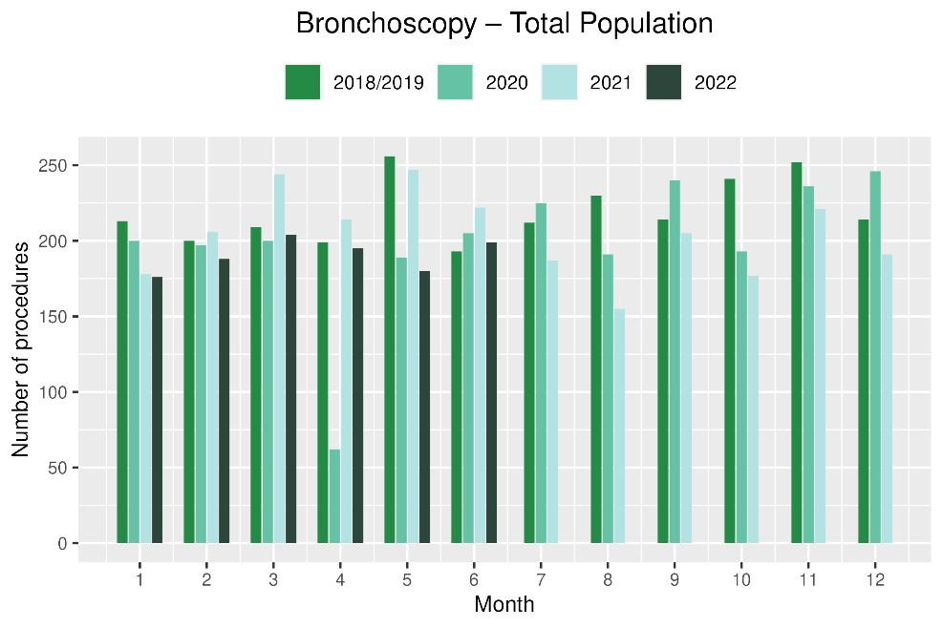 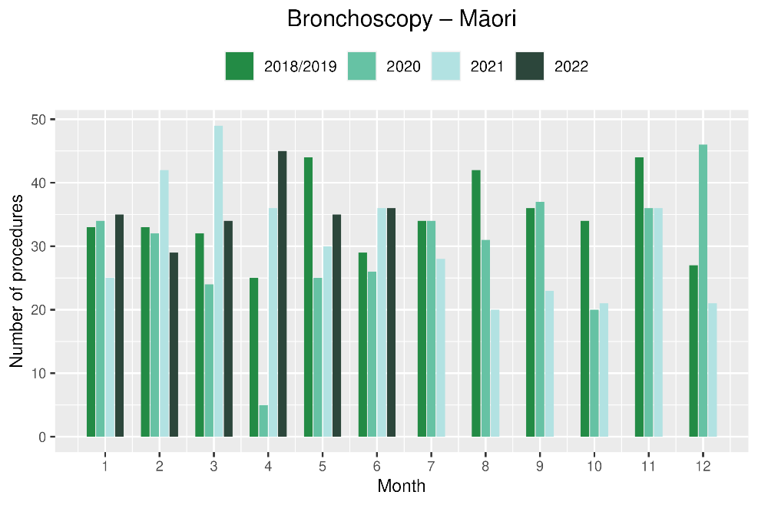

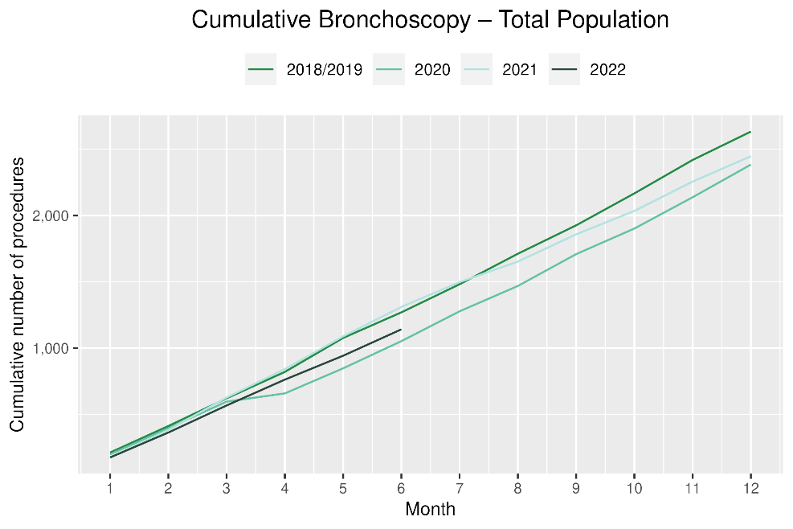 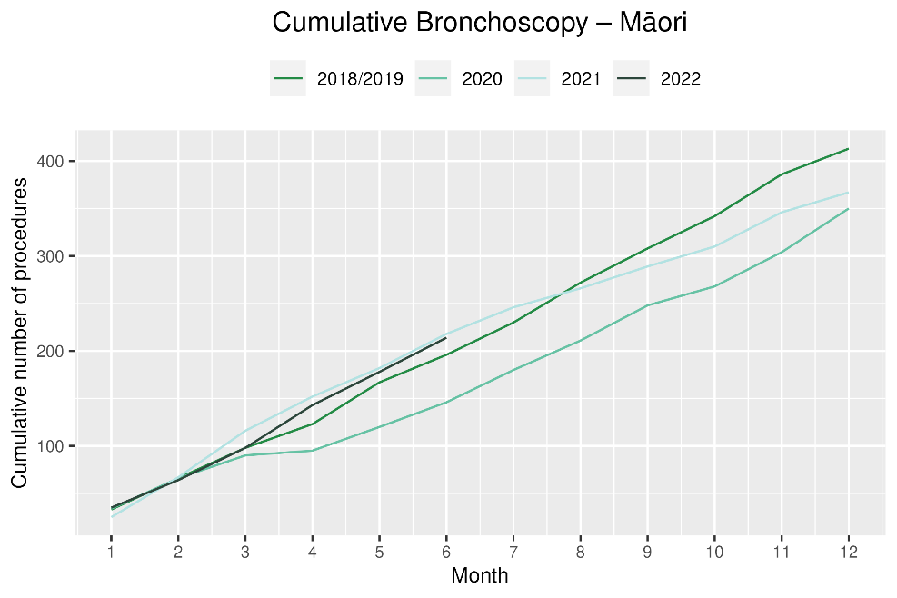

Table 5: Number of CT biopsy and percentage difference in 2022 compared to the average of 2018 and 2019, by month and cumulative year to date, by ethnicity

|  |  |  |  |  |  |  |  |  |  |  |  |  |
| --- | --- | --- | --- | --- | --- | --- | --- | --- | --- | --- | --- | --- |
|  | **April** | | | **May** | | | **June** | | | **Cumulative January-June** | | |
|  | **2018/2019** | **2022** | **% change** | **2018/2019** | **2022** | **% change** | **2018/2019** | **2022** | **% change** | **2018/2019** | **2022** | **% change** |
| Māori | * | * | * | * | * | * | * | * | * | 81 | 74 | -8% |
| Pacific Peoples | * | * | * | * | * | * | * | * | * | 18 | 15 | -14% |
| Non-Māori/Non-Pacific | 49 | 49 | 1% | 76 | 43 | -43% | 55 | 57 | 4% | 354 | 311 | -12% |
| Total Population | 64 | 67 | 6% | 99 | 59 | -40% | 69 | 76 | 11% | 452 | 400 | -11% |

Figure 5: Number of CT lung biopsies by month, 2018/19 average, 2020, 2021 and 2022, total population and Māori

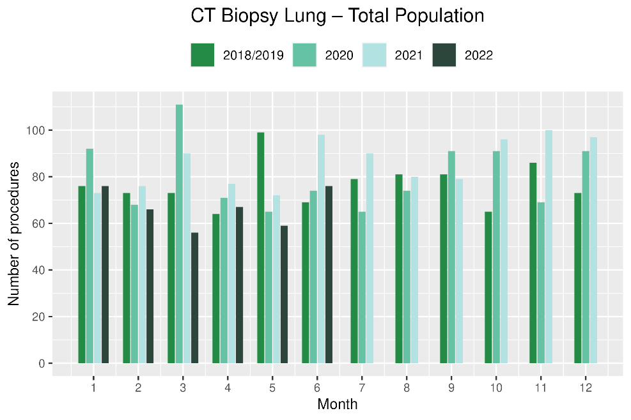 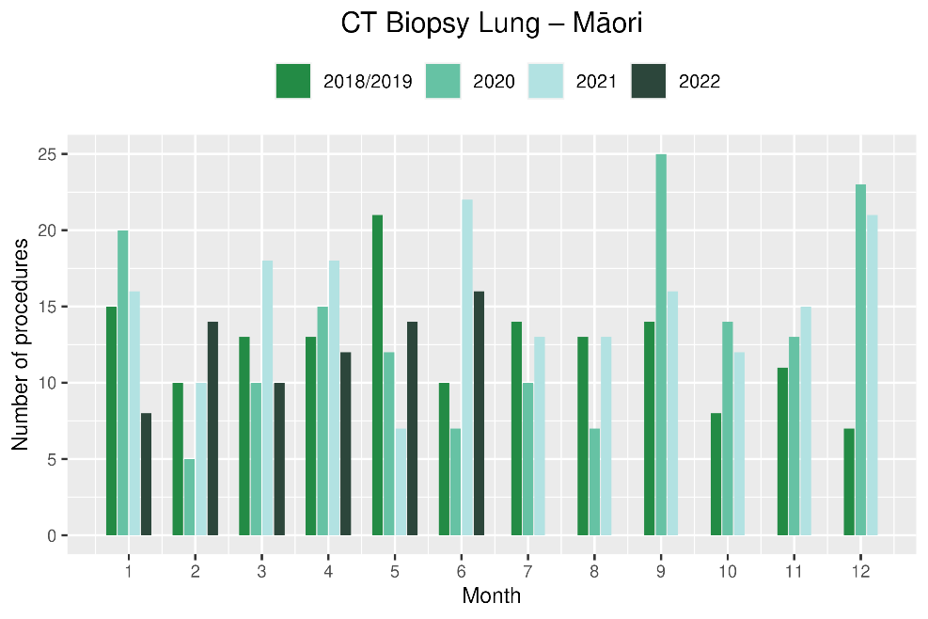

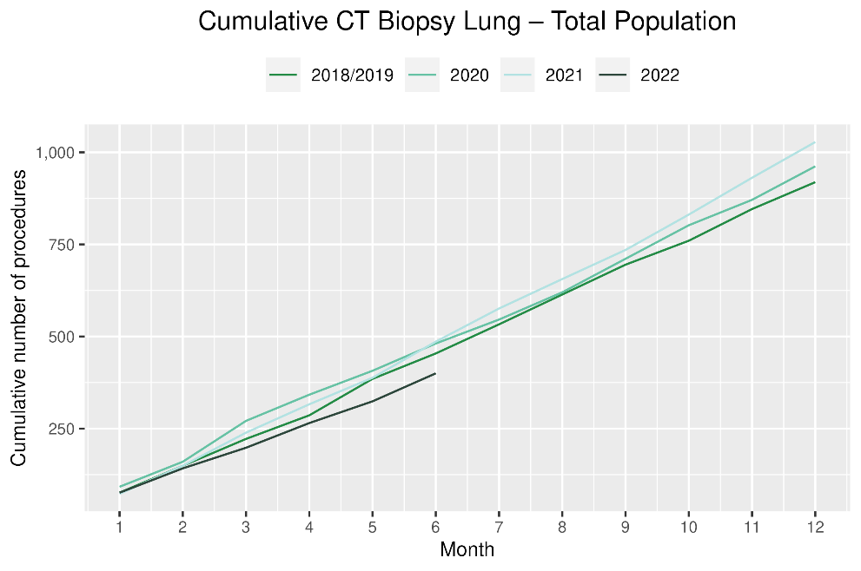 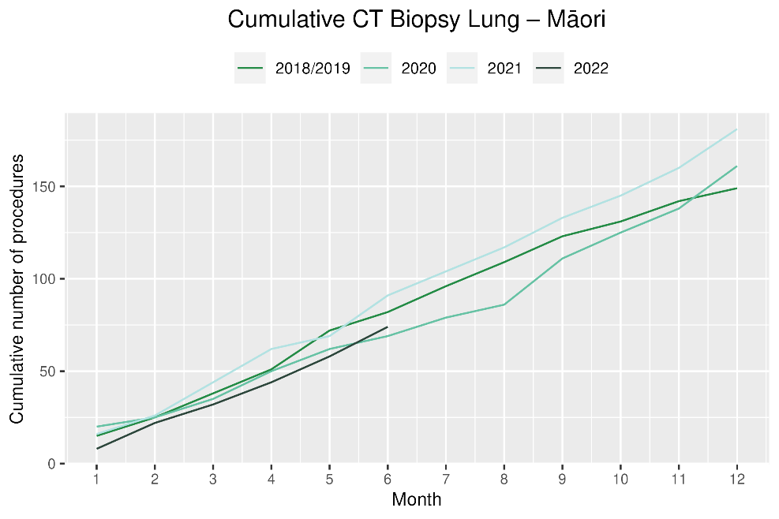

# Faster cancer treatment

## Notes on data

* The data were extracted from the Faster Cancer Treatment database on 27 July 2022. Fast Cancer Treatment Data is reported quarterly.
* These data aim to capture a broader part of the diagnostic and referral pathway; however, they only include a subset of people being investigated for cancer.
* Data relate to the 62-day pathway and includes people with a high-suspicion of cancer and a need to be seen within two weeks. This group of people should receive their first treatment within 62-day of receipt of referral. The target is 90% and Te Aho o Te Kahu has an escalation pathway for monitoring the performance of DHBs against the 62-day measure. Escalation includes regular meetings with service teams and CE to CE discussions against recovery planning and actions.
* Analysis includes all referrals onto the 62-day pathway.

## Key point

* For 2022 to date, there has been some fluctuation in the proportion of people with a high suspicion of cancer receiving their first treatment within 62 days of receipt of referral, however the measure has been met for 84% of people overall and 86% for Māori.

## Results

Table 6: Number of referrals for people with a high suspicion of cancer, in 2022 by month, and cumulative year to date

|  |  |  |  |  |  |  |  |  |
| --- | --- | --- | --- | --- | --- | --- | --- | --- |
|  |  | **January** | **February** | **March** | **April** | **May** | **June** | **Cumulative January-June** |
|  | Māori | 62 | 56 | 58 | 51 | 64 | 47 | 338 |
|  | Non-Māori/Non-Pacific | 296 | 385 | 430 | 300 | 376 | 280 | 2,067 |
|  | Total Population | 380 | 451 | 512 | 376 | 467 | 344 | 2,530 |

*Due to small numbers, volumes have not been included for Pacific peoples

Table 7: Proportion of people with a high-suspicion of cancer and a need to be seen within 2-weeks who received their first treatment within 62 day of receipt of referral, in 2021 by month, and average for the year to date

|  |  |  |  |  |  |  |  |
| --- | --- | --- | --- | --- | --- | --- | --- |
|  | **January** | **February** | **March** | **April** | **May** | **June** | **Cumulative January-June** |
| Māori | 78% | 91% | 86% | 93% | 85% | 85% | 86% |
| Non-Māori/Non-Pacific | 88% | 80% | 85% | 81% | 86% | 85% | 84% |
| Total Population | 86% | 81% | 85% | 83% | 86% | 85% | 84% |

*Due to small numbers, percentages have not been included for Pacific peoples

Figure 6: Proportion of patients with a high-suspicion of cancer and a need to be seen within 2-weeks who received their first treatment within 62 day of receipt of referral, by ethnicity, in 2022 by month

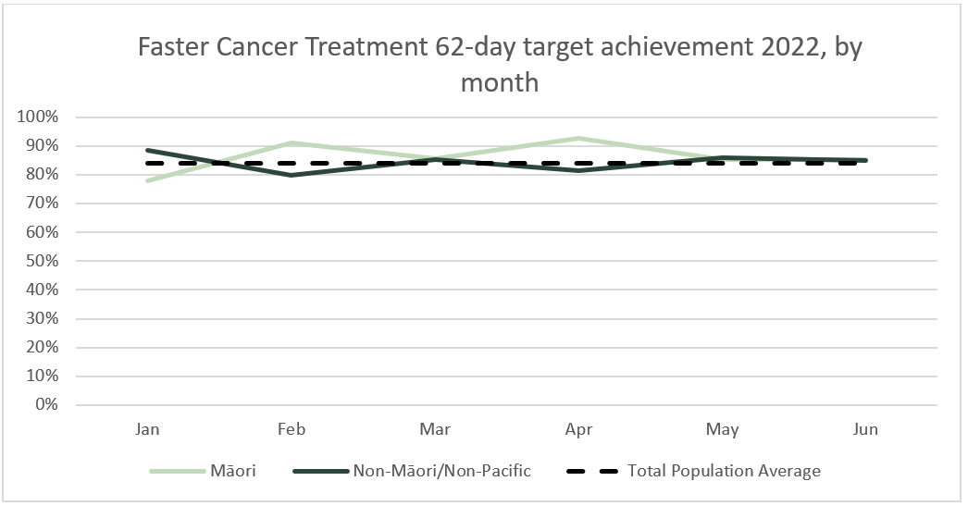

# Combined cancer surgery

## Notes on data

* This report includes data on surgery for breast, colorectal, lung and prostate cancer. These four cancers are therefore used as case studies for cancer surgery more generally.
* Colorectal, lung and prostate cancers were chosen because Te Aho o Te Kahu has a pre-validated list of surgical procedure codes for these cancers, agreed on as part of the quality performance indicator (QPI) work programme.
* For breast cancer, as the development of QPIs are currently underway, we have been able to provide provisional surgical procedure codes for the purposes of this report.
* The surgical procedure codes are listed in Appendix 5.
* The data were extracted from the NMDS on 8 Aug 2022.

## Key points

* In May 2022, there were 11% fewer cancer surgeries (breast, prostate, lung and colorectal combined) compared to May 2018/19. In June 2022, there were 3% fewer cancer surgeries compared to June 2018/19. For 2022 to date there were 4% fewer surgeries performed compared to 2018/19.
* For Māori, there has been a 3% increase in combined cancer surgeries for the year to date relative to 2018/19 (reflecting 10 more surgeries).
* For Pacific peoples there was a 25% increase for the year to date relative to 2018/19 (reflecting 25 more surgeries).

## Results

Table 8: Number of cancer surgeries (breast, prostate, colorectal, lung) and percentage difference in 2022 compared to the average of 2018 and 2019, by month and cumulative year to date, by ethnicity

|  |  |  |  |  |  |  |  |  |  |  |  |  |
| --- | --- | --- | --- | --- | --- | --- | --- | --- | --- | --- | --- | --- |
|  | **April** | | | **May** | | | **June** | | | **Cumulative January-June** | | |
|  | **2018/2019** | **2022** | **% change** | **2018/2019** | **2022** | **% change** | **2018/2019** | **2022** | **% change** | **2018/2019** | **2022** | **% change** |
| Māori | 55 | 36 | -34% | 62 | 49 | -20% | 52 | 62 | 19% | 317 | 327 | 3% |
| Pacific Peoples | 22 | 30 | 40% | 21 | 25 | 19% | 19 | 21 | 11% | 102 | 127 | 25% |
| Non-Māori/Non-Pacific | 392 | 387 | -1% | 410 | 363 | -11% | 391 | 367 | -6% | 2,292 | 2,152 | -6% |
| Total Population | 468 | 453 | -3% | 493 | 437 | -11% | 462 | 450 | -3% | 2,711 | 2,606 | -4% |

Figure 7: Number of cancer surgeries (breast, prostate, colorectal, lung) by month, 2018/19 average, 2020, 2021 and 2022, total population and Māori

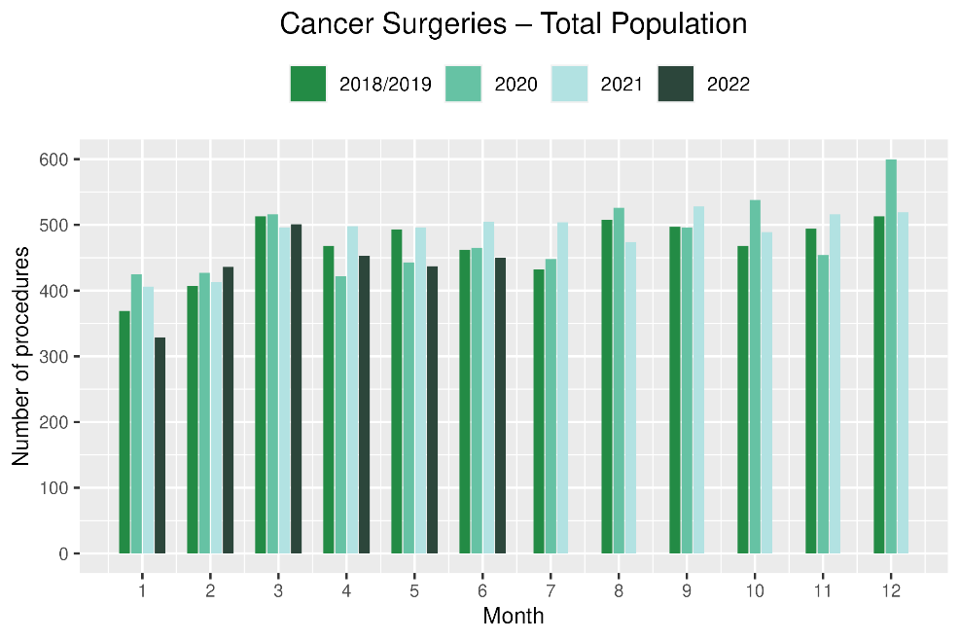 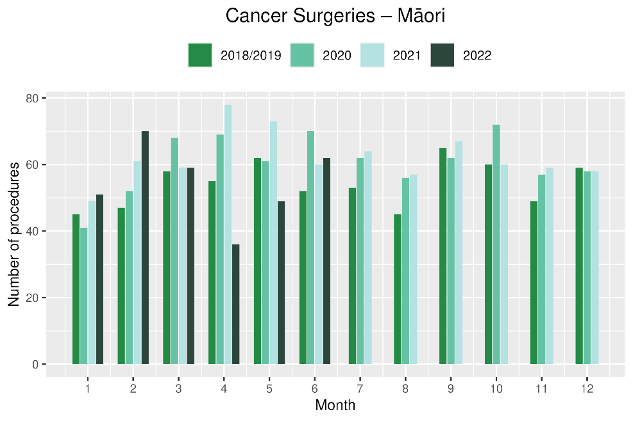

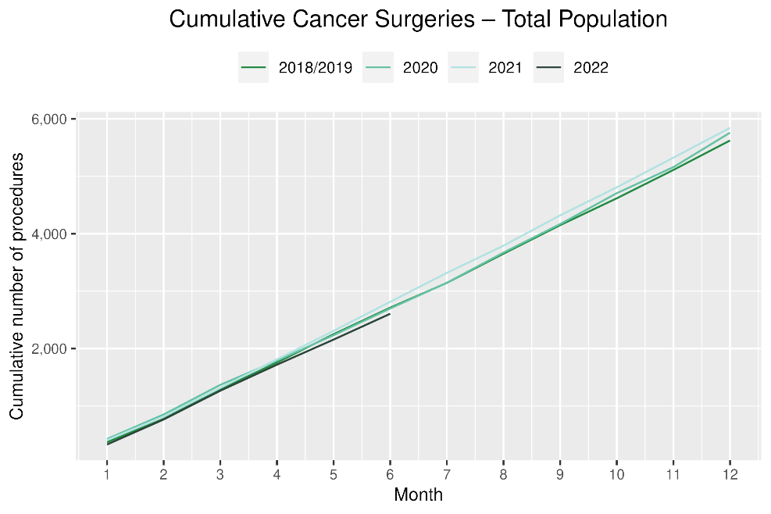 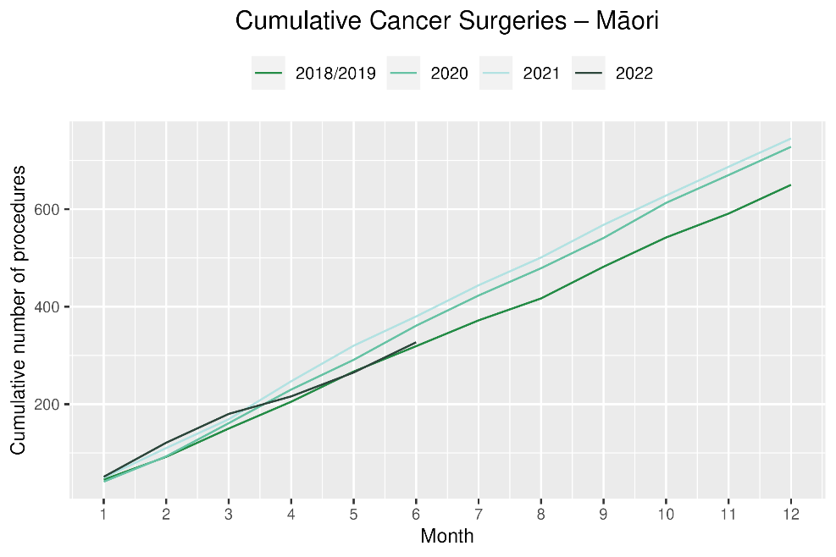

# Breast cancer surgery (mastectomy)

## Notes on data

* A list of the surgical procedure codes used for analysis are included in Appendix 5.
* The data were extracted from the NMDS on 8 Aug 2022.
* The number of mastectomies performed each month is relatively small, so caution is needed when comparing data by month.
* Procedure codes for mastectomy only are included in this report. There are a number of additional procedure codes used for breast cancer surgeries in addition to mastectomy, however the procedure codes for these surgeries are less specific for cancer. Therefore, using only mastectomy codes allows a more accurate view of any changes in breast cancer surgery volumes[4].

## Key points

* There were 15% fewer mastectomies performed in May 2022 compared with May 2018/19 and a 1% increase in June 2022 compared with 2018/19.
* For 2022 to date, there has been a 5% decrease in mastectomies in 2022 compared with 2018/19.

## Results

Table 9: Number of mastectomies and percentage difference in 2022 compared to the average of 2018 and 2019, by month and cumulative year to date, by ethnicity

|  |  |  |  |  |  |  |  |  |  |  |  |  |
| --- | --- | --- | --- | --- | --- | --- | --- | --- | --- | --- | --- | --- |
|  | **April** | | | **May** | | | **June** | | | **Cumulative January-June** | | |
|  | **2018/2019** | **2022** | **% change** | **2018/2019** | **2022** | **% change** | **2018/2019** | **2022** | **% change** | **2018/2019** | **2022** | **% change** |
| Māori | * | * | * | * | * | * | * | * | * | * | * | * |
| Pacific Peoples | * | * | * | * | * | * | * | * | * | * | * | * |
| Non-Māori/Non-Pacific | 83 | 89 | 7% | 109 | 101 | -7% | 111 | 101 | -9% | 590 | 548 | -7% |
| Total Population | 114 | 112 | -1% | 142 | 120 | -15% | 142 | 143 | 1% | 768 | 732 | -5% |

*Due to small numbers, some figures have not been included for Māori and Pacific peoples

Figure 8: Number of mastectomies by month, 2018/19 average, 2020, 2021 and 2022, total population and Māori

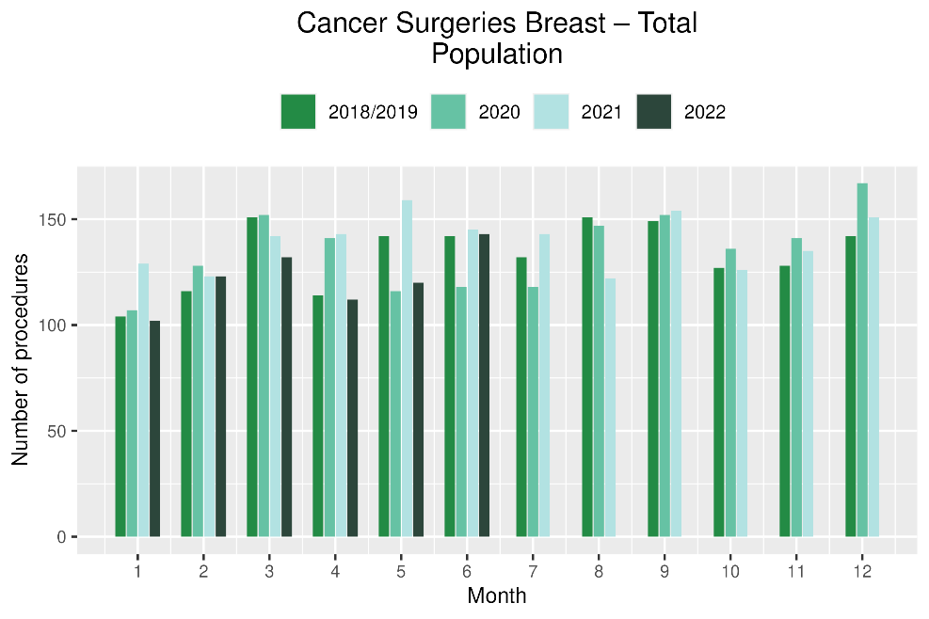 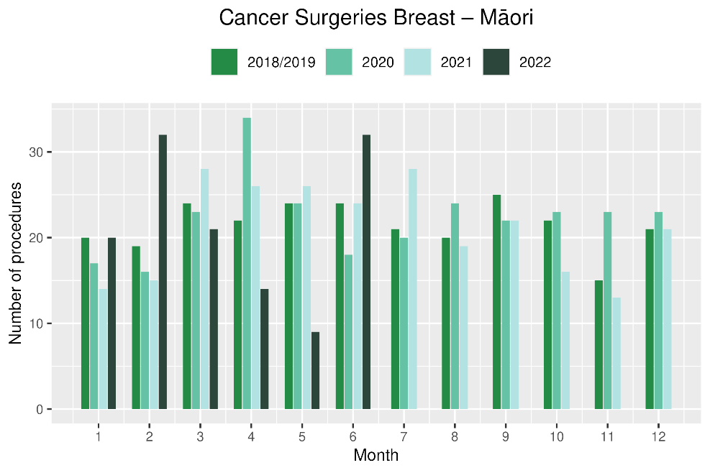

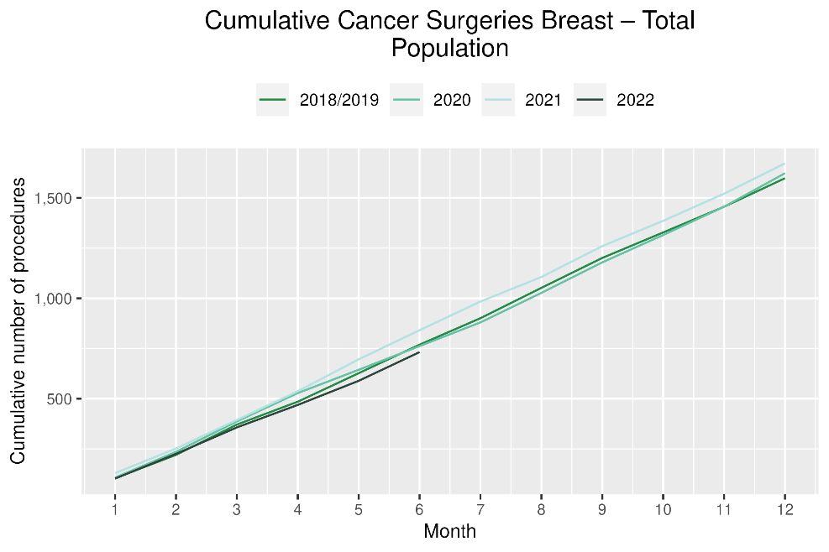 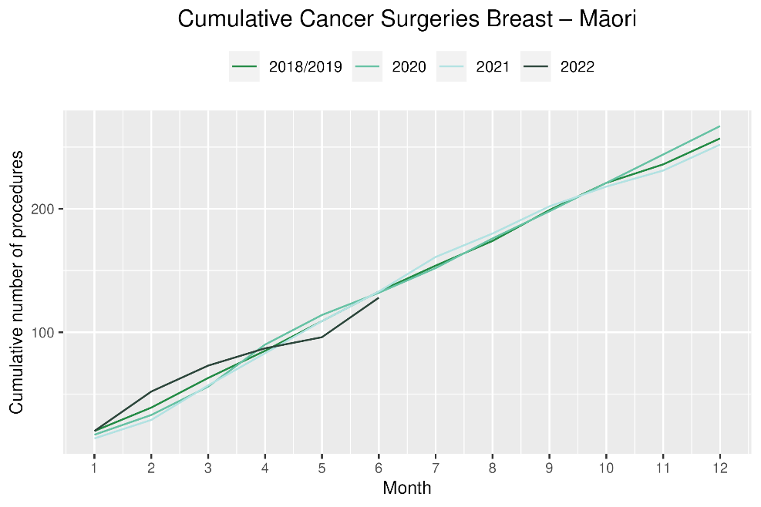

# Colorectal cancer surgery

## Notes on data

* The surgical procedure codes used for analysing colorectal cancer are listed in Appendix 5.
* The data were extracted from the NMDS on 8 Aug 2022.

## Key points

* There were 17% fewer colorectal cancer surgeries performed in May 2022 compared with May 2018/19 and 7% fewer in June 2022.
* For 2022 to date, there were 8% fewer colorectal cancer surgeries performed in total, 22% increase for Pacific peoples (noting small numbers) and a 18% increase for Māori compared with 2018/19.

## Results

Table 10: Number of colorectal cancer surgeries and percentage difference in 2022 compared to the average of 2018 and 2019, by month and cumulative year to date, by ethnicity

|  |  |  |  |  |  |  |  |  |  |  |  |  |
| --- | --- | --- | --- | --- | --- | --- | --- | --- | --- | --- | --- | --- |
|  | **April** | | | **May** | | | **June** | | | **Cumulative January-June** | | |
|  | **2018/2019** | **2022** | **% change** | **2018/2019** | **2022** | **% change** | **2018/2019** | **2022** | **% change** | **2018/2019** | **2022** | **% change** |
| Māori | 18 | 14 | -22% | * | * | * | * | * | * | 100 | 117 | 18% |
| Pacific Peoples | 10 | 15 | 50% | * | * | * | * | * | * | 35 | 42 | 22% |
| Non-Māori/Non-Pacific | 207 | 187 | -10% | 202 | 154 | -24% | 178 | 163 | -8% | 1,114 | 986 | -11% |
| Total Population | 235 | 216 | -8% | 228 | 190 | -17% | 199 | 184 | -7% | 1,248 | 1,145 | -8% |

*Due to small numbers, monthly figures have not been included for Māori and Pacific peoples

**Figure 9: Number of colorectal cancer surgeries by month, 2018/19 average, 2020, 2021 and 2022, total population and Māori**

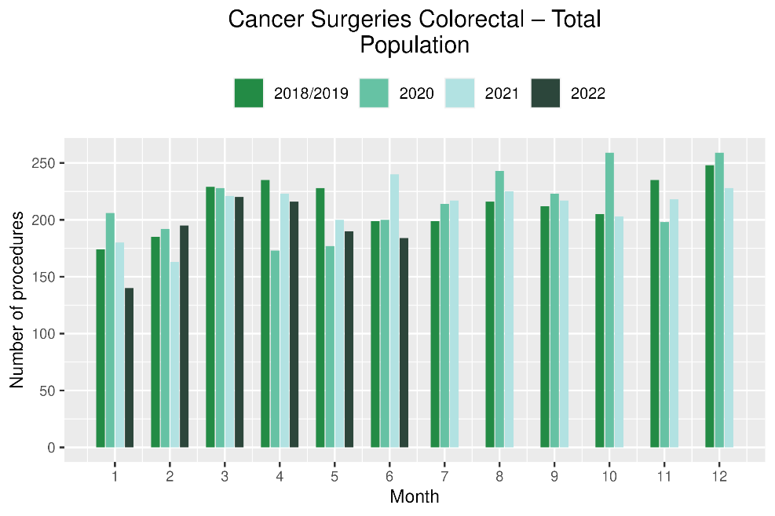 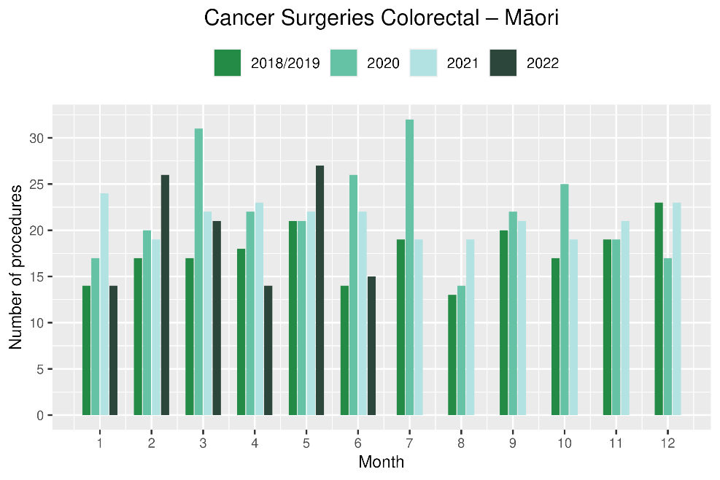

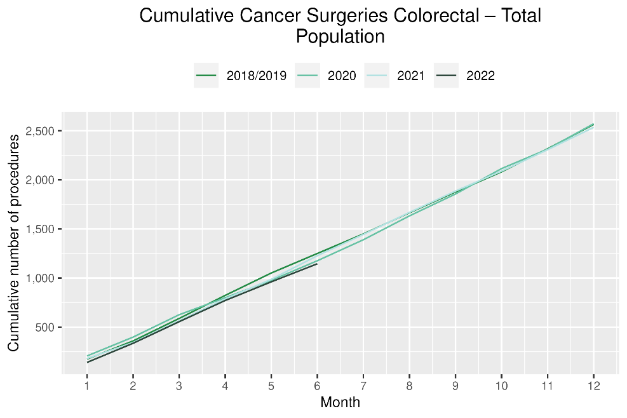 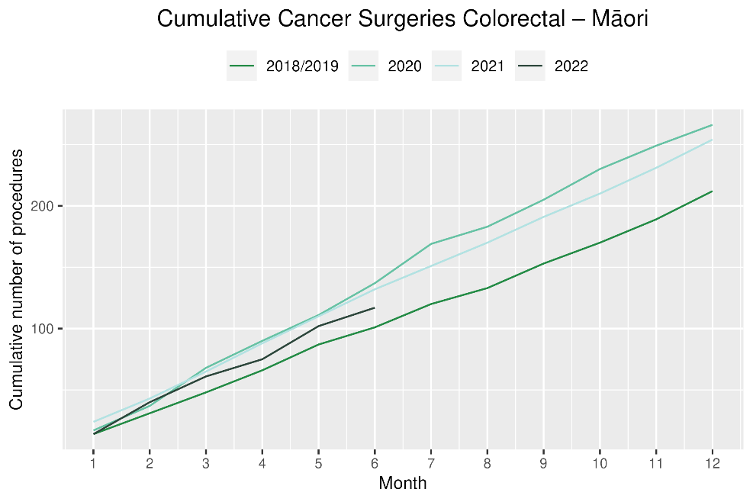

# Lung cancer surgery

## Notes on data

* A list of the surgical procedure codes used for analysis are included in Appendix 5.
* The data were extracted from the NMDS on 8 Aug 2022.
* The number of lung cancer surgeries performed each month is relatively small, so caution is needed when comparing data by month.

## Key points

* There was a 6% increase in the number of lung cancer surgeries performed in May and for June 2022 compared with the same months in 2018/19.
* For 2022 to date there was a 2% increase in the number of surgeries performed for the total population.
* For Māori there was a 25% decrease in lung cancer surgery, numbering 16 fewer surgeries in 2022 compared with 2018/19. For Pacific peoples there was a 48% increase, numbering 6 more surgeries.

## Results

Table 11: Number of lung cancer surgeries and percentage difference in 2022 compared to the average of 2018 and 2019, by month and cumulative year to date, by ethnicity

|  |  |  |  |  |  |  |  |  |  |  |  |  |
| --- | --- | --- | --- | --- | --- | --- | --- | --- | --- | --- | --- | --- |
|  | **April** | | | **May** | | | **June** | | | **Cumulative January-June** | | |
|  | **2018/2019** | **2022** | **% change** | **2018/2019** | **2022** | **% change** | **2018/2019** | **2022** | **% change** | **2018/2019** | **2022** | **% change** |
| Māori | * | * | * | * | * | * | * | * | * | 62 | 46 | -25% |
| Pacific Peoples | * | * | * | * | * | * | * | * | * | 14 | 20 | 48% |
| Non-Māori/Non-Pacific | 41 | 56 | 37% | 41 | 45 | 11% | 38 | 42 | 11% | 252 | 269 | 7% |
| Total Population | 55 | 62 | 14% | 56 | 59 | 6% | 51 | 54 | 6% | 327 | 335 | 2% |

* Due to small numbers, monthly figures have not been included for Māori and Pacific peoples

Figure 10: Number of lung cancer surgeries by month, 2018/19 average, 2020, 2021 and 2022, total population and Māori

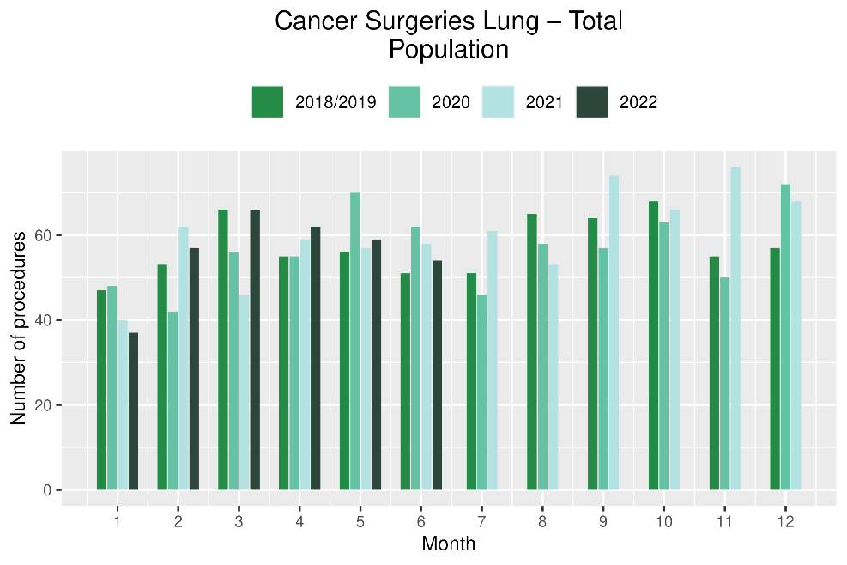 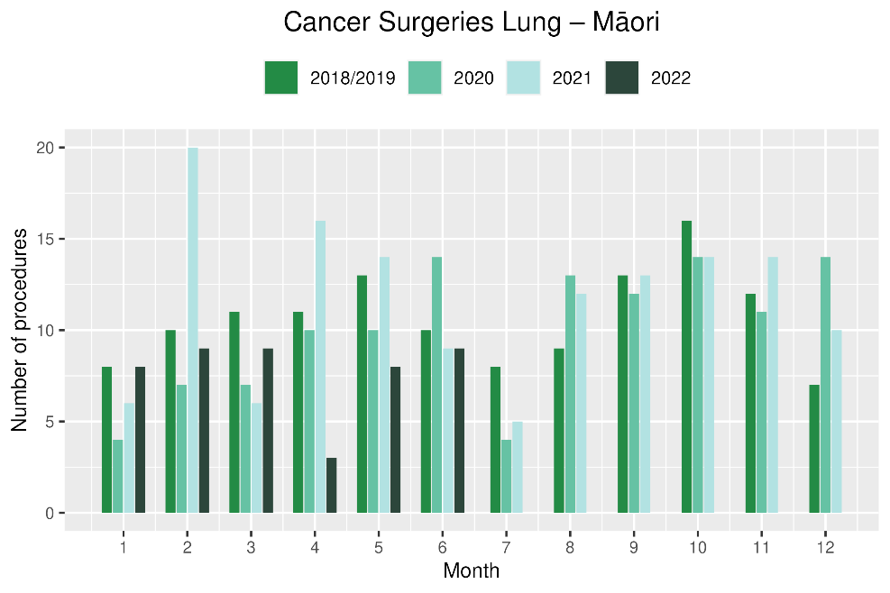

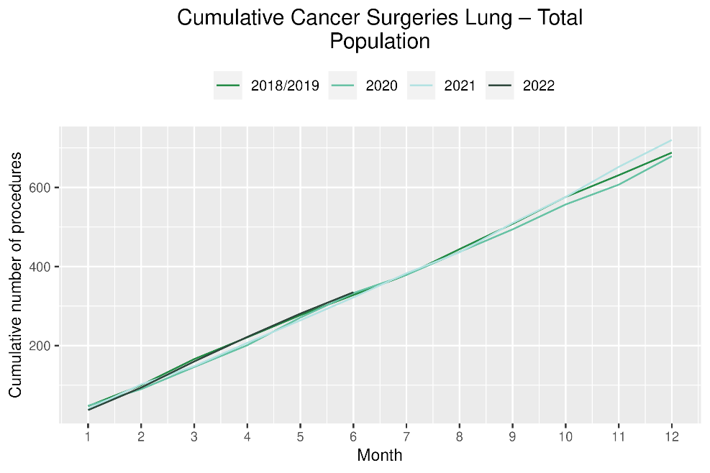 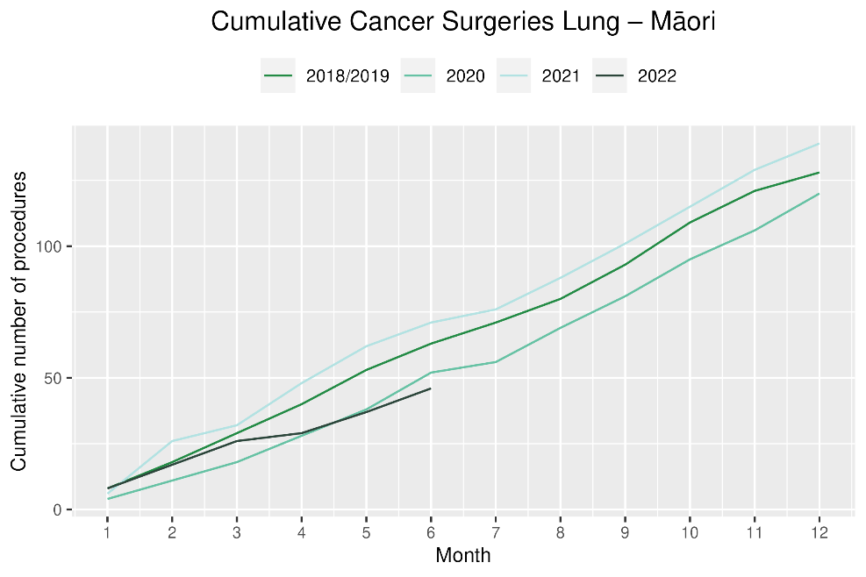

# Prostate cancer surgery

## Notes on data

* A list of the surgical procedure codes used for analysis are included in Appendix 5.
* The data was extracted from the NMDS on 08 Aug 2022.
* The number of prostate cancer surgeries performed each month is relatively small, so caution is needed when comparing data by month.

## Key points

* There was a 1% increase in prostate cancer surgeries performed in May 2022 compared with May 2018/19 and a 4% decrease for the month of June.
* For 2022 to date there were 7% more prostate cancer surgeries compared with cumulative figures from 2018/19.

## Results

Table 12: Number of prostate cancer surgeries and percentage difference in 2022 compared to the average of 2018 and 2019 by month and cumulative year to date

|  |  |  |  |  |  |  |  |  |  |  |  |  |
| --- | --- | --- | --- | --- | --- | --- | --- | --- | --- | --- | --- | --- |
|  | **April** | | | **May** | | | **June** | | | **Cumulative January-June** | | |
|  | **2018/2019** | **2022** | **% change** | **2018/2019** | **2022** | **% change** | **2018/2019** | **2022** | **% change** | **2018/2019** | **2022** | **% change** |
| Māori | * | * | * | * | * | * | * | * | * | * | * | * |
| Pacific Peoples | * | * | * | * | * | * | * | * | * | * | * | * |
| Non-Māori/Non-Pacific | 61 | 55 | -9% | 60 | 63 | 6% | 65 | 60 | -7% | 337 | 348 | 3% |
| Total Population | 65 | 63 | -2% | 68 | 68 | 1% | 71 | 68 | -4% | 368 | 393 | 7% |

*Due to small numbers, some figures have not been included for Māori and Pacific peoples

Figure 11: Number of prostate cancer surgeries by month, 2018/19 average, 2020,2021 and 2022, total population and Māori

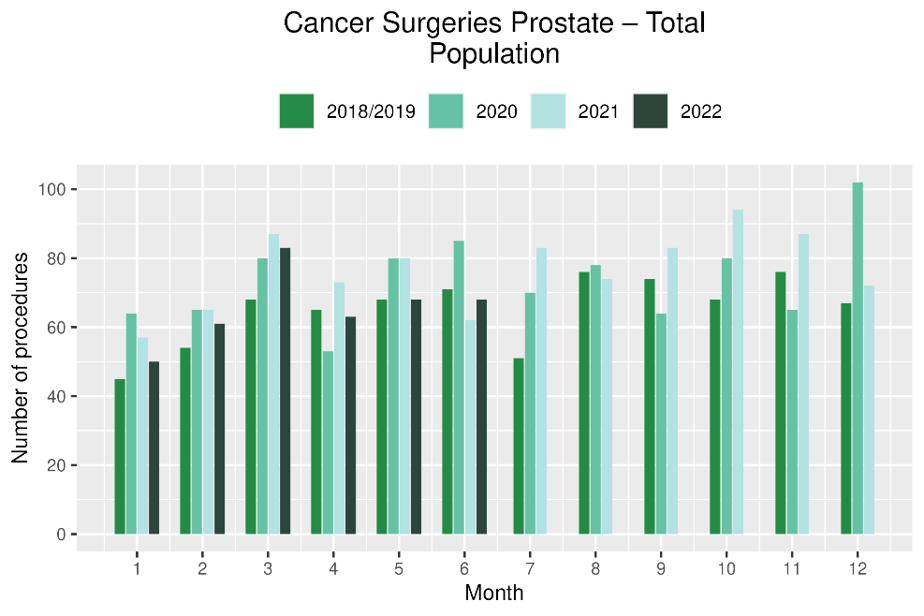 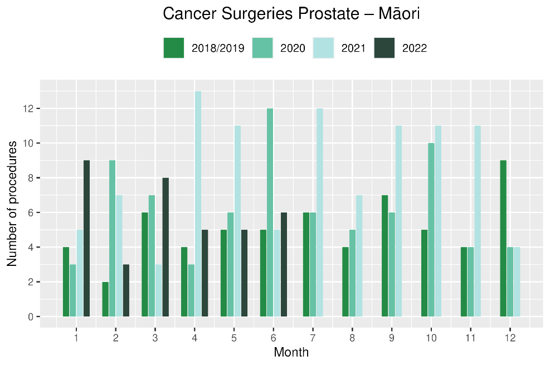

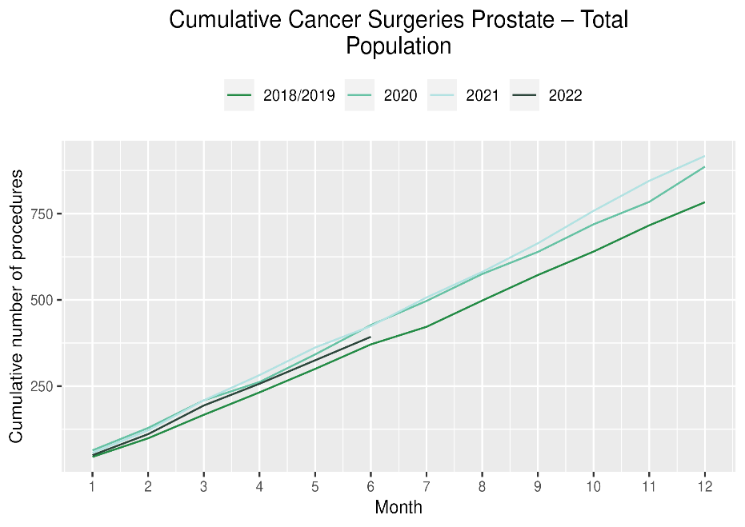 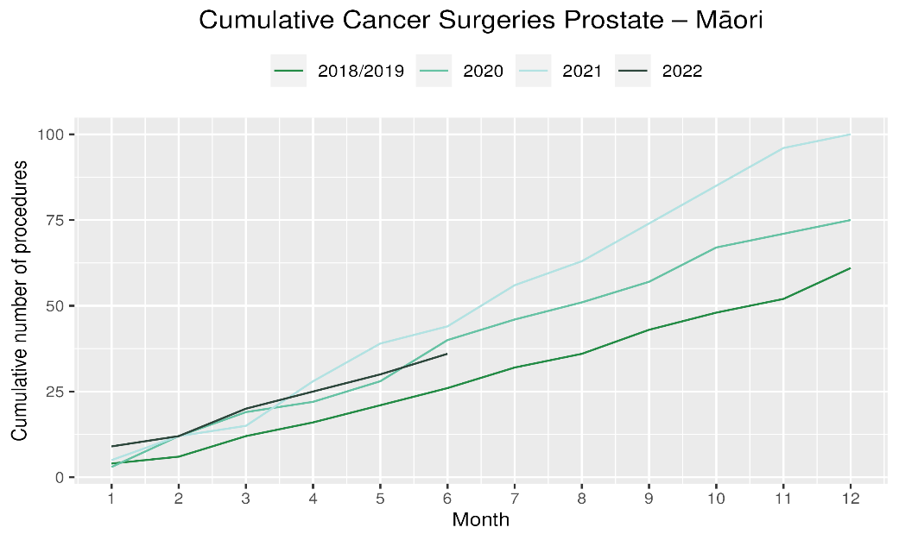

# Medical oncology

## Notes on data

* Data were extracted from NNPAC on 8 Aug 2022.
* First specialist assessment (FSA) reflects counts of first attendance for specialist medical oncology assessment.
* Intravenous (IV) chemotherapy reflects appointments for outpatient and inpatient IV chemotherapy for non-haematological indications.
* Technical information: medical oncology FSA (Purchase Unit Code: M50020) and IV chemotherapy (Purchase Unit Code: MS02009).

## Key points

* Attendances for medical oncology first specialist assessments (FSAs) showed a 2% increase in May 2022 compared to May 2018/19 and a 12% increase in June. For Māori, there was an 4% increase in FSAs in May 2022 compared to May 2018/19 and a 7% decrease in June.
* For 2022 to date, there was an overall 8% increase in medical oncology FSAs compared with 2018/19 and a 12% increase for Māori.
* Attendances for intravenous (IV) chemotherapy increased by 3% in May 2022 compared to May 2018/19 and increased by 17% in June. For Māori, there was a 29% increase in IV chemotherapy in May 2022 compared to May 2018/19 and increased by 39% in June.
* For 2022 to date, there was a 10% increase in IV chemotherapy compared with 2018/19 overall and a 34% increase for Māori.

## Results

Table 13: Number of medical oncology first specialist assessments and percentage difference in 2022 compared to the average of 2018 and 2019, by month and cumulative year to date, by ethnicity

|  |  |  |  |  |  |  |  |  |  |  |  |  |
| --- | --- | --- | --- | --- | --- | --- | --- | --- | --- | --- | --- | --- |
|  | **April** | | | **May** | | | **June** | | | **Cumulative January -June** | | |
|  | **2018/2019** | **2022** | **% change** | **2018/2019** | **2022** | **% change** | **2018/2019** | **2022** | **% change** | **2018/2019** | **2022** | **% change** |
| Māori | 94 | 101 | 8% | 112 | 116 | 4% | 109 | 101 | -7% | 593 | 662 | 12% |
| Pacific Peoples | 35 | 35 | 1% | 48 | 53 | 10% | 31 | 47 | 52% | 202 | 251 | 25% |
| Non-Māori/Non-Pacific | 544 | 544 | 0% | 723 | 727 | 1% | 556 | 629 | 13% | 3,590 | 3,842 | 7% |
| Total Population | 672 | 680 | 1% | 883 | 896 | 2% | 695 | 777 | 12% | 4,385 | 4,755 | 8% |

Figure 12: Number of medical oncology first specialist assessments by month, 2018/19 average, 2020, 2021 and 2022, total population and Māori

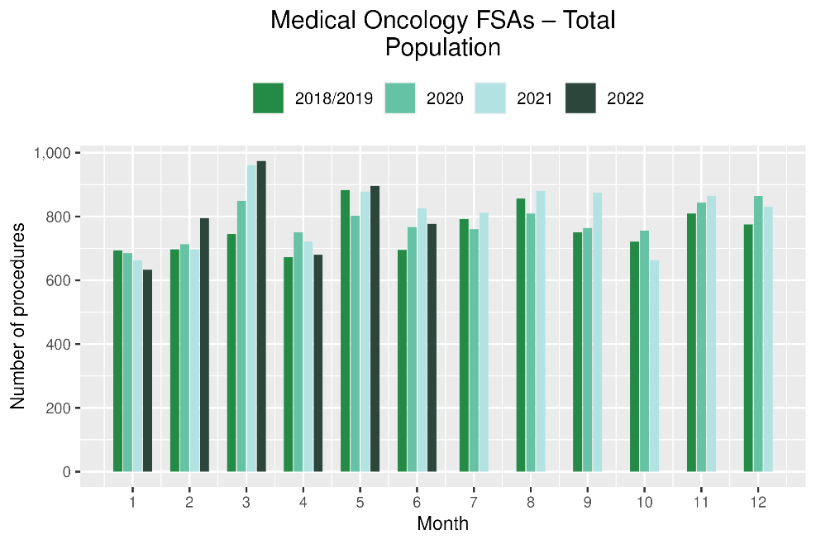 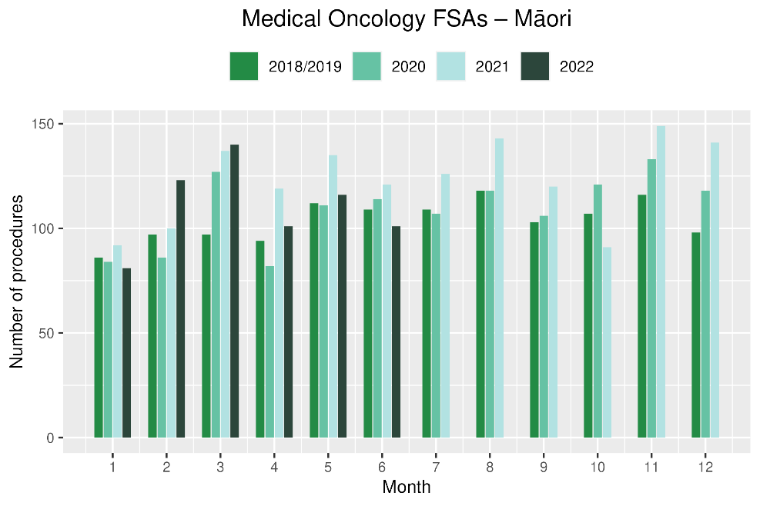

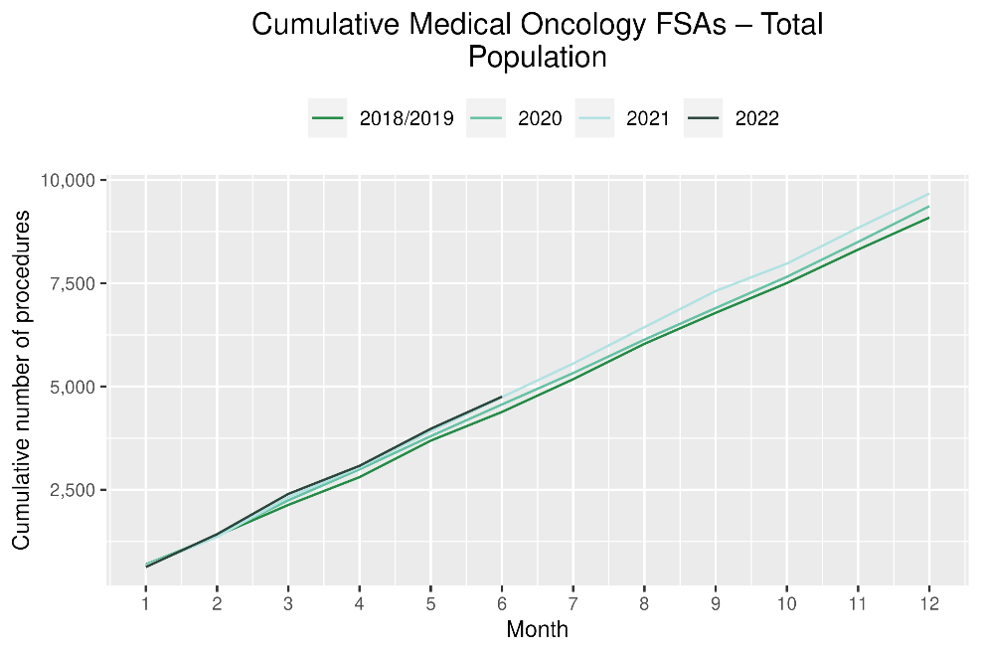 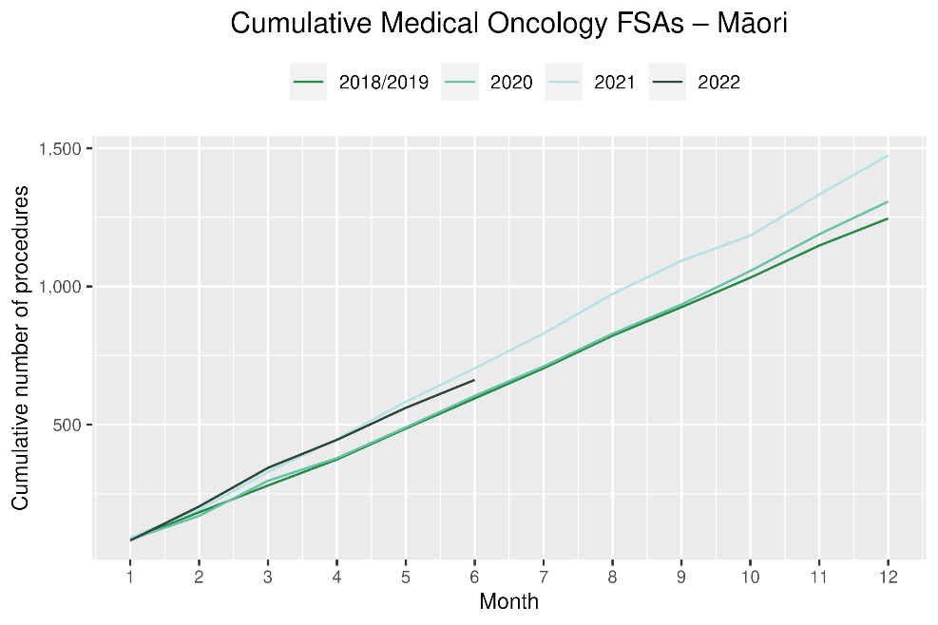

Table 14: Number of IV chemotherapy attendances and percentage difference in 2022 compared to the average of 2018 and 2019, by month and cumulative year to date, by ethnicity

|  |  |  |  |  |  |  |  |  |  |  |  |  |
| --- | --- | --- | --- | --- | --- | --- | --- | --- | --- | --- | --- | --- |
|  | **April** | | | **May** | | | **June** | | | **Cumulative January -June** | | |
|  | **2018/2019** | **2022** | **% change** | **2018/2019** | **2022** | **% change** | **2018/2019** | **2022** | **% change** | **2018/2019** | **2022** | **% change** |
| Māori | 674 | 930 | 38% | 756 | 973 | 29% | 682 | 945 | 39% | 4,209 | 5,651 | 34% |
| Pacific Peoples | 275 | 344 | 25% | 293 | 397 | 35% | 253 | 401 | 58% | 1,598 | 2,215 | 39% |
| Non-Māori/Non-Pacific | 4,753 | 4,941 | 4% | 5,400 | 5,265 | -3% | 4,628 | 5,162 | 12% | 28,909 | 30,479 | 5% |
| Total Population | 5,701 | 6,215 | 9% | 6,449 | 6,635 | 3% | 5,563 | 6,508 | 17% | 34,715 | 38,345 | 10% |

Figure 13: Number of IV chemotherapy attendances by month, 2018/19 average, 2020 and 2021, total population and Māori

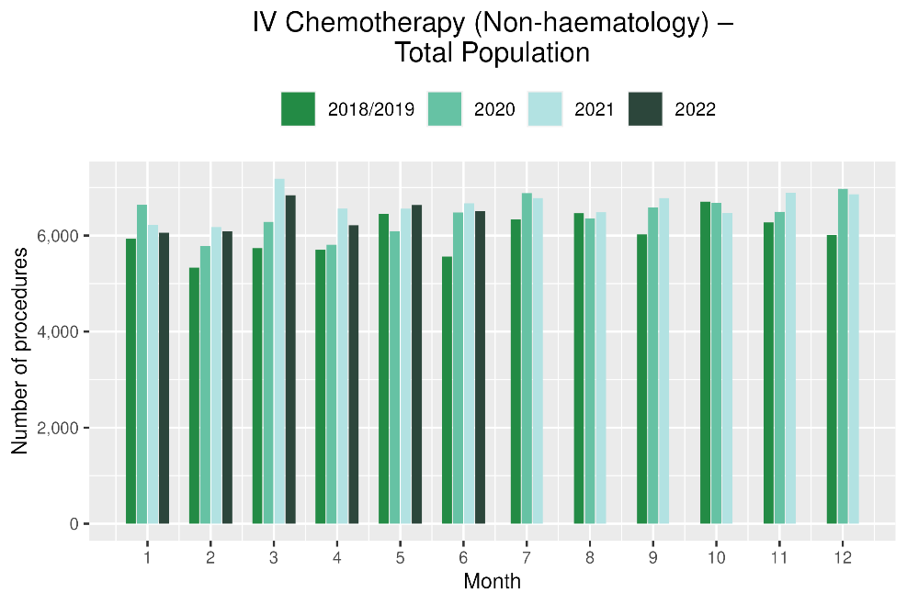 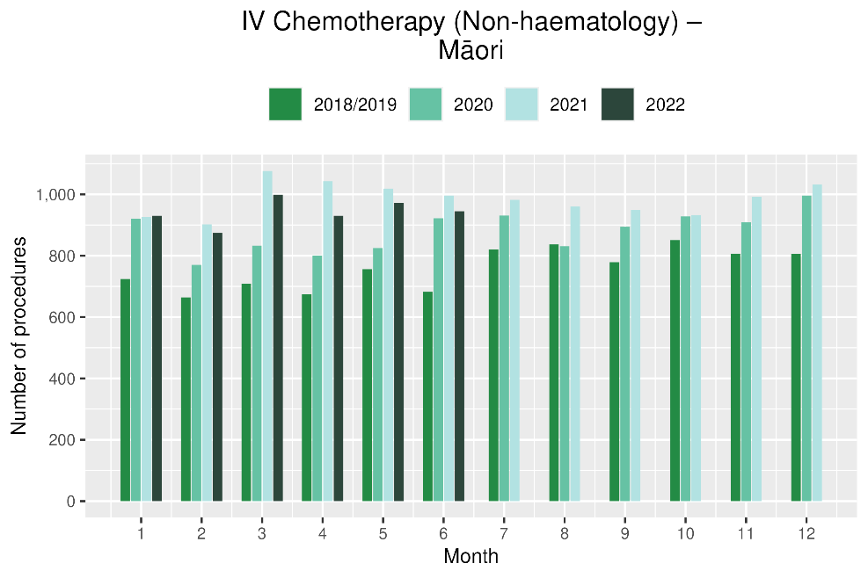

Figure 14: Cumulative number of attendances for IV chemotherapy, 2018/19 average, 2020 and 2021, total population and Māori

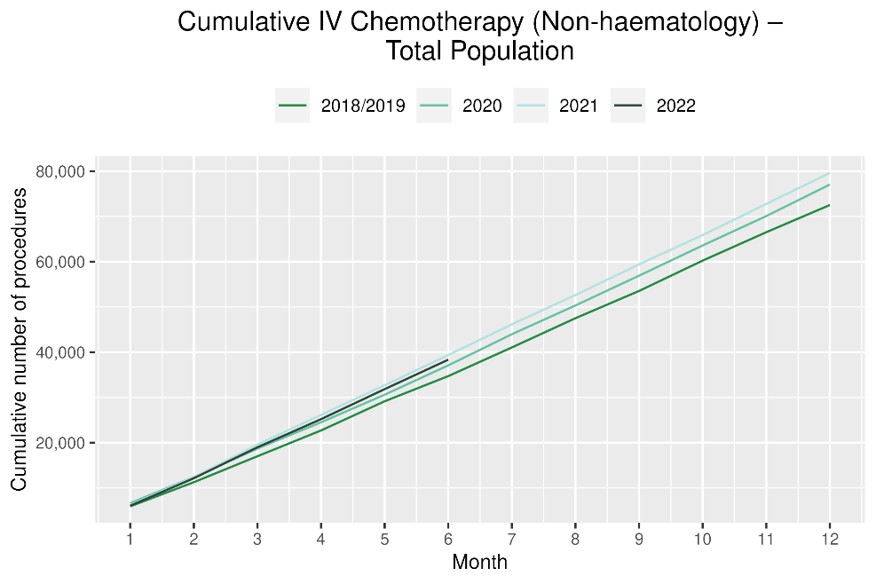 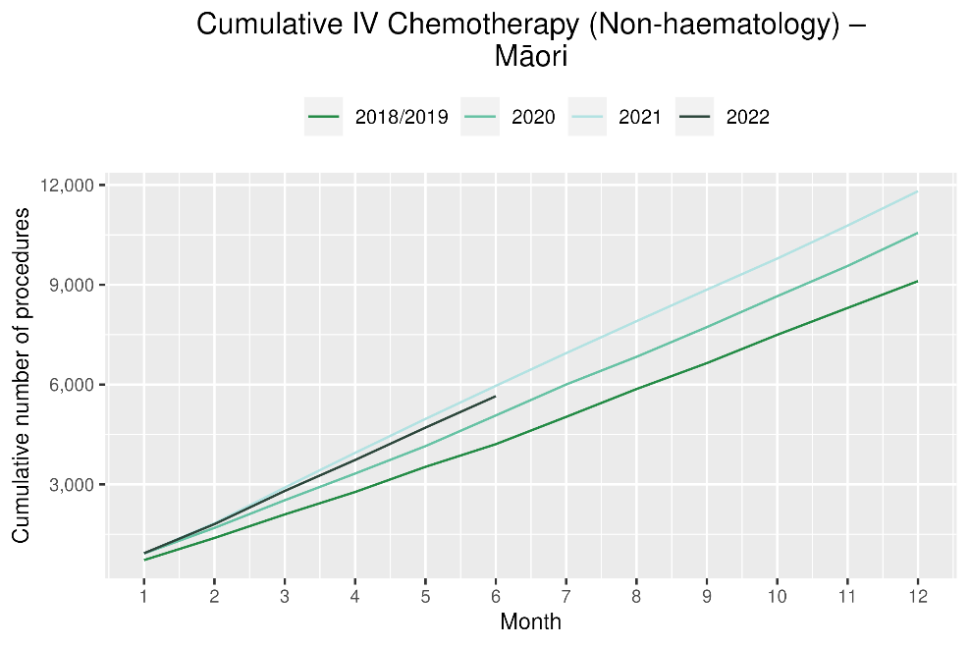

# Radiation oncology

## Notes on data

* Radiation oncology first specialist assessments and megavoltage attendances data were extracted from NNPAC on 8 Aug 2022.
* First specialist assessment (FSA) reflects counts of first attendance for radiation oncology specialist assessment.
* Radiation therapy attendances include appointments for planning/simulation and for treatment with radiation therapy on a linear accelerator.
* Radiation therapy courses data were extracted from Radiation Oncology Collection (ROC) on 18 Aug 2022. ROC is a national collection that contains diagnosis and treatment data for patients receiving radiation therapy from both the public and private providers. ROC is updated quarterly.
* A course of radiation therapy is a set of radiotherapy treatment(s) to a continuous or contiguous volume with a single intent from a single referral. A course can include multiple phases and multiple radiotherapy modalities. The monthly data here refers to the number of completed courses. The course starting date may not be in the same month.
* Radiation therapy course data reflect *completed* radiation therapy courses. This measure likely reflects trends in service volume over time better than radiation therapy attendance, as the increased use of hypofractionation[5] is likely to contribute to a decrease in the number of attendances required to complete a course of treatment.
* Technical information: radiation oncology FSA (Purchase Unit Code: M50022), megavoltage attendances (Purchase Unit Code: M50025).

## Key points

* Attendances for radiation oncology first specialist assessments (FSAs) increased by 6% in May 2022 compared to May 2018/19 and increased by 1% in June 2022. For Māori, there was a 23% increase in FSAs in May 2022 compared to May 2018/19 (note the previous month decrease) and for June 2022 there was a 2% increase.
* For 2022 to date, there was a 5% increase in radiation oncology FSAs compared with 2018/19, with a 12% increase for Māori over this time period.
* Radiation therapy attendances decreased by 18% in May 2022 compared to May 2018/19 and decreased by 7% in June 2022. For Māori, there was a 9% decrease in radiation therapy attendances in May 2022 compared to May 2018/19 and a 13% decrease in June 2022. For Pacific peoples there was a 17% decrease in radiation therapy attendances in May 2022 compared to May 2018/19 and a 3% increase in June 2022.
* For 2022 to date, there was an 11% decrease in radiation therapy attendances overall and a 3% decrease for Māori.
* Completed radiation therapy courses decreased by 6% in May 2022 compared to May 2018/19 and decreased by 11% in June 2022.
* For 2022 to date, there was a decrease of 7% in completed radiation therapy courses and an increase of 3% for Māori.

Table 15: Number of radiation oncology first specialist assessments and percentage difference in 2022 compared to the average of 2018 and 2019, by month and cumulative year to date, by ethnicity

|  |  |  |  |  |  |  |  |  |  |  |  |  |
| --- | --- | --- | --- | --- | --- | --- | --- | --- | --- | --- | --- | --- |
|  | **April** | | | **May** | | | **June** | | | **Cumulative January -June** | | |
|  | **2018/2019** | **2022** | **% change** | **2018/2019** | **2022** | **% change** | **2018/2019** | **2022** | **% change** | **2018/2019** | **2022** | **% change** |
| Māori | 112 | 99 | -12% | 129 | 158 | 23% | 115 | 117 | 2% | 673 | 753 | 12% |
| Pacific Peoples | 38 | 49 | 29% | 53 | 61 | 15% | 52 | 64 | 23% | 272 | 325 | 19% |
| Non-Māori/Non-Pacific | 741 | 757 | 2% | 955 | 988 | 4% | 782 | 778 | 0% | 4,890 | 5,067 | 4% |
| Total Population | 891 | 905 | 2% | 1,136 | 1,207 | 6% | 949 | 959 | 1% | 5,835 | 6,145 | 5% |

Figure 15: Number of radiation oncology first specialist assessments by month, 2018/19 average, 2020, 2021 and 2022, total population and Māori

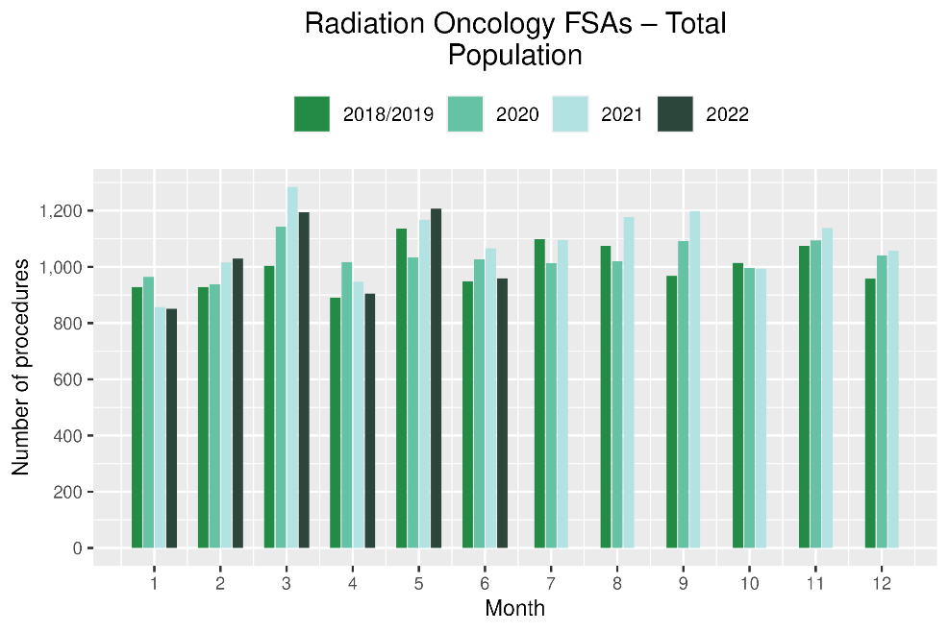 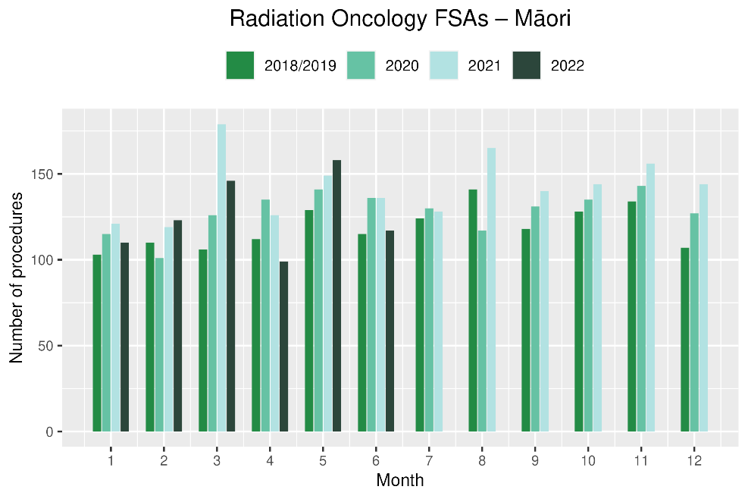

**Figure 16: Cumulative number of radiation oncology first specialist assessments by month, 2018/19 average, 2020, 2021 and 2022, total population and Māori**

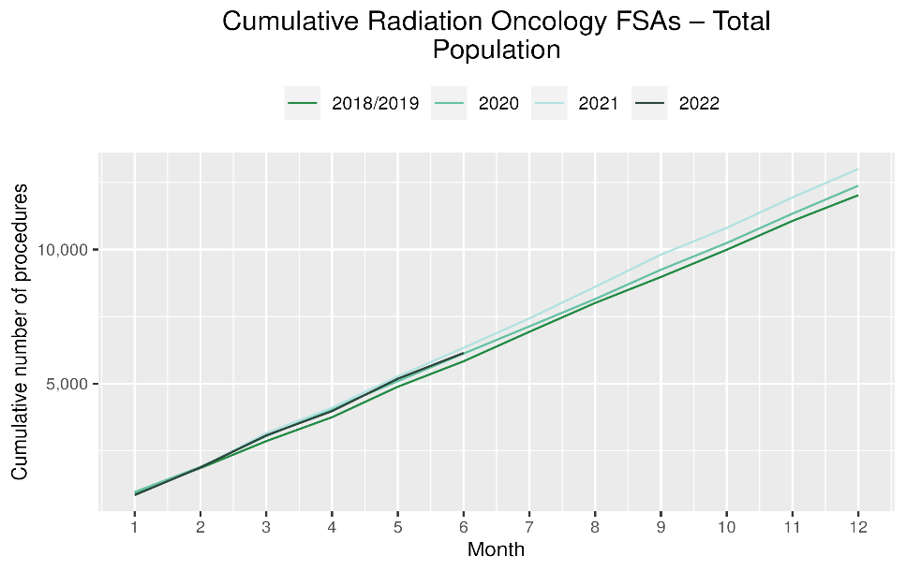 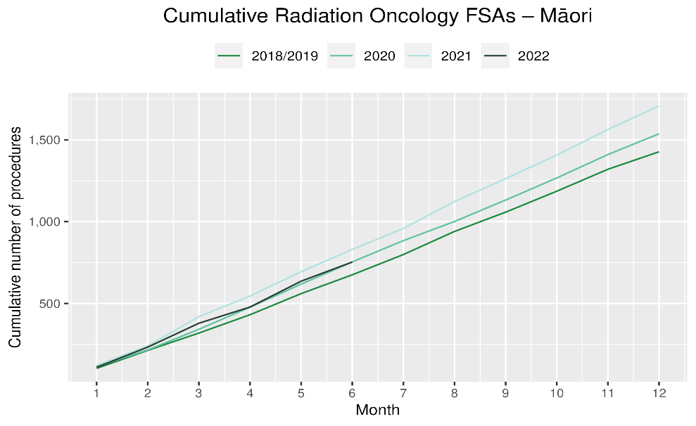

Table 16: Number of radiation therapy attendances and percentage difference in 2022 compared to the average of 2018 and 2019, by month and cumulative year to date, by ethnicity

|  |  |  |  |  |  |  |  |  |  |  |  |  |
| --- | --- | --- | --- | --- | --- | --- | --- | --- | --- | --- | --- | --- |
|  | **April** | | | **May** | | | **June** | | | **Cumulative January -June** | | |
|  | **2018/2019** | **2022** | **% change** | **2018/2019** | **2022** | **% change** | **2018/2019** | **2022** | **% change** | **2018/2019** | **2022** | **% change** |
| Māori | 1,711 | 1,564 | -9% | 1,897 | 1,726 | -9% | 1,729 | 1,496 | -13% | 10,285 | 10,002 | -3% |
| Pacific Peoples | 535 | 417 | -22% | 730 | 605 | -17% | 565 | 581 | 3% | 3,361 | 3,045 | -9% |
| Non-Māori/Non-Pacific | 11,111 | 9,464 | -15% | 13,344 | 10,814 | -19% | 11,162 | 10,383 | -7% | 69,498 | 60,560 | -13% |
| Total Population | 13,357 | 11,445 | -14% | 15,970 | 13,145 | -18% | 13,455 | 12,460 | -7% | 83,144 | 73,607 | -11% |

Figure 17: Number of radiation therapy attendances by month, 2018/19 average, 2020, 2021 and 2022, total population and Māori

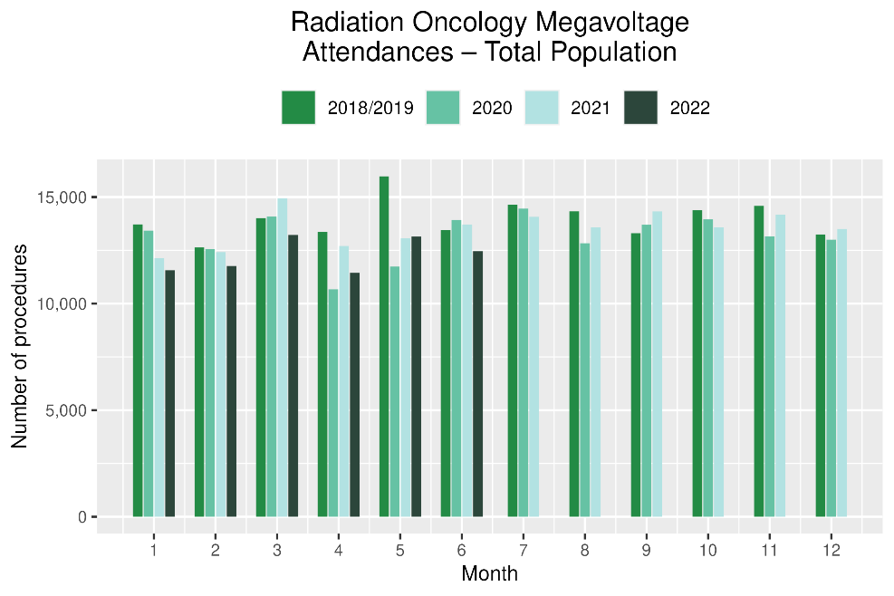 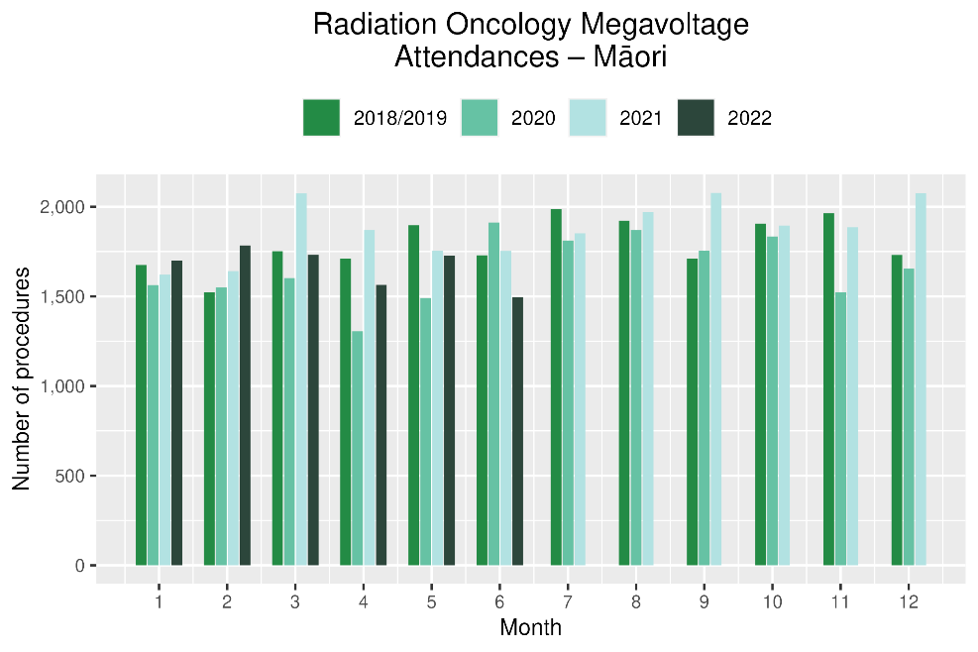

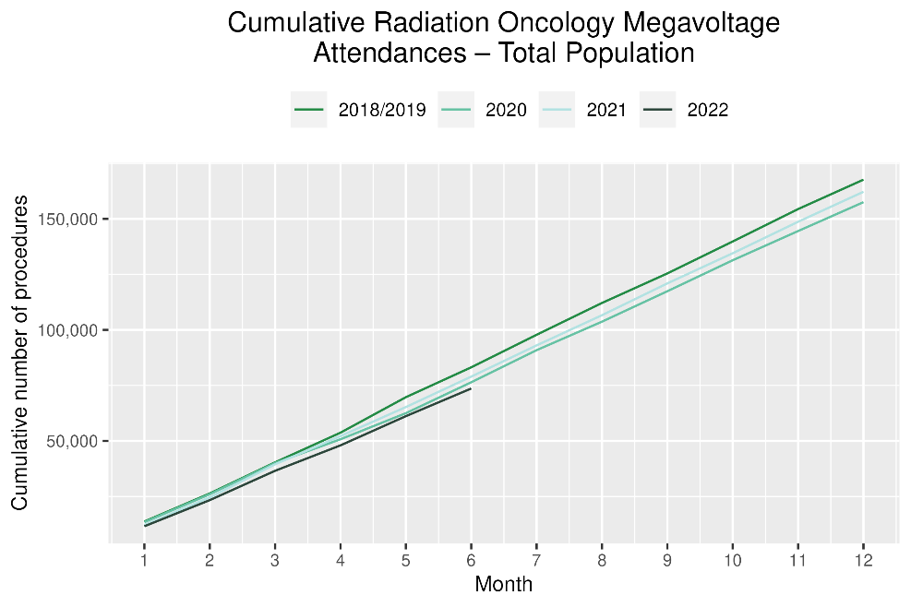 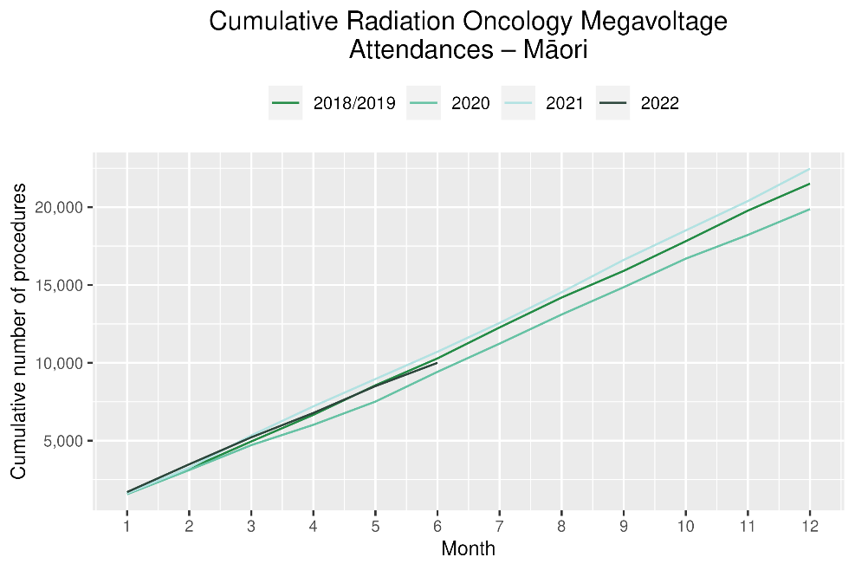

Table 17: Number of completed radiation therapy courses and percentage difference in 2022 compared to the average of 2018 and 2019, by month and cumulative year to date, by ethnicity

|  |  |  |  |  |  |  |  |  |  |  |  |  |
| --- | --- | --- | --- | --- | --- | --- | --- | --- | --- | --- | --- | --- |
|  | **April** | | | **May** | | | **June** | | | **Cumulative January-June** | | |
|  | **2018/2019** | **2022** | **% change** | **2018/2019** | **2022** | **% change** | **2018/2019** | **2022** | **% change** | **2018/2019** | **2022** | **% change** |
| Māori | 110 | 111 | 1% | 136 | 148 | 9% | 120 | 97 | -19% | 721 | 739 | 3% |
| Pacific Peoples | 44 | 38 | -14% | 53 | 48 | -9% | 36 | 37 | 4% | 246 | 236 | -4% |
| Non-Māori/Non-Pacific | 791 | 755 | -4% | 935 | 855 | -9% | 832 | 745 | -10% | 5,037 | 4,603 | -9% |
| Total Population | 944 | 904 | -4% | 1,124 | 1,051 | -6% | 988 | 879 | -11% | 6,004 | 5,578 | -7% |

Figure 20: Number of completed radiation therapy courses by month, 2018/19 average, 2020, 2021 and 2022, total population and Māori

# 

# 

# Haematology

## Notes on data

* Data were extracted from NNPAC and NMDS on 8 Aug 2022.
* First specialist assessment (FSA) reflects counts of first attendance for specialist haematology assessment for any indication, not just cancer.
* IV chemotherapy reflects appointments for IV chemotherapy for haematological malignancies.
* Technical information: Haematology FSA (Purchase Unite Code: M30002), IV haem/chemo (Purchase Unit Code: M30020).

## Key points

* There was a 11% decrease in attendances for haematology first specialist assessments (FSAs) in May 2022 compared to May 2018/19 and a 3% increase in June 2022. For Māori, there was a 17% increase in FSAs May 2022 compared to May 2018/19 and a 7% decrease in June.
* For 2022 to date, there was a 5% decrease in haematology FSAs compared with 2018/19, and for Māori there was a 1% increase.
* Attendances for haematology intravenous (IV) chemotherapy increased by 3% in May 2022 compared to May 2018/19 and a 17% increase in June 2022. For Māori, there was an 2% increase in haematology IV chemotherapy in May 2022 compared to May 2018/19 and a 32% increase in June 2022. For Pacific peoples there was a 4% increase in IV chemotherapy in May 2022 compared to May 2018/19 and a 10% increase in June 2022.
* For 2022 to date, there was a 13% increase in haematology IV chemotherapy compared with 2018/19 overall and for Māori.

## Results

Table 18: Number of haematology first specialist assessment attendances and percentage difference in 2022 compared to the average of 2018 and 2019, by month and cumulative year to date, by ethnicity

|  |  |  |  |  |  |  |  |  |  |  |  |  |
| --- | --- | --- | --- | --- | --- | --- | --- | --- | --- | --- | --- | --- |
|  | **April** | | | **May** | | | **June** | | | **Cumulative January -June** | | |
|  | **2018/2019** | **2022** | **% change** | **2018/2019** | **2022** | **% change** | **2018/2019** | **2022** | **% change** | **2018/2019** | **2022** | **% change** |
| Māori | 49 | 43 | -12% | 63 | 74 | 17% | 62 | 57 | -7% | 331 | 335 | 1% |
| Pacific Peoples | 23 | 25 | 9% | 33 | 38 | 17% | 29 | 29 | 2% | 160 | 197 | 24% |
| Non-Māori/Non-Pacific | 427 | 366 | -14% | 564 | 475 | -16% | 404 | 423 | 5% | 2,727 | 2,534 | -7% |
| Total Population | 499 | 434 | -13% | 659 | 587 | -11% | 494 | 509 | 3% | 3,217 | 3,066 | -5% |

Figure 18: Number of haematology first specialist assessments by month, 2018/19 average, 2020, 2021 and 2022, total population and Māori

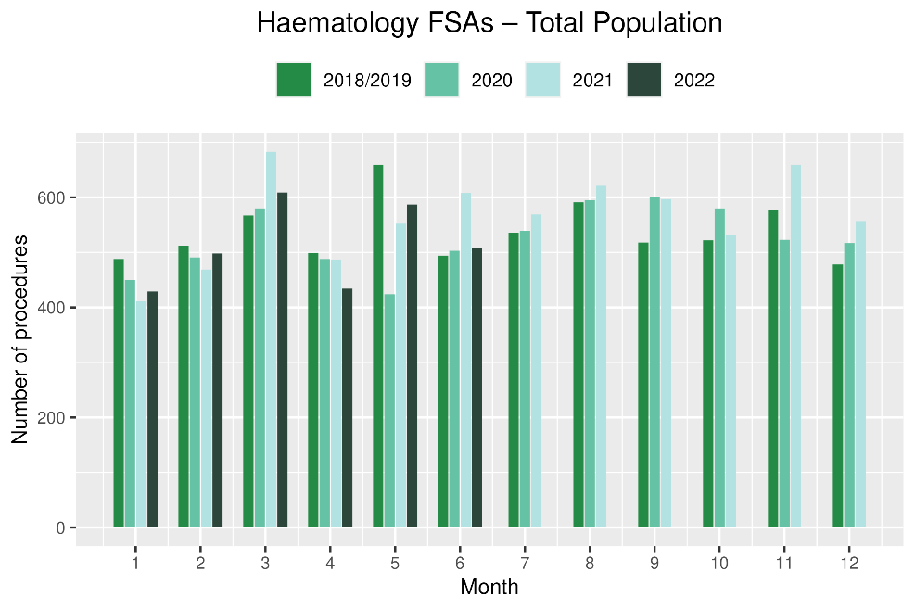 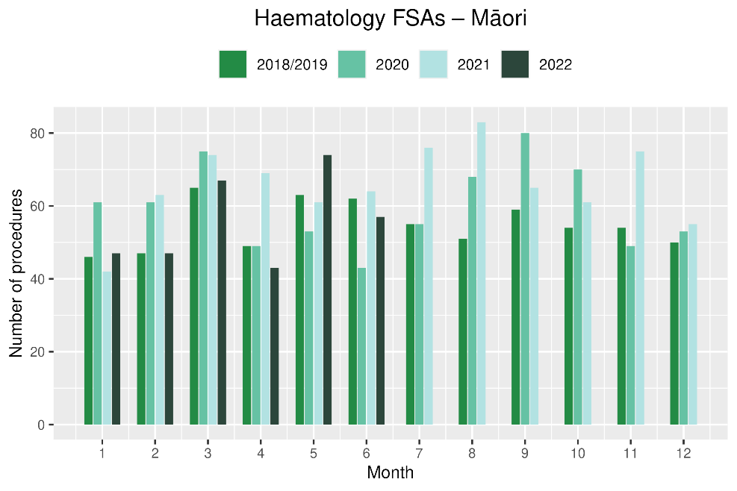

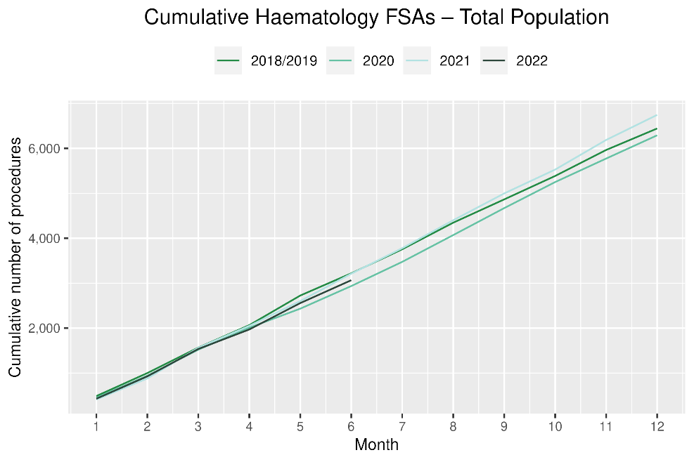 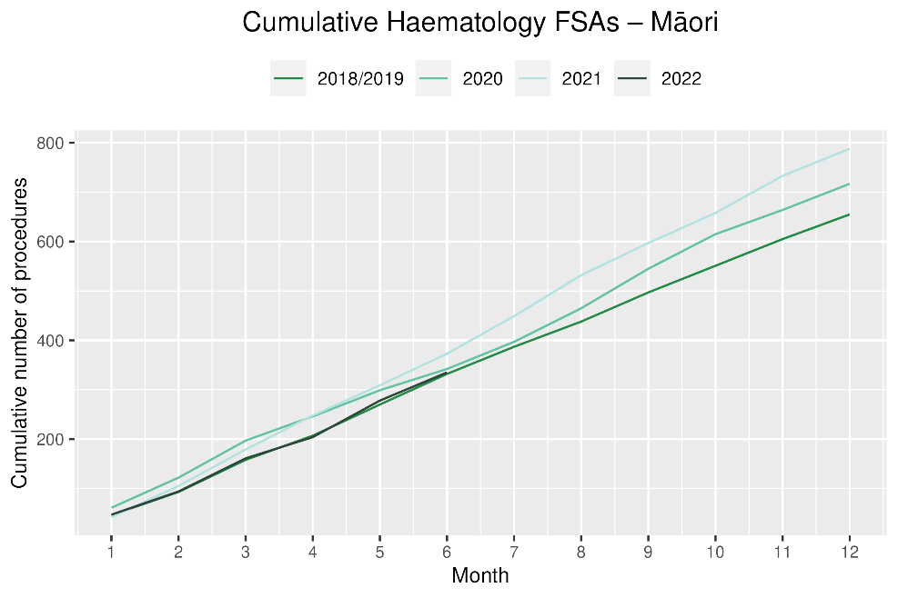

**Table 19: Number of IV chemotherapy attendances for haematological malignancies and percentage difference in 2022 compared to the average of 2018 and 2019, by month and cumulative year to date, by ethnicity**

|  |  |  |  |  |  |  |  |  |  |  |  |  |
| --- | --- | --- | --- | --- | --- | --- | --- | --- | --- | --- | --- | --- |
|  | **April** | | | **May** | | | **June** | | | **Cumulative January -June** | | |
|  | **2018/2019** | **2022** | **% change** | **2018/2019** | **2022** | **% change** | **2018/2019** | **2022** | **% change** | **2018/2019** | **2022** | **% change** |
| Māori | 163 | 209 | 28% | 200 | 205 | 2% | 184 | 243 | 32% | 1,139 | 1,287 | 13% |
| Pacific Peoples | 89 | 97 | 10% | 99 | 102 | 4% | 92 | 101 | 10% | 579 | 658 | 14% |
| Non-Māori/Non-Pacific | 1,563 | 1,612 | 3% | 1,815 | 1,866 | 3% | 1,606 | 1,849 | 15% | 9,725 | 10,958 | 13% |
| Total Population | 1,814 | 1,918 | 6% | 2,114 | 2,173 | 3% | 1,881 | 2,193 | 17% | 11,443 | 12,903 | 13% |

Figure 19: Number of attendances for IV chemotherapy for haematological malignancies by month, 2018/19 average, 2020, 2021 and 2022, total population and Māori

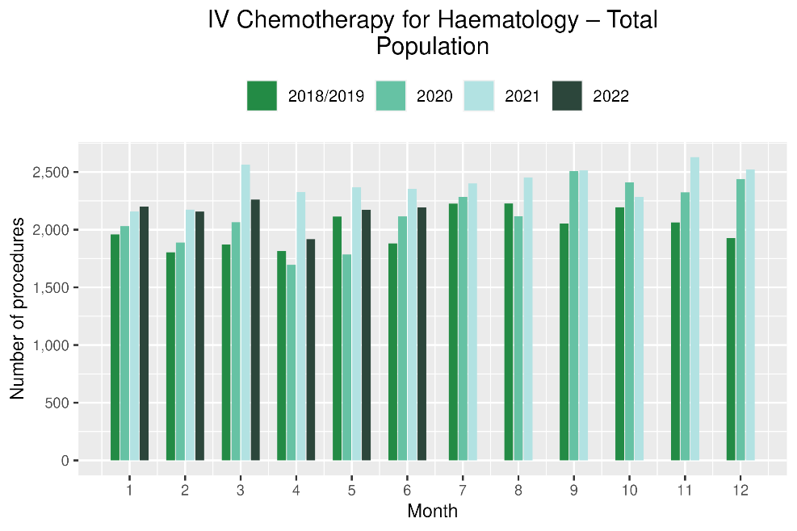 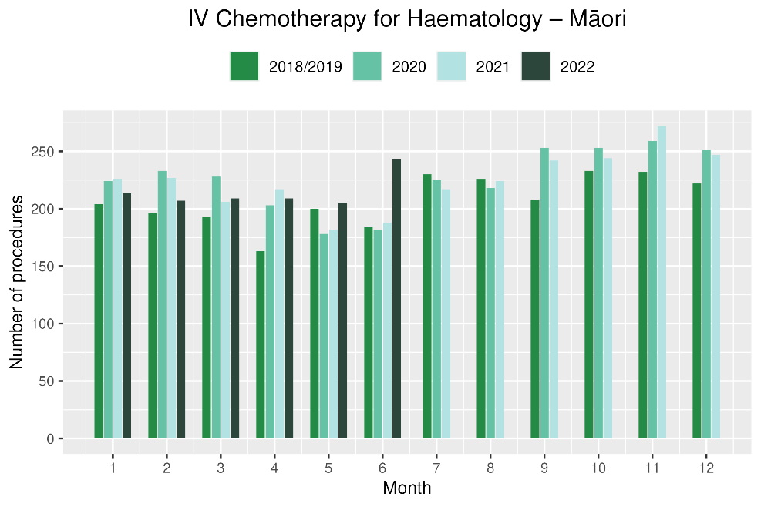

Figure 20: Cumulative number of attendances for IV chemotherapy for haematological malignancies, 2018/19 average, 2020, 2021 and 2022, total population and Māori

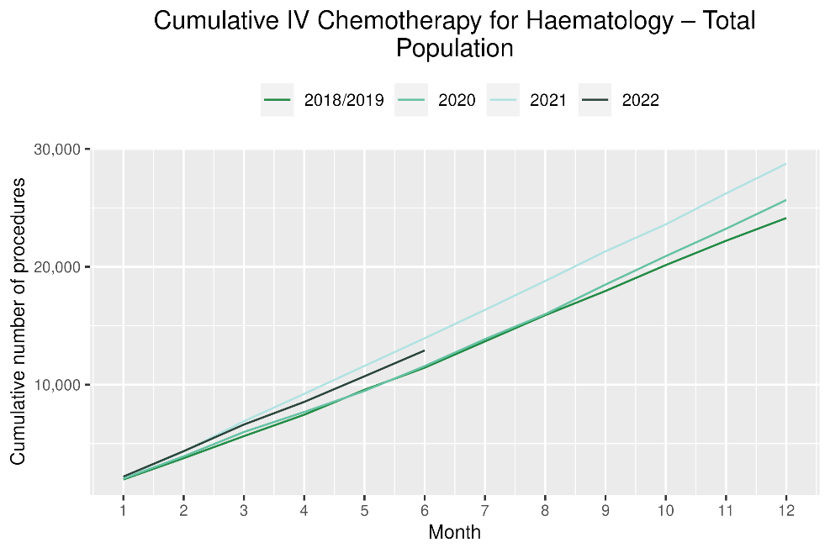 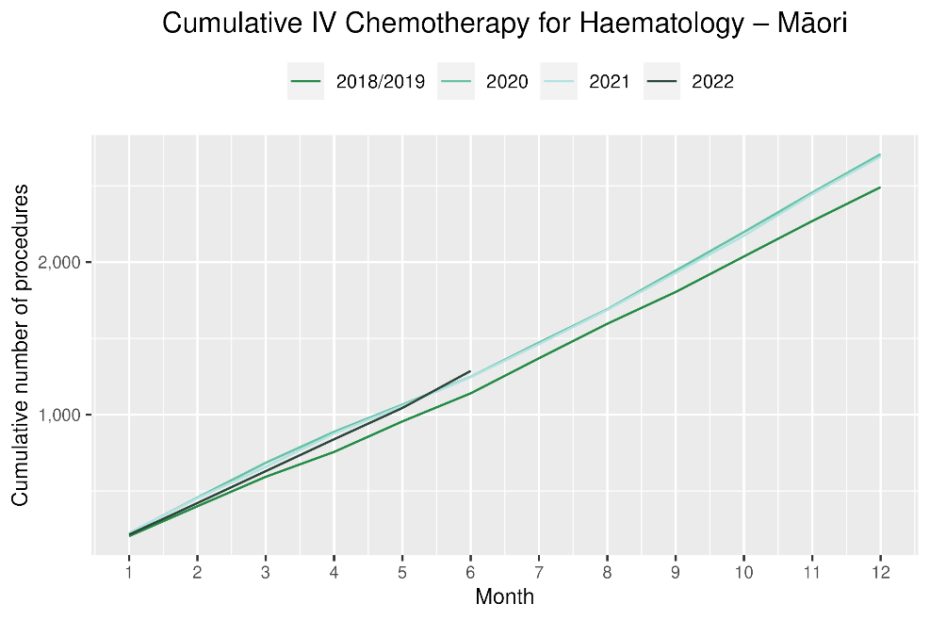

# Appendix 1: Key Dates

The follow provides a brief overview of key dates relating to COVID-19 restrictions (Alert Levels 3 and 4 where the greatest restrictions were in place) and outbreaks. More detailed information can be found on the Unite COVID-19 website[6], including an overview of Alert Levels and the COVID-19 Protection Framework[7].

|  |  |
| --- | --- |
| 23 March – 14 May 2020 | All Aotearoa New Zealand was at Alert Level 3 or 4 |
| 12 August – 30 September 2020 | Auckland only moved to Alert Level 3 |
| 28 Feb – 7 March 2021 | Auckland only was at Alert Level 3 |
| 17 August to 7 September 2021 | All Aotearoa New Zealand was at Alert 3 or 4 at the outset of the Delta variant outbreak |
| From 7 September 2021 | Auckland remained at Alert Level 4; the rest of the country moved to Alert Level 2 |
| September – December 2021 | Auckland moved to and remained at Alert Level 3 from 21 September. There were various regional changes between Alert Level 2 and 3 over this period some parts of the North Island including parts of Waikato. Details are available on the Unite COVID-19 website4. Note: The definition of Alert Level 3 was eased in early October and three gradually reducing steps of level 3 were introduced in October |
| 3 Dec 2021 | End of COVID-19 Alert System. All Aotearoa New Zealand moved to the COVID-19 Protection Framework (traffic lights) |
| 29 Dec 2021 | The first case of the Omicron variant in the community in New Zealand was detected |
| February 2022  10 March 2022  23 March 2022 | Omicron case numbers and hospitalisations increased more significantly in the second half of February onwards[8]  Seven day rolling average of cases is over 20,000, while daily count reaches over 23,000. This was the peak of case numbers at the time of writing.  Changes are made to the Red-Light setting: no limitations on numbers of people gathering outdoors, indoors limit increase to 2000 people. |
| 14 April 2022 | New Zealand changes to the Orange traffic light setting. Indoor venue capacity rules are removed but facemasks are still required in most indoor venues. |
| April – June 2022 | Continued Omicron outbreak, see figure 21 for graph showing the trends of new cases reported each day |

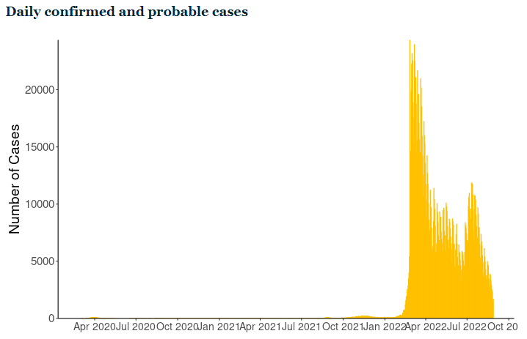

Figure 21 New COVID-19 cases reported each day (confirmed and probable) in Aotearoa New Zealand. Source: Ministry of Health, accessed August 2022 <https://www.health.govt.nz/covid-19-novel-coronavirus/covid-19-data-and-statistics/covid-19-current-cases>

# Appendix 2: NZCR data information

## The New Zealand Cancer Registry as a data source for new cancer diagnoses

Cancer registration is a process where data is collated from multiple sources about people diagnosed with cancer and rules are applied to determine the type of cancer they have. This information is recorded in the New Zealand Cancer Registry. Each tumour is classified using an international World Health Organization standard so that cancer incidence can be compared between countries. The tumour is staged based on all the information available within 4 months of diagnosis. This process may take up to six months or more depending on the number of missing reports that need to be followed up with laboratories.

For each registration there may be multiple pathology reports as there may be multiple procedures performed on the tumour. This means there will be more than one registration for people diagnosed with more than one type of tumour.

Cancer registrations come from pathology laboratories, haematology laboratories, mortality records and reviewing hospital discharge records. Laboratory reports provide the best source of near real time data to monitor new diagnoses of cancer in New Zealand.

## Pathology reports as a data source for providing near real time monitoring of cancer diagnoses

Pathology reports (documents) are received by the NZCR as electronic messages. An administrator triages these documents each day and if the document appears to meet the requirements for registration the document is “administered”. The document may relate to an existing registration or may contain information for a new cancer event. Documents that do not meet the cancer reporting requirements will be marked as “deleted”, “rejected” or “agreed not for registration”.

The administrator creates a new provisional cancer event if the pathology report identifies a new cancer diagnosis for this person. This new cancer event is assigned to a cancer group and this provisional event is then queued for further assessment by a clinical coder. If the required information has been provided the coder creates a new registration. If some information is not yet available, then the registration is held open until further information arrives to complete the registration or determine that the tumour does not meet the registration criteria.

# Appendix 3: NZCR registrations by DHB

Number of cancer registrations and percentage difference in 2022 compared to 2018/19 average, by month and cumulative year to date, by DHB of domicile

|  |  |  |  |  |  |  |  |  |  |  |
| --- | --- | --- | --- | --- | --- | --- | --- | --- | --- | --- |
|  |  | **April** | | | **May** | | | **Cumulative January-May** | | |
|  |  | **2018/19** | **2022** | **%Change** | **2018/19** | **2022** | **%Change** | **2018/19** | **2022** | **%Change** |
|  | Northland | 87 | 111 | 28% | 101 | 124 | 23% | 475 | 506 | 7% |
|  | Waitemata | 219 | 258 | 18% | 255 | 317 | 24% | 1154 | 1343 | 16% |
|  | Auckland | 156 | 162 | 4% | 193 | 201 | 4% | 843 | 895 | 6% |
|  | Counties Manukau | 166 | 170 | 3% | 205 | 230 | 12% | 888 | 963 | 8% |
|  | Waikato | 164 | 174 | 6% | 200 | 196 | -2% | 891 | 912 | 2% |
|  | Bay of Plenty | 106 | 110 | 4% | 126 | 145 | 16% | 567 | 610 | 8% |
|  | Tairawhiti | 18 | 20 | 11% | 22 | 31 | 44% | 90 | 103 | 15% |
|  | Lakes | 42 | 41 | -1% | 52 | 48 | -8% | 221 | 233 | 5% |
|  | Taranaki | 59 | 41 | -30% | 72 | 72 | 0% | 277 | 277 | 0% |
|  | Hawkes Bay | 73 | 54 | -26% | 77 | 92 | 19% | 353 | 371 | 5% |
|  | Whanganui | 37 | 37 | 1% | 37 | 29 | -22% | 173 | 159 | -8% |
|  | MidCentral | 92 | 56 | -39% | 86 | 78 | -9% | 418 | 372 | -11% |
|  | Capital and Coast | 120 | 122 | 2% | 126 | 118 | -6% | 578 | 593 | 3% |
|  | Hutt Valley | 55 | 52 | -5% | 68 | 74 | 9% | 291 | 304 | 5% |
|  | Wairarapa | 22 | 26 | 18% | 28 | 22 | -21% | 119 | 115 | -3% |
|  | Nelson Marlborough | 85 | 59 | -30% | 84 | 90 | 8% | 381 | 376 | -1% |
|  | West Coast | 16 | 11 | -29% | 19 | 25 | 35% | 81 | 88 | 9% |
|  | Canterbury | 218 | 200 | -8% | 238 | 290 | 22% | 1112 | 1229 | 11% |
|  | South Canterbury | 30 | 36 | 20% | 35 | 30 | -13% | 152 | 165 | 9% |
|  | Southern | 153 | 129 | -16% | 173 | 173 | 0% | 762 | 713 | -6% |

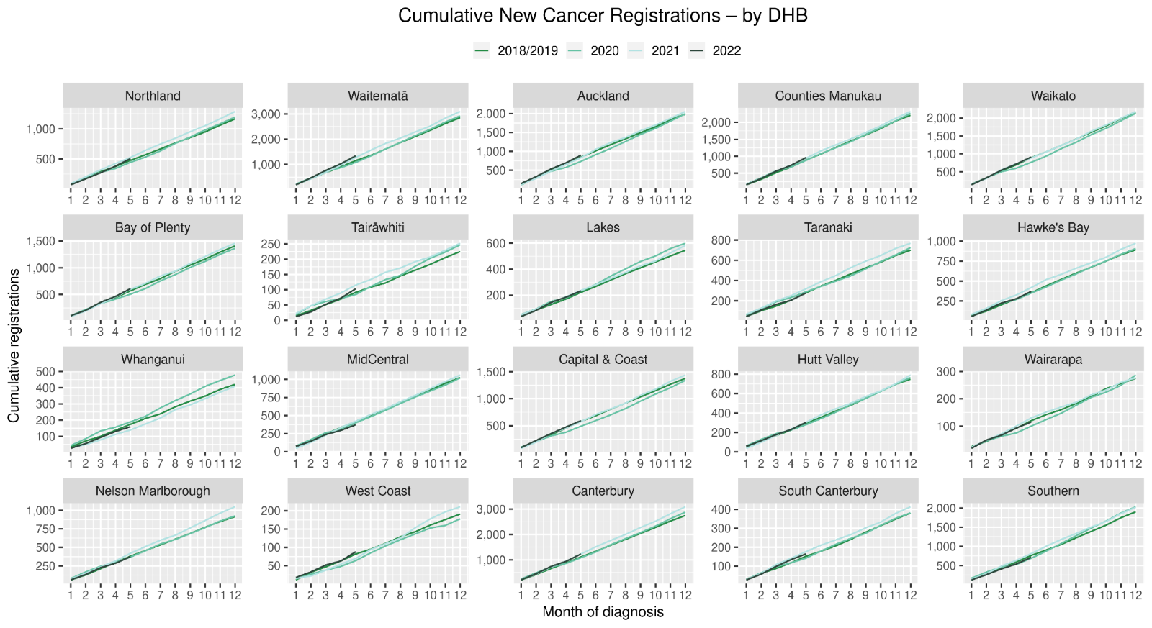

## Cumulative cancer registrations by DHB and ethnicity



## Cumulative cancer registrations by cancer type and ethnicity



# Appendix 4: Diagnosis and treatment data by DHB

Percentage differences are only presented if the cumulative total is 10 or greater. In some cases, the totals may differ to those presented in the national report due to non-DHB providers being excluded from the analyses within this appendix.

## Gastrointestinal endoscopy



## Bronchoscopy



## CT Lung Biopsy



## Breast cancer surgery (mastectomy)

## 

## Colorectal cancer surgery



## Lung cancer surgery



## Prostate cancer surgery

## 

## Medical oncology first specialist assessments



## Medical oncology IV chemotherapy



## Radiation oncology first specialist assessments



## Radiation oncology megavoltage fractions

## 

## Haematology first specialist assessment



## 

## Haematology IV chemotherapy

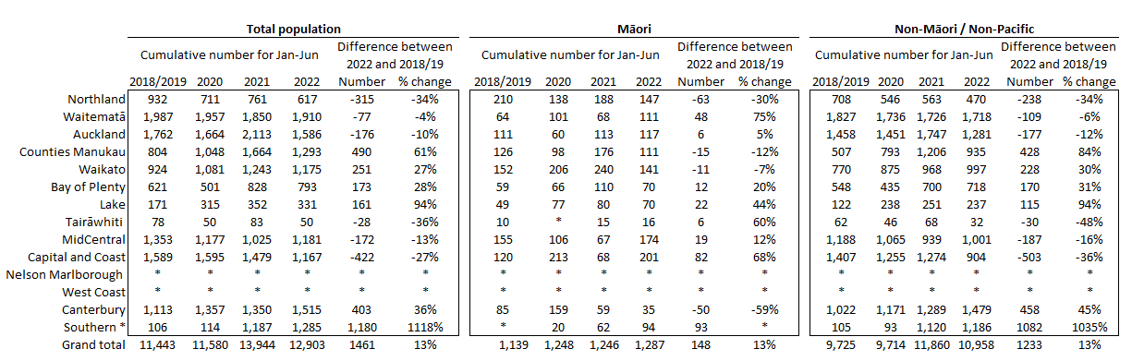

* Note the relatively low volumes in Southern DHB in prior years are due to variation in coding.

## Faster Cancer Treatment

# Appendix 5: Surgical procedure codes

Below is a list of the surgical procedure codes that were used for analysis on cancer surgery.

|  |  |  |
| --- | --- | --- |
| **COLORECTAL CANCER SURGERY** | | |
| Clinical code | Block short description | Clinical code description |
| 3200000 | Colectomy | Limited excision of large intestine with formation of stoma |
| 3200001 | Colectomy | Right hemicolectomy with formation of stoma |
| 3200300 | Colectomy | Limited excision of large intestine with anastomosis |
| 3200301 | Colectomy | Right hemicolectomy with anastomosis |
| 3200400 | Colectomy | Subtotal colectomy with formation of stoma |
| 3200401 | Colectomy | Extended right hemicolectomy with formation of stoma |
| 3200500 | Colectomy | Subtotal colectomy with anastomosis |
| 3200501 | Colectomy | Extended right hemicolectomy with anastomosis |
| 3200600 | Colectomy | Left hemicolectomy with anastomosis |
| 3200601 | Colectomy | Left hemicolectomy with formation of stoma |
| 3200900 | Colectomy | Total colectomy with ileostomy |
| 3201200 | Colectomy | Total colectomy with ileorectal anastomosis |
| 3201500 | Total proctocolectomy | Total proctocolectomy with ileostomy |
| 3202400 | Anterior resection of rectum | High anterior resection of rectum |
| 3202500 | Anterior resection of rectum | Low anterior resection of rectum |
| 3202600 | Anterior resection of rectum | Ultra low anterior resection of rectum |
| 3202800 | Anterior resection of rectum | Ultra low anterior resection of rectum with hand sutured coloanal anastomosis |
| 3203000 | Rectosigmoidectomy or proctectomy | Rectosigmoidectomy with formation of stoma |
| 3203900 | Rectosigmoidectomy or proctectomy | Abdominoperineal proctectomy |
| 3205100 | Total proctocolectomy | Total proctocolectomy with ileo-anal anastomosis |
| 3205101 | Total proctocolectomy | Total proctocolectomy with ileo-anal anastomosis and formation of temporary ileostomy |
| 3206000 | Rectosigmoidectomy or proctectomy | Restorative proctectomy |
| 3209900 | Excision of lesion or tissue of rectum or anus | Per anal submucosal excision of lesion or tissue of rectum |
| 3211200 | Rectosigmoidectomy or proctectomy | Perineal rectosigmoidectomy |
| 9220800 | Anterior resection of rectum | Anterior resection of rectum, level unspecified |

|  |  |  |
| --- | --- | --- |
| **LUNG CANCER SURGERY** | | |
| Clinical code | Clinical code description | Block Description |
| 3844000 | Wedge resection of lung | Partial resection of lung |
| 3844001 | Radical wedge resection of lung | Partial resection of lung |
| 3843800 | Segmental resection of lung | Partial resection of lung |
| 9016900 | Endoscopic wedge resection of lung | Partial resection of lung |
| 3843801 | Lobectomy of lung | Lobectomy of lung |
| 3844100 | Radical lobectomy | Lobectomy of lung |
| 3844101 | Radical pneumonectomy | Pneumonectomy |
| 3843802 | Pneumonectomy | Pneumonectomy |

|  |  |  |
| --- | --- | --- |
| **PROSTATE CANCER SURGERY** | | |
| Clinical code | Block short description | Clinical code description |
| 3720004 | Open prostatectomy | Retropubic prostatectomy |
| 3720900 | Open prostatectomy | Radical prostatectomy |
| 3720901 | Other closed prostatectomy | Laparoscopic radical prostatectomy |
| 3721000 | Open prostatectomy | Radical prostatectomy with bladder neck reconstruction |
| 3721001 | Other closed prostatectomy | Laparoscopic radical prostatectomy with bladder neck reconstruction |
| 3721100 | Open prostatectomy | Radical prostatectomy with bladder neck reconstruction and pelvic lymphadenectomy |
| 3721101 | Other closed prostatectomy | Laparoscopic radical prostatectomy with bladder neck reconstruction and pelvic lymphadenectomy |
| 3720900 | Open prostatectomy | Radical prostatectomy |
| 3720901 | Closed prostatectomy | Laparoscopic radical prostatectomy |
| 3721000 | Open prostatectomy | Radical prostatectomy with bladder neck reconstruction |
| 3721001 | Closed prostatectomy | Laparoscopic radical prostatectomy with bladder neck reconstruction |
| 3721100 | Open prostatectomy | Radical prostatectomy with bladder neck reconstruction and pelvic lymphadenectomy |

|  |  |  |
| --- | --- | --- |
| **BREAST CANCER SURGERY** | | |
| Clinical code | Block short description | Clinical code description |
| 3152400 | Subcutaneous mastectomy | Subcutaneous mastectomy, unilateral |
| 3152401 | Subcutaneous mastectomy | Subcutaneous mastectomy, bilateral |
| 3151800 | Simple mastectomy | Simple mastectomy, unilateral |
| 3151801 | Simple mastectomy | Simple mastectomy, bilateral |

1. Reports available here: <https://teaho.govt.nz/reports/cancer-care>
2. For example, for several measures in the March 2022 report, there were notably higher volumes for March 2021 compared with March in other recent years, including years presented in this report (2018, 2019, and 2020). The reasons for this data spike in March 2021 may include a catch-up period following lockdowns of the previous year.
3. This report includes an additional procedure code for CT Lung Biopsy (3881200). This is the back mapping code for CT Lung Biopsy prior to July 2019
4. We recognise there are limitations to this approach and aim to strike a balance between timely data availability, completeness, and accuracy, with the purpose of the reporting being to provide an initial indication of the current situation which may then require further interrogation at a regional level.
5. Hypofractionation is a radiation treatment technique used to treat some cancers, whereby larger doses of radiation are given each treatment, meaning that patients require fewer sessions to complete their treatment. The technique is being increasingly used for some prostate and breast cancers in New Zealand and around the world.
6. <https://covid19.govt.nz/about-our-covid-19-response/history-of-the-covid-19-alert-system/>
7. <https://covid19.govt.nz/traffic-lights/covid-19-protection-framework>
8. <https://www.health.govt.nz/covid-19-novel-coronavirus/covid-19-data-and-statistics/covid-19-current-cases>