COVID-19 and cancer services

Working report on the impact of COVID-19 on cancer services for the period ending October 2021

Released December 2021

Acknowledgements
With thanks to the technical support from the Ministry of Health Data Management team.
With thanks to members of the COVID-19 Data Response Advisory Group: Professor Diana Sarfati, Alex Dunn, Dr John Fountain, Dr Elinor Millar, John Manderson, Michelle Mako, Dr Shaun Costello, Michelle Liu, Dr Liz Dennett, Gabrielle Nicholson, Dawn Wilson, Jan Smith, Cushla Lucas, Angela Pidd, Christine Fowler, Dr Nina Scott, Associate Professor Bridget Robson, Dr Jason Gurney, Dr Chris Jackson, and Richard Hamblin.

Contents
Acknowledgements 2
Contents 3
Summary of findings 4
Introduction 6
Auckland Regional Snapshot 9
Cancer Registrations 13
Gastrointestinal endoscopy 17
Bronchoscopy 19
Combined curative cancer surgery 21
Colorectal cancer surgery 23
Lung cancer surgery 25
Prostate cancer surgery 27
Radiation oncology 33
Haematology 37
Appendix 1: NZCR data information 41
Appendix 2: NZCR registrations by DHB 42
Appendix 3: Diagnosis and treatment data by DHB 45
Appendix 4: Surgical procedure codes 56

Summary of findings
Impact of COVID-19 on cancer diagnosis and treatment
Overall, publicly funded cancer treatment services continue during the COVID-19 Delta outbreak. The dip in cancer registrations seen during August 2021 has resolved, with similar numbers of cancer registrations seen in October 2021, compared to October 2018/19. The disruption to gastrointestinal endoscopy procedures in the Auckland region has resolved. There has been some disruption to bronchoscopy procedures, not limited to Auckland. There has been a decrease in curative colorectal surgeries in October 2021, however for the year to date there has been a similar number to previous years. The overall impact of COVID-19 on diagnoses is considerably smaller and shorter-lived than the disruption seen in April and May 2020, demonstrating a health system that is learning how to safely deliver cancer services in the context of COVID-19.

Background and data
- The purpose of this report is to provide a rapid assessment of the impact of COVID-19 on cancer services during the 2021 COVID-19 Delta outbreak. It includes data up until 31 October 2021.
- The report focuses on the aspects of the cancer care pathway for which we have readily available data and does not capture all aspects of cancer care.
- We acknowledge individuals with cancer may have been impacted in significant way by COVID-19, including by changes to the way care has been delivered.
- The previous COVID-19 and Cancer reports, published in 2020, compared 2020 data directly with 2019 data. Given the disruption to health services in 2020, this report uses an average of observed numbers seen in 2018/19 as the comparator for numbers seen in 2021. For the purposes of this report, we have not added an adjustment for changes in incidence over time.

Auckland regional snapshot
- The Auckland region has been the most impacted by COVID-19 restrictions in 2021.
- There has been an overall increase in registrations for the year to date compared to 2018/19.
- COVID-19 caused a disruption to diagnostics services in both August and September, with a decrease in gastrointestinal endoscopies across the region in 2021 compared to 2018/19 (noting these procedures are completed for several indications, not just cancer related). These services appear to have returned to baseline in October 2021, including for Māori.
- Publicly funded cancer treatment – including surgery, chemotherapy and radiation therapy – continued across the Auckland region from August to October 2021.

Cancer diagnosis

Registrations
- Provisionally, there have been a similar number of cancer registrations in October 2021, compared to October 2018/19. This is compared with an increase in registrations of 13% seen in September 2021 compared with September 2018/2019.
- For the year to date there has been a 6% increase in the number of cancer registrations in 2021 compared to 2018/19, with the largest increases for Asian (20%) and Māori (12%).

Diagnostics
- Gastrointestinal endoscopies: there was an increase of 2% in gastrointestinal endoscopies performed in October 2021, compared to October 2018/19 (after decreases of 29% seen in August 2021 and 4% in September compared with respective months in 2018/19). The increase in endoscopies was largest for Pacific peoples (42%) and was 11% for Māori. The overall increase in endoscopies appear to be driven by a return to baseline service provision rates in the Auckland region. Overall, for the year to date there has been a 10% increase in the number of gastrointestinal endoscopies performed in 2021 compared to 2018/19 across all ethnic groups.
- Bronchoscopies: there was a 29% decrease in the number of bronchoscopies performed in October 2021 compared to October 2018/19. This was a larger change than seen in September (a 4% decrease), and similar to that seen at the beginning of the Delta outbreak in August 2021 (34% decrease). Overall, there have been 7% fewer bronchoscopies performed for the year to date compared to same time period in 2018/19.

Cancer Treatment

Surgery
- Curative cancer surgeries (for prostate, lung and colorectal cancer) continued during October 2021. Overall, for the year to date the number of combined surgeries in 2021 has been in line with the number of surgeries in 2018/19.
- There has been a decrease (7%) in curative colorectal cancer surgeries performed in October 2021 compared with October 2018/19. However, the year to date has seen a similar number of curative colorectal cancer surgeries performed in 2021 as were performed in 2018/19.

Chemotherapy and radiotherapy
- Medical oncology: Attendances for medical oncology first specialist appointments (FSAs) decreased by 5% in October 2021 compared to October 2018/19. The decrease was higher (10%) for Māori and there was no change for Pacific peoples. For the year to date in 2021 compared to the same time period in 2018/19, medical oncology FSAs increased by 7%. Attendances for intravenous (IV) chemotherapy decreased by 8% in October 2021 compared with October 2018/19. For the year to date in 2021 compared to the same time period in 2018/19, IV chemotherapy attendances increased by 5%, with a larger increase for Māori (22%) and Pacific peoples (30%) than for non-Māori/non-Pacific (1%).
- Radiation oncology: Attendances for radiation oncology first specialist appointments (FSAs) decreased by 7% in October 2021 compared to October 2018/19. For the year to date 2021 compared to the same time period in 2018/19, there has been a 6% increase in radiation oncology FSAs. Attendances for radiation therapy decreased in 2021 compared to 2018/19. This decrease likely reflects increased use of hypofractionation, where cancers are treated over a shorter time period, so that patients have fewer visits for treatment. For Māori, radiation therapy attendances have increased from 2018/19 to 2021.
- Haematology: attendances for haematology FSAs remained stable during the October 2021. Overall, for the year to date, there has been a small (1%) decrease in haematology FSAs in 2021 compared to 2018/19, and an 18% increase in haematology FSAs for Māori. Attendances for IV chemotherapy for haematology remained largely stable over October 2021, with an overall 13% increase in the number of attendances for the year to date compared to the same time period in 2018/19.

Introduction

Background
In 2020, Te Aho o Te Kahu released a series of reports outlining the impact of COVID-19 on cancer services in New Zealand. These reports showed that cancer treatment services – surgery, medical oncology, radiation oncology and haematology – continued during the COVID-19 pandemic. Following an initial drop in new cancer registrations during the April 2020 lockdown, the number of cancer registrations in 2020 increased steadily in the following months and, by the end of September, had caught up to the number seen in 2019.
As the COVID-19 situation and disruptions to health care settled, Te Aho o Te Kahu stopped regular COVID-19 and cancer reporting at the end of 2020. With the re-emergence of COVID-19 in the community in August 2021 and the return of lockdown restrictions, Te Aho o Te Kahu have re-instated COVID-19 monitoring.

Purpose
This is the third report looking at the impact of COVID-19 on cancer services during the 2021 COVID-19, Delta outbreak. It includes data up until the end of October 2021. The aim of this work is to rapidly collate evidence on any delays to cancer diagnosis and treatment to support policy development and recovery and response planning.
The report focuses on the aspects of the cancer care pathway for which we have readily available data and does not capture all aspects of the care. Critical aspects of cancer care, including access to primary health care, radiology, palliative care and patient experience, are not measured in this report. While the report focuses on the impact of COVID-19 on overall cancer diagnosis and treatment, we acknowledge that individuals with cancer may have been impacted in significant ways by COVID-19, including by changes to the way care has been delivered.

Data and analysis
The data in this report come from Ministry of Health national data collections. Each section of the report includes information on where the data is from and any limitations associated with the data. Of note Hawke’s Bay DHB Medical oncology Intravenous (IV) chemotherapy and Southern DHB radiotherapy treatment data is incomplete for 2021. Both DHBs are actively working on resolving this issue for the next report. In addition, numbers in this report may not match the previous report, due to exclusion of incomplete data in the previous reports and delayed coding/submission of data.
The purpose of the analysis is to rapidly measure the impact of COVID-19 and the recovery on cancer services, therefore the analysis does not consider pre-existing unmet need. The report also makes direct comparisons between 2021 and previous years and does not consider any increase in cancer diagnoses over time.

Comparator for this report
The previous COVID-19 and Cancer reports, published in 2020, compared 2020 data directly with 2019 data. Given the disruption COVID-19 caused to health services in 2020, 2020 was not considered an appropriate comparator. To improve the stability of the baseline for comparison, an average of observed numbers in 2018 and 2019 is used as a comparator for numbers seen in 2021 in this report. All graphs include data from 2021, 2020 and an average from 2018/19.

Key dates
Key dates in relation to COVID-19, up until the end of October 2021, that may be of use when reviewing the report include:
- 17 August 2021: all of New Zealand moves to Alert Level 4
- 31 August 2021: all of New Zealand south of Auckland moves to Alert Level 3, Auckland and Northland remain at Alert Level 4.
- 2 September 2021: Northland moves to Alert Level 3. All of New Zealand (except Auckland) at Alert Level 3
- 7 September 2021: New Zealand (except Auckland) moves to Alert Level 2.
- 21 September 2021: Auckland and Upper Hauraki move to Alert Level 3.
- 25 September 2021: Upper Hauraki moves to Alert Level 2.
- 3 October 2021: Raglan, Te Kauwhata, Huntly, Ngāruawāhia, Hamilton City and some surrounding areas move to Alert Level 3 for 5 days. Auckland remains at Alert Level 3. The rest of New Zealand remains at Alert Level 2.
- 5 October 2021: Alert Level 3 restrictions in Auckland are eased. Raglan, Te Kauwhata, Huntly, Ngāruawāhia, Hamilton City and some surrounding areas remain at Alert Level 3. The rest of New Zealand remains at Alert Level 2.
- 7 October 2021: Waikato Alert Level 3 boundary is extended to include Waitomo District, including Te Kuiti, Waipa District and Ōtorohanga District. Auckland remains at Alert Level 3 with some restrictions eased. The rest of New Zealand remains at Alert Level 2.
- 8 October 2021: Northland moves to Alert Level 3. Auckland and parts of Waikato remain at Alert Level 3. The rest of New Zealand remains at Alert Level 2.
- 19 October 2021: Northland moves to Alert Level 2. Auckland and parts of Waikato remain at Alert Level 3. The rest of New Zealand remains at Alert Level 2.
- 27 October 2021: The parts of Waikato at Alert Level 3 move to Step 1 of Alert Level 3. Auckland remains at Step 1 of Alert Level 3. The rest of New Zealand remains at Alert Level 2.
Key dates in relation to COVID-19 in 2020 include:
- 23 March 2020: all of New Zealand moves to Alert Level 3
- 26 March 2020: all of New Zealand moves to Alert Level 4
- 28 April 2020: all of New Zealand moves to Alert Level 3
- 14 May 2020: all of New Zealand moves to Alert Level 2
- 9 June 2020: all of New Zealand moves to Alert Level 1
- 12 August 2020: Auckland moves to Alert Level 3, the rest of New Zealand moves to Alert Level 2
- 30 September 2020: Auckland moves to Alert Level 2.5, the rest of New Zealand stays at Alert Level 2
- 22 September 2020: all regions, except Auckland, move to Alert Level 1
- 29 November 2020: Auckland moves to Alert Level 2, without extra restrictions on travel and gatherings
- 8 October 2020: all of New Zealand moves to Alert Level 1.

Ongoing reporting
Te Aho o Te Kahu will continue to monitor the impact of COVID-19 and lockdowns on cancer services. The next report will be released in February 2022, looking at data to the end of December 2021.

Auckland Regional Snapshot

Key points
- The Auckland region has been the most impacted by COVID-19 in 2021, remaining in Alert Level 3 throughout October 2021 after moving from Alert Level 4 to Alert Level 3 in the last week of September 2021.
- There has been an overall increase in registrations for the year to date compared to 2018/19.
- COVID-19 caused a disruption to diagnostics services in both August and September, with a decrease in gastrointestinal endoscopies across the region in 2021 compared to 2018/19 (noting these procedures are completed for several indications, not just cancer related). These services appear to have returned to baseline in October 2021, including for Māori.
- Publicly funded cancer treatment – including surgery, chemotherapy and radiation therapy – continued across the Auckland region from August to October 2021.
- Radiation therapy volumes in the Auckland region follow a similar pattern to that seen across New Zealand, with an overall decrease in volumes. For Māori, there appears to be a greater decrease in radiation therapy volumes between October 2021 and October 2018/19 compared to the previous two months comparisons (Figure 5). This may be related to the increased utilisation of hypofractionation, which may differ depending on cancer site and stage. Te Aho o Te Kahu is further investigating by exploring data related to courses of treatment in addition to attendances which will give more information as to the role of hypofractionation.

Cancer diagnosis and treatment

Registrations
Table 1: Number of provisional cancer registrations and percentage change in 2021 compared to the 2018/19 average, by month and cumulative year to date, by DHB
 | August |  |  | September |  |  | October |  |  | Cumulative January-October
DHB | 2018/19 average | 2021 | % change | 2018/19 average | 2021 | % change | 2018/19 average | 2021 | % change | 2018/19 average | 2021 | % change
Waitematā | 262 | 216 | -18% | 239 | 246 | 3% | 245 | 233 | -5% | 2,351 | 2,526 | 7%
Auckland | 160 | 140 | -12% | 158 | 184 | 17% | 156 | 151 | -3% | 1,648 | 1,708 | 4%
Counties Manukau | 190 | 182 | -4% | 178 | 187 | 5% | 188 | 193 | 3% | 1,815 | 1,899 | 5%

Figure 1: Cumulative number of cancer registrations by month, 2018/19 average, 2020 and 2021, for the Auckland region, by DHB
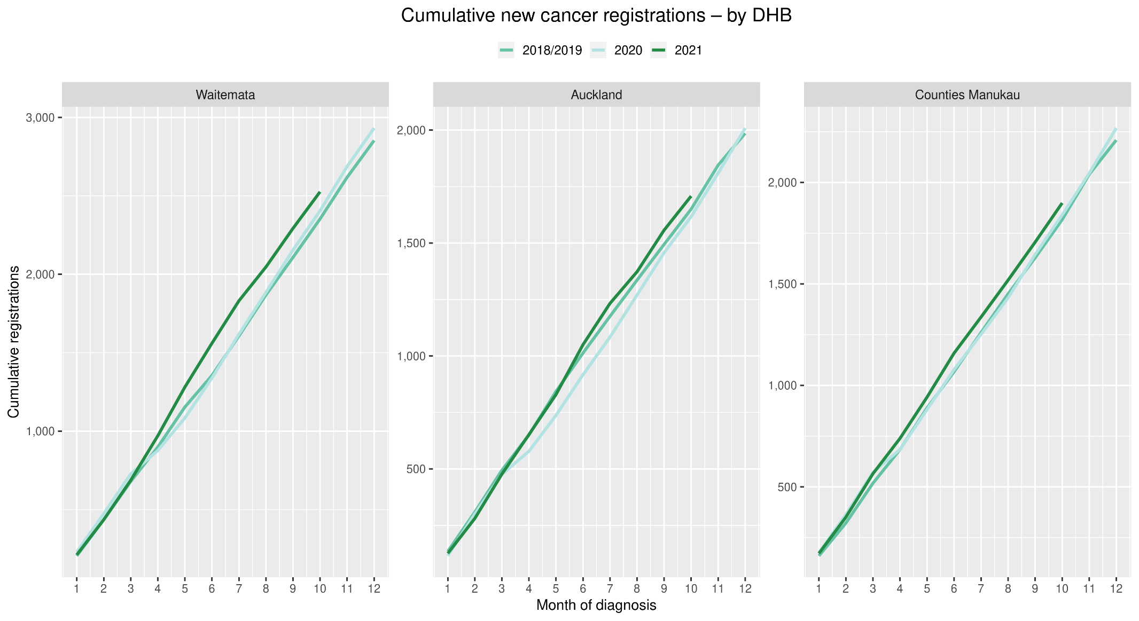

Gastrointestinal endoscopies
Figure 2: Number of gastrointestinal endoscopy procedures by month, 2018/19 average, 2020 and 2021, for the Auckland region
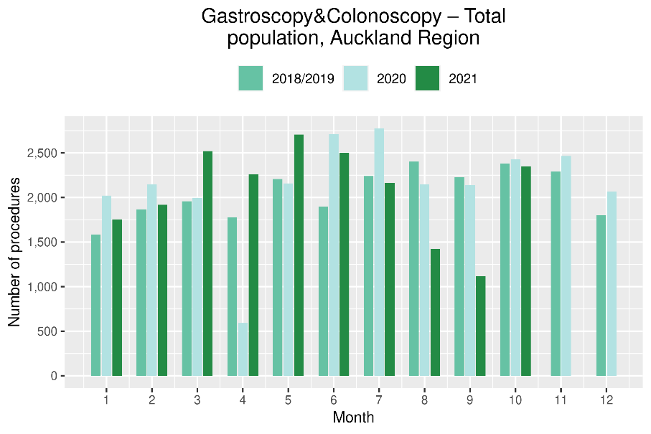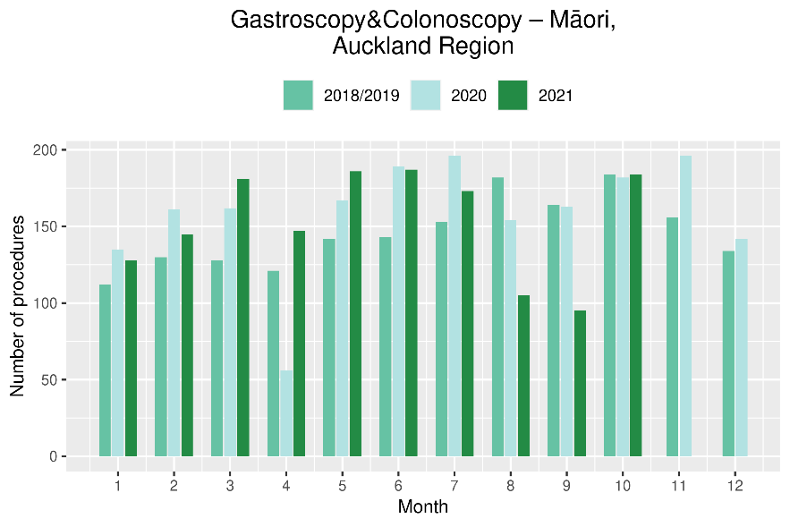

Cancer surgery
Figure 3: Number of curative cancer surgeries (prostate, colorectal, lung) by month, 2018/19 average, 2020 and 2021, for the Auckland region
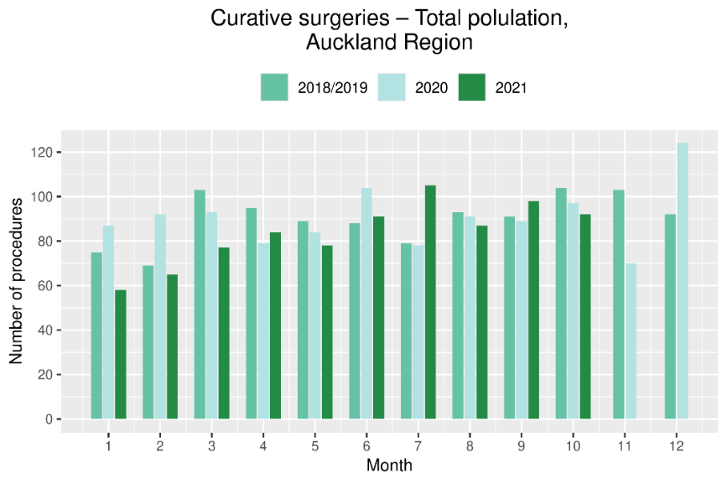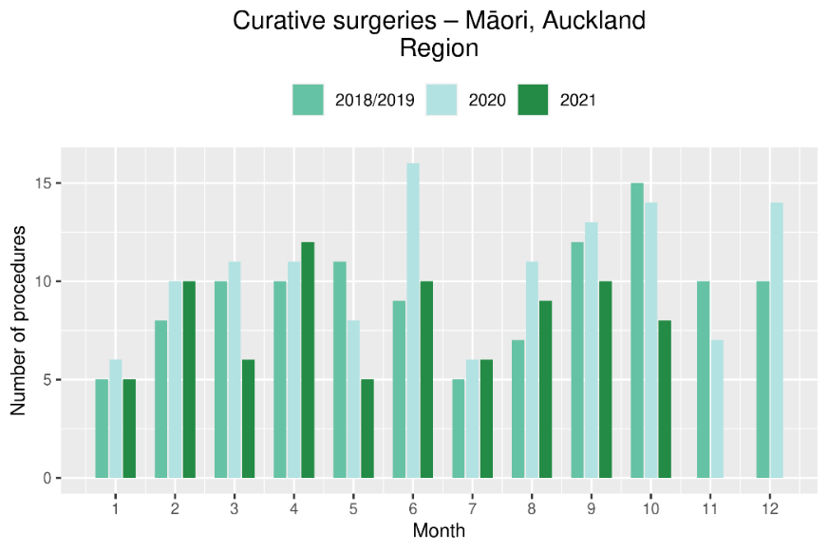

Non-surgical treatments
Figure 4: Number of IV chemotherapy attendances by month, 2018/19 average, 2020 and 2021, for the Auckland region
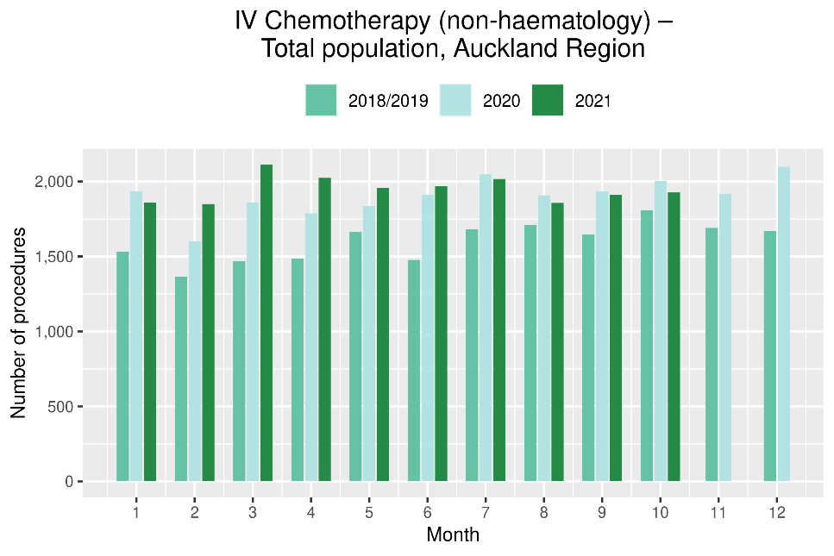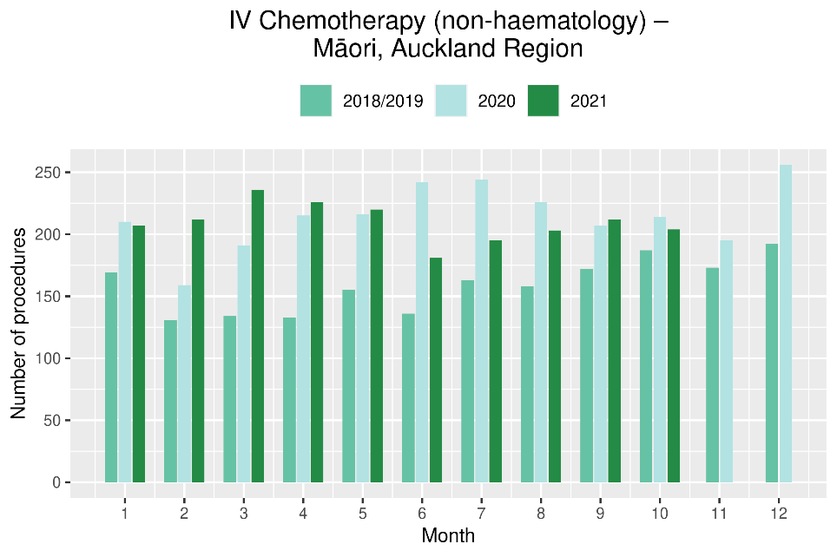
Figure 5: Number of radiation therapy attendances by month, 2018/19 average, 2020 and 2021, for the Auckland region
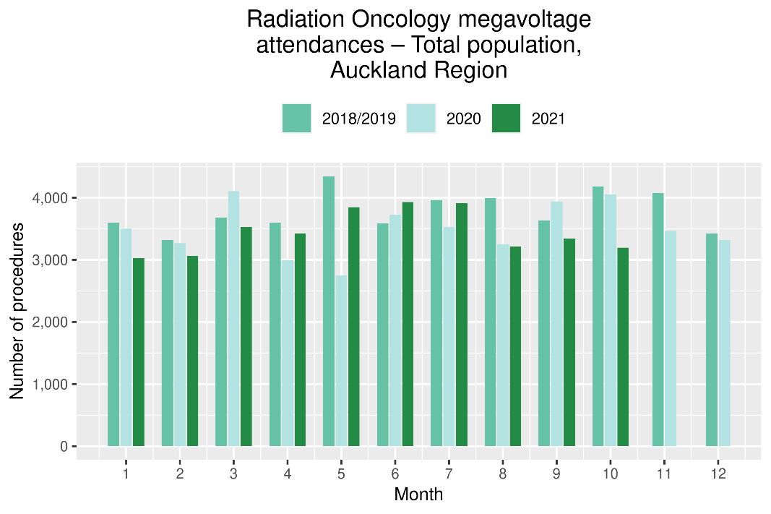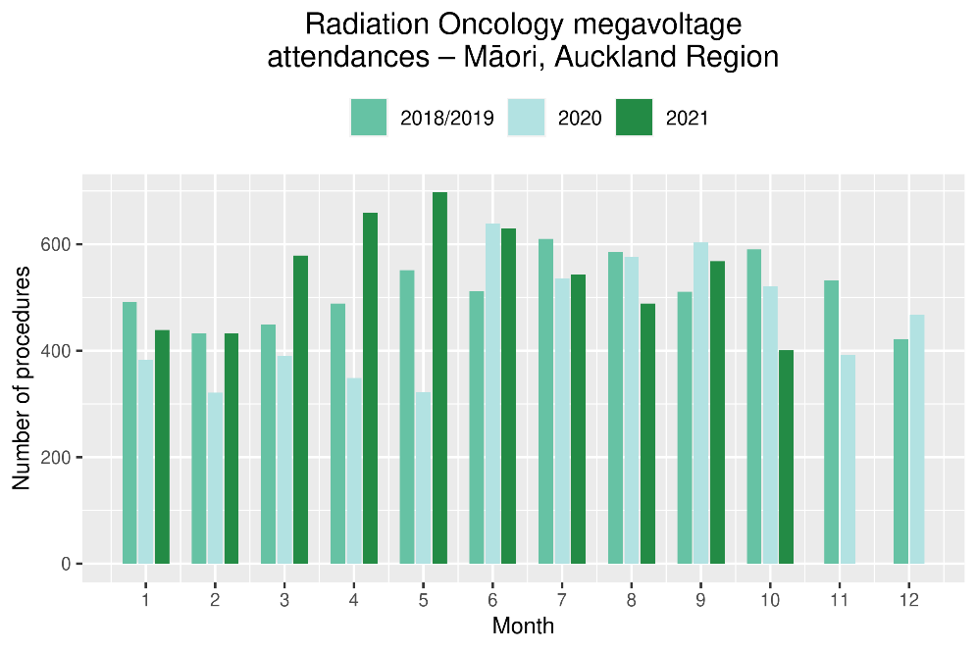
National Data

Cancer Registrations

Notes on data
- The data in this report come from laboratory reports to the New Zealand Cancer Register (NZCR). Cancers diagnosed without haematology or pathology, for example radiology alone, will not be counted in this analysis. Further information on these data is included in Appendix 1.
- Data included in this report are provisional, and exact numbers will change as data are finalised. Data were extracted from NZCR on 6 December 2021.
- ‘Date’ is date of diagnosis on the NZCR – usually the date the specimen was taken from the person and sent to the laboratory. Analyses include all new provisional and registered cancer events based on pathology and haematology reports.
- The extract used for this report excludes carcinoma in situ for breast and cervical, meaning the numbers are lower than in the 2020 COVID-19 and Cancer reports.

Key points
- Provisionally, there have been a similar number of cancer registrations in October 2021, compared to October 2018/19. This is compared with an increase in registrations of 13% seen in September 2021 compared with September 2018/2019.
- For the year to date there has been a 6% increase in the number of cancer registrations in 2021 compared to 2018/19, with the largest increases for Asian (20%) and Māori (12%).

Results
Table 2: Number of provisional cancer registrations and percentage change in 2021 compared to the 2018/19 average, by month and cumulative year to date, by ethnicity
 | August |  |  | September |  |  | October |  |  | Cumulative January-October
 | 2018/19 | 2021 | % change | 2018/19 | 2021 | % change | 2018/19 | 2021 | % change | 2018/19 | 2021 | % change
Māori | 217 | 229 | 6% | 216 | 257 | 19% | 209 | 240 | 15% | 2,134 | 2,394 | 12%
Pacific peoples | 72 | 75 | 4% | 76 | 104 | 37% | 78 | 90 | 16% | 816 | 902 | 11%
Asian | 116 | 118 | 2% | 100 | 116 | 17% | 93 | 104 | 12% | 994 | 1,196 | 20%
European/Other | 1,705 | 1,543 | -9% | 1,618 | 1,785 | 10% | 1,656 | 1,581 | -5% | 15,967 | 16,612 | 4%
Total population | 2,109 | 1,965 | -7% | 2,010 | 2,262 | 13% | 2,035 | 2,015 | -1% | 19,910 | 21,104 | 6%

Figure 6: Number of cancer registrations by month, 2018/19 average, 2020 and 2021, total population and by ethnicity
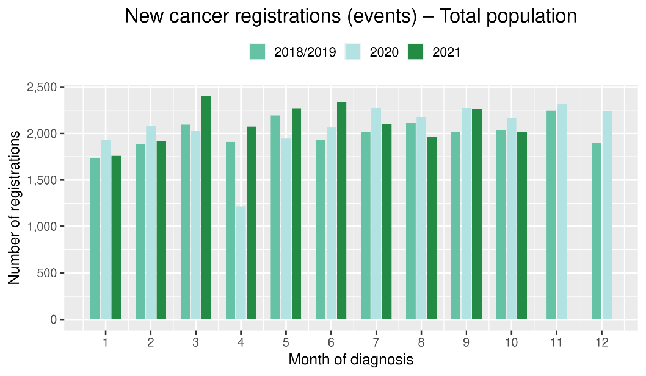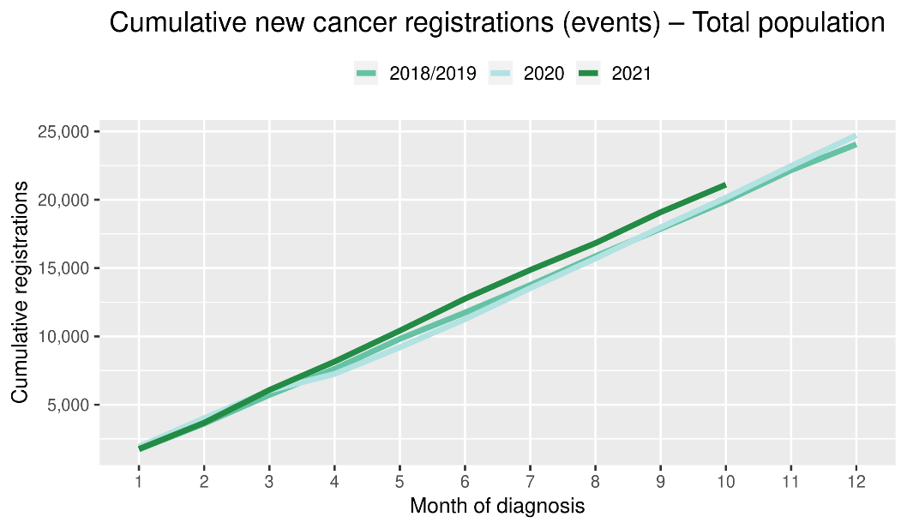

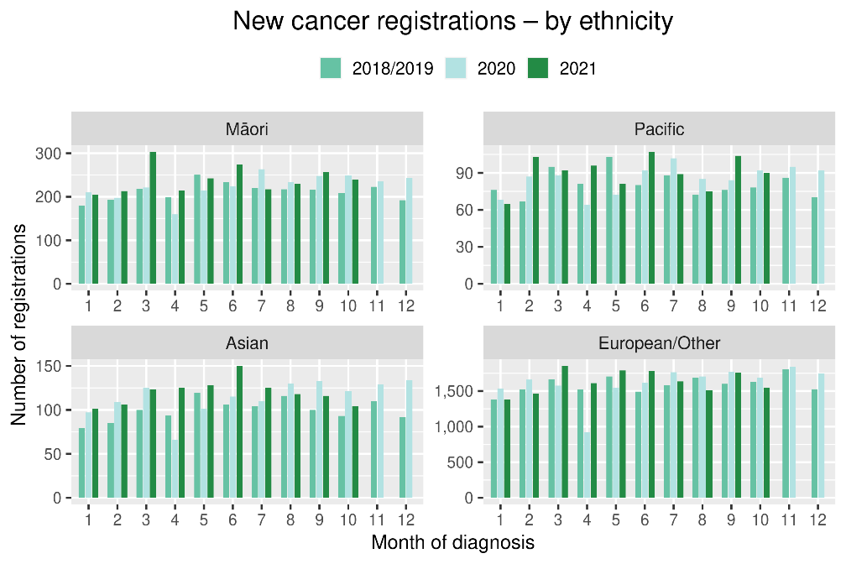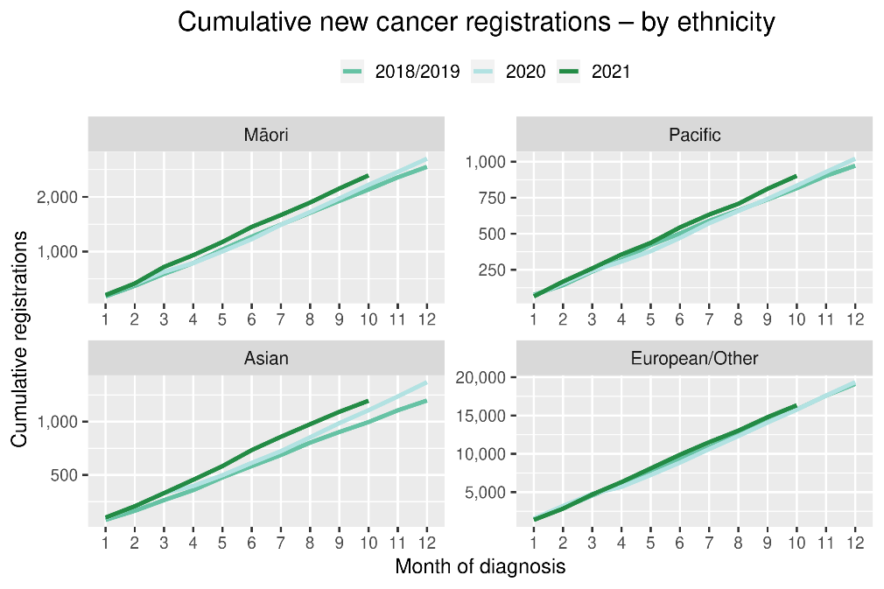

Table 3: Number of provisional cancer registrations and percentage change in 2021 compared to the 2018/19 average, by month and cumulative year to date, by tumour group
 | August |  |  | September |  |  | October |  |  | Cumulative January-October
Tumour group | 2018/19 | 2021 | % change | 2018/19 | 2021 | % change | 2018/19 | 2021 | % change | 2018/19 | 2021 | % change
Breast | 322 | 299 | -7% | 315 | 295 | -6% | 341 | 322 | -6% | 3,113 | 3,172 | 2%
Colorectal | 275 | 231 | -16% | 278 | 263 | -5% | 254 | 270 | 7% | 2,591 | 2,718 | 5%
Gynaecology | 92 | 100 | 9% | 91 | 118 | 30% | 78 | 91 | 17% | 873 | 937 | 7%
Haematology and Lymphoid | 197 | 205 | 4% | 207 | 217 | 5% | 211 | 185 | -12% | 2,048 | 2,041 | 0%
Melanoma and non-melanoma skin | 294 | 233 | -21% | 261 | 255 | -2% | 289 | 264 | -9% | 2,713 | 2,924 | 8%
Other digestive system | 127 | 143 | 13% | 112 | 147 | 31% | 132 | 137 | 4% | 1,216 | 1,384 | 14%
Prostate | 374 | 297 | -21% | 357 | 405 | 13% | 318 | 311 | -2% | 3,299 | 3,305 | 0%
Respiratory and thorax | 160 | 155 | -3% | 138 | 173 | 26% | 149 | 141 | -5% | 1,448 | 1,539 | 6%
Urinary system | 81 | 104 | 29% | 80 | 125 | 57% | 74 | 80 | 9% | 827 | 948 | 15%
*This analysis uses provisional data for the 2021 registrations, some cancers may initially be classified as ‘non-specified’ and subsequently be re-classified into one of the cancer groups as more information becomes available.
Figure 7: Number of cancer registrations by month, 2018/19 average, 2020 and 2021, by tumour group
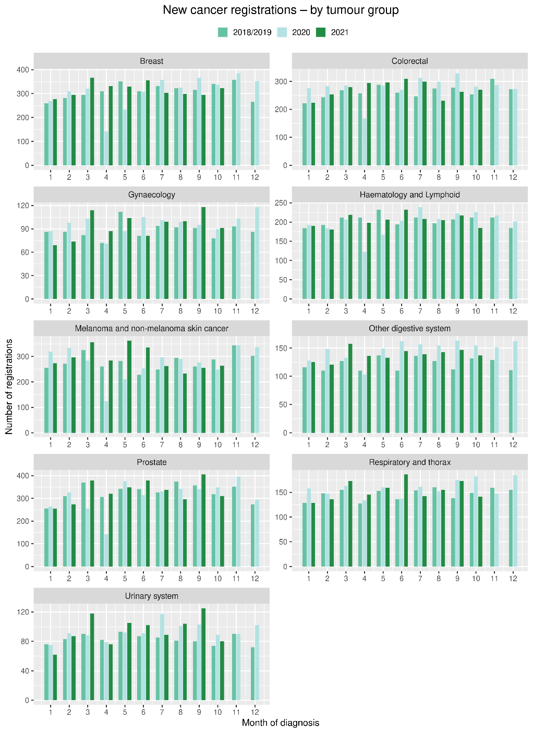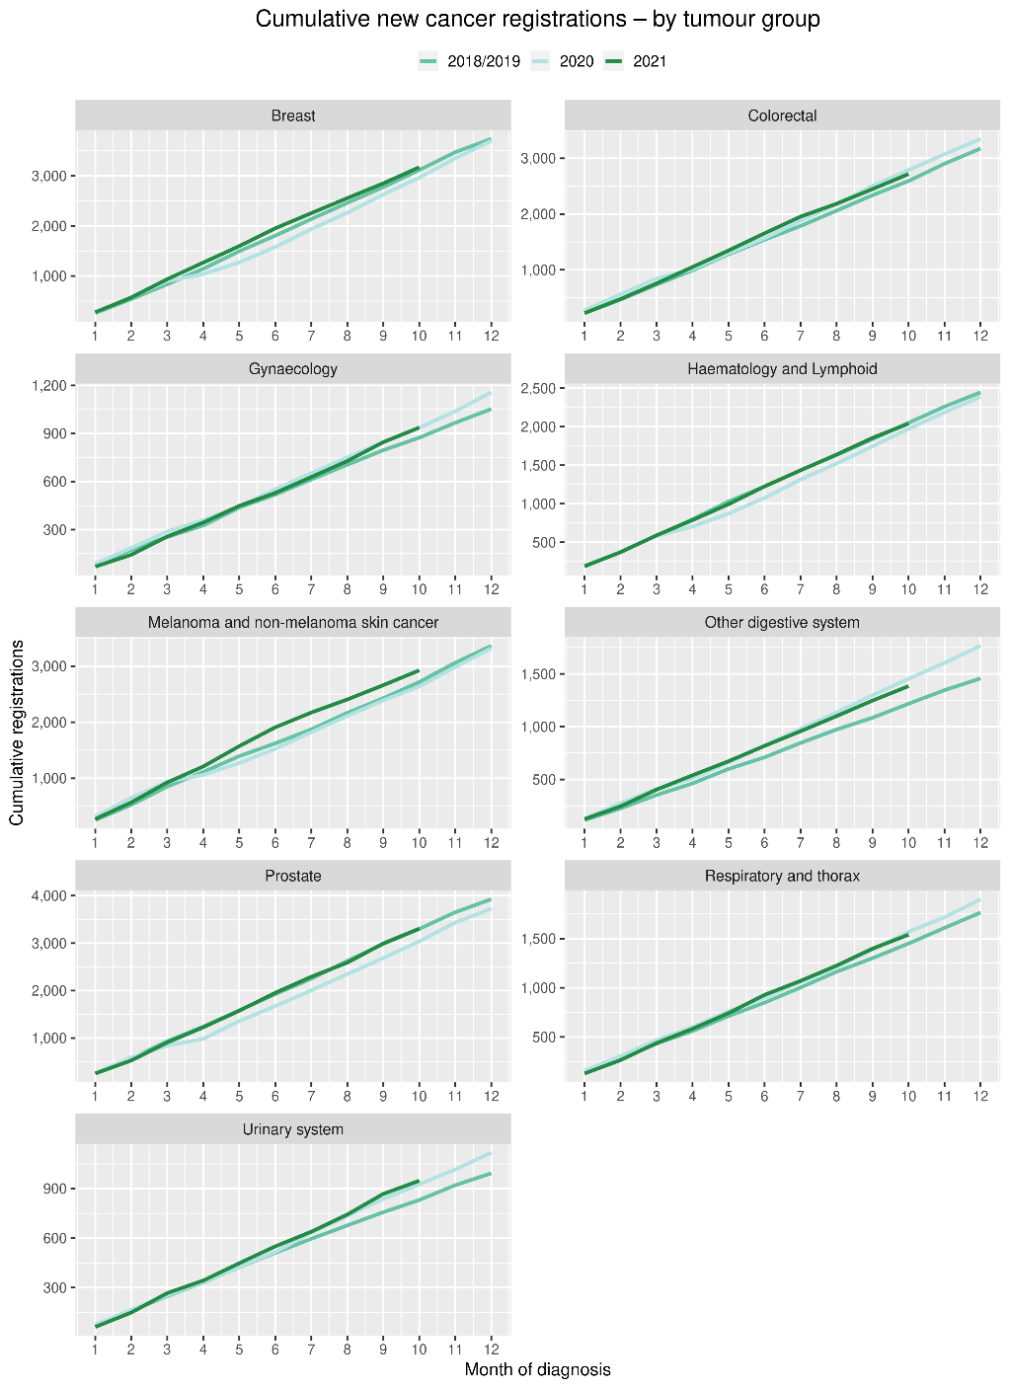

Gastrointestinal endoscopy

Notes on data
- Gastrointestinal endoscopy data were extracted from the National Non-admitted Patient Collection (NNPAC) and National Minimum Dataset (NMDS) on 29 November 2021.
- Includes colonoscopies and gastroscopies for all indications – not just cancer.
- Technical information: gastroscopies (Purchase Unit Code: MS02005), colonoscopies (Purchase Unit Code: MS02007), combined gastroscopies and colonoscopies (Purchase Unit Code: MS02014).

Key points
- There was an increase of 2% in gastrointestinal endoscopies performed in October 2021, compared to October 2018/19. In August 2021 29% decrease was seen and in September a 4% decrease was seen compared to the same months for 2018/19.
- The increase in endoscopies was largest for Pacific peoples (42%) and was 11% for Māori. For non-Māori/non-Pacific peoples there was a decrease of 1%.
- The overall increase in endoscopies appear to be driven by a return to baseline service provision rates in the Auckland region (see Figure 2).
- Overall, for the year to date there has been an increase in the number of gastrointestinal endoscopies performed in 2021 compared to 2018/19 across all ethnic groups.

Results
Table 4: Number of colonoscopy and gastroscopy procedures and percentage difference in 2021 compared to 2018/2019 average, by month and cumulative year to date, by ethnicity
 | August |  |  |  | September |  |  |  | October |  |  |  | Cumulative January - October
 | 2018/19 |  | 2021 | % change | 2018/19 |  | 2021 | % change | 2018/19 |  | 2021 | % change | 2018/19 | 2021 | % change
Māori | 670 | 530 |  | -21% | 598 | 619 |  | 4% | 607 | 676 |  | 11% | 5,537 | 6,598 | 19%
Pacific peoples | 243 | 178 |  | -27% | 208 | 173 |  | -17% | 235 | 334 |  | 42% | 2,071 | 2,441 | 18%
Non-Māori/non-Pacific | 6,180 | 4,349 |  | -30% | 5,569 | 5,339 |  | -4% | 5,681 | 5,611 |  | -1% | 53,529 | 58,236 | 9%
Total population | 7,093 | 5,057 |  | -29% | 6,374 | 6,131 |  | -4% | 6,522 | 6,621 |  | 2% | 61,137 | 67,275 | 10%

Figure 8: Number of gastrointestinal endoscopy procedures by month, 2018/19 average, 2020 and 2021, total population and Māori
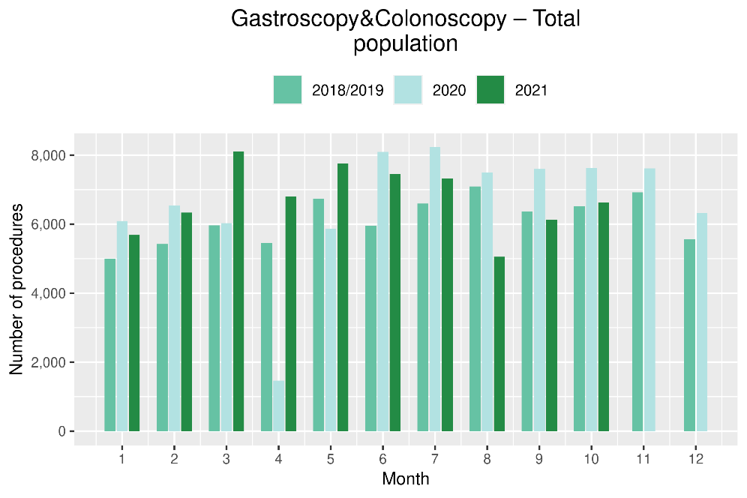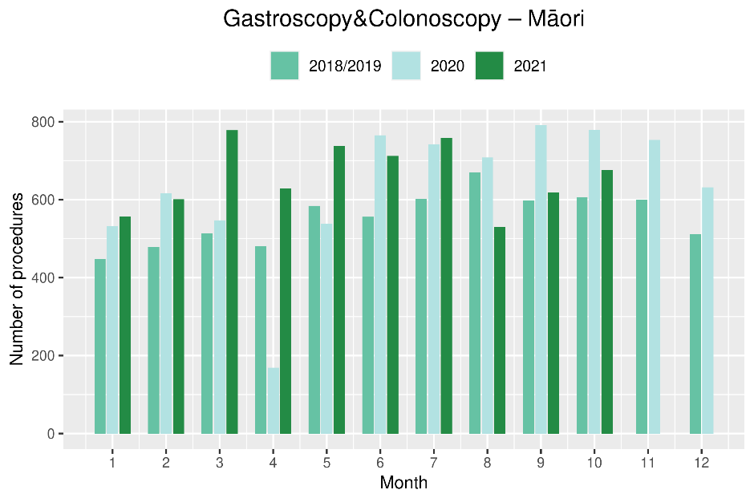
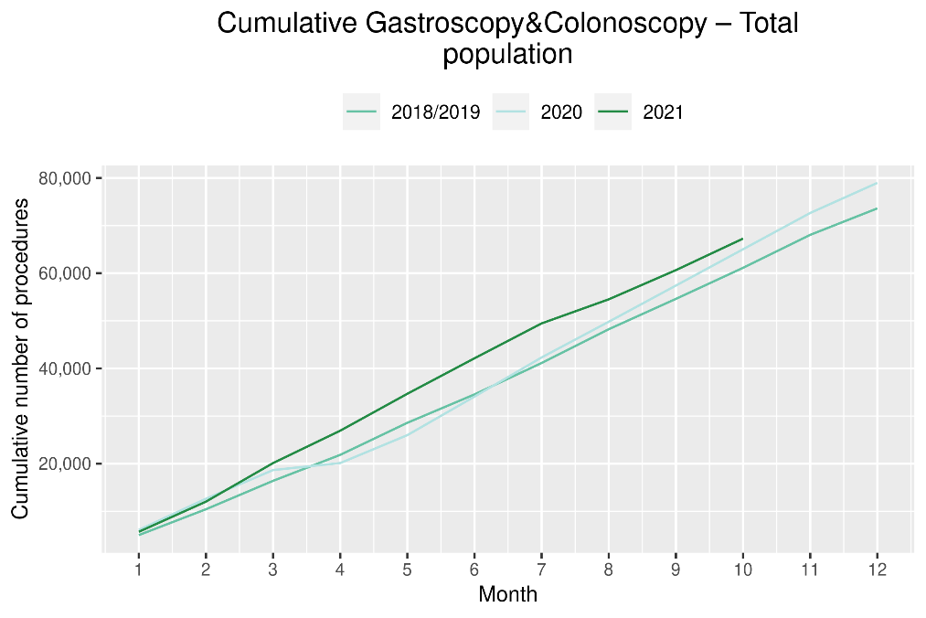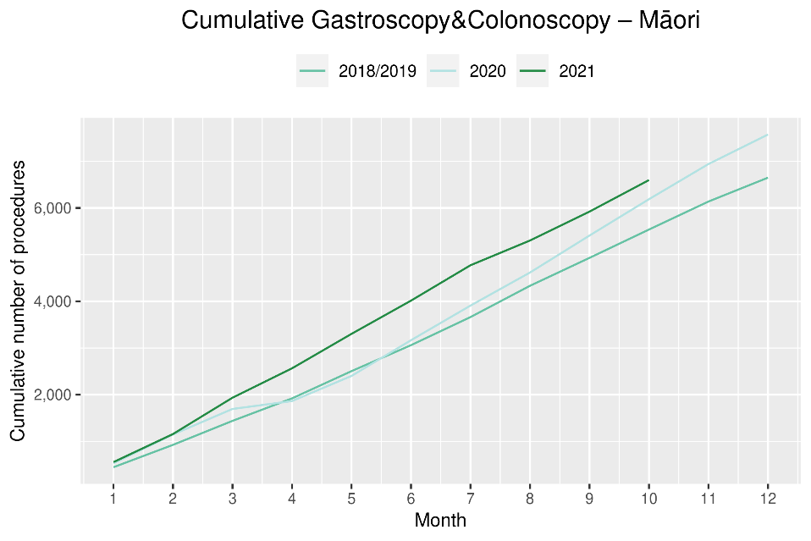

Bronchoscopy

Notes on data
- Bronchoscopy data were extracted from NNPAC and NMDS on 29 November 2021.
- These data include bronchoscopies for all indications, not solely cancer related procedures.
- Technical information: bronchoscopies (Purchase Unit Code - MS02003).

Key points
- There was a 29% decrease in the number of bronchoscopies performed in October 2021 compared to October 2018/19. This was a larger change than seen in the previous month, and similar to that seen at the beginning of the Delta outbreak in August 2021, after a small decrease of 4% was seen in September. Te Aho o Te Kahu is working with DHBs to understand these findings.
- Overall, there has been 7% fewer bronchoscopies performed for the year to date compared to same time period in 2018/19. This decrease was smaller for non-Māori/non-Pacific (5%), than for Māori (9%), and Pacific peoples (30%, noting small numbers).

Results
Table 5: Number of bronchoscopies and percentage difference in 2021 compared to 2018/2019 average, by month and cumulative year to date, by ethnicity
 | August |  |  | September |  |  | October |  |  | Cumulative January-October
 | 2018/19 | 2021 | % change | 2018/19 | 2021 | % change | 2018/19 | 2021 | % change | 2018/19 | 2021 | % change
Māori* |  |  |  |  |  |  |  |  |  | 340 | 309 | -9%
Pacific peoples* |  |  |  |  |  |  |  |  |  | 104 | 73 | -30%
Non-Māori/Non-Pacific | 175 | 124 | -29% | 167 | 178 | 7% | 191 | 141 | -26% | 1,721 | 1,640 | -5%
Total population | 230 | 151 | -34% | 214 | 205 | -4% | 241 | 170 | -29% | 2,165 | 2,022 | -7%
*Due to small numbers, monthly figures have not been included for Māori and Pacific peoples

Figure 9: Number of bronchoscopies by month, 2018/19 average, 2020 and 2021, total population and Māori
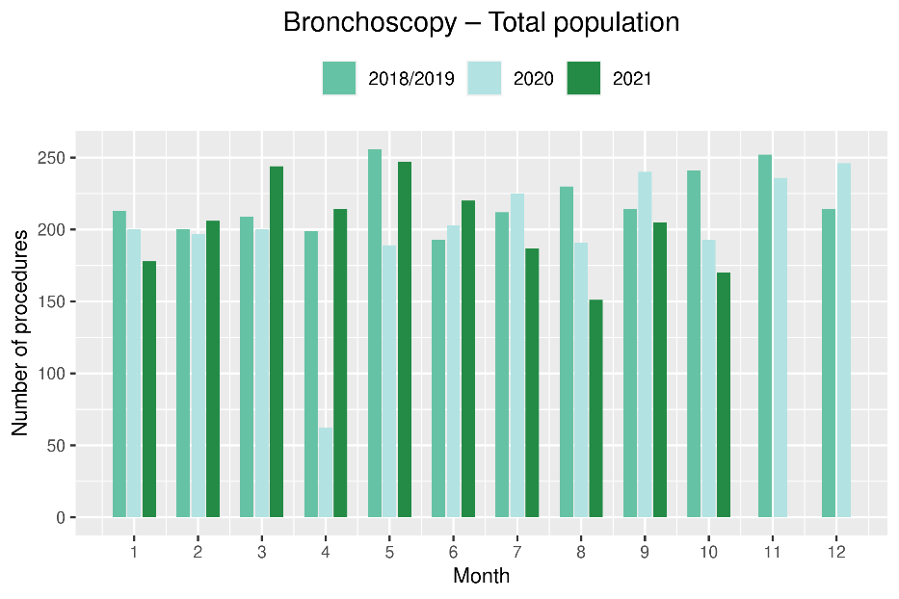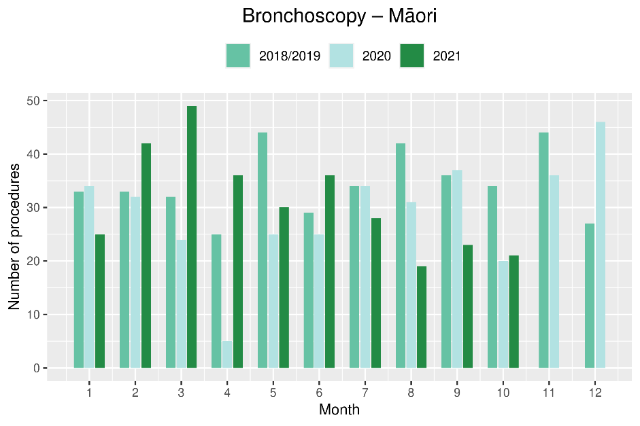
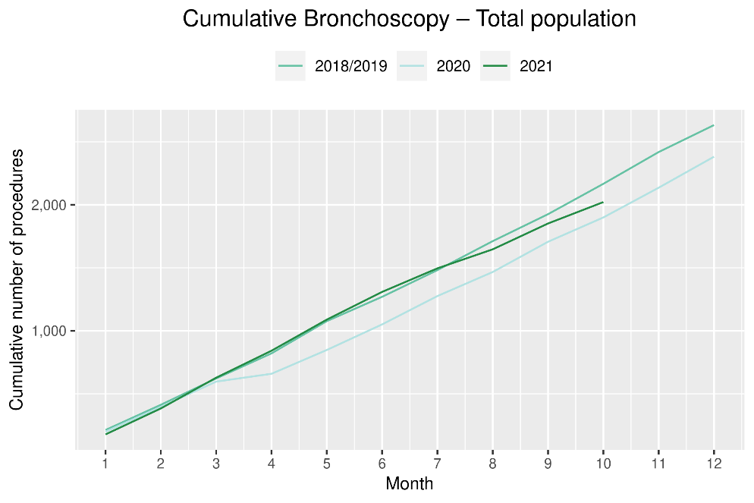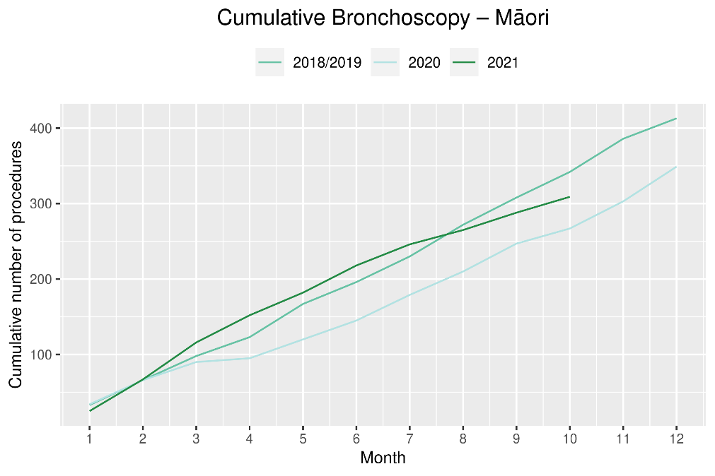

Combined curative cancer surgery

Notes on data
- This report includes data on curative surgery for colorectal, lung and prostate cancer. These cancers were chosen because Te Aho o Te Kahu already has a pre-validated list of surgical procedure codes for these cancers, agreed on as part of the quality performance indicator (QPI) work programme. These three cancers are therefore used as case studies for cancer surgery more generally. The surgical procedure codes are listed in Appendix 4.
- The data were extracted from the NMDS on 29 November 2021.

Key points
- There was a 2% increase in the number of curative cancer surgeries (prostate, lung and colorectal) performed in October 2021 compared to October 2018/19.
- For the year to date, there has been a 4% increase in these surgeries compared to the same time period in 2018/19. This increase is present for Māori (28% increase) and Pacific peoples (31% increase, noting small numbers).

Results
Table 6: Number of curative cancer surgeries (prostate, colorectal, lung) and percentage difference in 2021 compared to 2018/2019 average by month and cumulative year to date, by ethnicity
 | August |  |  | September |  |  | October |  |  | Cumulative January-October
 | 2018/19 | 2021 | % change | 2018/19 | 2021 | % change | 2018/19 | 2021 | % change | 2018/19 | 2021 | % change
Māori | 25 | 38 | 52% | 40 | 45 | 14% | 38 | 42 | 12% | 319 | 408 | 28%
Pacific peoples* |  |  |  |  |  |  |  |  |  | 104 | 136 | 31%
Non-Māori/Non-Pacific | 319 | 304 | -5% | 298 | 315 | 6% | 289 | 291 | 1% | 2,865 | 2,863 | 0%
Total population | 357 | 352 | -1% | 349 | 374 | 7% | 341 | 346 | 2% | 3,288 | 3,407 | 4%
*Due to small numbers, monthly figures have not been included for Pacific peoples

Figure 10: Number of curative cancer surgeries (prostate, colorectal, lung) by month, 2018/19 average, 2020 and 2021, total population and Māori
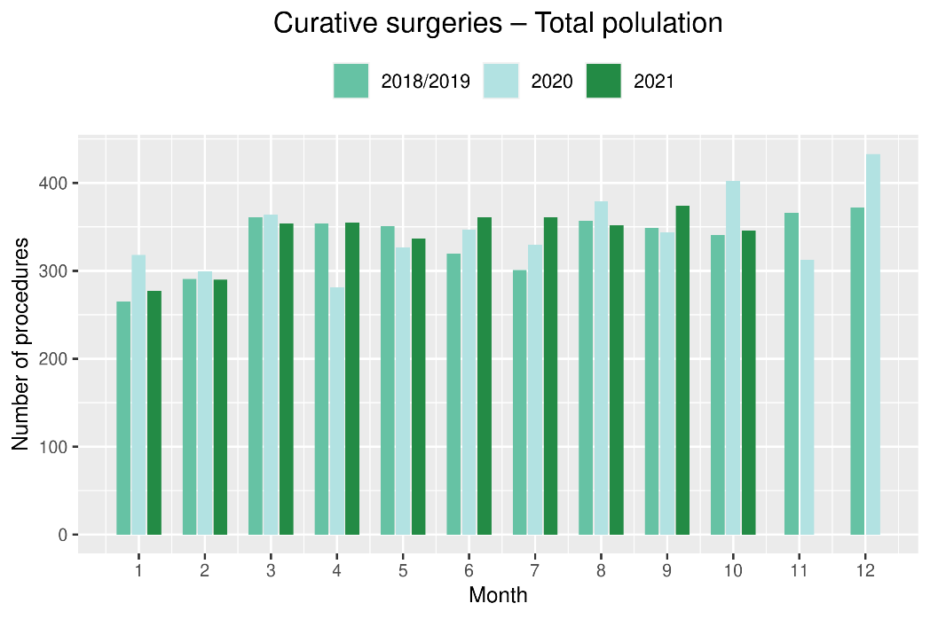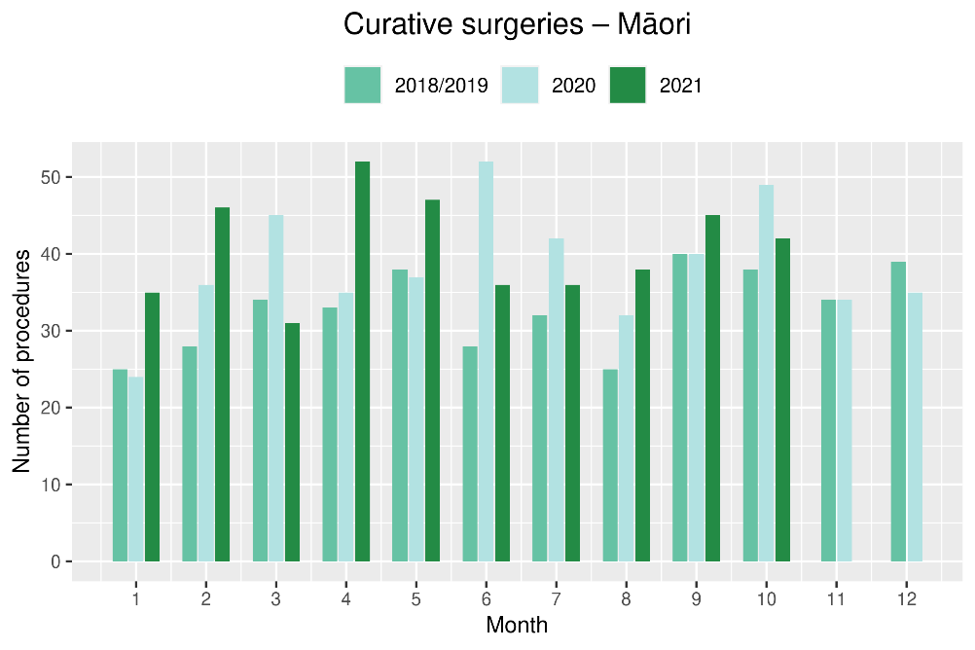
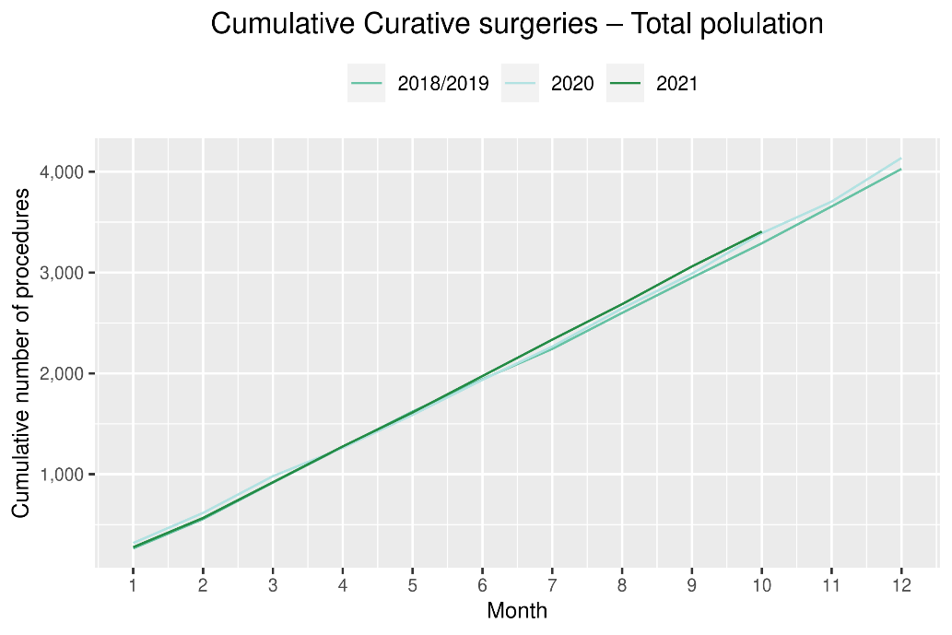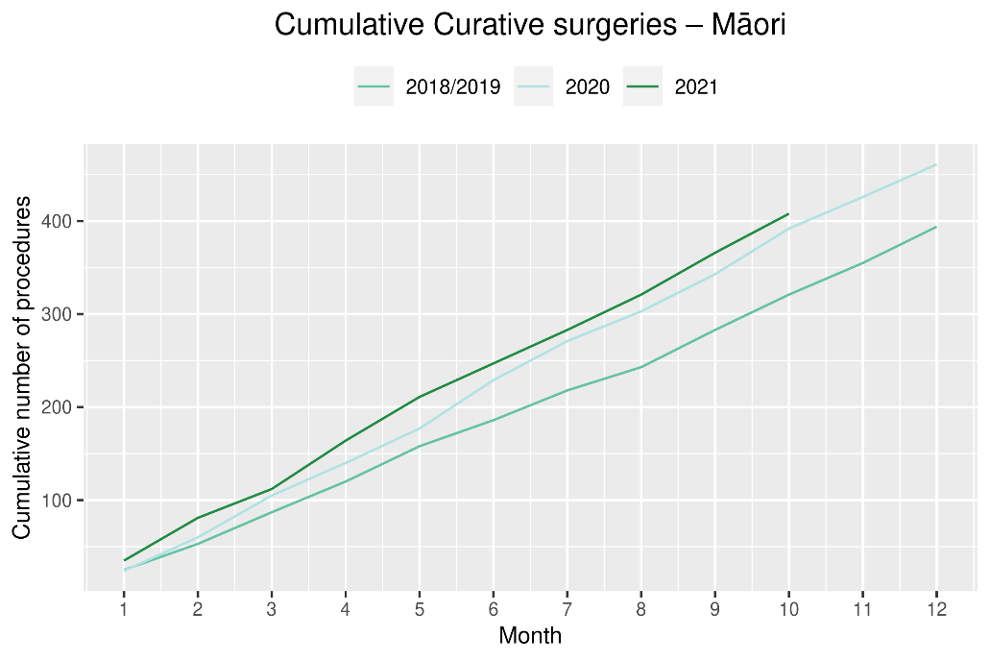

Colorectal cancer surgery

Notes on data
- The surgical procedure codes used for analysing colorectal cancer are listed in Appendix 4.
- The data were extracted from the NMDS on 29 November 2021.

Key points
- There has been a decrease (7%) in curative colorectal cancer surgeries performed in October 2021 compared with October 2018/19.
- However, the year to date has seen a similar number of curative colorectal cancer surgeries performed in 2021 as were performed in 2018/19.

Results
Table 7: Number of curative colorectal cancer surgeries and percentage difference in 2021 compared to 2018/2019 average, by month and cumulative year to date, by ethnicity
 | August |  |  |  | September |  |  |  | October |  |  |  | Cumulative January-October
 | 2018/19 |  | 2021 | % change | 2018/19 |  | 2021 | % change | 2018/19 |  | 2021 | % change | 2018/19 | 2021 |  | % change
Māori* |  |  |  |  |  |  |  |  |  |  |  |  | 168 |  | 208 | 24%
Pacific peoples* |  |  |  |  |  |  |  |  |  |  |  |  | 63 | 75 |  | 19%
Non-Māori/Non-Pacific | 196 |  | 200 | 2% | 185 |  | 190 | 3% | 179 |  | 165 | -8% | 1,849 | 1,793 |  | -3%
Total population | 216 |  | 225 | 4% | 212 |  | 216 | 2% | 205 |  | 190 | -7% | 2,079 | 2,076 |  | 0%
*Due to small numbers, monthly figures have not been included for Māori and Pacific peoples

Figure 11: Number of curative colorectal cancer surgeries by month, 2018/19 average, 2020 and 2021, total population and Māori
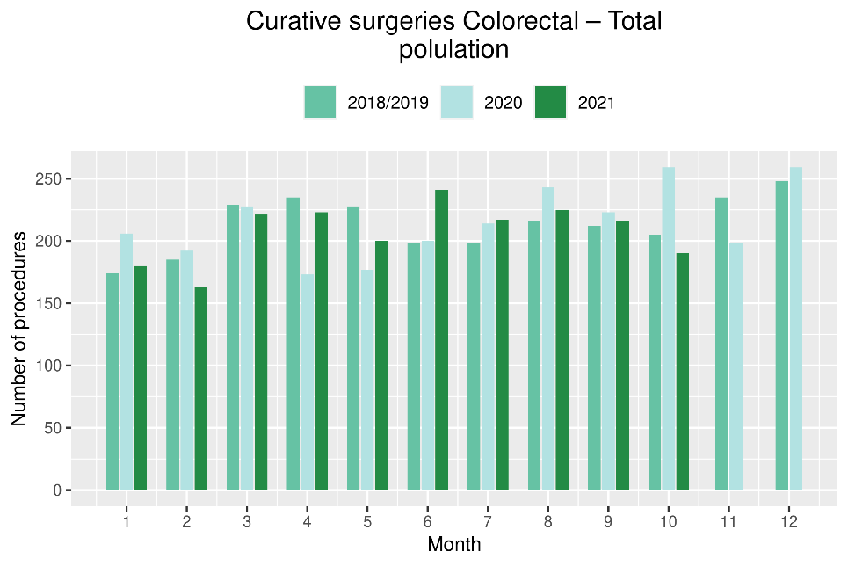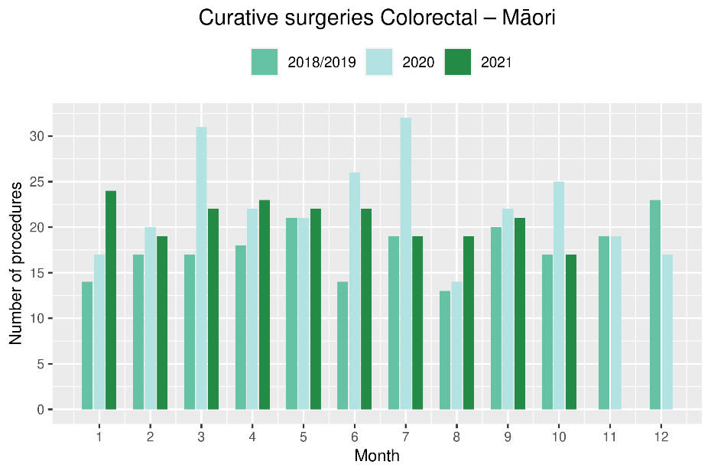

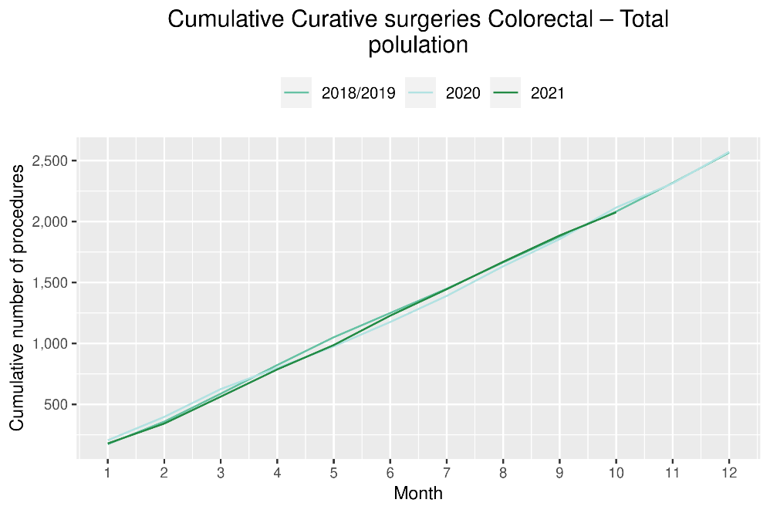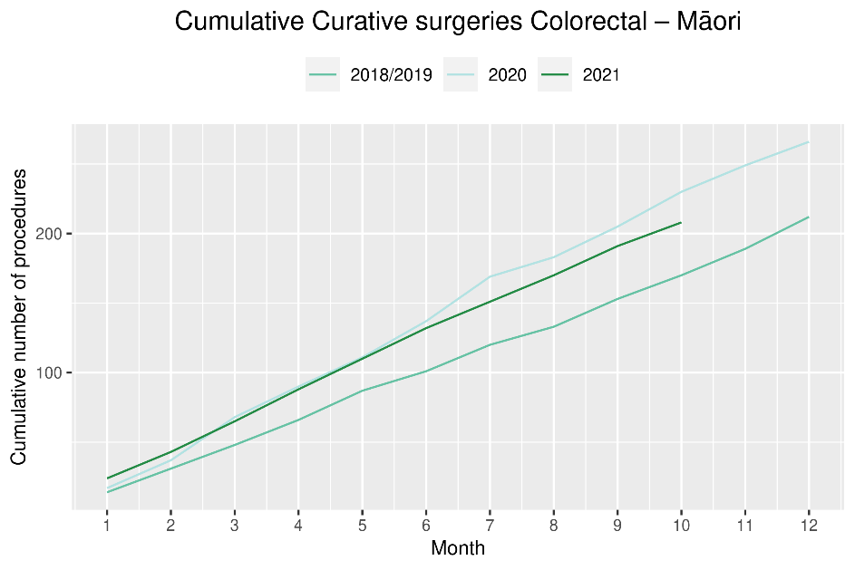

Lung cancer surgery

Notes on data
- A list of the surgical procedure codes used for analysis are included in Appendix 4.
- The data were extracted from the NMDS on 29 November 2021.
- The number of lung cancer surgeries performed each month is relatively small, so caution is needed when comparing data by month.

Key points
- There was a decrease in curative lung cancer surgeries in October 2021 compared to October 2018/19 (3 less surgeries)
- Overall, for the year to date there has been a similar number of lung cancer surgeries performed in 2021 compared to 2018/19, and an increase in the number of surgeries for Māori (8%, 9 more surgeries).

Results
Table 8: Number of curative lung cancer surgeries and percentage difference in 2021 compared to 2018/2019 average, by month and cumulative year to date, by ethnicity
 | August |  |  | September |  |  | October |  |  | Cumulative January-October
 | 2018/19 | 2021 | % change | 2018/19 | 2021 | % change | 2018/19 | 2021 | % change | 2018/19 | 2021 | % change
Māori* |  |  |  |  |  |  |  |  |  | 106 | 115 | 8%
Pacific peoples* |  |  |  |  |  |  |  |  |  | 25 | 27 | 10%
Non-Māori/Non-Pacific | 53 | 39 | -26% | 49 | 59 | 20% | 49 | 49 | 0% | 443 | 433 | -2%
Total population | 65 | 53 | -18% | 64 | 74 | 17% | 68 | 65 | -4% | 573 | 575 | 0%
* Due to small numbers, monthly figures have not been included for Māori and Pacific peoples

Figure 12: Number of curative lung cancer surgeries by month, 2018/19 average, 2020 and 2021, total population and Māori (cumulative only due to small numbers)
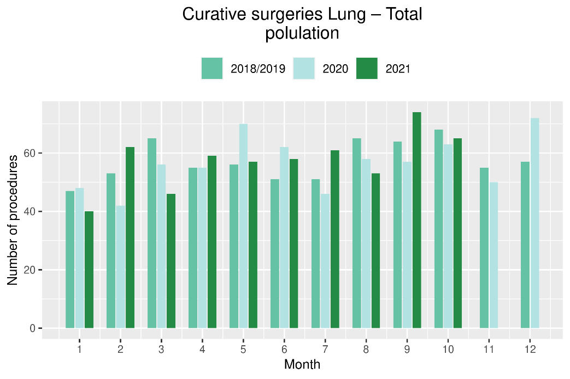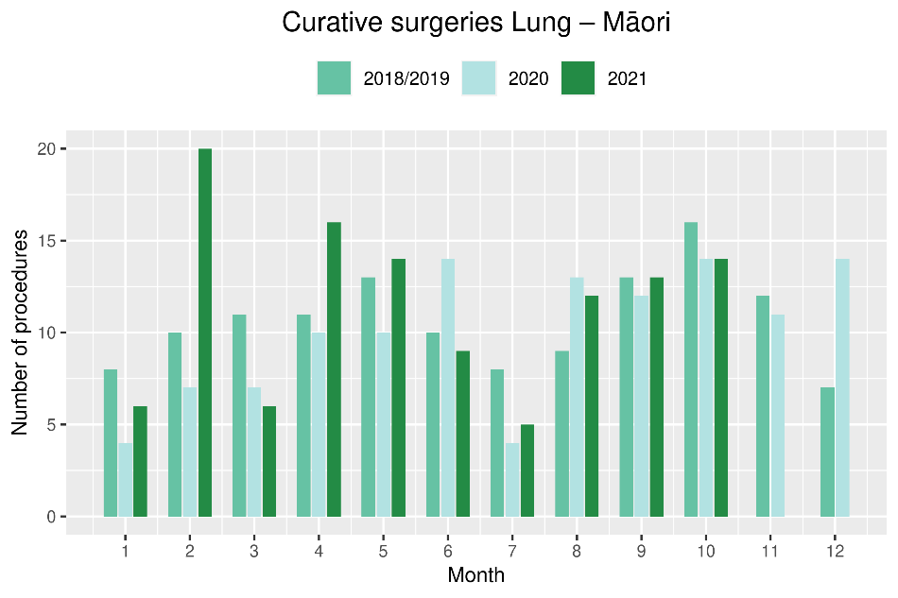
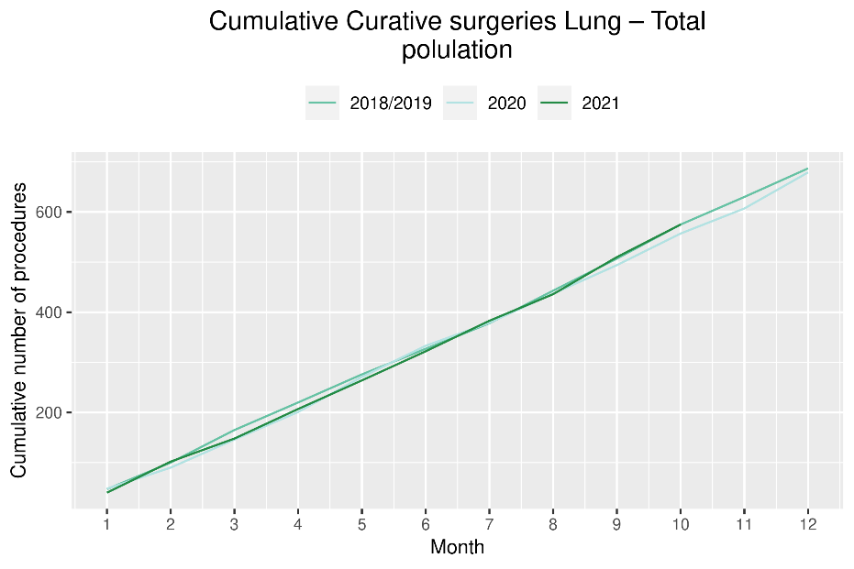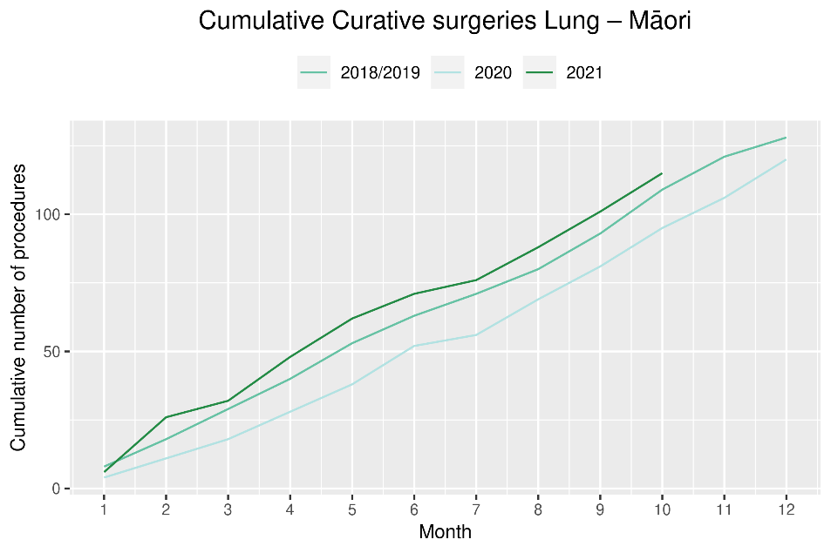

Prostate cancer surgery

Notes on data
- A list of the surgical procedure codes used for analysis are included in Appendix 4.
- The data was extracted from the NMDS on 29 November 2021.
- The volumes for prostate surgery are higher in this report than previously reported due to the inclusion of data from a private provider who provides publicly funded surgery.
- The number of curative prostate cancer surgeries performed each month is relatively small, so caution is needed when comparing data by month.

Key points
- There has been an increase in prostate cancer surgeries performed in October 2021 compared to October 2018/19 (34%, 23 more surgeries) and an increase in the number of surgeries for the year to date.
- There has been an increase in the number of Māori receiving curative prostate cancer surgery in 2021 compared to both 2020 and 2018/19; however, this appears unrelated to 2021 COVID-19 Delta outbreak.

Results
Table 9: Number of curative prostate cancer surgeries and percentage difference in 2021 compared to 2018/2019 average by month and cumulative year to date
 | August |  |  | September |  |  | October |  |  | Cumulative January-October
 | 2018/19 | 2021 | % change | 2018/19 | 2021 | % change | 2018/19 | 2021 | % change | 2018/19 | 2021 | % change
Total population* | 76 | 74 | -2% | 74 | 84 | 14% | 68 | 91 | 34% | 636 | 756 | 19%
*Due to the small number of surguries performed each month calculations have only been included for the total population

Figure 13: Number of curative prostate cancer surgeries by month, 2018/19 average, 2020 and 2021, total population and Māori (cumulative only due to small numbers)
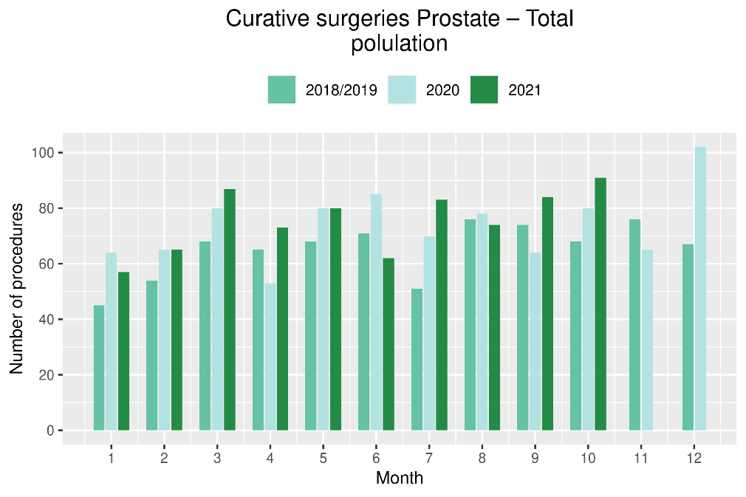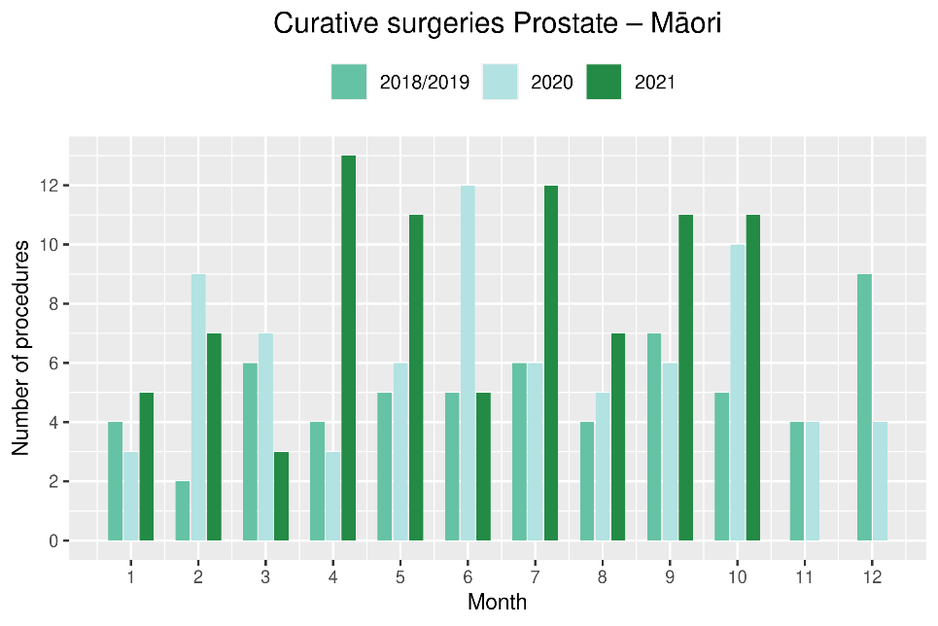
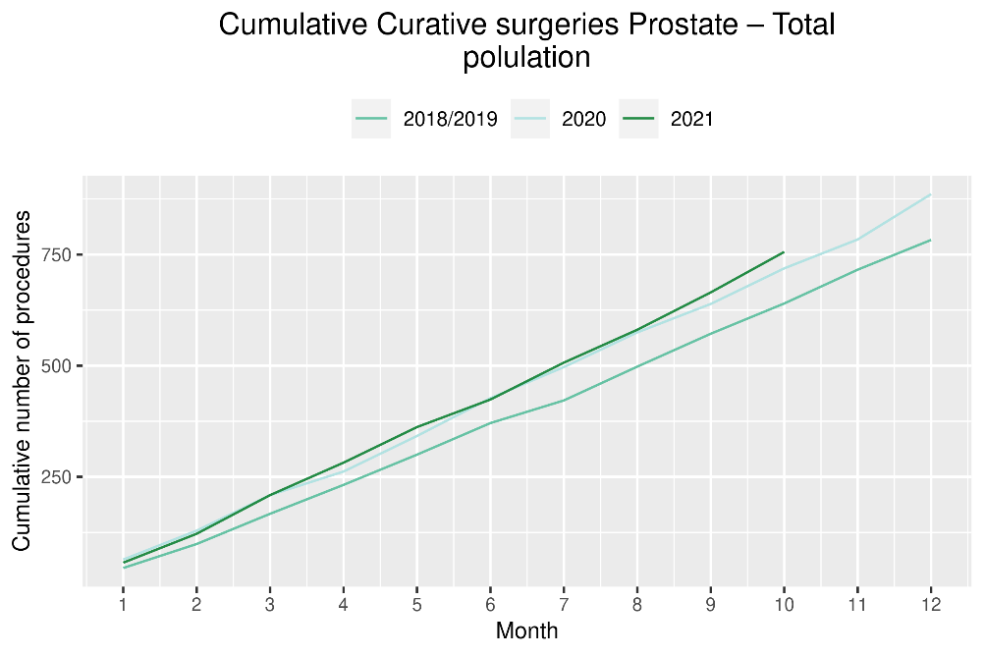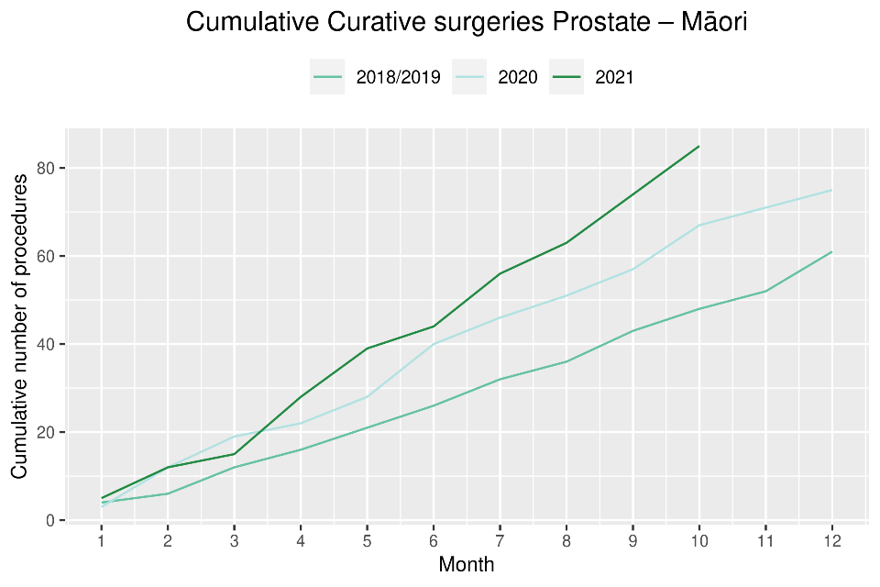
Medical oncology

Notes on data
- Data were extracted from NNPAC 29 November 2021.
- First specialist assessment (FSA) reflects counts of first attendance for specialist medical oncology assessment.
- Intravenous (IV) chemotherapy reflects appointments for outpatient and inpatient IV chemotherapy for non-haematological indications.
- Technical information: medical oncology FSA (PUC M50020) and IV chemotherapy (PUC MS02009).

Key points
- Attendances for medical oncology first specialist appointments (FSAs) decreased by 5% in October 2021 compared to October 2018/19. The decrease was higher (10%) for Māori and there was no change for Pacific peoples.
- For the year to date in 2021 compared to the same time period in 2018/19, medical oncology FSAs increased by 7%.
- Attendances for intravenous (IV) chemotherapy decreased by 8% in October 2021 compared with October 2018/19.
- For the year to date in 2021 compared to the same time period in 2018/19, IV chemotherapy attendances increased by 5%, with a larger increase for Māori (22%) and Pacific peoples (30%) than for non-Māori/non-Pacific (1%).

Results
Table 10: Number of medical oncology first specialist assessments and percentage difference in 2021 compared to 2018/2019 average, by month and cumulative year to date, by ethnicity
 | August |  |  | September |  |  | October |  |  | Cumulative January-October
 | 2018/19 | 2021 | % change | 2018/19 | 2021 | % change | 2018/19 | 2021 | % change | 2018/19 | 2021 | % change
Māori | 118 | 147 | 25% | 103 | 127 | 23% | 107 | 96 | -10% | 1,029 | 1,200 | 17%
Pacific peoples | 43 | 52 | 21% | 31 | 41 | 32% | 33 | 33 | 0% | 349 | 409 | 17%
Non-Māori/Non-Pacific | 693 | 694 | 0% | 615 | 750 | 22% | 579 | 551 | -5% | 6,108 | 6,418 | 5%
Total population | 854 | 893 | 5% | 749 | 918 | 23% | 718 | 680 | -5% | 7,485 | 8,027 | 7%

Figure 14: Number of medical oncology first specialist assessments by month, 2018/19 average, 2020 and 2021, total population and Māori
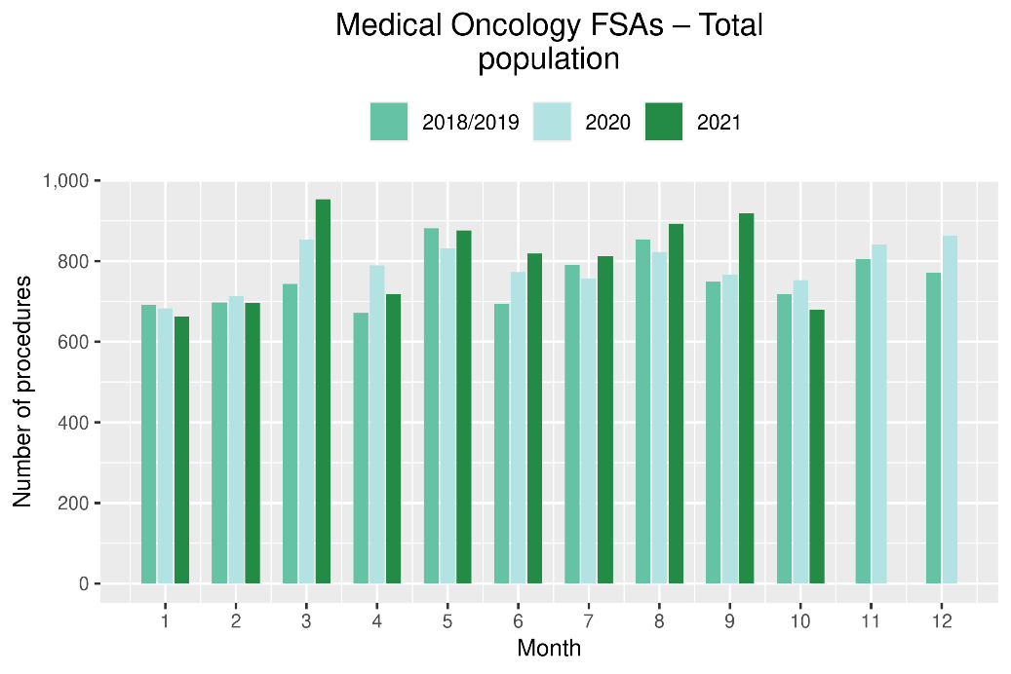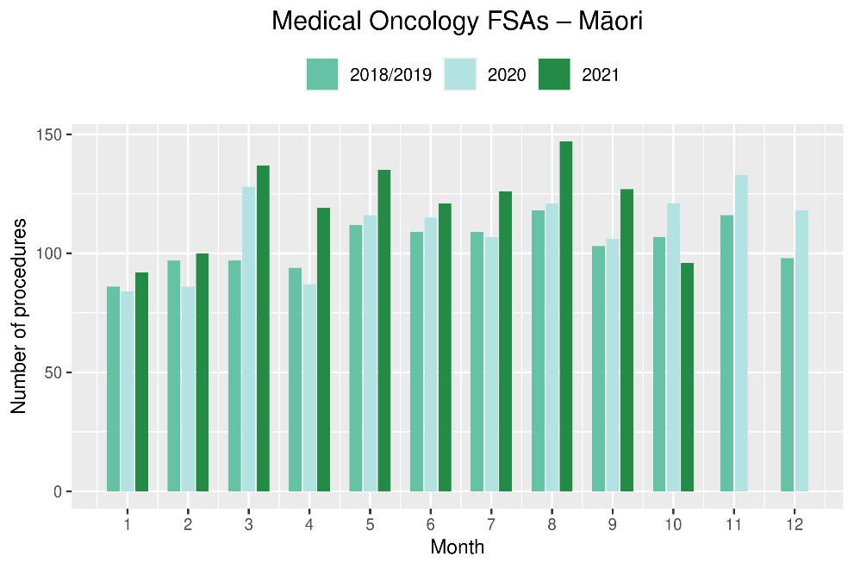
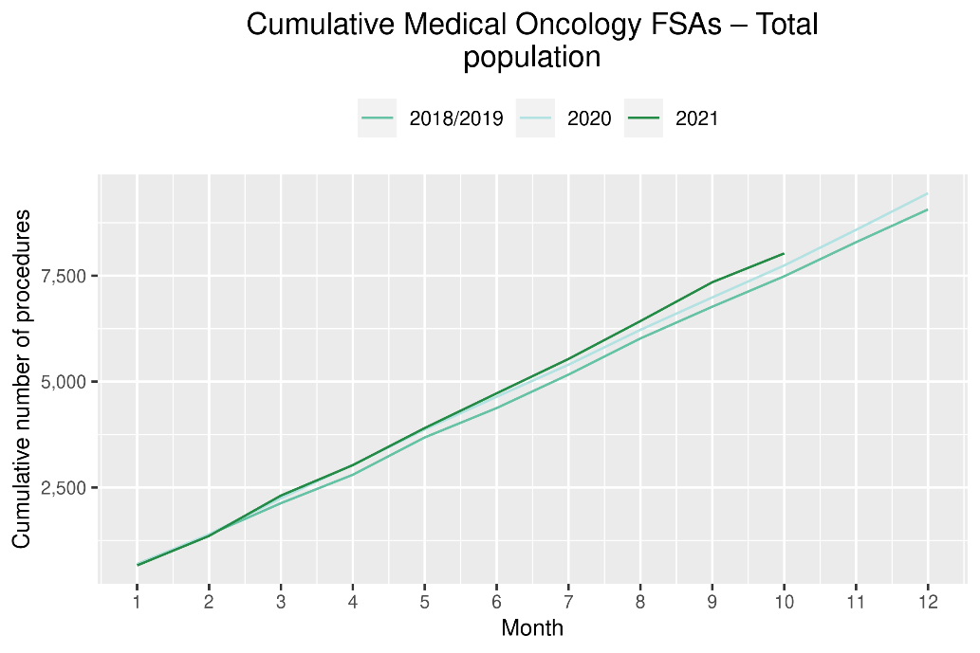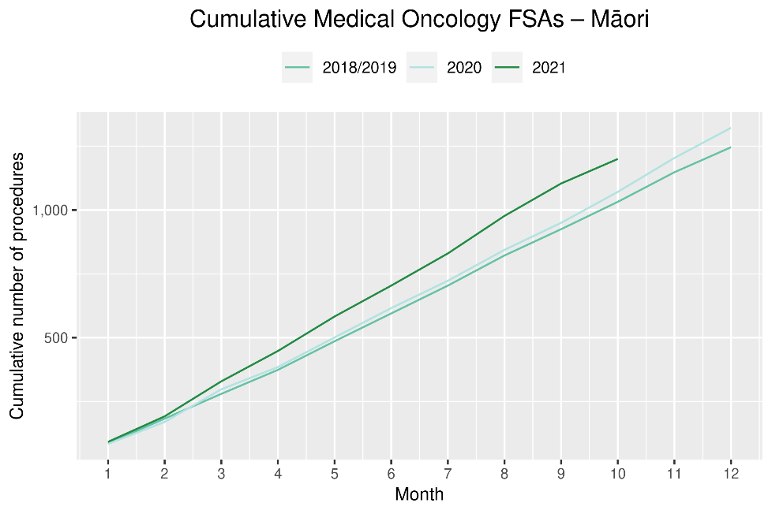
Table 11: Number of IV chemotherapy attendances and percentage difference in 2021 compared to 2018/2019 average, by month and cumulative year to date, by ethnicity
 | August |  |  | September |  |  | October |  |  | Cumulative January-October
 | 2018/19 | 2021 | % change | 2018/19 | 2021 | % change | 2018/19 | 2021 | % change | 2018/19 | 2021 | % change
Māori | 834 | 910 | 9% | 776 | 900 | 16% | 847 | 856 | 1% | 7,447 | 9,110 | 22%
Pacific peoples | 259 | 376 | 45% | 267 | 369 | 38% | 303 | 332 | 10% | 2,698 | 3,519 | 30%
Non-Māori/Non-Pacific | 5,234 | 4,813 | -8% | 4,858 | 5,132 | 6% | 5,423 | 4,880 | -10% | 48,784 | 49,323 | 1%
Total population | 6,327 | 6,099 | -4% | 5,900 | 6,401 | 8% | 6,573 | 6,068 | -8% | 58,929 | 61,952 | 5%

Figure 15: Number of IV chemotherapy attendances by month, 2018/19 average, 2020 and 2021, total population and Māori
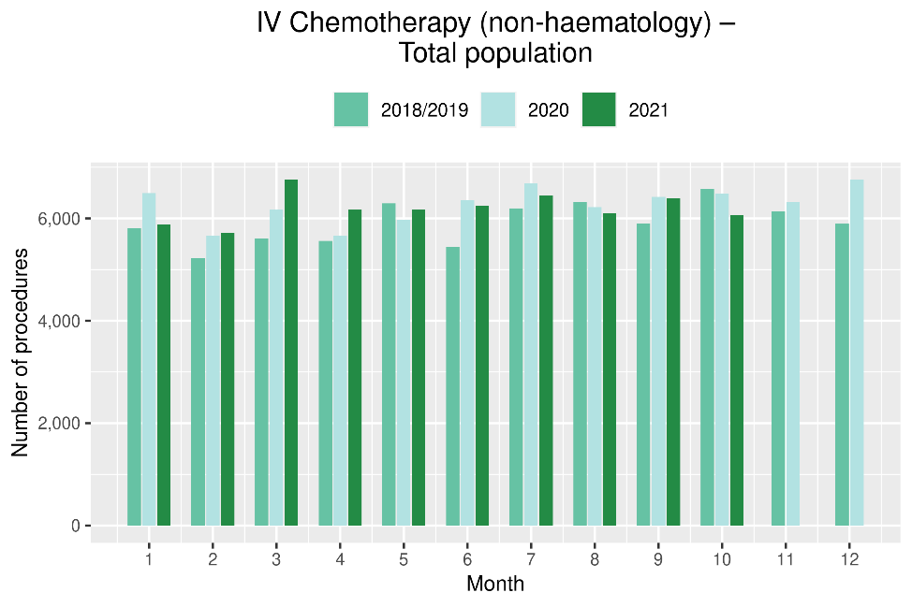
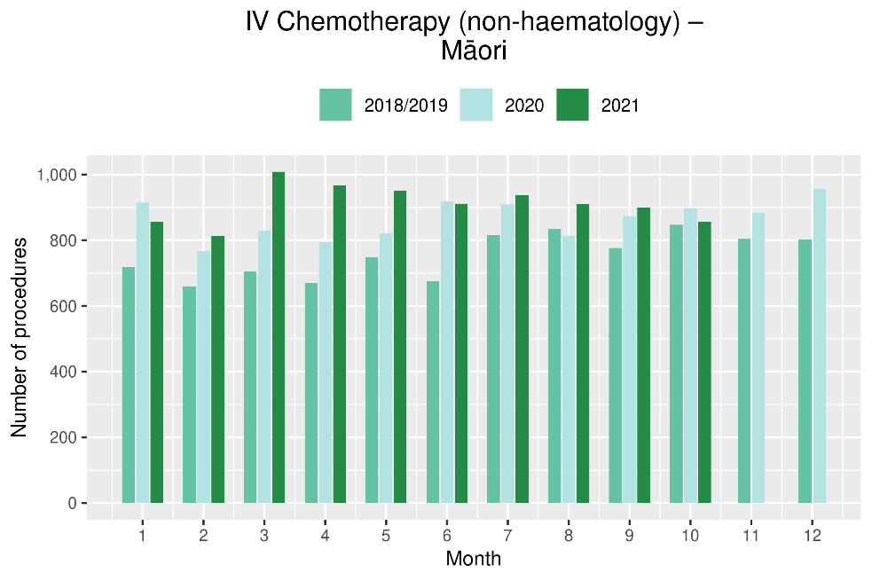

Figure 16: Cumulative number of attendances for IV chemotherapy, 2018/19 average, 2020 and 2021, total population and for Māori
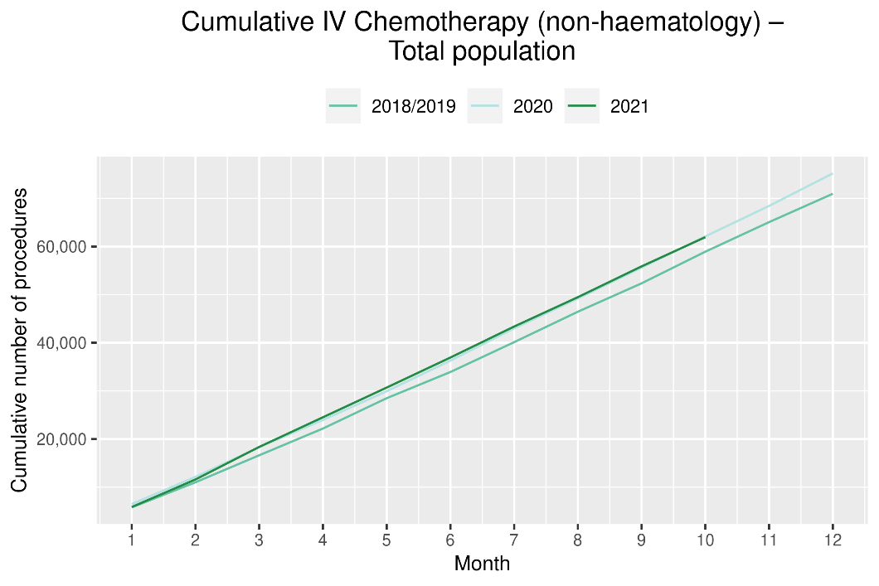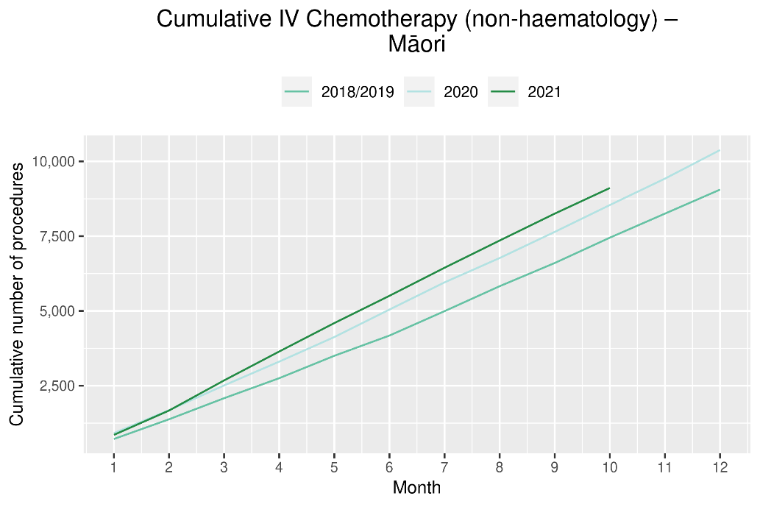

Radiation oncology

Notes on data
- Data were extracted from NNPAC on 29 November 2021.
- First specialist assessment (FSA) reflects counts of first attendance for radiation oncology specialist assessment.
- Radiation therapy attendances include appointments for planning/simulation and for treatment with radiation therapy on a linear accelerator.
- Technical information: radiation oncology FSA (PUC M50022), megavoltage attendances (Purchase Unit Code M50025)

Key points
- Attendances for radiation oncology first specialist appointments (FSAs) decreased by 7% in October 2021 compared to October 2018/19. For the year-to-date 2021 compared to the same time period in 2018/19, there has been a 6% increase in radiation oncology FSAs.
- Attendances for radiation therapy decreased in 2021 compared to 2018/19. This decrease likely reflects increased use of hypofractionation, where cancers are treated over a shorter time period, so that patients have fewer visits for treatment. For Māori, radiation therapy attendances have increased from 2018/19 to 2021.

Results
Table 12: Number of radiation oncology first specialist assessments and percentage difference in 2021 compared to 2018/2019 average, by month and cumulative year to date, by ethnicity
 | August |  |  | September |  |  | October |  |  | Cumulative January-October
 | 2018/19 | 2021 | % change | 2018/19 | 2021 | % change | 2018/19 | 2021 | % change | 2018/19 | 2021 | % change
Māori | 141 | 159 | 13% | 118 | 126 | 7% | 128 | 136 | 6% | 1,183 | 1,373 | 16%
Pacific peoples | 51 | 60 | 18% | 39 | 46 | 18% | 49 | 40 | -18% | 459 | 480 | 5%
Non-Māori/Non-Pacific | 881 | 934 | 6% | 810 | 943 | 16% | 836 | 769 | -8% | 8,326 | 8,738 | 5%
Total population | 1,073 | 1,153 | 8% | 967 | 1,115 | 15% | 1,013 | 945 | -7% | 9,968 | 10,591 | 6%
Figure 17: Number of radiation oncology first specialist assessments by month, 2018/19 average, 2020 and 2021, total population and Māori
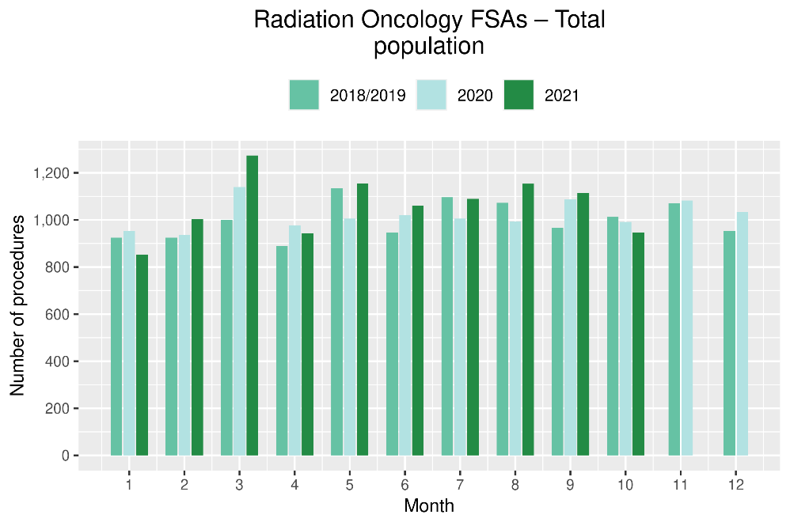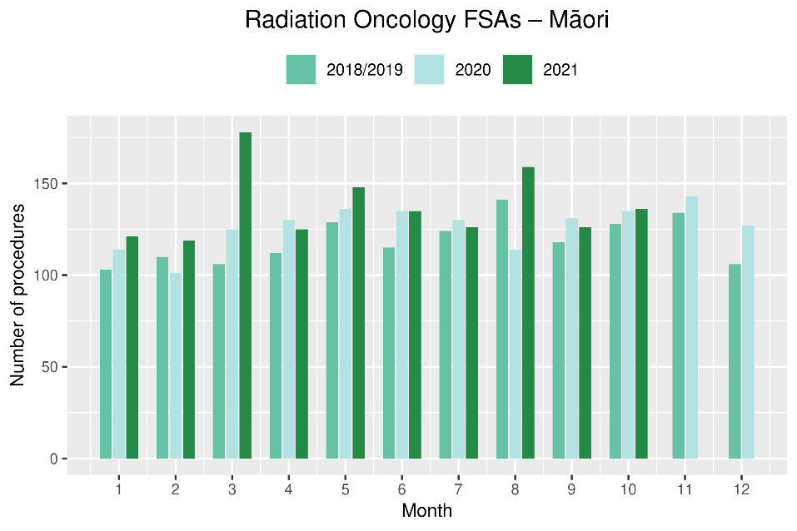
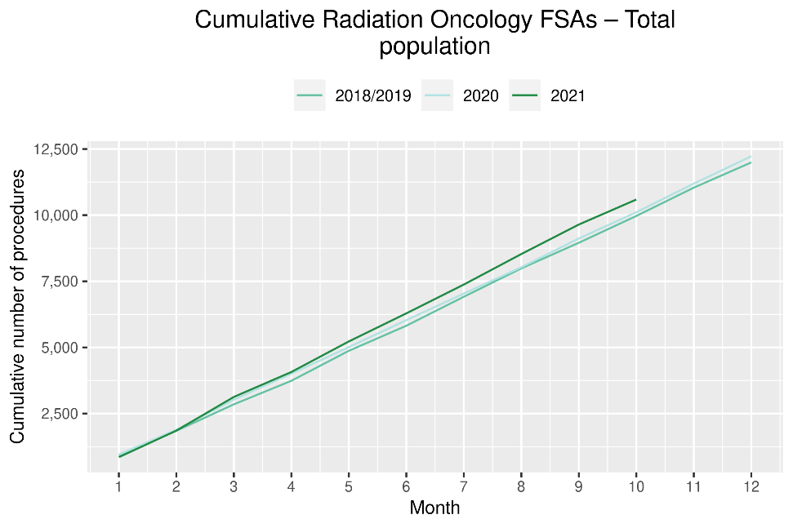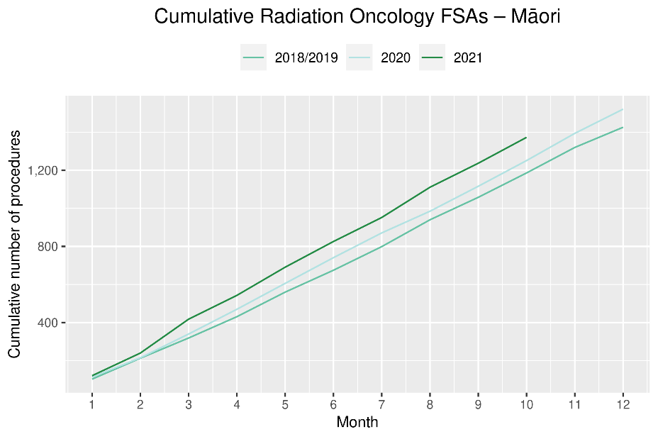
Table 13: Number of radiation oncology attendances and percentage difference in 2021 compared to 2018/2019 average, by month and cumulative year to date, by ethnicity
 | August |  |  | September |  |  | October |  |  | Cumulative January-October
 | 2018/19 | 2021 | % change | 2018/19 | 2021 | % change | 2018/19 | 2021 | % change | 2018/19 | 2021 | % change
Māori | 1,906 | 1,933 | 1% | 1,706 | 2,060 | 21% | 1,877 | 1,836 | -2% | 17,635 | 18,276 | 4%
Pacific peoples | 561 | 528 | -6% | 505 | 721 | 43% | 568 | 657 | 16% | 5,737 | 6,012 | 5%
Non-Māori/Non-Pacific | 11,470 | 10,577 | -8% | 10,766 | 10,973 | 2% | 11,592 | 10,487 | -10% | 112,991 | 105,849 | -6%
Total population | 13,936 | 13,038 | -6% | 12,976 | 13,754 | 6% | 14,036 | 12,980 | -8% | 136,362 | 130,137 | -5%

Figure 18: Number of radiation therapy attendances by month, 2018/19 average, 2020 and 2021, total population and for Māori

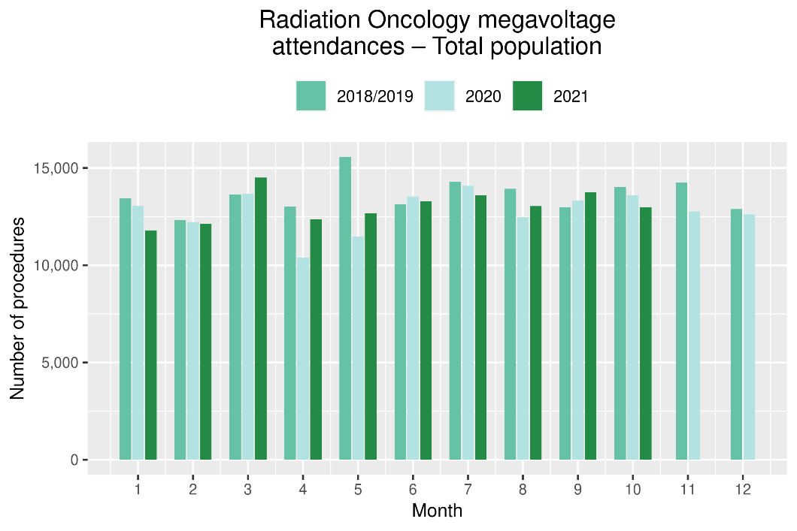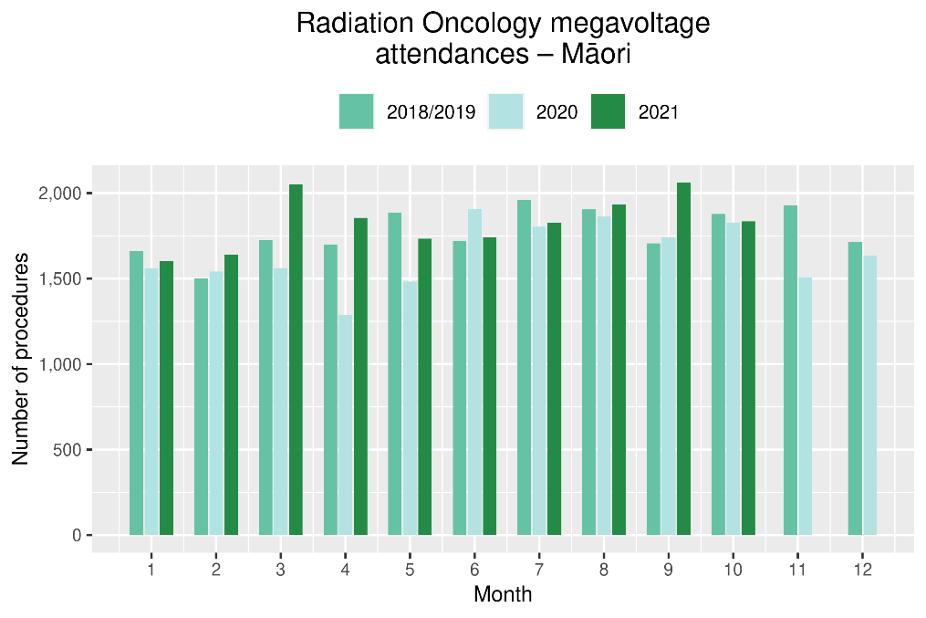

Figure 19: Cumulative number of attendances for radiation therapy, 2018/19 average, 2020 and 2021, total population and for Māori

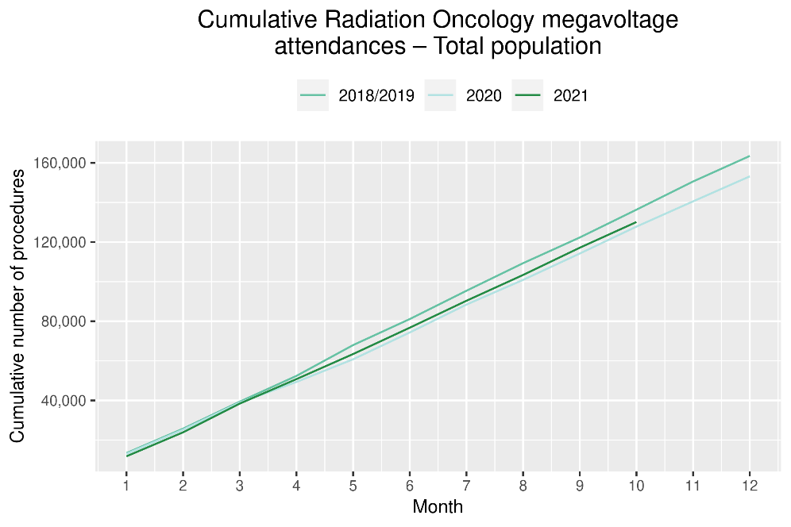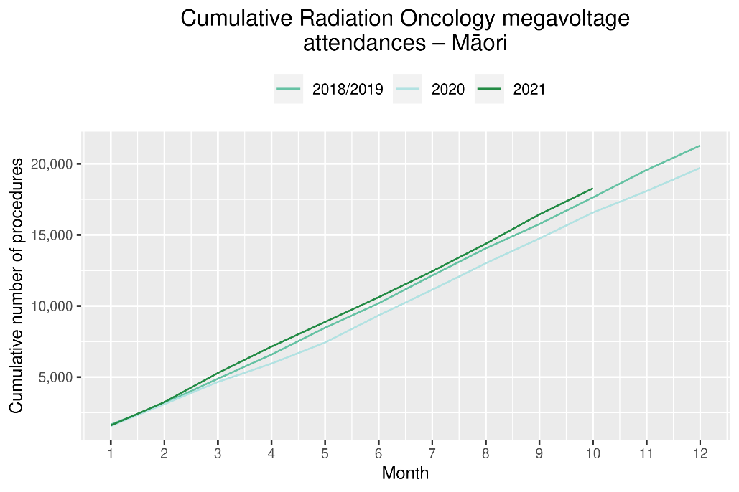

Haematology

Notes on data
- Data were extracted from NNPAC and NMDS on 29 November 2021.
- First specialist assessment (FSA) reflects counts of first attendance for specialist haematology assessment for any indication, not just cancer.
- IV chemotherapy reflects appointments for IV chemotherapy for haematological malignancies.
- Technical information: Haematology FSA (Purchase Unite Code: M30002), IV haem/chemo (Purchase Unit Code: M30020).

Key points
- Attendances for haematology FSAs remained stable during the October 2021. Overall, for the year to date, there has been a small (1%) increase in haematology FSAs in 2021 compared to 2018/19, and an 18% increase in haematology FSAs for Māori.
- Attendances for haematology IV chemotherapy remained largely stable over October 2021, with an overall 13% increase in the number of attendances for the year to date compared to the same time period in 2018/19. There has been an increase in haematology IV chemotherapy attendances of 39% for Pacific peoples over 2021 thus far, compared with 2018/19. This increase was smaller for Māori (3%) and non-Māori/non-Pacific peoples (12%).

Results
Table 14: Number of haematology first specialist assessment attendances and percentage difference in 2021 compared to 2018/2019 average, by month and cumulative year to date, by ethnicity
 | August |  |  | September |  |  | October |  |  | Cumulative January-October
 | 2018/19 | 2021 | % change | 2018/19 | 2021 | % change | 2018/19 | 2021 | % change | 2018/19 | 2021 | % change
Māori | 51 | 80 | 57% | 59 | 65 | 10% | 54 | 61 | 13% | 550 | 647 | 18%
Pacific peoples | 30 | 21 | -29% | 26 | 32 | 25% | 30 | 33 | 10% | 270 | 290 | 7%
Non-Māori/Non-Pacific | 511 | 501 | -2% | 434 | 493 | 14% | 438 | 435 | -1% | 4,564 | 4,511 | -1%
Total population | 591 | 602 | 2% | 518 | 590 | 14% | 522 | 529 | 1% | 5,384 | 5,448 | 1%

Figure 20: Number of haematology first specialist assessments by month, 2018/19 average, 2020 and 2021, total population and Māori
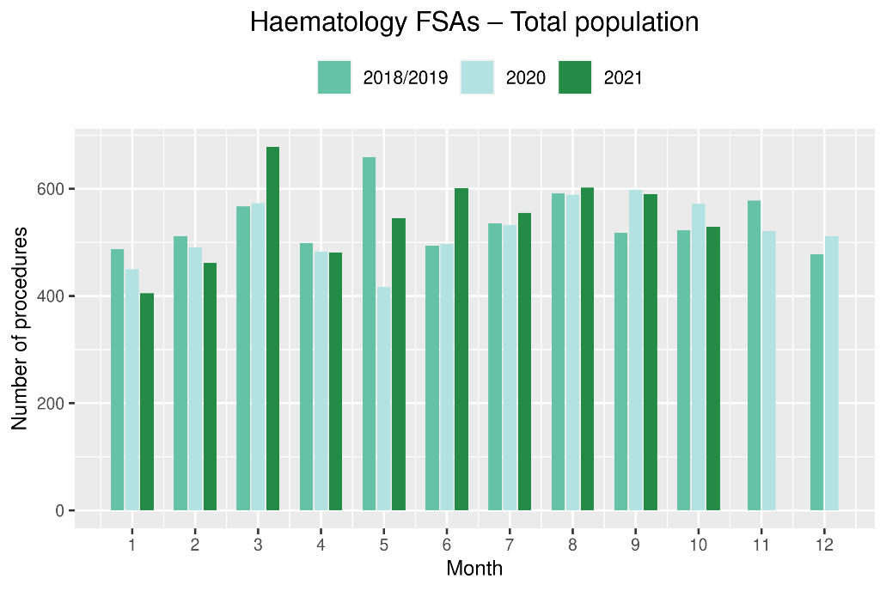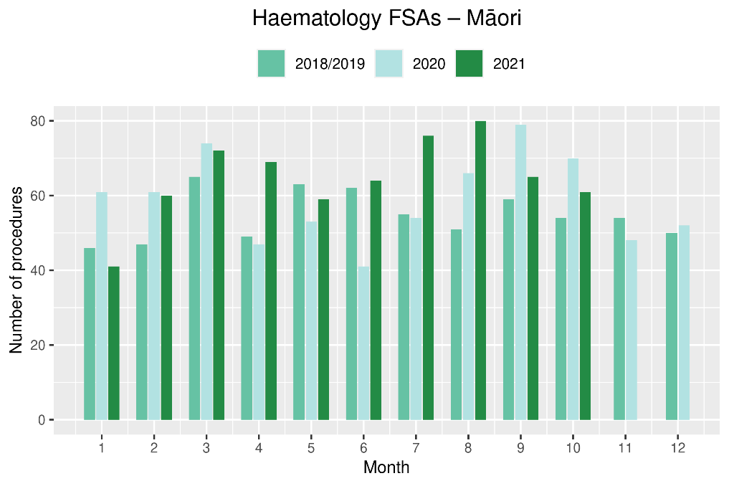
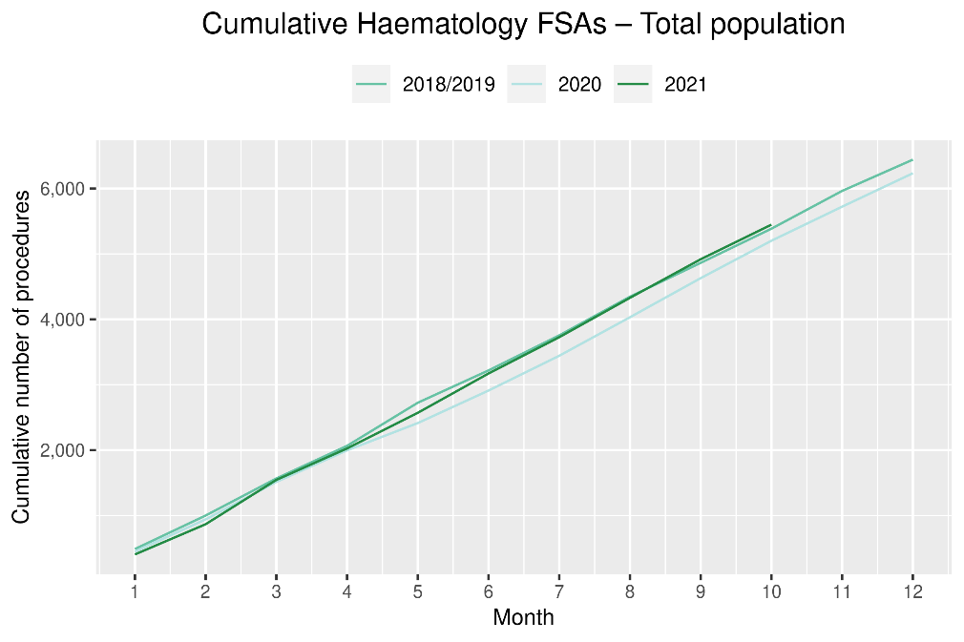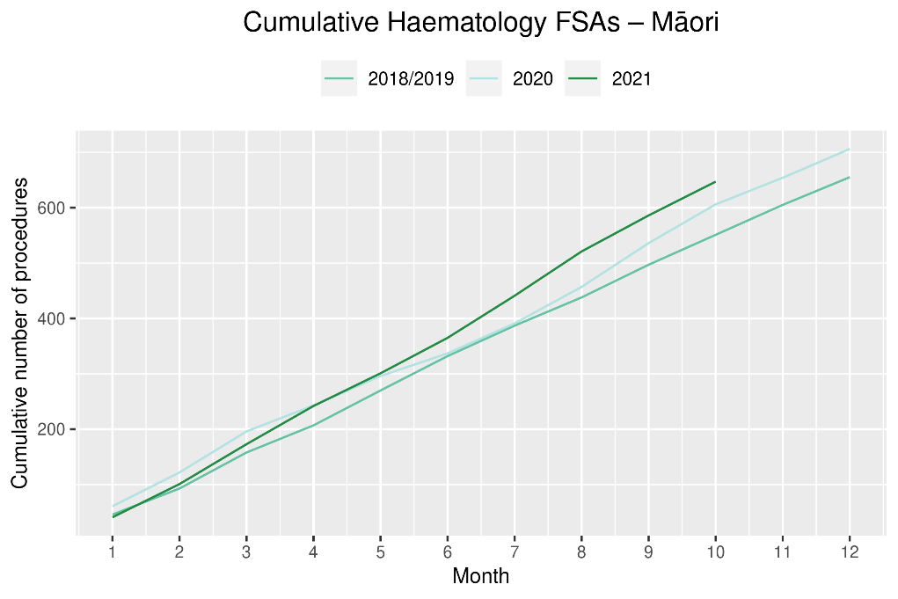
Table 15: Number of IV chemotherapy attendances for haematological malignancies and percentage difference in 2021 compared to 2018/2019 average, by month and cumulative year to date, by ethnicity
 | August |  |  | September |  |  | October |  |  | Cumulative January-October
 | 2018/19 | 2021 | % change | 2018/19 | 2021 | % change | 2018/19 | 2021 | % change | 2018/19 | 2021 | % change
Māori | 226 | 212 | -6% | 208 | 229 | 10% | 233 | 231 | -1% | 2,035 | 2,100 | 3%
Pacific peoples | 112 | 148 | 32% | 101 | 151 | 50% | 100 | 151 | 52% | 1,004 | 1,400 | 39%
Non-Māori/Non-Pacific | 1,889 | 1,939 | 3% | 1,744 | 1,986 | 14% | 1,862 | 1,801 | -3% | 17,102 | 19,205 | 12%
Total population | 2,227 | 2,299 | 3% | 2,053 | 2,366 | 15% | 2,194 | 2,183 | 0% | 20,141 | 22,705 | 13%
Figure 21: Number of attendances for IV chemotherapy for haematological malignancies by month, 2018/19 average, 2020 and 2021, total population and Māori
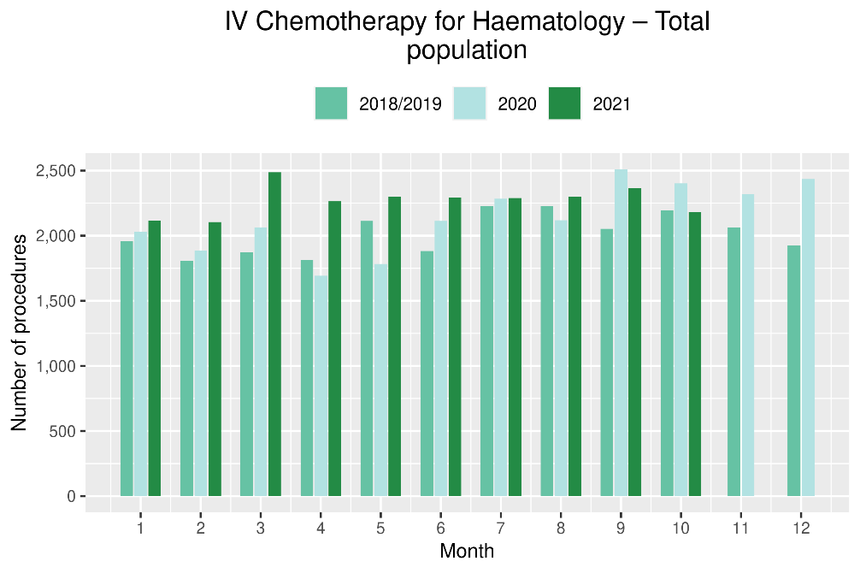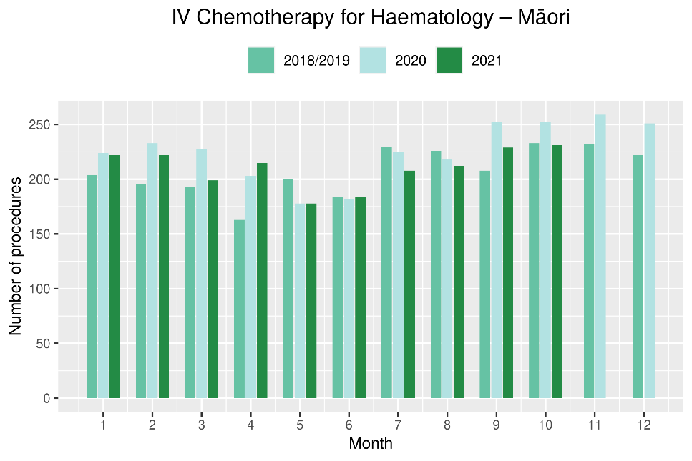

Figure 22: Cumulative number of attendances for IV chemotherapy for haematological malignancies, 2018/19 average, 2020 and 2021, total population and for Māori
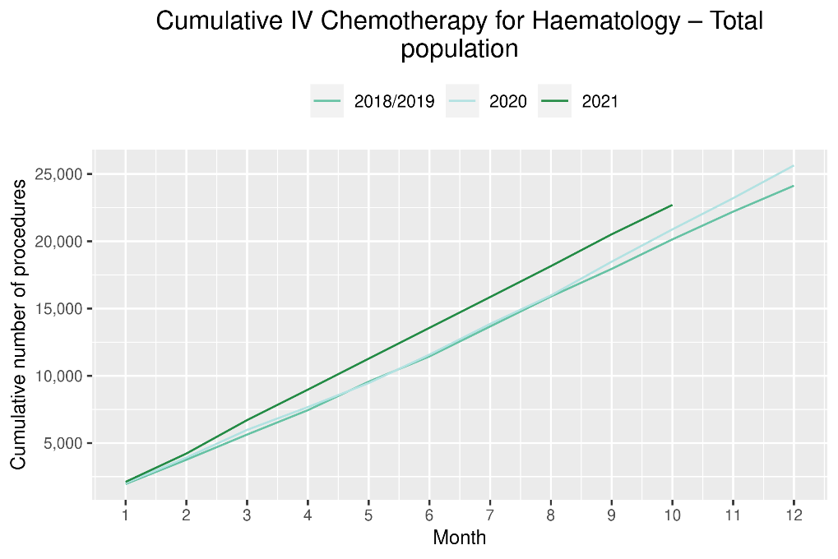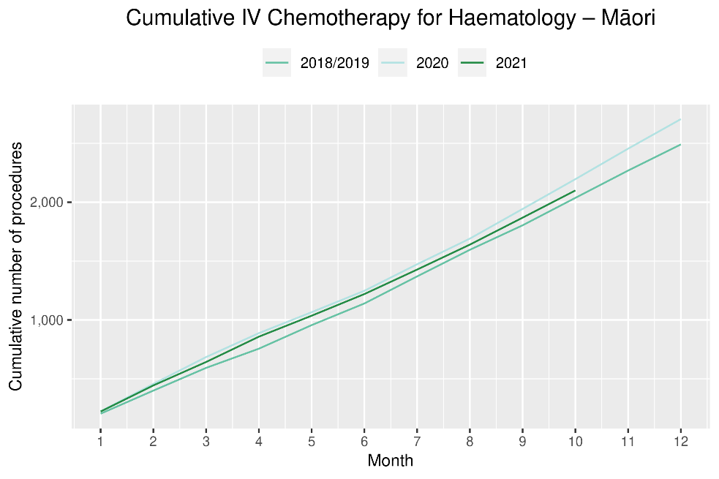

Appendix 1: NZCR data information

The New Zealand Cancer Registry as a data source for new cancer diagnoses
Cancer registration is a process where data is collated from multiple sources about people diagnosed with cancer and rules are applied to determine the type of cancer they have. This information is recorded in the New Zealand Cancer Registry. Each tumour is classified using an international World Health Organization standard so that cancer incidence can be compared between countries. The tumour is staged based on all the information available within 4 months of diagnosis. This process may take up to six months or more depending on the number of missing reports that need to be followed up with laboratories.
For each registration there may be multiple pathology reports as there may be multiple procedures performed on the tumour. This means there will be more than one registration for people diagnosed with more than one type of tumour.
Cancer registrations come from pathology laboratories, haematology laboratories, mortality records and reviewing hospital discharge records. Laboratory reports provide the best source of near real time data to monitor new diagnoses of cancer in New Zealand.

Pathology reports as a data source for providing near real time monitoring cancer diagnoses
Pathology reports (documents) are received by the NZCR as electronic messages. An administrator triages these documents each day and if the document appears to meet the requirements for registration the document is “administered”. The document may relate to an existing registration or may contain information for a new cancer event. Documents that do not meet the cancer reporting requirements will be marked as “deleted”, “rejected” or “agreed not for registration”.
The administrator creates a new provisional cancer event if the pathology report identifies a new cancer diagnosis for this person. This new cancer event is assigned to a cancer group and this provisional event is then queued for further assessment by a clinical coder. If the required information has been provided the coder creates a new registration. If some information is not yet available, then the registration is held open until further information arrives to complete the registration or determine that the tumour does not meet the registration criteria.

Appendix 2: NZCR registrations by DHB
Number of cancer registrations and percentage difference in 2021 compared to 2018/2019 average, by month and cumulative year to date, by DHB of domicile
 | August |  |  | September |  |  | October |  |  | Cumulative January-October
 | 2018/2019 average | 2021 | % | 2018/2019 average | 2021 | % | 2018/2019 average | 2021 | % | 2018/2019 average | 2021 | %
Northland | 99 | 95 | -4% | 89 | 105 | 19% | 94 | 104 | 11% | 945 | 1,053 | 11%
Waitematā | 262 | 216 | -18% | 239 | 246 | 3% | 245 | 233 | -5% | 2,351 | 2,526 | 7%
Auckland | 160 | 140 | -12% | 158 | 184 | 17% | 156 | 151 | -3% | 1,648 | 1,708 | 4%
Counties Manukau | 190 | 182 | -4% | 178 | 187 | 5% | 188 | 193 | 3% | 1,815 | 1,899 | 5%
Waikato | 180 | 175 | -3% | 188 | 217 | 16% | 179 | 181 | 1% | 1,777 | 1,809 | 2%
Bay of Plenty | 137 | 92 | -33% | 115 | 143 | 25% | 113 | 126 | 12% | 1,158 | 1,207 | 4%
Tairāwhiti | 23 | 14 | -38% | 19 | 23 | 24% | 19 | 15 | -19% | 180 | 209 | 16%
Lakes | 49 | 50 | 2% | 45 | 54 | 20% | 45 | 37 | -18% | 455 | 469 | 3%
Taranaki | 63 | 76 | 21% | 60 | 69 | 16% | 56 | 54 | -4% | 578 | 649 | 12%
Hawke's Bay | 78 | 77 | -1% | 73 | 67 | -8% | 76 | 67 | -12% | 746 | 789 | 6%
Whanganui | 44 | 51 | 16% | 35 | 31 | -11% | 31 | 37 | 21% | 346 | 332 | -4%
MidCentral | 97 | 96 | -1% | 78 | 90 | 16% | 88 | 91 | 3% | 852 | 873 | 2%
Capital & Coast | 113 | 110 | -2% | 115 | 149 | 30% | 114 | 115 | 1% | 1,144 | 1,182 | 3%
Hutt Valley | 60 | 60 | 0% | 71 | 71 | 1% | 73 | 59 | -19% | 621 | 632 | 2%
Wairarapa | 23 | 20 | -11% | 25 | 27 | 10% | 29 | 19 | -34% | 235 | 235 | 0%
Nelson Marlborough | 77 | 70 | -8% | 77 | 96 | 25% | 84 | 96 | 14% | 770 | 857 | 11%
West Coast | 18 | 16 | -11% | 14 | 27 | 93% | 18 | 21 | 17% | 159 | 173 | 9%
Canterbury | 233 | 240 | 3% | 233 | 273 | 17% | 234 | 241 | 3% | 2,274 | 2,522 | 11%
South Canterbury | 34 | 28 | -18% | 38 | 37 | -3% | 34 | 31 | -9% | 312 | 337 | 8%
Southern | 173 | 157 | -9% | 167 | 166 | 0% | 162 | 144 | -11% | 1,548 | 1,643 | 6%

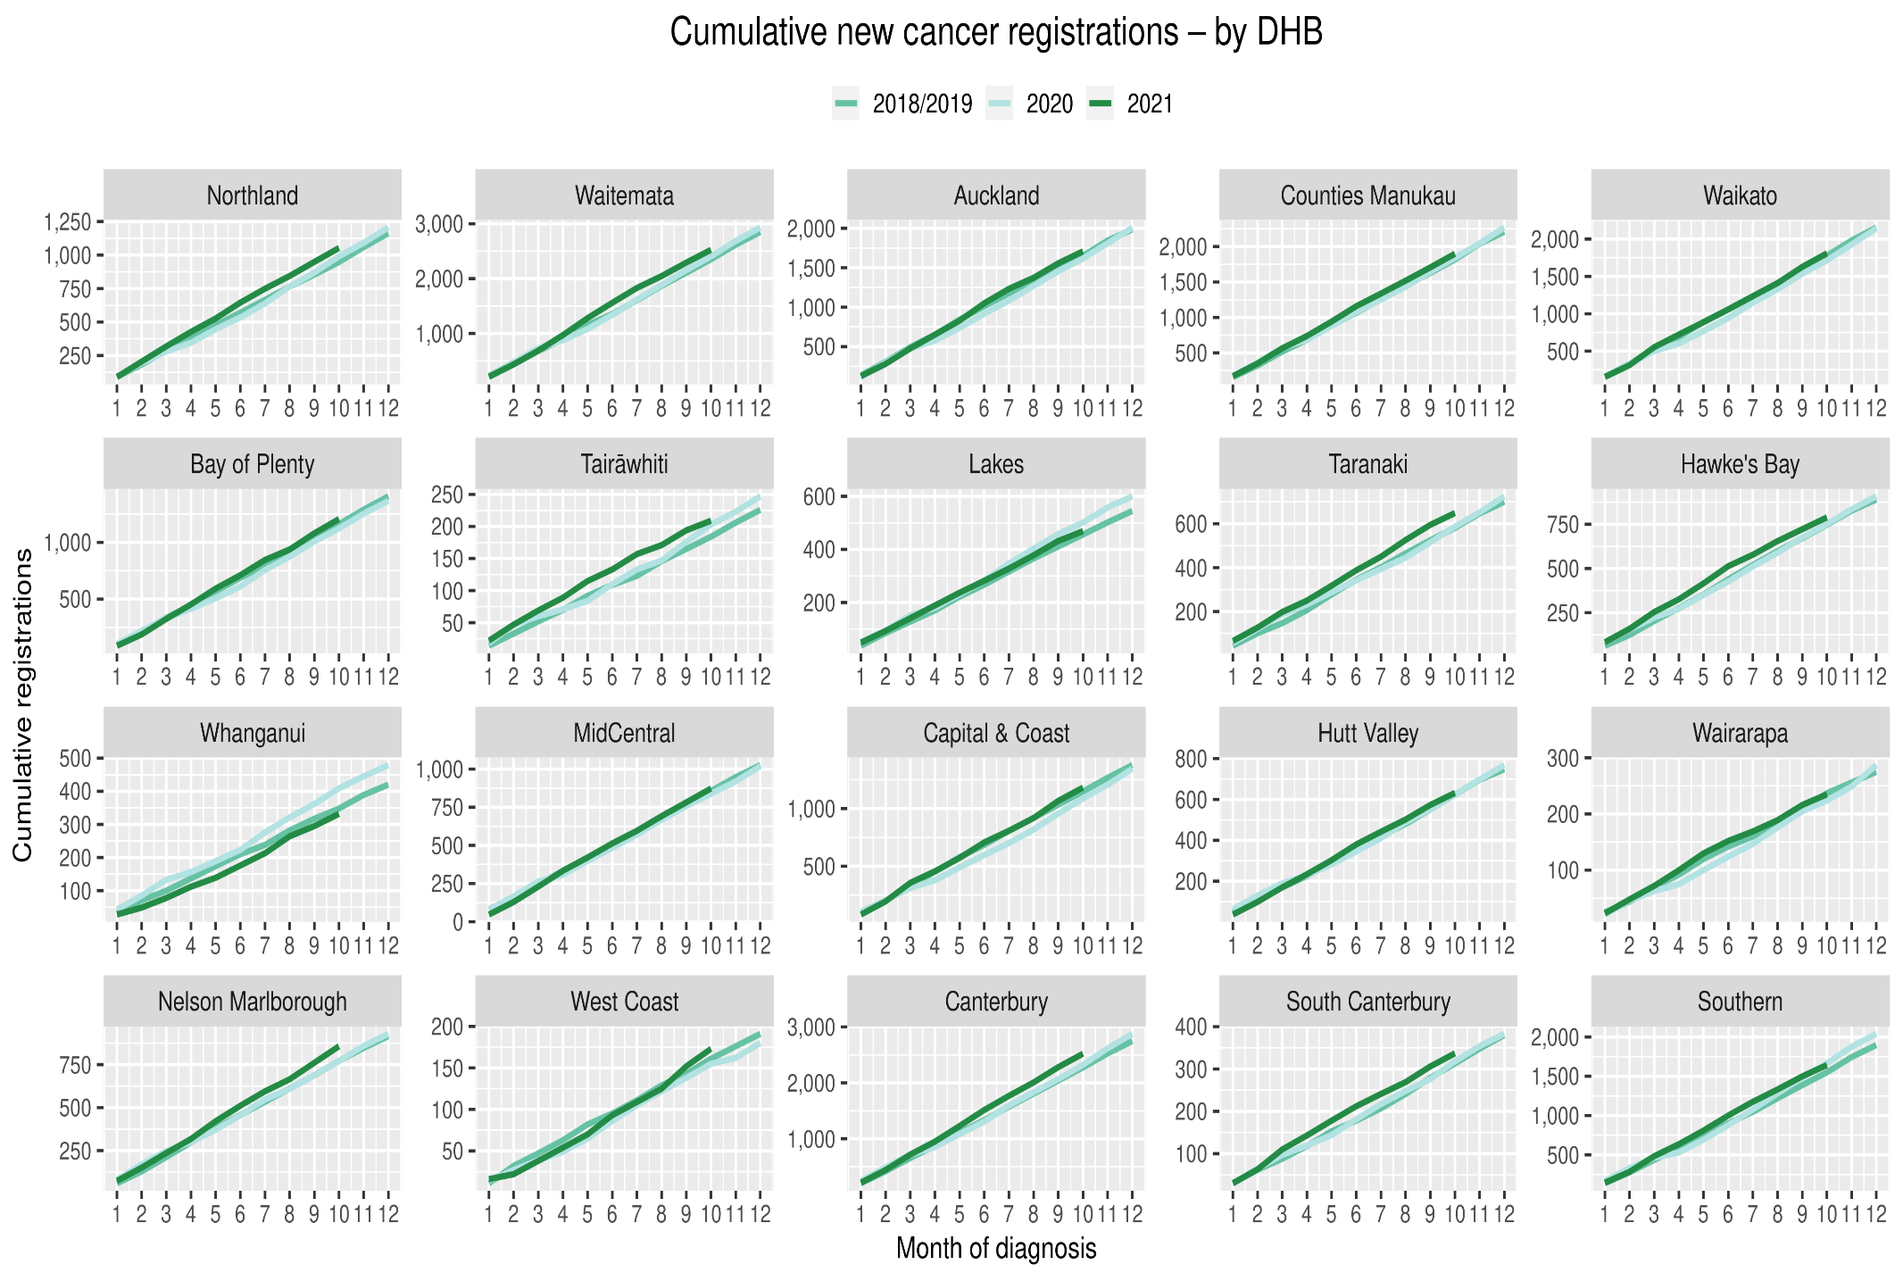

Cumulative cancer registrations by ethnicity
 | Total population |  |  |  |  |  | Māori |  |  |  |  |  |  |  | Non-Māori / Non-Pacific
 | Cumulative January-October |  |  | Difference between 2018/19 average and 2021 |  |  | Cumulative January-October |  |  | Difference between 2018/19 average and 2021 |  |  |  |  | Cumulative January-October |  |  | Difference between 2018/19 average and 2021
 | 2018/19 | 2020 | 2021 | Number | % |  | 2018/19 | 2020 | 2021 | Number |  |  | % |  | 2018/19 | 2020 | 2021 | Number | %
Northland | 945 | 990 | 1,053 | 108 | 11% |  | 215 | 232 | 257 |  | 42 | 20% |  |  | 719 | 747 | 789 | 70 | 10%
Waitematā | 2,351 | 2,405 | 2,526 | 175 | 7% |  | 143 | 154 | 141 |  | -2 | -1% |  |  | 2,105 | 2,118 | 2,261 | 157 | 7%
Auckland | 1,648 | 1,617 | 1,708 | 60 | 4% |  | 103 | 92 | 117 |  | 15 | 14% |  |  | 1,383 | 1,362 | 1,425 | 43 | 3%
Counties Manukau | 1,815 | 1,840 | 1,899 | 84 | 5% |  | 231 | 259 | 244 |  | 13 | 6% |  |  | 1,257 | 1,277 | 1,312 | 55 | 4%
Waikato | 1,777 | 1,715 | 1,809 | 33 | 2% |  | 285 | 267 | 269 |  | -16 | -5% |  |  | 1,469 | 1,422 | 1,509 | 40 | 3%
Bay of Plenty | 1,158 | 1,124 | 1,207 | 50 | 4% |  | 191 | 192 | 209 |  | 18 | 9% |  |  | 959 | 924 | 989 | 31 | 3%
Tairāwhiti | 180 | 203 | 209 | 29 | 16% |  | 66 | 78 | 81 |  | 15 | 23% |  |  | 112 | 122 | 126 | 14 | 13%
Lakes | 455 | 501 | 469 | 15 | 3% |  | 110 | 140 | 137 |  | 28 | 25% |  |  | 339 | 356 | 319 | -20 | -6%
Taranaki | 578 | 587 | 649 | 71 | 12% |  | 62 | 64 | 80 |  | 18 | 29% |  |  | 513 | 522 | 560 | 47 | 9%
Hawke's Bay | 746 | 750 | 789 | 44 | 6% |  | 53 | 59 | 68 |  | 16 | 30% |  |  | 291 | 349 | 262 | -29 | -10%
Whanganui | 346 | 409 | 332 | -14 | -4% |  | 84 | 96 | 97 |  | 13 | 15% |  |  | 760 | 729 | 767 | 7 | 1%
MidCentral | 852 | 838 | 873 | 21 | 2% |  | 82 | 65 | 81 |  | -1 | -1% |  |  | 515 | 528 | 510 | -5 | -1%
Capital & Coast | 1,144 | 1,087 | 1,182 | 38 | 3% |  | 20 | 24 | 28 |  | 9 | 44% |  |  | 213 | 200 | 205 | -8 | -4%
Hutt Valley | 621 | 625 | 632 | 11 | 2% |  | 41 | 35 | 46 |  | 6 | 14% |  |  | 724 | 731 | 807 | 84 | 12%
Wairarapa | 235 | 224 | 235 | 1 | 0% |  | 15 | 8 | 15 |  | 0 | 0% |  |  | 143 | 147 | 158 | 15 | 10%
Nelson Marlborough | 770 | 771 | 857 | 88 | 11% |  | 128 | 112 | 143 |  | 16 | 12% |  |  | 2,107 | 2,178 | 2,348 | 241 | 11%
West Coast | 159 | 155 | 173 | 14 | 9% |  | 87 | 96 | 118 |  | 32 | 36% |  |  | 999 | 925 | 989 | -10 | -1%
Canterbury | 2,274 | 2,322 | 2,522 | 249 | 11% |  | 132 | 146 | 148 |  | 16 | 12% |  |  | 598 | 594 | 626 | 28 | 5%
South Canterbury | 312 | 318 | 337 | 26 | 8% |  | 15 | 9 | 13 |  | -2 | -10% |  |  | 296 | 308 | 324 | 29 | 10%
Southern | 1,548 | 1,667 | 1,643 | 95 | 6% |  | 76 | 93 | 102 |  | 27 | 35% |  |  | 1,462 | 1,554 | 1,522 | 60 | 4%
Total | 19,910 | 20,148 | 21,104 | 1,195 | 6% |  | 2,134 | 2,221 | 2,394 |  | 261 |  | 12% |  | 16,961 | 17,093 | 17,808 | 848 | 5%

Appendix 3: Diagnosis and treatment data by DHB
Percentage differences are only presented if the cumulative total is 10 or greater. In some cases, the totals may differ to those presented in the national report due to non-DHB providers being excluded from the analyses within this appendix.

Gastrointestinal endoscopy
 | Total population |  |  |  |  |  | Māori |  |  |  |  |  | Non-Māori / Non-Pacific
 | Cumulative number for Jan to Oct |  |  | Difference between 2018/19 average and 2021 |  |  | Cumulative number for Jan to Oct |  |  | Difference between 2018/19 average and 2021 |  |  | Cumulative number for Jan to Oct |  |  | Difference between 2018/19 average and 2021
 | 2018/19 | 2020 | 2021 | Number | % |  | 2018/19 | 2020 | 2021 | Number | % |  | 2018/19 | 2020 | 2021 | Number | %
Northland | 3,226 | 3,164 | 3,636 | 410 | 13% |  | 589 | 592 | 732 | 144 | 24% |  | 2,615 | 2,545 | 2,870 | 256 | 10%
Waitematā | 7,674 | 8,039 | 8,007 | 334 | 4% |  | 441 | 448 | 516 | 76 | 17% |  | 6,982 | 7,240 | 7,185 | 204 | 3%
Auckland | 5,213 | 5,024 | 4,964 | -249 | -5% |  | 270 | 300 | 300 | 30 | 11% |  | 4,588 | 4,330 | 4,288 | -300 | -7%
Counties Manukau | 7,655 | 8,045 | 7,738 | 83 | 1% |  | 746 | 817 | 715 | -31 | -4% |  | 5,954 | 6,114 | 5,875 | -79 | -1%
Waikato | 4,920 | 5,617 | 5,015 | 95 | 2% |  | 595 | 656 | 649 | 55 | 9% |  | 4,261 | 4,887 | 4,304 | 43 | 1%
Bay of Plenty | 4,121 | 4,327 | 5,614 | 1,493 | 36% |  | 499 | 578 | 681 | 183 | 37% |  | 3,603 | 3,733 | 4,896 | 1,294 | 36%
Lakes | 1,644 | 1,613 | 1,988 | 344 | 21% |  | 300 | 323 | 394 | 94 | 31% |  | 1,320 | 1,263 | 1,568 | 248 | 19%
Tairāwhiti | 638 | 622 | 657 | 19 | 3% |  | 185 | 186 | 177 | -8 | -4% |  | 449 | 427 | 474 | 26 | 6%
Taranaki | 1,588 | 1,778 | 2,083 | 495 | 31% |  | 160 | 153 | 225 | 65 | 41% |  | 1,420 | 1,611 | 1,850 | 430 | 30%
Whanganui | 1,256 | 1,106 | 1,111 | -145 | -12% |  | 179 | 162 | 157 | -22 | -12% |  | 1,070 | 936 | 945 | -125 | -12%
Hawke's Bay | 2,265 | 2,544 | 2,845 | 581 | 26% |  | 274 | 357 | 383 | 109 | 40% |  | 1,964 | 2,147 | 2,428 | 464 | 24%
MidCentral | 1,839 | 1,927 | 2,221 | 382 | 21% |  | 138 | 170 | 222 | 85 | 61% |  | 1,684 | 1,732 | 1,980 | 296 | 18%
Capital and Coast | 2,355 | 2,786 | 2,640 | 286 | 12% |  | 166 | 223 | 247 | 82 | 49% |  | 2,093 | 2,465 | 2,289 | 196 | 9%
Hutt Valley | 2,206 | 2,788 | 2,721 | 515 | 23% |  | 187 | 290 | 267 | 80 | 43% |  | 1,943 | 2,397 | 2,337 | 395 | 20%
Wairarapa | 860 | 818 | 833 | -27 | -3% |  | 77 | 77 | 83 | 7 | 8% |  | 776 | 736 | 744 | -32 | -4%
Nelson Marlborough | 1,861 | 2,339 | 2,317 | 457 | 25% |  | 96 | 135 | 130 | 35 | 36% |  | 1,755 | 2,186 | 2,173 | 418 | 24%
West Coast | 562 | 574 | 704 | 142 | 25% |  | 40 | 27 | 53 | 13 | 33% |  | 520 | 543 | 648 | 129 | 25%
Canterbury | 6,365 | 6,936 | 6,298 | -67 | -1% |  | 371 | 404 | 369 | -2 | 0% |  | 5,903 | 6,434 | 5,848 | -55 | -1%
South Canterbury | 1,044 | 969 | 1,096 | 53 | 5% |  | 39 | 50 | 36 | -3 | -6% |  | 1,002 | 917 | 1,052 | 50 | 5%
Southern | 3,848 | 4,022 | 4,787 | 939 | 24% |  | 190 | 240 | 262 | 72 | 38% |  | 3,632 | 3,731 | 4,482 | 851 | 23%
Grand Total | 61,137 | 65,038 | 67,275 | 6,139 | 10% |  | 5,537 | 6,188 | 6,598 | 1,062 | 19% |  | 53,529 | 56,374 | 58,236 | 4,707 | 9%

Bronchoscopy

 | Total population |  |  |  |  |  | Māori |  |  |  |  |  | Non-Māori / Non-Pacific
 | Cumulative number for Jan to Oct |  |  | Difference between 2018/19 average and 2021 |  |  | Cumulative number for Jan to Oct |  |  | Difference between 2018/19 average and 2021 |  |  | Cumulative number for Jan to Oct |  |  | Difference between 2018/19 average and 2021
 | 2018/19 | 2020 | 2021 | Number | % |  | 2018/19 | 2020 | 2021 | Number | % |  | 2018/19 | 2020 | 2021 | Number | %
Northland | 68 | 63 | 85 | 17 | 25% |  | 20 | 22 | 24 | 4 | 20% |  | 47 | 40 | 61 | 14 | 30%
Waitematā | 118 | 124 | 170 | 52 | 44% |  | 7 | 11 | 21 | 15 |  |  | 106 | 107 | 146 | 41 | 38%
Auckland | 312 | 248 | 235 | -77 | -25% |  | 43 | 27 | 29 | -14 | -32% |  | 240 | 201 | 194 | -46 | -19%
Counties Manukau | 302 | 284 | 248 | -54 | -18% |  | 54 | 39 | 46 | -8 | -14% |  | 202 | 203 | 161 | -41 | -20%
Waikato | 228 | 183 | 186 | -42 | -18% |  | 51 | 36 | 33 | -18 | -35% |  | 173 | 143 | 153 | -20 | -12%
Bay of Plenty | 141 | 110 | 139 | -2 | -1% |  | 33 | 26 | 37 | 5 | 14% |  | 107 | 84 | 102 | -5 | -4%
Lakes | 75 | 71 | 67 | -8 | -10% |  | 26 | 24 | 24 | -2 | -6% |  | 48 | 44 | 43 | -5 | -10%
Tairāwhiti | 5 | 22 | 22 | 17 |  |  | 2 | 10 | 6 | 4 |  |  | 3 | 12 | 16 | 13
Taranaki | 48 | 37 | 48 | 0 | 0% |  | 9 | 4 | 10 | 2 |  |  | 40 | 33 | 38 | -2 | -4%
Whanganui | 13 | 11 | 13 | 0 | 0% |  | 6 | 5 | 8 | 3 |  |  | 8 | 6 | 5 | -3
Hawke's Bay | 54 | 38 | 55 | 1 | 2% |  | 13 | 8 | 17 | 4 | 31% |  | 39 | 29 | 37 | -2 | -5%
MidCentral | 34 | 23 | 29 | -5 | -13% |  | 7 | 2 | 7 | 1 |  |  | 27 | 21 | 21 | -6 | -22%
Capital and Coast | 80 | 59 | 55 | -25 | -31% |  | 9 | 8 | 5 | -4 |  |  | 68 | 49 | 47 | -21 | -30%
Hutt Valley | 95 | 76 | 70 | -25 | -26% |  | 18 | 12 | 12 | -6 | -33% |  | 74 | 59 | 52 | -22 | -29%
Nelson Marlborough | 63 | 71 | 76 | 14 | 22% |  | 5 | 6 | 2 | -3 |  |  | 58 | 64 | 74 | 17 | 29%
Canterbury | 320 | 305 | 289 | -31 | -10% |  | 23 | 18 | 17 | -6 | -26% |  | 293 | 281 | 269 | -24 | -8%
South Canterbury | 13 | 16 | 13 | 1 | 4% |  | 1 | 0 | 0 | -1 |  |  | 12 | 16 | 13 | 1 | 8%
Southern | 199 | 159 | 222 | 24 | 12% |  | 18 | 9 | 11 | -7 | -37% |  | 180 | 149 | 208 | 29 | 16%
Grand Total | 2,165 | 1,900 | 2,022 | -143 | -7% |  | 340 | 267 | 309 | -31 | -9% |  | 1,721 | 1,541 | 1,640 | -81 | -5%

Colorectal cancer surgery

 | Total population |  |  |  |  |  | Māori |  |  |  |  |  | Non-Māori / Non-Pacific
 | Cumulative number for Jan to Oct |  |  | Difference between 2018/19 average and 2021 |  |  | Cumulative number for Jan to Oct |  |  | Difference between 2018/19 average and 2021 |  |  | Cumulative number for Jan to Oct |  |  | Difference between 2018/19 average and 2021
 | 2018/19 | 2020 | 2021 | Number | % |  | 2018/19 | 2020 | 2021 | Number | % |  | 2018/19 | 2020 | 2021 | Number | %
Northland | 74 | 73 | 75 | 1 | 1% |  | 14 | 17 | 16 | 2 | 14% |  | 60 | 55 | 59 | -1 | -1%
Waitematā | 210 | 181 | 161 | -49 | -23% |  | 13 | 11 | 8 | -5 | -38% |  | 187 | 167 | 145 | -42 | -22%
Auckland | 161 | 171 | 181 | 20 | 12% |  | 11 | 20 | 14 | 4 | 33% |  | 132 | 142 | 147 | 15 | 11%
Counties Manukau | 118 | 122 | 102 | -16 | -13% |  | 8 | 16 | 8 | 0 |  |  | 97 | 89 | 77 | -20 | -20%
Waikato | 188 | 238 | 220 | 33 | 17% |  | 21 | 36 | 35 | 14 | 67% |  | 163 | 200 | 182 | 19 | 12%
Bay of Plenty | 113 | 158 | 118 | 5 | 4% |  | 12 | 25 | 20 | 8 | 67% |  | 101 | 133 | 92 | -9 | -8%
Lakes | 60 | 65 | 68 | 8 | 13% |  | 10 | 9 | 12 | 2 | 20% |  | 49 | 55 | 53 | 5 | 9%
Tairāwhiti | 21 | 25 | 28 | 8 | 37% |  | 6 | 8 | 13 | 8 |  |  | 15 | 17 | 14 | -1 | -7%
Taranaki | 73 | 72 | 68 | -5 | -7% |  | 6 | 9 | 7 | 2 |  |  | 68 | 63 | 61 | -7 | -10%
Whanganui | 40 | 45 | 37 | -3 | -6% |  | 6 | 3 | 1 | -5 |  |  | 34 | 42 | 36 | 2 | 6%
Hawke's Bay | 119 | 126 | 111 | -8 | -7% |  | 13 | 18 | 11 | -2 | -12% |  | 106 | 104 | 98 | -8 | -8%
MidCentral | 97 | 103 | 107 | 11 | 11% |  | 6 | 12 | 15 | 9 |  |  | 90 | 90 | 91 | 2 | 2%
Capital and Coast | 133 | 115 | 114 | -19 | -14% |  | 12 | 13 | 17 | 6 | 48% |  | 115 | 99 | 91 | -24 | -21%
Hutt Valley | 58 | 49 | 51 | -7 | -12% |  | 6 | 3 | 4 | -2 |  |  | 51 | 44 | 45 | -6 | -12%
Wairarapa | 19 | 5 | 17 | -2 | -8% |  | 2 | 0 | 2 | 1 |  |  | 17 | 5 | 15 | -2 | -12%
Nelson Marlborough | 76 | 59 | 61 | -15 | -19% |  | 3 | 4 | 1 | -2 |  |  | 72 | 55 | 60 | -12 | -17%
West Coast | 4 | 8 | 4 | 1 |  |  | 0 | 0 | 0 | 0 |  |  | 4 | 8 | 4 | 1
Canterbury | 260 | 259 | 306 | 46 | 18% |  | 14 | 18 | 15 | 2 | 11% |  | 243 | 238 | 288 | 45 | 19%
South Canterbury | 44 | 39 | 50 | 7 | 15% |  | 1 | 2 | 0 | -1 |  |  | 43 | 37 | 50 | 8 | 18%
Southern | 216 | 202 | 197 | -19 | -9% |  | 8 | 6 | 9 | 2 |  |  | 207 | 193 | 185 | -22 | -10%
Grand Total | 2,079 | 2,115 | 2,076 | -3 | 0% |  | 168 | 230 | 208 | 41 | 24% |  | 1,849 | 1,836 | 1,793 | -56 | -3%

Lung cancer surgery

 | Total population |  |  |  |  |  | Māori |  |  |  |  |  | Non-Māori / Non-Pacific
 | Cumulative number for Jan to Oct |  |  | Difference between 2018/19 average and 2021 |  |  | Cumulative number for Jan to Oct |  |  | Difference between 2018/19 average and 2021 |  |  | Cumulative number for Jan to Oct |  |  | Difference between 2018/19 average and 2021
 | 2018/19 | 2020 | 2021 | Number | % |  | 2018/19 | 2020 | 2021 | Number | % |  | 2018/19 | 2020 | 2021 | Number | %
Waitematā | 0 | 0 | 1 | 1 |  |  | 0 | 0 | 0 | 0 |  |  | 0 | 0 | 1 | 1
Auckland | 249 | 217 | 201 | -48 | -19% |  | 47 | 41 | 31 | -16 | -34% |  | 183 | 158 | 154 | -29 | -16%
Counties Manukau | 2 | 2 | 0 | -2 |  |  | 0 | 1 | 0 | 0 |  |  | 1 | 1 | 0 | -1
Waikato | 109 | 128 | 123 | 14 | 13% |  | 31 | 29 | 36 | 6 | 18% |  | 77 | 98 | 85 | 8 | 10%
Bay of Plenty | 0 | 0 | 1 | 1 |  |  | 0 | 0 | 0 | 0 |  |  | 0 | 0 | 1 | 1
Taranaki | 1 | 0 | 0 | -1 |  |  | 0 | 0 | 0 | 0 |  |  | 1 | 0 | 0 | -1
Hawke's Bay | 0 | 1 | 0 | 0 |  |  | 0 | 0 | 0 | 0 |  |  | 0 | 0 | 0 | 0
MidCentral | 0 | 0 | 1 | 1 |  |  | 0 | 0 | 1 | 1 |  |  | 0 | 0 | 0 | 0
Capital and Coast | 105 | 82 | 134 | 30 | 28% |  | 21 | 12 | 27 | 6 | 29% |  | 80 | 67 | 101 | 22 | 27%
Canterbury | 72 | 96 | 80 | 9 | 12% |  | 5 | 8 | 18 | 13 |  |  | 67 | 86 | 59 | -8 | -11%
Southern | 38 | 31 | 34 | -4 | -9% |  | 3 | 4 | 2 | -1 |  |  | 35 | 27 | 32 | -3 | -9%
Grand Total | 573 | 557 | 575 | 2 | 0% |  | 106 | 95 | 115 | 9 | 8% |  | 443 | 437 | 433 | -10 | -2%

Prostate cancer surgery

 |  | Total population |  |  |  |  |  |  | Māori |  |  |  |  |  | Non-Māori / Non-Pacific
 | Cumulative number for Jan to Oct |  |  |  | Difference between 2018/19 average and 2021 |  |  | Cumulative number for Jan to Oct |  |  |  | Difference between 2018/19 average and 2021 |  |  |  |  | Cumulative number for Jan to Oct |  |  | Difference between 2018/19 average and 2021
 | 2018/19 |  | 2020 | 2021 | Number | % |  | 2018/19 |  | 2020 | 2021 | Number | % |  |  |  | 2018/19 | 2020 | 2021 | Number |  | %
Northland | 47 |  | 31 | 45 | -2 | -3% |  | 7 |  | 6 | 7 | 0 |  |  |  |  | 39 | 25 | 37 | -2 |  | -5%
Waitematā | 65 |  | 88 | 91 | 27 | 41% |  | 4 |  | 5 | 9 | 6 |  |  |  |  | 59 | 80 | 79 | 20 |  | 34%
Auckland | 79 |  | 111 | 84 | 5 | 6% |  | 7 |  | 11 | 9 | 2 |  |  |  |  | 65 | 94 | 58 | -7 |  | -10%
Counties Manukau | 1 |  | 2 | 14 | 14 |  |  | 0 |  | 1 | 2 | 2 |  |  |  |  | 1 | 1 | 9 | 9
Waikato | 54 |  | 50 | 47 | -7 | -12% |  | 3 |  | 3 | 11 | 9 |  |  |  |  | 51 | 46 | 35 | -16 |  | -31%
Bay of Plenty | 42 |  | 36 | 30 | -12 | -28% |  | 6 |  | 5 | 6 | 1 |  |  |  |  | 36 | 31 | 24 | -12 |  | -33%
Lakes | 8 |  | 15 | 13 | 6 |  |  | 0 |  | 7 | 4 | 4 |  |  |  |  | 7 | 8 | 8 | 1
Tairāwhiti | 4 |  | 6 | 9 | 6 |  |  | 2 |  | 2 | 4 | 3 |  |  |  |  | 2 | 4 | 5 | 3
Taranaki | 23 |  | 28 | 42 | 20 | 87% |  | 2 |  | 5 | 4 | 2 |  |  |  |  | 20 | 23 | 38 | 18 |  | 90%
Whanganui | 4 |  | 5 | 9 | 6 |  |  | 1 |  | 0 | 0 | -1 |  |  |  |  | 3 | 5 | 9 | 6
Hawke's Bay | 15 |  | 22 | 30 | 16 | 107% |  | 2 |  | 5 | 3 | 2 |  |  |  |  | 13 | 17 | 27 | 14 |  | 108%
MidCentral | 63 |  | 68 | 49 | -14 | -22% |  | 6 |  | 4 | 5 | -1 |  |  |  |  | 58 | 64 | 43 | -15 |  | -25%
Capital and Coast | 54 |  | 59 | 79 | 25 | 46% |  | 3 |  | 4 | 4 | 1 |  |  |  |  | 48 | 53 | 71 | 24 |  | 49%
Wairarapa | 7 |  | 7 | 7 | 0 |  |  | 1 |  | 1 | 1 | 1 |  |  |  |  | 7 | 6 | 6 | -1
Nelson Marlborough | 38 |  | 37 | 38 | 1 | 1% |  | 0 |  | 0 | 2 | 2 |  |  |  |  | 37 | 37 | 35 | -2 |  | -5%
West Coast | 6 |  | 6 | 7 | 1 |  |  | 0 |  | 0 | 0 | 0 |  |  |  |  | 6 | 6 | 7 | 1
Canterbury | 55 |  | 61 | 60 | 6 | 10% |  | 1 |  | 3 | 5 | 4 |  |  |  |  | 54 | 57 | 54 | 1 |  | 1%
South Canterbury | 12 |  | 12 | 9 | -3 | -22% |  | 0 |  | 0 | 0 | 0 |  |  |  |  | 12 | 12 | 9 | -3 |  | -22%
Southern | 66 |  | 75 | 93 | 28 | 42% |  | 5 |  | 5 | 9 | 5 |  |  |  |  | 60 | 70 | 83 | 23 |  | 38%
Grand Total | 636 |  | 719 | 756 | 120 | 19% |  | 46 |  | 67 | 85 | 40 | 87% |  |  |  | 574 | 639 | 637 | 63 |  | 11%

Medical oncology first specialist assessments

 | Total population |  |  |  |  |  | Māori |  |  |  |  |  | Non-Māori / Non-Pacific
 | Cumulative number for Jan to Oct |  |  | Difference between 2018/19 average and 2021 |  |  | Cumulative number for Jan to Oct |  |  | Difference between 2018/19 average and 2021 |  |  | Cumulative number for Jan to Oct |  |  | Difference between 2018/19 average and 2021
 | 2018/19 | 2020 | 2021 | Number | % |  | 2018/19 | 2020 | 2021 | Number | % |  | 2018/19 | 2020 | 2021 | Number | %
Northland | 381 | 361 | 439 | 59 | 15% |  | 105 | 102 | 123 | 19 | 18% |  | 273 | 255 | 311 | 38 | 14%
Auckland | 1,950 | 2,165 | 2,159 | 209 | 11% |  | 229 | 253 | 254 | 26 | 11% |  | 1,473 | 1,613 | 1,613 | 141 | 10%
Waikato | 662 | 710 | 665 | 3 | 0% |  | 141 | 152 | 153 | 12 | 9% |  | 509 | 551 | 501 | -8 | -1%
Bay of Plenty | 399 | 438 | 484 | 85 | 21% |  | 81 | 80 | 91 | 11 | 13% |  | 316 | 354 | 387 | 72 | 23%
Lakes | 135 | 183 | 204 | 70 | 52% |  | 47 | 57 | 72 | 25 | 53% |  | 85 | 124 | 129 | 45 | 53%
Tairāwhiti | 94 | 125 | 127 | 33 | 35% |  | 42 | 52 | 55 | 13 | 31% |  | 51 | 72 | 72 | 21 | 41%
Taranaki | 202 | 193 | 204 | 3 | 1% |  | 24 | 22 | 32 | 9 | 36% |  | 177 | 170 | 169 | -8 | -4%
MidCentral | 921 | 920 | 988 | 67 | 7% |  | 144 | 153 | 191 | 48 | 33% |  | 762 | 756 | 780 | 19 | 2%
Capital and Coast | 733 | 733 | 772 | 40 | 5% |  | 85 | 91 | 97 | 13 | 15% |  | 608 | 593 | 621 | 13 | 2%
Nelson Marlborough | 352 | 375 | 373 | 22 | 6% |  | 26 | 19 | 18 | -8 | -29% |  | 325 | 354 | 352 | 28 | 8%
West Coast | 27 | 17 | 28 | 2 | 6% |  | 3 | 0 | 3 | 0 |  |  | 23 | 17 | 25 | 2 | 9%
Canterbury | 1,086 | 943 | 1,038 | -48 | -4% |  | 74 | 60 | 78 | 4 | 5% |  | 999 | 866 | 952 | -47 | -5%
South Canterbury | 5 | 52 | 106 | 102 |  |  | 0 | 2 | 4 | 4 |  |  | 5 | 50 | 102 | 98
Southern | 542 | 527 | 440 | -102 | -19% |  | 32 | 28 | 29 | -3 | -8% |  | 506 | 491 | 404 | -102 | -20%
Grand Total | 7,485 | 7,742 | 8,027 | 542 | 7% |  | 1,029 | 1,071 | 1,200 | 171 | 17% |  | 6,108 | 6,266 | 6,418 | 311 | 5%

Medical oncology IV chemotherapy

 | Total population |  |  |  |  |  | Māori |  |  |  |  |  | Non-Māori / Non-Pacific
 | Cumulative number for Jan to Oct |  |  | Difference between 2018/19 average and 2021 |  |  | Cumulative number for Jan to Oct |  |  | Difference between 2018/19 average and 2021 |  |  | Cumulative number for Jan to Oct |  |  | Difference between 2018/19 average and 2021
 | 2018/19 | 2020 | 2021 | Number | % |  | 2018/19 | 2020 | 2021 | Number | % |  | 2018/19 | 2020 | 2021 | Number | %
Northland | 2,533 | 2,740 | 2,861 | 329 | 13% |  | 578 | 844 | 914 | 337 | 58% |  | 1,925 | 1,873 | 1,903 | -22 | -1%
Waitematā | 2 | 0 | 2 | 1 |  |  | 0 | 0 | 1 | 1 |  |  | 2 | 0 | 1 | -1
Auckland | 15,821 | 18,820 | 19,484 | 3,664 | 23% |  | 1,537 | 2,124 | 2,095 | 559 | 36% |  | 12,434 | 14,509 | 14,750 | 2,317 | 19%
Counties Manukau | 0 | 0 | 1 | 1 |  |  | 0 | 0 | 0 | 0 |  |  | 0 | 0 | 0 | 0
Waikato | 6,265 | 5,599 | 6,645 | 381 | 6% |  | 1,030 | 904 | 1,150 | 121 | 12% |  | 5,163 | 4,588 | 5,402 | 240 | 5%
Bay of Plenty | 4,318 | 4,640 | 4,433 | 115 | 3% |  | 754 | 945 | 979 | 226 | 30% |  | 3,522 | 3,662 | 3,414 | -108 | -3%
Lakes | 2,546 | 2,614 | 2,666 | 120 | 5% |  | 724 | 758 | 877 | 154 | 21% |  | 1,777 | 1,829 | 1,715 | -62 | -3%
Tairāwhiti | 554 | 503 | 1,195 | 642 | 116% |  | 239 | 231 | 535 | 296 | 124% |  | 311 | 271 | 639 | 328 | 105%
Taranaki | 1,458 | 1,721 | 1,770 | 312 | 21% |  | 154 | 173 | 309 | 156 | 101% |  | 1,291 | 1,529 | 1,455 | 164 | 13%
Whanganui | 91 | 76 | 82 | -9 | -10% |  | 14 | 9 | 9 | -5 | -33% |  | 78 | 67 | 73 | -5 | -6%
Hawke's Bay* | 35 | 65 | 43 | 8 | 23% |  | 12 | 54 | 25 | 14 | 117% |  | 24 | 11 | 15 | -9 | -36%
MidCentral* | 6,071 | 6,661 | 5,377 | -694 | -11% |  | 1,011 | 1,157 | 1,026 | 16 | 2% |  | 4,914 | 5,426 | 4,263 | -651 | -13%
Capital and Coast | 5,600 | 5,171 | 4,716 | -884 | -16% |  | 583 | 563 | 528 | -55 | -9% |  | 4,755 | 4,297 | 3,828 | -927 | -19%
Hutt Valley | 97 | 99 | 125 | 28 | 29% |  | 8 | 9 | 11 | 3 |  |  | 83 | 83 | 109 | 27 | 32%
Wairarapa | 26 | 63 | 41 | 16 | 61% |  | 2 | 19 | 2 | 0 |  |  | 24 | 36 | 33 | 10 | 40%
Nelson Marlborough | 2,488 | 2,561 | 2,393 | -95 | -4% |  | 183 | 100 | 128 | -55 | -30% |  | 2,268 | 2,439 | 2,263 | -5 | 0%
West Coast | 24 | 30 | 17 | -7 | -29% |  | 1 | 5 | 0 | -1 |  |  | 23 | 25 | 17 | -6 | -26%
Canterbury | 5,459 | 5,308 | 5,333 | -126 | -2% |  | 342 | 354 | 333 | -9 | -2% |  | 4,978 | 4,790 | 4,929 | -49 | -1%
South Canterbury | 888 | 911 | 972 | 84 | 9% |  | 7 | 24 | 33 | 26 |  |  | 875 | 887 | 939 | 65 | 7%
Southern | 4,657 | 4,530 | 3,796 | -861 | -18% |  | 274 | 268 | 155 | -119 | -43% |  | 4,342 | 4,184 | 3,575 | -767 | -18%
Grand Total | 58,929 | 62,112 | 61,952 | 3,023 | 5% |  | 7,447 | 8,541 | 9,110 | 1,663 | 22% |  | 48,784 | 50,506 | 49,323 | 539 | 1%
* Data quality issues have been identified in MidCentral DHB’s data in the previous reporting period. The team have reviewed this and identified that data transfer between Hawke’s Bay and MDHB is not configured correctly to pick up Hawke’s Bay volumes. A sustainable solution to manage this is being developed and worked on as a matter of urgency.

Radiation oncology first specialist assessments

 | Total population |  |  |  |  |  | Māori |  |  |  |  |  | Non-Māori / Non-Pacific
 | Cumulative number for Jan to Oct |  |  | Difference between 2018/19 average and 2021 |  |  | Cumulative number for Jan to Oct |  |  | Difference between 2018/19 average and 2021 |  |  | Cumulative number for Jan to Oct |  |  | Difference between 2018/19 average and 2021
 | 2018/19 | 2020 | 2021 | Number | % |  | 2018/19 | 2020 | 2021 | Number | % |  | 2018/19 | 2020 | 2021 | Number | %
Northland | 295 | 245 | 336 | 42 | 14% |  | 79 | 85 | 102 | 23 | 29% |  | 212 | 158 | 231 | 20 | 9%
Auckland | 2,675 | 2,689 | 2,638 | -37 | -1% |  | 321 | 315 | 319 | -2 | -1% |  | 2,022 | 2,087 | 1,982 | -40 | -2%
Waikato | 1,145 | 1,237 | 1,276 | 131 | 11% |  | 201 | 261 | 252 | 51 | 25% |  | 923 | 960 | 1,005 | 82 | 9%
Bay of Plenty | 780 | 805 | 917 | 137 | 18% |  | 118 | 127 | 158 | 41 | 34% |  | 655 | 672 | 753 | 99 | 15%
Lakes | 27 | 15 | 16 | -11 | -41% |  | 9 | 5 | 6 | -3 |  |  | 18 | 10 | 10 | -8 | -44%
Tairāwhiti | 58 | 33 | 38 | -20 | -34% |  | 23 | 18 | 12 | -11 | -48% |  | 34 | 15 | 26 | -8 | -22%
MidCentral | 1,434 | 1,486 | 1,560 | 126 | 9% |  | 186 | 196 | 240 | 54 | 29% |  | 1,233 | 1,271 | 1,302 | 70 | 6%
Capital and Coast | 1,185 | 1,140 | 1,251 | 66 | 6% |  | 109 | 108 | 132 | 23 | 21% |  | 1,027 | 977 | 1,051 | 25 | 2%
Nelson Marlborough | 136 | 141 | 197 | 62 | 45% |  | 8 | 8 | 12 | 5 |  |  | 128 | 132 | 183 | 56 | 44%
West Coast | 9 | 7 | 11 | 3 |  |  | 1 | 0 | 1 | 1 |  |  | 8 | 7 | 10 | 2
Canterbury | 1,368 | 1,483 | 1,537 | 169 | 12% |  | 82 | 67 | 88 | 6 | 7% |  | 1,270 | 1,396 | 1,433 | 163 | 13%
Southern | 858 | 830 | 814 | -44 | -5% |  | 47 | 61 | 51 | 4 | 9% |  | 800 | 755 | 752 | -48 | -6%
Grand Total | 9,968 | 10,111 | 10,591 | 624 | 6% |  | 1,183 | 1,251 | 1,373 | 191 | 16% |  | 8,326 | 8,440 | 8,738 | 412 | 5%

Radiation oncology megavoltage fractions

 | Total population |  |  |  |  |  | Māori |  |  |  |  |  | Non-Māori / Non-Pacific
 | Cumulative number for Jan to Oct |  |  | Difference between 2018/19 average and 2021 |  |  | Cumulative number for Jan to Oct |  |  | Difference between 2018/19 average and 2021 |  |  | Cumulative number for Jan to Oct |  |  | Difference between 2018/19 average and 2021
 | 2018/19 | 2020 | 2021 | Number | % |  | 2018/19 | 2020 | 2021 | Number | % |  | 2018/19 | 2020 | 2021 | Number | %
Auckland | 37,905 | 35,113 | 34,495 | -3,410 | -9% |  | 5,221 | 4,639 | 5,437 | 217 | 4% |  | 28,854 | 26,919 | 24,931 | -3,923 | -14%
Waikato | 18,330 | 16,179 | 15,791 | -2,539 | -14% |  | 3,413 | 3,612 | 3,412 | -1 | 0% |  | 14,547 | 12,337 | 12,120 | -2,427 | -17%
Bay of Plenty | 13,813 | 14,064 | 14,533 | 721 | 5% |  | 2,341 | 2,394 | 2,644 | 303 | 13% |  | 11,326 | 11,487 | 11,745 | 420 | 4%
MidCentral | 18,956 | 18,781 | 20,575 | 1,620 | 9% |  | 2,758 | 2,568 | 3,205 | 447 | 16% |  | 16,068 | 15,839 | 17,159 | 1,091 | 7%
Capital and Coast | 16,673 | 16,228 | 17,100 | 428 | 3% |  | 1,917 | 1,821 | 2,108 | 191 | 10% |  | 13,977 | 13,469 | 14,074 | 98 | 1%
Canterbury | 21,856 | 20,502 | 21,146 | -710 | -3% |  | 1,507 | 1,203 | 1,074 | -433 | -29% |  | 19,989 | 19,074 | 19,768 | -221 | -1%
Southern* | 8,831 | 6,932 | 6,497 | -2,334 | -26% |  | 478 | 334 | 396 | -82 | -17% |  | 8,232 | 6,486 | 6,052 | -2,180 | -26%
Grand Total | 136,362 | 127,805 | 130,137 | -6,225 | -5% |  | 17,635 | 16,574 | 18,276 | 642 | 4% |  | 112,991 | 105,614 | 105,849 | -7,142 | -6%
* Southern DHB radiation therapy treatment data is incomplete for 2021. The DHB is actively working to resolve this issue.

Haematology first specialist assessment

 | Total population |  |  |  |  |  | Māori |  |  |  |  |  | Non-Māori / Non-Pacific
 | Cumulative number for Jan to Oct |  |  | Difference between 2018/19 and 2021 |  |  | Cumulative number for Jan to Oct |  |  | Difference between 2018/19 and 2021 |  |  | Cumulative number for Jan to Oct |  |  | Difference between 2018/19 and 2021
 | 2018/19 | 2020 | 2021 | Number | % |  | 2018/19 | 2020 | 2021 | Number | % |  | 2018 | 2019 | 2021 | Number | %
Northland | 183 | 234 | 159 | -24 | -13% |  | 37 | 62 | 43 | 6 | 16% |  | 143 | 169 | 115 | -28 | -20%
Waitematā | 578 | 592 | 537 | -41 | -7% |  | 33 | 38 | 40 | 8 | 23% |  | 521 | 527 | 468 | -53 | -10%
Auckland | 819 | 667 | 892 | 74 | 9% |  | 64 | 56 | 85 | 22 | 34% |  | 676 | 527 | 726 | 51 | 7%
Counties Manukau | 622 | 583 | 565 | -57 | -9% |  | 66 | 69 | 59 | -7 | -11% |  | 460 | 417 | 411 | -49 | -11%
Waikato | 582 | 598 | 606 | 25 | 4% |  | 103 | 101 | 102 | -1 | -1% |  | 471 | 488 | 488 | 18 | 4%
Bay of Plenty | 322 | 282 | 321 | -1 | 0% |  | 55 | 41 | 45 | -10 | -18% |  | 262 | 238 | 271 | 10 | 4%
Lakes | 1 | 1 | 0 | -1 |  |  | 1 | 0 | 0 | -1 |  |  | 1 | 1 | 0 | -1
Tairāwhiti | 33 | 40 | 47 | 14 | 42% |  | 11 | 11 | 16 | 6 | 52% |  | 22 | 29 | 29 | 7 | 32%
Taranaki | 129 | 150 | 167 | 38 | 29% |  | 13 | 22 | 20 | 7 | 54% |  | 116 | 127 | 147 | 32 | 27%
MidCentral | 650 | 676 | 701 | 51 | 8% |  | 77 | 97 | 117 | 40 | 52% |  | 566 | 564 | 576 | 11 | 2%
Capital and Coast | 652 | 547 | 531 | -121 | -18% |  | 51 | 63 | 59 | 8 | 16% |  | 571 | 455 | 430 | -141 | -25%
Nelson Marlborough | 145 | 96 | 113 | -32 | -22% |  | 4 | 4 | 5 | 2 |  |  | 140 | 92 | 108 | -32 | -23%
West Coast | 14 | 6 | 6 | -8 | -56% |  | 1 | 0 | 1 | 0 |  |  | 13 | 6 | 5 | -8 | -60%
Canterbury | 410 | 449 | 488 | 78 | 19% |  | 21 | 24 | 29 | 9 | 41% |  | 378 | 422 | 452 | 75 | 20%
Southern | 248 | 281 | 315 | 67 | 27% |  | 16 | 18 | 26 | 10 | 63% |  | 229 | 261 | 285 | 57 | 25%
Grand Total | 5,384 | 5,202 | 5,448 | 65 | 1% |  | 550 | 606 | 647 | 97 | 18% |  | 4,564 | 4,323 | 4,511 | -53 | -1%

Haematology IV chemotherapy

 | Total population |  |  |  |  |  | Māori |  |  |  |  |  | Non-Māori / Non-Pacific
 | Cumulative number for Jan to Oct |  |  | Difference between 2018/19 and 2021 |  |  | Cumulative number for Jan to Oct |  |  | Difference between 2018/19 and 2021 |  |  | Cumulative number for Jan to Oct |  |  | Difference between 2018/19 and 2021
 | 2018/19 | 2020 | 2021 | Number | % |  | 2018/19 | 2020 | 2021 | Number | % |  | 2018/19 | 2020 | 2021 | Number | %
Northland | 1,438 | 1,223 | 1,280 | -158 | -11% |  | 331 | 254 | 304 | -27 | -8% |  | 1,078 | 918 | 953 | -125 | -12%
Waitematā | 3,438 | 3,159 | 3,110 | -328 | -10% |  | 88 | 132 | 126 | 38 | 43% |  | 3,167 | 2,841 | 2,851 | -316 | -10%
Auckland | 3,053 | 2,875 | 3,496 | 443 | 15% |  | 190 | 121 | 245 | 56 | 29% |  | 2,547 | 2,427 | 2,824 | 278 | 11%
Counties Manukau | 1,613 | 2,180 | 2,663 | 1,050 | 65% |  | 195 | 231 | 268 | 74 | 38% |  | 1,106 | 1,595 | 1,935 | 829 | 75%
Waikato | 1,719 | 1,952 | 2,082 | 363 | 21% |  | 305 | 375 | 368 | 64 | 21% |  | 1,406 | 1,577 | 1,649 | 243 | 17%
Bay of Plenty | 1,109 | 1,108 | 1,386 | 278 | 25% |  | 107 | 172 | 172 | 66 | 62% |  | 982 | 921 | 1,176 | 194 | 20%
Lakes | 382 | 604 | 627 | 246 | 64% |  | 108 | 165 | 142 | 35 | 32% |  | 274 | 439 | 448 | 174 | 64%
Tairāwhiti | 142 | 90 | 141 | -1 | 0% |  | 17 | 21 | 25 | 8 | 47% |  | 117 | 69 | 116 | -1 | 0%
MidCentral | 2,297 | 2,016 | 1,415 | -882 | -38% |  | 280 | 150 | 120 | -160 | -57% |  | 2,004 | 1,843 | 1,292 | -712 | -36%
Capital and Coast | 2,732 | 2,836 | 2,270 | -462 | -17% |  | 234 | 322 | 143 | -91 | -39% |  | 2,403 | 2,212 | 1,925 | -478 | -20%
Nelson Marlborough | 3 | 10 | 0 | -3 |  |  | 1 | 0 | 0 | -1 |  |  | 2 | 10 | 0 | -2
West Coast | 11 | 9 | 9 | -2 | -18% |  | 2 | 0 | 0 | -2 |  |  | 9 | 9 | 9 | 0
Canterbury | 2,016 | 2,279 | 2,312 | 297 | 15% |  | 177 | 214 | 73 | -104 | -59% |  | 1,822 | 2,022 | 2,232 | 411 | 23%
Southern* | 192 | 546 | 1,914 | 1,723 |  |  | 4 | 39 | 114 | 110 |  |  | 188 | 502 | 1,795 | 1,608 | 857%
Total | 20,141 | 20,887 | 22,705 | 2,564 | 13% |  | 2,035 | 2,196 | 2,100 | 65 | 3% |  | 17,102 | 17,385 | 19,205 | 2,103 | 12%
* Note the relatively low volumes in Southern DHB in prior years are due to variation in coding.

Appendix 4: Surgical procedure codes
Below is a list of the surgical procedure codes that were used for analysis on curative cancer surgery.
COLORECTAL CANCER SURGERY
Clinical code | Block short description | Clinical code description
3200000 | Colectomy | Limited excision of large intestine with formation of stoma
3200001 | Colectomy | Right hemicolectomy with formation of stoma
3200300 | Colectomy | Limited excision of large intestine with anastomosis
3200301 | Colectomy | Right hemicolectomy with anastomosis
3200400 | Colectomy | Subtotal colectomy with formation of stoma
3200401 | Colectomy | Extended right hemicolectomy with formation of stoma
3200500 | Colectomy | Subtotal colectomy with anastomosis
3200501 | Colectomy | Extended right hemicolectomy with anastomosis
3200600 | Colectomy | Left hemicolectomy with anastomosis
3200601 | Colectomy | Left hemicolectomy with formation of stoma
3200900 | Colectomy | Total colectomy with ileostomy
3201200 | Colectomy | Total colectomy with ileorectal anastomosis
3201500 | Total proctocolectomy | Total proctocolectomy with ileostomy
3202400 | Anterior resection of rectum | High anterior resection of rectum
3202500 | Anterior resection of rectum | Low anterior resection of rectum
3202600 | Anterior resection of rectum | Ultra low anterior resection of rectum
3202800 | Anterior resection of rectum | Ultra low anterior resection of rectum with hand sutured coloanal anastomosis
3203000 | Rectosigmoidectomy or proctectomy | Rectosigmoidectomy with formation of stoma
3203900 | Rectosigmoidectomy or proctectomy | Abdominoperineal proctectomy
3205100 | Total proctocolectomy | Total proctocolectomy with ileo-anal anastomosis
3205101 | Total proctocolectomy | Total proctocolectomy with ileo-anal anastomosis and formation of temporary ileostomy
3206000 | Rectosigmoidectomy or proctectomy | Restorative proctectomy
3209900 | Excision of lesion or tissue of rectum or anus | Per anal submucosal excision of lesion or tissue of rectum
3211200 | Rectosigmoidectomy or proctectomy | Perineal rectosigmoidectomy
9220800 | Anterior resection of rectum | Anterior resection of rectum, level unspecified

LUNG CANCER SURGERY
Clinical code | Clinical code description | Block Description
3844000 | Wedge resection of lung | Partial resection of lung
3844001 | Radical wedge resection of lung | Partial resection of lung
3843800 | Segmental resection of lung | Partial resection of lung
9016900 | Endoscopic wedge resection of lung | Partial resection of lung
3843801 | Lobectomy of lung | Lobectomy of lung
3844100 | Radical lobectomy | Lobectomy of lung
3844101 | Radical pneumonectomy | Pneumonectomy
3843802 | Pneumonectomy | Pneumonectomy

PROSTATE CANCER SURGERY
Clinical code | Block short description | Clinical code description
3720004 | Open prostatectomy | Retropubic prostatectomy
3720900 | Open prostatectomy | Radical prostatectomy
3720901 | Other closed prostatectomy | Laparoscopic radical prostatectomy
3721000 | Open prostatectomy | Radical prostatectomy with bladder neck reconstruction
3721001 | Other closed prostatectomy | Laparoscopic radical prostatectomy with bladder neck reconstruction
3721100 | Open prostatectomy | Radical prostatectomy with bladder neck reconstruction and pelvic lymphadenectomy
3721101 | Other closed prostatectomy | Laparoscopic radical prostatectomy with bladder neck reconstruction and pelvic lymphadenectomy
3720900 | Open prostatectomy | Radical prostatectomy
3720901 | Closed prostatectomy | Laparoscopic radical prostatectomy
3721000 | Open prostatectomy | Radical prostatectomy with bladder neck reconstruction
3721001 | Closed prostatectomy | Laparoscopic radical prostatectomy with bladder neck reconstruction
3721100 | Open prostatectomy | Radical prostatectomy with bladder neck reconstruction and pelvic lymphadenectomy

Reports available here: https://teaho.govt.nz/reports/cancer-care
Hypofractionation is a radiation treatment technique used to treat some cancers, whereby larger doses of radiation are given each treatment, meaning that patients require fewer sessions to complete their treatment. The technique is being increasingly used for some prostate and breast cancers.

