

**COVID-19 and cancer services**

Working report on the impact of COVID-19 on cancer services for the period ending September 2022

**Released December 2022**

# Acknowledgements

With thanks to the Ministry of Health Data Management team for their technical support.

With thanks to members of the COVID-19 Data Response Advisory Group: Alex Dunn, Dr John Fountain, Dr Tess Luff, John Manderson, Michelle Mako, Dr Shaun Costello, Michelle Liu, Dr Liz Dennett, Gabrielle Nicholson, Dawn Wilson, Jan Smith, Cushla Lucas, Nicholas Glubb, Moira McLeod, Angela Pidd, Christine Fowler, Dr Nina Scott, Associate Professor Bridget Robson, Dr Bronwyn Rendle and Associate Professor Jason Gurney.

# Contents

Acknowledgements 2

Contents 3

Summary of findings 4

Introduction 8

Cancer Registrations 10

Gastrointestinal endoscopy 14

Bronchoscopy 16

Faster cancer treatment 20

Combined cancer surgery 22

Breast cancer surgery (mastectomy) 24

Colorectal cancer surgery 26

Lung cancer surgery 28

Prostate cancer surgery 31

Medical oncology 33

Radiation oncology 37

Haematology 43

Focus on Lung Cancer 47

Appendix 1: Key Dates 56

Appendix 2: NZCR data information 58

Appendix 3: NZCR registrations by Te Whatu Ora district 59

Appendix 4: Diagnosis and treatment data by Te Whatu Ora district 63

Appendix 5: Surgical procedure codes 77

# Summary of findings

This report includes data up to September 2022, except for cancer registration data which were available up to August 2022.

Cancer registrations until August 2022 show an 8% increase overall compared with the average of 2018/19 (ie, pre-COVID-19). For Māori there was an 7% increase in registrations over this time. Overall, for 2022 to date there were 3% fewer cancer surgeries performed compared to the average of 2018/19, due to lower volumes of colorectal cancer and breast cancer surgeries. For Māori, there has been a 5% increase in combined cancer surgeries for the year to date relative to 2018/19. The proportion of Māori lung cancer surgery in particular was down by 16% for the year to date relative to 2018/19 (15 fewer surgeries), however this proportion has improved compared to the 25% seen in the previous report using data up to June 2022. Some types of surgery showed a decrease in July 2022 compared with 2018/19 that improved by September.

For 2022 up until September, medical oncology first specialist assessments (FSAs) increased by 7% compared to the same period in 2018/19 and IV chemotherapy increased by 8%. Radiation oncology FSAs increased by 6% for 2022 to date compared to 2018/19 and radiation therapy attendances decreased by 10%. Although completed radiation therapy courses decreased by 3% compared to 2018/19, this was improved compared to the previous report. For haematology, there was a 2% decrease in FSAs for 2022 to date, and an increase of 5% for IV chemotherapy attendances compared with 2018/19.

For medical oncology, radiation oncology and haematology first specialist appointments and treatment measures, there was a decrease in the month of July 2022 compared with July 2019/18 that was not seen or much less notable in September. Disruption seen in July aligns with the peak of winter illnesses including COVID-19 in July which then improved into September.

There was evidence of some downturns in delivery of some services, particularly during July. These downturns are likely to be the result of the impact of the COVID-19 pandemic on the normal delivery of care, with the added impact of other illnesses such as influenza. There are some signs of improvement in this report (particularly August and September), however Te Aho o Te Kahu acknowledges the ongoing pressures on the cancer care system at this time, in particular on the cancer workforce due to staff illness and capacity issues as a result of COVID-19 and other illnesses.

That this reporting shows trends back towards the pre-pandemic period suggests that cancer care staff are working diligently to ensure the continuation of cancer care in Aotearoa New Zealand. Te Aho o Te Kahu continues to work with the sector and will monitor and further investigate downturns in service delivery, with particularly focus on evidence on inequity.

## Background and data

* The purpose of this report is to provide a rapid assessment of the impact of COVID-19 on cancer services. It includes data up until 30 Sep 2022 (31 Aug 2022 for cancer registrations). This period includes a surge of other viral illnesses spreading throughout the community the during winter months
* We acknowledge individuals with cancer may have been impacted in significant ways by COVID-19, including by changes to the way care has been delivered and that these may not be captured within the available data.
* Te Aho o Te Kahu acknowledges the considerable challenges cancer services are working under during the current COVID-19 pandemic. Our reporting so far has not identified extensive disruption; however, this is not to say that there have not been significant impacts on cancer services as a result of COVID-19 and other winter illnesses such as influenza (in particular staff capacity).
* The report focuses on the aspects of the cancer care pathway for which we have readily available data and does not capture all aspects of cancer care.
* This report compares 2022 with an average of 2018/19 data and provides additional graphs comparing 2022 data with that from 2021, 2020 and 2018/2019.
* For the purposes of this report, we have not adjusted for expected changes in incidence over time (such as due to population growth). We acknowledge that the value of comparing current trends in registrations and treatment to pre-pandemic trends is reducing over time.
* There may be some backlogs in data entry with pandemic-related impacts on staffing across the health sector, and in particular this has prevented the presentation of cancer registration data for September. This may result in future data updates altering the current results.

## Cancer diagnosis

### Registrations

* Cumulatively up to August 2022, there has been an increase of 8% in cancer registrations compared to the average of 2018/19 and a 7% increase for Māori.

### Diagnostics

* **Gastrointestinal endoscopies:** for 2022 to date (January to September), there was an increase of 15% in gastrointestinal endoscopies, compared with the average of 2018/19. For Māori there was a 34% increase and for Pacific peoples the increase was 38%.
* **Bronchoscopies:** For January to September 2022 (cumulatively), there was a 10% decrease in bronchoscopies compared with the same period in 2018/19. For Māori there was a 2% increase over the same time period.

## Cancer Treatment

### Faster Cancer Treatment

* For 2022 to date, there has been some fluctuation in the proportion of people with a high suspicion of cancer receiving their first treatment within 62 days of receipt of referral, however the measure has been met for 83% of people overall and 85% for Māori.

### Surgery

* For 2022 until September 2022, there were 3% fewer cancer surgeries (breast, prostate, lung and colorectal combined) compared to 2018/19. These decreases are due to decreases in colorectal cancer surgery and breast cancer surgery (mastectomy). There were 5% fewer colorectal cancer surgeries and 6% fewer breast cancer surgeries performed in 2022 to date compared with 2018/19.
* For Māori, there has been a 5% increase in combined cancer surgeries for the year to date relative to 2018/19 (reflecting 24 more surgeries). For Māori there was a 16% decrease in lung cancer surgery, numbering 15 fewer surgeries in 2022 compared with 2018/19.
* For Pacific peoples there was a 17% increase for the year to date relative to 2018/19 (reflecting 28 more surgeries).
* Breast cancer surgery (mastectomy only) volumes showed a decrease in August 2022 compared with 2018/19, this was improved in September. Colorectal cancer surgery volumes showed a decrease in July 2022 compared with 2018/19 but volumes were increased in August and September 2022 compared with 2018/19. Lung cancer surgery showed a decrease in August and September 2022 compared with 2018/19, however the September decrease was less notable (and small numbers make it difficult to be clear if there is a true trend). These decreases may have been related to the peak of COVID-19 (and other winter illnesses) seen in July 2022.

### Chemotherapy and radiotherapy

* **Medical oncology:** for 2022 to date (January to September), there was an overall 7% increase in medical oncology first specialist assessments compared with 2018/19 and a 12% increase for Māori. There was an 8% increase in IV chemotherapy attendances compared with 2018/19 overall and a 28% increase for Māori.
* **Radiation oncology:** for 2022 to date, there was a 6% increase in radiation oncology first specialist assessments compared with 2018/19, with a 13% increase for Māori over this time period. There was an 10% decrease in radiation therapy attendances overall and a 3% decrease in completed radiation therapy courses.
* **Haematology:** for 2022 to date, there was a 2% decrease in haematology first specialist assessments compared with 2018/19, and for Māori there was an 8% increase. There was a 5% increase in haematology intravenous (IV) chemotherapy compared with 2018/19 overall and for Māori an increase of 8%.
* **Overall trends:** for medical oncology, radiation oncology and haematology first specialist appointments and treatment measures, there was a decrease in the month of July 2022 compared with July 2019/18. However, the majority of measures decreased in September 2022 compared with September 2018/19, showing improvement compared to July. Disruption seen in July aligns with the peak of winter illnesses including COVID-19 in July which then improved into September (see Appendix 1).

## Focus on lung cancer

* As He Pūrongo Mate Pukupuku o Aotearoa|The State of Cancer in New Zealand 2020 report outlines, lung cancer is the most significant cancer for Māori in terms of mortality and is one of the largest contributors to inequity in mortality between Māori and non-Māori[1].
* Work undertaken by Te Aho o Te Kahu and published in the New Zealand Medical Journal (Gurney et al, 2022) showed a downtrend in lung cancer registrations in 2020 compared to pre-pandemic years and disparities in bronchoscopy rates for Māori[2]. In this section of the report we build on these findings.
* The rate of lung cancer registration for Māori in 2021 was similarly lower than that observed prior to the pandemic, with some flattening off during the course of the year. For bronchoscopy, the 2021 rate for Māori was higher than 2020 for the first part of the year but flattened from around mid-year. The timing of the downturn in registrations and bronchoscopy procedures is highly suggestive that these were affected by lockdowns that began in mid-2021. It is possible that there were more Māori in 2021 than the previous 3 years with an advanced stage of lung cancer at the time of diagnosis, although the large proportion in the unstaged category makes it challenging to interpret.
* There was overall a higher rate of lung cancer surgery for Māori compared to non-Māori/non-Pacific, in line with the higher incidence for Māori of this cancer. The rate for Māori is increased in 2021 compared to 2020, although there was a flattening of the trend mid-year. However, small numbers of lung cancer surgery for Māori, makes it challenging to interpret these findings in detail.
* This section includes an outline of some of the actions being undertaken to address inequities in lung cancer in Aotearoa.

# Introduction

## Purpose

The aim of this work is to provide a rapid collation of evidence on impacts to cancer diagnosis and treatment to support policy development and response planning.

## Background

In 2020, Te Aho o Te Kahu released a series of reports outlining the impact of COVID-19 on cancer services in New Zealand[3]. The 2020 reports showed that cancer treatment services – surgery, medical oncology, radiation oncology and haematology – continued during the start of the COVID-19 pandemic. Following an initial drop in new cancer registrations during the April 2020 lockdown, the number of cancer registrations in 2020 increased steadily in the following months and, by the end of September, had caught up to the number seen in 2019. As the COVID-19 situation and disruptions to health care settled, Te Aho o Te Kahu stopped regular COVID-19 and cancer reporting at the end of 2020. Te Aho o Te Kahu re-instated COVID-19 monitoring with the re-emergence of COVID-19 in the community in August 2021 (Delta strain), and continued with the arrival of the Omicron variant which continues to circulate in the community.

Te Aho o Te Kahu acknowledges the considerable challenges cancer services are working under during the pandemic. Our reporting so far has not identified extensive disruption; however, this is not to say that there have not been significant impacts on cancer services as a result of COVID-19 and other winter illnesses such as influenza. In particular, we are aware of widespread issues with staff capacity and pressures on the cancer workforce. It is affirmation of the hard work and dedication of the cancer workforce that this national reporting continues to only highlight pockets of disruption. We continue to liaise with cancer clinicians and service providers through our advisory groups and regional hubs and, when issues are identified, work with them to problem solve and support any work underway. We also note that the pandemic has further highlighted long-term issues within both the cancer care system (and wider health system). Te Aho o Te Kahu is maintaining a focus on supporting Te Whatu Ora, Te Aka Whai Ora, and the Ministry of Health to navigate these issues and work towards system improvement.

## Scope

The report focuses on the aspects of the cancer care pathway for which we have readily available national data and does not capture all aspects of care. Critical aspects of cancer care, including access to primary health care, radiology, palliative care, and patient experience are not measured.

As the purpose of the analysis is to rapidly measure the impact of COVID-19 and the response on cancer services; therefore, the analysis does not consider pre-existing unmet need or population growth over time.

The report focuses on the aspects of the cancer care pathway for which we have readily available national data and does not capture all aspects of care. Critical aspects of cancer care, including access to primary health care, radiology, palliative care, and patient experience are not measured.

We acknowledge that whānau affected by cancer may have been impacted in significant ways by COVID-19, including by changes to the way care has been delivered, and that this may not be captured within the available data.

## Data and analysis

The data in this report comes from the Ministry of Health’s national data collections. Each section of the report includes information on where the data is from, and any limitations associated with the data.

Numbers in this report may not match the previous report, due to exclusion of incomplete data in the previous reports and delayed coding or submission of data.

There may be some backlogs in data entry due to pandemic-related impacts on staffing across the health sector. In particular, this backlog has meant that it is not possible to report cancer registration data for September 2022 within the current report. These backlogs may result in future data updates altering the current results, for example, apparent disruption to services may be less severe than is reported here.

purpose of the analysis is to rapidly measure the impact of COVID-19 and the response on cancer services; therefore, the analysis does not consider pre-existing unmet need. In addition, the report makes direct comparisons between 2022 and previous years and does not consider any increase in cancer diagnoses or population size over time.

### Comparator for this report

The first set of COVID-19 and Cancer reports, published in 2020, compared 2020 data directly with 2019 data. The main comparison used was an average of 2018 and 2019 data, due to 2020 not being considered an appropriate comparator given the disruption to health services in 2020 due to COVID-19. For this report, we have actively chosen to continue the methodology of comparing to the 2018/19 average, for a) consistency, b) to account for the variation seen in 2021 data[4], and c) to enable comparison to a pre-pandemic time period. We acknowledge that the value of comparing current trends in registrations and treatment to pre-pandemic trends is reducing over time.

Appendix 1 outlines key dates for COVID-19 in Aotearoa that may be of use when reviewing this report.

# Cancer Registrations

## Notes on data

* The data below comes from laboratory reports to the New Zealand Cancer Register (NZCR). Cancers diagnosed without haematology or pathology, for example radiology alone, will not be counted in this analysis. Further information on these data is included in Appendix 2.
* The data below are provisional, and exact numbers will change as data are finalised. Data were extracted from NZCR on 14 November 2022.
* ‘Date’ is date of diagnosis on the NZCR – usually the date the specimen was taken from the person and sent to the laboratory. Analyses include all new provisional and registered cancer events based on pathology and haematology reports.
* The extract used for this report excludes carcinoma in situ for breast and cervical, meaning the numbers are lower than in the 2020 COVID-19 and Cancer reports.
* September NZCR data are excluded from this report as a lower volume of laboratory reports for the month of September were able to be processed and administered at the national level.

## Key points

* Cumulatively up to August 2022, there has been an increase of 8% in cancer registrations compared to the average of 2018/19 and a 7% increase for Māori.
* While our primary comparison is with 2018/19, we note that figure 1 shows Māori registrations are lower in 2022 thus far compared with 2021. Cumulatively, there is a 5% decrease for Māori cancer registrations in 2022 thus far compared with 2021. There was 21% decrease for Māori for the month of July 2022 compared with 2021, however there was a 22% increase in August and a 13% increase in July compared with 2021.
* Haematology and lymphoid cancer registrations showed a decrease of 3% for the year to date compared with 2018/19 and prostate cancer registrations showed a decrease of 1%, with other cancer types showing an increase compared to the same time period.

## Results

Table 1: Number of provisional cancer registrations and percentage difference in 2022 compared to the average of 2018 and 2019, by month and cumulative year to date, by ethnicity

|  |  |  |  |  |  |  |  |  |  |  |  |  |
| --- | --- | --- | --- | --- | --- | --- | --- | --- | --- | --- | --- | --- |
|  | **June** | | | **July** | | | **August** | | | **Cumulative Jan-Aug** | | |
|  | **2018/2019** | **2022** | **% change** | **2018/2019** | **2022** | **% change** | **2018/2019** | **2022** | **% change** | **2018/2019** | **2022** | **% change** |
| Māori | 237 | 221 | -7% | 220 | 252 | 15% | 221 | 287 | 30% | 1,725 | 1,838 | 7% |
| Pacific Island | 80 | 86 | 8% | 88 | 96 | 9% | 72 | 104 | 44% | 662 | 771 | 16% |
| Asian | 108 | 146 | 36% | 105 | 140 | 33% | 117 | 157 | 35% | 809 | 1,047 | 29% |
| European/Other | 1,508 | 1,702 | 13% | 1,601 | 1,675 | 5% | 1,700 | 1,910 | 12% | 12,682 | 13,471 | 6% |
| Total population | 1,932 | 2,155 | 12% | 2,014 | 2,163 | 7% | 2,109 | 2,458 | 17% | 15,877 | 17,127 | 8% |

Figure 1: Number of cancer registrations by month, 2018/19 average, 2020, 2021 and 2022, total population and by ethnicity

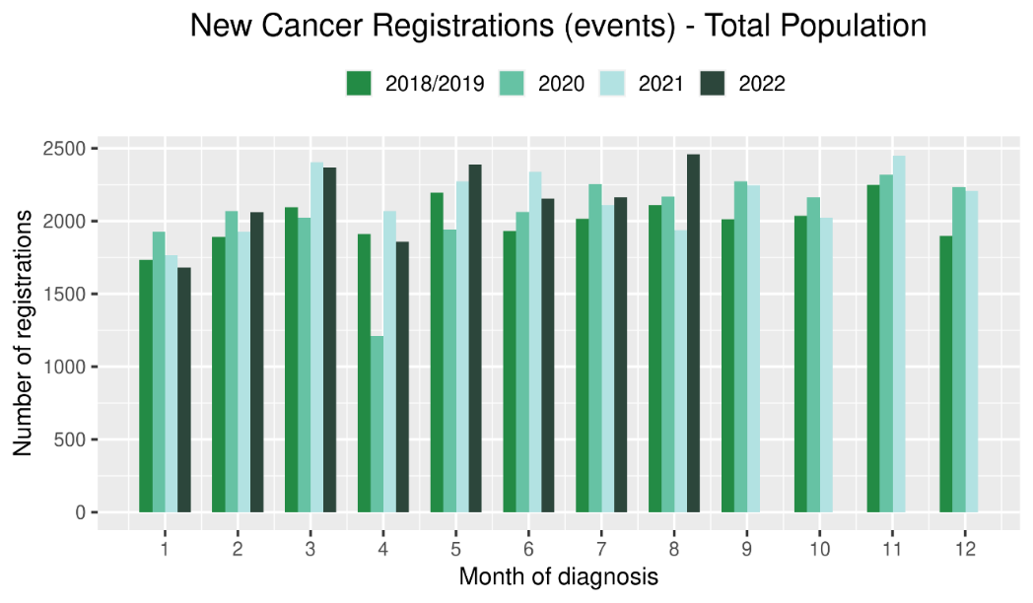 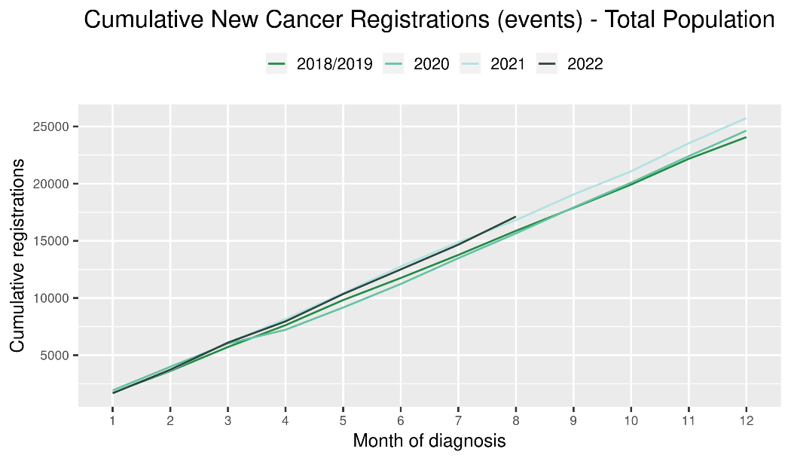

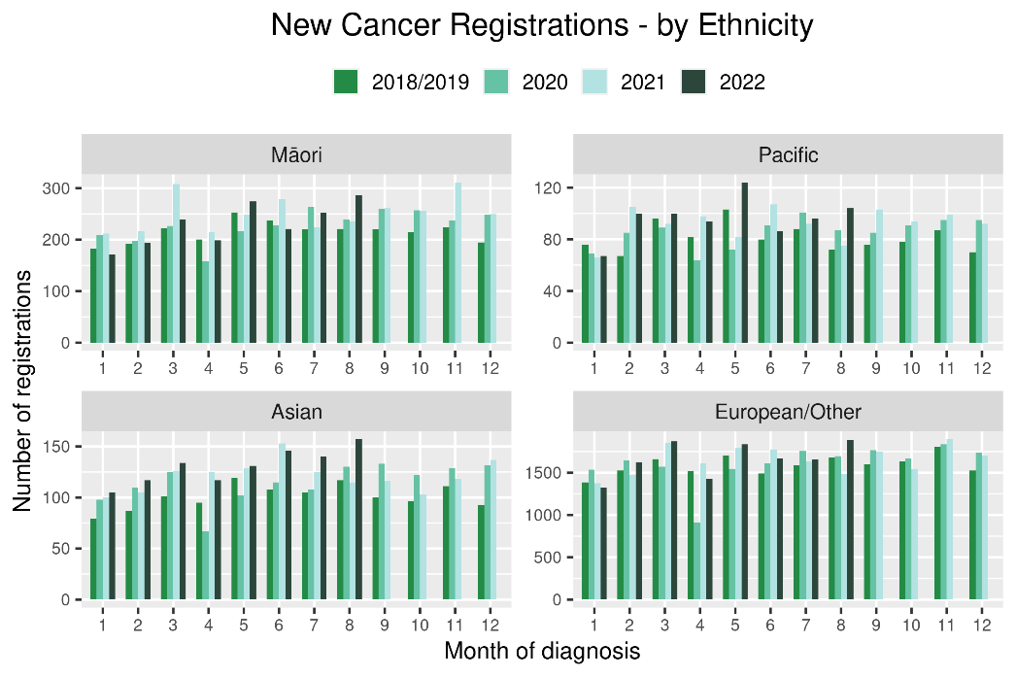 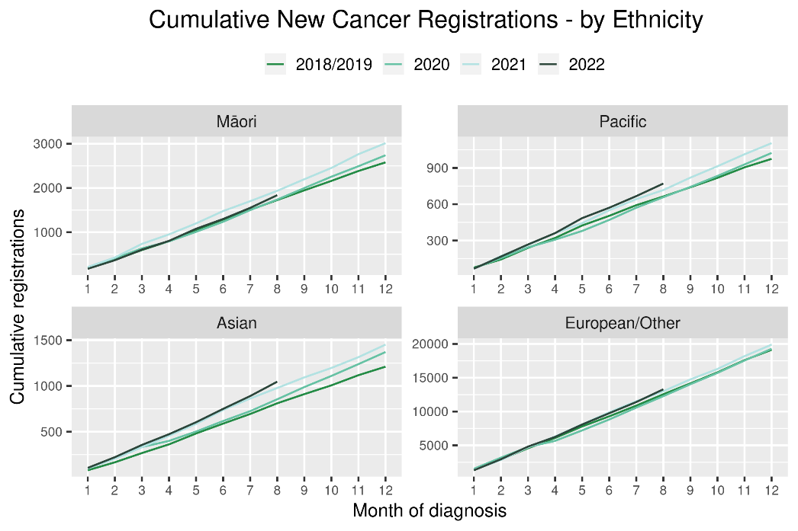

Table 2: Number of provisional cancer registrations* and percentage difference in 2022 compared to the average of 2018 and 2019, by month and cumulative year to date, by tumour group

|  |  |  |  |  |  |  |  |  |  |  |  |  |
| --- | --- | --- | --- | --- | --- | --- | --- | --- | --- | --- | --- | --- |
|  | **June** | | | **July** | | | **August** | | | **Cumulative January-August** | | |
| **Tumour group** | **2018/2019** | **2022** | **%change** | **2018/2019** | **2022** | **%change** | **2018/2019** | **2022** | **%change** | **2018/2019** | **2022** | **%change** |
| Breast | 311 | 353 | 14% | 332 | 290 | -13% | 322 | 347 | 8% | 2,458 | 2,528 | 3% |
| Colorectal | 260 | 244 | -6% | 247 | 292 | 18% | 275 | 327 | 19% | 2,060 | 2,280 | 11% |
| Gynaecology | 81 | 91 | 13% | 94 | 94 | 0% | 92 | 116 | 26% | 705 | 745 | 6% |
| Haematology and Lymphoid | 197 | 216 | 10% | 212 | 184 | -13% | 197 | 205 | 4% | 1,635 | 1,590 | -3% |
| Melanoma and non-melanoma skin cancer | 229 | 303 | 33% | 249 | 306 | 23% | 294 | 399 | 36% | 2,166 | 2,599 | 20% |
| Other digestive system | 111 | 150 | 36% | 136 | 157 | 15% | 128 | 155 | 22% | 976 | 1,132 | 16% |
| Prostate | 341 | 330 | -3% | 326 | 336 | 3% | 374 | 367 | -2% | 2,624 | 2,594 | -1% |
| Respiratory and thorax | 136 | 152 | 12% | 155 | 148 | -5% | 161 | 157 | -2% | 1,163 | 1,209 | 4% |
| Urinary system | 87 | 102 | 18% | 85 | 117 | 38% | 81 | 115 | 43% | 674 | 756 | 12% |

*This analysis uses provisional data for the 2022 registrations, some cancers may initially be classified as ‘non-specified’ and subsequently be re-classified into one of the cancer groups as more information becomes available.

**For the purposes of this report, non-melanoma skin cancer excludes basal cell carcinoma and squamous cell carcinoma

Figure 2: Number of cancer registrations by month, 2018/19 average, 2020, 2021 and 2022, by tumour group

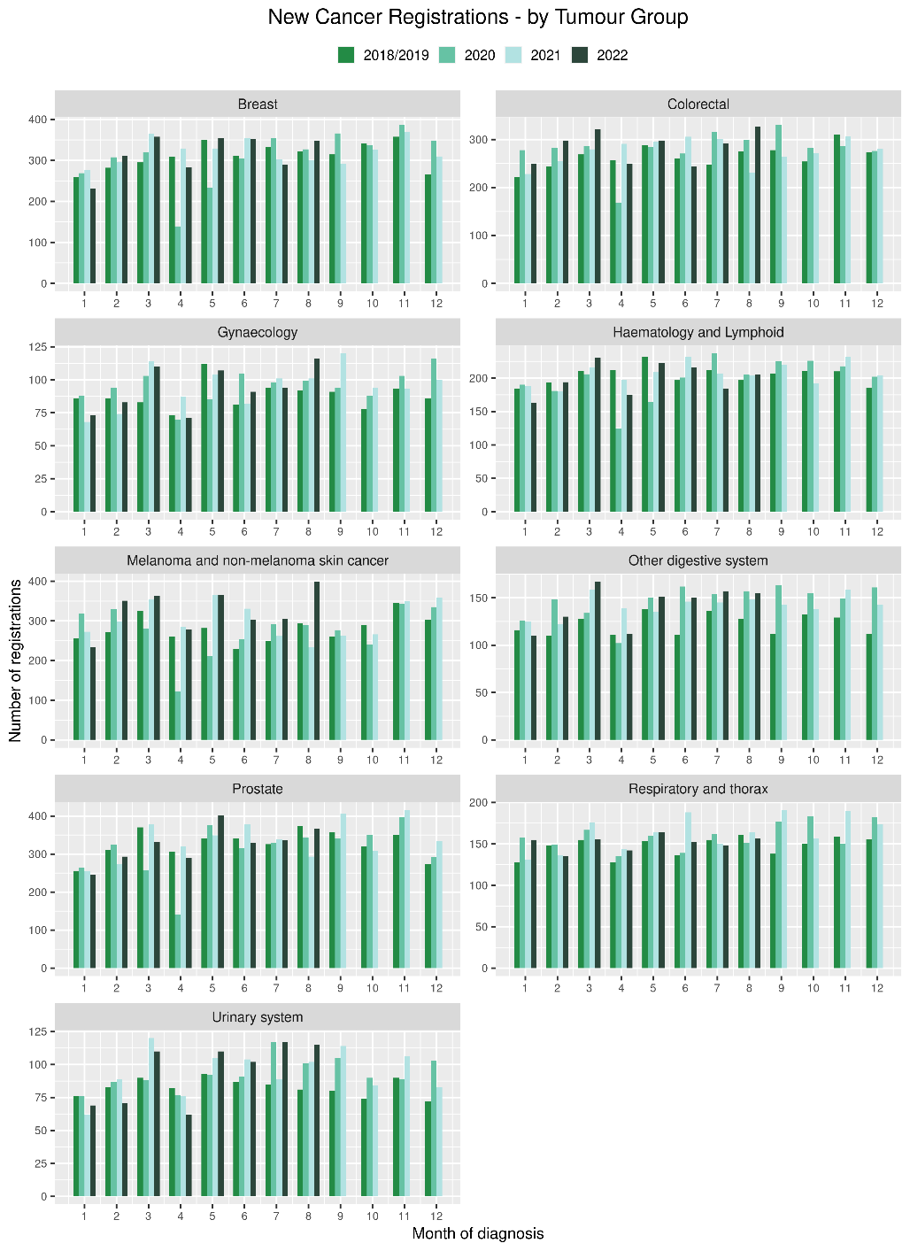 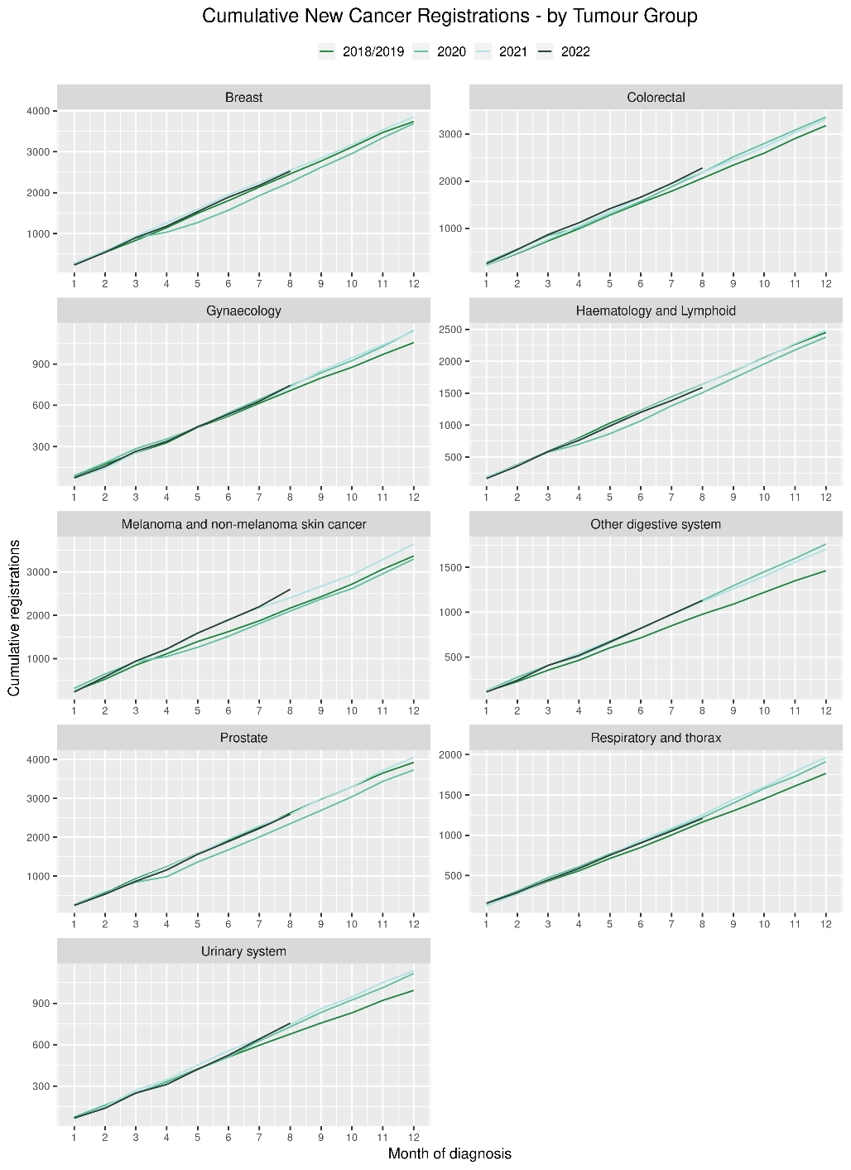

# Gastrointestinal endoscopy

## Notes on data

* Gastrointestinal endoscopy data were extracted from the National Non-admitted Patient Collection (NNPAC) and National Minimum Dataset (NMDS) on 14 November 2022.
* Includes colonoscopies and gastroscopies for all indications – not just cancer.
* Technical information: gastroscopies (Purchase Unit Code: MS02005), colonoscopies (Purchase Unit Code: MS02007), combined gastroscopies and colonoscopies (Purchase Unit Code: MS02014).

## Key points

* For 2022 until September 2022, there was an increase of 15% in gastrointestinal endoscopies, compared with the average of 2018/19. For Māori there was a 34% increase and for Pacific peoples the increase was 38%.

## Results

Table 3: Number of colonoscopy and gastroscopy procedures and percentage difference in 2022 compared to the average of 2018 and 2019, by month and cumulative year to date, by ethnicity

|  |  |  |  |  |  |  |  |  |  |  |  |  |
| --- | --- | --- | --- | --- | --- | --- | --- | --- | --- | --- | --- | --- |
|  | **July** | | | **August** | | | **September** | | | **Cumulative Jan-Sep** | | |
|  | **2018/2019** | **2022** | **% change** | **2018/2019** | **2022** | **% change** | **2018/2019** | **2022** | **% change** | **2018/2019** | **2022** | **% change** |
| Māori | 603 | 798 | 32% | 671 | 843 | 26% | 598 | 825 | 38% | 4,936 | 6,602 | 34% |
| Pacific Peoples | 232 | 300 | 30% | 243 | 307 | 27% | 208 | 297 | 43% | 1,837 | 2,544 | 38% |
| Non-Māori/Non-Pacific | 5,786 | 5,811 | 0% | 6,189 | 6,677 | 8% | 5,579 | 6,269 | 12% | 47,950 | 53,726 | 12% |
| Total Population | 6,620 | 6,909 | 4% | 7,102 | 7,827 | 10% | 6,384 | 7,391 | 16% | 54,723 | 62,872 | 15% |

Figure 3: Number of gastrointestinal endoscopy procedures by month, 2018/19 average, 2020, 2021 and 2022 total population and Māori

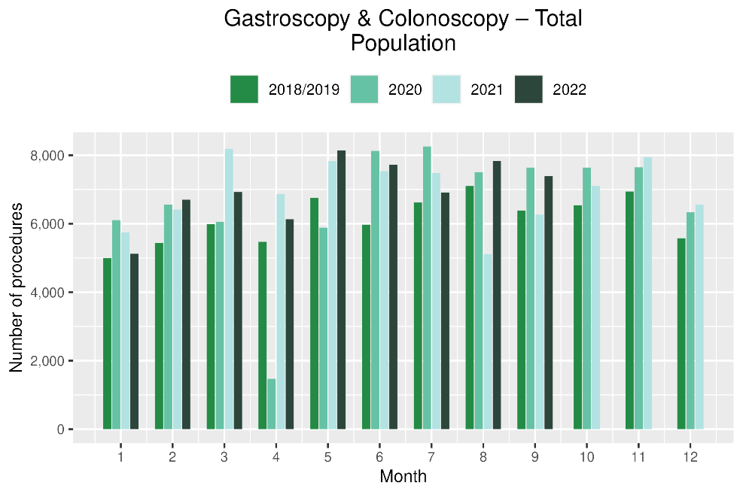 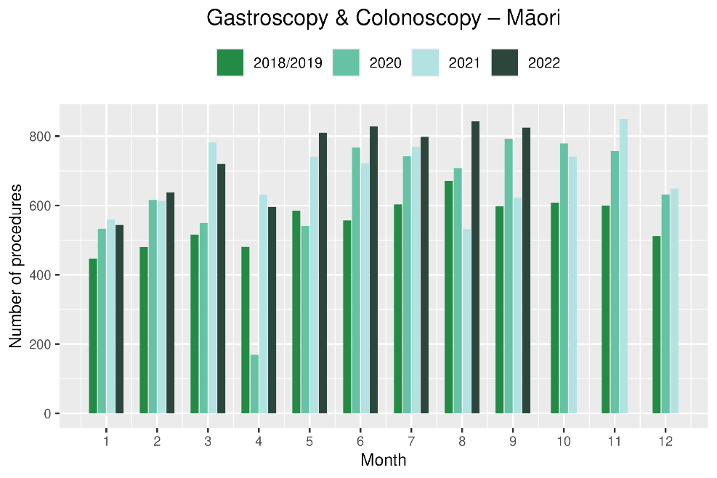

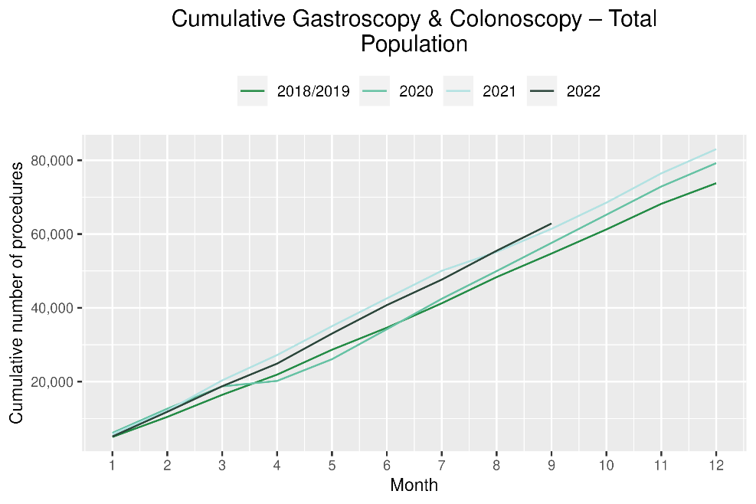 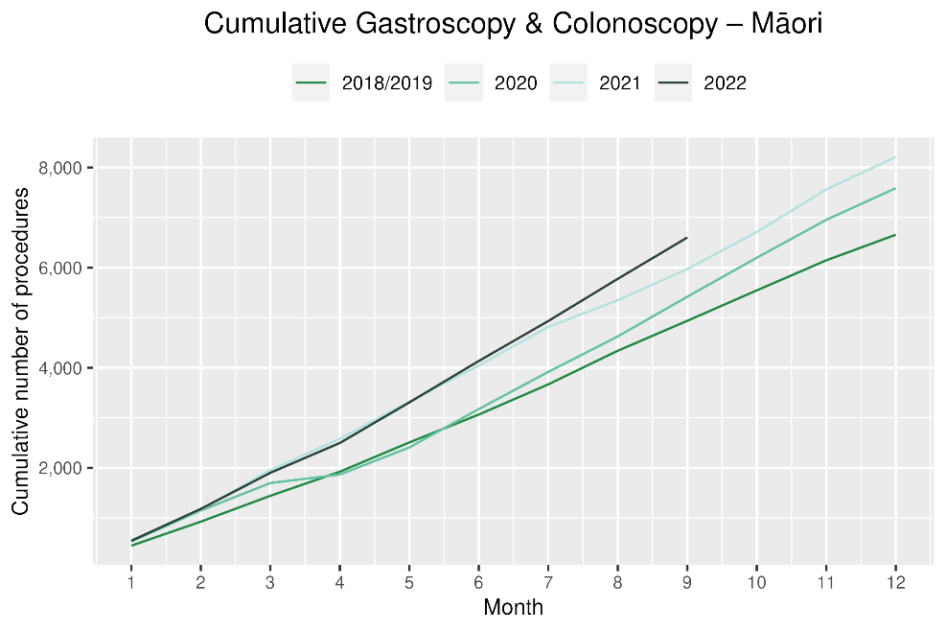

# Bronchoscopy

## Notes on data

* Bronchoscopy and CT Lung Biopsy data were extracted from NNPAC and NMDS on 14 November 2022.
* These data include bronchoscopies and CT lung biopsies for all indications, not solely cancer related procedures.
* Technical information: bronchoscopies (Purchase Unit Code: MS02003) and CT Lung Biopsy (Procedure codes: 3841808 and 3881200[5])

## Key points

* For January to September 2022 (cumulatively), there was a 10% decrease in bronchoscopies compared with the same period in 2018/19. For Māori there was a 2% increase over the same time period. Overall, a similar number of bronchoscopies were performed from January to September 2022 as were performed from January to September 2020 (ie, the first year of the pandemic).
* Te Aho o Te Kahu has discussed the potential reasons for the overall decrease in bronchoscopy volumes with respiratory physicians in the sector. It has been highlighted that due to the risks of COVID-19 transmission, logistical challenges and other factors, there has been a shift in modes of diagnosis for lung cancer away from bronchoscopy (noting that bronchoscopy is performed for a number of reasons, not just cancer diagnosis). These modes are thought to include Endobronchial Ultrasound Bronchoscopy (EBUS), Positron Emission Tomography - Computed Tomography (PET CT) scans and CT lung biopsy. PET CT and EBUS data are not reported here because the clinical coding of these procedures is not anatomically specific, meaning that we would not know whether they were performed on the lung. CT lung biopsy data were examined and are presented below (Figure 5), with these data suggesting a downturn in CT lung biopsies overall (but not for Māori). Even with this additional data, the overall picture of diagnosis remains incomplete, and it is therefore difficult to interpret whether any changes in volume of lung cancer diagnostic procedures have occurred. Of note, there has not been a decrease in lung cancer registrations overall for the year to date compared with 2018/19, although this is not true for Māori (see *Focus on lung cancer*, below).

## Results

Table 4: Number of bronchoscopies and percentage difference in 2022 compared to the average of 2018 and 2019, by month and cumulative year to date, by ethnicity

|  |  |  |  |  |  |  |  |  |  |  |  |  |
| --- | --- | --- | --- | --- | --- | --- | --- | --- | --- | --- | --- | --- |
|  | **July** | | | **August** | | | **September** | | | **Cumulative Jan -Sep** | | |
|  | **2018/2019** | **2022** | **% change** | **2018/2019** | **2022** | **% change** | **2018/2019** | **2022** | **% change** | **2018/2019** | **2022** | **% change** |
| Māori | 34 | 28 | -16% | 42 | 38 | -8% | 36 | 30 | -17% | 306 | 312 | 2% |
| Pacific Peoples | 10 | 10 | 5% | 14 | 9 | -33% | 11 | 15 | 36% | 88 | 90 | 3% |
| Non-Māori/Non-Pacific | 169 | 148 | -12% | 175 | 154 | -12% | 167 | 156 | -6% | 1,531 | 1,330 | -13% |
| Total Population | 212 | 186 | -12% | 230 | 201 | -13% | 214 | 201 | -6% | 1,924 | 1,732 | -10% |

*Due to small numbers, monthly figures have not been included for Māori and Pacific peoples

Figure 4: Number of bronchoscopies by month, 2018/19 average, 2020, 2021 and 2022, total population and Māori

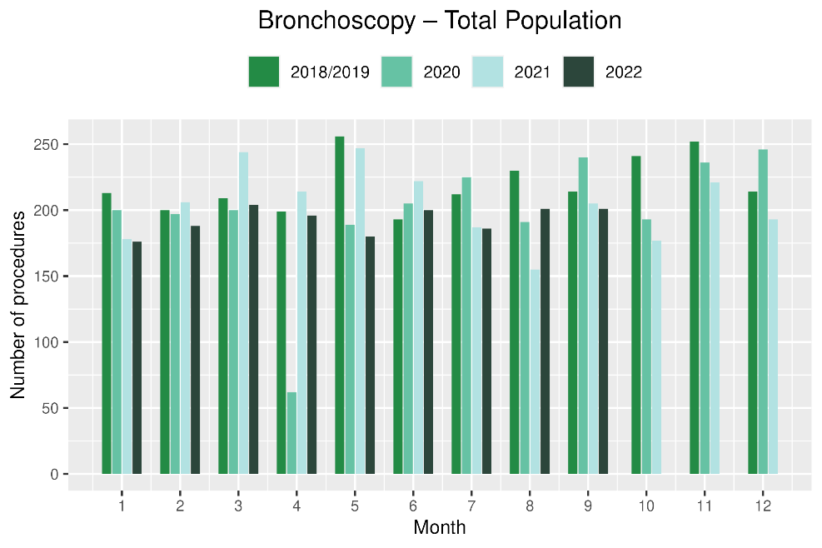 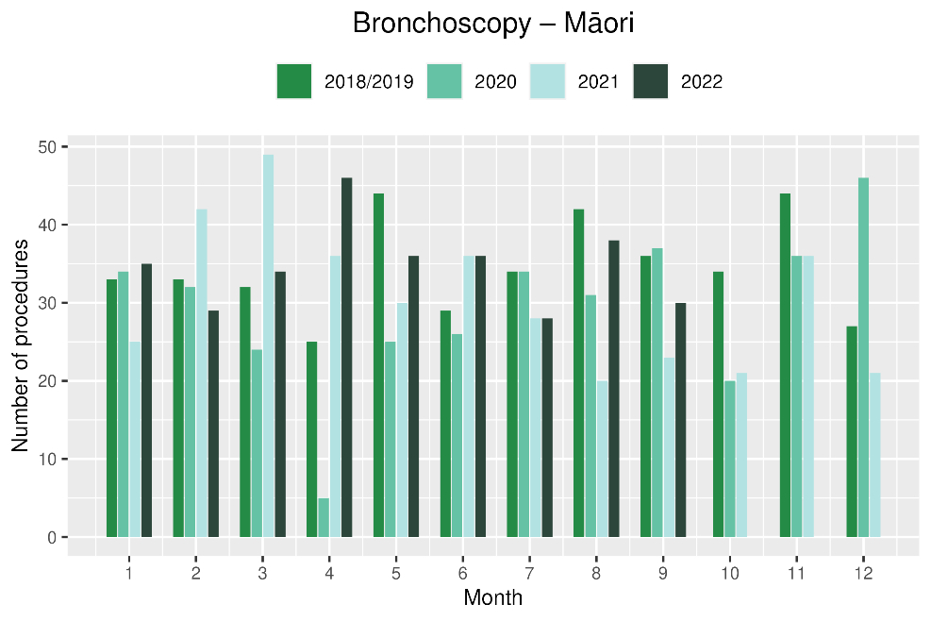

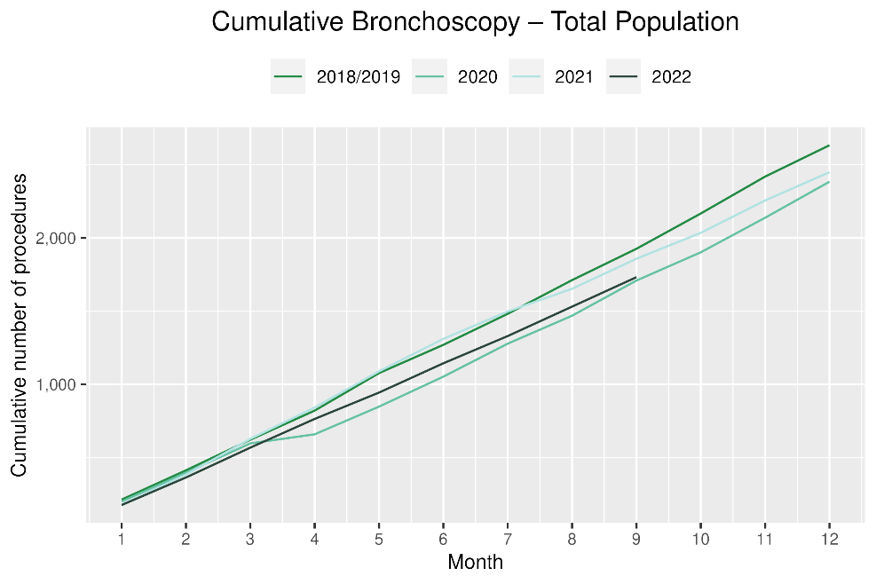 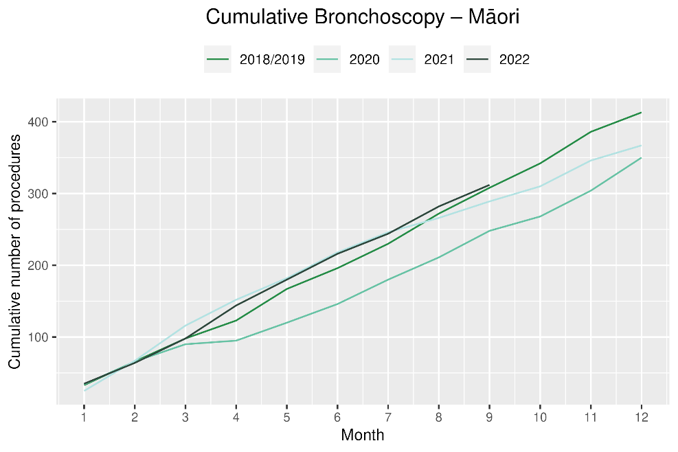

Table 5: Number of CT lung biopsies and percentage difference in 2022 compared to the average of 2018 and 2019, by month and cumulative year to date, by ethnicity

|  |  |  |  |  |  |  |  |  |  |  |  |  |
| --- | --- | --- | --- | --- | --- | --- | --- | --- | --- | --- | --- | --- |
|  | **July** | | | **August** | | | **September** | | | **Cumulative Jan-Sep** | | |
|  | **2018/2019** | **2022** | **% change** | **2018/2019** | **2022** | **% change** | **2018/2019** | **2022** | **% change** | **2018/2019** | **2022** | **% change** |
| Māori | * | * | * | * | * | * | * | * | * | 121 | 126 | 5% |
| Pacific Peoples | * | * | * | * | * | * | * | * | * | 30 | 26 | -12% |
| Non-Māori/Non-Pacific | 62 | 58 | -6% | 62 | 67 | 8% | 64 | 64 | 0% | 541 | 500 | -8% |
| Total Population | 79 | 75 | -4% | 81 | 83 | 3% | 81 | 94 | 17% | 691 | 652 | -6% |

Figure 5: Number of CT lung biopsies by month, 2018/19 average, 2020, 2021 and 2022, total population and Māori

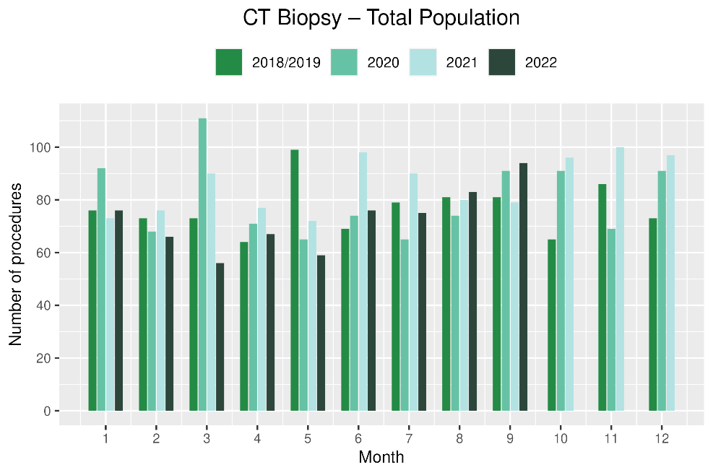 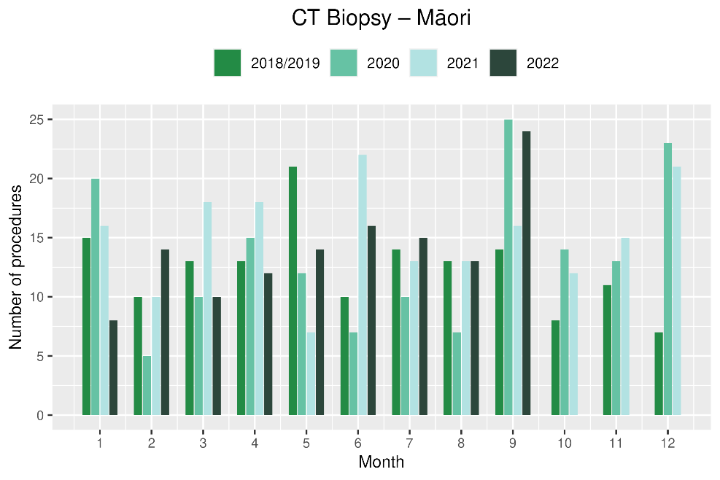

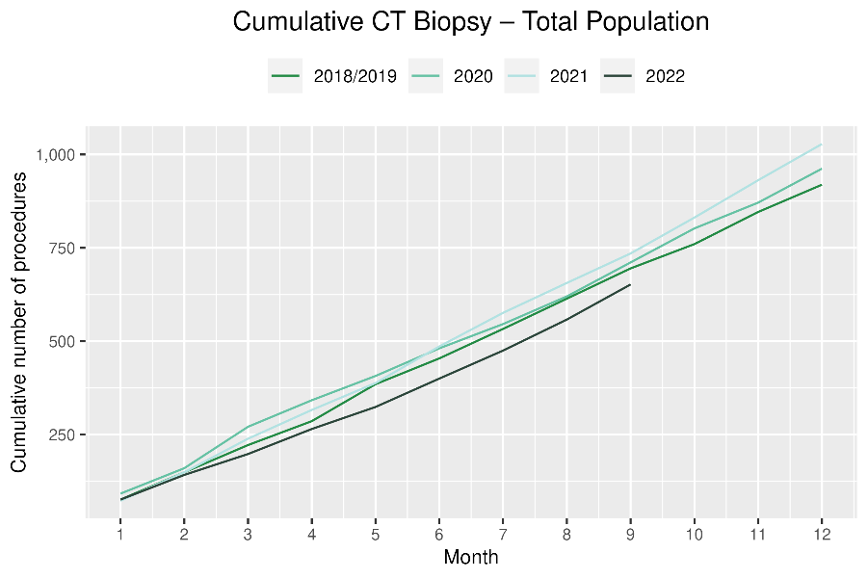 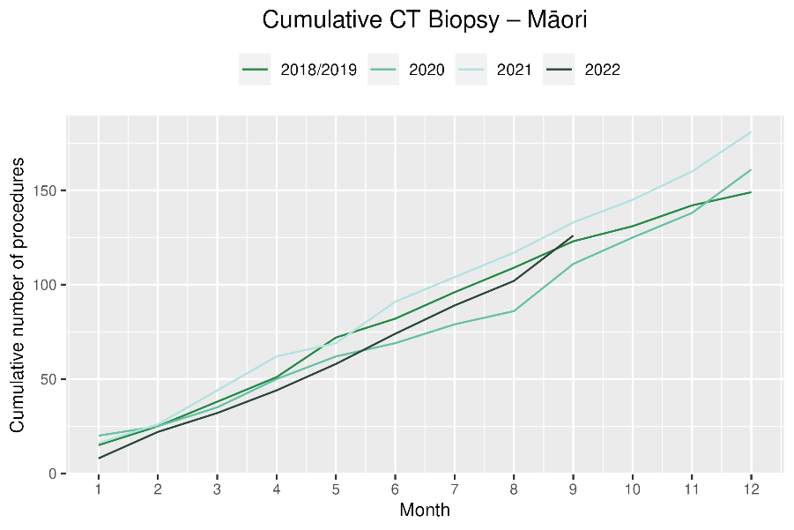

# Faster cancer treatment

## Notes on data

* The data were extracted from the Faster Cancer Treatment (FCT) database on 28 Oct 2022. Fast Cancer Treatment Data is reported quarterly.
* These data aim to capture a broader part of the diagnostic and referral pathway; however, they only include a subset of people being investigated for cancer. Data relate to the 62-day pathway and includes people with a high-suspicion of cancer and a need to be seen within two weeks. This group of people should receive their first treatment within 62-day of receipt of referral. The target is 90%.
* Te Aho o Te Kahu has an escalation pathway for monitoring the performance of DHBs against the FCT measure. Escalation includes regular meetings with service teams and CE to CE discussions against recovery planning and actions.
* Some Districts have not been able to submit all FCT data for 2022/23 quarter one, as a result of Patient Information System upgrade or reduced capacity for data coding and entry.

## Key point

* For 2022 to date, there has been some fluctuation in the proportion of people with a high suspicion of cancer receiving their first treatment within 62 days of receipt of referral, however the measure has been met for 83% of people overall and 85% for Māori.
* The proportion of Māori seen within two weeks in August was 72% compare with the total percentage of 85%. There were 15 records coded as delayed due to capacity constraints, with no further information available at a national level. Te Whatu Ora is provided with data at District level.

## Results

Table 6: Number of referrals for people with a high suspicion of cancer, in 2022 by month, and cumulative year to date

|  |  |  |  |  |  |  |  |  |  |  |  |
| --- | --- | --- | --- | --- | --- | --- | --- | --- | --- | --- | --- |
|  |  | **Jan** | **Feb** | **Mar** | **Apr** | **May** | **Jun** | **July** | **Aug** | **Sep** | **Total Jan to Sep** |
|  | Māori | 63 | 56 | 58 | 51 | 64 | 57 | 42 | 67 | 56 | 514 |
|  | Non-Māori/Non-Pacific | 298 | 382 | 436 | 298 | 380 | 348 | 296 | 379 | 300 | 3,117 |
|  | Total Population | 383 | 448 | 518 | 373 | 470 | 426 | 368 | 470 | 376 | 3,832 |

*Due to small numbers, volumes have not been included for Pacific peoples

Table 7: Proportion of people with a high-suspicion of cancer and a need to be seen within 2-weeks who received their first treatment within 62 days of receipt of referral, in 2022 by month, and average for the year to date

|  |  |  |  |  |  |  |  |  |  |  |
| --- | --- | --- | --- | --- | --- | --- | --- | --- | --- | --- |
|  | **Jan** | **Feb** | **Mar** | **Apr** | **May** | **Jun** | **July** | **Aug** | **Sep** | **Total Jan to Sep** |
| Māori | 78% | 91% | 86% | 93% | 85% | 88% | 88% | 72% | 86% | 85% |
| Non-Māori/Non-Pacific | 88% | 80% | 85% | 81% | 86% | 86% | 85% | 79% | 78% | 83% |
| Total Population Average | 84% | 84% | 84% | 82% | 86% | 86% | 85% | 79% | 80% | 83% |

*Due to small numbers, percentages have not been included for Pacific peoples

Figure 6: Proportion of patients with a high-suspicion of cancer and a need to be seen within 2-weeks who received their first treatment within 62 days of receipt of referral, by ethnicity, in 2022 by month

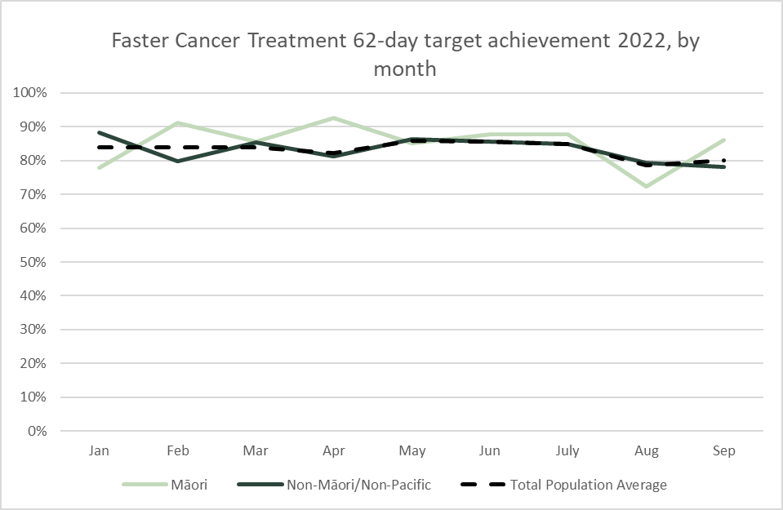

# Combined cancer surgery

## Notes on data

* This report includes data on surgery for breast, colorectal, lung and prostate cancer. These four cancers are therefore used as case studies for cancer surgery more generally.
* Colorectal, lung and prostate cancers were chosen because Te Aho o Te Kahu has a pre-validated list of surgical procedure codes for these cancers, agreed on as part of the quality performance indicator (QPI) work programme.
* For breast cancer, as the development of QPIs are currently underway, we have been able to provide provisional surgical procedure codes for the purposes of this report.
* The surgical procedure codes are listed in Appendix 5.
* The data were extracted from the NMDS on 14 November 2022.

## Key points

* For 2022 until September, there were 3% fewer cancer surgeries (breast, prostate, lung and colorectal combined) compared to 2018/19.
* For Māori, there has been a 5% increase in combined cancer surgeries for the year to date relative to 2018/19 (reflecting 24 more surgeries), although the cumulative number of surgeries in the year to date remain below those performed over the same period in either 2020 or 2021.
* For Pacific peoples there was a 17% increase for the year to date relative to 2018/19 (reflecting 28 more surgeries).

## Results

Table 8: Number of cancer surgeries (breast, prostate, colorectal, lung) and percentage difference in 2022 compared to the average of 2018 and 2019, by month and cumulative year to date, by ethnicity

|  |  |  |  |  |  |  |  |  |  |  |  |  |
| --- | --- | --- | --- | --- | --- | --- | --- | --- | --- | --- | --- | --- |
|  | **July** | | | **August** | | | **September** | | | **Cumulative Jan-Sep** | | |
|  | **2018/2019** | **2022** | **% change** | **2018/2019** | **2022** | **% change** | **2018/2019** | **2022** | **% change** | **2018/2019** | **2022** | **% change** |
| Māori | 53 | 50 | -5% | 45 | 58 | 30% | 65 | 67 | 4% | 479 | 503 | 5% |
| Pacific Peoples | 19 | 23 | 21% | 22 | 24 | 12% | 20 | 16 | -20% | 162 | 190 | 17% |
| Non-Māori/Non-Pacific | 361 | 365 | 1% | 442 | 394 | -11% | 413 | 422 | 2% | 3,507 | 3,334 | -5% |
| Total Population | 432 | 438 | 1% | 508 | 476 | -6% | 497 | 505 | 2% | 4,147 | 4,027 | -3% |

Figure 7: Number of cancer surgeries (breast, prostate, colorectal, lung) by month, 2018/19 average, 2020, 2021 and 2022, total population and Māori

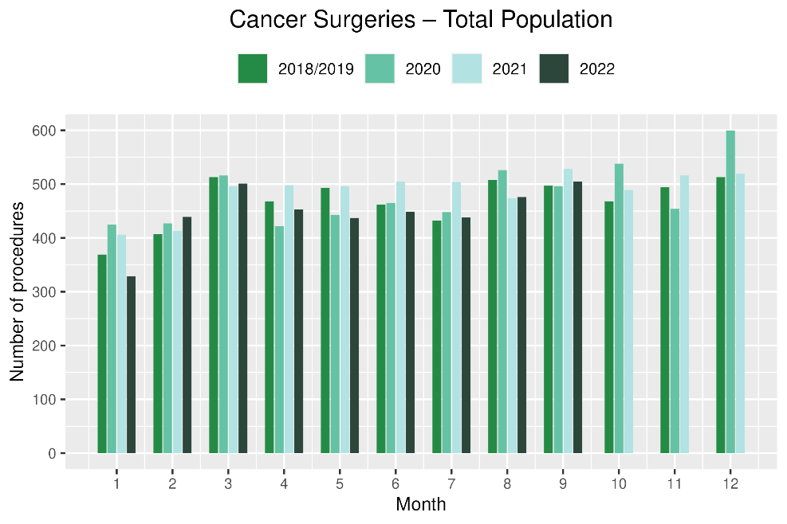 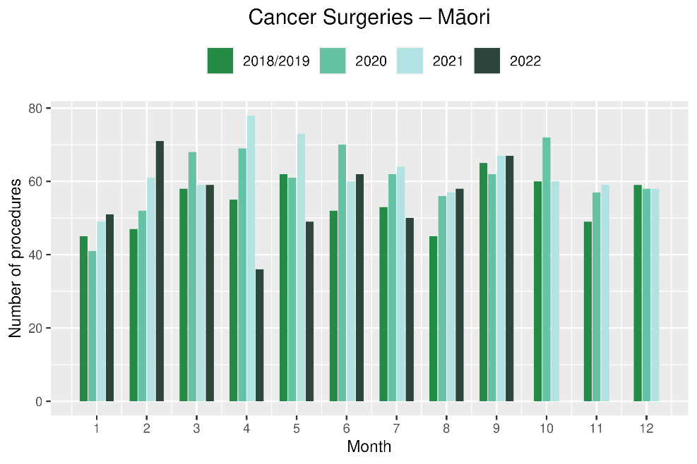

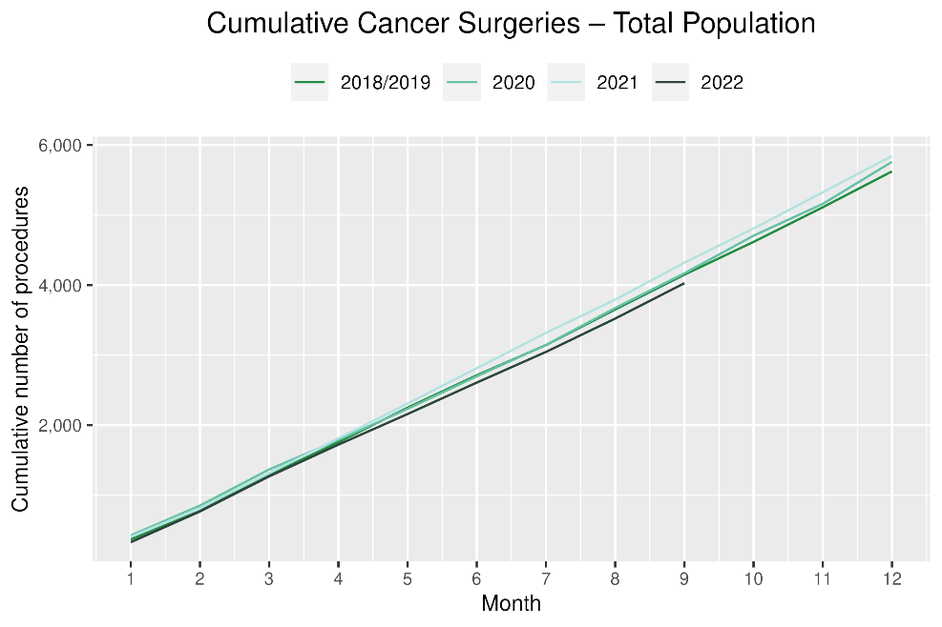 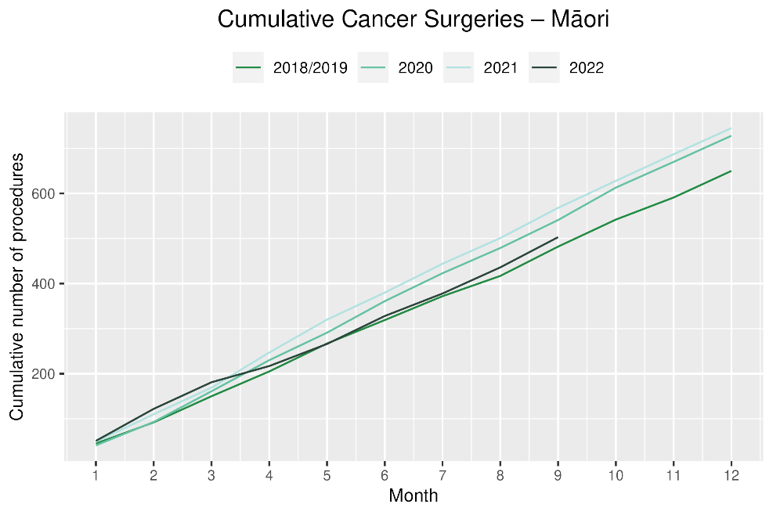

# Breast cancer surgery (mastectomy)

## Notes on data

* A list of the surgical procedure codes used for analysis are included in Appendix 5.
* The data were extracted from the NMDS on 14 November 2022.
* The number of mastectomies performed each month is relatively small, so caution is needed when comparing data by month.
* Procedure codes for mastectomy only are included in this report. There are a number of additional procedure codes used for breast cancer surgeries in addition to mastectomy, however the procedure codes for these surgeries are less specific for cancer. Therefore, using only mastectomy codes allows a more accurate view of any changes in breast cancer surgery volumes[6].

## Key points

* For 2022 to date, there has been a 6% decrease in mastectomies in 2022 compared with 2018/19. For Māori this decrease was 4% and for Pacific peoples there was a 12% increase.
* August saw a 20% decrease compared to the same time period in 2018/19, with July and September less affected.

## Results

Table 9: Number of mastectomies and percentage difference in 2022 compared to the average of 2018 and 2019, by month and cumulative year to date, by ethnicity

|  |  |  |  |  |  |  |  |  |  |  |  |  |
| --- | --- | --- | --- | --- | --- | --- | --- | --- | --- | --- | --- | --- |
|  | **July** | | | **August** | | | **September** | | | **Cumulative Jan-Sep** | | |
|  | **2018/2019** | **2022** | **% change** | **2018/2019** | **2022** | **% change** | **2018/2019** | **2022** | **% change** | **2018/2019** | **2022** | **% change** |
| Māori | * | * | * | * | * | * | * | * | * | 197 | 189 | -4% |
| Pacific Peoples | * | * | * | * | * | * | * | * | * | 73 | 81 | 12% |
| Non-Māori/Non-Pacific | 102 | 107 | 5% | 123 | 92 | -25% | 115 | 116 | 1% | 929 | 862 | -7% |
| Total Population | 132 | 133 | 1% | 151 | 121 | -20% | 149 | 147 | -1% | 1,199 | 1,132 | -6% |

*Due to small numbers, some figures have not been included for Māori and Pacific peoples

Figure 8: Number of mastectomies by month, 2018/19 average, 2020, 2021 and 2022, total population and Māori

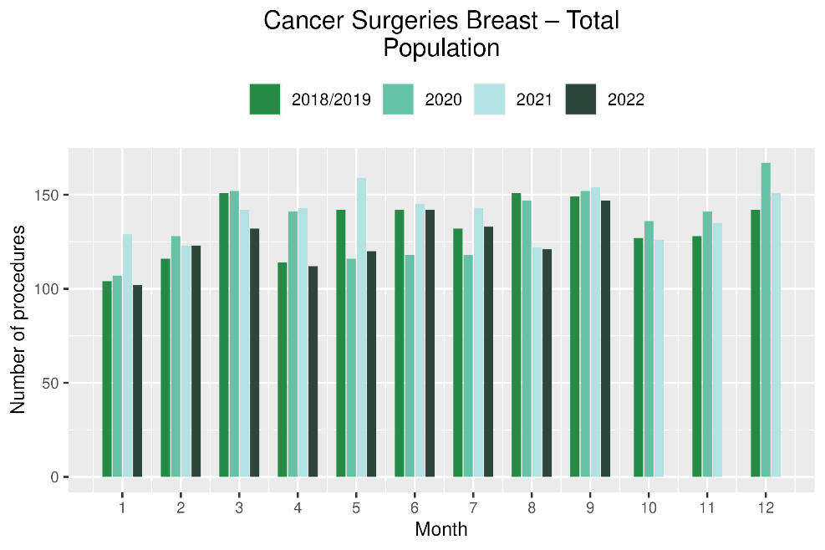 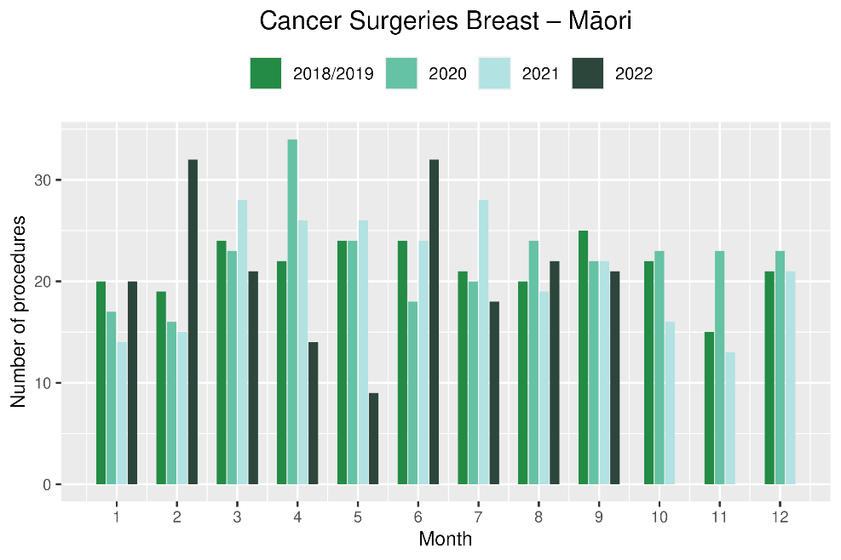

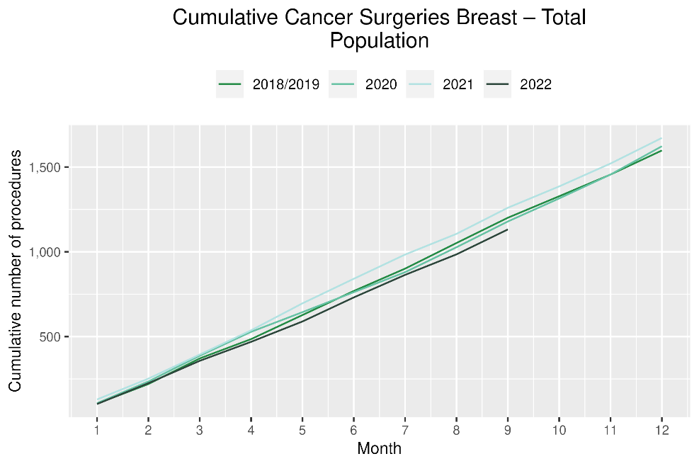 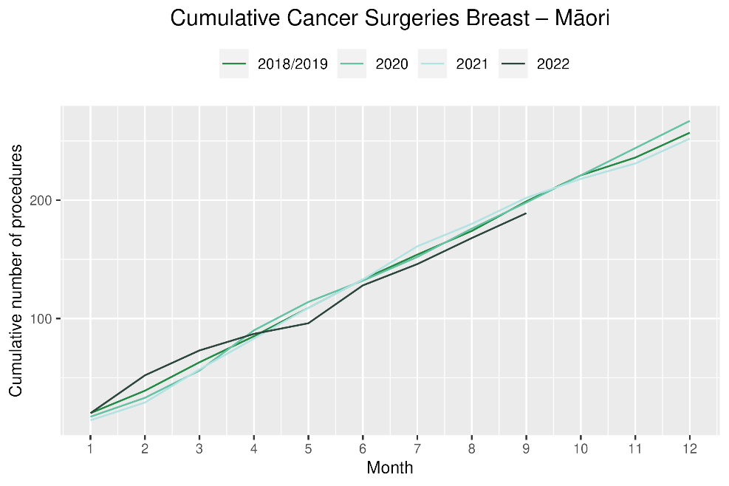

# Colorectal cancer surgery

## Notes on data

* The surgical procedure codes used for analysing colorectal cancer are listed in Appendix 5.
* The data were extracted from the NMDS on 14 November 2022.

## Key points

* For 2022 to date, there were 5% fewer colorectal cancer surgeries performed in total, 7% increase for Pacific peoples (noting small numbers) and a 22% increase for Māori compared with 2018/19. However, the number of colorectal cancer surgeries performed among Māori in the year to date remains lower than that performed over the same time period in either 2020 or 2021
* Colorectal cancer surgery volumes showed a decrease in July 2022 compared with 2018/19 (8% decrease) but volumes were increased in August and September 2022 compared with 2018/19.

## Results

Table 10: Number of colorectal cancer surgeries and percentage difference in 2022 compared to the average of 2018 and 2019, by month and cumulative year to date, by ethnicity

|  |  |  |  |  |  |  |  |  |  |  |  |  |
| --- | --- | --- | --- | --- | --- | --- | --- | --- | --- | --- | --- | --- |
|  | **July** | | | **August** | | | **September** | | | **Cumulative Jan -Sep** | | |
|  | **2018/2019** | **2022** | **% change** | **2018/2019** | **2022** | **% change** | **2018/2019** | **2022** | **% change** | **2018/2019** | **2022** | **% change** |
| Māori | * | * | * | * | * | * | * | * | * | 151 | 184 | 22% |
| Pacific Peoples | * | * | * | * | * | * | * | * | * | 54 | 58 | 7% |
| Non-Māori/Non-Pacific | 175 | 162 | -7% | 196 | 199 | 2% | 185 | 190 | 3% | 1,670 | 1,537 | -8% |
| Total Population | 199 | 184 | -8% | 216 | 228 | 6% | 212 | 222 | 5% | 1,875 | 1,779 | -5% |

*Due to small numbers, monthly figures have not been included for Māori and Pacific peoples

**Figure 9: Number of colorectal cancer surgeries by month, 2018/19 average, 2020, 2021 and 2022, total population and Māori**

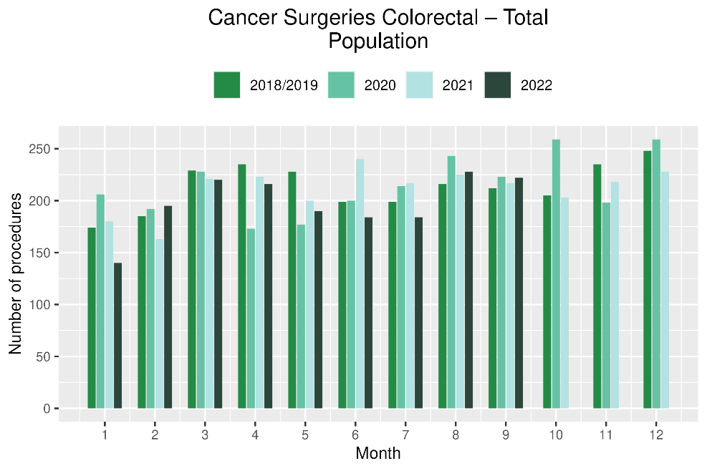 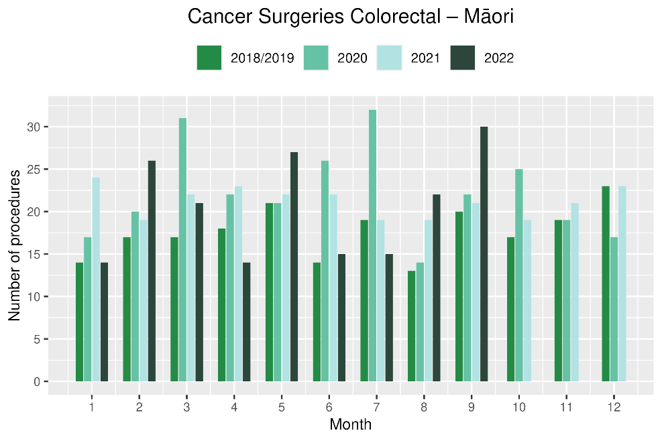

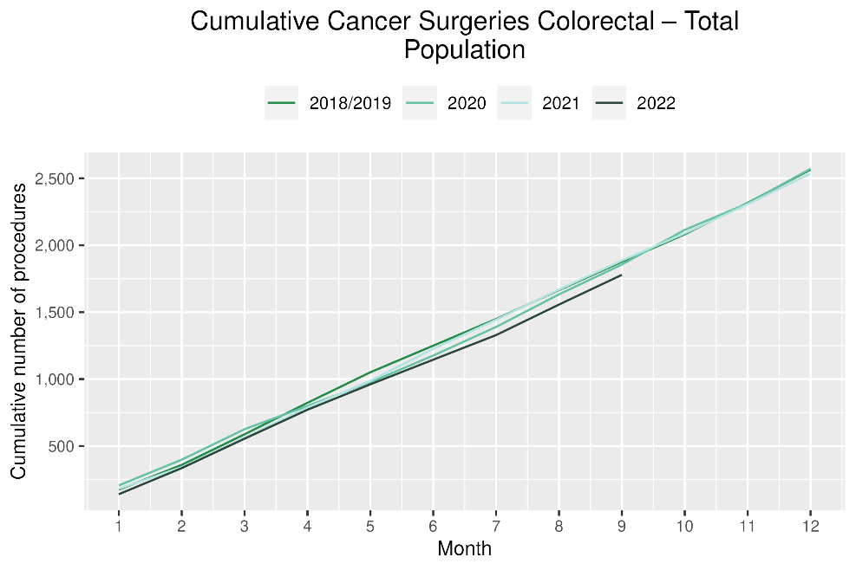 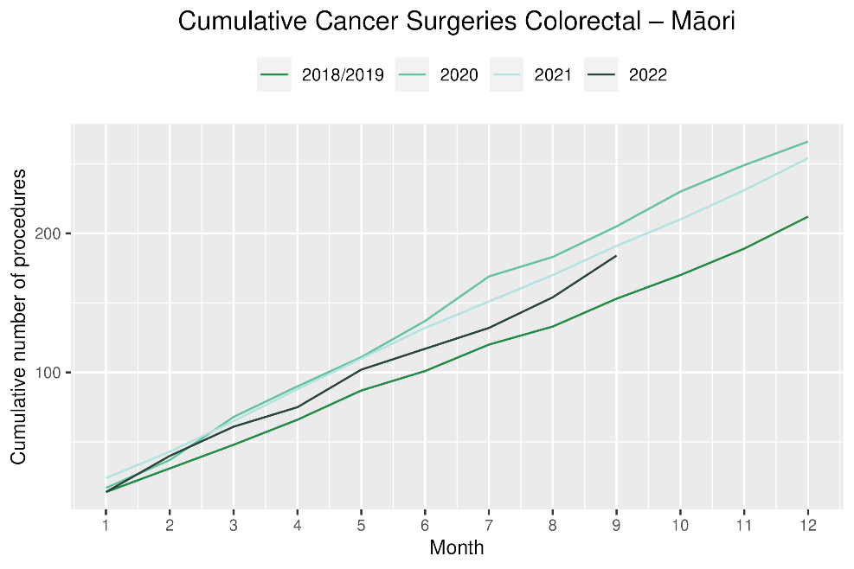

# Lung cancer surgery

## Notes on data

* A list of the surgical procedure codes used for analysis are included in Appendix 5.
* The data were extracted from the NMDS on 14 November 2022.
* The number of lung cancer surgeries performed each month is relatively small, so caution is needed when comparing data by month.

## Key points

* For 2022 to date there was a 1% increase in the number of surgeries performed for the total population compared with 2018/19.
* Lung cancer surgery showed a decrease in August and September 2022 compared with 2018/19 (25% and 10% respectively). Small numbers make it difficult to be clear if there is a true trend.
* For Māori there was a 16% decrease in lung cancer surgery, numbering 15 fewer surgeries in 2022 compared with 2018/19. This represents a marginal improvement compared to the previous report, where the cumulative data up until June 2022 showed a 25% decrease (16 fewer surgeries over this time).
* For Pacific peoples there was a 38% increase, numbering 8 more surgeries.

## Results

Table 11: Number of lung cancer surgeries and percentage difference in 2022 compared to the average of 2018 and 2019, by month and cumulative year to date, by ethnicity

|  |  |  |  |  |  |  |  |  |  |  |  |  |
| --- | --- | --- | --- | --- | --- | --- | --- | --- | --- | --- | --- | --- |
|  | **July** | | | **August** | | | **September** | | | **Cumulative Jan-Sep** | | |
|  | **2018/2019** | **2022** | **% change** | **2018/2019** | **2022** | **% change** | **2018/2019** | **2022** | **% change** | **2018/2019** | **2022** | **% change** |
| Māori | * | * | * | * | * | * | * | * | * | 91 | 76 | -16% |
| Pacific Peoples | * | * | * | * | * | * | * | * | * | 23 | 31 | 38% |
| Non-Māori/Non-Pacific | 41 | 51 | 26% | 53 | 34 | -36% | 49 | 48 | -2% | 395 | 404 | 2% |
| Total Population | 51 | 67 | 33% | 65 | 49 | -25% | 64 | 57 | -10% | 506 | 511 | 1% |

* Due to small numbers, monthly figures have not been included for Māori and Pacific peoples

Figure 10: Number of lung cancer surgeries by month, 2018/19 average, 2020, 2021 and 2022, total population and Māori

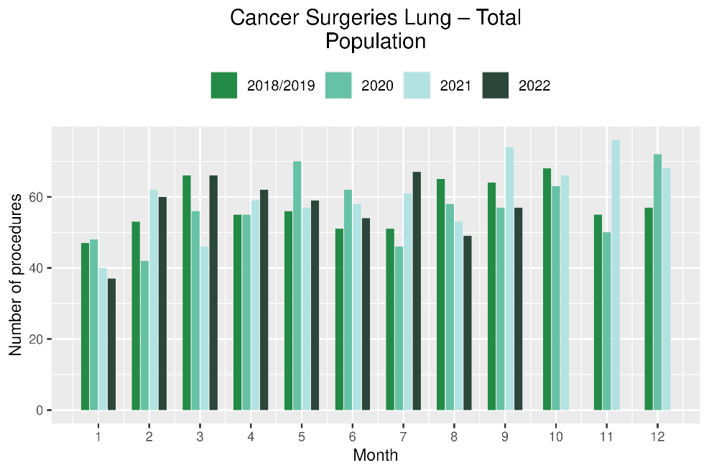 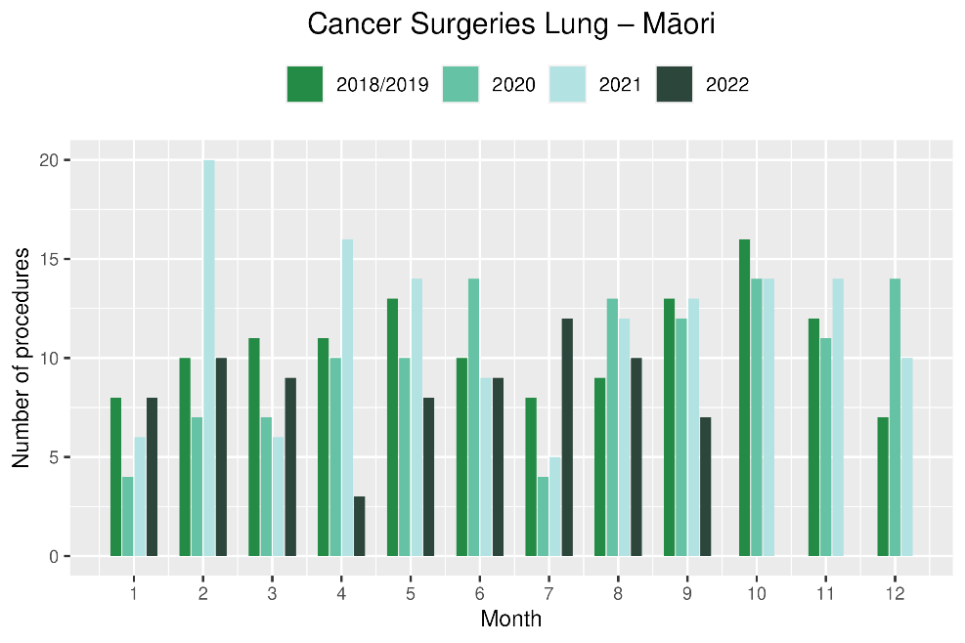

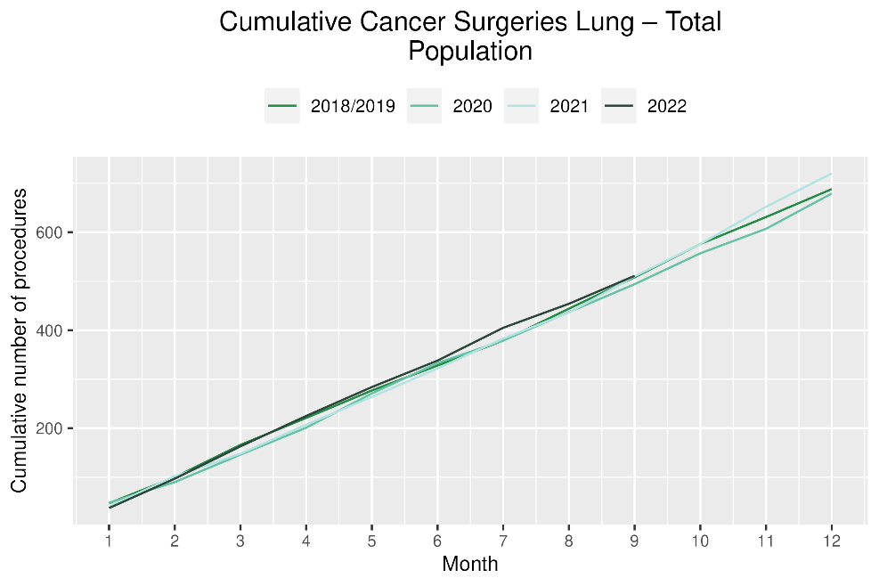 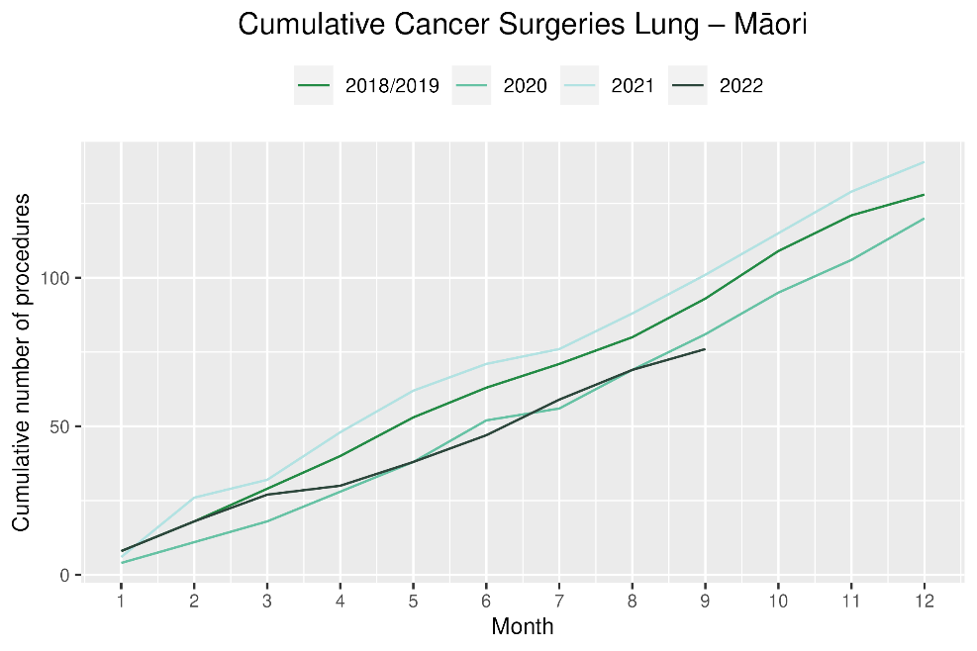

# Prostate cancer surgery

## Notes on data

* A list of the surgical procedure codes used for analysis are included in Appendix 5.
* The data was extracted from the NMDS on 14 November 2022.
* The number of prostate cancer surgeries performed each month is relatively small, so caution is needed when comparing data by month.

## Key points

* For 2022 to date there were 7% more prostate cancer surgeries compared with cumulative figures from 2018/19. For Māori, there were 33% more surgeries performed for 2022 to date and for Pacific Peoples there were 38% more surgeries performed (noting small numbers).
* However, both overall and for Māori, the number of prostate cancer surgeries performed among Māori in the year to date remains lower than that performed over the same time period in either 2020 or 2021.

## Results

Table 12: Number of prostate cancer surgeries and percentage difference in 2022 compared to the average of 2018 and 2019 by month and cumulative year to date

|  |  |  |  |  |  |  |  |  |  |  |  |  |
| --- | --- | --- | --- | --- | --- | --- | --- | --- | --- | --- | --- | --- |
|  | **July** | | | **August** | | | **September** | | | **Cumulative Jan-Sep** | | |
|  | **2018/2019** | **2022** | **% change** | **2018/2019** | **2022** | **% change** | **2018/2019** | **2022** | **% change** | **2018/2019** | **2022** | **% change** |
| Māori | * | * | * | * | * | * | * | * | * | 41 | 54 | 33% |
| Pacific Peoples | * | * | * | * | * | * | * | * | * | 15 | 20 | 38% |
| Non-Māori/Non-Pacific | 44 | 45 | 3% | 70 | 69 | -1% | 64 | 68 | 7% | 513 | 531 | 4% |
| Total Population | 51 | 54 | 6% | 76 | 78 | 3% | 74 | 79 | 7% | 568 | 605 | 7% |

*Due to small numbers, some figures have not been included for Māori and Pacific peoples

Figure 11: Number of prostate cancer surgeries by month, 2018/19 average, 2020,2021 and 2022, total population and Māori

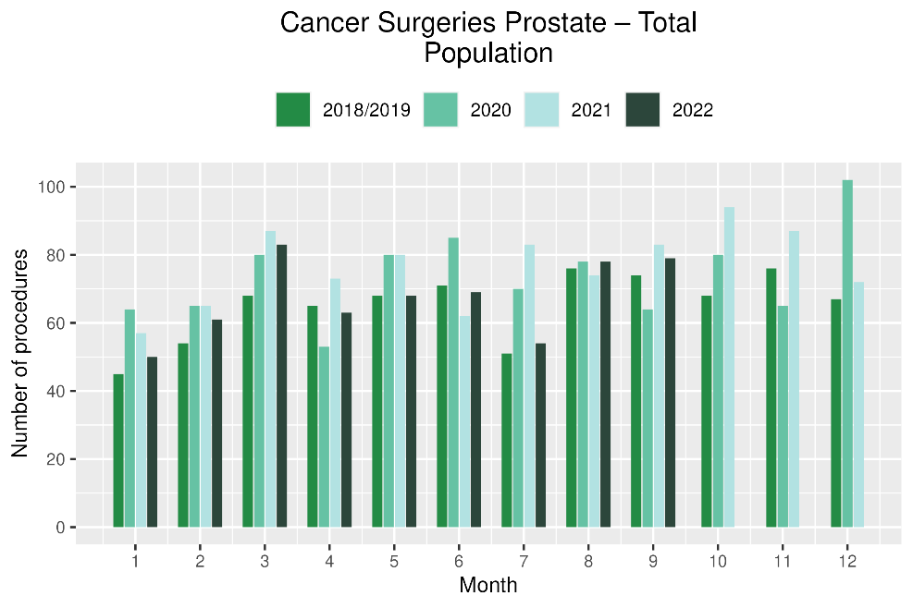 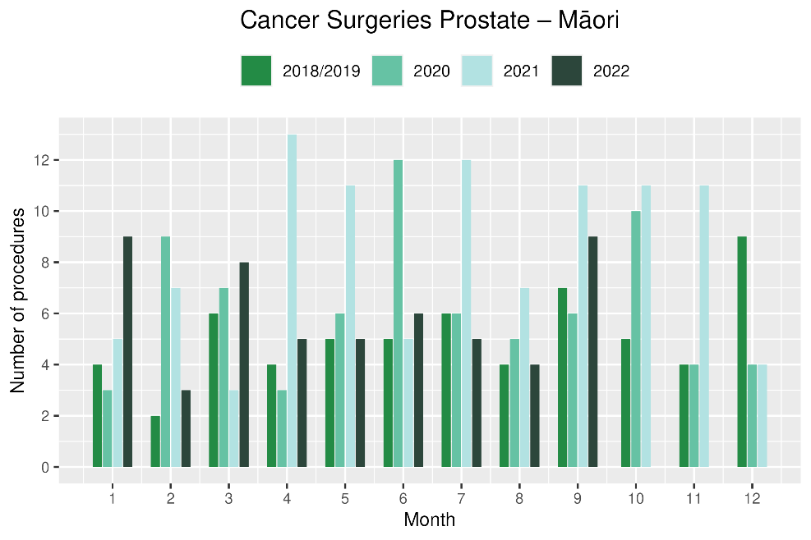

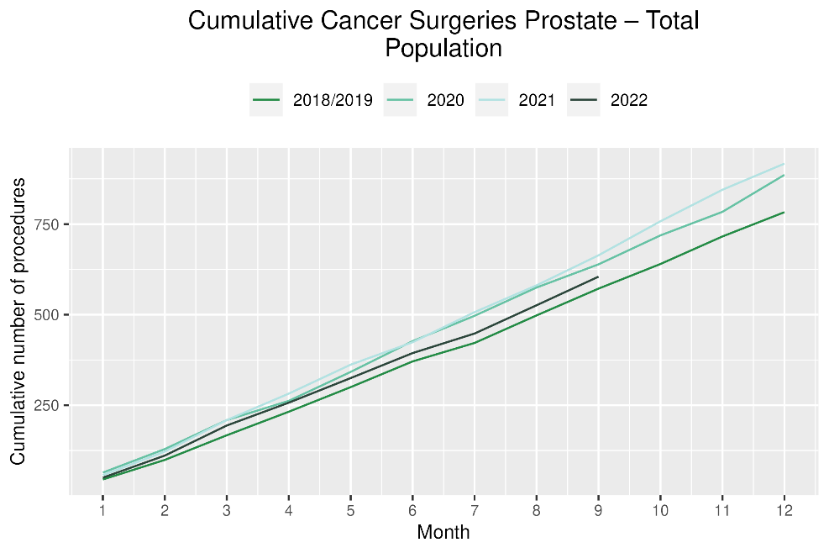 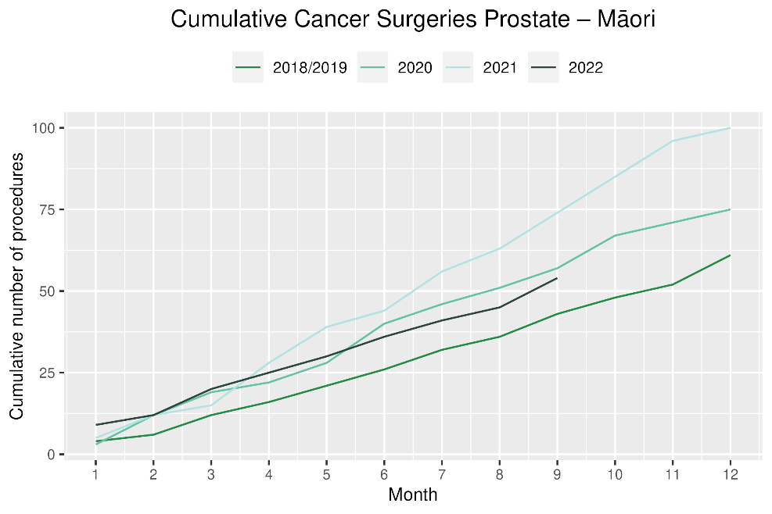

# Medical oncology

## Notes on data

* Data were extracted from NNPAC on 14 November 2022.
* First specialist assessment (FSA) reflects counts of first attendance for specialist medical oncology assessment.
* Intravenous (IV) chemotherapy reflects appointments for outpatient and inpatient IV chemotherapy for non-haematological indications.
* Technical information: medical oncology FSA (Purchase Unit Code: M50020) and IV chemotherapy (Purchase Unit Code: MS02009).

## Key points

* For 2022 to date (January to September), there was an overall 7% increase in medical oncology first specialist assessments (FSAs) compared with 2018/19 and a 12% increase for Māori.
* For 2022 to date, there was an 8% increase in IV chemotherapy attendances compared with 2018/19 overall and a 28% increase for Māori.
* Both FSAs and IV chemotherapy attendances showed decreases in July 2022 compared with 2018/19. Disruption seen in July aligns with the peak of winter illnesses including COVID-19 in July which then improved into September (see Appendix 1).

## Results

Table 13: Number of medical oncology first specialist assessments and percentage difference in 2022 compared to the average of 2018 and 2019, by month and cumulative year to date, by ethnicity

|  |  |  |  |  |  |  |  |  |  |  |  |  |
| --- | --- | --- | --- | --- | --- | --- | --- | --- | --- | --- | --- | --- |
|  | **July** | | | **August** | | | **September** | | | **Cumulative Jan-Sep** | | |
|  | **2018/2019** | **2022** | **% change** | **2018/2019** | **2022** | **% change** | **2018/2019** | **2022** | **% change** | **2018/2019** | **2022** | **% change** |
| Māori | 109 | 117 | 8% | 118 | 124 | 5% | 103 | 125 | 21% | 923 | 1,033 | 12% |
| Pacific Peoples | 40 | 46 | 15% | 43 | 43 | 0% | 31 | 49 | 58% | 315 | 389 | 23% |
| Non-Māori/Non-Pacific | 644 | 601 | -7% | 695 | 715 | 3% | 616 | 654 | 6% | 5,549 | 5,829 | 5% |
| Total Population | 792 | 764 | -4% | 856 | 882 | 3% | 750 | 828 | 10% | 6,787 | 7,251 | 7% |

Figure 12: Number of medical oncology first specialist assessments by month, 2018/19 average, 2020, 2021 and 2022, total population and Māori

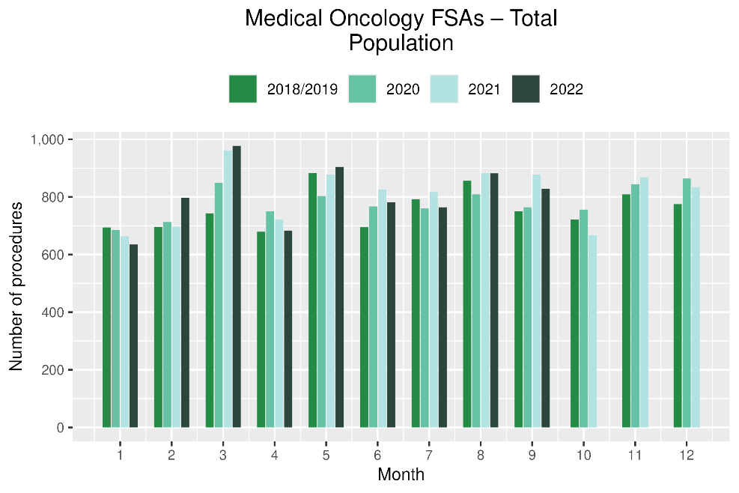 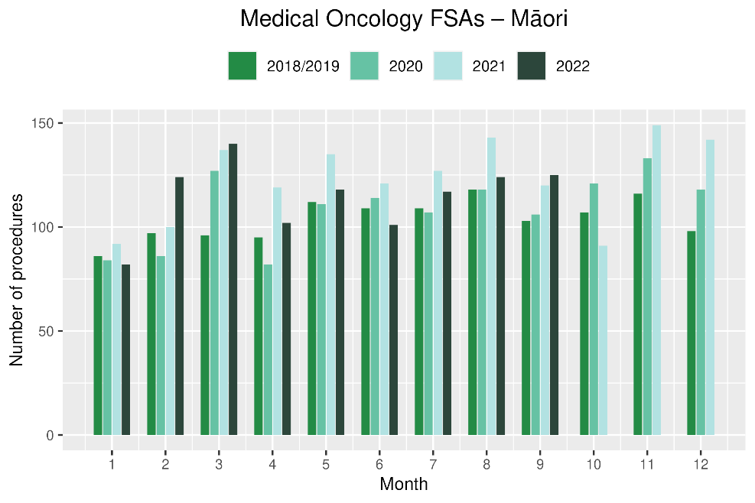

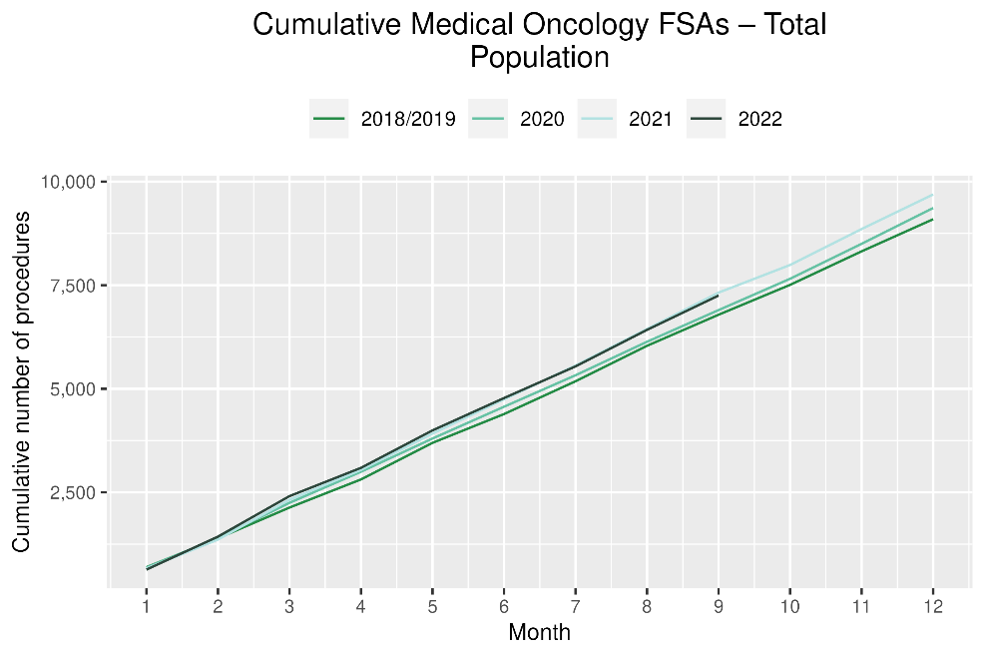 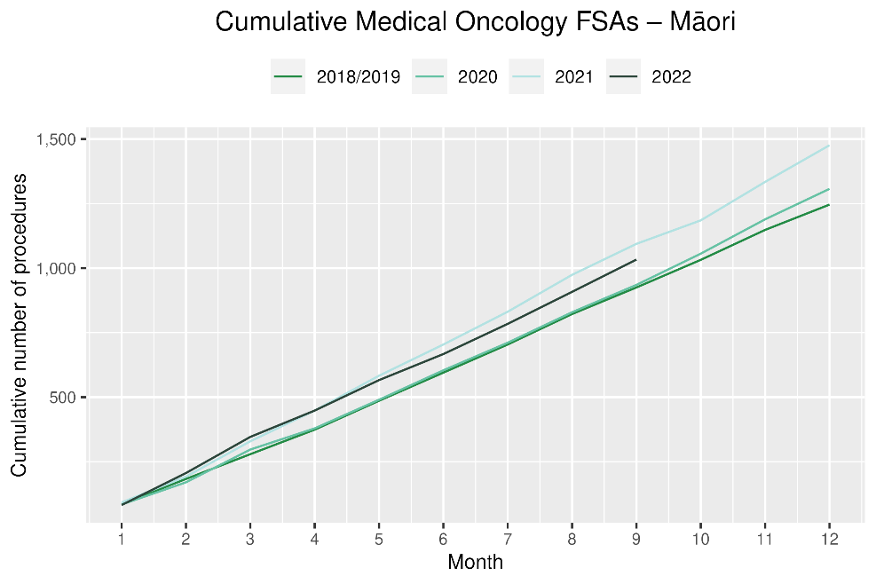

Table 14: Number of IV chemotherapy attendances and percentage difference in 2022 compared to the average of 2018 and 2019, by month and cumulative year to date, by ethnicity

|  |  |  |  |  |  |  |  |  |  |  |  |  |
| --- | --- | --- | --- | --- | --- | --- | --- | --- | --- | --- | --- | --- |
|  | **July** | | | **August** | | | **September** | | | **Cumulative Jan-Sep** | | |
|  | **2018/2019** | **2022** | **% change** | **2018/2019** | **2022** | **% change** | **2018/2019** | **2022** | **% change** | **2018/2019** | **2022** | **% change** |
| Māori | 821 | 887 | 8% | 837 | 1,019 | 22% | 779 | 925 | 19% | 6,649 | 8,490 | 28% |
| Pacific Peoples | 274 | 363 | 33% | 259 | 400 | 54% | 267 | 383 | 44% | 2,397 | 3,362 | 40% |
| Non-Māori/Non-Pacific | 5,246 | 4,741 | -10% | 5,371 | 5,393 | 0% | 4,980 | 5,049 | 1% | 44,513 | 45,740 | 3% |
| Total Population | 6,340 | 5,991 | -5% | 6,467 | 6,812 | 5% | 6,025 | 6,357 | 6% | 53,558 | 57,592 | 8% |

Figure 13: Number of IV chemotherapy attendances by month, 2018/19 average, 2020 and 2021, total population and Māori

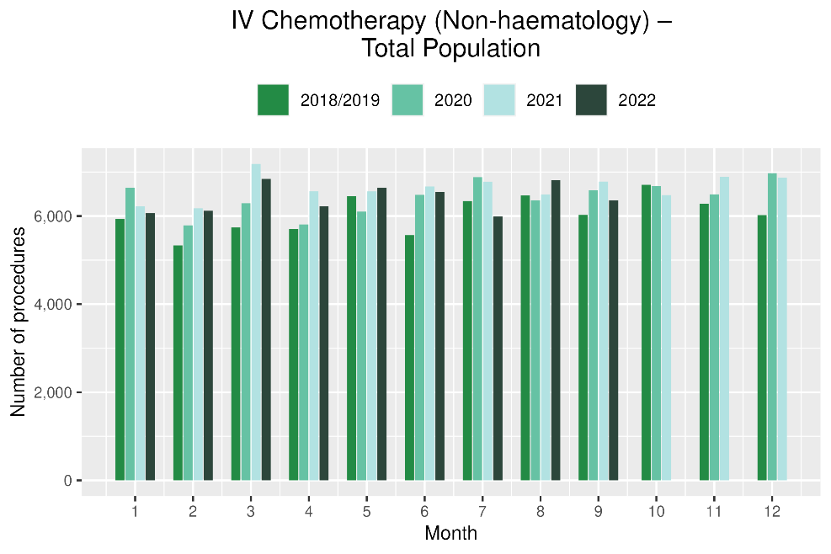 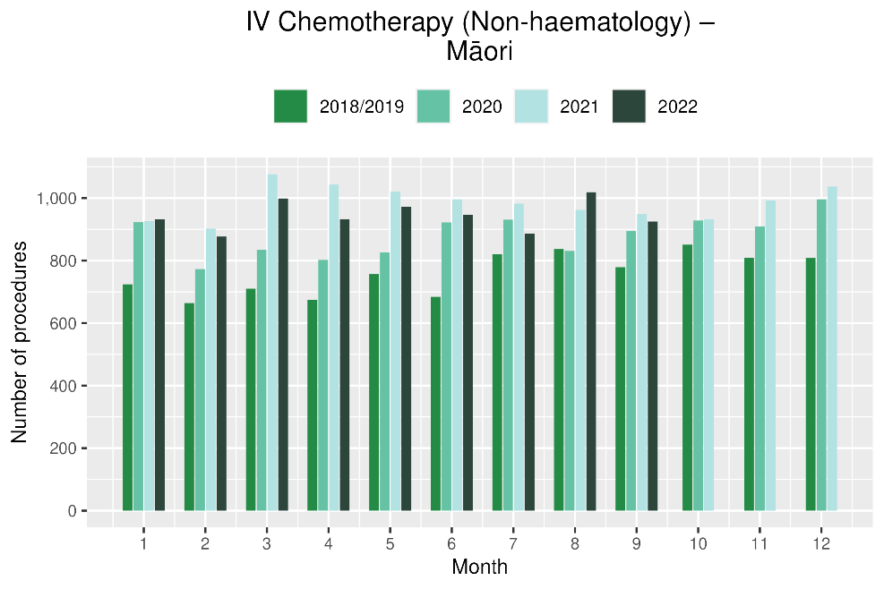

Figure 14: Cumulative number of attendances for IV chemotherapy, 2018/19 average, 2020 and 2021, total population and Māori

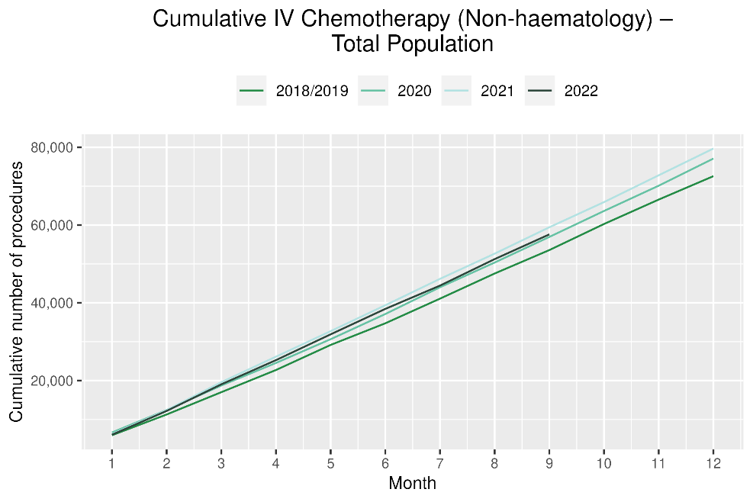 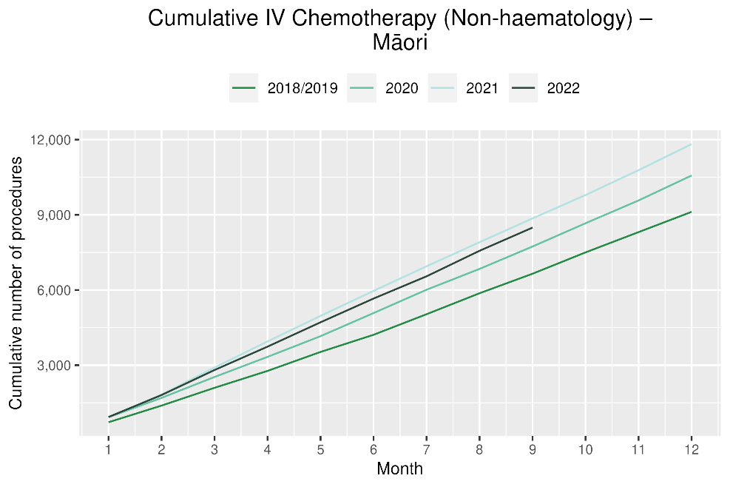

# Radiation oncology

## Notes on data

* Radiation oncology first specialist assessments and megavoltage attendances data were extracted from NNPAC on 14 November 2022.
* First specialist assessment (FSA) reflects counts of first attendance for radiation oncology specialist assessment.
* Radiation therapy attendances include appointments for planning/simulation and for treatment with radiation therapy on a linear accelerator.
* Radiation therapy courses data were extracted from Radiation Oncology Collection (ROC) on 14 November 2022. ROC is a national collection that contains diagnosis and treatment data for patients receiving radiation therapy from both the public and private providers. ROC is updated quarterly.
* A course of radiation therapy is a set of radiotherapy treatment(s) to a continuous or contiguous volume with a single intent from a single referral. A course can include multiple phases and multiple radiotherapy modalities. The monthly data here refers to the number of completed courses. The course starting date may not be in the same month.
* Radiation therapy course data reflect *completed* radiation therapy courses.
* Technical information: radiation oncology FSA (Purchase Unit Code: M50022), megavoltage attendances (Purchase Unit Code: M50025).

## Key points

* For 2022 to date, there was a 6% increase in radiation oncology first specialist assessments (FSAs) compared with 2018/19, with a 13% increase for Māori over this time period. The month of July saw a decrease of 5% compared with 2018/19. Disruption seen in July aligns with the peak of winter illnesses including COVID-19 in July which then improved into September (see Appendix 1).
* For 2022 to date, there was an 10% decrease in radiation therapy attendances overall and a 4% decrease for Māori. It is helpful to consider these results in relation to completed radiation therapy courses. This measure likely reflects trends in service volume over time better than radiation therapy attendance, as the increased use of hypofractionation[7] is likely to contribute to a decrease in the number of attendances required to complete a course of treatment.
* For 2022 to date, there was a decrease of 3% in completed radiation therapy courses. This appears to be improved compared to the previous report where there was a decrease of 7% as of June 2022 compared to 2018/19.
* For 2022 to date there was an increase of 8% for Māori in completed radiation therapy courses.

Table 15: Number of radiation oncology first specialist assessments and percentage difference in 2022 compared to the average of 2018 and 2019, by month and cumulative year to date, by ethnicity

|  |  |  |  |  |  |  |  |  |  |  |  |  |
| --- | --- | --- | --- | --- | --- | --- | --- | --- | --- | --- | --- | --- |
|  | **July** | | | **August** | | | **September** | | | **Cumulative Jan-Sep** | | |
|  | **2018/2019** | **2022** | **% change** | **2018/2019** | **2022** | **% change** | **2018/2019** | **2022** | **% change** | **2018/2019** | **2022** | **% change** |
| Māori | 124 | 144 | 17% | 141 | 180 | 28% | 118 | 110 | -6% | 1,054 | 1,189 | 13% |
| Pacific Peoples | 49 | 65 | 33% | 51 | 58 | 14% | 39 | 49 | 26% | 412 | 498 | 21% |
| Non-Māori/Non-Pacific | 926 | 837 | -10% | 884 | 1,002 | 13% | 812 | 879 | 8% | 7,506 | 7,790 | 4% |
| Total Population | 1,098 | 1,046 | -5% | 1,075 | 1,240 | 15% | 968 | 1,038 | 7% | 8,972 | 9,477 | 6% |

Figure 15: Number of radiation oncology first specialist assessments by month, 2018/19 average, 2020, 2021 and 2022, total population and Māori

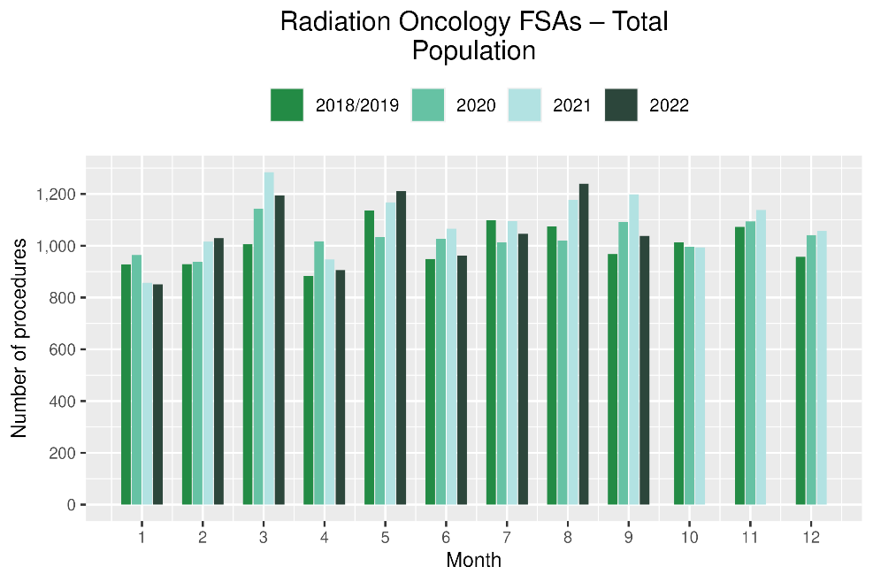 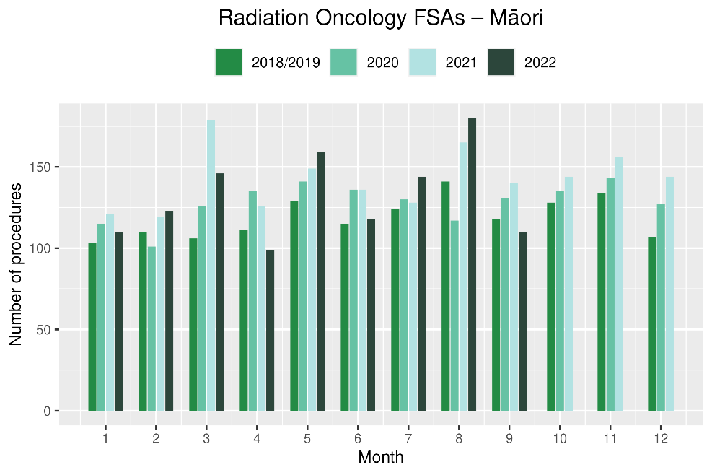

**Figure 16: Cumulative number of radiation oncology first specialist assessments by month, 2018/19 average, 2020, 2021 and 2022, total population and Māori**

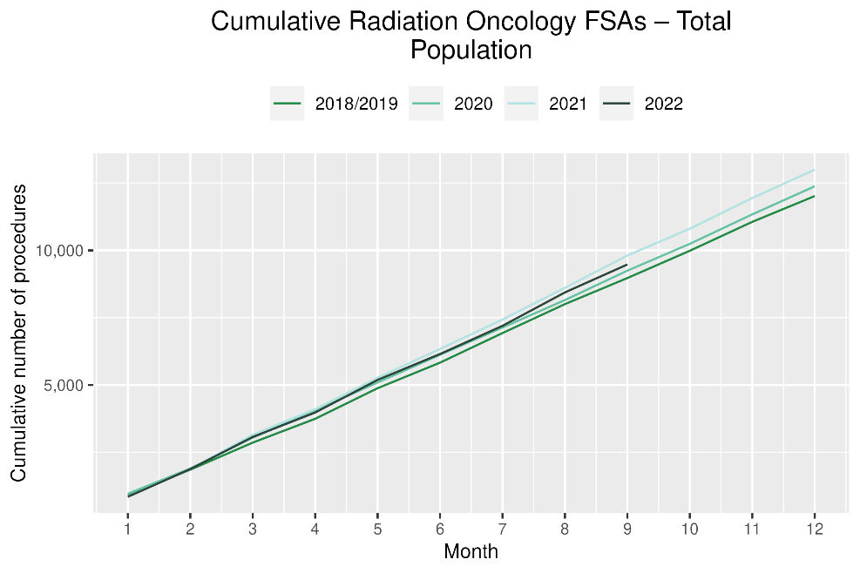 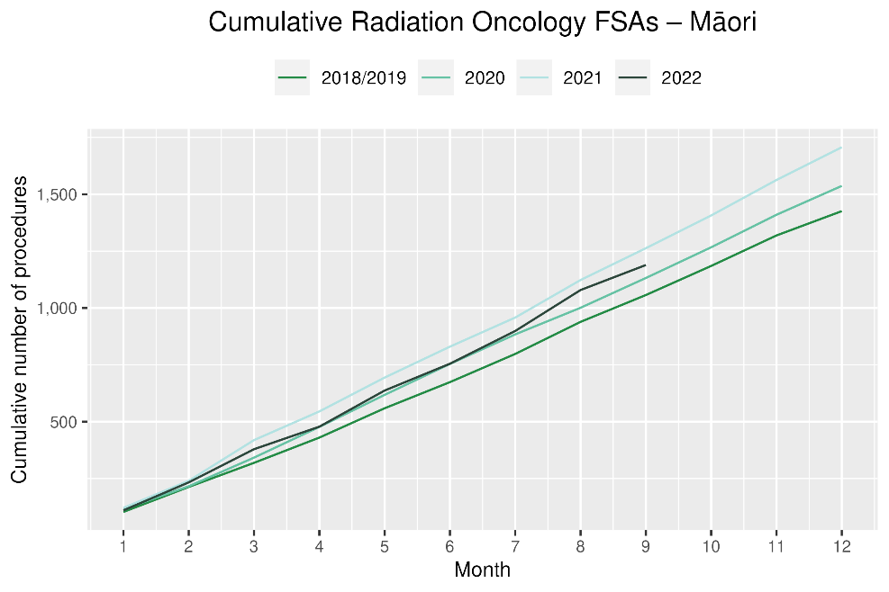

Table 16: Number of radiation therapy attendances and percentage difference in 2022 compared to the average of 2018 and 2019, by month and cumulative year to date, by ethnicity

|  |  |  |  |  |  |  |  |  |  |  |  |  |
| --- | --- | --- | --- | --- | --- | --- | --- | --- | --- | --- | --- | --- |
|  | **July** | | | **August** | | | **September** | | | **Cumulative Jan-Sep** | | |
|  | **2018/2019** | **2022** | **% change** | **2018/2019** | **2022** | **% change** | **2018/2019** | **2022** | **% change** | **2018/2019** | **2022** | **% change** |
| Māori | 1,987 | 1,583 | -20% | 1,922 | 1,761 | -8% | 1,712 | 1,984 | 16% | 15,906 | 15,331 | -4% |
| Pacific Peoples | 757 | 609 | -19% | 563 | 718 | 28% | 516 | 698 | 35% | 5,196 | 5,071 | -2% |
| Non-Māori/Non-Pacific | 11,906 | 10,066 | -15% | 11,846 | 11,632 | -2% | 11,074 | 10,773 | -3% | 104,324 | 93,087 | -11% |
| Total Population | 14,650 | 12,258 | -16% | 14,330 | 14,111 | -2% | 13,302 | 13,455 | 1% | 125,425 | 113,489 | -10% |

Figure 17: Number of radiation therapy attendances by month, 2018/19 average, 2020, 2021 and 2022, total population and Māori

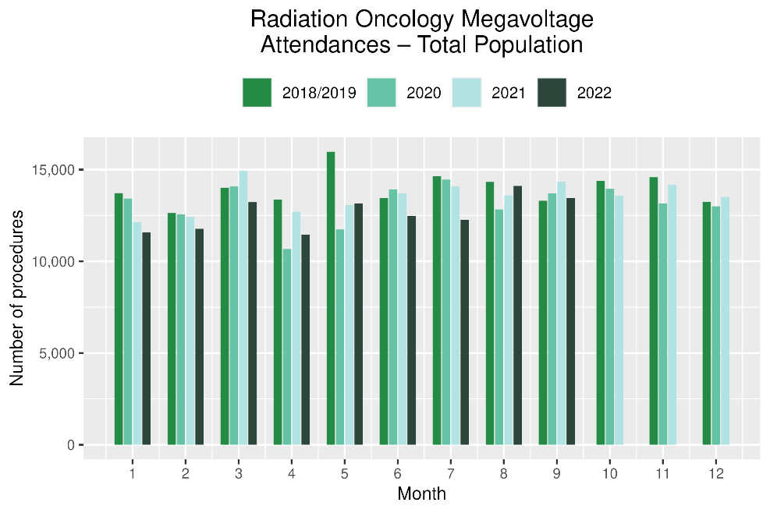 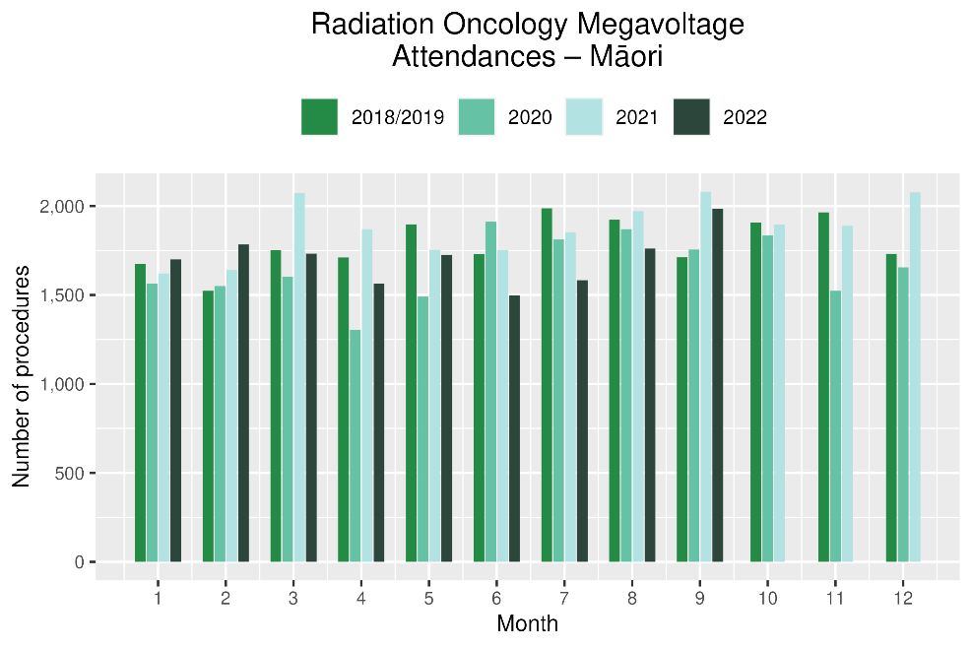

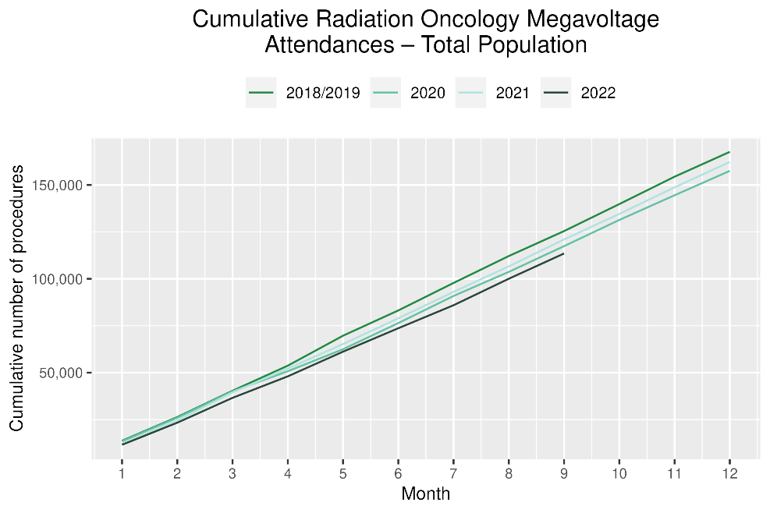 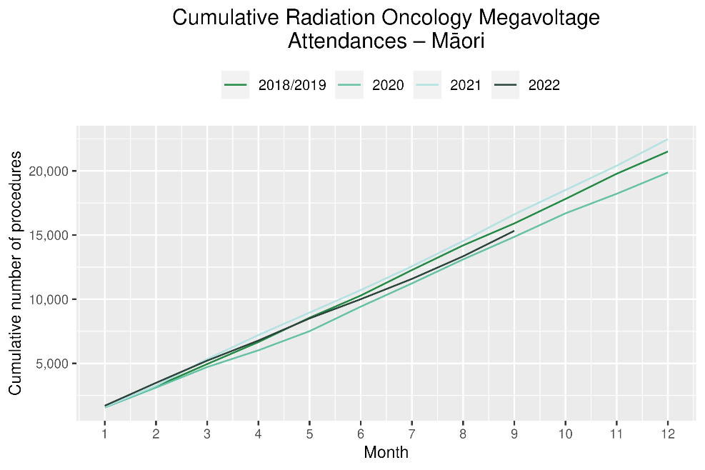

Table 17: Number of completed radiation therapy courses and percentage difference in 2022 compared to the average of 2018 and 2019, by month and cumulative year to date, by ethnicity

|  |  |  |  |  |  |  |  |  |  |  |  |  |
| --- | --- | --- | --- | --- | --- | --- | --- | --- | --- | --- | --- | --- |
|  | **July** | | | **August** | | | **September** | | | **Cumulative Jan-Sep** | | |
|  | **2018/2019** | **2022** | **% change** | **2018/2019** | **2022** | **% change** | **2018/2019** | **2022** | **% change** | **2018/2019** | **2022** | **% change** |
| Māori | 140 | 151 | 8% | 147 | 134 | -9% | 120 | 141 | 18% | 1,128 | 1,219 | 8% |
| Pacific Peoples | 59 | 50 | -15% | 49 | 50 | 3% | 41 | 43 | 6% | 394 | 388 | -2% |
| Non-Māori/Non-Pacific | 861 | 836 | -3% | 895 | 819 | -8% | 821 | 810 | -1% | 7,600 | 7,197 | -5% |
| Total Population | 1,059 | 1,037 | -2% | 1,091 | 1,003 | -8% | 981 | 994 | 1% | 9,122 | 8,804 | -3% |

Figure 20: Number of completed radiation therapy courses by month, 2018/19 average, 2020, 2021 and 2022, total population and Māori

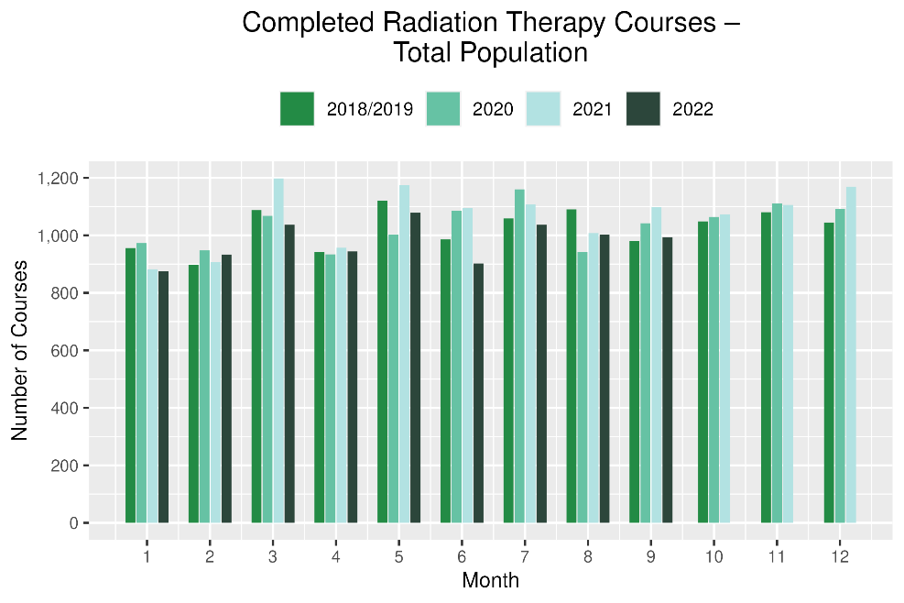 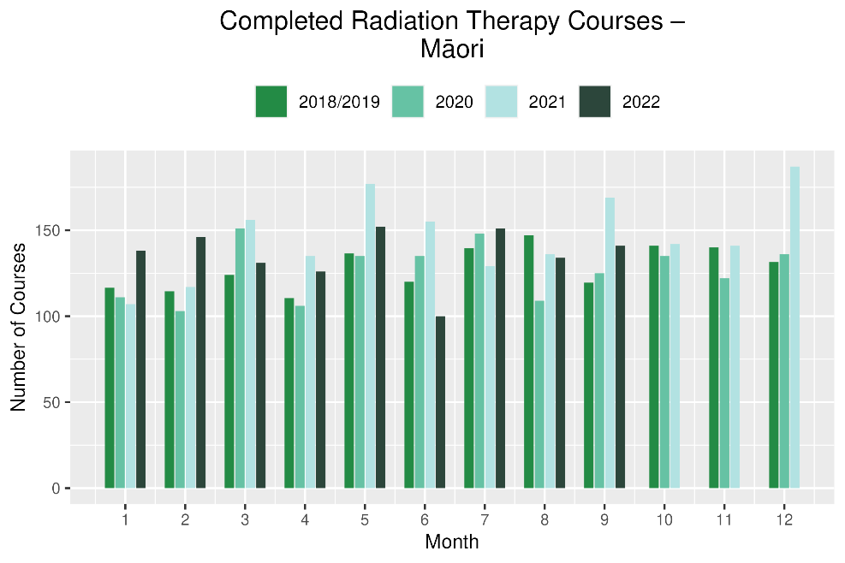

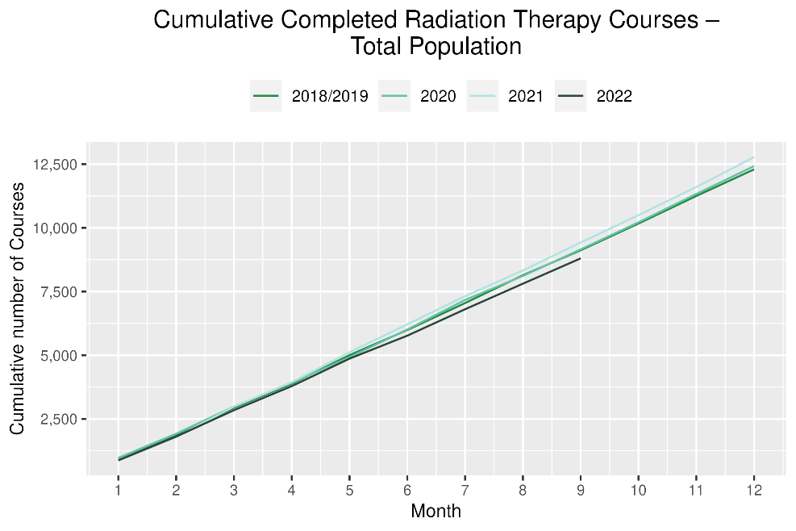 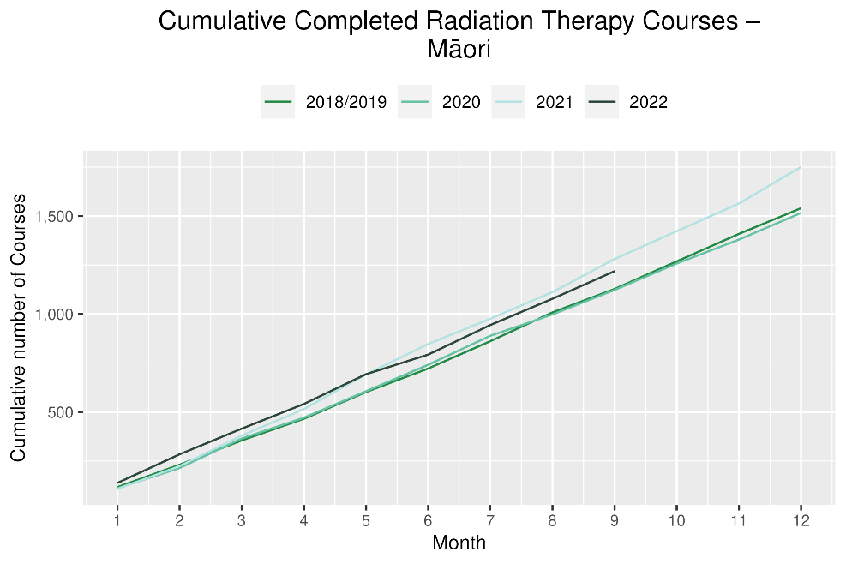

# Haematology

## Notes on data

* Data were extracted from NNPAC and NMDS on 14 November 2022.
* First specialist assessment (FSA) reflects counts of first attendance for specialist haematology assessment for any indication, not just cancer.
* IV chemotherapy reflects appointments for IV chemotherapy for haematological malignancies.
* Technical information: Haematology FSA (Purchase Unite Code: M30002), IV haem/chemo (Purchase Unit Code: M30020).

## Key points

* For 2022 to date, there was a 2% decrease in haematology first specialist assessments (FSAs) compared with 2018/19, and for Māori there was an 8% increase. The decrease has improved compared to the previous report where there was an 11% decrease overall for FSAs until June 2022, noting the increase in FSAs for the months of August and September 2022 (Table 18). FSAs showed a decrease of 17% in July 2022 compared with 2018/19.
* For 2022 to date, there was a 5% increase in haematology intravenous (IV) chemotherapy compared with 2018/19 overall and for Māori an increase of 8%. July showed a decrease of 17% compared to 2018/19 which was not seen in September.
* Disruption seen in July aligns with the peak of winter illnesses including COVID-19 in July which then improved into September (see Appendix 1).

## Results

Table 18: Number of haematology first specialist assessment attendances and percentage difference in 2022 compared to the average of 2018 and 2019, by month and cumulative year to date, by ethnicity

|  |  |  |  |  |  |  |  |  |  |  |  |  |
| --- | --- | --- | --- | --- | --- | --- | --- | --- | --- | --- | --- | --- |
|  | **July** | | | **August** | | | **September** | | | **Cumulative Jan-Sep** | | |
|  | **2018/2019** | **2022** | **% change** | **2018/2019** | **2022** | **% change** | **2018/2019** | **2022** | **% change** | **2018/2019** | **2022** | **% change** |
| Māori | 55 | 58 | 5% | 51 | 76 | 49% | 59 | 69 | 17% | 496 | 538 | 8% |
| Pacific Peoples | 26 | 25 | -2% | 30 | 32 | 8% | 26 | 29 | 14% | 240 | 283 | 18% |
| Non-Māori/Non-Pacific | 455 | 364 | -20% | 511 | 539 | 6% | 434 | 488 | 13% | 4,126 | 3,926 | -5% |
| Total Population | 536 | 447 | -17% | 591 | 647 | 9% | 518 | 586 | 13% | 4,862 | 4,747 | -2% |

Figure 18: Number of haematology first specialist assessments by month, 2018/19 average, 2020, 2021 and 2022, total population and Māori

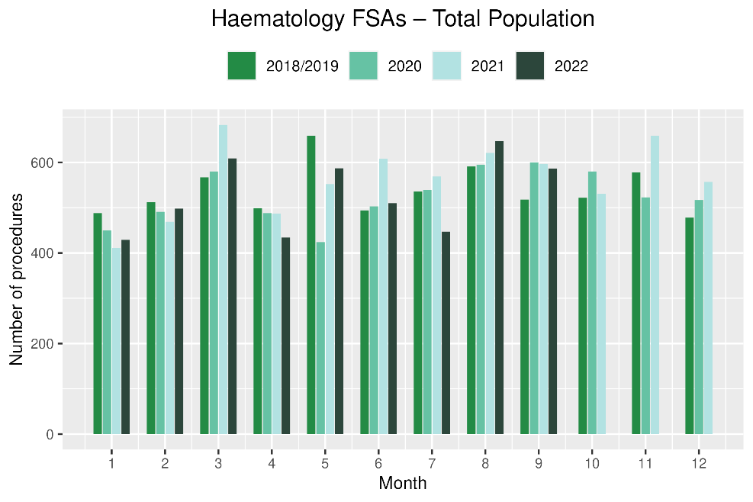 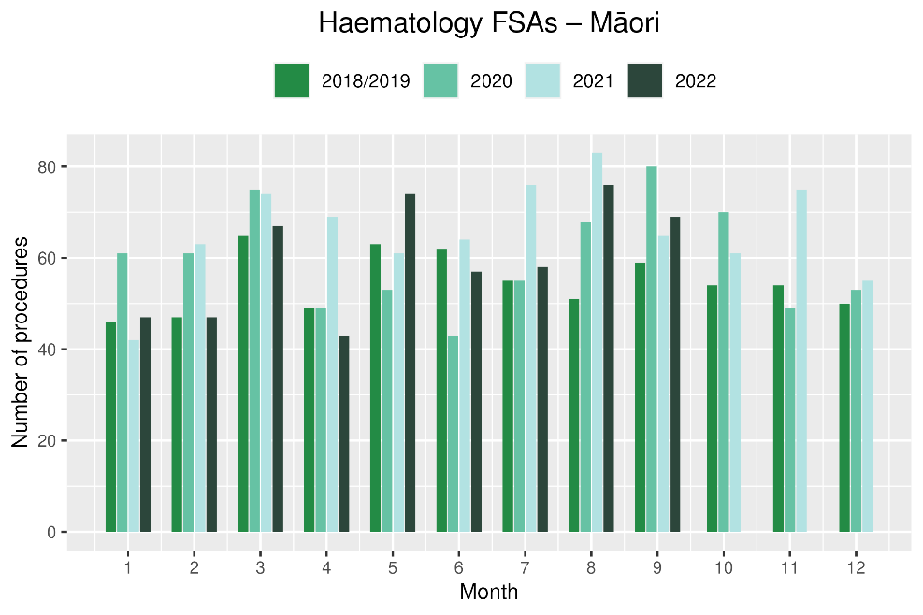

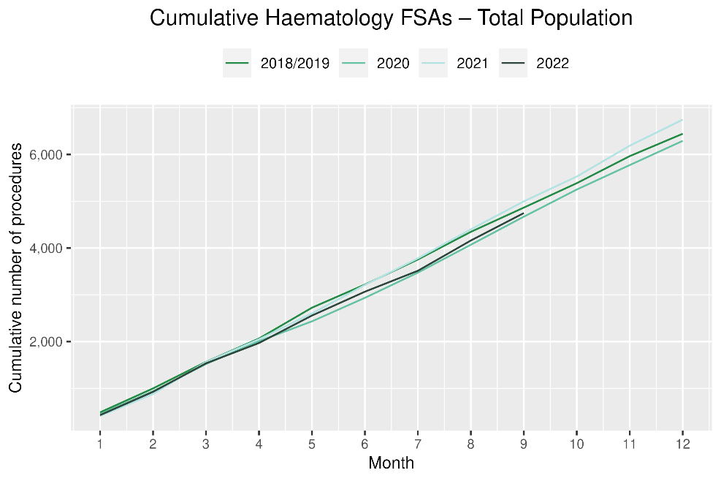 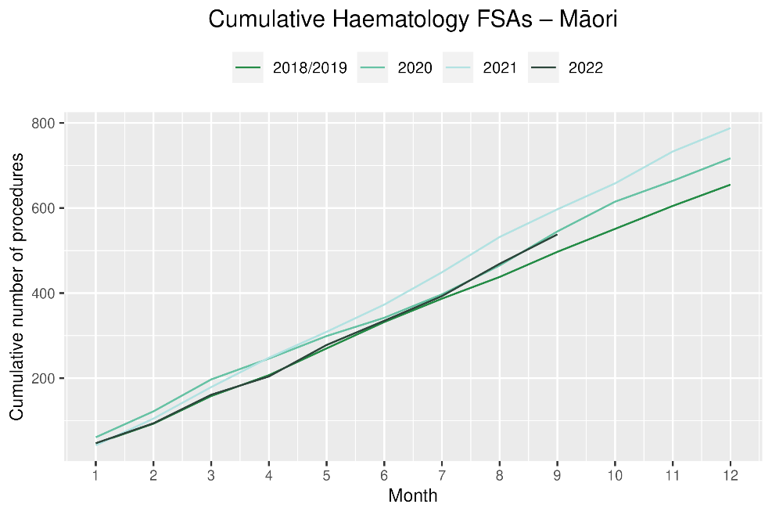

**Table 19: Number of IV chemotherapy attendances for haematological malignancies and percentage difference in 2022 compared to the average of 2018 and 2019, by month and cumulative year to date, by ethnicity**

|  |  |  |  |  |  |  |  |  |  |  |  |  |
| --- | --- | --- | --- | --- | --- | --- | --- | --- | --- | --- | --- | --- |
|  | **July** | | | **August** | | | **September** | | | **Cumulative Jan-Sep** | | |
|  | **2018/2019** | **2022** | **% change** | **2018/2019** | **2022** | **% change** | **2018/2019** | **2022** | **% change** | **2018/2019** | **2022** | **% change** |
| Māori | 230 | 215 | -6% | 226 | 238 | 5% | 208 | 255 | 23% | 1,844 | 1,995 | 8% |
| Pacific Peoples | 114 | 87 | -23% | 112 | 116 | 4% | 101 | 101 | 0% | 905 | 962 | 6% |
| Non-Māori/Non-Pacific | 1,883 | 1,545 | -18% | 1,889 | 1,848 | -2% | 1,744 | 1,797 | 3% | 15,399 | 16,178 | 5% |
| Total Population | 2,226 | 1,847 | -17% | 2,227 | 2,202 | -1% | 2,053 | 2,153 | 5% | 18,148 | 19,135 | 5% |

Figure 19: Number of attendances for IV chemotherapy for haematological malignancies by month, 2018/19 average, 2020, 2021 and 2022, total population and Māori

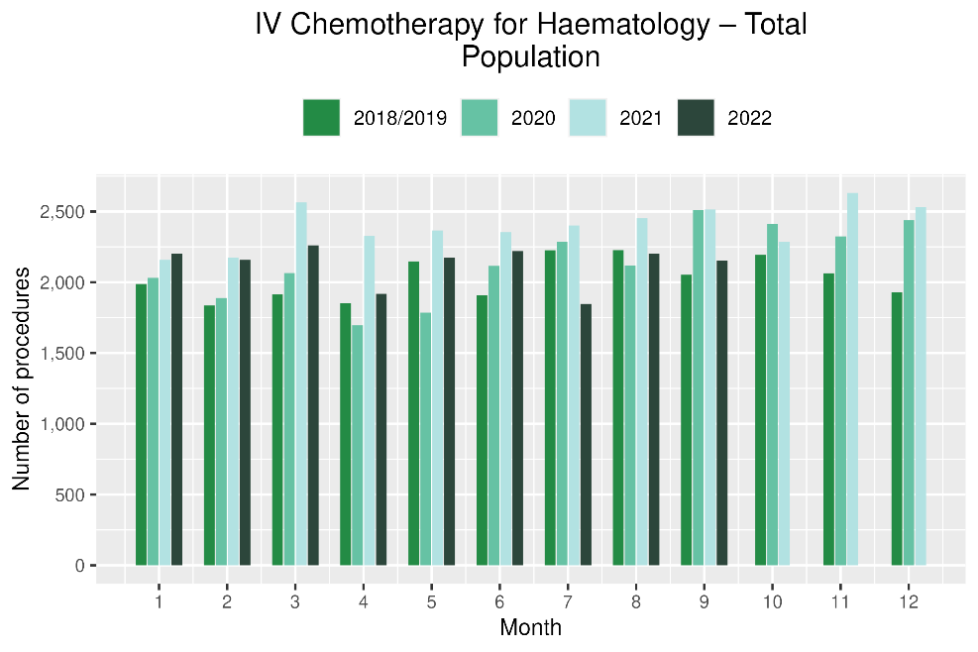 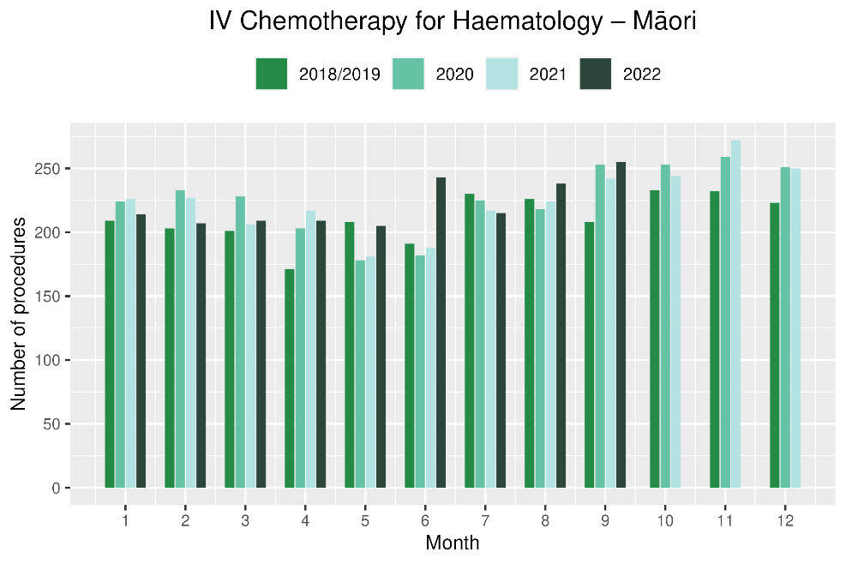

Figure 20: Cumulative number of attendances for IV chemotherapy for haematological malignancies, 2018/19 average, 2020, 2021 and 2022, total population and Māori

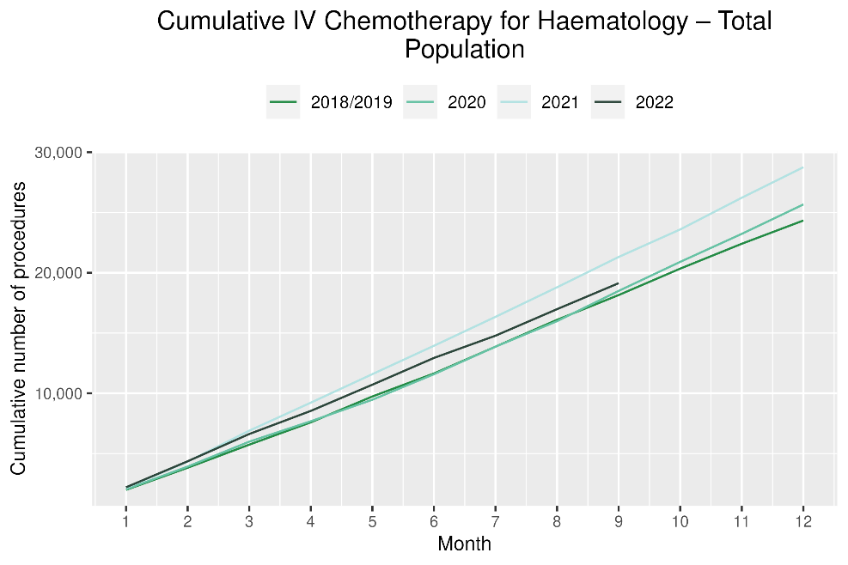 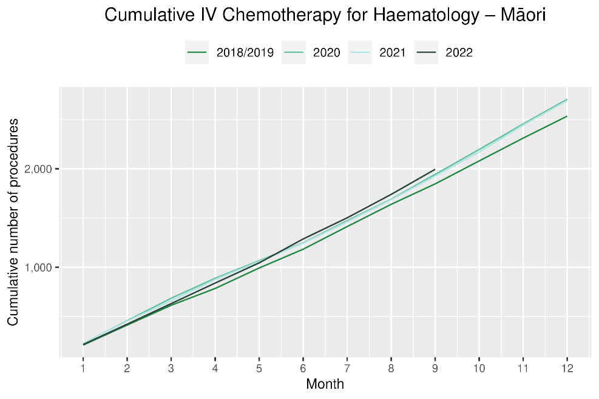

# Focus on Lung Cancer

## Introduction

As He Pūrongo Mate Pukupuku o Aotearoa|The State of Cancer in New Zealand 2020 report outlines, lung cancer is the most significant cancer for Māori in terms of mortality and is one of the largest contributors to inequity in mortality between Māori and non-Māori[8].

Previous Te Aho o Te Kahu COVID-19 and cancer reporting has identified potential disruption in bronchoscopy for the total population[9]. Work undertaken by Te Aho o Te Kahu and published in the New Zealand Medical Journal (NZMJ) showed a downtrend in lung cancer registrations and disparities in bronchoscopy rates for Māori in 2020 compared to pre-pandemic years (2018 and 2019), but no such disruption to registrations and service for other cancers[10]. In addition, more recent Te Aho o Te Kahu COVID-19 and cancer reporting using data up to June 2022 indicated lower volumes of lung cancer surgery for Māori[11].

This section of the report updated the data presented in the NZMJ paper with data from 2021, to allow further examination of disparities in detection, diagnosis and treatment for Māori over the COVID-19 pandemic period.

## Notes on methods

* Full details of methods used in this section can be found in the NZMJ paper by Gurney et al.10 with the exception of CT lung biopsy.
* Age-standardisation was performed using the 2001 Māori Census population.[12]
* Age-standardised graphs are used for comparison between ethnicities rather than as a standalone assessment of one ethnicity, therefore each graph in this section should be interpreted as a comparison between Māori and non-Māori/non-Pacific peoples.
* The numerators included in this section are cancer registrations, bronchoscopies, CT lung biopsies and lung cancer surgeries.
* The denominator is the total estimated residential population. The analysis used Stats NZ custom population projections as the denominator, mean year ended June 2018, 2019, 2020 and 2021.
* For the purposes of this analysis, in order to ensure an adequate volume of data we only included two ethnic group classifications: Māori and non-Māori/non-Pacific (ie, primarily the European/Pākehā population).
* Lung cancer surgical procedure codes are listed in Appendix 5.

## Results and discussion

### Registrations

* Overall, as anticipated, the rate of registration for Māori was notably higher than non-Māori/non-Pacific across all years.
* Lung cancer registrations were lower in both 2020 and 2021 for Māori than for 2018/2019 (Figure 21). In contrast, there was little difference in registration rates for non-Māori/non-Pacific peoples across the 2018-2021 period. As noted in the NZMJ paper, this downturn in lung cancer registrations in 2020 largely coincided with the first national lockdown from late-March 2020[13]. In 2021, the downturn in lung cancer registrations appears to coincide with the Level 3 and Level 4 lockdowns associated with the outbreak of the Delta variant (see Key Dates in Appendix 1). In combination, these observations suggest that the diagnosis of lung cancer for Māori was negatively impacted by the COVID-19 lockdowns.
* Figure 22 shows a similar distribution of stage of disease at diagnosis for both Māori and non-Māori/non-Pacific across the four years, with the possibility of a marginal increase in the relative proportion of Māori being diagnosed with advanced cancer (49%) relative to non-Māori/non-Pacific (43%). However, given the high proportion of unstaged lung cancers on the NZ Cancer Registry, it is difficult to adequately determine whether a shift in stage of disease at diagnosis has occurred, and also whether such a shift has occurred inequitably by ethnicity.

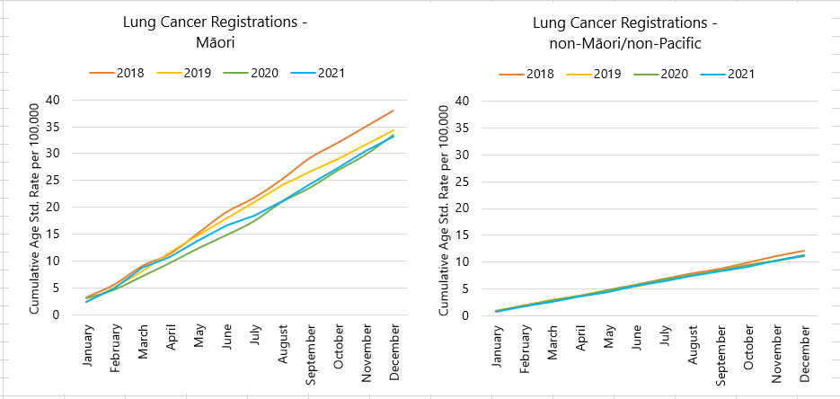

Figure 21 Cumulative age-standardised rate of lung cancer registrations by month and year (2018-2021) per 100,000 New Zealanders, for Māori (left) and non-Māori/non-Pacific (right)

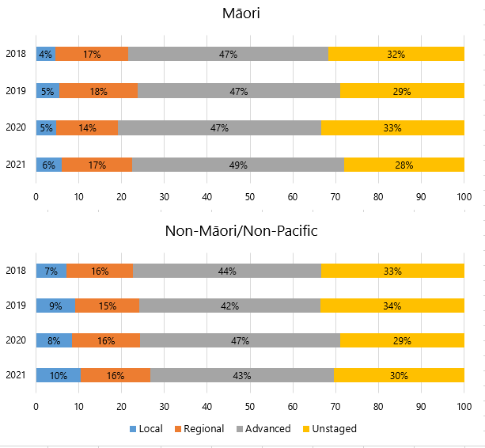

Figure 22 Stacked bar chart showing crude distribution of local, regional, advance and unstaged lung cancer on the New Zealand Cancer Registry, by year (2018-2020), for Māori and non-Māori/non-Pacific patients

### Diagnosis: Bronchoscopy

* In 2020 there was a decrease in rates of bronchoscopy for Māori and non-Māori/non-Pacific, particularly early in the first lockdown period in March (Figure 23). The first half of 2021 saw bronchoscopy rates comparable to 2019, with a flattening of the trend over the second half of the year largely coinciding with the lockdowns associated with the Delta variant outbreak. As a result, by the end of the year the total bronchoscopy rate for Māori in 2021 was largely similar to that of 2020.
* As noted in the bronchoscopy section of this report, this method of diagnosis has likely been used less during the COVID-19 pandemic due to the risk of aerosol spread. The data used for this measure covers all bronchoscopies, not just those completed for cancer, and it is possible that non-cancer reasons for bronchoscopy have been reduced and/or that people with suspicion of cancer have been offered other methods of diagnosis. CT biopsy is one such method that is captured in this report; however, as noted earlier, robust data are not available for all diagnostic procedures.

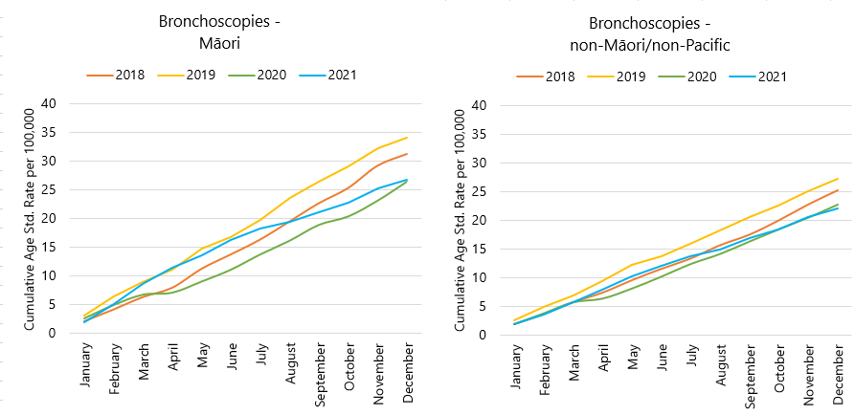

Figure 23 Cumulative age-standardised rate of bronchoscopy by month and year (2018-2021) per 100,000 New Zealanders, for Māori (left) and non-Māori/non-Pacific (right)

### Diagnosis: CT lung biopsy

* The cumulative rate of CT lung biopsy was substantially lower than the rate of bronchoscopy across all years (Figure 24). Rates of CT lung biopsy were higher for Māori than they were for non-Māori/non-Pacific.
* For both Māori and non-Māori/non-Pacific, the majority of the year of 2020 saw lower rates of CT lung biopsy compared with 2018 and 2019 although there appeared to be an increase in the final months of the year to match the rates in 2018. In 2021, rates of CT lung biopsy appeared similar to those performed in 2018 and 2019. Trends were similar for non-Māori/non-Pacific peoples.

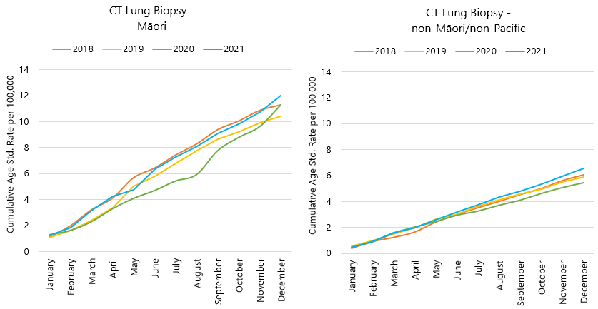

Figure 24 Cumulative age-standardised rate of CT lung biopsy by month and year (2018-2021) per 100,000 New Zealanders, for Māori (left) and non-Māori/non-Pacific (right)

### Surgery

* There was overall a higher rate of lung cancer surgery for Māori compared to non-Māori/non-Pacific (Figure 25), in line with the higher incidence for Māori of this cancer.
* The rate for Māori is increased in 2021 compared to 2020, although there was a flattening of the trend mid-year. However, small numbers of lung cancer surgery for Māori makes it challenging to interpret these findings in detail.
* Of note, the rate of lung cancer surgery for non-Māori/non-Pacific peoples in Figure 25 appears lower in 2021 compared to other years. As this rate is age-standardised to the 2001 Māori population, this finding reflects a difference in the age distribution of non-Māori/non-Pacific peoples receiving lung cancer surgery rather than a true decrease in volumes. The Lung Cancer section earlier in the report shows that volumes for the overall population are largely unchanged for 2021.

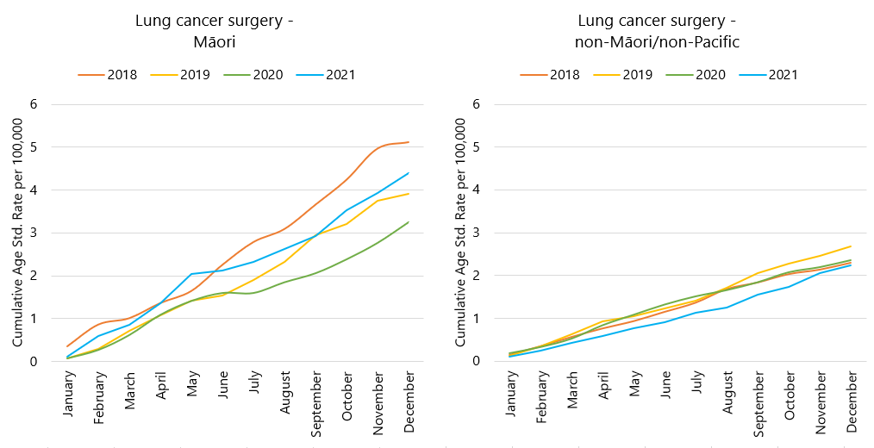

Figure Cumulative age-standardised rate of lung cancer surgeries by month and year (2018-2021) per 100,000 New Zealanders, for Māori (left) and non-Māori/non-Pacific (right)

## Summary of key points

This section of the current report builds on the findings published by Te Aho o Te Kahu in the NZMJ[14], where a downturn in cancer registrations was apparent for Māori but not non-Māori/non-Pacific. The rate of lung cancer registration for Māori in 2021 was similarly lower than that observed prior to the pandemic, with some flattening off during the course of the year. For bronchoscopy, the 2021 rate for Māori was higher than 2020 for the first part of the year but flattened from around mid-year. The timing of the downturn in registrations and bronchoscopy procedures is highly suggestive that these were affected by lockdowns that began in mid-2021.

It is possible that there were more Māori in 2021 than the previous 3 years with an advanced stage of lung cancer at the time of diagnosis, although the large proportion in the unstaged category makes it challenging to interpret. Te Aho o Te Kahu is looking at the feasibility of an investigation into whether a shift in stage of disease at diagnosis has occurred over the pandemic.

There was overall a higher rate of lung cancer surgery for Māori compared to non-Māori/non-Pacific, in line with the higher incidence for Māori of this cancer. The rate for Māori is increased in 2021 compared to 2020, although there was a flattening of the trend mid-year. However, small numbers of lung cancer surgery for Māori, makes it challenging to interpret these findings in detail.

## Government action to reduce inequities in lung cancer

In light of the above examples of the possible differential impact of the COVID-19 pandemic on access to lung cancer services for Māori, it is worthwhile to summarise the actions that are currently underway to reduce inequities in lung cancer outcomes for Māori in general.

### The National Lung Cancer Working Group

Te Aho o Te Kahu currently convenes the National Lung Cancer Working Group which brings together a range of clinicians, consumers, and Māori from across the motu to provide their expert input to ensure a consistent and equitable approach to timely and quality care for lung cancer patients.

### Lung cancer quality performance indicators

Quality performance indicators (QPIs) are used to improve the quality of cancer services and deliver better outcomes for people diagnosed with cancer. This Te Aho o Te Kahu programme develops, calculates, and reports on QPIs using national data collections. The data includes ethnicity data stratification and is presented in a way that allows for comparisons between districts with the intention that districts can identify unwarranted variation and implement quality improvement strategies as required.

The lung cancer QPI work was drafted and published with the support and advice of the National Lung Cancer Working Group and developed in partnership with the cancer sector.

### Reducing the incidence of lung cancer via tobacco control

The Smokefree 2025 Action Plan was launched in December 2021. Key areas in the Action Plan are:

* Māori leadership and decision-making
* health promotion and community mobilisation
* support for people to quit
* mandating low-level nicotine smoked tobacco products to make them non-addictive
* reducing the number of shops selling smoked tobacco products and implementing a smokefree generation (those born from 1 January 2009 will never be able to lawfully be sold smoked tobacco products)
* better compliance and enforcement

The Smokefree Environments and Regulated Products (Smoked Tobacco) Amendment Bill (the Bill) was introduced to Parliament on 21 June 2022[15].

The Bill introduces three key legislative changes: reducing retail availability, amending the age limits for sale of smoked tobacco products and reducing the appeal and addictiveness of smoked tobacco products. A specific provision provides for a regulation-making power to set limits on the quantity of nicotine levels and other constituents of smoked tobacco products.

The intent of these provisions is to increase the number of people who successfully stop smoking, and support tamariki/young people to remain smokefree, by making smoked tobacco products less appealing and addictive.

### Primary care

Early diagnosis can have a significant impact on lung cancer outcomes. To support primacy care providers, the Agency commissioned Best Practice Advocacy Centre NZ (BPAC) to develop journal articles on the early detection of lung cancer in primary care and lung cancer follow-up and surveillance. BPAC articles have a wide reach and are read by approximately 11 thousand clinicians.

In addition, the Agency has partnered with the Goodfellow Institute and delivered a webinar in November 2022 to support knowledge and awareness of the early detection of lung cancer within the primary care sector and gave updates on developments in lung cancer management.

### Preliminary work into lung cancer screening

There is growing evidence that screening asymptomatic people at high risk of lung cancer (people who smoke heavily or have previously smoked heavily) using low-dose computer tomography can reduce mortality by identifying lung cancer at an earlier stage - when it is more treatable. A modelling study from Aotearoa has also shown such a lung cancer screening programme is likely to be cost-effective, especially for Māori[16].

The National Screening Advisory Committee (which provides leadership and strategic direction for national population-based screening programmes) considered the evidence for lung cancer screening in November 2020. Their overall position was supportive of the development of lung cancer screening. Minister Little indicated his support for ongoing work in this area in April 2021.

Any potential lung cancer screening programme in Aotearoa must be designed to be pro-equity from the outset and have high and equitable participation and leadership by Māori. Several information gaps need to be filled including recruitment/invitation strategies to achieve high participation in priority populations, strategies to accurately identify high-risk populations, diagnostic and treatment pathways that maximise benefit and minimise harm and ensuring adequate health system capacity.

There is also a Māori-led trial of lung cancer screening in the Waitematā and Auckland districts, led by University of Otago senior Māori health researcher Professor Sue Crengle (Kāi Tahu, Kāti Māmoe, Waitaha). This research is investigating a key factor in participation in a future screening programme: invitation pathways.

### Medicines for lung cancer

Te Pātaka Whaioranga – Pharmac funds a number of treatments for lung cancer and recently has either approved funding or communicated the potential funding of further medicines associated with substantial clinical benefit for people with lung cancer: durvalumab for moderate stage lung cancer, and immunotherapies for late-stage lung cancer. As Pharmac’s report on equity of access to medicine in Aotearoa notes, equitable access is broader than availability alone and includes complex issues such as access to medical assessment and pharmacy services[17].

# Appendix 1: Key Dates

The follow provides a brief overview of key dates relating to COVID-19 restrictions (Alert Levels 3 and 4 where the greatest restrictions were in place) and outbreaks. More detailed information can be found on the Unite COVID-19 website[18], including an overview of Alert Levels and the COVID-19 Protection Framework (traffic lights)[19].

|  |  |
| --- | --- |
| 23 March – 14 May 2020 | All Aotearoa New Zealand was at Alert Level 3 or 4 |
| 12 August – 30 September 2020 | Auckland only moved to Alert Level 3 |
| 28 Feb – 7 March 2021 | Auckland only was at Alert Level 3 |
| 17 August to 7 September 2021 | All Aotearoa New Zealand was at Alert 3 or 4 at the outset of the Delta variant outbreak |
| From 7 September 2021 | Auckland remained at Alert Level 4; the rest of the country moved to Alert Level 2 |
| September – December 2021 | Auckland moved to and remained at Alert Level 3 from 21 September. There were various regional changes between Alert Level 2 and 3 over this period some parts of the North Island including parts of Waikato. Details are available on the Unite COVID-19 website4. Note: The definition of Alert Level 3 was eased in early October and three gradually reducing steps of level 3 were introduced in October |
| 3 Dec 2021 | End of COVID-19 Alert System. All Aotearoa New Zealand moved to the COVID-19 Protection Framework (traffic lights) |
| 29 Dec 2021 | The first case of the Omicron variant in the community in New Zealand was detected |
| February 2022  10 March 2022  23 March 2022 | Omicron case numbers and hospitalisations increased more significantly in the second half of February onwards[20]  Seven day rolling average of cases is over 20,000, while daily count reaches over 23,000. This was the peak of case numbers at the time of writing.  Changes were made to the *red-light* setting: no limitations on numbers of people gathering outdoors, indoors limit increase to 2000 people. |
| 14 April 2022 | New Zealand moved to the o*range* traffic light setting: indoor venue capacity rules are removed but facemasks are still required in most indoor venues. |
| April – September 2022 | Continued Omicron outbreak. There were over 20,000 cases at the peak of the first Omicron wave in late February and over 11,000 cases at the peak of the second wave in mid-July before a downward trend into September 2022. See Figure 21. The ‘traffic light’ system ended in September 2022. |

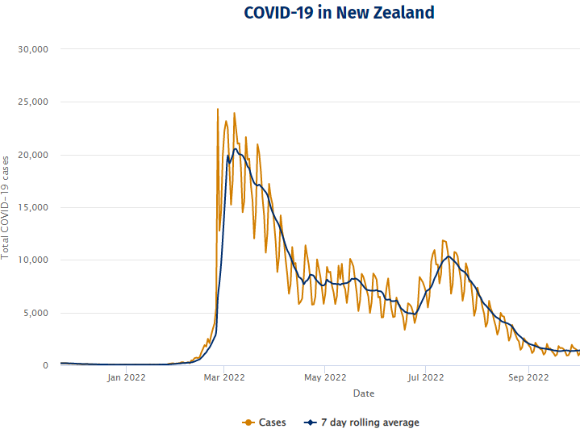

Figure 26 New reported COVID-19 cases and 7 day rolling average, Aotearoa New Zealand. Source: Unite Against COVID-19, accessed November 22 2022, <https://covid19.health.nz/advice/covid-19-data>

# Appendix 2: NZCR data information

## The New Zealand Cancer Registry as a data source for new cancer diagnoses

Cancer registration is a process where data is collated from multiple sources about people diagnosed with cancer and rules are applied to determine the type of cancer they have. This information is recorded in the New Zealand Cancer Registry. Each tumour is classified using an international World Health Organization standard so that cancer incidence can be compared between countries. The tumour is staged based on all the information available within 4 months of diagnosis. This process may take up to six months or more depending on the number of missing reports that need to be followed up with laboratories.

For each registration there may be multiple pathology reports as there may be multiple procedures performed on the tumour. This means there will be more than one registration for people diagnosed with more than one type of tumour.

Cancer registrations come from pathology laboratories, haematology laboratories, mortality records and reviewing hospital discharge records. Laboratory reports provide the best source of near real time data to monitor new diagnoses of cancer in New Zealand.

## Pathology reports as a data source for providing near real time monitoring of cancer diagnoses

Pathology reports (documents) are received by the NZCR as electronic messages. An administrator triages these documents each day and if the document appears to meet the requirements for registration the document is “administered”. The document may relate to an existing registration or may contain information for a new cancer event. Documents that do not meet the cancer reporting requirements will be marked as “deleted”, “rejected” or “agreed not for registration”.

The administrator creates a new provisional cancer event if the pathology report identifies a new cancer diagnosis for this person. This new cancer event is assigned to a cancer group and this provisional event is then queued for further assessment by a clinical coder. If the required information has been provided the coder creates a new registration. If some information is not yet available, then the registration is held open until further information arrives to complete the registration or determine that the tumour does not meet the registration criteria.

# Appendix 3: NZCR registrations by Te Whatu Ora district

Number of cancer registrations and percentage difference in 2022 compared to 2018/19 average, by month and cumulative year to date, by Te Whatu Ora district of domicile

|  |  |  |  |  |  |  |  |  |  |  |  |  |  |
| --- | --- | --- | --- | --- | --- | --- | --- | --- | --- | --- | --- | --- | --- |
|  |  | **June** | | | **July** | | | **August** | | | **Cumulative January-August** | | |
|  | **DHB** | **2018/19** | **2022** | **%Change** | **2018/19** | **2022** | **%Change** | **2018/19** | **2022** | **%Change** | **2018/19** | **2022** | **%Change** |
|  | Northland | 93 | 97 | 4% | 96 | 139 | 46% | 100 | 123 | 24% | 763 | 869 | 14% |
|  | Waitematā | 201 | 272 | 35% | 252 | 289 | 15% | 262 | 319 | 22% | 1869 | 2230 | 19% |
|  | Auckland | 170 | 182 | 7% | 163 | 170 | 4% | 160 | 206 | 29% | 1336 | 1460 | 9% |
|  | Counties Manukau | 179 | 207 | 16% | 195 | 168 | -14% | 190 | 219 | 16% | 1451 | 1563 | 8% |
|  | Waikato | 165 | 193 | 17% | 175 | 186 | 6% | 180 | 199 | 11% | 1411 | 1479 | 5% |
|  | Bay of Plenty | 120 | 122 | 2% | 108 | 134 | 24% | 137 | 155 | 13% | 932 | 1024 | 10% |
|  | Tairāwhiti | 17 | 25 | 52% | 14 | 16 | 14% | 23 | 21 | -7% | 143 | 161 | 13% |
|  | Lakes | 45 | 35 | -22% | 50 | 37 | -25% | 49 | 59 | 20% | 365 | 365 | 0% |
|  | Taranaki | 67 | 67 | 1% | 57 | 56 | -1% | 63 | 82 | 30% | 463 | 486 | 5% |
|  | Hawkes Bay | 87 | 98 | 13% | 81 | 102 | 26% | 78 | 108 | 38% | 599 | 682 | 14% |
|  | Whanganui | 36 | 29 | -18% | 28 | 24 | -13% | 44 | 29 | -34% | 280 | 239 | -15% |
|  | MidCentral | 87 | 61 | -30% | 86 | 90 | 5% | 97 | 98 | 2% | 687 | 623 | -9% |
|  | Capital and Coast | 106 | 126 | 19% | 121 | 121 | 0% | 113 | 139 | 24% | 917 | 979 | 7% |
|  | Hutt Valley | 64 | 68 | 6% | 64 | 69 | 9% | 60 | 80 | 33% | 478 | 522 | 9% |
|  | Wairarapa | 22 | 28 | 30% | 19 | 22 | 19% | 23 | 30 | 33% | 182 | 195 | 7% |
|  | Nelson Marlborough | 75 | 86 | 15% | 77 | 79 | 3% | 77 | 77 | 1% | 609 | 621 | 2% |
|  | West Coast | 13 | 15 | 20% | 16 | 8 | -50% | 18 | 17 | -6% | 127 | 129 | 2% |
|  | Canterbury | 222 | 271 | 22% | 242 | 268 | 11% | 233 | 278 | 19% | 1809 | 2048 | 13% |
|  | South Canterbury | 26 | 26 | 2% | 29 | 35 | 21% | 34 | 42 | 24% | 240 | 267 | 11% |
|  | Southern | 141 | 147 | 5% | 146 | 150 | 3% | 172 | 177 | 3% | 1221 | 1185 | -3% |

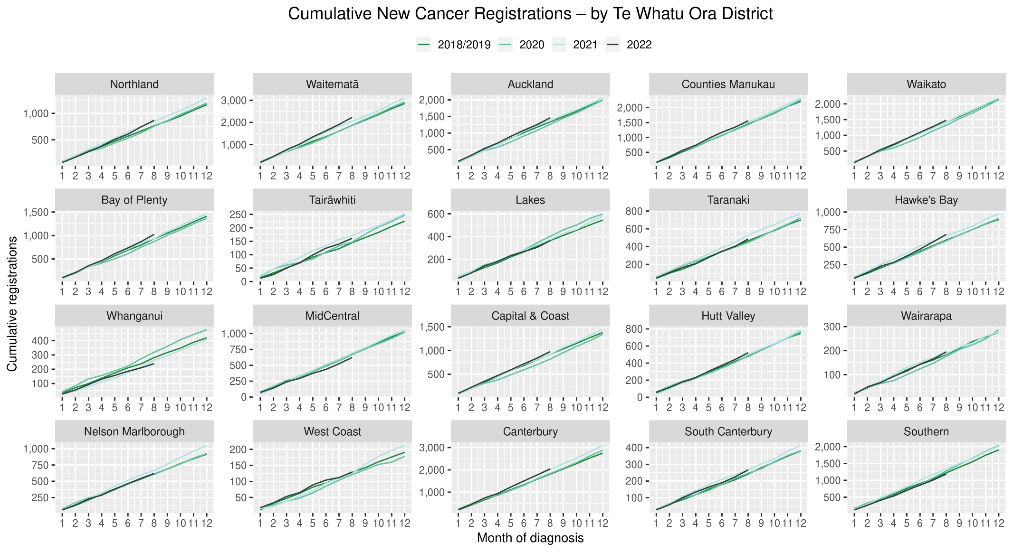

## Cumulative cancer registrations by DHB and ethnicity



## Cumulative cancer registrations by cancer type and ethnicity



# Appendix 4: Diagnosis and treatment data by Te Whatu Ora district

Percentage differences are only presented if the cumulative total the year is 10 or greater. In some cases, the totals may differ to those presented in the national report due to non-Te Whatu Ora providers being excluded from the analyses within this appendix.

## Gastrointestinal endoscopy



## Bronchoscopy

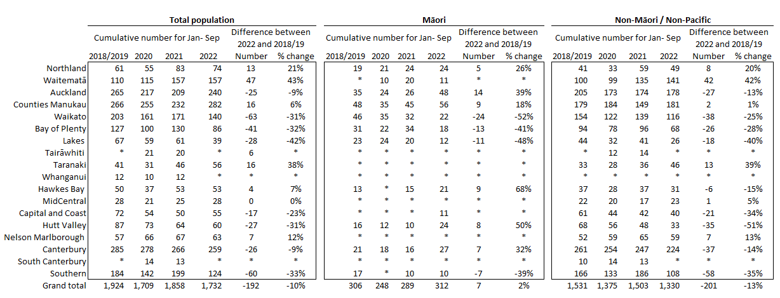

Southern District data is incomplete for 2022 due to code mapping issue. The District is actively working to resolve the issue and data will be updated in the next report.

## CT Lung Biopsy



## Breast cancer surgery (mastectomy)

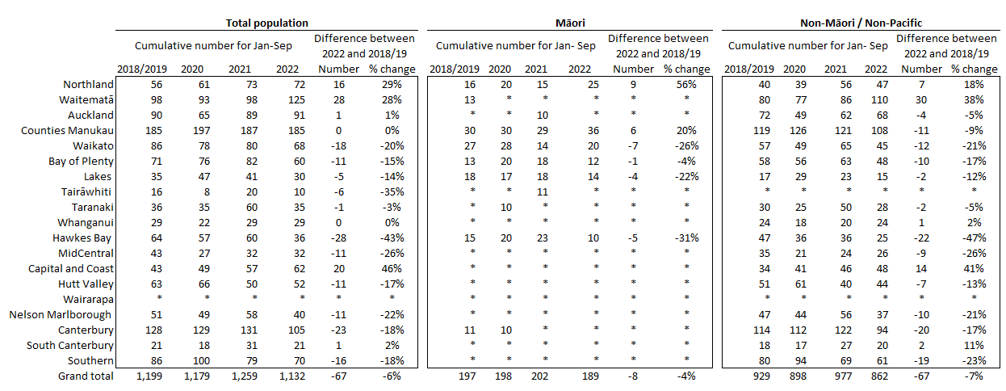

## Colorectal cancer surgery



## Lung cancer surgery



## Prostate cancer surgery



## Medical oncology first specialist assessments



## Medical oncology IV chemotherapy

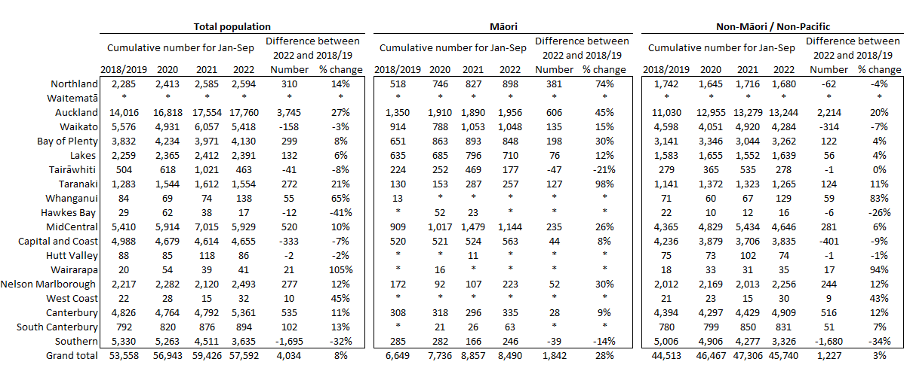

## Radiation oncology first specialist assessments



## Radiation oncology megavoltage fractions



## Radiation therapy completed courses



## Haematology first specialist assessment



## Haematology IV chemotherapy

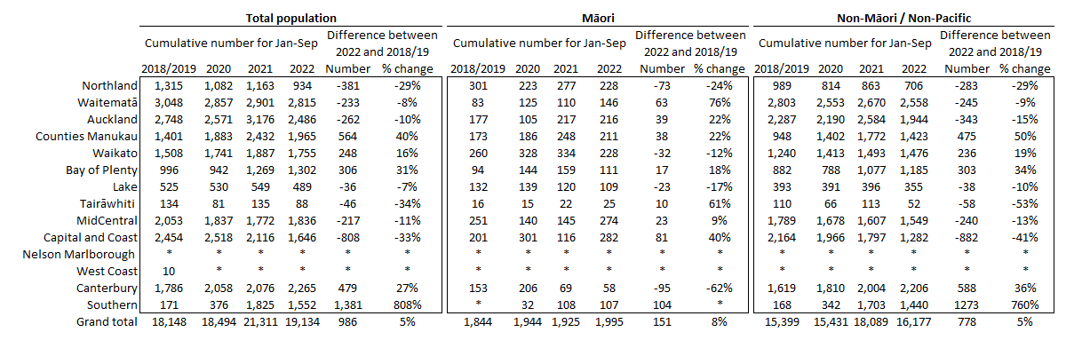

* Note the relatively low volumes in Southern DHB in prior years are due to variation in coding.

# Appendix 5: Surgical procedure codes

Below is a list of the surgical procedure codes that were used for analysis on cancer surgery.

|  |  |  |
| --- | --- | --- |
| **COLORECTAL CANCER SURGERY** | | |
| Clinical code | Block short description | Clinical code description |
| 3200000 | Colectomy | Limited excision of large intestine with formation of stoma |
| 3200001 | Colectomy | Right hemicolectomy with formation of stoma |
| 3200300 | Colectomy | Limited excision of large intestine with anastomosis |
| 3200301 | Colectomy | Right hemicolectomy with anastomosis |
| 3200400 | Colectomy | Subtotal colectomy with formation of stoma |
| 3200401 | Colectomy | Extended right hemicolectomy with formation of stoma |
| 3200500 | Colectomy | Subtotal colectomy with anastomosis |
| 3200501 | Colectomy | Extended right hemicolectomy with anastomosis |
| 3200600 | Colectomy | Left hemicolectomy with anastomosis |
| 3200601 | Colectomy | Left hemicolectomy with formation of stoma |
| 3200900 | Colectomy | Total colectomy with ileostomy |
| 3201200 | Colectomy | Total colectomy with ileorectal anastomosis |
| 3201500 | Total proctocolectomy | Total proctocolectomy with ileostomy |
| 3202400 | Anterior resection of rectum | High anterior resection of rectum |
| 3202500 | Anterior resection of rectum | Low anterior resection of rectum |
| 3202600 | Anterior resection of rectum | Ultra low anterior resection of rectum |
| 3202800 | Anterior resection of rectum | Ultra low anterior resection of rectum with hand sutured coloanal anastomosis |
| 3203000 | Rectosigmoidectomy or proctectomy | Rectosigmoidectomy with formation of stoma |
| 3203900 | Rectosigmoidectomy or proctectomy | Abdominoperineal proctectomy |
| 3205100 | Total proctocolectomy | Total proctocolectomy with ileo-anal anastomosis |
| 3205101 | Total proctocolectomy | Total proctocolectomy with ileo-anal anastomosis and formation of temporary ileostomy |
| 3206000 | Rectosigmoidectomy or proctectomy | Restorative proctectomy |
| 3209900 | Excision of lesion or tissue of rectum or anus | Per anal submucosal excision of lesion or tissue of rectum |
| 3211200 | Rectosigmoidectomy or proctectomy | Perineal rectosigmoidectomy |
| 9220800 | Anterior resection of rectum | Anterior resection of rectum, level unspecified |

|  |  |  |
| --- | --- | --- |
| **LUNG CANCER SURGERY** | | |
| Clinical code | Clinical code description | Block Description |
| 3844000 | Wedge resection of lung | Partial resection of lung |
| 3844001 | Radical wedge resection of lung | Partial resection of lung |
| 3843800 | Segmental resection of lung | Partial resection of lung |
| 9016900 | Endoscopic wedge resection of lung | Partial resection of lung |
| 3843801 | Lobectomy of lung | Lobectomy of lung |
| 3844100 | Radical lobectomy | Lobectomy of lung |
| 3844101 | Radical pneumonectomy | Pneumonectomy |
| 3843802 | Pneumonectomy | Pneumonectomy |

|  |  |  |
| --- | --- | --- |
| **PROSTATE CANCER SURGERY** | | |
| Clinical code | Block short description | Clinical code description |
| 3720004 | Open prostatectomy | Retropubic prostatectomy |
| 3720900 | Open prostatectomy | Radical prostatectomy |
| 3720901 | Other closed prostatectomy | Laparoscopic radical prostatectomy |
| 3721000 | Open prostatectomy | Radical prostatectomy with bladder neck reconstruction |
| 3721001 | Other closed prostatectomy | Laparoscopic radical prostatectomy with bladder neck reconstruction |
| 3721100 | Open prostatectomy | Radical prostatectomy with bladder neck reconstruction and pelvic lymphadenectomy |
| 3721101 | Other closed prostatectomy | Laparoscopic radical prostatectomy with bladder neck reconstruction and pelvic lymphadenectomy |
| 3720900 | Open prostatectomy | Radical prostatectomy |
| 3720901 | Closed prostatectomy | Laparoscopic radical prostatectomy |
| 3721000 | Open prostatectomy | Radical prostatectomy with bladder neck reconstruction |
| 3721001 | Closed prostatectomy | Laparoscopic radical prostatectomy with bladder neck reconstruction |
| 3721100 | Open prostatectomy | Radical prostatectomy with bladder neck reconstruction and pelvic lymphadenectomy |

|  |  |  |
| --- | --- | --- |
| **BREAST CANCER SURGERY** | | |
| Clinical code | Block short description | Clinical code description |
| 3152400 | Subcutaneous mastectomy | Subcutaneous mastectomy, unilateral |
| 3152401 | Subcutaneous mastectomy | Subcutaneous mastectomy, bilateral |
| 3151800 | Simple mastectomy | Simple mastectomy, unilateral |
| 3151801 | Simple mastectomy | Simple mastectomy, bilateral |

1. Te Aho o Te Kahu. (2021). *He Pūrongo Mate Pukupuku o Aotearoa 2020, The State of Cancer in New Zealand 2020*. Retrieved from Wellington: https://teaho.govt.nz/publications/cancer-state
2. Gurney, J. K., Dunn, A., Liu, M., Mako, M., Millar, E., Ruka, M., . . . Sarfati, D. (2022). The impact of COVID-19 on lung cancer detection, diagnosis and treatment for Māori in Aotearoa New Zealand. *N Z Med J, 135*(1556), 23-43.
3. Reports available here: <https://teaho.govt.nz/reports/cancer-care>
4. For example, for several measures in the March 2022 report, there were notably higher volumes for March 2021 compared with March in other recent years, including years presented in this report (2018, 2019, and 2020). The reasons for this data spike in March 2021 may include a catch-up period following lockdowns of the previous year.
5. This report includes an additional procedure code for CT Lung Biopsy (3881200). This is the back mapping code for CT Lung Biopsy prior to July 2019
6. We recognise there are limitations to this approach and aim to strike a balance between timely data availability, completeness, and accuracy, with the purpose of the reporting being to provide an initial indication of the current situation which may then require further interrogation at a regional level.
7. Hypofractionation is a radiation treatment technique used to treat some cancers, whereby larger doses of radiation are given each treatment, meaning that patients require fewer sessions to complete their treatment. The technique is being increasingly used for some prostate and breast cancers in New Zealand and around the world.
8. Te Aho o Te Kahu. (2021). *He Pūrongo Mate Pukupuku o Aotearoa 2020, The State of Cancer in New Zealand 2020*. Retrieved from Wellington: https://teaho.govt.nz/publications/cancer-state
9. https://teaho.govt.nz/covid-19/cancer-care
10. Gurney, J. K., Dunn, A., Liu, M., Mako, M., Millar, E., Ruka, M., . . . Sarfati, D. (2022). The impact of COVID-19 on lung cancer detection, diagnosis and treatment for Māori in Aotearoa New Zealand. *N Z Med J, 135*(1556), 23-43.
11. https://teaho.govt.nz/covid-19/cancer-care
12. Robson, B., Purdie, G., Cram, F., & Simmonds, S. (2007). Age standardisation - an indigenous standard? *Emerg Themes Epidemiol, 4*, 3. doi:10.1186/1742-7622-4-3
13. Gurney, J. K., Dunn, A., Liu, M., Mako, M., Millar, E., Ruka, M., . . . Sarfati, D. (2022). The impact of COVID-19 on lung cancer detection, diagnosis and treatment for Māori in Aotearoa New Zealand. *N Z Med J, 135*(1556), 23-43.
14. Gurney, J. K., Dunn, A., Liu, M., Mako, M., Millar, E., Ruka, M., . . . Sarfati, D. (2022). The impact of COVID-19 on lung cancer detection, diagnosis and treatment for Māori in Aotearoa New Zealand. *N Z Med J, 135*(1556), 23-43.
15. https://www.parliament.nz/en/pb/sc/reports/document/SCR_130048/smokefree-environments-and-regulated-products-smoked-tobacco
16. McLeod M, Sandiford P, Kvizhinadze G, et al. Impact of low-dose CT screening for lung cancer on ethnic health inequities in New Zealand: a cost-effectiveness analysis. BMJ Open 2020;10:e037145. doi: 10.1136/bmjopen-2020-037145
17. Achieving medicine access equity in Aotearoa New Zealand. Towards a theory of change. Pharmac. 2019. <https://pharmac.govt.nz/assets/achieving-medicine-access-equity-in-aotearoa-new-zealand-towards-a-theory-of-change.pdf>
18. <https://covid19.govt.nz/about-our-covid-19-response/history-of-the-covid-19-alert-system/>
19. <https://covid19.govt.nz/traffic-lights/covid-19-protection-framework>
20. <https://www.health.govt.nz/covid-19-novel-coronavirus/covid-19-data-and-statistics/covid-19-current-cases>