

**COVID-19 and cancer services**

Working report on the impact of COVID-19 on cancer services for the period ending February 2022

**Released April 2022**

# Acknowledgements

With thanks to the Ministry of Health Data Management team for their technical support.

With thanks to members of the COVID-19 Data Response Advisory Group: Professor Diana Sarfati, Alex Dunn, Dr John Fountain, Dr Elinor Millar, John Manderson, Michelle Mako, Dr Shaun Costello, Michelle Liu, Dr Liz Dennett, Gabrielle Nicholson, Dawn Wilson, Jan Smith, Cushla Lucas, Nicholas Glubb, Moira McLeod, Angela Pidd, Christine Fowler, Dr Nina Scott, Associate Professor Bridget Robson, Dr Bronwyn Rendle and Dr Jason Gurney.

# Contents

Acknowledgements 2

Contents 3

Summary of findings 4

Introduction 7

Auckland Regional Snapshot 9

Cancer Registrations 13

Gastrointestinal endoscopy 17

Bronchoscopy 19

Combined cancer surgery 21

Colorectal cancer surgery 23

Lung cancer surgery 25

Prostate cancer surgery 27

Medical oncology 29

Radiation oncology 33

Haematology 37

Appendix 1: Key Dates 41

Appendix 2: NZCR data information 42

Appendix 3: NZCR registrations by DHB 43

Appendix 4: Diagnosis and treatment data by DHB 47

Appendix 5: Surgical procedure codes 58

# Summary of findings

**Impact of COVID-19 on cancer** **services**

This is the first report to include data from the Omicron outbreak and covers up to February 2022. Cancer services have been disrupted during the January and February period nationally. In January there was a lower number of registrations nationally and in February there a higher number of registrations nationally. For Māori there were 16% fewer registrations in January and 17% fewer registrations in February 2022 compared with February 2021. The impact is not as substantial as that seen during the initial lockdown and outbreak in 2020, particularly during the month of April 2020, however these data are of concern. Te Aho o Te Kahu are returning to monthly monitoring and continue to work with the sector to ensure there is rapid recovery.

## Background and data

* The purpose of this report is to provide a rapid assessment of the impact of COVID-19 on cancer services. It includes data up until 28 February 2022. This is the first report to include the Omicron outbreak.
* The report focuses on the aspects of the cancer care pathway for which we have readily available data and does not capture all aspects of cancer care.
* We acknowledge individuals with cancer may have been impacted in significant ways by COVID-19, including by changes to the way care has been delivered.
* This report compares 2022 with 2021 data, and provides additional graphs comparing 2022 data with that from 2021, 2020 and an average over 2018/2019. For the purposes of this report, we have not added an adjustment for changes in incidence over time.
* There may be some backlogs in data entry with impacts on staffing across the health sector. This may result in future data updates altering the current results.
* Given the timing of the Omicron outbreak and related health service disruption, we may not expect to see evidence of recovery until after the next report, focused on March impacts.

## Auckland regional snapshot

* There was an overall increase in cancer registrations in 2021 compared to 2018/19. In January 2022, there was a decrease of 2% when compared to January 2021, however there was an increase of 8% in February 2022 when compared to February 2021. This results in a net 3% increase in cancer diagnoses in the Auckland region in the first two months of 2022 compared with the same period in 2021.
* COVID-19 caused disruption to diagnostic services in both August and September 2021, with a decrease in gastrointestinal endoscopies across the region in 2021 compared to 2018/19 (noting these procedures are completed for several indications, not just cancer related). These services have appeared to return to baseline since October 2021 and continue to track similarly in January and February 2022 compared with the same time period in 2021.
* Cancer surgery in January and February 2022 continued at a similar rate as in the same period in 2021 in the Auckland region.
* Radiation therapy attendances in January and February 2022 were slightly lower than January and February the previous year.
* Attendances for IV chemotherapy for medical oncology treatment shows similar numbers in January 2022 compare with January 2021, however there is indication of a decrease (9%) for February 2022 compared with February 2021.

## Cancer diagnosis

### Registrations

* For January 2022, provisional data show a lower number of registrations compared to the same month in 2021. For February 2022, data show a higher number of total registrations compared to February 2021. Overall there were 2% fewer cancer registrations in the first two months of 2022 compared with 2021.
* For Māori, there were 16% fewer registrations in January and 17% fewer in February 2022 compared with the same months in 2021. Registrations for Pacific peoples also were fewer in both months with 5% less registrations in January and February 2022 combined compared with the previous year. However, for Pacific peoples, February registrations were higher than 2018/19 and 2020.

### Diagnostics

* **Gastrointestinal endoscopies:** there was a decrease in gastrointestinal endoscopies performed in January 2022, compared to January 2021, however this decrease was not seen when comparing February 2022 with February 2021. This January decrease was higher for Non-Māori/Non-Pacific people (13%) compared with Māori (3%)
* **Bronchoscopies:** both January and February 2022 showed a decrease in the number of bronchoscopies performed compared to January and February 2021 with the combined decrease being 8%. This was a smaller decrease than that seen in in the previous report covering November and December 2021 compared with the same months in 2018/19 (13%).

## Cancer Treatment

### Surgery

* In January 2022, there were 19% fewer cancer surgeries (prostate, lung and colorectal) compared to January 2021. When comparing February 2022 with February 2021, there was an 8% increase in cancer surgeries. This meant a 9% lower rate of cancer surgery for prostate, lung and colorectal cancer in the first two months of 2022, compared with 2021.
* For Māori there was a 22% decrease in combined cancer surgeries for January and February 2022 combined compared with 2021, and for Pacific peoples this decrease was 35%, noting small numbers (particularly for Pacific peoples). For Māori, this decrease is smaller when compared with the same period in 2020.

### Chemotherapy and radiotherapy

* **Medical oncology:** attendances for medical oncology first specialist assessments (FSAs) decreased by 5% in January 2022 compared to January 2021 and increased by 13% in February 2022 compared to February 2021, resulting in an overall 4% increase over that period. Attendances for intravenous (IV) chemotherapy decreased by 2% in January 2022 compared to January 2021 and decreased by 4% in February 2022 compared to February 2021. For Māori, there was a 4% increase in IV chemotherapy in January 2022 compared to January 2021 and a 3% decrease in February 2022 compared to February 2021.
* **Radiation oncology:** attendances for radiation oncology FSAs decreased by 3% in both January and February 2022 compared to January and February 2021. Radiation therapy attendances decreased by 5% in both January and February 2022 compared to January and February 2021. Preliminary investigation suggests this decrease may reflect increased use of hypofractionation (resulting in a shift to fewer visits required in order to complete treatment) and this will be investigated further in future reports. For Māori, there was a 5% increase in radiation therapy attendances in January 2022 compared to January 2021 and a 9% increase in February 2022 compared to February 2021. For Pacific peoples there was a 3% decrease in radiation therapy attendances in January 2022 compared to January 2021 and a 4% decrease in February 2022 compared to February 2021.
* **Haematology:** there was a 5% increase in attendances for haematology FSAs in January 2022 compared to January 2021 and a 7% increase in February 2022 compared to February 2021. Attendances for haematology intravenous (IV) chemotherapy decreased by 3% in January 2022 compared to January 2021 and there was no change in February 2022 compared to February 2021. For Māori, there was a 6% decrease in haematology IV chemotherapy in January 2022 compared to January 2021 and a 14% decrease in February 2022 compared to February 2021.

# Introduction

## Background

In 2020, Te Aho o Te Kahu released a series of reports outlining the impact of COVID-19 on cancer services in New Zealand[1]. The 2020 reports showed that cancer treatment services – surgery, medical oncology, radiation oncology and haematology – continued during the start of the COVID-19 pandemic. Following an initial drop in new cancer registrations during the April 2020 lockdown, the number of cancer registrations in 2020 increased steadily in the following months and, by the end of September, had caught up to the number seen in 2019.

As the COVID-19 situation and disruptions to health care settled, Te Aho o Te Kahu stopped regular COVID-19 and cancer reporting at the end of 2020. Te Aho o Te Kahu re-instated COVID-19 monitoring with the re-emergence of COVID-19 in the community in August 2021 and the return of restrictions.

## Purpose

This is the fifth report looking at the impact of COVID-19 on cancer services since the reporting was reinstated in August 2021 at the beginning of the Delta outbreak. As this report includes data up until the end of February 2022, this is the first report for a time period inclusive of the Omicron outbreak. The aim of this work is to collate evidence on delays to cancer diagnosis and treatment to support policy development and response planning.

The report focuses on the aspects of the cancer care pathway for which we have readily available data and does not capture all aspects of the care. Critical aspects of cancer care, including access to primary health care, radiology, palliative care and patient experience are not measured in this report. While the report focuses on the impact of COVID-19 on overall cancer diagnosis and treatment, we acknowledge that individuals with cancer may have been impacted in significant ways by COVID-19, including by changes to the way care has been delivered.

## Data and analysis

The data in this report come from Ministry of Health national data collections. Each section of the report includes information on where the data is from and any limitations associated with the data. Numbers in this report may not match the previous report, due to exclusion of incomplete data in the previous reports and delayed coding/submission of data.

There may be some backlogs in data entry with impacts on staffing across the health sector. This may result in future data updates altering the current results, and may mean any disruption to services is less severe than is reported here.

The purpose of the analysis is to rapidly measure the impact of COVID-19 and the response on cancer services; therefore, the analysis does not consider pre-existing unmet need. The report also makes direct comparisons between 2022 and previous years and does not consider any increase in cancer diagnoses or population size over time.

### Comparator for this report

The first set of COVID-19 and Cancer reports, published in 2020, compared 2020 data directly with 2019 data. For reports looking at 2021 data, the main comparison used was an average of 2018 and 2019 data, due to 2020 not being considered an appropriate comparator given the disruption to health services in 2020 due to COVID-19.

For this report we have used 2021 as a comparator to 2022, and in addition, present graphs that include data from 2022, 2021, 2020 and an average from 2018/19.

Appendix 1 outlines key dates for COVID-19 restrictions in Aotearoa that may be of use when reviewing this report.

## Ongoing reporting

Te Aho o Te Kahu will continue to monitor the impact of COVID-19 and lockdowns on cancer services. The next report will be released in May 2022, looking at data to the end of March 2022. Given the timing of the Omicron outbreak and related health service disruption, we may not expect to see evidence of recovery until after this period.

# Auckland Regional Snapshot

## Key points

* There was an overall increase in cancer registrations in 2021 compared to 2018/19. In January 2022, there was a decrease of 2% when compared to January 2021, however there was an increase of 8% in February 2022 when compared to February 2021. This results in a net 3% increase in cancer diagnoses in the Auckland region in the first two months of 2022 compared with the same period in 2021.
* COVID-19 caused a disruption to diagnostics services in both August and September 2021, with a decrease in gastrointestinal endoscopies across the region in 2021 compared to 2018/19 (noting these procedures are completed for several indications, not just cancer related). These services have appeared to return to baseline since October 2021 and continue to track similarly in January and February 2022 compared with the same time period in 2021.
* Cancer surgery in January and February 2022 continued in the Auckland region at a similar rate as in the same period in 2021 (noting small numbers for Māori makes interpretation difficult for these groups).
* Radiation therapy attendances in January and February 2022 were slightly lower than January and February the previous year. As discussed in the Radiation Oncology section of this report, there is suggestion that this is due to hypofractionation (see Radiation Oncology section).
* Attendances for IV chemotherapy for medical oncology treatment shows similar numbers in January 2022 compare with January 2021, however there is indication of a decrease for February 2022 compared with February 2021 of 9% for total and 12% for Māori.

## Cancer diagnosis and treatment

### Registrations

Table 1: Number of provisional cancer registrations and percentage change in 2022 compared to 2021, by month and cumulative year to date, by DHB

|  |  |  |  |  |  |  |  |  |  |
| --- | --- | --- | --- | --- | --- | --- | --- | --- | --- |
|  | **January** | | | **February** | | | **Cumulative January-February** | | |
| **DHB in Auckland region** | **2021** | **2022** | **Change%** | **2021** | **2022** | **Change%** | **2021** | **2022** | **Change%** |
| Waitematā | 212 | 195 | -8% | 224 | 254 | 13% | 436 | 449 | 3% |
| Auckland | 126 | 151 | 20% | 155 | 165 | 6% | 281 | 316 | 12% |
| Counties Manukau | 173 | 154 | -11% | 178 | 181 | 2% | 351 | 335 | -5% |
| Total Auckland Region | 511 | 500 | -2% | 557 | 600 | 8% | 1,068 | 1,100 | 3% |

Figure 1: Cumulative number of cancer registrations by month, 2018/19 average, 2020,2021 and 2022, for the Auckland region, by DHB

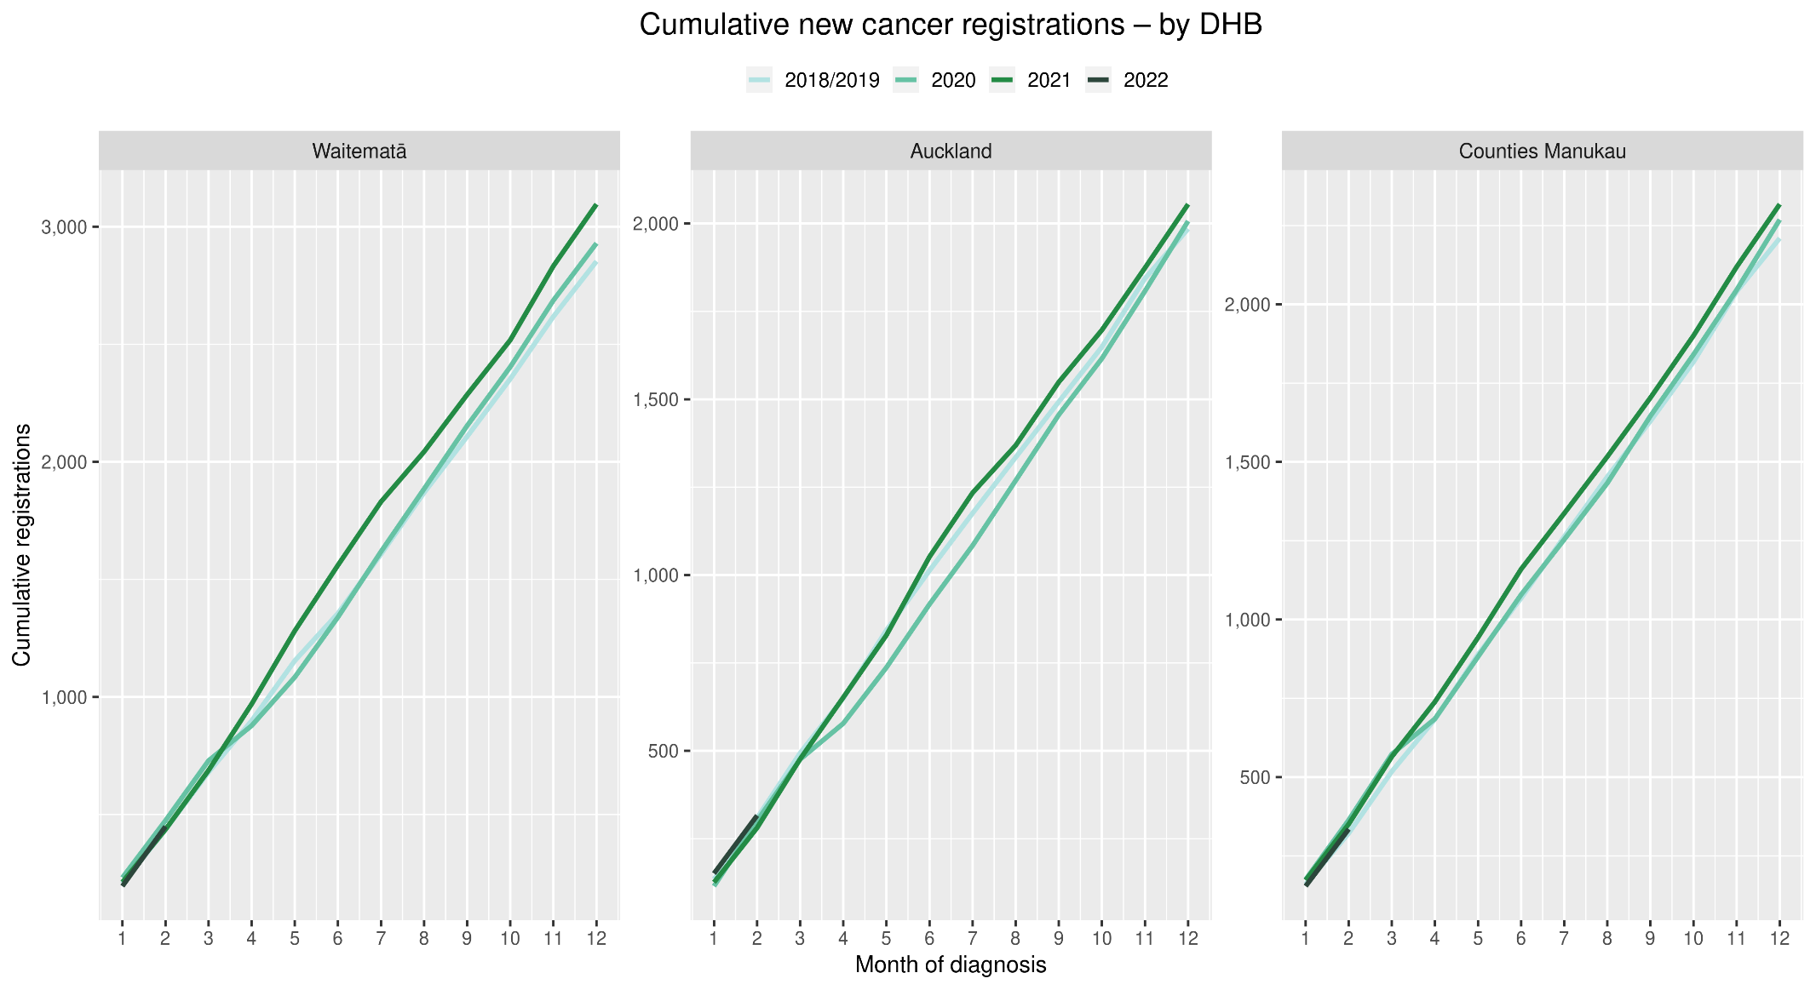

Gastrointestinal endoscopies

Figure 2: Number of gastrointestinal endoscopy procedures by month, 2018/19 average, 2020, 2021 and 2022, for the Auckland region

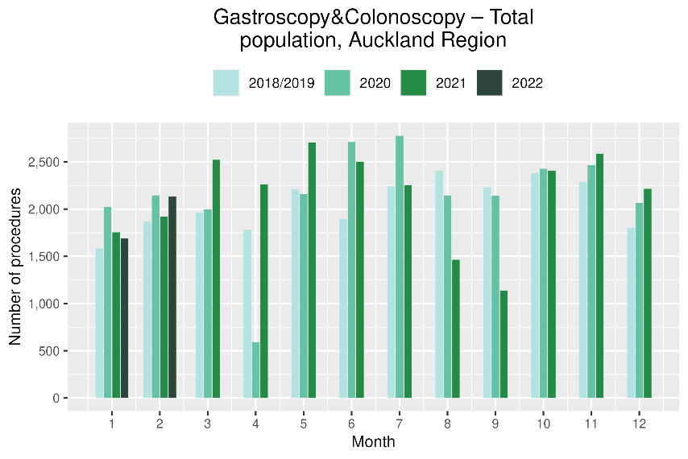 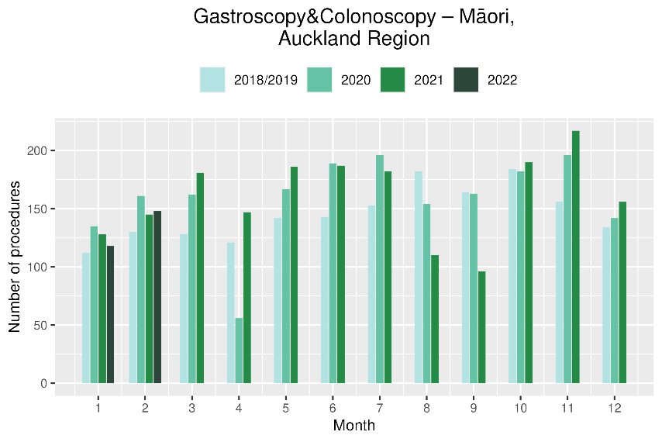

### Cancer surgery

Figure 3: Number of cancer surgeries (prostate, colorectal and lung) by month, 2018/19 average, 2020, 2021 and 2022, for the Auckland region

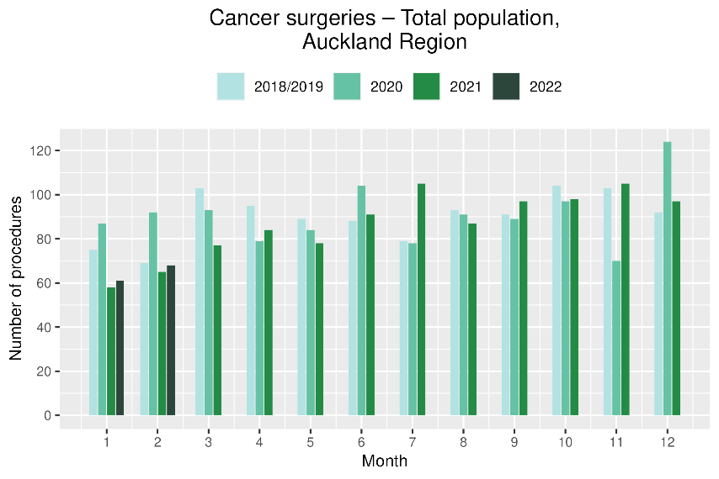 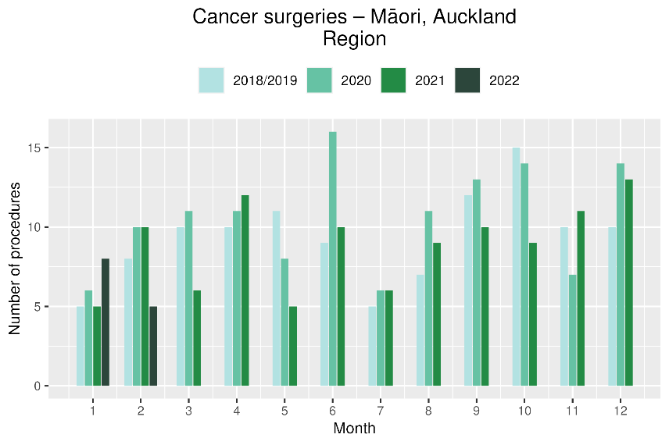

### Non-surgical treatments

Figure 4: Number of IV chemotherapy attendances by month, 2018/19 average, 2020, 2021 and 2022, for the Auckland region

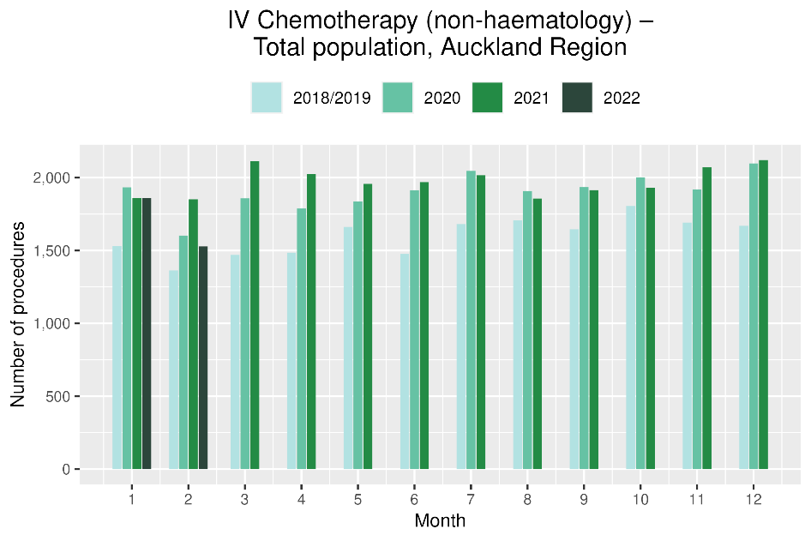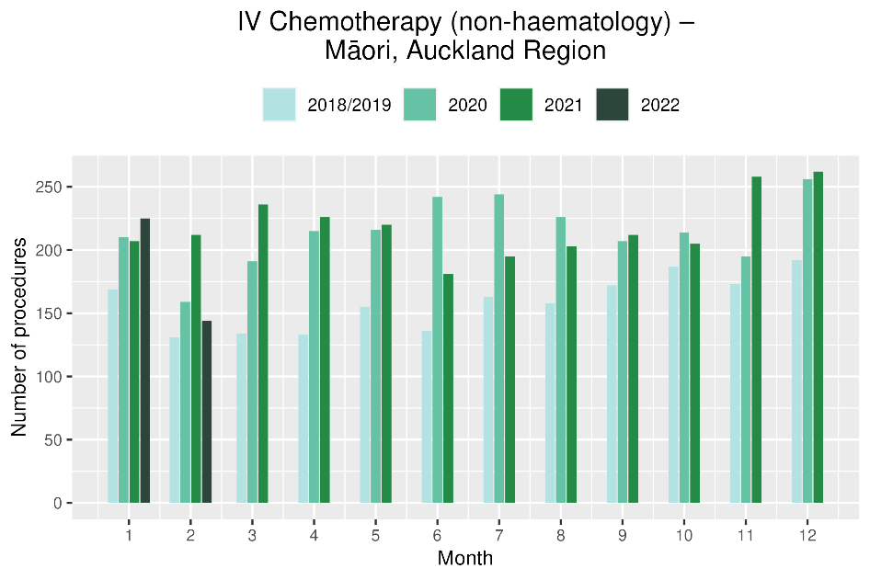

**Figure 5: Number of radiation therapy attendances by month, 2018/19 average, 2020, 2021 and 2022, for the Auckland region**

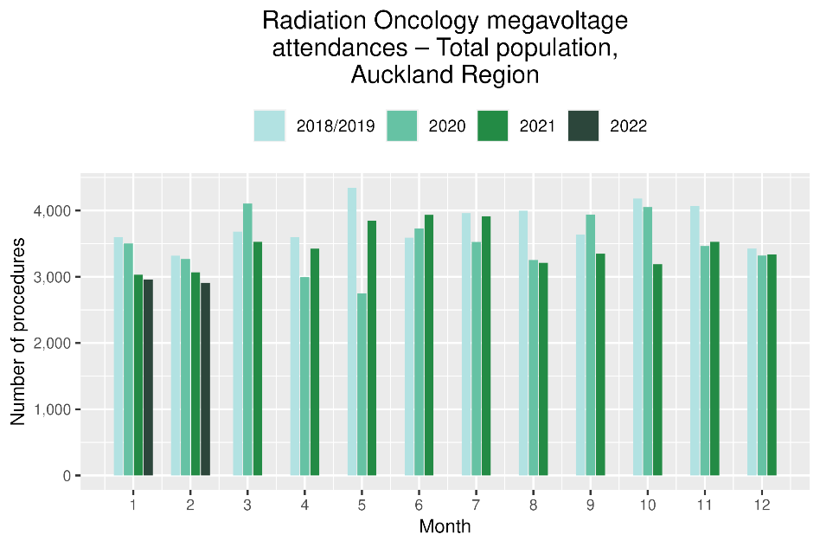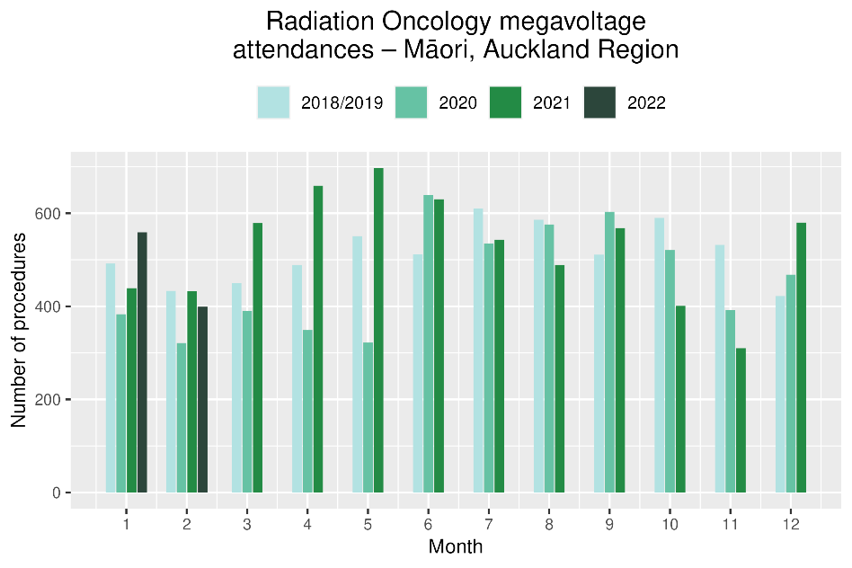

**National Data**

# Cancer Registrations

## Notes on data

* The data in this report come from laboratory reports to the New Zealand Cancer Register (NZCR). Cancers diagnosed without haematology or pathology, for example radiology alone, will not be counted in this analysis. Further information on these data is included in Appendix 2.
* Data included in this report are provisional, and exact numbers will change as data are finalised. Data were extracted from NZCR on 21 March 2022.
* ‘Date’ is date of diagnosis on the NZCR – usually the date the specimen was taken from the person and sent to the laboratory. Analyses include all new provisional and registered cancer events based on pathology and haematology reports.
* The extract used for this report excludes carcinoma in situ for breast and cervical, meaning the numbers are lower than in the 2020 COVID-19 and Cancer reports.
* There may be some backlogs in laboratory reports with impacts on staffing across the health sector. This may result in future data updates altering the current results.

## Key points

* For January 2022, provisional data show a lower number of registrations (5% decrease) compared to the same month in 2021. For February 2022, data show a higher number of total registrations (2% increase) compared to February 2021. Overall, there were 2% fewer cancer registrations in the first two months of 2022 compared with 2021.
* The February increase was not seen for Māori and Pacific peoples. For Māori, there were 16% fewer registrations in January and 17% fewer in February 2022 compared with the same months in 2021. Registrations for Pacific peoples also were fewer in both months with 5% fewer registrations in January and February 2022 combined compared with the previous year. However, for Pacific peoples, February registrations were higher than 2018/19 and 2020 (see figure 6).

## Results

Table 2: Number of provisional cancer registrations and percentage difference in 2022 compared to 2021, by month and cumulative year to date, by ethnicity

|  |  |  |  |  |  |  |  |  |  |
| --- | --- | --- | --- | --- | --- | --- | --- | --- | --- |
|  | **January** | | | **February** | | | **Cumulative January-February** | | |
|  | **2021** | **2022** | **%change** | **2021** | **2022** | **%change** | **2021** | **2022** | **%change** |
| Māori | 208 | 174 | -16% | 215 | 178 | -17% | 423 | 352 | -17% |
| Pacific peoples | 65 | 64 | -2% | 103 | 95 | -8% | 168 | 159 | -5% |
| Asian | 101 | 99 | -2% | 105 | 117 | 11% | 206 | 216 | 5% |
| European/Other | 1,386 | 1,328 | -4% | 1,497 | 1,569 | 5% | 2,883 | 2,897 | 0% |
| Total population | 1,760 | 1,665 | -5% | 1,920 | 1,959 | 2% | 3,680 | 3,624 | -2% |

Figure 6: Number of cancer registrations by month, 2018/19 average, 2020, 2021 and 2022, total population and by ethnicity

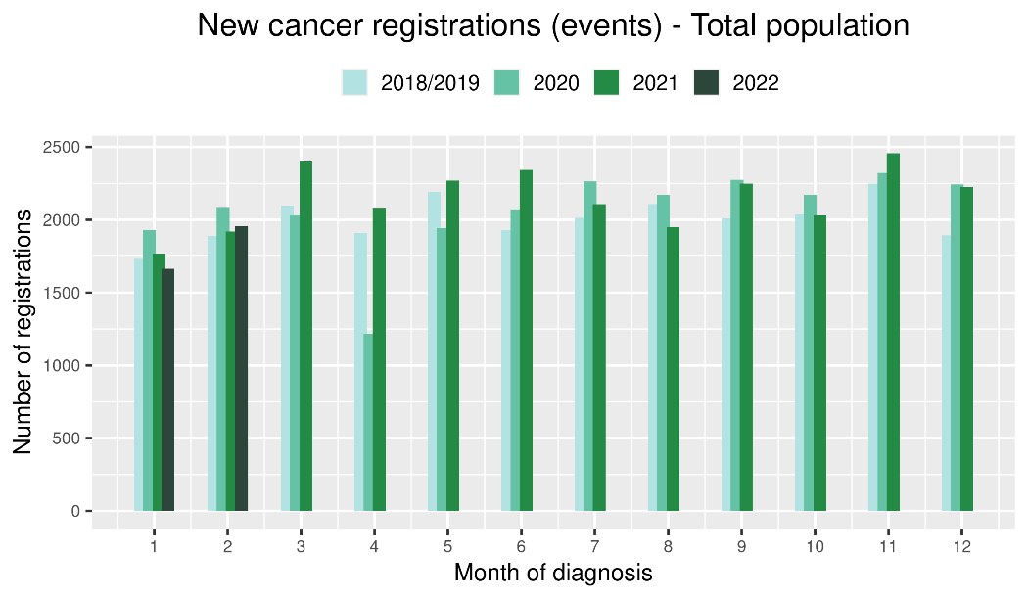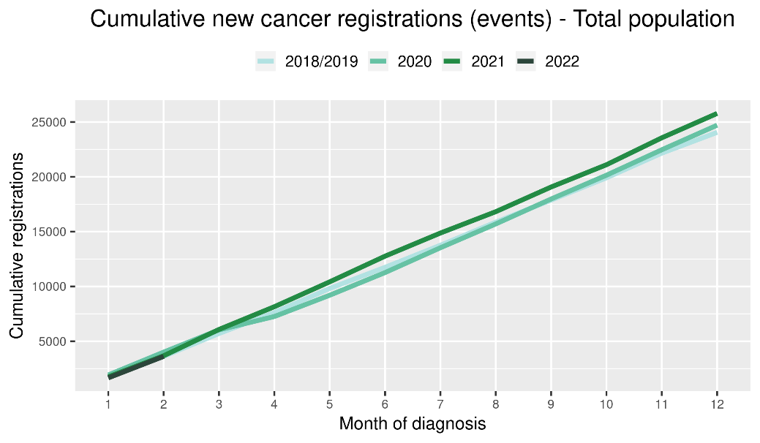

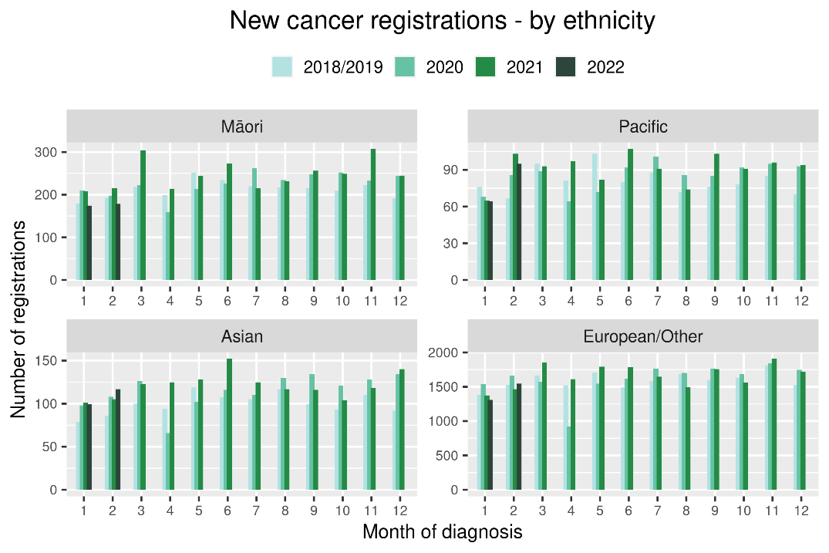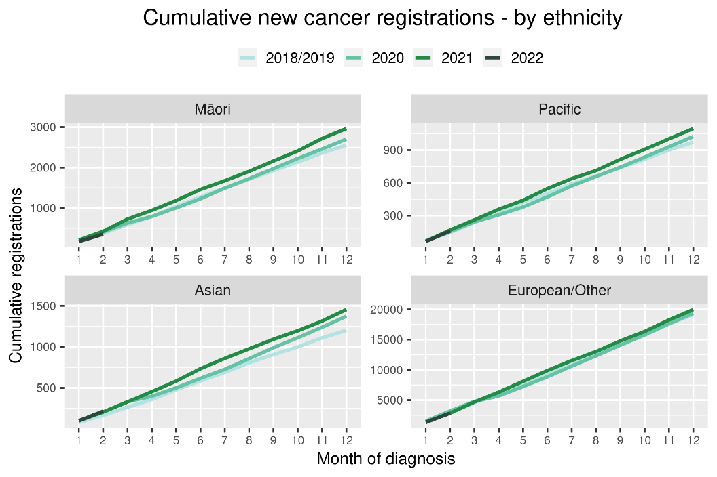

Table 3: Number of provisional cancer registrations* and percentage difference in 2022 compared to 2021, by month and cumulative year to date, by tumour group

|  |  |  |  |  |  |  |  |  |  |
| --- | --- | --- | --- | --- | --- | --- | --- | --- | --- |
|  | **January** | | | **February** | | | **Cumulative January-February** | | |
| **Tumour group** | **2021** | **2022** | **%change** | **2021** | **2022** | **%change** | **2021** | **2022** | **%change** |
| Breast | 278 | 229 | -18% | 295 | 298 | 1% | 573 | 527 | -8% |
| Colorectal | 226 | 242 | 7% | 253 | 281 | 11% | 479 | 523 | 9% |
| Gynaecology | 69 | 69 | 0% | 73 | 88 | 21% | 142 | 157 | 11% |
| Haematology and Lymphoid | 188 | 154 | -18% | 180 | 182 | 1% | 368 | 336 | -9% |
| Melanoma and non-melanoma skin cancer | 273 | 222 | -19% | 298 | 311 | 4% | 571 | 533 | -7% |
| Other digestive system | 124 | 111 | -10% | 121 | 131 | 8% | 245 | 242 | -1% |
| Prostate | 255 | 244 | -4% | 274 | 273 | 0% | 529 | 517 | -2% |
| Respiratory and thorax | 130 | 139 | 7% | 137 | 123 | -10% | 267 | 262 | -2% |
| Urinary system | 62 | 72 | 16% | 87 | 63 | -28% | 149 | 135 | -9% |

*This analysis uses provisional data for the 2021 registrations, some cancers may initially be classified as ‘non-specified’ and subsequently be re-classified into one of the cancer groups as more information becomes available.

Figure 7: Number of cancer registrations by month, 2018/19 average, 2020, 2021 and 2022, by tumour group

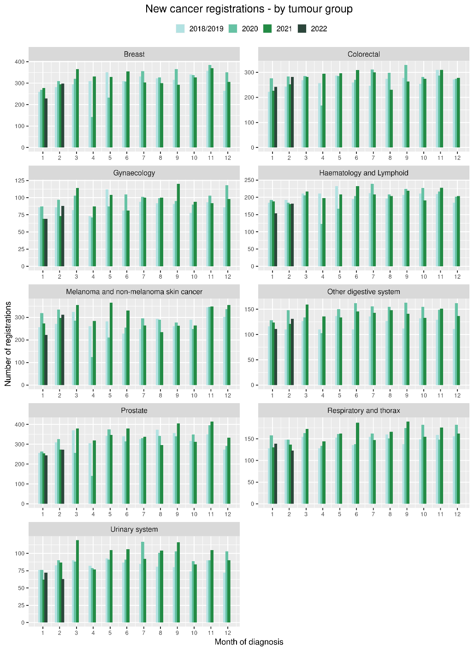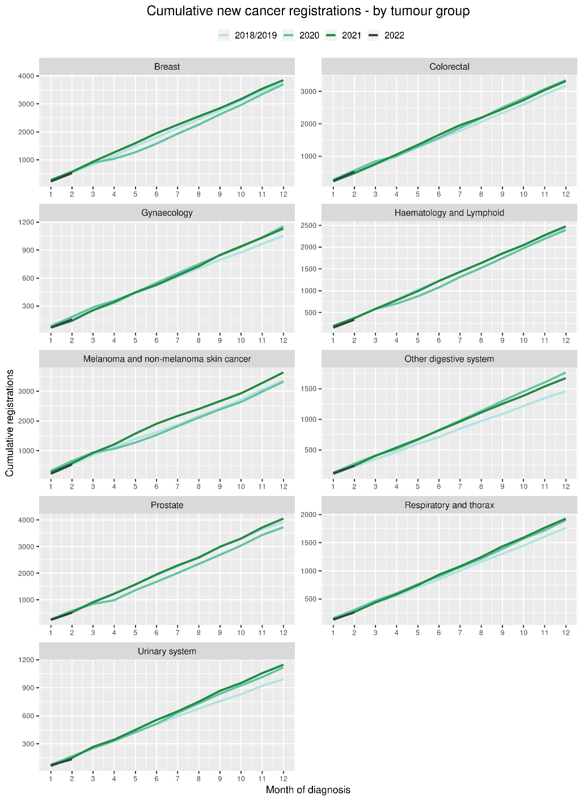

# Gastrointestinal endoscopy

## Notes on data

* Gastrointestinal endoscopy data were extracted from the National Non-admitted Patient Collection (NNPAC) and National Minimum Dataset (NMDS) on 30 March 2022.
* Includes colonoscopies and gastroscopies for all indications – not just cancer.
* Technical information: gastroscopies (Purchase Unit Code: MS02005), colonoscopies (Purchase Unit Code: MS02007), combined gastroscopies and colonoscopies (Purchase Unit Code: MS02014).

## Key points

* There was a decrease in gastrointestinal endoscopies performed in January 2022, compared to January 2021, however this decrease was not seen when comparing February 2022 with February 2021. This January decrease was higher for Non-Māori/Non-Pacific people (13%) compared with Māori (3%). There was an overall decrease of 5% for January and February 2022 combined compared with 2021.

## Results

Table 4: Number of colonoscopy and gastroscopy procedures and percentage difference in 2022 compared to 2021, by month and cumulative year to date, by ethnicity

|  |  |  |  |  |  |  |  |  |  |
| --- | --- | --- | --- | --- | --- | --- | --- | --- | --- |
|  | **January** | | | **February** | | | **Cumulative January -February** | | |
|  | **2021** | **2022** | **% change** | **2021** | **2022** | **% change** | **2021** | **2022** | **% change** |
| Māori | 558 | 540 | -3% | 601 | 601 | 0% | 1,159 | 1,141 | -2% |
| Pacific peoples | 184 | 198 | 8% | 222 | 254 | 14% | 406 | 452 | 11% |
| Non-Māori/Non-Pacific | 4,969 | 4,340 | -13% | 5,525 | 5,571 | 1% | 10,494 | 9,911 | -6% |
| Total Population | 5,711 | 5,078 | -11% | 6,348 | 6,426 | 1% | 12,059 | 11,504 | -5% |

Figure 8: Number of gastrointestinal endoscopy procedures by month, 2018/19 average, 2020, 2021 and 2022 total population and Māori

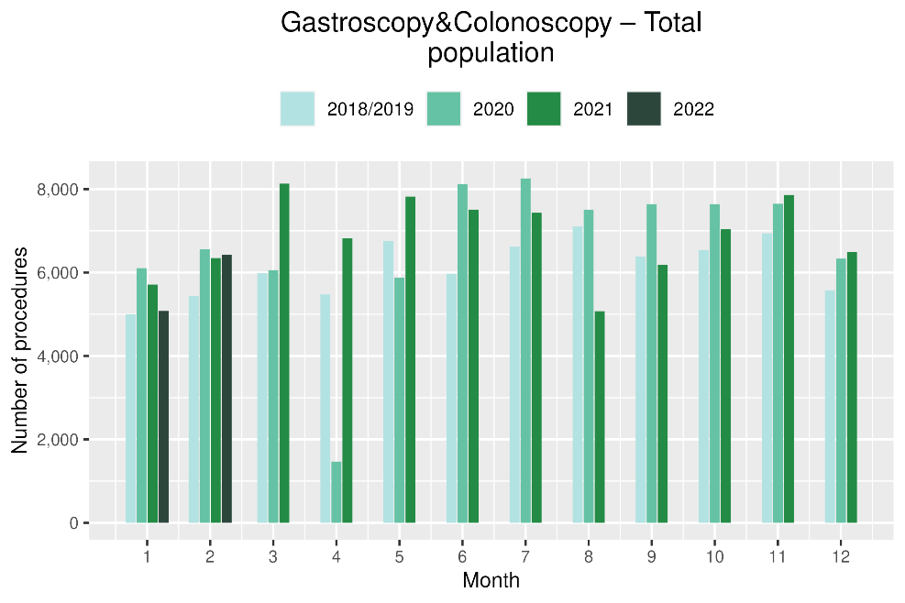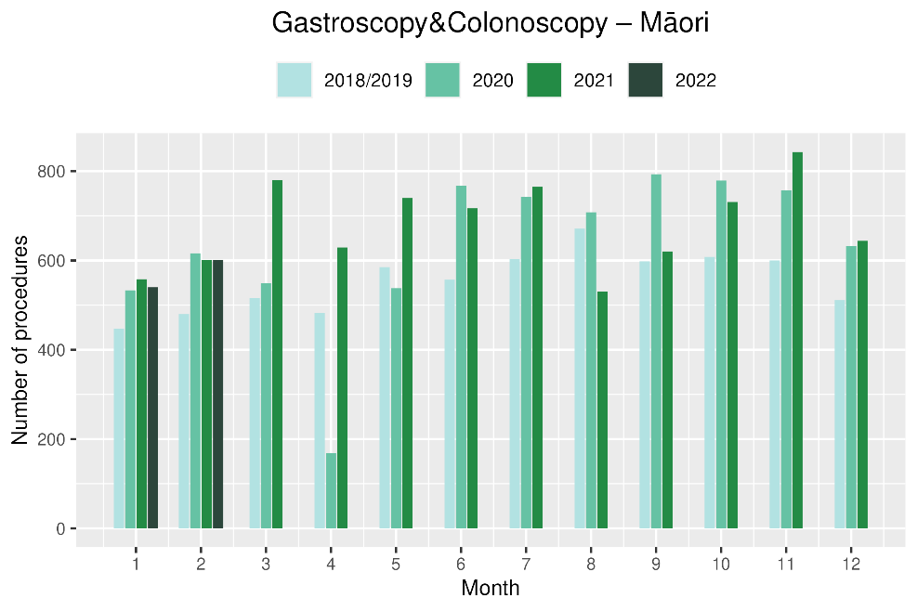 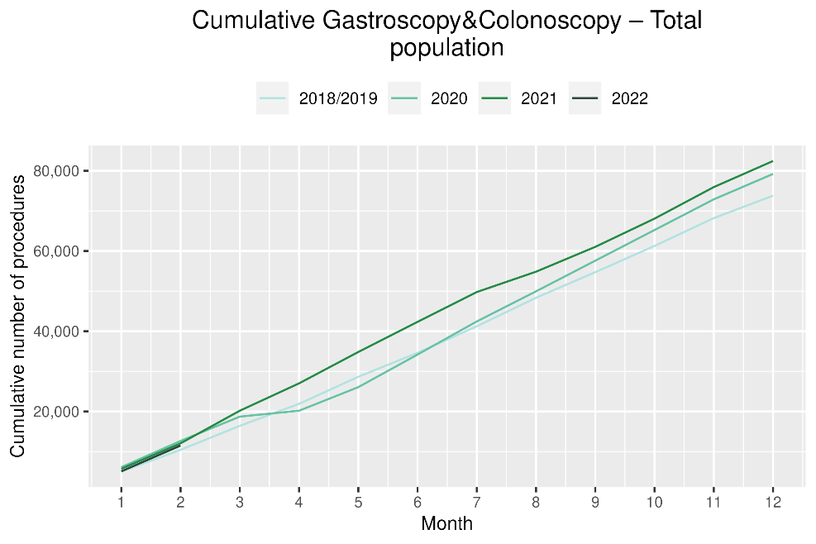 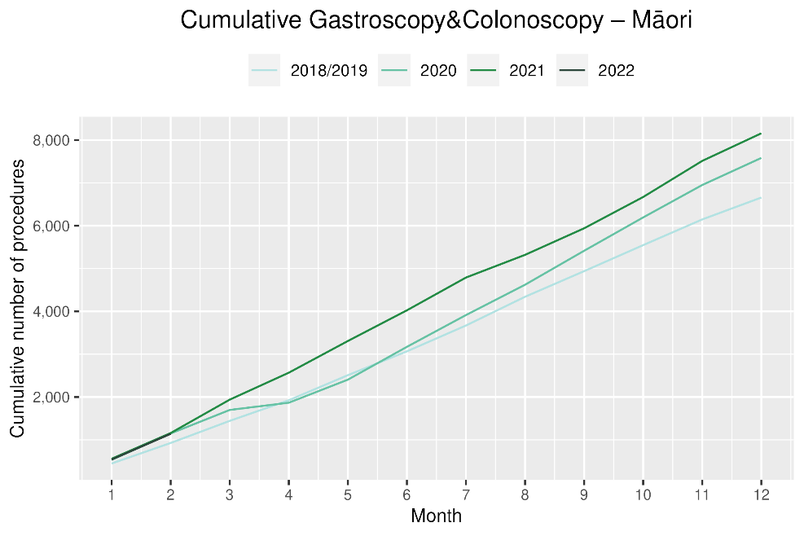

# Bronchoscopy

## Notes on data

* Bronchoscopy data were extracted from NNPAC and NMDS on 30 March 2022.
* These data include bronchoscopies for all indications, not solely cancer related procedures.
* Technical information: bronchoscopies (Purchase Unit Code - MS02003).

## Key points

* Both January and February 2022 showed a decrease in the number of bronchoscopies performed compared to January and February 2021, with the combined decrease being 8%. This was a smaller decrease than that seen in in the previous report covering November and December 2021 compared with the same months in 2018/19 (13%).
* Te Aho o Te Kahu has investigated potential reasons for the overall decrease in bronchoscopy numbers. It is thought that due to the risks of COVID-19 transmission, logistical challenges and other factors, there has been a shift in modes of diagnosis for lung cancer away from bronchoscopy (noting that bronchoscopy is performed for a number of reasons, not just cancer diagnosis). These modes are thought to include Endobronchial Ultrasound Bronchoscopy (EBUS), Positron Emission Tomography - Computed Tomography (PET CT) scans and CT lung biopsy. PET CT and EBUS data were not available because the coding for these procedures can be used for sites other than lung, however CT lung biopsy data were examined. A small number more CT lung biopsies were performed in 2021 compared with 2020 (2% increase), particularly from July onwards.

## Results

Table 5: Number of bronchoscopies and percentage difference in 2022 compared to 2021, by month and cumulative year to date, by ethnicity

|  |  |  |  |  |  |  |  |  |  |
| --- | --- | --- | --- | --- | --- | --- | --- | --- | --- |
|  | **January** | | | **February** | | | **Cumulative January -February** | | |
|  | **2021** | **2022** | **% change** | **2021** | **2022** | **% change** | **2021** | **2022** | **% change** |
| Māori* | - | - | - | - | - | - | 67 | 62 | -7% |
| Pacific Peoples* | - | - | - | - | - | - | 12 | 18 | 50% |
| Non-Māori/Non-Pacific | 149 | 130 | -13% | 156 | 143 | -8% | 305 | 273 | -10% |
| Total Population | 178 | 172 | -3% | 206 | 181 | -12% | 384 | 353 | -8% |

*Due to small numbers, monthly figures have not been included for Māori and Pacific peoples

Figure 9: Number of bronchoscopies by month, 2018/19 average, 2020, 2021 and 2022, total population and Māori

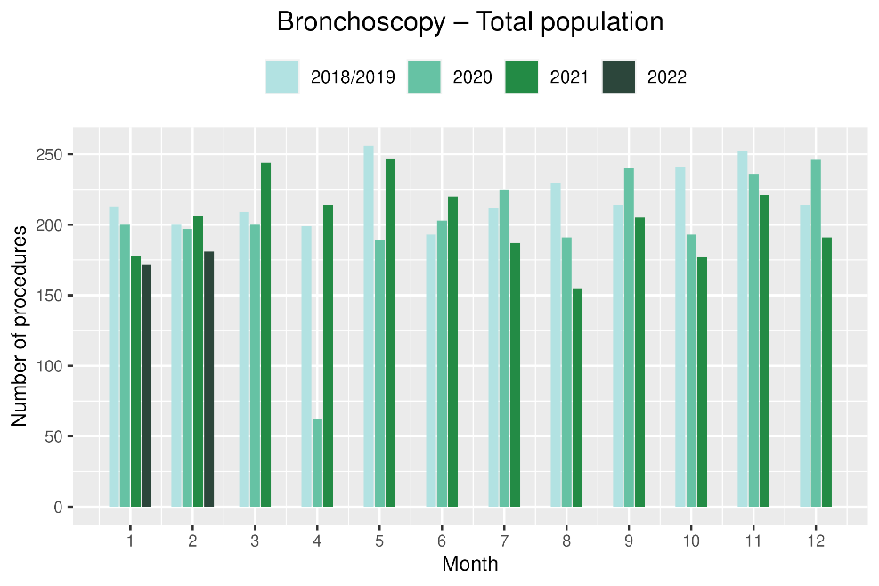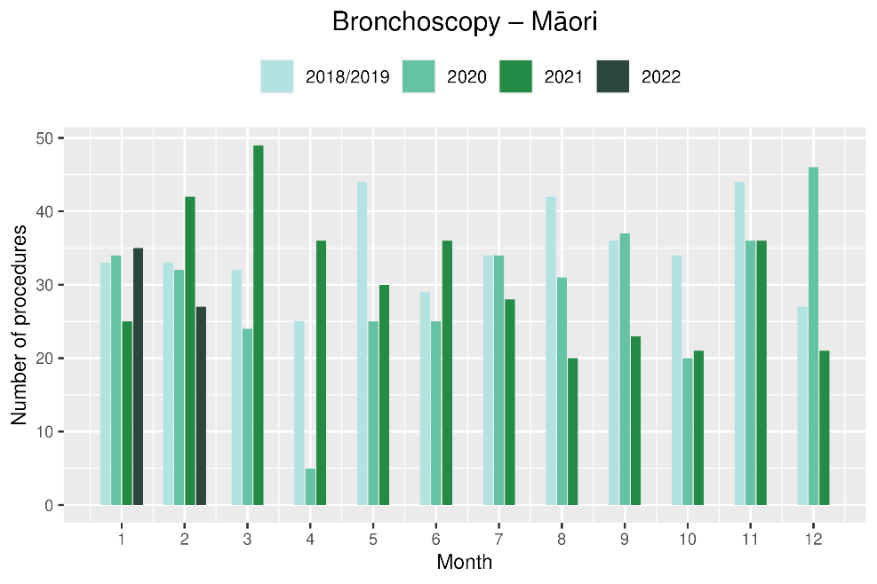

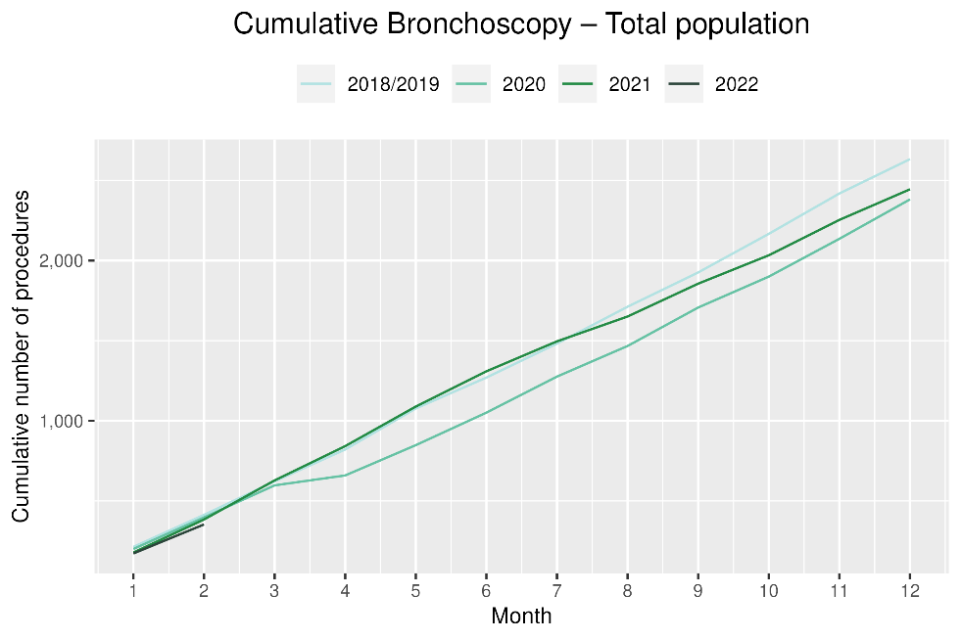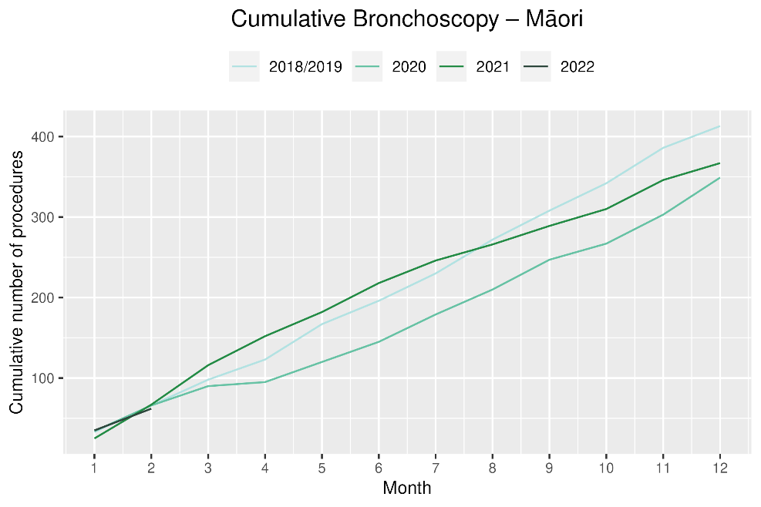

# Combined cancer surgery

## Notes on data

* This report includes data on surgery for colorectal, lung and prostate cancer. These cancers were chosen because Te Aho o Te Kahu already has a pre-validated list of surgical procedure codes for these cancers, agreed on as part of the quality performance indicator (QPI) work programme[2]. These three cancers are therefore used as case studies for cancer surgery more generally. The surgical procedure codes are listed in Appendix 5.
* The data were extracted from the NMDS on 30 March 2022.

## Key points

* In January 2022, there were 19% fewer cancer surgeries (prostate, lung and colorectal) compared to January 2021. When comparing February 2022 with February 2021, there was a 1% increase in cancer surgeries. This meant a 9% lower rate of cancer surgery for prostate, lung and colorectal cancer in the first two months of 2022, compared with 2021.
* For Māori, there was a 22% decrease in combined cancer surgeries for January and February 2022 combined compared with 2021 and for Pacific peoples this decrease was 35%, noting small numbers (particularly for Pacific peoples). For Māori, this decrease is smaller when compared with the same period in 2020, however small numbers make interpretation difficult (see figure 11).

## Results

Table 6: Number of cancer surgeries (prostate, colorectal, lung) and percentage difference in 2022 compared to 2021 by month and cumulative year to date, by ethnicity

|  |  |  |  |  |  |  |  |  |  |  |
| --- | --- | --- | --- | --- | --- | --- | --- | --- | --- | --- |
|  | **January** | | | **February** | | | **Cumulative January-February** | | | |
|  | **2021** | **2022** | **% change** | **2021** | **2022** | **% change** | **2021** | **2022** | **% change** |
| Māori* | - | - | - | - | - | - | 81 | 63 | -22% |
| Pacific peoples* | - | - | - | - | - | - | 17 | 11 | -35% |
| Non-Māori/Non-Pacific | 233 | 190 | -18% | 236 | 254 | 8% | 469 | 444 | -5% |
| Total population | 277 | 224 | -19% | 290 | 294 | 1% | 567 | 518 | -9% |

*Due to small numbers, monthly figures have not been included for Māori and Pacific peoples

Figure 10: Number of cancer surgeries (prostate, colorectal, lung) by month, 2018/19 average, 2020, 2021 and 2022, total population and Māori

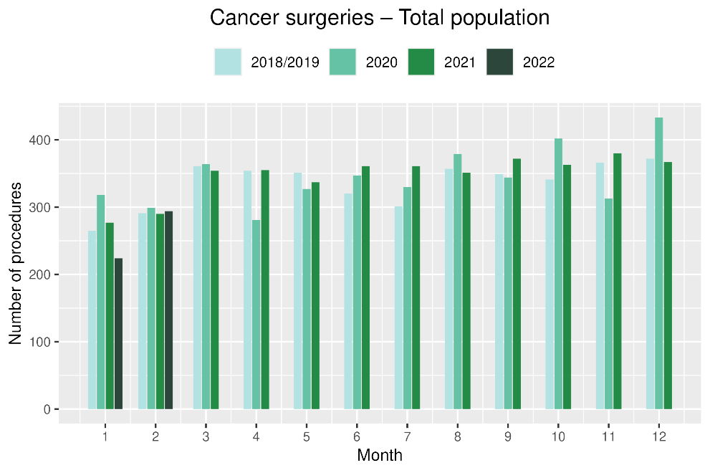 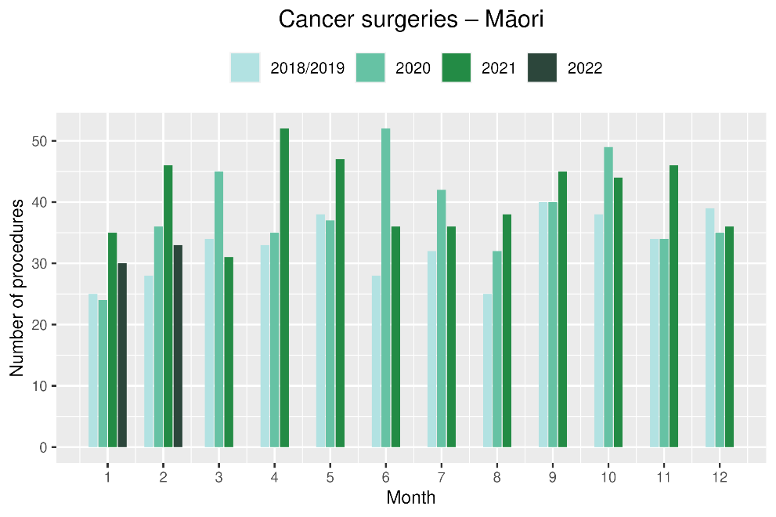

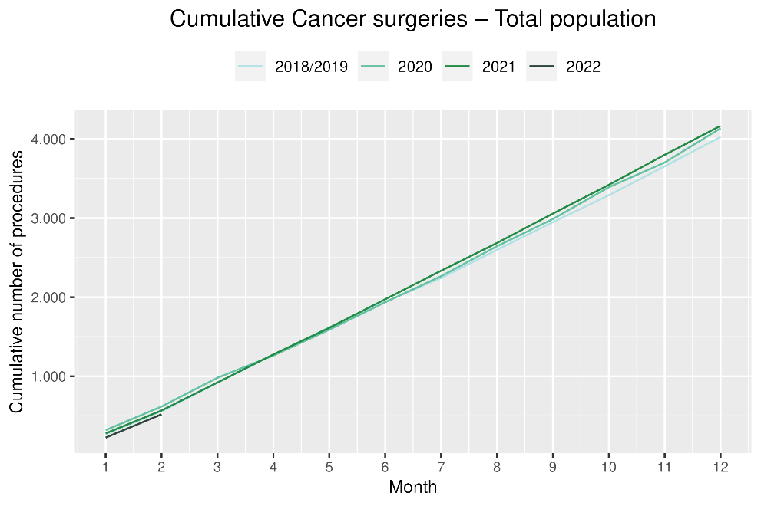 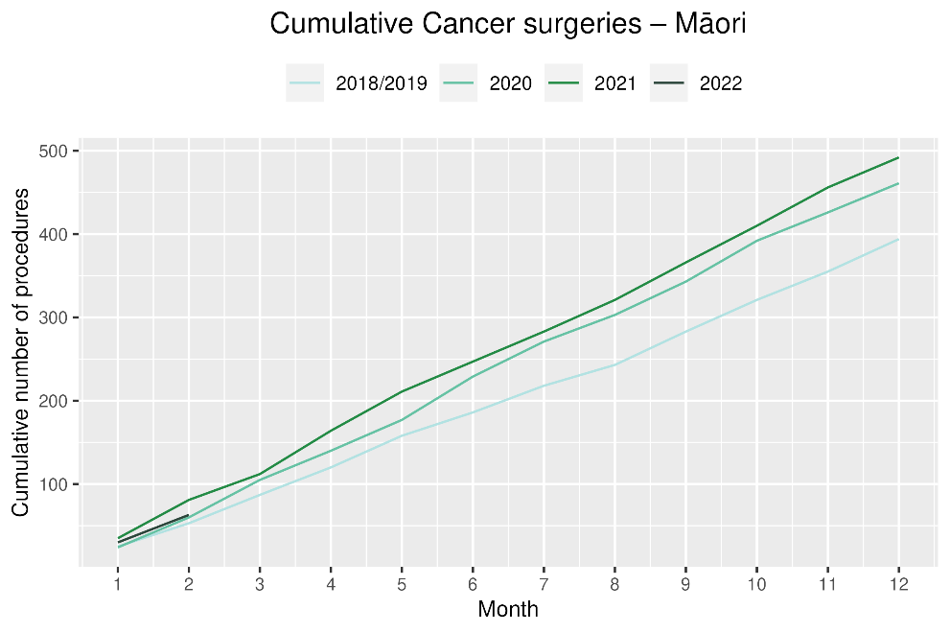

# Colorectal cancer surgery

## Notes on data

* The surgical procedure codes used for analysing colorectal cancer are listed in Appendix 5.
* The data were extracted from the NMDS on 30 March 2022.

## Key points

* There were 24% fewer colorectal cancer surgeries performed in January 2022 compared with January 2021 and a 10% increase in surgeries performed in February 2022 compared with February 2021, resulting in an overall 8% decrease over the two month period.

## Results

Table 7: Number of colorectal cancer surgeries and percentage difference in 2022 compared to 2021, by month and cumulative year to date, by ethnicity

|  |  |  |  |  |  |  |  |  |  |  |
| --- | --- | --- | --- | --- | --- | --- | --- | --- | --- | --- |
|  | **January** | | | **February** | | | **Cumulative January-** **February** | | | |
|  | **2021** | **2022** | **% change** | **2021** | **2022** | **% change** | **2021** | **2022** | **% change** |
| Māori* | - | - | - | - | - | - | - | - | - |
| Pacific peoples* | - | - | - | - | - | - | - | - | - |
| Non-Māori/Non-Pacific | 150 | 122 | -19% | 140 | 154 | 10% | 290 | 276 | -5% |
| Total population | 180 | 137 | -24% | 163 | 179 | 10% | 343 | 316 | -8% |

*Due to small numbers, monthly figures have not been included for Māori and Pacific peoples

**Figure 11: Number of colorectal cancer surgeries by month, 2018/19 average, 2020, 2021 and 2022, total population and Māori**

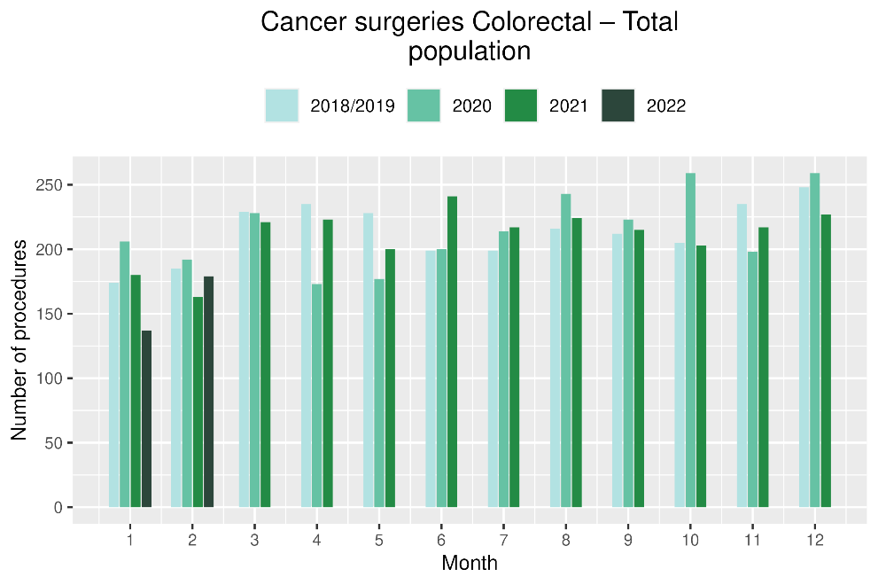 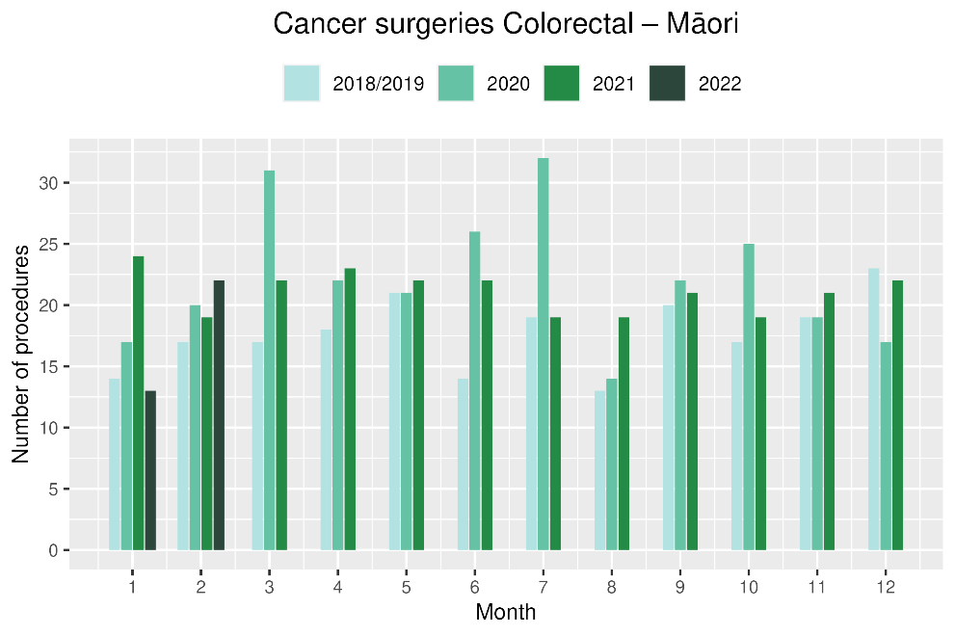

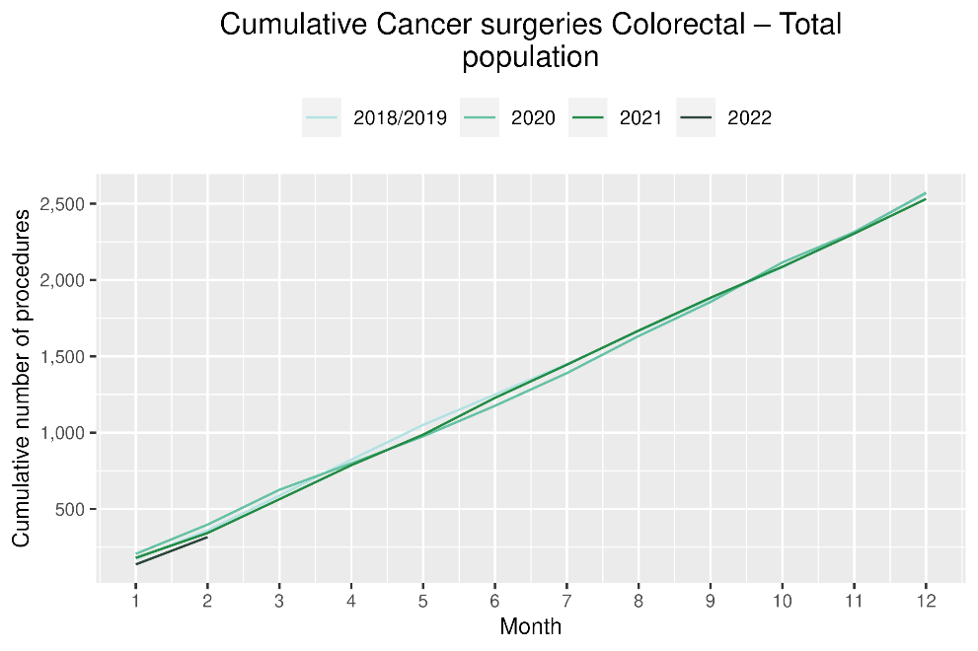 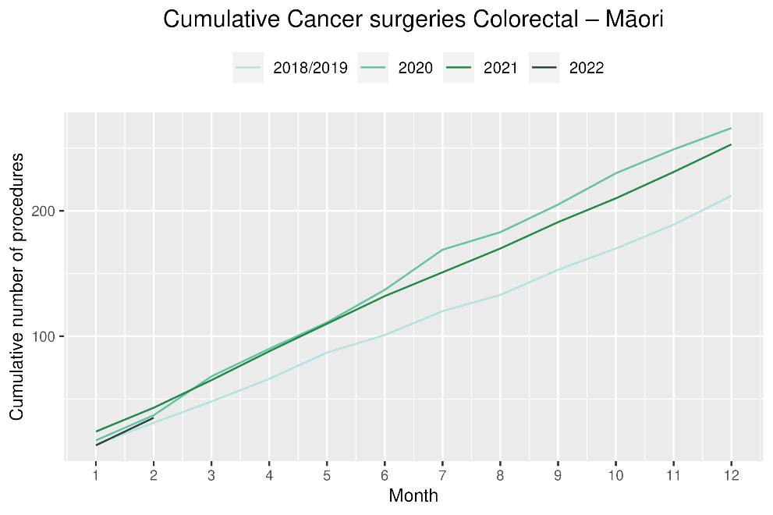

# Lung cancer surgery

## Notes on data

* A list of the surgical procedure codes used for analysis are included in Appendix 5.
* The data were extracted from the NMDS on 30 March 2022.
* The number of lung cancer surgeries performed each month is relatively small, so caution is needed when comparing data by month.

## Key points

* There were 8% fewer lung cancer surgeries performed in January 2022 compared with January 2021 and 10% fewer in February 2022 compared with February 2021, resulting in a 8% decrease over both months compared with 2021

## Results

Table 8: Number of lung cancer surgeries and percentage difference in 2022 compared to 2021, by month and cumulative year to date, by ethnicity

|  |  |  |  |  |  |  |  |  |  |
| --- | --- | --- | --- | --- | --- | --- | --- | --- | --- |
|  | **January** | | | **February** | | | **Cumulative January-February** | | |
|  | **2021** | **2022** | **% change** | **2021** | **2022** | **% change** | **2021** | **2022** | **% change** |
| Māori* | - | - | - | - | - | - | - | - | - |
| Pacific peoples* | - | - | - | - | - | - | - | - | - |
| Non-Māori/Non-Pacific | 32 | 27 | -16% | 38 | 45 | 18% | 70 | 72 | 3% |
| Total population | 40 | 37 | -8% | 62 | 56 | -10% | 102 | 93 | -9% |

* Due to small numbers, monthly figures have not been included for Māori and Pacific peoples

Figure 12: Number of lung cancer surgeries by month, 2018/19 average, 2020 and 2021, total population and Māori

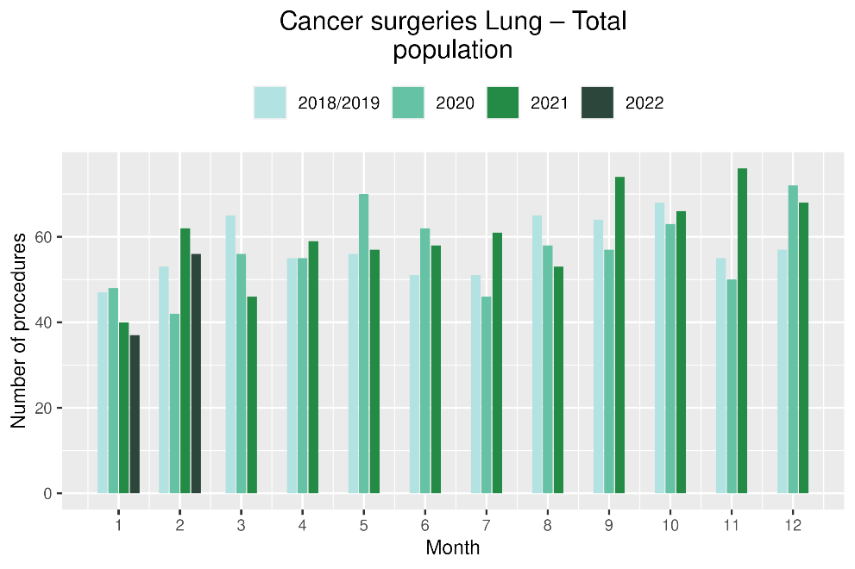 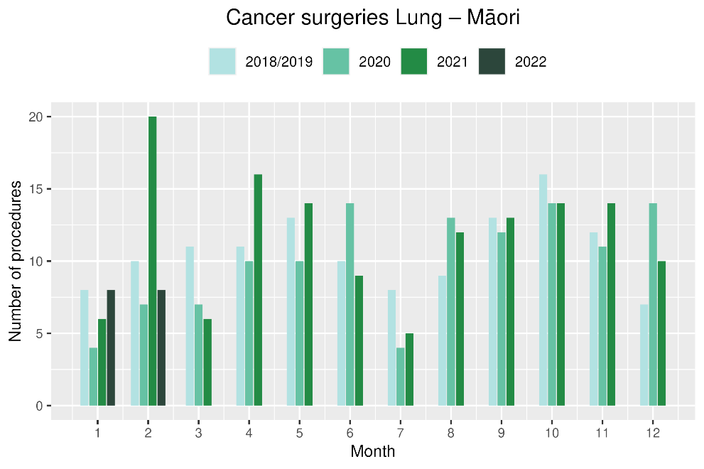

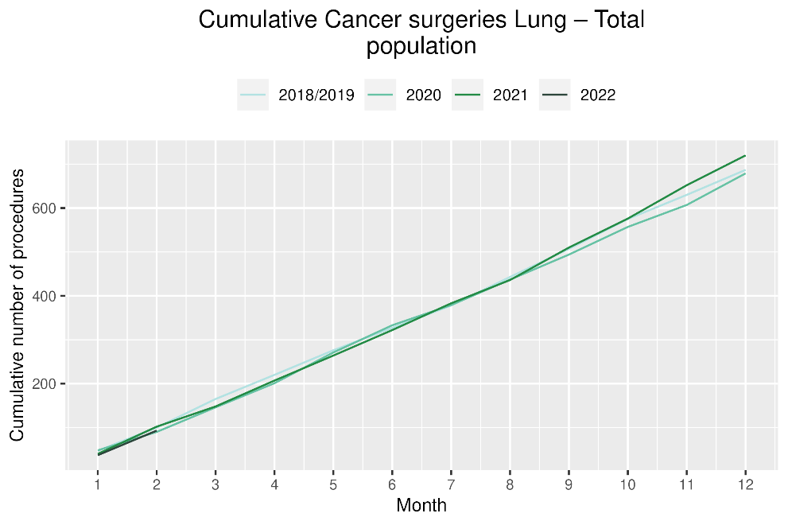 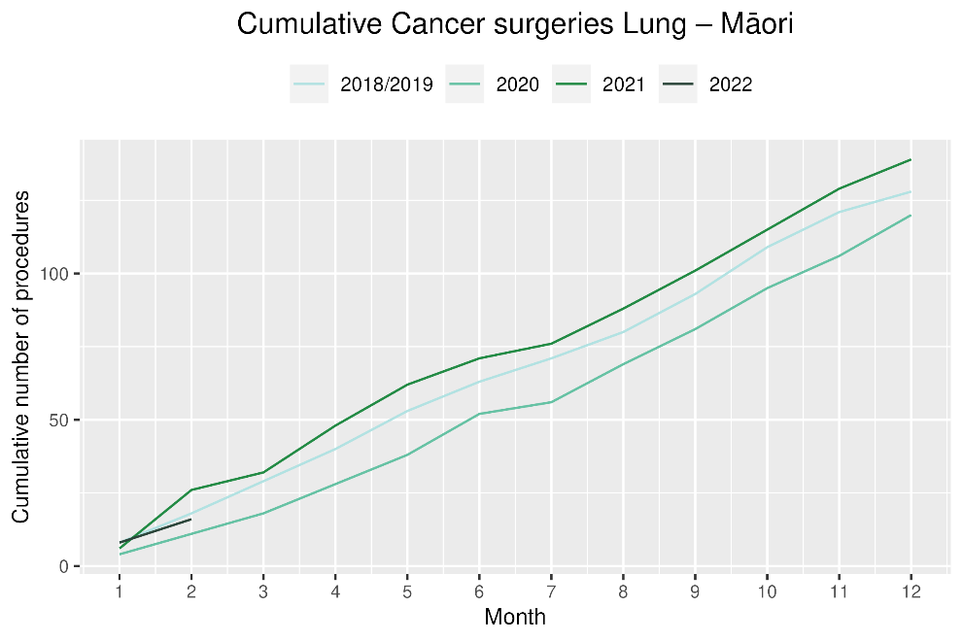

# Prostate cancer surgery

## Notes on data

* A list of the surgical procedure codes used for analysis are included in Appendix 5.
* The data was extracted from the NMDS on 30 March 2022.
* The volumes for prostate surgery are higher in this report than previously reported due to the inclusion of data from a private provider who provides publicly funded surgery.
* The number of prostate cancer surgeries performed each month is relatively small, so caution is needed when comparing data by month.

## Key points

* There were 12% fewer prostate cancer surgeries performed in January 2022 compared with January 2021 and 9% fewer in February 2022 compared with February 2021, meaning an overall decrease of 11% for both months compared with 2021

## Results

Table 9: Number of prostate cancer surgeries and percentage difference in 2022 compared to 2021 by month and cumulative year to date

|  |  |  |  |  |  |  |  |  |  |
| --- | --- | --- | --- | --- | --- | --- | --- | --- | --- |
|  | **January** | | | **February** | | | **Cumulative January-February** | | |
|  | **2021** | **2022** | **% change** | **2021** | **2022** | **% change** | **2021** | **2022** | **% change** |
| Total population | 57 | 50 | -12% | 65 | 59 | -9% | 122 | 109 | -11% |

* Due to small numbers, monthly figures have not been included for ethnic subgroups

Figure 13: Number of prostate cancer surgeries by month, 2018/19 average, 2020 and 2021, total population and Māori

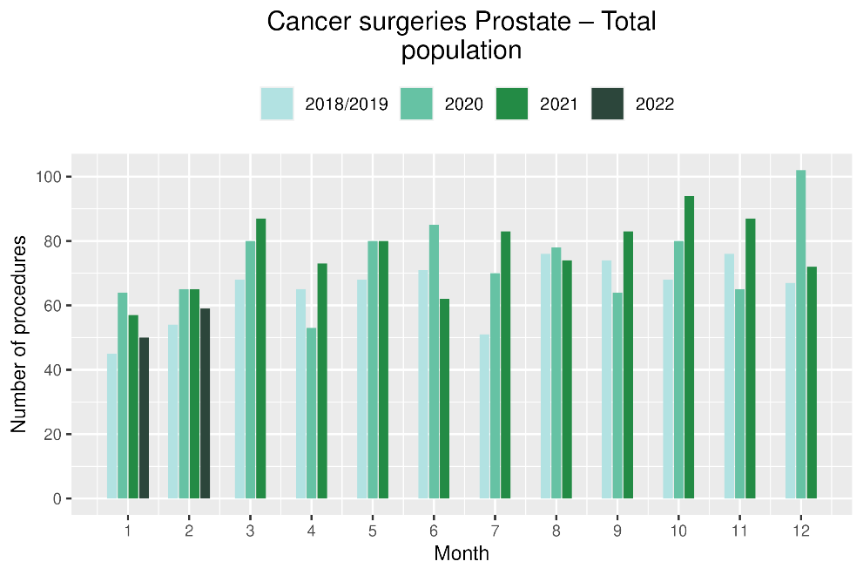 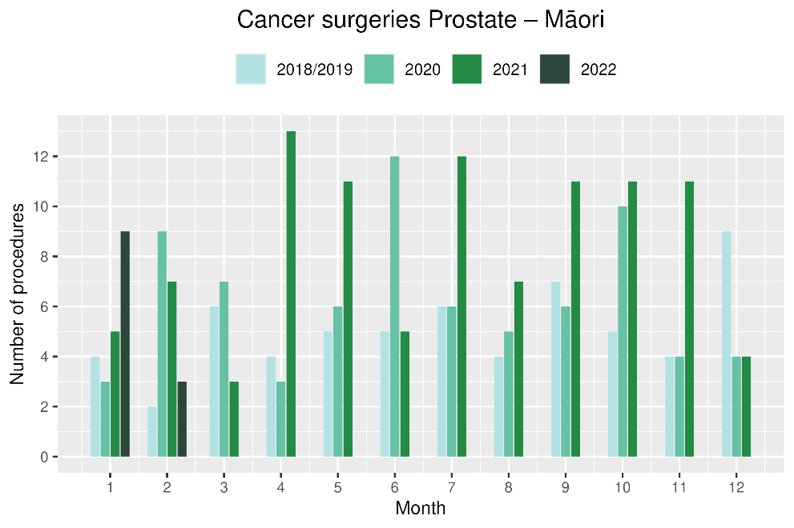

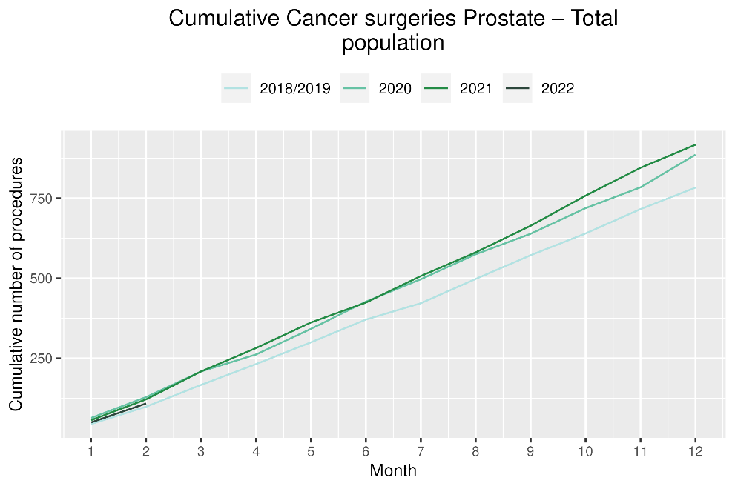 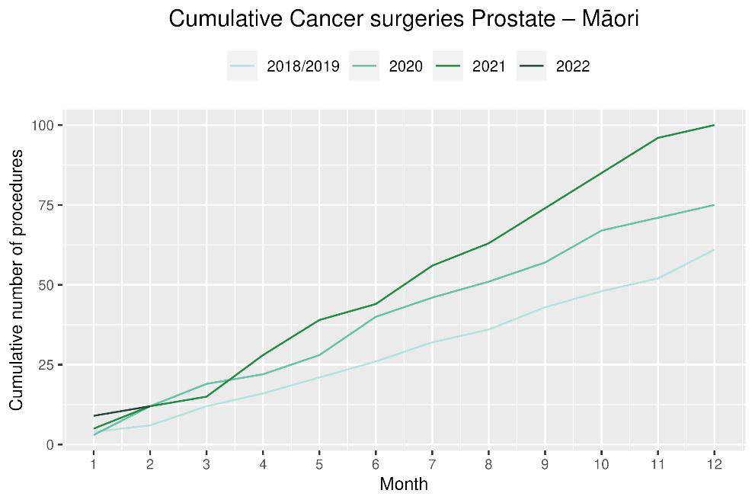

# Medical oncology

## Notes on data

* Data were extracted from NNPAC 30 March 2022.
* First specialist assessment (FSA) reflects counts of first attendance for specialist medical oncology assessment.
* Intravenous (IV) chemotherapy reflects appointments for outpatient and inpatient IV chemotherapy for non-haematological indications.
* Technical information: medical oncology FSA (PUC M50020) and IV chemotherapy (PUC MS02009).

## Key points

* Attendances for medical oncology first specialist assessments (FSAs) decreased by 5% in January 2022 compared to January 2021 and increased by 13% in February 2022 compared to February 2021, resulting in an overall 4% increase over that period. For Māori, there was a 12% decrease in FSAs in January 2022 compared to January 2021 and a 23% increase in February 2022 compared to February 2021.
* Attendances for intravenous (IV) chemotherapy decreased by 2% in January 2022 compared to January 2021 and decreased by 4% in February 2022 compared to February 2021 (with an combined decrease of 3% for both months). For Māori, there was a 4% increase in IV chemotherapy in January 2022 compared to January 2021 and a 3% decrease in February 2022 compared to February 2021. These decreases may reflect the decrease seen in FSAs in January.

## Results

Table 10: Number of medical oncology first specialist assessments and percentage difference in 2022 compared to 2021, by month and cumulative year to date, by ethnicity

|  |  |  |  |  |  |  |  |  |  |  |
| --- | --- | --- | --- | --- | --- | --- | --- | --- | --- | --- |
|  | **January** | | | **February** | | | **Cumulative January-February** | | | |
|  | **2021** | **2022** | **% change** | **2021** | **2022** | **% change** | **2021** | **2022** | **% change** |
| Māori | 92 | 81 | -12% | 100 | 123 | 23% | 192 | 204 | 6% |
| Pacific peoples | 26 | 36 | 38% | 38 | 35 | -8% | 64 | 71 | 11% |
| Non-Māori/Non-Pacific | 545 | 513 | -6% | 559 | 629 | 13% | 1,104 | 1,142 | 3% |
| Total population | 663 | 630 | -5% | 697 | 787 | 13% | 1,360 | 1,417 | 4% |

Figure 14: Number of medical oncology first specialist assessments by month, 2018/19 average, 2020, 2021 and 2022, total population and Māori

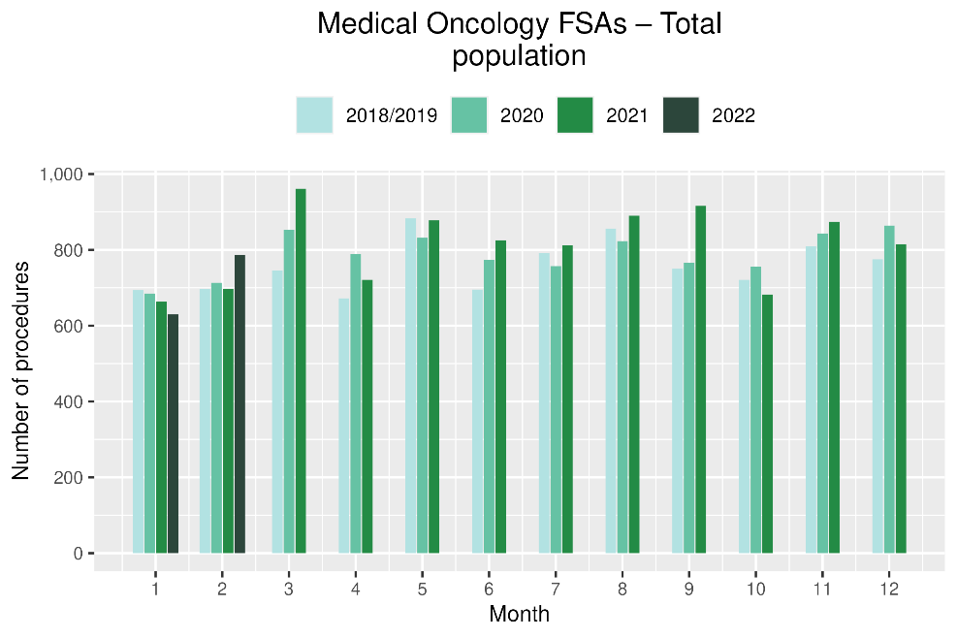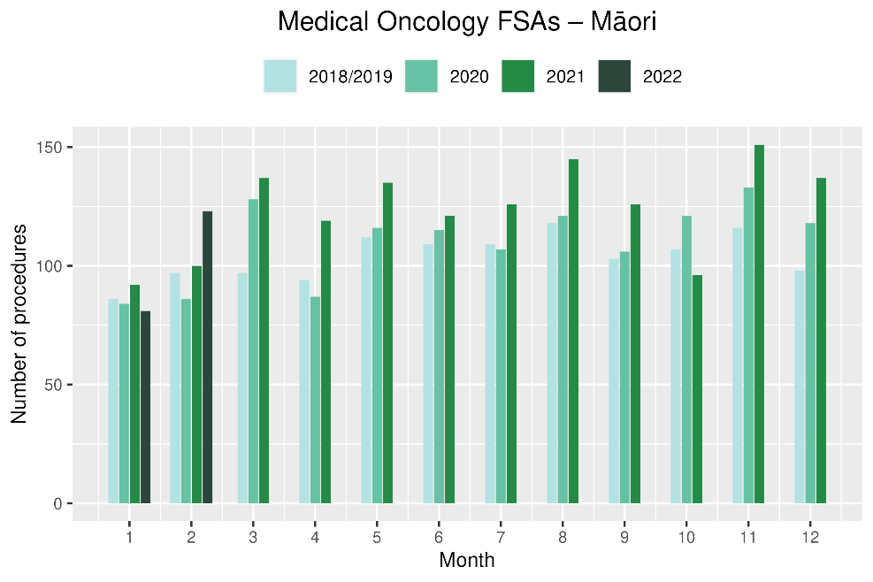

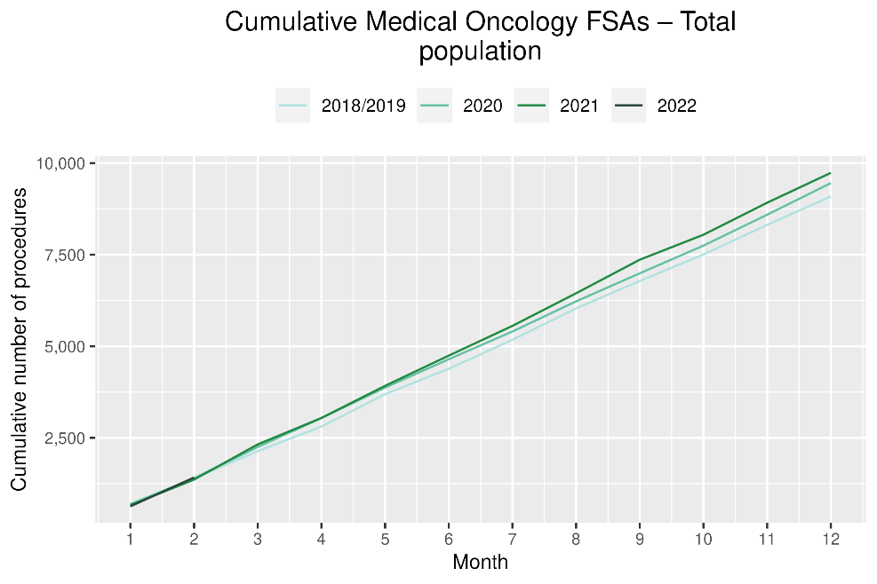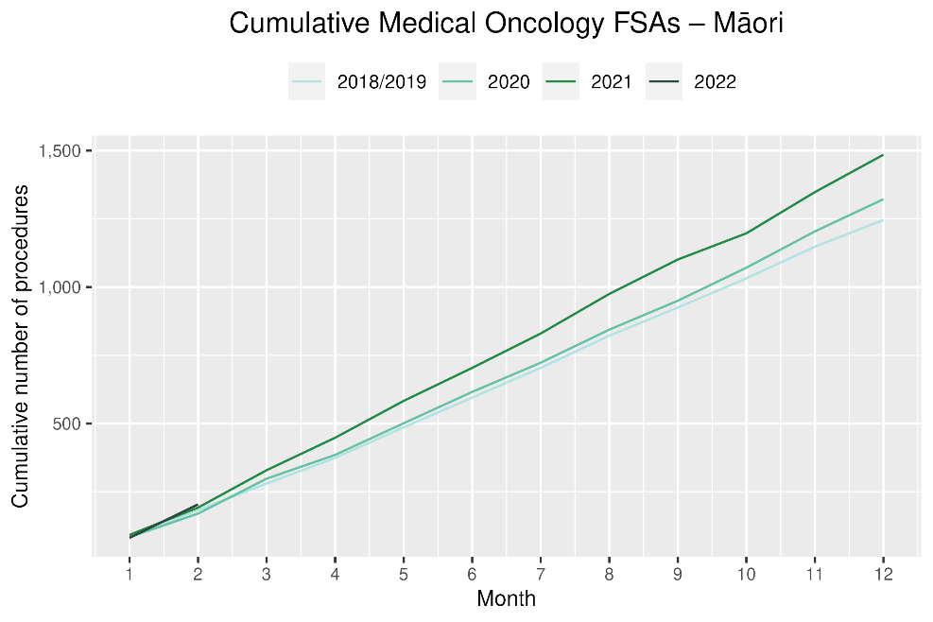

Table 11: Number of IV chemotherapy attendances and percentage difference in 2022 compared to 2021, by month and cumulative year to date, by ethnicity

|  |  |  |  |  |  |  |  |  |  |
| --- | --- | --- | --- | --- | --- | --- | --- | --- | --- |
|  | **January** | | | **February** | | | **Cumulative January-February** | | |
|  | **2021** | **2022** | **% change** | **2021** | **2022** | **% change** | **2021** | **2022** | **% change** |
| Māori | 897 | 934 | 4% | 850 | 821 | -3% | 1,747 | 1,755 | 0% |
| Pacific peoples | 288 | 345 | 17% | 302 | 261 | -14% | 590 | 606 | 3% |
| Non-Māori/Non-Pacific | 4,898 | 4,705 | -4% | 4,745 | 4,599 | -3% | 9,643 | 9,304 | -4% |
| Total population | 6,083 | 5,984 | -2% | 5,897 | 5,681 | -4% | 11,980 | 11,665 | -3% |

Figure 15: Number of IV chemotherapy attendances by month, 2018/19 average, 2020 and 2021, total population and Māori

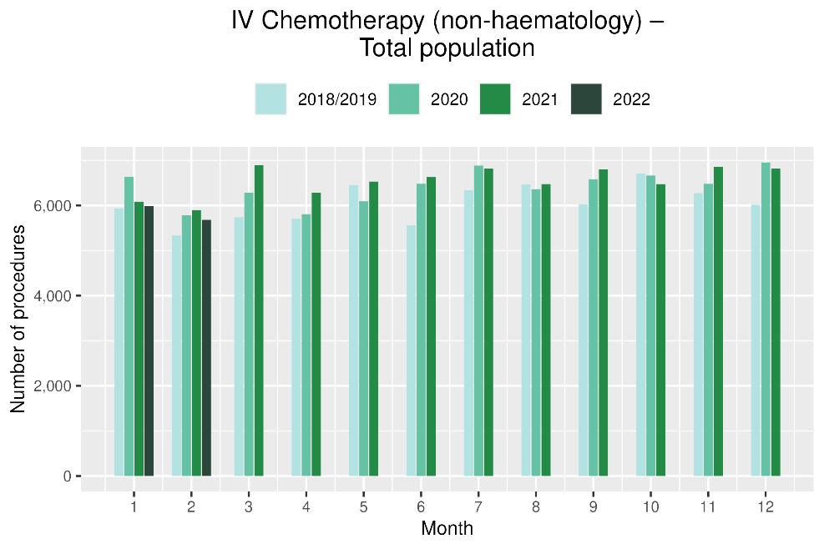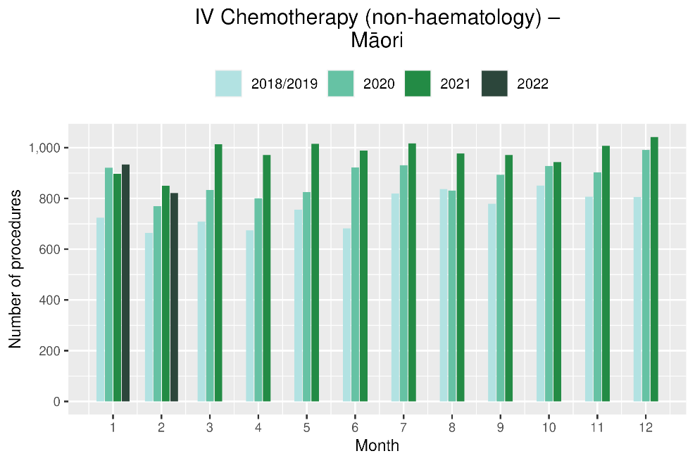

Figure 16: Cumulative number of attendances for IV chemotherapy, 2018/19 average, 2020 and 2021, total population and Māori

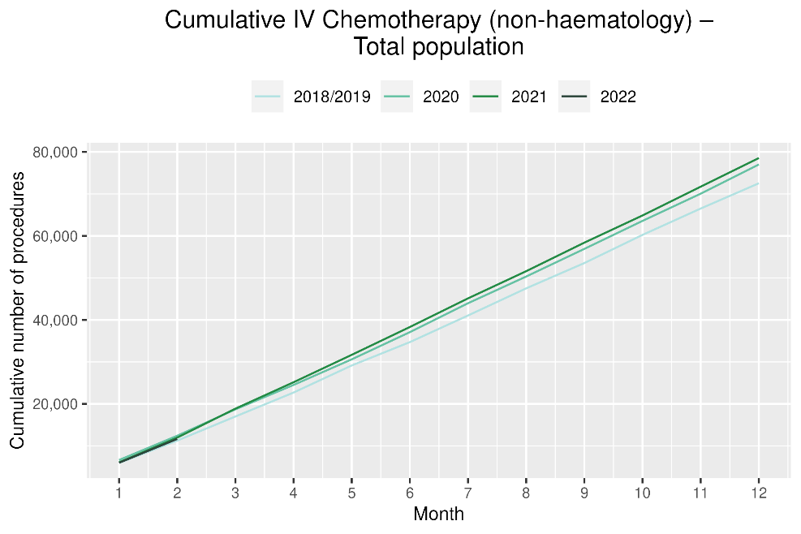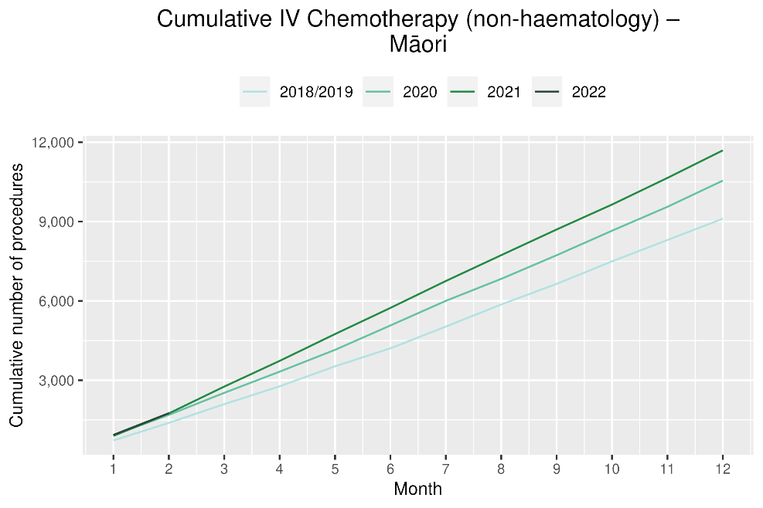

# Radiation oncology

## Notes on data

* Data were extracted from NNPAC on 30 March 2022.
* First specialist assessment (FSA) reflects counts of first attendance for radiation oncology specialist assessment.
* Radiation therapy attendances include appointments for planning/simulation and for treatment with radiation therapy on a linear accelerator.
* Technical information: radiation oncology FSA (PUC M50022), megavoltage attendances (Purchase Unit Code M50025)

## Key points

* Attendances for radiation oncology first specialist assessments (FSAs) decreased by 3% in both January and February 2022 compared to January and February 2021. For Māori, there was a 10% decrease in FSAs in January 2022 compared to January 2021 and a 2% increase in February 2022 compared to February 2021.
* Radiation therapy attendances decreased by 5% in both January and February 2022 compared to January and February 2021. For Māori, there was a 5% increase in radiation therapy attendances in January 2022 compared to January 2021 and a 9% increase in February 2022 compared to February 2021. For Pacific peoples there was a 3% decrease in radiation therapy attendances in January 2022 compared to January 2021 and a 4% decrease in February 2022 compared to February 2021.
* Te Aho o Te Kahu has been investigating the observed decrease in radiation therapy attendances by exploring data related to course of treatment, in addition to individual attendances for radiation therapy. 2021 data indicate that numbers of courses are not decreasing, therefore these trends may be related to utilisation of hypofractionation[3]. Te Aho o Te Kahu are working towards including the reporting of radiation therapy by course rather than by attendance in future reports.

## Results

Table 12: Number of radiation oncology first specialist assessments and percentage difference in 2022 compared 2021, by month and cumulative year to date, by ethnicity

|  |  |  |  |  |  |  |  |  |  |  |
| --- | --- | --- | --- | --- | --- | --- | --- | --- | --- | --- |
|  | **January** | | | **February** | | | **Cumulative January-February** | | | |
|  | **2021** | **2022** | **% change** | **2021** | **2022** | **% change** | **2021** | **2022** | **% change** |
| Māori | 121 | 109 | -10% | 119 | 121 | 2% | 240 | 230 | -4% |
| Pacific peoples | 41 | 47 | 15% | 48 | 40 | -17% | 89 | 87 | -2% |
| Non-Māori/Non-Pacific | 695 | 679 | -2% | 849 | 823 | -3% | 1,544 | 1,502 | -3% |
| Total population | 857 | 835 | -3% | 1,016 | 984 | -3% | 1,873 | 1,819 | -3% |

Figure 17: Number of radiation oncology first specialist assessments by month, 2018/19 average, 2020, 2021 and 2022, total population and Māori

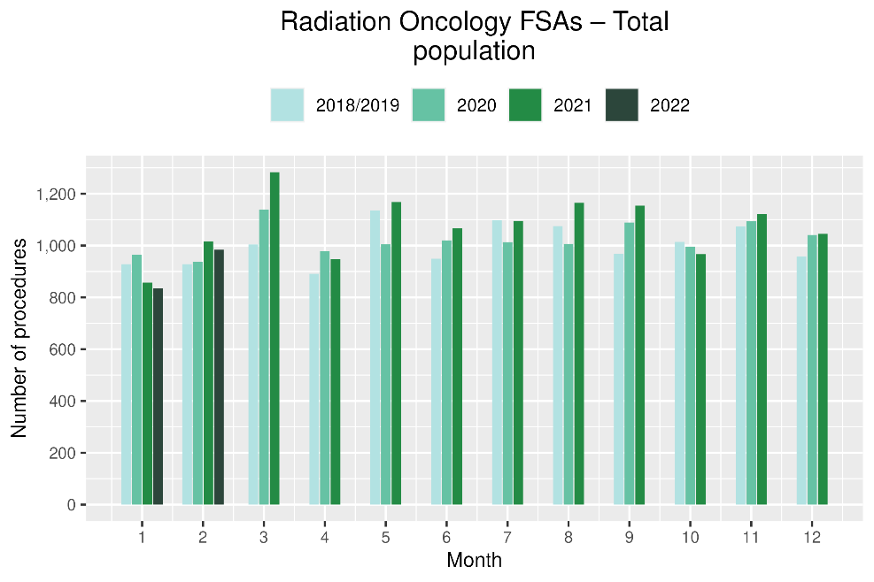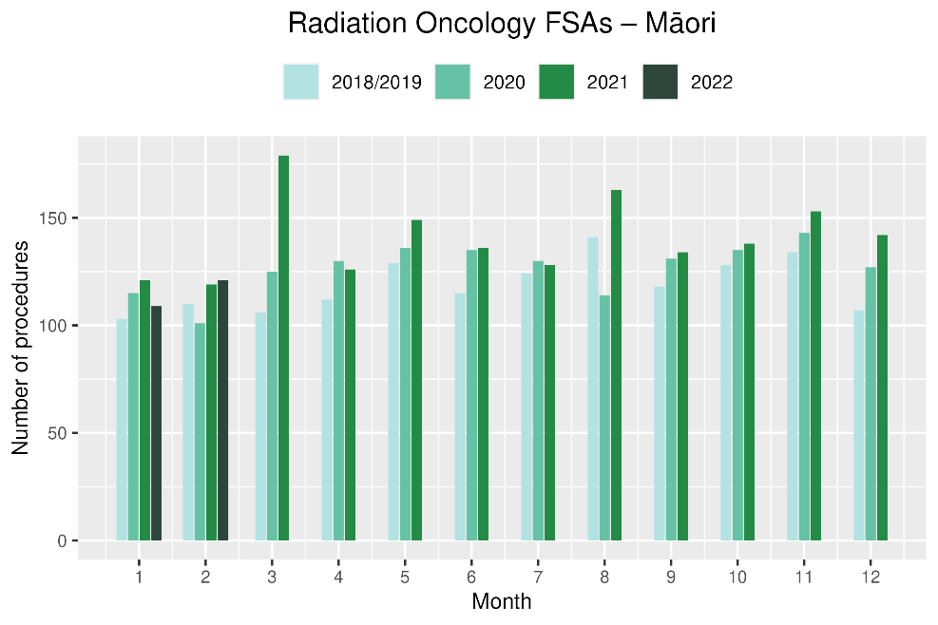

**Figure 19: Cumulative number of radiation oncology first specialist assessments by month, 2018/19 average, 2020, 2021 and 2022, total population and Māori**

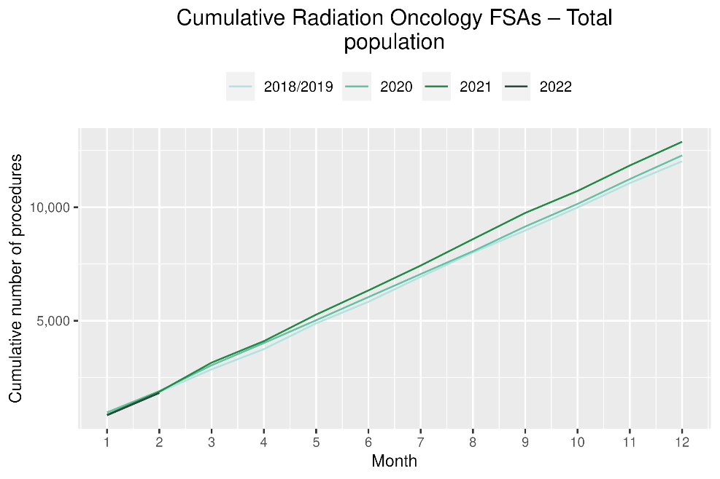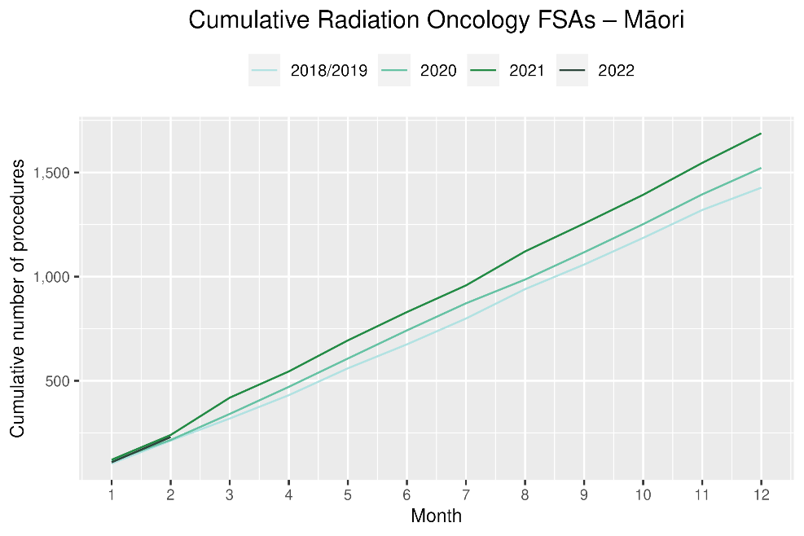

Table 13: Number of radiation therapy attendances and percentage difference in 2022 compared to 2021, by month and cumulative year to date, by ethnicity

|  |  |  |  |  |  |  |  |  |  |
| --- | --- | --- | --- | --- | --- | --- | --- | --- | --- |
|  | **January** | | | **February** | | | **Cumulative January-February** | | |
|  | **2021** | **2022** | **% change** | **2021** | **2022** | **% change** | **2021** | **2022** | **% change** |
| Māori | 1,621 | 1,700 | 5% | 1,640 | 1,784 | 9% | 3,261 | 3,484 | 7% |
| Pacific peoples | 480 | 464 | -3% | 538 | 519 | -4% | 1,018 | 983 | -3% |
| Non-Māori/Non-Pacific | 10,006 | 9,359 | -6% | 10,211 | 9,410 | -8% | 20,217 | 18,769 | -7% |
| Total population | 12,107 | 11,523 | -5% | 12,389 | 11,713 | -5% | 24,496 | 23,236 | -5% |

Figure 20: Number of radiation therapy attendances by month, 2018/19 average, 2020, 2021 and 2022, total population and Māori

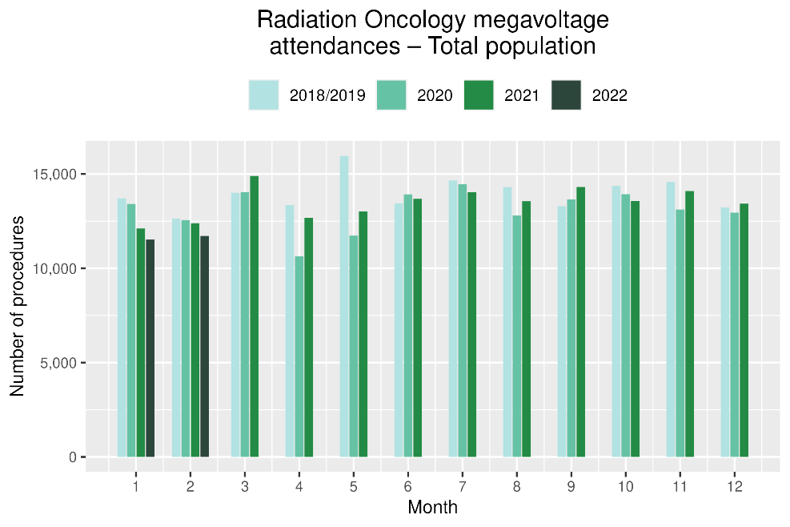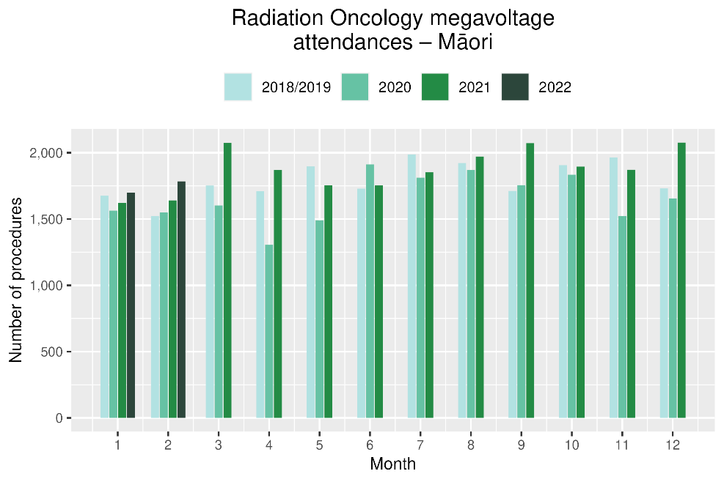

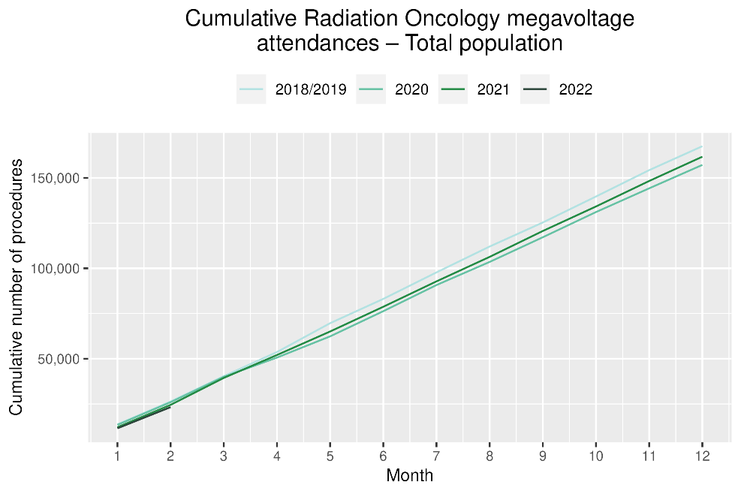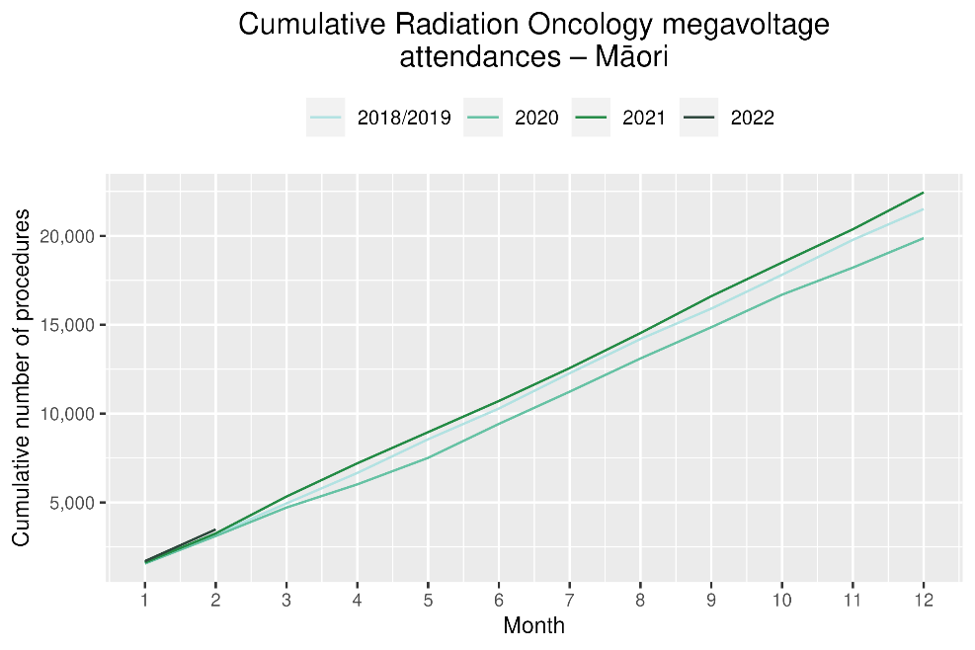

# Haematology

## Notes on data

* Data were extracted from NNPAC and NMDS on 30 March 2022.
* First specialist assessment (FSA) reflects counts of first attendance for specialist haematology assessment for any indication, not just cancer.
* IV chemotherapy reflects appointments for IV chemotherapy for haematological malignancies.
* Technical information: Haematology FSA (Purchase Unite Code: M30002), IV haem/chemo (Purchase Unit Code: M30020).

## Key points

* There was a 5% increase in attendances for haematology first specialist assessments (FSAs) in January 2022 compared to January 2021 and a 7% increase in February 2022 compared to February 2021, with a combined increase of 6% for both months. For Māori, there was a 15% increase in FSAs in January 2022 compared to January 2021 and a 23% decrease in February 2022 compared to February 2021 (noting small numbers).
* Attendances for haematology intravenous (IV) chemotherapy decreased by 3% in January 2022 compared to January 2021 and there was no change in February 2022 compared to February 2021, meaning a combined increase of 1% for both months. For Māori, there was a 6% decrease in haematology IV chemotherapy in January 2022 compared to January 2021 and a 14% decrease in February 2022 compared to February 2021. For Pacific peoples there was a 34% increase in IV chemotherapy in January 2022 compared to January 2021 and a 20% decrease in February 2022 compared to February 2021.

## Results

Table 14: Number of haematology first specialist assessment attendances and percentage difference in 2022 compared to 2021, by month and cumulative year to date, by ethnicity

|  |  |  |  |  |  |  |  |  |  |  |
| --- | --- | --- | --- | --- | --- | --- | --- | --- | --- | --- |
|  | **January** | | | **February** | | | **Cumulative January-February** | | | |
|  | **2021** | **2022** | **% change** | **2021** | **2022** | **% change** | **2021** | **2022** | **% change** |
| Māori | 41 | 47 | 15% | 60 | 46 | -23% | 101 | 93 | -8% |
| Pacific peoples | 19 | 27 | 42% | 26 | 36 | 38% | 45 | 63 | 40% |
| Non-Māori/Non-Pacific | 345 | 353 | 2% | 376 | 412 | 10% | 721 | 765 | 6% |
| Total population | 405 | 427 | 5% | 462 | 494 | 7% | 867 | 921 | 6% |

Figure 181: Number of haematology first specialist assessments by month, 2018/19 average, 2020, 2021 and 2022, total population and Māori

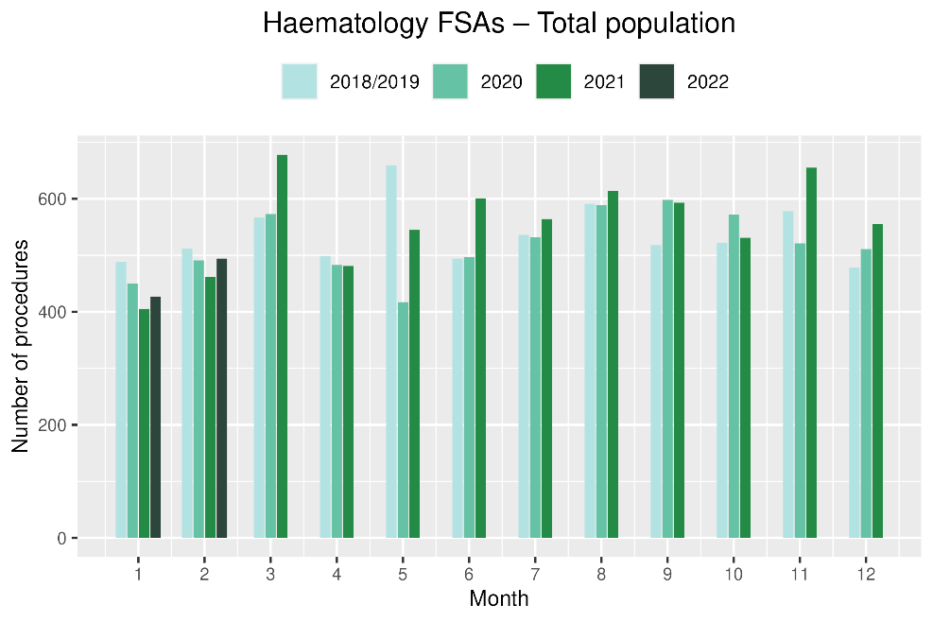 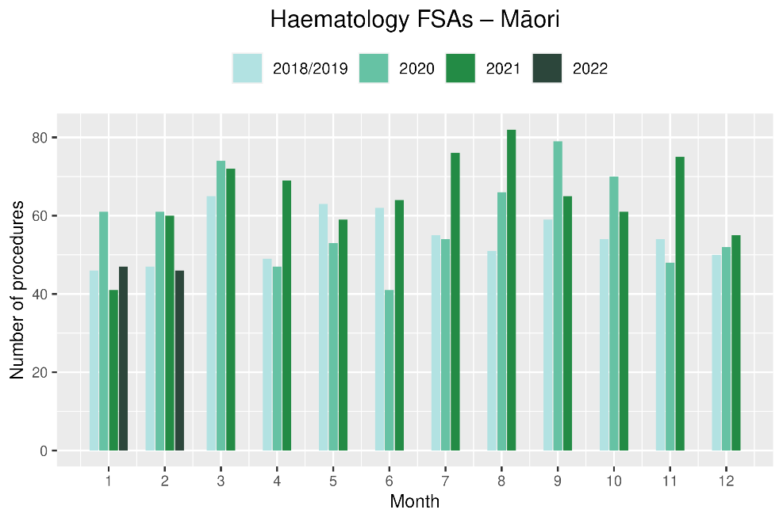

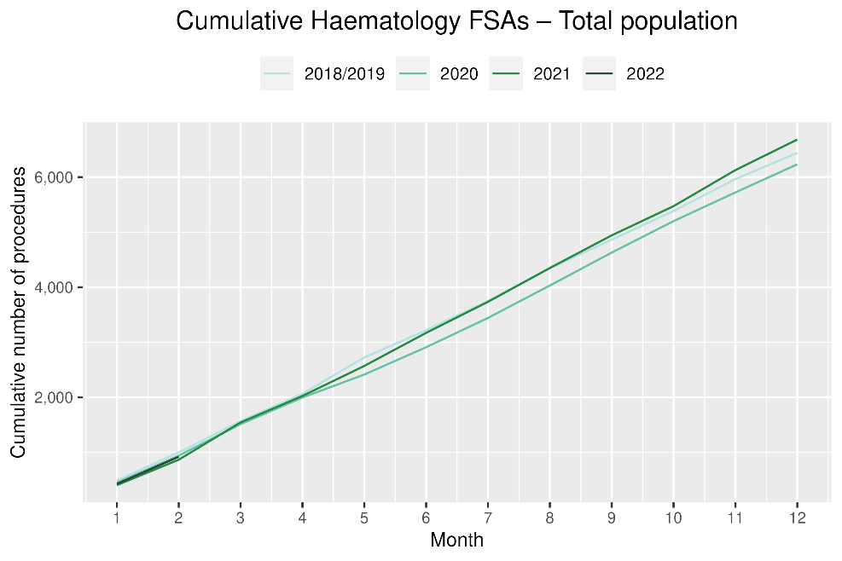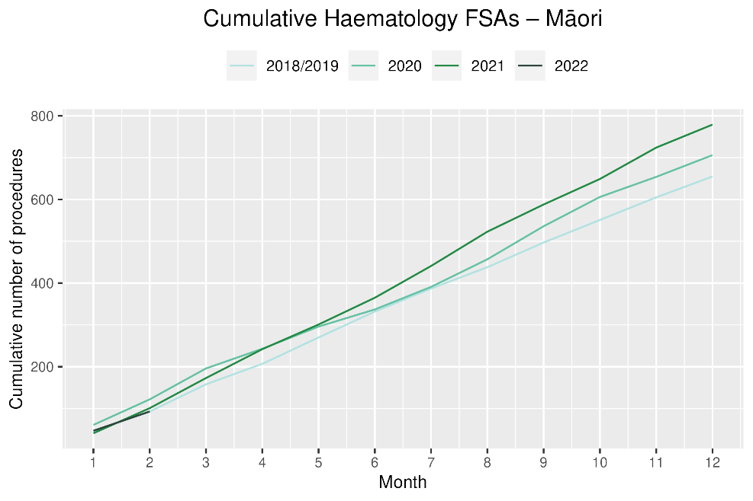

**Table 15: Number of IV chemotherapy attendances for haematological malignancies and percentage difference in 2022 compared to 2021, by month and cumulative year to date, by ethnicity**

|  |  |  |  |  |  |  |  |  |  |  |
| --- | --- | --- | --- | --- | --- | --- | --- | --- | --- | --- |
|  | **January** | | | **February** | | | **Cumulative January-February** | | | |
|  | **2021** | **2022** | **% change** | **2021** | **2022** | **% change** | **2021** | **2022** | **% change** |
| Māori | 222 | 209 | -6% | 222 | 192 | -14% | 444 | 401 | -10% |
| Pacific peoples | 103 | 138 | 34% | 144 | 115 | -20% | 247 | 253 | 2% |
| Non-Māori/Non-Pacific | 1,792 | 1,829 | 2% | 1,740 | 1,792 | 3% | 3,532 | 3,621 | 3% |
| Total population | 2,117 | 2,176 | 3% | 2,106 | 2,099 | 0% | 4,223 | 4,275 | 1% |

Figure 192: Number of attendances for IV chemotherapy for haematological malignancies by month, 2018/19 average, 2020, 2021 and 2022, total population and Māori

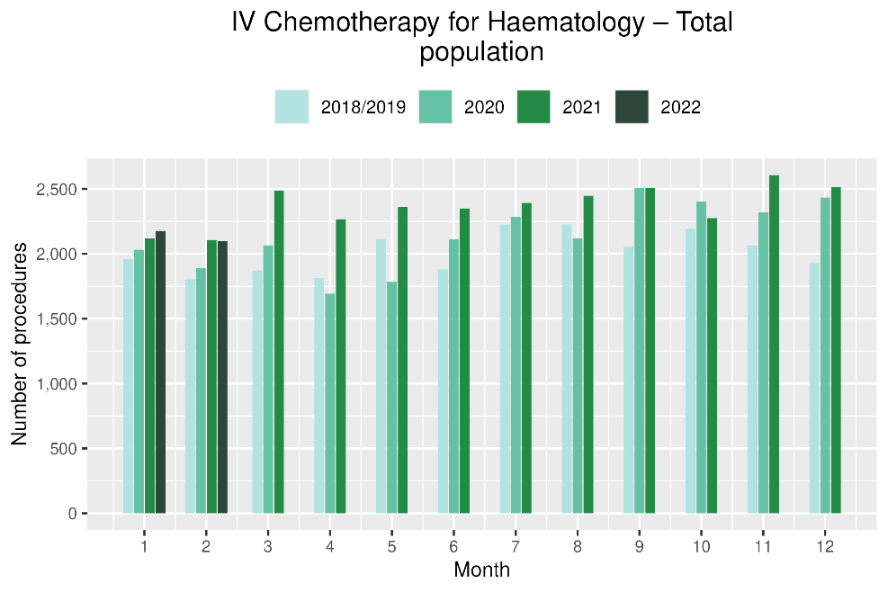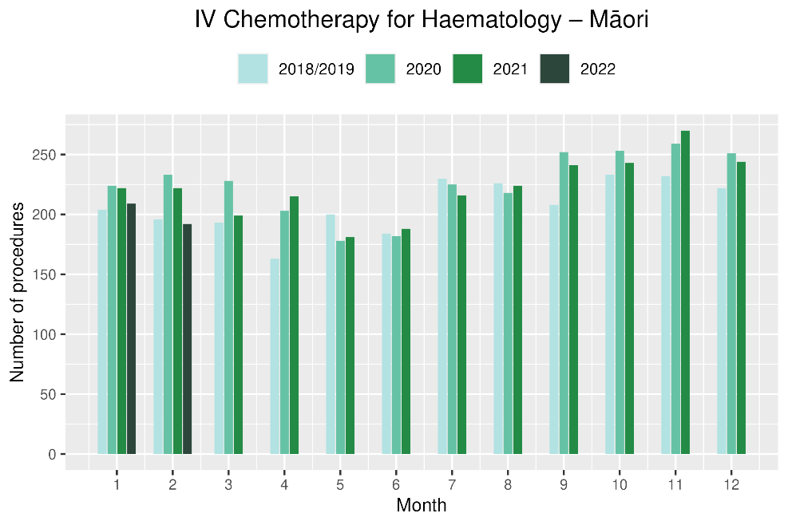

Figure 203: Cumulative number of attendances for IV chemotherapy for haematological malignancies, 2018/19 average, 2020, 2021 and 2022, total population and Māori

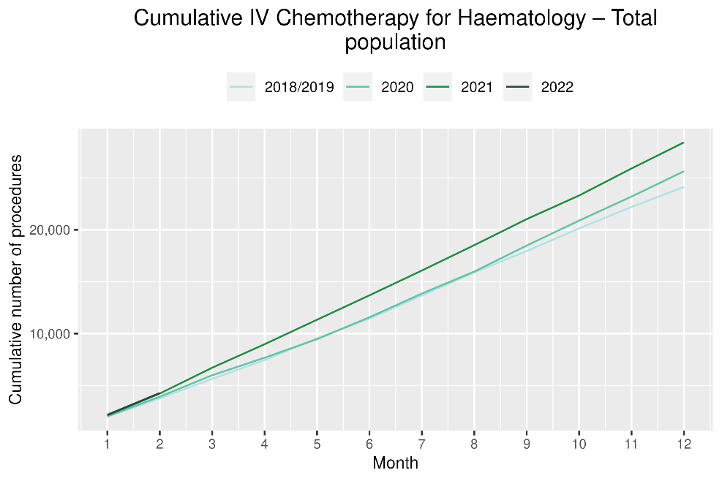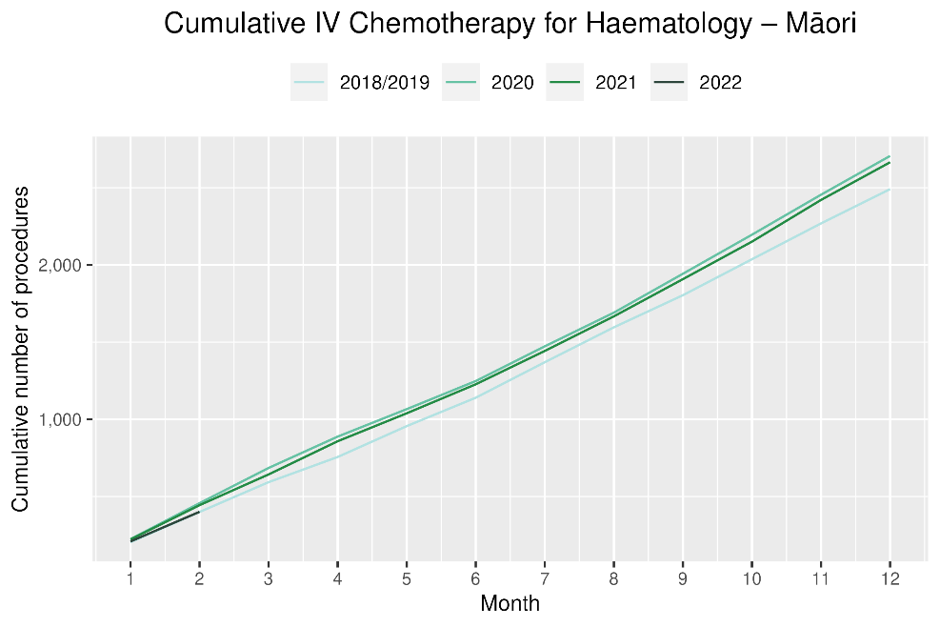

# Appendix 1: Key Dates

The follow provides a brief overview of key dates relating to COVID-19 restrictions (Alert Levels 3 and 4 where the greatest restrictions were in place) and outbreaks. More detailed information can be found on the Unite COVID-19 website[4], including an overview of Alert Levels and the COVID-19 Protection Framework[5].

|  |  |
| --- | --- |
| 23 March – 14 May 2020 | All Aotearoa New Zealand was at Alert Level 3 or 4 |
| 12 August – 30 September 2020 | Auckland only moved to Alert Level 3 |
| 28 Feb – 7 March 2021 | Auckland only was at Alert Level 3 |
| 17 August to 7 September 2021 | All Aotearoa New Zealand was at Alert 3 or 4 at the outset of the Delta variant outbreak |
| From 7 September 2021 | Auckland remained at Alert Level 4; the rest of the country moved to Alert Level 2 |
| September – December 2021 | Auckland moved to and remained at Alert Level 3 from 21 September. There were various regional changes between Alert Level 2 and 3 over this period some parts of the North Island including parts of Waikato. Details are available on the Unite COVID-19 website4. Note: The definition of Alert Level 3 was eased in early October and three gradually reducing steps of level 3 were introduced in October |
| 3 Dec 2021 | End of COVID-19 Alert System. All Aotearoa New Zealand moved to the COVID-19 Protection Framework (traffic lights) |
| 29 Dec 2021 | The first case of the Omicron variant in the community in New Zealand was detected |
| February 2021 | Omicron case numbers and hospitalisations increased more significantly in the second half of February onwards[6] |

# Appendix 2: NZCR data information

## The New Zealand Cancer Registry as a data source for new cancer diagnoses

Cancer registration is a process where data is collated from multiple sources about people diagnosed with cancer and rules are applied to determine the type of cancer they have. This information is recorded in the New Zealand Cancer Registry. Each tumour is classified using an international World Health Organization standard so that cancer incidence can be compared between countries. The tumour is staged based on all the information available within 4 months of diagnosis. This process may take up to six months or more depending on the number of missing reports that need to be followed up with laboratories.

For each registration there may be multiple pathology reports as there may be multiple procedures performed on the tumour. This means there will be more than one registration for people diagnosed with more than one type of tumour.

Cancer registrations come from pathology laboratories, haematology laboratories, mortality records and reviewing hospital discharge records. Laboratory reports provide the best source of near real time data to monitor new diagnoses of cancer in New Zealand.

## Pathology reports as a data source for providing near real time monitoring cancer diagnoses

Pathology reports (documents) are received by the NZCR as electronic messages. An administrator triages these documents each day and if the document appears to meet the requirements for registration the document is “administered”. The document may relate to an existing registration or may contain information for a new cancer event. Documents that do not meet the cancer reporting requirements will be marked as “deleted”, “rejected” or “agreed not for registration”.

The administrator creates a new provisional cancer event if the pathology report identifies a new cancer diagnosis for this person. This new cancer event is assigned to a cancer group and this provisional event is then queued for further assessment by a clinical coder. If the required information has been provided the coder creates a new registration. If some information is not yet available, then the registration is held open until further information arrives to complete the registration or determine that the tumour does not meet the registration criteria.

# Appendix 3: NZCR registrations by DHB

Number of cancer registrations and percentage difference in 2022 compared to 2021 average, by month and cumulative year to date, by DHB of domicile

|  |  |  |  |  |  |  |  |  |  |
| --- | --- | --- | --- | --- | --- | --- | --- | --- | --- |
|  | **January** | | | **February** | | | **Cumulative January-December** | | |
| **DHB** | **2021** | **2022** | **%Change** | **2021** | **2022** | **%Change** | **2021** | **2022** | **%Change** |
| Northland | 90 | 70 | -22% | 116 | 101 | -13% | 206 | 171 | -17% |
| Waitematā | 212 | 195 | -8% | 224 | 254 | 13% | 436 | 449 | 3% |
| Auckland | 126 | 151 | 20% | 155 | 165 | 6% | 281 | 316 | 12% |
| Counties Manukau | 173 | 154 | -11% | 178 | 181 | 2% | 351 | 335 | -5% |
| Waikato | 154 | 137 | -11% | 158 | 186 | 18% | 312 | 323 | 4% |
| Bay of Plenty | 89 | 103 | 16% | 100 | 96 | -4% | 189 | 199 | 5% |
| Tairāwhiti | 22 | 12 | -45% | 25 | 14 | -44% | 47 | 26 | -45% |
| Lakes | 49 | 36 | -27% | 44 | 46 | 5% | 93 | 82 | -12% |
| Taranaki | 66 | 46 | -30% | 61 | 64 | 5% | 127 | 110 | -13% |
| Hawkes Bay | 83 | 55 | -34% | 76 | 84 | 11% | 159 | 139 | -13% |
| Whanganui | 28 | 27 | -4% | 21 | 26 | 24% | 49 | 53 | 8% |
| MidCentral | 47 | 71 | 51% | 82 | 69 | -16% | 129 | 140 | 9% |
| Capital and Coast | 81 | 92 | 14% | 114 | 120 | 5% | 195 | 212 | 9% |
| Hutt Valley | 37 | 54 | 46% | 62 | 53 | -15% | 99 | 107 | 8% |
| Wairarapa | 23 | 19 | -17% | 25 | 26 | 4% | 48 | 45 | -6% |
| Nelson Marlborough | 74 | 62 | -16% | 77 | 65 | -16% | 151 | 127 | -16% |
| West Coast | 16 | 18 | 13% | 6 | 16 | 167% | 22 | 34 | 55% |
| Canterbury | 215 | 215 | 0% | 225 | 226 | 0% | 440 | 441 | 0% |
| South Canterbury | 29 | 28 | -3% | 33 | 30 | -9% | 62 | 58 | -6% |
| Southern | 146 | 120 | -18% | 138 | 137 | -1% | 284 | 257 | -10% |

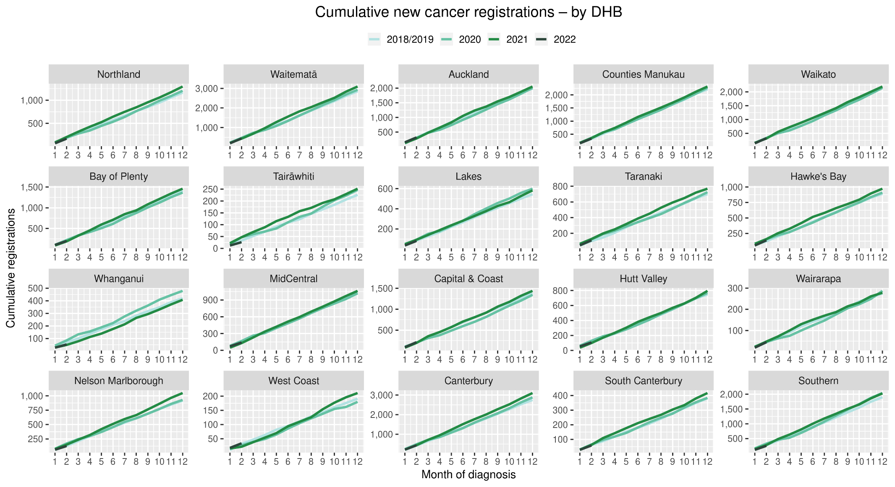

## Cumulative cancer registrations by DHB and ethnicity



## Cumulative cancer registrations by cancer type and ethnicity



# Appendix 4: Diagnosis and treatment data by DHB

Percentage differences are only presented if the cumulative total is 10 or greater. In some cases, the totals may differ to those presented in the national report due to non-DHB providers being excluded from the analyses within this appendix.

## Gastrointestinal endoscopy



## Bronchoscopy



## Colorectal cancer surgery



## Lung cancer surgery



## Prostate cancer surgery

## 

## Medical oncology first specialist assessments



## Medical oncology IV chemotherapy



## Radiation oncology first specialist assessments



## Radiation oncology megavoltage fractions



* Southern DHB radiation therapy treatment data is incomplete for 2021. DHB has resolved the issue and data will be updated in the next report.

## Haematology first specialist assessment



## Haematology IV chemotherapy



* MidCentral DHB Haematology IV chemotherapy data is incomplete for 2021. DHB has resolved the issue and data will be updated in the next report.

# Appendix 5: Surgical procedure codes

Below is a list of the surgical procedure codes that were used for analysis on cancer surgery.

|  |  |  |
| --- | --- | --- |
| **COLORECTAL CANCER SURGERY** | | |
| Clinical code | Block short description | Clinical code description |
| 3200000 | Colectomy | Limited excision of large intestine with formation of stoma |
| 3200001 | Colectomy | Right hemicolectomy with formation of stoma |
| 3200300 | Colectomy | Limited excision of large intestine with anastomosis |
| 3200301 | Colectomy | Right hemicolectomy with anastomosis |
| 3200400 | Colectomy | Subtotal colectomy with formation of stoma |
| 3200401 | Colectomy | Extended right hemicolectomy with formation of stoma |
| 3200500 | Colectomy | Subtotal colectomy with anastomosis |
| 3200501 | Colectomy | Extended right hemicolectomy with anastomosis |
| 3200600 | Colectomy | Left hemicolectomy with anastomosis |
| 3200601 | Colectomy | Left hemicolectomy with formation of stoma |
| 3200900 | Colectomy | Total colectomy with ileostomy |
| 3201200 | Colectomy | Total colectomy with ileorectal anastomosis |
| 3201500 | Total proctocolectomy | Total proctocolectomy with ileostomy |
| 3202400 | Anterior resection of rectum | High anterior resection of rectum |
| 3202500 | Anterior resection of rectum | Low anterior resection of rectum |
| 3202600 | Anterior resection of rectum | Ultra low anterior resection of rectum |
| 3202800 | Anterior resection of rectum | Ultra low anterior resection of rectum with hand sutured coloanal anastomosis |
| 3203000 | Rectosigmoidectomy or proctectomy | Rectosigmoidectomy with formation of stoma |
| 3203900 | Rectosigmoidectomy or proctectomy | Abdominoperineal proctectomy |
| 3205100 | Total proctocolectomy | Total proctocolectomy with ileo-anal anastomosis |
| 3205101 | Total proctocolectomy | Total proctocolectomy with ileo-anal anastomosis and formation of temporary ileostomy |
| 3206000 | Rectosigmoidectomy or proctectomy | Restorative proctectomy |
| 3209900 | Excision of lesion or tissue of rectum or anus | Per anal submucosal excision of lesion or tissue of rectum |
| 3211200 | Rectosigmoidectomy or proctectomy | Perineal rectosigmoidectomy |
| 9220800 | Anterior resection of rectum | Anterior resection of rectum, level unspecified |

|  |  |  |
| --- | --- | --- |
| **LUNG CANCER SURGERY** | | |
| Clinical code | Clinical code description | Block Description |
| 3844000 | Wedge resection of lung | Partial resection of lung |
| 3844001 | Radical wedge resection of lung | Partial resection of lung |
| 3843800 | Segmental resection of lung | Partial resection of lung |
| 9016900 | Endoscopic wedge resection of lung | Partial resection of lung |
| 3843801 | Lobectomy of lung | Lobectomy of lung |
| 3844100 | Radical lobectomy | Lobectomy of lung |
| 3844101 | Radical pneumonectomy | Pneumonectomy |
| 3843802 | Pneumonectomy | Pneumonectomy |

|  |  |  |
| --- | --- | --- |
| **PROSTATE CANCER SURGERY** | | |
| Clinical code | Block short description | Clinical code description |
| 3720004 | Open prostatectomy | Retropubic prostatectomy |
| 3720900 | Open prostatectomy | Radical prostatectomy |
| 3720901 | Other closed prostatectomy | Laparoscopic radical prostatectomy |
| 3721000 | Open prostatectomy | Radical prostatectomy with bladder neck reconstruction |
| 3721001 | Other closed prostatectomy | Laparoscopic radical prostatectomy with bladder neck reconstruction |
| 3721100 | Open prostatectomy | Radical prostatectomy with bladder neck reconstruction and pelvic lymphadenectomy |
| 3721101 | Other closed prostatectomy | Laparoscopic radical prostatectomy with bladder neck reconstruction and pelvic lymphadenectomy |
| 3720900 | Open prostatectomy | Radical prostatectomy |
| 3720901 | Closed prostatectomy | Laparoscopic radical prostatectomy |
| 3721000 | Open prostatectomy | Radical prostatectomy with bladder neck reconstruction |
| 3721001 | Closed prostatectomy | Laparoscopic radical prostatectomy with bladder neck reconstruction |
| 3721100 | Open prostatectomy | Radical prostatectomy with bladder neck reconstruction and pelvic lymphadenectomy |

1. Reports available here: <https://teaho.govt.nz/reports/cancer-care>
2. These lists were developed to focus on procedures that were more likely to be curative, however it is noted that there are palliative indications for these surgeries therefore we have removed the word curative from this report. The list of procedure codes remains the same, therefore comparisons with previous reports are uncomplicated.
3. Hypofractionation is a radiation treatment technique used to treat some cancers, whereby larger doses of radiation are given each treatment, meaning that patients require fewer sessions to complete their treatment. The technique is being increasingly used for some prostate and breast cancers in New Zealand and around the world.
4. <https://covid19.govt.nz/about-our-covid-19-response/history-of-the-covid-19-alert-system/>
5. <https://covid19.govt.nz/traffic-lights/covid-19-protection-framework>
6. <https://www.health.govt.nz/covid-19-novel-coronavirus/covid-19-data-and-statistics/covid-19-current-cases>