COVID-19 and cancer services

Working report on the impact of COVID-19 on cancer services for the period ending September 2021

Released November 2021

Acknowledgements
With thanks to the technical support from the Ministry of Health Data Management team.
With thanks to members of the COVID-19 Data Response Advisory Group: Professor Diana Sarfati, Alex Dunn, Dr John Fountain, Dr Elinor Millar, John Manderson, Michelle Mako, Dr Shaun Costello, Michelle Liu, Dr Liz Dennett, Gabrielle Nicholson, Dawn Wilson, Jan Smith, Cushla Lucas, Angela Pidd, Christine Fowler, Dr Nina Scott, Associate Professor Bridget Robson, Dr Jason Gurney, Dr Chris Jackson, and Richard Hamblin.

Contents
Acknowledgements 2
Contents 3
Summary of findings 4
Introduction 6
Auckland Regional Snapshot 8
Cancer Registrations 12
Gastrointestinal endoscopy 16
Bronchoscopy 18
Faster cancer treatment 20
Combined curative cancer surgery 22
Colorectal cancer surgery 24
Lung cancer surgery 26
Prostate cancer surgery 28
Medical oncology 30
Radiation oncology 34
Haematology 38
Appendix 1: NZCR data information 42
Appendix 2: NZCR registrations by DHB 43
Appendix 3: Diagnosis and treatment data by DHB 46
Appendix 4: Surgical procedure codes 57

Summary of findings
Impact of COVID-19 on cancer diagnosis and treatment
Overall, publicly funded cancer treatment services continued during the 2021 COVID-19 lockdown. The dip in cancer registrations seen during August 2021 has resolved, with an increase in new diagnoses of cancer in September 2021. There was some disruption to diagnostic procedures, most notably in the Auckland region. However, the overall impact of COVID-19 on diagnoses is considerably smaller and shorter-lived than the disruption seen in April and May 2020, demonstrating a health system that is learning how to safely deliver cancer services in the context of COVID-19. To date, COVID-19 does not appear to have increased inequities in access to cancer services for Māori.

Background and data
- The purpose of this report is to provide a rapid assessment of the impact of COVID-19 on cancer services during the 2021 COVID-19 Delta outbreak. It includes data up until 30 September 2021.
- The report focuses on the aspects of the cancer care pathway for which we have readily available data and does not capture all aspects of cancer care.
- We acknowledge individuals with cancer may have been impacted in significant way by COVID-19, including by changes to the way care has been delivered.
- The previous COVID-19 and Cancer reports, published in 2020, compared 2020 data directly with 2019 data. Given the disruption to health services in 2020, this report uses an average of observed numbers seen in 2018/19 as the comparator for numbers seen in 2021. For the purposes of this report, we have not added an adjustment for changes in incidence over time.

Auckland regional snapshot
- The Auckland region has been the most impacted by COVID-19 in 2021, remaining in Alert Level 4 for three weeks and Alert Level 3 for one week during September 2021.
- There was an initial decrease in new cancer diagnoses in August 2021 compared to August 2018/19 across all three Auckland DHBs. However, this increased in September 2021, and there has been an overall increase in diagnoses for the year to date compared to 2018/19.
- COVID-19 caused a disruption to the delivery of diagnostics services in both August and September, with a decrease in gastrointestinal endoscopies across the region in 2021 compared to 2018/19.
- Publicly funded cancer treatment – including surgery, IV chemotherapy and radiation therapy – continued across the Auckland region in August and September 2021.

Cancer diagnosis

Registrations
- Provisionally, there have been 241 more cancer registrations in September 2021, compared to September 2018/19 (a 12% increase). This increase was seen across all ethnic groups.
- For the year to date there has been a 7% increase in the number of cancer registrations in 2021 compared to 2018/19, with the largest increases for Asian (22%) and Māori (12%).

Diagnostics
- COVID-19 appears to have had a minimal impact on the number of referrals to secondary care with a high suspicion of cancer. A similar proportion of people are meeting the 62-day target time frame as pre-COVID-19.
- Gastrointestinal endoscopies: there was a 9% decrease in gastrointestinal endoscopies performed in September 2021, compared to September 2018/19 (a smaller decrease to the 31% decrease seen in August 2021). The decrease was smallest for Māori (1%) compared to non-Māori/non-Pacific (10%) and largest for Pacific peoples (20%). The decrease in endoscopies during September appears largely driven by the disruption to services in the Auckland region.
- Bronchoscopies: there was a 13% decrease in the number of bronchoscopies performed in September 2021 compared to September 2018/19. Overall, there has been 5% fewer bronchoscopies performed for the year to date compared to same time period in 2018/19. This decrease was similar for Māori (5%) and for non-Māori/non-Pacific (4%).

Cancer Treatment

Surgery
- Curative cancer surgeries (for prostate, lung and colorectal cancer) continued during September 2021. Overall, for the year to date the number of surgeries in 2021 has been in line with the number of surgeries in 2018/19 and 2020.

Chemotherapy and radiotherapy
- Medical oncology: there was a 25% increase in attendances for medical oncology FSAs in September 2021 compared to September 2018/19. The increase was similar across all ethnic groups. Attendances for IV chemotherapy remained stable over September 2021. There has been an overall 8% increase in the number of attendances for the year to date in 2021 compared to the same time period in 2018/19, with a larger increase for Māori (25%) and Pacific peoples (33%) than for non-Māori/non-Pacific (4%).
- Radiation oncology: attendances for radiation oncology FSAs remained stable in September 2021. For the year to date there has been a 9% increase in radiation oncology FSAs; however, there has been a decrease in attendances for radiotherapy in 2021 compared to 2018/19. The decrease in attendances for radiotherapy has been seen throughout the year and likely reflects increased utilisation of hypofractionation. The decrease in attendances in 2021 is less notable for Māori, which may reflect stage at diagnosis, with hypofractionation more likely to be utilised for early-stage cancer.
- Haematology: attendances for haematology FSAs and IV chemotherapy remained stable during September 2021. For the year to date there has been an overall 6% increase in the number of haematology attendances for IV chemotherapy compared to the same time period in 2018/19.

Introduction

Background
In 2020, Te Aho o Te Kahu released a series of reports outlining the impact of COVID-19 on cancer services in New Zealand. These reports showed that cancer treatment services – surgery, medical oncology, radiation oncology and haematology – continued during the COVID-19 pandemic. Following an initial drop in new cancer registrations during the April 2020 lockdown, the number of cancer registrations in 2020 increased steadily in the following months and, by the end of September, had caught up to the number seen in 2019.
As the COVID-19 situation and disruptions to health care settled, Te Aho o Te Kahu stopped regular COVID-19 and cancer reporting at the end of 2020. With the re-emergence of COVID-19 in the community in August 2021 and the return of lockdown restrictions, Te Aho o Te Kahu have re-instated monitoring related to COVID-19 in September 2021.

Purpose
This is the second report looking at the impact of COVID-19 on cancer services during the 2021 COVID-19, Delta outbreak. It includes data up until the end of September 2021. The aim of this work is to rapidly collate evidence on any delays to cancer diagnosis and treatment to support policy development and recovery and response planning.
The report focuses on the aspects of the cancer care pathway for which we have readily available data and does not capture all aspects of the care. Critical aspects of cancer care, including access to primary health care, radiology, palliative care and patient experience, are not measured in this report. While the report focuses on the impact of COVID-19 on overall cancer diagnosis and treatment, we acknowledge that individuals with cancer may have been impacted in significant way by COVID-19, including by changes to the way care has been delivered.

Data and analysis
The data in this report come from Ministry of Health national data collections. Each section of the report includes information on where the data is from and any limitations associated with the data. Of note Taranaki DHB and Southern DHB non-surgical cancer treatment data is not included due to incomplete data for the July 2021 and August 2021 period. Both DHBs are actively working on resolving this issue for the next report. Numbers in this report may not match the previous report exactly, due to exclusion of incomplete data and delayed coding/submission of data.
The purpose of the analysis is to rapidly measure the impact of COVID-19 and the recovery on cancer services, therefore the analysis does not consider pre-existing unmet need. The report also makes direct comparisons between 2021 and previous years and does not consider any increase in cancer diagnoses over time.

Comparator for this report
The previous COVID-19 and Cancer reports, published in 2020, compared 2020 data directly with 2019 data. Given the disruption COVID-19 caused to health services in 2020, 2020 was not considered an appropriate comparator. To improve the stability of the baseline for comparison, an average of observed numbers in 2018 and 2019 is used as a comparator for numbers seen in 2021 in this report. All graphs include data from 2021, 2020 and an average from 2018/19.

Key dates
Key dates in relation to COVID-19, up until the end of September 2021, that may be of use when reviewing the report include:
- 17 August 2021: all of New Zealand moves to Alert Level 4
- 31 August 2021: all of New Zealand south of Auckland moves to Alert Level 3, Auckland and Northland remain at Alert Level 4.
- 2 September 2021: Northland moves to Alert Level 3. All of New Zealand (except Auckland) at Alert Level 3
- 7 September 2021: New Zealand (except Auckland) moves to Alert Level 2.
- 21 September 2021: Auckland and Upper Hauraki move to Alert Level 3.
- 25 September 2021: Upper Hauraki moves to Alert Level 2.
Key dates in relation to COVID-19 in 2020 include:
- 23 March 2020: all of New Zealand moves to Alert Level 3
- 26 March 2020: all of New Zealand moves to Alert Level 4
- 28 April 2020: all of New Zealand moves to Alert Level 3
- 14 May 2020: all of New Zealand moves to Alert Level 2
- 9 June 2020: all of New Zealand moves to Alert Level 1
- 12 August 2020: Auckland moves to Alert Level 3, the rest of New Zealand moves to Alert Level 2
- 30 September 2020: Auckland moves to Alert Level 2.5, the rest of New Zealand stays at Alert Level 2
- 22 September 2020: all regions, except Auckland, move to Alert Level 1
- 8 November 2020: Auckland moves to Alert Level 2, without extra restrictions on travel and gatherings
- 8 October 2020: all of New Zealand moves to Alert Level 1.

Ongoing reporting
Te Aho o Te Kahu will continue to monitor the impact of COVID-19 and lockdown on cancer services, with the next report (looking at data to the end of October) released in December 2021.

Auckland Regional Snapshot

Key points
- The Auckland region has been the most impacted by COVID-19 in 2021, remaining in Alert Level 4 for three weeks and Alert Level 3 for one week during September 2021.
- There was an initial decrease in new cancer diagnoses in August 2021 compared to August 2018/19 across all three Auckland DHBs. However, this increased in September 2021, and there has been an overall increase in diagnoses for the year to date compared to 2018/19.
- COVID-19 caused a disruption to diagnostics services in both August and September, with a decrease in gastrointestinal endoscopies across the region in 2021 compared to 2018/19 (noting these procedures are completed for several indications, not just cancer related)
- Publicly funded cancer treatment – including surgery, chemotherapy and radiation therapy – continued across the Auckland region in August and September 2021.
- Radiation therapy volumes in the Auckland region follow a similar pattern to that seen across New Zealand, with an overall decrease in volumes in 2021 likely related to increased utilisation of hypofractionation (see Radiation oncology page 34).

Cancer diagnosis and treatment

Registrations
Table 1: Number of provisional cancer registrations and percentage change in 2021 compared to the 2018/19 average, by month and cumulative year to date, by DHB
 | July |  |  | August |  |  | September |  |  | Cumulative January-September
DHB | 2018/19 average | 2021 | % change | 2018/19 average | 2021 | % change | 2018/19 average | 2021 | % change | 2018/20 average | 2021 | % change
Waitematā | 252 | 268 | 7% | 262 | 220 | -16% | 238 | 245 | 3% | 2,106 | 2,295 | 9%
Auckland | 163 | 182 | 12% | 160 | 138 | -13% | 158 | 181 | 15% | 1,492 | 1,552 | 4%
Counties Manukau | 194 | 178 | -8% | 190 | 182 | -4% | 178 | 185 | 4% | 1,627 | 1,703 | 5%

Figure 1: Cumulative number of cancer registrations by month, 2018/19 average, 2020 and 2021, for the Auckland region, by DHB
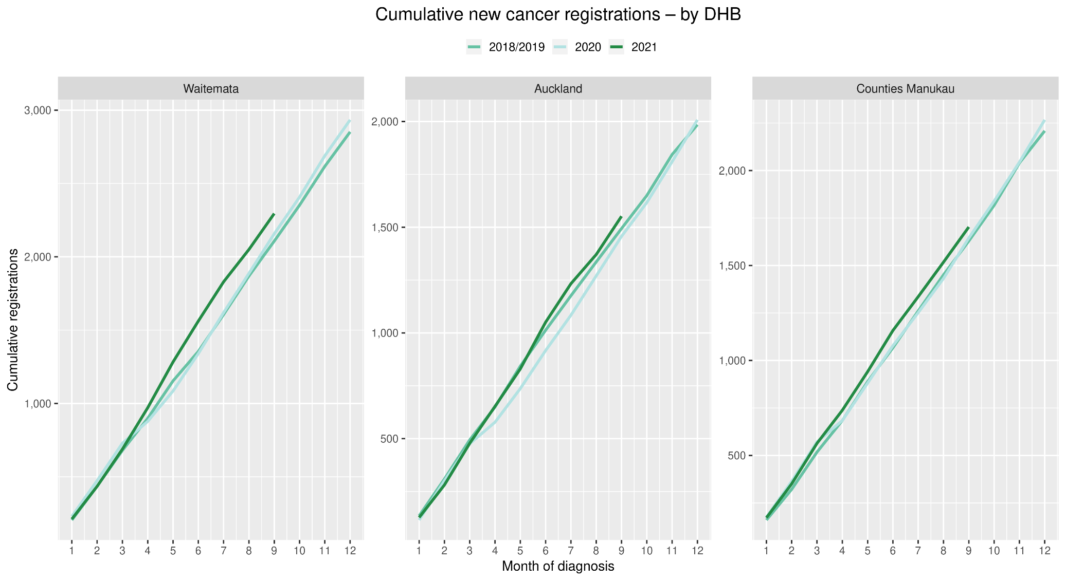
Gastrointestinal endoscopies
Figure 2: Number of gastrointestinal endoscopy procedures by month, 2018/19 average, 2020 and 2021, for the Auckland region
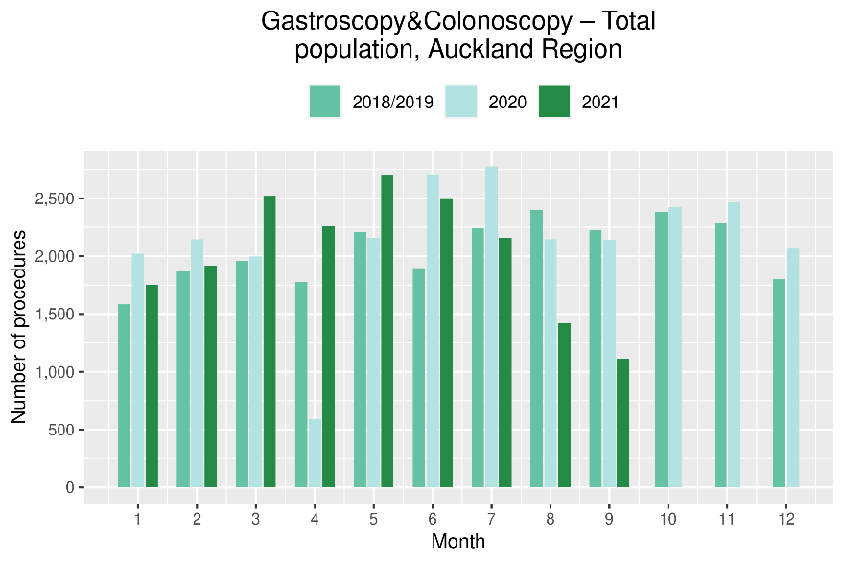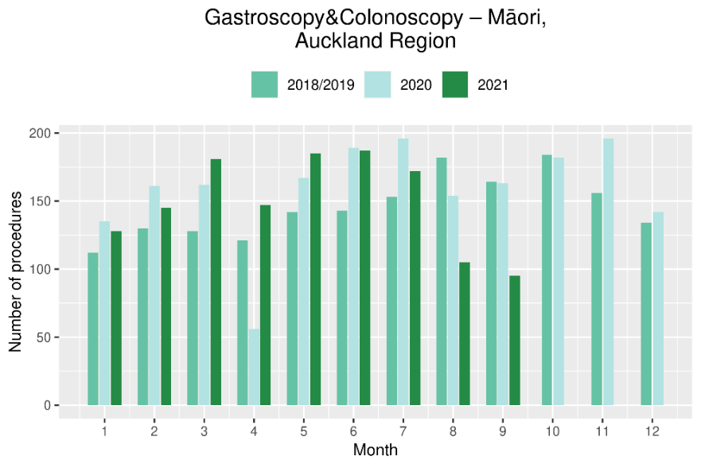

Cancer surgery
Figure 3: Number of curative cancer surgeries (prostate, colorectal, lung) by month, 2018/19 average, 2020 and 2021, for the Auckland region
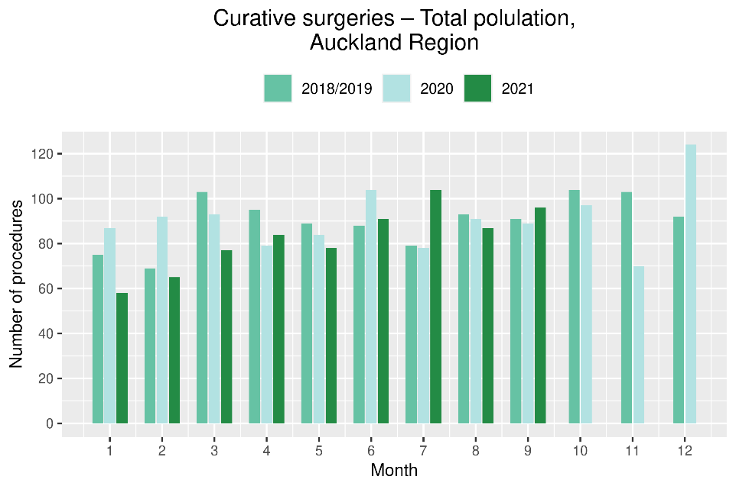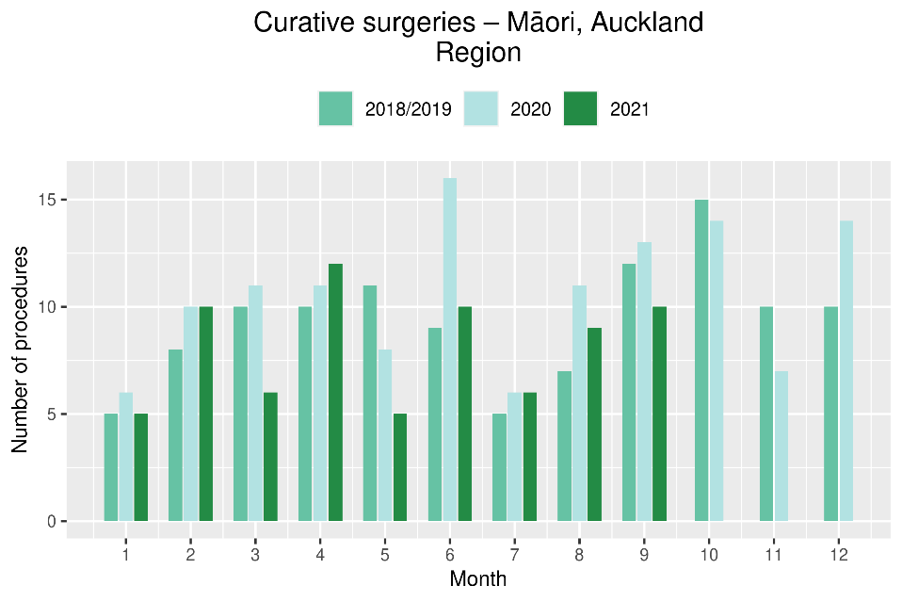

Non-surgical treatments
Figure 4: Number of IV chemotherapy attendances by month, 2018/19 average, 2020 and 2021, for the Auckland region
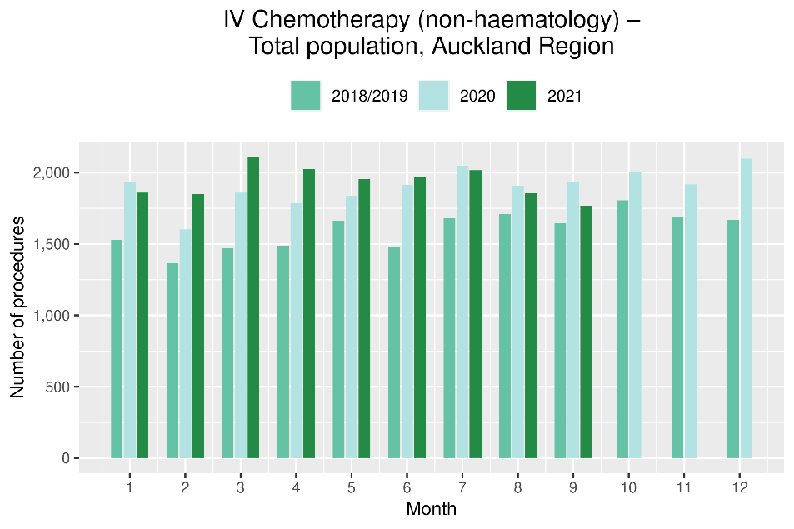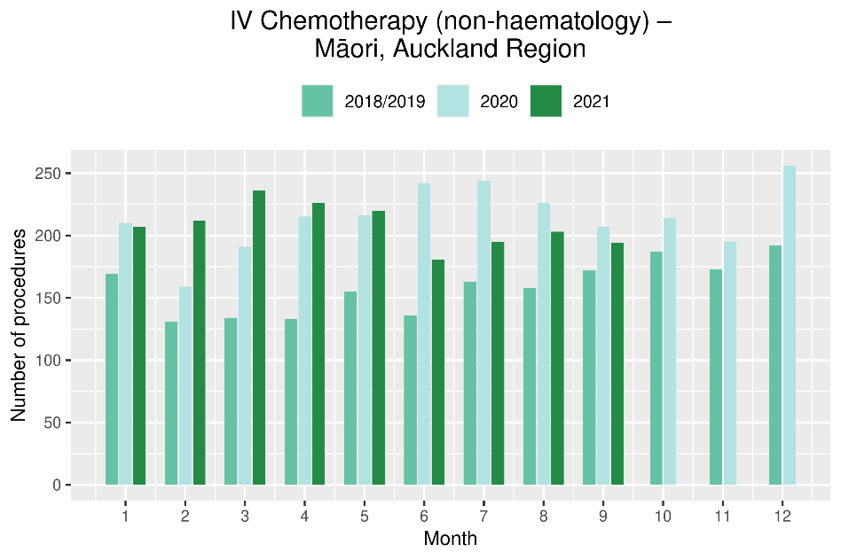
Figure 5: Number of radiation therapy attendances by month, 2018/19 average, 2020 and 2021, for the Auckland region
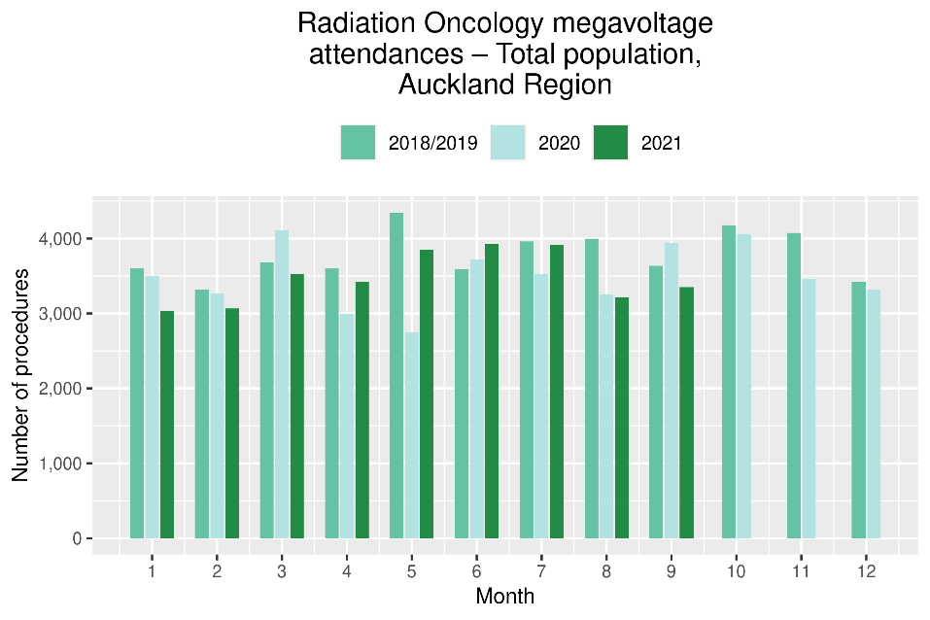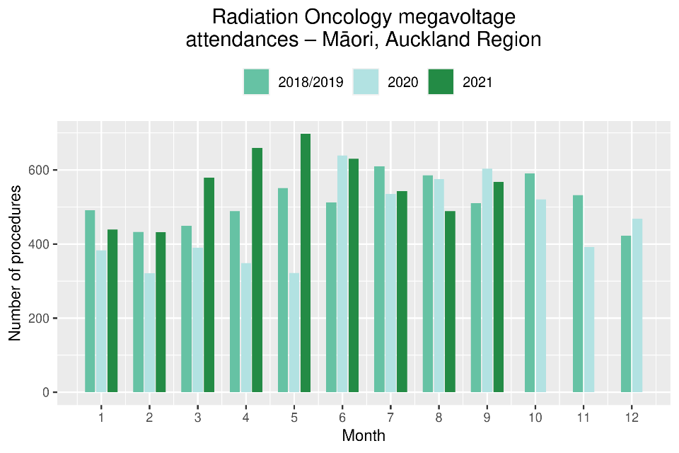
National Data

Cancer Registrations

Notes on data
- The data in this report come from laboratory reports to the New Zealand Cancer Register (NZCR). Cancers diagnosed without haematology or pathology, for example radiology alone, will not be counted in this analysis. Further information on these data is included in Appendix 1.
- Data included in this report are provisional, and exact numbers will change as data are finalised. Data were extracted from NZCR on 11 November 2021.
- ‘Date’ is date of diagnosis on the NZCR – usually the date the specimen was taken from the person and sent to the laboratory. Analyses include all new provisional and registered cancer events based on pathology and haematology reports.
- The extract used for this report excludes carcinoma in situ for breast and cervical, meaning the numbers are lower than in the 2020 COVID-19 and Cancer reports.

Key points
- Provisionally, there have been 241 more cancer registrations in September 2021, compared to September 2018/19 (a 12% increase). This increase was seen across all ethnic groups.
- For the year to date there has been a 7% increase in the number of cancer registrations in 2021 compared to 2018/19, with the largest increases for Asian (22%) and Māori (12%).
- The pattern appears slightly varied by tumour group, with the largest impact over the year appearing to be for melanoma/non-melanoma skin cancer (see cumulative Figure 7). This may reflect the shift towards virtual consultations in primary care at high alert levels and delay of minor procedures.

Results
Table 2: Number of provisional cancer registrations and percentage change in 2021 compared to the 2018/19 average, by month and cumulative year to date, by ethnicity
 | July |  |  | August |  |  | September |  |  | Cumulative January-September
 | 2018/19 | 2021 | % change | 2018/19 | 2021 | % change | 2018/19 | 2021 | % change | 2018/19 | 2021 | % change
Māori | 220 | 219 | 0% | 217 | 227 | 5% | 217 | 252 | 16% | 1,924 | 2,147 | 12%
Pacific peoples | 88 | 89 | 1% | 72 | 75 | 4% | 76 | 103 | 36% | 739 | 811 | 10%
Asian | 104 | 129 | 24% | 116 | 117 | 1% | 100 | 118 | 19% | 901 | 1,098 | 22%
European/Other | 1,601 | 1,664 | 4% | 1,705 | 1,529 | -10% | 1,617 | 1,777 | 10% | 14,311 | 15,004 | 5%
Total population | 2,013 | 2,101 | 4% | 2,109 | 1,948 | -8% | 2,009 | 2,250 | 12% | 17,874 | 19,060 | 7%

Figure 6: Number of cancer registrations by month, 2018/19 average, 2020 and 2021, total population and by ethnicity
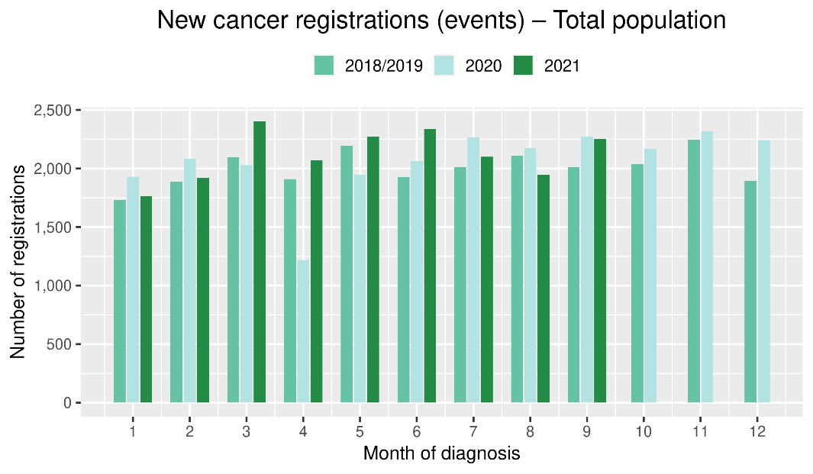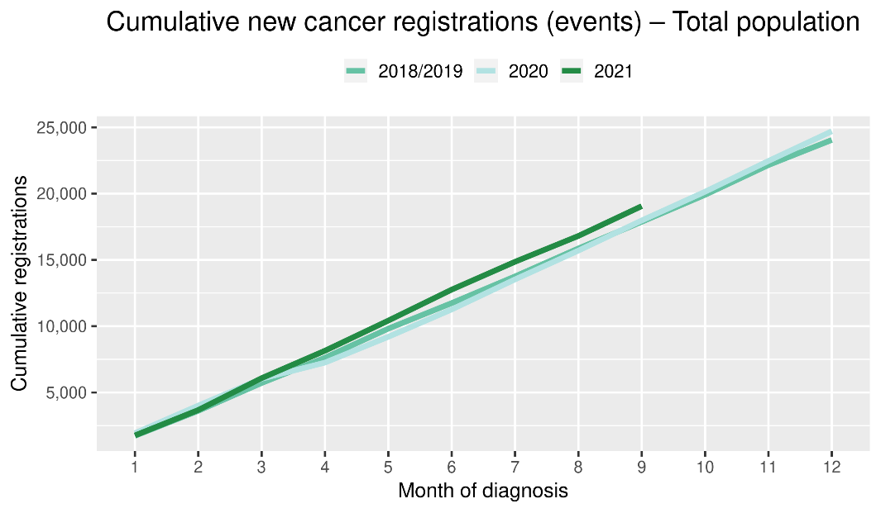
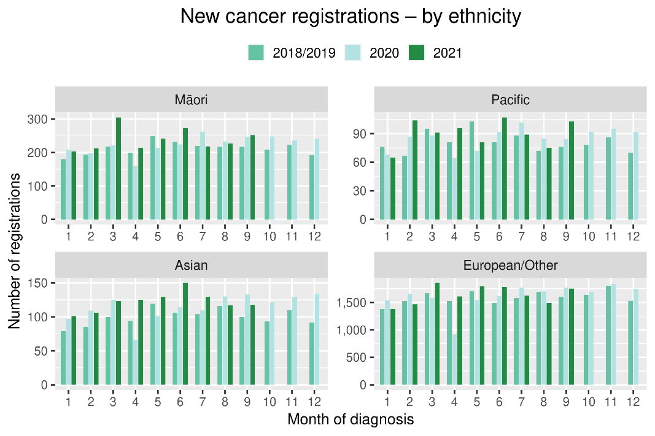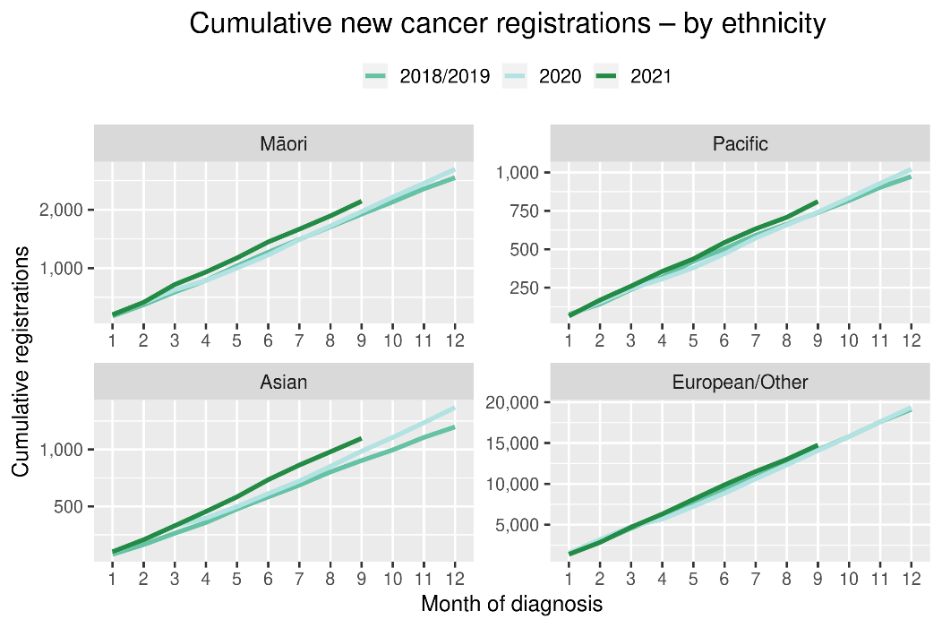
Table 3: Number of provisional cancer registrations and percentage change in 2021 compared to the 2018/19 average, by month and cumulative year to date, by tumour group
 | July |  |  | August |  |  | September |  |  | Cumulative January-September
Tumour group | 2018/19 | 2021 | % change | 2018/19 | 2021 | % change | 2018/19 | 2021 | % change | 2018/19 | 2021 | % change
Breast | 332 | 304 | -8% | 322 | 300 | -7% | 315 | 292 | -7% | 2,772 | 2,848 | 3%
Colorectal | 247 | 297 | 20% | 275 | 229 | -17% | 278 | 262 | -6% | 2,338 | 2,444 | 5%
Gynaecology | 94 | 99 | 5% | 92 | 98 | 7% | 91 | 118 | 30% | 795 | 844 | 6%
Haematology and Lymphoid | 212 | 208 | -2% | 197 | 203 | 3% | 207 | 212 | 2% | 1,838 | 1,847 | 1%
Melanoma and non-melanoma skin | 249 | 263 | 6% | 294 | 228 | -22% | 260 | 257 | -1% | 2,424 | 2,652 | 9%
Other digestive system | 136 | 137 | 1% | 127 | 142 | 12% | 112 | 144 | 29% | 1,084 | 1,239 | 14%
Prostate | 326 | 338 | 4% | 374 | 295 | -21% | 357 | 406 | 14% | 2,981 | 2,993 | 0%
Respiratory and thorax | 154 | 139 | -10% | 160 | 148 | -8% | 138 | 174 | 27% | 1,299 | 1,385 | 7%
Urinary system | 85 | 87 | 2% | 81 | 104 | 29% | 79 | 123 | 56% | 753 | 866 | 15%
*This analysis uses provisional data for the 2021 registrations, some cancers may initially be classified as ‘non-specified’ and subsequently be re-classified into one of the cancer groups as more information becomes available.

Figure 7: Number of cancer registrations by month, 2018/19 average, 2020 and 2021, by tumour group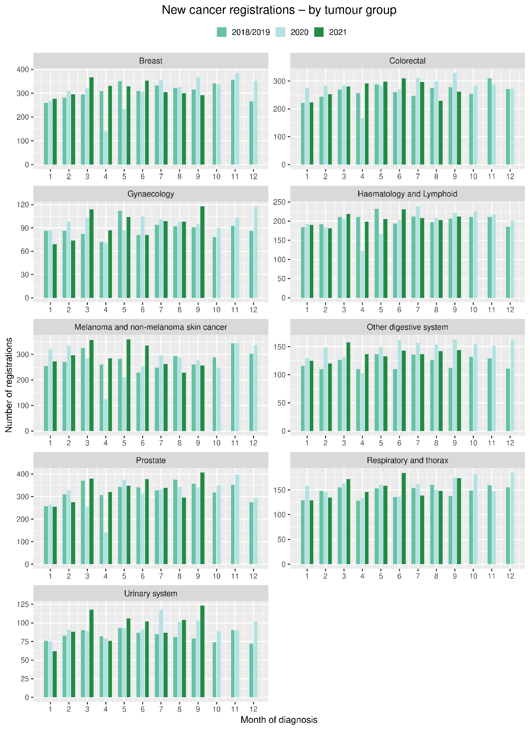 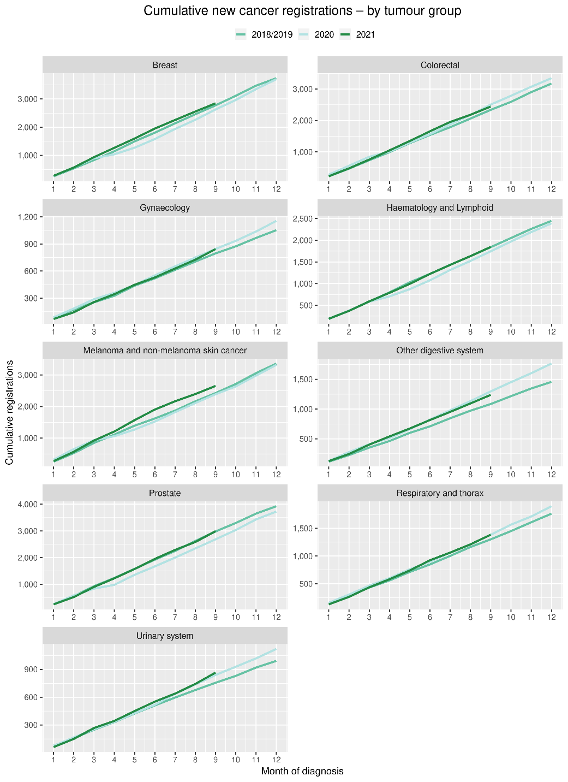

Gastrointestinal endoscopy

Notes on data
- Gastrointestinal endoscopy data were extracted from the National Non-admitted Patient Collection (NNPAC) and National Minimum Dataset (NMDS) on 8 November 2021.
- Includes colonoscopies and gastroscopies for all indications – not just cancer.
- Technical information: gastroscopies (Purchase Unit Code: MS02005), colonoscopies (Purchase Unit Code: MS02007), combined gastroscopies and colonoscopies (Purchase Unit Code: MS02014).

Key points
- There was a decrease in gastrointestinal endoscopies performed in September 2021, compared to September 2018/19. This decrease (9%) was smaller than the decrease in August 2021, compared to August 2018/19 (31%).
- The decrease in endoscopies was seen across all ethnic groups but was smaller for Māori (1%) compared to non-Māori/non-Pacific (10%). The decrease was largest for Pacific peoples (20%).
- The decrease in endoscopies during September appears largely driven by the disruption to services in the Auckland region (see Figure 2).
- Overall, for the year to date there has been an increase in the number of gastrointestinal endoscopies performed in 2021 compared to 2018/19 across all ethnic groups.

Results
Table 4: Number of colonoscopy and gastroscopy procedures and percentage difference in 2021 compared to 2018/2019 average, by month and cumulative year to date, by ethnicity
 | July |  |  | August |  |  | September |  |  | Cumulative January-September
 | 2018/19 | 2021 | % change | 2018/19 | 2021 | % change | 2018/19 | 2021 | % change | 2018/19 | 2021 | % change
Māori | 561 | 698 | 24% | 629 | 489 | -22% | 562 | 554 | -1% | 4,613 | 5,459 | 18%
Pacific peoples | 230 | 247 | 8% | 238 | 171 | -28% | 205 | 165 | -20% | 1,807 | 2,057 | 14%
Non-Māori/non-Pacific | 5,244 | 5,591 | 7% | 5,615 | 3,794 | -32% | 5,068 | 4,580 | -10% | 43,302 | 46,740 | 8%
Total population | 6,035 | 6,536 | 8% | 6,482 | 4,454 | -31% | 5,835 | 5,299 | -9% | 49,722 | 54,256 | 9%

Figure 8: Number of gastrointestinal endoscopy procedures by month, 2018/19 average, 2020 and 2021, total population and Māori
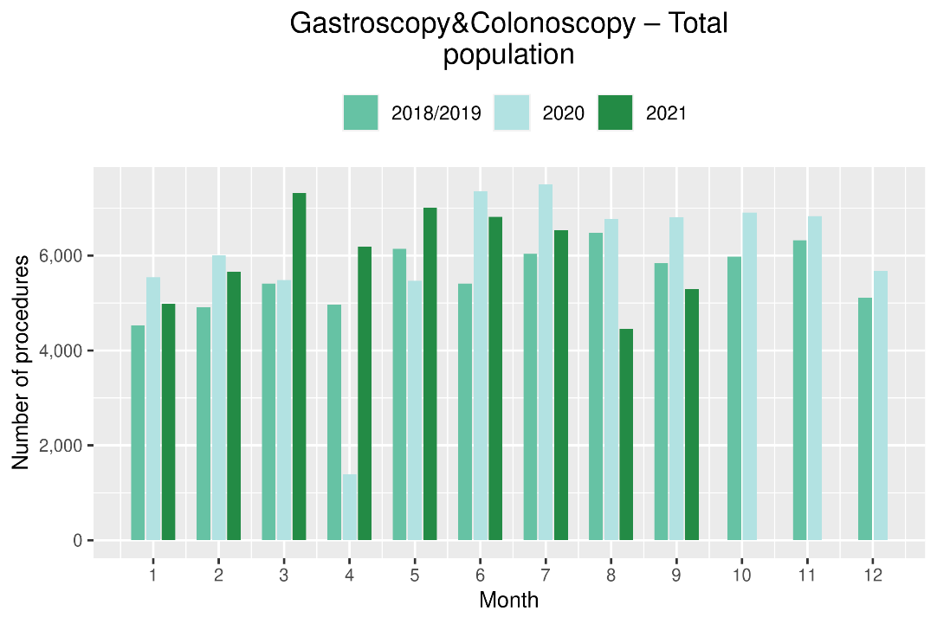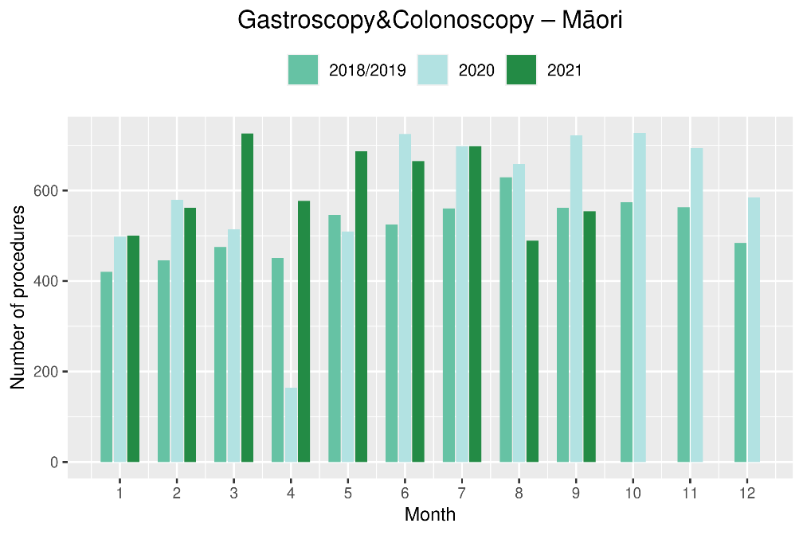
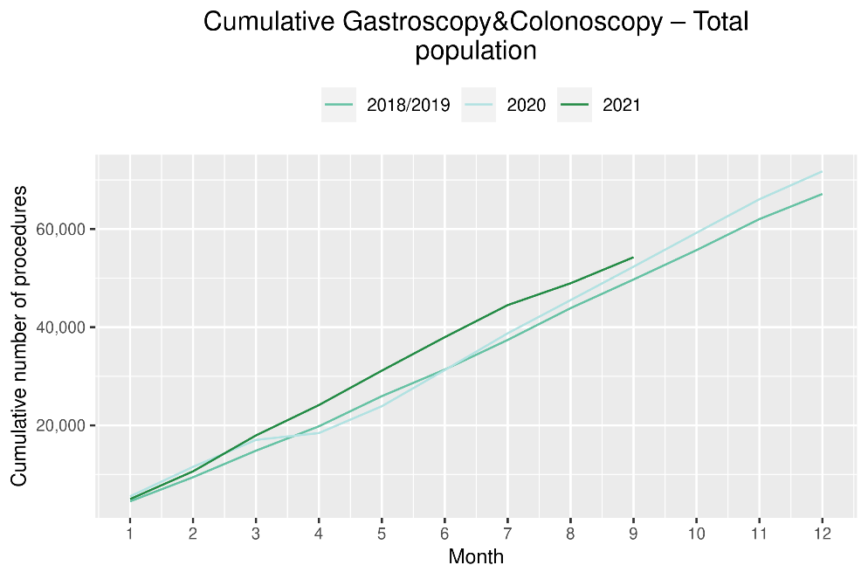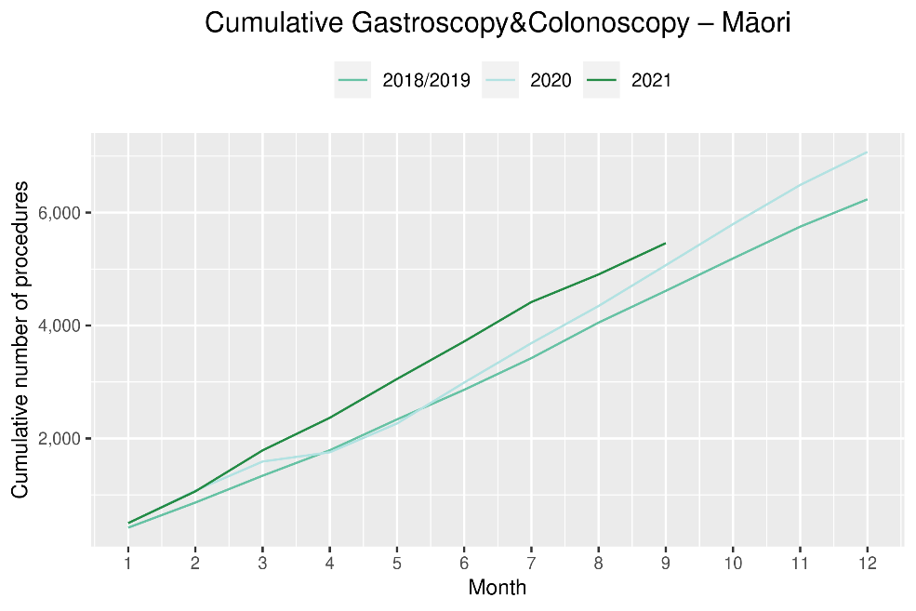

Bronchoscopy

Notes on data
- Bronchoscopy data were extracted from NNPAC and NMDS on 8 November 2021.
- These data include bronchoscopies for all indications, not solely cancer related procedures.
- Technical information: bronchoscopies (Purchase Unit Code - MS02003).

Key points
- There was a 13% decrease in the number of bronchoscopies performed in September 2021 compared to September 2018/19.
- Overall, there has been 5% fewer bronchoscopies performed for the year to date compared to same time period in 2018/19. This decrease was smaller for Māori (5%) and non-Māori/non-Pacific (4%), than for Pacific peoples (28%, noting small numbers).

Results
Table 5: Number of bronchoscopies and percentage difference in 2021 compared to 2018/2019 average, by month and cumulative year to date, by ethnicity
 | July |  |  | August |  |  | September |  |  | Cumulative January-September
 | 2018/19 | 2021 | % change | 2018/19 | 2021 | % change | 2018/19 | 2021 | % change | 2018/19 | 2021 | % change
Māori* | - | - | - | - | - | - | - | - | - | 282 | 267 | -5%
Pacific peoples* | - | - | - | - | - | - | - | - | - | 86 | 62 | -28%
Non-Māori/Non-Pacific | 151 | 133 | -12% | 147 | 100 | -32% | 147 | 140 | -5% | 1,331 | 1,278 | -4%
Total population | 193 | 164 | -15% | 200 | 125 | -37% | 189 | 165 | -13% | 1,699 | 1,607 | -5%
*Due to small numbers, monthly figures have not been included for Māori and Pacific peoples

Figure 9: Number of bronchoscopies by month, 2018/19 average, 2020 and 2021, total population and Māori
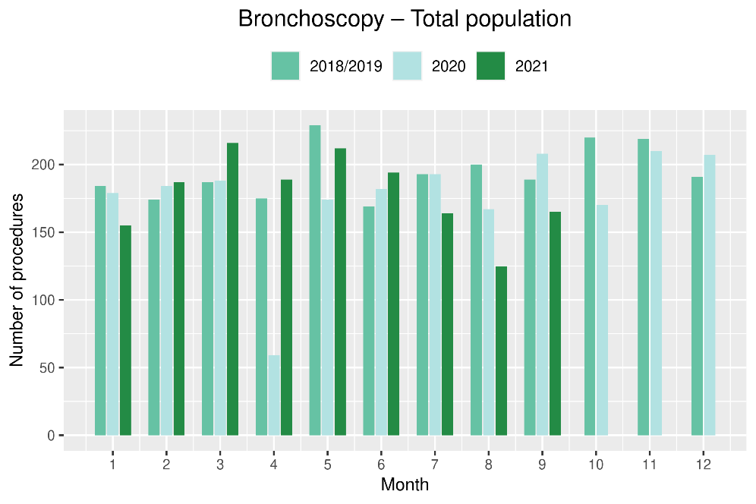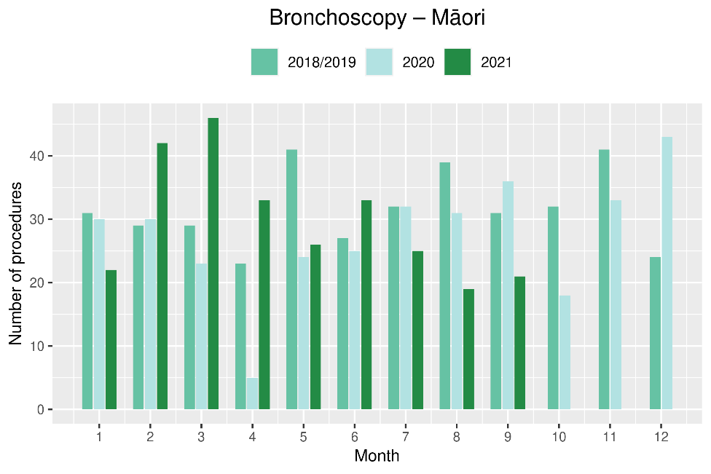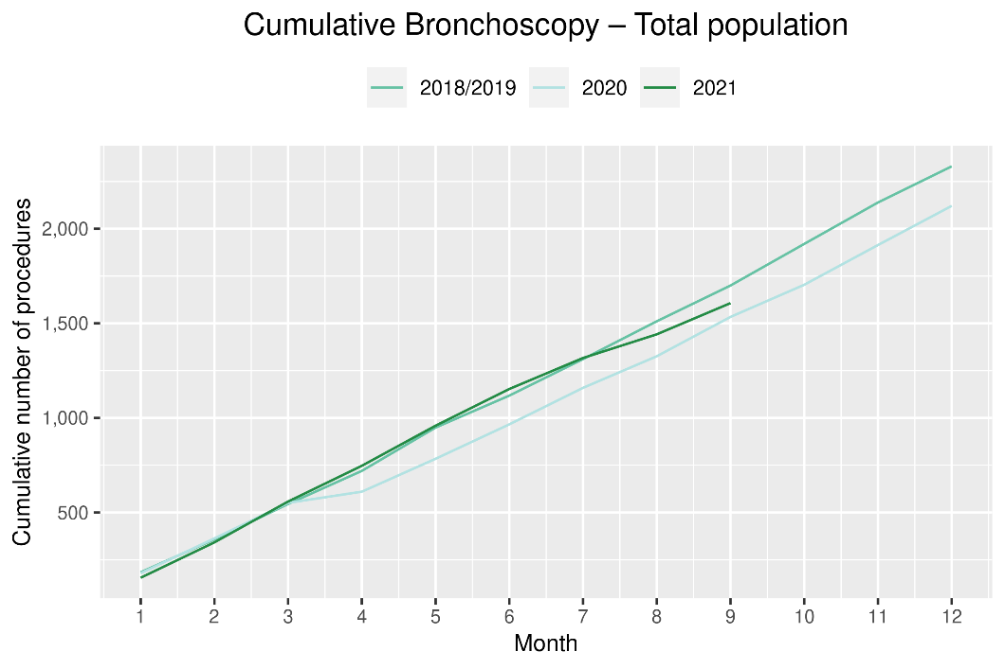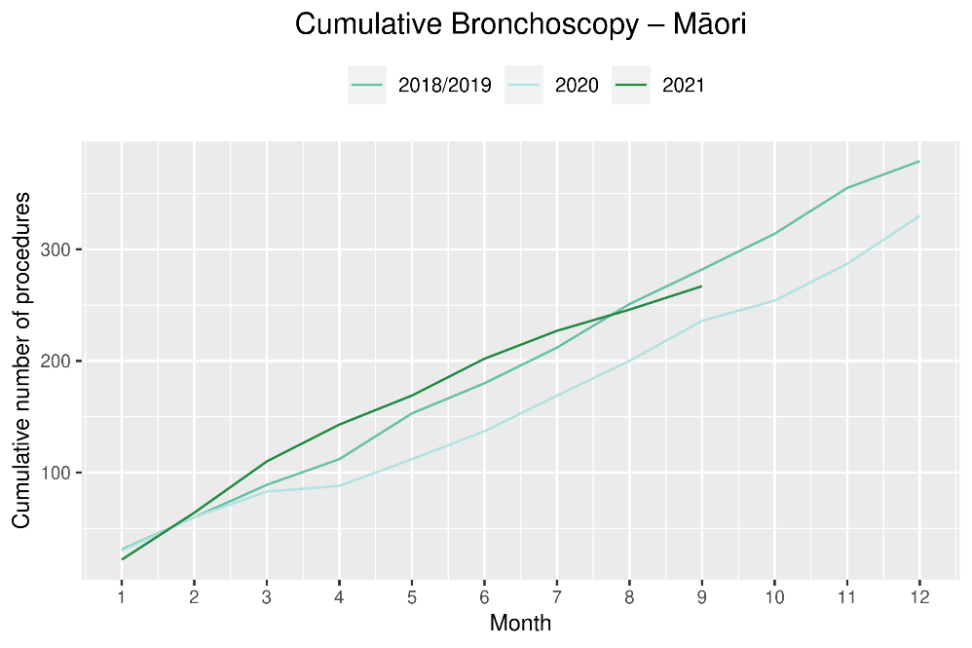

Faster cancer treatment

Notes on data
- The data were extracted from the Faster Cancer Treatment database on 10 November 2021. Fast Cancer Treatment Data is reported quarterly.
- These data aim to capture a broader part of the diagnostic and referral pathway; however, they only include a subset of people being investigated for cancer.
- Data relate to the 62-day pathway and includes patients with a high-suspicion of cancer and a need to be seen within two weeks. These patients should receive their first treatment within 62-day of receipt of referral. The target is 90% and Te Aho o Te Kahu has an escalation pathway for monitoring the performance of DHBs against the 62-day measure. Escalation includes regular meetings with service teams and CE to CE discussions against recovery planning and actions.
- Analysis includes all referrals onto the 62-day pathway.

Key points
- Overall, the COVID-19 Delta outbreak appears to have had a minimal impact on the number of referrals with a high suspicion of cancer, with volumes in August and September similar to the preceding four months.
- The proportion of referrals meeting the 62-day target (patients receiving their first treatment within 62 days of receipt of referral) has remained stable in 2021.
- The FCT data suggest that people who presented to their GP with signs/symptoms highly suspicious of cancer are still being referred through to secondary care. There are a similar number being referred as pre-COVID-19 and these people are being seen within a similar time frame.

Results
Table 6: Number of referrals for patients with a high-suspicion of cancer, in 2021 by month, and cumulative year to date
 | Apr | May | Jun | Jul | Aug | Sept | Total Jan-Sept
Māori | 44 | 41 | 41 | 42 | 59 | 36 | 263
Non-Māori/Non-Pacific | 266 | 314 | 366 | 292 | 306 | 299 | 1,843
Total population | 321 | 373 | 425 | 355 | 383 | 346 | 2,203
*Due to small numbers, volumes have not been included for Pacific peoples

Table 7: Proportion of patients with a high-suspicion of cancer and a need to be seen within 2-weeks receiving their first treatment within 62 day of receipt of referral, in 2021 by month, and average for the year to date
Māori  Non-Māori/Non-Pacific | Apr | May | Jun | Jul | Aug | Sept | Total Jan- Sept
 | 82%  86% | 93%  86% | 85%  88% | 83%  81% | 88%  82% | 83%  85% | 86%  85%
Total Population | 86% | 86% | 88% | 82% | 83% | 84% | 85%
*Due to small numbers, volumes have not been included for Pacific peoples
Figure 10: Proportion of patients with a high-suspicion of cancer and a need to be seen within 2-weeks receiving their first treatment within 62 day of receipt of referral, in 2020 by month

Combined curative cancer surgery

Notes on data
- This report includes data on curative surgery for colorectal, lung and prostate cancer. These cancers were chosen because Te Aho o Te Kahu already has a pre-validated list of surgical procedure codes for these cancers, agreed on as part of the quality performance indicator (QPI) work programme. These three cancers are therefore used as case studies for cancer surgery more generally. The surgical procedure codes are listed in Appendix 4.
- The data were extracted from the NMDS on 8 November 2021.

Key points
- There was a 6% increase in the number of curative cancer surgeries (prostate, lung and colorectal) performed in September 2021 compared to September 2018/19. For the year to date there has been a 4% increase in these surgeries compared to the same time period in 2018/19.
- The increase in surgery for the year to date is most notable for Māori (30% increase) and Pacific peoples (37% increase, noting small numbers).

Results
Table 8: Number of curative cancer surgeries (prostate, colorectal, lung) and percentage difference in 2021 compared to 2018/2019 average by month and cumulative year to date, by ethnicity
 | July |  |  | August |  |  | September |  |  | Cumulative January-September
 | 2018/19 | 2021 | % change | 2018/19 | 2021 | % change | 2018/19 | 2021 | % change | 2018/19 | 2021 | % change
Māori | 32 | 36 | 14% | 25 | 37 | 48% | 40 | 45 | 14% | 282 | 365 | 30%
Pacific peoples* | - | - | - | - | - | - | - | - | - | 90 | 123 | 37%
Non-Māori/Non-Pacific | 259 | 306 | 18% | 319 | 305 | -4% | 298 | 310 | 4% | 2,577 | 2,567 | 0%
Total population | 301 | 360 | 20% | 357 | 352 | -1% | 349 | 369 | 6% | 2,948 | 3,055 | 4%
*Due to small numbers, monthly figures have not been included for Pacific peoples

Figure 11: Number of curative cancer surgeries (prostate, colorectal, lung) by month, 2018/19 average, 2020 and 2021, total population and Māori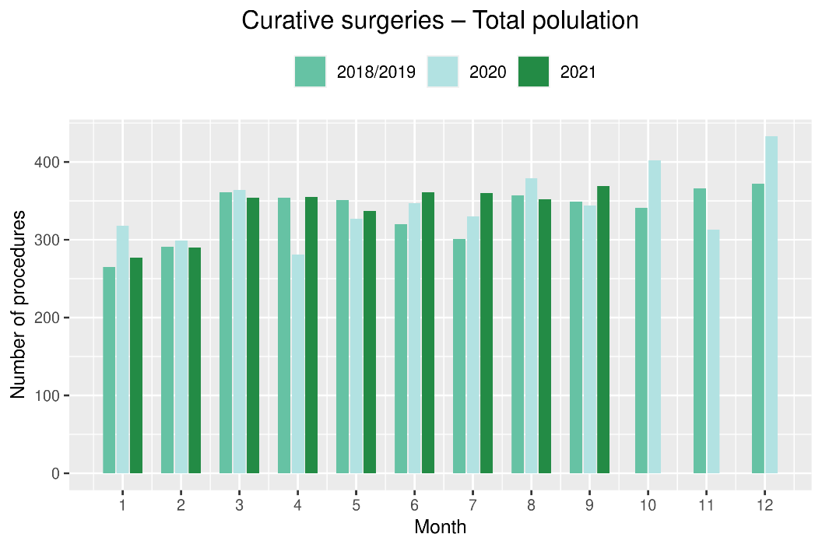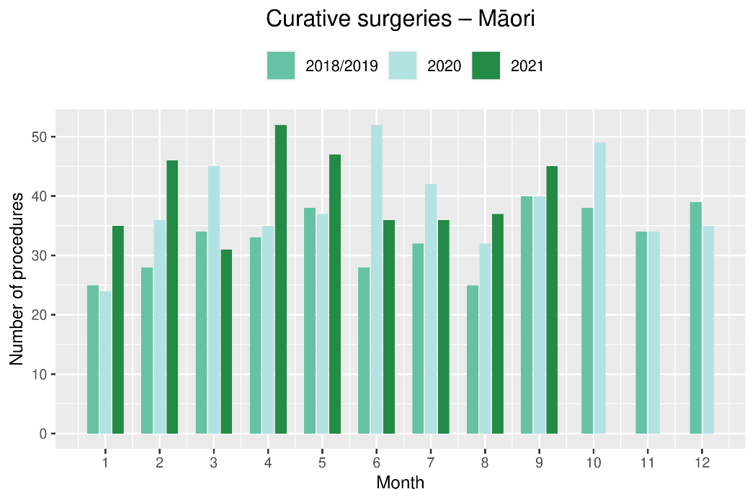
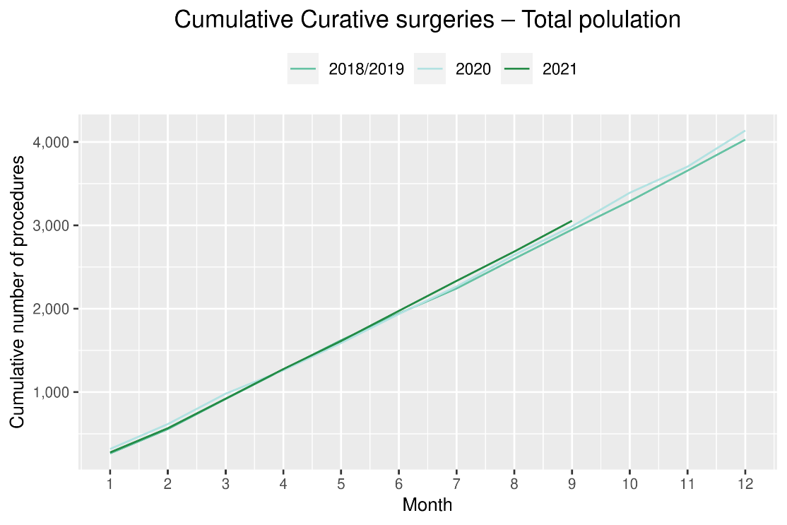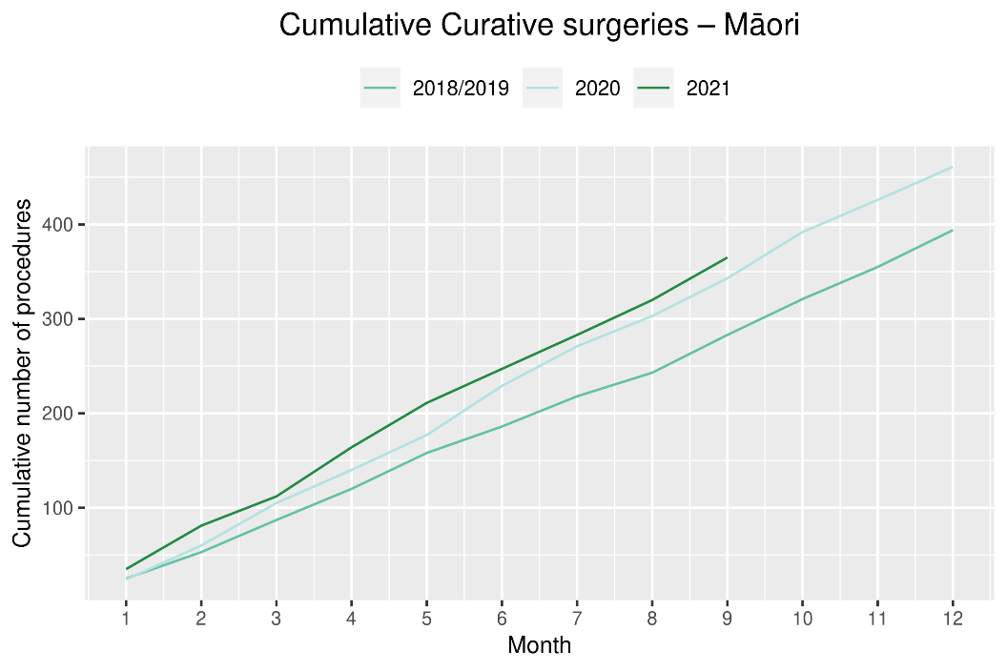

Colorectal cancer surgery

Notes on data
- The surgical procedure codes used for analysing colorectal cancer are listed in Appendix 4.
- The data were extracted from the NMDS on 8 November 2021.

Key points
- There has been a similar number of curative colorectal cancer surgeries performed in 2021 as were performed in 2018/19, with the number of surgeries performed in September 2021 the same as September 2018/19.
- In general, people with colorectal cancer would expect to receive surgery within a month of colonoscopy. The decrease in gastrointestinal endoscopies seen in August 2021 (see Figure 8) has not resulted in a decrease in colorectal cancer surgeries in September.

Results
Table 9: Number of curative colorectal cancer surgeries and percentage difference in 2021 compared to 2018/2019 average, by month and cumulative year to date, by ethnicity
 | July |  |  | August |  |  | September |  |  | Cumulative January-September
 | 2018/19 | 2021 | % change | 2018/19 | 2021 | % change | 2018/19 | 2021 | % change | 2018/19 | 2021 | % change
Māori* | - | - | - | - | - | - | - | - | - | 151 | 190 | 26%
Pacific peoples* | - | - | - | - | - | - | - | - | - | 54 | 67 | 24%
Non-Māori/Non-Pacific | 175 | 189 | 8% | 196 | 201 | 3% | 185 | 186 | 1% | 1,670 | 1,624 | -3%
Total population | 199 | 216 | 9% | 216 | 225 | 4% | 212 | 212 | 0% | 1,875 | 1,881 | 0%
*Due to small numbers, monthly figures have not been included for Pacific peoples
Figure 12: Number of curative colorectal cancer surgeries by month, 2018/19 average, 2020 and 2021, total population and Māori
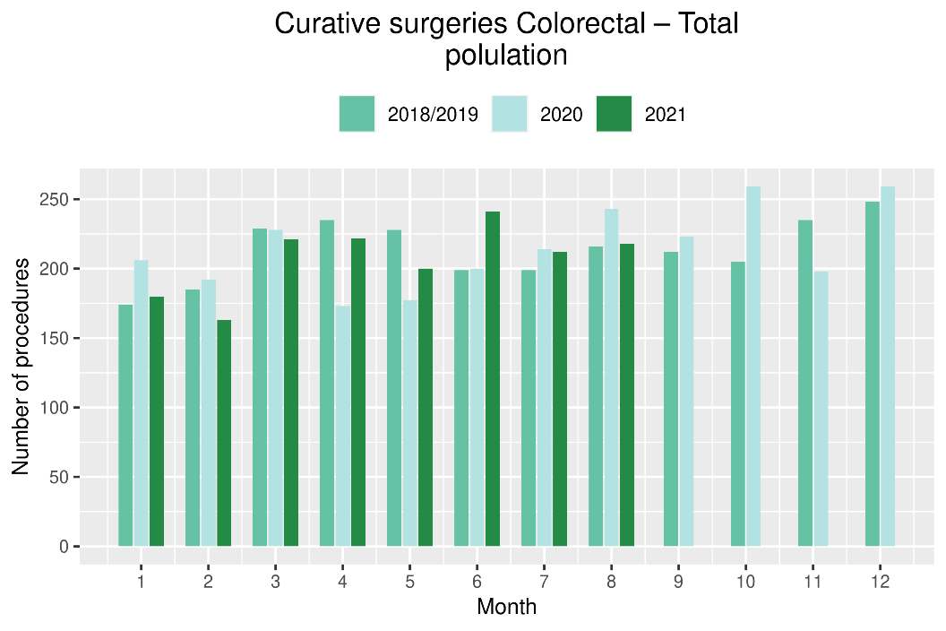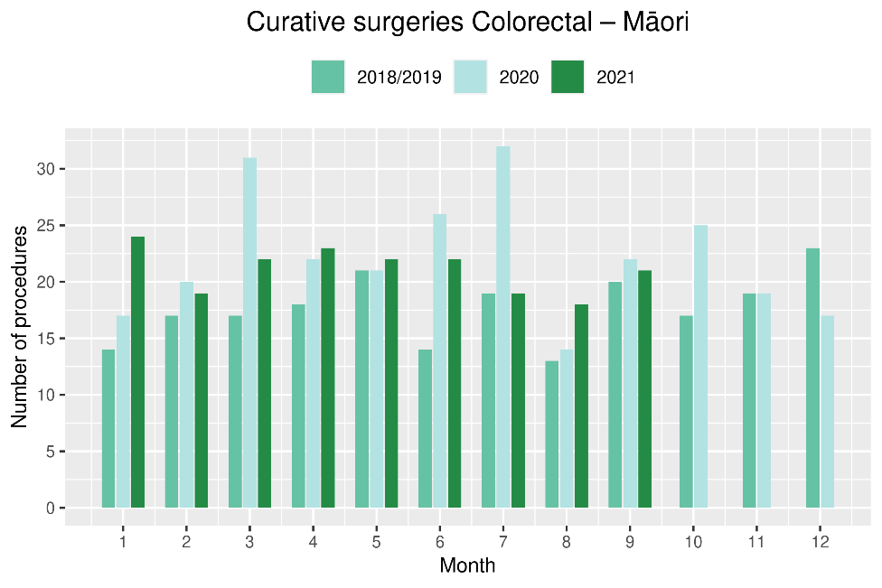
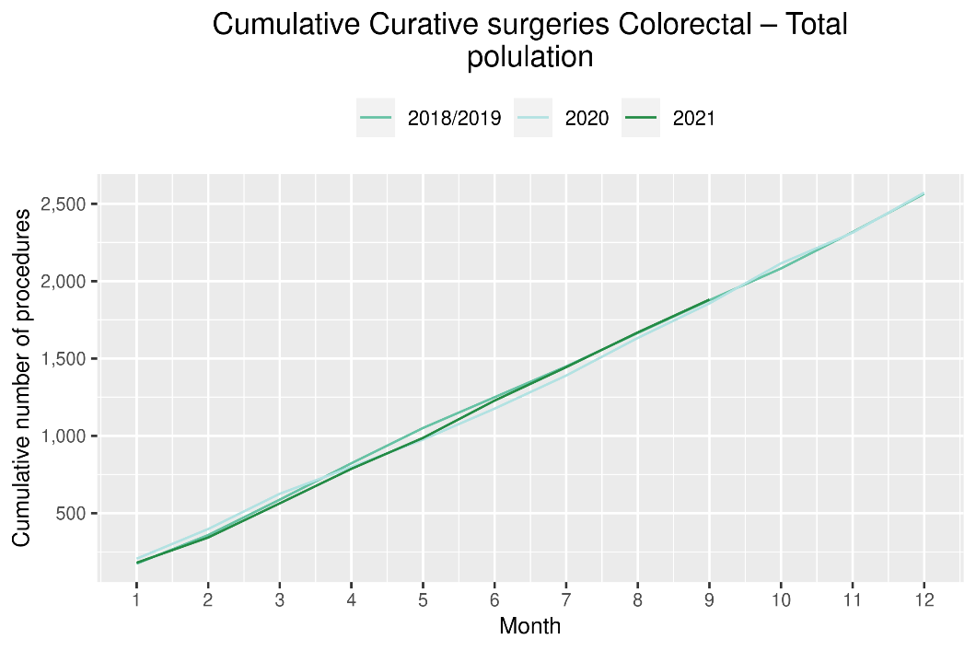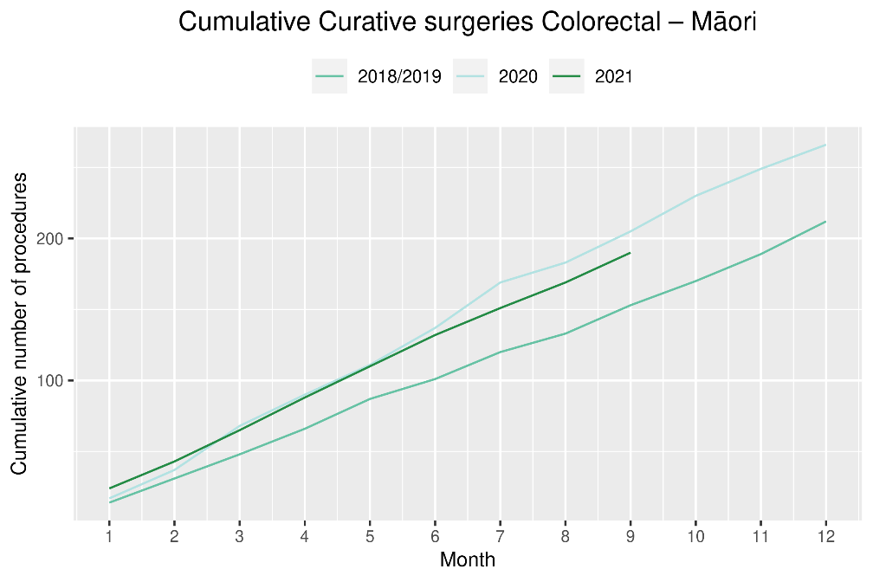

Lung cancer surgery

Notes on data
- A list of the surgical procedure codes used for analysis are included in Appendix 4.
- The data were extracted from the NMDS on 8 November 2021.
- The number of lung cancer surgeries performed each month is relatively small, so caution is needed when comparing data by month.

Key points
- There was an increase in curative lung cancer surgeries in September 2021 compared to September 2018/19 (10 more surgeries).
- Overall, for the year to date there has been a similar number of lung cancer surgeries performed in 2021 compared to 2018/19, and an increase in the number of surgeries for Māori (12%, 10 more surgeries).

Results
Table 10: Number of curative lung cancer surgeries and percentage difference in 2021 compared to 2018/2019 average, by month and cumulative year to date, by ethnicity
 | July |  |  | August |  |  | September |  |  | Cumulative January-September
 | 2018/19 | 2021 | % change | 2018/19 | 2021 | % change | 2018/19 | 2021 | % change | 2018/19 | 2021 | % change
Māori* | - | - | - | - | - | - | - | - | - | 91 | 101 | 12%
Pacific peoples* | - | - | - | - | - | - | - | - | - | 21 | 25 | 19%
Non-Māori/Non-Pacific | 41 | 51 | 26% | 53 | 39 | -26% | 49 | 59 | 20% | 394 | 384 | -2%
Total population | 51 | 61 | 21% | 65 | 53 | -18% | 64 | 74 | 17% | 505 | 510 | 1%
* Due to small numbers, monthly figures have not been included for Māori and Pacific peoples

Figure 13: Number of curative lung cancer surgeries by month, 2018/19 average, 2020 and 2021, total population and Māori (cumulative only due to small numbers)
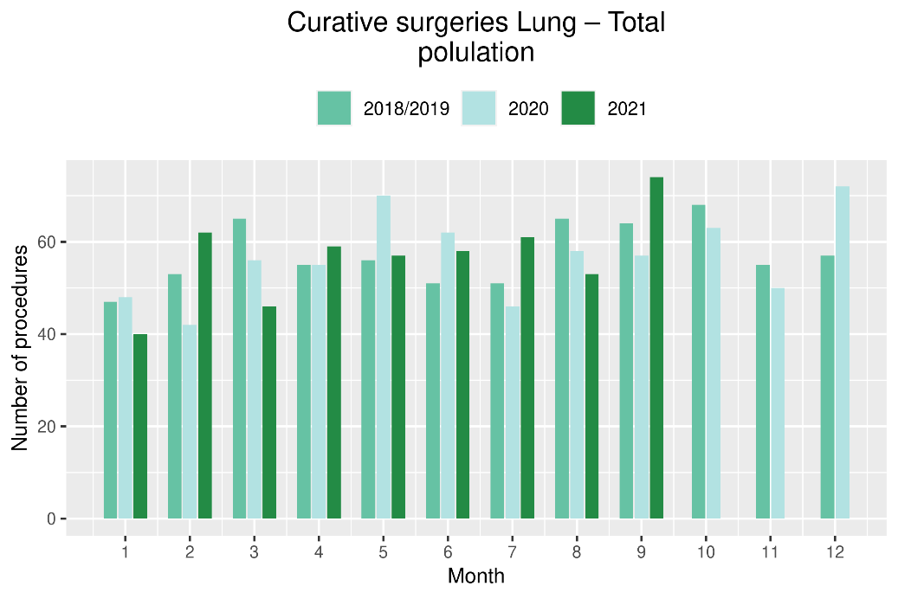
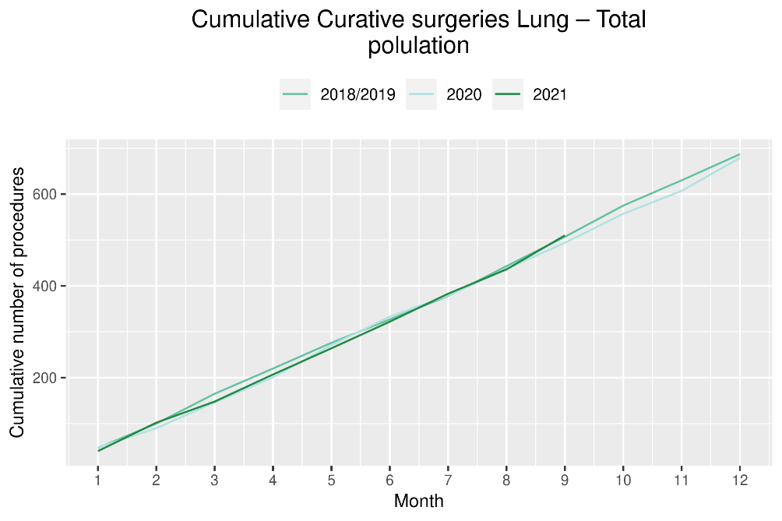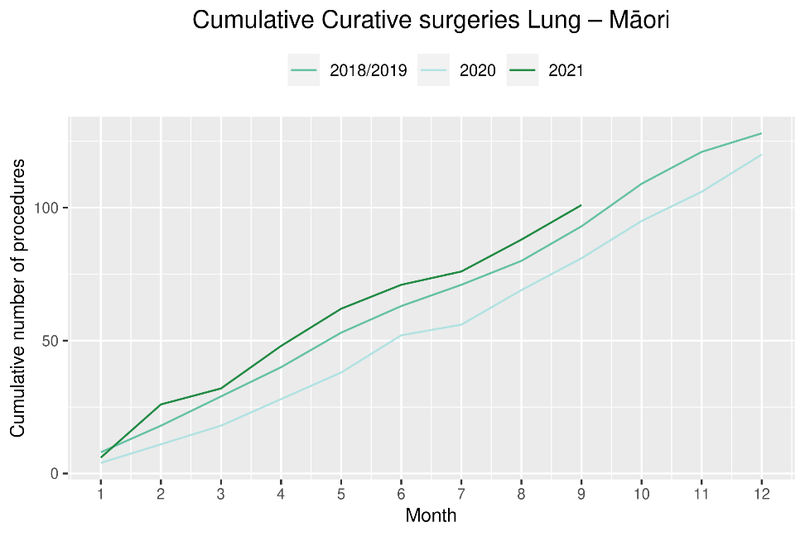

Prostate cancer surgery

Notes on data
- A list of the surgical procedure codes used for analysis are included in Appendix 4.
- The data was extracted from the NMDS on 8 November 2021.
- The volumes for prostate surgery are higher in this report than previously reported due to the inclusion of data from a private provider who provides publicly funded surgery.
- The number of curative prostate cancer surgeries performed each month is relatively small, so caution is needed when comparing data by month.

Key points
- There has been a similar number of prostate cancer surgeries performed in September 2021 compared to September 2018/19 and an increase in the number of surgeries for the year to date.
- There has been an increase in the number of Māori receiving curative prostate cancer surgery in 2021 compared to both 2020 and 2018/19; however, this appears unrelated to 2021 COVID-19 Delta outbreak.

Results
Table 11: Number of curative prostate cancer surgeries and percentage difference in 2021 compared to 2018/2019 average by month and cumulative year to date
 | July |  |  | August |  |  | September |  |  | Cumulative January-September
 | 2018/19 | 2021 | % change | 2018/19 | 2021 | % change | 2018/19 | 2021 | % change | 2018/19 | 2021 | % change
Total population* | 51 | 83 | 63% | 76 | 74 | -2% | 74 | 83 | 13% | 568 | 664 | 17%
*Due to the small number of surguries performed each month calculations have only been included for the total population
Figure 14: Number of curative prostate cancer surgeries by month, 2018/19 average, 2020 and 2021, total population and Māori (cumulative only due to small numbers)
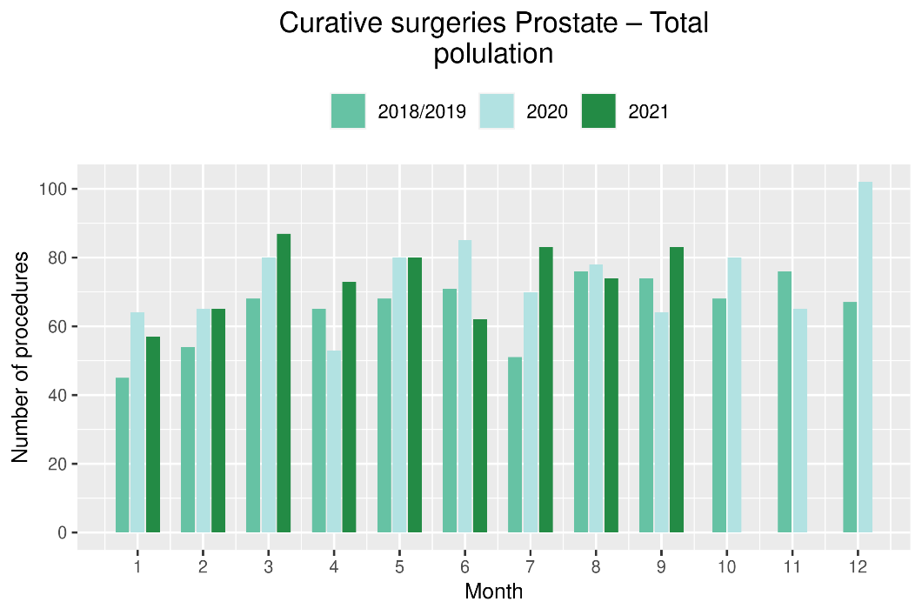
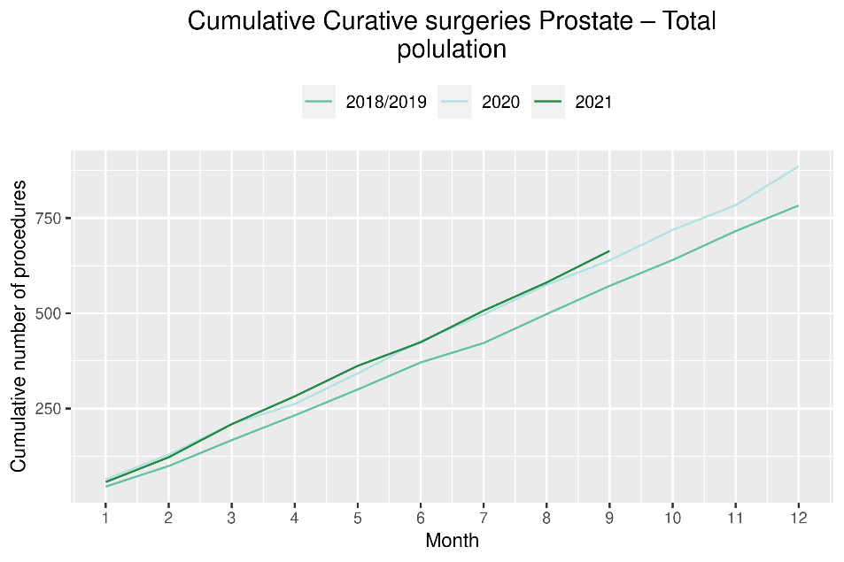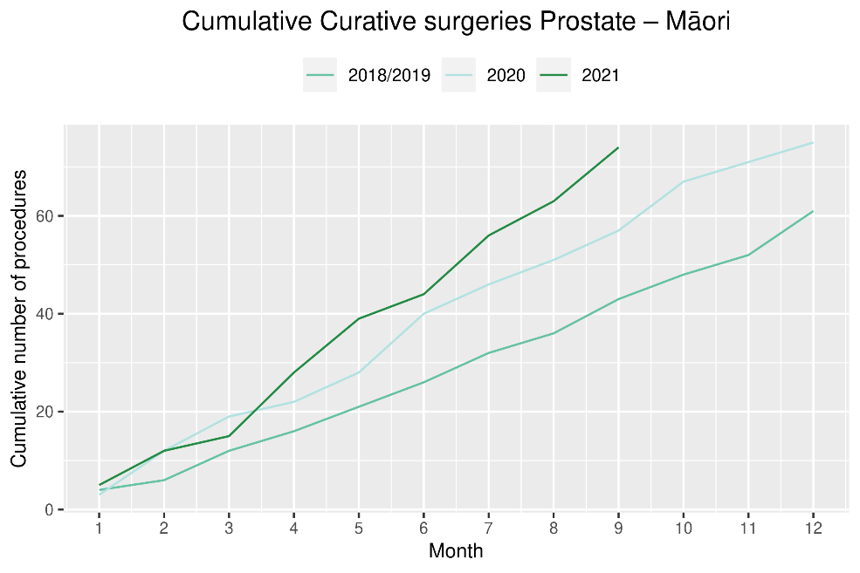

Medical oncology

Notes on data
- Data were extracted from NNPAC 8 November 2021.
- First specialist assessment (FSA) reflects counts of first attendance for specialist medical oncology assessment.
- Intravenous (IV) chemotherapy reflects appointments for outpatient and inpatient IV chemotherapy for non-haematological indications.
- Technical information: medical oncology FSA (PUC M50020) and IV chemotherapy (PUC MS02009).

Key points
- There was a 25% increase in attendances for medical oncology FSAs in September 2021 compared to September 2018/19. The increase was similar across all ethnic groups.
- Attendances for IV chemotherapy remained stable over September 2021. There has been an overall 8% increase in the number of attendances for the year to date in 2021 compared to the same time period in 2018/19, with a larger increase for Māori (25%) and Pacific peoples (33%) than for non-Māori/non-Pacific (4%).

Results
Table 12: Number of medical oncology first specialist assessments and percentage difference in 2021 compared to 2018/2019 average, by month and cumulative year to date, by ethnicity
 | July |  |  | August |  |  | September |  |  | Cumulative January-September
 | 2018/19 | 2021 | % change | 2018/19 | 2021 | % change | 2018/19 | 2021 | % change | 2018/19 | 2021 | % change
Māori | 103 | 118 | 15% | 113 | 138 | 23% | 96 | 120 | 25% | 875 | 1,047 | 20%
Pacific peoples | 38 | 44 | 16% | 43 | 51 | 19% | 30 | 39 | 32% | 311 | 366 | 18%
Non-Māori/Non-Pacific | 562 | 579 | 3% | 610 | 625 | 2% | 550 | 685 | 25% | 4,905 | 5,332 | 9%
Total population | 703 | 741 | 5% | 766 | 814 | 6% | 675 | 844 | 25% | 6,091 | 6,745 | 11%
Figure 15: Number of medical oncology first specialist assessments by month, 2018/19 average, 2020 and 2021, total population and Māori
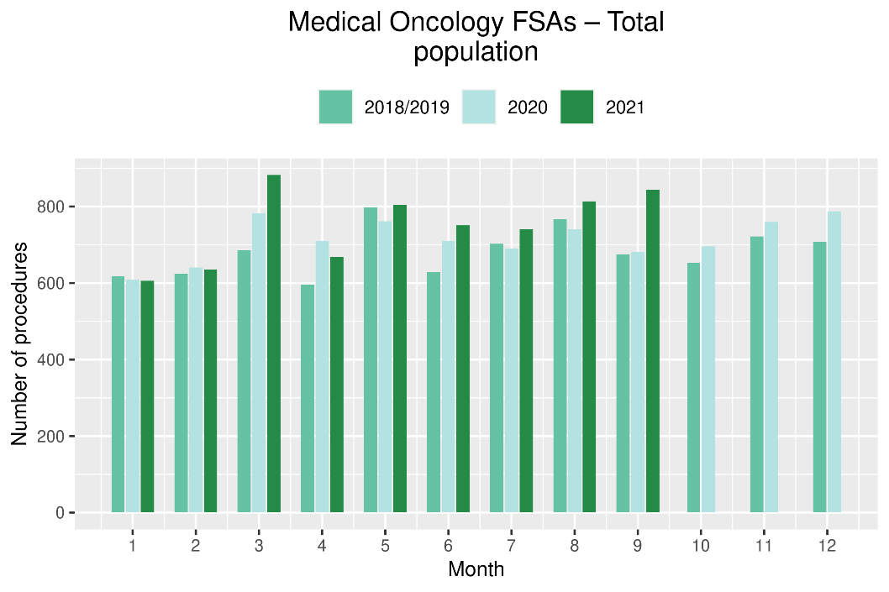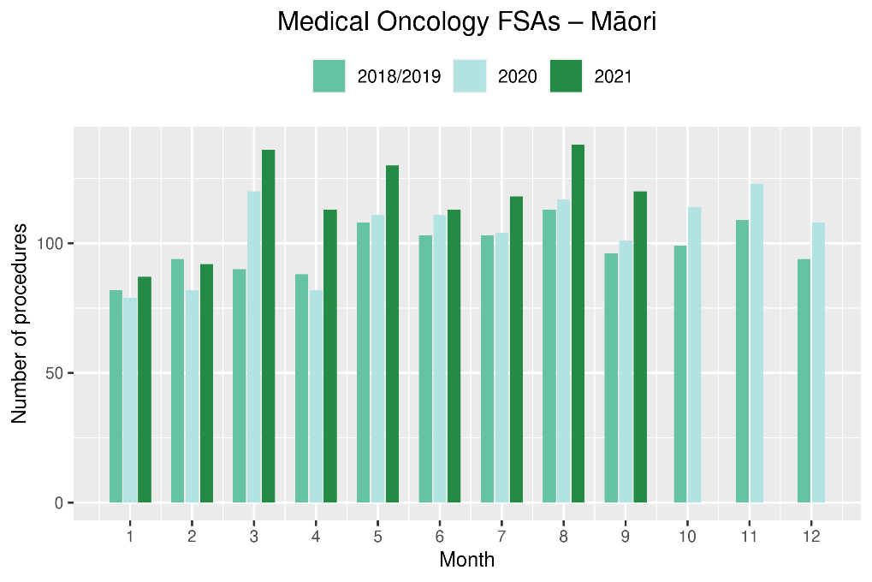
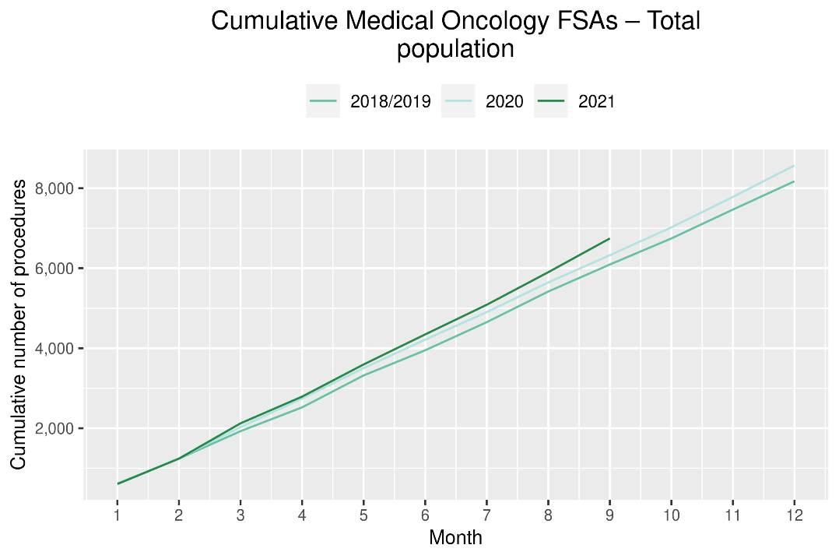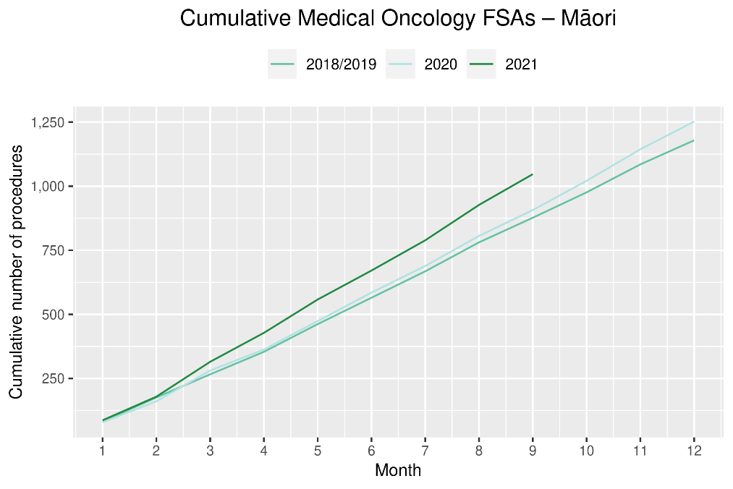
Table 13: Number of IV chemotherapy attendances and percentage difference in 2021 compared to 2018/2019 average, by month and cumulative year to date, by ethnicity
 | July |  |  | August |  |  | September |  |  | Cumulative January-September
 | 2018/19 | 2021 | % change | 2018/19 | 2021 | % change | 2018/19 | 2021 | % change | 2018/19 | 2021 | % change
Māori | 772 | 888 | 15% | 783 | 855 | 9% | 732 | 837 | 14% | 6,230 | 7,808 | 25%
Pacific peoples | 266 | 379 | 43% | 251 | 371 | 48% | 262 | 344 | 31% | 2,346 | 3,109 | 33%
Non-Māori/Non-Pacific | 4,503 | 4,609 | 2% | 4,623 | 4,311 | -7% | 4,316 | 4,532 | 5% | 38,351 | 39,736 | 4%
Total population | 5,541 | 5,876 | 6% | 5,656 | 5,537 | -2% | 5,310 | 5,713 | 8% | 46,926 | 50,653 | 8%

Figure 16: Number of IV chemotherapy attendances by month, 2018/19 average, 2020 and 2021, total population and Māori
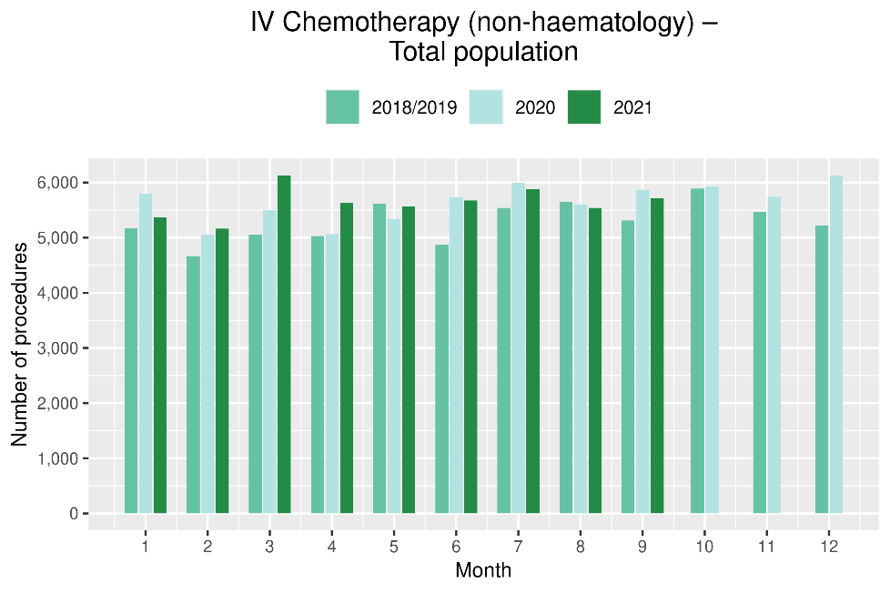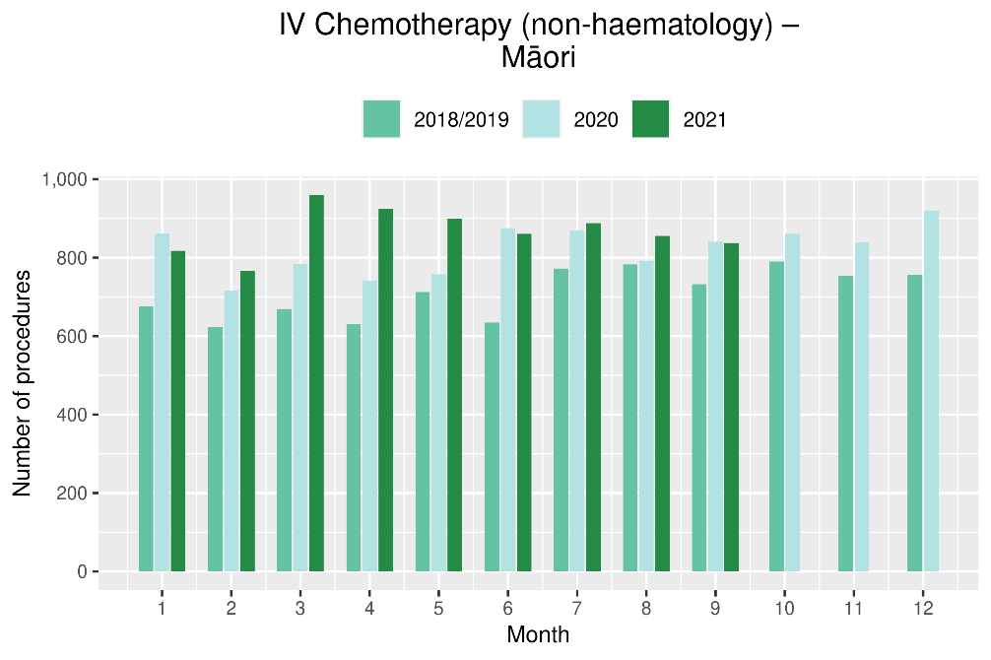

Figure 17: Cumulative number of attendances for IV chemotherapy, 2018/19 average, 2020 and 2021, total population and for Māori
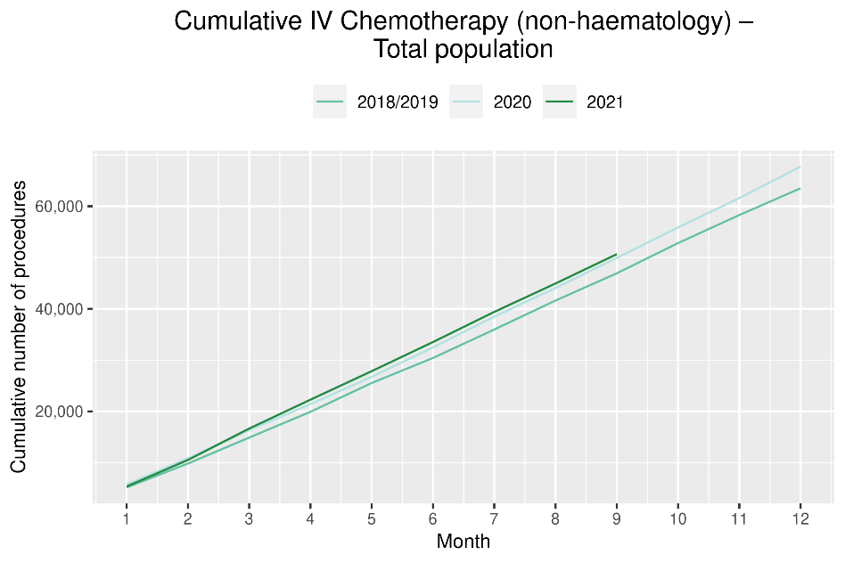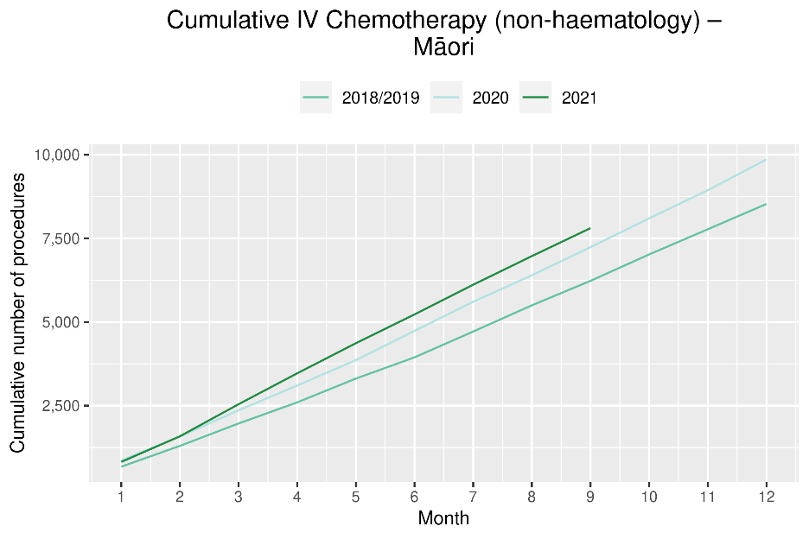

Radiation oncology

Notes on data
- Data were extracted from NNPAC on 8 November 2021.
- First specialist assessment (FSA) reflects counts of first attendance for radiation oncology specialist assessment.
- Megavoltage attendance reflects appointments for planning/simulation and for treatment with radiation therapy on a linear accelerator.
- Technical information: radiation oncology FSA (PUC M50022), megavoltage attendances (Purchase Unit Code M50025)

Key points
- Attendances for radiation oncology FSAs remained stable in September 2021.
- For the year to date there has been a 9% increase in radiation oncology FSAs; however, there has been a decrease in attendances for radiotherapy in 2021 compared to 2018/19. The decrease in attendances for radiotherapy has been seen throughout the year and likely reflects increased utilisation of hypofractionation. The decrease in attendances in 2021 is less notable for Māori, which may reflect stage at diagnosis, with hypofractionation more likely to be utilised for early-stage cancer.

Results
Table 14: Number of radiation oncology first specialist assessments and percentage difference in 2021 compared to 2018/2019 average, by month and cumulative year to date, by ethnicity
 | July |  |  | August |  |  | September |  |  | Cumulative January-September
 | 2018/19 | 2021 | % change | 2018/19 | 2021 | % change | 2018/19 | 2021 | % change | 2018/19 | 2021 | % change
Māori | 117 | 122 | 4% | 138 | 156 | 13% | 114 | 114 | 0% | 1,015 | 1,193 | 18%
Pacific peoples | 48 | 42 | -12% | 50 | 57 | 15% | 39 | 40 | 4% | 400 | 429 | 7%
Non-Māori/Non-Pacific | 812 | 839 | 3% | 795 | 824 | 4% | 738 | 845 | 15% | 6,765 | 7,283 | 8%
Total population | 976 | 1,003 | 3% | 982 | 1,037 | 6% | 890 | 999 | 12% | 8,179 | 8,905 | 9%
Figure 18: Number of radiation oncology first specialist assessments by month, 2018/19 average, 2020 and 2021, total population and Māori
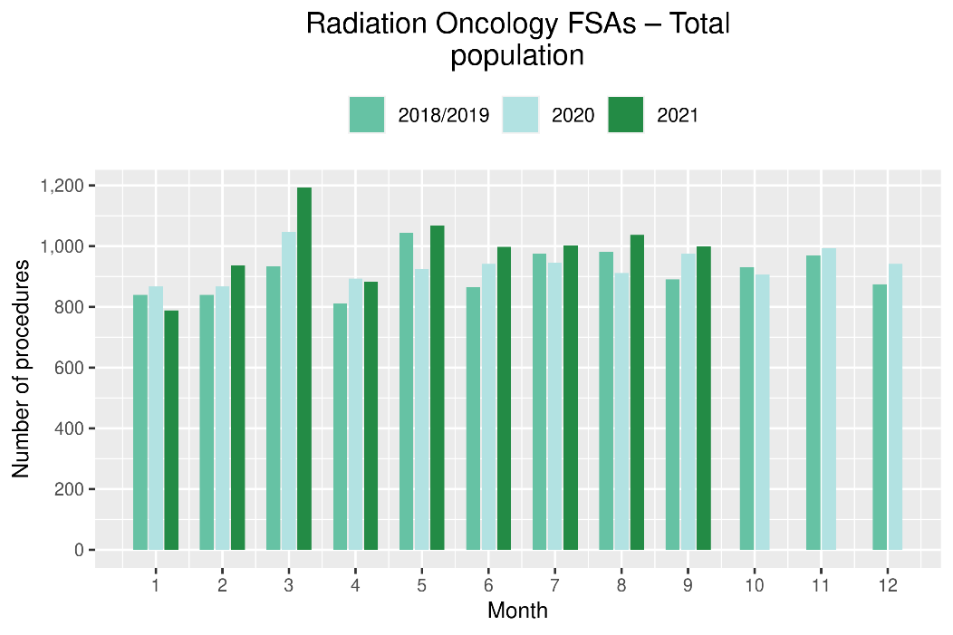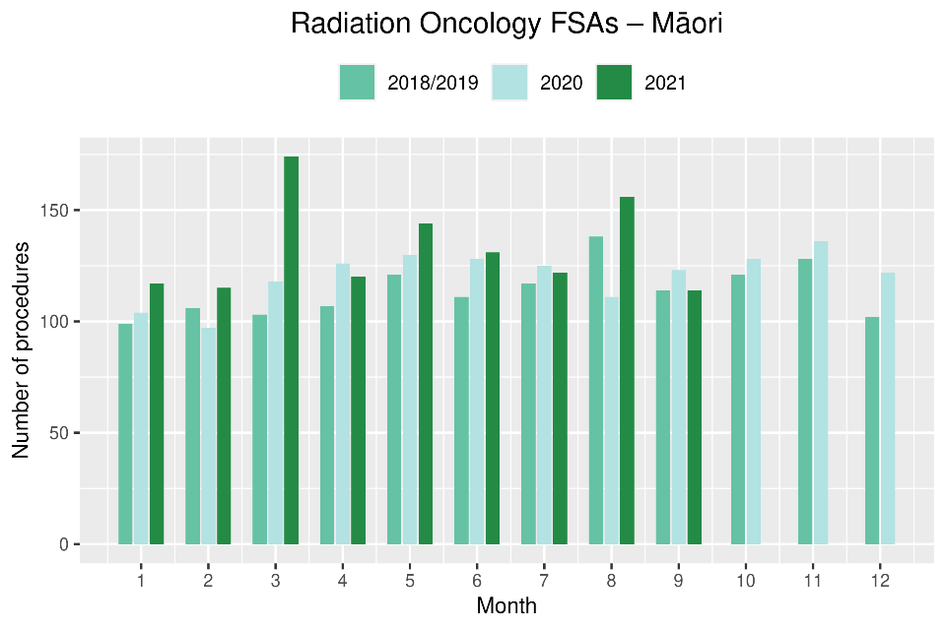
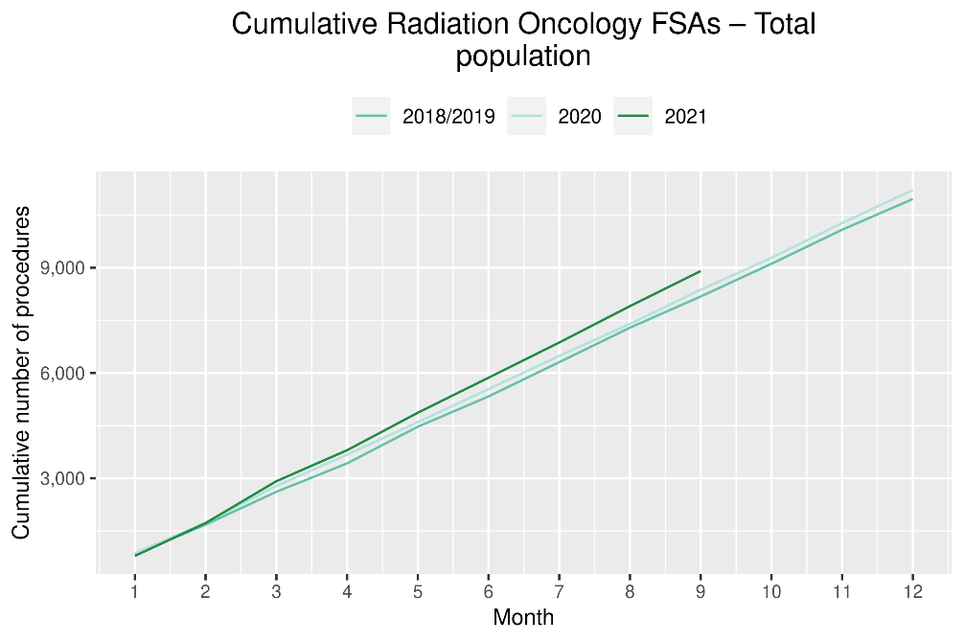 | 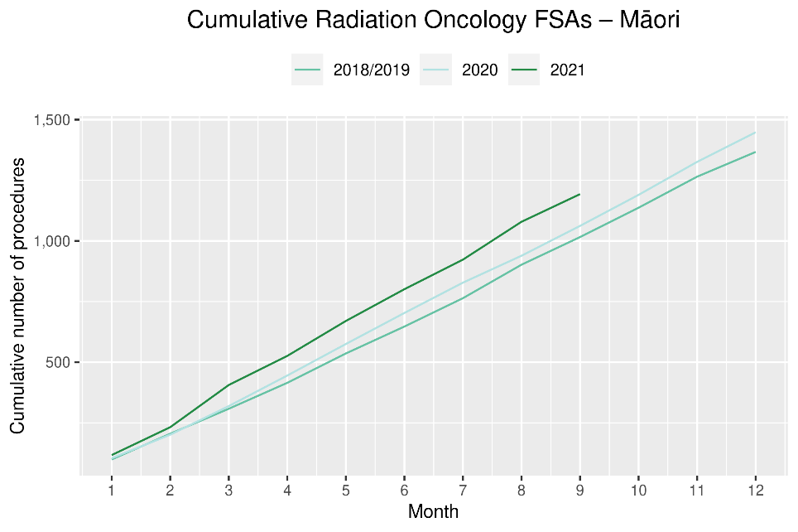
Table 15: Number of radiation oncology attendances and percentage difference in 2021 compared to 2018/2019 average, by month and cumulative year to date, by ethnicity
 | July |  |  | August |  |  | September |  |  | Cumulative January-September
 | 2018/19 | 2021 | % change | 2018/19 | 2021 | % change | 2018/19 | 2021 | % change | 2018/19 | 2021 | % change
Māori | 1,924 | 1,791 | -7% | 1,869 | 1,893 | 1% | 1,685 | 2,048 | 22% | 15,325 | 16,103 | 5%
Pacific peoples | 754 | 602 | -20% | 551 | 527 | -4% | 489 | 710 | 45% | 5,050 | 5,323 | 5%
Non-Māori/Non-Pacific | 10,729 | 10,597 | -1% | 10,488 | 10,090 | -4% | 10,022 | 10,399 | 4% | 93,941 | 89,792 | -4%
Total population | 13,407 | 12,990 | -3% | 12,907 | 12,510 | -3% | 12,196 | 13,157 | 8% | 114,316 | 111,218 | -3%

Figure 19: Number of radiation therapy attendances by month, 2018/19 average, 2020 and 2021, total population and for Māori
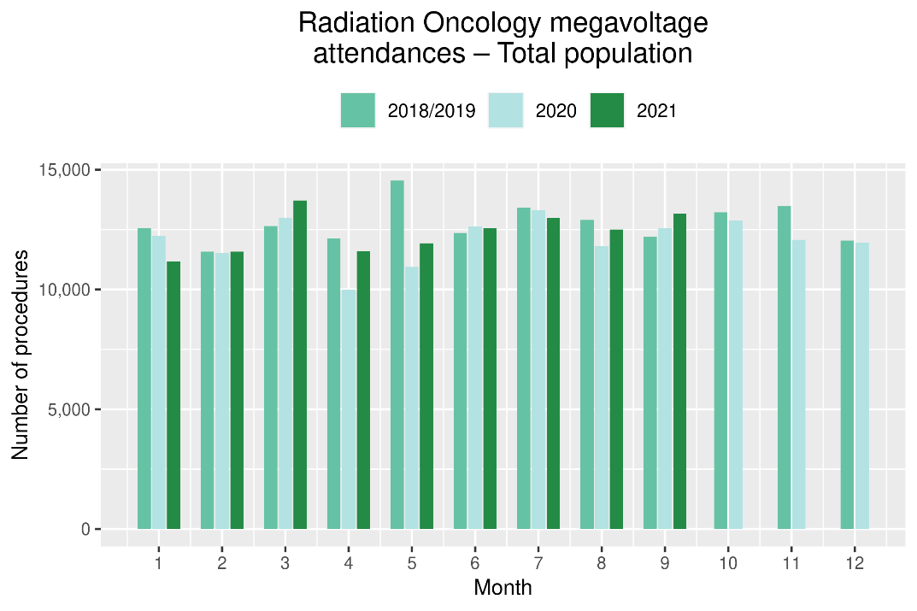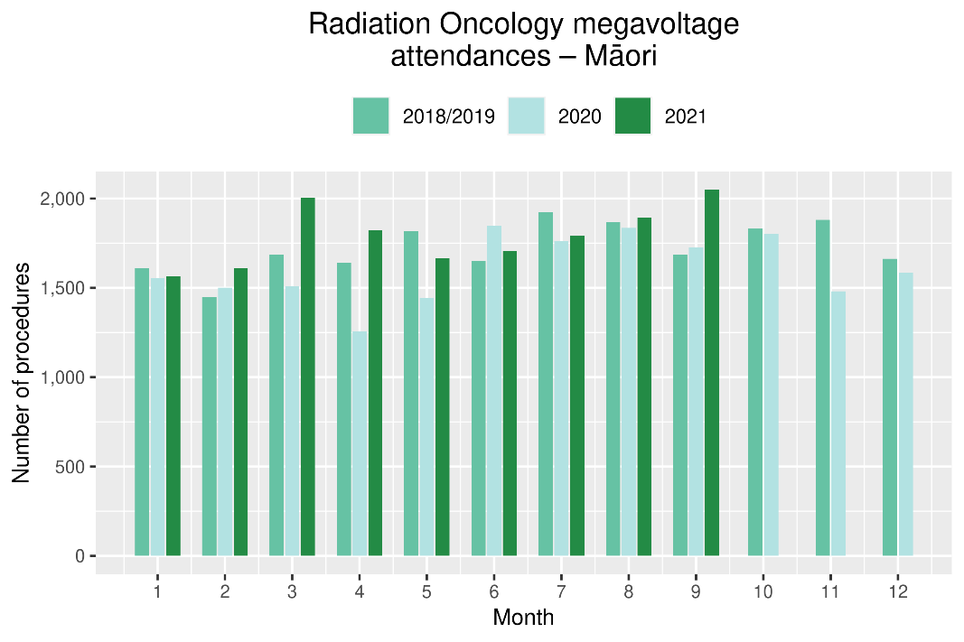

Figure 20: Cumulative number of attendances for radiation therapy, 2018/19 average, 2020 and 2021, total population and for Māori
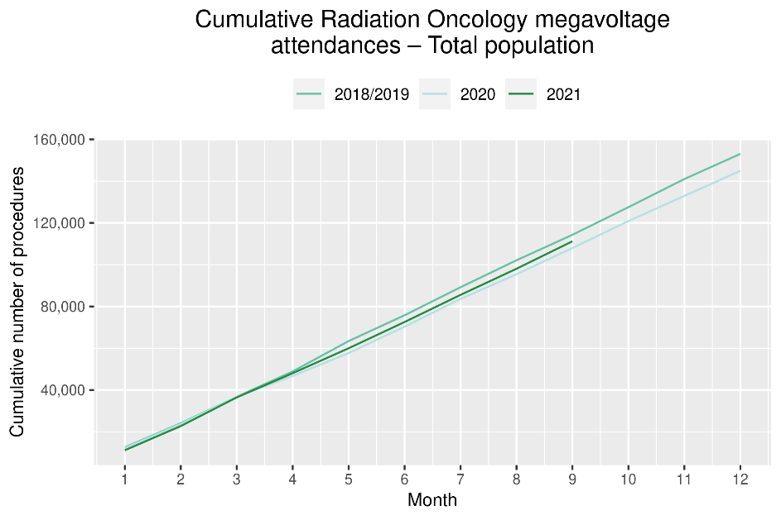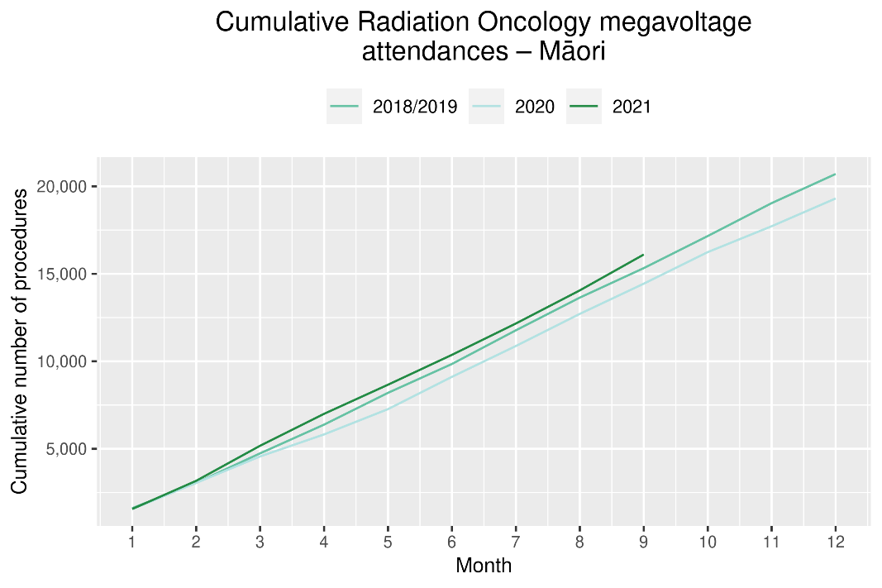

Haematology

Notes on data
- Data were extracted from NNPAC and NMDS on 8 November 2021.
- First specialist assessment (FSA) reflects counts of first attendance for specialist haematology assessment for any indication, not just cancer.
- IV chemotherapy reflects appointments for IV chemotherapy for haematological malignancies.
- Technical information: Haematology FSA (Purchase Unite Code: M30002), IV haem/chemo (Purchase Unit Code: M30020).

Key points
- Attendances for haematology FSAs remained stable during the September 2021. Overall, for the year to date, there has been a small (1%) decrease in haematology FSAs in 2021 compared to 2018/19.
- Attendances for IV chemotherapy remained largely stable over September 2021, with an overall 6% increase in the number of attendances for the year to date compared to the same time period in 2018/19.
- For the year to date there has been a 16% increase in haematology FSAs for Māori, but an overall decrease (2%) in attendances for IV chemotherapy. This does not appear to be related to the 2021 COVID outbreak, and worth noting that haematology FSAs include non-cancer indications.

Results
Table 16: Number of haematology first specialist assessment attendances and percentage difference in 2021 compared to 2018/2019 average, by month and cumulative year to date, by ethnicity
 | July |  |  | August |  |  | September |  |  | Cumulative January-September
 | 2018/19 | 2021 | % change | 2018/19 | 2021 | % change | 2018/19 | 2021 | % change | 2018/19 | 2021 | % change
Māori | 53 | 74 | 41% | 49 | 72 | 48% | 55 | 55 | 0% | 470 | 544 | 16%
Pacific peoples | 25 | 23 | -8% | 29 | 21 | -28% | 26 | 32 | 25% | 236 | 253 | 7%
Non-Māori/Non-Pacific | 415 | 410 | -1% | 469 | 455 | -3% | 401 | 424 | 6% | 3,815 | 3,664 | -4%
Total population | 492 | 507 | 3% | 546 | 548 | 0% | 482 | 511 | 6% | 4,520 | 4,461 | -1%

Figure 21: Number of haematology first specialist assessments by month, 2018/19 average, 2020 and 2021, total population and Māori
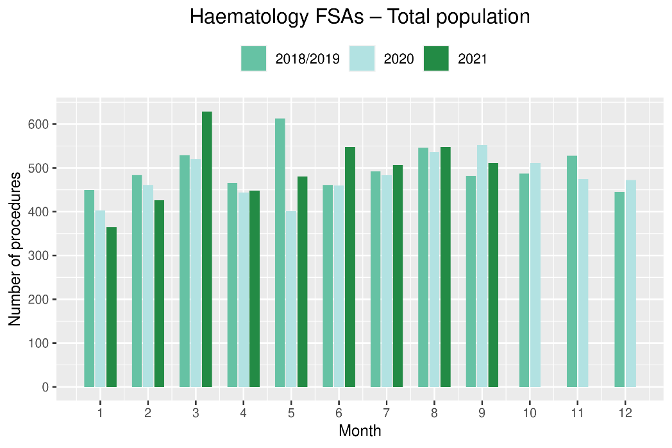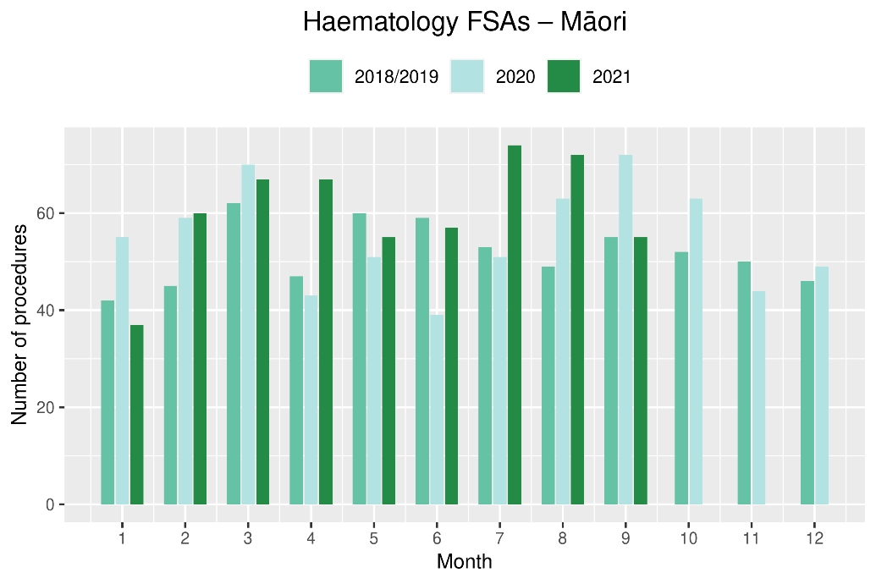
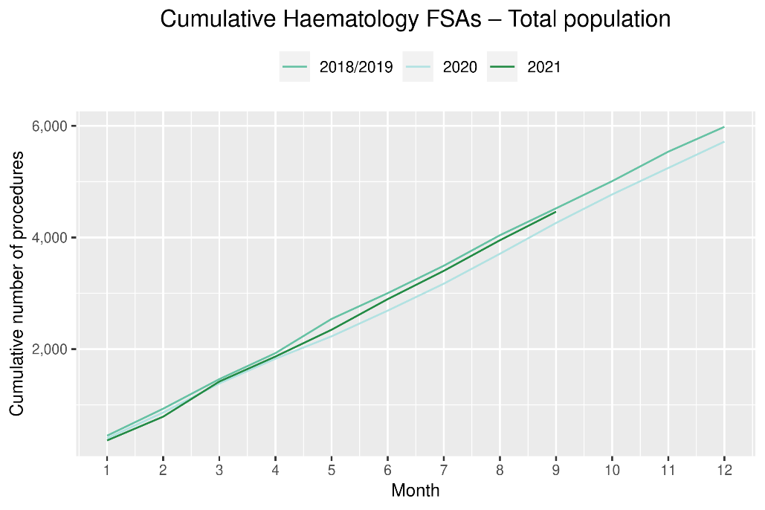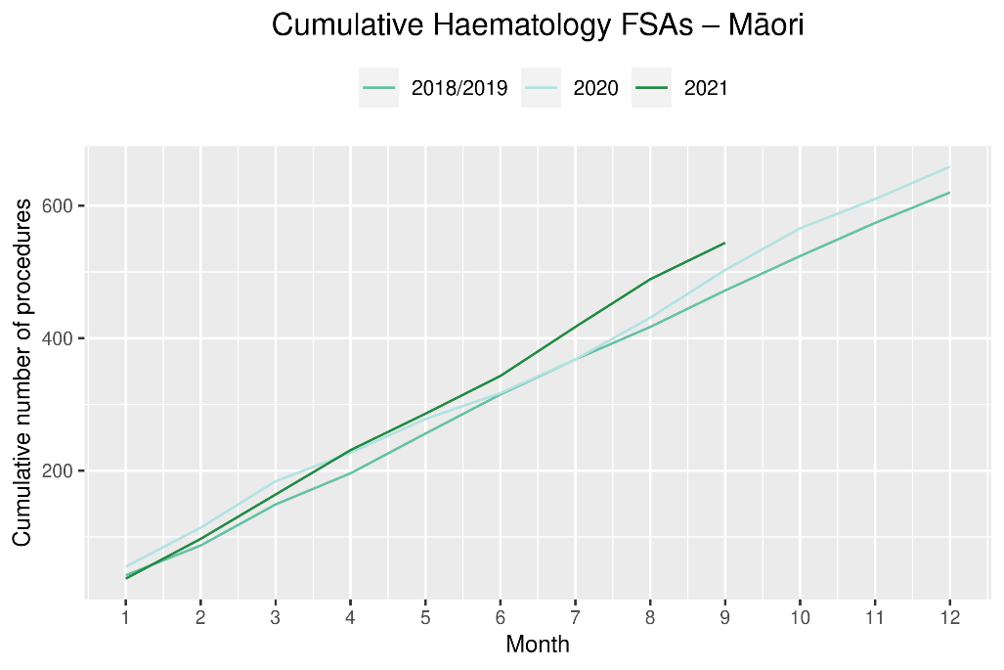
Table 17: Number of IV chemotherapy attendances for haematological malignancies and percentage difference in 2021 compared to 2018/2019 average, by month and cumulative year to date, by ethnicity
 | July |  |  | August |  |  | September |  |  | Cumulative January-September
 | 2018/19 | 2021 | % change | 2018/19 | 2021 | % change | 2018/19 | 2021 | % change | 2018/19 | 2021 | % change
Māori | 229 | 191 | -17% | 225 | 195 | -13% | 207 | 218 | 5% | 1,799 | 1,762 | -2%
Pacific peoples | 114 | 142 | 25% | 112 | 147 | 31% | 101 | 151 | 50% | 905 | 1,244 | 38%
Non-Māori/Non-Pacific | 1,858 | 1,782 | -4% | 1,864 | 1,756 | -6% | 1,731 | 1,802 | 4% | 15,073 | 15,759 | 5%
Total population | 2,200 | 2,115 | -4% | 2,201 | 2,098 | -5% | 2,039 | 2,171 | 6% | 17,777 | 18,765 | 6%
Figure 22: Number of attendances for IV chemotherapy for haematological malignancies by month, 2018/19 average, 2020 and 2021, total population and Māori
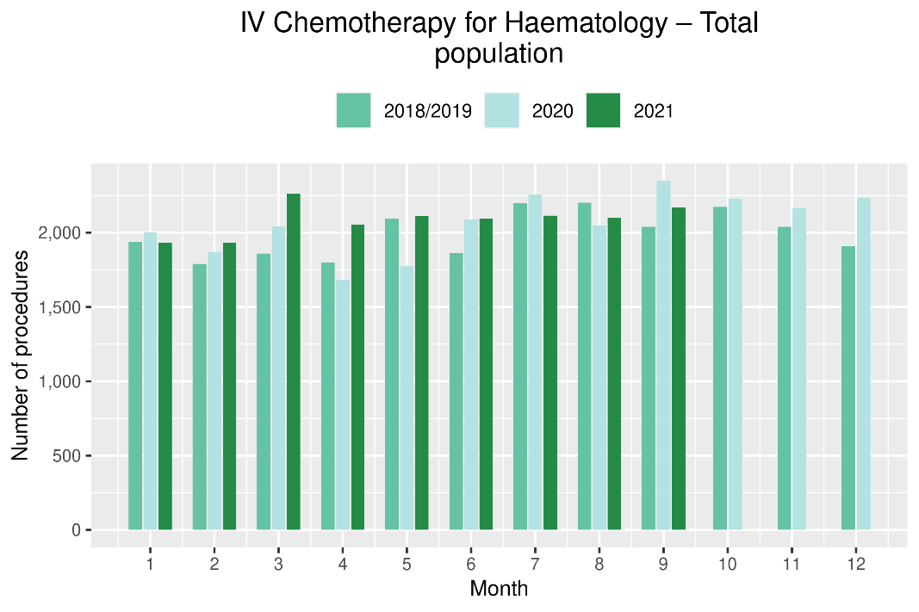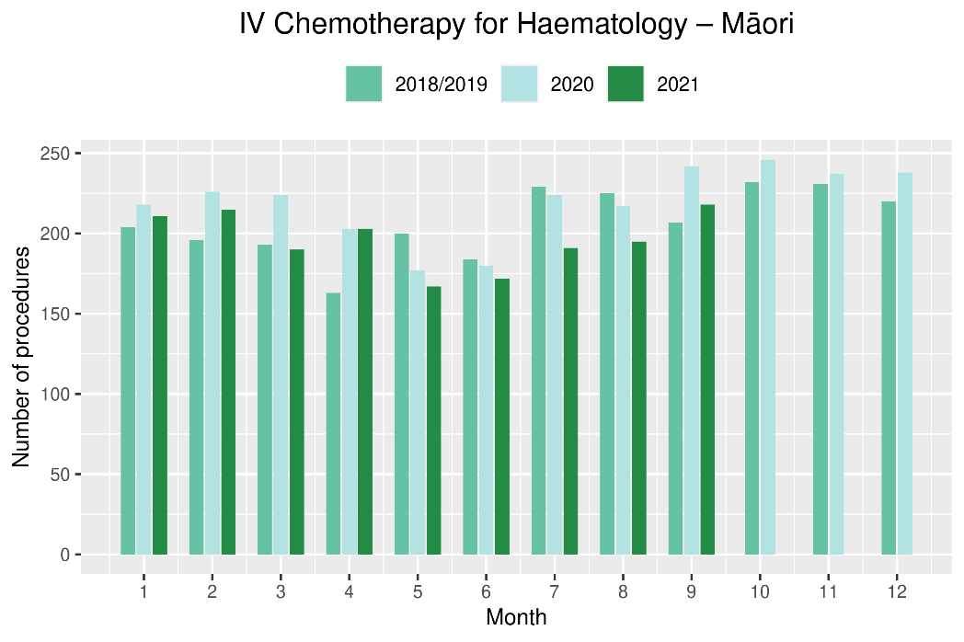

Figure 23: Cumulative number of attendances for IV chemotherapy for haematological malignancies, 2018/19 average, 2020 and 2021, total population and for Māori
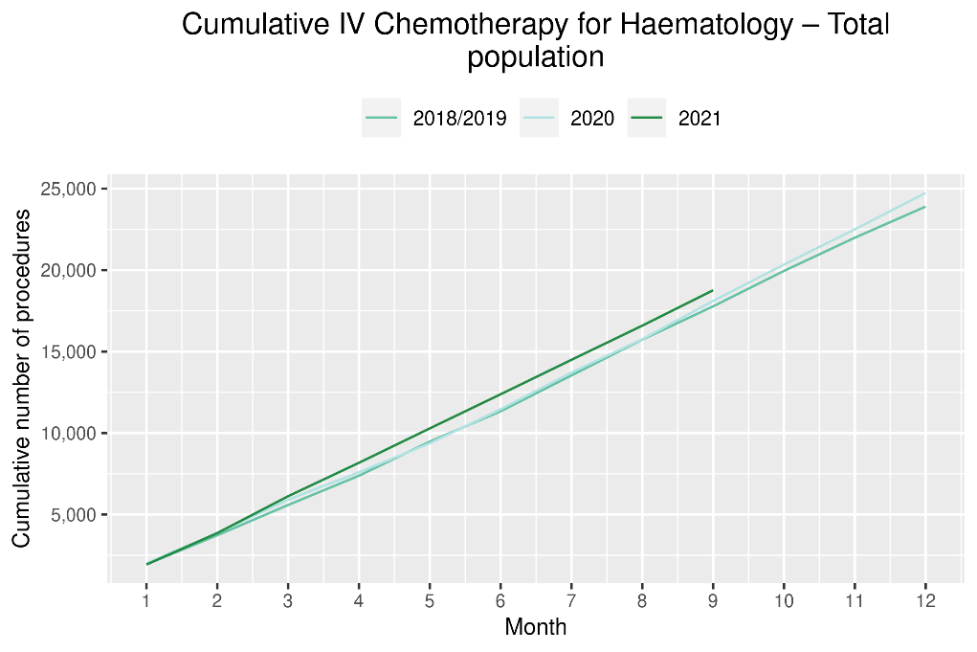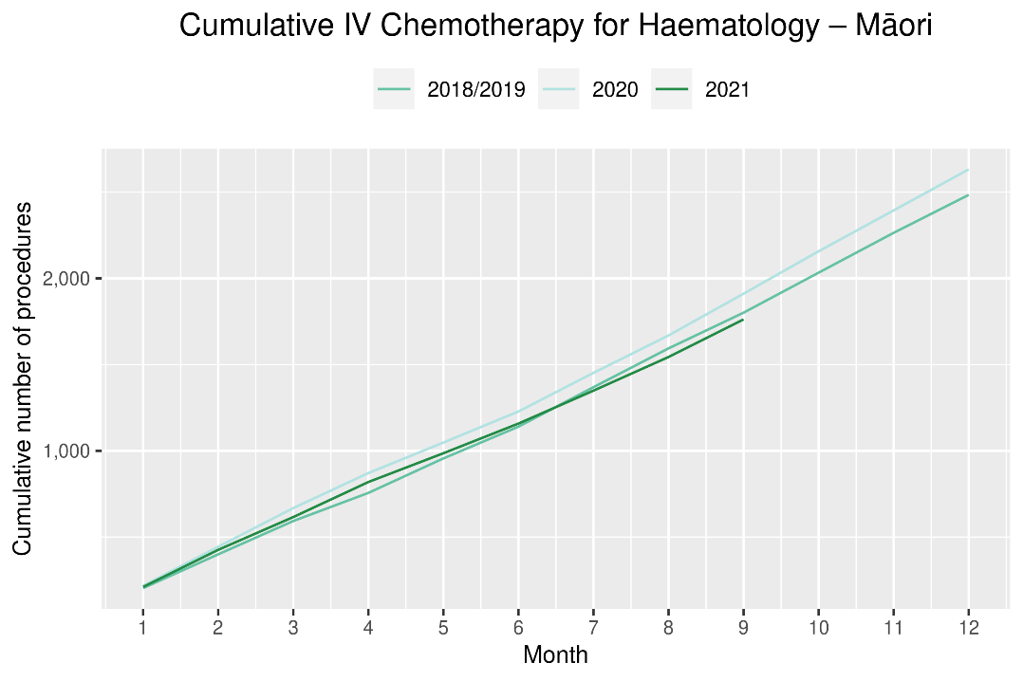

Appendix 1: NZCR data information

The New Zealand Cancer Registry as a data source for new cancer diagnoses
Cancer registration is a process where data is collated from multiple sources about people diagnosed with cancer and rules are applied to determine the type of cancer they have. This information is recorded in the New Zealand Cancer Registry. Each tumour is classified using an international World Health Organization standard so that cancer incidence can be compared between countries. The tumour is staged based on all the information available within 4 months of diagnosis. This process may take up to six months or more depending on the number of missing reports that need to be followed up with laboratories.
For each registration there may be multiple pathology reports as there may be multiple procedures performed on the tumour. This means there will be more than one registration for people diagnosed with more than one type of tumour.
Cancer registrations come from pathology laboratories, haematology laboratories, mortality records and reviewing hospital discharge records. Laboratory reports provide the best source of near real time data to monitor new diagnoses of cancer in New Zealand.

Pathology reports as a data source for providing near real time monitoring cancer diagnoses
Pathology reports (documents) are received by the NZCR as electronic messages. An administrator triages these documents each day and if the document appears to meet the requirements for registration the document is “administered”. The document may relate to an existing registration or may contain information for a new cancer event. Documents that do not meet the cancer reporting requirements will be marked as “deleted”, “rejected” or “agreed not for registration”.
The administrator creates a new provisional cancer event if the pathology report identifies a new cancer diagnosis for this person. This new cancer event is assigned to a cancer group and this provisional event is then queued for further assessment by a clinical coder. If the required information has been provided the coder creates a new registration. If some information is not yet available, then the registration is held open until further information arrives to complete the registration or determine that the tumour does not meet the registration criteria.

Appendix 2: NZCR registrations by DHB
Number of cancer registrations and percentage difference in 2021 compared to 2018/2019 average, by month and cumulative year to date, by DHB of domicile
 | July |  |  | August |  |  | September |  |  | Cumulative January-September
 | 2018/2019 average | 2021 | % | 2018/2019 average | 2021 | % | 2018/2019 average | 2021 | % | 2018/2019 average | 2021 | %
Northland | 96 | 105 | 10% | 99 | 90 | -9% | 89 | 106 | 20% | 851 | 946 | 11%
Waitematā | 252 | 268 | 7% | 262 | 220 | -16% | 238 | 245 | 3% | 2,106 | 2,295 | 9%
Auckland | 163 | 182 | 12% | 160 | 138 | -13% | 158 | 181 | 15% | 1,492 | 1,552 | 4%
Counties Manukau | 194 | 178 | -8% | 190 | 182 | -4% | 178 | 185 | 4% | 1,627 | 1,703 | 5%
Waikato | 175 | 180 | 3% | 180 | 177 | -2% | 188 | 216 | 15% | 1,598 | 1,627 | 2%
Bay of Plenty | 108 | 134 | 24% | 137 | 90 | -34% | 115 | 141 | 23% | 1,045 | 1,079 | 3%
Tairāwhiti | 14 | 24 | 71% | 23 | 14 | -38% | 19 | 22 | 19% | 162 | 194 | 20%
Lakes | 50 | 45 | -9% | 49 | 48 | -2% | 45 | 50 | 11% | 410 | 425 | 4%
Taranaki | 57 | 63 | 12% | 63 | 74 | 17% | 60 | 69 | 16% | 522 | 593 | 14%
Hawke's Bay | 81 | 65 | -20% | 78 | 77 | -1% | 73 | 69 | -5% | 670 | 722 | 8%
Whanganui | 28 | 37 | 35% | 44 | 49 | 11% | 35 | 33 | -6% | 315 | 296 | -6%
MidCentral | 86 | 84 | -2% | 97 | 95 | -2% | 78 | 91 | 17% | 764 | 784 | 3%
Capital & Coast | 121 | 101 | -16% | 113 | 109 | -3% | 115 | 147 | 28% | 1,031 | 1,064 | 3%
Hutt Valley | 63 | 61 | -3% | 60 | 62 | 3% | 71 | 69 | -2% | 549 | 572 | 4%
Wairarapa | 18 | 17 | -6% | 23 | 20 | -11% | 25 | 27 | 10% | 206 | 215 | 5%
Nelson Marlborough | 77 | 84 | 9% | 77 | 71 | -7% | 77 | 96 | 25% | 685 | 762 | 11%
West Coast | 16 | 16 | 0% | 18 | 16 | -11% | 14 | 26 | 86% | 141 | 151 | 7%
Canterbury | 242 | 254 | 5% | 233 | 232 | 0% | 233 | 274 | 18% | 2,040 | 2,276 | 12%
South Canterbury | 29 | 29 | 0% | 34 | 28 | -18% | 38 | 37 | -3% | 278 | 306 | 10%
Southern | 146 | 174 | 19% | 173 | 156 | -10% | 167 | 166 | 0% | 1,386 | 1,498 | 8%

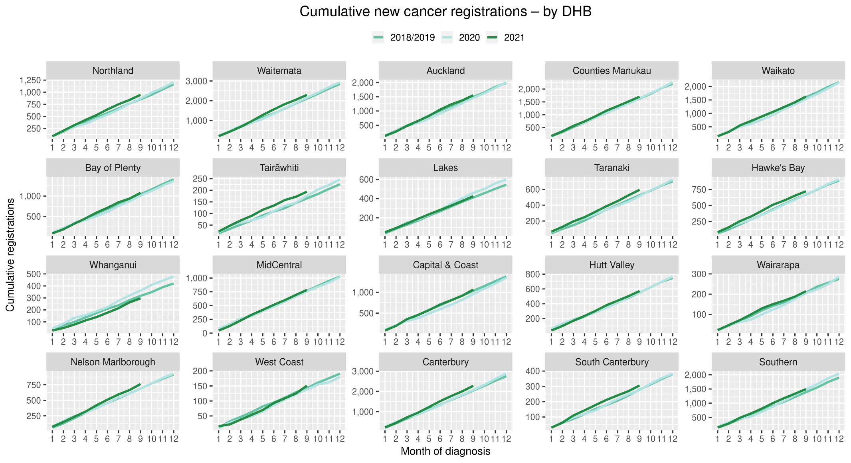

Cumulative cancer registrations by ethnicity
 | Total population |  |  |  |  |  | Māori |  |  |  |  |  |  |  | Non-Māori / Non-Pacific
 | Cumulative January-September |  |  | Difference between 2018/19 average and 2021 |  |  | Cumulative January-September |  |  | Difference between 2018/19 average and 2021 |  |  |  |  | Cumulative January-September |  |  | Difference between 2018/19 average and 2021
 | 2018/19 | 2020 | 2021 | Number | % |  | 2018/19 | 2020 | 2021 | Number |  |  | % |  | 2018/19 | 2020 | 2021 | Number | %
Northland | 851 | 869 | 946 | 95 | 11% |  | 195 | 196 | 234 |  | 39 | 20% |  |  | 656 | 673 | 712 | 56 | 9%
Waitematā | 2,106 | 2,157 | 2,295 | 190 | 9% |  | 128 | 142 | 128 |  | 0 | 0% |  |  | 1,978 | 2,015 | 2,167 | 190 | 10%
Auckland | 1,492 | 1,457 | 1,552 | 60 | 4% |  | 90 | 79 | 103 |  | 13 | 14% |  |  | 1,402 | 1,378 | 1,449 | 47 | 3%
Counties Manukau | 1,627 | 1,645 | 1,703 | 76 | 5% |  | 206 | 234 | 215 |  | 9 | 4% |  |  | 1,421 | 1,411 | 1,488 | 67 | 5%
Waikato | 1,598 | 1,536 | 1,627 | 29 | 2% |  | 257 | 238 | 242 |  | -15 | -6% |  |  | 1,341 | 1,298 | 1,385 | 44 | 3%
Bay of Plenty | 1,045 | 1,009 | 1,079 | 34 | 3% |  | 167 | 174 | 176 |  | 9 | 5% |  |  | 878 | 835 | 903 | 25 | 3%
Tairāwhiti | 162 | 176 | 194 | 33 | 20% |  | 61 | 68 | 75 |  | 15 | 24% |  |  | 101 | 108 | 119 | 18 | 18%
Lakes | 410 | 458 | 425 | 16 | 4% |  | 99 | 126 | 126 |  | 27 | 27% |  |  | 311 | 332 | 299 | -12 | -4%
Taranaki | 522 | 514 | 593 | 71 | 14% |  | 56 | 53 | 76 |  | 21 | 37% |  |  | 467 | 461 | 517 | 51 | 11%
Hawke's Bay | 670 | 675 | 722 | 53 | 8% |  | 48 | 52 | 61 |  | 14 | 28% |  |  | 268 | 309 | 235 | -33 | -12%
Whanganui | 315 | 361 | 296 | -19 | -6% |  | 78 | 85 | 91 |  | 13 | 17% |  |  | 686 | 673 | 693 | 7 | 1%
MidCentral | 764 | 758 | 784 | 20 | 3% |  | 76 | 58 | 70 |  | -6 | -8% |  |  | 473 | 494 | 502 | 30 | 6%
Capital & Coast | 1,031 | 956 | 1,064 | 34 | 3% |  | 18 | 21 | 27 |  | 10 | 54% |  |  | 188 | 184 | 188 | 0 | 0%
Hutt Valley | 549 | 552 | 572 | 24 | 4% |  | 37 | 30 | 42 |  | 6 | 15% |  |  | 649 | 659 | 720 | 72 | 11%
Wairarapa | 206 | 205 | 215 | 10 | 5% |  | 12 | 8 | 14 |  | 3 | 22% |  |  | 130 | 130 | 137 | 8 | 6%
Nelson Marlborough | 685 | 689 | 762 | 77 | 11% |  | 114 | 98 | 124 |  | 10 | 9% |  |  | 1,926 | 1,967 | 2,152 | 227 | 12%
West Coast | 141 | 138 | 151 | 10 | 7% |  | 77 | 89 | 103 |  | 26 | 34% |  |  | 954 | 867 | 961 | 8 | 1%
Canterbury | 2,040 | 2,065 | 2,276 | 237 | 12% |  | 126 | 127 | 136 |  | 10 | 8% |  |  | 544 | 548 | 586 | 43 | 8%
South Canterbury | 278 | 276 | 306 | 29 | 10% |  | 13 | 7 | 10 |  | -3 | -23% |  |  | 265 | 269 | 296 | 32 | 12%
Southern | 1,386 | 1,481 | 1,498 | 112 | 8% |  | 69 | 84 | 94 |  | 25 | 36% |  |  | 1,317 | 1,397 | 1,404 | 87 | 7%
Total | 17,874 | 17,977 | 19,060 | 1,187 | 7% |  | 1,924 | 1,969 | 2,147 |  | 223 |  | 12% |  | 15,950 | 16,008 | 16,913 | 964 | 6%

Appendix 3: Diagnosis and treatment data by DHB
Percentage differences are only presented if the cumulative total is 10 or greater. In some cases, the totals may differ to those presented in the national report due to non-DHB providers being excluded from the analyses within this appendix.

Gastrointestinal endoscopy
 | Total population |  |  |  |  |  | Māori |  |  |  |  |  | Non-Māori / Non-Pacific
 | Cumulative number for Jan to Sept |  |  | Difference between 2018/19 average and 2021 |  |  | Cumulative number for Jan to Sept |  |  | Difference between 2018/19 average and 2021 |  |  | Cumulative number for Jan to Sept |  |  | Difference between 2018/19 average and 2021
 | 2018/19 | 2020 | 2021 | Number | % |  | 2018/19 | 2020 | 2021 | Number | % |  | 2018/19 | 2020 | 2021 | Number | %
Northland | 2,896 | 2,718 | 3,346 | 450 | 16% |  | 533 | 505 | 659 | 126 | 24% |  | 2,343 | 2,191 | 2,655 | 313 | 13%
Waitematā | 6,677 | 6,942 | 7,248 | 572 | 9% |  | 382 | 389 | 448 | 66 | 17% |  | 6,080 | 6,246 | 6,528 | 449 | 7%
Auckland | 4,713 | 4,481 | 4,420 | -293 | -6% |  | 242 | 264 | 264 | 22 | 9% |  | 4,149 | 3,869 | 3,825 | -324 | -8%
Counties Manukau | 6,770 | 7,259 | 6,687 | -83 | -1% |  | 649 | 730 | 633 | -16 | -2% |  | 5,278 | 5,521 | 5,094 | -184 | -3%
Waikato | 4,409 | 5,016 | 4,624 | 215 | 5% |  | 530 | 583 | 608 | 78 | 15% |  | 3,821 | 4,365 | 3,955 | 135 | 4%
Bay of Plenty | 3,686 | 3,810 | 5,031 | 1,346 | 37% |  | 446 | 495 | 620 | 174 | 39% |  | 3,221 | 3,303 | 4,380 | 1,159 | 36%
Lakes | 1,484 | 1,416 | 1,792 | 309 | 21% |  | 269 | 287 | 334 | 65 | 24% |  | 1,193 | 1,105 | 1,433 | 240 | 20%
Tairāwhiti | 572 | 551 | 599 | 28 | 5% |  | 167 | 163 | 164 | -3 | -2% |  | 401 | 381 | 429 | 29 | 7%
Taranaki* | 1,443 | 1,537 | 1,888 | 446 | 31% |  | 148 | 135 | 201 | 53 | 36% |  | 1,288 | 1,390 | 1,680 | 392 | 30%
Whanganui | 1,128 | 985 | 1,009 | -119 | -11% |  | 158 | 141 | 141 | -17 | -11% |  | 962 | 836 | 862 | -100 | -10%
Hawke's Bay | 2,050 | 2,202 | 2,626 | 576 | 28% |  | 246 | 308 | 349 | 104 | 42% |  | 1,783 | 1,858 | 2,244 | 462 | 26%
MidCentral | 1,631 | 1,723 | 1,910 | 280 | 17% |  | 117 | 156 | 192 | 75 | 64% |  | 1,499 | 1,546 | 1,702 | 203 | 14%
Capital & Coast | 2,132 | 2,535 | 2,328 | 197 | 9% |  | 151 | 195 | 214 | 63 | 42% |  | 1,896 | 2,252 | 2,023 | 128 | 7%
Hutt Valley | 1,974 | 2,474 | 2,446 | 472 | 24% |  | 164 | 250 | 234 | 70 | 43% |  | 1,741 | 2,135 | 2,114 | 374 | 21%
Wairarapa | 779 | 692 | 784 | 6 | 1% |  | 67 | 65 | 79 | 12 | 18% |  | 705 | 622 | 700 | -5 | -1%
Nelson Marlborough | 1,587 | 2,022 | 2,060 | 474 | 30% |  | 83 | 120 | 114 | 32 | 38% |  | 1,497 | 1,885 | 1,937 | 441 | 29%
West Coast | 505 | 518 | 644 | 140 | 28% |  | 36 | 24 | 47 | 11 | 31% |  | 467 | 491 | 595 | 129 | 28%
Canterbury | 5,805 | 6,090 | 5,699 | -106 | -2% |  | 339 | 347 | 325 | -14 | -4% |  | 5,382 | 5,658 | 5,300 | -82 | -2%
South Canterbury | 929 | 901 | 1,003 | 74 | 8% |  | 37 | 46 | 34 | -3 | -7% |  | 890 | 853 | 964 | 75 | 8%
Southern* | 3,559 | 3,718 | 3,913 | 355 | 10% |  | 175 | 212 | 219 | 44 | 25% |  | 3,360 | 3,461 | 3,655 | 296 | 9%
Total | 54,723 | 57,590 | 60,057 | 5,335 | 10% |  | 4936 | 5415 | 5879 | 943 | 19% |  | 47,950 | 49,968 | 52,075 | 4,126 | 9%
*There were issues with data quality from Taranaki and Southern DHB during July and August 2021. Data has been included in the table, but changes are unlikely to be a true reflection of differences over time. Both DHBs are actively working on resolving this issue for the next report.

Bronchoscopy

 | Total population |  |  |  |  |  | Māori |  |  |  |  |  | Non-Māori / Non-Pacific
 | Cumulative number for Jan to Sept |  |  | Difference between 2018/19 average and 2021 |  |  | Cumulative number for Jan to Sept |  |  | Difference between 2018/19 average and 2021 |  |  | Cumulative number for Jan to Sept |  |  | Difference between 2018/19 average and 2021
 | 2018/19 | 2020 | 2021 | Number | % |  | 2018/19 | 2020 | 2021 | Number | % |  | 2018/19 | 2020 | 2021 | Number | %
Northland | 61 | 55 | 82 | 21 | 34% |  | 19 | 21 | 23 | 4 | 21% |  | 41 | 33 | 59 | 18 | 44%
Waitematā | 110 | 115 | 154 | 44 | 40% |  | 7 | 10 | 19 | 13 |  |  | 100 | 99 | 133 | 34 | 34%
Auckland | 265 | 217 | 209 | -56 | -21% |  | 35 | 24 | 26 | -9 | -25% |  | 205 | 173 | 174 | -31 | -15%
Counties Manukau | 266 | 253 | 230 | -36 | -14% |  | 48 | 34 | 45 | -3 | -5% |  | 179 | 183 | 148 | -31 | -17%
Waikato | 203 | 161 | 171 | -32 | -16% |  | 46 | 35 | 32 | -14 | -30% |  | 154 | 122 | 139 | -15 | -10%
Bay of Plenty | 127 | 100 | 130 | 4 | 3% |  | 31 | 22 | 34 | 4 | 11% |  | 94 | 78 | 96 | 2 | 2%
Tairāwhiti | 3 | 21 | 20 | 18 |  |  | 2 | 9 | 6 | 5 |  |  | 1 | 12 | 14 | 13
Lakes | 67 | 59 | 61 | -6 | -9% |  | 23 | 24 | 20 | -3 | -13% |  | 44 | 32 | 41 | -3 | -6%
Taranaki* | 41 | 31 | 45 | 5 | 11% |  | 8 | 3 | 10 | 3 |  |  | 33 | 28 | 35 | 2 | 6%
Hawke's Bay | 50 | 37 | 53 | 4 | 7% |  | 13 | 8 | 15 | 3 | 20% |  | 37 | 28 | 37 | 1 | 1%
Whanganui | 12 | 10 | 12 | 1 | 4% |  | 5 | 4 | 7 | 2 |  |  | 7 | 6 | 5 | -2
MidCentral | 28 | 21 | 25 | -3 | -11% |  | 6 | 1 | 7 | 1 |  |  | 22 | 20 | 17 | -5 | -23%
Capital & Coast | 72 | 54 | 50 | -22 | -30% |  | 8 | 8 | 5 | -3 |  |  | 61 | 44 | 42 | -19 | -31%
Hutt Valley | 86 | 73 | 64 | -22 | -26% |  | 16 | 12 | 10 | -6 | -38% |  | 67 | 56 | 48 | -19 | -28%
Nelson Marlborough | 57 | 66 | 67 | 11 | 19% |  | 5 | 6 | 2 | -3 |  |  | 52 | 59 | 65 | 13 | 25%
Canterbury | 285 | 278 | 266 | -19 | -7% |  | 21 | 18 | 16 | -5 | -22% |  | 261 | 254 | 247 | -14 | -5%
South Canterbury | 10 | 14 | 13 | 3 | 30% |  | 1 | 0 | 0 | -1 |  |  | 10 | 14 | 13 | 4
Southern* | 185 | 142 | 198 | 14 | 7% |  | 17 | 8 | 10 | -7 | -39% |  | 167 | 133 | 185 | 19 | 11%
Total | 1,924 | 1,707 | 1,850 | -74 | -4% |  | 306 | 247 | 287 | -19 | -6% |  | 1,531 | 1,374 | 1,498 | -33 | -2%
*There were issues with data quality from Taranaki and Southern DHB during July and August 2021. Data has been included in the table, but changes are unlikely to be a true reflection of differences over time. Both DHBs are actively working on resolving this issue for the next report

Colorectal cancer surgery

 | Total population |  |  |  |  |  | Māori |  |  |  |  |  | Non-Māori / Non-Pacific
 | Cumulative number for Jan to Sept |  |  | Difference between 2018/19 average and 2021 |  |  | Cumulative number for Jan to Sept |  |  | Difference between 2018/19 average and 2021 |  |  | Cumulative number for Jan to Sept |  |  | Difference between 2018/19 average and 2021
 | 2018/19 | 2020 | 2021 | Number | % |  | 2018/19 | 2020 | 2021 | Number | % |  | 2018/19 | 2020 | 2021 | Number | %
Northland | 67 | 62 | 71 | 5 | 7% |  | 12 | 16 | 16 | 5 | 39% |  | 55 | 46 | 55 | 1 | 1%
Waitematā | 191 | 161 | 144 | -47 | -24% |  | 12 | 10 | 8 | -4 | -33% |  | 170 | 148 | 130 | -40 | -23%
Auckland | 146 | 153 | 166 | 20 | 14% |  | 9 | 18 | 13 | 4 |  |  | 122 | 127 | 134 | 12 | 10%
Counties Manukau | 101 | 107 | 90 | -11 | -10% |  | 7 | 16 | 7 | 0 |  |  | 84 | 78 | 69 | -15 | -17%
Waikato | 165 | 205 | 199 | 35 | 21% |  | 16 | 30 | 32 | 16 | 100% |  | 146 | 174 | 164 | 19 | 13%
Bay of Plenty | 103 | 140 | 105 | 3 | 2% |  | 11 | 22 | 18 | 7 | 64% |  | 91 | 118 | 82 | -9 | -10%
Tairāwhiti | 20 | 20 | 25 | 6 | 28% |  | 5 | 7 | 11 | 7 |  |  | 15 | 13 | 13 | -2 | -13%
Lakes | 57 | 60 | 59 | 2 | 4% |  | 10 | 9 | 10 | 1 |  |  | 46 | 50 | 46 | 0 | 0%
Taranaki | 65 | 64 | 63 | -2 | -2% |  | 6 | 9 | 6 | 1 |  |  | 59 | 55 | 57 | -2 | -3%
Hawke's Bay | 106 | 110 | 96 | -10 | -9% |  | 11 | 15 | 8 | -3 | -27% |  | 94 | 92 | 86 | -8 | -9%
Whanganui | 37 | 41 | 35 | -2 | -4% |  | 6 | 3 | 1 | -5 |  |  | 31 | 38 | 34 | 3 | 10%
MidCentral | 89 | 97 | 102 | 14 | 15% |  | 6 | 11 | 15 | 10 |  |  | 82 | 85 | 87 | 5 | 6%
Capital & Coast | 125 | 97 | 107 | -18 | -14% |  | 11 | 12 | 17 | 7 | 62% |  | 108 | 83 | 84 | -24 | -22%
Hutt Valley | 54 | 44 | 46 | -8 | -14% |  | 6 | 3 | 2 | -4 |  |  | 47 | 40 | 42 | -5 | -11%
Wairarapa | 15 | 5 | 15 | 0 | 0% |  | 2 | 0 | 2 | 1 |  |  | 14 | 5 | 13 | -1 | -4%
Nelson Marlborough | 70 | 49 | 57 | -13 | -19% |  | 3 | 3 | 1 | -2 |  |  | 67 | 46 | 56 | -11 | -16%
West Coast | 4 | 6 | 4 | 1 |  |  | 0 | 0 | 0 | 0 |  |  | 4 | 6 | 4 | 1
Canterbury | 232 | 226 | 270 | 38 | 16% |  | 14 | 15 | 15 | 2 | 11% |  | 215 | 208 | 252 | 37 | 17%
South Canterbury | 39 | 34 | 42 | 4 | 9% |  | 1 | 2 | 0 | -1 |  |  | 38 | 32 | 42 | 5 | 12%
Southern | 196 | 175 | 185 | -11 | -5% |  | 8 | 4 | 8 | 1 |  |  | 186 | 169 | 174 | -12 | -6%
Total | 1,875 | 1,856 | 1,881 | 7 | 0% |  | 151 | 205 | 190 | 40 | 26% |  | 1,670 | 1,613 | 1,624 | -46 | -3%

Lung cancer surgery

 | Total population |  |  |  |  |  | Māori |  |  |  |  |  | Non-Māori / Non-Pacific
 | Cumulative number for Jan to Sept |  |  | Difference between 2018/19 average and 2021 |  |  | Cumulative number for Jan to Sept |  |  | Difference between 2018/19 average and 2021 |  |  | Cumulative number for Jan to Sept |  |  | Difference between 2018/19 average and 2021
 | 2018/19 | 2020 | 2021 | Number | % |  | 2018/19 | 2020 | 2021 | Number | % |  | 2018/19 | 2020 | 2021 | Number | %
Waitematā | 0 | 0 | 1 | 1 |  |  | 0 | 0 | 0 | 0 |  |  | 0 | 0 | 1 | 1
Auckland | 213 | 199 | 183 | -30 | -14% |  | 38 | 35 | 27 | -11 | -28% |  | 160 | 146 | 140 | -20 | -13%
Counties Manukau | 2 | 2 | 0 | -2 |  |  | 0 | 1 | 0 | 0 |  |  | 1 | 1 | 0 | -1
Waikato | 101 | 115 | 112 | 12 | 11% |  | 28 | 26 | 32 | 4 | 14% |  | 71 | 88 | 78 | 7 | 10%
Bay of Plenty | 0 | 0 | 1 | 1 |  |  | 0 | 0 | 0 | 0 |  |  | 0 | 0 | 1 | 1
Taranaki | 1 | 0 | 0 | -1 |  |  | 0 | 0 | 0 | 0 |  |  | 1 | 0 | 0 | -1
Hawke's Bay | 0 | 1 | 0 | 0 |  |  | 0 | 0 | 0 | 0 |  |  | 0 | 0 | 0 | 0
MidCentral | 0 | 0 | 1 | 1 |  |  | 0 | 0 | 1 | 1 |  |  | 0 | 0 | 0 | 0
Capital & Coast | 96 | 63 | 113 | 18 | 18% |  | 20 | 8 | 22 | 3 | 13% |  | 72 | 52 | 85 | 13 | 18%
Canterbury | 63 | 90 | 71 | 8 | 13% |  | 4 | 8 | 18 | 15 |  |  | 60 | 80 | 52 | -8 | -13%
Southern | 32 | 24 | 28 | -4 | -11% |  | 2 | 3 | 1 | -1 |  |  | 30 | 21 | 27 | -3 | -8%
Total | 505 | 494 | 510 | 5 | 1% |  | 91 | 81 | 101 | 11 | 12% |  | 394 | 388 | 384 | -10 | -2%

Prostate cancer surgery

 |  | Total population |  |  |  |  |  |  |  | Māori |  |  |  |  |  | Non-Māori / Non-Pacific
 | Cumulative number for Jan to Sept |  |  |  | Difference between 2018/19 average and 2021 |  |  |  | Cumulative number for Jan to Sept |  |  |  | Difference between 2018/19 average and 2021 |  |  |  |  | Cumulative number for Jan to Sept |  |  | Difference between 2018/19 average and 2021
 | 2018/19 |  | 2020 | 2021 | Number | % |  |  | 2018/19 |  | 2020 | 2021 | Number | % |  |  |  | 2018/19 | 2020 | 2021 | Number |  | %
Northland | 42 |  | 25 | 44 | 3 | 6% |  |  | 7 |  | 6 | 7 | 1 | - |  |  |  | 35 | 19 | 36 | 2 |  | 4%
Waitematā | 57 |  | 81 | 74 | 18 | 31% |  |  | 3 |  | 3 | 9 | 6 | - |  |  |  | 52 | 75 | 62 | 11 |  | 20%
Auckland | 71 |  | 94 | 71 | 0 | 0% |  |  | 6 |  | 9 | 7 | 1 | - |  |  |  | 59 | 81 | 49 | -10 |  | -17%
Counties Manukau | 1 |  | 0 | 11 | 11 |  |  |  | 0 |  | 0 | 2 | 2 | - |  |  |  | 1 | 0 | 7 | 7
Waikato | 49 |  | 44 | 40 | -9 | -18% |  |  | 3 |  | 3 | 10 | 8 | - |  |  |  | 46 | 40 | 29 | -17 |  | -37%
Bay of Plenty | 35 |  | 30 | 24 | -11 | -30% |  |  | 5 |  | 5 | 4 | -1 | - |  |  |  | 30 | 25 | 20 | -10 |  | -32%
Tairāwhiti | 4 |  | 6 | 9 | 6 |  |  |  | 2 |  | 2 | 4 | 3 | - |  |  |  | 2 | 4 | 5 | 3
Lakes | 6 |  | 11 | 11 | 5 |  |  |  | 0 |  | 6 | 4 | 4 | - |  |  |  | 6 | 5 | 6 | 1
Taranaki* | 18 |  | 26 | 36 | 19 | 106% |  |  | 2 |  | 4 | 3 | 2 | - |  |  |  | 16 | 22 | 33 | 18 |  | 113%
Hawke's Bay | 13 |  | 19 | 27 | 15 | 116% |  |  | 1 |  | 5 | 3 | 3 | - |  |  |  | 12 | 14 | 24 | 12 |  | 100%
Whanganui | 4 |  | 5 | 9 | 6 |  |  |  | 1 |  | 0 | 0 | -1 | - |  |  |  | 3 | 5 | 9 | 6
MidCentral | 59 |  | 62 | 45 | -14 | -23% |  |  | 5 |  | 3 | 5 | 0 | - |  |  |  | 54 | 59 | 39 | -15 |  | -27%
Capital & Coast | 50 |  | 53 | 72 | 23 | 45% |  |  | 3 |  | 2 | 3 | 0 | - |  |  |  | 43 | 49 | 65 | 22 |  | 51%
Wairarapa | 7 |  | 7 | 7 | 0 |  |  |  | 1 |  | 1 | 1 | 1 | - |  |  |  | 7 | 6 | 6 | -1
Nelson Marlborough | 32 |  | 32 | 32 | 0 | 0% |  |  | 0 |  | 0 | 2 | 2 | - |  |  |  | 32 | 32 | 29 | -3 |  | -8%
West Coast | 5 |  | 4 | 6 | 1 |  |  |  | 0 |  | 0 | 0 | 0 | - |  |  |  | 5 | 4 | 6 | 1
Canterbury | 50 |  | 59 | 56 | 7 | 13% |  |  | 1 |  | 3 | 4 | 3 | - |  |  |  | 49 | 55 | 51 | 3 |  | 5%
South Canterbury | 11 |  | 12 | 9 | -2 | -14% |  |  | 0 |  | 0 | 0 | 0 | - |  |  |  | 11 | 12 | 9 | -2 |  | -14%
Southern* | 60 |  | 69 | 81 | 21 | 35% |  |  | 4 |  | 5 | 6 | 2 | - |  |  |  | 56 | 64 | 74 | 19 |  | 33%
Total | 568 |  | 639 | 664 | 96 | 17% |  |  | 41 |  | 57 | 74 | 34 | 83% |  |  |  | 513 | 571 | 559 | 46 |  | 9%

Medical oncology first specialist assessments

 | Total population |  |  |  |  |  | Māori |  |  |  |  |  | Non-Māori / Non-Pacific
 | Cumulative number for Jan to Sept |  |  | Difference between 2018/19 average and 2021 |  |  | Cumulative number for Jan to Sept |  |  | Difference between 2018/19 average and 2021 |  |  | Cumulative number for Jan to Sept |  |  | Difference between 2018/19 average and 2021
 | 2018/19 | 2020 | 2021 | Number | % |  | 2018/19 | 2020 | 2021 | Number | % |  | 2018/19 | 2020 | 2021 | Number | %
Northland | 347 | 322 | 394 | 48 | 14% |  | 95 | 89 | 114 | 20 | 21% |  | 249 | 229 | 275 | 26 | 10%
Auckland | 1,762 | 1,930 | 1,972 | 211 | 12% |  | 203 | 225 | 231 | 28 | 14% |  | 1,333 | 1,430 | 1,472 | 139 | 10%
Waikato | 609 | 652 | 612 | 4 | 1% |  | 130 | 140 | 143 | 14 | 10% |  | 468 | 505 | 459 | -9 | -2%
Bay of Plenty | 362 | 396 | 448 | 87 | 24% |  | 71 | 71 | 88 | 17 | 24% |  | 288 | 322 | 354 | 66 | 23%
Tairāwhiti | 85 | 107 | 118 | 34 | 40% |  | 36 | 47 | 52 | 16 | 44% |  | 48 | 60 | 66 | 18 | 38%
Lakes | 123 | 157 | 183 | 60 | 49% |  | 43 | 45 | 64 | 21 | 49% |  | 78 | 110 | 116 | 39 | 50%
Taranaki* | 183 | 175 | 138 | -45 | -24% |  | 21 | 19 | 25 | 5 | 22% |  | 161 | 155 | 112 | -49 | -30%
MidCentral | 821 | 835 | 908 | 88 | 11% |  | 127 | 136 | 175 | 48 | 38% |  | 679 | 688 | 719 | 41 | 6%
Capital & Coast | 664 | 657 | 700 | 37 | 6% |  | 79 | 80 | 88 | 9 | 11% |  | 549 | 530 | 562 | 14 | 2%
Nelson Marlborough | 318 | 342 | 340 | 23 | 7% |  | 24 | 17 | 15 | -9 | -36% |  | 293 | 323 | 323 | 30 | 10%
West Coast | 21 | 11 | 24 | 3 | 14% |  | 2 | 0 | 3 | 2 |  |  | 19 | 11 | 21 | 2 | 11%
Canterbury | 978 | 872 | 948 | -30 | -3% |  | 67 | 55 | 70 | 3 | 4% |  | 899 | 801 | 871 | -28 | -3%
South Canterbury | 5 | 45 | 98 | 94 |  |  | 0 | 2 | 4 | 4 |  |  | 5 | 43 | 94 | 90
Southern* | 509 | 491 | 352 | -157 | -31% |  | 27 | 24 | 19 | -8 | -30% |  | 478 | 461 | 327 | -151 | -32%
Total | 6,782 | 6,992 | 7,235 | 453 | 7% |  | 923 | 950 | 1091 | 169 | 18% |  | 5,544 | 5,668 | 5,771 | 227 | 4%
*There were issues with data quality from Taranaki and Southern DHB during July and August 2021. Data has been included in the table, but changes are unlikely to be a true reflection of differences over time. Both DHBs are actively working on resolving this issue for the next report.

Medical oncology IV chemotherapy
 | Total population |  |  |  |  |  | Māori |  |  |  |  |  | Non-Māori / Non-Pacific
 | Cumulative number for Jan to Sept |  |  | Difference between 2018/19 average and 2021 |  |  | Cumulative number for Jan to Sept |  |  | Difference between 2018/19 average and 2021 |  |  | Cumulative number for Jan to Sept |  |  | Difference between 2018/19 average and 2021
 | 2018/19 | 2020 | 2021 | Number | % |  | 2018/19 | 2020 | 2021 | Number | % |  | 2018/19 | 2020 | 2021 | Number | %
Northland | 2,285 | 2,413 | 2,581 | 297 | 13% |  | 518 | 746 | 824 | 307 | 59% |  | 1,742 | 1,645 | 1,715 | -27 | -2%
Auckland | 14,016 | 16,818 | 17,412 | 3,397 | 24% |  | 1,350 | 1,910 | 1,873 | 523 | 39% |  | 11,030 | 12,955 | 13,170 | 2,140 | 19%
Waikato | 5,576 | 4,931 | 6,042 | 467 | 8% |  | 914 | 788 | 1,048 | 135 | 15% |  | 4,598 | 4,051 | 4,910 | 312 | 7%
Bay of Plenty | 3,832 | 4,234 | 3,971 | 140 | 4% |  | 651 | 863 | 893 | 243 | 37% |  | 3,141 | 3,346 | 3,044 | -97 | -3%
Tairāwhiti | 504 | 438 | 1,083 | 579 | 115% |  | 224 | 199 | 492 | 269 | 120% |  | 279 | 238 | 572 | 293 | 105%
Lakes | 2,241 | 2,341 | 2,411 | 171 | 8% |  | 631 | 677 | 795 | 165 | 26% |  | 1,569 | 1,640 | 1,552 | -17 | -1%
Taranaki* | 1,283 | 1,544 | 1,282 | -1 | 0% |  | 130 | 153 | 221 | 91 | 70% |  | 1,141 | 1,372 | 1,061 | -80 | -7%
Hawke's Bay | 29 | 62 | 38 | 9 | 31% |  | 8 | 52 | 23 | 16 | - |  | 22 | 10 | 12 | -10 | -44%
Whanganui | 84 | 69 | 74 | -10 | -11% |  | 13 | 9 | 7 | -6 | -46% |  | 71 | 60 | 67 | -4 | -5%
MidCentral | 5,410 | 5,914 | 4,856 | -554 | -10% |  | 909 | 1,017 | 937 | 28 | 3% |  | 4,365 | 4,829 | 3,841 | -524 | -12%
Capital & Coast | 4,988 | 4,675 | 4,223 | -765 | -15% |  | 520 | 520 | 473 | -47 | -9% |  | 4,236 | 3,877 | 3,413 | -823 | -19%
Hutt Valley | 87 | 85 | 118 | 32 | 36% |  | 8 | 6 | 11 | 4 | - |  | 74 | 73 | 102 | 28 | 38%
Wairarapa | 20 | 54 | 39 | 19 | 95% |  | 2 | 16 | 2 | 0 | - |  | 18 | 33 | 31 | 13 | 72%
Nelson Marlborough | 2,217 | 2,282 | 2,120 | -97 | -4% |  | 172 | 92 | 107 | -65 | -38% |  | 2,012 | 2,169 | 2,013 | 1 | 0%
West Coast | 22 | 28 | 15 | -7 | -32% |  | 1 | 5 | 0 | -1 | - |  | 21 | 23 | 15 | -6 | -29%
Canterbury | 4,826 | 4,765 | 4,792 | -34 | -1% |  | 308 | 318 | 296 | -12 | -4% |  | 4,394 | 4,298 | 4,429 | 36 | 1%
South Canterbury | 792 | 820 | 875 | 83 | 10% |  | 6 | 21 | 26 | 20 | - |  | 780 | 799 | 849 | 69 | 9%
Southern* | 5,327 | 5,262 | 3,924 | -1,403 | -26% |  | 285 | 282 | 150 | -135 | -47% |  | 5,003 | 4,905 | 3,716 | -1,287 | -26%
Total | 53,536 | 56,735 | 55,859 | 2,324 | 4% |  | 6,645 | 7,674 | 8,179 | 1,535 | 23% |  | 44,495 | 46,323 | 44,513 | 19 | -
*There were issues with data quality from Taranaki and Southern DHB during July and August 2021. Data has been included in the table, but changes are unlikely to be a true reflection of differences over time. Both DHBs are actively working on resolving this issue for the next report.

Radiation oncology first specialist assessments

 | Total population |  |  |  |  |  | Māori |  |  |  |  |  | Non-Māori / Non-Pacific
 | Cumulative number for Jan to Sept |  |  | Difference between 2018/19 average and 2021 |  |  | Cumulative number for Jan to Sept |  |  | Difference between 2018/19 average and 2021 |  |  | Cumulative number for Jan to Sept |  |  | Difference between 2018/19 average and 2021
 | 2018/19 | 2020 | 2021 | Number | % |  | 2018/19 | 2020 | 2021 | Number | % |  | 2018/19 | 2020 | 2021 | Number | %
Northland | 271 | 217 | 310 | 39 | 14% |  | 72 | 72 | 96 | 25 | 34% |  | 196 | 144 | 211 | 16 | 8%
Auckland | 2,395 | 2,409 | 2,430 | 35 | 1% |  | 291 | 283 | 296 | 6 | 2% |  | 1,810 | 1,863 | 1,825 | 16 | 1%
Waikato | 1,020 | 1,119 | 1,169 | 149 | 15% |  | 176 | 241 | 231 | 56 | 32% |  | 825 | 866 | 920 | 96 | 12%
Bay of Plenty | 707 | 717 | 844 | 138 | 19% |  | 104 | 108 | 149 | 45 | 43% |  | 596 | 604 | 689 | 94 | 16%
Tairāwhiti | 55 | 33 | 30 | -25 | -45% |  | 21 | 18 | 7 | -14 | -67% |  | 33 | 15 | 23 | -10 | -29%
Lakes | 25 | 13 | 15 | -10 | -39% |  | 7 | 3 | 6 | -1 |  |  | 18 | 10 | 9 | -9 | -49%
MidCentral | 1,292 | 1,339 | 1,339 | 107 | 8% |  | 165 | 174 | 202 | 37 | 22% |  | 1,113 | 1,149 | 1,180 | 67 | 6%
Capital & Coast | 1,065 | 1,021 | 1,146 | 81 | 8% |  | 99 | 96 | 121 | 22 | 22% |  | 922 | 873 | 965 | 44 | 5%
Nelson Marlborough | 118 | 130 | 176 | 58 | 49% |  | 7 | 8 | 9 | 2 | - |  | 111 | 121 | 166 | 56 | 50%
West Coast | 9 | 5 | 10 | 2 | - |  | 1 | - | 1 | 1 | - |  | 8 | 5 | 9 | 1 | -
Canterbury | 1,224 | 1,371 | 1,376 | 152 | 12% |  | 74 | 59 | 75 | 2 | 2% |  | 1,137 | 1,295 | 1,286 | 150 | 13%
Southern* | 797 | 760 | 629 | -168 | -21% |  | 40 | 55 | 40 | - | 0% |  | 746 | 692 | 582 | -164 | -22%
Total | 8,976 | 9,134 | 9,534 | 558 | 6% |  | 1,055 | 1,117 | 1,233 | 179 | 17% |  | 7,511 | 7,637 | 7,865 | 355 | 5%
*There were issues with data quality from Southern DHB during July and August 2021. Data has been included in the table, but changes are unlikely to be a true reflection of differences over time. The DHB is actively working to resolve this issue for the next report.

Radiation oncology megavoltage fractions

 | Total population |  |  |  |  |  | Māori |  |  |  |  |  | Non-Māori / Non-Pacific
 | Cumulative number for Jan to Sept |  |  | Difference between 2018/19 average and 2021 |  |  | Cumulative number for Jan to Sept |  |  | Difference between 2018/19 average and 2021 |  |  | Cumulative number for Jan to Sept |  |  | Difference between 2018/19 average and 2021
 | 2018/19 | 2020 | 2021 | Number | % |  | 2018/19 | 2020 | 2021 | Number | % |  | 2018/19 | 2020 | 2021 | Number | %
Auckland | 33,725 | 31,061 | 31,303 | -2,422 | -7% |  | 4,631 | 4,118 | 5,036 | 406 | 9% |  | 25,668 | 23,769 | 22,541 | -3,127 | -12%
Waikato | 16,363 | 14,567 | 13,974 | -2,389 | -15% |  | 3,012 | 3,265 | 3,017 | 5 | 0% |  | 13,034 | 11,108 | 10,718 | -2,316 | -18%
Bay of Plenty | 12,504 | 12,541 | 13,340 | 836 | 7% |  | 2,160 | 2,077 | 2,374 | 214 | 10% |  | 10,220 | 10,285 | 10,834 | 615 | 6%
MidCentral | 16,931 | 16,818 | 18,321 | 1,391 | 8% |  | 2,421 | 2,265 | 2,915 | 495 | 20% |  | 14,389 | 14,237 | 15,243 | 854 | 6%
Capital & Coast | 15,006 | 14,547 | 15,454 | 448 | 3% |  | 1,763 | 1,653 | 1,831 | 69 | 4% |  | 12,517 | 11,989 | 12,812 | 296 | 2%
Canterbury | 19,789 | 18,442 | 18,826 | -963 | -5% |  | 1,340 | 1,057 | 930 | -410 | -31% |  | 18,115 | 17,190 | 17,644 | -471 | -3%
Southern* | 4,888 | 3,246 | 2,320 | -2,568 | -53% |  | 289 | 180 | 169 | -120 | -42% |  | 4,515 | 3,038 | 2,143 | -2,372 | -53%
Total | 119,204 | 111,228 | 113,538 | -5,666 | -5% |  | 15,614 | 14,618 | 16,272 | 658 | 4% |  | 98,456 | 91,619 | 91,935 | -6,521 | -7%
*There were issues with data quality from Southern DHB during July and August 2021. Data has been included in the table, but changes are unlikely to be a true reflection of differences over time. The DHB is actively working to resolve this issue for the next report.

Haematology first specialist assessment

 | Total population |  |  |  |  |  | Māori |  |  |  |  |  | Non-Māori / Non-Pacific
 | Cumulative number for Jan to Sept |  |  | Difference between 2018/19 and 2021 |  |  | Cumulative number for Jan to Sept |  |  | Difference between 2018/19 and 2021 |  |  | Cumulative number for Jan to Sept |  |  | Difference between 2018/19 and 2021
 | 2018/19 | 2020 | 2021 | Number | % |  | 2018/19 | 2020 | 2021 | Number | % |  | 2018 | 2019 | 2021 | Number | %
Northland | 165 | 201 | 151 | -14 | -8% |  | 33 | 54 | 39 | 7 | 20% |  | 130 | 144 | 111 | -19 | -14%
Waitematā | 517 | 537 | 483 | -34 | -6% |  | 28 | 35 | 36 | 8 | 29% |  | 467 | 476 | 419 | -48 | -10%
Auckland | 738 | 585 | 804 | 66 | 9% |  | 58 | 47 | 77 | 20 | 34% |  | 609 | 464 | 657 | 49 | 8%
Counties Manukau | 568 | 532 | 500 | -68 | -12% |  | 63 | 65 | 56 | -7 | -11% |  | 421 | 381 | 361 | -60 | -14%
Waikato | 532 | 548 | 516 | -16 | -3% |  | 92 | 91 | 90 | -2 | -2% |  | 432 | 449 | 414 | -18 | -4%
Bay of Plenty | 291 | 252 | 292 | 1 | 0% |  | 50 | 37 | 40 | -10 | -20% |  | 237 | 212 | 248 | 12 | 5%
Tairāwhiti | 31 | 34 | 41 | 11 | 34% |  | 10 | 11 | 15 | 6 | - |  | 21 | 23 | 24 | 4 | 17%
Taranaki* | 121 | 131 | 99 | -22 | -18% |  | 12 | 18 | 10 | -2 | -17% |  | 108 | 112 | 89 | -19 | -18%
MidCentral | 584 | 591 | 636 | 52 | 9% |  | 71 | 81 | 108 | 37 | 52% |  | 506 | 496 | 521 | 15 | 3%
Capital & Coast | 583 | 489 | 484 | -99 | -17% |  | 43 | 56 | 49 | 7 | 15% |  | 517 | 405 | 395 | -122 | -24%
Nelson Marlborough | 132 | 87 | 101 | -31 | -23% |  | 4 | 4 | 5 | 2 | - |  | 127 | 83 | 96 | -31 | -24%
West Coast | 13 | 4 | 6 | -7 | -52% |  | 1 | - | 1 | - | - |  | 12 | 4 | 5 | -7 | -57%
Canterbury | 369 | 400 | 447 | 79 | 21% |  | 19 | 22 | 28 | 10 | 51% |  | 339 | 375 | 413 | 75 | 22%
Southern* | 221 | 239 | 239 | 18 | 8% |  | 15 | 15 | 22 | 8 | 52% |  | 203 | 222 | 213 | 10 | 5%
Total | 4,862 | 4,630 | 4,799 | -63 | -1% |  | 496 | 536 | 576 | 80 | 16% |  | 4,126 | 3,846 | 3,966 | -160 | -4%
*There were issues with data quality from Taranaki and Southern DHB during July and August 2021. Data has been included in the table, but changes are unlikely to be a true reflection of differences over time. Both DHBs are actively working on resolving this issue for the next report.

Haematology IV chemotherapy
 | Total population |  |  |  |  |  | Māori |  |  |  |  |  | Non-Māori / Non-Pacific
 | Cumulative number for Jan to Sept |  |  | Difference between 2018/19 and 2021 |  |  | Cumulative number for Jan to Sept |  |  | Difference between 2018/19 and 2021 |  |  | Cumulative number for Jan to Sept |  |  | Difference between 2018/19 and 2021
 | 2018/19 | 2020 | 2021 | Number | % |  | 2018/19 | 2020 | 2021 | Number | % |  | 2018/19 | 2020 | 2021 | Number | %
Northland | 1,315 | 1,082 | 1,163 | -152 | -12% |  | 301 | 223 | 277 | -24 | -8% |  | 989 | 814 | 863 | -126 | -13%
Waitematā | 3,048 | 2,857 | 2,784 | -264 | -9% |  | 83 | 125 | 107 | 24 | 29% |  | 2,803 | 2,553 | 2,561 | -242 | -9%
Auckland | 2,748 | 2,571 | 3,178 | 431 | 16% |  | 177 | 105 | 217 | 40 | 23% |  | 2,287 | 2,190 | 2,586 | 299 | 13%
Counties Manukau | 1,401 | 1,878 | 2,432 | 1,031 | 74% |  | 173 | 186 | 248 | 75 | 43% |  | 948 | 1,397 | 1,772 | 824 | 87%
Waikato | 1,508 | 1,741 | 1,877 | 370 | 25% |  | 260 | 328 | 333 | 74 | 28% |  | 1,240 | 1,413 | 1,485 | 245 | 20%
Bay of Plenty | 996 | 942 | 1,269 | 273 | 27% |  | 94 | 144 | 159 | 65 | 69% |  | 882 | 788 | 1,077 | 195 | 22%
Tairāwhiti | 134 | 81 | 135 | 2 | 1% |  | 16 | 15 | 22 | 7 | 42% |  | 110 | 66 | 113 | 3 | 3%
Lakes | 325 | 528 | 550 | 226 | 69% |  | 90 | 139 | 121 | 31 | 34% |  | 235 | 389 | 396 | 162 | 69%
MidCentral | 2,053 | 1,837 | 1,221 | -832 | -41% |  | 251 | 140 | 97 | -154 | -61% |  | 1,789 | 1,678 | 1,123 | -666 | -37%
Capital & Coast | 2,454 | 2,517 | 2,068 | -386 | -16% |  | 201 | 300 | 112 | -89 | -44% |  | 2,164 | 1,966 | 1,767 | -397 | -18%
Nelson Marlborough | 1 | 10 | - | -1 | - |  | - | - | - | - | - |  | 1 | 10 | - | -1 | -
West Coast | 10 | 8 | 9 | -1 | -10% |  | 2 | - | - | -2 | - |  | 9 | 8 | 9 | 1 | -
Canterbury | 1,786 | 2,058 | 2,079 | 293 | 16% |  | 153 | 206 | 69 | -84 | -55% |  | 1,619 | 1,810 | 2,007 | 389 | 24%
Southern* | 171 | 376 | 1,578 | 1,407 | 823% |  | 4 | 32 | 88 | 85 |  |  | 168 | 342 | 1,480 | 1,313 | 784%
Total | 17,948 | 18,486 | 20,343 | 2,396 | 13% |  | 1,803 | 1,943 | 1,850 | 48 | 3% |  | 15,241 | 15,424 | 17,239 | 1,999 | 13%
* Note the relatively low volumes in Southern DHB in prior years are due to variation in coding.

Appendix 4: Surgical procedure codes
Below is a list of the surgical procedure codes that were used for analysis on curative cancer surgery.
COLORECTAL CANCER SURGERY
Clinical code | Block short description | Clinical code description
3200000 | Colectomy | Limited excision of large intestine with formation of stoma
3200001 | Colectomy | Right hemicolectomy with formation of stoma
3200300 | Colectomy | Limited excision of large intestine with anastomosis
3200301 | Colectomy | Right hemicolectomy with anastomosis
3200400 | Colectomy | Subtotal colectomy with formation of stoma
3200401 | Colectomy | Extended right hemicolectomy with formation of stoma
3200500 | Colectomy | Subtotal colectomy with anastomosis
3200501 | Colectomy | Extended right hemicolectomy with anastomosis
3200600 | Colectomy | Left hemicolectomy with anastomosis
3200601 | Colectomy | Left hemicolectomy with formation of stoma
3200900 | Colectomy | Total colectomy with ileostomy
3201200 | Colectomy | Total colectomy with ileorectal anastomosis
3201500 | Total proctocolectomy | Total proctocolectomy with ileostomy
3202400 | Anterior resection of rectum | High anterior resection of rectum
3202500 | Anterior resection of rectum | Low anterior resection of rectum
3202600 | Anterior resection of rectum | Ultra low anterior resection of rectum
3202800 | Anterior resection of rectum | Ultra low anterior resection of rectum with hand sutured coloanal anastomosis
3203000 | Rectosigmoidectomy or proctectomy | Rectosigmoidectomy with formation of stoma
3203900 | Rectosigmoidectomy or proctectomy | Abdominoperineal proctectomy
3205100 | Total proctocolectomy | Total proctocolectomy with ileo-anal anastomosis
3205101 | Total proctocolectomy | Total proctocolectomy with ileo-anal anastomosis and formation of temporary ileostomy
3206000 | Rectosigmoidectomy or proctectomy | Restorative proctectomy
3209900 | Excision of lesion or tissue of rectum or anus | Per anal submucosal excision of lesion or tissue of rectum
3211200 | Rectosigmoidectomy or proctectomy | Perineal rectosigmoidectomy
9220800 | Anterior resection of rectum | Anterior resection of rectum, level unspecified

LUNG CANCER SURGERY
Clinical code | Clinical code description | Block Description
3844000 | Wedge resection of lung | Partial resection of lung
3844001 | Radical wedge resection of lung | Partial resection of lung
3843800 | Segmental resection of lung | Partial resection of lung
9016900 | Endoscopic wedge resection of lung | Partial resection of lung
3843801 | Lobectomy of lung | Lobectomy of lung
3844100 | Radical lobectomy | Lobectomy of lung
3844101 | Radical pneumonectomy | Pneumonectomy
3843802 | Pneumonectomy | Pneumonectomy

PROSTATE CANCER SURGERY
Clinical code | Block short description | Clinical code description
3720004 | Open prostatectomy | Retropubic prostatectomy
3720900 | Open prostatectomy | Radical prostatectomy
3720901 | Other closed prostatectomy | Laparoscopic radical prostatectomy
3721000 | Open prostatectomy | Radical prostatectomy with bladder neck reconstruction
3721001 | Other closed prostatectomy | Laparoscopic radical prostatectomy with bladder neck reconstruction
3721100 | Open prostatectomy | Radical prostatectomy with bladder neck reconstruction and pelvic lymphadenectomy
3721101 | Other closed prostatectomy | Laparoscopic radical prostatectomy with bladder neck reconstruction and pelvic lymphadenectomy
3720900 | Open prostatectomy | Radical prostatectomy
3720901 | Closed prostatectomy | Laparoscopic radical prostatectomy
3721000 | Open prostatectomy | Radical prostatectomy with bladder neck reconstruction
3721001 | Closed prostatectomy | Laparoscopic radical prostatectomy with bladder neck reconstruction
3721100 | Open prostatectomy | Radical prostatectomy with bladder neck reconstruction and pelvic lymphadenectomy

Data relate to the 62-day pathway and includes patients with a high-suspicion of cancer and a need to be seen within two weeks. These patients should receive their first treatment within 62-day of receipt of referral.
Reports available here: https://teaho.govt.nz/reports/cancer-care
Hypofractionation is a radiation treatment technique used to treat some cancers, whereby larger doses of radiation are given each treatment, meaning that patients require fewer sessions to complete their treatment. The technique is being increasingly used for some prostate and breast cancers.

