COVID-19 and cancer services

Working report on the impact of COVID-19 on cancer services for the period ending August 2021

Released October 2021

Acknowledgements
With thanks to the technical support from the Ministry of Health Data Management team.
With thanks to members of the COVID-19 Data Response Advisory Group: Professor Diana Sarfati, Alex Dunn, Dr John Fountain, Dr Elinor Millar, John Manderson, Michelle Mako, Dr Shaun Costello, Michelle Liu, Dr Liz Dennett, Gabrielle Nicholson, Dawn Wilson, Jan Smith, Cushla Lucas. Angela Pidd, Christine Fowler, Dr Nina Scott, Dr Scott Macfarlane, Heidi Watson, Associate Professor Bridget Robson, Dr Jason Gurney, Dr Chris Jackson, and Richard Hamblin.

Contents
Acknowledgements 2
Contents 3
Summary of findings 4
Introduction 6
Cancer Registrations 8
Gastrointestinal endoscopy 12
Bronchoscopy 14
Combined curative cancer surgery 16
Colorectal cancer surgery 18
Lung cancer surgery 20
Prostate cancer surgery 22
Medical oncology 24
Radiation oncology 28
Haematology 32
Appendix 1: NZCR data information 36
Appendix 2: NZCR registrations by DHB 37
Appendix 3: Diagnosis and treatment data by DHB 40
Appendix 4: Surgical procedure codes 51

Summary of findings
Impact of COVID-19 on cancer diagnosis and treatment
Cancer treatment services continued during the 2021 COVID-19 lockdown. There was some disruption to diagnostic procedures and a provisional decrease in the number of cancer registrations in August 2021. The overall impact of the August lockdown on the trend for the year to date appears to be minimal, but caution is needed as disruptions to services may not be fully seen in the timeframe of this report. To date, the extent of disruptions to cancer services appears to be less for Māori than non-Māori.

Background and data
- The purpose of this report is to provide a rapid assessment of the impact of COVID-19 on cancer services during the 2021 COVID-19 Delta outbreak. It includes data up until 31 August 2021.
- The report focuses on the aspects of the cancer care pathway for which we have readily available data and does not capture all aspects of cancer care.
- The previous COVID-19 and Cancer reports, published in 2020, compared 2020 data directly with 2019 data. Given the disruption to health services in 2020, this report uses an average of observed numbers seen in 2018/19 as the comparator for numbers seen in 2021. For the purposes of this report, we have not added an adjustment for changes in incidence over time.
- It is important to note that New Zealand went into Alert Level 4 lockdown two weeks into August 2021, so any disruption to services may not be fully seen in the timeframe of this report. Te Aho o Te Kahu will continue to monitor the impact of COVID-19 and lockdown on cancer services, particularly in the Auckland region.

Cancer diagnosis

Registrations
- Provisionally, there have been 193 fewer cancer registrations in August 2021 compared to August 2018/19 (a 9% decrease); however, this varied by ethnicity, with a 4% increase in registrations for Māori.
- The decrease in registrations in August 2021 was most notable for skin, prostate and colorectal cancer.
- The decrease in registrations in August has had minimal impact on the trend for the year to date, with a 5% increase in the total number of cancer registrations in 2021 compared to 2018/19.

Diagnostics
- Gastrointestinal endoscopies: there was a 34% decrease in gastrointestinal endoscopies performed in August 2021 compared to August 2018/19. The decrease in endoscopies was seen across all ethnic groups but was smaller for Māori (26%) compared to non-Māori/non-Pacific (35%). Overall, for the year to date there has been a 12% increase in the number of gastrointestinal endoscopies performed in 2021 compared to 2018/19.
- Bronchoscopies: there was a 44% decrease in the number of bronchoscopies performed in August 2021 compared to August 2018/19. Overall, there has been 5% fewer bronchoscopies performed for the year to date compared to same time period in 2018/19. This decrease was similar for Māori (2%) and for non-Māori/non-Pacific (4%).

Cancer Treatment

Surgery
- Curative cancer surgeries (for prostate, lung and colorectal cancer) continued during August 2021. Overall, for the year to date the number of surgeries in 2021 has been in line with the number of surgeries in 2018/19 and 2020.

Chemotherapy and radiotherapy
- Medical oncology: attendances for medical oncology first specialist assessments (FSAs) remained stable during the August lockdown, with an increase in FSAs for both Māori and Pacific peoples in August 2021 compared to August 2018/19. Attendances for IV chemotherapy remained largely stable over August 2021. There has been an overall 8% increase in the number of attendances for the year to date in 2021 compared to the same time period in 2018/19, with a larger increase for Māori (28%) and Pacific peoples (32%) than for non-Māori/non-Pacific (3%).
- Radiation oncology: Attendances for radiation oncology FSAs remained stable during the August lockdown, with an increase in FSAs for both Māori and Pacific peoples in August 2021 compared to August 2018/19. For the year to date, despite an increase in radiation oncology FSAs there has been a decrease in attendances for radiotherapy in 2021 compared to 2018/19. The decrease in attendances for radiotherapy has been seen throughout the year and likely reflects increased utilisation of hypofractionation. The decrease in attendances in 2021 is less notable for Māori, which may reflect stage at diagnosis, with hypofractionation more likely to be utilised for early-stage cancer.
- Haematology: Attendances for haematology FSAs and IV chemotherapy remained relatively stable during the August lockdown. For the year to date there has been an overall 5% increase in the number of haematology attendances for IV chemotherapy for the year to date compared to the same time period in 2018/19.

Introduction

Background
In 2020, Te Aho o Te Kahu released a series of reports outlining the impact of COVID-19 on cancer services in New Zealand. These reports showed that cancer treatment services – surgery, medical oncology, radiation oncology and haematology – continued during the COVID-19 pandemic. Following an initial drop in new cancer registrations during the April 2020 lockdown, the number of cancer registrations in 2020 increased steadily in the following months and, by the end of September, had caught up to the number seen in 2019.
As the COVID-19 situation and disruptions to health care settled, Te Aho o Te Kahu stopped regular COVID-19 and cancer reporting at the end of 2020. With the re-emergence of COVID-19 in the community in August 2021 and the return of lockdown restrictions, Te Aho o Te Kahu have re-instated monitoring related to COVID-19 in September 2021.

Purpose
This is the first report looking at the impact of COVID-19 on cancer services during the 2021 COVID-19, Delta outbreak. It includes data up until the end of August 2021. The aim of this work is to rapidly collate evidence on any delays to cancer diagnosis and treatment to support policy development and recovery and response planning.
The report focuses on the aspects of the cancer care pathway for which we have readily available data and does not capture all aspects of the care. Critical aspects of cancer care, including access to primary health care, radiology and palliative care, are not measured in this report.

Data and analysis
The data in this report come from Ministry of Health national data collections. Each section of the report includes information on where the data is from and any limitations associated with the data. Numbers in this report may not match the previous report exactly, due to delayed coding/submission of data. Te Aho o Te Kahu are actively working with district health boards (DHBs) to improve the accuracy and completeness of national collections data within the context of cancer.
It is important to note that the purpose of the analysis is to rapidly measure the impact of COVID-19 and the recovery on cancer services, and the analysis does not consider pre-existing unmet need. The report also makes direct comparisons between 2021 and previous years and does not consider any increase in cancer diagnoses over time.

Comparator for this report
The previous COVID-19 and Cancer reports, published in 2020, compared 2020 data directly with 2019 data. Given the disruption COVID-19 caused to health services in 2020, 2020 was not considered an appropriate comparator. To improve the stability of the baseline for comparison, an average of observed numbers in 2018 and 2019 is used as a comparator for numbers seen in 2021 in this report. All graphs include data from 2021, 2020 and an average from 2018/19.

Key dates
Key dates in relation to COVID-19, up until the end of August 2021, that may be of use when reviewing the report include:
- 17 August 2021: all of New Zealand moves to Alert Level 4
- 31 August 2021: all of New Zealand south of Auckland moves to Alert Level 3, Auckland and Northland remain at Alert Level 4.
Key dates in relation to COVID-19 in 2020 include:
- 23 March 2020: all of New Zealand moves to Alert Level 3
- 26 March 2020: all of New Zealand moves to Alert Level 4
- 28 April 2020: all of New Zealand moves to Alert Level 3
- 14 May 2020: all of New Zealand moves to Alert Level 2
- 9 June 2020: all of New Zealand moves to Alert Level 1
- 12 August 2020: Auckland moves to Alert Level 3, the rest of New Zealand moves to Alert Level 2
- 31 August 2020: Auckland moves to Alert Level 2.5, the rest of New Zealand stays at Alert Level 2
- 22 September 2020: all regions, except Auckland, move to Alert Level 1
- 24 September 2020: Auckland moves to Alert Level 2, without extra restrictions on travel and gatherings
- 8 October 2020: all of New Zealand moves to Alert Level 1.

Ongoing reporting
Te Aho o Te Kahu will continue to monitor the impact of COVID-19 and lockdown on cancer services, particularly in the Auckland region, with the next report (looking at data to the end of September) released in November 2021.

Cancer Registrations

Notes on data
- The data in this report come from laboratory reports to the New Zealand Cancer Register (NZCR). Cancers diagnosed without haematology or pathology, for example radiology alone, will not be counted in this analysis. Further information on these data is included in Appendix 1.
- Data included in this report are provisional, and exact numbers will change as data are finalised. Data were extracted from NZCR on 8 October 2021.
- ‘Date’ is date of diagnosis on the NZCR – usually the date the specimen was taken from the person and sent to the laboratory. Analyses include all new provisional and registered cancer events based on pathology and haematology reports.
- The extract used for this report excludes carcinoma in situ for breast and cervical, meaning the numbers are lower than in the 2020 Covid-19 and Cancer reports.

Key points
- Provisionally, there have been 193 fewer cancer registrations in August 2021, compared to August 2018/19 (a 9% decrease). However, this has had minimal impact on the trend for the year to date, with a 5% increase in the number of cancer registrations in 2021 compared to 2018/19.
- There was an increase in cancer registrations in August 2021 compared to August 2018/19 for Māori (a 4% increase) and a 12% decrease for European/other.
- The increase in cancer registrations for the year to date was seen across all ethnic groups, with a larger increase for Asian (21%), Māori (9%) and Pacific peoples (6%), than for European/Other (4%).
- The decrease in registrations in August 2021 was most notable for skin, prostate and colorectal cancer.

Results
Table 1: Number of provisional cancer registrations and percentage change in 2021 compared to the 2018/19 average, by month and cumulative year to date, by ethnicity
 | June |  |  | July |  |  | August |  |  | Cumulative January-August
 | 2018/19 | 2021 | % change | 2018/19 | 2021 | % change | 2018/19 | 2021 | % change | 2018/19 | 2021 | % change
Māori | 232 | 262 | 13% | 221 | 215 | -3% | 216 | 225 | 4% | 1,708 | 1,870 | 9%
Pacific peoples | 81 | 106 | 32% | 88 | 90 | 3% | 73 | 75 | 3% | 663 | 704 | 6%
Asian | 106 | 145 | 37% | 104 | 125 | 20% | 116 | 116 | 0% | 801 | 967 | 21%
European/Other | 1,509 | 1,795 | 19% | 1,600 | 1,666 | 4% | 1,705 | 1,500 | -12% | 12,694 | 13,158 | 4%
Total population | 1,927 | 2,308 | 20% | 2,013 | 2,096 | 4% | 2,109 | 1,916 | -9% | 15,866 | 16,699 | 5%
Figure 1: Number of cancer registrations by month, 2018/19 average, 2020 and 2021, total population and by ethnicity
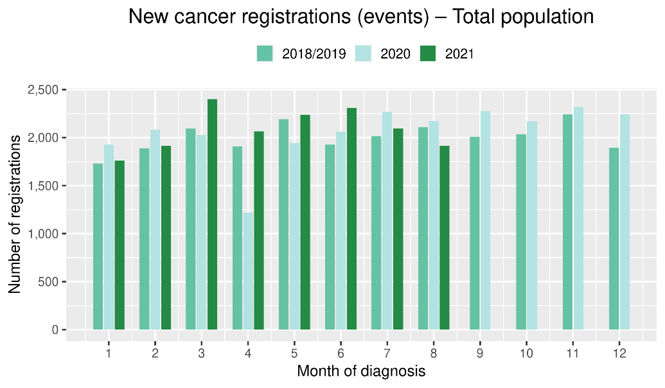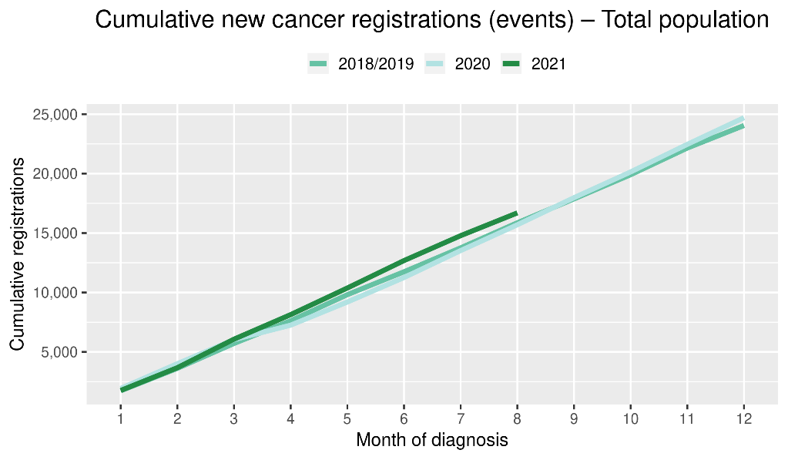
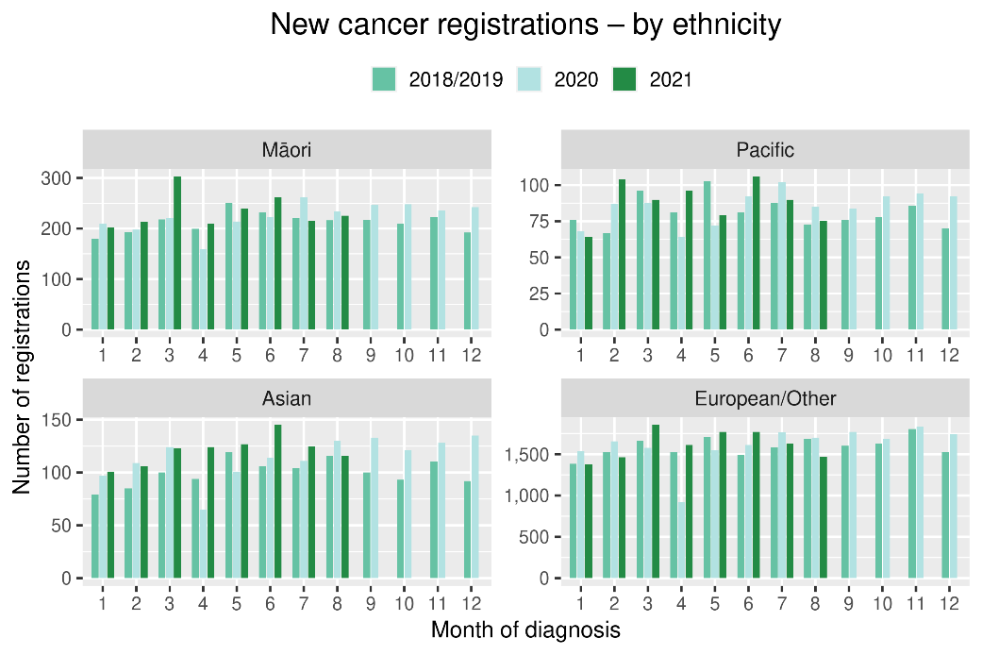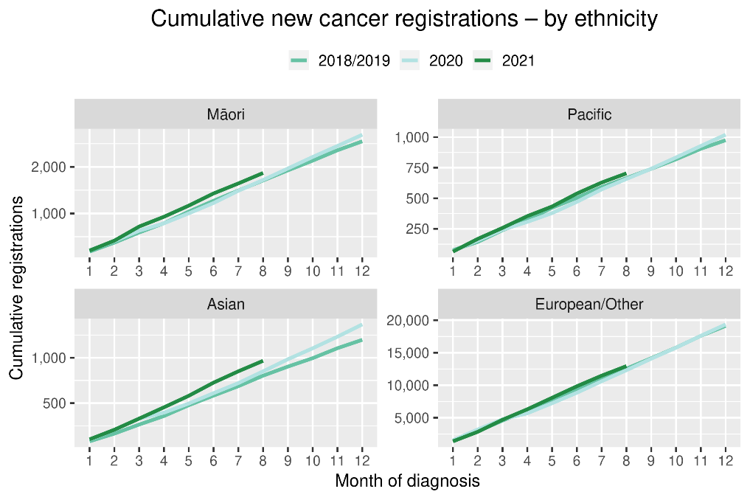
Table 2: Number of provisional cancer registrations and percentage change in 2021 compared to the 2018/19 average, by month and cumulative year to date, by tumour group
 | June |  |  | July |  |  | August |  |  | Cumulative January-August
Tumour group | 2018/19 | 2021 | % change | 2018/19 | 2021 | % change | 2018/19 | 2021 | % change | 2018/19 | 2021 | % change
Breast | 310 | 340 | 10% | 332 | 309 | -7% | 322 | 294 | -9% | 2,458 | 2,536 | 3%
Colorectal | 260 | 305 | 18% | 247 | 293 | 19% | 275 | 220 | -20% | 2,060 | 2,160 | 5%
Gynaecology | 81 | 82 | 2% | 94 | 96 | 2% | 92 | 95 | 3% | 704 | 716 | 2%
Haematology and Lymphoid | 194 | 228 | 18% | 212 | 205 | -3% | 197 | 208 | 6% | 1,631 | 1,630 | 0%
Melanoma and non-melanoma skin | 228 | 331 | 45% | 249 | 259 | 4% | 294 | 232 | -21% | 2,164 | 2,389 | 10%
Other digestive system | 110 | 140 | 27% | 136 | 135 | -1% | 127 | 135 | 7% | 972 | 1,075 | 11%
Prostate | 341 | 379 | 11% | 326 | 336 | 3% | 374 | 294 | -21% | 2,624 | 2,583 | -2%
Respiratory and thorax | 136 | 174 | 28% | 154 | 138 | -10% | 160 | 137 | -14% | 1,161 | 1,184 | 2%
Urinary system | 87 | 98 | 13% | 85 | 85 | 0% | 81 | 106 | 32% | 674 | 735 | 9%
*This analysis uses provisional data for the 2021 registrations, some cancers may initially be classified as ‘non-specified’ and subsequently be re-classified into one of the cancer groups as more information becomes available.
Figure 2: Number of cancer registrations by month, 2018/19 average, 2020 and 2021, by tumour group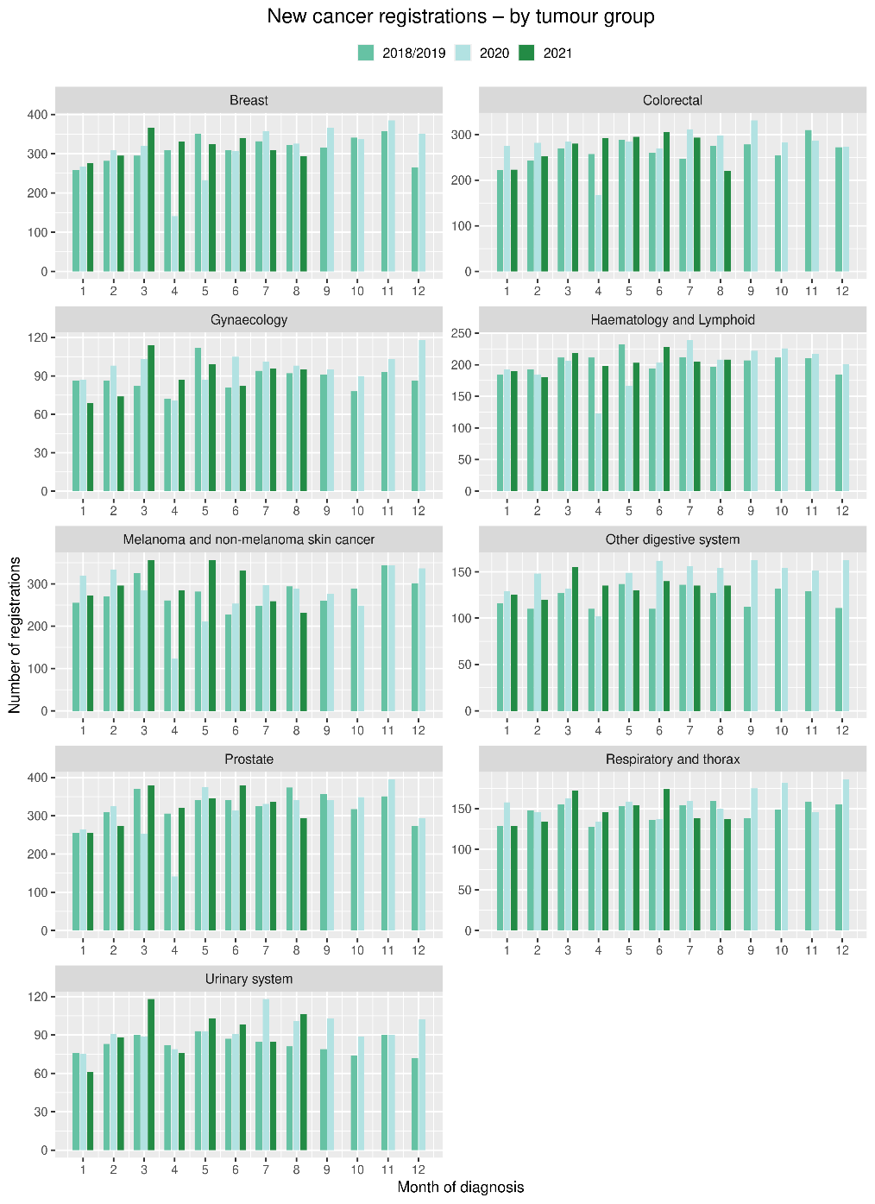 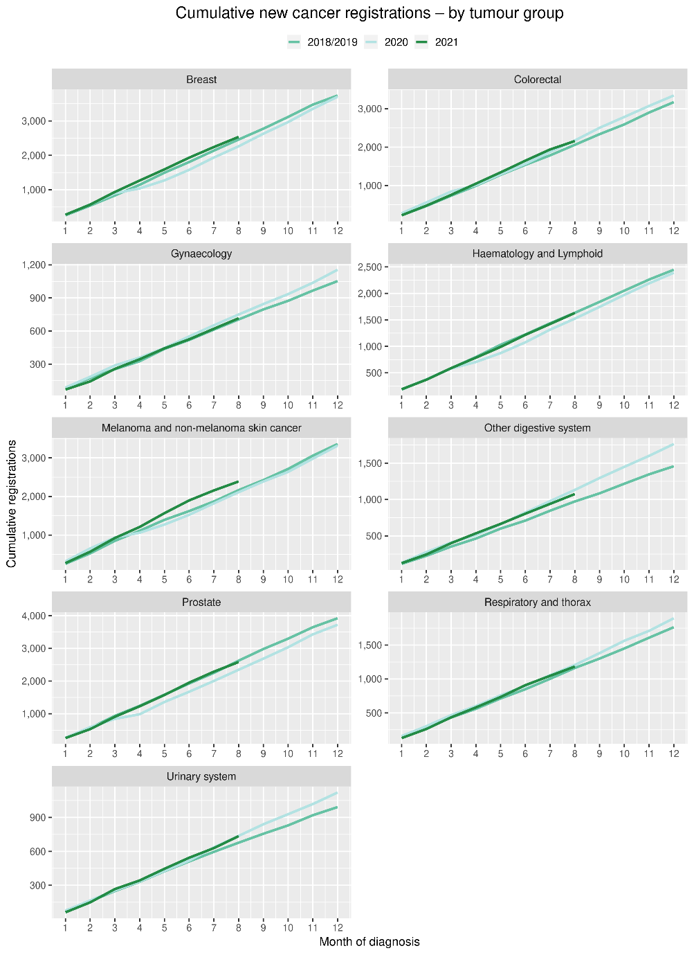

Gastrointestinal endoscopy

Notes on data
- Gastrointestinal endoscopy data were extracted from the National Non-Admitted Patient Collection (outpatient) and National Minimum Dataset (inpatient) on 24 September 2021.
- Includes colonoscopies and gastroscopies for all indications – not just cancer.
- Technical information: gastroscopies (Purchase Unit Code: MS02005), colonoscopies (Purchase Unit Code: MS02007), combined gastroscopies and colonoscopies (Purchase Unit Code: MS02014).

Key points
- There was a decrease in gastrointestinal endoscopies performed in August 2021, aligning with the COVID-19 lockdown.
- The decrease in endoscopies was seen across all ethnic groups but was smaller for Māori (26%) compared to non-Māori/non-Pacific (35%).
- Overall, for the year to date there has been an increase in the number of gastrointestinal endoscopies performed in 2021 compared to 2018/19.

Results
Table 3: Number of colonoscopy and gastroscopy procedures and percentage difference in 2021 compared to 2018/2019 average, by month (June, July, August) and cumulative year to date, by ethnicity
 | June |  |  | July |  |  | August |  |  | Cumulative January-August
 | 2018/19 | 2021 | % change | 2018/19 | 2021 | % change | 2018/19 | 2021 | % change | 2018/19 | 2021 | % change
Māori | 541 | 685 | 27% | 581 | 727 | 25% | 645 | 477 | -26% | 4,186 | 5,054 | 21%
Pacific peoples | 200 | 272 | 36% | 230 | 248 | 8% | 240 | 171 | -29% | 1,608 | 1,898 | 18%
Non-Māori/non-Pacific | 4,852 | 6,062 | 25% | 5,392 | 5,776 | 7% | 5,775 | 3,780 | -35% | 39,387 | 43,513 | 10%
Total population | 5,593 | 7,019 | 26% | 6,202 | 6,751 | 9% | 6,659 | 4,428 | -34% | 45,180 | 50,465 | 12%

Figure 3: Number of gastrointestinal endoscopy procedures by month, 2018/19 average, 2020 and 2021, total population and Māori
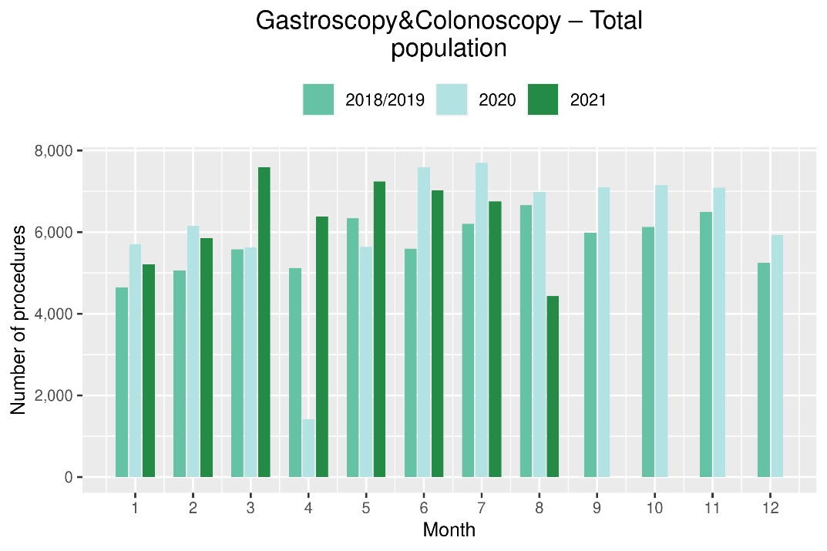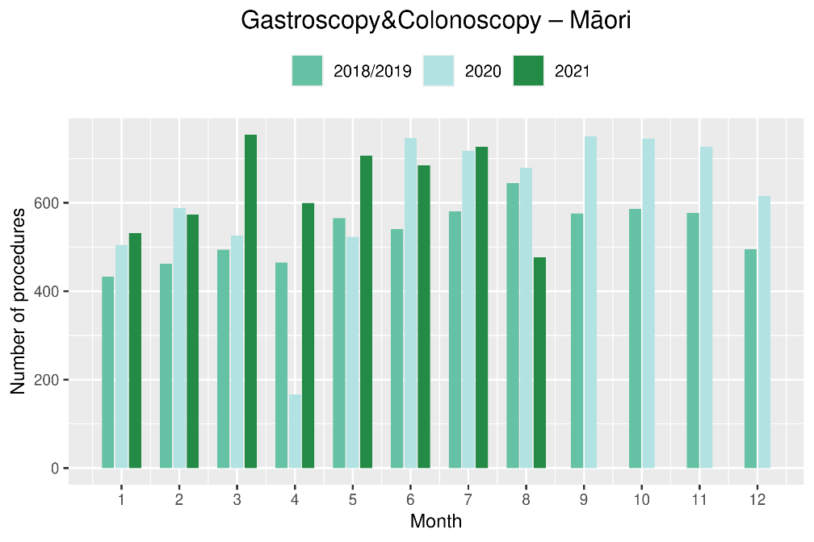
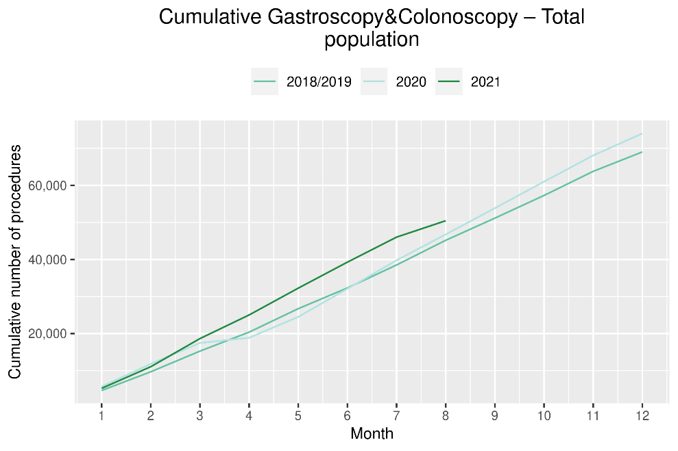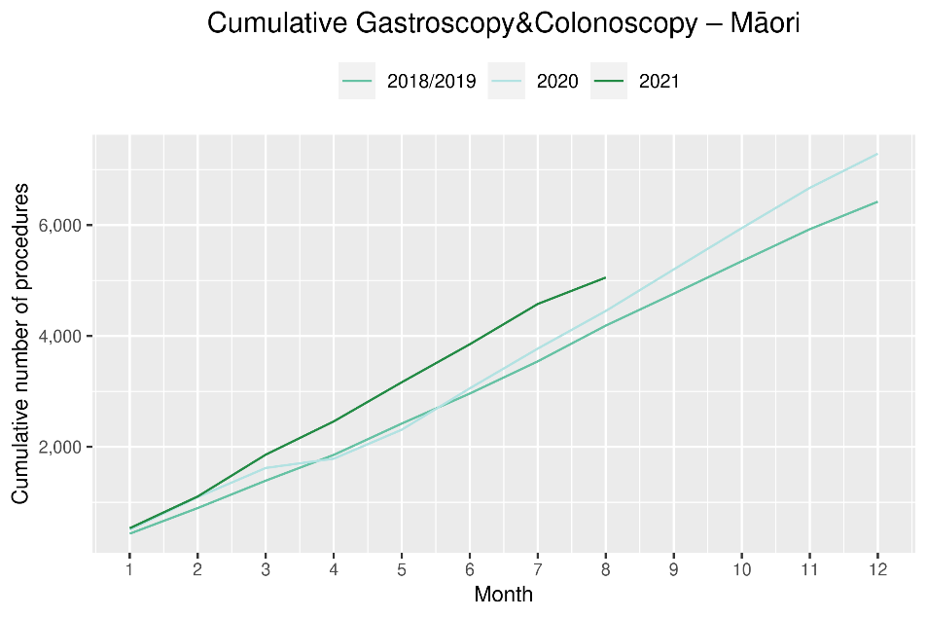

Bronchoscopy

Notes on data
- Bronchoscopy data were extracted from National Non-admitted Patient Collection (outpatient) and National Minimum Dataset (inpatient) on the 24 September 2021.
- Includes bronchoscopies for all indications – not just cancer
- Technical information: bronchoscopies (Purchase Unit Code - MS02003).

Key points
- There was a 44% decrease in the number of bronchoscopies performed in August 2021 compared to August 2018/19.
- Overall, there has been 5% fewer bronchoscopies performed for the year to date compared to same time period in 2018/19. This decrease was smaller for Māori (2%) and non-Māori/non-Pacific (4%), than for Pacific peoples (23%, noting given smaller numbers this represents 17 fewer bronchoscopies over eight months).

Results
Table 4: Number of bronchoscopies and percentage difference in 2021 compared to 2018/2019 average, by month (June, July, August) and cumulative year to date, by ethnicity
 | June |  |  | July |  |  | August |  |  | Cumulative January-August
 | 2018/19 | 2021 | % change | 2018/19 | 2021 | % change | 2018/19 | 2021 | % change | 2018/19 | 2021 | % change
Māori* | - | - | - | - | - | - | - | - | - | 257 | 252 | -2%
Pacific peoples* | - | - | - | - | - | - | - | - | - | 75 | 58 | -23%
Non-Māori/Non-Pacific | 135 | 155 | 15% | 155 | 139 | -10% | 154 | 95 | -38% | 1,214 | 1,160 | -4%
Total population | 173 | 199 | 15% | 197 | 171 | -13% | 208 | 117 | -44% | 1,546 | 1,470 | -5%
*Due to small numbers, monthly figures have not been included for Māori and Pacific Peoples

Figure 4: Number of bronchoscopies by month, 2018/19 average, 2020 and 2021, total population and Māori
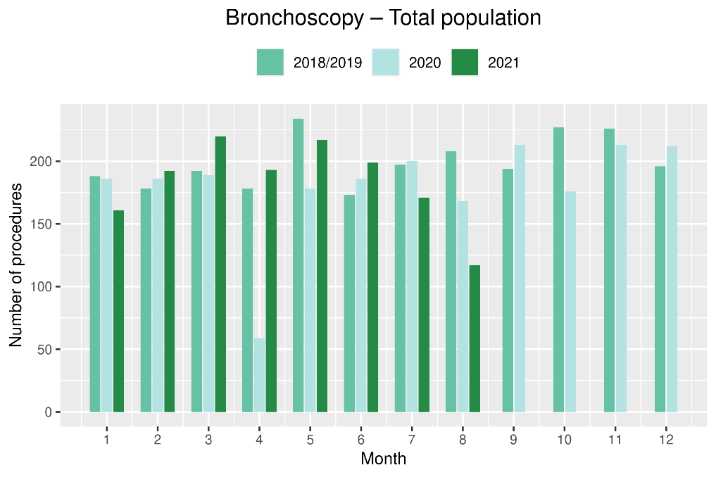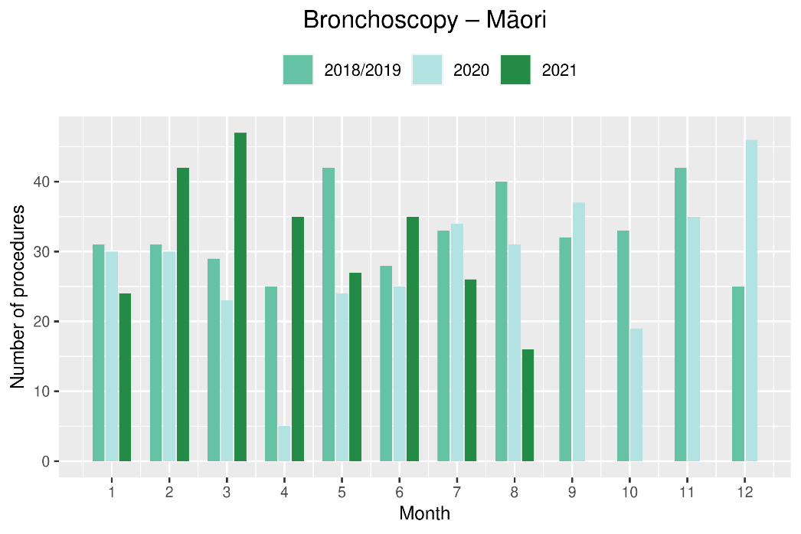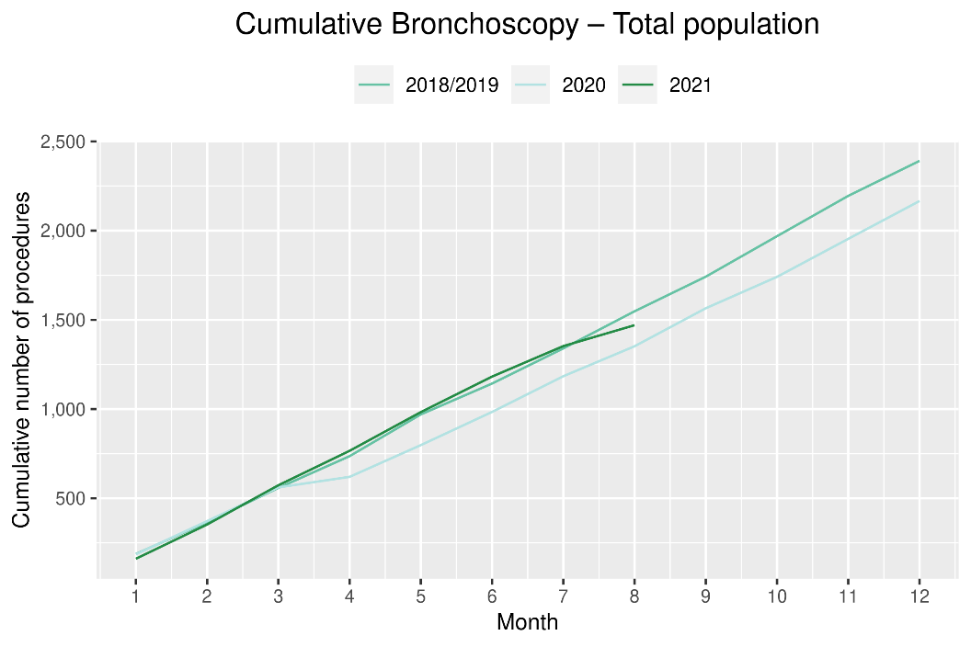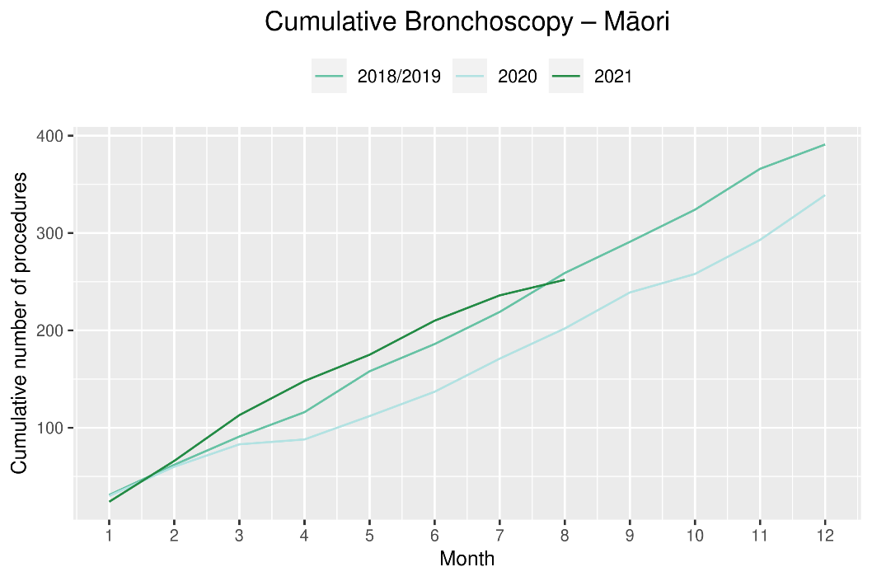

Combined curative cancer surgery

Notes on data
- This report includes data on curative surgery for colorectal, lung and prostate cancer. These cancers were chosen because Te Aho o Te Kahu already has a pre-validated list of surgical procedure codes for these cancers, agreed on as part of the quality performance indicator work programme. These three cancers are therefore used as case studies for cancer surgery more generally. The surgical procedure codes are listed in Appendix 4.
- The data were extracted from the National Minimum Dataset on 24 September 2021.

Key points
- There was a small (4%) decrease in the number of curative cancer surgeries (prostate, lung and colorectal) performed in August 2021 compared to August 2018/19. However, for the year to date there has been a 3% increase in these surgeries compared to the same time period in 2018/19.
- The increase in surgery for the year to date is most notable for Māori (32% increase) and Pacific people (40% increase, nothing that due to small numbers this represents 31 additional surgeries over eight months).

Results
Table 5: Number of curative cancer surgeries (prostate, colorectal, lung) and percentage difference in 2021 compared to 2018/2019 average by month (June, July, August) and cumulative year to date, by ethnicity
 | June |  |  | July |  |  | August |  |  | Cumulative January-August
 | 2018/19 | 2021 | % change | 2018/19 | 2021 | % change | 2018/19 | 2021 | % change | 2018/19 | 2021 | % change
Māori | 28 | 36 | 29% | 32 | 35 | 11% | 25 | 37 | 48% | 242 | 319 | 32%
Pacific peoples* | - | - | - | - | - | - | - | - | - | 78 | 109 | 40%
Non-Māori/Non-Pacific | 281 | 308 | 10% | 259 | 302 | 17% | 319 | 296 | -7% | 2,279 | 2,243 | -2%
Total population | 320 | 361 | 13% | 301 | 355 | 18% | 357 | 343 | -4% | 2,599 | 2,671 | 3%
*Due to small numbers, monthly figures have not been included for Pacific peoples

Figure 5: Number of curative cancer surgeries (prostate, colorectal, lung) by month, 2018/19 average, 2020 and 2021, total population and Māori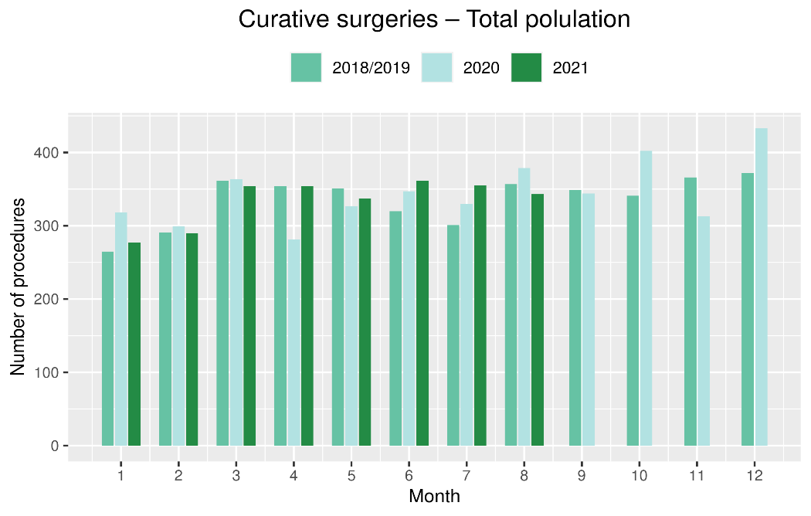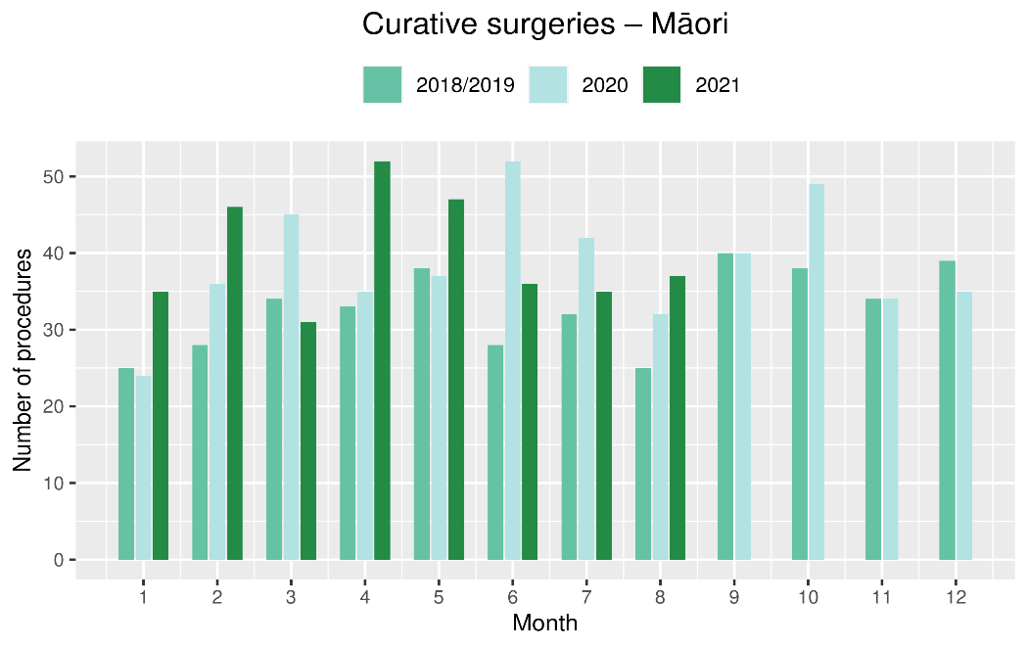
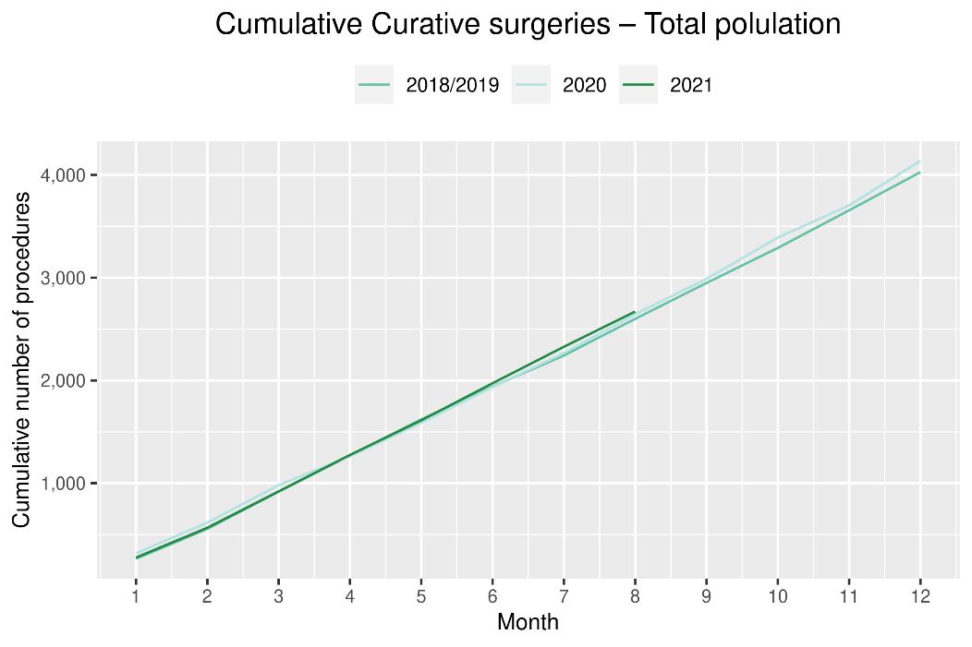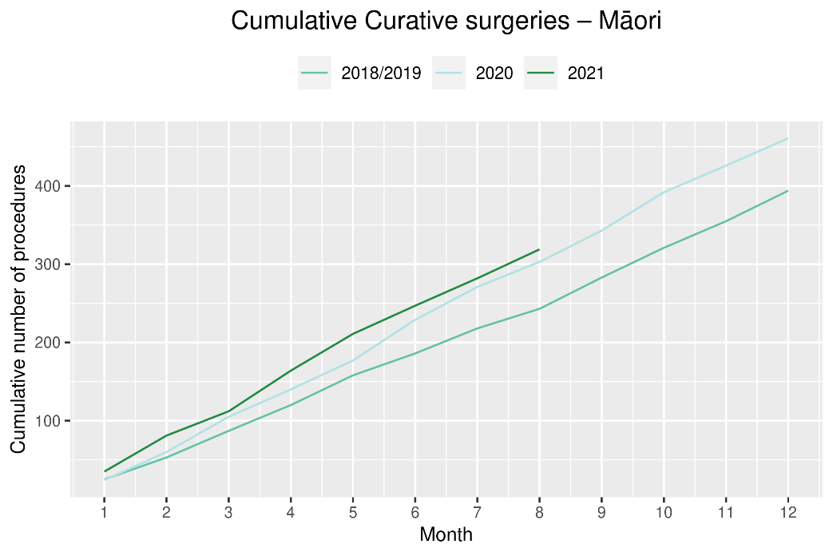

Colorectal cancer surgery

Notes on data
- The surgical procedure codes used for analysing colorectal cancer are listed in Appendix 4.
- The data were extracted from the National Minimum Dataset on 24 September 2021.

Key points
- There has been a similar number of curative colorectal cancer surgeries performed in 2021 as were performed in 2018/19, with the number of surgeries performed in August 2021 the same as August 2018/19.
- In general, people with colorectal cancer would expect to receive surgery within a month on colonoscopy, meaning a decrease in colorectal cancer surgeries may be seen in the coming months following the decrease in gastrointestinal endoscopies seen in August 2021 (see Figure 3)

Results
Table 6: Number of curative colorectal cancer surgeries and percentage difference in 2021 compared to 2018/2019 average, by month (June, July, August) and cumulative year to date, by ethnicity
 | June |  |  | July |  |  | August |  |  | Cumulative January-August
 | 2018/19 | 2021 | % change | 2018/19 | 2021 | % change | 2018/19 | 2021 | % change | 2018/19 | 2021 | % change
Māori* | - | - | - | - | - | - | - | - | - | 131 | 169 | 30%
Pacific peoples* | - | - | - | - | - | - | - | - | - | 48 | 62 | 31%
Non-Māori/Non-Pacific | 178 | 205 | 15% | 175 | 185 | 6% | 196 | 194 | -1% | 1,485 | 1,426 | -4%
Total population | 199 | 241 | 21% | 199 | 212 | 7% | 216 | 218 | 1% | 1,663 | 1,657 | 0%
*Due to small numbers, monthly figures have not been included for Pacific peoples
Figure 6: Number of curative colorectal cancer surgeries by month, 2018/19 average, 2020 and 2021, total population and Māori
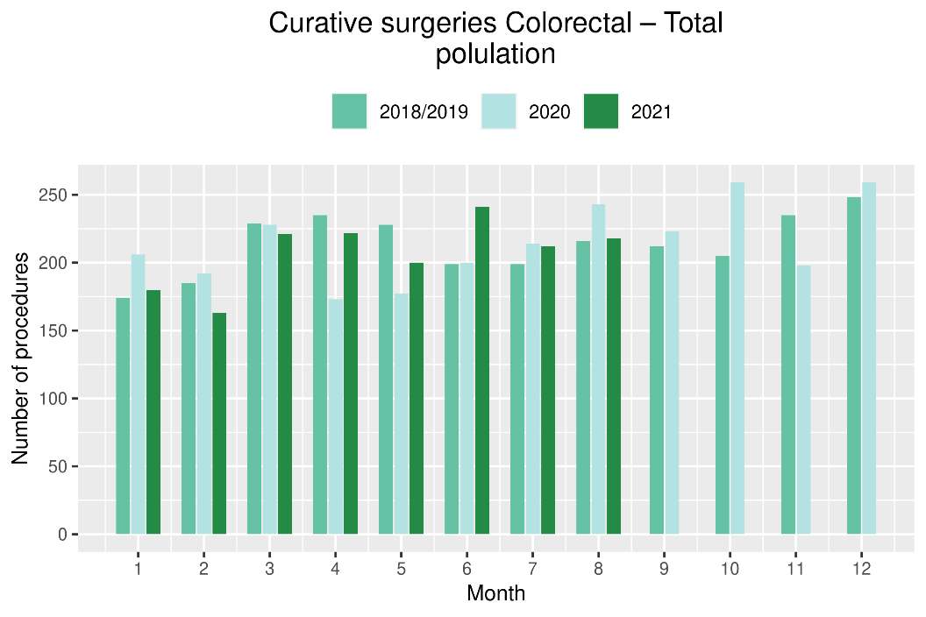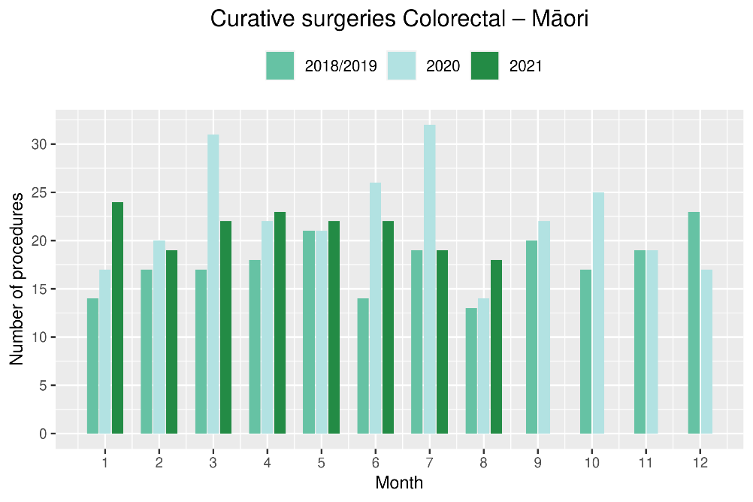
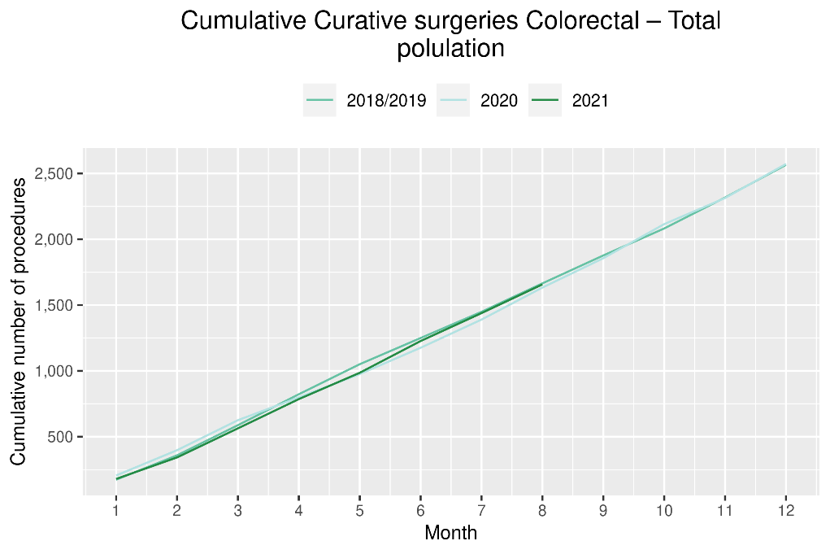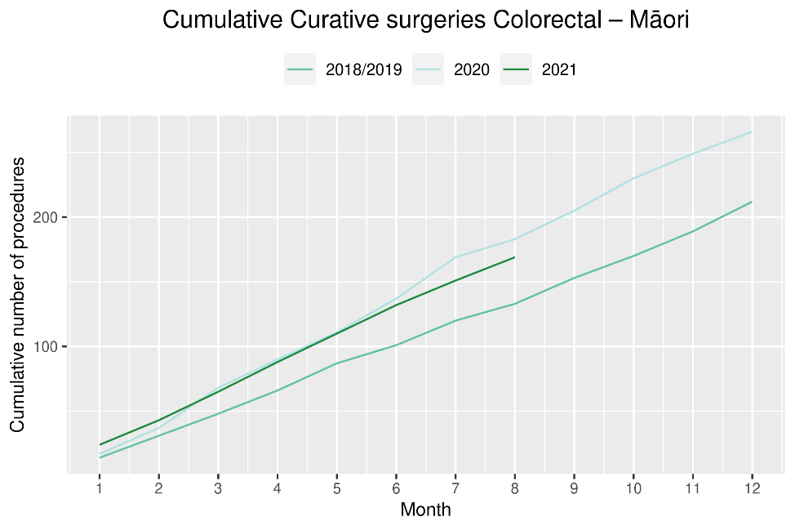

Lung cancer surgery

Notes on data
- A list of the surgical procedure codes used for analysis are included in Appendix 4.
- The data were extracted from the National Minimum Dataset on 24 September 2021.
- The number of lung cancer surgeries performed each month is relatively small, so caution is needed when comparing data by month.

Key points
- There was a decrease in curative lung cancer surgeries in August 2021 compared to August 2018/19 (13 fewer surgeries).
- Overall, for the year to date there has been a similar number of lung cancer surgeries performed in 2021 compared to 2018/19, and an increase in the number of surgeries for Māori (14%, 10 more surgeries).

Results
Table 7: Number of curative lung cancer surgeries and percentage difference in 2021 compared to 2018/2019 average, by month (June, July, August) and cumulative year to date, by ethnicity
 | June |  |  | July |  |  | August |  |  | Cumulative January-August
 | 2018/19 | 2021 | % change | 2018/19 | 2021 | % change | 2018/19 | 2021 | % change | 2018/19 | 2021 | % change
Māori* | - | - | - | - | - | - | - | - | - | 78 | 88 | 14%
Pacific peoples* | - | - | - | - | - | - | - | - | - | 20 | 23 | 18%
Non-Māori/Non-Pacific | 38 | 47 | 24% | 41 | 51 | 26% | 53 | 38 | -28% | 345 | 324 | -6%
Total population | 51 | 58 | 14% | 51 | 61 | 21% | 65 | 52 | -20% | 442 | 435 | -1%
* Due to small numbers, monthly figures have not been included for Māori and Pacific peoples

Figure 7: Number of curative lung cancer surgeries by month, 2018/19 average, 2020 and 2021, total population and Māori
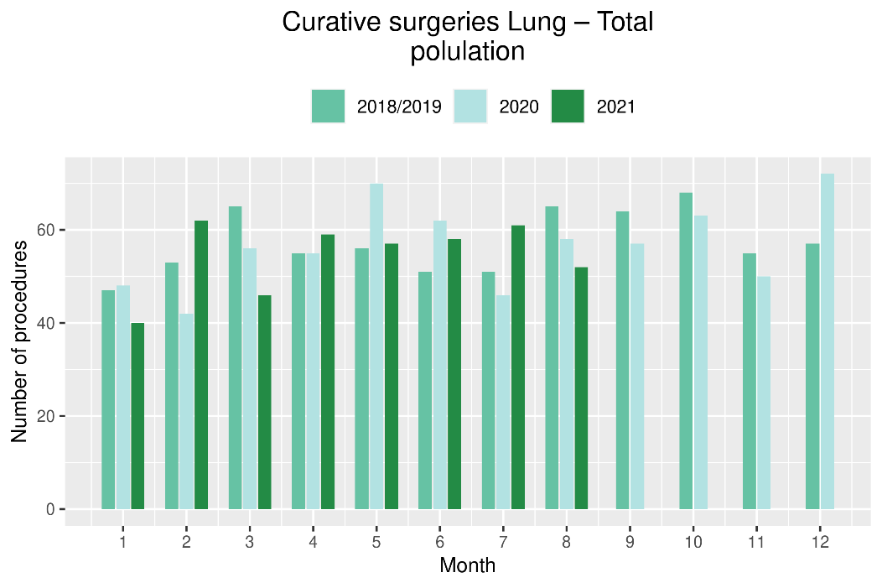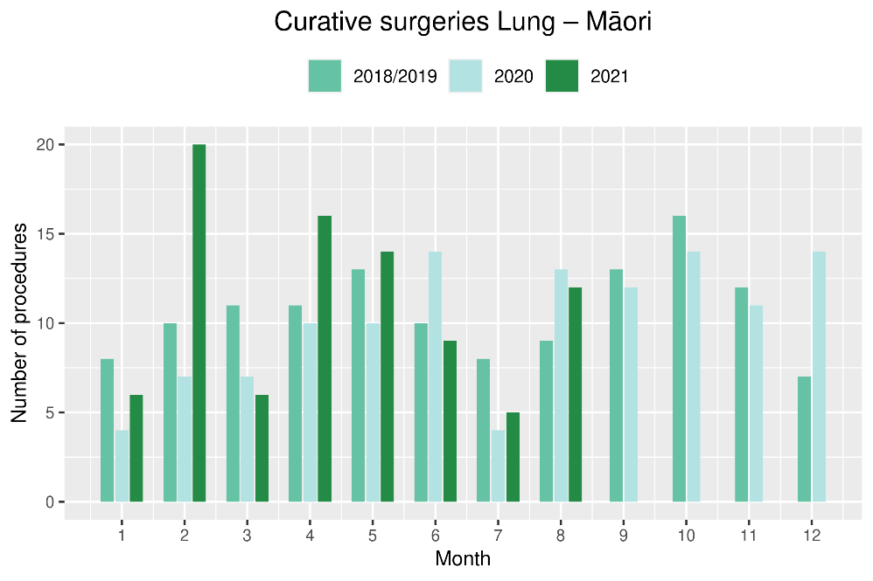
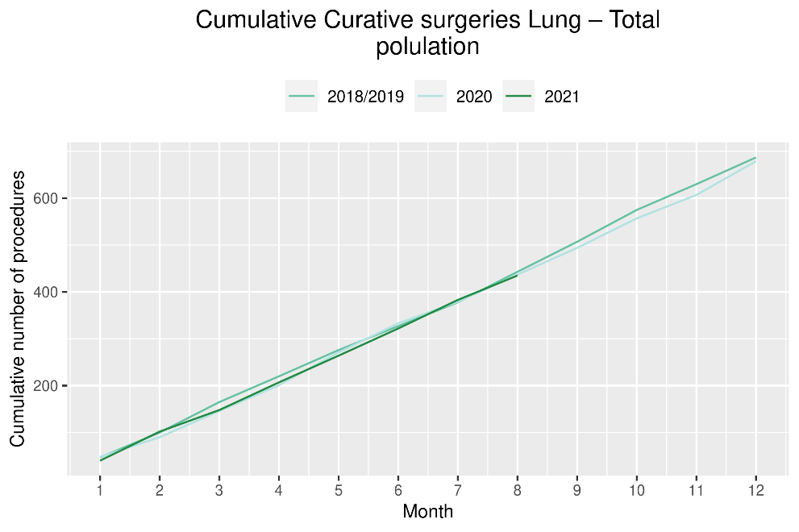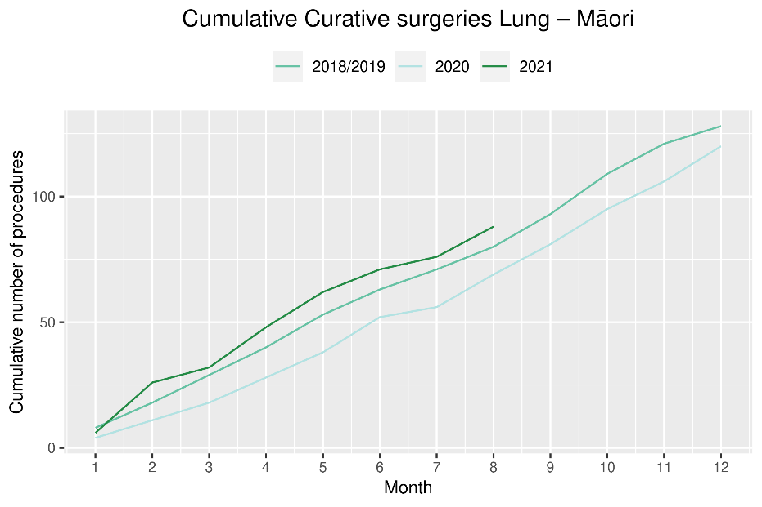

Prostate cancer surgery

Notes on data
- A list of the surgical procedure codes used for analysis are included in Appendix 4.
- The data was extracted from the National Minimum Dataset on 24 September 2021.
- The volumes for prostate surgery are higher in this report than previously reported due to the inclusion of data from a private provider (that provides public surgery).
- The number of curative prostate cancer surgeries performed each month is relatively small, so caution is needed when comparing data by month.

Key points
- There impact of COVID-19 and August lockdown is not seen for prostate surgery volumes, with a similar number of surgeries performed in August 2021 compared to August 2018/19 and for the year to date.

Results
Table 8: Number of curative prostate cancer surgeries and percentage difference in 2021 compared to 2018/2019 average by month (June, July, August) and cumulative year to date
 | June |  |  | July |  |  | August |  |  | Cumulative January-August
 | 2018/19 | 2021 | % change | 2018/19 | 2021 | % change | 2018/19 | 2021 | % change | 2018/19 | 2021 | % change
Total population* | 71 | 62 | -12% | 51 | 82 | 61% | 76 | 73 | -3% | 495 | 579 | 17%
*Due to the small number of surguries performed each month calculations have only been included for the total population
Figure 8: Number of curative prostate cancer surgeries by month, 2018/19 average, 2020 and 2021, total population and Māori
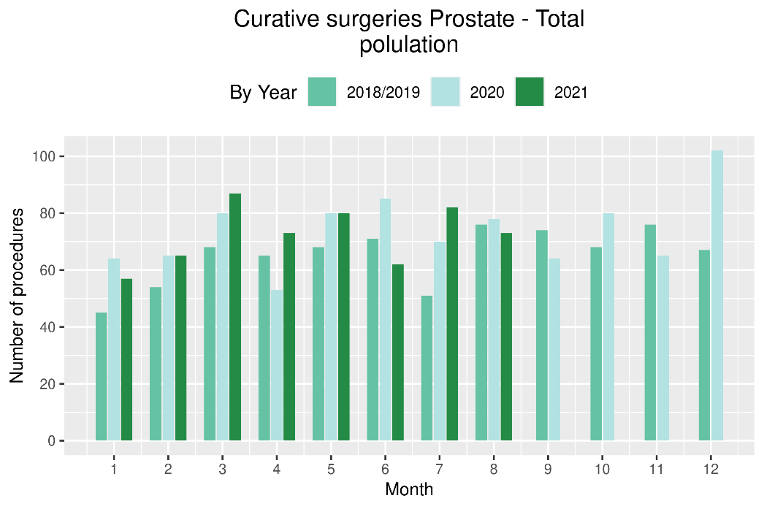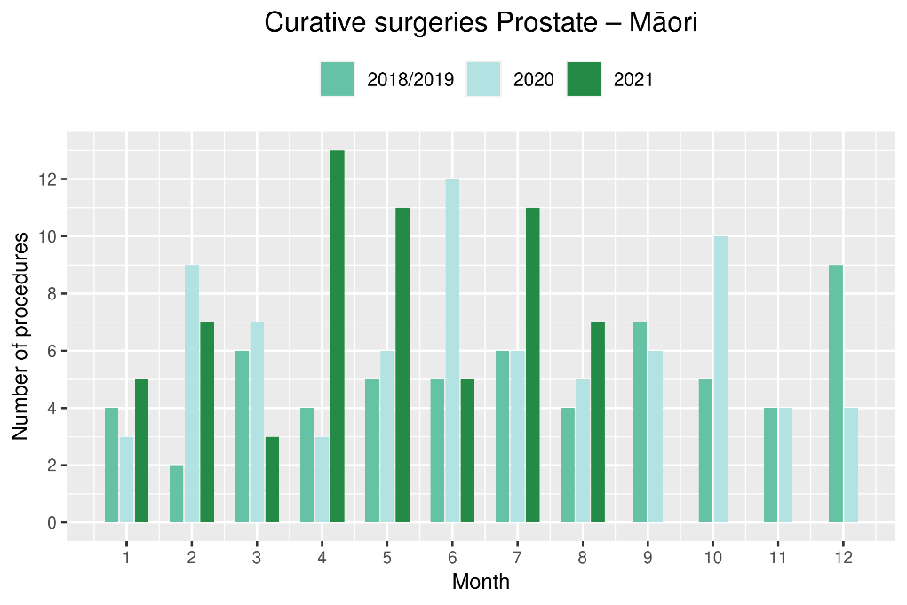
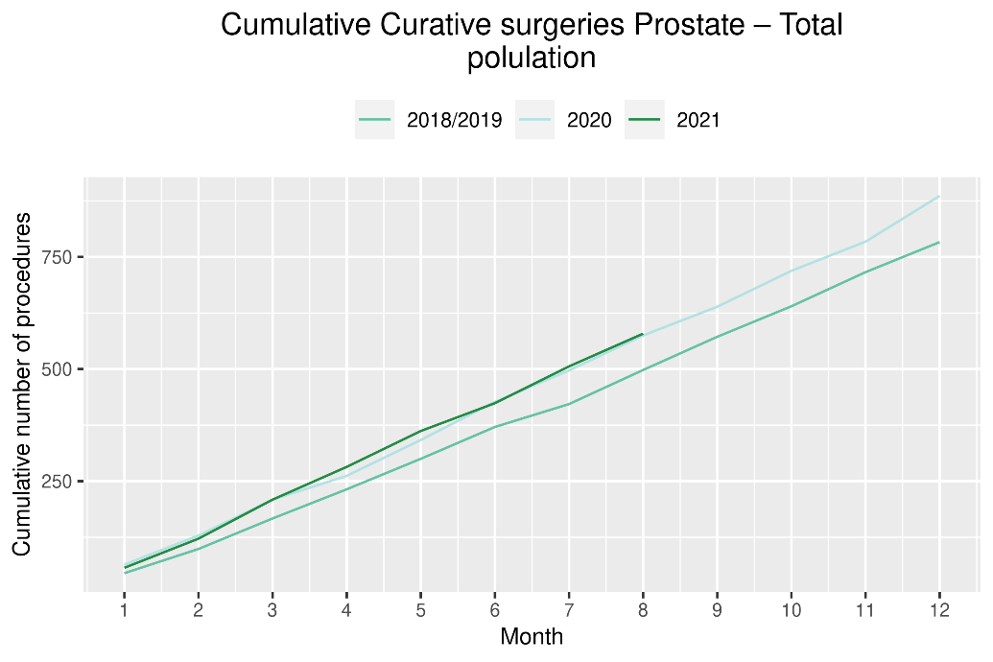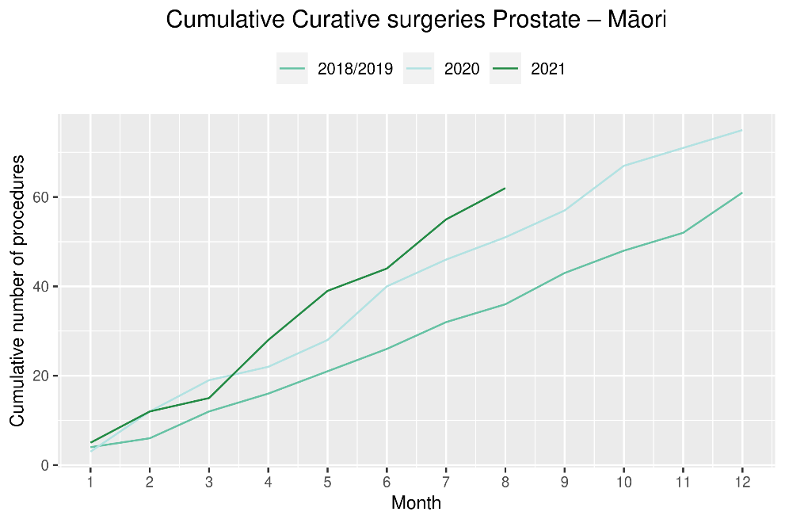

Medical oncology

Notes on data
- Extracted from National non-admitted patient collection (Outpatient collection) on 24 September 2021.
- First specialist assessment (FSA) reflects counts of first attendance for specialist medical oncology assessment.
- Intravenous (IV) chemotherapy reflects appointments for outpatient and inpatient IV chemotherapy for non-haematological indications.
- Technical information: medical oncology FSA (PUC M50020) and IV chemotherapy (PUC MS02009).

Key points
- Attendances for medical oncology FSAs remained stable during the August lockdown, with an increase in FSAs for both Māori and Pacific peoples in August 2021 compared to August 2018/19.
- Attendances for IV chemotherapy remained largely stable over August 2021. There has been an overall 8% increase in the number of attendances for the year to date in 2021 compared to the same time period in 2018/19, with a larger increase for Māori (28%) and Pacific peoples (32%) than for non-Māori/non-Pacific (3%).

Results
Table 9: Number of medical oncology first specialist assessments and percentage difference in 2021 compared to 2018/2019 average, by month (June, July, August) and cumulative year to date, by ethnicity
 | June |  |  | July |  |  | August |  |  | Cumulative January-August
 | 2018/19 | 2021 | % change | 2018/19 | 2021 | % change | 2018/19 | 2021 | % change | 2018/19 | 2021 | % change
Māori | 106 | 117 | 11% | 107 | 123 | 15% | 115 | 138 | 21% | 796 | 952 | 20%
Pacific peoples | 31 | 37 | 19% | 39 | 44 | 14% | 43 | 51 | 19% | 282 | 328 | 16%
Non-Māori/Non-Pacific | 510 | 622 | 22% | 586 | 594 | 1% | 631 | 624 | -1% | 4,494 | 4,760 | 6%
Total population | 646 | 776 | 20% | 731 | 761 | 4% | 788 | 813 | 3% | 5,572 | 6,040 | 8%
Figure 9: Number of medical oncology first specialist assessments by month, 2018/19 average, 2020 and 2021, total population and Māori
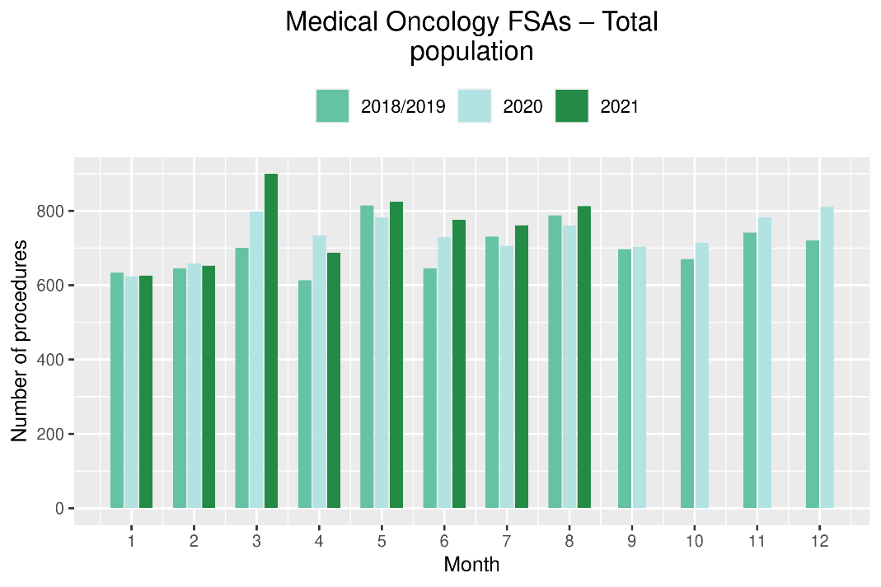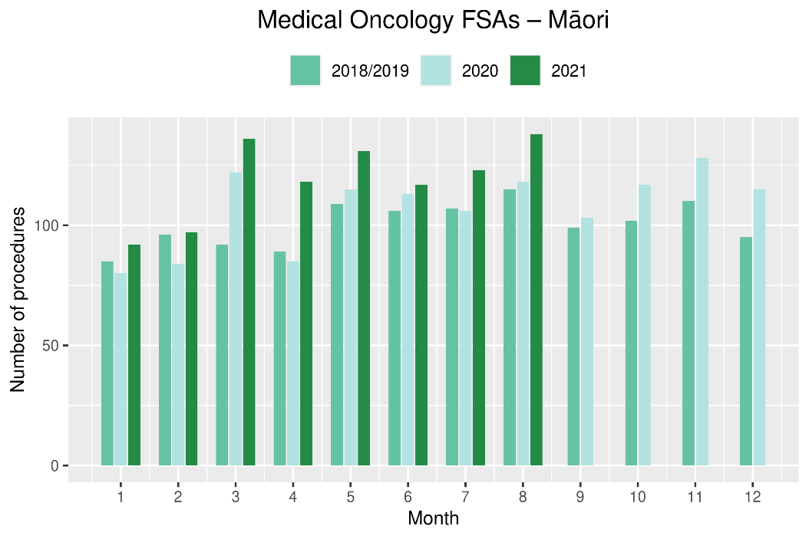
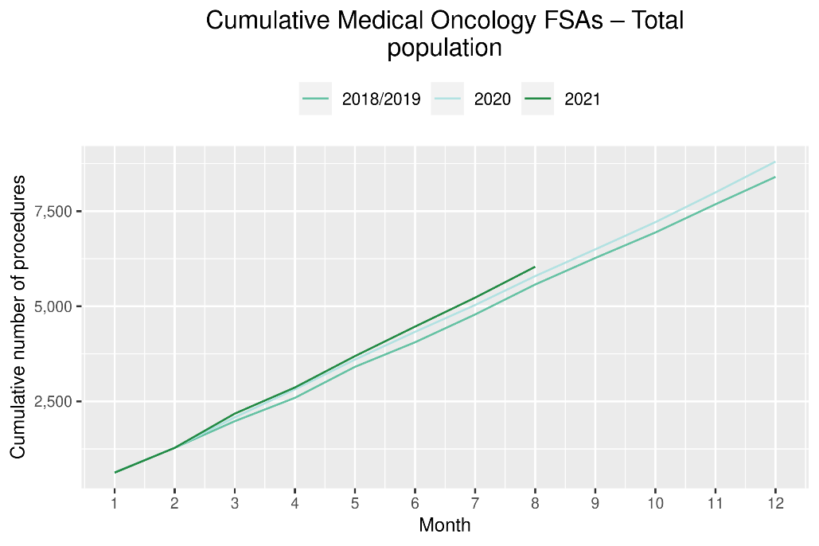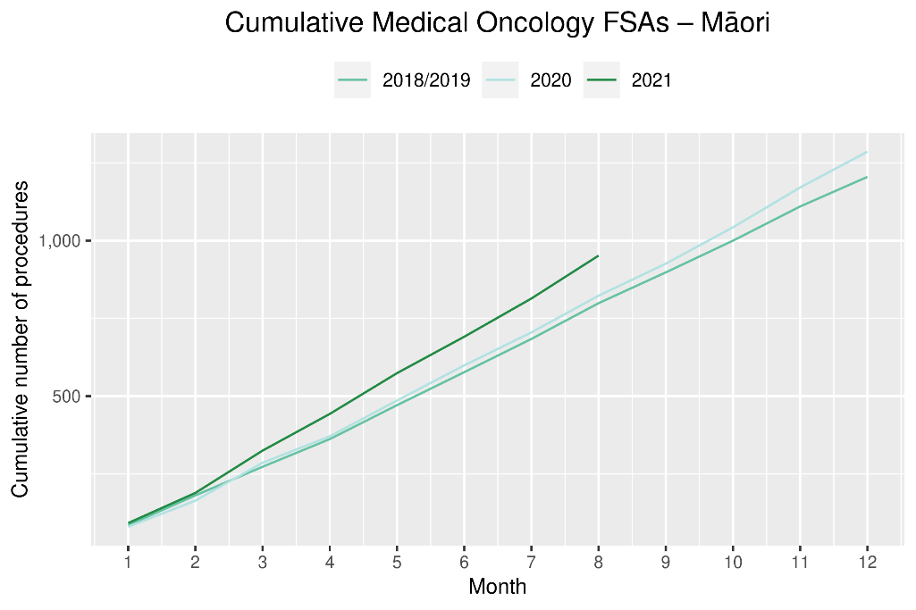
Table 10: Number of IV chemotherapy attendances and percentage difference in 2021 compared to 2018/2019 average, by month (June, July, August) and cumulative year to date, by ethnicity
 | June |  |  | July |  |  | August |  |  | Cumulative January-August
 | 2018/19 | 2021 | % change | 2018/19 | 2021 | % change | 2018/19 | 2021 | % change | 2018/19 | 2021 | % change
Māori | 648 | 897 | 38% | 784 | 920 | 17% | 805 | 847 | 5% | 5,611 | 7,181 | 28%
Pacific peoples | 248 | 381 | 54% | 266 | 379 | 42% | 251 | 370 | 47% | 2,095 | 2,764 | 32%
Non-Māori/Non-Pacific | 4,106 | 4,567 | 11% | 4,631 | 4,725 | 2% | 4,761 | 4,276 | -10% | 35,040 | 36,193 | 3%
Total population | 5,002 | 5,845 | 17% | 5,681 | 6,024 | 6% | 5,816 | 5,493 | -6% | 42,745 | 46,138 | 8%

Figure 10: Number of IV chemotherapy attendances by month, 2018/19 average, 2020 and 2021, total population and Māori
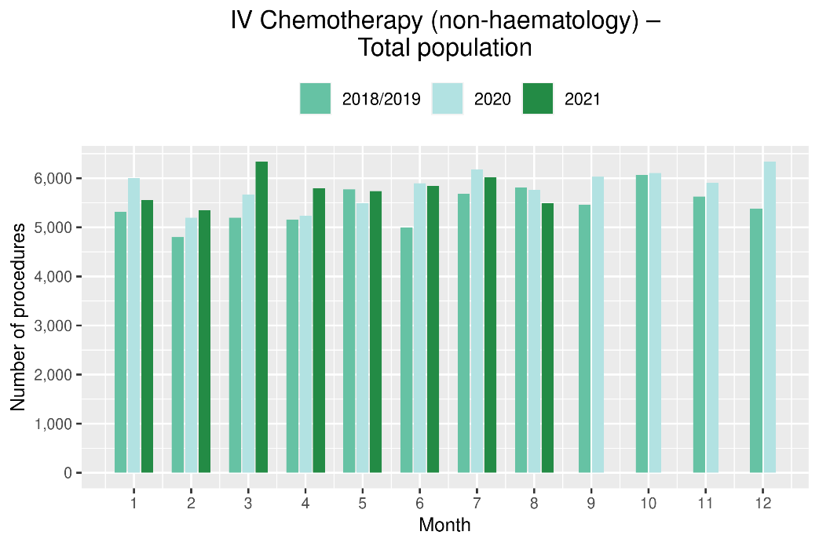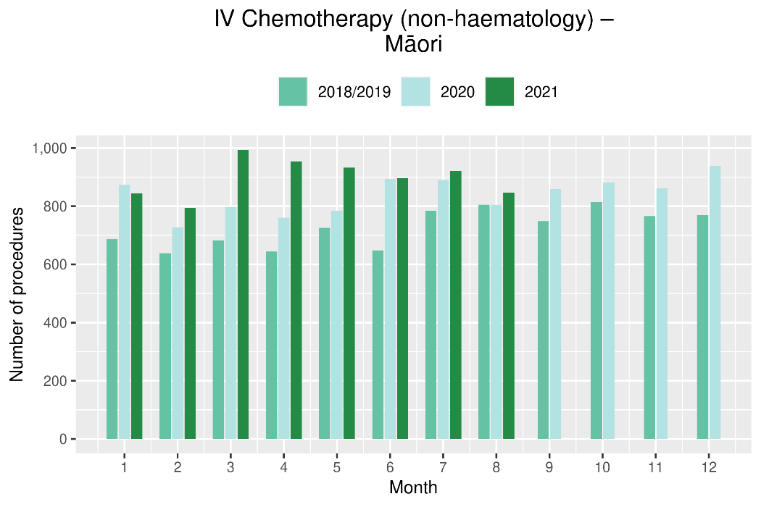

Figure 11: Cumulative number of attendances for IV chemotherapy, 2018/19 average, 2020 and 2021, total population and for Māori
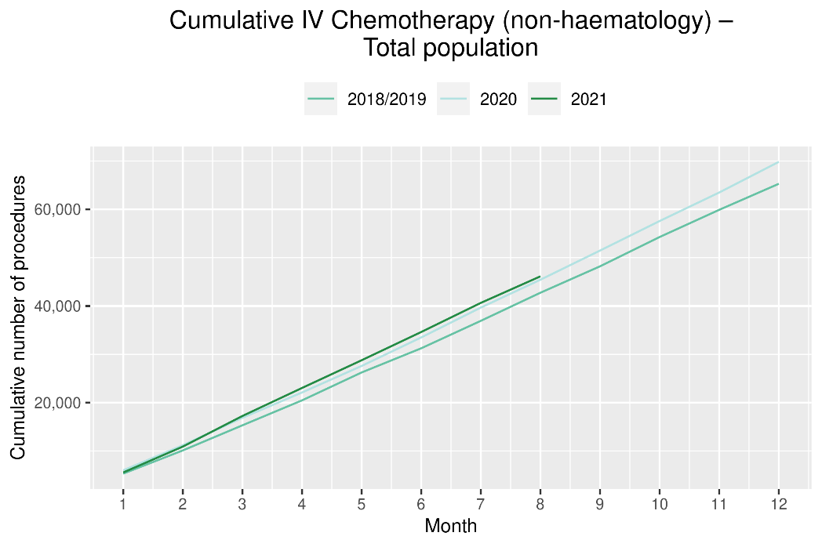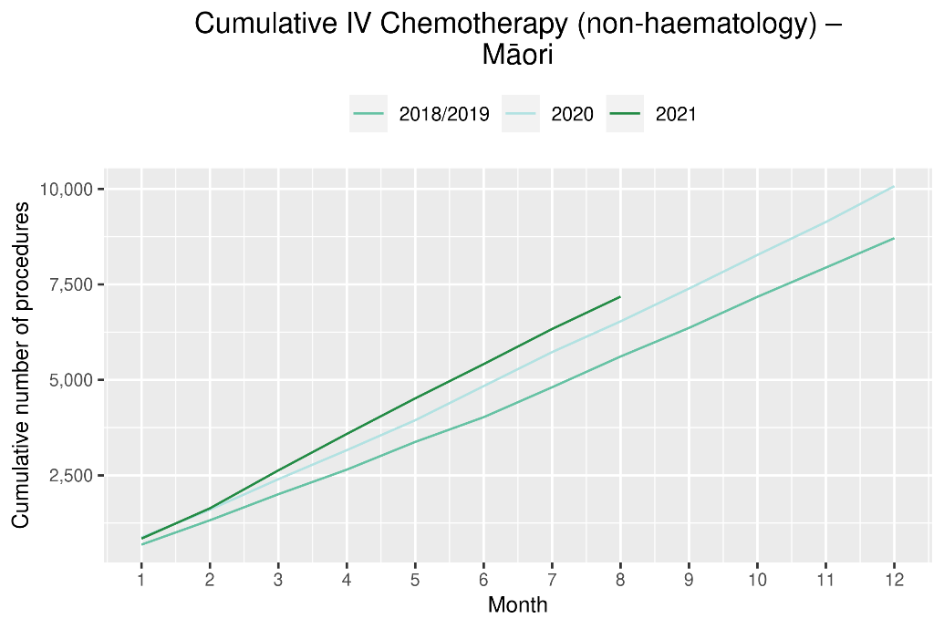

Radiation oncology

Notes on data
- Extracted from National Non-admitted patient collection on 24 September 2021.
- First specialist assessment (FSA) reflects counts of first attendance for radiation oncology specialist assessment.
- Megavoltage attendance reflects appointments for planning/simulation and for treatment with radiation therapy on a linear accelerator.
- Technical information: radiation oncology FSA (PUC M50022), megavoltage attendances (Purchase Unit Code M50025)

Key points
- Attendances for radiation oncology FSAs remained stable during the August lockdown, with an increase in FSAs for both Māori and Pacific peoples in August 2021 compared to August 2018/19.
- For the year to date there has been an increase in radiation oncology FSAs; however, there has been a decrease in attendances for radiotherapy in 2021 compared to 2018/19. The decrease in attendances for radiotherapy has been seen throughout the year and likely reflects increased utilisation of hypofractionation. The decrease in attendances in 2021 is less notable for Māori, which may reflect stage at diagnosis, with hypofractionation more likely to be utilised for early-stage cancer.

Results
Table 11: Number of radiation oncology first specialist assessments and percentage difference in 2021 compared to 2018/2019 average, by month (June, July, August) and cumulative year to date, by ethnicity
 | June |  |  | July |  |  | August |  |  | Cumulative January-August
 | 2018/19 | 2021 | % change | 2018/19 | 2021 | % change | 2018/19 | 2021 | % change | 2018/19 | 2021 | % change
Māori | 111 | 131 | 18% | 117 | 122 | 4% | 138 | 153 | 11% | 901 | 1,076 | 19%
Pacific peoples | 51 | 49 | -4% | 48 | 42 | -12% | 50 | 55 | 11% | 362 | 387 | 7%
Non-Māori/Non-Pacific | 702 | 818 | 17% | 812 | 835 | 3% | 795 | 797 | 0% | 6,027 | 6,407 | 6%
Total population | 864 | 998 | 16% | 976 | 999 | 2% | 982 | 1,005 | 2% | 7,289 | 7,870 | 8%
Figure 12 Number of radiation oncology first specialist assessments by month, 2018/19 average, 2020 and 2021, total population and Māori
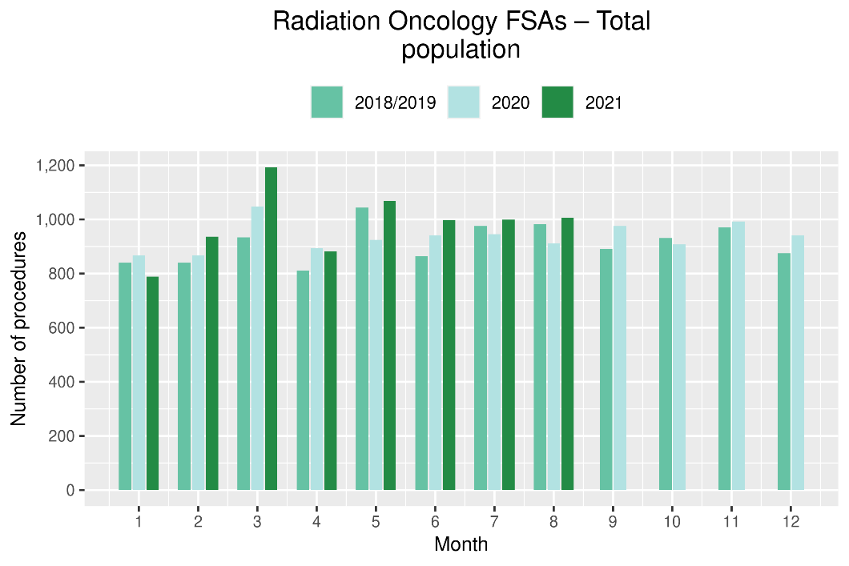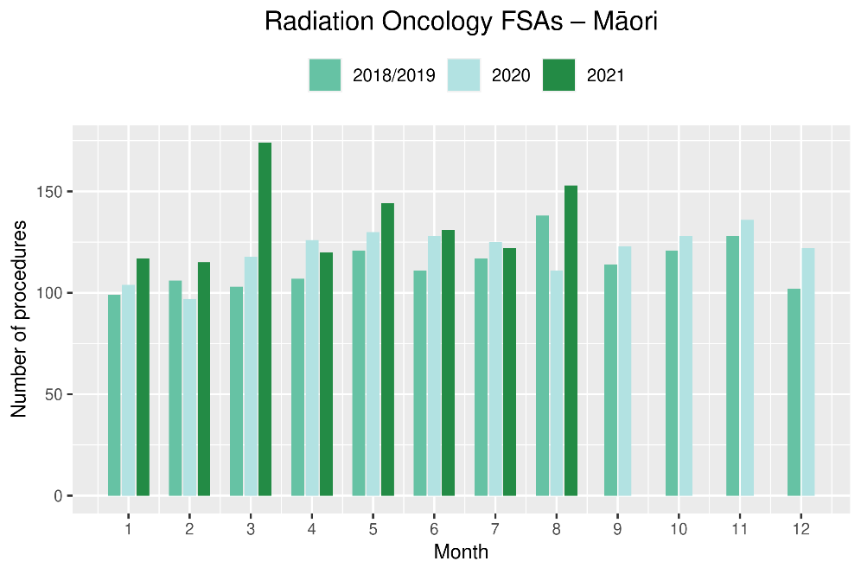
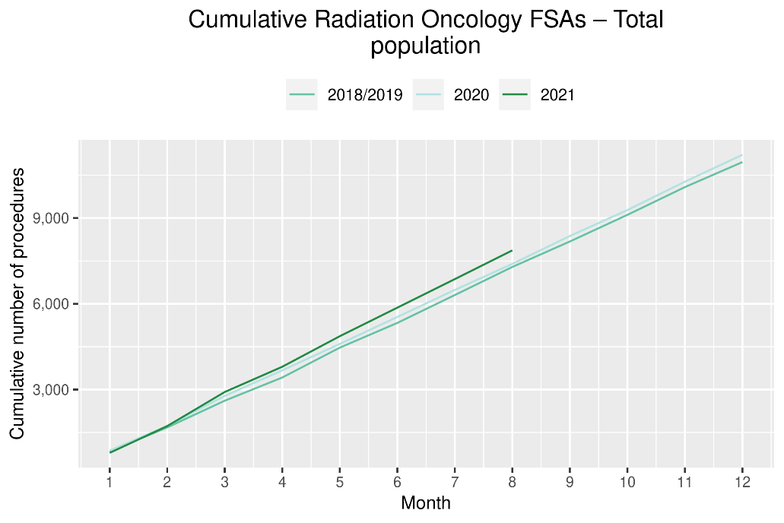 | 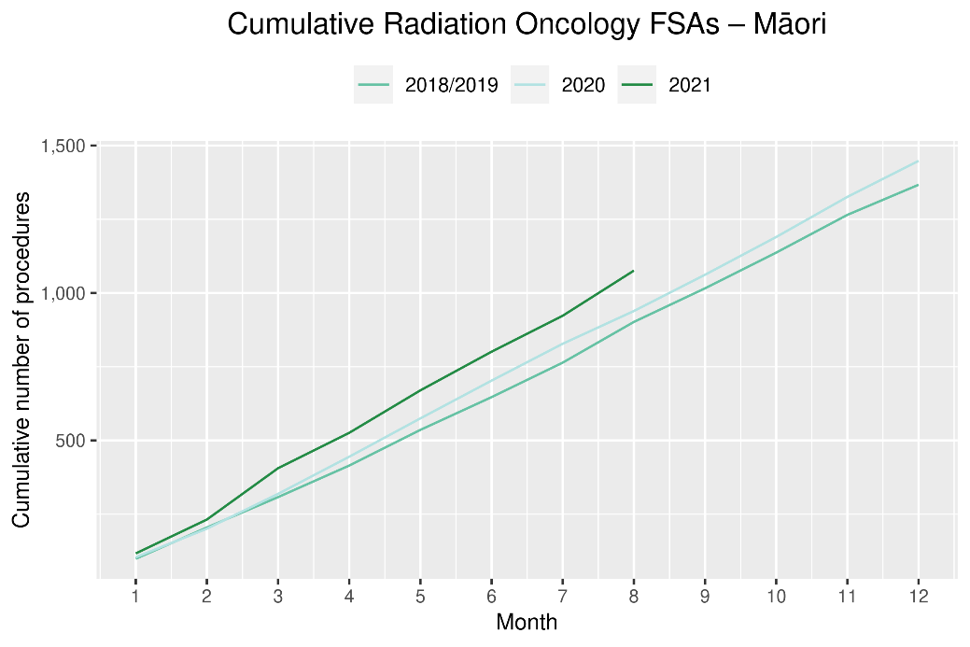
Table 12: Number of radiation oncology attendances and percentage difference in 2021 compared to 2018/2019 average, by month (June, July, August) and cumulative year to date, by ethnicity
 | June |  |  | July |  |  | August |  |  | Cumulative January-August
 | 2018/19 | 2021 | % change | 2018/19 | 2021 | % change | 2018/19 | 2021 | % change | 2018/19 | 2021 | % change
Māori | 1,649 | 1,649 | 0% | 1,924 | 1,719 | -11% | 1,869 | 1,807 | -3% | 13,640 | 13,806 | 1%
Pacific peoples | 554 | 491 | -11% | 754 | 440 | -42% | 551 | 456 | -17% | 4,561 | 4,201 | -8%
Non-Māori/Non-Pacific | 10,162 | 9,395 | -8% | 10,729 | 9,740 | -9% | 10,488 | 9,436 | -10% | 83,918 | 76,847 | -8%
Total population | 12,365 | 11,535 | -7% | 13,407 | 11,899 | -11% | 12,907 | 11,699 | -9% | 102,119 | 94,854 | -7%

Figure 13: Number of radiation therapy attendances by month, 2018/19 average, 2020 and 2021, total population and for Māori
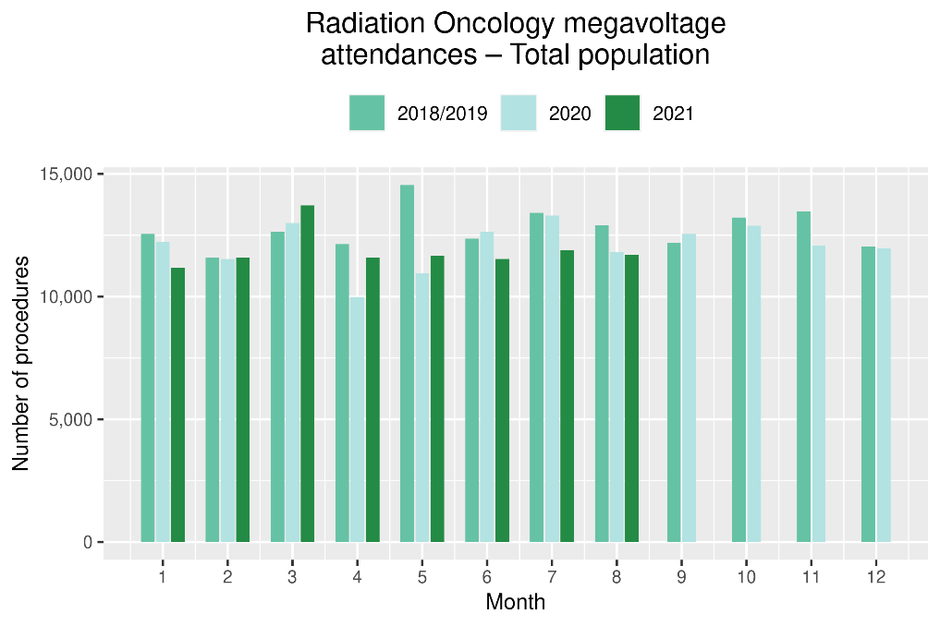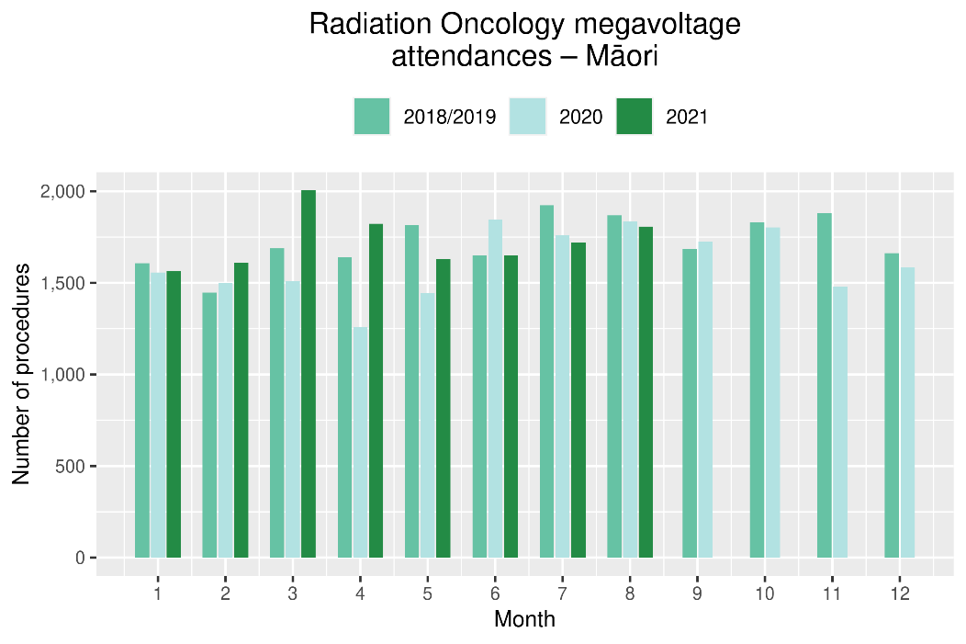

Figure 14: Cumulative number of attendances for radiation therapy, 2018/19 average, 2020 and 2021, total population and for Māori
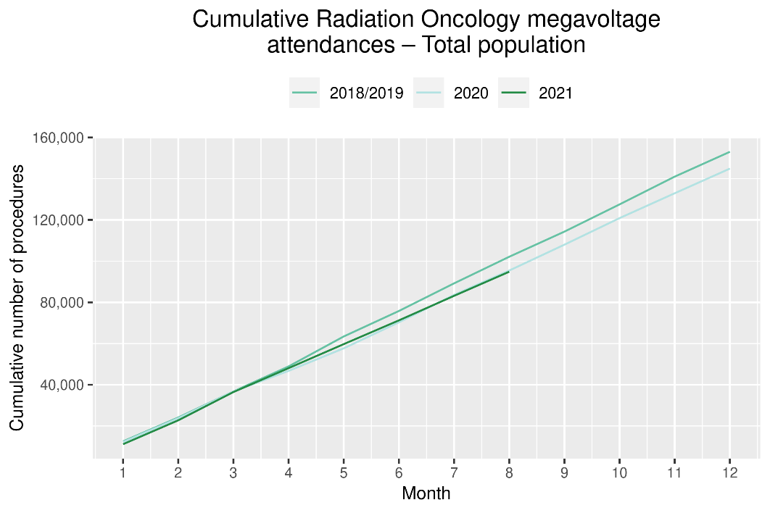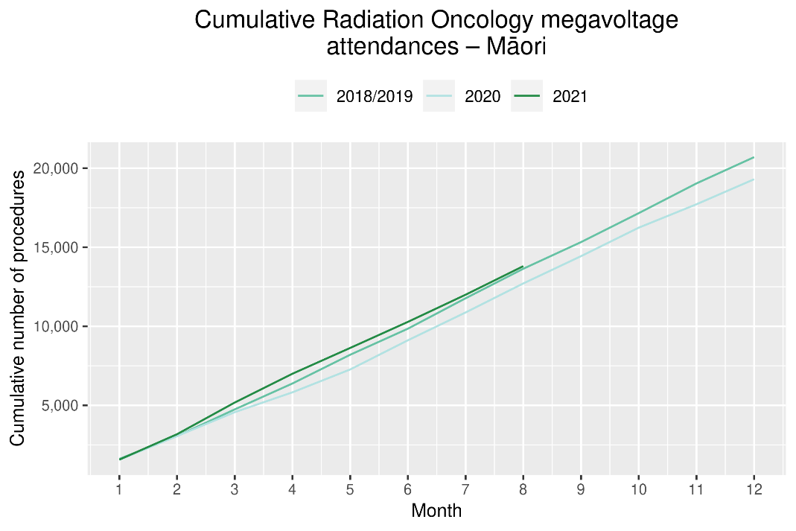

Haematology

Notes on data
- Data extracted from National Non-admitted Patient Collection (outpatient) and National Minimum Dataset (inpatient) on 24 September 2021.
- First specialist assessment (FSA) reflects counts of first attendance for specialist haematology assessment for any indication, not just cancer.
- IV chemotherapy reflects appointments for IV chemotherapy for haematological malignancies.
- Technical information: Haematology FSA (Purchase Unite Code: M30002), IV haem/chemo (Purchase Unit Code: M30020).

Key points
- Attendances for haematology FSAs remained relatively stable during the August lockdown.
- Attendances for IV chemotherapy remained largely stable over August 2021, with an overall 5% increase in the number of attendances for the year to date compared to the same time period in 2018/19.
- For the year to date there has been an increase in haematology FSAs for Māori, but an overall decrease in attendances for IV chemotherapy. This does not appear to be related to the 2021 COVID outbreak, and worth noting that haematology FSAs include non-cancer indications.

Results
Table 13: Number of haematology first specialist assessment attendances and percentage difference in 2021 compared to 2018/2019 average, by month (June, July, August) and cumulative year to date, by ethnicity
 | June |  |  | July |  |  | August |  |  | Cumulative January-August
 | 2018/19 | 2021 | % change | 2018/19 | 2021 | % change | 2018/19 | 2021 | % change | 2018/19 | 2021 | % change
Māori | 61 | 59 | -2% | 53 | 77 | 45% | 50 | 72 | 45% | 424 | 498 | 17%
Pacific peoples | 28 | 34 | 21% | 25 | 23 | -8% | 29 | 20 | -31% | 211 | 220 | 4%
Non-Māori/Non-Pacific | 384 | 468 | 22% | 428 | 418 | -2% | 483 | 441 | -9% | 3,505 | 3,307 | -6%
Total population | 473 | 561 | 19% | 506 | 518 | 2% | 561 | 533 | -5% | 4,140 | 4,025 | -3%

Figure 15: Number of haematology first specialist assessments by month, 2018/19 average, 2020 and 2021, total population and Māori
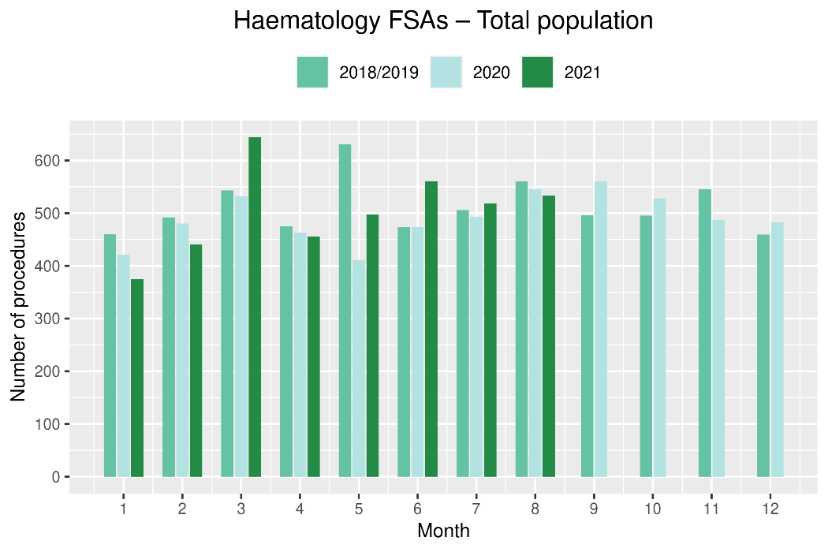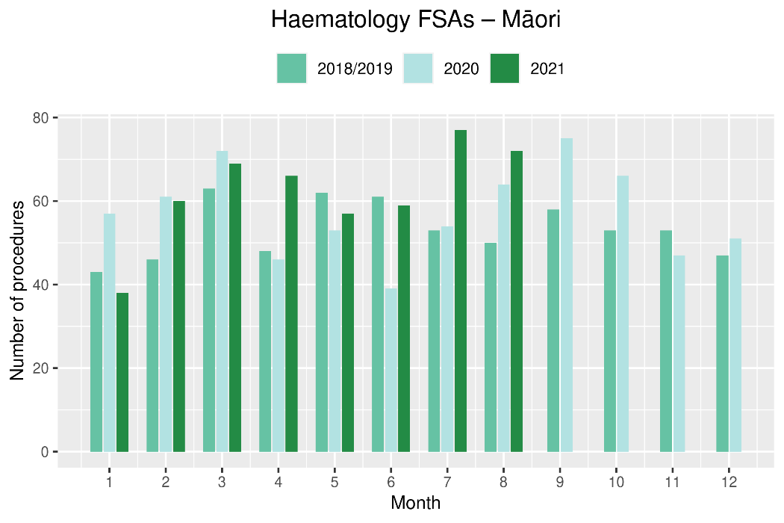
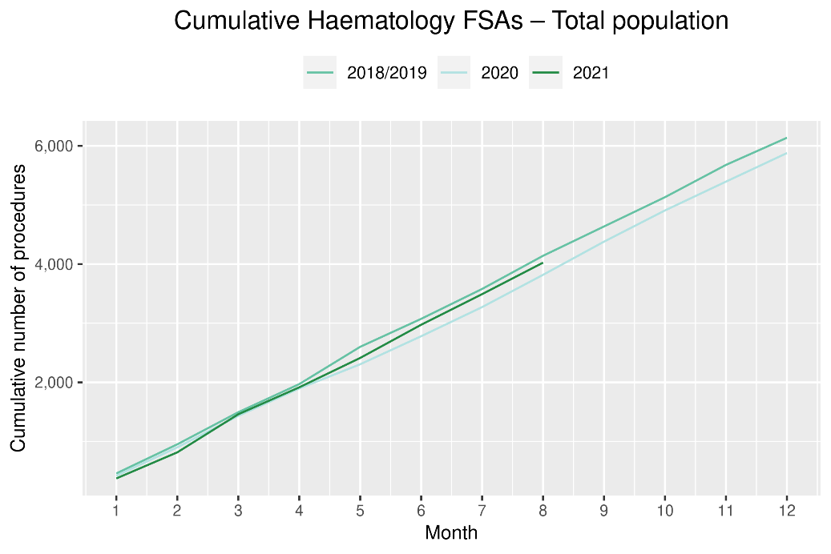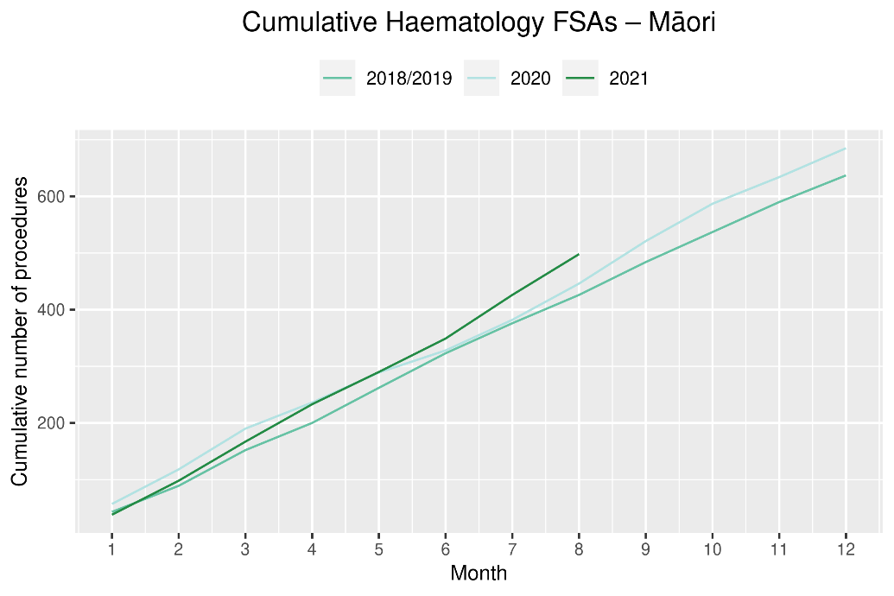
Table 14: Number of IV chemotherapy attendances for haematological malignancies and percentage difference in 2021 compared to 2018/2019 average, by month (June, July, August) and cumulative year to date, by ethnicity
 | June |  |  | July |  |  | August |  |  | Cumulative January-August
 | 2018/19 | 2021 | % change | 2018/19 | 2021 | % change | 2018/19 | 2021 | % change | 2018/19 | 2021 | % change
Māori | 184 | 172 | -6% | 229 | 191 | -17% | 225 | 194 | -14% | 1,592 | 1,543 | -3%
Pacific peoples | 92 | 140 | 53% | 114 | 142 | 25% | 112 | 146 | 30% | 804 | 1,092 | 36%
Non-Māori/Non-Pacific | 1,587 | 1,781 | 12% | 1,858 | 1,782 | -4% | 1,864 | 1721 | -8% | 13,342 | 13,918 | 4%
Total population | 1,862 | 2,093 | 12% | 2,200 | 2,115 | -4% | 2,201 | 2061 | -6% | 15,738 | 16,553 | 5%
Figure 16: Number of attendances for IV chemotherapy for haematological malignancies by month, 2018/19 average, 2020 and 2021, total population and Māori
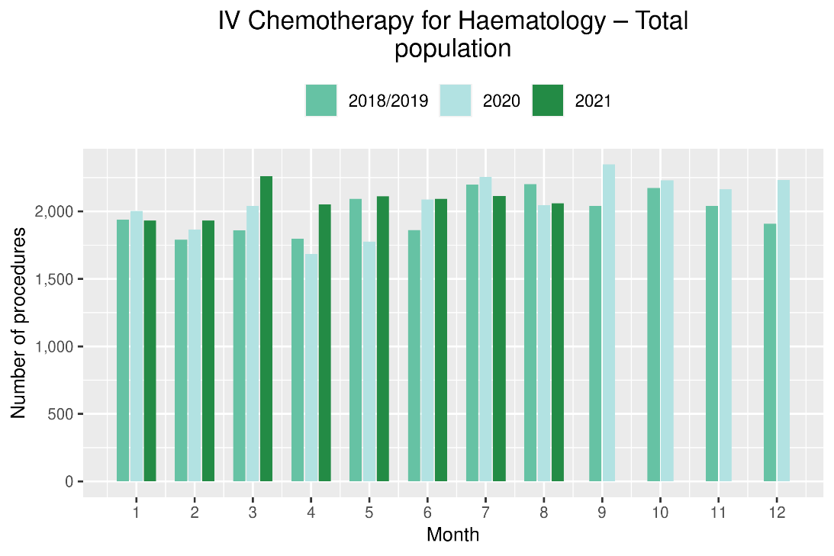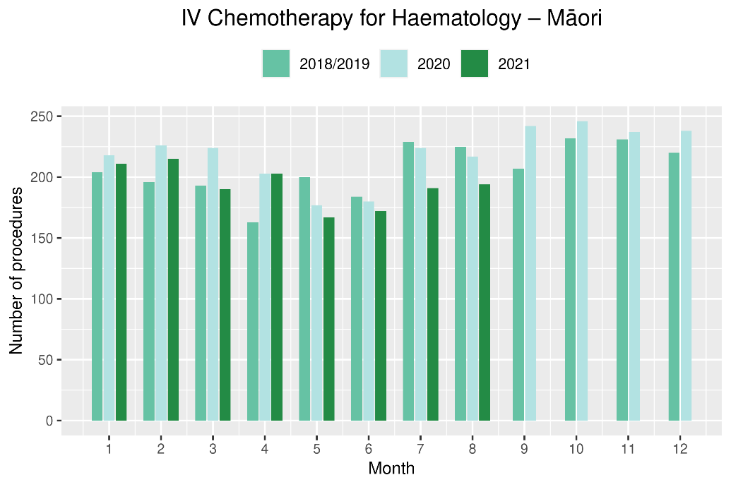

Figure 17: Cumulative number of attendances for IV chemotherapy for haematological malignancies, 2018/19 average, 2020 and 2021, total population and for Māori
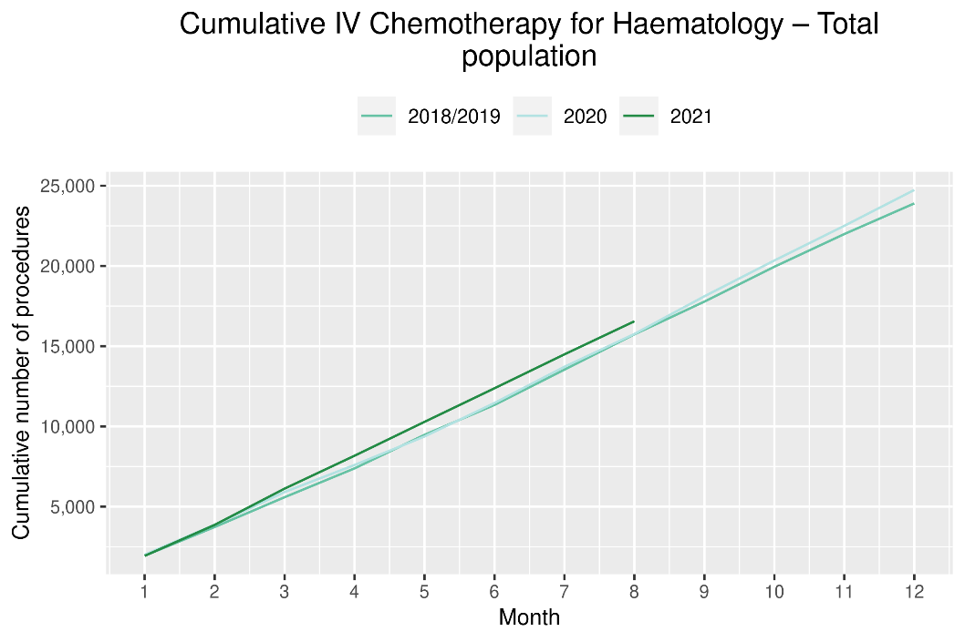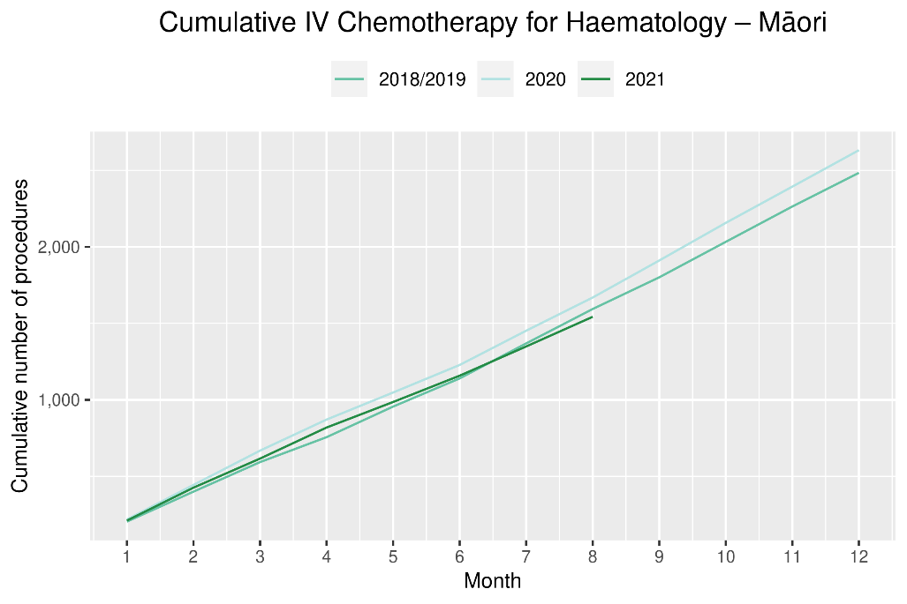

Appendix 1: NZCR data information

The New Zealand Cancer Registry as a data source for new cancer diagnoses
Cancer registration is a process where data is collated from multiple sources about people diagnosed with cancer and rules are applied to determine the type of cancer they have. This information is recorded in the New Zealand Cancer Registry. Each tumour is classified using an international World Health Organization standard so that cancer incidence can be compared between countries. The tumour is staged based on all the information available within 4 months of diagnosis. This process may take up to six months or more depending on the number of missing reports that need to be followed up with laboratories.
For each registration there may be multiple pathology reports as there may be multiple procedures performed on the tumour. This means there will be more than one registration for people diagnosed with more than one type of tumour.
Cancer registrations come from pathology laboratories, haematology laboratories, mortality records and reviewing hospital discharge records. Laboratory reports provide the best source of near real time data to monitor new diagnoses of cancer in New Zealand.

Pathology reports as a data source for providing near real time monitoring cancer diagnoses
Pathology reports (documents) are received by the NZCR as electronic messages. An administrator triages these documents each day and if the document appears to meet the requirements for registration the document is “administered”. The document may relate to an existing registration or may contain information for a new cancer event. Documents that do not meet the cancer reporting requirements will be marked as “deleted”, “rejected” or “agreed not for registration”.
The administrator creates a new provisional cancer event if the pathology report identifies a new cancer diagnosis for this person. This new cancer event is assigned to a cancer group and this provisional event is then queued for further assessment by a clinical coder. If the required information has been provided the coder creates a new registration. If some information is not yet available, then the registration is held open until further information arrives to complete the registration or determine that the tumour does not meet the registration criteria.

Appendix 2: NZCR registrations by DHB
Number of cancer registrations and percentage difference in 2021 compared to 2018/2019 average, by month (June, July, August) and cumulative year to date, by DHB of domicile
 | June |  |  | July |  |  | August |  |  | Cumulative January-August
 | 2018/2019 average | 2021 | % | 2018/2019 average | 2021 | % | 2018/2019 average | 2021 | % | 2018/2019 average | 2021 | %
Northland | 93 | 120 | 29% | 96 | 102 | 6% | 99 | 87 | -12% | 763 | 834 | 9%
Waitematā | 201 | 279 | 39% | 252 | 278 | 11% | 262 | 216 | -18% | 1,868 | 2,056 | 10%
Auckland | 170 | 218 | 29% | 163 | 184 | 13% | 160 | 135 | -15% | 1,335 | 1,365 | 2%
Counties Manukau | 178 | 217 | 22% | 194 | 179 | -7% | 190 | 179 | -6% | 1,449 | 1,513 | 4%
Waikato | 165 | 154 | -7% | 175 | 172 | -2% | 180 | 171 | -5% | 1,411 | 1,364 | -3%
Bay of Plenty | 120 | 116 | -3% | 108 | 131 | 21% | 137 | 92 | -33% | 931 | 931 | 0%
Tairāwhiti | 17 | 19 | 15% | 14 | 24 | 71% | 23 | 13 | -42% | 143 | 171 | 20%
Lakes | 45 | 43 | -4% | 50 | 42 | -15% | 49 | 45 | -8% | 365 | 365 | 0%
Taranaki | 67 | 69 | 4% | 57 | 61 | 8% | 63 | 76 | 21% | 463 | 521 | 13%
Hawke's Bay | 86 | 96 | 12% | 81 | 65 | -20% | 78 | 74 | -5% | 597 | 649 | 9%
Whanganui | 36 | 37 | 4% | 28 | 37 | 35% | 44 | 50 | 14% | 280 | 263 | -6%
MidCentral | 87 | 92 | 6% | 86 | 84 | -2% | 97 | 98 | 2% | 687 | 693 | 1%
Capital & Coast | 106 | 133 | 26% | 121 | 101 | -16% | 113 | 111 | -1% | 916 | 917 | 0%
Hutt Valley | 64 | 75 | 17% | 63 | 62 | -2% | 60 | 58 | -3% | 478 | 498 | 4%
Wairarapa | 22 | 22 | 2% | 18 | 17 | -6% | 23 | 17 | -24% | 181 | 186 | 3%
Nelson Marlborough | 75 | 88 | 17% | 77 | 85 | 10% | 77 | 72 | -6% | 609 | 664 | 9%
West Coast | 13 | 22 | 76% | 16 | 13 | -19% | 18 | 15 | -17% | 127 | 120 | -6%
Canterbury | 221 | 287 | 30% | 242 | 255 | 5% | 233 | 227 | -3% | 1,807 | 1,998 | 11%
South Canterbury | 25 | 33 | 32% | 29 | 29 | 0% | 34 | 27 | -21% | 240 | 267 | 11%
Southern | 140 | 188 | 34% | 146 | 175 | 20% | 173 | 153 | -11% | 1,220 | 1,324 | 9%

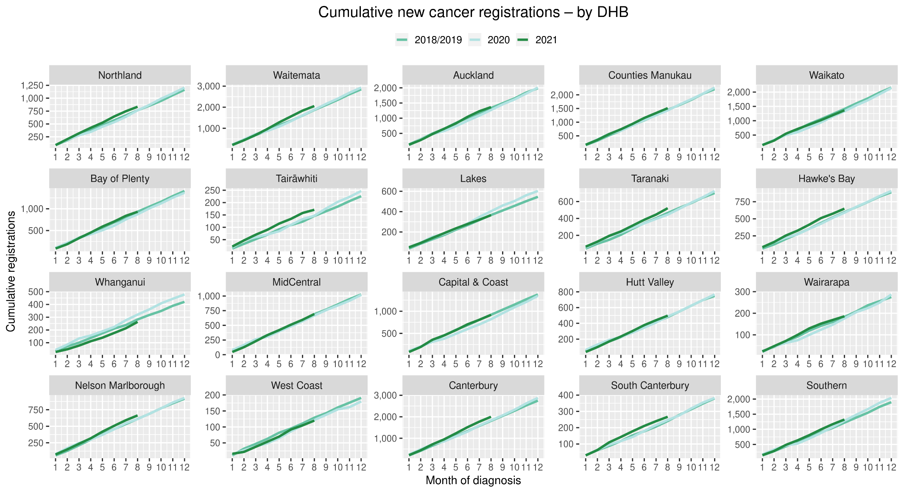

Cumulative cancer registrations by ethnicity
 | Total population |  |  |  |  |  | Māori |  |  |  |  |  |  |  |  | Non-Māori / Non-Pacific
 | Cumulative number for Jan to Aug |  |  | Difference between 2018/19 average and 2021 |  |  | Cumulative number for Jan to Aug |  |  | Difference between 2018/19 average and 2021 |  |  |  |  |  | Cumulative number for Jan to Aug |  |  | Difference between 2018/19 average and 2021
 | 2018/19 | 2020 | 2021 | Number | % |  | 2018/19 | 2020 | 2021 | Number |  |  |  | % |  | 2018/19 | 2020 | 2021 | Number | %
Northland | 763 | 765 | 834 | 71 | 9% |  | 176 | 174 | 206 |  | 30 |  | 17% |  |  | 587 | 591 | 628 | 41 | 7%
Waitematā | 1,868 | 1,885 | 2,056 | 188 | 10% |  | 110 | 125 | 109 |  | -1 |  | 0% |  |  | 1,759 | 1,760 | 1,947 | 189 | 11%
Auckland | 1,335 | 1,270 | 1,365 | 31 | 2% |  | 77 | 70 | 86 |  | 10 |  | 12% |  |  | 1,258 | 1,200 | 1,279 | 21 | 2%
Counties Manukau | 1,449 | 1,432 | 1,513 | 65 | 4% |  | 188 | 206 | 190 |  | 3 |  | 1% |  |  | 1,261 | 1,226 | 1,323 | 62 | 5%
Waikato | 1,411 | 1,328 | 1,364 | -47 | -3% |  | 229 | 215 | 199 |  | -30 |  | -13% |  |  | 1,182 | 1,113 | 1,165 | -17 | -1%
Bay of Plenty | 931 | 874 | 931 | 0 | 0% |  | 149 | 144 | 149 |  | 0 |  | 0% |  |  | 782 | 730 | 782 | 0 | 0%
Tairāwhiti | 143 | 147 | 171 | 28 | 20% |  | 53 | 60 | 66 |  | 14 |  | 26% |  |  | 91 | 87 | 105 | 15 | 16%
Lakes | 365 | 403 | 365 | 1 | 0% |  | 88 | 107 | 111 |  | 23 |  | 26% |  |  | 277 | 296 | 254 | -23 | -8%
Taranaki | 463 | 445 | 521 | 59 | 13% |  | 47 | 46 | 65 |  | 18 |  | 38% |  |  | 416 | 399 | 456 | 41 | 10%
Hawke's Bay | 597 | 589 | 649 | 52 | 9% |  | 43 | 46 | 57 |  | 14 |  | 33% |  |  | 237 | 274 | 206 | -31 | -13%
Whanganui | 280 | 320 | 263 | -17 | -6% |  | 73 | 76 | 83 |  | 11 |  | 14% |  |  | 614 | 592 | 610 | -4 | -1%
MidCentral | 687 | 668 | 693 | 7 | 1% |  | 68 | 51 | 63 |  | -5 |  | -7% |  |  | 410 | 437 | 435 | 25 | 6%
Capital & Coast | 916 | 818 | 917 | 1 | 0% |  | 16 | 20 | 23 |  | 8 |  | 48% |  |  | 166 | 156 | 163 | -3 | -2%
Hutt Valley | 478 | 488 | 498 | 20 | 4% |  | 33 | 25 | 31 |  | -2 |  | -5% |  |  | 576 | 584 | 633 | 57 | 10%
Wairarapa | 181 | 176 | 186 | 5 | 3% |  | 9 | 6 | 13 |  | 5 |  | 53% |  |  | 119 | 116 | 107 | -12 | -10%
Nelson Marlborough | 609 | 609 | 664 | 56 | 9% |  | 102 | 87 | 109 |  | 7 |  | 7% |  |  | 1,705 | 1,746 | 1,889 | 184 | 11%
West Coast | 127 | 122 | 120 | -7 | -6% |  | 65 | 75 | 91 |  | 26 |  | 40% |  |  | 851 | 743 | 826 | -25 | -3%
Canterbury | 1,807 | 1,833 | 1,998 | 191 | 11% |  | 112 | 108 | 127 |  | 16 |  | 14% |  |  | 486 | 481 | 522 | 37 | 8%
South Canterbury | 240 | 247 | 267 | 28 | 11% |  | 12 | 7 | 8 |  | -4 |  | -33% |  |  | 228 | 240 | 259 | 32 | 14%
Southern | 1,220 | 1,281 | 1,324 | 105 | 9% |  | 63 | 72 | 84 |  | 21 |  | 33% |  |  | 1,157 | 1,209 | 1,240 | 84 | 7%
Total | 15,866 | 15,700 | 16,699 | 834 | 5% |  | 1,708 | 1,720 | 1,870 |  |  | 162 |  | 9% |  | 14,158 | 13,980 | 14,829 | 672 | 5%

Appendix 3: Diagnosis and treatment data by DHB
Percentage differences are only presented if the cumulative total is 10 or greater. In some cases, the totals may differ to those presented in the national report due to non-DHB providers being excluded from the analyses within this appendix.
Southern DHB endoscopy and non-surgical cancer treatment data is not included due incomplete data for the July 2021 and August 2021 period. Te Aho o Te Kahu is actively working with the Ministry of Health to support the DHB resolve this issue for our next report.

Gastrointestinal endoscopy
 | Total population |  |  |  |  |  | Māori |  |  |  |  |  | Non-Māori / Non-Pacific
 | Cumulative number for Jan to Aug |  |  | Difference between 2018/19 average and 2021 |  |  | Cumulative number for Jan to Aug |  |  | Difference between 2018/19 average and 2021 |  |  | Cumulative number for Jan to Aug |  |  | Difference between 2018/19 average and 2021
 | 2018/19 | 2020 | 2021 | Number | % |  | 2018/19 | 2020 | 2021 | Number | % |  | 2018/19 | 2020 | 2021 | Number | %
Northland | 2,598 | 2,318 | 2,773 | 176 | 7% |  | 470 | 421 | 562 | 92 | 20% |  | 2,108 | 1,878 | 2,185 | 77 | 4%
Waitematā | 5,802 | 6,074 | 6,823 | 1,022 | 18% |  | 339 | 335 | 416 | 77 | 23% |  | 5,269 | 5,474 | 6,157 | 889 | 17%
Auckland | 4,207 | 3,805 | 4,175 | -32 | -1% |  | 207 | 219 | 245 | 39 | 19% |  | 3,711 | 3,288 | 3,624 | -87 | -2%
Counties Manukau | 5,926 | 6,664 | 6,243 | 317 | 5% |  | 563 | 666 | 590 | 27 | 5% |  | 4,621 | 5,076 | 4,759 | 138 | 3%
Waikato | 3,907 | 4,341 | 4,282 | 376 | 10% |  | 466 | 499 | 557 | 92 | 20% |  | 3,391 | 3,778 | 3,672 | 282 | 8%
Bay of Plenty | 3,256 | 3,307 | 4,359 | 1,103 | 34% |  | 397 | 413 | 544 | 147 | 37% |  | 2,845 | 2,884 | 3,789 | 945 | 33%
Lakes | 1,317 | 1,170 | 1,609 | 293 | 22% |  | 239 | 243 | 296 | 57 | 24% |  | 1,057 | 905 | 1,291 | 234 | 22%
Tairāwhiti | 500 | 467 | 509 | 9 | 2% |  | 144 | 136 | 143 | -1 | -1% |  | 353 | 325 | 363 | 11 | 3%
Taranaki | 1,293 | 1,254 | 1,677 | 384 | 30% |  | 135 | 107 | 178 | 44 | 32% |  | 1,152 | 1,138 | 1,492 | 340 | 30%
Whanganui | 1,003 | 844 | 923 | -80 | -8% |  | 139 | 115 | 133 | -6 | -4% |  | 859 | 723 | 785 | -74 | -9%
Hawke's Bay | 1,817 | 1,901 | 2,296 | 479 | 26% |  | 218 | 266 | 310 | 93 | 43% |  | 1,580 | 1,605 | 1,955 | 375 | 24%
MidCentral | 1,440 | 1,491 | 1,698 | 258 | 18% |  | 102 | 133 | 172 | 71 | 69% |  | 1,325 | 1,340 | 1,512 | 188 | 14%
Capital & Coast | 1,924 | 2,185 | 2,001 | 77 | 4% |  | 135 | 172 | 185 | 50 | 37% |  | 1,711 | 1,937 | 1,735 | 24 | 1%
Hutt Valley | 1,755 | 2,124 | 2,127 | 373 | 21% |  | 145 | 219 | 202 | 57 | 39% |  | 1,551 | 1,832 | 1,832 | 282 | 18%
Wairarapa | 669 | 588 | 696 | 28 | 4% |  | 57 | 53 | 68 | 11 | 19% |  | 605 | 530 | 623 | 18 | 3%
Nelson Marlborough | 1,366 | 1,771 | 1,776 | 411 | 30% |  | 73 | 98 | 100 | 27 | 37% |  | 1,287 | 1,657 | 1,667 | 381 | 30%
West Coast | 442 | 444 | 580 | 139 | 31% |  | 32 | 17 | 44 | 13 | 40% |  | 409 | 425 | 534 | 126 | 31%
Canterbury | 5,148 | 5,237 | 5,024 | -124 | -2% |  | 295 | 304 | 277 | -18 | -6% |  | 4,777 | 4,860 | 4,679 | -98 | -2%
South Canterbury | 816 | 781 | 894 | 79 | 10% |  | 33 | 35 | 32 | -1 | -3% |  | 781 | 744 | 859 | 79 | 10%
Total | 45,180 | 46,766 | 50,465 | 5,285 | 12% |  | 4186 | 4451 | 5054 | 869 | 21% |  | 39,387 | 40,399 | 43,513 | 4,127 | 10%

Bronchoscopy

 | Total population |  |  |  |  |  | Māori |  |  |  |  |  | Non-Māori / Non-Pacific
 | Cumulative number for Jan to Aug |  |  | Difference between 2018/19 average and 2021 |  |  | Cumulative number for Jan to Aug |  |  | Difference between 2018/19 average and 2021 |  |  | Cumulative number for Jan to Aug |  |  | Difference between 2018/19 average and 2021
 | 2018/19 | 2020 | 2021 | Number | % |  | 2018/19 | 2020 | 2021 | Number | % |  | 2018/19 | 2020 | 2021 | Number | %
Northland | 54 | 43 | 70 | 16 | 30% |  | 17 | 14 | 20 | 3 | 18% |  | 36 | 28 | 50 | 14 | 39%
Waitematā | 97 | 96 | 130 | 33 | 34% |  | 7 | 9 | 17 | 11 | - |  | 87 | 83 | 111 | 25 | 28%
Auckland | 231 | 186 | 183 | -48 | -21% |  | 28 | 19 | 20 | -8 | -27% |  | 182 | 149 | 154 | -28 | -15%
Counties Manukau | 235 | 219 | 210 | -25 | -11% |  | 43 | 28 | 40 | -3 | -6% |  | 159 | 159 | 136 | -23 | -14%
Waikato | 187 | 137 | 156 | -31 | -16% |  | 42 | 32 | 32 | -10 | -24% |  | 142 | 102 | 124 | -18 | -13%
Bay of Plenty | 110 | 90 | 121 | 11 | 10% |  | 26 | 21 | 33 | 8 | 29% |  | 83 | 69 | 88 | 6 | 7%
Tairāwhiti | 2 | 17 | 18 | 16 | - |  | 1 | 6 | 6 | 5 | - |  | 1 | 11 | 12 | 11 | -
Lakes | 59 | 49 | 52 | -7 | -12% |  | 20 | 21 | 18 | -2 | -10% |  | 39 | 27 | 34 | -5 | -12%
Taranaki | 36 | 26 | 36 | 0 | 0% |  | 7 | 2 | 9 | 3 | - |  | 30 | 24 | 27 | -3 | -8%
Hawke's Bay | 48 | 30 | 49 | 2 | 3% |  | 13 | 8 | 14 | 2 | 12% |  | 35 | 21 | 34 | -1 | -1%
Whanganui | 11 | 10 | 12 | 1 | 9% |  | 5 | 4 | 7 | 2 | - |  | 6 | 6 | 5 | -1 | -
MidCentral | 26 | 20 | 25 | -1 | -2% |  | 5 | 1 | 7 | 2 | - |  | 21 | 19 | 17 | -4 | -17%
Capital & Coast | 64 | 48 | 46 | -18 | -28% |  | 8 | 7 | 4 | -4 | - |  | 53 | 39 | 39 | -14 | -26%
Hutt Valley | 77 | 62 | 57 | -20 | -25% |  | 15 | 11 | 10 | -5 | -31% |  | 59 | 47 | 41 | -18 | -31%
Nelson Marlborough | 48 | 57 | 58 | 11 | 22% |  | 5 | 5 | 2 | -3 | - |  | 43 | 51 | 56 | 13 | 30%
Canterbury | 255 | 249 | 236 | -19 | -7% |  | 19 | 14 | 13 | -6 | -32% |  | 233 | 229 | 221 | -12 | -5%
South Canterbury | 9 | 13 | 11 | 2 | - |  | 1 | 0 | 0 | -1 | - |  | 9 | 13 | 11 | 3 | -
Total | 1,546 | 1,352 | 1,470 | -76 | -5% |  | 257 | 202 | 252 | -5 | 2% |  | 1,214 | 1,077 | 1,160 | -54 | -4%

Colorectal cancer surgery

 | Total population |  |  |  |  |  | Māori |  |  |  |  |  | Non-Māori / Non-Pacific
 | Cumulative number for Jan to Aug |  |  | Difference between 2018/19 average and 2021 |  |  | Cumulative number for Jan to Aug |  |  | Difference between 2018/19 average and 2021 |  |  | Cumulative number for Jan to Aug |  |  | Difference between 2018/19 average and 2021
 | 2018/19 | 2020 | 2021 | Number | % |  | 2018/19 | 2020 | 2021 | Number | % |  | 2018/19 | 2020 | 2021 | Number | %
Northland | 57 | 56 | 65 | 8 | 14% |  | 10 | 15 | 16 | 6 | 60% |  | 47 | 41 | 49 | 3 | 5%
Waitematā | 172 | 145 | 128 | -44 | -25% |  | 11 | 10 | 6 | -5 | -45% |  | 152 | 132 | 118 | -34 | -22%
Auckland | 132 | 130 | 142 | 11 | 8% |  | 8 | 16 | 12 | 5 | - |  | 113 | 107 | 114 | 2 | 1%
Counties Manukau | 89 | 96 | 79 | -10 | -11% |  | 6 | 15 | 6 | 0 | - |  | 74 | 70 | 59 | -15 | -20%
Waikato | 147 | 182 | 165 | 18 | 12% |  | 15 | 26 | 25 | 11 | 72% |  | 130 | 155 | 137 | 7 | 5%
Bay of Plenty | 94 | 122 | 96 | 2 | 2% |  | 10 | 17 | 16 | 6 | 60% |  | 84 | 105 | 75 | -9 | -10%
Tairāwhiti | 16 | 17 | 22 | 7 | 42% |  | 3 | 5 | 11 | 8 | - |  | 13 | 12 | 10 | -3 | -20%
Lakes | 52 | 54 | 53 | 1 | 2% |  | 10 | 8 | 10 | 1 | - |  | 41 | 45 | 40 | -1 | -2%
Taranaki | 60 | 55 | 58 | -2 | -3% |  | 6 | 8 | 6 | 1 | - |  | 55 | 47 | 52 | -3 | -5%
Hawke's Bay | 97 | 100 | 85 | -12 | -12% |  | 11 | 14 | 6 | -5 | -45% |  | 86 | 83 | 77 | -9 | -10%
Whanganui | 32 | 37 | 27 | -5 | -14% |  | 3 | 3 | 1 | -2 | - |  | 29 | 34 | 26 | -3 | -9%
MidCentral | 79 | 86 | 90 | 11 | 14% |  | 5 | 11 | 14 | 9 | - |  | 73 | 75 | 76 | 3 | 4%
Capital & Coast | 107 | 92 | 96 | -11 | -10% |  | 8 | 10 | 15 | 7 | - |  | 93 | 80 | 75 | -18 | -19%
Hutt Valley | 45 | 36 | 42 | -3 | -6% |  | 4 | 3 | 2 | -2 | - |  | 40 | 32 | 38 | -2 | -5%
Wairarapa | 14 | 3 | 12 | -2 | -11% |  | 2 | 0 | 2 | 1 | - |  | 12 | 3 | 10 | -2 | -17%
Nelson Marlborough | 60 | 41 | 53 | -7 | -12% |  | 3 | 2 | 1 | -2 | - |  | 57 | 39 | 52 | -5 | -9%
West Coast | 3 | 6 | 4 | 2 | - |  | 0 | 0 | 0 | 0 | - |  | 3 | 6 | 4 | 2
Canterbury | 207 | 196 | 238 | 32 | 15% |  | 11 | 14 | 12 | 1 | 9% |  | 192 | 179 | 223 | 31 | 16%
South Canterbury | 36 | 27 | 40 | 5 | 13% |  | 1 | 2 | 0 | -1 | - |  | 35 | 25 | 40 | 6 | 16%
Southern | 169 | 152 | 162 | -7 | -4% |  | 7 | 4 | 8 | 2 | - |  | 161 | 147 | 151 | -10 | -6%
Total | 1,663 | 1,633 | 1,657 | -6 | 0% |  | 131 | 183 | 169 | 39 | 30% |  | 1,485 | 1,417 | 1,426 | -59 | -4%

Lung cancer surgery

 | Total population |  |  |  |  |  | Māori |  |  |  |  |  | Non-Māori / Non-Pacific
 | Cumulative number for Jan to Aug |  |  | Difference between 2018/19 average and 2021 |  |  | Cumulative number for Jan to Aug |  |  | Difference between 2018/19 average and 2021 |  |  | Cumulative number for Jan to Aug |  |  | Difference between 2018/19 average and 2021
 | 2018/19 | 2020 | 2021 | Number | % |  | 2018/19 | 2020 | 2021 | Number | % |  | 2018/19 | 2020 | 2021 | Number | %
Waitematā | 0 | 0 | 1 | 1 | - |  | 0 | 0 | 0 | 0 | - |  | 0 | 0 | 1 | 1 | -
Auckland | 185 | 172 | 155 | -30 | -16% |  | 32 | 27 | 24 | -8 | -24% |  | 140 | 129 | 117 | -23 | -16%
Counties Manukau | 2 | 2 | 0 | -2 | - |  | 0 | 1 | 0 | 0 | - |  | 1 | 1 | 0 | -1 | -
Waikato | 86 | 106 | 94 | 9 | 10% |  | 25 | 26 | 26 | 1 | 4% |  | 59 | 79 | 66 | 7 | 12%
Bay of Plenty | 0 | 0 | 1 | 1 | - |  | 0 | 0 | 0 | 0 | - |  | 0 | 0 | 1 | 1 | -
Taranaki | 1 | 0 | 0 | -1 | - |  | 0 | 0 | 0 | 0 | - |  | 1 | 0 | 0 | -1 | -
Hawke's Bay | 0 | 1 | 0 | 0 | - |  | 0 | 0 | 0 | 0 | - |  | 0 | 0 | 0 | 0 | -
MidCentral | 0 | 0 | 1 | 1 | - |  | 0 | 0 | 1 | 1 | - |  | 0 | 0 | 0 | 0 | -
Capital & Coast | 87 | 61 | 100 | 14 | 16% |  | 17 | 8 | 20 | 4 | 21% |  | 66 | 50 | 74 | 8 | 12%
Canterbury | 57 | 76 | 62 | 5 | 9% |  | 3 | 5 | 17 | 14 | - |  | 54 | 70 | 44 | -10 | -19%
Southern | 26 | 19 | 21 | -5 | -19% |  | 2 | 2 | 0 | -2 | - |  | 25 | 17 | 21 | -4 | -14%
Total | 442 | 437 | 435 | -7 | -1% |  | 78 | 69 | 88 | 11 | 14% |  | 345 | 346 | 324 | -21 | -6%

Prostate cancer surgery

 |  | Total population |  |  |  |  |  |  |  | Māori |  |  |  |  |  | Non-Māori / Non-Pacific
 | Cumulative number for Jan to Aug |  |  |  | Difference between 2018/19 average and 2021 |  |  |  | Cumulative number for Jan to Aug |  |  |  | Difference between 2018/19 average and 2021 |  |  |  |  | Cumulative number for Jan to Aug |  |  | Difference between 2018/19 average and 2021
 | 2018/19 |  | 2020 | 2021 | Number | % |  |  | 2018/19 |  | 2020 | 2021 | Number | % |  |  |  | 2018/19 | 2020 | 2021 | Number |  | %
Northland | 34 |  | 22 | 43 | 9 | 26% |  |  | 6 |  | 5 | 7 | 2 | - |  |  |  | 28 | 17 | 35 | 7 |  | 25%
Waitematā | 48 |  | 74 | 63 | 16 | 33% |  |  | 3 |  | 2 | 7 | 5 | - |  |  |  | 44 | 70 | 54 | 10 |  | 23%
Auckland | 63 |  | 89 | 63 | 0 | 0% |  |  | 4 |  | 8 | 6 | 2 | - |  |  |  | 54 | 77 | 45 | -9 |  | -17%
Counties Manukau | 1 |  | 0 | 8 | 8 | - |  |  | 0 |  | 0 | 1 | 1 | - |  |  |  | 1 | 0 | 5 | 5 |  | -
Waikato | 44 |  | 38 | 34 | -10 | -22% |  |  | 2 |  | 3 | 8 | 6 | - |  |  |  | 42 | 34 | 26 | -16 |  | -37%
Bay of Plenty | 33 |  | 28 | 18 | -15 | -45% |  |  | 5 |  | 5 | 3 | -2 | - |  |  |  | 28 | 23 | 15 | -13 |  | -45%
Tairāwhiti | 4 |  | 6 | 6 | 3 | - |  |  | 2 |  | 2 | 3 | 2 | - |  |  |  | 2 | 4 | 3 | 1 |  | -
Lakes | 6 |  | 11 | 11 | 6 | - |  |  | 0 |  | 6 | 4 | 4 | - |  |  |  | 6 | 5 | 6 | 1 |  | -
Taranaki | 15 |  | 25 | 31 | 16 | 107% |  |  | 2 |  | 4 | 2 | 1 | - |  |  |  | 13 | 21 | 29 | 16 |  | 123%
Hawke's Bay | 12 |  | 16 | 22 | 11 | 91% |  |  | 1 |  | 4 | 3 | 3 | - |  |  |  | 11 | 12 | 19 | 8 |  | 73%
Whanganui | 4 |  | 3 | 7 | 4 | - |  |  | 1 |  | 0 | 0 | -1 | - |  |  |  | 3 | 3 | 7 | 4 |  | -
MidCentral | 51 |  | 58 | 40 | -11 | -22% |  |  | 5 |  | 3 | 4 | -1 | - |  |  |  | 46 | 55 | 35 | -11 |  | -24%
Capital & Coast | 43 |  | 44 | 64 | 22 | 51% |  |  | 2 |  | 2 | 3 | 2 | - |  |  |  | 38 | 41 | 57 | 19 |  | 50%
Wairarapa | 7 |  | 7 | 7 | 1 | - |  |  | 1 |  | 1 | 1 | 1 | - |  |  |  | 6 | 6 | 6 | 0 |  | -
Nelson Marlborough | 27 |  | 27 | 29 | 2 | 7% |  |  | 0 |  | 0 | 2 | 2 | - |  |  |  | 27 | 27 | 27 | 1 |  | 2%
West Coast | 5 |  | 4 | 6 | 2 | - |  |  | 0 |  | 0 | 0 | 0 | - |  |  |  | 5 | 4 | 6 | 2 |  | -
Canterbury | 42 |  | 52 | 46 | 4 | 10% |  |  | 1 |  | 2 | 3 | 2 | - |  |  |  | 41 | 49 | 42 | 1 |  | 2%
South Canterbury | 10 |  | 12 | 7 | -3 | - |  |  | 0 |  | 0 | 0 | 0 | - |  |  |  | 10 | 12 | 7 | -3 |  | -
Southern | 52 |  | 59 | 74 | 23 | 44% |  |  | 3 |  | 4 | 5 | 2 | - |  |  |  | 48 | 55 | 69 | 21 |  | 44 %
Total | 495 |  | 575 | 579 | 85 | 17% |  |  | 34 |  | 51 | 62 | 28 | 82% |  |  |  | 450 | 515 | 493 | 44 |  | 10%

Medical oncology first specialist assessments

 | Total population |  |  |  |  |  | Māori |  |  |  |  |  | Non-Māori / Non-Pacific
 | Cumulative number for Jan to Aug |  |  | Difference between 2018/19 average and 2021 |  |  | Cumulative number for Jan to Aug |  |  | Difference between 2018/19 average and 2021 |  |  | Cumulative number for Jan to Aug |  |  | Difference between 2018/19 average and 2021
 | 2018/19 | 2020 | 2021 | Number | % |  | 2018/19 | 2020 | 2021 | Number | % |  | 2018/19 | 2020 | 2021 | Number | %
Northland | 315 | 285 | 347 | 33 | 10% |  | 85 | 78 | 107 | 22 | 26% |  | 228 | 203 | 235 | 8 | 3%
Auckland | 1,570 | 1,710 | 1,721 | 151 | 10% |  | 181 | 201 | 197 | 17 | 9% |  | 1,187 | 1,266 | 1,282 | 96 | 8%
Waikato | 548 | 574 | 540 | -8 | -1% |  | 118 | 122 | 130 | 13 | 11% |  | 419 | 445 | 401 | -18 | -4%
Bay of Plenty | 324 | 352 | 383 | 59 | 18% |  | 62 | 63 | 78 | 16 | 26% |  | 260 | 287 | 300 | 41 | 16%
Tairāwhiti | 74 | 97 | 101 | 28 | 37% |  | 33 | 44 | 45 | 12 | 36% |  | 41 | 53 | 56 | 16 | 38%
Lakes | 106 | 133 | 167 | 61 | 58% |  | 37 | 37 | 61 | 25 | 67% |  | 67 | 94 | 103 | 36 | 54%
Taranaki | 161 | 153 | 138 | -23 | -14% |  | 18 | 17 | 25 | 8 | 43% |  | 143 | 135 | 112 | -31 | -21%
MidCentral | 722 | 725 | 798 | 77 | 11% |  | 112 | 117 | 156 | 44 | 39% |  | 595 | 599 | 632 | 38 | 6%
Capital & Coast | 585 | 579 | 608 | 24 | 4% |  | 71 | 75 | 77 | 6 | 8% |  | 481 | 464 | 486 | 5 | 1%
Nelson Marlborough | 278 | 306 | 301 | 23 | 8% |  | 21 | 15 | 12 | -9 | -41% |  | 257 | 289 | 287 | 31 | 12%
West Coast | 19 | 11 | 21 | 2 | 11% |  | 2 | 0 | 3 | 2 | - |  | 17 | 11 | 18 | 1 | 6%
Canterbury | 868 | 829 | 832 | -36 | -4% |  | 59 | 52 | 58 | -1 | -2% |  | 799 | 762 | 768 | -31 | -4%
South Canterbury | 4 | 40 | 83 | 79 | - |  | 0 | 2 | 3 | 3 | - |  | 4 | 38 | 80 | 76 | -
Total | 5,572 | 5,794 | 6,040 | 469 | 8% |  | 796 | 823 | 952 | 156 | 20% |  | 4,494 | 4,646 | 4,760 | 267 | 6%

Medical oncology IV chemotherapy
 | Total population |  |  |  |  |  | Māori |  |  |  |  |  | Non-Māori / Non-Pacific
 | Cumulative number for Jan to Aug |  |  | Difference between 2018/19 average and 2021 |  |  | Cumulative number for Jan to Aug |  |  | Difference between 2018/19 average and 2021 |  |  | Cumulative number for Jan to Aug |  |  | Difference between 2018/19 average and 2021
 | 2018/19 | 2020 | 2021 | Number | % |  | 2018/19 | 2020 | 2021 | Number | % |  | 2018/19 | 2020 | 2021 | Number | %
Northland | 2,032 | 2,117 | 2,300 | 268 | 13% |  | 450 | 660 | 737 | 288 | 64% |  | 1,561 | 1,436 | 1,525 | -36 | -2%
Auckland | 12,371 | 14,883 | 15,637 | 3,266 | 26% |  | 1,179 | 1,703 | 1,677 | 499 | 42% |  | 9,747 | 11,473 | 11,844 | 2,097 | 22%
Waikato | 4,947 | 4,248 | 5,372 | 426 | 9% |  | 811 | 685 | 934 | 123 | 15% |  | 4,080 | 3,491 | 4,364 | 284 | 7%
Bay of Plenty | 3,380 | 3,815 | 3,509 | 130 | 4% |  | 571 | 766 | 810 | 239 | 42% |  | 2,773 | 3,028 | 2,672 | -101 | -4%
Lakes | 459 | 376 | 939 | 480 | 105% |  | 205 | 172 | 434 | 230 | 112% |  | 254 | 203 | 490 | 236 | 93%
Tairāwhiti | 1,977 | 2,050 | 2,166 | 189 | 10% |  | 559 | 606 | 718 | 159 | 28% |  | 1,378 | 1,425 | 1,393 | 15 | 1%
Taranaki | 1,130 | 1,376 | 1,271 | 141 | 12% |  | 113 | 135 | 221 | 109 | 96% |  | 1,007 | 1,222 | 1,050 | 44 | 4%
Whanganui | 23 | 59 | 35 | 12 | 52% |  | 6 | 49 | 20 | 15 | - |  | 18 | 10 | 12 | -6 | -31%
Hawke's Bay | 75 | 62 | 59 | -16 | -21% |  | 12 | 8 | 7 | -5 | -42% |  | 63 | 54 | 52 | -11 | -17%
MidCentral | 4,834 | 5,217 | 4,263 | -571 | -12% |  | 805 | 874 | 830 | 26 | 3% |  | 3,904 | 4,280 | 3,363 | -541 | -14%
Capital & Coast | 4,462 | 4,183 | 3,656 | -806 | -18% |  | 454 | 474 | 416 | -38 | -8% |  | 3,798 | 3,464 | 2,948 | -850 | -22%
Hutt Valley | 78 | 71 | 107 | 30 | 38% |  | 7 | 3 | 10 | 4 | - |  | 67 | 62 | 93 | 26 | 39%
Wairarapa | 16 | 50 | 35 | 20 | 126% |  | 2 | 14 | 2 | 0 | - |  | 14 | 32 | 27 | 14 | 100%
Nelson Marlborough | 1,957 | 2,006 | 1,849 | -108 | -5% |  | 155 | 85 | 85 | -70 | -45% |  | 1,774 | 1,902 | 1,764 | -10 | -1%
West Coast | 20 | 23 | 15 | -5 | -23% |  | 1 | 5 | - | -1 | - |  | 19 | 18 | 15 | -4 | -21%
Canterbury | 4,273 | 4,179 | 4,176 | -97 | -2% |  | 280 | 277 | 259 | -21 | -7% |  | 3,884 | 3,761 | 3,854 | -30 | -1%
South Canterbury | 713 | 724 | 746 | 34 | 5% |  | 6 | 17 | 20 | 15 | - |  | 701 | 707 | 726 | 25 | 4%
Total | 42,745 | 45,439 | 46,138 | 3,394 | 8% |  | 5,611 | 6,533 | 7,181 | 1,571 | 28% |  | 35,040 | 36,568 | 36,193 | 1,154 | 3%

Radiation oncology first specialist assessments

 | Total population |  |  |  |  |  | Māori |  |  |  |  |  | Non-Māori / Non-Pacific
 | Cumulative number for Jan to Aug |  |  | Difference between 2018/19 average and 2021 |  |  | Cumulative number for Jan to Aug |  |  | Difference between 2018/19 average and 2021 |  |  | Cumulative number for Jan to Aug |  |  | Difference between 2018/19 average and 2021
 | 2018/19 | 2020 | 2021 | Number | % |  | 2018/19 | 2020 | 2021 | Number | % |  | 2018/19 | 2020 | 2021 | Number | %
Northland | 240 | 195 | 271 | 31 | 13% |  | 62 | 67 | 89 | 27 | 44% |  | 174 | 127 | 180 | 6 | 3%
Auckland | 2,145 | 2,130 | 2,208 | 64 | 3% |  | 258 | 248 | 276 | 19 | 7% |  | 1,624 | 1,653 | 1,654 | 31 | 2%
Waikato | 915 | 985 | 1,026 | 111 | 12% |  | 159 | 213 | 208 | 49 | 31% |  | 737 | 762 | 800 | 63 | 9%
Bay of Plenty | 629 | 616 | 752 | 123 | 20% |  | 92 | 93 | 134 | 43 | 46% |  | 532 | 519 | 612 | 81 | 15%
Tairāwhiti | 50 | 26 | 26 | -24 | -47% |  | 19 | 13 | 7 | -12 | -62% |  | 30 | 13 | 19 | -11 | -37%
Lakes | 22 | 10 | 15 | -7 | -32% |  | 5 | 3 | 6 | 1 | - |  | 17 | 7 | 9 | -8 | -47%
MidCentral | 1,141 | 1,180 | 1,225 | 84 | 7% |  | 146 | 150 | 183 | 37 | 25% |  | 982 | 1,014 | 1,028 | 47 | 5%
Capital & Coast | 954 | 902 | 991 | 38 | 4% |  | 91 | 89 | 98 | 7 | 8% |  | 822 | 765 | 840 | 18 | 2%
Nelson Marlborough | 99 | 117 | 139 | 40 | 40% |  | 7 | 8 | 6 | -1 | - |  | 92 | 108 | 132 | 40 | 43%
West Coast | 7 | 3 | 10 | 4 | - |  | 1 | 0 | 1 | 1 | - |  | 6 | 3 | 9 | 3 | -
Canterbury | 1,089 | 1,234 | 1,207 | 118 | 11% |  | 63 | 55 | 68 | 5 | 8% |  | 1,013 | 1,163 | 1,124 | 112 | 11%
Total | 7,289 | 7,398 | 7,870 | 581 | 8% |  | 901 | 939 | 1,076 | 176 | 19% |  | 6,027 | 6,134 | 6,407 | 380 | 6%

Radiation oncology megavoltage fractions

 | Total population |  |  |  |  |  | Māori |  |  |  |  |  | Non-Māori / Non-Pacific
 | Cumulative number for Jan to Aug |  |  | Difference between 2018/19 average and 2021 |  |  | Cumulative number for Jan to Aug |  |  | Difference between 2018/19 average and 2021 |  |  | Cumulative number for Jan to Aug |  |  | Difference between 2018/19 average and 2021
 | 2018/19 | 2020 | 2021 | Number | % |  | 2018/19 | 2020 | 2021 | Number | % |  | 2018/19 | 2020 | 2021 | Number | %
Auckland | 30,088 | 27,122 | 24,735 | -5,353 | -18% |  | 4,120 | 3,515 | 4,218 | 98 | 2% |  | 22,890 | 20,748 | 17,703 | -5,187 | -23%
Waikato | 14,692 | 12,925 | 12,080 | -2,612 | -18% |  | 2,655 | 2,844 | 2,553 | -102 | -4% |  | 11,763 | 9,939 | 9,328 | -2,435 | -21%
Bay of Plenty | 11,250 | 11,351 | 12,021 | 771 | 7% |  | 1,980 | 1,909 | 2,145 | 166 | 8% |  | 9,149 | 9,308 | 9,744 | 595 | 7%
MidCentral | 15,061 | 14,997 | 16,085 | 1,024 | 7% |  | 2,124 | 1,989 | 2,572 | 448 | 21% |  | 12,825 | 12,726 | 13,373 | 548 | 4%
Capital & Coast | 13,567 | 12,873 | 13,578 | 12 | 0% |  | 1,594 | 1,524 | 1,488 | -106 | -7% |  | 11,314 | 10,624 | 11,340 | 26 | -
Canterbury | 17,462 | 16,159 | 16,355 | -1,107 | -6% |  | 1,168 | 929 | 830 | -338 | -29% |  | 15,978 | 15,079 | 15,359 | -619 | -4%
Total | 102,119 | 95,432 | 94,854 | -7,265 | -7% |  | 13,640 | 12,712 | 13,806 | 166 | 1% |  | 83,918 | 78,427 | 76,847 | -7,071 | -8%

Haematology first specialist assessment

 | Total population |  |  |  |  |  | Māori |  |  |  |  |  | Non-Māori / Non-Pacific
 | Cumulative number for Jan to Aug |  |  | Difference between 2018/19 and 2021 |  |  | Cumulative number for Jan to Aug |  |  | Difference between 2018/19 and 2021 |  |  | Cumulative number for Jan to Aug |  |  | Difference between 2018/19 and 2021
 | 2018/19 | 2020 | 2021 | Number | % |  | 2018/19 | 2020 | 2021 | Number | % |  | 2018 | 2019 | 2021 | Number | %
Northland | 147 | 173 | 129 | -18 | -12% |  | 27 | 46 | 34 | 8 | 28% |  | 118 | 124 | 94 | -24 | -20%
Waitematā | 456 | 474 | 416 | -40 | -9% |  | 25 | 31 | 33 | 9 | 35% |  | 413 | 420 | 362 | -51 | -12%
Auckland | 659 | 502 | 715 | 57 | 9% |  | 50 | 44 | 69 | 19 | 38% |  | 546 | 395 | 585 | 40 | 7%
Counties Manukau | 503 | 474 | 434 | -69 | -14% |  | 57 | 59 | 51 | -6 | -11% |  | 370 | 342 | 310 | -60 | -16%
Waikato | 480 | 490 | 462 | -18 | -4% |  | 83 | 82 | 78 | -5 | -6% |  | 390 | 401 | 373 | -17 | -4%
Bay of Plenty | 267 | 210 | 260 | -7 | -2% |  | 44 | 30 | 37 | -7 | -15% |  | 219 | 177 | 219 | 1 | 0%
Tairāwhiti | 27 | 25 | 38 | 12 | 43% |  | 8 | 6 | 14 | 6 | - |  | 18 | 19 | 23 | 5 | 28%
Taranaki | 106 | 119 | 99 | -7 | -7% |  | 10 | 15 | 10 | 1 | - |  | 96 | 103 | 89 | -7 | -7%
MidCentral | 514 | 509 | 555 | 41 | 8% |  | 64 | 63 | 96 | 32 | 50% |  | 444 | 432 | 453 | 9 | 2%
Capital & Coast | 527 | 416 | 438 | -89 | -17% |  | 38 | 48 | 43 | 6 | 15% |  | 468 | 342 | 359 | -109 | -23%
Nelson Marlborough | 118 | 79 | 95 | -23 | -19% |  | 3 | 3 | 5 | 3 | - |  | 114 | 76 | 90 | -24 | -21%
West Coast | 13 | 4 | 6 | -7 | -52% |  | 1 | 0 | 1 | 0 | - |  | 12 | 4 | 5 | -7 | -57%
Canterbury | 326 | 344 | 378 | 53 | 16% |  | 17 | 19 | 27 | 11 | 64% |  | 299 | 322 | 345 | 46 | 15%
Total | 4,140 | 3,819 | 4,025 | -115 | -3% |  | 424 | 446 | 498 | 74 | 17% |  | 3,505 | 3,157 | 3,307 | -198 | -6%

Haematology IV chemotherapy
 | Total population |  |  |  |  |  | Māori |  |  |  |  |  | Non-Māori / Non-Pacific
 | Cumulative number for Jan to Aug |  |  | Difference between 2018/19 and 2021 |  |  | Cumulative number for Jan to Aug |  |  | Difference between 2018/19 and 2021 |  |  | Cumulative number for Jan to Aug |  |  | Difference between 2018/19 and 2021
 | 2018/19 | 2021 | 2020 | Number | % |  | 2018/19 | 2020 | 2021 | Number | % |  | 2018/19 | 2020 | 2021 | Number | %
Northland | 1,198 | 949 | 1,028 | -170 | -14% |  | 272 | 197 | 247 | -25 | -9% |  | 903 | 713 | 762 | -141 | -16%
Waitematā | 2,711 | 2,552 | 2,433 | -278 | -10% |  | 78 | 119 | 90 | 13 | 16% |  | 2,491 | 2,266 | 2,249 | -242 | -10%
Auckland | 2,419 | 2,237 | 2,856 | 438 | 18% |  | 160 | 89 | 182 | 23 | 14% |  | 2,014 | 1,913 | 2,334 | 320 | 16%
Counties Manukau | 1,217 | 1,576 | 2,173 | 957 | 79% |  | 158 | 147 | 225 | 67 | 42% |  | 807 | 1,182 | 1,584 | 777 | 96%
Waikato | 1,330 | 1,496 | 1,652 | 323 | 24% |  | 223 | 281 | 298 | 75 | 34% |  | 1,100 | 1,215 | 1,302 | 203 | 18%
Bay of Plenty | 876 | 780 | 1,128 | 252 | 29% |  | 81 | 115 | 144 | 63 | 78% |  | 775 | 659 | 957 | 182 | 23%
Tairāwhiti | 120 | 72 | 117 | -3 | -2% |  | 14 | 10 | 18 | 4 | 29% |  | 98 | 62 | 99 | 2 | 2%
Lakes | 276 | 450 | 479 | 204 | 74% |  | 76 | 114 | 102 | 26 | 34% |  | 200 | 336 | 349 | 150 | 75%
MidCentral | 1,825 | 1,617 | 1,011 | -814 | -45% |  | 221 | 132 | 79 | -142 | -64% |  | 1,591 | 1,470 | 932 | -659 | -41%
Capital & Coast | 2,191 | 2,212 | 1,853 | -338 | -15% |  | 177 | 272 | 93 | -84 | -47% |  | 1,933 | 1,723 | 1,594 | -339 | -18%
Nelson Marlborough | 1 | 10 | 0 | -1 | - |  | 0 | 0 | 0 | 0 | - |  | 1 | 10 | 0 | -1 | -
West Coast | 8 | 6 | 9 | 1 | - |  | 1 | 0 | 0 | -1 | - |  | 7 | 6 | 9 | 2 | -
Canterbury | 1,570 | 1,806 | 1,814 | 245 | 16% |  | 133 | 193 | 65 | -68 | -51% |  | 1,424 | 1,576 | 1,747 | 323 | 23%
Total | 15,738 | 15,763 | 16,553 | 815 | 5% |  | 1,592 | 1,669 | 1,543 | -49 | -3% |  | 13,342 | 13,131 | 13,918 | 576 | 4%

Appendix 4: Surgical procedure codes
Below is a list of the surgical procedure codes that were used for analysis on curative cancer surgery.
COLORECTAL CANCER SURGERY
Clinical code | Block short description | Clinical code description
3200000 | Colectomy | Limited excision of large intestine with formation of stoma
3200001 | Colectomy | Right hemicolectomy with formation of stoma
3200300 | Colectomy | Limited excision of large intestine with anastomosis
3200301 | Colectomy | Right hemicolectomy with anastomosis
3200400 | Colectomy | Subtotal colectomy with formation of stoma
3200401 | Colectomy | Extended right hemicolectomy with formation of stoma
3200500 | Colectomy | Subtotal colectomy with anastomosis
3200501 | Colectomy | Extended right hemicolectomy with anastomosis
3200600 | Colectomy | Left hemicolectomy with anastomosis
3200601 | Colectomy | Left hemicolectomy with formation of stoma
3200900 | Colectomy | Total colectomy with ileostomy
3201200 | Colectomy | Total colectomy with ileorectal anastomosis
3201500 | Total proctocolectomy | Total proctocolectomy with ileostomy
3202400 | Anterior resection of rectum | High anterior resection of rectum
3202500 | Anterior resection of rectum | Low anterior resection of rectum
3202600 | Anterior resection of rectum | Ultra low anterior resection of rectum
3202800 | Anterior resection of rectum | Ultra low anterior resection of rectum with hand sutured coloanal anastomosis
3203000 | Rectosigmoidectomy or proctectomy | Rectosigmoidectomy with formation of stoma
3203900 | Rectosigmoidectomy or proctectomy | Abdominoperineal proctectomy
3205100 | Total proctocolectomy | Total proctocolectomy with ileo-anal anastomosis
3205101 | Total proctocolectomy | Total proctocolectomy with ileo-anal anastomosis and formation of temporary ileostomy
3206000 | Rectosigmoidectomy or proctectomy | Restorative proctectomy
3209900 | Excision of lesion or tissue of rectum or anus | Per anal submucosal excision of lesion or tissue of rectum
3211200 | Rectosigmoidectomy or proctectomy | Perineal rectosigmoidectomy
9220800 | Anterior resection of rectum | Anterior resection of rectum, level unspecified

LUNG CANCER SURGERY
Clinical code | Clinical code description | Block Description
3844000 | Wedge resection of lung | Partial resection of lung
3844001 | Radical wedge resection of lung | Partial resection of lung
3843800 | Segmental resection of lung | Partial resection of lung
9016900 | Endoscopic wedge resection of lung | Partial resection of lung
3843801 | Lobectomy of lung | Lobectomy of lung
3844100 | Radical lobectomy | Lobectomy of lung
3844101 | Radical pneumonectomy | Pneumonectomy
3843802 | Pneumonectomy | Pneumonectomy

PROSTATE CANCER SURGERY
Clinical code | Block short description | Clinical code description
3720004 | Open prostatectomy | Retropubic prostatectomy
3720900 | Open prostatectomy | Radical prostatectomy
3720901 | Other closed prostatectomy | Laparoscopic radical prostatectomy
3721000 | Open prostatectomy | Radical prostatectomy with bladder neck reconstruction
3721001 | Other closed prostatectomy | Laparoscopic radical prostatectomy with bladder neck reconstruction
3721100 | Open prostatectomy | Radical prostatectomy with bladder neck reconstruction and pelvic lymphadenectomy
3721101 | Other closed prostatectomy | Laparoscopic radical prostatectomy with bladder neck reconstruction and pelvic lymphadenectomy
3720900 | Open prostatectomy | Radical prostatectomy
3720901 | Closed prostatectomy | Laparoscopic radical prostatectomy
3721000 | Open prostatectomy | Radical prostatectomy with bladder neck reconstruction
3721001 | Closed prostatectomy | Laparoscopic radical prostatectomy with bladder neck reconstruction
3721100 | Open prostatectomy | Radical prostatectomy with bladder neck reconstruction and pelvic lymphadenectomy

Reports available here: https://teaho.govt.nz/reports/cancer-care
Hypofractionation is a radiation treatment technique used to treat some cancers, whereby larger doses of radiation are given each treatment, meaning that patients require fewer sessions to complete their treatment. The technique is being increasingly used for some prostate and breast cancers.

