Prostate Cancer Quality Improvement Monitoring Report
September 2021

Acknowledgements
This report publishes quality performance indicator (QPI) data from the New Zealand Cancer Registry and the Ministry of Health’s national data collections for patients diagnosed with prostate cancer in New Zealand Aotearoa between 1 January 2016 and 31 December 2018.
The report is being released by Te Aho o Te Kahu | Cancer Control Agency, which worked with the national Urological Cancer Working Group to identify and report on prostate cancer QPIs. The partners have worked collaboratively to develop indicators, identify and access national data required to inform the prostate cancer QPIs, and finally analyse the data that is contained within this report.
The development group acknowledges that each data point reflects an individual or cluster of patients and that each prostate cancer will have significantly affected the patient and their whānau/family. The group acknowledge all of those involved.
For simplicity of language the term man/men is used throughout this report but should be taken to include all patients with prostate cancer.

Authors
This report was prepared by Te Aho o Te Kahu and published as part of our quality improvement programme.
Citation: Te Aho o Te Kahu. 2021. Prostate Cancer Quality Improvement Monitoring Report 2021. Wellington: Te Aho o Te Kahu.
Published in September 2021 by Te Aho o Te Kahu, the Cancer Control Agency
PO Box 5013, Wellington 6140, New Zealand
ISBN 978-1-99-100734-6 (online)
HP 7777
This document is available at teaho.govt.nz and health.govt.nz
This work is licensed under the Creative Commons Attribution 4.0 International licence. In essence, you are free to: share ie, copy and redistribute the material in any medium or format; adapt ie, remix, transform and build upon the material. You must give appropriate credit, provide a link to the licence and indicate if changes were made.

Contents
Executive summary vi
1 Key findings and recommendations 1
1.1 Equity 1
1.2 Diagnostic pathway 2
1.3 Treatment 2
2 Introduction 5
2.1 Background 5
2.2 Management of men with prostate cancer 6
2.3 Equity 7
2.4 Report process 8
2.5 Limitations in data 9
2.6 Patient-reported measures 9
2.7 The Prostate Cancer Outcomes Registry – Australia and New Zealand 9
2.8 Data improvement 10
2.9 Prostate cancer cohort 10
3 Quality performance indicators 12
3.1 Routes to diagnosis 12
3.2 Discussion with radiation oncologist before radical prostatectomy 15
3.3 Equitable access to treatment 19
3.4 Length of stay after surgery 26
3.5 Medical oncology review of men with advanced disease 30
Appendix A : Methods 33
A.1 Methods summary 33
A.2 Data sources 33
A.3 Data links 33
A.4 Data processing 35
A.5 Data completeness 36
A.6 Privately funded service provider data 37
A.7 Definitions derived from national data collections 37
A.8 Statistical analysis 37
Appendix B : DHB result tables 39
Appendix C : References 43
Appendix D : Working group members 44
List of Tables
Table 1: Men diagnosed with prostate cancer by year, age group, ethnic group, socioeconomic deprivation, Gleason score and ISUP grade group, 2016–18 11
Table 2: Proportion of men diagnosed with prostate cancer following ED presentation, 2016–18 13
Table 3: Proportion of men with prostate cancer being considered for radical prostatectomy who met with a radiation oncologist before treatment, including remote consultations, 2016–18 17
Table 4: Proportion of men diagnosed with prostate cancer who had radical surgery, curative radiation treatment and curative treatment, 2016–18 24
Table 5: Proportion of men with prostate cancer discharged three or more days and five or more days after surgery, 2016–18 28
Table 6: Proportion of men who died from prostate cancer who had a first specialist appointment with a medical oncologist, 2017–19 32
Table 7: Number of people on the NZCR with prostate cancer by morphology code and description, 2016–18 36
Table 8: Men who had prostate cancer surgery with pathological tumour, node, metastasis stage available on the NZCR, 2016–18 36
Table 9: Proportion of men with prostate cancer being considered for radical prostatectomy who met with a radiation oncologist prior to treatment, including remote consultations, by DHB of residence, 2016–18 39
Table 10: Men diagnosed with prostate cancer and curative treatment type received, by DHB of residence, 2016–18 40
Table 11: Men diagnosed with prostate cancer and length of stay after surgery, by DHB of residence, 2016–18 41
Table 12: Proportion of men who died from prostate cancer who had a first specialist appointment with a medical oncologist, by DHB of residence, 2017–19 42

List of Figures
Figure 1: Proportion of men with prostate cancer being considered for radical prostatectomy who met with a radiation oncologist before treatment, including remote consultations, by DHB of residence, 2016–18 16
Figure 2: Proportion of men diagnosed with prostate cancer who had curative treatment (surgery or radiation), by DHB of residence, 2016–18 20
Figure 3: Proportion of men diagnosed with prostate cancer who had radical surgery, by DHB of residence, 2016–18 21
Figure 4: Proportion of men diagnosed with prostate cancer who had curative radiation treatment, by DHB of residence, 2016–18 22
Figure 5: Proportion of men with prostate cancer discharged three or more days after surgery, by DHB of residence, 2016–18 26
Figure 6: Proportion of men with prostate cancer discharged five or more days after surgery, by DHB of residence, 2016–18 27
Figure 7: Proportion of men who died from prostate cancer who had a first specialist appointment with a medical oncologist by DHB of residence, 2017–19 31
Figure 8: Summary of men who were diagnosed with prostate cancer, 2016–18 35

Executive summary
This report presents results from analysing data in the Ministry of Health’s national collections to measure district health board (DHB) performance against quality performance indicators (QPIs) for people diagnosed with prostate cancer.

The report presents five QPIs, one nationally and four by DHB. These results can be used to inform and drive improvements in patient care and outcomes and reduce inequities for people diagnosed with prostate cancer.

The primary audience for this report is people who deliver care to people with prostate cancer and people who manage health care service delivery generally. This report will also support Te Aho o Te Kahu in developing and prioritising its work programme.

In March 2021, a draft report was shared with each DHB for their review and feedback. The report was also presented at the Te Aho o Te Kahu Lung and Prostate QPI Forum, with over 80 attendees from around the country, on 8 April 2021. Feedback has been considered and incorporated into this report, where appropriate.

This report found geographic variation in delivery against the QPIs across the spectrum in both diagnosis and treatment of prostate cancer. There was also variation in access to and provision of cancer services for different ethnic and age groups across the country. Overall, where comparable data is available, our national results are similar to those experienced in the United Kingdom; this information has been provided where possible.

Further investigation of the QPI results is needed at DHB level to understand the variation between DHBs, particularly for DHBs presenting as outliers from this initial investigation. The results of further investigations may present opportunities to reduce inequalities, improve health services and care pathways, validate and improve local data collections, and encourage collaborative learning between DHBs.

Risk group and stage are not available in the national data collections at this time. We encourage DHBs to undertake local audits if this data exists, to help interpret the results in this report.

Prostate cancer priorities highlighted in this report align with the four outcomes outlined in the New Zealand Cancer Action Plan 2019–2029, Te Mahere mō te Mate Pukupuku o Aotearoa 2019–2020 (Ministry of Health 2019b) and its strategies for implementation.

Future iterations of this report will also be adjusted to reflect the Health and Disability Sector Reforms, which were announced in mid-2021 and will be implemented from 2022 onwards.

The prostate QPIs will be recalculated in approximately two years’ time.

It’s important to note here that data for total cancer diagnoses was sourced from both public and private providers, but this report presents only publicly funded interventions.

Private hospitals in New Zealand Aotearoa have recently begun voluntary submission of treatment data, but reporting was incomplete from 2016 to 2018. Therefore, this report does not include private care events.

Context around private provision of prostate cancer treatment is important in understanding the impact of not including private data in this report. Private providers are in Christchurch, Wellington (very small number), the Bay of Plenty (although this is mostly publicly funded) and Auckland.

We know that a reasonable proportion (10%+) of prostate patients in many DHBs get radiation oncology and surgical cancer treatment from private providers. This proportion is highest in the metropolitan Auckland DHBs, which is where the largest private provider is located.

Working with private providers, so we can include their data in future, is a priority.

Key findings and recommendations

Equity
Prostate cancer contributes to ethnic inequities in health outcomes in New Zealand Aotearoa, with mortality rates higher for Māori (17.0 deaths per 100,000) compared with non-Māori (12.5 deaths per 100,000) (Ministry of Health 2019c).

In this report the results for two indicators (route to diagnosis and equitable access to treatment) showed significant differences for Māori men compared to non-Māori men.

Māori men were more likely than men in the European/Other ethnic group to be diagnosed in association with presentation at an emergency department (ED) (8.4 percent vs 5.8 percent). Reasons for this are unclear but may include variation in access to primary health care.

Māori men were also more likely to receive more publicly funded curative treatment (37.4 percent vs 27.9 percent for European/Other) and, within that, be more likely to receive more publicly funded curative radiation treatment (20.0 percent vs 12.6 percent). This may reflect variation in stage at presentation or variation in private insurance between Māori and non-Māori.

Following are some other results of note from an equity perspective.
- Pacific and Asian men were in some cases more likely to be diagnosed following presentation at an ED (10.7 percent and 8.0 percent) than European/Other ethnic group men (5.8 percent).
- Men aged 75 and over were more likely to be diagnosed around the time of presentation at an ED (17.2 percent) compared to men in younger age groups (5 percent or less).
- Men who lived in areas of high social deprivation were more likely to be diagnosed following presentation at an ED (8.7 percent) than men living is areas of low social deprivation (3.9 percent).
- Men aged 50–59 were less likely to see a radiation oncologist prior to radical prostatectomy (14.5 percent) than men aged 60–69 (21.7 percent).

Recommendations
All quality improvement initiatives for prostate cancer should focus on improving care pathways for Māori. These should be developed by DHBs in partnership with Māori.

Quality improvement initiatives to improve access for other groups with poor access to diagnosis or treatment such as Pacific and Asian ethnic groups, older men and men living in areas of high deprivation should be also be investigated by DHBs.

Diagnostic pathway

Route to diagnosis
Overall, a relatively low proportion of patients (6.1 percent) were diagnosed with prostate cancer in association with a presentation to ED. This indicator showed wide variation by ethnicity, social deprivation and age.

The overall rate of ED presentation of prostate cancer in New Zealand Aotearoa was better than ED presentation rates for prostate cancer in the United Kingdom. However, diagnosis following presentation to an ED should be a very rare event. Ideally it should never happen – rather, diagnosis should be through an established elective referral pathway.

Recommendations
All quality improvement initiatives for prostate cancer should focus on improving care pathways. Actions to reduce variation in access to primary health care and improve or ensure appropriate pathways from primary to secondary/specialist care should be considered to avoid prostate cancer being diagnosed in association with an ED presentation.

Treatment
Stage and risk group will affect an individual’s suitability for treatment. Although we do not have comprehensive data for this, it is unlikely to be the sole cause of variation seen between DHBs. In some centres, a higher use of MRI and targeted biopsies may lead to diagnosis of fewer low-risk prostate cancer patients. DHBs where there are more late presentations also have a higher proportion of men in the high-risk group who are likely to be treated with active surveillance or watch and wait, so these DHBs may appear to be offering fewer radical treatment than others.

This section presents only publicly funded treatment data.

Discussion with radiation oncologist before radical prostatectomy
Significant variation exists for the proportion of men reported to have a consultation with a radiation oncologist before radical prostatectomy, with DHBs ranging from 3.8 to 45.9 percent. As a result, the overall rate is low (19.5 percent).

Surgical resection and length of stay
The surgical resection rate at public hospitals showed a marked variation by DHB of residence, ranging from 9.5 to 26.2 percent. The reason is unclear but it may be influenced by patients being more likely to undergo surgery in the private sector in some regions.

The median length of stay after surgical resection for prostate cancer decreased from three days in 2016 to two days in 2018.

Radiation therapy
The average proportion of men receiving public curative radiation treatment was 13.4 percent, with wide variation between DHBs (4.5 percent to 20.9 percent).

Māori, older men and men with higher grade cancers were more likely to receive radiation than surgery as curative treatment.

Our intention to work with private providers so private prostate cancer treatment data can be included in future iterations of this report, will help us to better understand variation in prostate cancer radiation therapy provision.

Equitable access to treatment
Overall, 28.9 percent of men had some form of public hospital curative treatment, with wide variation between DHBs (ranging from 16.7 to 44.5 percent).

Medical oncology review of men with advanced disease
Of men with prostate cancer listed as a cause of their death, only 38.7 percent had had a first specialist appointment with a medical oncologist (24.7 percent in the two years before death and 14.0 percent more than two years before death).

Older men were less likely to see a medical oncologist and there was significant variation between DHBs (18.5 to 57.7 percent).

Recommendations
Further investigation is required at the DHB level to explain the drivers of variation across the different methods of treatment. DHBs should stratify their results by risk group and stage from local data sources if possible.

DHBs should consider implementing standardised pathways including referral for radiation oncology consult in men considering radical treatment, and for medical oncology consult for men with metastatic disease.

Te Aho o Te Kahu is working to improve collection of systemic anti-cancer therapy data for reporting purposes. Once the Anti-Cancer Therapy – Nationally Organised Workstreams (ACT-NOW) project has been completed, more detail on access to chemotherapy and other electronically prescribed oncology medicines will be available and can be incorporated into future reports.

Introduction

Background
There are around 4,000 new prostate cancer cases and 700 deaths a year, making it one of the leading causes of cancer death in New Zealand Aotearoa. It remains the most common cancer to affect men nationwide, regardless of ethnicity, and results in significant morbidity.

Prostate cancer also contributes to inequities in health outcomes. Unlike other cancers where disparity is primarily due to cancer incidence, the disparity in prostate cancer mortality is primarily evidenced by poorer survival outcomes among Māori patients. Māori are less likely than non-Māori to be diagnosed with prostate cancer and are more likely to have poorer survival rates once they are diagnosed (Gurney et al 2020).

While overall cancer incidence is higher among those living in more-deprived areas, this varies depending on the type of cancer. Overall cancer survival is generally lower where deprivation is higher. Prostate cancer incidence is highest for those living in less-deprived areas (Ministry of Health 2016). This is likely driven by higher rates of prostate-specific antigen (PSA) testing in these areas. Given prostate cancer has a higher survival rate than other tumour types, there are added complexities for the system in terms of follow-up care.

For prostate cancer, without knowing the relevant stage and risk groups, it is difficult to determine how much of this survival difference is due to overdiagnosis of indolent prostate cancer related to PSA testing. However, given PSA testing is likely to be more frequent in more affluent areas, some of the apparent survival difference could be due to this. Having said that, poverty is a barrier to accessing early diagnosis and best-practice treatment for all cancers, leading to inequities in cancer survival between the deprived and the affluent (International Agency for Research on Cancer 2019). The same argument may be applied to Māori and Pacific peoples.

People do not always recognise the symptoms of cancer (Koia et al 2020), which can lead to delays in seeking medical care for investigation and diagnosis. Furthermore, even if the symptoms are recognised, poor access to health services can also delay diagnosis.
I was diagnosed with quite advanced prostate cancer. I’d been ignoring the warning signs, such as frequent urination and inability to hold urine … one of the problems was that I didn’t have a good relationship with my GP, so I didn’t really talk with them, and I didn’t grasp the seriousness of the implications myself.
Cancer patient

Also, while some cancers may present with advanced symptoms, many symptoms are vague and shared with several other conditions. This creates challenges for primary health care teams to recognise and investigate symptoms (McMenamin 2020). An investigation of reports to the Health and Disability Commissioner about perceived delays in diagnosis found that just over half of patients had non-specific or atypical symptoms (Health and Disability Commissioner 2015).

In December 2019, Te Aho o Te Kahu was set up to provide national leadership for, and oversight of, cancer control in New Zealand Aotearoa.

Te Aho o Te Kahu has continued the Ministry of Health’s work with the national Urological Cancer Working Group (UCWG) to develop the QPIs contained in this report, with the aim of driving nationwide quality improvement in prostate cancer diagnosis and management.

This report presents QPIs that are agreed measures of good care, and primarily describes the variation in these measures between DHBs. The report presents the results of the five QPIs (one nationally and four by DHB) for which data is available in the Ministry of Health’s national data collections. Diagnosis and mortality data includes all men in New Zealand Aotearoa, while the treatment data includes only those treated in public facilities. Even though private data has not been included, the results of the QPI calculations provide a baseline for discussion and quality improvement.

Te Aho o Te Kahu expects that DHBs will review their performance and, where unwarranted variation is identified, take action to improve their performance and patient outcomes. The variations noted in our investigations and discussed in this report will also help guide national quality improvement programmes.

Management of men with prostate cancer
After a man is diagnosed with prostate cancer, he and his family/whānau need to decide how to manage the disease. This decision will be influenced by the man’s age and general health, the grade, stage and risk group of his cancer, as well as symptoms and lifestyle and personal choices.

Many men’s prostate cancer is diagnosed as low risk and localised. Often these tumours are slow growing and may not become life threatening or may not need treatment for some years. Men with localised, low-risk prostate cancer are less likely to benefit from curative (radical) treatment options, such as prostatectomy, as radical treatment can expose patients to treatment-related harms. Therefore, approximately 80 percent of such men initially choose active surveillance rather than radical treatment. About a third of the men choosing active surveillance later proceed to radical treatment.

Men diagnosed with localised prostate cancer that is intermediate or high risk, and who have a good life expectancy most likely need curative (radical) treatment. The options are radical prostatectomy or radiation.

Our results show that radical treatment (publicly funded) with curative intent is delivered to approximately 30 percent of men diagnosed with prostate cancer (~1400). Of this approximately 30 percent, similar numbers (approximately half and half) are treated with surgery and radiation. We are unable to identify the risk group for these men.

Androgen deprivation therapy is a very common treatment. It is used in men:
- who are not suitable for radical treatment
- with intermediate and high-risk disease in conjunction with radiation
- with recurrent disease after treatment
- whose prostate cancer has spread.

Adding systemic treatment (eg, chemotherapy, novel hormonal therapies) to androgen deprivation therapy has been shown to prolong life in patients with metastatic prostate cancer. These treatments, while not curative, can lead to a significantly longer and better quality of life.

Equity
In New Zealand Aotearoa, people have health differences that are not only avoidable but unfair and unjust. Equity recognises that people with different levels of advantage require different approaches and resources to get equitable health outcomes (Ministry of Health 2019a).

Māori currently experience a disproportionate and inequitable burden in mortality from prostate cancer. Addressing variation in the quality of cancer services is pivotal to delivering equitable, high-quality care.

Internationally, QPIs are a recognised tool for identifying opportunities for quality improvement and addressing equity. By stratifying QPIs by ethnicity, Te Aho o Te Kahu and DHBs will identify specific areas of inequity and be able to develop quality improvement initiatives to address these and monitor progress over time.

Te Tiriti o Waitangi
Te Tiriti o Waitangi | Treaty of Waitangi provides an imperative for the Crown to protect and promote the health and wellbeing of Māori, including responding to and meeting Māori health needs.

The Waitangi Tribunal Health Services and Outcomes Inquiry (Wai 2575), initiated in November 2016, began hearing all claims concerning grievances relating to health services and outcomes of national significance for Māori.

The Wai 2575 Māori Health Trends Report (Ministry of Health 2019c) identifies prostate cancer as the most common cancer for Māori men.

Given that Māori have the poorest overall health status in New Zealand Aotearoa and are significantly disadvantaged in terms of health inequities, it is essential that we ensure the rights and meet the needs of Māori people (Ministry of Health 2019b).

From the initial hearings related to primary health care, the Waitangi Tribunal made several recommendations in accordance with the principles of equity, active protection, options and partnership.

QPIs have been or are being developed to support quality improvement that will help to address and deliver improvements for Māori. This includes presenting data stratified by ethnicity. Quality improvement planning by services will require initiatives that improve both access and treatment issues for Māori.

Report process
This report is part of the national cancer quality improvement programme. Before the formation of Te Aho o Te Kahu, the Ministry of Health worked with the UCWG to identify measures to drive improvement in the quality of care for people with prostate cancer. In total, 13 QPIs for prostate cancer were agreed following consultation and feedback from the wider cancer care sector.

Five QPIs are currently measurable using existing national collections data. The full list of QPIs and the indicator selection and development process are outlined in Prostate Cancer Quality Performance Indicators: Descriptions, 2021 (Te Aho o Te Kahu 2021).

This report includes DHB data extracted from the New Zealand Cancer Registry (NZCR) for people with a new primary diagnosis of prostate cancer from 1 January 2016 to 31 December 2018 for all indicators except medical oncology review of men with advanced disease. The medical oncology indicator includes DHB data from the Mortality Collection on men who died of prostate cancer as their primary cause of death.

The report presents the variation in diagnosis and treatment indicators between DHBs, with funnel plots used to compare results. Results have also been compared with previous research in New Zealand Aotearoa and, if possible, with international results.

Members of the working group have audited the indicator results against local DHB clinical records and generally found the results agree with their local records. Subsequent to the release of the draft report, Te Aho o Te Kahu also provided data to other DHBs on request, so they could audit the results against their local data.

Te Aho o Te Kahu expects that DHBs will review their performance and, if it is outside appropriate levels, take action to improve performance and therefore patient outcomes. The variations noted in our investigations and discussed in this report will also help guide national quality improvement programmes.

Limitations in data
The indicators presented in this report are surrogate measures and there are limitations, such as the absence of data for private prostate cancer treatment. Private hospitals in New Zealand Aotearoa have recently begun voluntary submission of treatment data, but reporting was incomplete from 2016 to 2018. Therefore, this report does not include private care events.

The absolute numbers may not tell the whole story; however, variation provides a starting point for discussions about access to and improvement of services for men with prostate cancer. The purpose of presenting the QPI data, even with limitations, is to prompt consideration of differences and action to ensure improvement where needed.

Patient-reported measures
Patient-reported measures (PRMs) focus on quality of life, symptoms and side effects, and experiences of care and treatment. These measures provide a platform for people to voice their perspectives, which can assist with clinical decision-making and communication, as well as improving health outcomes.

Overall, PRMs can help us better understand variations in care and experiences across New Zealand Aotearoa and provide a direct route for patients to drive improvement in cancer services based on their experiences and outcomes.

The collection of cancer-specific PRMs currently does not occur at a national level; however, several regional tumour-specific PRMs have been established in different cancer centres. Capturing PRMs is a key implementation activity in the New Zealand Cancer Action Plan 2019–2029, particularly to ensure the voices of Māori, Pacific peoples and other priority populations are heard (Ministry of Health 2019b). Work is currently under way to scope a national PRMs project to understand and test how PRMs can be implemented and used effectively across New Zealand Aotearoa.

The Prostate Cancer Outcomes Registry – Australia and New Zealand
The Prostate Cancer Outcomes Registry – Australia and New Zealand (PCOR-ANZ) collects information on the care provided and the outcomes for people diagnosed with prostate cancer in New Zealand. Collecting this information allows clinicians and researchers to identify population-wide trends in diagnosis and treatment practices, track survival rates, and understand the effect of different treatments on quality of life.

An important feature of the registry is the collection of PRMs at baseline and then at 12 months post-treatment.

DHB coverage was incomplete in the time period (2016–18) used for analysis in this report, so the data has not been included. However, the PCOR-ANZ registry data set will significantly contribute to the measurability of further QPIs in the future.

Data improvement
Data are not currently available for all 13 recommended prostate cancer QPIs, and Te Aho o Te Kahu is prioritising the development of technical solutions to address these data gaps.

The ACT-NOW project will improve the collection of national data for chemotherapy and immunotherapy.

Scoping work is under way to look at the development of structured pathology reporting. This will provide more reliable data on pathological stage, serum PSA and genomic profile.

These projects will support ongoing quality improvement initiatives.

Prostate cancer cohort
The cohort used for the analysis includes 11,182 men with a new primary diagnosis of prostate cancer from 1 January 2016 to 31 December 2018 from the NZCR. The sources of data for the indicators and the methods of analysis are explained in Appendix A.

Prostate cancer demographic characteristics
Table 1 presents the demographic characteristics of those included in the indicator analyses.

Overall, the number of men diagnosed with prostate cancer increased each year, with a 23 percent increase from 2016 to 2018.

The average age at diagnosis was 67.6 years. One-third (36.6 percent) of those diagnosed were aged 70 and over.

Māori accounted for 7.7 percent of those included in the cohort, which is lower than their proportion in the general population (16.5 percent).

Men diagnosed with prostate cancer were more likely to live in the least-deprived areas.

Although most men diagnosed with prostate cancer had low-to-intermediate grade disease (Gleason score ≤ 7 and ISUP grade group ≤ 3), 22.6 percent had high-grade disease at diagnosis (Gleason score ≥ 8 and ISUP grade group ≥ 4).

Table 1: Men diagnosed with prostate cancer by year, age group, ethnic group, socioeconomic deprivation, Gleason score and ISUP grade group, 2016–18
 | Men with prostate cancer
 | N | %
Total | 11,182 | 100.0
Year of diagnosis
2016 | 3,328 | 29.8
2017 | 3,767 | 33.7
2018 | 4,087 | 36.5
Age group (years)
18–49 | 170 | 1.5
50–59 | 1,679 | 15.0
60–69 | 5,241 | 46.9
70–74 | 1,883 | 16.8
75+ | 2,209 | 19.8
Ethnic group
Māori | 860 | 7.7
Pacific | 355 | 3.2
Asian | 351 | 3.1
European/Other | 9,476 | 84.7
Unknown | 140 | 1.3
NZDep2013 quintile
1 = least deprived | 2,538 | 22.7
2 | 2,237 | 20.0
3 | 2,285 | 20.4
4 | 2,268 | 20.3
5 = most deprived | 1,850 | 16.5
Gleason score
4/5 | 10 | 0.1
6 | 3,533 | 31.6
7 | 4,333 | 38.7
8–10 | 2,530 | 22.6
Unknown | 776 | 6.9
ISUP grade group
1 | 3,543 | 31.7
2 | 2,753 | 24.6
3 | 1,580 | 14.1
4 | 1,171 | 10.5
5 | 1,359 | 12.2
Unknown | 776 | 6.9

Quality performance indicators

Routes to diagnosis

Statement of intent
Most men with prostate cancer should be diagnosed through an established elective referral pathway. Diagnosis following presentation to an ED should be a very rare event and ideally should never happen.

Context
People diagnosed with prostate cancer following presentation to an ED are more likely to have advanced disease. In most cases, men experience a long period of symptoms before they seek acute/emergency medical attention. Earlier detection of symptomatic prostate cancer, particularly in primary care, can lead to better outcomes, including better survival and lower risk of complications.

Results
Prostate cancer diagnosis following ED presentation affects a small but important group of men. Because the numbers are small, we have chosen to present this nationally rather than by DHB. This also is due to being unable to confirm the accuracy of the data at DHB level. We will work on improving the quality of the data. However, the fact that any diagnosis following ED presentation occurs is a cause for concern and a reason to undertake quality improvement activity. Te Aho o Te Kahu will follow up with the DHBs individually regarding this.

Māori men were more likely than men in the European/Other ethnic group to be diagnosed following presentation at an ED (8.4 percent vs 5.8 percent).

Pacific men and Asian men (10.7 percent and 8.0 percent) were more likely than European/ Other ethnic group men (5.8 percent) to be diagnosed following presentation at an ED.

Men aged 75 years and over were more likely to be diagnosed following presentation at an ED (17.2 percent) compared to men in younger age groups (5 percent or less).

Men who lived in areas of high social deprivation were more likely to be diagnosed following presentation at an ED (8.7 percent) than men living in areas of low social deprivation (3.9 percent).
Table 2: Proportion of men diagnosed with prostate cancer following ED presentation, 2016–18
 | Men with prostate cancer | Emergency presentation
 |  | N | %
Total | 11,182 | 686 | 6.1
Year of diagnosis
2016 | 3,328 | 203 | 6.1
2017 | 3,767 | 245 | 6.5
2018 | 4,087 | 238 | 5.8
Age group (years)
18–49 | 170 | 9 | 5.3
50–59 | 1,679 | 52 | 3.1
60–69 | 5,241 | 150 | 2.9
70–74 | 1,883 | 96 | 5.1
75+ | 2,209 | 379 | 17.2
Ethnic group
Māori | 860 | 72 | 8.4
Pacific | 355 | 38 | 10.7
Asian | 351 | 28 | 8.0
European/Other | 9,476 | 546 | 5.8
Unknown | 140 | 2 | 1.4
NZDep2013 quintile
1 = least deprived | 2,538 | 100 | 3.9
2 | 2,237 | 119 | 5.3
3 | 2,285 | 142 | 6.2
4 | 2,268 | 163 | 7.2
5 = most deprived | 1,850 | 161 | 8.7
Gleason score
4/5 | 10 | 0 | 0
6 | 3,533 | 70 | 2.0
7 | 4,333 | 86 | 2.0
8–10 | 2,530 | 163 | 6.4
Unknown | 776 | 367 | 47.3
ISUP grade group
1 | 3,543 | 70 | 2
2 | 2,753 | 50 | 1.8
3 | 1,580 | 36 | 2.3
4 | 1,171 | 58 | 5.0
5 | 1,359 | 105 | 7.7
Unknown | 776 | 367 | 47.3

Comparison
The rate of ED presentation in New Zealand Aotearoa at 6.1 percent was slightly lower than the ED presentation rate for prostate cancer in the United Kingdom of 7.1 percent for 2016–18 (National Cancer Registration and Analysis Service 2021).

Recommendations
Prostate cancer diagnosis in association with an ED presentation constitutes less than 7 percent of all prostate cancer diagnoses. However, men will have better outcomes if the prostate cancer is detected before becoming advanced or metastatic. As diagnosis following presentation to ED should be a very rare event, the 6.1 percent of prostate diagnoses through this pathway in this time period is a cause for concern and a reason to undertake further investigation and potentially prioritise quality improvement activity.

Although population-based PSA screening of asymptomatic men remains controversial, men who show lower urinary tract symptoms or symptoms of metastatic disease should have their symptoms initially investigated in a primary care setting and be offered a PSA test. Based on the results of that test, men with suspected prostate cancer should be referred to a specialist clinic for further investigations, including a digital rectal examination.

Discussion with radiation oncologist before radical prostatectomy

Statement of intent
The majority of men with prostate cancer being considered for radical prostatectomy should consult with a radiation oncologist before treatment, including through remote consultations, if necessary, so they are well-informed to make decisions about their treatment options.

Context
Patient-centred care and informed decision-making are recognised as essential components of best-practice cancer care. Men with prostate cancer should discuss their treatment options with the relevant treatment specialist(s). They should receive comprehensive and personalised information that empowers them to make well-informed decision(s) about their preferred type of treatment.

Results
The proportion of men with prostate cancer who were being considered for radical prostatectomy and were reported to have met with a radiation oncologist before their treatment, including remote consultations, was low at 19.5 percent. The proportion varied widely across DHBs, ranging from 3.8 percent to 45.9 percent. Three DHBs were above and four DHBs were below the outer limits of the funnel plot (Figure 1).

Figure 1: Proportion of men with prostate cancer being considered for radical prostatectomy who met with a radiation oncologist before treatment, including remote consultations, by DHB of residence, 2016–18
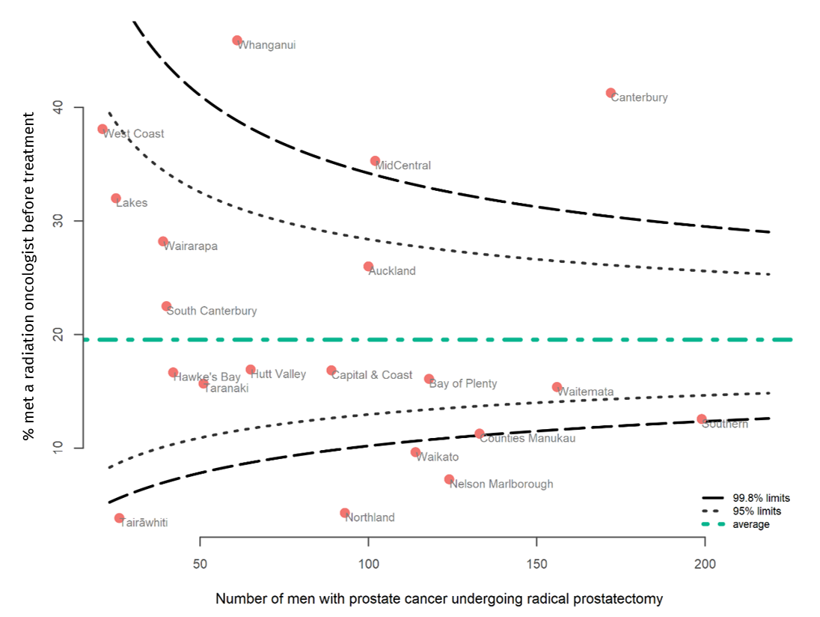

The proportion of men with prostate cancer who were reported to have met with a radiation oncologist before their treatment was higher in 2017 (21.5 percent) and 2018 (21.4 percent) than in 2016 (15.1 percent), as shown in Table 3 on the next page. Men with prostate cancer aged 50–59 (14.5 percent) were less likely to see a radiation oncologist compared to men aged 60–69 (21.7 percent).

Table 3: Proportion of men with prostate cancer being considered for radical prostatectomy who met with a radiation oncologist before treatment, including remote consultations, 2016–18
 | Men with prostate cancer having a radical prostatectomy | Met with a  radiation oncologist
 | N | N | %
Total | 1,770 | 346 | 19.5
Year of diagnosis
2016 | 536 | 81 | 15.1
2017 | 594 | 128 | 21.5
2018 | 640 | 137 | 21.4
Age group (years)
18–49 | 41 | 11 | 26.8
50–59 | 392 | 57 | 14.5
60–69 | 1,067 | 232 | 21.7
70–74 | 215 | 38 | 17.7
75+ | 55 | 8 | 14.5
Ethnic group
Māori | 142 | 23 | 16.2
Pacific | 63 | 16 | 25.4
Asian | 60 | 17 | 28.3
European/Other | 1,486 | 289 | 19.4
Unknown | 19 | 1 | 5.3
NZDep2013 quintile
1 = least deprived | 319 | 53 | 16.6
2 | 365 | 74 | 20.3
3 | 392 | 74 | 18.9
4 | 373 | 80 | 21.4
5 = most deprived | 320 | 64 | 20.0
Gleason score
4/5 | 0 | 0 | NA
6 | 310 | 60 | 19.4
7 | 1,060 | 240 | 22.6
8–10 | 320 | 46 | 14.4
Unknown | 80 | 0 | 0
ISUP grade group
1 | 310 | 60 | 19.4
2 | 713 | 170 | 23.8
3 | 347 | 70 | 20.2
4 | 204 | 28 | 13.7
5 | 116 | 18 | 15.5
Unknown | 80 | 0 | 0

Comparison
No comparable international data is available for this indicator.

Recommendations
Overall, the proportion of men with prostate cancer who were reported to have met with a radiation oncologist before their radical prostatectomy was low. It varied significantly across the country and was very low in some areas. The data used to generate the funnel plot in Figure 1 are provided in Table 9 in Appendix B. The highest is 45.9 percent and the lowest is 3.8 percent. This level of variation is not appropriate and warrants investigation. DHBs with low percentages should consider how these men can be supported to access specialist radiation oncology advice.

The reasons for the low rates are not known at this time. One of the DHBs with a low percentage reviewed its data and found that radiation oncology consultations before radical prostatectomy were not being offered – rather than being offered and declined, which was originally thought to be the case. It is recommended that other DHBs with low percentages also look into their data to clarify the reason for their low rates.

The appropriate level for this indicator is yet to be decided, but we need to ensure equitable and standardised access to well-timed radiation oncology consultation services across all DHBs and to improve the rates in the future. As radiation treatment facilities are generally located in larger city centres, options may be needed to provide accessible services, such as remote consultations, for patients in smaller centres and rural areas.

Radiation treatment and surgery have equivalent survival outcomes for prostate cancer. Therefore, the treatment method is generally decided by the patient rather than the multidisciplinary team caring for him. For this reason, it is important to ensure men receive evidence-based and personalised information about their treatment options by a treatment specialist (eg, a radiation oncologist for radiation treatment or a urologist who performs radical prostatectomy). Cancer nurse specialists also play an important role in helping communicate treatment options to men and their whānau. Tailored information will support patients in their choice of treatment and inform them of the intent and possible side effects of their preferred option.

All DHBs should consider implementing standardised referral pathways including radiation oncology consultation for all men with prostate cancer, and their whānau, who are considering radical treatment.

Equitable access to treatment

Statement of intent
Men with prostate cancer should receive treatment that is appropriate to their risk group, life expectancy and lifestyle.

Context
Not every man with prostate cancer needs to be treated right away. Men with low-risk prostate cancer are usually best managed with active surveillance. However, many factors need to be considered before deciding the most appropriate intervention, including the extent and grade of tumour, and the patient’s age, expected life span and any other serious health conditions. It is also important to consider the likelihood that treatment will cure the cancer (or help in some other way), the patient’s feelings about the possible side effects from each treatment as well as the opinion of the relevant treatment specialist.

Results
The proportion of men with prostate cancer who received curative treatment (either surgery or radiation) varied significantly across DHBs, ranging from 16.7 percent to 44.5 percent (Figure 2).
Figure 2: Proportion of men diagnosed with prostate cancer who had curative treatment (surgery or radiation), by DHB of residence, 2016–18
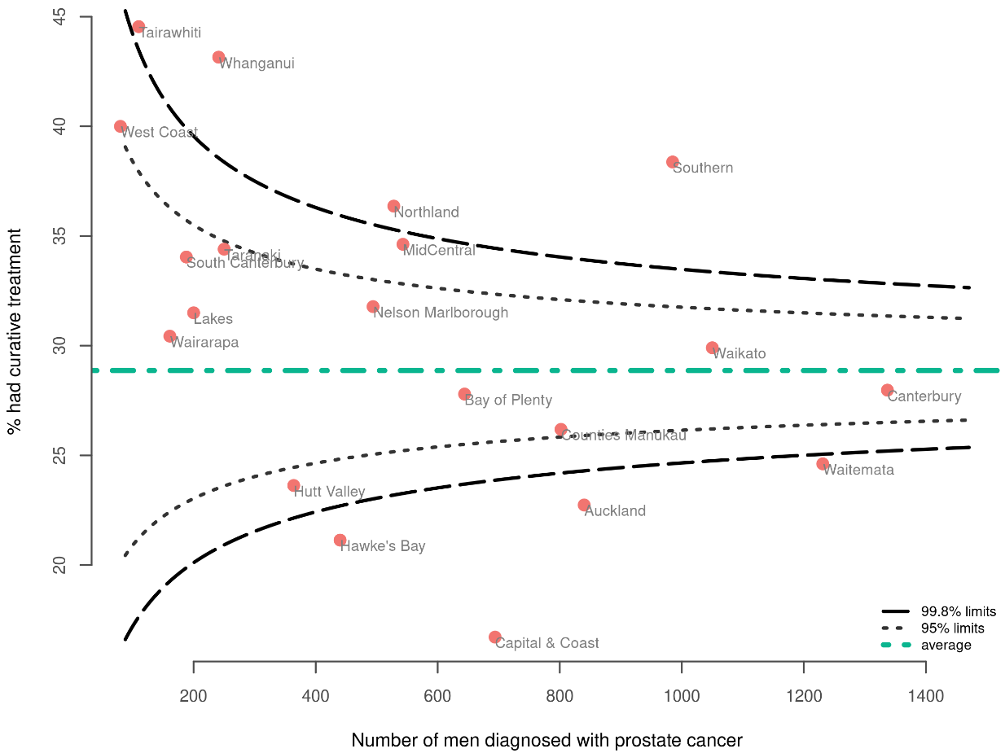

There was substantial variation between DHBs in the use of surgery to treat prostate cancer (Figure 3). The proportion of men with prostate cancer who had radical surgery ranged from 9.5 percent to 26.2 percent across DHBs. Three DHBs were above the upper limits of the funnel plot and five DHBs were below the lower limits.

Figure 3: Proportion of men diagnosed with prostate cancer who had radical surgery, by DHB of residence, 2016–18
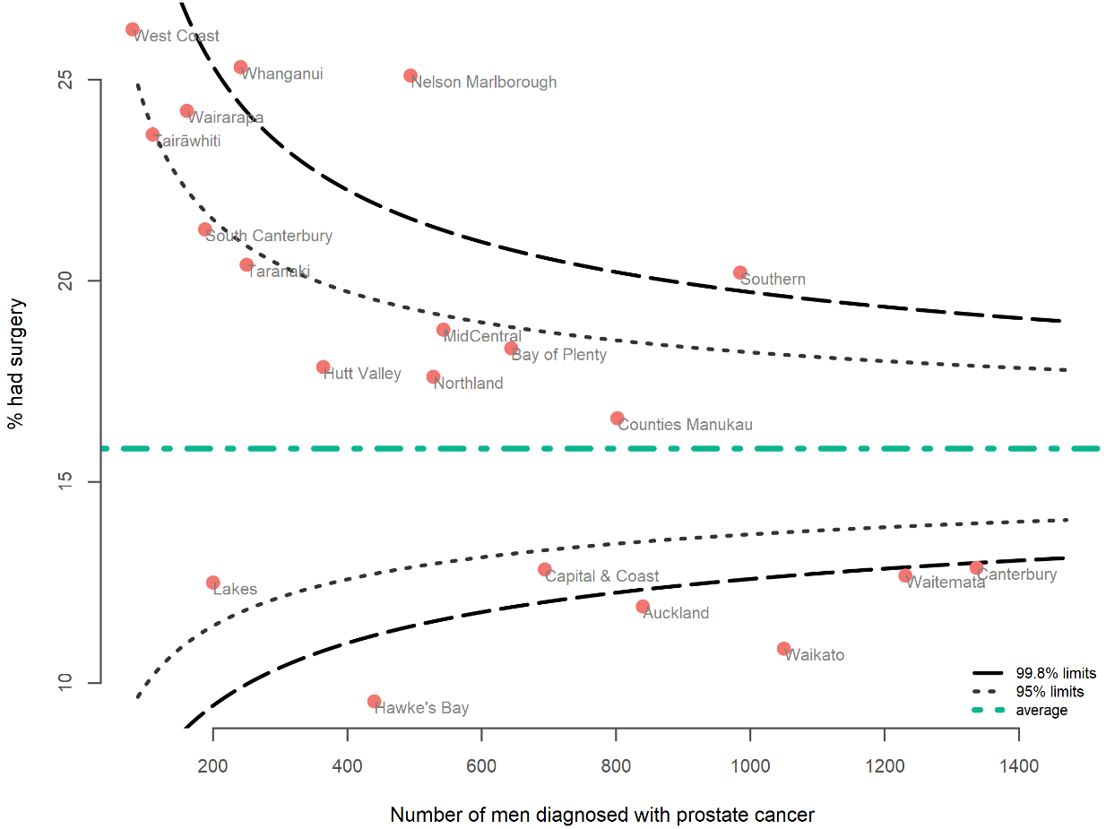

The proportion of those who had curative radiation treatment varied widely across DHBs, ranging from 4.5 percent to 20.9 percent (Figure 4). Two DHBs were above the upper limits of the funnel plot and four DHBs were below the lower limits.

Figure 4: Proportion of men diagnosed with prostate cancer who had curative radiation treatment, by DHB of residence, 2016–18
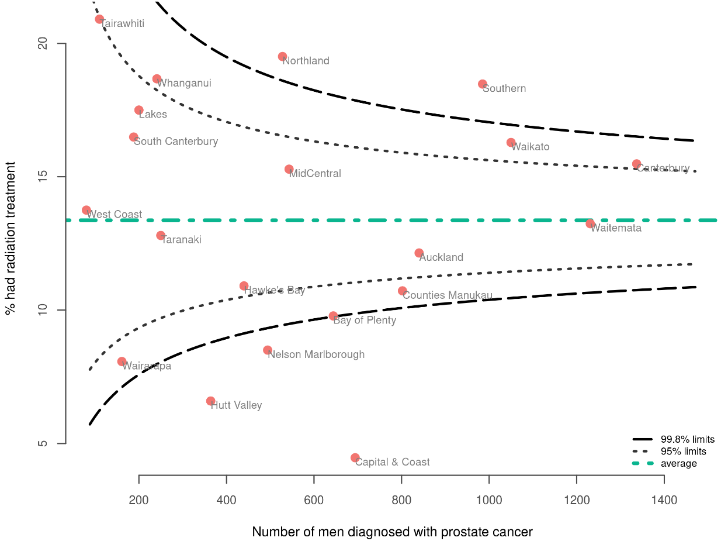

In most DHBs the proportion of men with prostate cancer who had surgery or radiation was similar. However, in four DHBs, the proportion who had radiation was less than half the proportion of those who had surgery. It is unclear whether private treatment data would help explain the number of men undergoing interventions and the type of intervention across New Zealand Aotearoa as a whole.

The proportion of men with prostate cancer who had surgery (15.8 percent) and radiation treatment (13.4 percent) remained generally consistent over the three-year period
(2016–18), as Table 4 indicates. Younger men (under 70 years) were more commonly treated with surgery (21.2 percent) than radiation (10.9 percent). Older men (aged 70 and over) were less likely to have surgery (6.6 percent) than radiation (17.7 percent).

Māori men were more likely to receive publicly funded curative treatment (37.4 percent) compared to European/Other men (27.9 percent), which may be related to private insurance rates. They were also more likely to receive curative radiation treatment (20.0 percent) compared to European/Other men (12.6 percent), which may be because greater comorbidities and higher grade tumours make them less suitable surgical candidates.

Asian men were more likely to receive curative radiation treatment (16.8 percent) compared to European/Other men (12.6 percent).

Men who lived in areas of high socioeconomic deprivation had higher levels of publicly funded treatment (radical surgery or curative radiation treatment) than men living in areas of low socioeconomic deprivation.

Men with high-grade prostate cancer (Gleason score 8–10/ISUP Grade 4 and 5) received more radiation treatment (20.2 percent) than surgery (12.6 percent).

Table 4: Proportion of men diagnosed with prostate cancer who had radical surgery, curative radiation treatment and curative treatment, 2016–18
 | Men with prostate cancer | Had radical surgery |  | Had curative radiation treatment |  | Had curative treatment (surgery or radiation)
 |  | N | % | N | % | N | %
Total | 11,182 | 1,770 | 15.8 | 1,495 | 13.4 | 3,228 | 28.9
Year of diagnosis
2016 | 3,328 | 536 | 16.1 | 430 | 12.9 | 947 | 28.5
2017 | 3,767 | 594 | 15.8 | 534 | 14.2 | 1,099 | 29.2
2018 | 4,087 | 640 | 15.7 | 531 | 13 | 1,182 | 28.9
Age group (years)
18–49 | 170 | 41 | 24.1 | 6 | 3.5 | 46 | 27.1
50–59 | 1,679 | 392 | 23.3 | 115 | 6.8 | 482 | 28.7
60–69 | 5,241 | 1,067 | 20.4 | 651 | 12.4 | 1,683 | 32.1
70–74 | 1,883 | 215 | 11.4 | 429 | 22.8 | 652 | 34.6
75+ | 2,209 | 55 | 2.5 | 294 | 13.3 | 365 | 16.5
Ethnic group
Māori | 860 | 142 | 16.5 | 172 | 20 | 322 | 37.4
Pacific | 355 | 63 | 17.7 | 57 | 16.1 | 115 | 32.4
Asian | 351 | 60 | 17.1 | 59 | 16.8 | 112 | 31.9
European/Other | 9,476 | 1,486 | 15.7 | 1,192 | 12.6 | 2,646 | 27.9
Unknown | 140 | 19 | 13.6 | 15 | 10.7 | 33 | 23.6
NZDep2013 quintile
1 = least deprived | 2,538 | 319 | 12.6 | 244 | 9.6 | 559 | 22.0
2 | 2,237 | 365 | 16.3 | 273 | 12.2 | 615 | 27.5
3 | 2,285 | 392 | 17.2 | 309 | 13.5 | 700 | 30.6
4 | 2,268 | 373 | 16.4 | 356 | 15.7 | 721 | 31.8
5 = most deprived | 1,850 | 320 | 17.3 | 313 | 16.9 | 632 | 34.2
Gleason score
4/5 | 10 | 0 | 0 | 0 | 0 | 0 | 0
6 | 3,533 | 310 | 8.8 | 129 | 3.7 | 434 | 12.3
7 | 4,333 | 1,060 | 24.5 | 845 | 19.5 | 1,855 | 42.8
8–10 | 2,530 | 320 | 12.6 | 511 | 20.2 | 846 | 33.4
Unknown | 776 | 80 | 10.3 | 10 | 1.3 | 93 | 12.0
ISUP grade group
1 | 3,543 | 310 | 8.7 | 129 | 3.6 | 434 | 12.2
2 | 2,753 | 713 | 25.9 | 492 | 17.9 | 1,170 | 42.5
3 | 1,580 | 347 | 22 | 353 | 22.3 | 685 | 43.4
4 | 1,171 | 204 | 17.4 | 259 | 22.1 | 460 | 39.3
5 | 1,359 | 116 | 8.5 | 252 | 18.5 | 386 | 28.4
Unknown | 776 | 80 | 10.3 | 10 | 1.3 | 93 | 12.0

Comparison
The surgical resection rate for New Zealand Aotearoa men with prostate cancer (15.8%) was the same as the rate reported in the United Kingdom (15.7%). However, we do not know the percentage of men accessing privately funded treatment for prostate cancer in either country.

There was variation between DHBs with the number of men receiving curative radiation treatment, and the numbers of men having surgery.

Recommendations
There was wide variation between DHBs in the proportion of men with prostate cancer who had surgery or radiation treatment.

In general, there was no clear correlation between low rates of patients being seen by a radiation oncologist before surgery and low rates of radiation treatment, although this was illustrated at one DHB where 8.5 percent of men had radiation treatment (25.1 percent had surgery) and only 7.3 percent of men were seen by a radiation oncologist.

The higher incidence of surgery in younger men and radiation in older men is expected. Older men are more likely to have other comorbidities that may increase surgical risk, whereas younger men are at higher risk of developing radiation-induced malignancies.

The more frequent use of radiation treatment (along with neoadjuvant/adjuvant androgen deprivation treatment) in men with high-grade disease is expected.

DHBs should investigate their results and consider how to optimise access to curative treatment for men with prostate cancer. Some of the factors that affect whether men received curative treatment include access to:
- MRI staging and targeted biopsies
- prostate-specific membrane antigen staging
- urology services, radiation oncologist consultations and radiation treatment.

Clinical management of patients may include differing selection criteria for active surveillance, radical treatment, and watch and wait.

DHBs should develop standardised national criteria for access to staging tests, clinical services and indications for management.

Length of stay after surgery

Statement of intent
The majority of men with prostate cancer who have a radical prostatectomy should be discharged from hospital within three days after surgery.

Context
Length of stay in hospital following surgery is an indicator of health service efficiency and an important indicator for treatment quality when it comes to faster recovery and fewer complications.

Results
More than half of all men (57.7 percent) were discharged less than three days after surgery for prostate cancer. The proportion of men discharged three or more days after surgery was 42.3 percent, including 10.0 percent who were discharged five or more days after surgery.

The proportion of those discharged three or more days after surgery varied widely across DHBs, ranging from 12.8 percent to 100 percent. Five DHBs were above and five DHBs were below the outer limits of the funnel plot (Figure 5).

Figure 5: Proportion of men with prostate cancer discharged three or more days after surgery, by DHB of residence, 2016–18
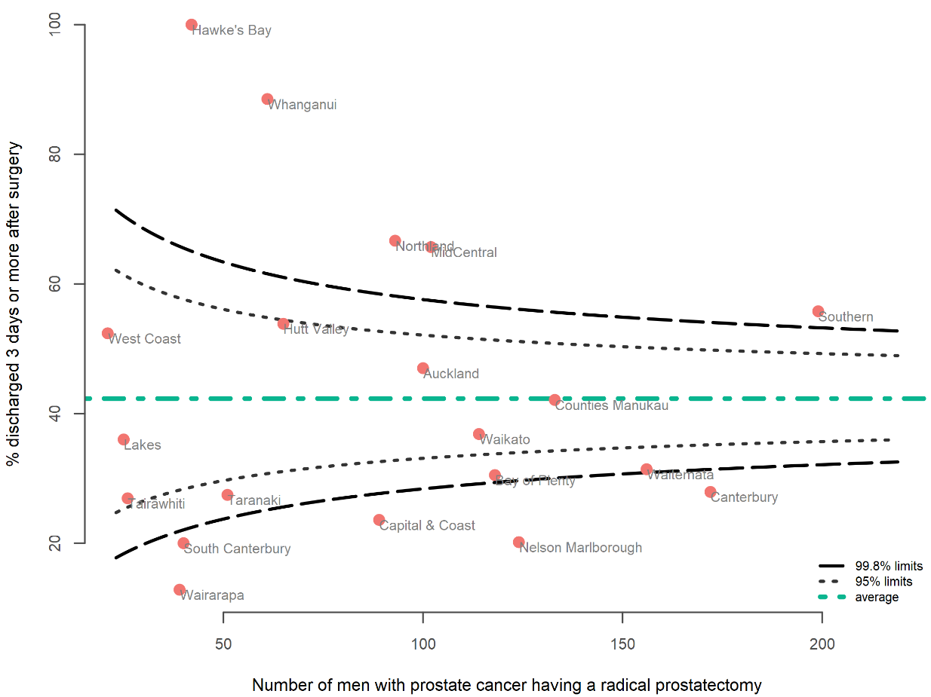

The proportion of men discharged five or more days after surgery also varied widely across DHBs, ranging from 1.6 percent to 35.7 percent. Only one DHB was above and two DHBs were below the outer limits of the funnel plot (Figure 6).

Figure 6: Proportion of men with prostate cancer discharged five or more days after surgery, by DHB of residence, 2016–18
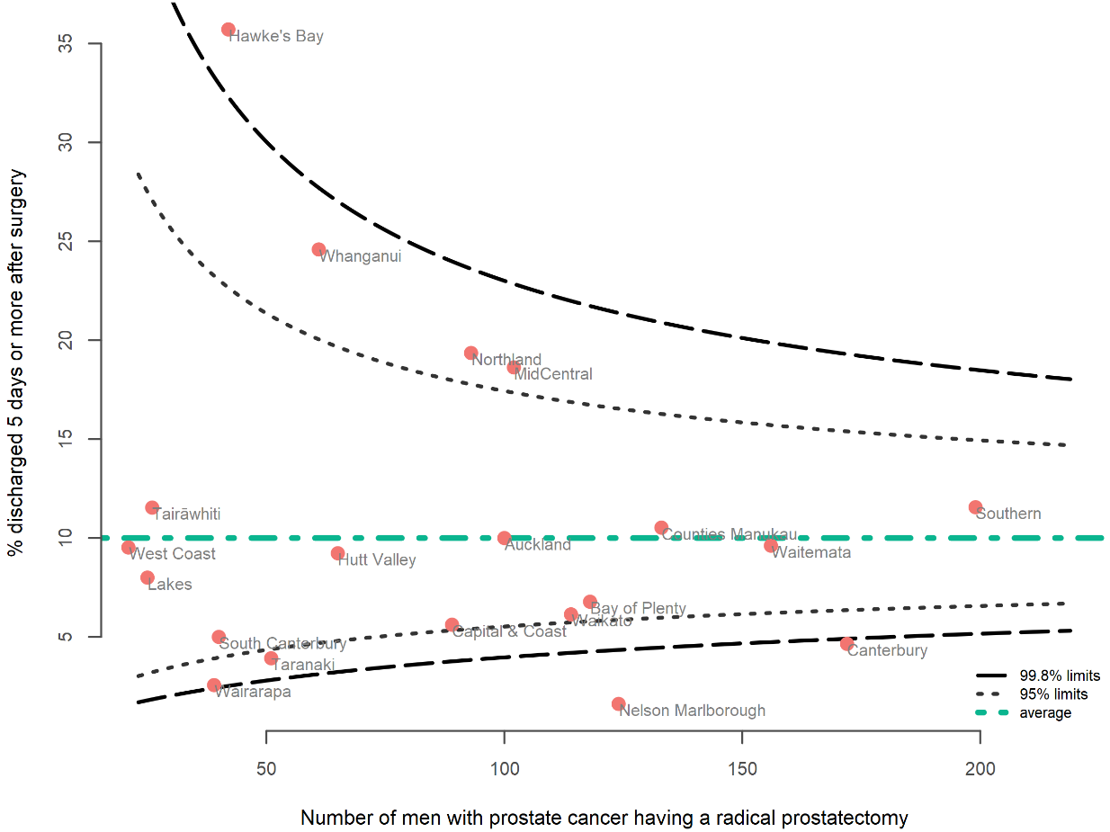

Overall, the median length of stay after surgery decreased from three days to two days between 2016 and 2018. The proportion of men with prostate cancer who were discharged three days or more after surgery decreased from 50.7 percent in 2016 to 35.0 percent in 2018. Similarly, the proportion of men discharged five days or more after surgery decreased from 12.7 percent in 2016 to 7.3 percent in 2018.

Older men (aged 75 and over) stayed longer after surgery compared with other age groups. In this group, 67.3 percent were discharged after three or more days, compared with 38.2 percent discharged after five or more days.

Table 5: Proportion of men with prostate cancer discharged three or more days and five or more days after surgery, 2016–18
 | Men with prostate cancer having a radical prostatectomy | Discharged three or more days after surgery |  | Discharged five or more days after surgery |  | Median length of stay
 | N | N | % | N | % | days
Total | 1,770 | 749 | 42.3 | 177 | 10 | 2
Year of diagnosis
2016 | 536 | 272 | 50.7 | 68 | 12.7 | 3
2017 | 594 | 253 | 42.6 | 62 | 10.4 | 2
2018 | 640 | 224 | 35 | 47 | 7.3 | 2
Age group (years)
18–49 | 41 | 17 | 41.5 | 2 | 4.9 | 2
50–59 | 392 | 165 | 42.1 | 27 | 6.9 | 2
60–69 | 1,067 | 444 | 41.6 | 100 | 9.4 | 2
70–74 | 215 | 86 | 40 | 27 | 12.6 | 2
75+ | 55 | 37 | 67.3 | 21 | 38.2 | 4
Ethnic group
Māori | 142 | 70 | 49.3 | 15 | 10.6 | 2
Pacific | 63 | 28 | 44.4 | 7 | 11.1 | 2
Asian | 60 | 29 | 48.3 | 7 | 11.7 | 2
European/Other | 1,486 | 615 | 41.4 | 146 | 9.8 | 2
Unknown | 19 | 7 | 36.8 | 2 | 10.5 | 2
NZDep2013 quintile
1 = least deprived | 319 | 124 | 38.9 | 28 | 8.8 | 2
2 | 365 | 143 | 39.2 | 34 | 9.3 | 2
3 | 392 | 166 | 42.3 | 42 | 10.7 | 2
4 | 373 | 162 | 43.4 | 34 | 9.1 | 2
5 = most deprived | 320 | 154 | 48.1 | 39 | 12.2 | 2
Gleason score
4/5 | 0 | 0 |  | 0
6 | 310 | 120 | 38.7 | 27 | 8.7 | 2
7 | 1,060 | 409 | 38.6 | 67 | 6.3 | 2
8–10 | 320 | 155 | 48.4 | 27 | 8.4 | 2
Unknown | 80 | 65 | 81.2 | 56 | 70 | 8
ISUP grade group
1 | 310 | 120 | 38.7 | 27 | 8.7 | 2
2 | 713 | 253 | 35.5 | 38 | 5.3 | 2
3 | 347 | 156 | 45 | 29 | 8.4 | 2
4 | 204 | 91 | 44.6 | 14 | 6.9 | 2
5 | 116 | 64 | 55.2 | 13 | 11.2 | 3
Unknown | 80 | 65 | 81.2 | 56 | 70 | 8

Comparison
There is no comparable international data available for this indicator.

Recommendations
There was a consistent reduction in the length of stay after surgery during the period analysed. This may indicate an improvement in the quality of treatment. However, several factors determine the length of stay required after surgery. These include the criteria used to select men who would benefit from surgery (case selection), preoperative activities (care and education), whether there are any complications after surgery, and the availability of community services and support after surgery. We recommend that DHBs investigate their length of stay results and compare their results with other DHBs. This will help DHBs identify where they can improve processes and support for men with prostate cancer undergoing surgery.

Medical oncology review of men with advanced disease

Statement of intent
The majority of men with newly diagnosed castrate-sensitive metastatic prostate cancer should consult with a medical oncologist regarding the addition of systemic treatment to androgen deprivation (hormone) therapy. This should occur within two months of starting the therapy, and may include remote consultations, if necessary, so they are fully informed when making decisions about their systemic treatment options (eg, chemotherapy, novel hormonal therapies).

Patients with metastatic disease that becomes castrate resistant also need to consult with a medical oncologist.

Context
International studies have shown that men with metastatic prostate cancer who receive chemotherapy or novel hormonal therapy when starting androgen deprivation therapy have increased survival rates.

This indicator is used to provide a measure of referral rates to medical oncology. It is currently not possible to accurately identify the start date for androgen deprivation therapy, or to consistently identify men who have metastatic prostate cancer from national data collections.

Because it is difficult to reliably identify men with metastatic cancer, we are using a proxy cohort of men who had prostate cancer listed as their cause of death as the denominator to calculate this indicator. This will undercount the total number of men diagnosed with metastatic cancer but will allow an estimation of this indicator in a subset of those men.

As the collection of stage and medical oncology data improves, we will be able to more accurately measure and report this indicator.

Unlike the other QPIs, which use the 2016-18 time period, the data for this QPI is from 2017–19. To calculate this QPI, we extracted all records for men with prostate cancer as the primary cause of death between 1 January 2017 and 31 December 2019 from the mortality collection at the Ministry of Health. The different time period used is because we have allowed for a 12-month lag for deaths to be registered in the national mortality collection.

Results
In contrast to the other indicators in this report, which are based on men who were diagnosed with prostate cancer and reported to the NZCR, this indicator is based on men whose primary cause of death was prostate cancer.

Overall, 38.7 percent of men who died from prostate cancer had had a first specialist appointment with a medical oncologist (24.7 percent in the two years before death and 14.0 percent within two or more years).

Men aged 75 years and older were less likely to see a medical oncologist (Table 6).

The proportion of men who died from prostate cancer who had had a first specialist appointment with a medical oncologist varied by DHB (ranging from 18.5 to 57.7 percent). Two DHBs were below the lower limits of the funnel plot (Figure 7).

Figure 7: Proportion of men who died from prostate cancer who had a first specialist appointment with a medical oncologist by DHB of residence, 2017–19
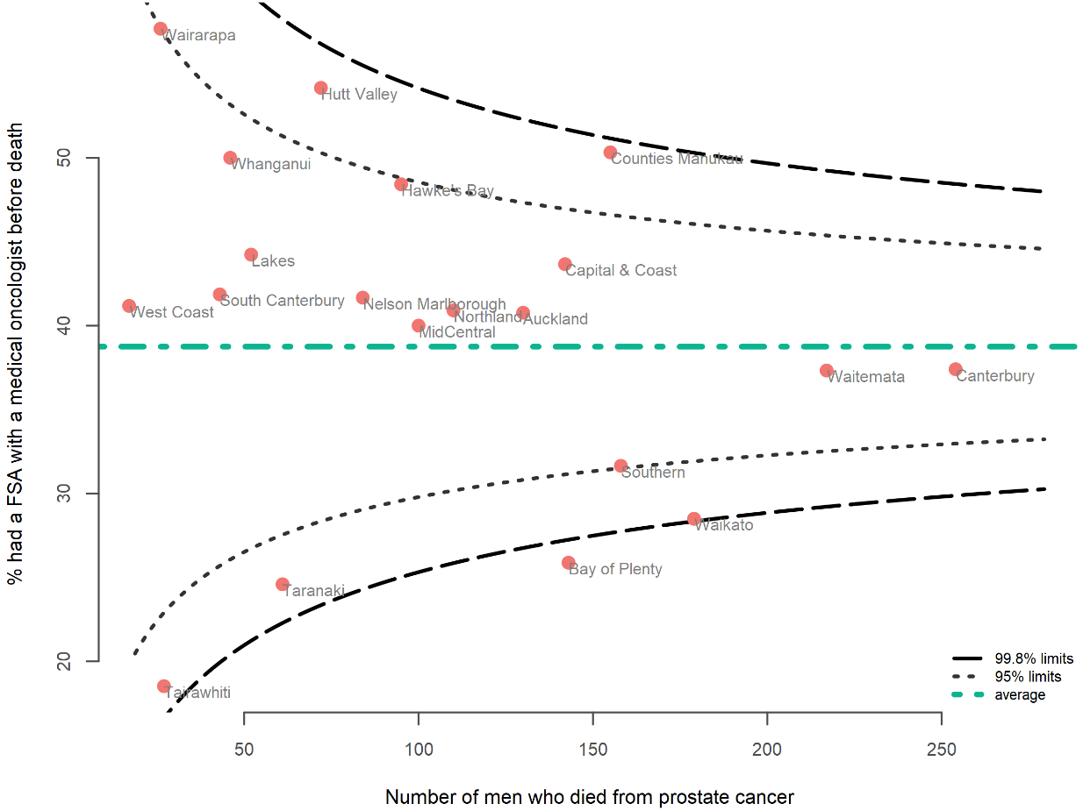

Table 6: Proportion of men who died from prostate cancer who had a first specialist appointment with a medical oncologist, 2017–19
 | Men who died from prostate cancer | Had medical oncology  first specialist appointment
 | N | N | %
Total | 2,111 | 818 | 38.7
Year of death
2017 | 704 | 266 | 37.8
2018 | 693 | 260 | 37.5
2019 | 714 | 292 | 40.9
Age group (years)
18–49 | 4 | 4 | 100
50–59 | 49 | 35 | 71.4
60–69 | 224 | 144 | 64.3
70–74 | 243 | 161 | 66.3
75+ | 1,591 | 474 | 29.8
Ethnic group
Māori | 174 | 67 | 38.5
Pacific | 69 | 38 | 55.1
Asian | 49 | 28 | 57.1
European/Other | 1,819 | 685 | 37.7
NZDep2013 quintile
1 =least deprived | 336 | 146 | 43.5
2 | 406 | 154 | 37.9
3 | 462 | 171 | 37.0
4 | 495 | 185 | 37.4
5 = most deprived | 412 | 162 | 39.3

Comparison
No comparable international data was available.

Recommendations
Overall, the results indicate a wide range across DHBs in access to medical oncology for men diagnosed with metastatic disease. These results provide a starting point for further investigation into the reasons for and resolution of any unwarranted variation. One possibility is that education may be needed regarding identification of patients who are eligible for chemotherapy.

- : Methods
- Methods summary
We extracted data from the NZCR for people diagnosed with prostate cancer from 1 January 2016 to 31 December 2018. For the purpose of this report, our data set only includes people with a new primary diagnosis of prostate cancer.

We linked data from the Ministry of Health’s national collections to the cancer registrations at the patient level using National Health Index (NHI) numbers to obtain information on patient care and follow-up.

We used funnel plots to make comparisons between DHBs. There were no adjustments of outcomes for patient-case mix.
- Data sources
All patient data for this report came from administrative data sets held within the Ministry of Health’s national data collections. These include only publicly funded treatments following diagnosis for men diagnosed with prostate cancer in New Zealand Aotearoa between 1 January 2016 and 31 December 2018.

For the medical oncology indicator, we extracted all records for men with prostate cancer as the primary cause of death between 1 January 2017 and 31 December 2019 from the mortality collection at the Ministry of Health.
- Data links

New Zealand Cancer Registry
The New Zealand Cancer Registry is a population-based registry. It is the most comprehensive source of information on people who have been diagnosed with malignant cancer in Aotearoa, New Zealand. It is primarily based on pathology reporting but includes information from other sources, including death certificates and reviews of the diagnosis coding for people admitted to public hospitals.

National Minimum Data Set
The National Minimum Data Set (NMDS) is a national collection of public and private hospital discharge information, including coded clinical data for inpatients and day patients.

Linking NZCR data to NMDS data gave us a view of the procedures each patient underwent when treated in public hospitals leading up to and following their prostate cancer diagnosis.

Radiation Oncology Collection
The Radiation Oncology Collection is a national collection of data about private and public courses of radiation therapy delivered.

Treatment centres have submitted data electronically in an agreed format since 2018, although most providers have also supplied historical data to 2012.

Data collected for each course of radiation therapy delivered includes treatment centre, diagnosis code (according to the International Statistical Classification of Diseases and Related Health Problems, Tenth Revision, Australian Modification (ICD-10-AM), 8th edition), treatment site, intent of the treatment, dose, fractions and number of treatment sessions.

Only publicly funded radiation therapy treatments were extracted from this collection for linking with the NZCR data. We included only doses and fractions consistent with curative radiation treatment (ie, we excluded doses and fractions indicating salvage bed radiation treatment).

National Non-Admitted Patients Collection
The National Non-Admitted Patients Collection (NNPAC) information includes event-based purchase units that relate to medical and surgical outpatient events and ED events. This includes information on the type of service provided and the health specialty involved.

The NNPAC allows the Ministry of Health and DHBs to monitor outpatient activity and ensure that DHBs are appropriately remunerated for the services they provide.

The NNPAC provides consistent nationwide data on non-admitted patient (outpatient and ED) activity.

Mortality Collection
The Mortality Collection (MORT) classifies the underlying cause of death for all deaths registered in New Zealand, and all registerable stillbirths (fetal deaths).

MORT combines death registration and stillbirth registration data with cause of death information, which is then collated and coded to create national cause of death statistics.

- Data processing
We used existing data within the Ministry of Health’s national collections to analyse the QPIs. No data was provided by DHBs specifically for these indicators.

We used routinely available national administrative data sources to work through individual patients’ cancer journeys for all men diagnosed with prostate cancer between 1 January 2016 and 31 December 2018 and examined the sequence of events that took them to that diagnosis, treatment and outcome. These routes to diagnosis included ED presentation or referral to a clinic (as inpatients (NMDS) or outpatients (NNPAC)).

We linked prostate cancer patients from the NZCR to data sources within the national collections using encrypted NHIs.

A patient is considered diagnosed with primary prostate cancer when he is registered on the NZCR for the first time with a diagnosis of prostate cancer. We defined prostate cancer as C61 according to the ICD-10-AM, 8th edition. We assumed a patient’s diagnosis to be the first diagnosis if we could identify no previous diagnosis for that patient in the NZCR since 1 January 1995.

We excluded from all analyses men who were registered on the NZCR from death certificates only.

Figure 8: Summary of men who were diagnosed with prostate cancer, 2016–18
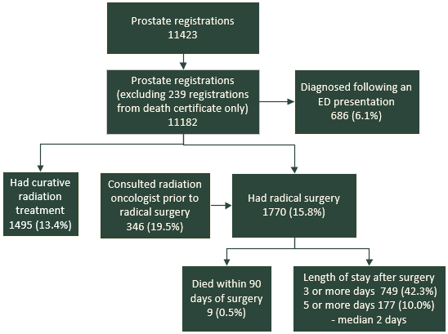

We included cancer registrations using the morphology recorded on the NZCR (Table 7).

Table 7: Number of people on the NZCR with prostate cancer by morphology code and description, 2016–18
Morphology code | Morphology description | Total people  (N)
8000 | Neoplasm, malignant | 437
8010 | Carcinoma, not otherwise specified | 10
8140 | Adenocarcinoma, not otherwise specified | 10,595
8255 | Adenocarcinoma with mixed subtypes | 109
8480 | Mucinous adenocarcinoma | 1
8481 | Mucin-producing adenocarcinoma | 1
8490 | Signet ring cell carcinoma | 1
8500 | Prostate cancer – not otherwise specified | 18
8574 | Adenocarcinoma with neuroendocrine differentiation | 10
Total |  | 11,182

- Data completeness
We defined data completeness as the proportion of people with complete data on all variables: age; sex; pathological tumour, node, metastasis (TNM) stage; and site of cancer, as we will use these to calculate a risk group in the future. The risk group will also need data on the pre-treatment serum PSA result and clinical stage. We only assessed data completeness in patients who underwent major surgery for prostate cancer because only in these patients could we expect all data items to be complete.

Table 8: Men who had prostate cancer surgery with pathological tumour, node, metastasis stage available on the NZCR, 2016–18
Year | Total people | Tumour  (T) |  | Node  (N) |  | Metastases  (M) |  | Any  (T, N or M) |  | All  (T, N and M)
 | N | N | % | N | % | N | % | N | % | N | %
2016 | 536 | 230 | 42.9 | 163 | 30.4 | 6 | 1.1 | 230 | 42.9 | 6 | 1.1
2017 | 594 | 284 | 47.8 | 212 | 35.7 | 16 | 2.7 | 284 | 47.8 | 16 | 2.7
2018 | 640 | 290 | 45.3 | 206 | 32.2 | 7 | 1.1 | 290 | 45.3 | 7 | 1.1
Total | 1,770 | 804 | 45.4 | 581 | 32.8 | 29 | 1.6 | 804 | 45.4 | 29 | 1.6

The Ministry’s national data collections have high rates of completion of data fields. For patients undergoing major surgery, data included sex, age and site of cancer.

While most cases of prostate cancer reported to the NZCR are derived from positive histology or cytology, a proportion are reported from radiology reports, admissions coding or death certificates, as required by the Cancer Registry Act 1993.

This introduces a potential source of bias in identifying people with cancer and is relevant to all international cancer registries that use multi-source case identification methods.

Large variances in the proportion of patients diagnosed by histology or cytology may be due to differences in case ascertainment or case identification. This may affect indicator interpretation related to case denominator. A focused audit of hospitals with outlier status of cases with histological confirmation may identify possible issues with case ascertainment.
- Privately funded service provider data
The national data collections include all publicly funded hospital events. Private hospitals in New Zealand Aotearoa have recently begun voluntary submission of treatment data, but reporting was incomplete from 2016 to 2018. Therefore, this report does not include private care events. We hope that future quality reports will include this data.
- Definitions derived from national data collections
Men diagnosed following an ED presentation were defined as men who have an ED presentation (from NNPAC) or admission (from NMDS) in the two weeks before their date of diagnosis.

Men with surgical resection for prostate cancer were derived from the procedures coded on inpatient admitted events (from NMDS) where the procedure was one of 12 procedures identified as curative surgery for prostate cancer.

Men who consulted a radiation oncologist before radical surgery were derived from NMDS inpatient admitted events and NNPAC radiation oncology first specialist appointments.

Men receiving radiation treatment were derived from the Radiation Oncology Collection data using indication of curative intent of the course of treatment.

Men who died of prostate cancer as their primary cause of death were derived from the Mortality Collection and linked to NNPAC first specialist appointments for medical oncology.
- Statistical analysis
Most results discussed in this report are descriptive. We report the results of categorical data as percentages. We typically group results by DHB of residence (ie, where the patient resided at the time of diagnosis).

We also present results by year of diagnosis, ethnic group (prioritised), sex, age group (years) and NZDep2013 (Atkinson et al 2014) quintile (based on domicile at the time of diagnosis) in the data tables in Appendix B.

We have not presented results in the tables when there are fewer than 10 people in the denominator.

Funnel plots
This report uses funnel plots to compare between DHBs. We plot the rate for each DHB against the total number of patients used to estimate the rate. The average across all DHBs appears as an orange line.

The funnel limits depend on the average rate and the number of patients included in the estimate; rate estimates have greater uncertainty when estimated from fewer patients. Results fall outside the inner limits if they are statistically different from the average at a 95 percent confidence limit, and outside the outer limits if they are statistically significantly different from the average at a 99.8 percent confidence limit.

Adjusted outcomes
No risk adjustment was made to the data due to missing stage data and other risks, such as comorbidity.

We encourage service providers to interpret their results in context of the case mix of their unit. Data is stratified and presented in data tables in Appendix B. Stratifying variables include age group, sex, ethnic group (prioritised) and NZDep2013 quintile with data from the NZCR. Other variables (such as risk group, performance status, TNM group stage and comorbidity) are not available in the national data collections but should be available in local DHB records.
- : DHB result tables
Table 9: Proportion of men with prostate cancer being considered for radical prostatectomy who met with a radiation oncologist prior to treatment, including remote consultations, by DHB of residence, 2016–18
DHB of residence | Men with prostate cancer who  had a radical prostatectomy | Met with a radiation oncologist before surgery
 | N | N | %
Northland | 93 | 4 | 4.3
Waitemata | 156 | 24 | 15.4
Auckland | 100 | 26 | 26.0
Counties Manukau | 133 | 15 | 11.3
Waikato | 114 | 11 | 9.6
Lakes | 25 | 8 | 32.0
Bay of Plenty | 118 | 19 | 16.1
Tairāwhiti | 26 | 1 | 3.8
Taranaki | 51 | 8 | 15.7
Hawke's Bay | 42 | 7 | 16.7
Whanganui | 61 | 28 | 45.9
MidCentral | 102 | 36 | 35.3
Capital & Coast | 89 | 15 | 16.9
Hutt Valley | 65 | 11 | 16.9
Wairarapa | 39 | 11 | 28.2
Nelson Marlborough | 124 | 9 | 7.3
West Coast | 21 | 8 | 38.1
Canterbury | 172 | 71 | 41.3
South Canterbury | 40 | 9 | 22.5
Southern | 199 | 25 | 12.6

Table 10: Men diagnosed with prostate cancer and curative treatment type received, by DHB of residence, 2016–18
DHB of residence | Men with prostate cancer | Had radical surgery |  | Had curative radiation |  | Had curative treatment (surgery or radiation)
 | N | N | % | N | % | N | %
Northland | 528 | 93 | 17.6 | 103 | 19.5 | 192 | 36.4
Waitemata | 1,231 | 156 | 12.7 | 163 | 13.2 | 303 | 24.6
Auckland | 840 | 100 | 11.9 | 102 | 12.1 | 191 | 22.7
Counties Manukau | 802 | 133 | 16.6 | 86 | 10.7 | 210 | 26.2
Waikato | 1,050 | 114 | 10.9 | 171 | 16.3 | 314 | 29.9
Lakes | 200 | 25 | 12.5 | 35 | 17.5 | 63 | 31.5
Bay of Plenty | 644 | 118 | 18.3 | 63 | 9.8 | 179 | 27.8
Tairāwhiti | 110 | 26 | 23.6 | 23 | 20.9 | 49 | 44.5
Taranaki | 250 | 51 | 20.4 | 32 | 12.8 | 86 | 34.4
Hawke's Bay | 440 | 42 | 9.5 | 48 | 10.9 | 93 | 21.1
Whanganui | 241 | 61 | 25.3 | 45 | 18.7 | 104 | 43.2
MidCentral | 543 | 102 | 18.8 | 83 | 15.3 | 188 | 34.6
Capital & Coast | 694 | 89 | 12.8 | 31 | 4.5 | 116 | 16.7
Hutt Valley | 364 | 65 | 17.9 | 24 | 6.6 | 86 | 23.6
Wairarapa | 161 | 39 | 24.2 | 13 | 8.1 | 49 | 30.4
Nelson Marlborough | 494 | 124 | 25.1 | 42 | 8.5 | 157 | 31.8
West Coast | 80 | 21 | 26.2 | 11 | 13.8 | 32 | 40
Canterbury | 1,337 | 172 | 12.9 | 207 | 15.5 | 374 | 28
South Canterbury | 188 | 40 | 21.3 | 31 | 16.5 | 64 | 34
Southern | 985 | 199 | 20.2 | 182 | 18.5 | 378 | 38.4

Table 11: Men diagnosed with prostate cancer and length of stay after surgery, by DHB of residence, 2016–18
DHB of residence | Men with prostate cancer having a radical prostatectomy | Discharged three or more days after surgery |  | Discharged five or more days after surgery |  | Median length of stay
 | N | N | % | N | % | (days)
Northland | 93 | 62 | 66.7 | 18 | 19.4 | 3
Waitemata | 156 | 49 | 31.4 | 15 | 9.6 | 2
Auckland | 100 | 47 | 47.0 | 10 | 10.0 | 2
Counties Manukau | 133 | 56 | 42.1 | 14 | 10.5 | 2
Waikato | 114 | 42 | 36.8 | 7 | 6.1 | 2
Lakes | 118 | 36 | 30.5 | 8 | 6.8 | 2
Bay of Plenty | 26 | 7 | 26.9 | 3 | 11.5 | 2
Tairāwhiti | 25 | 9 | 36.0 | 2 | 8.0 | 2
Taranaki | 51 | 14 | 27.5 | 2 | 3.9 | 2
Hawke's Bay | 42 | 42 | 100.0 | 15 | 35.7 | 4
Whanganui | 62 | 55 | 88.7 | 16 | 25.8 | 3
MidCentral | 102 | 67 | 65.7 | 19 | 18.6 | 3
Capital & Coast | 90 | 22 | 24.4 | 6 | 6.7 | 2
Hutt Valley | 65 | 35 | 53.8 | 6 | 9.2 | 3
Wairarapa | 39 | 5 | 12.8 | 1 | 2.6 | 2
Nelson Marlborough | 124 | 25 | 20.2 | 2 | 1.6 | 2
West Coast | 21 | 11 | 52.4 | 2 | 9.5 | 3
Canterbury | 172 | 48 | 27.9 | 8 | 4.7 | 2
South Canterbury | 40 | 8 | 20.0 | 2 | 5.0 | 2
Southern | 199 | 111 | 55.8 | 23 | 11.6 | 3

Table 12: Proportion of men who died from prostate cancer who had a first specialist appointment with a medical oncologist, by DHB of residence, 2017–19
DHB of residence | Men who died from prostate cancer | Had medical oncology first specialist appointment
 | N | N | %
Northland | 110 | 45 | 40.9
Waitemata | 217 | 81 | 37.3
Auckland | 130 | 53 | 40.8
Counties Manukau | 155 | 78 | 50.3
Waikato | 179 | 51 | 28.5
Lakes | 52 | 23 | 44.2
Bay of Plenty | 143 | 37 | 25.9
Tairāwhiti | 27 | 5 | 18.5
Taranaki | 61 | 15 | 24.6
Hawke's Bay | 95 | 46 | 48.4
Whanganui | 46 | 23 | 50
MidCentral | 100 | 40 | 40
Capital & Coast | 142 | 62 | 43.7
Hutt Valley | 72 | 39 | 54.2
Wairarapa | 26 | 15 | 57.7
Nelson Marlborough | 84 | 35 | 41.7
West Coast | 17 | 7 | 41.2
Canterbury | 254 | 95 | 37.4
South Canterbury | 43 | 18 | 41.9
Southern | 158 | 50 | 31.6

- : References
Gurney J, Stanley J, McLeod M, et al. 2020. Disparities in cancer-specific survival between Māori and non-Māori New Zealanders, 2007–2016. JCO Global Oncology (6): 766–74.
Health and Disability Commissioner. 2015. Delayed Diagnosis of Cancer in Primary Care: Complaints to the Health and Disability Commissioner 2004–2013. Auckland: Health and Disability Commissioner.
International Agency for Research on Cancer. 2019. Reducing Social Inequalities in Cancer: Evidence and priorities for research. Lyon FR. International Agency for Research on Cancer.
Koia M, Te WI, Webster J. 2020. Deep Dive Feedback Report: June 2020. URL: https://centralcancernetwork.org.nz/wp-content/uploads/2020/06/New-J402106-Deep-Dive-Feedback-Report-June-2020.pdf (accessed 1 March 2021).
McMenamin J. 2020. Cancer care at a crossroads: realising the potential in primary care in New Zealand. Journal of Cancer Policy 23: 100213.
Ministry of Health. 2016. Cancer: New registrations and deaths 2013. Wellington: Ministry of Health.
Ministry of Health. 2019a. Achieving Equity in Health Outcomes: Summary of a discovery process. Wellington: Ministry of Health.
Ministry of Health. 2019b. New Zealand Cancer Action Plan 2019–2029 – Te Mahere mō te Mate Pukupuku o Aotearoa 2019–2029 (ed RJ 2020). Wellington: Ministry of Health.
Ministry of Health. 2019c. Wai 2575 Māori Health Trends Report. Wellington: Ministry of Health.
National Cancer Registration and Analysis Service. 2021. Official Statistics: Emergency Presentations. URL: http://www.ncin.org.uk/cancer_type_and_topic_specific_work/topic_specific_work/cancer_outcome_metrics (accessed 2 March 2021).

- : Working group members
The National Urological Cancer Working Group comprised:

Chair
Mr Andrew Williams, Urologist, Auckland and Counties Manukau District Health Board

Deputy Chair
Dr Suzanne Beuker, Urologist, Nelson Marlborough District Health Board

Members
Emma Drake, Cancer Nurse Specialist, Southern District Health Board
Dr Peter Fong, Medical Oncologist, Auckland District Health Board
Dr Jason Gurney, Senior Research Fellow, Cancer Control and Screening Research Group, University of Otago
Tui Hancock, Whānau Ora Nurse Practitioner, Central Primary Health Organisation
Sharon Harber, Cancer Nurse Specialist, South Canterbury District Health Board
Mr Quinten King, Urologist, MidCentral District Health Board
Madhu Koya, Consultant Urologist, Waitemata District Health Board
Dr Remy Lim, Consultant Radiologist, Auckland District Health Board
Rob Macfarlane, Consumer
Mr Stephen Mark, Urologist, Canterbury District Health Board
Dr John Matthews, Consultant Radiation Oncologist, Auckland DHB
Sarah Mortimer, Operations Manager, Blood, Cancer, Renal & Palliative Care, Capital & Coast District Health Board
Tiffany Schwass, Cancer Nurse Specialist, Waikato District Health Board
Dr Alvin Tan, Medical Oncologist, Waikato District Health Board
Mr Simon van Rij, Urologist, Auckland District Health Board
Dr Jonathan Zwi, Pathologist, Auckland District Health Board

The ACT-NOW project was launched in late 2018 by the Ministry of Health. It aims to develop a detailed database of information on patients receiving systemic anti-cancer therapy across New Zealand Aotearoa. This will help identify and reduce variation, enhance equity of access, and support resource planning.
Hormone therapy for prostate cancer is also known as androgen deprivation therapy. Prostate cancer cannot grow or survive without androgens, which include testosterone and other male hormones. Hormone therapy decreases the level of androgens in a man's body.

