Prostate Cancer Quality Performance Indicator Specifications
2021

Citation: Te Aho o Te Kahu. 2021. Prostate Cancer Quality Performance Indicator Specifications. Wellington: Te Aho o Te Kahu.
Published in September 2021 by Te Aho o Te Kahu
PO Box 5013, Wellington 6140, New Zealand
ISBN 978-1-99-100755-1 (online)
HP 7847
This document is available at teaho.govt.nz
This work is licensed under the Creative Commons Attribution 4.0 International licence. In essence, you are free to: share ie, copy and redistribute the material in any medium or format; adapt ie, remix, transform and build upon the material. You must give appropriate credit, provide a link to the licence and indicate if changes were made.

Contents
Introduction 1
PCQI 1. Route to diagnosis 2
Sources of data for indicator 2
Data items 2
Case eligibility criteria (denominator) 4
Numerator criteria 5
Flow diagram 5
PCQI 5. Discussion with radiation oncologist 6
Sources of data for indicator 6
Data items 6
Case eligibility criteria (denominator) 8
Numerator criteria 9
Surgical procedure codes and descriptions 9
Purchase unit codes and descriptions 10
Flow diagram 10
PCQI 9. Equitable access to treatment 11
Sources of data for indicator 11
Data items 11
Case eligibility criteria (denominator) 13
Numerator criteria 14
Surgical procedure codes and descriptions 15
Flow diagram 16
PCQI 8. Length of stay after surgery 17
Sources of data for indicator 17
Data items 17
Case eligibility criteria (denominator) 19
Numerator criteria 20
Surgical procedure codes and descriptions 20
Flow diagram 21
PCQI 6. Medical oncology review of men with advanced disease 22
Sources of data for indicator 22
Data items 22
Case eligibility criteria (denominator) 23
Numerator criteria 24
Purchase unit codes 24
Flow diagram 25

Introduction
Te Aho o Te Kahu, the Cancer Control Agency (Te Aho o Te Kahu) and the National Urological Cancer Working Group (the working group) worked together to identify a set of 13 quality performance indicators (QPIs) for prostate cancer.

The Prostate Cancer Quality Improvement Indicators (Descriptions) document sets out descriptions of and the evidence and rationale for the full set of 13 QPIs.

The five QPIs that were able to be calculated using the Ministry of Health’s national collections are presented in the associated Prostate Cancer Quality Improvement Monitoring Report (the monitoring report).

This document, the Prostate Cancer Quality Performance Indicator Technical Specifications, provides specifications for the final five QPIs to make it easier for analysts to replicate our calculations.

To this aim we have provided information on data sources, numerator criteria, denominator criteria, relevant data codes and descriptions and data flow diagrams.

The final five QPI measures for which technical specifications are provided are as follows, in the same order as the monitoring report:
Indicator | Measure | Measure abbreviation | Measure  type
PCQI 1. Routes to diagnosis | Proportion of men with prostate cancer who are diagnosed following presentation to an emergency department | emergency | Quality improvement
PCQI 5. Discussion with radiation oncologist before radical prostatectomy | Proportion of men with prostate cancer who saw a radiation oncologist prior to radical prostatectomy | radoncdis | Quality improvement
PCQI 9. Equitable access to treatment | Proportion of men with prostate cancer who had radical surgery | radsurg | Quality improvement
 | Proportion of men with prostate cancer who had curative radiation | radrt | Quality improvement
 | Proportion of men with prostate cancer who had radical treatment (surgery or radiation treatment) | radtrmt | Quality improvement
PCQI 8. Length of stay after surgery | Proportion of men who stayed three or more days after surgery | surg3mo | Quality improvement
 | Proportion of men who stayed five or more days after surgery | surg5mo | Quality improvement
PCQI 6. Medical oncology review of men with advanced disease | Proportion of men who met with a medical oncologist prior to death from prostate cancer | deathmo | Quality improvement

PCQI 1. Route to diagnosis
Proportion of men with prostate cancer who are diagnosed following presentation to an emergency department.

Sources of data for indicator
- New Zealand Cancer Registry (NZCR) – a population-based register of all primary malignant diseases diagnosed in New Zealand, excluding squamous and basal cell skin cancers
- National Minimum Dataset (NMDS) – a collection of public and private hospital discharge information, including coded clinical data for inpatients and day patients
- National Non-Admitted Patients Collection (NNPAC) – includes event-based purchase units that relate to medical and surgical outpatient events and emergency department events

Data items
Dataset | Data item | Description
NZCR | NHI | Patient identifier
NZCR | Cancer event ID | Cancer registration identifier
NZCR | Date of initial diagnosis | Date person first diagnosed with prostate cancer
NZCR | Diagnosis year | Calendar year of first diagnosis
NZCR | Site | Primary organ of origin of the cancer (ICD-10-AM 8th edition code)
NZCR | Morphology code | 4-digit code (ICD-O-3) for microscopic or cellular anatomy of the cancer
NZCR | Basis | Basis of diagnosis
NZCR | DHB of domicile | DHB code for domicile of patient at diagnosis
NZCR | DHB | DHB name based on domicile of patient at diagnosis
NZCR | Age at diagnosis | Age of patient at diagnosis in years
NZCR | Prioritised ethnicity | Ethnic group derived from patient’s ethnicity
NZCR | Sex | Sex of patient
NZCR | Deprivation quintile | NZDep2013 index of social deprivation quintile based on patient’s domicile
NZCR | Date of death | Date patient died
NZCR | TNM_T | Stage at diagnosis – tumour
NZCR | TNM_N | Stage at diagnosis – node
NZCR | TNM_M | Stage at diagnosis – metastases
NZCR | Behaviour code | Neoplastic behaviour of the cancer
NZCR | Multiple tumour flags | Person diagnosed with more than one tumour
NZCR | Registration status code | Status of registration processing
NZCR | Site | Primary organ of origin of the cancer
NZCR | Sex | Sex of patient
NZCR | Age at diagnosis | Age of patient at diagnosis
NZCR | Ethnicity | Prioritised ethnicity for patient
NZCR | Behaviour code | Neoplastic behaviour of the cancer
NZCR | Date of initial diagnosis | Date person first diagnosed with prostate cancer
NZCR | Basis | Basis of diagnosis
NZCR | NZDep13 | Social deprivation index quintile based on address of patient at time of diagnosis
NZCR | Multiple tumour flags | Person diagnosed with more than one tumour
NZCR | Registration status code | Status of registration processing
NMDS | Health specialty | Type of inpatient admission
NMDS | Event start date | Date of admission
NMDS | LOS | Length of hospital stay
NNPAC | Purchase unit code | Type of outpatient attendance
NNPAC | Date time of service | Date and time of outpatient service
NNPAC | Attendance code | Attendance of outpatient event

Case eligibility criteria (denominator)
Diagram reference | Assessment | Item | Codes
1 | First or only diagnosis of malignant neoplasm | Primary site | First diagnosis of prostate cancer (C61)
2 | Exclude manually censored case | Exclusion | Registration codes not registered complete R_C or registered R_R  No incident cancer (exclude people with multiple tumour flags = yes)  Patients diagnosed following death certificate only (basis = 0)  Patient domiciled outside of New Zealand (DHB_code = 999)  Morphology (ICD-O) codes  8041 – Small cell carcinoma, not otherwise specified, 8045 – Small cell-large cell carcinoma, 8246 – Neuroendocrine carcinoma, not otherwise specified, 8890 – Leiomyosarcoma, not otherwise specified, 8980 – Carcinosarcoma, not otherwise specified
3 | Diagnosis date | Date of initial diagnosis | 2016–18
4 | Male | Sex | M
5 | Adult patient 18 years and older at diagnosis | Age at diagnosis | 18 years and older
6 | Invasive tumours | Behaviour code | 3

Numerator criteria
Diagram reference | Assessment | Item | Codes
7 | Patient was diagnosed following presentation to an emergency department | emergency | Inpatient (NMDS)  - Health speciality = M05 (Emergency Medicine) and length of inpatient stay is between 0 and 1 days  Outpatient (NNPAC)  - Outpatient attendance (purchase code) of ED  - ED admission/presentation within 2 weeks prior to diagnosis date

Flow diagram
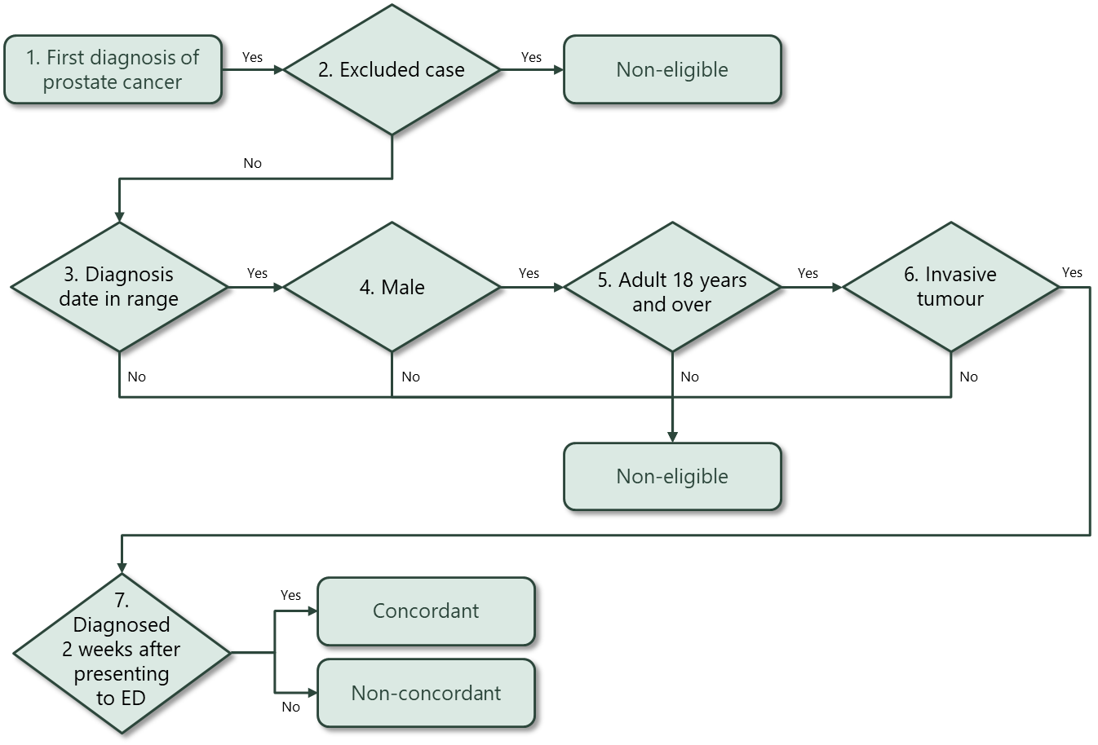

PCQI 5. Discussion with radiation oncologist
Proportion of men with prostate cancer who saw a radiation oncologist before radical prostatectomy.

Sources of data for indicator
- New Zealand Cancer Registry (NZCR) – a population-based register of all primary malignant diseases diagnosed in New Zealand, excluding squamous and basal cell skin cancers
- National Minimum Dataset (NMDS) – a collection of public and private hospital discharge information, including coded clinical data for inpatients and day patients
- National Non-Admitted Patients Collection (NNPAC) – includes event-based purchase units that relate to medical and surgical outpatient events and emergency department events

Data items
Dataset | Data item | Description
NZCR | NHI | Patient identifier
NZCR | Cancer event ID | Cancer registration identifier
NZCR | Date of initial diagnosis | Date person first diagnosed with prostate cancer
NZCR | Diagnosis year | Calendar year of first diagnosis
NZCR | Site | Primary organ of origin of the cancer (ICD-10-AM 8th edition code)
NZCR | Morphology code | 4-digit code (ICD-O-3) for microscopic or cellular anatomy of the cancer
NZCR | Basis | Basis of diagnosis
NZCR | DHB of domicile | DHB code for domicile of patient at diagnosis
NZCR | DHB | DHB name based on domicile of patient at diagnosis
NZCR | Age at diagnosis | Age of patient at diagnosis in years
NZCR | Prioritised ethnicity | Ethnic group derived from patient’s ethnicity
NZCR | Sex | Sex of patient
NZCR | Deprivation quintile | NZDep2013 index of social deprivation quintile based on patient’s domicile
NZCR | Date of death | Date patient died
NZCR | TNM_T | Stage at diagnosis – tumour
NZCR | TNM_N | Stage at diagnosis – node
NZCR | TNM_M | Stage at diagnosis – metastases
NZCR | Behaviour code | Neoplastic behaviour of the cancer
NZCR | Multiple tumour flags | Person diagnosed with more than one tumour
NZCR | Registration status code | Status of registration processing
NZCR | Site | Primary organ of origin of the cancer
NZCR | Sex | Sex of patient
NZCR | Age at diagnosis | Age of patient at diagnosis
NZCR | Ethnicity | Prioritised ethnicity for patient
NZCR | Behaviour code | Neoplastic behaviour of the cancer
NZCR | Date of initial diagnosis | Date person first diagnosed with prostate cancer
NZCR | Basis | Basis of diagnosis
NZCR | NZDep13 | Social deprivation index quintile based on address of patient at time of diagnosis
NZCR | Multiple tumour flags | Person diagnosed with more than one tumour
NZCR | Registration status code | Status of registration processing
NMDS | DHB name | DHB of service for patient
NMDS | Surgical procedure | Surgical procedure of primary site
NMDS | Date of surgery | Date of most definitive surgical procedure of the primary site
NNPAC | Purchase code | Type of outpatient attendance
NNPAC | Date and time of service | Date and time of service

Case eligibility criteria (denominator)
Diagram reference | Assessment | Item | Codes
1 | First or only diagnosis of malignant neoplasm | Primary site | First diagnosis of prostate cancer (C61)
2 | Exclude manually censored case | Exclusion | Registration codes not registered complete (R_C) or registered (R_R)  No incident cancer (exclude people with multiple tumour flags = yes)  Patients diagnosed following death certificate only (basis = 0)  Patient domiciled outside of New Zealand (DHB_code = 999)  Morphology (ICD-O) codes  8041 – Small cell carcinoma, not otherwise specified, 8045 – Small cell-large cell carcinoma, 8246 – Neuroendocrine carcinoma, not otherwise specified, 8890 – Leiomyosarcoma, not otherwise specified, 8980 – Carcinosarcoma, not otherwise specified
3 | Diagnosis date | Date of initial diagnosis | 2016–18
4 | Adult male patient 18 years and older at diagnosis | Age at diagnosis | 18 years and older
5 | Invasive tumours | Behaviour code | 3
6 | Surgical procedure | Surgical procedure of the primary site | Includes ACHI (8th edition) procedure codes:  3720004, 3720900, 3720901, 3721000, 3721001, 3721100, 3721101, 3720900, 3720901, 3721000, 3721001, 3721100  Only includes procedures between 31 days prior and 456 days after diagnosis of prostate cancer.

Numerator criteria
Diagram reference | Assessment | Item | Codes
7 | Patient consulted radiation oncologist prior to radical prostatectomy | radoncdis | One of the purchase unit codes M50022 or M50023 recorded prior to the patient’s surgery date

Surgical procedure codes and descriptions
Clinical code | Block short description | Clinical code description
3720004 | Open prostatectomy | Retropubic prostatectomy
3720900 | Open prostatectomy | Radical prostatectomy
3720901 | Other closed prostatectomy | Laparoscopic radical prostatectomy
3721000 | Open prostatectomy | Radical prostatectomy with bladder neck reconstruction
3721001 | Other closed prostatectomy | Laparoscopic radical prostatectomy with bladder neck reconstruction
3721100 | Open prostatectomy | Radical prostatectomy with bladder neck reconstruction and pelvic lymphadenectomy
3721101 | Other closed prostatectomy | Laparoscopic radical prostatectomy with bladder neck reconstruction and pelvic lymphadenectomy
3720900 | Open prostatectomy | Radical prostatectomy
3720901 | Closed prostatectomy | Laparoscopic radical prostatectomy
3721000 | Open prostatectomy | Radical prostatectomy with bladder neck reconstruction
3721001 | Closed prostatectomy | Laparoscopic radical prostatectomy with bladder neck reconstruction
3721100 | Open prostatectomy | Radical prostatectomy with bladder neck reconstruction and pelvic lymphadenectomy

Purchase unit codes and descriptions
Purchase unit code | Description | Definition
M50022 | Radiation Oncology 1st Attendance | First attendance to radiation oncologist or medical officer at registrar level or above or nurse practitioner for specialist assessment. Excludes medical oncology.
M50023 | Radiation Oncology Subsequent Attendance | Follow-up attendances to a radiation oncologist or medical officer at registrar level or above or nurse practitioner. Excludes medical oncology and radiotherapy.

Flow diagram
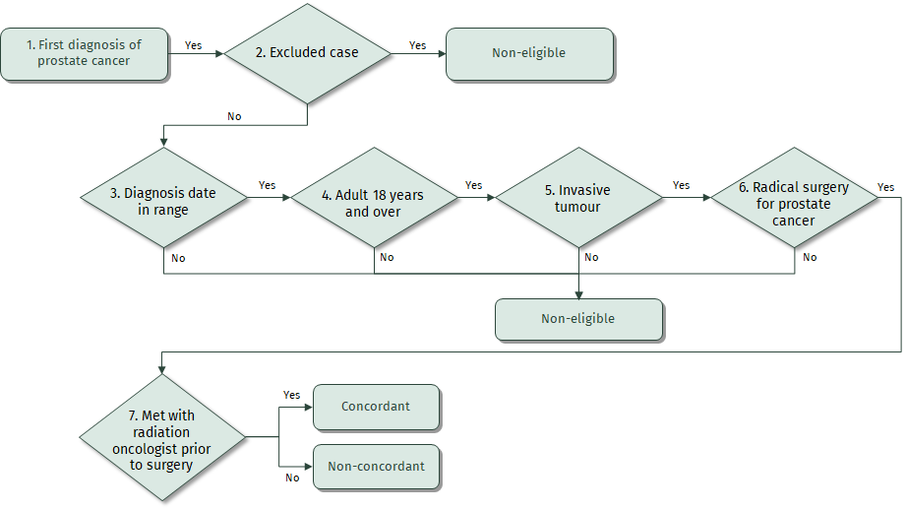

PCQI 9. Equitable access to treatment
Proportion of men with prostate cancer who had radical surgery
Proportion of men with prostate cancer who had curative radiation
Proportion of men with prostate cancer who had radical treatment (surgery or radiation treatment)

Sources of data for indicator
- New Zealand Cancer Registry (NZCR) – a population-based register of all primary malignant diseases diagnosed in New Zealand, excluding squamous and basal cell skin cancers
- National Minimum Dataset (NMDS) – a collection of public and private hospital discharge information, including coded clinical data for inpatients and day patients
- Radiation Oncology Collection (ROC) – includes private and public courses of radiation therapy delivered

Data items
Dataset | Data item | Description
NZCR | NHI | Patient identifier
NZCR | Cancer event ID | Cancer registration identifier
NZCR | Date of initial diagnosis | Date person first diagnosed with prostate cancer
NZCR | Diagnosis year | Calendar year of first diagnosis
NZCR | Site | Primary organ of origin of the cancer (ICD-10-AM 8th edition code)
NZCR | Morphology code | 4-digit code (ICD-O-3) for microscopic or cellular anatomy of the cancer
NZCR | Basis | Basis of diagnosis
NZCR | DHB of domicile | DHB code for domicile of patient at diagnosis
NZCR | DHB | DHB name based on domicile of patient at diagnosis
NZCR | Age at diagnosis | Age of patient at diagnosis in years
NZCR | Prioritised ethnicity | Ethnic group derived from patient’s ethnicity
NZCR | Sex | Sex of patient
NZCR | Deprivation quintile | NZDep2013 index of social deprivation quintile based on patient’s domicile
NZCR | Date of death | Date patient died
NZCR | TNM_T | Stage at diagnosis – tumour
NZCR | TNM_N | Stage at diagnosis – node
NZCR | TNM_M | Stage at diagnosis – metastases
NZCR | Behaviour code | Neoplastic behaviour of the cancer
NZCR | Multiple tumour flags | Person diagnosed with more than one tumour
NZCR | Registration status code | Status of registration processing
NZCR | Site | Primary organ of origin of the cancer
NZCR | Sex | Sex of patient
NZCR | Age at diagnosis | Age of patient at diagnosis
NZCR | Ethnicity | Prioritised ethnicity for patient
NZCR | Behaviour code | Neoplastic behaviour of the cancer
NZCR | Date of initial diagnosis | Date person first diagnosed with prostate cancer
NZCR | Basis | Basis of diagnosis
NZCR | NZDep13 | Social deprivation index quintile based on address of patient at time of diagnosis
NZCR | Multiple tumour flags | Person diagnosed with more than one tumour
NZCR | Registration status code | Status of registration processing
NMDS | DHB name | DHB of service for patient
NMDS | Surgical procedure | Surgical procedure of primary site
NMDS | Date of surgery | Date of most definitive surgical procedure of the primary site
ROC | Treatment start date | Radiation treatment start date
ROC | Planned doses | Planned doses
ROC | Clinical code | ICD-10-AM code
ROC | Intent of treatment | Intent of treatment

Case eligibility criteria (denominator)
Diagram reference | Assessment | Item | Codes
1 | First or only diagnosis of malignant neoplasm | Primary site | First diagnosis of prostate cancer (C61)
2 | Exclude manually censored case | Exclusion | Registration codes not registered complete (R_C) or registered (R_R)  No incident cancer (exclude people with multiple tumour flags = yes)  Patients diagnosed following death certificate only (basis = 0)  Patient domiciled outside of New Zealand (DHB_code = 999)  Morphology (ICD-O) codes  8041 – Small cell carcinoma, not otherwise specified, 8045 – Small cell-large cell carcinoma, 8246 – Neuroendocrine carcinoma, not otherwise specified, 8890 – Leiomyosarcoma, not otherwise specified, 8980 – Carcinosarcoma, not otherwise specified
3 | Diagnosis date | Date of initial diagnosis | 2016–18
4 | Male | Sex | M
5 | Adult patient 18 years and older at diagnosis | Age at diagnosis | 18 years and older
6 | Invasive tumours | Behaviour code | 3

Numerator criteria
Diagram reference | Assessment | Item | Codes
7a | Radical surgery | radsurg | Surgical procedure of the primary site Includes ACHI (8th edition) procedure codes:  3720004, 3720900, 3720901, 3721000, 3721001, 3721100, 3721101, 3720900, 3720901, 3721000, 3721001, 3721100  Includes procedures between 31 days prior and 456 days after diagnosis of prostate cancer.
7b | Curative radiation treatment | radrt | Radiation treatment start date within one year of diagnosis and PLANNED_DOSES_CNT >=60 AND CLINICAL_CODE_ICD10_AM8 in (‘C61’,’C610’) AND INTENT_OF_TREATMENT_IND = 1 AND TMTSTARTDT – DIAG_DATE > -31”
7c | Radical surgery or curative radiation treatment | radtrmt | Includes ACHI (8th edition) procedure codes:  3720004, 3720900, 3720901, 3721000, 3721001, 3721100, 3721101, 3720900, 3720901, 3721000, 3721001, 3721100  Includes procedures between 31 days prior and 456 days after diagnosis of prostate cancer.  OR  Radiation Treatment start date within one year of diagnosis and PLANNED_DOSES_CNT >=60 AND CLINICAL_CODE_ICD10_AM8 in (‘C61’,’C610’) AND INTENT_OF_TREATMENT_IND = 1 AND TMTSTARTDT – DIAG_DATE > -31”

Surgical procedure codes and descriptions
Clinical code | Block short description | Clinical code description
3720004 | Open prostatectomy | Retropubic prostatectomy
3720900 | Open prostatectomy | Radical prostatectomy
3720901 | Other closed prostatectomy | Laparoscopic radical prostatectomy
3721000 | Open prostatectomy | Radical prostatectomy with bladder neck reconstruction
3721001 | Other closed prostatectomy | Laparoscopic radical prostatectomy with bladder neck reconstruction
3721100 | Open prostatectomy | Radical prostatectomy with bladder neck reconstruction and pelvic lymphadenectomy
3721101 | Other closed prostatectomy | Laparoscopic radical prostatectomy with bladder neck reconstruction and pelvic lymphadenectomy
3720900 | Open prostatectomy | Radical prostatectomy
3720901 | Closed prostatectomy | Laparoscopic radical prostatectomy
3721000 | Open prostatectomy | Radical prostatectomy with bladder neck reconstruction
3721001 | Closed prostatectomy | Laparoscopic radical prostatectomy with bladder neck reconstruction
3721100 | Open prostatectomy | Radical prostatectomy with bladder neck reconstruction and pelvic lymphadenectomy

Flow diagram
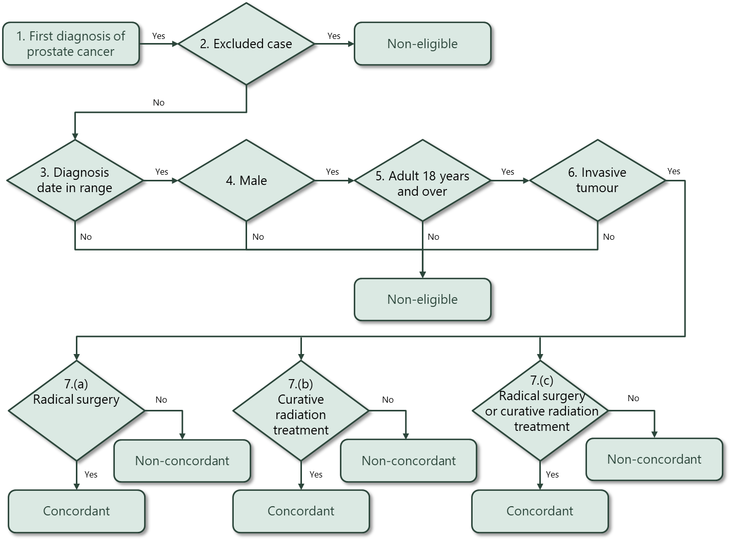

PCQI 8. Length of stay after surgery
        - Proportion of men who stayed three or more days after surgery
Proportion of men who stayed five or more days after surgery

Sources of data for indicator
- New Zealand Cancer Registry (NZCR) – a population-based register of all primary malignant diseases diagnosed in New Zealand, excluding squamous and basal cell skin cancers
- National Minimum Dataset (NMDS) – a collection of public and private hospital discharge information, including coded clinical data for inpatients and day patients

Data items
Dataset | Data item | Description
NZCR | NHI | Patient identifier
NZCR | Cancer event ID | Cancer registration identifier
NZCR | Date of initial diagnosis | Date person first diagnosed with prostate cancer
NZCR | Diagnosis year | Calendar year of first diagnosis
NZCR | Site | Primary organ of origin of the cancer (ICD-10-AM 8th edition code)
NZCR | Morphology code | 4-digit code (ICD-O-3) for microscopic or cellular anatomy of the cancer
NZCR | Basis | Basis of diagnosis
NZCR | DHB of domicile | DHB code for domicile of patient at diagnosis
NZCR | DHB | DHB name based on domicile of patient at diagnosis
NZCR | Age at diagnosis | Age of patient at diagnosis in years
NZCR | Prioritised ethnicity | Ethnic group derived from patient’s ethnicity
NZCR | Sex | Sex of patient
NZCR | Deprivation quintile | NZDep2013 index of social deprivation quintile based on patient’s domicile
NZCR | Date of death | Date patient died
NZCR | TNM_T | Stage at diagnosis – tumour
NZCR | TNM_N | Stage at diagnosis – node
NZCR | TNM_M | Stage at diagnosis – metastases
NZCR | Behaviour code | Neoplastic behaviour of the cancer
NZCR | Multiple tumour flags | Person diagnosed with more than one tumour
NZCR | Registration status code | Status of registration processing
NZCR | Site | Primary organ of origin of the cancer
NZCR | Sex | Sex of patient
NZCR | Age at diagnosis | Age of patient at diagnosis
NZCR | Ethnicity | Prioritised ethnicity for patient
NZCR | Behaviour code | Neoplastic behaviour of the cancer
NZCR | Date of initial diagnosis | Date person first diagnosed with prostate cancer
NZCR | Basis | Basis of diagnosis
NZCR | NZDep13 | Social deprivation index quintile based on address of patient at time of diagnosis
NZCR | Multiple tumour flags | Person diagnosed with more than one tumour
NZCR | Registration status code | Status of registration processing
NMDS | DHB name | DHB of service for patient
NMDS | Surgical procedure | Surgical procedure of primary site
NMDS | Date of surgery | Date of most definitive surgical procedure of the primary site
NMDS | Date of discharge | Date of discharge from hospital

Case eligibility criteria (denominator)
Diagram reference | Assessment | Item | Codes
1 | First or only diagnosis of malignant neoplasm | Primary site | First diagnosis of prostate cancer (C61)
2 | Exclude manually censored case | Exclusion | Registration codes not registered complete (R_C) or registered (R_R)  No incident cancer (exclude people with multiple tumour flags = yes)  Patients diagnosed following death certificate only (basis = 0)  Patient domiciled outside of New Zealand (DHB_code = 999)  Morphology (ICD-O) codes  8041 – Small cell carcinoma, not otherwise specified, 8045 – Small cell-large cell carcinoma, 8246 – Neuroendocrine carcinoma, not otherwise specified, 8890 – Leiomyosarcoma, not otherwise specified, 8980 – Carcinosarcoma, not otherwise specified
3 | Diagnosis date | Date of initial diagnosis | 2016–18
4 | Male | Sex | M
5 | Adult patient 18 years and older at diagnosis | Age at diagnosis | 18 years and older
6 | Invasive tumours | Behaviour code | 3
7 | Surgical procedure | Surgical procedure of the primary site | Includes ACHI (8th edition) procedure codes:  3720004, 3720900, 3720901, 3721000, 3721001, 3721100, 3721101, 3720900, 3720901, 3721000, 3721001, 3721100  Only includes procedures between 31 days prior and 456 days after diagnosis of prostate cancer.

Numerator criteria
Diagram reference | Assessment | Item | Codes
8a | Patient stayed 3 or more days after date of surgery | surg3mo | Date of discharge – date of surgery >=3
8b | Patient stayed 5 or more days after date of surgery | surg5mo | Date of discharge – date of surgery >=5

Surgical procedure codes and descriptions
Clinical code | Block short description | Clinical code description
3720004 | Open prostatectomy | Retropubic prostatectomy
3720900 | Open prostatectomy | Radical prostatectomy
3720901 | Other closed prostatectomy | Laparoscopic radical prostatectomy
3721000 | Open prostatectomy | Radical prostatectomy with bladder neck reconstruction
3721001 | Other closed prostatectomy | Laparoscopic radical prostatectomy with bladder neck reconstruction
3721100 | Open prostatectomy | Radical prostatectomy with bladder neck reconstruction and pelvic lymphadenectomy
3721101 | Other closed prostatectomy | Laparoscopic radical prostatectomy with bladder neck reconstruction and pelvic lymphadenectomy
3720900 | Open prostatectomy | Radical prostatectomy
3720901 | Closed prostatectomy | Laparoscopic radical prostatectomy
3721000 | Open prostatectomy | Radical prostatectomy with bladder neck reconstruction
3721001 | Closed prostatectomy | Laparoscopic radical prostatectomy with bladder neck reconstruction
3721100 | Open prostatectomy | Radical prostatectomy with bladder neck reconstruction and pelvic lymphadenectomy

Flow diagram
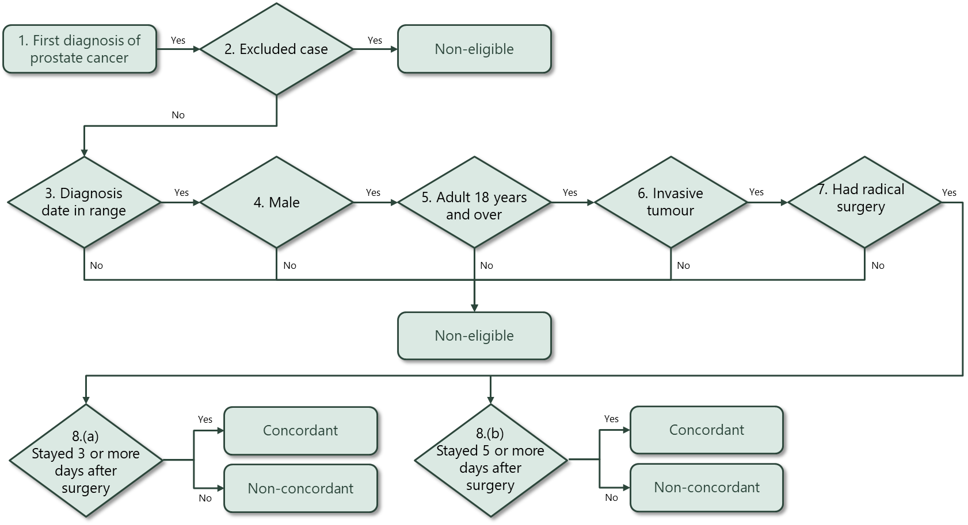

PCQI 6. Medical oncology review of men with advanced disease
Proportion of men who met with a medical oncologist prior to death from prostate cancer.

Sources of data for indicator
- New Zealand Cancer Registry (NZCR) – a population-based register of all primary malignant diseases diagnosed in New Zealand, excluding squamous and basal cell skin cancers
- National Non-Admitted Patients Collection (NNPAC) – includes event-based purchase units that relate to medical and surgical outpatient events and emergency department events
- The Mortality Collection (MORT) combines death registration and stillbirth registration data with cause of death information which is then collated and coded

Data items
Dataset | Data item | Description
MORT | BDM registration no | Death registration number
MORT | Master encrypted NHI | Encrypted NHI number
MORT | Sex | Sex of patient
MORT | Age at death | Age of patient at death
MORT | Age in years | Age at death in years
MORT | Prioritised ethnic group | Prioritised ethnic group (from death record) derived from patient’s ethnicity
MORT | Domicile code | Domicile code at time of death
MORT | Domicile name | Name of domicile at time of death
MORT | NZDEP13 | NZDep2013 index of social deprivation quintile based on patient’s domicile
MORT | DHB | District Health Board of residence at time of death
MORT | Death date | Date of death
MORT | Death year | Year of death
MORT | Diagnosis type | Type of diagnosis (death)
MORT | Clinical code | Primary cause of death clinical code
MORT | Clinical code type | Primary cause of death clinical code type
MORT | Clinical code system | Primary cause of death clinical code system
NNPAC | Date/time of service | Date of appointment with medical oncologist
NNPAC | Service type | Type of service (first, follow-up, pre-admission)
NNPAC | Attendance code | Whether patient attended appointment

Case eligibility criteria (denominator)
Diagram reference | Assessment | Item | Codes
1 | Died from prostate cancer | Clinical code | D61
2 | Exclude manually censored case | Exclusion | DHB_CODE = ‘999’
3 | Death date | Date of death | 2017–19
4 | Male | Sex | M
5 | Adult patient 18 years and older at death | Age at death | 18 years and older
6 | Prostate was primary cause of death | Diagnosis type | D (underlying cause of death)

Numerator criteria
Diagram reference | Assessment | Item | Codes
8 | Patient consulted medical oncologist prior to death | deathmo | NNPAC outpatients  date of service BETWEEN 20100101 AND 20201231  purchase_unit_code in (‘M50020’,’M50021’) AND  service_type = ‘FIRST’ AND attendance_code = ‘ATT’  DeathMO2yr = DEATH_DATE – DATETIME_OF_SERVICE < 730  DeathMO3more = DEATH_DATE – DATETIME_OF_SERVICE >= 730

Purchase unit codes
Purchase unit code | Purchase unit description | Purchase unit definition | Unit of measure
M50020 | Medical oncology 1st attendance | First attendance to medical oncologist or medical officer at registrar level or above or nurse practitioner for specialist assessment. Excludes radiation oncology. | Attendance
M50021 | Medical oncology subsequent attendance | Follow-up attendances to a medical oncologist or medical officer at registrar level or above or nurse practitioner. Excludes radiation oncology and chemotherapy. | Attendance

Flow diagram
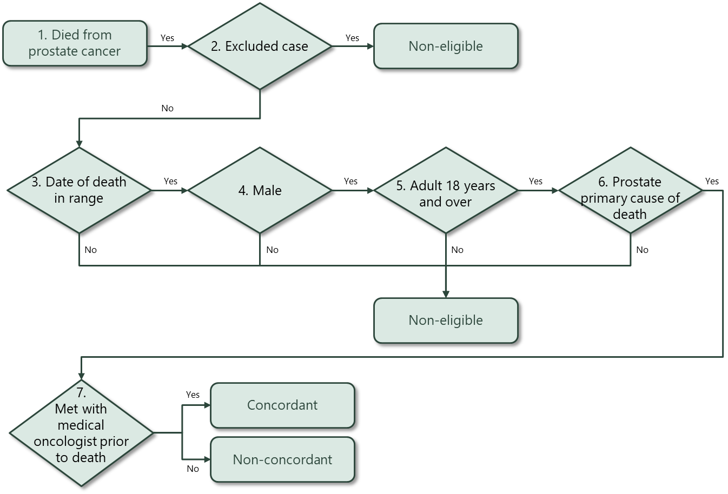

Hospital events in NMDS are coded using the International Statistical Classification of Diseases and Related Health Problems, Tenth Revision, Australian Modification (ICD-10-AM) for diagnoses and the Australian Classification of Health Interventions (ACHI) for procedures. Both ICD-10-AM and ACHI are from the Independent Hospital Pricing Authority, Australia.
From CAS-SOP #4.5 Linking treatment tables – chemotherapy, tumour resections and radiotherapy Version 4.5 available from http://www.ncin.org.uk/cancer_type_and_topic_specific_work/topic_specific_work/main_cancer_treatments.
Curative radiation includes adjuvant and salvage radiotherapy.

