Te Aho o Te Kahu | Cancer Control Agency Annual Report 2021/22

Our purpose
We provide strong central leadership and oversight of cancer control. We lead and unite efforts to deliver better cancer outcomes for Aotearoa New Zealand.

Our work is
- equity led
- knowledge driven
- outcomes focused
- person and whānau centred.

Who we are
Te Aho o Te Kahu, the Cancer Control Agency is a departmental agency reporting
directly to the Minister of Health and hosted by the Ministry of Health.

The agency was created in recognition of the impact cancer has on the lives of
New Zealanders and provides a sharp focus on this important health issue.

We have 60 people working for us across six Wellington-based teams and four
regional hubs.

He mihi | Chief Executive foreword
I am very pleased to be able to present the third annual report for Te Aho o Te Kahu, the Cancer Control Agency.

Since the Agency was established, I have enjoyed taking stock of our achievements in each annual report. While there is still much to be done, I am extremely proud of our team and the work they have undertaken over the last 12 months.

We have remained as committed as ever to our vision of:
Fewer cancers Kia whakaiti iho te mate pukupuku
Better survival Kia runga noa ake te mataora
Equity for all Kia taurite ngā huanga.

Over the last year, Te Aho o Te Kahu has shown leadership and consistency throughout a time of change for the health system. The health reforms have provided an exciting
opportunity to rethink the way cancer services are delivered in Aotearoa New Zealand, and Te Aho o Te Kahu has taken a leading role in many of the conversations, plans and pieces of work taking place across the motu.

Not only are we building enduring relationships with the new health entities, we are also continuing to foster the connections we have across the cancer sector. The work of He Ara Tangata, our consumer reference group, has been critical over the last year. Our regional hubs have also done an incredible job of connecting with communities across the motu to ensure Te Aho o Te Kahu remains tethered to those on the ground. I also acknowledge the tireless work of our partners Hei Āhuru Mōwai, Māori Cancer Leadership Aotearoa, as we, together, pursue equity in cancer outcomes for whānau Māori.

The ongoing COVID-19 pandemic has continued to influence the work of Te Aho o Te Kahu. We have guided the cancer sector through the Omicron outbreak by providing guidance to clinicians and patients, as well as producing regular monitoring reports of the cancer system. It has been a challenging time for the cancer workforce, and I am incredibly grateful for the dedication of all who have ensured whānau continue to receive the cancer care they need.

Alongside our expanding work programme, we have continued to build a high-performing agency. This was reflected in the 2022 Te Taunaki, Public Service Census, which showed our staff had an elevated level of confidence when engaging with Māori. It also reaffirmed that our staff feel Te Aho o Te Kahu has a culture that celebrates diversity, inclusivity, and acceptance.

I want to take this opportunity to thank all those who work in the cancer sector – you have gone above and beyond for your patients, their whānau and their wider communities in the last 12 months.

Finally, I want to acknowledge those who are living with cancer. You are the focus of our work, and we will continue to do our utmost to ensure Aotearoa New Zealand maintains a world-class cancer care system.

Dr Diana Sarfati
Chief Executive and National Director of Cancer Control
Te Aho o Te Kahu, Cancer Control Agency

Anei mātou | Who we are
Te Aho o Te Kahu, Cancer Control Agency (Te Aho o Te Kahu), is a departmental agency reporting directly to the Minister of Health and hosted by Manatū Hauora, Ministry of Health. Te Aho o Te Kahu was created in recognition of the impact cancer has on the lives of New Zealanders and provides a sharp focus on this important health issue.

Cancer presents some unique challenges to the health system.
- The number of people diagnosed with cancer is projected to double over the next two decades.
- The costs and complexity of care and pace of change present major challenges for our health care systems and services.
- Māori and Pacific peoples have worse cancer survival rates than other New Zealanders.
- Cancer survival is improving in Aotearoa New Zealand, but our rate of improvement is slower than rates in other comparable countries, so we are at risk of falling behind.

Tā mātou aronga | Our purpose: an agency focused on cancer
We provide strong, central leadership and oversight of cancer control. We lead and unite efforts to deliver better cancer outcomes for Aotearoa New Zealand. We are also accountable for ensuring there is transparency in our country’s progress towards
achieving the goals and outcomes outlined in the New Zealand Cancer Action Plan 2019– 2029.

In practice, we deliver this leadership and oversight by:
- providing advice to government about the future design and function of cancer services and options for resolving operational issues
- bringing stakeholders together to progress and achieve shared objectives
- undertaking national initiatives to improve cancer outcomes for New Zealanders
- assembling and disseminating cancer data and information to inform decision-making and service delivery
- providing support for cancer service providers when service is, or is likely to be, disrupted or is not meeting demand or expectations.

Tō mātou whāinga | Our vision
We strive to achieve fewer cancers, better survival, and equity for all.

We are driven to achieve a work programme aligned to our values.

Te taonga me te kupu taurangi o te ingoa | Our name: Te Aho o Te Kahu

Our te reo Māori name is a taonga, gifted to us by Hei Āhuru Mōwai, Māori Cancer Leadership Aotearoa in June 2020. This name is core to who we are and how we work.

Te Aho o Te Kahu means ‘the central thread of the cloak’. This thread (aho) binds the many strands (whenu) into one cloak (kahu) that protects people and their whānau.

Te Aho: The central thread symbolises our Agency and our role as a leader and connector across the cancer control continuum.

Te Kahu: The cloak symbolises all the services, organisations, communities, and people that work with those affected by cancer.

Equity is not only the priority for us in our role as ‘Te Aho’; it is also embedded in our architecture, processes, systems and tikanga.

Te taonga: Te Kahu Āhuru | Our treasure: Te Kahu Āhuru
Taking inspiration from the vision and name gifted to us, the cloak Te Kahu Āhuru was created by kairaranga (weaver) Pip Devonshire and gifted to Te Aho o Te Kahu on 3 August 2021 at Pipitea Marae in Wellington.

This physical embodiment of our purpose is now on display in our Wellington office and is available to be worn by our kaimahi (staff) at events.

Ngā rōpū tūhono | Our partners
This year, we have continued to connect with our key partners (shown in green and blue in the organisational structure diagram) to strengthen our work programme and external advice. The role and functions of these groups is regularly reviewed to ensure we make best use of their valuable time and expertise.

Te Aho o Te Kahu Organisational Structure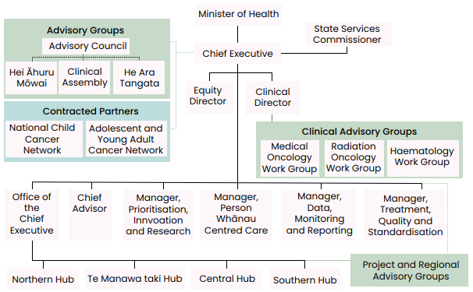

Advisory Council
The Advisory Council supports our chief executive to ensure our organisation has a whole-of-system focus on preventing, treating, and managing cancer. The council also supports our chief executive to oversee system-wide prioritisation and coordination of cancer care in Aotearoa New Zealand. It considers and provides advice on how to get the best value from existing cancer prevention and care investment. As part of our commitment to Te Tiriti in our work the council has 50 percent Māori membership and a Māori co-chair.

Hei Āhuru Mōwai, Māori Cancer Leadership Aotearoa
Hei Āhuru Mōwai is the Māori cancer leadership group. Its membership brings a range of expertise, including clinical, community care, epidemiology, health services management and research. The Chair of Hei Āhuru Mōwai is also a member of the Advisory Council.

We support the leadership and rangatiratanga of Hei Āhuru Mōwai through operational and project funding, and Hei Āhuru Mōwai works closely with us and provides expertise and support for negotiated strategic work and projects centred on improving Māori cancer outcomes.

National Clinical Assembly
The National Clinical Assembly provides clinical advice to support us with our long-term strategic direction for reducing cancer incidence and improving cancer services across the cancer continuum. The assembly includes clinicians from a broad range of cancer- related medical, nursing, and allied health specialities.

He Ara Tangata
He Ara Tangata is the Consumer Reference Group that provides us with advice and
solutions for people affected by cancer and their whānau. He Ara Tangata members are embedded on projects across our work programme, and their input ensures our work remains focused on the needs of people across the continuum of cancer care.

Other advisory groups
To ensure we remain connected with those on the ground, and hear directly from them, we have three primary clinical working groups (Medical Oncology, Radiation Oncology and Haematology) and more than 17 other advisory groups, involving over 200 health professionals and consumers. We meet regularly with these working groups, and their input feeds into our work at all levels.

COVID-19 response team
As the nationwide COVID-19 pandemic response strategy shifted from ‘elimination’ to
‘endemic’ across the course of 2021/22, we reconvened our rapid response team, initially established in March 2020, to ensure we were directly connected to the health sector and could respond to issues and opportunities as they arose. Initially meeting twice weekly, the group now meets on an ad-hoc basis when members indicate there are issues to be discussed.

Contracted partners
We contract National Child Cancer Network New Zealand (NCCN) and Adolescent and
Young Adult Cancer Network Aotearoa (AYA) to deliver care for children and young people with cancer. We collaborate on the direction of their work programmes, meet regularly to discuss progress and issues, and provide support on programme delivery.

Other external partners
One of our key functions is to liaise with the many parties and organisations involved
with cancer prevention and care. In the country’s new health system, this includes direct relationships between the chief executives of Te Aho o Te Kahu and Te Whatu Ora, Health New Zealand; Te Aka Whai Ora, Māori Health Authority; Manatū Hauora, Ministry of Health; the Public Health Agency; Pharmac; Health Quality & Safety Commission New Zealand and many more.

The relationship between us and our host, Manatū Hauora, Ministry of Health is particularly important and is supported through co-location and an interdepartmental agency agreement signed in August 2021.

Being ‘Te Aho’ – the central thread
In addition to these core relationships, we have developed strong active links with
Māori and Pacific health leaders, consumer-led groups, clinical leadership groups, non-governmental organisations and primary health care practitioners. These relationships continue to develop and evolve as the new health system beds in.
We are committed to hearing the voices of those across the cancer continuum in Aotearoa New Zealand. There is a wide array of other government entities, sector groups, programmes and projects we contribute to across all workstreams as part of being ‘Te Aho’ for the cancer continuum.

Te ū ki Te Tiriti | Our commitment to Te Tiriti o Waitangi
We strive to achieve the following four goals of Te Tiriti o Waitangi (Te Tiriti), each expressed in terms of mana.

Mana whakahaere
Encouraging effective and appropriate stewardship or kaitiakitanga over the health and
disability system. (This goes beyond the management of assets or resources.)

Mana motuhake
Enabling Māori to be Māori; to exercise their authority over their lives and to live on Māori terms and according to Māori philosophies, values and practices, including tikanga Māori.

Mana tangata
Achieving equity in health and disability outcomes for Māori across the life course and
contributing to Māori wellness.

Mana Māori
Enabling ritenga Māori (Māori customary rituals), which are framed by te ao Māori (the
Māori world), enacted through tikanga Māori (Māori philosophy and customary practices) and encapsulated within mātauranga Māori (Māori knowledge).

The principles of Te Tiriti outlined below, provide the framework for how we will meet our obligations under Te Tiriti in our day-to-day work.

Tino rangatiratanga
The assurance of tino rangatiratanga provides self-determination and mana motuhake
for Māori in the design, delivery and monitoring of health and disability services.

Equity
The principle of equity requires the Crown to commit to achieving equitable health
outcomes for Māori.

Active protection
The principle of active protection requires the Crown to act, to the fullest extent
practicable, to achieve equitable health outcomes for Māori.

Options
The principle of options requires the Crown to provide for and properly resource Kaupapa Māori health and disability services. Furthermore, the Crown is obliged to ensure that all health and disability services are provided in a culturally appropriate way.

Partnership
The principle of partnership requires the Crown and Māori to work in partnership in the
governance, design, delivery and monitoring of health and disability services, especially in regard to development and delivery of the primary health system for Māori.

Tō mātou whānau | Our people

Personnel
As at 30 June 2022, we had 63 people employed or 60.6 full-time equivalents (FTE), supported by an additional contracted 4.8 FTE.

Of the 60.6 FTE, we have 58.6 FTE employed on permanent contracts, with 1.2 FTE fixed term and 0.8 FTE on secondment.

Eight permanent staff (13 percent) resigned during 2021/22.

Full-time and part-time staff
Twenty percent of our permanent staff work part time.

Gender
The majority of our staff are female (78 percent). No staff identify as gender diverse.

Ethnicity
We have followed a deliberate strategy to attract and recruit staff who identify as Māori, although this is not without its challenges as there is high demand for Māori staff across the new health entities. Our proportion of Māori staff rose slightly to 11 percent this year (from six staff in 2020/21 to seven in 2021/22). Two of our secondments are Māori also.

At year end, 6 percent of our staff were Pacific peoples, and 40 percent were non-European.

Diversity and inclusion
We strive to be a diverse and inclusive workplace where all people feel valued. We are
a member of Te Kawa Mataaho, Public Service Commission’s Diversity and Inclusion Executive Champions Network. Papa Pounamu, the Te Kawa Mataaho diversity programme, identifies five priority areas for development: cultural competence, addressing bias, inclusive leadership, building relationships and employee-led networks. We are engaged across all of these priorities via our Whāinga Amorangi: Transforming Leadership plans and E Tipu E Tipu, our Māori Language Plan (see Tō mātou tutuki | What we have achieved and Tō mātou whakahaere | Our performance sections).

Whiria te Tangata, the Manatū Hauora culture and inclusion strategy outlines a shared overarching approach to diversity and inclusion. Our staff work alongside Manatū Hauora staff in developing, delivering, and participating in Manatū Hauora awareness and celebration events and are encouraged to engage with the many employee-led networks on offer at both Manatū Hauora and the wider public service.

Ō mātou takune | Our intentions for 2021/22
The strategic direction of Te Aho o Te Kahu is articulated through The New Zealand Cancer Control Strategy 2003 and the New Zealand Cancer Action Plan 2019–2029 (the Cancer Action Plan). Our work is focused on achieving the Aotearoa New Zealand health system goal of pae ora: healthy futures and the three system outcomes – living longer in good health, improved quality of life and equity for all – through delivering our vision of fewer cancers, better survival and equity for all.

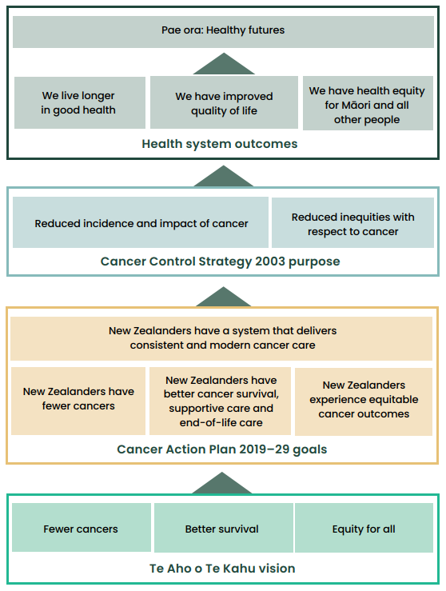
In 2021/22, in recognition that a core function of our agency is to shape the health environment, we adopted a ‘shaping strategy’. This strategic approach supports us to work in a way that maximises opportunities to engage and influence.

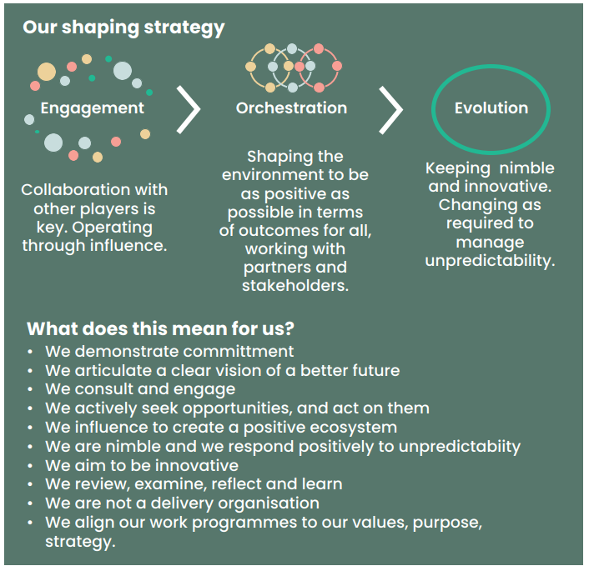

Work programme
Our work programme for 2021/22 sought to progress the goals in the Cancer Action Plan and focused on planning for the delivery of cancer care in the new health system.

All aspects of our work programme consider the likely or intended impact on improving equity in access, quality, and outcomes. Our work programme has focused on the following Cancer Action Plan outcomes.

New Zealanders have a system that delivers consistent and modern cancer care
Te Aho o Te Kahu priorities | Te Aho o Te Kahu work
Supporting a system that delivers consistent and modern care | Building a high-performing agency  Commitment to capability building  Systems and processes  Active health sector support  COVID-19
Transforming the future of cancer service delivery | Seven cancer services planning projects
Developing a monitoring framework | Delivering the first monitoring report
Providing better quality, more connected data | CanShare  Anti-Cancer Therapies – Nationally  Organised Workstreams  Structured pathology  National radiation oncology collection  Faster cancer treatment reporting  HISO standards  Collaboration across data and digital health
New Zealanders have fewer cancers
Te Aho o Te Kahu priorities | Te Aho o Te Kahu work
Achieving fewer cancers through a focus on prevention | Cancer Prevention Report  Cancer research  Primary health care project  Advice for primary care
New Zealanders have better cancer survival
Te Aho o Te Kahu priorities | Te Aho o Te Kahu work
Improving cancer survival | Quality improvement programme  Cancer medicines availability analysis  Clinical trials
New Zealanders experience equitable cancer outcomes
Te Aho o Te Kahu priorities | Te Aho o Te Kahu work
Improving equity of cancer outcomes | Māori community hui  Embedding equity-led thinking  Being equity-led and whānau-centred with data  Pacific research project  Supporting equity-led work across the sector

Ā mātou whakatutukitanga | What we have achieved

He pūnaha manaaki | Supporting a system that delivers consistent and modern care

Building a high-performing agency
Te Aho o Te Kahu has a reputation, within Government and across the health and disability sector, for responsiveness and delivery. In the 2021/22 year, we continued to strengthen our relationships with stakeholders, grow our staff capabilities and support the wellbeing of our team around the motu – all during a challenging year of COVID-19 disruptions and health system reforms.

We supported the Minister of Health and Associate Ministers by providing high-quality, timely advice across a range of cancer topics through regular meetings, briefing papers and weekly updates. Our communications team has built a strong relationship with the Ministers’ secretaries to ensure we can meet the needs of the Ministers’ offices as they arise. We have cemented our place as the trusted cancer advisor to Government.

We have bedded in our sector stakeholder engagement this year through regular meetings with our advisory groups (outlined in the section Ngā roopu tūhono | Our partners) and by scaling up the many project and tumour stream advisory groups supporting our work programmes. We have held more than 200 stakeholder meetings and engagements in 2021/22 – with many focused on the work we are doing to design cancer services for the new health system. Engagements will continue as we begin to work with the new health entities to deliver change.

Of note this year is our deepening partnership with Hei Āhuru Mōwai, Māori Cancer Leadership Aotearoa. Hei Āhuru Mōwai members sit on many of our major advisory groups, providing strategic input to our work programme direction, targeted advice towards equitable cancer outcomes for Māori, access to Māori cancer expertise and support for developing Māori capability across our organisation. We have engaged Hei Āhuru Mōwai co-chair Gary Thompson as pou tikanga to provide us with cultural guidance as needed. We support the aspirations of Hei Āhuru Mōwai and its growth as an organisation. We have provided resource to support their priorities, including the development of infographics for whānau with cancer throughout the COVID-19 pandemic. The strength of this partnership has been recognised by Te Kawa Mataaho, Public Service Commission, and we are finalists in its Spirit of Service, Māori Crown Relationship award.

Māori leadership and engagement are evident at every level within our organisation: through proactively recruiting Māori staff, engaging with Māori clinical and lived- experience leaders, holding hui with whānau Māori and Māori communities, partnering with Hei Āhuru Mōwai and ensuring key advisory bodies have 50 percent Māori membership and a Māori chair/co-chair.

The involvement of He Ara Tangata, Consumer Reference Group has also gathered momentum this year, and reference group members are now embedded in projects across our organisation, to provide a critical lived-experience lens to our work.

Commitment to capability building
Capability building remains a major focus for us. We have an induction process that
requires all staff to undertake modules on te ao Māori along with learning about our obligations as public servants. Our staff can access all Manatū Hauora professional development resources, including external workshops and online courses. We also deliver our own bespoke courses, including a two-day ‘machinery of government’ course, staff forums and information sessions and an annual all-staff capability-building day. Each staff member’s professional development plan must contain capability-building goals.

Our commitment to Te Tiriti can be seen in our ambitious programme to build capability to engage with Māori. In 2021/22, we delivered four Whāinga Amorangi: Transforming Leadership plans to Te Arawhiti, The Office for Māori Crown Relations, and these were endorsed without change. Te Arawhiti have directed other Government entities to us to provide guidance on their plans. We have made strong progress against the goals and measures set out in the plans through activities such as a day at Pipitea Marae, a presentation by Meihana Durie on mātauranga Māori, attending The Wall Walk® (the interactive workshop designed to raise awareness about key events in the history of Aotearoa New Zealand’s bicultural relations), hosting a Te Tiriti session, delivering a racial bias workshop, Waitangi, Matariki and Te Wiki o Te Reo Māori activities and twice-weekly waiata sessions. Every staff member is required to have a goal in their professional development plan that relates to Whāinga Amorangi.

Our commitment can also be measured in our progress against our Māori language plan, E Tipu E Tipu. The staff survey showed confidence in speaking te reo has increased across every measure (see Tō mātou whakahaere | Our performance section).

Systems and processes
We continued to develop our systems and processes in the 2021/22 year, aided by the
signing of the departmental agency agreement with our hosts, Manatū Hauora.

We launched a suite of project management templates that have been extremely useful in providing an agency-wide view of national and regional work in progress and created an equity toolkit to support staff to develop equity led thinking at all levels across the Agency.

We have embedded a new leadership group meeting structure, separating out operational, tactical and strategic work and allowing us to streamline our agenda and workflow. We have responded to all ministerial enquiries, Official Information Act requests (OIAs) and pieces of correspondence within expected timeframes.
Our focus on growing and supporting our staff saw the launch of our Leadership Pledge and Wellbeing Strategy this year. The pledge is a compelling reminder of our people leaders’ commitment to the wellbeing of their team members, and the strategy outlines how we will prioritise wellbeing using a Te Whare Tapa Whā model.

The Leadership Group’s pledge to Wellbeing
As leaders, we recognise staff wellbeing as a critical aspect of being successful as an agency. We whakamana, give respect to, Te Whare Tapa Whā, which emphasises the connections between our physical, spiritual, mental, emotional, family, and social dimensions of health. These concepts indicate the importance of balance in our lives.

We always want staff to feel comfortable, respected and connected.

As leaders, our responsibility is to uphold this pledge and organisational manaakitanga. We will set positive examples and, by doing so, enhance mana and support for individuals.

As leaders we will:
- Promote work life balance, e.g. flexible working
- Provide opportunities for whakawhanaungatanga, to establish relationships in all aspects of work
- Be open to discussions about workload and consider wellbeing when assigning work
- Make space in meetings to discuss wellbeing, e.g. team meetings, leadership meetings, 1:1s
- Dedicate time towards an activity that promotes organisational wellbeing
- Actively take part in training that enables us to develop and support our staff
- Be active and intentional in supporting staff belonging to diverse SOGIESC (sexual orientation, gender identity and expression, and sex characteristics), religious and ethnic communities
- Listen to and consider staff suggestions for enhancing wellbeing
- Be mindful of and adapt to new ways of approaching wellbeing.

We are very proud of our results in the inaugural Public Service Census, Te Taunaki, in 2021. There are over 60,000 public servants across 36 agencies. The results highlight much of the work we are doing, particularly around diversity and inclusion, te reo Māori and Māori Crown relations (see Tō mātou whakahaere | Our performance section).

As yet another validation of our performance, we were thrilled to learn our chief executive was nominated for and selected as one of three global finalists in the Union for International Cancer Control (UICC) Chief Executive Office Award. The winner will be announced at the UICC General Assembly in Geneva in October. We are very proud to support Diana in this nomination.

Active health sector support
We continue to offer support to the secondary and tertiary cancer sector through our four regional hubs. The hubs are responsible for:
- developing positive working relationships with regional stakeholders
- maintaining links with regional and local governance groups
- working closely with cancer service providers to implement national priorities
- understanding regional and local needs and performance
- promoting a regional perspective and advocating for regional needs
- coordinating responses to regional or local issues or opportunities.

This includes working directly with clinical and operational leadership of cancer services to support service delivery and timely access to diagnosis and treatment. Across the 2021/22 year, that support has been tailored to the needs of each region and affected district. It included providing insight into service performance data and working with clinicians and service staff to identify and support appropriate responses.

COVID-19
We have provided national leadership for the cancer care sector throughout the COVID-19 pandemic. In 2021/22, we responded promptly in the initial stages of the Delta and Omicron outbreaks and re-issued guidance to the cancer care sector to ensure cancer treatments continued in a safe and effective manner at all alert levels and traffic light settings.

We developed guidelines for clinicians on vaccinating people with cancer and worked alongside cancer care sector partners to ensure key information reached patients. We set up a monitoring framework to identify how cancer services were being impacted by the pandemic and provide an up-to-date picture for the health sector to respond to.
The monitoring has shown that, in general, the cancer system operated well during the pandemic and has not worsened any existing inequities or created new ones. Where treatment has been impacted, we have worked with the sector to find solutions, with a particular focus on prioritising Māori and Pacific populations in any catch-up activities.

We are currently supporting Te Whatu Ora to respond to the increased pressure on the health system because of winter illnesses and COVID-19. We provided advice to district health boards (DHBs) on how cancer services should continue and, as part of this, we requested DHBs alert us when there are changes to the availability of cancer surgery or treatment in their services. We continue to support our clinical working groups with COVID- 19-related issues, such as the roll-out of new antiviral medications.

Transforming the future of cancer service delivery
We are currently undertaking a large, proactive programme of work to transform the way cancer treatment services are provided in Aotearoa New Zealand. The aim of this work is to support everyone to access high-quality care, regardless of who they are or where they live. The Cancer Services Planning Programme aims to provide evidence-based guidance to commissioning entities on how to change the way specialist cancer treatment and support services are organised and distributed to achieve optimal, equitable cancer outcomes for all people with cancer in Aotearoa New Zealand.

The design and implementation phase of the programme started in March 2022 and aims to take our thinking beyond what changes need to occur to how the recommendations could be implemented by the new commissioning entities. The outputs from the seven projects within the programme will provide the new entities with a head start on implementing the recommendations. The diagram below (with the seven projects in green) provides a representation of this work. In addition, a second programme of work will soon examine how the services and processes prior to cancer diagnosis could be organised and delivered.

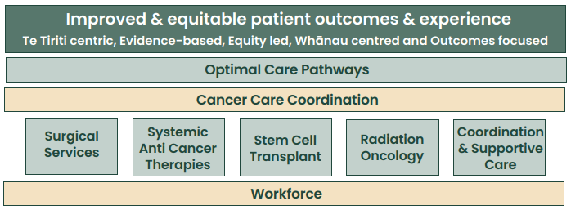

We presented a high-level recommendations summary to the Minister of Health in October 2021. This summary was then shared with the Health System Reform Transition Unit, for input into the interim New Zealand Health Plan of Te Whatu Ora. The full report on the programme He Mahere Ratonga Mate Pukupuku, Cancer Services Planning: A vision for cancer treatment in the reformed health system is available on our website.

1. Workforce
Addressing the challenges facing the cancer workforce is a priority across the whole
Cancer Services Planning Programme. The cancer workforce is struggling to meet current demand much less meet the projected 40 percent increase in new cancer diagnoses between 2020 and 2040. In 2021/22, our focus was on developing an implementation plan that concentrated on immediate short-term actions (subject to available funding). We delivered the plan to Te Whatu Ora and provided advice on utilising existing funding, starting with areas of greatest need – oncology and haematology nursing, the radiation oncology workforce and developing a stem cell transplant workforce model of care. The plan also provided the building blocks for future workforce planning that will continue in 2022/23. We will work with Te Whatu Ora, Te Aka Whai Ora, Māori Health Authority and the Health Workforce Taskforce to ensure there is appropriate cancer workforce capacity and capability to align with future demand for, and changes to, cancer treatment in this country.

2. Tumour optimal cancer care pathway
Unwarranted tumour cancer variation in the delivery of cancer care means that some
people receive sub-optimal care, and resources are used in ways that do not lead to optimal outcomes. This project supports improvements in cancer care by defining the optimal (evidence-based, best-practice), publicly funded care we should provide.
Planning has commenced to develop the optimal cancer care pathways for health care providers and services along the pathway, and for whānau there will be a ‘what to expect’ guide. The pathways will be a tool to help identify and address unwanted variation and inequity, particularly for Māori and Pacific peoples, encourage a proactive response to addressing and eliminating such inequity and drive continuious quality improvement.

3. Stem cell transplant
Stem cell transplant services have become fragmented, inequitable, and no longer fit for purpose. This contributes to a cancer services system that does not work equally well for everybody, especially Māori and Pacific peoples. This project aims to design a sustainable future service model for stem cell transplant, at the same time, working to address immediate capacity challenges.

4. Surgical services
Aotearoa New Zealand does not have a national policy to guide how surgery for
different cancers should be distributed throughout our country. This means many New Zealanders experience barriers to accessing surgical care, and treatment pathways are inconsistent. The focus of this project is on developing a framework that can help determine how cancer surgical services should be distributed across Aotearoa New
Zealand, including the level of centralisation/localisation required for equity of access and quality.

5. Systemic anti-cancer therapies
Care for patients receiving systemic anti-cancer therapies (SACT) – chemotherapy,
immunotherapy, targeted therapy and hormone therapy – is becoming more complex, and demand is increasing. Our focus is on addressing immediate capacity challenges while developing new models of care for delivering SACT, looking to enable more SACT to be delivered in the community, where it is appropriate to do so.

6. Radiation oncology
Radiation oncology (RO) in Aotearoa is of high quality but not all population groups are receiving the same access to, or benefit from, it. Currently RO services are managed by six host hospitals operating independently from each other. This project looks to describe and support the move to provide a single RO system of care, operating under a standardised national RO service model. It also focuses on increasing RO workforces and the public Linear Accelerator (LINAC) machine stock and accessibility.

7. Cancer care coordination
We are developing an establishment plan so that cancer care coordination services
can be commissioned throughout the country, with the initial focus on supporting Māori and Pacific cancer patients and their whānau. This plan includes strategic advice for the commissioning entities on how they can create cancer coordination services that are broadly consistent and high quality but also tailored to suit local communities and delivered in a range of settings, including primary health care, secondary health care, kaupapa Māori and community health organisations.

Developing a monitoring framework
The New Zealand Cancer Action Plan 2019–2029 sets four outcomes and multiple related actions across the cancer control pathway. This year, we have developed a monitoring framework so we can transparently assess our progress towards achieving the aspirations of the Cancer Action Plan.

We will report on 11 broad indicators to give a ‘snapshot’ of the current state of cancer control in Aotearoa New Zealand. Each year, we will calculate the indicators and present the results in a monitoring report to show progress in the cancer control system. The monitoring report will also present activities being undertaken to achieve the outcomes and actions of the Cancer Action Plan. A summary of the first monitoring report is available in Tō mātou whakahaere, Our performance section.

Better quality and more connected data and information

CanShare
CanShare is a new national health informatics platform that aims to allow the timely sharing of relevant and accurate cancer data. The primary intent of the CanShare programme is to support clinical and patient decision making at the point of care.
Outcomes from this work will include advanced analytics capability supporting up-to- date monitoring of cancer care throughout the country.

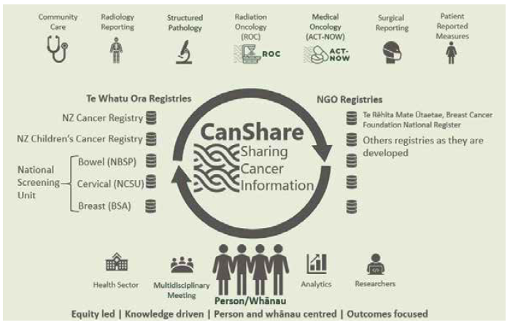
This will enable the collection of complete and accurate cancer data, joining currently disparate data siloes and providing a means to share timely clinical cancer information as needed. Over the past year some 200 contributors including health care practitioners, subject matter experts and consumers have been consulted or participated in working groups to advise on CanShare. Alongside the technical aspects of CanShare, we are building the partnerships critical to give effect to Te Tiriti of Waitangi, in particular Māori data sovereignty in the development and use of cancer data. Connections have been established with Te Whatu Ora, a cloud database is being built and there has been much work undertaken in the individual programmes comprising CanShare, as outlined below.

Anti-Cancer Therapies – Nationally Organised Workstreams
ACT-NOW (Anti-Cancer Therapies – Nationally Organised Workstreams) is a national
systemic anti-cancer therapy (SACT) data collection and analytics programme. In 2021/22 stakeholders collaborated to agree on SACT treatment definitions. This has now happened for 90 percent of cancers, meaning that treatment regimens can be compared across the country, outliers investigated, and quality improvement activities instigated.

Implementation of these definitions is underway within the public system, enabling the development of prototype analyses and early insights that can be used as a basis for clinical decision making.

There are multiple projects across our regional hubs now focused on operationalising the benefits of the ACT-NOW programme. Our Central Hub has stood up an ACT-NOW project for the Wellington Blood and Cancer Centre and the Regional Cancer Treatment Service. Functional requirements have been endorsed for the transition to oncology e-prescribing in our Te Manawa Taki Hub. In the Northern Hub, ACT-NOW is integral to the implementation of a new e-prescribing system, with our staff on the implementation working group and steering group.

MOSAIQ Oncology software system
The Southern Hub continues to support the implementation of MOSAIQ across the region. The hub hosted a workshop to continue reviewing and updating Canterbury DHB care plans in MOSAIQ and ensuring alignment with the ACT- NOW project. Clinical staff, supported by Southern Hub staff, updated several existing care plans and created new ones. This will ensure the system is current when other districts come on board. Engagement with Nelson Marlborough and Canterbury DHBs
to develop a detailed project plan, including timelines for MOSAIQ implementation, is underway.

Multidisciplinary meeting dashboard
The South Island cancer multidisciplinary meeting (MDM) electronic platform has been a key enabler to streamlining MDM meeting management functions, documentation processes and supporting workflows across the region. One of the key outputs has been the development of a regional power BI dashboard which provides almost real time visibility of MDM resource, volumes and key tumour specific data.

Leveraging off this dashboard, the Southern Hub has supported the development of tumour stream visuals (beginning with the hepato-pancreato-biliary tumour stream) which has combined key surgical, oncology and mortality data to measure patient flow, outcomes and survival. This work is unique to the South Island and will continue to be rolled out to include other cancer tumour streams. These visuals also provide valuable insight into areas which would benefit from quality improvement initiatives.

Structured pathology
Pathology is integral to the diagnosis and treatment of cancer. The ever-increasing
complexity of cancer treatment requires a greater level of pathology reporting; however, pathology services are facing major challenges with legacy paper-based data systems and work volumes.

For pathology services to transition to a more connected digital health environment, data standards must be developed. These data standards will identify and describe the clinically relevant data elements, creating consistent workflows for all professionals involved in pathology services.

In 2021/22, we determined a development and release approach to speed up the delivery of data standards and ensure they are robust and meet our Tiriti obligations, including recognising Māori data sovereignty in the development and use of cancer data. In 2021/22, thoracic (lung, pleural and thymic) and breast cancer draft data standards were released, and four more are in development.

National radiation oncology collection
The national radiation oncology collection (ROC) is a national data collection and
analytics programme to support efficiencies and improved outcomes for people with cancer receiving radiation therapy. ROC continues to support data-driven improvements to treatment equity, quality, consistency, and efficiency in Aotearoa New Zealand.

ROC has been used as the key data source to underpin national planning to increase treatment capacity and the workforce to support this. This is intended to address inequities by reducing the barriers to access to radiation therapy and support the provision of radiation therapy closer to home for many people.

Faster cancer treatment reporting
Faster cancer treatment (FCT) indicators were introduced by the Government in 2012,
requiring DHBs to collect standardised information on patients who had been referred urgently with a high suspicion of cancer. There are two indicators.
- 31-day indicator – patients with a confirmed cancer diagnosis receive their first cancer treatment (or other management) within 31 days of a decision to treat.
- 62-day indicator – patients referred urgently with a high suspicion of cancer receive their first treatment (or other management) within 62 days of the hospital receiving the referral.

We support ongoing FCT data quality improvement by enhancing transactional data business rules and working with DHBs and Manatū Hauora on data quality. We also coordinate FCT data collection, reporting and dissemination.
Throughout 2021/22, our regional hubs continued to support DHBs to improve their performance against FCT measures. Different regions have experienced different needs and challenges, and therefore the support provided by each hub has varied. Collectively, the regional hubs have supported their DHBs with regional FCT analysis, including providing equity-focused reporting, contributing to local DHB cancer service improvement work groups, collating regional narrative reports, and assisting with specific improvement initiatives. Most recently, we have initiated a project to support a consistent interpretation and use of the cancer wait-time business rules to better support service improvements and regional hub project manager knowledge.

HISO (Health Information Standards Organisation) standards
Nationally agreed and HISO endorsed data standards support the vision we share with Te Whatu Ora for a fully interoperable digital health system to facilitate the timely sharing of cancer information for decision making, quality improvement and research. Standards ensure the integrity of collected health information so that systems can ‘talk to each other’. These standards are part of a system in which patients and their whānau have access to and control over their own information.

Two data standards have been published in 2021/22: the structured pathology data standard and the multidisciplinary meetings data standard. More are currently being developed.

Leadership and collaboration across data and digital health
We have been working alongside Manatū Hauora, Te Whatu Ora and Te Aka Whai Ora to ensure the needs of cancer patients and whānau are considered within data and digital system changes. We now have staff sitting on key digital governance and advisory groups including the Hira programme governance group, the Digital Enablement Oversight Group, the Digital Health Equity Reference Group and Te Rangapū Tiriti, a new co-governance group established by Manatū Hauora to ensure Māori have a voice within the area of data & digital health. We also chair the Cancer Working Group within the New Zealand Telehealth Forum. In 2021/22 we facilitated a New Zealand Telehealth Forum webinar on telehealth in cancer care and took part in two other webinars, Pae Ora and Improving Māori Health Gains.

Kia whakaiti iho te mate pukupuku | Achieving fewer cancers through a focus on prevention

Cancer Prevention Report
Te Aho o Te Kahu released Pūrongo Ārai Mate Pukupuku, Cancer Prevention Report
(Cancer Prevention Report) on 4 February 2022, in collaboration with Te Hiringa Hauora, Health Promotion Agency and the University of Otago Wellington. The Cancer Prevention Report outlines evidence-based interventions to prevent cancer across six key cancer risk factors: tobacco, alcohol, poor nutrition and excess body weight, insufficient physical activity, excessive exposure to sun and chronic infections.

Up to half of all cancers can be prevented by reducing or removing everyone’s exposure to the cancer risk factors present in our lives and environments. The purpose of this report is to summarise how Aotearoa New Zealand is doing in each of those risk factor areas and to highlight where we could do better. Our aim was to identify ways to create the environments that help whānau live long healthy lives, free of cancer. We will work alongside Manatū Hauora, the Public Health Agency, Te Whatu Ora and Te Aka Whai Ora as needed in areas that the Government is keen to progress.

Cancer research
In 2021/22 we teamed up with the Health Research Council of New Zealand (HRC) and
Manatū Hauora to provide $6.2 million in funding for research aimed at addressing the stark inequities in cancer care and survival for Māori and Pacific peoples in Aotearoa New Zealand. There were six recipients with proposals across a range of areas: lung cancer screening, improving clinical care in lung and uterine cancer and whānau ora navigation within the delivery of cancer care.

Primary health care
Our Person and Whānau Centred Care team have initiated a project to provide us with an in-depth understanding of the state of primary and community health care in Aotearoa New Zealand with respect to cancer. This is a three-phase project that involves a stocktake of the current state, a literature review and consideration of actions across the continuum of care where primary health care can be better supported/optimised. Stakeholder engagement will be undertaken across each aspect. Focused implementation work will be determined once the initial stocktake and literature review phases are complete.

Advice and guidance to primary health care
In 2021/22 we commissioned the independent, not-for-profit health professional
educational organisation Best Practice Advocacy Centre New Zealand (bpacnz) to develop evidence-based packages on the early detection and follow-up and surveillance of lung cancer and melanoma. These information packages are supported by peer group discussion points and a quiz that help both general and nurse practitioners with their ongoing medical education. Around 11,000 health practitioners currently use bpacnz, and it is seen as a powerful platform for sharing educational materials with a primary health care audience.

Kia runga noa ake te mataora | Improving cancer survival

Quality improvement programme
Quality performance indicators (QPIs) are used to improve the quality of cancer services and deliver better outcomes for people diagnosed with cancer. They enable DHBs to compare their performance with other DHBs. QPIs are selected by an expert working group with consumer representation and a range of clinical experts involved in providing care to cancer patients. To date, we have selected, calculated, and reported on QPIs for bowel, lung, and prostate cancers. Currently, we are working on QPIs for breast and pancreatic cancers.

This year, we worked with the National Bowel Cancer Working Group to recalculate the bowel cancer quality performance indicators that were first published by Manatū Hauora in March 2019. This latest report published QPI data for patients diagnosed with bowel cancer in Aotearoa New Zealand from 2017 to 2019. We released the Bowel Cancer Quality Improvement Monitoring Report Update 2022 to DHBs at the start of March and published the final report at the end of April.

After calling for nominations via our website and through key stakeholders, we convened a national Breast Cancer QPI Working Group late last year. Its role is to work with us to identify potential breast cancer QPIs. Once the breast cancer QPIs have gone through public consultation and been finalised, they will be calculated using data from the New Zealand Cancer Registry and Manatū Hauora national data collections for patients diagnosed with breast cancer in Aotearoa New Zealand from 2017 to 2019.

We also worked with the national Pancreatic Cancer Working Group to finalise the pancreatic cancer QPI descriptions after receiving feedback via the public consultation process in October 2021. The indicators are now being calculated, and we hope to publish the results soon.

Cancer medicines availability analysis
In April 2022 we released Mārama Ana ki te Āputa: He tātari i te wāteatanga o ngā rongoā mate pukupuku i Aotearoa | Understanding the Gap: an analysis of the availability of cancer medicines in Aotearoa, our cancer medicines availability analysis report. The report describes the findings of an analysis that compares the availability of cancer medicines in Aotearoa (medicines publicly funded via Pharmac) with that of Australia – not only in terms of the number of medicines funded but also in terms of clinical benefit.

Cancer medicines are a crucial part of cancer care. In our work, we often hear concerns from patients, their whānau and their health professionals regarding cancer medicines availability. The aim of this work was to provide useful insights to Pharmac, the New Zealand Government, the health sector and to the public. We identified 20 different medicine-indication pair gaps across nine different solid-tumour cancer types where the medicines were publicly funded in Australia and not in Aotearoa New Zealand and
where the analysis indicated that the medicine would offer substantial clinical benefit. This analysis was conducted separately to the independent review of Pharmac announced by the Government in March 2021, but we shared the preliminary results of this analysis with the Pharmac review panel.

Clinical trials
Inadequate and inequitable access to cancer clinical trials has been highlighted by
the cancer sector as an area of concern. Manatū Hauora is leading work to improve clinical trial infrastructure for all conditions, including cancer, and this year, we continue to advocate and provide support from a cancer perspective. The teletrials model (implemented in Australia) gives people with cancer who are living away from the major centres the opportunity to participate in clinical trials without needing to travel. In 2021/22, we funded the organisation Cancer Trials New Zealand to develop core infrastructure to support teletrials in Aotearoa New Zealand.

Te whakapai mana taurite o ngā hua mate pukupuku | Improving equity of cancer outcomes

Māori community hui
In 2020/21 Te Aho o Te Kahu launched a series of community hui, specifically aimed at
whānau Māori who were affected by cancer. The last of these hui was completed in 2021/22, with our team travelling to Southland and Waikato in July 2021. Over 2,800 whānau Māori supported and attended a community hui, helping us gain a deeper understanding of the experiences and issues faced by Māori cancer patients and whānau.

We’ve been analysing the data and insights shared throughout the hui series and discussing these insights with stakeholders working in Māori health and cancer care. We are in the final stages of producing a report summarising the collective voice of whānau Māori and look forward to sharing the findings back with the communities and
contributors. We’ve also used the insights internally to elevate the patient voice in several key projects, including the Cancer Services Planning Programme.

Embedding equity led thinking
In 2021/22 we continued to build our focus on equity, with capability development a key area of work. Our Equity team developed a toolkit that included resources and research. This toolkit is designed to educate, inform, and challenge our staff.

We have also incorporated equity frameworks into key business processes and project planning methodology. We established a community of practice, Te Kāhui Mana Taurite, to support equity analysis across the entire Cancer Services Planning Programme. This roopu identified and analysed equity issues across each area of the programme. The voice of patients and whānau was integrated into this analysis, as was national and international literature.

We have also been supporting the equity work of other agencies and organisations. Our Equity team has shared insights with other health and community colleagues, both formally and informally, through guest speaker presentations, various governance and advisory roles, and publication of research papers.

Being equity led and whānau centred in the development and use of data
We are actively working with our partners to better understand and put into practice our obligations and responsibilities with respect to Māori data sovereignty and governance. We are mindful of the privilege we have in accessing people’s cancer data. We understand our obligations to ensure cancer information is timely, sharable, relevant, and accessible, and used appropriately for the purpose for which it was intended. To give effect to Te Tiriti o Waitangi, we treat data as a taonga (treasure) and apply appropriate safeguards to secure and protect Māori data from misuse. We recognise the rights and interests of Māori in the collection, ownership and application of data.

We have developed a position statement on the collection of cancer data and information in Aotearoa New Zealand in relation to hapū and iwi affiliation, Māori descent and ethnicity. Equity impact assessments inform the foundation data programmes of ACT-NOW and structured pathology reporting of cancer. We have started scoping for an overarching equity impact assessment to inform CanShare development and delivery. This will include integrating safeguards in development and use of Māori data for analytics, improvement, and research.

Pacific research project
We have been working with Moana Connect to explore Pacific cancer pathways to
diagnosis, treatment, follow-up after treatment, support, and the handover back to primary health care services. We want to understand at what points along the cancer pathway Pacific peoples experience breakdowns in the system or face challenges and barriers and what supports they have received.

This research follows an empowerment approach where Pacific stories and perspectives are championed and, once completed, will inform our work around identifying opportunities to improve cancer coordination and supportive care for Pacific peoples during cancer treatment. We expect to release the findings from this research later in 2022.

Supporting equity led work across the cancer sector
Te Aho o Te Kahu has supported a number of organisations looking to embed equity in their work. This includes the Cancer Society, who have been codesigning a proposed new model of care with equity as a key principle, and the National Child Cancer Network, who have established a roopu and research project focused on better understanding any inequities of experience among families living with child cancer.

We have also collaborated with the New Zealand Telehealth Forum and the University of Auckland to support an internship examining the resources are available to help patients understand and use telehealth and are working with the Forum and Massey University to survey all public hospital cancer clinics on their use of and attitudes towards telehealth in cancer care.

Tā mātou whakahaere | Our performance

Agency performance
Performance measure | 2020/21 | 2021/22 | Notes
Staff satisfaction | 7.3/10 | NA | Ministry of Health Kōrero Mai Survey is undertaken every two years. Will be carried out again in Nov 2022.
Sick leave taken | 3.1 days | 4.7 days | Most staff have taken COVID-19 sick leave across 2021/22 (either contracting COVID-19 themselves or caring for dependents).
Staff turnover | 4% | 13% | Staff turnover has increased as we have become fully established and are settling into BAU operation.
Percentage Māori staff | 8% | 11% | Deliberate recruitment focus on Māori staff and capability.
Percentage Pacific staff | 0% | 6% | Deliberate recruitment focus on Pacific staff and capability, creation of a Pacific Equity role in the Northern Hub.
Percentage Non-European staff | 26% | 40%
Diversity and Inclusion |  |  | Statements from 2021 Public Service Census
I believe my agency supports and actively promotes an inclusive workplace | 93% |  | Average across the Public Service was 78%
The people in my workgroup behave in an accepting manner to people from diverse backgrounds | 91% |  | Average across the Public Service was 81%
I feel accepted as a valued member of the team | 86% |  | Average across the Public Service was 79%
I am satisfied with my work/life balance | 59% |  | Average across the Public Service was 52%
Te Reo Māori |  |  | Statements from 2021 Public Service Census
I use at least some te reo words and phrases | 84% |  | Average across the Public Service was 58%
I hear leaders regularly using te reo words and phrases | 93% |  | Average across the Public Service was 67%
Staff are supported to improve our te reo Māori | 84% |  | Average across the Public Service was 59%
How many staff have never  studied te reo | 23  people | 6  people | From internal Whāinga Amorangi individual capability surveys
Māori Crown Relations |  |  | Statements from 2021 Public Service Census
I am comfortable supporting tikanga Māori in my agency | 87% |  | Average across the Public Service was 69%
I am encouraged and supported to engage with Māori | 91% |  | Average across the Public Service was 65%
I feel confident in my ability to identify aspects of my agency’s work that may disadvantage Māori | 89% |  | Average across the Public Service was 58%
I understand how my agency’s Te Tiriti responsibilities apply to its work | 89% |  | Average across the Public Service was 69%
Te Aho o Te Kahu enables me to apply Māori Crown relations skills to my mahi | 49% | 76% | From internal Whāinga Amorangi individual capability surveys
OIA timeliness | 100% | 100% | From Ministry of Health data

Te Aho o Te Kahu Whāinga Amorangi | Individual Māori Crown Relations Surveys

(baseline in 2021, repeated in 2022)
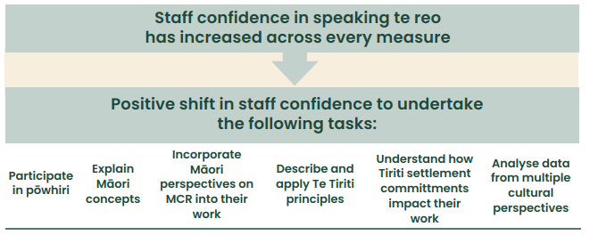

Sector performance
The New Zealand Cancer Action Plan 2019-2029 sets four outcomes and multiple actions across the cancer control pathway. In 2021/22 we developed a monitoring framework and are currently in the process of developing the first monitoring report.

This report presents eleven broad indicators of the current state of cancer control in Aotearoa along with activities being undertaken to achieve the aspirations of the Cancer Action Plan.

Monitoring will take place annually and we will be able to track system change over time. These measures tell us if we are heading in the right direction – however it is important to note, they are not solely attributable to Te Aho o Te Kahu and will likely shift slowly.

Outcome 1: New Zealanders have a system that delivers consistent and modern cancer care

Indicator 1: Ethnic distribution of the current cancer workforce
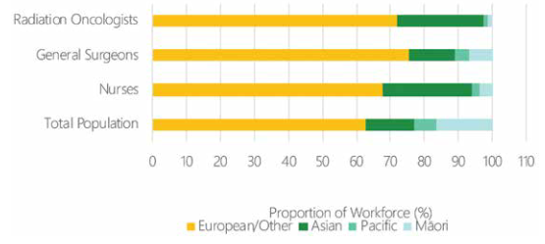
Ethnic distribution of radiation oncologists, general surgeons and nurses in 2021, shown alongside the ethnic distribution of the total New Zealand population.

There is a mismatch between the ethnic distribution of the cancer workforce and the general population. Māori and Pacific peoples are underrepresented in the cancer workforce.

Indicator 2: Government investment in cancer-focused research
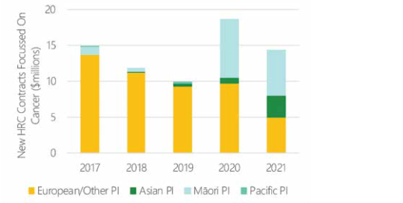

In 2020 and 2021 there has been an increase in diversity, with Māori leading projects worth more than $6 million and Asian principle investigators leading projects worth more than $3 million. There are few Pacific-led HRC-funded cancer-focused research.

Te Aho o Te Kahu-led activities related to Outcome 1
 | Te Aho o Te Kahu-led activity | Related Action(s) within the Cancer Action Plan
Outcome 1:  New Zealanders have a system that delivers consistent and modern cancer care | Creation of a cancer control agency for New Zealand | Leadership and governance
 | Creation of groups to assist in the governance of cancer care delivery | Leadership and governance
 | Partnership with Māori cancer leaders | Leadership and governance
 | Building infrastructure to make real-time cancer data sharing a reality | Data and information
 | Structured Pathology Reporting of Cancer | Data and information
 | MDM Data Standard refresh | Data and information
 | New funding for research to drive equitable cancer outcomes | Research and innovation
 | Supporting improved access to cancer clinical trials via teletrials | Research and innovation

Outcome 2: New Zealanders experience equitable cancer outcomes

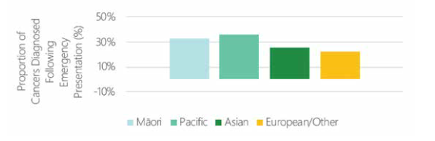
Indicator 1: Diagnosis of cancer following an emergency presentation

In 2020, Māori and Pacific peoples were more likely to be diagnosed with cancer following an emergency presentation.

Indicator 2: Participation in national cancer screening programmes
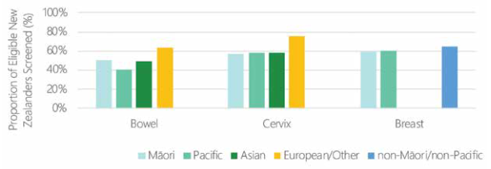

Based on data from 2021, there are strong disparities in access to each of the three national screening programmes between ethnic groups.

Te Aho o Te Kahu-led activities related to Outcome 2
 | Te Aho o Te Kahu-led activity | Related Action(s) within the Cancer Action Plan
Outcome 2:  New Zealanders experience equitable cancer outcomes | Gathering the voice of the Māori community | Achieve equity by design
 | Building Mana Enhancing Relationships with Māori Leaders and Cancer Care Provider | Achieve equity by design
 | Project focusing on primary care | Achieve equity by design
 | Project on cancer care for Pacific peoples | Achieve equity by design

Outcome 3: New Zealanders have fewer cancers

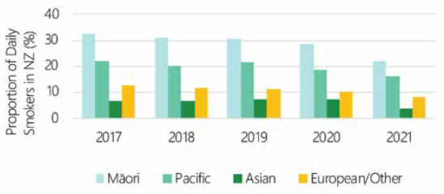
Indicator 1: Proportion of New Zealanders who are daily smokers

There are strong disparities in daily tobacco smoking between ethnic groups in New Zealand. The rate of daily smoking appears to be reducing for most ethnic groups over time, although there does not appear to have been a change in disparities between ethnic groups.

Indicator 2: Proportion of New Zealanders who are obese
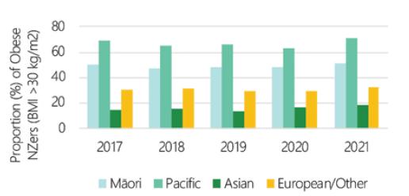

Stark disparities exist in rates of obesity between ethnic groups in New Zealand. The highest rates of obesity are seen among Pacific peoples, followed by Māori, European/ Other and Asian peoples. The rates of obesity are not reducing over time for any ethnic group, and disparities between ethnic groups are not changing.

Indicator 3: Proportion of New Zealand children immunised against hepatitis B
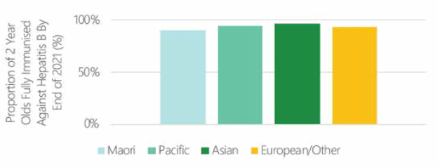

Less Māori are immunised against hepatitis B than other ethnic groups. Falling rates of childhood immunisation against hepatitis B are particularly important for Māori, since the rate of primary liver cancer is higher for Māori and the incidence of liver cancer is increasing abruptly over time for Māori, but not for non-Māori.

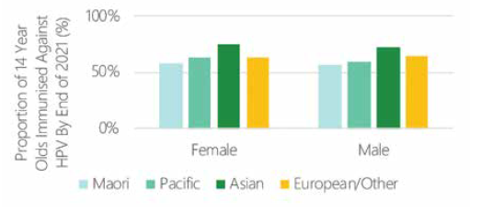
Indicator 4: Proportion of New Zealand children immunised against HPV

Around 60 percent of New Zealanders who turned 14 in 2021 are fully immunised against HPV. The proportion of fully immunised 14-year-olds is increasing although rates for Māori females have plateaued over the last decade.

Te Aho o Te Kahu-led activities related to Outcome 3
 | Te Aho o Te Kahu-led activity | Related Action(s) within the Cancer Action Plan
Outcome 3:  New Zealanders have fewer cancers | Cancer Prevention Report  To view this report, go to  https://teaho.govt.nz/publications/prevention-report | Smokefree by 2025  Encourage and support healthy living  Prevent cancers related to infection  Reduce the incidence and impact of avoidable skin cancer caused by UVR

Outcome 4: New Zealanders have better cancer survival, supportive care and end of life care

Indicator 1: Proportion of New Zealanders with cancer who received surgical treatment
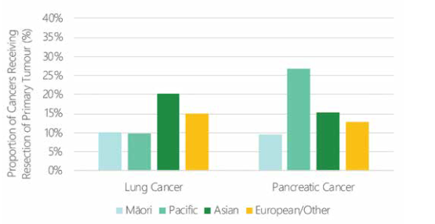

Overall, the rate of surgical resection for both cancers was around 10-15%, with limited evidence of disparities between ethnic groups.

Indicator 2: Proportion of New Zealanders with cancer who received radiation therapy
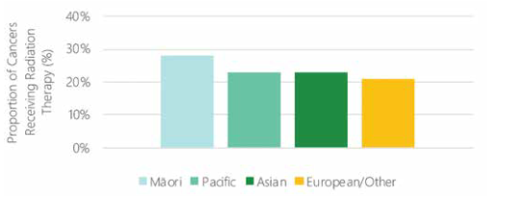

Māori appeared more likely to access radiation therapy. While this might suggest that Māori have better access to radiation therapy than other ethnic groups, there is evidence that Māori are more likely to be referred for curative or palliative radiation therapy rather than surgery compared to non-Māori.

Indicator 3: Proportion of New Zealanders with cancer who received systemic therapy
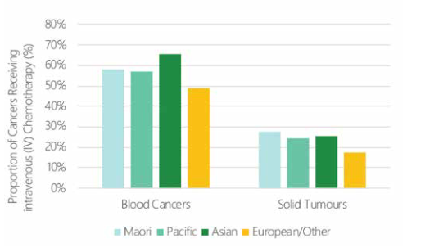

More than half of blood cancers and around a quarter of solid tumours were treated with IV chemotherapy infusion. European/Other population appeared to access less IV chemotherapy however some private providers do not report data and European/Other access more privately funded care than other groups.

Te Aho o Te Kahu-led activities related to Outcome 4
 | Te Aho o Te Kahu-led activity | Related Action(s) within the Cancer Action Plan
Outcome 4:  New Zealanders have better survival | Cancer Medicines Availability Analysis  To view the report, go to https://teaho.govt.nz/publications/cancer-medicines | Improve cancer diagnosis and treatment outcomes
 | Measuring cancer treatment quality | Improve cancer diagnosis and treatment outcomes
 | Cancer service planning  To view copy of the report, go to  https://teaho.govt.nz/publications/cancer-  services-planning. | Improve cancer diagnosis and treatment outcomes

Tauākī Haepapa | Statement of responsibility
We are jointly responsible for the accuracy of any end-of-year performance information prepared by Te Aho o Te Kahu, whether or not that information is included in the Annual Report.

In our opinion, the Annual Report fairly reflects the operations, progress, and organisational health and capability of Te Aho o Te Kahu.
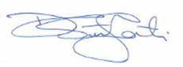

Dr Diana Sarfati Nicola Hill
Chief Executive (to end June 2022) Acting Chief Executive (from July 2022) Te Aho o Te Kahu, Cancer Control Agency Te Aho o Te Kahu, Cancer Control Agency 30 September 2022 30 September 2022

Ministry of Health. 2019. New Zealand Cancer Action Plan 2019–2029 – Te Mahere mō te Mate Pukupuku o Aotearoa 2019–2029. Revised January 2020 Wellington: Ministry of Health.
Minister of Health. 2003. The New Zealand Cancer Control Strategy. Wellington: Ministry of Health and the New Zealand Cancer Control Trust.
Ministry of Health. 2019. New Zealand Cancer Action Plan 2019–2029 – Te Mahere mō te Mate Pukupuku o Aotearoa 2019–2029. Revised January 2020 Wellington: Ministry of Health.
Ministry of Health. 2019. Bowel Cancer Quality Improvement Report. Wellington: Ministry of Health.

