Te Aho o Te Kahu | Cancer Control Agency Annual Report 2022/23

Our vision
Fewer cancers | Kia whakaiti iho te mate pukupuku
Better survival | Kia runga noa ake te mataora
Equity for all | Kia taurite ngā huanga.

Our purpose
We provide strong central leadership and oversight of cancer control. We lead and unite efforts to deliver better cancer outcomes for Aotearoa New Zealand.

Our work is
- equity led
- knowledge driven
- outcomes focused
- person and whānau centred.

Who we are
Te Aho o Te Kahu, the Cancer Control Agency is a departmental agency reporting directly to the Minister of Health and hosted by the Manatū Hauora.

The agency was created in recognition of the impact cancer has on the lives of New Zealanders and provides a sharp focus on this important health issue.

We have 60 people working for us across six Wellington-based teams and four regional hubs.

He mihi nā te Tumuaki | Chief Executive foreword
Kia ora koutou

I am delighted to present the fourth annual report for Te Aho o Te Kahu | the Cancer Control Agency.

Throughout the implementation of the broadest health and disability system reforms in Aotearoa New Zealand’s history, our purpose remained constant
— we continue to lead and unite across the cancer continuum, sharing system-level cancer expertise and providing high-quality advice to the Government, health entities and wider health sector.

As Te Whatu Ora | Health New Zealand, Te Aka Whai Ora | Māori Health Authority, and Whaikaha | Ministry of Disabled People bed in, we have been making connections and providing expert advice to ensure cancer care and equitable outcomes are front of mind in the design of Aotearoa New Zealand’s new health system. As Acting Tumuaki | Chief Executive, I have been working closely with the tumuaki of the other health agencies and organisations to ensure we are making cohesive, strategic progress towards a joined-up health system that is equity led. Our kaimahi | staff continue to collaborate across the health system, including working alongside clinical leadership and those responsible for service delivery at district, regional and national levels.

There are many health professionals and whānau with cancer who contribute to better outcomes in cancer care, and who through their participation directly feed into our work — providing a vital connection to what is happening on the ground. Our four regional hubs continue to foster important relationships with the work happening on the frontline and across our communities. My thanks to all those involved — your input is an essential ingredient in delivering our vision:

Fewer cancers | Kia whakaiti iho te mate pukupuku
Better survival | Kia runga noa ake te mataora
Equity for all | Kia taurite ngā huanga.

I am proud of the work the agency has delivered throughout 2022/23 and the impact it has had.

I wish to welcome Rami Rahal, the newly appointed Tumuaki of Te Aho o Te Kahu. Since he joined early in July 2023, he has taken over leading our organisation and building on the work undertaken across 2022/23 and is appropriately a joint signatory to this annual report.

Finally, I wish to acknowledge those who are living with cancer and their whānau. We strive to keep your voices at the forefront of our efforts, to strengthen and support the cancer care system across Aotearoa New Zealand for everyone. Waiho i te toipoto, kaua i te toiroa | Let us keep close together, not far apart.

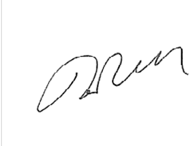
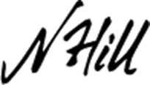

Nicola Hill Rami Rahal
Tumuaki | Acting Chief Executive Tumuaki | Chief Executive
Te Aho o Te Kahu | Cancer Control Agency Te Aho o Te Kahu | Cancer Control Agency

Anei mātou | Who we are
Te Aho o Te Kahu | the Cancer Control Agency is a departmental agency reporting directly to the Minister of Health and hosted by Manatū Hauora | the Ministry of Health. Te Aho o Te Kahu was created in 2019 in recognition of the effect cancer has on the lives of New Zealanders and the need to do better for whānau affected by cancer. We provide a sharp focus on this important health issue. Our agency is led by the Tumuaki | Chief Executive, who also holds the position of National Director of Cancer Control. Cancer presents some unique challenges to the health system and across communities.
- The number of people diagnosed with cancer is projected to double over the next two decades.
- The costs and complexity of care and pace of change present major challenges for our health systems and services.
- Māori and Pacific peoples have worse cancer survival rates than other people living in New Zealand.
- Cancer survival is improving in Aotearoa, but our rate of improvement is slower than rates in comparable countries, so we are falling behind.

Tā mātou aronga | Our purpose: an agency focused on cancer
We provide strong, central leadership and oversight of cancer control. We lead and unite efforts to deliver better cancer outcomes for Aotearoa. We are also accountable for ensuring there is transparency in our country’s progress towards achieving the goals and outcomes outlined in the New Zealand Cancer Action Plan 2019–2029. In practice, we deliver this leadership and oversight by:
- providing advice to government about the future design and function of cancer services and options for resolving medium- to long-term operational issues
- developing and sustaining strong partnerships between the key health entities with responsibility across the cancer continuum
- bringing sector stakeholders together to progress and achieve shared objectives
- undertaking national initiatives to improve cancer outcomes for New Zealanders
- assembling and disseminating cancer data and information to inform decision-making and service delivery
- providing support for cancer service providers when service is, or is likely to be, disrupted or is not meeting demand or expectations.

It remains critical to have a stand-alone, strong state entity to coordinate across and integrate the many stakeholders involved in cancer care and control. The cancer continuum intersects with every aspect of the wider health system. Countries that have attempted to include cancer control in a broader commissioning entity tend not to perform as well as those that have an entity focused on cancer.

Tō mātou whāinga | Our vision
We strive to achieve:
- fewer cancers
- better survival
- equity for all.

Our work programme is driven by and aligned to our values of being:
- equity led
- whānau centred
- knowledge driven
- outcomes focused.

Te taonga me te kupu taurangi o te ingoa | Our name: Te Aho o Te Kahu
Our te reo Māori | Māori language name is a taonga | treasure, gifted to us by Hei Āhuru Mōwai | Māori Cancer Leadership Aotearoa in June 2020. This name is central to who we are and how we work.

Te Aho o Te Kahu means ‘the central thread of the cloak’. This aho | thread binds the many whenu | strands into one kahu | cloak that protects people with cancer and their whānau.

Te Aho: The central thread symbolises our agency and our role as a leader and connector across the cancer control continuum.

Te Kahu: The cloak symbolises all the services, organisations, communities and people that work with those affected by cancer.

Equity is not only the priority for us in our role as ‘Te Aho’; it is also embedded in our architecture, processes, systems and tikanga | Māori philosophy and culture. In acknowledgement of the honour in the gift of our name, Te Aho o Te Kahu signed an oati with Hei Āhuru Mōwai. The signed version is framed in the Wellington office. The oati acknowledges that:
- Te Tiriti o Waitangi, its principles and intentions are the foundation for the name, and Te Aho o Te Kahu will honour our commitment to these
- Te Aho o Te Kahu has a commitment to uphold the mana | status and integrity of the name and its meaning in its entirety, that the name and its mauri | essence is respected, nurtured and cared for, and its core principles are adhered to, including ensuring that this is reflected in our appropriate use of te reo Māori and tikanga in our work.

Te taonga: Te Kahu Āhuru | Our treasure: Te Kahu Āhuru
Taking inspiration from the vision and name gifted to us, the cloak Te Kahu Āhuru was created by kairaranga | weaver Pip Devonshire (Ngāti Manomano, Ngāti Te Au hapū of Ngāti Raukawa) and gifted to Te Aho o Te Kahu on 3 August 2021 at Pipitea Marae in Wellington.

This physical embodiment of our purpose is now on display in our Wellington office and is available to be worn by our kaimahi | staff at events.

Te ū ki Te Tiriti o Waitangi | Our commitment to Te Tiriti o Waitangi
As part of the public service, Te Aho o Te Kahu has a responsibility to contribute to the Crown meeting its obligations to the special relationship between Māori and the Crown under Te Tiriti o Waitangi (Te Tiriti).

We strive to achieve the following four goals of Te Tiriti, each expressed in terms of mana.

Mana whakahaere
Encouraging effective and appropriate stewardship or kaitiakitanga over the health and disability system. (This goes beyond the management of assets or resources.)

Mana motuhake
Enabling Māori to be Māori — to exercise their authority over their lives and to live on Māori terms and according to Māori philosophies, values and practices, including tikanga Māori.

Mana tangata
Achieving equity in health and disability outcomes for Māori across the life course and contributing to Māori wellness.

Mana Māori
Enabling ritenga Māori | Māori customary rituals, which are framed by te ao Māori | the Māori world, enacted through tikanga Māori | Māori philosophy and customary practices and encapsulated within mātauranga Māori | Māori knowledge.

The principles of Te Tiriti outlined below provide the framework for how we will meet our obligations under Te Tiriti in our day-to-day work.

Tino rangatiratanga
The assurance of tino rangatiratanga provides self-determination and mana motuhake for Māori in the design, delivery and monitoring of health and disability services.

Equity
The principle of equity requires the Crown to commit to achieving equitable health outcomes for Māori.

Active protection
The principle of active protection requires the Crown to act to the fullest extent practicable to achieve equitable health outcomes for Māori.

Options
The principle of options requires the Crown to provide for and properly resource kaupapa Māori health and disability services. Furthermore, the Crown is obliged to ensure that all health and disability services are provided in a culturally appropriate way.

Partnership
The principle of partnership requires the Crown and Māori to work in partnership in the governance, design, delivery and monitoring of health and disability services, especially in regard to the development and delivery of the primary health system for Māori.

Tō mātou whānau | Our people
As at 30 June 2023, 61 people or 58.1 full time equivalents (FTE) were employed by Te Aho o Te Kahu. This includes two people on parental leave. There were an additional 5 FTE contract roles.

Of the 58.1 FTE, 54.9 FTE were employed on permanent contracts, with 3.2 FTE on fixed term and 0.6 FTE on secondment.

There were 9.6 FTE vacancies (3.6 on hold, 5.7 in recruitment).
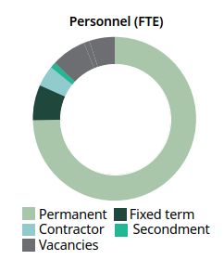

Full-time and part-time kaimahi
Eighty-three percent of our permanent kaimahi work full time.
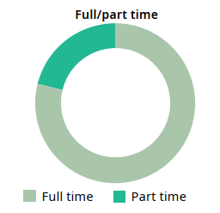

Gender
Seventy-five percent of our kaimahi are female.
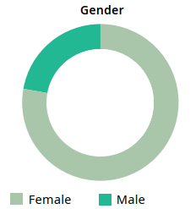

Ethnicity
We follow a deliberate strategy to attract and recruit kaimahi who identify as Māori, although this is not without its challenges as there is high demand for Māori kaimahi across the new health entities. 11% of kaimahi are Māori, 5% are Pacific, and 35% are non-European.
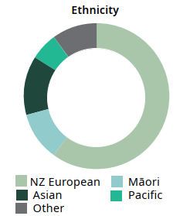

Diversity and inclusion
We strive to be a diverse and inclusive workplace where all people feel valued. We are a member of Te Kawa Mataaho, Public Service Commission’s Diversity and Inclusion Executive Champions Network. Papa Pounamu, the Te Kawa Mataaho diversity programme, identifies five priority areas for development: cultural competence, addressing bias, inclusive leadership, building relationships and employee-led networks. We are engaged across all of these priorities via our Whāinga Amorangi: Transforming Leadership plans and E Tipu E Tipu, our Māori Language Plan (see Tō mātou tutuki | What we have achieved and Tō mātou whakahaere | Our performance sections).

Whiria te Tangata, the Manatū Hauora culture and inclusion strategy outlines a shared overarching approach to diversity and inclusion. Our staff work alongside Manatū Hauora staff in developing, delivering, and participating in Manatū Hauora awareness and celebration events and are encouraged to engage with the many employee-led networks on offer at both Manatū Hauora and the wider public service.

Our organisational structure
Since July 2022 there have been interim leadership arrangements in place after Diana Sarfati, previous Tumuaki | Chief Executive of Te Aho o Te Kahu, was appointed Interim Director-General of Health. In November 2022, Diana was confirmed in that role permanently and recruitment began for her replacement. Across that time Nicola Hill, General Manager, has been Acting Tumuaki; Nicholas Glubb, Southern Regional Manager, has been Acting General Manager; and Janfrey Doak, Project Manager Southern Hub, has been Acting Southern Hub Manager. Our new Tumuaki Rami Rahal joined Te Aho o Te Kahu on 10 July 2023, which is when those in acting roles returned to their day-to-day role.

Our leadership
Tumuaki | Acting Chief Executive — Nicola Hill  Nicola was Acting Tumuaki from July 2022 to July 2023 when former Tumuaki, Dr Diana Sarfati, was named the Interim Director-General of Health.  Nicola has 17 years experience at Manatū Hauora, including periods advising the Director-General of Health and as Acting Group Manager, Strategy Group, in the Strategy and Policy Directorate. Since 2019 Nicola has been Pou Whakahaere Mātāmua | General Manager at Te Aho o Te Kahu. | 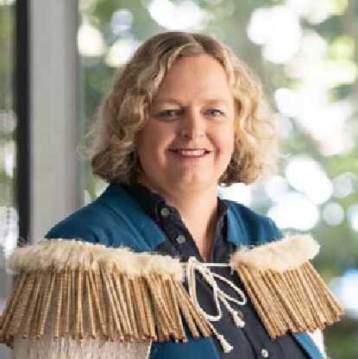
Pou Whakahaere Mātāmua | Acting General Manager — Nicholas Glubb (Substantive role: Manager Southern Hub)
Nicholas began his career in health in 1978, and clinical, leadership, operational and change management roles followed over the next 25 years. From 2009 these included roles leading and managing regional district health board (DHB) cancer services.
Nicholas joined Te Aho o Te Kahu in July 2020 as Pou Whakahaere Mātāmua | Manager of the Southern Regional Hub.
Kaitohu Mātāmua | Chief Advisor — Dawn Wilson  Dawn joined Manatū Hauora in 2015 where she first worked in the Addictions team as a Kaiwhakahaere kaupapa| Senior Project Manager, before taking on the role of Pou Kaiwhakahaere | Manager, Cancer Services, in April 2017.  In early 2020, Dawn supported the Cancer Services team through a transition to new roles in Te Aho o Te Kahu and took up her current position of Kaitohu Mātāmua | Chief Advisor. | 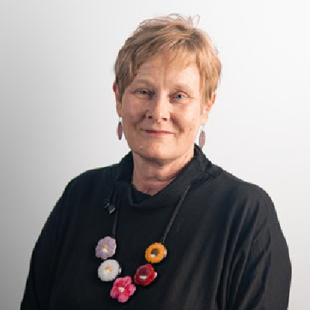

Directors
Tumutuarua Haumanu | Clinical Director — Dr Elizabeth Dennett  Liz is a specialist general and colorectal surgeon and, in addition to her clinical practice, she has been an Associate Professor of Surgery at Otago University.  Liz is a current college examiner in general surgery — the first New Zealand female general surgeon appointed to the Court of Examiners, Royal Australasian College of Surgeons.  Liz joined Te Aho o Te Kahu in 2020 as Tumutuarua Haumanu | Clinical Director. | 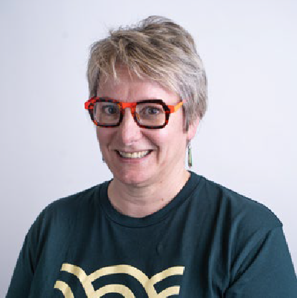
Tumutuarua Mana Taurite | Equity Director — Sasha Webb (Ngāti Kahu, Ngāpuhi)  Sasha has spent 20 years working with public, private, and not-for-profit organisations and has a background in communications and systems change. She joined Te Aho o Te Kahu in 2020 as Kaiwhakahaere Kaupapa Mana Taurite | Senior Project Manager Equity.  She is leading several key projects focused on cancer inequities and took on the role of Acting Tumutuarua Mana Taurite | Equity Director before being confirmed in the role in April 2023. Sasha is also temporarily managing the Person and Whānau Centred Care Team. | 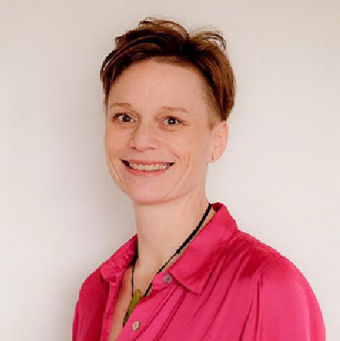

National Managers
Pou Whakahaere Tātari Raraunga | Manager, Data Monitoring and Reporting — John Fountain  After medical graduation, John worked for the military, United Nations, in general practice and as a Medical Toxicologist at the New Zealand National Poisons Centre (University of Otago). During his university employment, John developed an interest in health informatics.  John furthered his experience in the data and digital area while working at the Best Practice Advocacy Centre, contributing to the development of clinical decision support software. He has been a member of the Health Information Standards Organisation (HISO) Committee for six years and has been a member of and chaired a range of health-related committees and working groups. John joined Te Aho o Te Kahu in June 2020. | 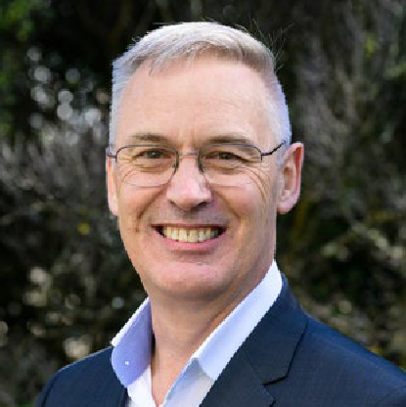
Pou Whakahaere-Haumanu | Manager, Quality Improvement — Gabrielle Nicholson  Gabrielle has a consultancy background and has worked in the public sector in Australia, England and Wales, as well as New Zealand. Prior to joining Te Aho o Te Kahu she worked at the New Zealand Health Quality & Safety Commission for nearly nine years, managing a portfolio of national quality improvement programmes.  Gabrielle is passionate about working with the health sector to improve patient experiences and outcomes. Gabrielle graduated with a master’s in public policy from Victoria University in 2014. | 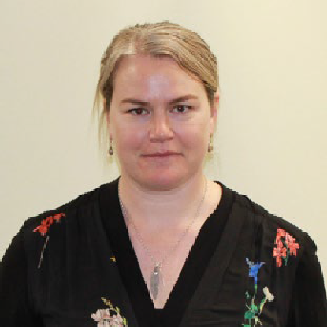
Pou Whakahaere | Manager, Clinical Advisory Team — Bridget Kerkin  Bridget joined Te Aho o Te Kahu in 2023. Whānau centred care approaches and a focus on quality, safety and excellence in healthcare service delivery have been central to Bridget’s work throughout her career.  After many years providing midwifery care in urban and rural communities, and as a DHB-employed midwife, Bridget joined Otago Polytechnic in 2012 as an undergraduate lecturer. She then took up a role in the Maternity Team at Manatū Hauora in 2020, transitioning across to Te Whatu Ora in 2022 to work in the Health of Older People sector with the Healthy Ageing team. These roles further developed Bridget’s passion for equity-focused, strategic, whole-of-system approaches to national health service development. | 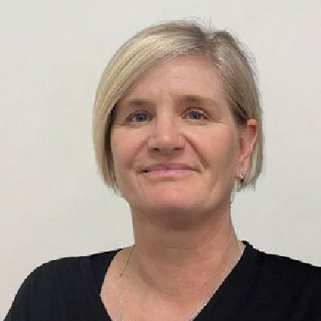

Regional Managers
Pou Whakahaere | Manager, Northern Hub — Heather Walker  Heather began her career in cancer policy in 2009. She worked across health, science and charity sector policy issues at Cancer Research UK, achieving increased innovation and investment in NHS diagnostic and radiotherapy services. She moved to Melbourne, where she led Cancer Council Victoria’s skin cancer prevention programme and chaired Cancer Council Australia’s National Skin Cancer Committee.  Heather also brought her passions for improving cancer outcomes and reducing inequity to teaching as a Subject Coordinator on the University of Melbourne’s Master of Cancer Sciences degree. Heather moved to Aotearoa New Zealand in 2022 and, after briefly working in tobacco and alcohol prevention at Te Whatu Ora, joined Te Aho o Te Kahu in 2023. | 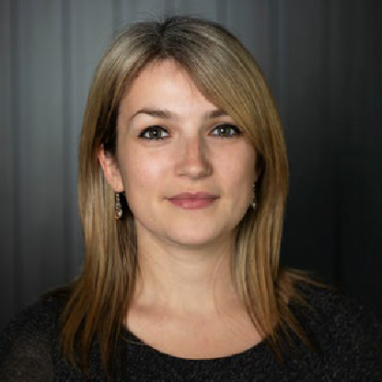
Pou Whakahaere | Manager, Te Manawa Taki Hub — Jan Smith  Jan joined as Te Manawa Taki Regional Hub Pou Whakahaere | Manager on 1 July 2020 following the transition of the regional cancer network teams to Te Aho o Te Kahu. Prior to this, Jan was Pou Kaiwhakahaere |Manager of the Midland Cancer Network, which delivered a significant number of successful regional and national initiatives.  Jan began her career as a registered nurse, going on to be a clinical nurse leader and working in management and leadership roles within Bay of Plenty, MidCentral, Taranaki, Lakes, and Waikato and HealthShare Limited. | 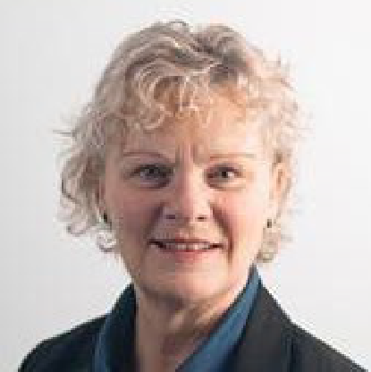
Pou Whakahaere | Manager, Central Hub — Cushla Lucas
Cushla has worked in health for over 30 years, starting as an obstetric sonographer before moving to management in 2006 as Regional Lead for BreastScreen Aotearoa.
Cushla was involved in changes that improved access to radiation treatment, upgraded equipment and facilities, and modernised service delivery to be more patient centred and equity focused. Seeking to ease the burden cancer patients face when living remote from the main centres, Cushla led the work that resulted in approval to build new radiotherapy centres in Hawke’s Bay and Taranaki. She joined Te Aho o Te Kahu in November 2020 and is currently managing our Cancer Services Planning programme.
Pou Whakahaere | Acting Manager, Southern Hub — Janfrey Doak (Substantive role: Project Manager, Southern Hub)  Janfrey worked as a radiation therapist and held a number of local and national roles in cancer clinical trials. She joined the Southern Cancer Network in 2013 and has led clinical cancer improvement work focused on implementing tools and systems to support clinicians to deliver care and treatment.  She led the implementation of an electronic multidisciplinary meeting (MDM) management system for the South Island region, and the development of dashboards to report patient progress across the tumour stream care pathway. Janfrey joined in July 2020 following the transition of the regional cancer network teams to Te Aho o Te Kahu. | 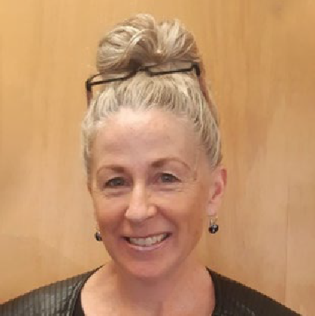

Te Aho o Te Kahu | the Cancer Control Agency Organisational Structure
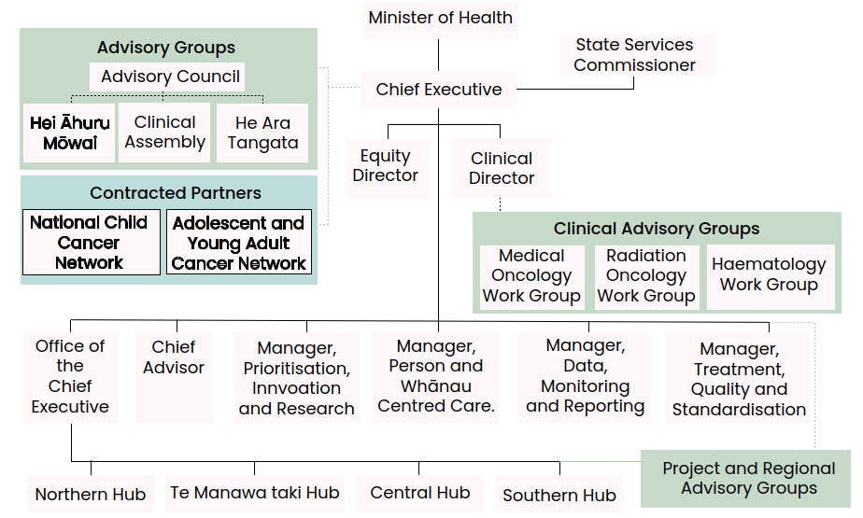

Ngā rōpū tūhono l Our partners
We regularly connect with our key partners (shown in green and blue in the organisational structure diagram on previous page) to strengthen our work programme and hear what is ‘happening on the ground’. The role and functions of these groups is regularly reviewed to ensure we make best use of their valuable time and expertise.
- The Advisory Council supports our Tumuaki to oversee system-wide development and coordination of the cancer care system. The council provides insights and advice on how to get the best value for investment in cancer prevention and care. As part of our commitment to Te Tiriti, the council has a Māori co-chair and 50% Māori membership.
- Hei Āhuru Mōwai is a Māori cancer leadership group. Its membership brings a range of expertise, including clinical, community care, epidemiology, health services management and research. The Co-Chair of Hei Āhuru Mōwai is a member of the Advisory Council. We support the leadership and rangatiratanga of Hei Āhuru Mōwai through operational and project funding. Hei Āhuru Mōwai works closely with us and provides expertise and support for negotiated strategic work and projects centred on improving Māori cancer outcomes.
- The National Clinical Assembly provides clinical advice to support our long-term strategic direction for reducing cancer incidence and improving cancer services across the cancer continuum. The assembly includes clinicians from a broad range of cancer- related medical, nursing, and allied health specialities.
- He Ara Tangata is our Consumer Reference Group, providing insights and solutions from a lived-experience perspective. He Ara Tangata members are embedded on projects across our work programme, and their input ensures our work remains focused on the needs of people across the continuum of cancer care. As part of our commitment to Te Tiriti, our Consumer Reference Group has a Māori chair and 50% Māori membership.
- Other advisory groups — To ensure we remain connected with those on the ground, and hear directly from them, we have three primary clinical working groups (Medical Oncology, Radiation Oncology and Haematology) and more than 17 other time-limited advisory groups, involving over 200 health professionals and consumers. We meet regularly with the working groups, and their input feeds into our work at all levels.
- Contracted partners — We contract National Child Cancer Network New Zealand and Adolescent and Young Adult Cancer Network Aotearoa to deliver care for children and young people with cancer. We collaborate on the direction of their work programmes, meet regularly to discuss progress and issues, and provide support on programme delivery.

Being ‘Te Aho’ — the central thread
Across 2022/23 we continued to develop strong links with Māori and Pacific health leaders, consumer-led groups, clinical leadership groups, non-governmental organisations and primary health care practitioners. These relationships continue to develop through our engagement with the sector and our response to system challenges. We anticipate these will evolve as the new health system beds in.

We are committed to hearing the voices of those across the cancer continuum in Aotearoa and respond constructively to those who wish to engage. There is a wide array of other government entities, sector groups, programmes and projects we contribute to as part of being ‘Te Aho’ for the cancer continuum. Some of these include:
- other government entities, including Whaikaha | Ministry of Disabled People; Ministry for Ethnic Communities | Te Tari Mātāwaka; Health and Disability Commissioner | Te Toihau Hauora, Hauātanga; and Health Research Council
- whānau with lived experience of cancer
- clinicians (in the Clinical Assembly and specialised clinical working groups)
- research/academic institutions: University of Otago | Te Whare Wānanga o Ōtākou, University of Otago Wellington | Te Whare Wānanga o Ōtākou ki Pōneke, and University of Auckland | Waipapa Taumata Rau
- international organisations — including Cancer Australia, Cancer Council Australia and the International Cancer Benchmarking Partnership
- Cancer Non-Governmental Organisations (CANGO)
- Cancer Society
- iwi and Māori organisations and service providers
- Pacific organisations and service providers
- peak and professional bodies, including Royal Australasian College of Surgeons and Cancer Nurses College.

Our operating environment
Te Aho o Te Kahu is the principal advisor on cancer to the Government, and national leader for cancer control. We continue to be the central thread that connects and unites both new and existing health entities, and the wider cancer sector, providing expertise and support to improve outcomes for whānau with cancer.

The health system reforms have not changed the role of Te Aho o Te Kahu — however, it has been necessary to adjust how we engage with our key partners across the health
system. With the key health entities now also having a national structure, Te Aho o Te Kahu is ensuring we are developing relationships across Te Whatu Ora and Te Aka Whai Ora at national, regional and district levels across our responsibilities.

One of our key functions is to liaise with the many parties and organisations involved with cancer prevention, promotion, diagnosis, treatment and care. In the country’s new health system, the Tumuaki of Te Aho o Te Kahu is part of the Health Leadership Forum, which includes all tumuaki of the main health entities. Our Tumuaki also holds direct relationships with the tumuaki of:
- Te Whatu Ora | Health New Zealand
- Te Aka Whai Ora | Māori Health Authority
- Manatū Hauora | Ministry of Health, including Te Pou Hauora Tūmatanui | the Public Health Agency
- Te Pātaka Whaioranga | Pharmac
- Te Tāhū Hauora | Health Quality & Safety Commission New Zealand, and many more.

Increasingly, we are looking to have a shared approach to common priorities and work streams, and at how we can share our insights in ways that can be embedded effectively across the health system. We act to create change through influence and have built a strong reputation for expert cancer knowledge and equity-led, systems-level thinking. The responsibility for commissioning and delivery sits with our partners, but we play a key role in bringing together the capability within the sector, and the experiences of people and whānau living with cancer, to agree on and develop solutions for implementation.

We provide advice and cancer expertise to Te Whatu Ora and Te Aka Whai Ora, and we are currently supporting them to shape how cancer care will be delivered in the new health system through our Cancer Services Planning programme (see the Our Work section).

The relationship between us and our host, Manatū Hauora, is particularly important and is supported through co-location and an interdepartmental agency agreement signed in August 2021. This recognises our place within the health system and our need to ensure our cancer-focused work is integral to the wider work of Manatū Hauora.

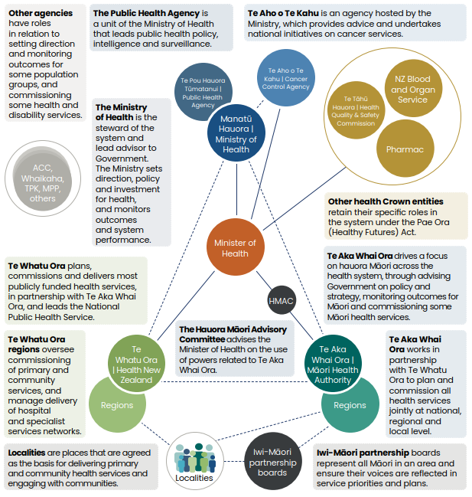

Source: Ministry of Health. 2022. Developing the future Ministry of Health: Our strategy and strategic intentions, 2022 to 2026. Wellington: Ministry of Health

Ō mātou takune | Our intentions for 2022/23
The New Zealand Cancer Control Strategy 2003 and the New Zealand Cancer Action Plan 2019–2029 set out the strategic direction of Te Aho o Te Kahu. Our work focuses on contributing to the health system’s goal of Pae Ora | Healthy Futures and delivering our agency’s vision of fewer cancers, better survival, and equity for all. Our intentions align with the six priorities identified in the interim Government Policy Statement on Health 2022–2024.

We have adopted a ‘shaping strategy’ to enable us to work in a way that maximises opportunities to engage, influence and create a positive and receptive environment for developing and implementing new and better ways of doing things across the cancer continuum. The three strands of the shaping strategy are:
- engagement — collaborating with others and operating through influence
- orchestration — shaping the environment to achieve Te Aho o Te Kahu outcomes
- evolution — changing as required to innovate and manage unpredictability.
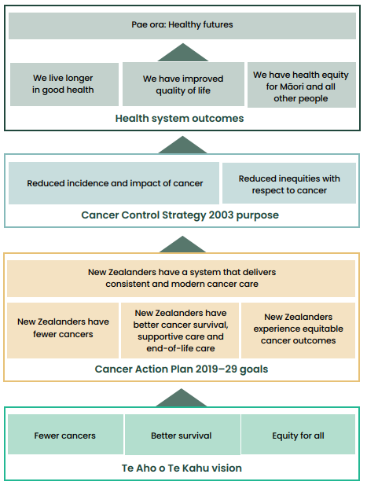

Ngā mahi | Our work
We provide national leadership with a programme of work that sets the direction for equity-led change and supports improved cancer outcomes for the people of Aotearoa. We are responsible for transparently monitoring progress towards the outcomes identified in the New Zealand Cancer Action Plan 2019–2029.

The Cancer Action Plan
In January 2019, the Minister of Health announced at the Cancer at a Crossroads Conference that a new cancer control action plan would be developed. The development of the plan was undertaken in consultation with a wide range of key stakeholders to ensure whānau views would be prominent.

The plan, which was published in February 2020, has a strong emphasis on delivering and targeting services to ensure equitable outcomes for all New Zealanders.

The plan has four key outcomes:
- New Zealanders have a system that delivers consistent and modern cancer care
To continue to lift our performance in cancer care, we need to ensure we have strong national leadership, a skilled and sustainable workforce, and the right information to make the best possible decisions.
- New Zealanders experience equitable cancer outcomes
Following a cancer diagnosis New Zealanders will receive the best treatment and care no matter who they are or where they live.
- New Zealanders have fewer cancers
Investment in the prevention of cancer will ultimately make the largest contribution to reducing the burden of cancer in New Zealand and to achieving equity in outcomes. We want to support prevention programmes and policies that will help New Zealanders to make healthy choices.
- New Zealanders have better cancer survival, supportive care and end-of-life care
New Zealanders receive person and whānau centred cancer care that is appropriately timed and of high quality, from early detection through to living well with and beyond cancer and end-of-life care.

What we don’t do
While we work alongside these organisations to support this work, Te Aho o Te Kahu does not have responsibility for:
- cancer screening programmes (Te Whatu Ora)
- New Zealand Cancer Registry (Te Whatu Ora)
- funding cancer drugs (Pharmac)
- palliative care (Manatū Hauora and Te Whatu Ora)
- delivery of cancer services (Te Whatu Ora).

However, we are consulted with, and generally provide joint advice, as opportunities or issues arise.
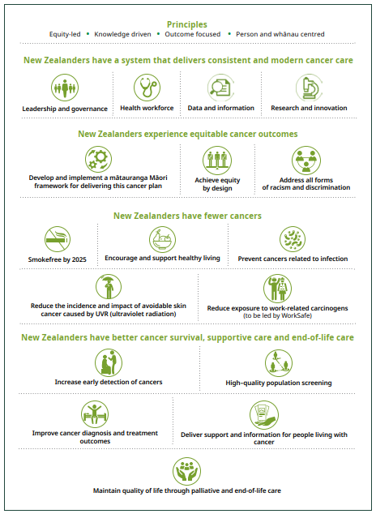

Current work programme
New Zealanders have a system that delivers consistent and modern cancer care
Our priorities | Our work
Supporting a system that delivers consistent and modern care | Building a high-performing agency  Commitment to capability building  Systems and processes  Active health sector support  COVID-19
Transforming the future of cancer service delivery | Cancer Services Planning programme (more detail in text)
Developing a monitoring framework | Delivering the first monitoring report
Providing better quality, more connected data | CanShare (more detail in text), including:  - Anti-Cancer Therapies — Nationally Organised Workstreams (ACT-NOW) Programme  - Structured Pathology Reporting of Cancer Data Standards Project  - National Radiation Oncology Collection (ROC)  - Collaboration across data and digital health
New Zealanders have fewer cancers
Our priorities | Our work
Achieving fewer cancers through a focus on prevention | Pūrongo Ārai Mate Pukupuku | Cancer Prevention Report  Cancer research  Primary health care project  Advice for primary care
New Zealanders have better cancer survival
Our priorities | Our work
Improving cancer survival | Quality improvement programme  Cancer medicines availability analysis  Clinical trials
New Zealanders experience equitable cancer outcomes
Te Aho o Te Kahu priorities | Te Aho o Te Kahu work
Improving equity of cancer outcomes | Māori community hui | meetings  Embedding equity-led thinking  Pacific research project  Disability and cancer project initiated  Supporting equity-led work across the sector

Ngā whakatutukitanga | What we have achieved

He pūnaha manaaki | Supporting a system that delivers consistent and modern care

Building a high-performing agency
Te Aho o Te Kahu has continued to build on its reputation, within government and across the health and disability sector, for responsiveness and delivery. In the 2022/23 year, we continued to strengthen our existing relationships with stakeholders, and worked to establish strong partnerships with Te Whatu Ora and Te Aka Whai Ora.
Internally, we have maintained our focus on extending our kaimahi capabilities and supporting their wellbeing around the motu | country — during a year of transition internally with a change in Tumuaki | Chief Executive and the ongoing wider health system reforms.

We were delighted to be selected as finalists in Te Hāpai Hapori | the Spirit of Service Awards 2022. In recognition, the Public Service Commissioner noted that it was a testament to our dedication to creating true partnerships and ongoing spirit of service. They also acknowledged that our organisation is making a real impact for those affected by cancer in Aotearoa, with a true commitment to Te Tiriti and equitable outcomes.

We continued our support to the Minister of Health and Associate Ministers by providing high-quality, timely advice across a range of cancer topics through regular meetings, briefing papers and weekly updates. This included the transition to a new Minister and Associate Ministers in January 2023. We have built strong relationships with the Ministers’ secretaries to ensure we meet the needs of the Ministers’ offices as they arise. We privilege our place as the trusted cancer advisor to government and ensure that we respond in a timely fashion with information that reflects a whole of health system perspective on cancer.

Recognition of individual kaimahi contribution was to the fore this year with Dr Humphrey Pullon, Clinical Haematologist and Clinical Advisor at Te Aho o Te Kahu, being a worthy recipient of the New Zealand Public Service Medal. This medal is part of the formal New Zealand Royal Honours system. It recognised Humphrey’s distinguished service across his long career, central to which has been a dedicated focus on improving cancer care, leading initiatives in the Te Manawa Taki region and most recently our haematopoietic stem cell transplantation improvement work. Also out of Te Manawa Taki, Lydia Rickard (He uri ia o Tainui, Ngāti Koata, Ngāti Tahinga, Ngāti Porou), Senior Project Manager, Equity, received The Public Service Commissioner’s Commendation for Excellence. For over 40 years, she has devoted time to helping improve outcomes for Māori by addressing system-wide inequities. Her strategic focus and service-planning skills have ensured whānau get the best possible care in hospital and community settings. Lydia is credited as being largely responsible for dramatically improving the speed of cancer treatment at Lakes District — which is an amazing feat.

We have reinforced our sector stakeholder engagement this year through regular meetings with our advisory groups (outlined in the section ‘Ngā rōpū tūhono l Our partners’) and by scaling up the many project and tumour stream advisory groups supporting our work programmes. We continue to hold meetings with stakeholders, nationally and regionally, across the cancer continuum, including clinicians, patients and their whānau, Māori and other populations. This highlights the span of our sector involvement and our reach for the full range of perspectives on cancer in relation to our work.

Engagement with Te Whatu Ora and Te Aka Whai Ora has had a strong focus on the Cancer Services Planning programme. We connected with many service providers to ensure that our approach to this crucial development work is relevant to the needs of those organisations. In addition, we engage strongly with Te Whatu Ora in the clinical and operational space, supporting them to address challenges and take opportunities to embed improvements in care.

Our partnership with Hei Āhuru Mōwai | Māori Cancer Leadership Aotearoa has continued, supported by mutual engagement with Te Aka Whai Ora. Hei Āhuru Mōwai members continue to sit on many of our major advisory groups, providing strategic input to our work programme direction, targeted advice towards equitable cancer outcomes for Māori, access to Māori cancer expertise and support for developing Māori capability across our organisation. Matua Gary Thompson (Ngāti Pāoa, Ngāti Hauā) stood down from his role as our inaugural pou tikanga, and we welcomed Matua Tau Huirama (Ngāti Tamainupō, Ngāti Maniapoto) into the role to provide us with cultural guidance. We also farewelled outgoing Tumuaki of Hei Āhuru Mōwai Moahuia Goza (Ngāti Kauwhata, Ngāti Matakore, Ngāti Raukawa, Ngāti Unu) and welcomed Cindy Dargaville (Ngāti Maniapoto, Waikato, Te Rarawa) as their new Tumuaki. The strength of this partnership is central to the strength of Te Aho o Te Kahu as an organisation, giving confidence that our focus on equity and Te Tiriti is both actively supported and challenged where necessary.

Our commitment to Whāinga Amorangi (see details in next section) has ensured a strong focus on developing Māori–Crown relations capability. In addition, we proactively recruited Māori kaimahi and engaged with Māori clinical and lived-experience leaders. We also ensured key advisory bodies continue to have 50% Māori membership and a Māori chair or co-chair.

He Ara Tangata, our Consumer Reference Group, is more actively contributing and responding to issues, which has matured to where members are now working alongside our kaimahi and directly contributing to our work. Feedback from
participants reflects this through expressions of increased satisfaction and a sense of increased responsiveness from Te Aho o Te Kahu. The membership of this group was refreshed in 2022/23, and their participation continues in projects across our organisation to provide a critical lived-experience lens to our work.

Commitment to capability building
Our recruitment strategy is focused on growing a diverse, highly capable workforce that includes a significant proportion of people who identify as Māori or Pacific.

The strengths collectively offered by our people include:
- leadership
- critical thinking
- Māori and Pacific cultural expertise
- clinical experience and expertise
- cancer sector knowledge and understanding
- analytics
- innovation
- technical writing
- cognitive diversity
- passion for our work
- strong networks and relationships.

These capabilities are strengthened through our effective relationships across the sector, including the new health entities. This is reflected in increased collaboration over shared work or work of mutual interest.

We continue to develop areas where we have less capability — where bridging that gap is going to strengthen our ability to fulfil our purpose. Areas given attention across 2022/23 to build our capability included:
- formal project management expertise
- meeting facilitation
- machinery of government expertise
- te ao Māori
- SNOMED CT skills
- expertise in continuous quality improvement.

Te Aho o Te Kahu can access support from the Manatū Hauora Organisational Development Team. They have set up a digital learning space tailored to our requirements. This enables us to access learning and development opportunities through online and in-person courses and resources to support our kaimahi as we build our workplace skills and te ao Māori knowledge and undertake professional development.

Our commitment to capability building is also displayed in our progress against our Māori language plan, E Tipu E Tipu. The kaimahi survey showed our confidence in speaking te reo has increased across every measure (see ‘Tō mātou whakahaere | Our performance’ section).

Capability building remains a major focus for us. We have an induction process that requires all kaimahi to undertake modules on te ao Māori along with learning
about our obligations as public servants. Our kaimahi can access all Manatū Hauora professional development resources, including external workshops and online courses. We also deliver our own bespoke courses, including a two-day ‘machinery of government’ course, kaimahi forums, information sessions and an annual all-kaimahi capability-building day. Each kaimahi member’s professional development plan must contain capability-building goals.

Our commitment to Te Tiriti can be seen in our ambitious programme to build capability to effectively engage with Māori. In 2022/23, we delivered Whāinga Amorangi: Transforming Te Aho o Te Kahu Phase Two plan to Te Arawhiti | the Office for Māori Crown Relations, and this was endorsed without change. Te Arawhiti has directed other government entities to us to provide guidance on their plans. We continue to make strong progress against the goals and measures set out in our Phase One plan through activities such as:
- engaging with the Ngā taura ā Māui framework to support how we apply our equity and Te Tiriti focus to the design, development and delivery of our work programme
- a wānanga | seminar by Leonie Pihama, Linda Smith and Ngarophi Cameron — He Oranga Ngākau: Exploring the Power of Indigenous Knowledge
- presentations by Dr Heather Came on systemic racism and Professor Meihana Durie on mātauranga Māori | Māori knowledge
- attending The Wall Walk® (an interactive workshop designed to raise awareness about key events in the history of Aotearoa New Zealand’s bicultural relations)
- hosting and attending pōwhiri | welcome and poroaki | farewell events for several kaimahi | staff
- kaimahi sharing their personal journey connecting to whakapapa | genealogy
- wānanga on Whāinga Amorangi and E Tipu E Tipu
- Waitangi, Matariki and Te Wiki o Te Reo Māori activities
- twice-weekly waiata | singing sessions
- all kaimahi required to have a goal in their professional development plan that relates to Whāinga Amorangi (many have more than one goal).

Implementation of our Phase Two Whāinga Amorangi plan will begin in 2023/24. We have focused on establishing an implementation model that is not only sustainable but accounts for ongoing monitoring and implementation of all our Māori–Crown relations mahi | work, including our Phase One plan and E Tipu E Tipu — Māori Language plan.

The Whāinga Amorangi Working Group was established to support the implementation of Phase Two and it also assumes responsibility for the ongoing implementation of our Phase One plan.

Whāinga Amorangi Working Group
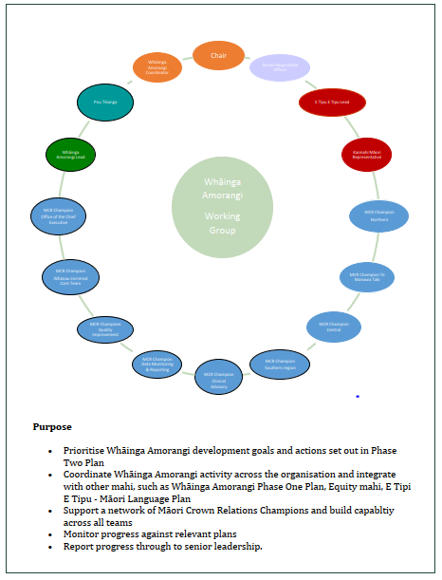

E Tipu E Tipu | Māori Language Plan
As mentioned previously, we are committed to honouring Te Tiriti. This includes the protection of te reo Māori me ōna tikanga. Te reo Māori is an official language of Aotearoa and he taonga tuku iho for Māori.

Te reo Māori is protected by Te Ture mō Te Reo Māori | The Māori Language Act 2016, which affirms the mana | status of the Māori language.

Maihi Karauna, the Crown’s Strategy for Māori Language Revitalisation 2019–2023, was established to support and create societal conditions for te reo Māori to thrive and at the same time ensure that government systems support that.

E Tipu E Tipu, our te reo Māori plan, supports not only Te Ture mō Te Reo Māori and Maihi Karauna but also acts to:
- whakamana | give authority to our name in accordance with our oati
- whakamana the intention of He Korowai Oranga | the Māori Health Strategy and Whakamaua | the Māori Health Action Plan
- whakamana Te Tiriti
- whakamana our oati ingoa | name agreement with Hei Āhuru Mōwai
- increase our organisational health by growing a confident and capable workforce
- contribute to the revitalisation of te reo Māori
- enhance our effectiveness and provide better services to Māori.

Systems and processes
We continued to develop our systems and processes over 2022/23 incrementally in line with our connection to and support from Manatū Hauora.

Work has been undertaken to enable a ‘promotion round’ to recognise potential for career progress for our kaimahi. This process allows for a regular assessment of the readiness of staff members to move up their career pathway and facilitates selected kaimahi to advance. This work is largely complete, and we plan to implement it in the 2023/24 year. Over time this will provide a component of a wider career progression framework.

We are very proud of our results in the inaugural Te Taunaki | Public Service Census in 2021. There are over 60,000 public servants across 36 agencies. The results highlight much of the work we are doing, particularly around diversity and inclusion, te reo Māori and Māori– Crown relations (see ‘Tō mātou whakahaere | Our performance’ section).

As yet another validation of our performance, we were thrilled to learn our previous Tumuaki was nominated for and selected as one of three global finalists in the Union for International Cancer Control Chief Executive Office Award in October 2022.

Active health sector support
Te Aho o Te Kahu has four regional teams that provide our outward-facing connection with the sector. This includes working directly with the clinical and operational leadership of cancer services — in a way which is tailored to the needs of each region.
We are:
- developing positive working relationships with stakeholders and maintaining links with regional and local clinical and service leadership
- promoting visibility of our national work programme
- providing insight into service performance data and working with clinicians and service kaimahi to identify and implement appropriate responses
- understanding regional and local needs and the challenges they face
- promoting a regional perspective and a focus on the needs of the population
- supporting a regional service/quality improvement focus.

Monitoring the impact of COVID-19 on cancer
Over the year we continued to monitor the impact of COVID-19 on cancer services to ensure improvements identified are sustained over the winter months. We will decide soon on whether further monitoring reports are required.

In December 2022 the Royal Commission of Inquiry into COVID-19 Lessons Learned was announced with a view to ensure New Zealand’s response to any future pandemic would be strengthened. While Manatū Hauora is the lead health agency, we are playing an active part in the review, sharing our experiences and learnings from a cancer perspective. This work is expected to be completed by mid-2024.

Transforming the future of cancer service delivery
We are currently undertaking a large, proactive programme of work, called Cancer Services Planning, to transform the way cancer treatment is delivered. We will support Te Whatu Ora and Te Aka Whai Ora to deliver equitable access to high-quality care by producing evidence-based guidance to commissioning entities on how treatment and support services should be organised to achieve optimal, equitable cancer outcomes.

Phase 1 of this work centred on providing a summary of the current issues in adult cancer treatment services in Aotearoa and key focus areas to improve cancer treatment.

The design and implementation phase of the programme started in March 2022 and takes our thinking beyond what changes need to occur, to how the recommendations could be implemented. A second programme of work will soon examine how primary and community care could improve cancer outcomes and access to cancer diagnostic services.

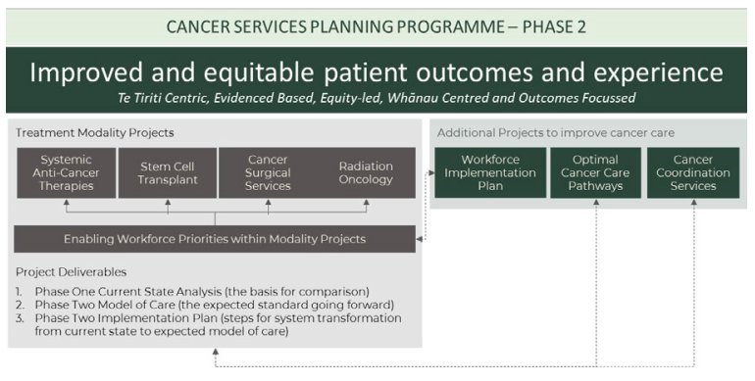

The projects within Phase 2 of the Cancer Services Planning programme focus on the following areas:
- Systemic anti-cancer therapies
Care for patients receiving systemic anti-cancer therapies (SACT) — chemotherapy, immunotherapy, targeted therapy, and hormone therapy — is becoming more complex, and demand is increasing. Access to new medicines will place additional strain on the pressured clinical networks. Our focus is on working with Te Whatu Ora on addressing immediate capacity challenges while developing new models of care for delivering SACT and looking to enable more SACT to be delivered in the community, where it is appropriate to do so.
- Stem cell transplant
Stem cell transplant services have become fragmented, inequitable, and no longer fit for purpose given the volume and complexity of service delivery required. This project has designed a sustainable future service model for stem cell transplant, while planning to address immediate capacity challenges.
- Surgical services
Complex cancer surgery is currently delivered without a national model of care to ensure consistency, sustainability, and equity across Aotearoa. To achieve better cancer outcomes this project is developing and testing frameworks that can be used to determine optimal distribution of services across the motu.
- Radiation oncology
This project described, and supports the move to, a single system of care, operating under a standardised national service model in alignment with the emerging Te Whatu Ora national clinical network model (radiation oncology is the first clinical network to be established). It also focuses on increasing the workforce and the linear accelerator stock in public hospitals.
- Workforce
The cancer workforce is struggling to meet current demand, much less the projected 40% increase in new cancer diagnoses between 2020 and 2040. In 2022/23, our focus was on developing an implementation plan with Te Whatu Ora that concentrated on immediate short-term actions. The plan also provided the building blocks for future workforce planning. We are working with Te Whatu Ora, Te Aka Whai Ora and the Health Workforce Taskforce to ensure the cancer workforce capacity and capability will align with future demand for, and improvements to, cancer treatment in Aotearoa. This includes both a short-term and a longer-term focus. This is a key area of concern and focus for Te Aho o Te Kahu.
- Optimal Cancer Care Pathways
Unwarranted variation in the delivery of cancer care means that some people receive sub-optimal care, and resources are used in ways that do not lead to optimal outcomes. In response we are developing cancer care pathways, by tumour stream, that will clearly describe expectations in the delivery of optimal cancer care. The pathways are based on the Australian Optimal Care Pathway approach and will be
a tool for system leaders and service providers to identify unwanted variation and inequity and drive continuous quality improvement.

Cancer care coordination
We are developing an establishment plan so that cancer care coordination services can be commissioned throughout the country, with the initial focus on supporting Māori and Pacific cancer patients and their whānau. This plan includes strategic advice for the commissioning entities on how they can create cancer coordination services that are broadly consistent and high quality but also tailored to suit local communities and delivered in a range of settings, including primary health care, secondary health care, kaupapa Māori and community health organisations.

CanShare
CanShare is a new national health informatics platform currently under development that will allow the timely sharing of relevant and accurate cancer data across the motu. The primary intent of CanShare is to support clinical and whānau decision-making at the point of care.

Outcomes from this work will include advanced analytics capability supporting up-to-date monitoring of cancer care throughout the country.

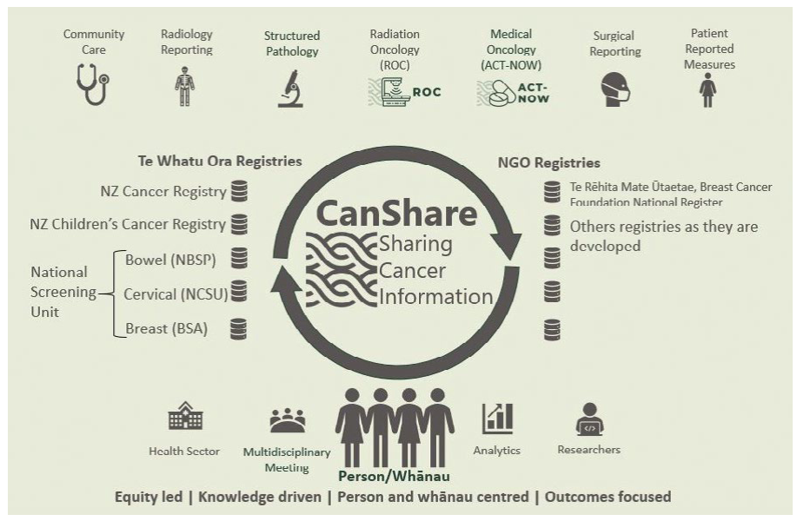

CanShare will enable the collection of complete and accurate cancer data, joining currently disparate data siloes and providing a means to share clinical cancer information as needed. Connections have been established with Te Whatu Ora, a cloud database is being built, and there has been much work undertaken in CanShare’s individual programmes, some of which are outlined below.

Anti-Cancer Therapies — Nationally Organised Workstreams (ACT-NOW)
ACT-NOW is a national systemic anti-cancer therapy (SACT) data collection and analytics programme. Stakeholders have collaborated to agree on SACT treatment definitions — meaning that treatment regimens can be compared across the country. The information about the use of regimens will support identifying unwarranted variation so that it can be investigated and quality improvement activities instigated.

Structured pathology
A project is underway to develop and support the national adoption of data standards so pathology information can be easily shared for clinical decision-making. Currently 39 data standards are being developed across gastrointestinal, genitourinary, gynaecological and haematological cancer groups. Alongside standard development, we are building productive relationships with pathology vendors and providers to plan implementation of the standards over the coming years.

National Radiation Oncology Collection (ROC)
This central repository of detailed radiation oncology information informs an understanding of radiation oncology service delivery and linear accelerator capacity, utilisation and planning. This supports actions to improve access to radiotherapy and drive more cost-effective treatment. The ROC has been used as the key data source to underpin national planning for increased treatment capacity and workforce.

Faster cancer treatment reporting
Faster cancer treatment wait time indicators (62 and 31 day) require districts to collect standardised information on patients who have been referred urgently with a high suspicion of cancer and/or information around timely access to treatment once a ‘decision to treat’ is made.

We are currently supporting the quality improvement of these indicators — for example, through our work to improve consistency of business rules, quality data management and reporting. We will look to transfer ownership of this work to Te Whatu Ora in the future.

Health Information Standards Organisation (HISO) standards
Nationally agreed and HISO-endorsed data standards support the vision for a fully interoperable digital health system to facilitate sharing cancer information for decision-making, quality improvement and research. Standards ensure data systems can ‘talk to each other’. Two data standards were published last year: the structured pathology data standard and the multidisciplinary meetings data standard. More are currently being developed.

Developing a monitoring framework
The New Zealand Cancer Action Plan 2019–2029 sets four outcomes and multiple related actions across the cancer control pathway. This year, we have continued to report against this monitoring framework so we can transparently assess our progress towards achieving the aspirations of the Cancer Action Plan.

We will report on 11 broad indicators to give a ‘snapshot’ of the current state of cancer control in Aotearoa New Zealand. Each year, we will calculate the indicators and present the results in a monitoring report to show progress in the cancer control system. The monitoring report will also present activities being undertaken to achieve the outcomes and actions of the Cancer Action Plan. A summary of the monitoring report is available in the section ‘Tō mātou whakahaere | Our performance’.

Leadership and collaboration across data and digital health
We are continuing to work alongside Manatū Hauora, Te Whatu Ora and Te Aka Whai Ora to ensure the needs of cancer patients and whānau are considered within data and digital system changes. In August 2022 we released our position statement on the collection of cancer data and information in Aotearoa in relation to hapū and iwi affiliation, Māori descent and ethnicity.

Our work on the development of the CanShare cancer information sharing platform was presented to the Digital Health Week Conference by John Fountain, our Pou Whakahaere Tātari Raraunga | Manager of Data, Monitoring and Reporting. The presentation was focused on ‘CanShare: Learnings from a National SNOMED CT / FHIR Implementation’.

In 2022/23 our kaimahi sat on key digital governance and advisory groups, including the Hira Programme Governance Group, the Digital Enablement Oversight Group, the Digital Health Equity Reference Group, the National Data Platform Steering Committee and Tātai Pae Ora. We also chair the Cancer Working Group within the New Zealand Telehealth Forum.

Kia whakaiti iho te mate pukupuku | Achieving fewer cancers through a focus on prevention

Cancer prevention and early diagnosis
To date, the main focus of our work has been on improving cancer treatment and extending peoples’ survival. This has been important given the significant expectations of stakeholders and the level of public concern about access to cancer treatment. However, we also recognise that inequities exist right across the cancer continuum. There are opportunities to reduce the incidence of cancer and improve overall cancer outcomes by having a greater focus on prevention, early diagnosis and detection.

In February 2022 we published Pūrongo Ārai Mate Pukupuku | Cancer Prevention Report, which highlights where cancer prevention efforts can be strengthened. This information will shape policies that will help prevent cancers, as well as other health conditions for the people of Aotearoa. The report focuses on six key areas:
- tobacco
- alcohol
- poor nutrition and excess body weight
- insufficient physical activity
- excessive exposure to ultraviolet radiation
- and chronic infections.

The establishment of Te Pou Hauora Tūmatanui | the Public Health Agency within Manatū Hauora provides us with a crucial partner to advance this work. We will work to support initiatives to minimise and prevent the incidence of cancer, and to bring a cancer perspective to prevention activities.

In November 2022 we partnered with the Goodfellow Unit of the University of Auckland to run an educational webinar for health professionals to raise awareness of lung cancer symptoms, improve early detection and referral to secondary health care for patients with a high suspicion of lung cancer, and increase awareness of new treatment paradigms. The webinar was well received, with over 345 participants.

We are also in the early stages of scoping potential areas for improvement in cancer outcomes through primary and community care. This work will inform our efforts to support the primary and community care to help people affected by cancer. The first of these initiatives is likely to be partnering with Te Whatu Ora on the Te Pae Tata priority to streamline access to diagnostic tools by primary care practitioners.

Cancer research
We supported the following research projects in 2022/23:
- The National Child Cancer Network is working to better understand the whānau experience of child cancer and cancer services in Aotearoa in order to improve the future experiences of child cancer patients and their whānau.
- Hei Āhuru Mōwai identified a gap in the knowledge base for the management and support of Māori patients and their whānau living with both cancer and COVID-19 and has commissioned a cycle of evaluative learning to better understand these experiences and inform ongoing development and improvement.
- Researchers Dr Nina Scott and Dr Myra Ruka from Te Aka Whai Ora and Te Whatu Ora are leading a Health Research Council funded project looking at how the COVID-19 pandemic created opportunities for system redesign using an integrated response to maximise Māori health gains for those with a suspected diagnosis of cancer.

We also partnered with the New Zealand Telehealth Forum on three projects of mutual interest:
- supporting a University of Auckland internship examining the resources available to help patients understand and use telehealth, particularly for cancer care
- working with Massey University to survey all public hospital cancer clinics on their use of and attitudes towards telehealth in cancer care
- co-authoring a white paper on a proposed national telehealth model of care that could deliver specialist health care to patients in any location throughout the country.

Kia runga noa ake te mataora | Improving cancer survival

Quality improvement programme
The Cancer Quality Performance Indicator (QPI) programme involves identifying key steps in the cancer diagnosis, treatment and outcome pathway to measure and report against. It aims to identify unwarranted variation. The cancer-specific QPIs are developed particularly for that cancer type so that the indicators are relevant to that cancer or its treatment pathway. The process of identifying these indicators involves substantial clinical engagement, broad consultation, and consensus that the indicators selected, developed and published are appropriate.

Once the indicators are identified, a report is produced that provides information about how each district is doing in relation to each indicator, and whether there is inequity between population groups (that is, by ethnicity, age, gender, geographic location and deprivation quintile). Where variation is seen, we will work with the districts to understand the causes. We would then aim to develop and implement programmes of work to address the causes of variation at national, regional or district level as appropriate. QPIs will be regularly monitored and re-reported to ensure that the actions taken have been effective in reducing inequities and improving the quality of care and outcomes for people with cancer.

Over the 12 months we reported on QPIs for bowel and pancreatic cancers. Currently, we are working on QPIs for breast cancers (due for publication in 2024).

The next project for the QPI programme is the selection, calculation and reporting of universal QPIs, which is modelled on similar approaches from comparable jurisdictions. The universal indicators will be common across many cancer types and will be reported by cancer type. As we have calculated QPIs for specific cancer types to date, we have identified consistent indicators that are both measurable and universal. We aim to report on the universal QPIs at regular intervals throughout 2023 and 2024, as each indicator is ready. We will also recalculate the universal QPIs at regular intervals to measure change over time.

With the introduction of the national health reforms and new health organisations that are responsible for commissioning and delivering health services, we are relooking at our cancer service quality improvement approach. As part of this work, we are developing a Quality Improvement Framework for Te Aho o Te Kahu, to guide the quality improvement work that will result from the QPI programme and other projects such as CanShare.

Clinical trials
Clinical trials are critical to advancing cancer outcomes for patients. Inadequate and inequitable access to cancer clinical trials in Aotearoa is a concern for patients and whānau, as well as clinicians and the broader health sector. Manatū Hauora is
collaborating with Te Whatu Ora and Te Aka Whai Ora to build the necessary infrastructure to deliver equitable access to clinical trials for all conditions, including cancer, building on the recommendations in the Enhancing Aotearoa New Zealand Clinical Trials report.

This year, Te Aho o Te Kahu has been, and will continue, collaborating on this work, to advocate and provide support from a cancer perspective. Teletrials (or decentralised trials) is one way of improving access to clinical trials for people who are living away from the major cancer treatment centres. In 2022/23, we provided funding to Cancer Trials New Zealand to continue the development and implementation of core infrastructure to enable teletrials in Aotearoa New Zealand.

Te whakataurite i ngā hua mate pukupuku | Improving equity of cancer outcomes

Hearing the voices of whānau Māori
In 2021, Te Aho o Te Kahu partnered with mana whenua | indigenous people who have historic and territorial rights over the land, and local health organisations to hold 13 community hui across the motu. The aim was to hear the voices of whānau Māori affected by cancer and connect with local organisations working in cancer and health care.

Collectively, we spoke with more than 2,500 whānau Māori, including patients, whānau and Māori working in cancer care or the wider health and social sectors. We understand this to be the largest engagement process undertaken with Māori affected by cancer.

In March 2023, we released three reports on the hui series, each available in both te reo Māori and English:
- Rongohia Te Reo, Whatua He Oranga: The voices of whānau Māori affected by cancer shares the experiences, insights, and aspirations of thousands of whānau Māori affected by cancer.
- Te Tikanga — Engaging with whānau Māori affected by cancer: a kaupapa Māori approach outlines the kaupapa Māori principles that we used to design and deliver the hui series.
- He Urupare: Responding to the experiences of whānau Māori affected by cancer describes some of the work Te Aho o Te Kahu and other health agencies are doing that responds to, or aligns with, whānau insights.

These insights are informing our work programme and have also been shared with a number of other cancer and health organisations.

Embedding equity-led thinking
In 2021/22 we continued to build our focus on equity, with capability development a key area of work. Our Equity team developed a toolkit that included resources and research. This toolkit is designed to educate, inform and challenge our kaimahi.

We have also incorporated equity frameworks into key business processes and project planning methodology. Our internal community of practice, Te Kāhui Mana Taurite, supports equity analysis across the entire Cancer Services Planning programme. This rōpū | group identified and analysed equity issues across each area of the programme. The voices of patients and whānau were integrated into this analysis, as was national and international literature. Te Kāhui Mana Taurite will be broadened in 2023/24 to cover all of our agency’s work programme.

We have also been supporting the equity work of other agencies and organisations. Our Equity team has shared insights with other health and community colleagues, both formally and informally, through guest speaker presentations, various governance and advisory roles, and publication of research papers.

Our work has been highlighted internationally as well. This included publication of a paper titled ‘Te Aho o Te Kahu: weaving equity into national-level cancer control’ in The Lancet Oncology in September 2022. This was led by then- Tumutuarua Mana Taurite | Equity Director Michelle Mako and co-authored by members of Hei Āhuru Mōwai. We presented three topics at the World Cancer Congress held in Switzerland in October 2022. These presentations focused on:
- improving Māori cancer outcomes using indigenous data
- improving breast cancer outcomes for Māori women through screening
- diversity, equity and inclusion as a part of the DNA of cancer control organisations.

We continued our work to better understand the lived experiences of population groups experiencing inequitable cancer outcomes. This included the publication of the hui report series mentioned in the previous section, as well as a focus on two other population groups:
- Pacific cancer patients and whānau — We partnered with Moana Connect to explore Pacific cancer pathways to diagnosis, treatment, follow-up after treatment, support, and the handover back to primary health care services. Our aim is to understand at what points along the cancer pathway Pacific peoples experience breakdowns in the system, what challenges and barriers they face, and what supports they have received. This research will inform our work around identifying opportunities to improve cancer coordination and supportive care for Pacific peoples during cancer treatment. We expect to release the findings from this research towards the end of 2023.
- Disabled people with cancer — There is limited research on the incidence, experience of cancer, and cancer outcomes for disabled New Zealanders, but we know disabled people can experience poorer health outcomes. In 2022/23, we began working with the disabled community to review data and evidence on the incidence, experience, and outcomes of disabled people with cancer. This work will build our understanding of how we can improve cancer services for disabled people in Aotearoa. We identified a research population we could match with the New Zealand Cancer Registry and have started analysis to identify unwarranted variations, undertook a literature review, and appointed three lived-experience advisors (disability and cancer) to guide our future work.

With respect to Māori data sovereignty and governance, we are actively working to better understand our obligations and responsibilities and ensure we are equity
led and whānau centred in the development and use of data. We are mindful of the privilege we have in accessing people’s cancer data. To give effect to Te Tiriti, we treat data as a taonga | treasure and apply appropriate safeguards to secure and protect Māori data from misuse. We recognise the rights and interests of Māori in the collection, ownership and application of data.

Our work to date has included an overarching equity impact assessment for the CanShare model. We have also collaborated with other health sector data experts to better understand the operating environment and opportunities presented by the
newly reformed health system. The focus going forward will be alignment with national governance, fostering partnerships with Māori data leaders, embedding the Māori Data Governance Model, and building our whānau centred data analytics capabilities. This will ensure we can make an enduring contribution to driving equity-focused decisions, better inform the measurement of outcomes, and ensure Māori have the information needed to exercise their tino rangatiratanga | sovereignty.

Tā mātou whakahaere | Our performance

Agency performance
Performance measure | 2021/22 | 2022/23 | Notes
Kaimahi satisfaction | NA | 84% | Kōrero Mai Survey undertaken November 2022.
Sick/domestic leave taken | 4.7 days | 8.2 days | We have actively promoted a lower threshold for taking sick leave, to support both public health efforts and staff wellbeing.
Kaimahi turnover | 13% | 16% | The reforms created opportunities for a number of our staff to move into system leadership roles, which contributed to a higher staff turnover compared to 2021/22.
Percentage Māori kaimahi | 11% | 11% | Deliberate recruitment focus on Māori kaimahi and capability.
Percentage Pacific kaimahi | 6% | 5% | Deliberate recruitment focus on Pacific kaimahi and capability, creation of a Pacific Equity role in the Northern Hub.
Percentage non-European kaimahi | 40% | 34%
Diversity and Inclusion |  |  | Statements from 2021 Public Service Census (next census March 2024)
I believe my agency supports and actively promotes an inclusive workplace. | 93% |  | Average across the public service was 78%.
The people in my workgroup behave in an accepting manner to people from diverse backgrounds. | 91% |  | Average across the public service was 81%.
I feel accepted as a valued member of the team. | 86% |  | Average across the public service was 79%.
I am satisfied with my work– life balance. | 59% |  | Average across the public service was 52%.
Te reo Māori |  |  | Statements from 2021 public service Census
I use at least some te reo Māori words and phrases. | 84% | 89.7% | Average across the public service was 58%.
I hear leaders regularly using te reo words and phrases. | 93% |  | Average across the public service was 67%.
Staff are supported to improve our te reo Māori. | 84% |  | Average across the public service was 59%.
How many staff have never | 6 people | 12 people
Māori–Crown relations |  |  | Statements from 2021 Public Service Census
I am comfortable supporting tikanga Māori in my agency. | 87% | 97.9% | Average across the public service was 69%.
I am encouraged and supported to engage with Māori. | 91% |  | Average across the public service was 65%.
I feel confident in my ability to identify aspects of my agency’s work that may disadvantage Māori. | 89% | 95% | Average across the public service was 58%.
I understand how my agency’s Te Tiriti  responsibilities apply to its work. | 89% | 89.7% | Average across the public service was 69%.
Te Aho o Te Kahu enables me to apply Māori–Crown relations skills to my mahi. | 49% | 34% | From internal Whāinga Amorangi individual capability surveys
Official Information Act (OIA) timeliness | 100% | 100% | From Manatū Hauora data

Ngā Uiuinga Takitahi mō te Māori–Crown relations
(baseline in 2021, repeated in 2022/23)

Our commitment to Te Tiriti and Māori–Crown relations is outlined in our ambitious Whāinga Amorangi: Transforming Te Aho o Te Kahu plan for building our capabilities in engaging with Māori. This plan is broken into two phases.

We continued to make strong progress against the goals and measures set out in Phase One through activities such as the ones listed below.

Te reo Māori
- Each kamahi is required to have at least one goal in their professional development plan relating to Whāinga Amorangi, with many kaimahi choosing to have more than one.
- Nearly half of kaimahi (45.8%) completed at least one te reo Māori course.
- Twice-weekly waiata sessions.
- Kaimahi sharing their personal journey connecting to whakapapa | genealogy.
- Whāinga Amorangi and E Tipu E Tipu — Māori language plan wānanga.
Engaging with Māori
- Rongohia Te Reo, Whatua He Oranga: The voices of whānau affected by cancer
- themes and insights from nationwide hui with Māori community in 2021 shared across health sector and regions
- building our capability in whānau centred story telling.
- Engaged with the Ngā taura ā Māui framework to support how we apply equity and a Te Tiriti focus when designing, developing, and delivering our work programme.
- Embedded the Māori Data Governance Model in data-informed projects and activities.
- A wānanga by Leonie Pihama, Linda Smith and Ngarophi Cameron — He Oranga Ngākau: Exploring the Power of Indigenous Knowledge.
Aotearoa New Zealand history and Te Tiriti
- Presentation by Dr Heather Came on systemic racism.
- Kaimahi attended The Wall Walk® interactive workshop on key events in our nation’s history of bicultural relations.
- Kaimahi attended a commemorative event at Parliament to mark the 50th anniversary of the Māori Language Petition.
Tikanga
- Hosted and attended pōwhiri | welcome or poroporoaki | farewell events for several kaimahi, advisory group members, and key stakeholders.
- Waitangi, Matariki and Te Wiki o Te Reo Māori activities.

In 2022/23, we delivered Phase Two of this plan to Te Arawhiti | the Office for Māori Crown Relations, which was endorsed without change. Te Arawhiti has directed other government entities to us for guidance on developing their plans.

E Tipu E Tipu — our Māori Language Plan
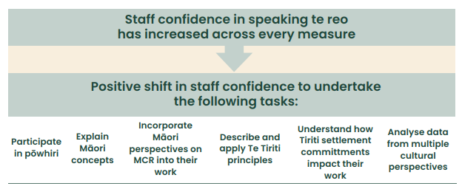

Sector performance
The New Zealand Cancer Action Plan 2019–2029 sets four outcomes and multiple actions across the cancer control pathway. In 2021/22 we developed a monitoring framework, which is in the process of being refined.

This report presents one indicator per outcome of the current state of cancer control in Aotearoa along with activities being undertaken to achieve the aspirations of the Cancer Action Plan.

Monitoring will take place annually so we will be able to track system changes over time. These measures will show if the sector is heading in the right direction. It is important to note that the results are not solely attributable to Te Aho o Te Kahu and some are likely to shift slowly.

Outcome 1: New Zealanders have a system that delivers consistent and modern cancer care

Indicator: Ethnic distribution of the current cancer workforce
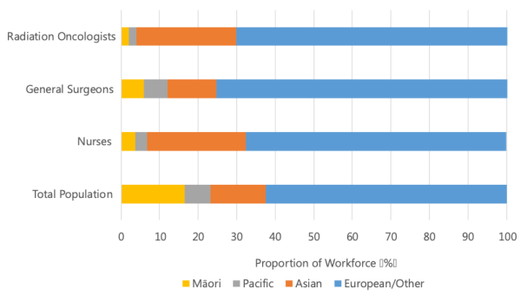
The figure above shows the ethnic distribution of radiation oncologists, general surgeons and nurses in 2022, alongside the ethnic distribution of the total New Zealand population. It illustrates that there is a mismatch between the ethnic distribution of the cancer workforce and the general population. Māori and Pacific peoples are underrepresented in the cancer workforce.

Activities led by Te Aho o Te Kahu related to Outcome 1
 | Te Aho o Te Kahu-led activity | Related Action(s) within the Cancer Action Plan
Outcome 1:  New Zealanders have a system that delivers consistent and modern cancer care | Creation of a cancer control agency for New Zealand | Leadership and governance
 | Creation of groups to assist in the governance of cancer care delivery | Leadership and governance
 | Partnership with Māori cancer leaders | Leadership and governance
 | Building infrastructure to make real-time cancer data sharing a reality | Data and information
 | Structured Pathology Reporting of Cancer | Data and information
 | MDM Data Standard refresh | Data and information
 | New funding for research to drive equitable cancer outcomes | Research and innovation
 | Supporting improved access to cancer clinical trials via teletrials | Research and innovation

Outcome 2: New Zealanders experience equitable cancer outcomes

Indicator: Routes to diagnosis — Proportion of cancers that were diagnosed in 2021 following an emergency presentation within 14 days prior to the date of diagnosis.
In 2021, Māori (32%) and Pacific peoples (35%) were more likely to be diagnosed with cancer following an emergency presentation, compared to 26% Asian and 22% European/Other for all cancers.

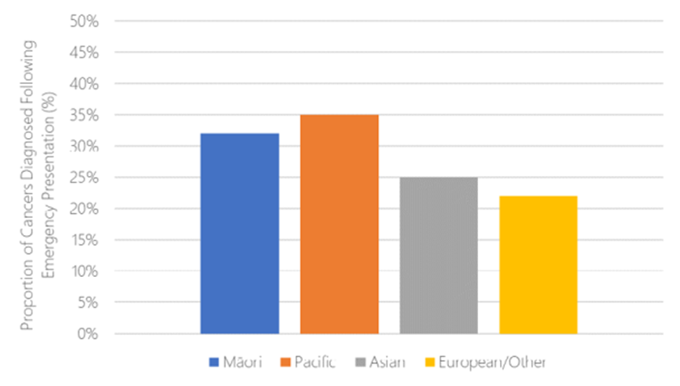

Activities led by Te Aho o Te Kahu related to Outcome 2
 | Te Aho o Te Kahu-led activity | Related Action(s) within the Cancer Action Plan
Outcome 2:  New Zealanders experience equitable cancer outcomes | Gathering the voice of the Māori community | Achieve equity by design
 | Building Mana Enhancing Relationships with Māori Leaders and Cancer Care Provider | Achieve equity by design
 | Project focusing on primary care | Achieve equity by design
 | Project on cancer care for Pacific peoples | Achieve equity by design

Outcome 3: New Zealanders have fewer cancers

Indicator: Tobacco — Proportion of New Zealanders who are daily smokers
There are strong disparities in daily tobacco smoking between ethnic groups in New Zealand. The rate of daily smoking appears to be reducing for most ethnic groups over time, although there does not appear to have been a change in disparities between ethnic groups.

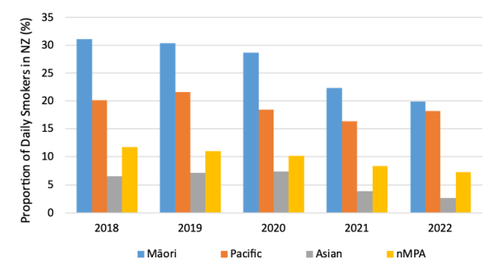

Activities led by Te Aho o Te Kahu related to Outcome 3
 | Te Aho o Te Kahu-led activity | Related Action(s) within the Cancer Action Plan
Outcome 3:  New Zealanders have fewer cancers | Pūrongo Ārai Mate Pukupuku | Cancer Prevention Report  To view this report, go to teaho.govt.nz/publications/prevention-report | - Smokefree by 2025  - Encourage and support healthy living  - Prevent cancers related to infection  - Reduce the incidence and impact of avoidable skin cancer caused by ultraviolet radiation

Outcome 4: New Zealanders have better cancer survival, supportive care and end-of-life care

Indicator: Surgery — Proportion of New Zealanders with cancer who received surgical treatment in 2021/22
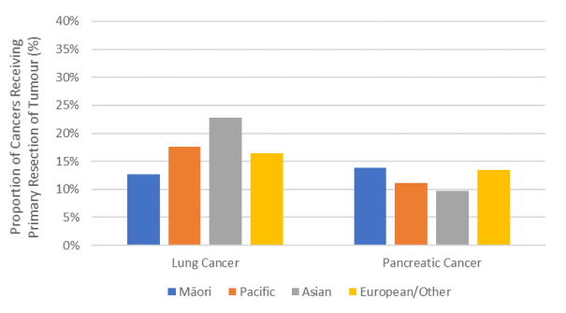

Overall, the rate of surgical resection for lung and pancreatic cancers was around 10–25%, with limited evidence of disparities between ethnic groups. The fluctuation in rates for Pacific and Asian peoples is primarily driven by small numbers of surgeries for these ethnic groups and should therefore be interpreted with caution.

Activities led by Te Aho o Te Kahu related to Outcome 4
 | Te Aho o Te Kahu-led activity | Related Action(s) within the Cancer Action Plan
Outcome 2:  New Zealanders experience equitable cancer outcomes | Mārama ana ki te Āputa: he tātari i te wāteatanga o ngā rongoā mate pukupuku i Aotearoa | Understanding the Gap: an analysis of the availability of cancer medicines in Aotearoa  To view the report, go to teaho.govt.nz/ publications/cancer-medicines | Improve cancer diagnosis and treatment outcomes
 | Measuring cancer treatment quality | Improve cancer diagnosis and treatment outcomes
 | He Mahere Ratonga Mate Pukupuku | Cancer Services Planning  To view copy of the report, go to teaho.govt.nz/ publications/cancer-services-planning | Improve cancer diagnosis and treatment outcomes

Te Tauākī Haepapa | Statement of responsibility
We are jointly responsible for the accuracy of any end-of-year performance information prepared by Te Aho o Te Kahu, whether or not that information is included in the annual report.

In our opinion, the annual report fairly reflects the operations, progress, and organisational health and capability of Te Aho o Te Kahu.

Nicola Hill Rami Rahal
Tumuaki | Acting Chief Executive Tumuaki | Chief Executive
(until 9 July 2023) (from 10 July 2023)
Te Aho o Te Kahu | Cancer Control Agency Te Aho o Te Kahu | Cancer Control Agency
30 September 2023 30 September 2023

Oati means ‘swearing an oath, swear in, promise, pledge, guarantee, vow, swear, assure, undertake’.

