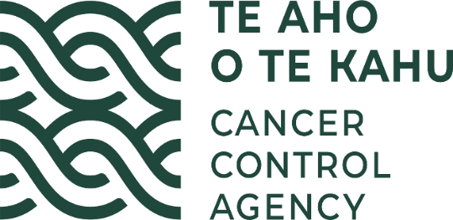

E Tipu E TIPU

Māori language plan for

Te Aho o Te Kahu, Cancer Control Agency

Whārangi Ihirangi - Table of Contents

1. He Whakamārama - Background 3
1.1 Te Tiriti o Waitangi - the Treaty of Waitangi 3
2. Te Takohatanga o Tō tātou Ingoa – The gifting of our name 4
2.1 He Māramatanga – Explanation 4
2.2 Tō Tātou Whāinga - Our Vision 5
2.3 O Tātou Uaratanga – Our Values 5
3. te tūranga mō naianei - Current State 7
4. Whaiwhakaarotanga - Considerations 8
5. Te Hōtaka o te mahi whakarauora reo / schedule of language revitalisation activities 10
6. Āpitihanga – Appendix: Karakia and Waiata 13

He Whakamārama - Background
Te Aho o Te Kahu, Cancer Control Agency was established on 3 December 2019 to deliver against the NZ Cancer Control Action Plan 2019-2029 (CCAP), which is guided by four overarching principles:
- He Mana Taurite - Equity-Led
- Mana Tangata - Person and Whānau-Centred
- Whai Māramatanga - Knowledge-Driven
- Kia Angitū - Outcomes-Focused
As our name implies, our purpose is to bind all the strands of cancer control into one cloak. We do this by communicating and directing cancer control initiatives via language modalities such as policies, reports, and advice both written and oral. Both formal and informal communication are key to our organisation.

Te Tiriti o Waitangi - the Treaty of Waitangi
Te Aho o Te Kahu, Cancer Control Agency is committed to honouring Te Tiriti o Waitangi. This includes the protection of Te Reo Māori me ōna tikanga. Te Reo Māori is an official language of Aotearoa and he taonga tuku iho for Māori.

Te Reo Māori is protected by Te Ture mō te Reo Māori, The Māori Language Act 2016 which affirms the mana (status) of the Māori language as:
- the indigenous language of New Zealand
- a taonga of iwi and Māori
- a language valued by the nation
- an official language of New Zealand.

The Maihi Karauna strategy was established to support and create societal conditions for te reo Māori to thrive and at the same time ensure that government systems support that. The three main goals of Te Maihi Karauna are that by 2040:
- 85 percent (or more) of New Zealanders (or more) will value te reo Māori as a key part of national identity
- 1,000,000 (or more) New Zealanders (or more) will have the ability and confidence to talk about at least basic things in te reo Māori
- 150,000 Māori aged 15 and over will use te reo Māori at least as much as English.

Te Takohatanga o Tō tātou Ingoa – The gifting of our name
Te Aho o Te Kahu works within a partnership arrangement with Hei Āhuru Mōwai, the National Māori Cancer Leadership Group who gifted us our name ‘Te Aho o Te Kahu’ to the Cancer Control Agency on 18 June 2020 at a ceremony held at Parliament, Wellington.

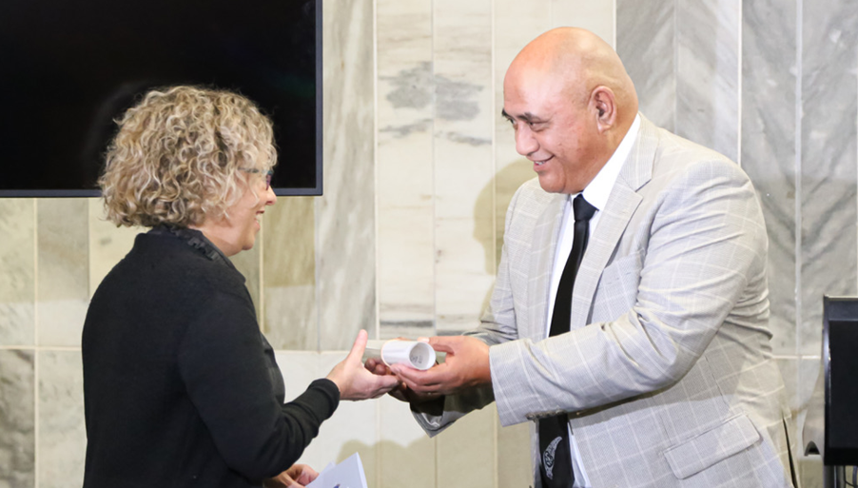

He Māramatanga – Explanation
Te Aho o Te Kahu, Cancer Control Agency:
a) The central thread of the cloak...or
b) The central information highway… or
c) The central thread that binds and unites the many strands of cancer control into one cloak, clothing and protecting our people, our whānau and our country.
Te Aho: the central thread symbolises the Agency,
Te Kahu: the cloak / garment symbolises all the services, organisations, people, and communities that work across the cancer continuum.
The core principles of this name speak to: the aho being strong, connecting all the muka (strands of cancer control), motivating, enabling and driving equity, unifying, connecting, sharing intelligence and along with the rest of the kahu providing warmth, equity, options and protection.

In acknowledgement of the honour in the gift of our name Te Aho o Te Kahu signed an oati with Hei Āhuru Mōwai that acknowledges that:
- Te Tiriti o Waitangi, its principles and intentions are the foundation for the name and the Te Aho o Te Kahu will honour our commitment to these
- Te Aho o Te Kahu has a commitment to uphold the mana and integrity of the name and its meaning in its entirety, that the name and its mauri is respected, nurtured and cared for, and its core principles are adhered to, including ensuring that this is reflected in our appropriate use of te reo Māori in our work.

Tō Tātou Whāinga - Our Vision
We lead and unite efforts to deliver better cancer outcomes for Aotearoa.
Fewer cancers. Kia whakaiti iho te mate pukupuku.
Better survival. Kia runga noa ake te mataora.
Equity for all. Kia taurite ngā huanga.

O Tātou Uaratanga – Our Values

He Mana Taurite – Equity Led
Mā te whiritahi, ka whakatūtuki ai ngā pūmanawa ā tāngata
Weaving together our expertise we realise each person’s potential

Language equity ensures that te Reo Māori as a living taonga is natural and normalised across all our work programmes. Equitable language access and acculturation of te reo Māori has benefits for the social, physical, mental and spiritual health of Māori and therefore all New Zealanders’.

Mana Tāngata – Whānau Centred
Whiri te tāngata ka puta he oranga
Weave the people together and wellness will ensue
As a living kauwaka mauri (embodiment of health) te reo Māori is central to mātauranga Māori and is the preferred mechanism through which Māori knowledge is transmitted. Karakia, whakawhiti kōrero, and waiata are forms of te reo that are commonly used in mātauranga Māori health practices . Te Aho o Te Kahu recognises that the revitalisation of te reo Māori is an important component to ensure the health and wellbeing of Māori whānau in Aotearoa.

Whai Māramatanga – Knowledge Driven
Poipoia te kākano kia puāwai
Nurture the seed and it will blossom
Te reo Māori conveys and reflects the whakapapa relationship between te Ao mārama (the world of light and life) and te Ao kikokiko (the physical embodiment). Mātauranga Māori (Māori knowledge) including knowledge pertaining to health and wellbeing is transmitted through te reo Māori. Te reo Māori enables the transference of knowledge between generations and supports a deeper understanding of Māori cultural beliefs and values.

Kia Angitū – Outcomes Focussed
Kotahi te aho ka whati; ki te kāpuia e kore e whati
A single strand is easily broken; many strands woven together cannot be
A strong sense of cultural identity, access to cultural domains and to reo Māori me ōnā tikanga are associated with improved health outcomes . Working in partnership with Māori is an important driver of the work of Te Aho o Te Kahu and building and strengthening the competence and capability in te reo has been identified has a key strategy to support effective working relationships.
This te reo plan ‘E Tipu E Tipu’ supports not only the Māori Language Act 2016 and the Maihi Karauna but also acts to:
- whakamana our name in accordance with our oati
- whakamana the intention of He Korowai Oranga and Whakamaua – the Māori Health Action Plan
- whakamana Te Tiriti o Waitangi
- whakamana our oati ingoa /name agreement with Hei Āhuru Mōwai
- increase our organisational health by growing a confident and capable workforce
- contribute to the revitalisation of Te Reo
- enhance our effectiveness and provide better services to Māori.

te tūranga mō naianei - Current State
Te Aho o Te Kahu is a relatively new agency committed to inclusion of te reo in both written and oral communications and is still in the process of developing the capability and confidence to ensure that this occurs consistently and appropriately across its relevant workstreams. To date we have:
- signed and committed to a formal declaration to uphold the mana and integrity of our Māori name, including appropriate use of te reo Māori
- commissioned a karakia and waiata for Te Aho o Te Kahu which are aligned to our name and purpose (Appendix 1) and which staff are proactively supported to use as appropriate in internal and external meetings and forums
- supported our staff in our Wellington office to undertake introductory te reo classes, implemented twice weekly karakia and waiata sessions for Wellington office staff
- developed informal and social activities to support staff developing confidence and vocabulary in te reo including Rāmere Reo Māori coffee sessions, and te reo Māori card games (Tākaro) in our Wellington office
- developed bi-lingual signage on Te Aho o Te Kahu website, inclusion of te reo Māori in internal and external communications https://teaho.govt.nz/
- established a Pou Tikanga role to support the work of the agency
- delivered the Government’s Response to the Māori Affairs Committee into Health Inequities for Māori in a fully bilingual format https://www.parliament.nz/en/pb/papers-presented/current-papers/document/PAP_109920/he-urupare-n%C4%81-te-k%C4%81wanatanga-ki-te-p%C5%ABrongo-a-t%C4%81-te-komiti
- undertaken 13 regional Māori Cancer hui to which over 2000 Māori attended, including Māori experiencing cancer and their whānau, local Māori providers and leaders, and mana whenua. Hui were held on marae and in community settings where people were supported to share their kōrero and experiences of cancer in order to inform the ongoing work of the Agency. Both the presence of fluent te reo Māori speakers and the ability of Te Aho o Te Kahu staff to work in te reo Māori settings and environments were vital to the successful delivery of these engagements
- had a te reo proficient member of staff provide interviews for te reo Māori news media about the work of the agency
- run a series of internal workshops for all Te Aho o Te Kahu staff to develop our Whāinga Amorangi plan and in which staff have shared their te reo Māori aspirations, which have also informed this plan
- run a series of wānanga through the Māori community hui to discuss mātauranga as a vehicle to understand and address complex health needs of Māori. A key project area for Te Aho o Te Kahu is to support Māori whānau to be able to access mātauranga Māori as part of their cancer care. Consequently, understanding of the role te reo plays in health and wellbeing for Māori has been identified is a learning objective for Te Aho o Te Kahu staff.

Whaiwhakaarotanga - Considerations
In developing this plan Te Aho o Te Kahu has reflected on the following considerations for incorporating Te Reo Māori into our work:
Whaiwhakaarotanga – Considerations | Ngā kaupapa mahi - Proposed approaches
Te reo Māori used by Te Aho o Te Kahu needs to be supported by application of appropriate tikanga. | - Develop the capability of Te Aho o Te Kahu staff to actively maintain the hononga and mana of Te Reo me ōna tikanga.  - Development of Pou Tikanga role to support and advise Te Aho o Te Kahu on matters of tikanga.  - Development and maintenance of relationships with mana whenua.
Te reo Māori must be used in ways that are appropriate and relevant e.g. appropriate use of reo Māori, kupu Māori or whakataukī Māori in our work. | - Organisation wide professional development includes internal capacity building of Te Reo.  - Development of Pou Tikanga role to support and advise Te Aho o Te Kahu on matters of tikanga associated with the use of te reo Māori in our work.  - Ensuring communications plans include opportunities to support the appropriate use of te reo Māori in our work including commonly used kupu & whakataukī and translations of commonly used technical and operational terms and phrases in Te Aho o Te Kahu work.  - Development of induction materials to ensure staff understand the whakapapa of our name, and the tikanga that sits behind our values.  - Support staff to improve pronunciation of te reo and appropriate use of te reo in their work.  - Translation services used as required and appropriate relative to the complexity and significance of the work.
Te reo Māori needs to be seen as a centralised hauora or mauri ora mechanism and not an add on. | - Maintain reo capacity/capability across the organisation in order to normalise its use in internal and external, and formal and informal settings.  - Appropriate internal and external resources are identified and applied.  - Ensure appropriate access to external translations services to ensure Māori speaking staff are not unduly overburdened.
Te Aho o Te Kahu, Cancer Control Agency acts in accordance with the obligations inherent in carrying a Māori name and delivering against the oati. | - Executive Leadership Team maintains accountability for upholding the terms of the oati.  - Development of induction materials to ensure staff understand the whakapapa of our name, and the tikanga that sits behind our values.

Te Hōtaka o te mahi whakarauora reo / schedule of language revitalisation activities 2021/22
Language Planning Elements | Action Area | Indicator | Responsibility | Measure
Status  Raising the profile and value of the Māori language within Te Aho o Te Kahu. | - Induction guides and processes include and support commitment to growing reo competency.  - Communications plans to consider and provide guidance for the appropriate inclusion and use of te reo Māori.  - Staff receive training and instruction about Te Tiriti o Waitangi and implications for the status of te reo Māori. | - All staff understand the importance and relevance of te reo Māori to their work and the work of Te Aho o Te Kahu.  - Te reo Māori included in public facing documents and communications platforms.  - Staff understand the importance of te reo Māori as a Te Tiriti right, as a taonga tuku iho, and the fundamental basis of mātauranga Māori. | - Office of the CE  - People managers  - All staff | - 100% of new staff are provided with induction information clearly describing our ingoa, our values and our commitment to te ao Māori (%).  - All communication plans cover appropriate inclusion of te reo (Y/N).  - 100% of staff receive annual refresh on Te Tiriti (%).
Critical awareness  Te Aho o Te Kahu contributes to promoting and creating awareness of the need for revitalisation of te reo Māori. | - Developing an understanding of the relationship between te reo Māori and the Agency’s work.  - Te Aho o Te Kahu actively participates in te Wiki o Te Reo activities. | - Staff actively consider and include te reo Māori in the delivery of their work.  - Te reo Māori is utilised and actively promoted across the work of Te Aho o Te Kahu. | - Office of the CE  - People managers  - All staff | - Communication plans cover appropriate inclusion of te reo (Y/N).
Acquisition  Increasing the number of Te Aho o Te Kahu staff learning te reo Māori, through either formal (courses/training) or informal means. | - Ensuring all new and current staff in Te Aho o Te Kahu have an avenue to acquire basic te reo.  - Te reo Māori me ōnā tikanga are included in everyday processes e.g. use of karakia to open meetings.  - Providing regular and informal opportunities for staff to practice the use of te reo e.g. karakia and waiata proactice session, te reo me te kapu tī, kēmu. | - Professional development plans for staff include a commitment to increasing competency and use of te reo Māori.  - Staff increase their confidence and proficiency in pronunciation and appropriate use of te reo in their work and in everyday situations.  - Staff are encouraged and supported to undertake professional development in te reo Māori. | - People managers | - Formal learning is available to staff (Y/N).  - Identified meetings (e.g. Staff fora) always commence with karakia and waiata (Y/N).  - An element of te reo is evident in all staff personal development plans (%).
Use  Normalising and increasing Te Aho o Te Kahu staff and stakeholders use of te reo Māori, including supporting domains where language is seen and heard and where it may be used freely. | - Upskilling all staff, particularly those who work directly with the public or stakeholders to be able to pronounce our name, and Māori personal and place names.  - Strategically adding te reo Māori to organisational communications both internally and externally e.g. Websites, internal and external updates.  - Te reo Māori me ōnā tikanga are included in everyday processes e.g. use of karakia to open meetings, te reo Māori used in internal formal and informal communications, emails etc. | Te Aho o Te Kahu staff are comfortable in using te reo Maori in everyday settings e.g.  - te reo Māori role titles will be included in staff signatures on emails and external communications  - in greetings and farewells in te reo, both in person and via email  - in delivery of Te Aho o Te Kahu karakia and waiata  - with pronunciation of te reo  - in introducing themselves with a basic pepehā  - in using te reo words on a daily basis (days, months, numbers and common phrases). | - Communications team, supported by reo champions, and Pou tikanga  - All staff | - All staff have good pronunciation of our agency name (%).  - Proportion of staff who self-assess as competent in te reo pronunciation (%).  - All staff know their basic pepeha and demonstrate use (%).  - All staff know our karakia and waiata (%).
Corpus  Increasing the availability and/or development of terms and words to widen language use specific to Te Aho o Te Kahu.  Ensuring the quality, contextual relevance and appropriate use of te reo Māori in Te Aho o Te Kahu. | - Ensure communications plans incudes opportunities to support the appropriate use of te reo Māori in our work.  - Pou Tikanga role to support and advise Te Aho o Te Kahu on matters of tikanga.  - Ensure appropriate access to external translations services as required. | - Use of te reo Māori is planned and executed in accordance with the communications plan.  - External translators used appropriately in the development of projects that require significantly large or complex translations. | - Office of the CE | - At least one Pou Tikanga assigned to support the agency at all times (Y/N).  - Specified budget available for formal translation services (Y/N).

Āpitihanga – Appendix: Karakia and Waiata

Te Aho o Te Kahu Karakia
Aho nuku Aho rangi
Hei mataaho tuanuku
Hei mataaho tuarangi
Hei aho rā rikiriki
Hei aho o te wao
Kia hoki ki te pū
Kia hoki ki te rito
Kia hoki ki te whānau
Whakaemi, whakamana, whakaora i te tangata
Turuturu whakamaua kia tina
Tina
Hui e, taiki e

Whakapapa
This karakia has specifically been made for Te Aho o Te Kahu, Cancer Control Agency. The karakia talks about the mana of the aho between Papatūānuku and Ranginui, acknowledges those who have passed on, and those who are still living on this earthly plane. The end of the karakia reminds us of what is most important – it is whānau.
Nā Kiingi Hepi, Moahuia Goza, Michelle Mako & Gary Thompson.

Te Aho o Te Kahu Waiata:

Te Kahu Āhuru

Mā wai te kahu āhuru e kanoi,  Mōku, mō te iwi, mō te motu e?  Me moanarua te hae,  Me whakamahu te kino  ka ngau i te aho ki te manawa.  Ka hihiri, ka rarapa i te pō,  ki te whei ao,  Ka ao mārama.  He ranga wairua nō Hine, nō Rongo,  Tēnei āhuru mōwai e.  Mā wai te kahu āhuru e kanoi?  Me hoki …. ki te whānau e. (x2) | Who shall weave this protective cloak,  For me, for the people, for the nation?  To repair the tear,  To heal the wound  That bites upon the thread to the heart, mind, spirit.  (I/We) sought for it in te pō (realm of hidden potential),  In te whei ao (realm of dawning potential),  And it is clear (te ao mārama – the realm of realised potential).  Inspired from/by Hine (female divinity) & Rongo (healing),  This haven of protection (a nod to Hei Āhuru Mōwai who gave us our name).  Who shall weave this protective cloak?  (The answer is) centred within family.

Nā Kiingi Hepi, Moahuia Goza

Durie, M. K. (2019). Mātauranga Māori: Achieving Māori Health Gains. [Unpublished Paper prepared on behalf the Māori Expert Advisory Group for the Health and Disability System Review].
Ibid.
Durie, M. (1999). Te Pae Māhutonga: A model for Māori health promotion. Health Promotion Forum of New Zealand Newsletter.
King, M., et al. (2009). "Indigenous health part 2: the underlying causes of the health gap." The lancet 374(9683): 76-85.

